# Overview

To support FEMAs Risk MAP program, STARR processed 332 square miles of Light Detection and Ranging (LiDAR) data for Racine County, Wisconsin.

# Figure 1 Racine County Project Area

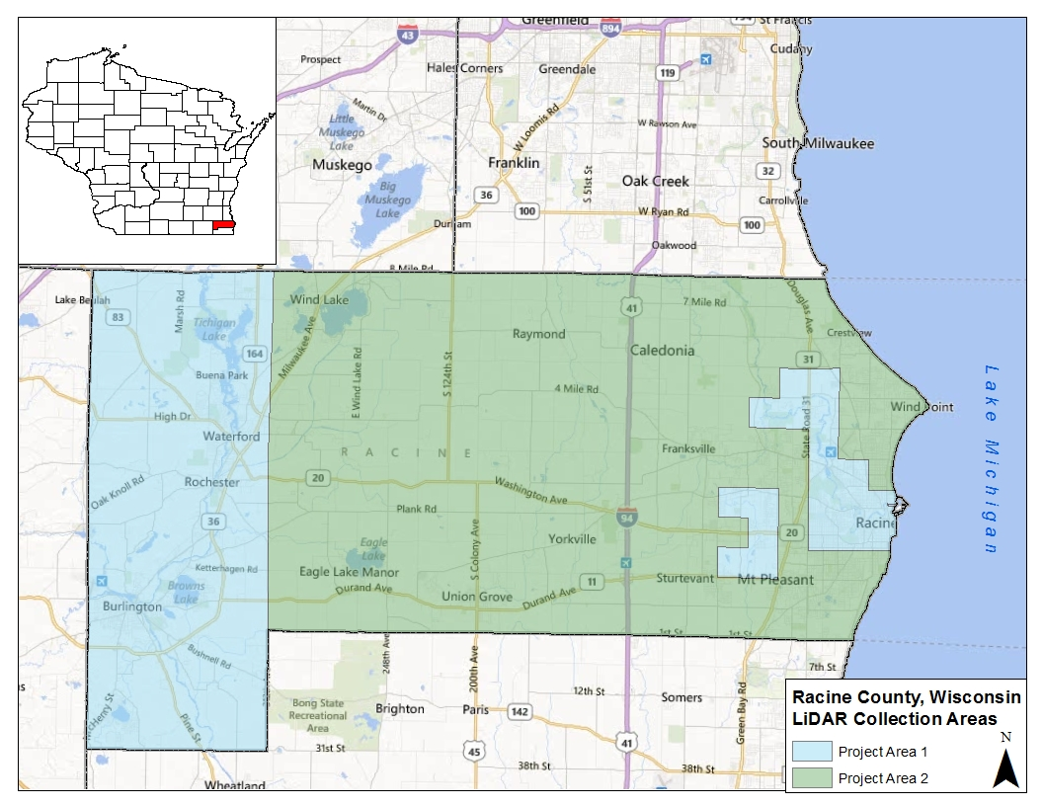

The objectives for the Racine County project post processing are shown in Table 1.

# Table 1 Project Parameters

|  |  |  |  |  |  |  |  |
| --- | --- | --- | --- | --- | --- | --- | --- |
| **Collection**  **Area** | **Processed**  **Area** | **FEMA**  **Specification Level** | **Contour**  **Accuracy** | **NPS** | **RMSEz** | **FVA** | **CVA** |
| 332 mi2 | 332 mi2 | Highest | 2ft | 1m | 0.61ft | 0.80 ft | 1.19 ft |

This project included both LiDAR raw point cloud development and bare earth post processing. All LiDAR points classified as class 2 are considered to be Bare Earth and points classified as class 8 are Model Key. All data for this project has been collected using the following spatial reference information:

Projection: Universal Transverse Mercator UTM Zone: 16 North

Linear units: Meter

Horizontal Datum: North American Datum 1983

Vertical Datum: North American Vertical Datum of 1988 - Geoid 09 Vertical units: US Survey Foot

**Vertical Accuracy Test Results**

Final Test Results

The vertical accuracy requirements based on flood risk and terrain slope are met with

0.481ft Root Mean Square Error(RMSEZ ). The mandatory requirement for the highest specification for vertical accuracy is 0.61ft RMSEZ.

CVA Test

Tested 0.93ft consolidated vertical accuracy (CVA) at 95th percentile in: brush, forest, hard surfaces, long grass and low grass. The RMSE for the elevation differences between GPS control points and LiDAR points is 0.48 ft calculated with 221 supplemental vertical accuracy points (SVA).

# Scope of Work

Statement of Priorities

PTS Elevation Data Acquisition

STARR – Contract # HSFEHQ-09-D-0370 Task Order # HSFE05-11-J-0090, Change Request # ST393

# LiDAR Processing

* 1. **Background**

All data collected under this contract will adhere to the FEMA Procedure Memorandum No. 61 - Standards for LiDAR and Other High Quality Digital Topography.

This project is to take elevation data collected by the Southeast WisconsinRegional Planning Commission (SEWRPC) on behalf of Racine County, and develop the Fully Classified LAS files. The resultant data will also be tested for the CVA at the 95% Confidence Level to meet the ‘Highest’ FEMA Specification Level (or 1.19 feet). Deliverables will include the following: survey check points, ‘point cloud’ Unclassified LAS files, Fully Classified LAS files, Post-Flight Aerial Acquisition and Calibration Report, breaklines, DEMs, Contours, QA testing report, TSDN narrative and metadata. FEMA does not require the data to be hydro-flattened, as specified in USGS v.13.

# Technical Discussion

The requirements for this contract are summarized in Table 2.

# Table 2 LiDAR Tasking Summary

**Specification**

|  |  |  |  |  |
| --- | --- | --- | --- | --- |
| **Project Name** | **State** | **STARR LiDAR Provider** | **Area in Square Miles** | **FEMA Specification Level** |
| Racine | WI | Quantum Spatial, Inc (formerly AeroMetric, Inc. | 232 | Highest |

1. Work Tasks

Survey

Survey checkpoints were collected by Quantum Spatial distributed throughout Racine County. Table 3 provides a summary of the number of points within each of the ground cover categories. The FVA points are collected in open terrain.

# Table 3 Survey Summary

|  |  |  |  |  |  |  |  |
| --- | --- | --- | --- | --- | --- | --- | --- |
| **Project Name** | **FVA Points** | **SVA Points** | | | | | **Total CVA Test Points** |
| **Hard Surface** | **Short Grass** | **Long Grass** | **Brush** | **Forest** |
| Racine | 46 | 46 | 44 | 45 | 43 | 45 | 221 |

LiDAR Collection

The flightline configuration is depicted in Figure 2. As previously stated, the LiDAR data was contracted by SEWRPC. Their contractor was Quantum Spatial, who is also under contract to STARR. For further details on the collection of the LiDAR data, please refer to the Racine County WI Post-Flight Aerial Acquisition and Calibration Report.

LiDAR Processing

*Automated Processing*

The following is a brief explanation of the LiDAR processing.

Raw airborne GPS and IMU data will be extracted and differentially processed, to derive a smoothed best estimate of trajectory (SBET).The SBET is used to reduce the LiDAR slant range measurements to derive the return measurement for each LiDAR pulse within each flight line.

The LiDAR points will be imported into the processing software and tiled into 1500m x 1500m tiles. An initial accuracy assessment using the ground control survey data will be calculated to ensure the data is accurately 'tied' to the ground.. The data will then be classified using automated processes to extract a bare earth digital elevation model (DEM). Once all project data is imported and classified, the survey ground control data will be calculated against the LAS Class 2 (Ground) data for an accuracy assessment. As a QC measure, a routine will be used to generate accuracy statistical reports by comparison among LiDAR points, ground control, and triangulated irregular networks (TIN). Any systematic bias in the data is removed to meet or exceed the vertical accuracy requirements. At this point the FVA test will be conducted.

# Figure 2 Racine County Project Flightlines



*Manual Processing*

The calibrated and filtered LiDAR point cloud will be hand checked for accuracy. All points will be placed in one of the following categories: 1 Unclassified, 2 Ground, 7 Noise, and 12 Overlap Points. Model Key points will then be generated from the Ground points and placed in Category 8. CVA testing will be conducted and final reports generated.

Quality Control Testing

*Survey*

To ensure valid in-field collections, an NGS monument with suitable vertical reporting was measured using the same equipment and procedures used for control, FVA and CVA points on a daily basis. The measurement was compared to the NGS published values to ensure that the GPS collection schema was producing valid data and as a physical proof point of quality of collections. Those monument measurements are summarized in the accuracy report included in the Survey data deliverables.

*LiDAR Acquisition*

Calibration

All of the sensors are calibrated by flying lines at multiple altitudes and at varying directions over features on land, typically at the airport where the acquisition is staged. These lines are used to remove angular errors between the IMU and scanning mirror and to determine the precise positioning of the sensor in relationship with the phase center of the GPS antenna mounted on the fuselage of the aircraft.

Cross Lines

Cross flight lines are run perpendicular to the overall flight lines for the survey area. Careful analysis takes place from the crossing flight lines to ensure that accurate modeling of the ground surface is attained from the use of the LiDAR sensor.

Sidelap Analysis

The side overlap is planned for each project based on the terrain to be acquired. Typically for flat terrain the overlap is 20%. For more rugged terrain an overlap of up to 50% (100% duplicated coverage) will be required. The sidelap will ensure that no data gaps exist within the coverage.

Forward and Reverse GPS Solutions

During the initial processing of the inertial navigation system (INS) data, the raw GPS observations are processed against the ground base station data in both a forward and reverse sense. The two solutions are then compared against one another for all GPS epochs and the individual differences for the northing, easting, and elevation components are plotted for easy comparison. Any anomalies in the data are quickly analyzed, and if required, re-flights take place for the portions of the flight missions that require remediation.

Calibration of the Elevation Surface

The raw LiDAR surface is compared against ground points that are established for the calibration of the elevation surface. System biases are identified and removed during this calibration. An early statistical analysis takes place that provides an indication of the precision of the acquired data.

RMSE Testing

The LAS data will be tested at the conclusion of the automated processing step. At this point the LAS points have been calibrated and open area points should accurately reflect the bare earth surface. Using the FVA x, y coordinates the elevation is determined at that location. These elevations compared to the actual elevations to determine the vertical offsets at each point location. Calculation of the RMSE and the 95% Confidence Level will be done via a spreadsheet. If the value is within the acceptable range, manual processing can continue. If the value is not within range, the LiDAR contractor must analyze the data further to get within acceptable range. Likewise, at the conclusion of the manual bare earth processing the CVA test points will be checked against the produced bare earth surface following the same methodology.

Quality Assurance

Stantec conducted the Quality Assurance activities on behalf of STARR. These activities are guided by our Quality Assurance checklist which was developed to include all of the suggested information found in PM61. In addition a statistical sampling of LAS data tiles are reviewed, checking for spikes in the data, incomplete coverage, and cleanliness of the data. This review is done using the LP360 software (commercially available software). The software allows for review of the data via a rolling cross section approach whereby a tile of data can easily be reviewed ensuring there are no artifacts remaining in the bare earth data. The final step in the quality assurance process is the construct of the TSDN documentation and the final assembly of the metadata for the terrain products.

Management

Project management of the contract and oversight of the subcontractor was performed for STARR by Stantec. Standard project management activities include progress reporting, MIP update, approval of subcontractor invoicing, etc.

1. Deliverables

Survey

* + Shape file of the points;
  + Station diagrams for each point;
  + Spreadsheet of all points;

LiDAR

* + Post-flight Aerial Acquisition and Calibration Report (PostFlight Report);
  + Point cloud LAS points (partially classified);
  + Fully classified LAS points (includes 1. Unclassified, 2 Bare-earth ground, 7. Noise, 8. Model Key Points, 9. Water - if breaklines are collected, 10 Ignored ground, 11. Withheld, 12 Overlap);
  + Metadata
  + Compliance certificate.

Quality Assurance

* + Quality Assurance Checklist;
  + TSDN; and
  + Final compiled metadata record.

# Issues

* 1. **Special Problem Reports**

None

* 1. **Project Modifications**

None

# Information for the next Mapping Partner

None

# Conclusion

STARR has completed the processing of the Racine County area of interest as described in Task Order # HSFE05-11-J-0009, Change Request #ST393. The processing for the Racine County Wisconsin project meet the requirements set forth by FEMA Procedure Memorandum 61– Standards for LiDAR and Other High Quality Digital Topography, USGS LiDAR Guidelines and Base Specifications v13, and ASPRS LAS v1.2 specifications.

Final deliverables have been shipped to the FEMA Engineering Library, via external hard drive, and the appropriate documentation has been uploaded to the MIP.

J:\FEMA\R05\WISCONSIN_55\RACINE_55101\RACINE_101C\14-05-

2315S\SubmissionUpload\Terrain\2166098