Technical Support Data Notebook Project Narrative

Task: Topographic Data Development Marinette County, Wisconsin
FEMA Case Number: 15-05-1270S
October 30, 2015

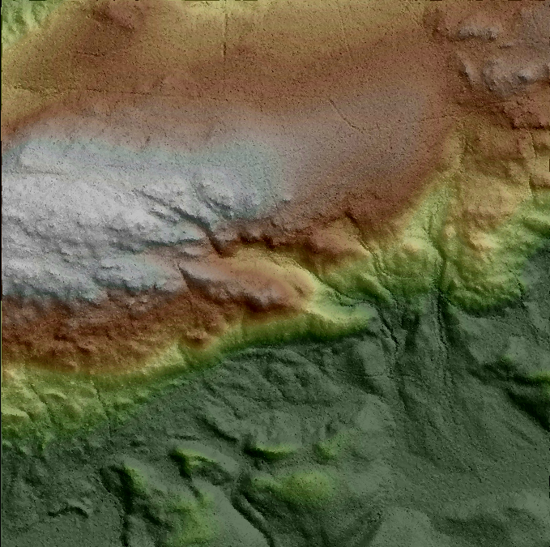

Submitted to:

Federal Emergency Management Agency, Region 5
Department of Homeland Security
536 South Clark Street, 6th Floor
Chicago, IL 60605

Prepared by:

Contents
1. INTRODUCTION 3
1.1 PURPOSE 3
1.2 PROJECT SCOPE OF WORK 3
1.2.1 COLLECT CALIBRATED LiDAR POINT CLOUD DATA 3
1.2.2 BARE EARTH PROCESSING 5
1.2.3 BREAKLINES 6
1.2.4 CHECKPOINT SURVEYS 7
1.2.5 INDEPENDENT QA/QC 8
2. INFORMATION FOR THE NEXT MAPPING PARTNER 10
2.1 UNCLASSIFIED POINT CLOUD LIDAR DATA REVIEW 10
2.2 CLASSIFIED POINT CLOUD LIDAR DATA REVIEW 11
2.3 INDEPENDENT QA/QC RESULTS 12

INTRODUCTION

  - PURPOSE

Terrain data, as defined in FEMA’s Guidelines and Standards for Flood Risk
Analysis and Mapping, describe the elevation data used to create the topographic environment of a watershed and/or floodplain. Terrain data requirements allow for flexibility in the types of information used to produce final deliverables. Submission of the data sources allows FEMA to account for the origins of the flood study elevation data.

The purpose of these datasets is to provide a basis for coastal/riverine hydraulic and hydrologic modeling in Marinette County, Wisconsin. All terrain data collected for hydrologic analysis, hydraulic analysis, floodplain boundary delineation, and/or testing of floodplain boundary standard compliance meets the requirements outlined in the Federal Emergency Management Agency, Standards for Flood Risk Analysis and Mapping, Standard ID (40, 43-49) November 18, 2014, USGS LiDAR Base Specifications Version 1.0, and ASPRS standards for LAS 1.2

  - PROJECT Scope of Work

Marinette County Elevation/LiDAR Task SOW
This task involves the preparation of elevation data for use in hydrologic analysis, hydraulic analysis, coastal analysis, floodplain boundary standard compliance and/or testing compliance, and non-regulatory products (e.g. depth grids and risk probability grids).

1.2.1 Collect Calibrated LiDAR Point Cloud Data
Task involves aerial acquisition of LiDAR data and processing to the calibrated point cloud deliverable.

Scope
STARR will collect and calibrate LiDAR point cloud data for Marinette County, Wisconsin (Figure 1). Data will be in compliance with USGS LiDAR Base Specification Version 1.0 and ASPRS LAS Specification Version 1.2. STARR shall generate new topographic data for areas defined in Figure 1 below, to include a 100m buffer of the project area. Vertical accuracy for the topographic data shall be to the Highest FEMA Specification Level (equivalent 2‐ft contour accuracy). The data will be referenced to the NAD83 horizontal datum and NAVD 88 vertical datum using the most recently approved National Geodetic Survey Geoid model. The coordinate reference system is to be determined in consultation with the Regional Project Monitor. Vertical units will be in US Survey feet. In addition, STARR shall address all concerns or questions regarding the topographic data development and processing that are raised during the Independent QA/QC review.

For this task order, STARR sub‐contractor Woolpert, Inc. will develop the flight plan, acquire the LiDAR points and process the data to the point cloud deliverable. STARR will hold a kick‐off meeting with Woolpert within 10 days of the task order signing. The kick‐off meeting will set expectations, clearly define the scope of services and schedule. STARR will monitor the Woolpert activity by requiring weekly progress updates which will include progress to date, issues encountered and mitigation plans, and scheduled activities for the next period. All STARR subcontractors are expected to adhere to the STARR Quality Manual requirements.

Figure 1 Marinette County Wisconsin Project Area

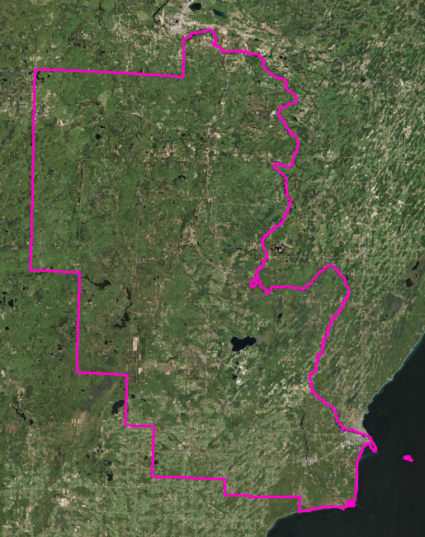

Deliverables
STARR shall make the following products available to FEMA by uploading the digital data to the MIP, where appropriate. LAS point files will be delivered to the FEMA Engineering Library only. All other deliverables will be uploaded to the MIP in addition to being delivered to the library with the point files.

- Pre‐Flight Operations Planning Report summarizing the acquisition flight plans, including planned flightlines, GPS stations, control, airport locations, calibration plans, quality procedures, sensor parameters, aircraft, procedure for reflights, and considerations for terrain, ground cover, and weather.
- Post‐Flight Aerial Acquisition and Calibration Report summarizing acquisition flight and LiDAR sensor parameters, processing and calibration settings and results, to include GPS stations, flight logs, actual flightlines/trajectories (ESRI shapefile), ground control data, and results of data verification;
- LAS Mass Points data set to Class 1;
- FVA analysis report describing the assessment of the vertical accuracy of the data, including the Root Mean Square Error (RMSE) calculation spreadsheet;
- Identification of areas of low confidence or data voids and methods used to supplement these areas;
- Metadata file FGDC compliant loaded to the MIP;
- Supporting documentation including Geospatial files (ESRI shapefile format) of project boundary and tiling scheme, and Certification of Work;
- TSDN narrative describing the scope of work, direction from FEMA, issues, information for next mapping partner, etc. ;
- Updates to the National Digital Elevation Program (NDEP) project tracking at http://www.ndep.gov/.

    - Bare Earth Processing
Task involves processing LiDAR data that has been calibrated, but not classified. Resultant data will be classified LAS files.

Scope
STARR will perform bare earth processing for data covering Marinette County, Wisconsin.

For this activity, STARR shall process the Calibrated LiDAR Point Cloud data to generate a Classified LAS dataset, including Bare Earth (LAS Class 2). In addition, STARR shall address all concerns or questions regarding the topographic data development and processing that are raised during the Independent QA/QC review.

For this task order, STARR sub‐contractor Continental Mapping Consultants, Inc. will process the LiDAR point cloud to the Classified LAS dataset. STARR will hold a kick‐off meeting with Continental when the Calibrated Point Cloud is ready for processing. The kick‐off meeting will set expectations, clearly define the scope of services and schedule. STARR will monitor the sub‐contractor activity by requiring weekly progress updates which will include progress to date, issues encountered and mitigation plans, and scheduled activities for the next period. All STARR subcontractors are expected to adhere to the STARR Quality Manual requirements.

Deliverables
STARR shall make the following products available to FEMA by uploading the digital data to the MIP, where appropriate. Large datasets such as LAS point files greater than 1 GB, will be delivered to the FEMA Engineering Library.

- Classified LAS Mass Point data;
- CVA analysis report describing the assessment of the vertical accuracy of the data, including the SVA analysis and Root Mean Square Error (RMSE) calculation spreadsheet;
- Metadata file;
- Certification of Work;
- TSDN narrative describing the scope of work, direction from FEMA, issues, information for next mapping partner, etc.;
- Updates to the National Digital Elevation Program (NDEP) project tracking at http://www.ndep.gov

    - Breaklines
Task involves collection of Breaklines to be used in the Bare Earth Processing to further define the resultant surface model.

Scope
STARR shall collect Breaklines for Marinette County, Wisconsin. 3D Breaklines shall be collected along streams greater than 100ft in width and water bodies greater than 2 acres in area. Breaklines will be used during the classification of LAS data to define water points and hydro‐flatten the data.

Breaklines shall also be collected at breaks in slope (edge of road surfaces, edge of cliff, etc). These Breaklines will be collected to support production of 2 foot contours.

For this task order, STARR sub‐contractor Continental Mapping Consultants, Inc. will collect the required Breaklines. As noted above STARR will conduct the kickoff meeting and monitor progress weekly.

Deliverables
STARR shall make the following products available to FEMA by uploading the digital data to the MIP.

- 3D Breaklines;
- Metadata file;
- TSDN narrative describing the scope of work, direction from FEMA, issues, information for next mapping partner, etc.

    - Checkpoint Surveys
Activity involves collecting ground control and vertical accuracy checkpoints via traditional field survey techniques. Ground control is used during the LiDAR processing steps to calibrate the data to the earth's surface. Vertical accuracy checkpoints are used for the Independent QA/QC of the data.

Scope
STARR will perform checkpoint surveys for Marinette County, Wisconsin. STARR shall collect ground control points for use by the LiDAR Acquisition subcontractors for calibration of the LiDAR data during the processing of the Calibrated LAS Point Cloud Data. STARR shall also collect vertical accuracy checkpoints as required by the scope of the LiDAR collection and processing tasks.

STARR will collect ground control and Fundamental Vertical Accuracy (FVA) points in areas of consistent slope and open ground cover where the LiDAR pulses have a reasonable chance to penetrate to the earth's surface. The FVA points, however, will be held and utilized in the QC process as blind checkpoints to determine the vertical accuracy of the Calibrated LiDAR Point Cloud dataset. A minimum of 20 points are required to provide the statistical sampling.

STARR will collect Supplemental Vertical Accuracy (SVA) points in areas of consistent slope. Points will be collected in up to 3 major land classification categories representative of the area of interest. These points will be held for use in the QC process as blind check points to determine the vertical accuracy of the Bare Earth dataset. The number of points must be at least 20 per category to provide adequate statistical sampling.

All points will be distributed across the collection area to avoid clustering.
For this task order, STARR sub‐contractor CompassData, Inc. will conduct the ground control and accuracy checkpoint survey. STARR will hold a kick‐off meeting with CompassData within 10 days of the task order signing. The kick‐off meeting will set expectations, clearly define the scope of services and schedule. STARR will monitor the CompassData activity by requiring weekly progress updates which will include progress to date, issues encountered and mitigation plans, and scheduled activities for the next period. All STARR subcontractors are expected to adhere to the STARR Quality Manual requirements.

Deliverables
STARR shall make the following products available to FEMA by uploading the digital data to the MIP.

- x,y,z point data, in tabular format;
- digital pictures of point location;
- National Geodetic Survey data sheets for Network Control Points used to control ground surveys;
- Equipment calibration report;
- Metadata file;
- Support documentation and Certification of Work;
- TSDN narrative describing the scope of work, direction from FEMA, issues, information for next mapping partner, etc.;
- Results of Fundamental Vertical Accuracy and Consolidated Vertical Accuracy testing.

    - Independent QA/QC
Task involves QA/QC review of digital terrain and associated products. Calibrated LiDAR point cloud and Bare Earth LAS point datasets will also include vertical accuracy assessment reviews. Datasets will undergo digital and visual inspections for adherence to FEMA Standards.

Scope
STARR will review all deliverables from vendors to ensure completeness and adherence to current FEMA Standards and Guidelines. Included in this review is:

- Surveyed x,y,z points;
- Calibrated LAS Point Cloud;
- Classified (Bare Earth) LAS dataset;
- Breaklines.

STARR will compile a Quality Assurance Report detailing the quality checks used, results of the quality checks, statistical analysis of the LAS datasets, illustrative pictures and diagrams as warranted by the dataset conditions.

Deliverables
STARR shall make the following products available to FEMA by uploading the digital data to the MIP, where appropriate.

- Quality Assurance Report, associated checklists, quality check printouts;
- TSDN narrative describing the scope of work, direction from FEMA, issues, information for next mapping partner, etc.

STARR will provide all mentioned deliverables to FEMA via external hard drive. To the extent possible, datasets other than the source LAS files will be loaded to the MIP at this location:
J:/R05/WISCONSIN_55/MARINETTE_55075/MARINETTE_075C/15-05-1270S/SubmissionUpload/Terrain/2174371

INFORMATION FOR THE NEXT MAPPING PARTNER

LiDAR collected under FEMA Task Order No. HSFE05-14-J-0037 dated August 14, 2014 was collected and processed by STARR. CompassData, Inc. performed the ground control survey and RMSE vertical quality control. Woolpert, Inc. conducted the LiDAR Acquisition, while LiDAR post processing was accomplished by Continental Mapping Consultants, Inc. Stantec, Inc. performed Independent Quality Assurance of the unclassified and classified LiDAR datasets. All firms performed duties under task order contract to STARR.

All LiDAR derived products for this project have been collected using the following spatial reference information:
Projection: UTM Zone 16 N
Linear units: Meter
Horizontal Datum: North American Datum 1983 (2011)
Vertical Datum: North American Vertical Datum of 1988 Vertical units: US Survey Foot

  - UNCLASSIFIED POINT CLOUD LiDAR DATA REVIEW

This review was conducted on the unclassified point cloud dataset. The purpose of this review was to determine whether the dataset was produced in a manner consistent with requirements set forth in the USGS LiDAR Base Specifications Version 1.0 and ASPRS LAS Specifications Version 1.2. The review included an examination of vendor submittal files, LiDAR coverage, point density and nominal point spacing, spatial distribution, data voids, LAS file characteristics, vertical accuracy verification, and a visual review of a sample dataset.

Data submitted by STARR team members were reviewed for completeness and proper functionality. The data provided contained appropriate collection conditions, spatial references, and the project area met USGS specifications. The total point counts and measured area within each tile were used to calculate point density and NPS (ppsm = 1/NPS²), ensuring that an NPS of 1 meter for the project area was met.

Spatial distribution and data voids were determined to meet expectations. LAS files were checked to insure data consistency, appropriate public block headers, variable length records, multiple discrete returns, intensity values, minimum and maximum scan angles, adjusted GPS time, the correct coordinate reference system, swath ID, and point families. It was determined that the ASPRS LAS Specification Version 1.2 requirements were met.

For the unclassified point cloud dataset, FVA was used to determine the vertical accuracy. Fields in both feet and meters were created for each of the checkpoint elevations, LiDAR elevations, and difference between LiDAR and checkpoint measures (checkpoint – LiDAR) within the FVA checkpoints shapefile provided by the vendor. Elevation values provided by the vendor were used to populate the attributes for checkpoint elevations. For LiDAR elevation values, information was obtained through using the “Add Surface Information” tool under the 3D Analyst toolset and adding elevation information from the terrain dataset developed from the unclassified point cloud dataset. The differences were loaded into an excel spreadsheet where ∆Z mean, ∆Z min, ∆Z max, RMSE, and the 95% confidence level were determined.

A sample set of unclassified tiles was selected to receive a visual review to ensure multiple discrete returns exist, intensity values exist and are correct, edge matching is consistent, any voids present are acceptable, and that blunders and other anomalies are non-existent.

  - CLASSIFIED POINT CLOUD LiDAR DATA REVIEW

The classified review underwent the same process as the unclassified review with a few exceptions. Data voids, spatial distribution, point density, and NPS were not necessary to repeat, as they each provided a measure of the entire dataset. The LAS file review included the same examination with the addition of point assignment to the various classes.

The vertical accuracy assessment observed CVA values, rather than FVA values as was assessed in the unclassified review. The DEM was used to add surface values representing LiDAR elevations to the CVA checkpoint shapefile created from coordinates provided by the vendor.

A visual check of the Breaklines and classified tiles was conducted through hands on evaluation. The Breaklines were examined through the entire dataset and the tiles through a sample dataset. The visual check confirmed the Breaklines met the specifications given in USGS LiDAR Base Specification Version 1.0. The review of the classified tiles acknowledged the following requirements were met:

- Scan lines were removed from bare earth
- No excessive noise in the bare earth
- No elevation steps in data
- Voids are only found in acceptable areas as noted in Section 3.5
- Seamless edge matching between tiles
- All artifacts removed (vegetation, bridges, buildings, etc.)
- Proper definition of roads and drainage patterns
- No areas “over-smoothed” during filtering
- No existence of corn row effects
- Absence of mounds and divots
- Any other anomaly resulting with reduced accuracy of terrain representation
- Within any 1 kilometer (km) x 1 km area, no more than 2 percent of non-withheld points will possess a demonstrably erroneous classification value

Classified tiles and Breaklines were reviewed through ArcMap 10.1. A DSM and a DEM developed from first returns and last returns respectively, were used to check the classified tile sample set.

  - INDEPENDENT QA/QC RESULTS
Through the Independent QA/QC process outlined above, the data was deemed to have met or exceeded the referenced Standards and Specifications. Thus, the data is usable for the express stated intent of the task order issued by FEMA Region V.

