LiDAR Quality Review Report

Burnett County, Wisconsin
Land Information Office

September 2016

Prepared by:

PointCloud Mapping, LLC
790 State Highway 32
Three Lakes, WI 54562

- Project Description

This Scope of Work of this project was to obtain and create high resolution elevation data sets that, when combined with Burnett County’s GIS data sets would establish an authoritative source for elevation information for the entire County and would be shared across County departments, other government agencies, non-profits, and the public at large.
The contract for the project was awarded to Ayres Associates who acts as the prime contractor and whose prime production responsibility is LiDAR data editing while the Quantum Spatial team is responsible for data collection. The third party Quality Review portion was awarded to PointCloud Mapping.
The project basically consists of LiDAR collection and processing of 1067 tiles (5000 foot by 5000 foot) comprising the entire county plus a 1000 foot buffer around the western edge and 100 feet on the north, east and southern borders. One tile of the 1067 tiles is located completely within a lake. The LiDAR data was classified into 9 different classifications along with the generation of break line development for use in hydro-flattening. The LiDAR data will be used to generate 2 foot contours, DEM’s, DSM’s, and intensity images. There are three phases to the LiDAR project and are summarized below:
- Data Acquisition
- Data Processing
- Product Development

Project Area Map
The project tiles are shown in magenta and the 16 Pilot Area tiles are indicated in bold outlines.
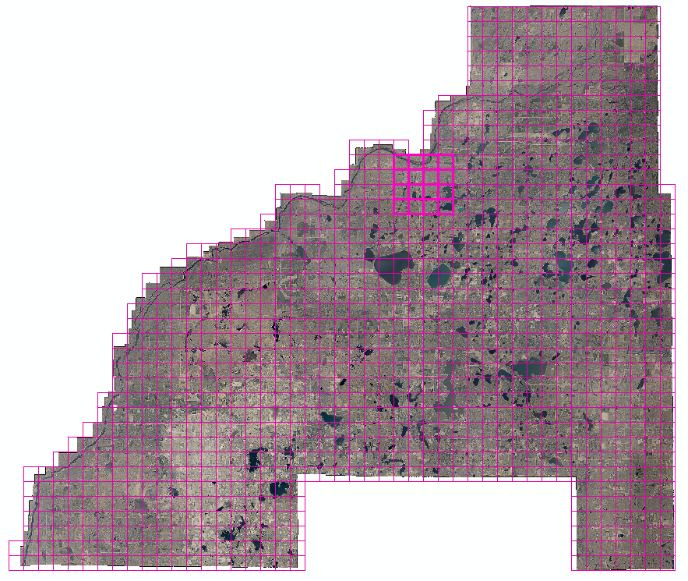
Figure 1 – Project Tile Extents

2. Review Analysis

2.1 Completeness Assessment
A review was conducted of all the deliverables to confirm that all required deliverables were present. Two required items were missing: first, the ground data in ASCII format was missing, and second, there was no metadata. These files were furnished with the final deliverables.

2.2 Ground Control Surveys
The Quality Review by PointCloud Mapping, LLC started by checking the vertical accuracy of the LiDAR data. For the entire project area, the Land Information Office of Burnett County provided 128 GPS ground survey points established in 5 different land use categories. The various land use categories were clustered and distributed throughout the project area. Figure 2, QC Point Locations, shows the distribution of the blind QC points. The points were surveyed on the following system:
Horizontal Datum: NAD 83 (NSRS 2007)
Vertical Datum: NAVD88
Projection: Burnett County – Wisconsin Coordinate Reference System, US Survey Feet

These points were withheld from Ayres and only used by the QR team.
The coordinates and land use categories are summarized in the spreadsheet “Burnett County QCGroundControl 1-12-16.xlsx”.
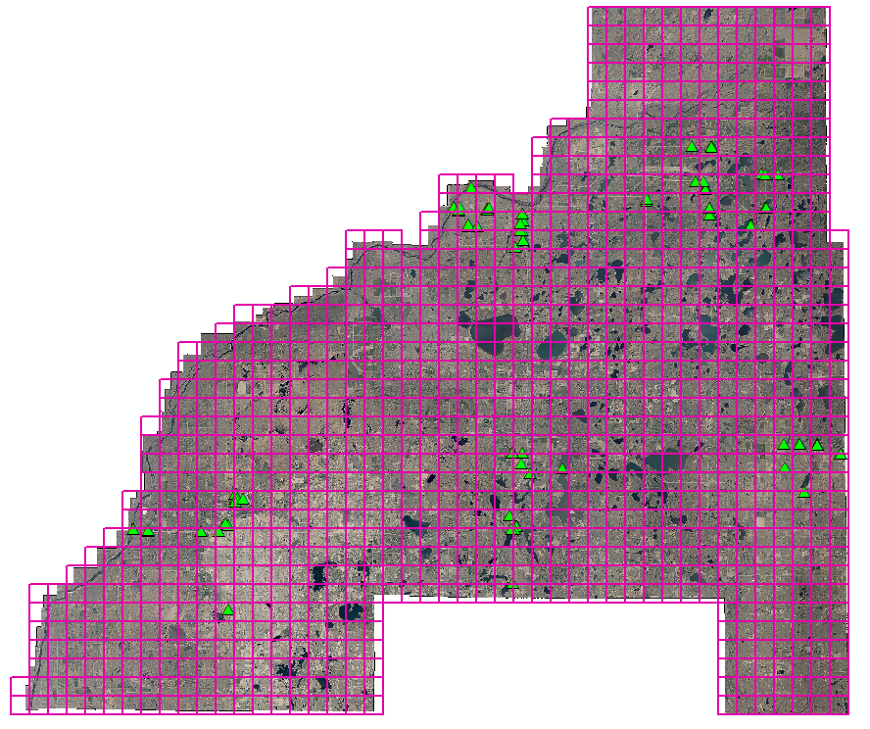
Figure 2 - QC Point Locations

2.3 LiDAR Accuracy Assessment
The computation of the vertical accuracy assessment considers not only the vertical component of the points but also the type of vegetation where the point is located. Two different standards are used to evaluate the accuracy depending upon the vegetated categories. A RMSE calculation is performed for bare earth points and a 95th percentile is used for vegetated areas.

2.3.1 Quality Review Criteria for Vertical Accuracy
The criteria for evaluating the quality of the vertical accuracy of the blind QC points as compared to the LiDAR surface are given in the FEMA Appendix A document.

The assigned Mapping Partner shall separately evaluate and report on the TIN accuracy for the main categories of ground cover in the study area, including the following:
1. Bare-earth and low grass (e.g., plowed fields, lawns, golf courses);
2. High grass, weeds, and crops (e.g., hay fields, corn fields, wheat fields);
3. Brush lands and low trees (e.g., chaparrals, mesquite);
4. Forested, fully covered by trees (e.g., hardwoods, evergreens, mixed forests);
5. Urban areas (e.g., high, dense manmade structures);

Definitions and Target accuracies are taken from the FEMA Procedure Memo No. 61
Accuracyz — The NSSDA reporting standard in the vertical component that equals the linear uncertainty value, such that the true or theoretical vertical location of the point falls within that linear uncertainty value 95-percent of the time. Accuracyz = 1.9600 x RMSEz. Vertical accuracy is defined as the positional accuracy of a dataset with respect to a vertical datum.
Consolidated Vertical Accuracy (CVA) – The result of a test of the accuracy of vertical checkpoints (z-values) consolidated for two or more of the major land cover categories, representing both open terrain and other land cover categories. Computed by using the 95th percentile, CVA is always accompanied by Fundamental Vertical Accuracy (FVA).
Fundamental Vertical Accuracy (FVA) – The value by which vertical accuracy can be equitably assessed and compared among datasets. The FVA is determined with vertical checkpoints located only in open terrain, where there is a very high probability that the sensor will have detected the ground surface. FVA is calculated at the 95% confidence level in open terrain only, using RMSEz x 1.9600,

Supplemental Vertical Accuracy (SVA) – The result of a test of the accuracy of z-values over areas with ground cover categories or combination of categories other than open terrain. Computed by using the 95th percentile, SVA is always accompanied by Fundamental Vertical Accuracy (FVA). SVA values are computed individually for different land cover categories. Each land cover type representing 10% of more of the total project area is typically tested and reported as an SVA. SVA specifications are normally target values that may be exceeded so long as overall CVA requirements are satisfied.
95% Confidence Level – Accuracy reported at the 95% confidence level means that 95% of the positions in the dataset will have an error with respect to true ground position that is equal to or smaller than the reported accuracy value. The reported accuracy value reflects all uncertainties, including those introduced by geodetic control coordinates, compilation, and final computation of ground coordinate values in the product. Where errors follow a normal error distribution, Accuracy z defines vertical accuracy at the 95% confidence level (computed as RMSE z x 1.9600), and Accuracy r defines horizontal (radial) accuracy at the 95% confidence level (computed as RMSE r x 1.7308).

95th Percentile – Accuracy reported at the 95th percentile indicates that 95% of the errors will be of equal or lesser value and 5% of the errors will be of larger value. This term is used when errors may not follow a normal error distribution, e.g., in forested areas where the classification of bare-earth elevations may have a positive bias. Vertical accuracy at the 95% confidence level and 95th percentile may be compared to evaluate the degree to which actual errors approach a normal distribution.

.
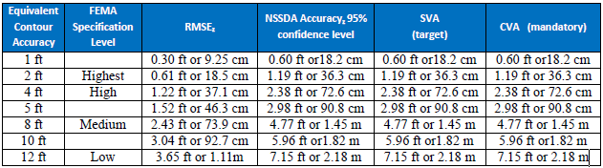
2.3.2 Vertical Data Accuracy Analysis
The Pilot Area was evaluated using 48 bare earth points that were previously established by Burnett County. The comparison to the LiDAR data indicated a RMSE of 0.28 feet.
After the submittal of final LiDAR from Ayres, all of the vertical QC points that were surveyed were checked against the LiDAR TIN surface. The following table shows the results of the all of the points properly registered data.

When looking at all of the points the mean is -0.08 feet indicates a well distributed set of readings. The RMSE for all points of 0.30 feet indicates a high degree of reliability and accuracy of all of the land use classes. The accuracy determined by either the RMSE standard or the 95th percentile standards are both given. By either standard, the data is well within the accuracy requirements and thereby the data set passes this test.

Following is the summary of the RMSE calculations and the accuracy calculations. The complete spreadsheet showing all of the individual points along with the calculations are given in “Burnett County QCGroundControl 1-12-16.xlsx”.

 | Summary of Ground Points
Class | RMSE | Point count | 95th Percentile
All | 0.30 | 128 | 0.60
Bare Earth | 0.20 | 43 | 0.32
Brush | 0.24 | 24 | 0.46
Low Veg | 0.58 | 18 | 1.19
Forested | 0.25 | 39 | 0.49
Urban | 0.25 | 3 | 0.30

3. LiDAR Quality Assessment
The results of the Quality Review are given in the spreadsheet named “Burnett County Lidar Review 1-12-16.xlsx”. The individual items reviewed along with the specific criteria, the review comments and additional responses are given. In addition, a shape file named “QR-Comments_1-12-16.shp” is provided to give specific calls in the data set.

  - LiDAR Quality Review – General Items
Many of the items under the LiDAR Quality Review were checked using either automated routines or manual methods. Where possible, automated routines are used on 100% of the tiles. Where manual methods are used to evaluate the data, a random sample of tiles are reviewed. For this review, 10% (107 tiles total) of the 1067 las tiles were reviewed.

Flight lines were visually checked to make sure they agreed with the approved flight plans, and that no gaps were present. Readability by two different programs was checked using LP360 and LASTools. Data voids were checked by inspecting the LiDAR data during the classification review (No data voids were evident except in areas such as rivers and lakes where voids are acceptable). File Naming, Project Coverage, Nominal Post Spacing, Horizontal Datum, Vertical Datum, Units, Projection, LAS Version, LAS Header Information, and Point Cloud Classes were checked using automated routines in LP360. The LP360 reports are furnished in the form of an ESRI shape file where the attributes list the various items (Statistics_1.shp).

Because some of the review is automated, we also produced statistics for minimum and maximum scan angles, GPS time stamps, generating software, minimum and maximum x, y & z coordinates, and generated a point count per class.

All of these checks passed.

3.2 Classification Analysis

The following systematic approach for each Delivery Area was followed by PointCloud Mapping, LLC in performing the classification review and analysis:

- Performed tile-by-tile analyses
  - Using LP360, the data tiles were loaded, general statistics run (LP360) and reviewed for any gross anomalies. Point density, minimum and maximum scan angles, and proper classes were reviewed for adherence to specifications. A separate standalone program was run to check for duplicate points.
  - The following procedure was used to manually check for proper classifications.
    - Each tile was visually reviewed for anomalies in the point classifications. Any anomalies were noted in a shape file and became part of the review document. Burnett County 2015 digital orthoimagery was used as a back drop to aide in the interpretation.
    - Check for only approved classes.
    - Check for Buildings left in the vegetation points class.
    - Check for Vegetation left in the bare-earth or vegetation points class.
    - Check for Vegetation appearing on hard surfaces and water.
    - Check for Bridges placed in the proper classes.
    - Check for Ground areas that may have been overly aggressively removed during the automated routines.
    - Determine if more than 2% of points have been mis-classified.
- Prepare a review document and error shape file for each area and send to Ayres and Burnett County.
- Ayres submits revisions and PointCloud Mapping, LLC back checks for correctness. Review document is updated. Conduct a teleconference to discuss any appropriate changes in the interpretation of specifications.
- Process continues until all elements have reached a “Pass” status.

3.3 Classification Results
During an automated routines to check for duplicate points, it was noticed that 10 tiles had duplicate points ranging from counts of 1 to 4,861,622. These tiles are detailed in the “Burnett County Lidar Review 1-12-16 v2.xlsx” document. A similar situation exists for the Bare Earth las delivery. These duplicate points were removed from the data set.

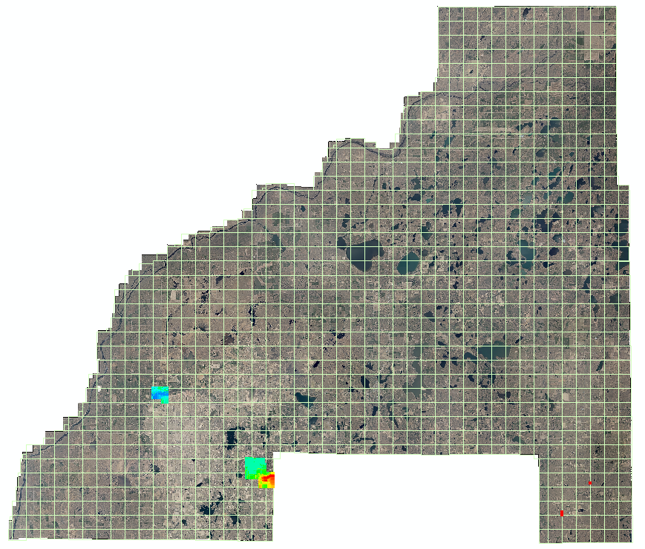
Figure 3 – Duplicate Points
Tiles 1533, 3126, 3742, 3942, 3943, 3940, 2937, 2822, 1633, 3840, 1738, 3844, 3845, 3127, 1142, 1543, 2338, 3228, 1531, 1736, 1740, 3541 and 3941 contain Class 18 points. Figure 4 is an example of tile
1533, in plan and profile view, and the Class 18 points that fall below the ground surface. The traditional ASPRS numbering scheme uses Class 18 as high noise. Class 18 points were reclassified and placed in Class 7 (Low Points).

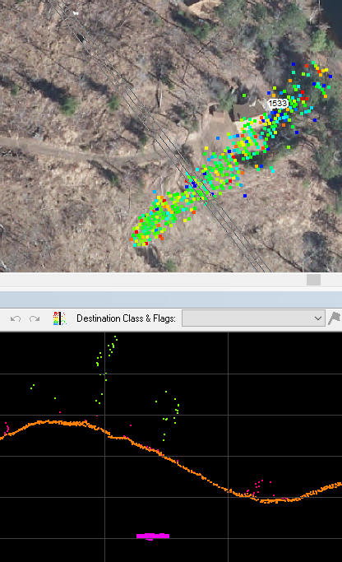
Figure 4 Class 18 Points

Figure 5 shows Class 17 points on tile 2907. In the northern portion there is a correctly classified bridge spanning the river. All of the other points in yellow are Class 17 but do not represent bridges. These spurious bridge points on this, and other tiles, were corrected.

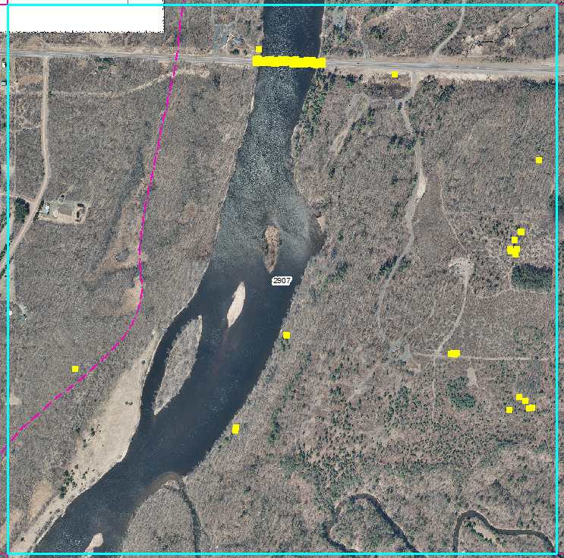
Figure 5 - Misidentified Bridge Points

3.4 Overlap Analysis

The following figure shows the area where north-south flight lines do not overlap the diagonal flight lines. The reason for having overlap between flight swaths is to 1) minimize the chances of having data voids and 2) allow the contractor to clip the outside edges of each flight swath where errors are most likely to occur. It is quite common to trim the data at the midpoint between adjacent flight swaths. In this particular case, Ayres clipped the flight swaths to a common line to make a butt join. While this is a bit unusual, it still passes the accuracy and point density standards.

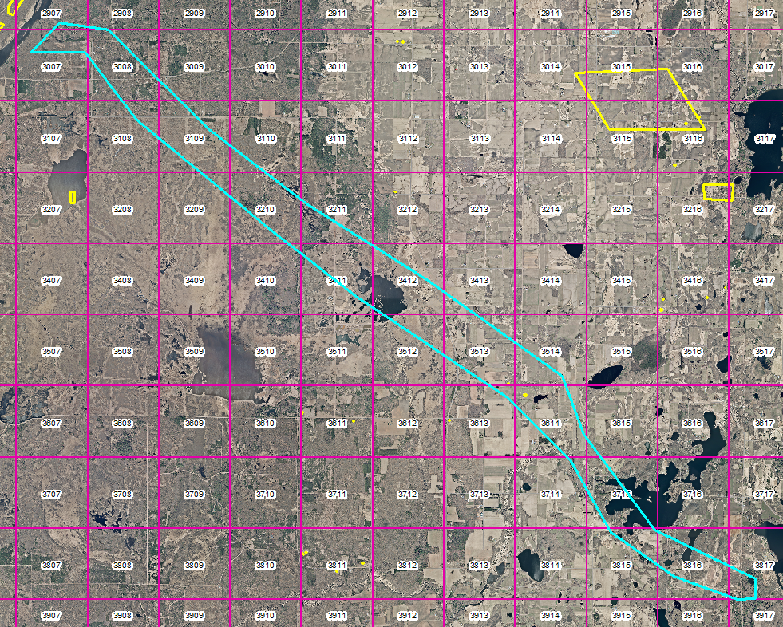
Figure 6 - Missing Overlap Between Flight Lines

The following figure shows incomplete coverage in the corners of various tiles. The below figure shows Class 11 points (Withheld) to emphasize the unusual coverage in the corners of the tiles. As previously discussed, the normal process is to trim the overlap at the midpoint between the flight swaths. In this case it appears that the trimming was done periodically along the tile edges. The data coverage is complete and passes the accuracy standards and point density requirements, but the method used to trim the overlap area is unusual.
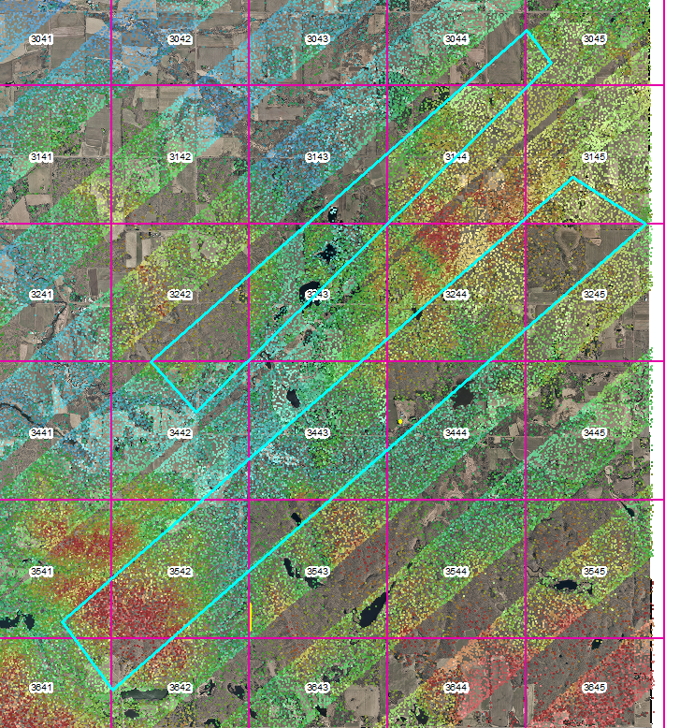
Figure 7 - Gaps in Coverage

3.5 Other Classifications
Of the 185 calls made in the “QR-Comments_1-12-16.shp” file, 115 calls were specific to mis-classified, or incomplete, buildings. Since the contract states that “Classification of points in Classes 5 and 6 will be done using automated routines (these classifications do not include a statement of positional accuracy or completeness of content).”, Ayres can’t be held liable for these calls. It is important, however, for the County to recognize that these errors exist in the dataset.
There were a few calls regarding interpretation of ground versus water in low lying areas. The number of these calls were not sufficient to reject the data set. There were several instances of high vegetation located in water bodies. For consistency, these should be reclassified into another class such as Class 1. For those areas that are subjective, the interpretation by Ayres was accepted. For those areas that had high vegetation in the water, those points were reclassified into Class 1.

4. Review of Contours
A geodatabase of the contours with each tile comprising a different feature within the database was reviewed. A random sampling of tiles was conducted and all items passed.

Item reviewed | Results
Ground Class used in contour generation | Pass
Bridges removed from Ground Class | Pass
Edge matching at tile edges | Pass
Crossing Contours | Pass
Continuous Contours | Pass
Unbroken Contours | Pass
Proper Attribution | Pass

All of the required tiles were delivered according to the original tiling scheme. The contours joined between tiles, were properly attributed, were continuous and did not contain any gaps. The bridge classification (Class 17) was not used during the contour generation process therefore, the contours are correct and properly portrayed.

5. Review of Hydro Flattening
A random sampling of the Waterbodies and the HydroFeatures was performed.
Item Reviewed | Results
Waterbodies - Flatness | Pass
HydroFeatures – Monotonic, smoothness | Pass
Used break lines for contour generation | Pass
Seamless across tile boundaries | Pass
No Stair stepping | Pass

- DEM’s, DSM’s, and Intensity Images
In Figure 8, the tile on the left the DSM contains elevation differences of 42 feet in a tile that only contains water. This comes from using Class 1 (Unclassified) points when generating the DSM. Since Class 1 contains anomalous points, it should not be used in the generation of other products. The tile on the right contains elevations that are 45 feet higher than the water surface from the Class 5 (High Veg).
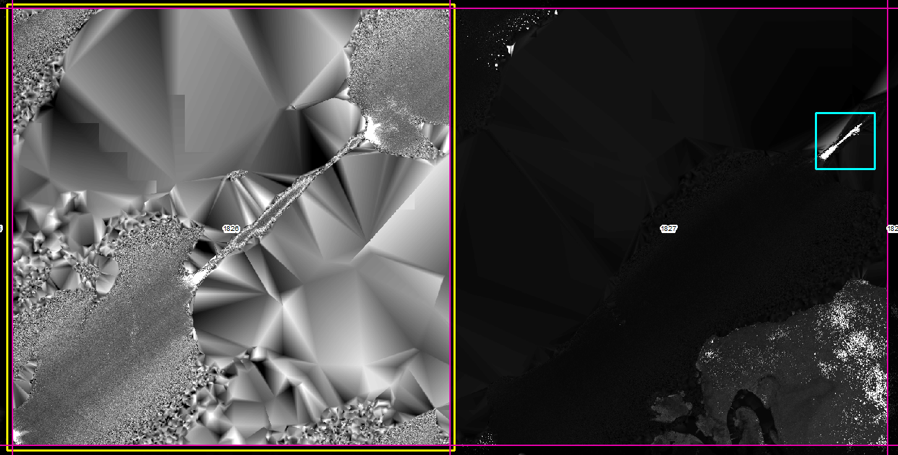
Figure 8 - DSM Issues
With minor modifications, by Ayres, to the DEM’s, DSM’s and Intensity images, the final products passed the specifications.

In Figure 9, there is a portion of the DSM and DEM at the corner that interpolates across the corner and provides incorrect elevations. All DEM’s and DSM’s were clipped to the project boundary and these corner issues were corrected.

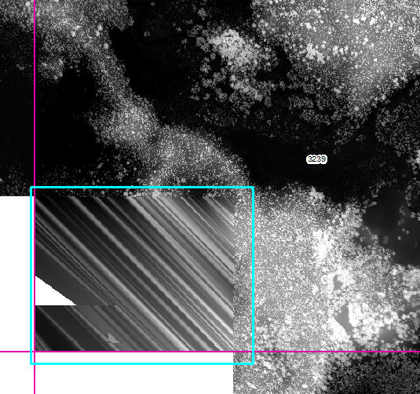
Figure 9 - DSM and DEM Corner Issues

In Figure 10, the DSM contains triangles in the water. Apparently, points located in Class 1 are being used to generate the DSM and contains tree tops overhanging the water’s edge. There can be two slightly different approaches to create DSM’s along water bodies. First, you can select the first returns from the entire dataset. This would include trees that are overhanging the water body and thus create triangles in the water and the TIN triangles connect across the water body. This creates false elevations above the water. The second approach is to us the hydro enforced break lines to clip the overhanging trees and use the break lines to make the water “flat”. This presents a more aesthetically pleasing DSM but it omits the overhanging trees. Both alternatives are technically correct and Ayres chose to use the first option.
In addition, the strip in the SE corner of the tile is from erroneous points contained in Class 1. This error was corrected in the final data set.

Figure 10 - DSM Issues in Water

7. Metadata
Metadata was delivered with the final deliverables but had an improper number of square miles. This error was corrected. .

8. Final Deliverables
A partial set of deliverables were submitted on 8-02-16. These re-submittals were immediately reviewed and were considered acceptable. An e-mail was submitted to Ayres notifying them that a complete and final set of deliverables should be submitted. The final deliverables were submitted on 9-01-16 and the review was completed on 9-08-16. The final deliverables were checked for completeness and readability. The data set passed this criteria, and along with previous reviews, was deemed acceptable.

