Readme file to accompany 2011 Aztalan LiDAR Data

The data and accompanying documentation were provided by Ann Scott, DNR Land Records Officer and GIS Coordinator for the Bureau of Facilities & Lands, on January 2, 2019.

Ann also provided this brief description of the data:
“There are two geodatabases-- file and personal.
The file gdb has the raw data for the section; the personal gdb has a clip of Aztalan as well as the entire section plus all the other geometries-- clip polygon, bare earth, first contact-- multi and single point.”

The LiDAR data was provided as Multipoints in both the file and personal geodatabase; the data does not include the raw LAS files.

These screen captures show the feature classes that were provided:
- File geodatabase:
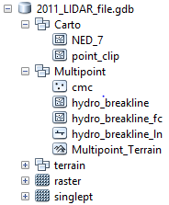

- Personal geodatabase:
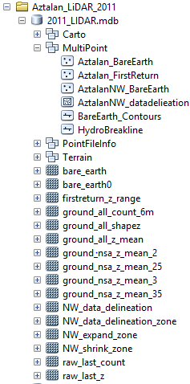

This file was last updated 1/3/2019 by John Laedlein, WDNR GIS Section.

