Data Specifications for 3D Imagery Project for
Aztalan State Park
T07N R14E Sections 16, 17, 20 & 21
Town of Aztalan, Jefferson County, Wisconsin

Supplemental to the 3-D representation of the study area, but equally as important is the detailed spatial analysis of an archaeological site, therefore high-density data specifications are requested to provide finest resolution of the study area.

Survey Extents:
Coordinate System—UTM NAD83, Zone 15N, meters

Primary Study Area (1000 acres):

NORTHING |  | EASTING |  | CORNER
4777249.23683000 |  | 838214.45190000 |  | NE
4777364.64614000 |  | 835760.40147900 |  | NW
4775551.04389000 |  | 835822.71046700 |  | SW
4775636.91532000 |  | 838240.18688000 |  | SE

Secondary Study Area (7500 acres):

NORTHING |  | EASTING |  | CORNER
4778923.97683000 |  | 838215.95434900 |  | NE
4778733.31577000 |  | 831807.98173600 |  | NW
4773983.16949000 |  | 831985.88369300 |  | SW
4774177.24792000 |  | 838276.96562400 |  | SE

See Map 1: Aztalan Study Area Extent Map for details (attached)

Time of Survey:
Data collection is to occur during leaf-off conditions with no snow cover between the dates of March 18 and April 30, 2011.

Collection Specifications:
  - Average point spacing—0.5 to 0.7 meter (or better)
  - Vertical Accuracies—15 cm RMSE (or better)
  - Horizontal Accuracies—0.5 meter (or better)

Deliverables:
The following is to be delivered with ten (10) weeks following the data collection:
    - Raw data (point cloud) data as either ASCII or LAS format
    - Bare earth DEM in ESRI GRID format—1-m resolution
    - Black & White Orthoimagery—0.5-ft resolution
    - First and Last Returns
    - Return Intensity Data
    - Data collection reports and spatial metadata
    - Tile Size: 2000 m x 2000 m (PLSS Section)
    - Provided on DVD in the following projection:
UTM, Zone 15N, meters
Horizontal Datum: NAD83 (97)
Vertical Datum: NAVD88

Other Deliverables (if available):
  - 3-D Modeling
  - Digital Terrain Model (DTM)
  - Shaded Relief Model
  - Triangular Irregular Network (TIN)
  - High-quality fly-through visualization
  - Earthwork profile

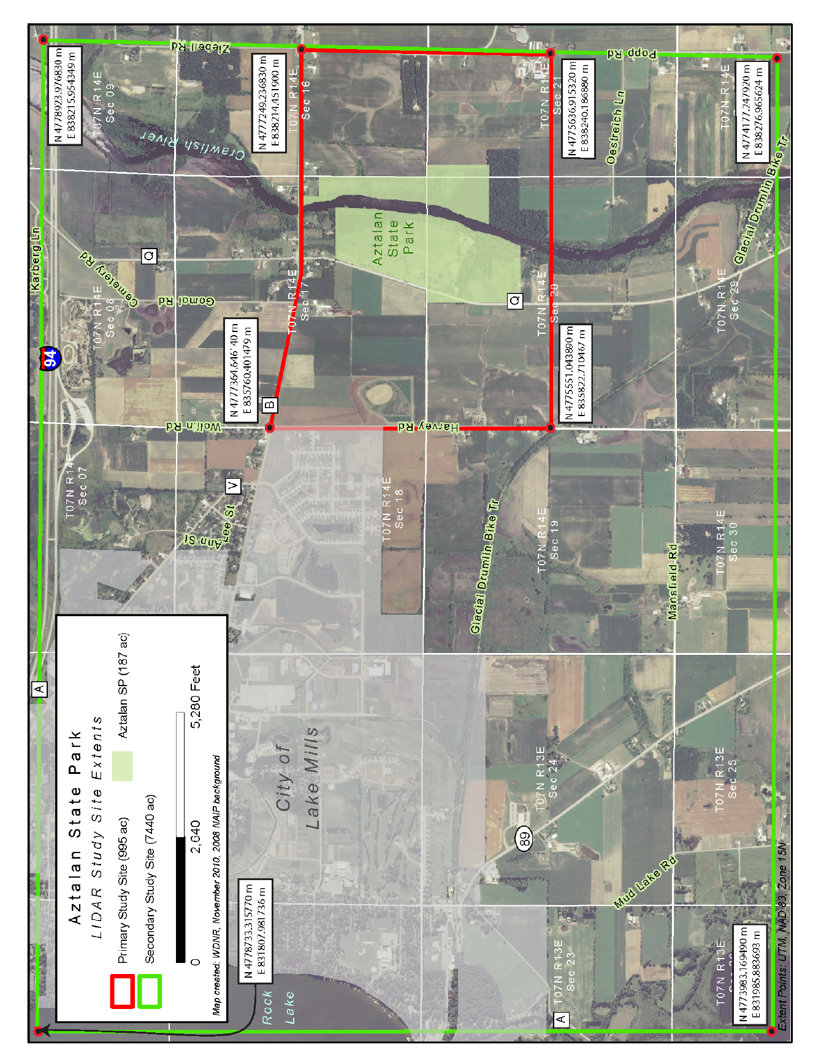
Map 1: Aztalan Study Area Extents

