How to REMOVE COLLARS from NW County Imagery

The interim delivery of county mosaics for 12 counties in NW Wisconsin contains 6 counties with extremely large black collars (Bayfield, Price, Polk, Rusk, Sawyer, Taylor). This document briefly describes how to remove collars from the ECW imagery in numerous GIS platforms for easier viewing and work (particularly where counties overlap). DNR Forestry is currently working to remove the collars for final delivery as MrSID images which will not contain these large collar issues.

fGIS
- Open an ECW and view the large collar.
- If you’re looking at the edge of two counties:
  - Select the ECW Layer so it is highlighted in blue in the table of contents.
  - Click the Layer menu Image Transparent Zones tool.
  - Enter 0 in the Start Pixel Range Value and 7 in the End Pixel Range Value by using the value slide bars.
  - Click Set.
  - The large collar will mostly disappear.
  - Unfortunately, there are a few zero values interior to the image (e.g. some lakes) those will become transparent also. This will not completely remove the black collar, but it will aid in edge matching with an adjacent county photo.

ArcGIS (with Forestry Tools)
- Open an ECW and view the large collar.
- If you’re looking at the edge of two counties:
  - Select the ECW Layer so it is highlighted in blue in the table of contents.
  - Click the Utilities menu Make DOP collar transparent tool.
  - Select input DOP collar color: Black.
  - Click OK.
  - The large collar will mostly disappear.
  - Unfortunately, there are a few zero values interior to the image (e.g. some lakes) those will become transparent also. This will not completely remove the black collar, but it will aid in edge matching with an adjacent county photo.

ArcGIS (with ECW plug-in)*
Installation of the ECW plug-in requires Administrator privileges.
* All ECW’s are to be converted to SID format over the next year. Hence, the ECW plug-in solution will not be necessary long-term and may not be advisable for most users.

- Right-click on the ECW and go to the symbology tab.
- Click the check box next to “Alpha” under “Channel”, and use the drop down under “Band” to select “Band_4”.
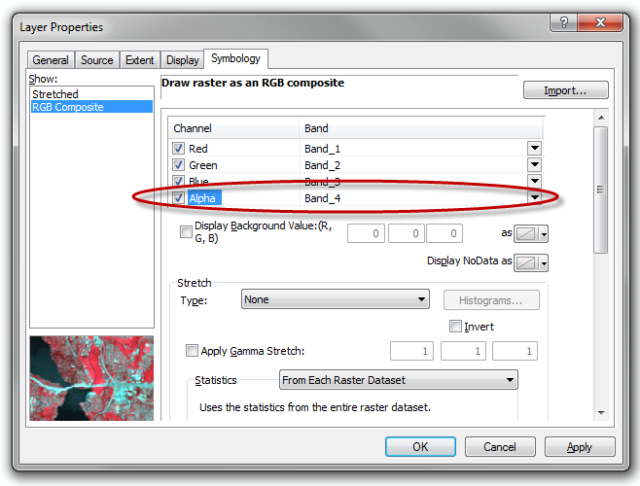

- Hit OK. The black collar should now be removed.

This document was last updated on September 21, 2012.

