SOVCC discussion session notes:
Thanks to everyone who contributed to the discussion I think it was really useful to hear from various different stakeholders. I think both discussion sessions extended beyond their intended remit, but this allowed us to have more useful discussions about what really matters for volcanic cloud forecasting going forward. Thanks also to Mike for chairing the second session and to my Met Office colleagues for taking all of the notes below (I certainly couldn’t have done this and contributed to the discussion sessions!). As the discussion sessions were a bit more freeform than originally planned the notes on each session have been grouped after the event into the most relevant subheadings.

Discussion Session 1: Uncertainty in satellite data
Aim to answer some of the following questions and perhaps roughly quantify various sources of uncertainty, discuss methods to reduce the uncertainty (both in near-real time and more generally):
- What systematic biases and uncertainties exist (e.g optically thick plumes, ice rich plumes, plumes with limited fine ash)?
- How significant is random uncertainty?
- How do we handle uncertainty in the data in an operational setting (i.e both in forecast evaluation and adjustment (through insertion/inversion etc))?
- How can we constrain the systematic biases and uncertainties better?

General uncertainty comments
Systematic errors from observation operators – not included in simulated imagery / retrieval experiments.
Mike Pavolonis: Primary versus Secondary satellite products. Uncertainties are larger for secondary products. Retrievals of ash properties (secondary) versus imagery / detection (primary). For some events plume is not seen in the satellite data (e.g., could be under cloud) – how do you include that in the uncertainty. Need data from e.g., ground sources too. Some volcanoes have little local data – so more reliant on satellite data. The composition uncertainty can make it difficult to retrieve ash reliably (gives systematic uncertainty in retrieval). For some cases the retrieval, no matter what input you use for e.g., refractive index, will not give a reliable answer. Need more focus on retrievals/ modelling / simulation of complex eruption and not just the “ideal/simple” eruptions.
Alice Crawford: Hysplit has high-bias in mass loadings initially compared to satellite obs. Temporal evolution of the cloud helps resolve this (presumably lower mass loadings later, fewer large particles). Dispersion models tend to spread horizontally too much.
Jamie Kibler: Can detect ash down to 0.1g/m^{-2}. For most VAACs, regular emissions 98% of the time, and big eruptions only 2% of the time. VAGs and VAAs may be around for many years if people still want them. QVA for regular emissions? Ash concs so low that people will fly through them every day – will that cause problems for planes in long term.
Chris Lucas: Darwin VAAC changed model set up to put more ash towards top of plume (umbrella) rather than using a uniform vertical distribution to get better quantities. Model keeps the ash for too long.

VAAC responsibilities
Bernie Connell: Are VAACs only responsible for Aviation or other customers?
Jarrad Denman: yes, funded by Aviation. Volcano observatories cover other customers. Should VAACs also cover marine impact (ash getting into ships engines)?
Bernie: Need to know how much distal ash will fall for urban impacts / civil protection – can VAACs help?
Jamie: should we have a list in each region of who is responsible for what e.g., ash fall amounts and impacts.

SO2
Jamie: SO2 RGB can help distinguish ash from SO2.
Bernie: Can SO2 mask ash?
Soledad Osores: Cloudiness has big impact on satellite uncertainty (so need local obs). Need variable uncertainty for QVA due to e.g., cloud impacts on uncertainty. Buenos Aires – already offer civil protection service as well as VAAC (and maritime in future). Teams message: WMO Task team on volcanic activity and safety of marine navigation. This is the WMO team that is discussing the volcanic products for marine navigation.
Chris: Need significant SO2 signal to see in SO2 RBG?? Bernie –SO2 RGB colour is height dependent. Should see >10DU.
Discussion on use of units of SO2 concentration – ppm and DU.
SO2 RGB link from Team chat from Chris and unknown user
https://rammb.cira.colostate.edu/training/visit/quick_guides/Quick_Guide_SO2_RGB.pdf
https://www.jma.go.jp/jma/jma-eng/satellite/VLab/QG/RGB_QG_SO2_en.pdf
https://rammb.cira.colostate.edu/training/visit/quick_guides/Quick_Guide_SO2_RGB.pdf
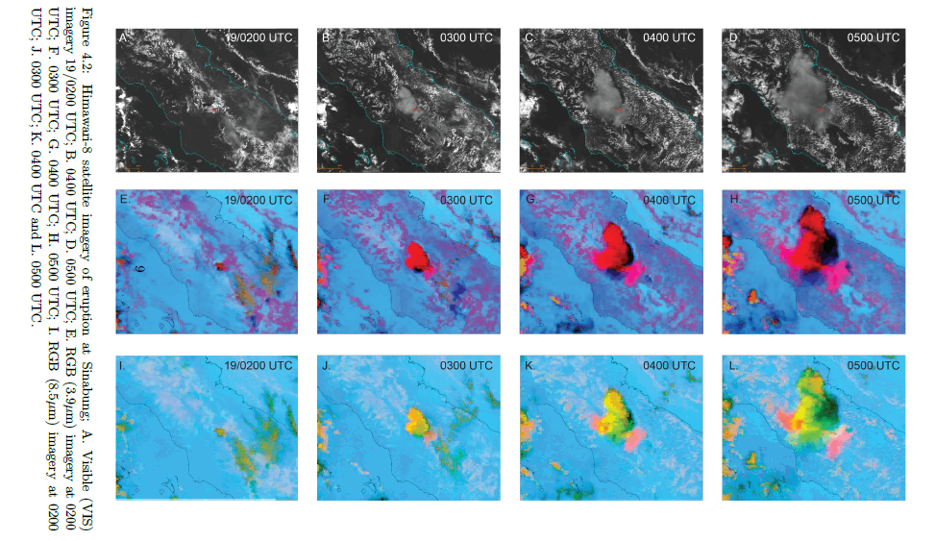
Teams meeting comment [Jarrad]: At VAAC Darwin we use the SO2 RGB imagery with Himawari-9 imagery. It’s quite useful for looking at ash plumes and when the SO2 and ash start to separate due to different dispersions. For smaller activity can help with showing if the eruption is SO2 or ash. We had an eruption at Mt Sinabung in 2018 which showed up quite strong in multiple RGB imagery.
Jarrad: Darwin VAAC use SO2 products too. To look at spread and SO2/ash colocation/separation, and to detect smaller eruptions.
Ben Esse: SO2 units. DU (column amount) to concentrations requires assumption on the SO2 thickness.
Same applies to ash to get from column load obs (g/m2) to concentration.
Nicolas Theys: DU use from Ozone community. Detection limits: Broadband 10-20 DU, but IASI/TROPOMI an order of magnitude better detection limit. SO2 RGB: SO2 Index from SEVIRI presented tomorrow (by Hugues Brenot).
Bernie (Teams Chat comment): A few years back I heard that ICAO was looking at flight levels of SO2 that were potentially hazardous to humans. Has anything come out of this?
Jamie (Teams Chat comment:): No Bernie, nothing yet. It has been tabled. Trying to figure out the amounts hazardous to humans on aircraft vs exposure time......dosage. They are still trying to figure this out.
Nina Kristiansen (Teams Chat comment): we have done some work on SO2 aviation exposure and threshold assessments using the WHO threshold and alternative: https://doi.org/10.21203/rs.3.rs-2397636/v1

Data fusion
Nina: Which satellite products shall we use with data fusion. Shall we use more primary products as well as secondary products.
Mike: Cloud evolution from tracking primary products can provide a lot of information that can be used for model initialisation.
Franco Marenco: Data assimilation is robust and used for years in NWP and handles uncertainty well. Shall DA be used?
Chris: Darwin VAAC use DA.. ensemble of runs and do a particle filter (pick by pattern correlations).
Nina: Combining DA, source inversion and bias correction could be a way forward.
Mike: Volcanic ash advisories / polygons could be used as a first order way to determine the uncertainty in a satellite product. VAAs are incredible valuable as they include a human interpretation and are underutilized. Commented on IWXXM format as the next polygon.
Bernie: Utilization of VAAC experts that have looked at a number of eruption and their experience is valuable.

QVA, VAAC workflows and response to Sheveluch
Jarrad: Additional workload for VAAC forecasters for QVA and needs automated workflows. Darwin VAAC has a dedicated ash forecaster as they have more eruptions. Darwin is working more closely with Wellington, share ideas and discussions. Sharing experience and expertise. Value of satellite observations and forecasters that can analyse imagery which automated products might not get. Ensemble products are important in the tropics as deterministic often doesn’t do well. Met data uncertainties accounted for. Uncertainties in many other parts to consider.
Jamie: Washington VAAC is quite busy with a number of eruptions (small) all the time, many different products. Large burden on forecasters. Re-examines workflows and what can be automated. QVA increases demand and they are trying to work out how to do this in the best way. Tabletop on QVA and demo showed that forecasters will not have time to look at all ensemble members and tweak, and so requires more automation of workflows. Satellite most important products.
Dov Bensimon: VAAC Montreal similar to London – not many cases. To maintain skills, they test and do training on regular basis with forecasters. Real events are always different. Interpretation of RGB imagery is still a learning process, what is volcanic ash or not. Sheveluch eruption they responded to (with Anchorage and Washington). They were unsure what was volcanic ash or not in satellite imagery and started using SO2 imagery. Enjoyed the talks and discussion about distinguishing volcanic ash from other volcanic products (SO2, ice) and progression that would be very useful.
Jamie: Ash spreading across multiple VAACs: communication between VAACs is quite good. The challenge is that each VAAC needs to re-examine and look at all the data (PIREPS, what they see in satellite etc). Sheveluch response - they got information that ash was in a lot of places, but they could not see anything in their satellite data. Forecasters worry they miss something, but need to make decision about whether advisories shall end or continue. With QVA this will continue and a challenge that needs to address.
Dov: Sheveluch (4 VAACs involved). During big events they get and ask for PIREPS but they are more subjective than satellite data can be. They assess how much weight to put into each piece of information they get (PIREPS, sat data etc). When a VAAC inherits an area from another VAAC there is a height associated with that. For Sheveluch – they interested an area which had quite a high altitude (due to PIREPS). They look at winds at different altitude. Which winds are best explaining ash movements. This can give quite precise info on the height of the cloud. For Sheveluch winds were quite similar at several height levels so hard to distinguish and could not be very precise with the determination about the height of the ash cloud.

Ice (and another not typical ash hazards)
Stefano Corradini: Often speak about ash and SO2 but should also consider ice! It is very hard to distinguish ash with ice and met cloud. Are modellers thinking about including ice in their modelling? Uncertainties on satellite ash data are not huge shown by the WMO exercises. Ash retrievals in the presence of SO2 is tricky. Integration of microwave and TIR is important to give info on particle size distribution and ash mass.
Cameron: Ash/ice in proximity to volcano versus further downwind (more important).
Mike: Avoid flying through cloud close to volcano. Cases with umbrella clouds can be tricky to forecast whether it is going to be a large impact or not.
Frances Beckett: Echo Stefano about ice. Started thinking about including ice in the model, very initial work. Using dispersion model output for ice nuclei (Cambridge work, paper in progress)
Dov: VAACs tracking “non-volcanic”. Volcanic ash encounter which initialised the VAAC creation. Whether VAACs should track SO2 has been discussed. SO2 typically remains in the atmosphere for much longer than ash and has impact on operational requirements. ICAO working group has “paused” this SO2 work.
Soledad: Resuspension has not been discussed yet. Cordon Caulle eruption has a huge deposit. Modelling resuspension is different to modelling release from volcano. Different source terms.
Bernie: Can groups doing dust resuspension help with resuspended ash?

Discussion session 2: Verification of satellite detection and retrieval algorithms
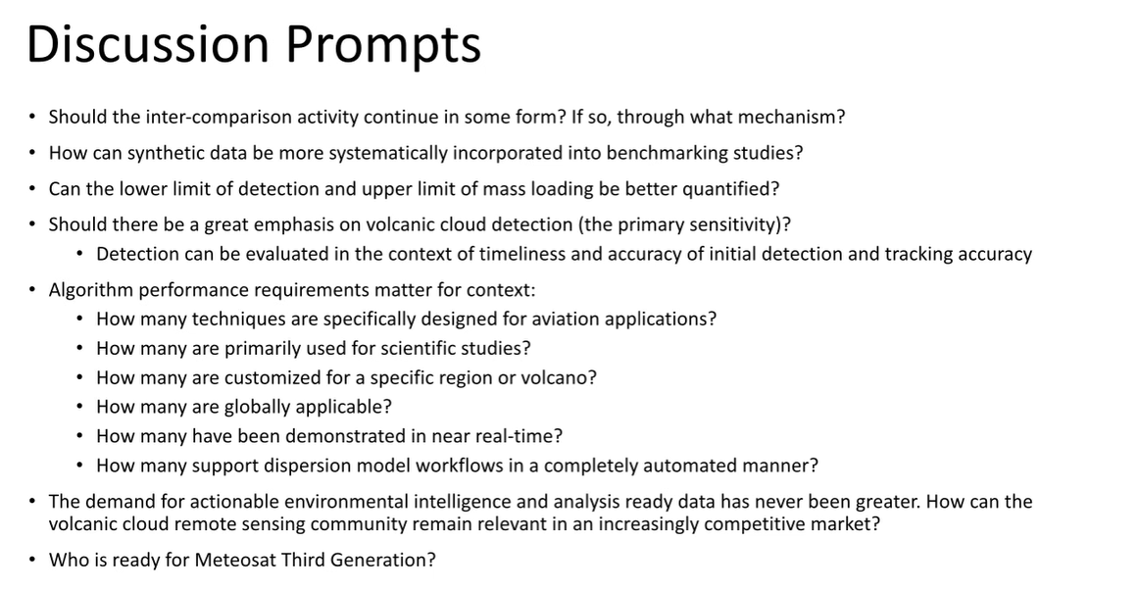
Cameron comments on the importance of using standard datasets to compare different retrievals.

Possible paper on 2015/2018 intercomparison
Franco encourages writing a paper on the 2015/2018 intercomparisons as the material is there.
Mike suggests an early career enthusiastic person to do this.
Cameron: Can someone who was not part of the exercises easily pick up and write up a paper on this?
Mike says a partner with someone who has the knowledge and was at the intercomparison should be possible for someone who didn’t take part to take it on. Mike is willing to help along.
Stefano supports creating a group that can publish a paper in the reports. He would like to be part of that group. Can develop a plan and deadline.
Mike says he can direct some support for this too through someone from this group.
Don Grainger argues that the data is now 5 years old, and some retrieval algorithms have been further improved since, and whether its now too late to publish this.
Mike says data can be redelivered with present day algorithms.
If updating the data, then Don is supportive.
Franco suspects the main conclusions will remain the same. Franco is also interested in contributing (in his free time, so not taking any lead).
Cameron makes the point that the focus on a paper could be more on the more general essence of what was learnt rather than details of specific results from each algorithm. “Yes” from Mike – and gives a more impacts.
Franco says the paper is already nearly there in the slides that Mike just showed.
Cameron is optimistic about being involved and spending some time on this!
All agree this should live on and continue and get the paper out!

Funding opportunities?
Mike says it’s hard to get this centrally funded. Part of fund that teams already have.
Some bodies are just coordinating bodies but does not provide funding.
Franco suggests checking the European scheme COST to explore for funding. Stefano also very much agree to explore COST action. https://www.cost.eu/cost-actions/what-are-cost-actions/
Robert Tubbs: In terms of getting grassroots support, do we need a statement from WMO to say that an intercomparison is required? That would motivate Met Services to support this.
Mike says the new VASAG called AG-VSA (Advisory Group on Volcanic Science for Applications) which Mike will report to about this, can possibly be a route to get some statements/help to support funding. He makes the point he is not able to lead this. Franco says he should pass it on to 2-3 people so that the work done is not lost and Mike very much agree.
Cameron is also willing to help as much as he can.

Synthetic data
Franco: Yes, good to use as we know the truth.
Mike: Not easy to generate the synthetic data sets.
Cameron’s data set can probably share the synthetic dataset he has used and should be in a format that others should be able to run their algorithms on. May only be for MSG/MTG. Can quite likely be expanded to other sensors. Dennis Piontek also has a large dataset and was keen to be involved in intercomparisons going forward and willing to share data.
Mike says this is not required for a paper on the 2015/2018 intercomparison but something that can be useful going forward.
Stefano: 2018 intercomparison showed MODIS simulated measurements. Should be able to generate other multispectral (VIIRS etc) for anther exercise.
Cameron: More discussion and agreement on what the simulated data should look like might be needed for using this more generally.
Franco imagines a good, simulated data for intercomparisons as an imaginary volcano somewhere and a dispersing plume, and simulate for several sensors (e.g., IASI with a geo sensor). And different radiative transfer models too.
Mike suggests using a sophisticated rad transfer models to generate simulated imagery, and then use fast ones in the various retrievals. Having simulated data which are actually real images would be good. There are many possibilities and acknowledges that the synthetic data is an under used tool.

Algorithm performance requirements matter for context
Cameron: importance of whether it’s a VAAC focus on development, or a scientific focus and goal is different.
Franco says 2 goals for Met Office – one for VAAC forecasters, and one for initialising the model. Two different applications of the same product.
Cameron says the first application is diminishing and the second one becomes more important. Other VAACs probably have other applications and focuses. 80% was very case specific.
Franco thinks the best product is using the radiances – and do the inversion in radiance space. Work in observation space rather than model space! Mike says that’s interesting but more computationally complicated.
Jamie K: All tools we have available, VOLCAT etc. Many aviation users of it. Unified effort for a session with all users who uses the data. Training and sessions for users would be good. Both for remote sensing and dispersion modellers. Lots of work but he is willing to help with setting up some user workshops.
Mike highlights that many users want to see the data themselves and what to “see the ash” in the satellite data etc. He agrees with Jamie’s thoughts on the importance of talking to aviation users.

Demand for environmental intelligence and analysis
Mike: Competitive market. Societal impacts are important.
Jamie: agrees and people will go to find the data somewhere else if the experts don’t provide it (quick enough). This can be without education and training. Time sensitive versus a good product is hard.
Jarrad: Echo Jamie. The way we provide information is regulated with audits etc to be able to provide information to the users, whereas private companies might not have the same regulation. This is a risk and something we want to avoid. Have to make sure our guidance is accurate. Airlines often ask if they can show the ash on satellite imagery as they want to see it for themselves. They do provide this extra information, but also ask for more.
Mike says fake images that look real can in the future become problematic. What is real and what isn’t. Researchers need to be good at communicating. For a variety of hazards.
Cameron: other data providers highlights need to have standard datasets. Be able to distinguish “bad” and “good” datasets.
Mike: establish trusted data providers and be transparent and open about the data being provided is important.

Dispersion model evaluation
Frankie: using satellite data to evaluate dispersion model output. Has anybody thought about whether the dispersion model and satellite data are located in the same place and what about met cloud.
Mike: sometimes ash will be obscured. Can fill in gaps/info by looking a spatial and temporal evolution. Ash detection on a feature basis is important.
Soledad: in the cases with clouds use supplementary data like ground based is important. Without additional information then consider remove that part of the data to it is left unverified in the model.
Cameron: actively filling the gaps by other information, or another method can be a product to illustrate what the satellite can/cannot show to be used for model verification. Making it clear where the data isn’t good.
Mike says yes both would be good. Edges of the cloud is always fuzzy and not very clear.
Don: With ORAC they retrieve various species ash/ice/water cloud. Give best possible answer for each pixel. Ash under water cloud will give water cloud. Sometimes retrieval fail and cannot say anything.
Mike: variety of ways to solve the problem. Be as transparent of how you have solved it. Generalisation is a challenge.

Lower detection limit
Mike: lower limit of detection. This varies a LOT and depends on a LOT of things. New satellites are different. Thoughts on getting out the lower limit? Need to communicate that it is a RANGE and not a fixed number.
Cameron was able to find a lower detection limit in his work 0.1. Specific to that algorithm. Other algorithms use other information and will therefore be different.
Alice Crawford: Is there also a value which you would almost always detect?
Mike: Probably not. Maybe for an ideal ash cloud but generally not.
Cameron: His work shows which ranges where the retrieval works well. Other retrievals will have other ranges.

Upper retrieval limit
Cameron’s work showed around ~7 g/m2. Mike suggests this is probably quite representative for most IR retrievals.
Mike: Mass eruption rate estimates using the mass loading, or techniques that uses the ash cloud evolution to estimate MER. What to use in dispersion model input?
Cameron points to sensitivity to particle size distribution.

Constraining/understanding/communicating uncertainty
Alice: Implication for forecast. MER sensitivity. Relating on the mass loading or plume growth. Models tend to have a high bias. Communicating uncertainty. Initial forecast is conservative. User expectation that they expect forecast be show reduced ash cloud with time.
Mike: umbrella cloud. Some event shows a lot of ash removed quickly. Others don’t show this. The distinction for the two for operational response is hard. Can we make any improvements there?
Alice: probably won’t get rid of the uncertainty anytime soon. A large part is communication the uncertainty and provide a range of forecasts which will cover the uncertainty.
Mike says the range of forecasts will be huge. Will that be meaningful?
Alice says wind direction will still give useful information. Below/above tropopause. Communicating that users need to “check back often”.
Mike says communication needs advice from the scientist.
Cameron: Do umbrella clouds with less spectral signature often not produce long lived ash?
Mike: Usually within 6 hours can say if it is going to produce a lot of ash. But before 6 hours really hard to say. Some subtleties might be communicated better.
Soledad: big challenge on using satellite data to verify QVA. Need to develop method to combine quantitative satellite data. Small steps. Verify location first. Then to integrate ash mass loading and errors to verify.
Cameron: this product will hopefully be developed at the Met Office. Understand the uncertainty in the satellite data. Based on column loading and errors but some pixels will be different and that can be assesses differently. Hoping to develop a verification product in a year’s time or so.
Alice: recently published a paper on verification with VOLCAT. Bias correction. Lots of questions from reviewers about whether the satellite data is the truth etc. Benchmarking the satellite data is important for that reason. Satellite data is what we have – for aviation the advice is to avoid detectable ash. If satellite can’t detect it, then theoretically not a concern to aviation.
Mike: visually detecting ash below the levels that are of concern is a challenge.
Franco: thanking Cameron for organising this! Bye!
Frankie: Uncertainty on mass eruption rate. Discrepancy between modelled ash in the atmosphere and satellite. Can we use tephra deposits too? Is anyone using that with satellite data sets?
Mike: limitations are deposit maps are constrained to near the vent, and often not for the dispersed plume. Near source estimates
Karen Strehlow: Deposit data only available post event. Will not help in the situation. But would be useful afterwards. Post analysis tool and not real time.
Alice: Mastin formula and fine ash fraction has huge uncertainty, but it seems to always be a high bias. It is never a low bias. Why is that?
Jamie: Deposit is post-analysis. Limited resources in some parts of the world. Deposit data can be useful for information future information.
Mike: Pilot reports. Post analysis of suspected encounters. USGS and Dave Schneider working on this. Learn a lot from encounters. Keep an eye on encounters database. Look at encounters with sat data, model data.
Cameron: High bias in model. Useful to look at the deposit data to understand this. If ground deposits show the mass has been there that is useful. Understanding the mass in the distal plume is important. Microwave data is useful as it shows that mass doesn’t transport very far.
Mike: Mastin formula is an approximation. Cloud growth rate can be used to constrain the mass eruption rate. That hasn’t been fully automated and just offline for research.
Soledad: Uncertainty in ensemble modelling based on uncertainty in satellite data and how we will communicate this to users will need more discussion in the future.

MTG and other upcoming missions/sensors
Mike: who is ready for MTG? They will receive test data next month. Has anyone tested they software to process MTG?
Hugues: We plan to make COBRA products from FCI.
Cameron: set up to reproduce what they do for SEVIRI. Requires some retuning when the test data becomes available. Nothing for MTG-IRS yet. Hyperspectral instruments would be really useful going forward.
Alice: end users of satellite data get asks about what data they use and what they like to see. Do end users communicate well enough what they need?
Mike: mission driven! Clearly communicate.
Cameron: influencing future satellite missions. Some people at the met office who influence this.
Alice: do you see future instruments meeting the needs for volcanic ash detection?
Cameron: Microwave instruments lacking but not clear how useful.
Alice: CALIOP ending lifetime. Is there a replacement coming up?
Jason Tackett: some CALIOP like around 2030 will probably come up. Might be a gap. Earthcare lidar with do lidar ratio and depol. Will come in the near future. https://earth.esa.int/eogateway/missions/earthcare

Volcanic ash verification metric
Cameron: which are the best methods to use for volcanic ash verification (e.g., from Alice’s paper)?
Mike: probably not a single metric. Variety from a table. Probably of detection. Critical success index is Mike’s favourite.
Alice: Verification model-sat, or verification of satellite data?
Both!
Alice: Verification of models - lots of details in her paper, hard to make a brief comment. Interested I the classification scheme for CALIOP.
Jason: database of expertly classified tropospheric volcanic features would be good. All agree. I started on the CALIOP volcanic aerosol database as part of the supplement to our paper on stratospheric aerosol subtyping. There are a number of major eruptions included, all stratospheric. Adding tropospheric plumes would really add value I think. https://amt.copernicus.org/articles/16/745/2023/amt-16-745-2023-supplement.pdf
Stefano: Use of ground-based data to validate!
Alice: enthusiastic about using simulated satellite imagery.

