7. CIMSS GOES-R Risk Reduction Program

7.2 ProbSevere: Upgrades and Adaptation to Offshore Thunderstorms
CIMSS Task Leader(s): John Cintineo
CIMSS Support Scientist(s): Justin Sieglaff, Jason Brunner
NOAA Collaborator(s): Mike Pavolonis
Budget: $123K

NOAA Long Term Goals:
- Weather-Ready Nation

NOAA Strategic Goals:
- Serve society’s needs for weather and water
- Support the nation’s commerce with information for safe, efficient and environmentally sound transportation
- Provide critical support for the NOAA mission

CIMSS Research Themes:
- Satellite Meteorology Research and Applications
- Satellite Sensors and Techniques
- Environmental Models and Data Assimilation

One Clearly Stated Objective

The goals are: 1) to improve ProbSevere over land with the incorporation of GLM data, more ABI fields, and HRRR data; 2) to create a ProbSevere-like product adapted for offshore thunderstorms, where radar data are not available.

Project Overview
Severe thunderstorms endanger lives and can cause damage in excess of $10 billion dollars in a single year (USA Today, 2016). Timely and accurate severe thunderstorm and tornado warnings are critical for protecting life and property. The Science and Technology Plan of the NWS’s Weather-Ready Nation Roadmap (NWS 2013) highlights the value of data fusion techniques for improving operational decision-making, including severe weather warning operations. In an effort to support severe weather warning operations through data fusion, the NOAA/CIMSS ProbSevere model (Cintineo et al., 2013; Cintineo et al., 2014, Cintineo et al., 2018) was developed under a previous GOES-R Risk Reduction project. ProbSevere utilizes NWP, GOES, NEXRAD, and ground based lightning data to estimate the probability that a developing thunderstorm will produce severe weather up to 90 minutes in the future, including hazard specific predictions of severe hail, severe wind gusts, and tornadoes. This project focuses on feedback from NWS user requests for improving ProbSevere. The two primary topics include upgrades to ProbSevere for improved WFO severe weather warning operations within the current warning paradigm (as well as within the FACETS warning paradigm) and developing a version of ProbSevere for predicting which offshore thunderstorms will produce gale force winds. The Ocean Prediction Center (OPC) requested that an offshore version of ProbSevere be developed to assist with their real-time warnings to mariners.

Milestones with Summary of Accomplishments and Findings

Progress toward AWIPS-2 plug-in development:

At the HWT in 2018, forecasters expressed a desire to be able to simultaneously display the overall probability of severe and the probability of tornado (ProbTor). Based on NWS forecaster feedback from a field survey last summer, we have developed a new AWIPS-2 plug-in capability to do just that. Figure 1 highlights a storm with two contours around it – the inner contour is the traditional probability of any severe (in ProbSevere v2, this is the max[ProbHail, ProbWind, ProbTor]), and the outer contour is the ProbTor value. Forecasters can configure the minimum ProbTor value when a second contour will appear, with an option of completely disabling the display of the second contour, if desired. To facilitate quick interpretation, both contours correspond to the same colormap. Now forecasters will be able to more easily see rapid changes in the probability of tornado for a given storm. This capability will be evaluated in the 2019 HWT.
Development is still ongoing with respect to a time series capability for ProbSevere in AWIPS-2, and we expect that a prototype will be ready for the 2020 HWT.

Progress toward improvement of ProbSevere v2 and creation of ProbSevere Offshore:

We have added GLM derived metrics to our storm object database, which includes over 10,000 severe storms and 121,000 non-severe storms that occurred between March and September of 2018. The following GLM metrics were added to the database, which also includes Earth Networks, Inc. (ENI) lightning products: Flash Extent Density, Flash Centroid Density, Total Optical Energy, Average Flash Area, Group Extent Density, and Group Centroid Density. The GLM gridded fields were aggregated over five minutes. Analysis of the updated database reveals the following first order conclusions:

- While in a bulk statistical sense, the GLM and Earth Networks, Inc. (ENI) flash rates are fairly similar, there are some interesting differences. In a large percentage of the severe storms, the ENI flash rates significantly exceed the GLM flash rates at times during the storm lifecycle. The discrepancy in flash rates between ENI and GLM could be leveraged for ProbHail, as the probability of producing large hail generally increases as the ratio between ENI / GLM flash rates increases in combination with an increase in ENI flash rate (see Figure 2). The smaller GLM flash rates are likely due to attenuation of the optical energy from lightning generated within the core of the storm.
- When only GLM data are considered, the flash rate and flash extent density products are best for discriminating between severe and non-severe storms.
- The ratio of total optical energy and average flash area (TOE / AFA) is better for discriminating between severe/non-severe storms than either field alone. We hypothesize that the ratio constrains large TOE to convection with robust updrafts.

With the aforementioned updated 2018 database, we have begun exploring several fields of convection allowing model data from the HRRR. The 10m wind gust field has shown the best discrimination between severe and non-severe thunderstorms over CONUS (not shown). The 10m-wind field from the HRRR may also be useful for gale-force wind prediction over the Ocean Prediction Center (OPC) offshore regions. We are working on incorporating the HRRR into both ProbSevere v2 and ProbSevere Offshore.

Progress is continuing on incorporating 1-min GOES-R mesoscale sector data into ProbSevere. The current object identification and tracking method works well, but is too computationally intensive from real-time applications. We are working on modifications to the object tracking that will allow for real-time utilization.

Figures

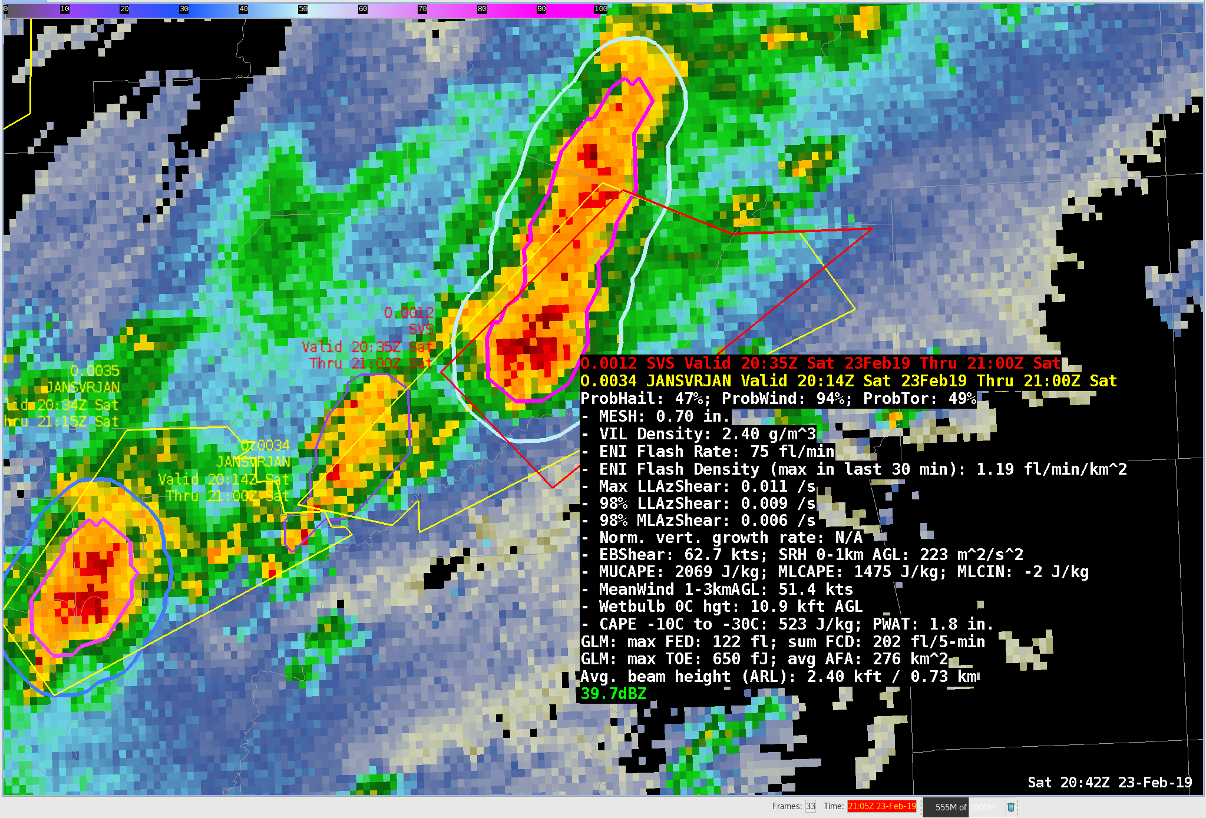
Figure 1: An example of the two contour ProbSevere display option within AWIPS-2. The inner contour is the normal probability of severe. The outer contour is the probability of tornado (ProbTor). For this storm, the probability of severe is 94% (pink inner contour) and the probability of tornado is 49% (light cyan outer contour).

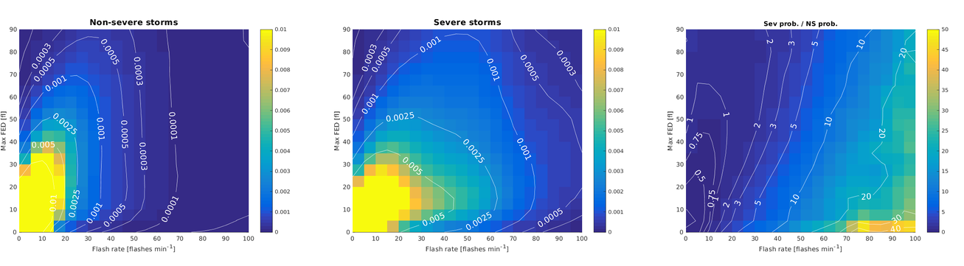
Figure 2: The joint conditional probability distributions of ENI flash rates and GLM flash extent density (FED) for non-severe storms (left), severe hail-producing storms (center) and the ratio of the severe to non-severe classes (right). The region between 5-20 GLM max FED (y-axis) and 20-80 ENI flash rate (x-axis) highlights an area of large ENI flash rates relative to GLM FED, where severe hail is more probable.

Publications and Conference Reports

Published with support of another GOES-R3 project, but relevant to ProbSevere Offshore development:

- Pavolonis, M.J., J. Cintineo, and J. Sieglaff, 2018: Automated Detection of Explosive Volcanic Eruptions Using Satellite-derived Cloud Vertical Growth Rates, Journal Geophysical Research, 5(2), 903-928.

- ProbSevere work was presented at the 2018 Coordination Group for Meteorological Satellites (CGMS) International Cloud Working Group workshop in Madison, WI (Pavolonis)

References

Cintineo, J. L., M. J. Pavolonis, J. M. Sieglaff, D. T. Lindsey, L. Cronce, J. Gerth, B. Rodenkirch, J. Brunner, and C. Gravelle, 2018: The NOAA/CIMSS ProbSevere Model - incorporation of total lightning and validation. Wea. Forecasting, 33, 331-345.

Cintineo, J. L., Pavolonis, M. J.; Sieglaff, J. M. and Lindsey, D. T., 2014: An empirical model for
assessing the severe weather potential of developing convection. Weather and Forecasting, 29(3),
639–653.

Cintineo, J. L., Pavolonis, M. J.; Sieglaff, J. M. and Heidinger, A. K., 2013: Evolution of severe
and nonsevere convection inferred from GOES-derived cloud properties. Journal of Applied
Meteorology and Climatology, 52(9), 2009–2023.

NWS, 2013: National Weather Service Weather-Ready Nation Roadmap. [Available online at:
http://www.nws.noaa.gov/com/weatherreadynation/files/nws_wrn_roadmap_final_april17.pdf]

Pavolonis, M.J., J. Cintineo, and J. Sieglaff, 2018: Automated Detection of Explosive Volcanic
Eruptions Using Satellite-derived Cloud Vertical Growth Rates, Journal Geophysical Research,
5(2) 903-928.

USA Today, 2016: Tornadoes, severe storms cost $10 billion in 2015.
[Available online at: http://www.usatoday.com/story/weather/2016/01/03/tornadoes-severe-storms-insured-
losses/78234474/]

