34. Demonstration Study Using Artificial Intelligence (AI) for the NowCasting of Tornadoes
CIMSS Task Leader(s): John Cintineo
CIMSS Support Scientist(s): Anthony Wimmers, Justin Sieglaff, Bill Bellon
NOAA Collaborator(s): Mike Pavolonis
Budget: $40K

NOAA Long Term Goals:
- Weather-Ready Nation

NOAA Strategic Goals:
- Serve society’s needs for weather and water
- Support the nation’s commerce with information for safe, efficient and environmentally sound transportation
- Provide critical support for the NOAA mission

CIMSS Research Themes:
- Satellite Meteorology Research and Applications
- Satellite Sensors and Techniques
- Environmental Models and Data Assimilation

One Clearly Stated Objective

This project demonstrates how to use artificial intelligence with satellite imagery to better nowcast severe convective weather.

Project Overview

Severe storm forecasting is a vital component of NOAA’s mission to protect life and property. With the increasing resolution, frequency, and information content of data coming into NWS forecast offices, making efficient use of the avalanche of data for timely and accurate warning decisions can be difficult. One way to help capitalize on all of the new information is to use artificial intelligence, which is using computer systems to mimic human tasks, such as complex pattern recognition. One powerful way to do this is using convolutional neural networks (CNNs), or “deep learning”. GOES-16 ABI imagery is full of useful information that humans can pick out amid varied and complicated background conditions, but is difficult for explicitly coded algorithms to reliably detect. Because humans have limitations in observing many storms simultaneously and continuously in satellite imagery, CNNs are a good candidate to systematically deduce complex patterns in the evolution of storm-top properties that can inform storm severity. The goal of this project is to train a CNN to accurately detect and possibly predict whether or not a storm is a ‘supercell’ automatically. Supercell thunderstorms are tied very closely to severe weather at the surface and so such a model may add confidence to warning decisions as well as likely severe weather in areas of North and South America where there is no radar coverage.

Milestones with Summary of Accomplishments and Findings

Building deep learning expertise and toolbox
Using the powerful Keras API and Google TensorFlow backend, we have begun developing tools to train and validate CNNs using a single GPU. Many of these tools provide verification statistics on an independent testing dataset, but some involve model interpretation (see Figure 1). We will use these tools and develop further ones as needed to aid in our CNN training.

Building a truth database
Using mySQL and javascript/PHP APIs, we have developed an online tool for humans to quickly perform storm classification on infrared and visible images (e.g., supercell, ordinary cell, linear). This will allow us to quickly build up a training database of images for the supercell classification task. We anticipate that we can manually classify 10,000 storm images in a matter of 10-20 hours, using infrared and visible imagery, as well as radar imagery.

Trained a CNN for severe weather
As a proof of concept, we used readily available training labels in NCEI severe weather reports and linked them to ProbSevere storm objects (Cintineo et al. 2018). Then we trained a CNN to predict the probability of severe weather using only the 11-µm brightness temperature within a small neighborhood of storms. This is just a test prior to training our supercell classification model (because we need more labeled data), but even this simple CNN demonstrated some skill (see Figure 2). A CNN with skill comparable to human forecasters will likely need to incorporate lightning, radar, NWP, more satellite data, and many more samples, which is outside the scope of this project. However, a supercell identification model with only satellite data could still be useful in the warning process.

Figures

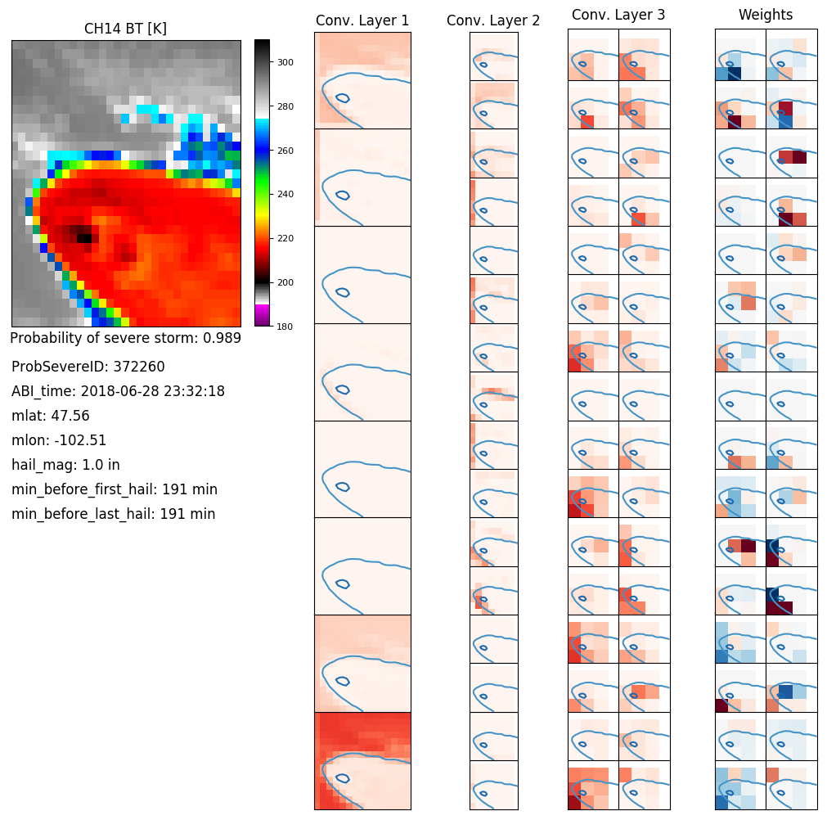
Figure 1: A graphic visualizing feature maps along several layers of a trained convolutional neural network. Snapshots like this may help us see why the model is making the predictions it is, and what features the model says are important. In this case, several feature maps seem to highlight the isolated nature of this storm, strong 11-µm brightness temperature gradients, and the overshooting top.
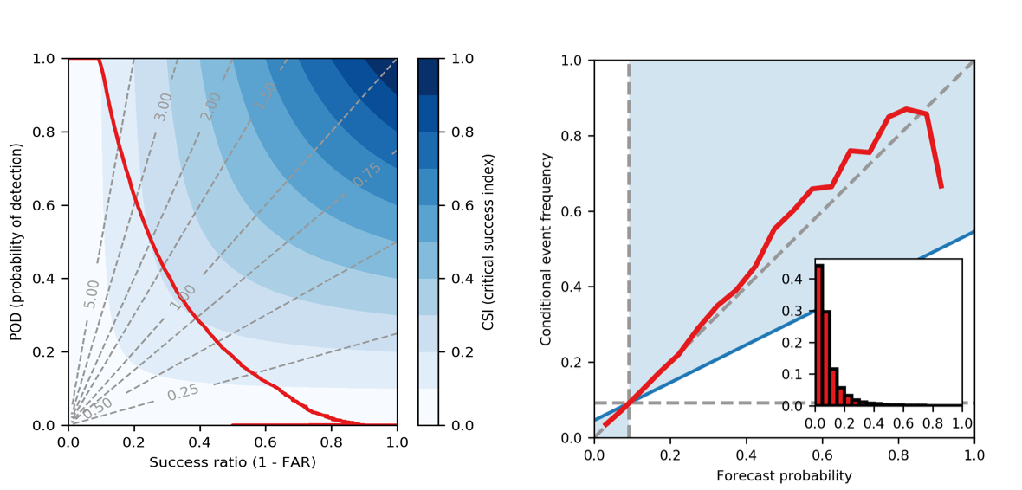
Figure 2: The figure on the left is a performance diagram, plotting the POD vs. success ratio, yielding the CSI (where the red line intersects with shaded blue regions. We can see that the maximum CSI is about 0.22 at a bias (dashed lines) near 1.0. The figure on the right is an attributes diagram, showing the calibration and frequency of the forecasted predictions on independent data samples. This model has very good reliability except for very high predicted probabilities.

Publications and Conference Reports

An abstract was submitted to the 2019 AMS satellite conference.

References

Lagerquist, R., and D.J. Gagne II, 2019: "Interpretation of deep-learning models for predicting thunderstorm rotation: Python tutorial". https://github.com/djgagne/ams-ml-python-course/blob/ryan_branch/module_4/ML_Short_Course_Module_4_Interpretation.ipynb.

Cintineo, J. L., and Coauthors, 2018: The NOAA/CIMSS ProbSevere Model: Incorporation of total lightning and validation. Wea. Forecasting, 33, 331–345

