12. CIMSS Support for ProbSevere Integration into MRMS for Transition to NWS Operations

CIMSS Task Leader(s): John Cintineo
CIMSS Support Scientist(s):
NOAA Collaborator(s): Mike Pavolonis
Budget: $95K

NOAA Long Term Goals:
- Weather-Ready Nation

NOAA Strategic Goals:
- Serve society’s needs for weather and water
- Support the nation’s commerce with information for safe, efficient and environmentally sound transportation
- Provide critical support for the NOAA mission

CIMSS Research Themes:
- Satellite Meteorology Research and Applications
- Environmental Models and Data Assimilation

One Clearly Stated Objective

The goal of this project is to transition code and knowledge base of ProbSevere from CIMSS to NCEP Central Operations (NCO).

Project Overview

NOAA/CIMSS ProbSevere is a suite of statistical models for short-term severe weather prediction. ProbSevere fuses together data from geostationary satellites (GOES), numerical weather prediction (NWP) models (e.g., RAP), Multi-Radar, Multi-Sensor products (MRMS) and Earth Networks (ENI) total lightning information in a storm-centric automated fashion to produce probabilities of severe weather occurrence for thunderstorms CONUS-wide. ProbSevere has been running in real-time at CIMSS since 2013 and has been evaluated at the Hazardous Weather Testbed (HWT) from 2014-2018. This project involves making the ProbSevere code base compatible with MRMS v12, for which ProbSevere will operate as a subsystem. Another goal is to transfer scientific knowledge to the NWS Meteorological Development Laboratory (MDL).

Milestones with Summary of Accomplishments and Findings

Transfer of code and programmatic knowledge base to NSSL and NCO

The National Severe Storms Laboratory hosts the experimental MRMS v12, which ProbSevere will operate under. The ProbSevere code base and knowledge of how to use and troubleshoot the code has been transitioned to NSSL and their experimental MRMS v12 system. The ProbSevere code was modified where necessary to conform to MRMS standards. NSSL has been able to routinely produce ProbSevere end products at NSSL (Figure 1), which compared very well with ProbSevere output from CIMSS. Furthermore, documentation has been created and provided to NSSL and NCO, including documents on how to build, deploy, stop, start, and troubleshoot problems. The code base is available on NOAA’s VLAB (https://vlab.ncep.noaa.gov/redmine/projects/probsevere) and the ProbSevere code and MRMS v12 are set to be operational at NCO in August 2019.

Transfer of scientific code and knowledge base to MDL

Codes and data to train and evaluate ProbSevere predictors have been supplied to scientists at MDL. They have been able to synthesize predictor distributions and understand the computation of the naïve Bayesian models in ProbSevere, as well understand the contribution/importance of each predictor in ProbSevere v1.

Figures

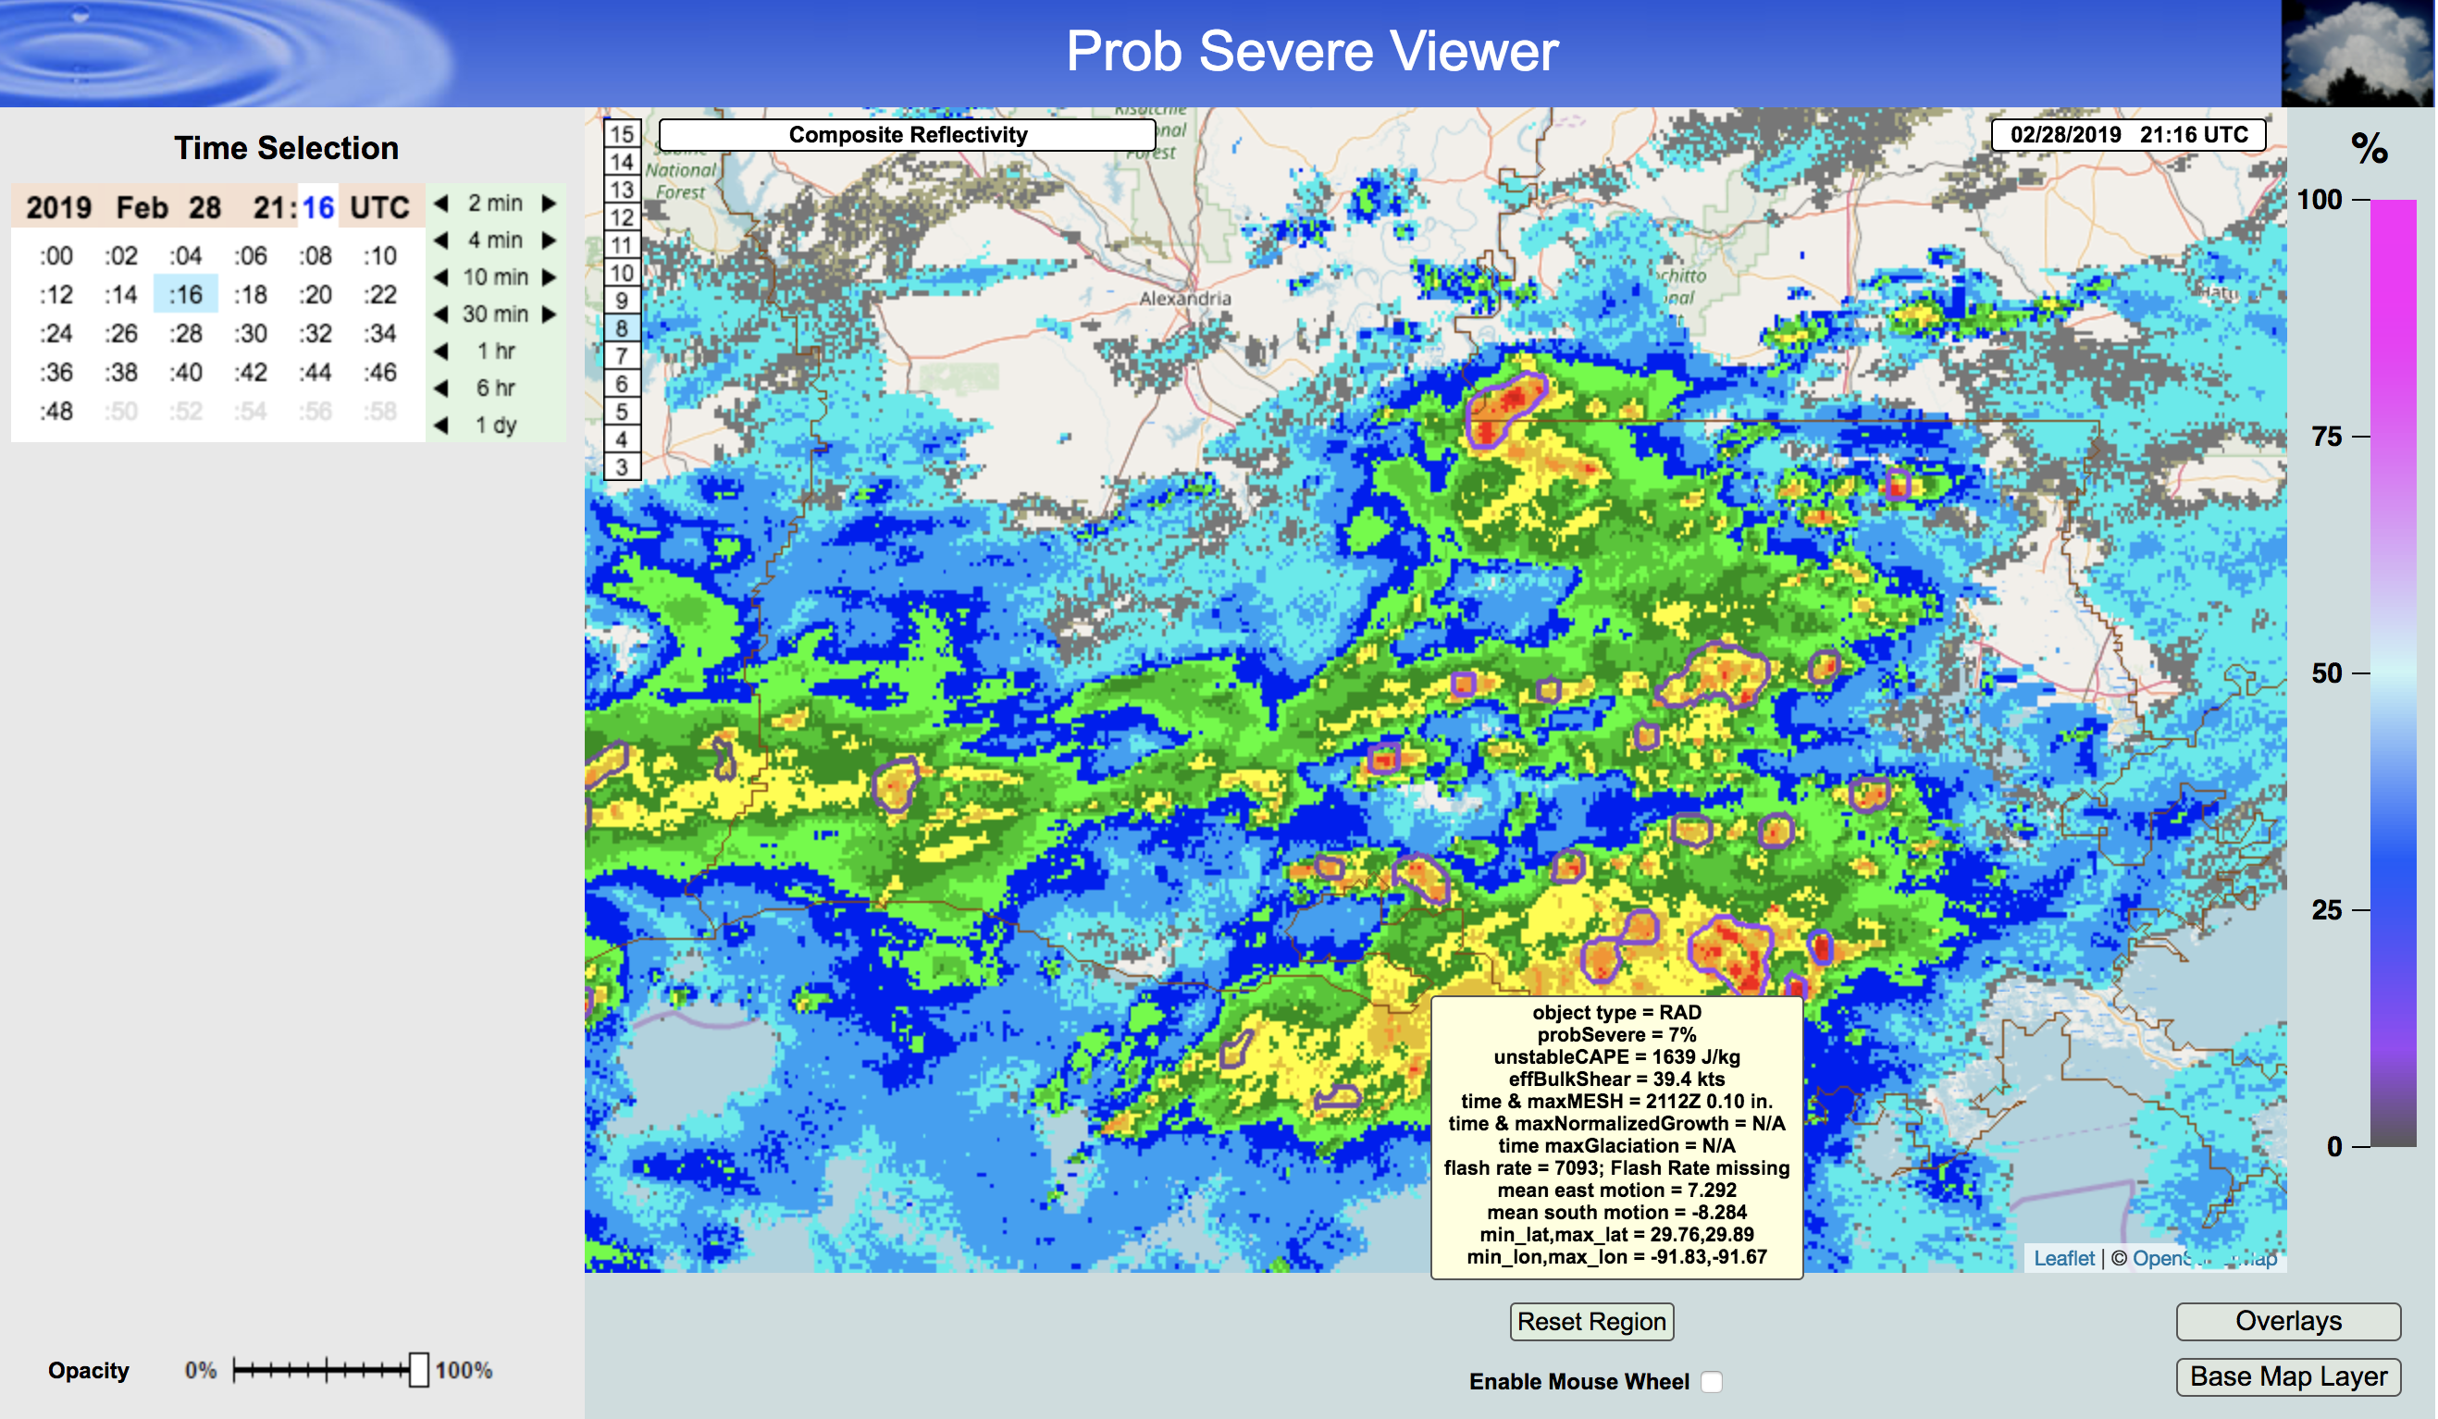
Figure 1: A screenshot from NSSL’s internal MRMS viewer of some ProbSevere objects with hover readout.

Publications and Conference Reports

None

References

None

