McIDAS-X Workshop

May 2018 (software version 2018.1)

In existence since 1973, McIDAS (Man computer Interactive Data Access System) is a suite of sophisticated software packages that perform a wide variety of functions with satellite imagery, observational reports, numerical forecasts, and other geophysical data. Those functions include displaying, analyzing, interpreting, acquiring and managing the data.

McIDAS-X is supported for the current GOES-R satellite series (currently estimated as being in service until 2036), with no end date in sight.

In this McIDAS-X tutorial, some exercises will be completed using different methods of data access: local data files and real-time access to default remote servers. If you have access to your own real-time ADDE servers, you may also use those, but be aware that different server configurations may make the explanations in this document not quite applicable to all data that you may load. A source for free data served via ADDE is Unidata’s LEAD.UNIDATA.UCAR.EDU server.

This tutorial assumes that you have McIDAS-X installed on your machine, and that you know how to start McIDAS-X.

**ABI Background**

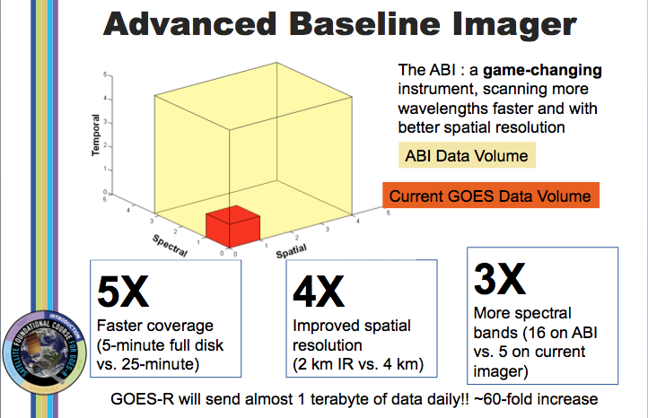

Image from J. Gerth, CIMSS.

There is a 60-fold increase in the amount of data sent by the ABI compared to GOES-13 through -15. The ABI on GOES-R acquires a full-disk image 5 times faster than the imager on GOES-13 through GOES-15. The spatial resolution on the ABI compared to present GOES increases by a factor of 2 in both horizontal directions. There are about 3x more spectral bands on GOES-R. The cubes represent the data volumes from present GOES, in dark orange, and GOES-R, in beige. The combination of increased resolutions means a 60-fold increase in data; about a terabyte of data is flowing daily from GOES-R!

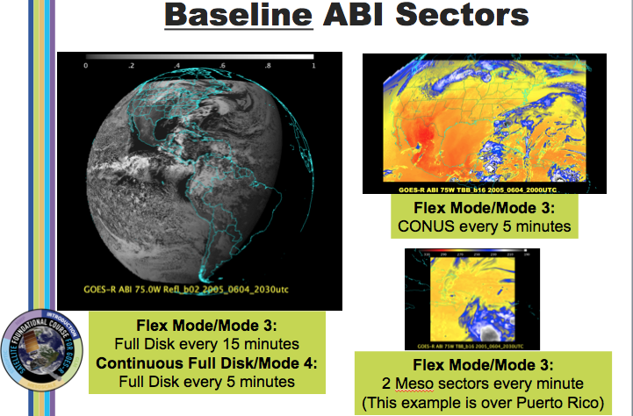

Image from Tim Schmit, Mat Gunshor and Scott Lindstrom (Satellite Foundational Course – GOES-R)

There are two main scanning modes for GOES-R, Mode 3 and Mode 4. The most likely default mode is Mode 3, where one FD image is scanned, 3 CONUS sectors are scanned, and 30 30-second mesoscale sectors are scanned in each 15 minutes. Those 2 mesoscale sectors could be split in two locations so you'd get 2 separate views with 1-minute imagery during the 15 minutes.

Mode 4 is the highest data rate for GOES-R's ABI and results in a full disk every 5 minutes. This might be used if multiple high-impact weather/volcanic events are happening, say a volcano in Chile, strong hurricanes over the Atlantic or Pacific basins, and high-impact severe weather over the central United States.

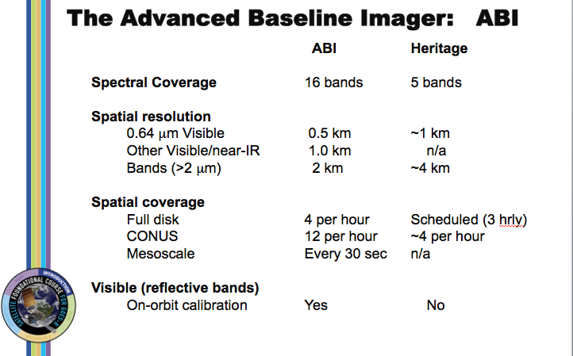

Image from Tim Schmit, Mat Gunshor and Scott Lindstrom (Satellite Foundational Course – GOES-R)

This comparison table shows the improvements in spectral, spatial and temporal coverage that GOES-R has over its predecessors.



Image from the RAMMB/CIRA website, VIIRS Imagery and Visualization Team: http://rammb.cira.colostate.edu/projects/npp/VIIRS_bands_and_bandwidths.pdf

Visible Infrared Imaging Radiometer Suite (VIIRS) SDR imagery from the NASA/NOAA Joint Polar Satellite System (JPSS)-1 spacecraft (NOAA-20) and from Suomi National Polar-orbiting Partnership (SNPP) can be utilized in McIDAS-X and McIDAS-V.

**GOES-R ABI Band List**

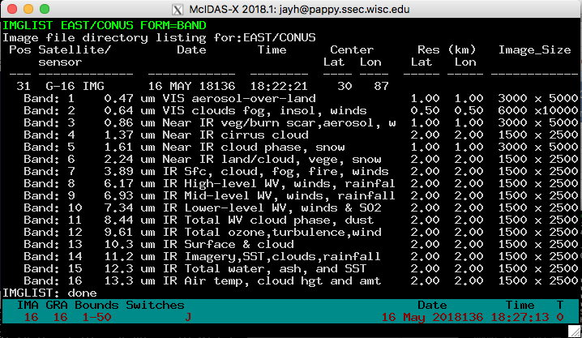

**Creating Local Datasets**

You can access GOES-16 netCDF format files with the IMG* commands by using DSSERVE to assign a dataset name to the files. When doing so, specify "ABIN" in the *format* parameter, TYPE=IMAGE, and the directory and file masks in the DIRFILE keyword. The files must be mission-standard Level 1b or Level 2 files in netCDF-4 format, like those from NOAA CLASS or from the GRB data stream after they've been decoded with CSPP Geo or other software. The names of files should look similar to ***ABI-L1b-RadC-M3C01_G16_s2015229195720.nc*** (current CSPP Geo naming convention) or ***OR_ABI-L1b-RadC-M4C16_G16_s20151702215532_e20151702220362_c20151702220394.nc*** (GOES-R Ground System naming convention).

1. Create a local dataset to access the ABI netCDF files on your local machine in the ***Data/GOES16/ABI/NetCDF*** directory.

***OR_ABI-L1b-RadC-M3C02_G16_s20180041657204_e20180041659577_c20180041700012.nc***

***OR_ABI-L1b-RadC-M3C14_G16_s20180041657204_e20180041659577_c20180041700023.nc***

***OR_ABI-L2-TPWC-M3_G16_s20180041657204_e20180041659577_c20180041701161.nc***

* 1. Run the DSSERVE command to access the Level 1b netCDF imagery files.

**DSSERVE ADD ABI/CONUS ABIN TYPE=IMAGE DIRFILE=** **'<*local-path*>/Data/GOES16/ABI/NetCDF/*RadC*'**

* 1. Use the IMGLIST command to list the most recent image in the dataset.

**IMGLIST ABI/CONUS**

* 1. Datasets can be organized however the user chooses. Run DSSERVE to include all of the files in the data directory.

**DSSERVE ADD ABI/DATA ABIN TYPE=IMAGE DIRFILE=** **'*<local-path>* /Data/GOES16/ABI/NetCDF/*'**

* 1. IMGLIST can list the image directory and band information with the FORM=ALL keyword. Your IMGLIST command should match the image.

**IMGLIST ABI/DATA.ALL FORM=ALL**

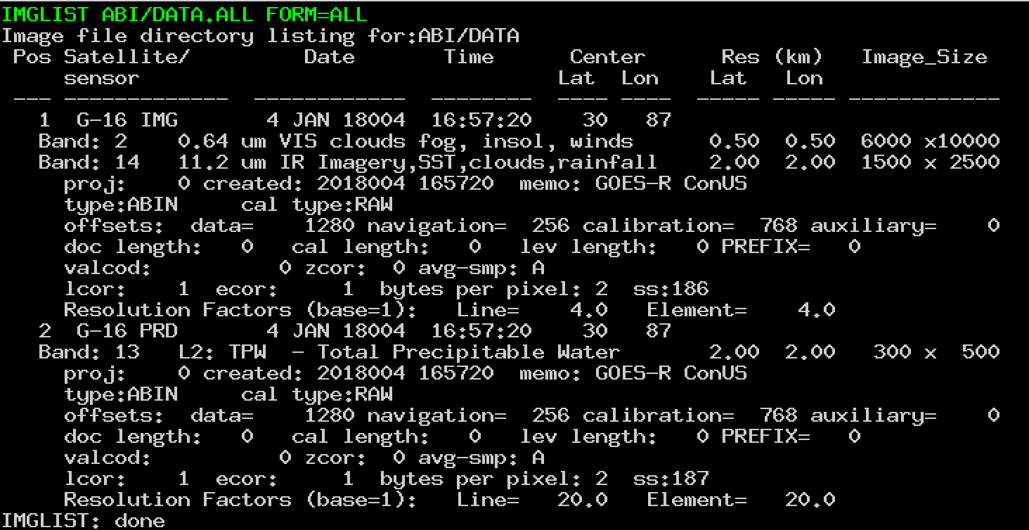

* 1. Another IMGLIST keyword, FORM=BAND, lists the band and resolution without the file’s expanded listing.

**IMGLIST ABI/DATA.1 BAND=2 FORM=BAND**

1. The data can be displayed and inspected with the IMGDISP and IMGPROBE commands.
   1. Run this series of commands to display BAND 2 of an ABI Level 1b file, display a navigated map over the image, place the cursor at the center of the image and run an IMGPROBE command to inspect the pixel values under the cursor.

**IMGDISP ABI/CONUS BAND=2 MAG= -16**

**MAP X X LALO**

**PC C**

**IMGPROBE MODE=N**

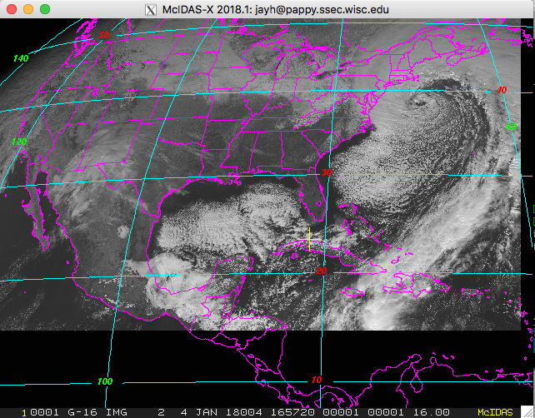

* 1. Display BAND 14 with a yellow map on a new frame which is automatically displayed with the SF=YES keyword. Move the cursor to a latitude/longitude point (29° N, 91° W), and list the statistics of the pixel values under the cursor.

**IMGDISP ABI/CONUS 2 BAND=14 LATLON=29 91 SF=YES ; MAP X 3**

**PC E 29.4 90.7 ; IMGPROBE STAT BOX TEMP**

Move the cursor around and press alt-g or the right mouse button over desired features. Be sure to quit each interactive IMGPROBE command with *Alt-Q* or by clicking the right and center mouse buttons.

* 1. Display the Total Precipitable Water Level 2 product file in the local dataset by specifying the absolute position number of the data. Plot a map and inspect the data in the middle of the frame with the IMGPROBE command.

**IMGDISP ABI/DATA.2 3 SF=YES ; MAP**

**PC C ; IMGPROBE**

**Accessing Remote ADDE Datasets**

1. To access a remote ADDE server with Level 1b ABI netCDF image files, follow these steps.
   1. Modify your client routing table with the DATALOC command so that commands requesting data from a dataset in the group EAST are routed to the remote server with the IP address EASTA.SSEC.WISC.EDU. (You may prefer to use your own data source or the RTGOESR group that can be routed to the remote server with the IP address LEAD.UNIDATA.UCAR.EDU.)

**DATALOC ADD EAST EASTA.SSEC.WISC.EDU**

* 1. Logon to the workstation to access the EAST dataset. (This step may be skipped when using RTGOESR from Unidata’s server. All real time GOES commands for the remainder of the McIDAS-X tutorial will use the EAST group.)

**LOGON TEST 6999**

* 1. List all datasets available in the EAST group with the DSINFO command.

**DSINFO ALL EAST**

* 1. Run IMGLIST commands to see the available data in the datasets. Using a position number of .-2 will list the 3 most recent times in the dataset. Not specifying a position number will default to listing the most recent time.

**IMGLIST EAST/CONUS.-2 FORM=BAND**

**IMGLIST EAST/FD FORM=ALL**

* 1. Run the following list of commands to erase the frames and display a loop of 4 BAND 9 CONUS images centered on Madison with a map. Use 4 images and the REFRESH keyword to display a map on each frame. Then set the loop sequence with the LS command and animate the loop.

**ERASE X 1 4**

**IMGDISP EAST/CONUS.16 1 REP=4 BAND=9 STATION=KMSN SF=YES**

**REFRESH='MAP GRA=(GRA) IMA=(IMA)'**

**LS 1-4**

**Alt-L** (Press *Alt-L* again to stop the looping.)

* 1. Run the following list of commands to erase frames 1-4 and fill the frames with the four most recent BAND 2 times in the full disk dataset and a map. The LATLON= keyword centers the image at 20° N, 80° W. The MAG= -10 blows down the data by 10.

**ERASE X 1 4**

**IMGDISP EAST/FD 1 ALL=1 4 BAND=2 MAG= -10 LATLON=0 90**

**REFRESH='MAP GRA=(GRA) IMA=(IMA)'**

**Alt-L** (Press *Alt-L* again to stop the looping.)

1. To access a remote ADDE server with Level 2 ABI netCDF product data, follow these steps.
   1. Add the group name to modify your client routing table with the ABIL2 group that exists on the server PAPPY.SSEC.WISC.EDU.

**DATALOC ADD ABIL2 PAPPY.SSEC.WISC.EDU**

* 1. Run DSINFO to find the available dataset names. In this example, use “I” instead of “ALL” to list only the image datasets available in the ABIL2 group.

**DSINFO I ABIL2**

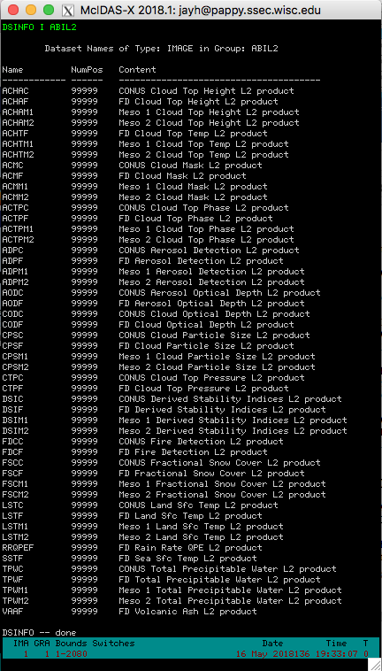

* 1. Run IMGLIST with FORM=ALL for the expanded image list for the Cloud Top Temperature product.

**IMGLIST ABIL2/ACHTF FORM=ALL**

* 1. Display a loop of the Cloud Top Pressure product with a map and enhancement.

**ERASE X 1 4**

**IMGDISP ABIL2/CTPC.4 1 REP=4 LAT=29 91 REFRESH='MAP GRA=(GRA) IMA=(IMA)'**

**EU REST L2-CTP 1 4**

**Alt-L** (Press Alt-L again to stop the looping.)

Note: In McIDAS-X 2018.1, 22 L2-*.ET files were added to the McIDAS-XRD distribution. The calibration and related L2-*.ET files were updated to best match the color enhancements of AWIPS II. When McIDAS-XRD is installed, these files are added to the /home/mcidas/data directory and are named with the corresponding L2 product name. (e.g., L2-ACHA.ET, L2-TPW.ET, L2-DSI-CAPE.ET, etc.) To list the files run the DMAP command.

**DMAP L2-*.ET**

* 1. The DSI (Derived Stability Indices) product has multiple bands. List the bands and display BAND 9 which is the CAPE product (Convective Available Potential Energy). Add the corresponding enhancement and use Alt-D to probe the data (Alt-D is a shortcut to execute IMGPROBE LIST POINT MODE=N).

**IMGLIST ABIL2/DSIC FORM=BAND**

**SF 5 ; IMGDISP ABIL2/DSIC BAND=9 LAT=30 87 MAG=2**

**EU REST L2-DSI-CAPE ; BAR ; MAP**

**Alt-D**

* 1. Note the BAR on frame 5 is labeled with the 0-255 BRIT values. Make a BAR that is labeled with the calibrated CAPE values.

**SU INI DEMO X CAPE**

**SU MAKE DEMO 0 5000 0 255**

**EG LEV=3 ; BAR SU=DEMO RANGE=0 5000 LINT=200**

**Using Other IMG* Commands with GOES-R Data**

The ADDE ABIN server reads netCDF files directly to do IMGLIST and IMGDISP display commands. IMGCOPY uses the ADDE ABIN server to read the netCDF file and to outputs a McIDAS AREA file.

1. Use the ADDE commands to copy an ABI netCDF file to a McIDAS AREA file.   
   (The following exercises will overwrite AREA0001 through AREA0009 files on your local machine.)
   1. Assign the MYDATA/TEST-IMAGES data to all of the AREA files on your local workstation.

**DSSERVE ADD MYDATA/TEST-IMAGES AREA 1 9999 "ALL AREA FILES**

* 1. Create the alias TI for the MYDATA/TEST-IMAGES dataset.

**AKA ADD TI MYDATA/TEST-IMAGES**

* 1. Copy the band 2 image from a local netCDF file to a local AREA file.

**IMGCOPY ABI/DATA.1 TI.1 BAND=2 STATION=KMSN**

* 1. Copy the band 14 image to a local AREA file at full resolution and list your new local AREA files.

**IMGCOPY ABI/DATA.1 TI.2 BAND=14 SIZE=SAME**

* 1. Copy a remote SST product file and list your new local AREA files.

**IMGCOPY ABIL2/SSTF TI.3 LAT=0 89 SIZE=960 1280**

**IMGLIST TI.1 3 FORM=ALL**

* 1. Display the AREA files.

**IMGDISP TI.1 6 REFRESH='MAP GRA=(GRA) IMA=(IMA)'**

**IMGDISP TI.2 7 LAT=33 77 MAG=-2 REFRESH='MAP GRA=(GRA) IMA=(IMA)'**

**IMGDISP TI.3 8 MAG=-2 REFRESH='MAP X X LALO GRA=(GRA) IMA=(IMA) ; EU REST L2-SST (IMA) (IMA)'**

* 1. Use the SF command to show each frame and inspect the data with the IMGPROBE command. Be sure to quit each IMGPROBE command with *Alt-Q* or by clicking the right and center mouse buttons.

**SF 6 ; IMGPROBE**

**IMGPROBE HIST BOX BRIT**

* 1. Use the cursor size and IMGPROBE to inspect calibrated values on the IR and product images.

**CUR 11 11**

**SF 7 ; IMGPROBE STAT BOX TEMP**

**SF 8 ; IMGPROBE HIST LINE SST OUTL=YES**

1. Use IMGREMAP to create a remapped product AREA file.
   1. Create a rectilinear remapped product image at 4 km resolution.

**IMGREMAP EAST/CONUS.-1 TI.4 PRO=RECT LAT=38 91 BAND=12 SIZE=480 640 RES=4**

* 1. Display the new rectilinear AREA file.

**IMGDISP TI.4 9 SF=YES ; MAP X X LALO**

* 1. Use the PRO=DEST keyword in the IMGREMAP command to use an AREA file as the domain for a remapped product image.

**IMGREMAP ABIL2/ACMC TI.4 PRO=DEST SAVESRC=YES**

* 1. Now the cloud mask data will be in the product image AREA file.

**IMGDISP TI.4 10 SF=YES ; MAP X X LALO**

**Problem Set**

IMGOPER is used to perform mathematical operations on images. The domain of the source imagery must be the same for the operations to work correctly. The source imagery can reside on remote servers, local ABI netCDF files or local AREA files. Use IMGOPER to create a temperature difference image between two images in the ABIL2/LSTC dataset, make an enhancement for the difference, and put a color bar on the image that matches the scale of the data.

**Problem Set Solution**

1. Create a temperature difference image from two Land Surface Temperature product files on an ADDE server. The output values are the product name DIFF and multiplied by 10. The product values from -50 to 50 are scaled from brightness 0 to 255.

**IMGOPER ABIL2/LSTC.1 ABIL2/LSTC.4 TI.5 STA=KSTL SIZE=480 640 UNIT=LST**

**FORM=ADD COEF=1 -1 SCALE=-50 50 0 255 MCON=10 PROD=DIFF**

1. Display, draw a map, place the cursor, and probe the data with 4 concatenated commands. This will aid in creating the enhancement and color bar.

**IMGDISP TI.5 11 SF=YES ; MAP X 8 ; PC E 34 93 ; D**

1. The difference AREA file contains difference from the calibrated LST value, which is a temperature. Enhance the image from blue (cold negative values) to red (warm positive values), then make BRIT value 1 black.

**EU MAKE 0 255 BLUE RED**

**EU MAKE 0 1 BLACK**

1. Create the stretch table for the difference area file, then use SU= in the BAR command to display the color bar.

**SU INI DIFF X DIFF**

**SU MAKE DIFF -50 50 0 255**

**BAR SU=DIFF**

**Using GLM Data with GLM* Commands**

You can access GOES-R Series (GOES-16 and later) netCDF Geostationary Lightning Mapper (GLM) point files with the GLMDISP, GLMLIST and PT* commands by using DSSERVE to assign a dataset name to the files. When doing so, specify "GLMN" in the *format* parameter, TYPE=POINT, the directory and file masks to the netCDF point files in the DIRFILE keyword, and the configuration file that maps the netCDF file parameter names to McIDAS parameter names in the INFO keyword. The files must be mission-standard format and follow the GRB naming convention, and thus look similar to **OR_GLM-L2-LCFA_G16_s20172151749200_e20172151749400_c20172151749467.nc**. Three configuration files for GLM data are provided in the **~mcidas/data** directory: **GLM_EVENT.cfg**, **GLM_FLASH.cfg** and **GLM_GROUP.cfg**.

GLM data processing in the Ground System groups lightning flashes from the smallest increments (Events), to aggregates of Events (Groups) to aggregates of Groups (Flashes). Thus, Events are on a rectangular grid wherein each gridpoint is a GLM Field of View. Groups are plotted at the centroid of the Events that comprise the Group, and Flashes are plotted at the centroid of the Groups that comprise the Flash. Typically, the number of Events is greater than the number of Groups, which is greater than the number of Flashes. Real-time GLM datasets normally consist of netCDF files that each contain 20 seconds of data. For example, there are separate files at 21:25:00, 21:25:20, 21:25:40, 21:26:00, 21:26:20, etc., assuming the GLM detected lightning during each of the corresponding 20 second intervals.

1. Create local datasets to access the GLM netCDF files on your local machine in the ***Data/GOES16/GLM/NetCDF*** directory.

***OR_GLM-L2-LCFA_G16_s20180041656400_e20180041657000_c20180041657016.nc***

***OR_GLM-L2-LCFA_G16_s20180041657000_e20180041657200_c20180041657218.nc***

***OR_GLM-L2-LCFA_G16_s20180041657200_e20180041657400_c20180041657427.nc***

* 1. Run the DSSERVE command to access the Level 1b netCDF GLM point data files for each type of GLM data.

**DSSERVE ADD GLM/EVENT GLMN TYPE=POINT DIRFILE=** **'<*local-path*>/Data/GOES16/GLM/NetCDF/OR_GLM*' INFO=*'<mcidas-path>/mcidas*/data/GLM_EVENT.cfg'**

**DSSERVE ADD GLM/GROUP GLMN TYPE=POINT DIRFILE=** **'<*local-path*>/Data/GOES16/GLM/NetCDF/OR_GLM*' INFO=*'<mcidas-path>/mcidas*/data/GLM_GROUP.cfg'**

**DSSERVE ADD GLM/FLASH GLMN TYPE=POINT DIRFILE=** **'<*local-path*>/Data/GOES16/GLM/NetCDF/OR_GLM*' INFO=*'<mcidas-path>/mcidas*/data/GLM_FLASH.cfg'**

* 1. Use the GLMLIST command to list each type of data and note the number of records for each type.

**GLMLIST NA TYPE=EVENT DATASET=GLM/EVENT DAY=4 TIME=16:58**

**GLMLIST NA TYPE=GROUP DATASET=GLM/GROUP DAY=4 TIME=16:58**

**GLMLIST NA TYPE=FLASH DATASET=GLM/FLASH DAY=4 TIME=16:58**

* 1. Use the MAP and GLMDISP commands to display each type over a small area. Inspect the differences with Alt-A and Alt-B to switch between the frames.

**SF 12;MAP DEF LAT=-7 0 LON=72 82 GRA=12-14**

**GLMDISP TYPE=EVENT DATASET=GLM/EVENT DAY=4 TIME=16:58**

**GLMDISP X 13 TYPE=GROUP DATASET=GLM/GROUP DAY=4 TIME=16:58 COL=3**

**GLMDISP X 14 TYPE=FLASH DATASET=GLM/FLASH DAY=4 TIME=16:58 COL=2**

* 1. Display a conus image and use the time matching keywords in GLMDISP to overlay the corresponding GLM lightning GROUP display. Then use the zoom feature to inspect the data closer.

**IMGDISP ABI/CONUS 15 BAND=2 MAG=-8 LAT=36 74 SF=YES**

**GLMDISP TYPE=GROUP DATA=GLM/GROUP DAY=IMA**

**Alt-Z** (Move the cursor over the region with lightning strikes, press Alt-Z to toggle the zooming.)

* 1. Display the same conus image at full resolution and use the POSITION= in GLMDISP to overlay the corresponding GLM lightning GROUP display with and without the parallax correction. (Note: the default is POSITION=GROUND which plots the lightning strikes at the corrected ground positions, keeping the native parallax correction in the GLM file. POSITION=CLOUDTOP plots the lightning strikes at the approximate cloudtop positions as viewed from the GOES-R series satellite, removing the native parallax correction in the GLM file.)

**IMGDISP ABI/CONUS 16 BAND=2 LAT=39 63 SF=YES**

**GLMDISP TYPE=GROUP DATA=GLM/GROUP DAY=IMA**

**GLMDISP TYPE=GROUP DATA=GLM/GROUP DAY=IMA POSITION=CLOUDTOP COL=3**

1. To access a remote ADDE server with GLM netCDF point files, follow these steps to use the EAST dataset that was previously added.
   1. Inspect the dataset to identify the name of the GLM realtime datasets.

**DSINFO P EAST**

* 1. Display the most recent hour of FLASH data with a time step of 15 minutes over a specific domain. (Note: the GLM* commands default to the EAST servers in Satellite Data Services at SSEC. If using other servers, DATASET= will need to be used with GLMLIST/GLMDISP, or the GLM.SITE or GLM.USER file will need to redefine the default GLM servers.)

**SF 17;** **GLMDISP TYPE=FLASH INC=60 15 LAT=-25 25 LON=40 90**

* 1. Display a band 13 full disk image and overlay the corresponding GLM GROUP data. Display the data as asterisks (*).

**IMGDISP EAST/FD.-5 18 BAND=13 LAT=0 75 MAG=-10 SF=YES**

**GLMDISP DAY=IMA LOC=\***

* 1. Display a band 2 full disk image and overlay the corresponding GLM GROUP data. Display the GLMDISP data on the full image window and echo the PT* commands that are being executed to the text frame.

**IMGDISP EAST/FD.-5 19 BAND=2 LAT=0 75 MAG=-20 SF=YES**

**GLMDISP TYPE=GROUP TIME=IMA ECHO=YES LEGEND=OFF**

* 1. Display a loop of band 9 full disk imagery with GLM FLASH data and a map overlaid one each frame.

**IMGDISP EAST/FD BAND=9 ALL=21 24 LAT=0 75 SF=YES MAG=-8 REFRESH=’MAP X X LALO IMA=(IMA) GRA=(GRA);GLMDISP X (GRA) TYPE=FLASH TIME=IMA’**

**Using the MCSTRETCH= Keyword When Displaying Imagery**

McIDAS-X versions 2017.2 and later include improvements to visualize more bit-depth in the data and provide more contrast in the images.

This expanded stretch feature was added to increase the detail shown in visible, water vapor and short-wave infrared imagery when displayed with IMGDISP from an updated ADDE server or copied to a 1-byte Area file using commands like IMGCOPY with STYPE=VISR or IMGREMAP. This is done by expanding the range of data values stretched out over the 8-bit brightness values in the higher reflectances in visible bands, and in the very hot temperatures in short-wave IR bands. The range of data values is narrowed in both colder and warmer temperatures in the water vapor bands.

The examples and the list of satellites and bands can be found here:

<http://www.ssec.wisc.edu/mcidas/software/x/mcstretch_info.html>

Or the text file is included in the distribution and can be viewed with the SEE command:

**SEE MCSTRETCH.TXT**

1. Display a current GOES-16 image in a paneled frame with and without MCSTRETCH.

**SF 25 ; PANEL 1 2 25**

**IMGDISP EAST/FD.-1 STA=KSTL BAND=9 MAG=-2 PANEL=1  
IMGDISP EAST/FD.-1 STA=KSTL BAND=9 MAG=-2 PANEL=2 MCS=ORIG**

1. Analyze the data by using IMGPROBE/Alt-D to compare the BRIT values between the images. (Note: The RAW/RAD/TEMP calibrated values remain the same. The only difference is in the BRIT value for the 0-255 value the pixel is displayed at.)

**PC C PANEL=1 ; D**

**PC C PANEL=2 ; D**

1. Because EU tables are based on BRIT display values, the EU command was enhanced with a conversion option to convert old *.ET files to match the new stretched display BRIT values. This option is EU CONV.

The ***Data/MCSTRETCH*** directory contains a pre-2017.2 enhancement table:

***SPECTRUM_ORIG.ET***

* 1. Copy the ***SPECTRUM_ORIG.ET*** file to your local mcidas/data directory in a Unix terminal.
  2. Display a band 2 GOES-16 image with an original stretch and enhance it with SPECTRUM_ORIG.ET.

**IMGDISP ABI/CONUS 26 SF=YES BAND=2 LAT=15:38 75:08 MCS=ORIG**

**EU REST SPECTRUM_ORIG**

* 1. Convert the SPECTRUM_ORIG file with EU CONV and use the converted *.ET file to display an enhanced (the default) display for the GOES-16 image. (Note: The original file is saved in SPECTRUM_ORIG_OLD.ET.) Compare frames 26 and 27 and place the cursor over the whitish areas and compare BRIT values

**EU CONV SPECTRUM_ORIG VIS**

**IMGDISP ABI/CONUS 27 SF=YES BAND=2 LAT=15:38 75:08**

**EU REST SPECTRUM_ORIG**

**D**

* 1. Display a current band 7 GOES-16 image in a paneled frame with and without MCSTRETCH and inspect the data.

**SF 28 ; PANEL 1 2 28**

**IMGDISP EAST/FD.-1 STA=KMIA BAND=7 MAG=2 PANEL=1  
IMGDISP EAST/FD.-1 STA=KMIA BAND=7 MAG=2 PANEL=2 MCS=ORIG**

**PC L KMIA PANEL=1 ; D**

**PC L KMIA PANEL=2 ; D**

**SU TAB SWIRCORE**

**RGBDISP – Displaying and Looping RGB Imagery**

The RGBDISP command works similar to the COMBINE command, except that it displays its output color image in a regular image frame in the Image Window rather than in a separate Combine Window. RGBDISP uses the brightness (BRIT) values of the three input frames or datasets to calculate the red, green and blue components, respectively, of the output color image. This allows the user to interactively use the RGB displays and create loops.

The ***Data/RGBDISP/*** directory contains AREA files that are used in the following examples.

***AREA3000 – 0.64um Himawari Band 3***

***AREA3001 – 0.51um Himawari Band 2***

***AREA3002 – 0.47um Himawari Band 1***

***AREA3010 – 0.70um Meteosat-11 HRV Band 12***

***AREA3011 – All bands Meteosat-11 Band 1-11***

Copy these files to your local mcidas/data directory or use the REDIRECT command to point to them:

**REDIRECT ADD AREA30* “<*local-path*>/Data/RGBDISP**

**DSSERVE ADD AREA/RGB AREA 3000 3020 “AREA FILES FOR RGB**

1. Use the RGBDISP command to do a variety of RGB displays and loops.
   1. Display a True-Color RGB composite with the 0.64, 0.51 and 0.47 um images from the Himawari satellite, and echo the IMGDISP commands being executed.

**SF 29 ; RGBDISP AREA/RGB.1 AREA/RGB.2 AREA/RGB.3 MAG=-40 -20 -20 BAND=3 2 1 ECHO=YES**

* 1. Display the RGB composite E-View display from Meteosat-11, a procedure developed by Eumetsat. It is dedicated to detailed cloud monitoring including water clouds. Use different LINELE= values to match up the images.

**SF 30 ; RGBDISP AREA/RGB.11 AREA/RGB.11 AREA/RGB.12 BAND=X X 9 MAG=-15 -15 -5 PLACE=CENTER LIN='5580 5573' '5580 5573' '5583 5583' I**

* 1. Create a loop of ‘Icing RGB’ in AWIPS (also called the ‘Day Land Cloud’ RGB) images using the real time GOES-16 server.

**SF 31 ; RGBDISP EAST/FD.-4 MAG=-6 -6 -12 BAND=5 3 2 STA=KSTL**

**RGBDISP EAST/FD.-3 32 MAG=-6 -6 -12 BAND=5 3 2 STA=KSTL**

**RGBDISP EAST/FD.-2 33 MAG=-6 -6 -12 BAND=5 3 2 STA=KSTL**

**RGBDISP EAST/FD.-1 34 MAG=-6 -6 -12 BAND=5 3 2 STA=KSTL**

**LS 31-34 ; Alt-L**

**Problem Set**

Create an Airmass RGB jpeg image with the IMGOPER, IMGDISP, RGBDISP and FRMSAVE commands for the most recent image in the real-time ABI dataset.

EUMETSAT has created many different useful RGB composites for their SEVIRI instrument, and many can be applied to GOES-16. (http://oiswww.eumetsat.org/IPPS/html/MSG/RGB/)

Airmass is an RGB composite based upon data from infrared and water vapor channels. It is designed and tuned to monitor the evolution of cyclones, in particular rapid cyclogenesis, jet streaks and PV (potential vorticity) anomalies. Due to the incorporation of the water vapor and ozone channels, its usage at high satellite viewing angles is limited. The Airmass RGB can be composed from a scaled combination of GOES-16 bands 8 (6.19 um high-level water vapor), 10 (7.34 um lower/mid-level water vapor), 12 (9.61 um ozone), and 14 (11.2 um longwave infrared).

From <http://www.eumetrain.org/RGBguide/recipes/recipe_Airmass_RGB.pdf>:

|  |  |  |  |
| --- | --- | --- | --- |
| Color beam | Channel (difference) | Range [K] | |
| Red | WV6.2 – WV7.3 | -25 | 0 |
| Green | IR9.7 – IR10.8 | -40 | +5 |
| Blue | WV6.2 inverted | 243 | 208 |

**Problem Set Solution**

1. Run the following commands to create and display the scaled products for the RGB combination.

**IMGOPER EAST/FD.-1 EAST/FD.-1 TI.6 BAND=8 10 COEF=1 -1 MAG= -10 LAT=0 75 UNIT=TEMP MISS=NONE SCALE=-25 0 0 255**

**IMGOPER EAST/FD.-1 EAST/FD.-1 TI.7 BAND=12 14 COEF=1 -1 MAG= -10 LAT=0 75 UNIT=TEMP MISS=NONE SCALE=-40 5 0 255**

**IMGOPER EAST/FD.-1 TI.8 MAG= -10 BAND=8 LAT=0 75 UNIT=TEMP SCALE=243 208 0 255**

**ERASE X 1 34 ; EU REST X 1 34**

**IMGDISP TI.6 1 REP=3 SF=YES**

1. Use RGBDISP to combine the displays in three frames into a RGB image then FRMSAVE will convert the image into a jpeg file.

**RGBDISP 1 2 3 4**

**SF 4**

**FRMSAVE 4 AIRMASS_RGB**

FRMSAVE will list the output file path where the jpeg file is created. Go to that directory and display it with a jpeg viewing application.

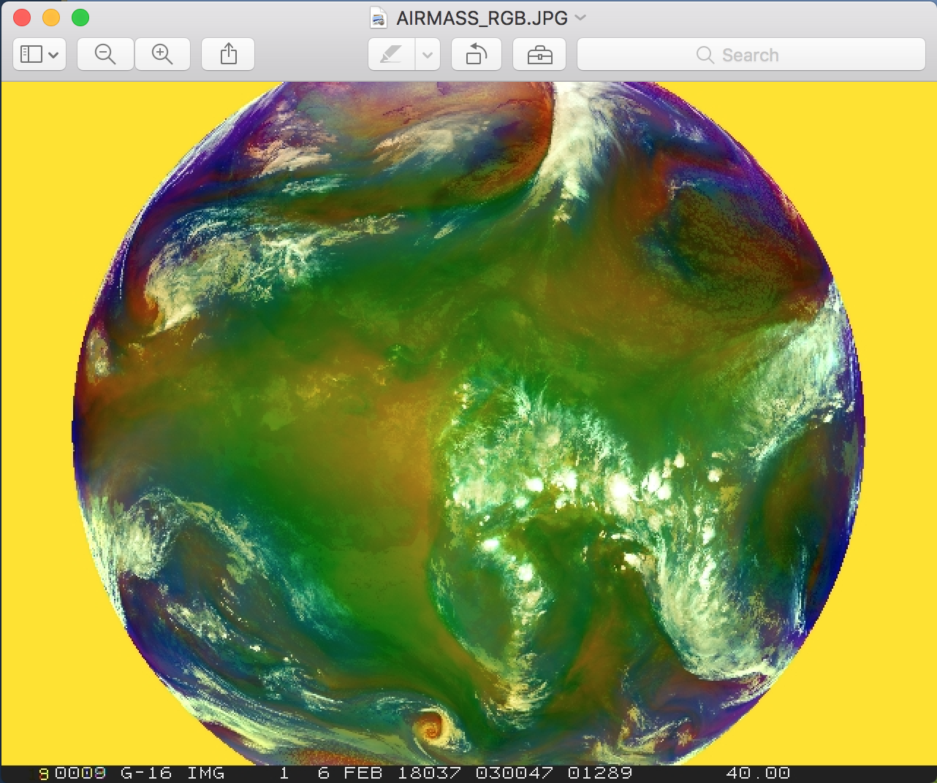

**Note the following in the image:**

* Dry sinking air masses appear red in the Airmass RGB image.
* In tropical and subtropical regions the RGB depicts hot and dry air masses in red-orange tones.
* High reaching opaque clouds appear white in the image. Lower clouds turn into red, green or blue depending on the air mass they lay within.
* Polar air masses appear blue in the image.
* The blue color can also come from the so-called "limb cooling effect" at the edge of the image.

**McIDAS-XRD: Servers for VIIRS/NOAA-20 Data**

McIDAS-XRD is a package containing research and development software that is not part of the core supported McIDAS-X package. The -XRD software is provided on an "as is" basis, meaning it is not MUG-supported.

Included in the –XRD package are servers that will serve VIIRS instrument data from the Suomi NPP and NOAA 20-24 JPSS satellites. When using DSSERVE to create a VIIRS dataset, specify "VIIR" in the *format* parameter, TYPE=IMAGE, the directory and file masks to the data files in the DIRFILE= keyword, the directory and file masks to the geolocation files in the INFO= keyword, and "SVI" or "SVM" for the dataset descriptor (e.g., VIIRS/SVM). Also, the data (SVM*, SVI*) and terrain-corrected geolocation (GMTCO*, GITCO*) must be in separate files in the NOAA CLASS naming format.

1. Create a local dataset to access the NOAA-20 HDF files on your local machine in the ***Data/NOAA20/VIIRS*** directory.

***GMTCO_j01_d20180513_t1811286_e1812531_b02503_c20180513183337907316_noac_ops.h5***

***GMTCO_j01_d20180513_t1812544_e1814189_b02503_c20180513183342266088_noac_ops.h5***

***GMTCO_j01_d20180513_t1814201_e1815447_b02503_c20180513183356170645_noac_ops.h5***

***SVM03_j01_d20180513_t1811286_e1812531_b02503_c20180513183516946272_noac_ops.h5***

***SVM03_j01_d20180513_t1812544_e1814189_b02503_c20180513183532011739_noac_ops.h5***

***SVM03_j01_d20180513_t1814201_e1815447_b02503_c20180513183542156909_noac_ops.h5***

***SVM04_j01_d20180513_t1811286_e1812531_b02503_c20180513183516953162_noac_ops.h5***

***SVM04_j01_d20180513_t1812544_e1814189_b02503_c20180513183532023286_noac_ops.h5***

***SVM04_j01_d20180513_t1814201_e1815447_b02503_c20180513183542163590_noac_ops.h5***

***SVM05_j01_d20180513_t1811286_e1812531_b02503_c20180513183516968584_noac_ops.h5***

***SVM05_j01_d20180513_t1812544_e1814189_b02503_c20180513183532035203_noac_ops.h5***

***SVM05_j01_d20180513_t1814201_e1815447_b02503_c20180513183542171287_noac_ops.h5***

**DSSERVE ADD NOAA20/SVM VIIR TYPE=IMAGE DIRFILE='*<local-path>* /Data/NOAA20/VIIRS/SVM*' INFO='*<local-path>*/Data/NOAA20/VIIRS/GMTCO*'**

1. Use the IMG* commands and RGBDISP to display and manipulate the data.
   1. Use IMGLIST to list out NOAA-20 band information.

**IMGLIST NOAA20/SVM.1 FORM=BAND**

* 1. Display an image with IMGDISP and use Alt-D to inspect it.

**IMGDISP NOAA20/SVM.2 5 SF=YES LAT=41 80 BAND=10**

**Alt-D**

* 1. Use IMGCOPY with STYP=VISR, IMGREMAP, and IMGOPER to merge together Band 9 for two consecutive granules.

**IMGCOPY NOAA20/SVM.2 TI.9 BAND=9 SIZE=SAME STYPE=VISR**

**IMGCOPY NOAA20/SVM.1 TI.10 BAND=9 SIZE=SAME STYPE=VISR**

**IMGREMAP TI.9 TI.11 PRO=RECT RES=8 BAND=9 LAT=36 78**

**IMGREMAP TI.10 TI.12 PRO=RECT RES=8 BAND=9 LAT=36 78**

**IMGOPER TI.11 TI.12 TI.13 FORM=CMIN MISS=NONE**

**IMGDISP TI.12 6 SF=YES ; MAP**

* 1. The image is dark, IMGFILT will brighten the image with the default CLEAN filter.

**IMGFILT TI.13 TI.14**

**IMGDISP TI.14 7 SF=YES ; MAP**

**McIDAS-XRD: Creating GLM Density Plots with GLMIMG**

The GLMIMG command in the McIDAS-XRD package will take GLMLIST data, aggregate the lightning reports into bins and create an AREA file for display.

1. Run GLMIMG to create a density image and merge it with the corresponding imagery with an enhancement.
2. Run GLMIMG to create the density AREA file and display it.

**GLMIMG 40 'TYPE=EVENT TIME=1 INC=5 POS=CLOUDTOP DAY=#Y' ECHO=Y   
IMGDISP TI.40 8 SF=YES ; MAP**

1. Use the density image from the previous step and combine it with the corresponding image using IMGDISP, IMGREMAP and IMGOPER. Then enhance the lightning density points.

**DATALOC ADD EASTAL EASTA.SSEC.WISC.EDU**

**IMGOPER TI.40 TI.41 SCALE=0 255 0 50**

**IMGCOPY EASTAL/CONUS TI.42 TIME=00:55 1:05 DAY=2018141 BAND=13 STYPE=VISR LAT=40 96 SIZE=1200 1200**

**IMGREMAP TI.41 TI.43 PRO=RECT RES=6 LAT=40 96**

**IMGREMAP TI.42 TI.44 PRO=RECT RES=6 LAT=40 96**

**IMGOPER TI.43 TI.44 TI.45 FORM=CMIN MISS=NONE**

**IMGDISP TI.45 9 SF=YES; MAP**

**EU MAKE 0 50 WHITE YELLOW**

McIDAS-V Tutorial

Using GOES-16 and JPSS Data

Created May 2018 (software version 1.7u1)

­­­­

McIDAS-V is a free, open source, visualization and data analysis software package that is the next generation in SSEC's 40-year history of sophisticated McIDAS software packages. McIDAS-V displays weather satellite (including hyperspectral) and other geophysical data in 2- and 3-dimensions. McIDAS-V can also analyze and manipulate data with its powerful mathematical functions. McIDAS-V is built on SSEC's VisAD and Unidata's IDV libraries. The functionality of SSEC's HYDRA software package is also being integrated into McIDAS-V for viewing and analyzing hyperspectral satellite data.

More training materials are available on the McIDAS-V webpage and in the Getting Started chapter of the McIDAS-V User’s Guide, which is available from the Help menu within McIDAS-V. You will be notified at the startup of McIDAS-V when new versions are available on the McIDAS-V webpage - <http://www.ssec.wisc.edu/mcidas/software/v/>.

If you encounter an error or would like to request an enhancement, please post it to the McIDAS-V Support Forums - <http://www.ssec.wisc.edu/mcidas/forums/>. The forums also provide the opportunity to share information with other users.

This tutorial assumes that you have McIDAS-V installed on your machine, and that you know how to start McIDAS-V. If you cannot start McIDAS-V on your machine, you should follow the instructions in the document entitled *McIDAS-V Tutorial – Installation and Introduction*.

Terminology

There are two windows displayed when McIDAS-V first starts, the **McIDAS-V Main Display** (hereafter **Main Display**) and the **McIDAS-V Data Explorer** (hereafter **Data Explorer**).

The **Data Explorer** contains three tabs that appear in bold italics throughout this document: ***Data Sources*, *Field Selector***, and ***Layer Controls***. Data is selected in the ***Data Sources*** tab, loaded into the ***Field Selector***, displayed in the **Main Display**, and output is formatted in the ***Layer Controls***.

Menu trees will be listed as a series (e.g. ***Edit -> Remove -> All Layers and Data Sources***).  
  
Mouse clicks will be listed as combinations (e.g. *Shift+Left Click+Drag*).

**ABI Introduction**

McIDAS-V currently supports ABI netCDF data through remote servers as well as through the local file chooser on all platforms. Local servers for ABI data are currently available on OS X and Linux platforms. This tutorial will cover how to access this data through remote servers and different ways that the data can be displayed and interrogated in McIDAS-V.

**Accessing GOES-16 ABI Data from a Remote Server – 1 Timestep**

1. In the ***Data Sources*** tab of the **Data Explorer**, navigate to the ***Satellite -> Imagery*** chooser. Select *lead.unidata.ucar.edu* as the **Server** and *RTGOESR* as the **Dataset**. Click **Connect**.
2. Select *FD – GOES-16 FD all bands* as the **Image Type**.
3. In the **Times** panel, select the ***Relative*** tab. For **Number of times**, enter *1* and click **Add Source** to create a data source of the most recent time.
4. Display band 13 temperature data.  
   1. Navigate to the ***Field Selector*** tab of the **Data Explorer** to see a listing of each band included with the data. Select the ***10.3 um IR Surface & cloud -> Temperature*** field.
   2. From the **Displays** panel, select the ***Imagery -> Image Display*** display type.
   3. Select the ***Region*** tab to see a low-resolution preview image of the data. Note that there is a green box drawn around the preview image. Any data inside this bounding box will be displayed.
   4. Select the ***Advanced*** tab to see information about the band and calibration selected. These values match the domain of the data selected in the ***Region*** tab, so it covers the entire domain of the data. Notice that the **Image Size** is only *904 x 904* when the raw size of the data is *5424 x 5424*. The magnification of the data is set to *-6*, *-6*. This reduction in resolution is the default to allow for an efficient display of the data. Modify the ***Advanced*** tab to display full resolution data over Florida.  
      1. **Coordinate Type:** *Latitude/Longitude*
      2. **Location:** *Center*
      3. **Lat:** *28*; **Lon:** *-83.5*
      4. **Image Size:** 4*00 x 400*
      5. **Magnification:** *1 x 1*
   5. Click **Create Display**.
5. Investigate the display.  
   1. In the **Main Display** window, practice navigating around in the display. To do this, use *Control+Right-Click+Drag* to translate the display. This shifts the data left/right and up/down without rotating the display. Zoom in on the display by scrolling down on the mouse wheel. As an alternative, select a region in the **Main Display** by using *Shift+Left-Click+Drag* to zoom in on a specific domain.
   2. Probe individual pixel values by holding down the middle mouse button over the display. This will print out probe values at the bottom of the display. Notice that latitude, longitude, and temperature values are included in the probe output.
   3. Navigate to the ***Histogram*** tab of the ***Layer Controls*** to see a histogram of band 13 temperature values.
6. Add a data transect to the display.  
   1. From the ***Field Selector*** tab of the **Data Explorer**, select the ***Data Transect*** display type and click **Create Display**.
   2. In the **Main Display** window, there is a red line that is referred to as the data transect. The values along this transect line are output in the ***Layer Controls*** tab of the **Data Explorer**. The two end points of the transect can be moved around by *Left-Clicking+Dragging* them, or by entering new Lat/Lon values at the bottom of the ***Display*** tab in the ***Layer Controls***. The transect line as a whole can be moved by *Left-Clicking+Dragging* the triangle in the middle of the transect line.
7. Create a display of the 10.3 micron temperatures so only values of 273K and less are plotted.  
   1. Add a new two-paneled map display by selecting ***File -> New Display Tab -> Map Display -> Two Panels*** menu item.
   2. *Left-Click* in the left panel to make this panel active. The active panel has a blue frame around it, and this is the panel any displays will be added to.
   3. In the ***Field Selector*** tab of the **Data Explorer**, select the ***10.3 um IR Surface & cloud -> Temperature*** field. Choose the ***Imagery -> Image Display*** display type and click **Create Display**.
   4. Create the cloud mask display.  
      1. *Left-Click* in the right panel to make this panel active. The active panel has a blue frame around it, and this is the panel any displays will be added to.
      2. In the ***Field Selector*** tab of the **Data Explorer**, select **Formulas**.
      3. Select the ***Imagery -> Mask Value*** formula, the ***Imagery -> Image Display*** display type, and click **Create Display**.
      4. In the **Select input** window, enter the following and then click **OK**:  
         1. **comparison:** *<*
         2. **cutoff:** *273*
         3. **useNaN:** *1*  
            Notes: The comparison is set to < or ‘less then’ since the goal is to display values less than 273, which was set as the cutoff value. Setting useNaN to 1 makes it so that if the pixels were probed outside of the masked range (where values are greater than 273) they wouldn’t show a value. useNaN can be set to 0 as well, and in this case pixel values greater than 273 would probe as 0. Note that if these pixel values are set to 0, then these 0 values will be included in any calculations with the data that may be done later.
      5. In the new **Field Selector** window, for **inputFieldForMask**, select ***10.3 um IR Surface & cloud -> Temperature***. This is the field that is being masked.
      6. For **displayFieldToBeMasked**, select ***10.3 um IR Surface & cloud -> Temperature***. This is the field that will be displayed where the **inputFieldForMask** is less than 273 degrees. In this case, we are displaying the same field that is being masked.
      7. Click **OK**.
   5. Investigate the display. Note that as one of the panels is navigated, the other will be navigated in the same way. This is because by default panels in the same tab are set to share views. This setting can be disabled in a panel by unchecking ***Projections -> Share Views*** in the display panels.
8. Create a display of a subtraction of two bands.  
   1. Add a new one-paneled map display by selecting ***File -> New Display Tab -> Map Display -> One Panel*** menu item, or by clicking the **Add new tab** () button in the **Main Toolbar**.
   2. In the ***Field Selector*** tab of the **Data Explorer**, select **Formulas**.
   3. Select the ***Miscellaneous -> Simple difference a-b*** formula, the ***Imagery -> Image Display*** display type, and click **Create Display**.
   4. In the new **Field Selector** window, for **a**, select the ***8.44 um IR Total WV cloud phase, dust -> Temperature*** field. For field **b**, select the ***7.34 um IR Lower-level WV, winds & SO2-> Temperature*** field.
   5. Click **OK** in the **Field Selector** window to display the band subtracted data.
   6. *Right-Click* on the colorbar of the ABI layer in the **Legend** and select the ***System -> Inverse Gray Scale*** enhancement.
   7. Add latitude and longitude labels to the display.  
      1. *Left-Click* on the blue text for the *Default Background Maps* layer in the **Legend** to get to the ***Layer Controls*** tab of the **Data Explorer** for the layer.
      2. From the ***Lat/Lon*** tab of the ***Layer Controls***, set the following:  
         1. Check the visibility checkboxes for **Lines** and **Labels** to plot them in the display.
         2. **Lines**: **Interval**: *5.0*
         3. **Labels**: **Interval**: *5.0*; **At Longitudes**: *-85.0*, **At Latitudes**: *30.0*, **Color**: *light blue*
         4. **Font**: *Arial*; *Bold*; *20*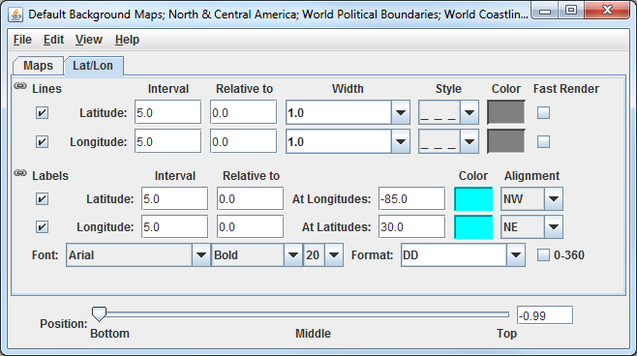
   8. Investigate the display to see the latitude and longitude lines and labels. Probe the data to see the temperature difference between the two bands.
9. Capture an image of the display.  
   1. From the **Main Display**, select the ***View -> Capture -> Image*** menu item.
   2. In the **Save As** text field, enter the name to give your image, for example: *band_subtraction.gif*.
   3. Use the dropdown below **Save As** to select the directory to save your image to.
   4. Under **Capture What**, select *Current View*. This will capture an image of the display without including any other components of the **Main Display** such as menu items and the **Legend**.
   5. Click **Save**.
   6. View your saved image to verify the image was captured correctly.

**Accessing GOES-16 ABI Data from a Remote Server – 5 Timesteps**

1. Remove all layers and data sources from any previous displays via the ***Edit -> Remove -> All Layers and Data Sources*** menu item from the **Main Display**.
2. Add a new one-paneled map display by selecting ***File -> New Display Tab -> Map Display -> One Panel*** menu item. Close any previously-existing tabs.
3. In the ***Data Sources*** tab of the **Data Explorer**, navigate to the ***Satellite -> Imagery*** chooser. In the ***Relative*** tab of the **Times** panel, for **Number of times**, enter *5* and click **Add Source**.
4. Display a loop of 10.4um Temperature data over Wisconsin and Illinois.  
   1. Navigate to the ***Field Selector*** tab of the **Data Explorer** to see a listing of each band included with the data. Select the ***10.3 um IR Surface & cloud -> Temperature*** field.
   2. From the **Displays** panel, select the ***Imagery -> Image Display*** display type.
   3. Navigate to the ***Advanced*** tab, and enter the following information:
      1. **Coordinate Type:** *Latitude/Longitude*
      2. **Location:** *Center*
      3. **Lat:** *42*; **Lon:** *-89.6*
      4. **Image Size:** *450 x 450*
      5. **Magnification:** *1 x 1*
   4. Click **Create Display**.
5. Investigate the display.  
   1. The **Main Display** now has a loop of the 5 most recent times of data in the FD dataset. As done in step 5 earlier, navigate around and zoom in/out of the display. Probe the display by holding down the middle mouse button over the data.
   2. Use the Time Animation Widget at the top of the display panel to play through a loop of the data.  
        
      
   3. Click the **Properties** button () in the Time Animation Widget to modify settings of the animation including the dwell rate (the time spent on each frame in the animation). As an example, set the **Forward**, **First**, and **Last** dwell rates to *0.2* and click **OK**. This reduced dwell rate allows the display to loop faster.
6. Change the enhancement used in the display.  
   1. Stop the animation by clicking the **Stop Animation** button in the Time Animation Widget ().
   2. *Right-Click* on the colorbar of the ABI layer in the **Legend** and select the ***Satellite -> GOES-R -> ABI IR Temperature*** enhancement.
7. Add a color scale to the display.  
   1. *Right-Click* on the ABI layer in the **Legend** and select ***Edit -> Properties***.
   2. 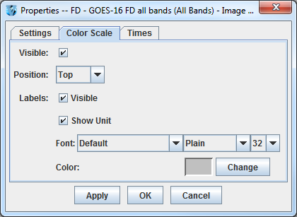In the **Properties** window, navigate to the ***Color Scale*** tab and set the following:
      1. **Visible**: Check this option to add the color scale to the display.
      2. **Position**: *Top*. This will position the color scale at the top of the display.
      3. **Labels -> Visible**: Check this option to add numerical labels to the color scale.
      4. **Labels -> Show Unit**: Check this to add the display unit to the color scale labels.
      5. **Labels -> Font**: Set the size to *32*.
   3. Click **OK**.
8. Create a Data Probe/Time Series display of band 13 temperature data. This display type allows for plotting how temperature values at a specific location change through time throughout the loop.  
   1. In the ***Field Selector*** tab of the **Data Explorer**, select the ***Data Probe/Time Series*** display type and click **Create Display**.
   2. The ***Layer Controls*** tab of the **Data Explorer** now shows a time series display of temperature values at the location of the probe in the **Main Display**. Change the range of the y-axis (temperature values) to match the range of the data.  
      1. At the bottom of the ***Layer Controls*** tab, *Double-Click* on the *186-Band13_TEMP* parameter to open the **Properties** window.
      2. In the **Properties** window, change the **Range** text boxes to a **Min** of *180* and a **Max** of *320* to match the range of the enhancement in the **Main Display**.
      3. Click **OK** to apply the new range in the ***Layer Controls*** and close the **Properties** window.
   3. Move the data probe in the **Main Display** around with *Left-Click+Drag*. The time series display in the ***Layer Controls*** automatically updates itself as the probe’s location changes.
   4. The data probe in the **Main Display** can also be set to a specific latitude/longitude value by using the **Lat** and **Lon** text boxes at the bottom of the ***Layer Controls***. For example, enter values of *38.6* for **Lat** and *-88.1* for **Lon**. Note that you must press *Enter* in each text field for latitude/longitude to update the location of the data probe.

**Accessing ABI Data from a Remote Server through Scripting**

Both of the previous sections of this tutorial can be replicated through scripting. This section covers creating a loop of ABI data and applying an enhancement to the display.

1. Remove all layers and data sources from any previous displays via the ***Edit -> Remove -> All Layers and Data Sources*** menu item from the **Main Display**.
2. From the **Main Display**, select ***Tools -> Formulas -> Jython Shell*** to open the **Jython Shell**.
3. The **Jython Shell** defaults to single-line input mode, where only one line of code can be executed at a time. This script is more than one line long, so it requires multi-line input. To switch to multi-line input, click the double-down blue arrow button () to the right of the text entry box.
4. In a text editor, open the ***Data/GOES16/abiLoop.py*** file. Copy this text and paste it into the **Jython Shell**.
5. To evaluate this code, click the **Evaluate** button, or use *Shift+Enter*. In-line documentation of what the script is doing can be found in the script (lines that begin with ‘#’ are comments). More information about McIDAS-V scripting can be found in the User’s Guide as well as the *Scripting* and *User Functions* tutorials.
6. After you are done analyzing the display created with the script, close the new display window.

**Using GOES-16 GLM and Satellite Derived Winds**

1. 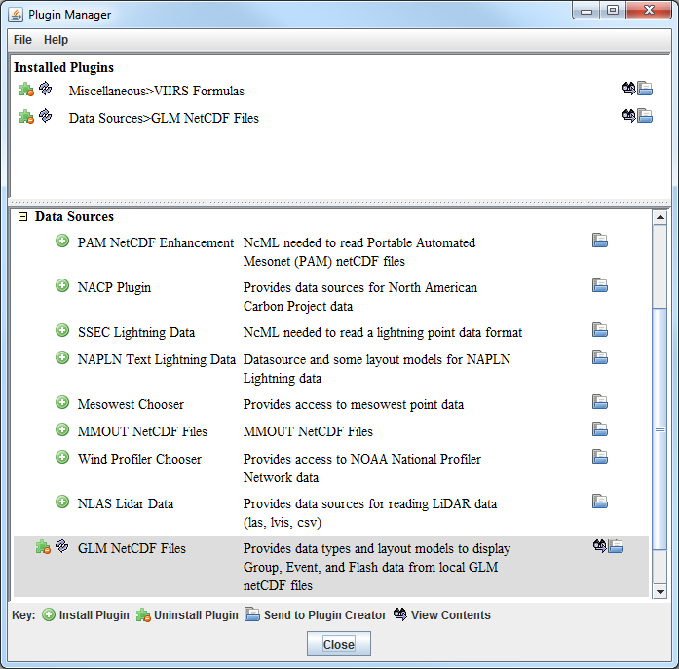This section of the tutorial uses a new Data Type through the ***General -> Files/Directories*** chooser as well as a new layout model which is must be added via a plugin. Add this plugin. 
   1. From the **Main Display** window, navigate to the ***Tools -> Plugins -> Manage*** menu item to open the **Plugin Manager**.
   2. The top of the **Plugin Manager** lists plugins currently installed, and the bottom panel lists the various plugins available for installation. Expand the ***Data Sources*** tree and click the green **Install Plugin** button next to ***GLM NetCDF Files***.
   3. This pops up a message notifying the user that McIDAS-V must be restarted to complete the installation of the plugin. Click **OK** through this message and restart McIDAS-V.
2. Display GOES-16 band 14 data.  
   1. From the ***General -> Files/Directories*** chooser, navigate to the *<local data>***/Data/GOES16/ABI** directory.
   2. Select the GOES16_CONUS* file.
   3. From the **Data Type** dropdown, select *Grid files (netCDF/GRIB/OPeNDAP/GEMPAK)*.
   4. Click **Add Source**.
   5. In the **Fields** panel of the ***Field Selector***, verify that ***brightness_temperature*** is selected.
   6. In the **Displays** panel of the ***Field Selector***, select ***Imagery -> Image Display***.
   7. Click **Create Display**.
3. Modify the display of the GOES-16 band 14 data.  
   1. To make the cold clouds white and the relatively warmer land darker, change the enhancement used by the displayed layer by *Right-Clicking* on the colorbar in the **Legend** and selecting ***System -> Inverse Gray Scale***.
   2. Disable the wireframe box around the display by selecting ***View -> Show -> Wireframe Box*** in the display panel.
   3. Other layers will be added to the display in the next several steps. To maintain the current projection, from the display panel, disable ***Projections -> Auto-Set Projection***.
4. Add a data source of six consecutive (2 minutes total) GLM files as group data.  
   1. From the ***General -> Files/Directories*** chooser, navigate to the *<local data>***/Data/GOES16/GLM** directory.
   2. Use *Shift+Left-Click* to select all six OR_GLM-L2-LFCA* files.
   3. From the **Data Type** dropdown, select *GLM Groups Data files*. This data type was added from the plugin that was installed in step 24 above.
   4. Click **Add Source**.
5. By default, each data point in each GLM file has its own timestep, which would create a loop of potentially thousands of frames. Bin all of the times together so each data point plots at the same timestep.  
   1. From the ***Field Selector***, *Right-Click* on the **6 Files** Data Source and choose ***Properties***.
   2. At the bottom of the ***Properties*** tab of this window, find the **Time Binning** section. Set the following using the dropdown menus:   
        
      **Bin Size**: *5 minutes*  
      **Round To**: *1 hour*  
        
      A bin size of 5 minutes is large enough to contain all of the data. The round to value of 1 hour sets this timestep to be right on the hour, 13Z, thus matching the time of the band 14 data displayed earlier.
   3. Click **OK** at the bottom of the **Properties** window.
6. Display the GLM data.  
   1. In the **Fields** panel of the ***Field Selector***, select ***Point Data***.
   2. In the **Displays** panel of the ***Field Selector***, choose the ***Point Data -> Point Data Plot*** display type.
   3. In the ***Layout Model*** subset tab, click the double-down blue arrows next to ***None*** and choose ***GLM -> Group***. This layout model was added from the plugin that was installed in step 24 above.
   4. Click **Create Display**.
7. Investigate and modify the display of GLM data. Note that the points of GLM data are parallax-corrected (from the data itself), so they may not perfectly match up with the location of the band 14 imagery, which is not parallax-corrected.  
   1. The pink plus signs in the display represent the GLM group data points. As you zoom in and out of the display, you’ll see the number of points change. This is because of decluttering that McIDAS-V does to the display. To modify the decluttering, *Left-Click* on the *6 files* data source in the **Legend** to get to the ***Layer Controls*** of the layer. Disable the **Declutter** checkbox to show every point. Another option would be leaving **Declutter** enabled (checked) and adjusting the **Density** slider. As the slider moves to the right, more points will be shown.
   2. If you wish to change the size of the plus signs in the display, adjust the **Scale** value in the ***Layer Controls***. Decreasing the value from 1 (for example, 0.5) will make the points smaller. Increasing the value from 1 (for example, 2) will make the points larger.
8. Add a data source of satellite derived winds.  
   1. From the ***General -> Files/Directories*** chooser, navigate to the *<local data>***/Data/GOES16/Derived Winds** directory.
   2. Select the OR_ABI-L2-DMWC* file.
   3. From the **Data Type** dropdown, select *netCDF/GEMPAK Point Data files*.
   4. Click **Add Source**.
9. Display the satellite derived winds.  
   1. In the **Fields** panel of the ***Field Selector***, choose the ***Point Data*** field.
   2. In the **Displays** panel of the ***Field Selector***, choose the ***Point Data -> Point Data Plot*** display type.
   3. A new layout model will be imported to plot the satellite derived winds colored by speed. To do this, go to the ***Layout Model*** subset tab of the ***Field Selector*** and choose ***Edit***.
   4. From the **Layout Model Editor** window, select ***File -> Import***.
   5. From the **Layout Model import** window, select the *<local data>***/Data/GOES16/G16_Winds.ism** file and click **Open**.
   6. From the **Layout Model Editor** window, select ***File -> Save*** and close the **Layout Model Editor**.
   7. From the ***Layout Model*** subset tab of the ***Field Selector***, click the double-down blue arrows next to ***None*** and choose ***G16_Winds <local>***.
   8. Click **Create Display**.
10. Investigate and modify the display of GOES-16 satellite derived winds using the same methods used in step 30 above with GLM data.

**JPSS Introduction**

McIDAS-V has the ability of displaying JPSS (Suomi NPP and NOAA-20) data through the ***Under Development -> Imagery – JPSS*** chooser. Among the JPSS products that McIDAS-V can display are data from the VIIRS (all bands of SVM and SVI, EDRs, Day/Night band), CrIS, and ATMS instruments. In order for the data to be recognized by McIDAS-V, the geolocation files must be contained within the same directory as the data. Some sources of data, including NOAA’s CLASS, package the data and geolocation files together by default. Other sources of JPSS data may store the geolocation in a separate file from the data. Note that this chooser is still under development and improvements in functionality as well as the ability to utilize different JPSS products will be added in the future.

**Installing the VIIRS Formulas Plugin**

1. 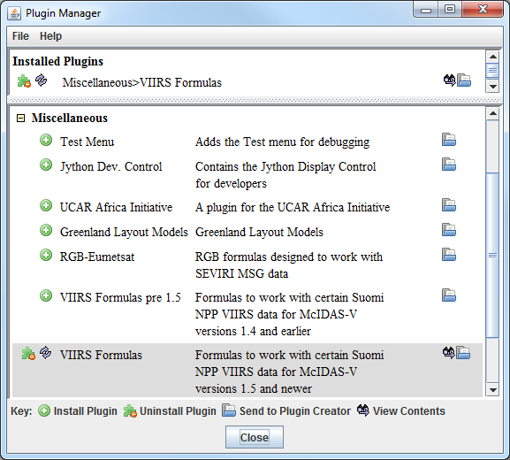This section of the tutorial uses two formulas specifically designed to work with VIIRS data. These formulas are not packaged as part of the core group of formulas in McIDAS-V, and must be added via a plugin. Add this plugin.  
   1. From the **Main Display** window, navigate to the ***Tools -> Plugins -> Manage*** menu item to open the **Plugin Manager**.
   2. The top of the **Plugin Manager** lists plugins currently installed, and the bottom panel lists the various plugins available for installation. Expand the ***Miscellaneous*** tree and click the green **Install Plugin** button next to ***VIIRS Formulas***.
   3. This pops up a message notifying the user that McIDAS-V must be restarted to complete the installation of the plugin. Click **OK** through this message and restart McIDAS-V.

**Display a Single Granule of NOAA-20 Data**

1. Load a single granule of NOAA-20 SVM03 VIIRS data.
2. In the ***Data Sources*** tab of the **Data Explorer**, select ***Under Development -> Imagery – JPSS***.
3. Under **Files**, select the following file:  
     
   *<local path>***/Data/ NOAA20/VIIRS/SVM03_j01_d20180513_t1814201\***  
     
   Note that the *<local path>***/Data/NOAA20/VIIRS** directory contains nine SVM data granules (three timesteps of three different bands). There are also three GMTCO* geolocation files (one for each timestep) that are in this directory, but are either not visible or grayed out through this ***Imagery – JPSS*** chooser.
4. Click **Add Source**.  
     
   Note that the first time a JPSS granule is added through this chooser, a **Plugin Compatibility Notice** window may appear letting users of the older version of the VIIRS Formulas plugin know that a new one is available. In step 34 above the most recent version of this plugin was installed. Click the *Do not show this message again* checkbox and click **OK**.
5. Display Radiance data at low resolution.
6. In the ***Field Selector*** tab of the **Data Explorer**, select the ***VIIRS-M3-SDR_All/Radiance*** field, and the ***Imagery -> Image Display*** display type.
7. Note that the ***Region*** tab in the ***Field Selector*** shows a preview image of the selected field.
8. Click **Create Display**.
9. Investigate the display and note that the resolution of the display is course, not the native 750 meter resolution of the data. This is because no subsetting of the data was done in the ***Region*** tab of the ***Field Selector***.
10. Display Radiance data at the full resolution of the data.
11. From the ***Region*** tab of the ***Field Selector***, use *Shift+Left-Click+Drag* to draw a green box in the data. Any data contained within this box will be displayed at full resolution. Note that the entire box must be contained within the granule’s data.
12. Click **Create Display**.
13. Investigate the display and note that the resolution of the data has improved. However, note that the bowtie deletion lines still exist on the east and west edges of the granule.
14. Use the swathToGrid formula to display the Radiance data at full resolution with the bowtie deletion lines removed.
15. In the ***Field Selector*** tab of the **Data Explorer** select **Formulas**.
16. Choose the ***swathToGrid*** formula, the ***Imagery -> Imagery Display*** display type, and click **Create Display**. Note that this formula was added as part of the plugin installed in step 34 above.
17. In the **Select input** window, enter a value of *750* for **resolution in meters** and click **OK**.
18. In the **Field Selector** window, select the ***VIIRS* -> Image -> VIIRS-M3-SDR_All/Radiance*** field.
19. Wait for the ***Region*** tab to appear at the bottom of the **Field Selector** window showing a preview image of the granule and click **OK**.
20. Investigate the display and notice that the data is now displayed at full resolution with the bowtie deletion lines removed.
21. When you are done investigating the display, remove all layers and data sources.

**Create a RGB Display with Aggregated Granules**

McIDAS-V has the ability to aggregate several small granules into one large one by selecting multiple time-consecutive granules in the ***Data Sources*** tab of the **Data Explorer** before clicking **Add Source**. Multiple bands can also be included in the same data source if the times match up between the bands.

1. Create a data source of three time-consecutive granules of three visible SVM bands.
2. In the ***Data Sources*** tab of the **Data Explorer**, select ***Under Development -> Imagery – JPSS***.
3. Use *Shift+Left-Click* to select all of the SVM* data files.
4. Click **Add Source**.
5. From the ***Field Selector*** tab of the **Data Explorer**, notice that all three bands (SVM03, SVM04, and SVM05) are included in the list in the **Fields** panel.
6. Use the VIIRS_M_RGB(M5, M4, M3) formula to create a RGB display from the data source.
7. Add a new one-paneled map display by selecting ***File -> New Display Tab -> Map Display -> One Panel*** menu item. Close any previously-existing tabs.
8. In the ***Field Selector*** tab of the **Data Explorer**, select **Formulas**.
9. Choose the ***VIIRS_M_RGB(M5, M4, M3)*** formula, the ***RGB Composite*** display type, and click **Create Display**.
10. In the **Field Selector** window, select the following:  
    * 1. **Field M5: *VIIRS 2018-05-13 18:11:28 GMT -> Image -> VIIRS-M5-SDR_All/Radiance***.  
           
         Once the ***Region*** tab appears, use *Shift+Left-Click+Drag* to draw a bounding box within the bounds of the data. This subsetting step only has to be done for this field (the Red component of the formula) since this domain will be carried over to the Green and Blue fields. Make sure that the subsetted area includes land, water, and data near the east and/or west edges of the granule to include the bowtie deletion regions.
      2. **Field M4: *VIIRS 2018-05-13 18:11:28 GMT -> Image -> VIIRS-M4_SDR_All/Radiance***.
      3. **Field M3: *VIIRS 2018-05-13 18:11:28 GMT -> Image -> VIIRS-M3_SDR_All/Radiance***.
11. Once all three ***Region*** subset tabs are visible, click **OK** at the bottom of the **Field Selector** window.
12. Investigate and brighten the display to make it easier to interpret.
13. From the **Main Display** window, notice that the display looks mainly black and white, though the bowtie deletion lines have been removed and the data is at full (750 meter) resolution.
14. Click on the blue *RGB Composite* text in the **Legend** of the **Main Display** to get to the ***Layer Controls*** tab of the **Data Explorer**.
15. The intensities of the red, green, and blue colors are controlled by their Gamma values. Adjust all three colors to have a Gamma value of 0.4 by typing *0.4* into the **Common Gamma** field of the ***Layer Controls*** and click **Apply to All Gamma Fields**.
16. Go back to the **Main Display** and notice how the red, green, and blue colors are now more intense and you can see green and brown over the land and blue over areas of water.
17. By default, a wireframe box is drawn in the **Main Display**. This is the white box going around and partially through the data. Disable the wireframe box by unselecting ***View -> Show -> Wireframe Box*** from the panel in the **Main Display** window.
18. When you are done investigating the display, remove all layers and data sources.

Note that this formula suggests the user selects SVM05 for Red, SVM04 for Green, and SVM03 for Blue to create a true color RGB display. However, any bands can be used to create different types of RGB displays.

**Using CrIS Data in McIDAS-V**

This section utilizes CrIS data from NOAA-20. The *<local path>***/Data/NOAA20/CrIS** directory contains SCRIS data files and GCRSO geolocation files. Only the SCRIS data files will be listed in the ***Imagery – JPSS*** chooser.

1. Create a data source of nine time-consecutive granules of SCRIS data.
2. In the ***Data Sources*** tab of the **Data Explorer**, select ***Under Development -> Imagery – JPSS***.
3. In the **Files** panel, navigate to the *<local path>***/Data/NOAA20/CrIS** directory.
4. Use *Shift+Left-Click* to select all of the SCRIS* data files.
5. Click **Add Source**.
6. Display the data and investigate the display.
7. Add a new one-paneled map display by selecting ***File -> New Display Tab -> Map Display -> One Panel*** menu item. Close any previously-existing tabs.
8. In the **Fields** panel of the ***Field Selector***, verify that the ***CrIS-SDR_All/ES_RealLW*** field is selected.
9. In the **Displays** panel of the ***Field Selector***, select the ***Imagery -> MultiSpectral Display*** display type.
10. Click **Create Display**.
11. This display type creates a grayscale display in the **Main Display** window along with two data probes (originally stacked on top of each other), as well as a spectra in the ***Layer Controls***. Move the probes around in the **Main Display** window by using *Left-Click+Drag* to place one probe over a cloud and one over cloud-free land. Compare the spectras in the ***Layer Controls***.
12. From the ***Layer Controls*** tab of the **Data Explorer**, use *Left-Click+Drag* to move the green selector line to a new wavenumber value. Notice that the grayscale display in the **Main Display** window updates itself to reflect the new wavenumber.
13. When you are done investigating the display, remove all layers and data sources.

**Using ATMS Data in McIDAS-V**

This section utilizes ATMS data from NOAA-20. The *<local path>***/Data/NOAA20/ATMS** directory contains SATMS data files and GATMO geolocation files. Only the SATMS data files will be listed in the ***Imagery – JPSS*** chooser.

1. Create a data source of eight time-consecutive granules of SATMS data.  
   1. In the ***Data Sources*** tab of the **Data Explorer**, select ***Under Development -> Imagery – JPSS***.
   2. In the **Files** panel, navigate to the *<local path>***/Data/NOAA20/ATMS** directory.
   3. Use *Shift+Left-Click* to select all of the SATMS* data files.
   4. Click **Add Source**.
2. Display the data and investigate the display.  
   1. Add a new one-paneled map display by selecting ***File -> New Display Tab -> Map Display -> One Panel*** menu item. Close any previously-existing tabs.
   2. In the **Fields** panel of the ***Field Selector***, select ***MultiSpectral -> ATMS-SDR_All/BrightnessTemperature***.
   3. In the **Displays** panel of the ***Field Selector***, select the ***Imagery -> MultiSpectral Display*** display type.
   4. Click **Create Display**.
   5. Investigate the display as done in steps 43e and 43f above. One difference is this ATMS data uses channel numbers instead of wavenumbers. Notice how the longer wavelengths make areas with more precipitation stand out over Iowa and the Atlantic Ocean.

**Using Day/Night Band Data in McIDAS-V**

This section utilizes VIIRS Day/Night band data from Suomi NPP. This data, ordered from NOAA CLASS, packages the data (SVDNB) and geolocation (GDNBO) into the same file. Each file includes several small granules aggregated together to cover a relatively large geographical area.

1. Remove all layers and data sources from any previous displays via the ***Edit -> Remove -> All Layers and Data Sources*** menu item from the **Main Display**.
2. Add a new one-paneled map display by selecting ***File -> New Display Tab -> Map Display -> One Panel*** menu item. Close any previously-existing tabs.
3. Create a data source of the two time-consecutive files of GDNBO-SVDNB* files.  
   1. In the ***Data Sources*** tab of the **Data Explorer**, select ***Under Development -> Imagery – JPSS***.
   2. In the **Files** panel, navigate to the *<local path>***/Data/SuomiNPP** directory.
   3. Use *Shift+Left-Click* to select both of the GDNBO-SVDNB* files.
   4. Click **Add Source**.
4. Display the data and investigate the display.  
   1. 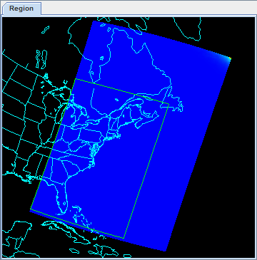In the **Fields** panel of the ***Field Selector***, select ***IMAGE -> VIIRS-DNB-SDR_All/Radiance***.
   2. In the **Displays** panel of the ***Field Selector***, select the ***Imagery -> Image Display*** display type.
   3. In the ***Region*** tab of the ***Field Selector***, use *Shift+Left-Click+Drag* to draw a green bounding contained entirely within the data over the eastern United States extending into the Atlantic (similar to this image). Any data in this bounding box will be displayed at the full resolution of the data.
   4. Click **Create Display**.
5. Investigate the display.  
   1. In the **Main Display** window, you will likely notice that no data is visible. This is due to the enhancement range values being set based on the minimum and maximum values contained in the data. Adjust the enhancement by *Right-Clicking* on the enhancement in the **Legend** and choosing ***Change Range…***.
   2. In the **Change Range** window, enter **From** and **To** values that better match up with the radiance values contained in the display. For example, you can use values of:  
        
      **From:** *8.8E-10*  
      **To:** *1.9E-8*
   3. This is near full-moon scene, which allows for a display similar to a daytime visible image to be viewed. Other features, such as city lights and ships can be viewed in this scene. The range set in step 50b can be expanded or contracted on either end to make different features easier to see.

**Problem Sets**

The previous examples were intended to give you a general knowledge of how to load and display JPSS data.  The problem sets below are intended to introduce you to new topics related to the data, as well as challenge your knowledge of McIDAS-V.  We recommend that you attempt to complete each problem set before looking at the solutions, which are provided below the problem set.  
  
Note that this example utilizes Suomi NPP data from NOAA CLASS. The files contain both the data and geolocation in the same file. Also, several small granules are aggregated together into one file, so a relatively large geographic domain is covered by a single file.

1. Using the *<local path>***/Data/SuomiNPP/GMODO-SVM03-SVM04-SVM05\*** file, create an RGB image using the Reflectance field of all three bands. Create the display by using the **VIIRS_M_RGB(M5,M4,M3)** formula. Display the data at full-resolution and make sure to include a large portion of the granule in your subsetted region. Adjust the **Common Gamma** field in the ***Layer Controls*** to make the individual colors stand out more in the display.
2. Looking at the display over the Great Lakes, it is difficult to discern between clouds and snow over the land. Using the file loaded from question 1, display SVM14 brightness temperature data with the **swathToGrid** formula over the Great Lakes region. Adjust the enhancement to make the clouds display as white instead of black. Overlay this display on the RGB image created in problem 1. This longwave infrared band is useful to distinguish between clouds and snow.
3. Looking at the RGB display over Louisiana, smoke can be observed. Using the file loaded from question 1, display SVM13 brightness temperature data with the **swathToGrid** formula over Louisiana. Overlay this display on the RGB image created in problem 1. This medium-wave infrared band is useful to detect fire activity.
4. Determine the smoke concentration from the Louisiana fire using the <*local path*>/**Data/SuomiNPP /GMTCO-VSUMO\*** VIIRS suspended matter EDR data. Overlay this display on the RGB image created in problem 1.

**Problem Set #1 – Solution**

Using the *<local path>***/Data/SuomiNPP/GMODO-SVM03-SVM04-SVM05\*** file, create an RGB image using the Reflectance field of all three bands. Create the display by using the **VIIRS_M_RGB(M5,M4,M3)** formula. Display the data at full-resolution and make sure to include a large portion of the granule in your subsetted region. Adjust the **Common Gamma** field in the ***Layer Controls*** to make the individual colors stand out more in the display.

1. Remove all layers and data sources from the previous displays.
2. Select ***File -> New Display Tab -> Map Display -> One Panel*** to create a new one-panel map display tab.
3. Load in a granule containing three bands of VIIRS SVM visible data (SVM03, SVM04 and SVM05).  
   1. In the ***Data Sources*** tab of the **Data Explorer**, select ***Under Development******>******Imagery – Suomi NPP***
   2. Select *<local path>***/Data/SuomiNPP/GMODO-SVM03-SVM04-SVM05_npp\***

**(**Note: this file packages the geolocation (GMODO) and the data (SVM*) together into the same file.)

* 1. Click the **Add Source** button.

1. Use theVIIRS formula to create a true-color RGB image with the bowtie effect removed.  
   1. In the ***Field Selector*** tab, under **Data Sources** select **Formulas**.
   2. Under **Fields**, select the **VIIRS_M_RGB(M5,M4,M3)** formula. Click **Create Display**.
   3. In the new **Field Selector** window, select:

* 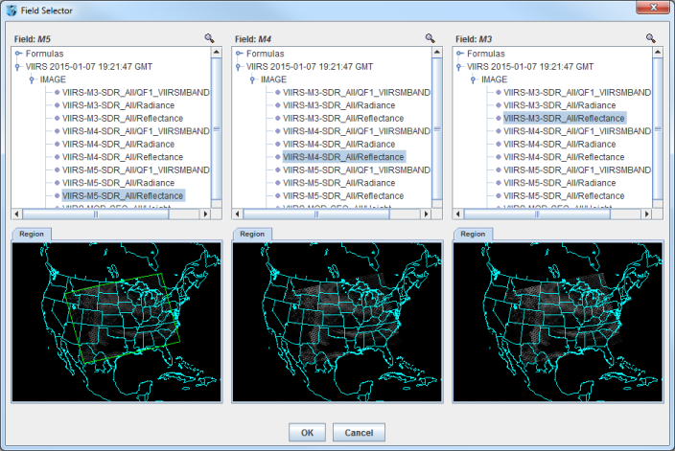For **Field: M5**, select ***VIIRS -> IMAGE -> VIIRS-M5-SDR_All/Reflectance***
* For **Field: M4**, select ***VIIRS -> IMAGE -> VIIRS-M4-SDR_All/Reflectance***
* For **Field: M3**, select ***VIIRS -> IMAGE -> VIIRS-M3-SDR_All/Reflectance***
  1. In the **Region** tab of **Field: M5**, use *Shift+Left-Click+Drag* to select a region to display at full-resolution. Select a region that contains most of the granule, as shown in the image above. It is not necessary to subset a region in for **M4** and **M3**, as the region selected for **M5** will be used for all fields.
  2. Click **OK** to display the results of the **VIIRS_M_RGB(M5,M4,M3)** formula.

1. Adjust the display to enhance the Red, Green, and Blue components of the display.  
   1. Navigate to the ***Layer Controls*** tab of the **Data Explorer**. By default, all **Gamma** values for all colors are set to 1.0. Change this value to 0.4 by entering in *0.4* in the **Common Gamma** field and clicking the **Apply to All Gamma Fields** button.
   2. Return to the **Main Display** window to observe the RGB display and also notice that the bowtie effect has been removed by the formula.

**Problem Set #2 – Solution**

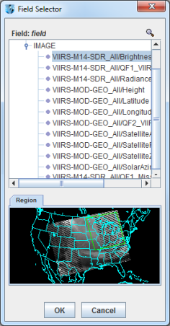Looking at the display over the Great Lakes, it is difficult to discern between clouds and snow over the land. Using the file loaded from question 1, display SVM14 brightness temperature data with the **swathToGrid** formula over the Great Lakes region. Adjust the enhancement to make the clouds display as white instead of black. Overlay this display on the RGB image created in problem 1. This longwave infrared band is useful to distinguish between clouds and snow.

1. Use the **swathToGrid** formula to create a full-resolution display of the data without the bowtie effect.  
   1. In the ***Field Selector*** tab, under **Data Sources** select **Formulas**.
   2. Under **Fields**, select the **swathToGrid** formula. Under **Displays**, select ***Imagery > Image Display***. Click **Create Display**.
   3. In the new **Select input** window, enter *750* for **res** and *1.0* for **mode**. Click **OK**.
   4. In the **Field Selector**, select ***VIIRS* -> IMAGE -> VIIRS-M14-SDR_All/BrightnessTemperature***.
   5. In the **Region** tab, use *Shift+Left-Click+Drag* to select a region over the Great Lakes (as seen in the image on the right) to display at full-resolution.
   6. Click **OK** to display the result of the **swathToGrid** formula.
2. Adjust the display to make the clouds over the Great Lakes appear as white instead of black and investigate the display.  
   1. Change the colorbar to Inverse Gray Scale. To do this, *Right-Click* on the colorbar in the **Legend** and select ***System -> Inverse Gray Scale***. This is done to make the lower data values (colder temperatures, such as clouds) display as white, while warmer temperatures are darker.
   2. Use the visibility checkbox in the **Legend** to toggle the SVM14 layer on and off to compare with the RGB display underneath. The temperature difference between clouds and snow in this infrared band allows the clouds to stand out more than they do in the visible bands used in the RGB display.

**Problem Set #3 – Solution**

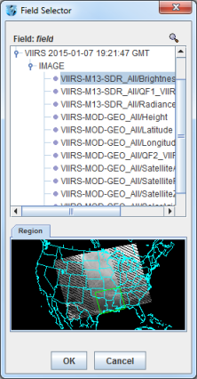Looking at the RGB display over Louisiana, smoke can be observed. Using the file loaded from question 1, display SVM13 brightness temperature data with the **swathToGrid** formula over Louisiana. Overlay this display on the RGB image created in problem 1. This medium-wave infrared band is useful to detect fire activity.

1. Use the **swathToGrid** formula to create a full-resolution display of the data without the bowtie deletion.  
   1. In the ***Field Selector*** tab, select **Formulas** under **Data Sources**.
   2. Under **Fields**, select the **swathToGrid** formula. Under **Displays**, select ***Imagery -> Image Display***. Click **Create Display**.
   3. In the new **Select input** window, enter *750* for **res** and *1.0* for **mode**. Click **OK**.
   4. In the **Field Selector** window, select ***VIIRS* -> IMAGE -> VIIRS-M13-SDR_All/BrightnessTemperature***.

In the **Region** tab, use *Shift+Left-Click+Drag* to select a region over Louisiana to display at full-resolution. Click **OK** to display the result of the **swathToGrid** formula.

1. Use the visibility checkbox in the **Legend** to toggle the SVM13 layer on and off to compare with the RGB display underneath.

**Problem Set #4 – Solution**

Determine the smoke concentration from the Louisiana fire using the <*local path*>/**Data/SuomiNPP /GMTCO-VSUMO\*** VIIRS suspended matter EDR data. Overlay this display on the RGB image created in problem 1.

1. In the ***Data Sources*** tab of the **Data Explorer**, navigate to the ***Under Development*** *-****>******Imagery -> Suomi NPP*** chooser.  
   1. Under **Files**, select the following file:  
      *<local path>***/Data/SuomiNPP/GMTCO-VSUMO\***
   2. Click the **Add Source** button.
2. Display the smoke concentration from the EDR data.  
   1. In the **Fields** panel of the **Field Selector**, select:  
      ***Image -> VIIRS-SusMat-EDR_/All/SmokeConcentration*** field.
   2. Select ***Imagery -> Image Display*** in the **Displays** panel of the ***Field Selector***.
   3. In the ***Region*** tab of the ***Field Selector***, use *Shift+Left-Click+Drag* to subset a region over Louisiana. Anything within this subsetted region will display at the full resolution of the data.
   4. Click **Create Display**.
3. Investigate the smoke concentration from the Louisiana fire.  
   1. In the **Legend** of the **Main Display**, toggle off the visibilities of the SVM13 and SVM14 data so only the RGB and the VIIRS EDR data is displayed.
   2. Navigate over the fire in Louisiana and toggle the VIIRS EDR layer on and off with the visibility checkbox in the **Legend**.

**Zooming, Panning, and Rotating Controls**

|  |  |  |
| --- | --- | --- |
| **Zooming** | **Panning** | **Rotating** |
|  | **Mouse** |  |
| **Shift-Left Drag:** Select a region by pressing the ***Shift*** key and dragging the left mouse button. **Shift-Right Drag:** Hold ***Shift*** key and drag the right mouse button. Moving up zooms in, moving down zooms out. | **Control-Right Mouse Drag:** Hold ***Control*** key and drag right mouse to pan. | **Right Mouse Drag:** Drag right mouse to rotate. |
|  | **Scroll Wheel** |  |
| **Scroll Wheel-Up:** Zoom Out. **Scroll Wheel-Down:** Zoom In. |  | **Control-Scroll Wheel-Up/Down:** Rotate clockwise/counter clockwise. **Shift-Scroll Wheel-Up/Down:** Rotate forward/backward clockwise. |
|  | **Arrow Keys** |  |
| **Shift-Up:** Zoom In. **Shift-Down:** Zoom Out. | **Control-Up arrow:** Pan Down. **Control-Down arrow:** Pan Up. **Control-Right arrow:** Pan Left. **Control-Left arrow**: Pan Right. | **Left/Right arrow:** Rotate around vertical axis. **Up/Down arrow:** Rotate around horizontal axis. **Shift-Left/Right arrow:** Rotate Clockwise/Counterclockwise. |