McIDAS-V Tutorial

Displaying Point Observations from ADDE Datasets

updated September 2015 (software version 1.5)

McIDAS-V is a free, open source, visualization and data analysis software package that is the next generation in SSEC's 40-year history of sophisticated McIDAS software packages. McIDAS-V displays weather satellite (including hyperspectral) and other geophysical data in 2- and 3-dimensions. McIDAS-V can also analyze and manipulate the data with its powerful mathematical functions. McIDAS-V is built on SSEC's VisAD and Unidata's IDV libraries. The functionality of SSEC's HYDRA software package is also being integrated into McIDAS-V for viewing and analyzing hyperspectral satellite data.

More training materials are available on the McIDAS-V webpage and in the Getting Started chapter of the McIDAS-V User’s Guide, which is available from the Help menu within McIDAS-V. You will be notified at the startup of McIDAS-V when new versions are available on the McIDAS-V webpage - <http://www.ssec.wisc.edu/mcidas/software/v/>.

If you encounter an error or would like to request an enhancement, please post it to the McIDAS-V Support Forums - <http://www.ssec.wisc.edu/mcidas/forums/>. The forums also provide the opportunity to share information with other users.

This tutorial assumes that you have McIDAS-V installed on your machine, and that you know how to start McIDAS-V. If you cannot start McIDAS-V on your machine, you should follow the instructions in the document entitled *McIDAS-V Tutorial – Installation and Introduction*.

In this McIDAS-V Tutorial, most exercises will use real-time access to default remote servers. You must have internet access to complete this lesson. If you have access to your own real-time servers, you may also use those, but be aware that different server configurations may make the explanations in this document not quite applicable to all data that you may load.

Terminology

There are two windows displayed when McIDAS-V first starts, the **McIDAS-V Main Display** (hereafter **Main Display**) and the **McIDAS-V Data Explorer** (hereafter **Data Explorer**).

The **Data Explorer** contains three tabs that appear in bold italics throughout this document: ***Data Sources*, *Field Selector***, and ***Layer Controls***. Data is selected in the ***Data Sources*** tab, loaded into the ***Field Selector***, displayed in the **Main Display**, and output is formatted in the ***Layer Controls***.

Menu trees will be listed as a series (e.g. ***Edit -> Remove -> All Layers and Data Sources***).  
  
Mouse clicks will be listed as combinations (e.g. *Shift+Left Click+Drag*).

**Plotting and Contouring Surface Point Observations around the world**

1. Remove all layers and data sources from the previous displays. If you have created more than one tab, close the extra tabs by clicking on the “X” in the right corner of the tabs.
2. From the ***Data Sources*** tab of the **Data Explorer**, select the ***Point Observations -> Plot/Contour*** chooser.
   1. Connect to *adde.ssec.wisc.edu* **Server** with the *RTPTSRC* **Dataset**.
   2. Choose the *SFCHOURLY - Real-Time SFC Hourly* **Point Type**.
   3. Select the most recent time and click **Add Source**.
   4. In the ***Field Selector***, select ***Point Data*** in the **Fields** panel.
   5. Select the ***Point Data -> Point Data Plot*** display type.
   6. In the lower**-**right panel, click the ***Layout Model*** tab and click the double down blue arrows next to METAR to select ***Observations -> Temperature*** to plot all available temperatures.
   7. Click **Create Display**. The default display is a world projection with temperatures plotted from around the world. As you zoom in you will see more stations appear in the plot.
3. Reset the display projection using the Reset Display Projection button on the left side of the **Main Display** or through the ***Projections -> From Displays*** menu item.



1. Return to the ***Data Sources*** tab of the **Data Explorer** and select the ***Satellite -> Imagery*** chooser.
   1. Connect to the *adde.ssec.wisc.edu* **Server** with the *RTIMAGES* **Dataset**.
   2. Select an **Image Type** of *GE-VIS - GOES-East 0.63 um Visible*.
   3. Select the most recentimage and add the source.
   4. In the ***Field Selector***tab, expand the ***0.63 um*** field, and select ***Brightness***.
   5. Select the ***Imagery -> Image Display*** display type. Click **Create Display**.
2. To contour the temperatures plotted on the screen, return to the ***Field Selector***.
   1. Select *SFCHOURLY* in the **Data Sources** panel.
   2. In the **Fields** panel, select ***Gridded Fields -> T***.
   3. Select ***Plan Views -> Contour Plan View*** in the list of displays, and click **Create Display**. The contour properties can be changed in the ***Layer Controls*** tab of the Data Explorer.

* Note that these contours are drawn from surface observations, which are recorded over land, not water. Therefore, contours will look better if you zoom in over a land area in the **Main Display**.

**Creating Time Series of Point Observations**

1. Remove all layers and data sources.
2. Return to ***Point Observations -> Plot/Contour*** chooser in the ***Data Sources*** tab. Use the *adde.ssec.wisc.edu* **Server**, the *RTPTSRC* **Dataset**, and the *SFCHOURLY* **Point Type**.
3. Select a group of times from the ***Absolute*** time tab (to select more than one time, use *Shift+Click*), and click **Add Source**.
4. Select ***Point Data***in the **Fields** panel and click **Create Display** to plot the default station models.
5. In the ***Layer Controls***, follow these steps:
6. Click on the ***Plot*** tab to create a time series.
7. Zoom in over a station in the **Main Display** and *Left Click* on the center of it. The station information should fill into the table below the plot in the ***Layer Controls***.
8. Add the temperature to the plot by *Right Clicking* on the **T** field in the table and selecting **Add To Chart**.

**Displaying RAOB Sounding Data**

1. Remove all layers and data sources.
2. For local data, select the ***Point Observations -> Soundings -> Local*** chooser in the ***Data Sources*** tab.   
   1. Under **File**, click **Select File**. Change **Files of Type** to ‘*All Files*’, and select the *<local path>***/Data/Point_ADDE/20090903_1200-raob.nc** file. Click **Open**.
   2. Skip to step 12, or continue to step 11 to use remote data.
3. For remote data, select the ***Point Observations -> Soundings -> Remote*** chooser in the ***Data Sources*** tab.   
   1. Connect to the *adde.ssec.wisc.edu* **Server** with the *RTPTSRC* **Dataset**.
   2. Select *UPPERMAND* for the Mandatory Levels and *UPPERSIG* for the Optional Significant Levels.
4. Select a station for your sounding display.
   1. Use the zooming and panning buttons to find your station(s).
   2. Select an available time and click on your station to see if a sounding is available. Available soundings will show up in the *Selected* box on the bottom right of the chooser.
   3. If more than one is available for your station, select the most recent time and add the source.
   4. Under the **Displays** panel of the ***Field Selector***, you have the option to choose which type of thermodynamic diagram to display (Skew-T, Stuve, Emagram).
   5. Select one of the thermodynamic diagrams and click **Create Display**.
5. The sounding will show up in a 2D display in the ***Layer Controls*** tab along with a list of thermodynamic parameters. As you move the mouse over the sounding, the thermodynamic parameters will update.

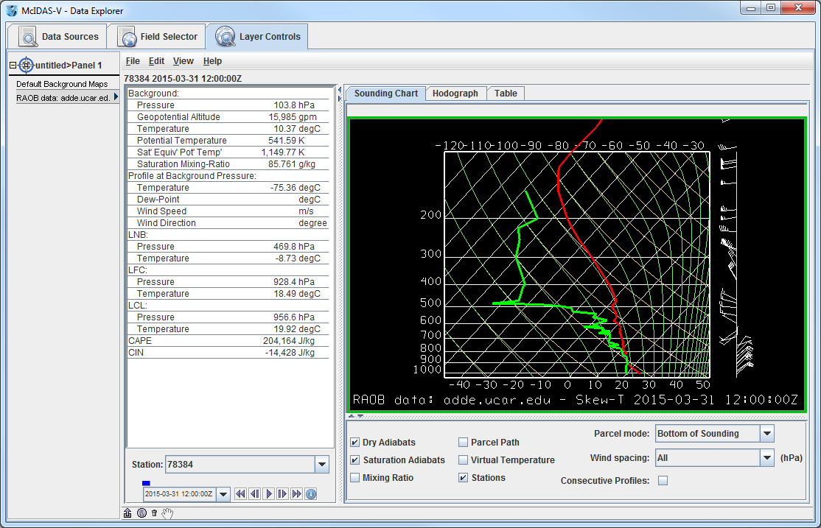

1. The temperature and dewpoint traces can be modified via the cursor.
   1. *Left Click* on the first data-point to be modified and drag it horizontally along an isobar to the desired position, then move the pointer diagonally along an isotherm to keep the data-point at the desired position and to pick-up the next data-point.
   2. Repeat until done and then release the mouse button.
   3. To reset the sounding, use the ***Edit -> Reset Sounding*** menu item of the ***Layer Controls*** tab.
   4. Use the checkboxes below the sounding to configure the sounding chart. When the **Stations** box is checked, you will see a square box in the **Main Display** indicating the location of each sounding selected in the ***Data Sources*** tab. Select a new station by *Left Clicking* another square box in the **Main Display**, or by choosing a station in the **Station** dropdown menu in the ***Layer Controls***.
   5. In the ***Layer Controls***, in addition to the ***Sounding Chart***, there are also tabs for a ***Hodograph***, and a ***Table*** of all of the data in the sounding.

**Problem Sets**

The previous examples were intended to give you a general knowledge of how to load and display surface point data.  The problem sets below are intended to introduce you to new topics related to the data, as well as challenge your knowledge of McIDAS-V.  We recommend that you attempt to complete each problem set before looking at the solutions, which are provided below the problem set.

1. Create a time series of surface Temperature, Dewpoint Temperature and Wind Barbs for the last 24 hours over Chicago (KORD). Change the Temperature and Dewpoint Temperature axes in the plot so they have the same range. Look at the current zone forecast for Chicago to check the accuracy of the forecast for today. (Hint: Weather text products can be found under ***Tools -> Text Data***)
2. Modify the chart from problem #1 so you have three separate charts: Place Wind Barbs and Gusts in the top left chart, Pressure in the top right chart, and Temperature and Dewpoint Temperature in the bottom chart (Hint: Change the chart names to separate out parameters!)
3. Create your own station model layout that displays the Dewpoint Depression in green over the center of the station with the station ID below the Dewpoint Depression, the Temperature to the upper left, and Dewpoint Temperature to the upper right. Display the most recent observations using the new layout.

**Problem Set #1 – Solution**

Create a time series of surface Temperature, Dewpoint Temperature and Wind Barbs for the last 24 hours over Chicago (KORD). Change the Temperature and Dewpoint Temperature axes in the plot so they have the same range. Look at the current zone forecast for Chicago to check the accuracy of the forecast for today. (Hint: Weather text products can be found under ***Tools -> Text Data***).

1. Remove all layers and data sources from the previous display.
2. Return to the ***Point Observations -> Plot/Contour*** chooser in the ***Data Sources*** tab. Connect to the *adde.ssec.wisc.edu* **Server** with the *RTPTSRC* **Dataset**. Select the *SFCHOURLY – Real-Time SFC Hourly* **Point Type** and the 24 most recent times with the interval set to Hourly. Click **Add Source**.
3. Select the ***Point Data*** field, and the ***Point Data -> Point Data Plot*** display type. Click **Create Display**.
4. In the **Main Display**, use the ***Zooming and Panning*** controls to zoom in over Chicago, and *Left Click* on the Chicago O’Hare International station (KORD).
5. In the ***Layer Controls***, click on the ***Plot*** tab, and at the bottom, scroll down through the list of fields until you find temperature (T).
6. *Right Click* on **T** and select **Add to Chart**, and repeat for dewpoint temperature (**TD**).
7. To add wind barbs, add speed (SPD) and direction (DIR) to the chart. When both of these parameters are added, they are converted into wind barbs.
8. *Right Click* on the table of fields and select ***T -> Chart Properties***.
   1. For the **Range** property, enter in a Min and Max value appropriate for both temperature and dewpoint temperature. Click **OK**.
9. *Right Click* on the table of fields and select ***TD -> Chart Properties***.
   1. To the right of the **Range** property, there is a **...** button. Click on this button and select “Fixed Range from: T...” (with the range values set in step 8a), and click **OK**.
10. Open up the Weather Text Product Display by selecting the ***Tools -> Text Data -> Weather Text Products (from server)*** menu item in the **Main Display**.
    1. In the ***Products*** tab, open the ***Public Products -> Zone Forecasts***.
    2. In the **Main Display** window, zoom in over Illinois and click on KLOT. The zone forecast for KLOT, including Chicago will now be shown in the weather text product window.
    3. At the bottom of the **Weather Text Product Display** window, open the **Time Covered** menu item and select *24 Hours****.*** This will add in zone forecasts created over the last 24 hours, which can be controlled through the Time Animation Controls. Check to see if forecasted temperatures were verified by the data plotted in the chart in the ***Layer Controls***.

**Problem Set #2 – Solution**

Modify the chart from problem #1 so you have three separate charts: Place Wind Barbs and Gusts in the top left chart, Pressure in the top right chart, and Temperature and Dewpoint Temperature in the bottom chart (Hint: Change the chart names to separate out parameters!).

1. Return to the temperature chart properties by *Right-Clicking* on the table of fields and selecting ***T -> Chart Properties***.
   1. Enter in “*Temperature*” in the **Chart Name** field.
   2. Click **OK**. The temperature plot should appear in a new chart below the current plot titled “Plot”.
2. Repeat this step for dewpoint temperature and place it in the “*Temperature*” plot.
3. Add wind gusts (**GUS**) and pressure (**PSL**) to the charts and place pressure in a separate chart titled “*Pressure*”.
4. Add speed (**SPD**) and direction (**DIR**) to the “*Plot*” plot.
5. Select ***View -> Chart -> Layout -> Change Grid Layout*** menu item in the ***Layer Controls***.
   1. Expand the **Edit Chart Layout** window by clicking and dragging on the corner of the window.
   2. Use the **Columns** and **Rows** buttons to add/remove columns and rows.
   3. *Left-Click+Drag* on a chart to move it to a different location.
   4. Use the black squares around the individual charts to control their width and length.

**Problem Set #3 – Solution**

Create your own station model layout that displays the Dewpoint Depression in green over the center of the station with the station ID below the Dewpoint Depression, the Temperature to the upper left, and Dewpoint Temperature to the upper right. Display the most recent observations using the new layout.

* 1. Remove all layers.
  2. In the **Main Display**, select the ***Tools -> Station Model Template*** menu item.
  3. In the editor, select ***File -> New*** and enter in “*Dewpoint Depression*” for the name of the layout.
  4. Click on “123 Value” and click in the middle of the layout. The **Properties Dialog** box will pop up.
  5. In the **Parameter** field, enter in: *=T-TD*
  6. Change the **Foreground Color** to *green*, and click **OK**.
  7. Add a Temperature and Dewpoint Temperature values in the appropriate locations. Do this by clicking the “123 Value” and clicking on the appropriate location on the layout. Enter *T* as the **Parameter**. Do the same for dewpoint temperature, with *TD* as the **Parameter**.
  8. Click on “Text” and click below the dewpoint depression. In the **Parameter** field, enter: *ID*
  9. In the editor select ***File -> Save*** and then close the window.
  10. Load the most recent surface hourly data into the ***Field Selector***.

1. In the ***Field Selector*** tab of the **Data Explorer**, select the **SFCHOURLY** Data Source.
2. In the **Fields** panel, select ***Point Data***, with the ***Point Data -> Point Data Plot*** display type.
3. In the ***Times*** tab, use the dropdown menu to select *Use Selected* and choose the most recent time.
4. In the ***Layout Model*** tab in the lower right corner, change the model to “***Dewpoint Depression <local>***”. Click **Create Display**.

**Zooming, Panning, and Rotating Controls**

|  |  |  |
| --- | --- | --- |
| **Zooming** | **Panning** | **Rotating** |
|  | **Mouse** |  |
| **Shift-Left Drag:** Select a region by pressing the ***Shift*** key and dragging the left mouse button.  **Shift-Right Drag:** Hold ***Shift*** key and drag the right mouse button. Moving up zooms in, moving down zooms out. | **Control-Right Mouse Drag:** Hold ***Control*** key and drag right mouse to pan. | **Right Mouse Drag:** Drag right mouse to rotate. |
|  | **Scroll Wheel** |  |
| **Scroll Wheel-Up:** Zoom Out.  **Scroll Wheel-Down:** Zoom In. |  | **Control-Scroll Wheel-Up/Down:** Rotate clockwise/counter clockwise.  **Shift-Scroll Wheel-Up/Down:** Rotate forward/backward clockwise. |
|  | **Arrow Keys** |  |
| **Shift-Up:** Zoom In.  **Shift-Down:** Zoom Out. | **Control-Up arrow:** Pan Down.  **Control-Down arrow:** Pan Up.  **Control-Right arrow:** Pan Left.  **Control-Left arrow**: Pan Right. | **Left/Right arrow:** Rotate around vertical axis.  **Up/Down arrow:** Rotate around horizontal axis.  **Shift-Left/Right arrow:** Rotate Clockwise/Counterclockwise. |