McIDAS-V Tutorial

Displaying Satellite Imagery

updated September 2018 (software version 1.8)

McIDAS-V is a free, open source, visualization and data analysis software package that is the next generation in SSEC's 40-year history of sophisticated McIDAS software packages. McIDAS-V displays weather satellite (including hyperspectral) and other geophysical data in 2- and 3-dimensions. McIDAS-V can also analyze and manipulate the data with its powerful mathematical functions. McIDAS-V is built on SSEC's VisAD and Unidata's IDV libraries. The functionality of SSEC's HYDRA software package is also being integrated into McIDAS-V for viewing and analyzing hyperspectral satellite data.

More training materials are available on the McIDAS-V webpage and in the Getting Started chapter of the McIDAS-V User’s Guide, which is available from the Help menu within McIDAS-V. You will be notified at the startup of McIDAS-V when new versions are available on the McIDAS-V webpage - <http://www.ssec.wisc.edu/mcidas/software/v/>.

If you encounter an error or would like to request an enhancement, please post it to the McIDAS-V Support Forums - <http://www.ssec.wisc.edu/mcidas/forums/>. The forums also provide the opportunity to share information with other users.

In this McIDAS-V Tutorial, some exercises will be explained using different methods of data access: local data files, pre-loaded data bundles and real-time access to default remote servers. If you have access to your own real-time ADDE servers, you may also use those, but be aware that different server configurations may make the explanations in this document not quite applicable to all data that you may load.

This tutorial assumes that you have McIDAS-V installed on your machine, and that you know how to start McIDAS-V. If you cannot start McIDAS-V on your machine, you should follow the instructions in the document entitled *McIDAS-V Tutorial – Installation and Introduction*.

Terminology

There are two windows displayed when McIDAS-V first starts, the **McIDAS-V Main Display** (hereafter **Main Display**) and the **McIDAS-V Data Explorer** (hereafter **Data Explorer**).

The **Data Explorer** contains three tabs that appear in bold italics throughout this document: ***Data Sources*, *Field Selector***, and ***Layer Controls***. Data is selected in the ***Data Sources*** tab, loaded into the ***Field Selector***, displayed in the **Main Display**, and output is formatted in the ***Layer Controls***.

Menu trees will be listed as a series (e.g. ***Edit -> Remove -> All Layers and Data Sources***).

Mouse clicks will be listed as combinations (e.g. *Shift+Left Click+Drag*).

**Loading Geostationary Satellite Images and Loops**

1. Create a local dataset to access the imagery files on your local machine. If you want to load real-time data, skip to step 3.
   1. In the **Main Menu Bar** of the **Main Display**, select ***Tools -> Manage ADDE Datasets***.
   2. In the **ADDE Data Manager**, select ***File -> New Local Dataset*.** Enter the following parameters to set up a dataset with the AREA files provided with this tutorial:

* **Dataset** – *MSG*
* **Image Type** – *MSG satellite data*
* **Format** – *McIDAS AREA*
* **Directory** – select the *<local path>****/*Data/Satellite/msg_data** directory

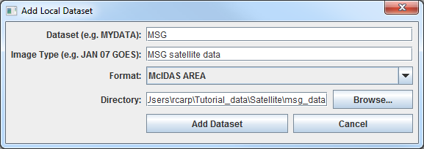

* 1. Click **Add Dataset**. Close the **ADDE Data Manager** by clicking **Ok** or selecting ***File -> Close***.

1. To load the data in this local dataset, follow these steps.

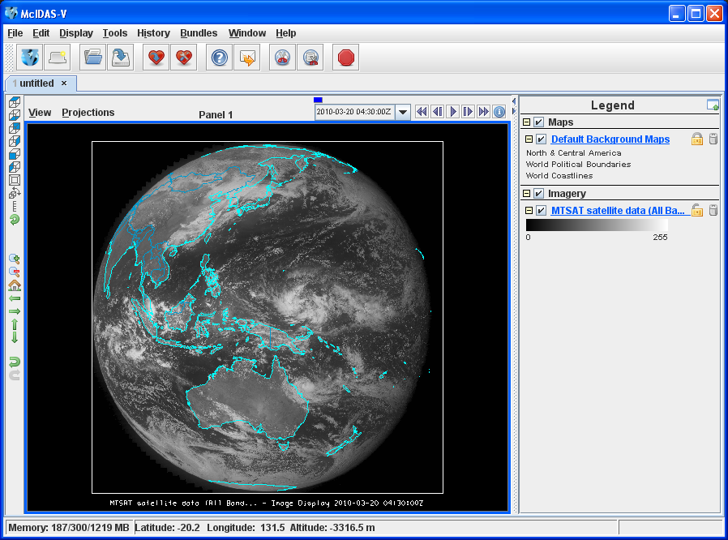

* 1. Click on the button in the main toolbar to go to the **Data Explorer**.



* 1. From the ***Data Sources*** tab, select the ***Satellite -> Imagery*** chooser.
  2. Select *<LOCAL-DATA>* for **Server**, select *MSG* for **Dataset**, click **Connect**.
  3. Choose the *MSG satellite* *data* **Image Type** and select an **absolute** time of *12:00 UTC*.
  4. Click **Add Source** to show the ***Field Selector***.
  5. In the **Fields** panel of the ***Field Selector****,* choose ***0.6 um VIS Cloud and Surface Features -> Brightness.***
  6. Click **Create Display**. The 12:00 UTC 0.6 μm image is displayed in the **Main Display** window.

1. To load real-time data, follow these steps. If you have already loaded the data in step one and two, proceed to step 4.
   1. Click on the button in the **Main Toolbar** to go to the **Data Explorer**.



* 1. Select the ***Satellite -> Imagery*** chooser from the ***Data Sources*** tab.
  2. If you’re using the default servers in McIDAS-V, you can connect to the *lead.unidata.ucar.edu* **Server** with the *RTGOESR* **Dataset**.
  3. Choose the *CONUSC – GOES-16 CONUS all bands* **Image Type**.
  4. Using the ***Absolute*** tab, select a time during daylight hours. For example, around *18 UTC*.
  5. Click **Add Source** to show the ***Field Selector***.
  6. In the **Fields** panel of the Field Selector, choose ***0.47 um VIS aerosol-over-land -> Brightness***.
  7. Click **Create Display**. The 0.47 μm image is displayed in the ***Map Display*** window.

1. Use the zooming and panning controls in the left toolbar to inspect the image.
   1. Reset the display projection by clicking on the icon below the zooming buttons on the left toolbar.



* 1. Turn off the **Auto-set Projection** option under the **Projections** menu of the **Main Display**. When this option is checked, the projection will automatically change to the native projection of the new layer. When this option is unchecked, all new layers will be reprojected into the current projection.

1. Edit the maps in the display by using the options in the ***Layer Controls***.
   1. Click on *Default Background Maps* in the **Legend** to go to the ***Layer Controls***. The map controls will have two tabs. The first ***Maps*** tab lists the available maps, and the second ***Lat/Lon*** tab allows the user to control latitude and longitude lines and labels. At the bottom of both tabs, there is a **Position** slider that allows you to control the vertical positioning of the maps in the **Main Display**.
   2. In the ***Maps*** tab, you can remove a map, change its visibility, line width, style and color. Use these options to create your own map display.
   3. If you choose, also add latitude and longitude lines and labels in the ***Lat/Lon*** tab.
   4. To save a map configuration as the default, in the ***Layer Controls*** select ***File -> Default Maps -> Save as the Default Map Set***. The next time you open a new tab, window, or start McIDAS-V, the defaults will reflect what you selected.
2. Return to the ***Field Selector*** to load an infrared image. If you are using real-time data skip to step 7.
   1. Select ***10.8 um IR Surface/Cloud-top Temp -> Temperature***.
   2. Click **Create Display**.
3. If you are using real-time data, follow the steps below.
   1. From the ***Field Selector***, select ***10.3 um IR Surface & cloud -> Temperature***.
   2. Click **Create Display**.
4. The 10.8 µm temperature image is overlaid on top of the visible image. To see the visible image, turn off the top *MSG Satellite Data (All Bands...)* checkbox in the **Legend**. Turn the image back on and click and drag the middle mouse button to activate the **Cursor/Data Readout** option. This option brings up a latitude, longitude, and data value readout below the display. Since there are two layers in the main display, there are two different readouts with the appropriate values and units.
5. Change the font and color of the labels on the **Main Display**.  
   1. In the **Main Display**, choose ***Edit -> Preferences***. Click on ***Display Window***.
   2. In the right column under ***Layer List Properties,*** change **Font** to *Arial*/*Plain*/*14*. Change the **Color** to *yellow*. Click **OK**. Return to the **Main Display** to see the changes.
6. In the ***Layer Controls***, you can view a histogram of the displayed imagery. Go to the ***Layer Controls*** and click on the ***Histogram*** tab for the 10.8 µm image. You can zoom in on a range of data and the display window will correspondingly change. *Left Click+Drag* on the histogram to create a box of data to inspect closer. Note the range of the data in the image display changes to match the range on your histogram. Click **Reset** if you wish to return to the original histogram and to the original image.
7. Create a local dataset to access the FY2E Visible imagery files. To load real-time data skip to step 17.
   1. In the **Main Display** window, select the ***Tools -> Manage ADDE Datasets*** menu item.
   2. In the ADDE Data Manager, select ***File -> New Local*** Dataset, and enter the following parameters:

* **Dataset –** *MEGI_VIS*
* **Image Type –** *FY2E VIS satellite data*
* **Format –** *McIDAS AREA*
* **Directory –** select the *<local path>***/Data/Satellite/fy2e_vis_megi** directory

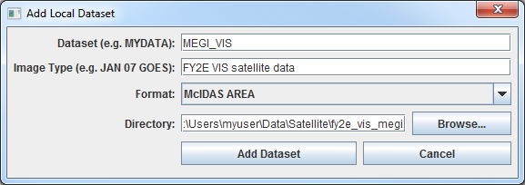

* 1. Click **Add Dataset**.

1. Create a local dataset to access the FY2E Infrared imagery files on your machine.  
   1. In the ADDE Data Manager, select ***File -> New Local Dataset***, and enter the following parameters:

* **Dataset –** *MEGI_IR*
* **Image Type –** *FY2E IR satellite data*
* **Format –** *McIDAS-AREA*
* **Directory –** select the *<local path>***/Data/Satellite/fy2e_ir_megi** directory

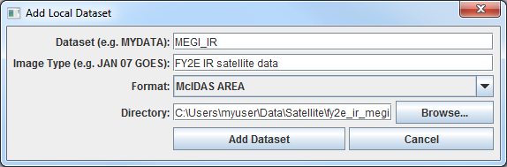

* 1. Click **Add Dataset**.

1. Close the **ADDE Data Manager** by clicking **Ok** or select ***File -> Close****.*
2. Create a 4 panel display and change the name of the tab.
   1. Select ***Edit -> Remove -> All Layers and Data Sources****.*
   2. Select ***File -> New Display Tab -> Map Display -> Four Panels*** from the main menu to create a 4 panel tab.
   3. *Double Click* on the “untitled” tab name and enter “*FY2E 4-panel”* in the entry box and click **OK** to change the tab name.
3. Display the FY2E Visible image in the top left panel.  
   1. By default, the last panel created will be the active panel. The lower right panel will be highlighted with a default color of blue. Click on the top left panel to activate this panel for the next data load.
   2. From the ***Satellite -> Imagery*** chooser in the ***Data Sources*** tab of the **Data Explorer**,select *<LOCAL-DATA>* for **Server**, select *MEGI_VIS* for **Dataset**, click **Connect**.

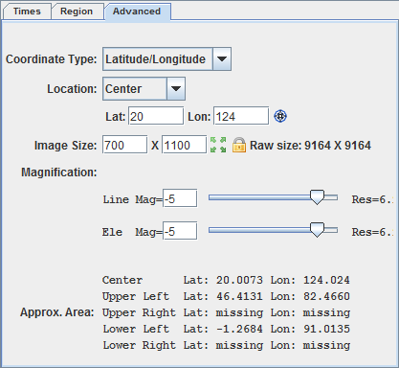

* 1. Choose the *FY2E VIS satellite data* **Image Type**. From the ***Relative*** tab, enter a value of *5* into the **Number of times** field. Check the **Create preview image** box. This checkbox allows the satellite data to display in the ***Region*** tab of the ***Field Selector*** instead of just a map of where the data will be once displayed. Click **Add Source** to show the ***Field Selector***.
  2. In the **Fields** panel, select ***0.73 um VIS Cloud and Surface Features -> Brightness***.
  3. Change the centering of the image as well as the image size. The screenshot represents the values to enter in the ***Advanced*** tab.  
     + Under **Displays,** click on the ***Advanced*** tab.
     + Change the **Lat**: to *20* and **Lon**: to *124*.
     + Change the **Image Size**: to *700* X *1100*.
     + Change the **Magnification** to *-5* X *-5*.
     + Click **Create Display**.

The **Magnification** of -5 X -5 will reduce the amount of data downloaded. The data is sampled with every fifth line and fifth element being sent from the server. Also note that the number of lines and elements chosen may not fit into the display window. Zoom out to display all the pixels requested.

1. Repeat the actions in the previous step to display the FY2E IR images in the remaining panels.   
   1. Repeat step 15 using the MEGI_IR dataset and load the FY2E 10.8 µm brightness.   
      * Click on the top right panel to make it active.
      * From the chooser select *<LOCAL-DATA>* for **Server** and *MEGI_IR* for **Dataset**. Click **Connect.**
      * Choose the *FY2E IR satellite data* **Image Type,** and enter a value of *5* in the ***Relative*** tab.
      * Click **Add Source** to show the ***Field Selector***.
      * In the **Fields** panel, select ***10.8 um IR Surface/Cloud-top Temp -> Brightness***.
      * Under **Displays,** click on the ***Advanced*** tab.
      * Change the **Lat**: to *20* and **Lon**: to *124*.
      * Change the **Image Size**: to *700* X *1100*.
      * Change the **Magnification** to *1* X *1* to download the full resolution data.
      * Click **Create Display**.
   2. Click the bottom left panel to make it active, and follow the steps above (after the **Add Source** step) to add FY2E IR 6.8 µm Brightness data to this panel.
   3. Click the bottom right panel to make it active, and follow the steps above (after the **Add Source** step) to add FY2E IR 3.8 µm Brightness data to this panel.
   4. Skip to step 19.
2. If you are using real-time data, follow the steps below.
   1. From the **Main Display**, select ***Edit -> Remove -> All Layers and Data Sources***.
   2. Open a new 4 panel tab by selecting ***File -> New Display Tab -> Map Display -> Four Panels*** from the **Main Menu**.
   3. By default, the last panel created will be the active panel. The lower right panel will be highlighted with a default color of blue. Click on the top left panel to activate this panel for the next data load.
   4. *Double Click* on the “untitled” tab name and enter “*GOES 4-panel”* in the entry box and click **OK** to change the tab name.
   5. Go to the ***Data Sources*** tab of the **Data Explorer**, and using the ***Satellite -> Imagery*** chooser with *lead.unidata.ucar.edu*/*RTGOESR*, select the *CONUS – GOES-16 CONUS all bands* **Image Type**. In the ***Absolute*** tab, use *Shift+Left-Click* to select the 5 last times in the list.
   6. Click **Add Source** to show the ***Field Selector***.
   7. Select ***0.47 um VIS aerosol-over-land -> Brightness***.
   8. In the lower right corner of the ***Field Selector***, open the ***Advanced*** tab. Ensure that the full domain is displayed at the native resolution of the data by clicking the four green arrow button () next to **Image Size** and click **Create Display**. Dependent on the memory allocated to McIDAS-V, a warning message may pop up about the amount of data you will be loading; click **OK**.



1. Click on the top right panel to make it the active tab. Repeat step 17g and 17h displaying 3.89 µm in the top right panel, 10.3 µm in the bottom left panel, and 13.3 µm in the bottom right panel.
2. Because the four tabs all have shared views, using the animation controls and zooming and panning in one panel will make the corresponding changes in the other panels. Observe that this is the case, and then turn off the share views option in one of the panels.
3. In one of the panels, animate the image loop and zoom in on an interesting weather feature. The other panels should also begin looping and zoom in on the same geographical location.
4. You may remove one of the panels from updating with the other panels by selecting ***Projections -> Share Views*** in that panel’s Projections menu.
5. Data polling which allows the data and display to be updated when a new image exists. Make polling active for all four data sources, have they automatically reload, and check for new data every 10 minutes.  
   1. In the ***Field Selector*** tab, *Right Click* on the *M1 – GOES-16 Mesoscale-1* data source and select **Properties**. (Note: The option would function for local datasets if files are updated in the local dataset’s directory.)
   2. Under *Polling* click on the **Automatically Reload:** **Active** checkbox. Click on the **Reload Displays** checkbox at the bottom of the window.
   3. Click **Apply** and **OK**. Every 10 minutes (the default polling time) a check will be made for a new image and if one exists, the satellite loop will be automatically updated in your display.

**Creating RGB images using formulas**

1. Create an RGB display from NASA’s high resolution Earth imagery, the *Big Blue Marble (BBM) red, green and blue channels*.
   1. In the **Main Display** window, select ***File -> Open File…*** and select the *<local path>****/*Data/Satellite/Sat‑RGB-BBM.mcvz** file to open. Select *Replace session* when prompted.
   2. Create a new tab via ***File -> New Display Tab -> Map Display -> One Panel***.
   3. Remove any previously-existing tabs.
2. Define the Red, Green, and Blue channels for your image display.  
   1. Click on **Formulas** under the **Data Sources** listed in the ***Field Selector***.
   2. Select ***Imagery -> Three Color (RGB) Image***, and click **Create Display**.
   3. In the **Field Selector** window, select ***Big Blue Marble red -> Band 1*** as red, ***Big Blue Marble green -> Band 1*** as green, ***Big Blue Marble blue -> Band 1*** as blue, and click **OK**.
3. Save this as a favorite bundle in the toolbar.
   1. In the **Main Display** window, select the ***File -> Save Favorite…*** menu item.
   2. Under *Category* select **Toolbar** and under *Name* enter in **BBM**.
   3. Make sure the *Save as zipped data bundle* option is checked and click **OK**.
   4. In the **Save Data** window choose the **Save All Displayed Data** option. Click **OK**. To the right of the toolbar buttons in the **Main Display**, there should now be a **BBM** button.
4. Remove all layers and data sources, and click on the **BBM** button to see the bundle load. Select *Merge with active tab(s)* when prompted.

**Problem Sets**

The previous examples were intended to give you a general knowledge of how to load and display satellite data.  The problem sets below are intended to introduce you to new topics related to the data, as well as challenge your knowledge of McIDAS-V.  We recommend that you attempt to complete each problem set before looking at the solutions, which are provided below the problem set.

1. Create a new local dataset for the mudslide files contained in *<local path>***/Data/Satellite/ fy2e_ir_zhouqu**. Load the five most recent FY2E 10.8 µm IR Temperature images from the Zhou Qu mudslide event. Change the range to enhance the colder clouds. Create a color enhancement that has values from 180 to 273 interpolated between blue and green, and values greater than 273 interpolated to yellow. Add a color bar to the image display window and save the loop as an animated gif.
2. Create a Parameter default for temperature images so all FY2E Temperature images use the same enhancement and range as in Problem 1. Then, load several different bands of temperature (10.8 µm, 3.8 µm, etc.) and loop through the different bands.
3. Display a masked loop of FY2E 10.8 µm brightness images from the Zhou Qu mudslide event and overlay a masked range of 6.8 µm brightness images. Load a data transect for each image and sync them together. Load a data probe/time series for the 10.8 µm temperature values with the 6.8 µm temperatures on the same graph. Create a new projection to center the display over China, and change the display to use this projection.

**Problem Set #1 – Solution**

Create a new local dataset for the mudslide files contained in *<local path>***/Data/Satellite/fy2e_ir_zhouqu**. Load the five most recent FY2E 10.8 µm IR Temperature images from the Zhou Qu mudslide event. Change the range to enhance the colder clouds. Create a color enhancement that has values from 180 to 273 interpolated between blue and green, and values greater than 273 interpolated to yellow. Add a color bar to the image display window and save the loop as an animated gif.

1. Create a local dataset for the mudslide event data and display the 10.8µm temperature data at full resolution.
   1. In the **ADDE Data Manager**, select ***File -> New Local Dataset***. To set up a dataset with the Infrared AREA files provided with this tutorial enter the following parameters: **Dataset**:*ZQ_IR*; **Image Type**: *FY2E IR satellite data*; **Format**:*McIDAS AREA*. Under **Directory**:, select the *<local path>***/Data/Satellite/fy2e_ir_zhouqu**. Close the ADDE Data Manager.
   2. Select ***Edit -> Remove -> All Layers and Data Sources***.
   3. Return to the **Data Explorer** by clicking on the button in the **Main Toolbar**.



* 1. From the ***Satellite -> Imagery*** chooser select *<LOCAL-DATA>* for **Server** and *ZQ_IR* for **Dataset**. Click **Connect**.
  2. Choose the *FY2E IR satellite data* **Image Type**. In the ***Relative*** tab, enter *5* in the **Number of times** field. Click **Add Source** to show the ***Field Selector***.
  3. Select ***10.8 µm IR Surface/Cloud-top Temp -> Temperature***.
  4. Under **Displays** go to the ***Advanced*** tab. Move the magnification sliders to *1* X *1*. Click in the ***Region*** tab. *Shift+Left Click* in the map display to choose China as the selected display region. Click **Create Display**.
  5. If the map lines in the display aren’t connected properly, click on *Default Background Maps* in the **Legend**. Enable the **Fast rendering** option for each map that is drawn in the display.

1. *Right Click* on the color table in the **Legend** and select **Change Range...**. Edit the values to focus on the colder clouds. Change the range to *180* to *290* and click **OK**.
2. To create a color enhancement, *Right Click* on the color table and select **Edit Color Table**. The inverse gray scale color table will be loaded in with the 180 to 290 K range.

The editor uses “breakpoints” which are used for a number of things: showing the data value at a point along the color table and changing the colors (fill, interpolation or transparency) directly below the breakpoint. Breakpoints are indicated along the top of the color legend bar with little triangles and a number.

* 1. Create a new breakpoint at 273 K by *Right Clicking* on or near the color table and selecting ***Add Breakpoint -> At Data Point***. Enter in 273 and click **OK**. By default, this breakpoint will be active. The active breakpoint will have a yellow outline around the triangle above the color table.
  2. The Color Chooser in the lower half of the editor window allows you to select any possible color. Use the slider bar to choose a green hue. Once you have chosen a hue, *Left Click* in the color display to choose a specific color, which should also update the color of the breakpoint.
  3. Click on the 180 breakpoint to make it active and use the same method to select a dark blue color.
  4. Interpolate the colors from 180 to 273 by *Right Clicking* on the 180 breakpoint and selecting ***Edit Colors -> Interpolate -> Right****.* The enhancement on the images will automatically update.
  5. *Left Click* on the 290 breakpoint, select a yellow color, and interpolate left to interpolate between 273 and 290.
  6. Save the color table as *IR Temps* in the Satellite category.
     1. At the top right of the editor, select *Satellite* from the **Category** pull down list.
     2. Select ***File -> Save As...***, enter in *IR Temps* and click **OK**. This color table will now show up in the list of color tables as ***Satellite -> IR Temps***. Close the **Color Table Editor**.

1. Add a color bar to the top of the image.
   1. In the ***Legend***, *Right Click* on the ***FY2E IR satellite data*** and select ***Edit -> Properties…***.
   2. In the **Properties** window chose the ***Color Scale*** tab. Click the **Visible** checkbox. Click the **Visible** and **Show Unit** checkboxes for **Labels**. Change the **Font** size to *18*. Click **OK**.
2. In the **Main Display** select ***View -> Capture -> Movie*** to bring up the **Movie Capture** window.
   1. Make sure that the **Main Display** window is not obscured by any other window, including the **Data Explorer** and the **Movie Capture** window.
   2. Click the **Time Animation** button. Each time in the loop will be automatically captured.
   3. When the capture is complete, a **Save** window will pop up. Select *Animated GIF* from the **Files of Type** pull down menu, enter in a file name, and click **Save**.
3. Click **Close** to close the **Movie Capture** window.
4. View the movie file in a browser window or movie application.

**Problem Set #2 – Solution**

Create a Parameter default for temperature images so all FY2E Temperature images use the same enhancement and range as in Problem 1. Then, load several different bands of temperature (10.8 µm, 3.8 µm, etc.) and loop through the different bands.

1. From the **Main Display** window, select ***Tools -> Parameters -> Defaults*** to bring up the **Parameter Defaults Editor**.
   1. Select ***File -> New Row*** from the editor menu.
   2. Click the double down arrows to the right of the **Parameter** entry box and select ***Current Fields -> FY2E IR (All Bands) -> 37_Band2_TEMP***.
   3. Modify the Parameter name and replace “37” and “2” with an asterisk followed by a period “\***.**”. The final result should be: **\*._Band*._TEMP**. These **\*.** symbols act as wildcards, allowing any value to be in its place.
   4. Check the **Color Table** option and select ***Satellite -> IR Temps***.
   5. Check the **Range** option and enter in a range of *180* to *290*.
   6. Click **OK**.
   7. Click **Close** in the **Parameter Defaults Editor**.
2. Remove all layers and data sources, and from the ***Satellite -> Imagery*** chooser select *<LOCAL-DATA>* for **Server**, select *MEGI_IR* for **Dataset**, and click **Connect**.
   1. Choose the *FY2E IR satellite data* **Image Type**. In the ***Relative*** tab, enter *5* in the **Number of times** field. Click **Add Source** to show the ***Field Selector***.
3. Select ***10.8 µm IR Surface/Cloud-top Temp -> Temperature***.
4. Click **Create Display**. The Typhoon Megi image should have the same range and enhancement as the Zhou Qu loop did in the previous problem.
5. Repeat using other FY2E Infrared bands with Temperature Data Types with the saved parameter default.
   1. Load the 12.0 µm, 6.8 µm and 3.8 µm images in the same display
   2. Use the ***View -> Bring to Front*** menu option in the ***Layer Controls*** for each band to bring the display to the front.
6. To loop through the different bands, in the **Main Display** use the ***View -> Displays -> Visibility Animation -> On*** option.

**Problem Set #3 – Solution**

Display a loop of FY2E 10.8 µm temperature images less than 240 degrees K from the Zhou Qu mudslide event and overlay a masked range of 6.8 µm temperature images between 240 and 258 degrees K. Load a data transect for each image and sync them together. Load a data probe/time series for the 10.8 µm temperature values with the 6.8 µm temperatures on the same graph. Create a new projection to center the display over China, and change the display to use this projection.

1. Remove all layers and data sources.
2. Display the FY2E IR data.  
   1. In the ***Data Sources*** tab of the **Data Explorer**, navigate to the ***Satellite -> Imagery*** chooser. Select *<LOCAL-DATA>* for **Server**, select *ZQ_IR* for **Dataset**, and click **Connect**.
   2. Choose the *FY2E IR satellite data* **Image Type** and select the *5 most recent* times. Click **Add Source**.
   3. In the ***Field Selector*** tab, select **Formulas** under **Data Sources**. Under **Fields**, open the **Imagery** tree and select **Mask Value**. Click **Create** Display.
   4. In the **Select Input** window, enter the following parameters, then click **OK**:

* **comparison –** *<*
* **cutoff –** *240*
* **useNaN** **–** *1*
  1. In the new **Field Selector** window, select:  
     + For **Field: inputFieldForMask**, open and select the ***ZQ_IR(All Bands)-> 10.8*** ***µm IR Surface/Cloud-top Temp -> Temperature,*** and in the Region tab select a region over China.
     + For **Field: displayFieldToBeMasked**, open and select the ***ZQ_IR(All Bands)-> 10.8*** ***µm IR Surface/Cloud-top Temp -> Temperature*** , and click **OK**.
  2. *Right Click* on the color table in the **Legend** and select **Change Range...** Edit the values to match the range of values masked. Change the range to *240* to *180* K and click **OK**.

1. In the ***Field Selector*** tab, select **Formulas** under **Data Sources**. Under **Fields**, open the **Imagery** tree and select **Mask Values Within Range**. Click **Create Display**.
2. In the **Select Input** window, enter the following parameters, then click **OK**:

* **minValue –** *240*
* **maxValue –** *258*
* **useNaN** **–** *1*
  1. In the new **Field Selector** window, select:  
     + For **Field: inputFieldForMask**, open and select the ***ZQ_IR(All Bands)-> 6.8*** ***µm IR Mid-level Water Vapor -> Temperature***, and in the Region tab select a region over China (should be selected from previous step).
     + For **Field: displayFieldToBeMasked**, open and select the ***ZQ_IR(All Bands)-> 6.8*** ***µm IR Mid-level Water Vapor -> Temperature***, and click **OK**.
  2. *Right Click* on the color table in the **Legend** and select **Change Range...** Edit the values to match the range of values masked. Change the range to *258* to *240* K and click **OK**. To differentiate from the other layer, change the color enhancement. *Right Click* on the color table in the **Legend** and select ***Satellite -> IR Temps***.

1. Go back to the ***Field Selector*** and select **ZQ_IR (All Bands)** under **Data Sources.** Under **Fields**, select ***10.8 µm IR Surface/Cloud-top Temp -> Temperature***. Under **Displays**, select the **Data Transect** display type and click **Create Display**.
2. Move the transect in the **Main Display**. *Left Click+Drag* on the triangle in the center to move the whole transect. *Left Click+Drag* on the “+” or “box” to move the endpoints of the transect. The transect will update in the ***Layer Controls***.
3. Repeat step 3 to the data transect for the ***6.8 µm -> Temperature*** field.
4. In the **Legend**, *Right Click* on both transects (under “Cross Sections”) and select ***Edit -> Sharing -> Sharing On***.
5. In the ***Layer Controls***, click on each transect layer and select ***View -> Undock from Data* *Explorer***to remove the transects from the **Data Explorer**.
6. Turn off the FY2E imagery by clicking off the **Imagery** checkbox in the **Legend**.
7. Move the WV transect line, keeping it within the bounds of the image. Once you move one of the transects in the **Main Display** window, both transects will align and move to the same points.
8. Create a **Data Probe/Time Series** display of 10.8 µm and 6.8 µm Temperatures.
   1. Return to the ***Field Selector*** and select the ***10.8 µm IR Surface/Cloud-top Temp -> Temperature*** field.
   2. In the **Displays** panel, select **Data Probe/Time Series** and click **Create Display**. The data probe appears in the **Main Display** and the time series is in the ***Layer Controls***. Animate the display to see the data probe time indicator (small black triangle at the top of the graph) and the values in the table below the graph changing with time.
   3. Turn on the FY2E imagery by clicking on the **Imagery** checkbox in the **Legend**.
   4. In the **Main Display** move the probe over a cloud with a *Left Click+Drag*. In the ***Layer Controls*** for the Data Probe, *Right Click* on the parameter name 37_Band2_TEMP, choose ***Add Parameter…***.
   5. In the new **Field Selector** window choose ***6.8 µm IR Mid-level Water Vapor -> Temperature***. Click ***OK***. The cyan 6.8 µm values are added to the graph.
   6. Set the vertical scale of the Data Probe/Time Series display to match the enhancement values. At the bottom of the chart, *Right-Click* on ***37_Band2_TEMP*** and select ***Parameter 37_Band2_TEMP -> Chart Properties***. In the **Range** field, enter *180* for **Min** and *290* for **Max**. Click **OK**. Do the same thing for the ***37_Band4_TEMP*** field.
9. China is not a default projection included with McIDAS-V. Create a new projection to center the display over China.  
   1. In the **Main Display**, select the ***Tools -> Projections -> Edit Map Projections*** menu item. This will open a **Projection Manager** window.
   2. In the **Projection Manager** window, click the **New** button to create a new projection.
   3. In the **Define/Edit Projection** window, create a projection over China.

* In the **Name** field, enter *China*
* In the **Type** field, select *Lat/Lon*
* In the **Map** panel, *Left Click+Drag* the black squares to create a bounding box over China.
* Click **Save**  
  1. Click **OK** to close the **Projection Manager** window.

1. Apply your newly-created projection to the display. In the **Main Display** window, select the ***Projections -> Predefined -> China*** menu item at the bottom of the list.

The display is now centered over China, using the projection created in step 11. This projection will be saved and can be used in subsequent sessions of McIDAS-V.

**Zooming, Panning, and Rotating Controls**

|  |  |  |
| --- | --- | --- |
| **Zooming** | **Panning** | **Rotating** |
|  | **Mouse** |  |
| **Shift-Left Drag:** Select a region by pressing the ***Shift*** key and dragging the left mouse button.  **Shift-Right Drag:** Hold ***Shift*** key and drag the right mouse button. Moving up zooms in, moving down zooms out. | **Control-Right Mouse Drag:** Hold ***Control*** key and drag right mouse to pan. | **Right Mouse Drag:** Drag right mouse to rotate. |
|  | **Scroll Wheel** |  |
| **Scroll Wheel-Up:** Zoom Out.  **Scroll Wheel-Down:** Zoom In. |  | **Control-Scroll Wheel-Up/Down:** Rotate clockwise/counter clockwise.  **Shift-Scroll Wheel-Up/Down:** Rotate forward/backward clockwise. |
|  | **Arrow Keys** |  |
| **Shift-Up:** Zoom In.  **Shift-Down:** Zoom Out. | **Control-Up arrow:** Pan Down.  **Control-Down arrow:** Pan Up.  **Control-Right arrow:** Pan Left.  **Control-Left arrow**: Pan Right. | **Left/Right arrow:** Rotate around vertical axis.  **Up/Down arrow:** Rotate around horizontal axis.  **Shift-Left/Right arrow:** Rotate Clockwise/Counterclockwise. |