McIDAS-V Tutorial

Displaying Polar Satellite Imagery

updated September 2018 (software version 1.8)

McIDAS-V is a free, open source, visualization and data analysis software package that is the next generation in SSEC's 40-year history of sophisticated McIDAS software packages. McIDAS-V displays weather satellite (including hyperspectral) and other geophysical data in 2- and 3-dimensions. McIDAS-V can also analyze and manipulate the data with its powerful mathematical functions. McIDAS-V is built on SSEC's VisAD and Unidata's IDV libraries. The functionality of SSEC's HYDRA software package is also being integrated into McIDAS-V for viewing and analyzing hyperspectral satellite data.

More training materials are available on the McIDAS-V webpage and in the Getting Started chapter of the McIDAS-V User’s Guide, which is available from the Help menu within McIDAS-V. You will be notified at the startup of McIDAS-V when new versions are available on the McIDAS-V webpage - <http://www.ssec.wisc.edu/mcidas/software/v/>.

If you encounter an error or would like to request an enhancement, please post it to the McIDAS-V Support Forums - <http://www.ssec.wisc.edu/mcidas/forums/>. The forums also provide the opportunity to share information with other users.

This tutorial assumes that you have McIDAS-V installed on your machine, and that you know how to start McIDAS-V. If you cannot start McIDAS-V on your machine, you should follow the instructions in the document entitled *McIDAS-V Tutorial – Installation and Introduction*.

Terminology

There are two windows displayed when McIDAS-V first starts, the **McIDAS-V Main Display** (hereafter **Main Display**) and the **McIDAS-V Data Explorer** (hereafter **Data Explorer**).

The **Data Explorer** contains three tabs that appear in bold italics throughout this document: ***Data Sources*, *Field Selector***, and ***Layer Controls***. Data is selected in the ***Data Sources*** tab, loaded into the ***Field Selector***, displayed in the **Main Display**, and output is formatted in the ***Layer Controls***.

Menu trees will be listed as a series (e.g. ***Edit -> Remove -> All Layers and Data Sources***).

Mouse clicks will be listed as combinations (e.g. *Shift+Left Click+Drag*).

#### Loading Polar Satellite Images and Loops

1. Create a local dataset to access the imagery files on your local machine.
   1. In the **Main Display** window of McIDAS-V, select ***Tools -> Manage ADDE Datasets***.
   2. In the **ADDE Data Manager**, select ***File -> New Local Dataset*.** Enter in the following parameters to set up a dataset with the MODIS Level 1b HDF files provided with this tutorial:

* **Dataset** – *MODIS*
* **Image Type** – *HDF MOD02 1km files*
* **Format** – *MODIS MOD 02 – Level-1B Calibrated Geolocated Radiances*
* **Directory** – select the *<local path>***/Data/Polar/modis_files** directory

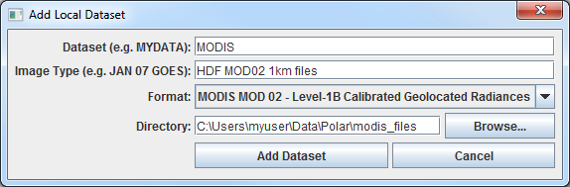

* 1. Click **Add Dataset**.
  2. Close the **ADDE Data Manager** by clicking **Ok** or ***File -> Close***.

1. To load the data in this local dataset, follow these steps.
   1. Click on the button in the **Main Toolbar** to go to the **Data Explorer**.

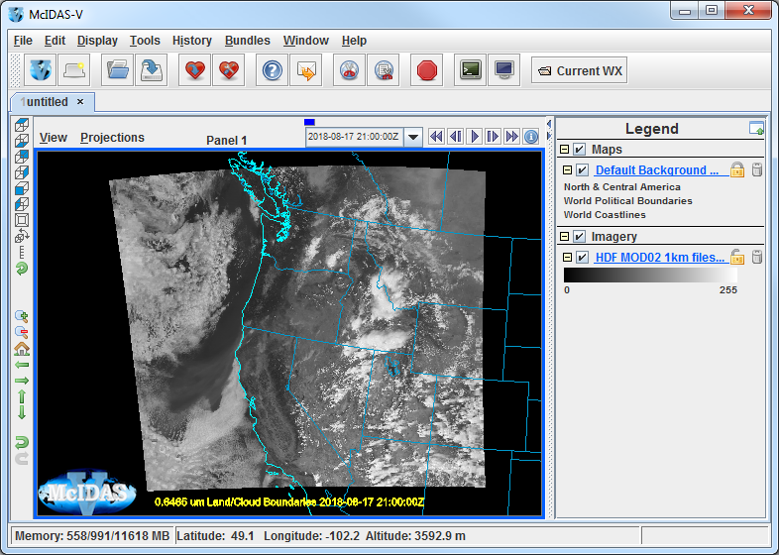

* 1. Select the ***Satellite -> Imagery*** chooser from the ***Data Sources*** tab.
  2. Select *<LOCAL-DATA>* for the **Server**, select *MODIS* for the **Dataset**, and click **Connect**.
  3. Choose the *HDF MOD02 1km files* **Image Type** and select an **Absolute** time of *21:00 UTC*.
  4. Click **Add Source** to show the ***Field Selector***.
  5. Select ***0.6465 um Land/Cloud Boundaries -> Brightness***.
  6. Click **Create Display**. The 21:00 UTC 0.6465 μm image is displayed in the **Main Display** window.

1. Use the zooming and panning controls in the left toolbar to inspect the image. Specifically, notice the fires in Northern California and Southern Oregon.
   1. Reproject the image with a pre-defined domain. Select ***Projections -> Predefined -> US -> CONUS***. Use the scroll wheel to zoom into the image or *Shift+Left Click+Drag* a box around the image.
   2. Turn off the **Auto-set Projection** option under the **Projections** menu. When this option is checked, the projection will automatically change to the native projection of the new layer. When this option is unchecked, all new layers will be reprojected into the current projection.
2. Return to the ***Field Selector*** to load an atmospheric temperature image.
   1. Select ***4.5454 um Atmospheric Temperature -> Temperature***.
   2. Click **Create Display**. The 4.5454 µm temperature image is overlaid on top of the visible image. To see the visible image, turn off the top *HDF MOD02 1km file (All Bands...)* checkbox in the **Legend**.
3. Use the cursor readout option to see the temperature values for the fire pixels.  
   1. Turn the *HDF MOD02 1km file (All Bands...)* checkbox in the **Legend** back on.
   2. Click and drag the middle mouse button to activate the **Cursor/Data Readout** option and list the latitude, longitude, and data value under the cursor. Since there are two layers in the main display, there are two different readouts with the appropriate values and units. Notice the high 4.5454 μm temperature values are located at the location of the fire. The data probe from the cursor/data readout option shows that values in the fire are approximately 50 degrees K warmer than outside of the fire.
4. Edit the maps in the display by using the options in the ***Layer Controls***.
   1. Click on *Default Background Maps* in the **Legend** to go to the ***Layer Controls***. The map controls will have two tabs. The first ***Maps*** tab lists the available maps, and the second ***Lat/Lon*** tab allows the user to control latitude and longitude lines and labels. At the bottom of both tabs, there is a **Position** slider that allows you to control the vertical positioning of the maps in the **Main Display**.
   2. In the ***Maps*** tab you can remove a map, change its visibility, line width, style and color. Use these options to create your own map display.
   3. If you choose, also add latitude and longitude lines and labels in the ***Lat/Lon*** tab.
   4. To save a map configuration as the default, in the ***Layer Controls*** select ***File -> Default Maps -> Save as the Default Map Set***. The next time you open a new tab, window, or start McIDAS-V, the defaults will reflect what you selected.
5. Notice that both layers are labeled the same in the **Legend**. Change the text of the labels in the **Main Display**.  
   1. *Right Click* on the top *HDF MOD02 1km files (All Bands...)* label in the **Legend**.
   2. Choose ***Edit -> Properties…***. Enter the following for the **Legend Label**:

* **Legend Label** – *4.5454 um - AQUA*

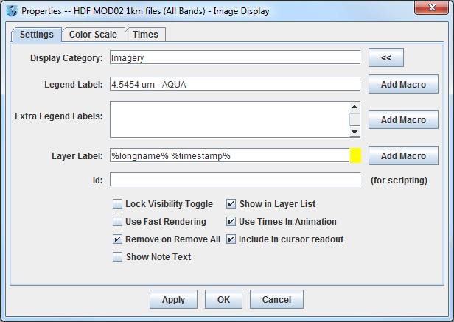

1. Return to the ***Data Sources*** tab of the **Data Explorer** to load another time.
   1. In the ***Data Sources*** tab of the **Data Explorer**, select the ***Satellite -> Imagery*** chooser with *<LOCAL-DATA>/*MODIS, the **Image Type** *HDF MOD02 1km files*,and an **Absolute** time of *20:55 UTC*.
   2. Click **Add Source** to show the ***Field Selector***.
   3. A new data source is created in the ***Field Selector***. To distinguish it from the first data source, the label is editable. *Right Click* on the highlighted *HDF MOD02 1km files (All Bands...)* and choose **Properties**. In the **Name** field enter, *HDF 21:15 UTC MOD02 1km*. Click **OK**.
   4. Select ***0.6465 um Land/Cloud Boundaries -> Brightness***.
   5. Click **Create Display**. The 21:15 UTC 0.6465 μm image is displayed in the **Main Display** window with the other displays also visible (because the **Auto-set Projection** setting is unchecked).
   6. In the **Legend**, click on the trash can next to *4.5454 µm AQUA* to remove the atmospheric temperature display (the middle one listed with the color table range of 180 to 320).
2. Create a local dataset to access the HRPT (High Resolution Picture Transmission) and GAC (Global Area Coverage) NOAA-18 Area polar orbiter imagery files on your local machine.
   1. In the **Main Menu Bar** of the **Main Display** window, select ***Tools -> Manage ADDE Datasets***. This will open the **ADDE Data Manager**.
   2. Select ***File -> New Local Dataset***. Enter the following parameters to set up the dataset:

* **Dataset –** *HRPT*
* **Image Type –** *HRPT N18 area files*
* **Format –** *McIDAS AREA*
* **Directory –** select the *<local path>/***Data/Polar/HRPT_areas** directory.

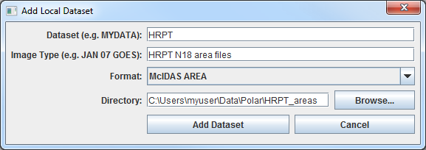

* 1. Click **Add Dataset**.
  2. In the **ADDE Data Manager**, select ***File -> New Local Dataset***. Enter the following parameters to set up the dataset:
* **Dataset –** *GAC*
* **Image Type –** *GAC N18 area files*
* **Format –** *McIDAS AREA*
* **Directory –** select the *<local path>/***Data/Polar/GAC_areas** directory.

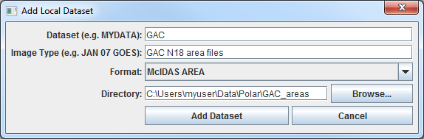

* 1. Click **Add Dataset**.
  2. Close the **ADDE Data Manager** by clicking **Ok** or select ***File -> Close***.

1. Remove all layers and data sources and display HRPT 10.8 um Temperature data.
2. In the **Main Display** window, select ***Edit -> Remove -> All Layers and Data Sources***.
3. In the **Main Display** select ***File -> New Display Tab -> Map Display -> One Panel***.
4. In the ***Satellite -> Imagery*** chooser of the ***Data Sources*** tab of the **Data Explorer**, select *<LOCAL-DATA>* for the **Server**, select *HRPT* for the **Dataset**, and click **Connect**.
5. Choose the *HRPT N18 area files* **Image Type** and select an **Absolute** time of *04:45:04 UTC*.
6. Select *Lat/Lon* for the **Navigation**.
7. Click **Add Source** to show the ***Field Selector***.
8. Select ***10.8 um Surface/Cloud-top Temp -> Temperature***.
9. Under **Displays** click on the ***Advanced*** tab. Click on the green arrow icon next to **Image Size** to load the full image. Change the **Magnification** to *1* X *1* with the sliders, and click **Create Display**. (The **Magnification** of *1* X *1* downloads the full resolution of the data. Negative magnification values will reduce the amount of data downloaded. For example, *-5* X *-5* will sample the data, and every fifth line and every fifth element is sent from the server.)
10. Load an FY2E satellite image over the HRPT image. This dataset was previously created in the *Displaying Satellite Imagery* tutorial.
    1. In the ***Data Sources*** tab of the **Data Explorer,** using the ***Satellite -> Imagery*** chooser, select *<LOCAL-DATA>* for the **Server**, select *ZQ_IR* for the **Dataset**, and click **Connect**.
    2. Choose the *FY2E IR satellite data* **Image Type** and select an **Absolute** time of 05:01 UTC.
    3. Click **Add Source** to show the ***Field Selector***.
    4. Select ***10.8 um Surface/Cloud-top Temp -> Temperature***.
    5. Under **Displays** click on the ***Advanced*** tab. Click on the green arrow icon next to **Image Size** to load the full image. Click **Create Display**.
11. Center the **Main Display** over the HRPT image and place the HRPT image over the FY2E image. Compare the two displays.
    1. Turn off the FY2E full disk image by unchecking the *FY2E IR Satellite Data* box in the **Legend**.
    2. Use *Shift+Left Click+Drag* to create a box over the HRPT image to zoom into it.
    3. Turn on the FY2E full disk image by rechecking the *FY2E IR Satellite Data* box in the **Legend**.
    4. In the **Legend**, *Right Click* on the *HRPT N18 area files* and select ***View -> Bring to Front***.
    5. Use the middle mouse button to click and probe the data for a temperature comparison. Note that the resolution of the HRPT data is better than the FY2E data.
    6. If the map lines in the display are missing or dashed instead of solid lines, click on *Default Background Maps* in the **Legend** to go to the ***Layer Controls***. In the ***Maps*** tab, change the setting for **Fast rendering** for each of the displayed maps.

**Creating RGB images using formulas**

1. Add MODIS data using the local MODIS server created earlier in this tutorial.
   1. Remove all layers and data sources.
   2. In the ***Data Sources*** tab of the **Data Explorer,** using the ***Satellite -> Imagery*** chooser, select *<LOCAL-DATA>* for the **Server**, select *MODIS* for the **Dataset**, and click **Connect**.
   3. Choose the *HDF MOD02 1km files* **Image Type** and select the **Absolute** time of *21:00 UTC*.
   4. Click **Add Source** to show the ***Field Selector***.
2. Define the Red, Green, and Blue channels of your image display.  
   1. Click on **Formulas** under the **Data Sources** listed in the ***Field Selector***.
   2. Select ***Imagery -> Three Color (RGB) Image***, and click **Create Display**.
   3. In the **Field Selector**, select ***HDF MOD02 1km files -> 0.6465 um -> Brightness*** as red, ***MODIS... -> 0.5537 um -> Brightness*** as green, and ***MODIS... -> 0.4656 um -> Brightness*** as blue and click **OK**.
   4. Change the projection to over the United States via ***Projections -> Predefined -> US -> CONUS*** in the **Main Display**. Use *Shift+Left Click+Drag* to zoom in on the data.

**Problem Sets**

The previous examples were intended to give you a general knowledge of how to load and display polar satellite data.  The problem sets below are intended to introduce you to new topics related to the data, as well as challenge your knowledge of McIDAS-V.  We recommend that you attempt to complete each problem set before looking at the solutions, which is provided below the problem set.

1. Load a loop of GAC (Global Area Coverage) NOAA-18 images on a Globe Display. Load visible and low-level water vapor images. Animate the loop on a rotating globe with a solid blue background image. Use the GAC N18 dataset created earlier in this tutorial.
2. Load a HRPT NOAA-18 image. Display the polar orbit track for the image using a two-line element text file with the Polar Orbit Track chooser. Add the swath width and antenna circles for the Wallops ground station.

**Problem Set #1 – Solution**

Load a loop of GAC (Global Area Coverage) NOAA-18 images on a Globe Display. Load visible and low-level water vapor images. Animate the loop on a rotating globe with a solid blue background image. Use the GAC N18 dataset created earlier in this tutorial.

1. Remove all layers and data sources, create a globe display, and load the data.  
   1. Remove all layers and data sources.
   2. In the **Main Display** select ***File -> New Display Tab -> Globe Display -> One Panel***.
   3. In the ***Data Sources*** tab of the **Data Explorer,** using the ***Satellite -> Imagery*** chooser, select *<LOCAL-DATA>* for the **Server**, select *GAC* for the **Dataset**, and click **Connect**.
   4. Choose the *GAC N18 area files* **Image Type**. In the ***Relative*** tab, enter a value of *8* for **Number of times**.
   5. Select *Lat/Lon* for the **Navigation**.
   6. Click **Add Source** to show the ***Field Selector***.
2. Select the 0.63 μm and 12.0 μm bands and display them.
   1. Select ***0.63 um VIS Cloud and Surface Features -> Brightness***.
   2. Under **Displays** click on the ***Advanced*** tab. For **Coordinate Type:** choose **Image Coordinates**. Click on the green arrow icon next to **Image Size** to load the full-size image. For **Location:** choose *Upper Left*, and click **Create Display**.



* 1. Repeat this process with the ***12.0 um IR SFC/Cloud Temp, Low-level WV -> Brightness***.

1. Animate the globe and add the background image. Then analyze and animate the globe display.
   1. From the **Main Display**, select ***Display -> Add Background Image***. In the ***Layer Controls*** for the background image, choose **Solid Blue**.
   2. Start the loop by using the Time Animation buttons at the top of the **Main Display**.
   3. Turn on the **Auto-Rotate view** option (***View -> Viewpoint*** from the **Main Display** window, or the Auto-Rotate button in the Viewpoint Toolbar to the left of the image).



* 1. Change the orientation of the globe in the **Main Display** with the mouse controls. Restart the **Auto rotate view**.

**Problem Set #2 – Solution**

Load a HRPT NOAA-18 image. Display the polar orbit tracks for the image using a two-line element text file with the Polar Orbit Track chooser. Add an antenna circle for the Wallops ground station.

1. Remove all layers and data sources, and display the 19:46:04 UTC NOAA-18 image in a new tab.
2. Remove all layers and data sources.
3. Click the button in the **Main Display** to create a new tab.

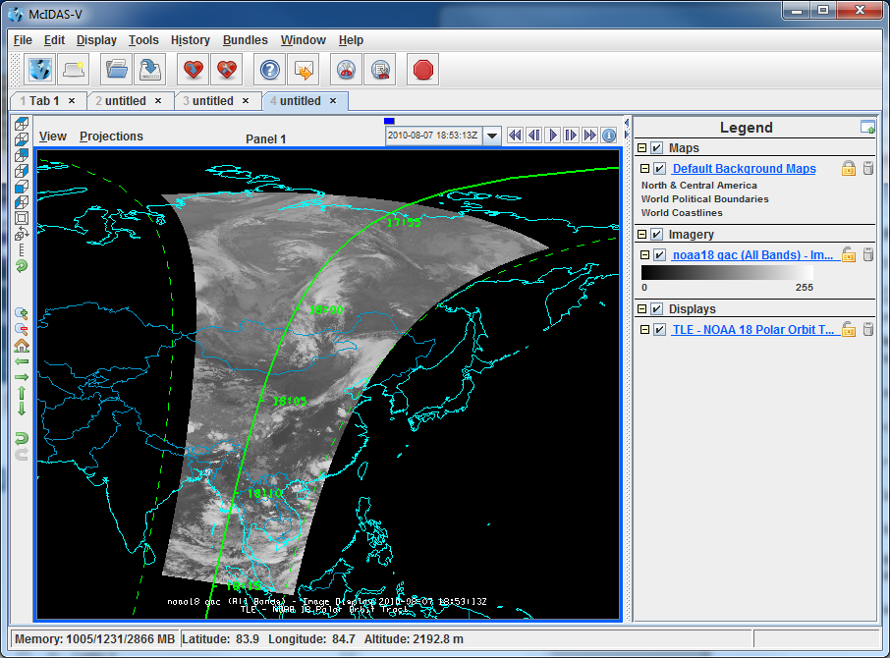

1. In the ***Data Sources*** tab of the **Data Explorer,** using the ***Satellite -> Imagery*** chooser, select *<LOCAL-DATA>* for the **Server**, select *HRPT* for the **Dataset**, and click **Connect**.
2. Choose the *HRPT N18 area files* **Image Type**
3. Select an **Absolute** time of *19:46:04 UTC*.
4. Select *Lat/Lon* for the **Navigation**.
5. Click **Add Source** to show the ***Field Selector***.
6. Display the 19:46:00 UTC NOAA-18 image
7. Select ***0.63 um VIS Cloud and Surface Features -> Brightness***.
8. Under **Displays** select the ***Advanced***tab.

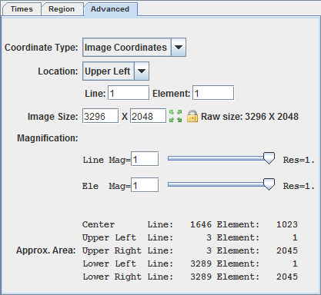

* + For **Coordinate Type:** choose *Image Coordinates*.
  + Click on the green arrow icon to load the full-size image.



* + For **Location:** choose *Upper Left*.

1. Click **Create Display**.
2. Reproject the display to the continental United States domain. In the **Main Display**, select ***Projections ‑> Predefined -> US ‑> CONUS***. Zoom into the image to fill the display.
3. Display the polar orbit tracks from a two-line element file.
4. In the ***Data Sources*** tab of the **Data Explorer**, select the ***Under Development -> Imagery – Satellite Orbit Track*** chooser.
5. In the **Local** panel, under **Look In**, navigate to the *<local path>/***Data/Polar/** directory and select the noaa18.txt file.
6. Click **Add Source** to show the ***Field Selector***.
7. Under **Displays**, select ***Satellite Orbit Track***.
8. Select what data to display in the ***Time Range*** tab of the ***Field Selector***.  
   * Use the calendar button to select *Apr 26, 2012* in both **Date** fields.
   * Enter *19:40:00* for **Begin Time**, and enter *20:00:00* for **End Time**. Click **Create Display**.
9. Navigate to the ***Layer Controls*** of the TLE data to modify the display.

* In the **Ground Station Controls** panel, expand the dropdown menu for **Ground Stations Available**, select **Wallops Island 14** (near the bottom of the list) and click **Add Selected**.

**Zooming, Panning, and Rotating Controls**

|  |  |  |
| --- | --- | --- |
| **Zooming** | **Panning** | **Rotating** |
|  | **Mouse** |  |
| **Shift-Left Drag:** Select a region by pressing the ***Shift*** key and dragging the left mouse button.  **Shift-Right Drag:** Hold ***Shift*** key and drag the right mouse button. Moving up zooms in, moving down zooms out. | **Control-Right Mouse Drag:** Hold ***Control*** key and drag right mouse to pan. | **Right Mouse Drag:** Drag right mouse to rotate. |
|  | **Scroll Wheel** |  |
| **Scroll Wheel-Up:** Zoom Out.  **Scroll Wheel-Down:** Zoom In. |  | **Control-Scroll Wheel-Up/Down:** Rotate clockwise/counterclockwise.  **Shift-Scroll Wheel-Up/Down:** Rotate forward/backward clockwise. |
|  | **Arrow Keys** |  |
| **Shift-Up:** Zoom In.  **Shift-Down:** Zoom Out. | **Control-Up arrow:** Pan Down.  **Control-Down arrow:** Pan Up.  **Control-Right arrow:** Pan Left.  **Control-Left arrow**: Pan Right. | **Left/Right arrow:** Rotate around vertical axis.  **Up/Down arrow:** Rotate around horizontal axis.  **Shift-Left/Right arrow:** Rotate Clockwise/Counterclockwise. |