McIDAS-V Tutorial

Displaying Point Observations from netCDF Files

updated October 2018 (software version 1.8)

McIDAS-V is a free, open source, visualization and data analysis software package that is the next generation in SSEC's 40-year history of sophisticated McIDAS software packages. McIDAS-V displays weather satellite (including hyperspectral) and other geophysical data in 2- and 3-dimensions. McIDAS-V can also analyze and manipulate the data with its powerful mathematical functions. McIDAS-V is built on SSEC's VisAD and Unidata's IDV libraries. The functionality of SSEC's HYDRA software package is also being integrated into McIDAS-V for viewing and analyzing hyperspectral satellite data.

More training materials are available on the McIDAS-V webpage and in the Getting Started chapter of the McIDAS-V User’s Guide, which is available from the Help menu within McIDAS-V. You will be notified at the startup of McIDAS-V when new versions are available on the McIDAS-V webpage - <http://www.ssec.wisc.edu/mcidas/software/v/>.

If you encounter an error or would like to request an enhancement, please post it to the McIDAS-V Support Forums - <http://www.ssec.wisc.edu/mcidas/forums/>. The forums also provide the opportunity to share information with other users.

This tutorial assumes that you have McIDAS-V installed on your machine, and that you know how to start McIDAS-V. If you cannot start McIDAS-V on your machine, you should follow the instructions in the document entitled *McIDAS-V Tutorial – Installation and Introduction*.

Terminology

There are two windows displayed when McIDAS-V first starts, the **McIDAS-V Main Display** (hereafter **Main Display**) and the **McIDAS-V Data Explorer** (hereafter **Data Explorer**).

The **Data Explorer** contains three tabs that appear in bold italics throughout this document: ***Data Sources*, *Field Selector***, and ***Layer Controls***. Data is selected in the ***Data Sources*** tab, loaded into the ***Field Selector***, displayed in the **Main Display**, and output is formatted in the ***Layer Controls***.

Menu trees will be listed as a series (e.g. ***Edit -> Remove -> All Layers and Data Sources***).  
  
Mouse clicks will be listed as combinations (e.g. *Shift+Left Click+Drag*).

**Plotting and Contouring Surface Point Observations around the world**

1. Remove all layers and data sources from the previous displays.
2. If you have created more than one tab, close the extra tabs by clicking the “X” in the right corner of the tabs.
3. Display the data from the *<local path>***/Data/Point_netCDF/metar/20090903_0100-metar.nc** file.
   1. In the ***Data Sources*** tab of the **Data Explorer**, open the ***General*** ***-> Files/Directories*** chooser.
   2. In the **Data Type** field, choose **netCDF/GEMPAK Point Data files**.
   3. Navigate to the *<local path>***/Data/Point_netCDF/metar/20090903_0100-metar.nc** file. Click **Add Source**.
   4. In the ***Field Selector***, select ***Point Data*** in the **Fields** panel.
   5. In the lower-right panel, click the ***Layout Model*** tab and click the down arrows to select the parameter to plot. Select ***Observations -> Temperature*** to plot all available temperatures.
   6. Click **Create Display**. The default display is a world projection with temperatures plotted from around the world. As you zoom in you will see more stations appear in the plot.
4. One feature of this dataset is that the data is plotted every minute. This can be convenient for some applications, but is hard to view in an animated loop. Change the time step to every fifteen minutes.  
   1. Select the icon in the **Main Display** to edit the **Time Animation Properties**.



* 1. Go to the ***Define Animation Times*** tab.
  2. Select **Define your own list of times**, change the **Interval** and **Round To** values to *15* minutes.
  3. Click **OK**. Note that the time interval in the Time Animation Widget has changed from 1 minute to 15 minutes, and more data points are displayed at each time step.

1. Contour the temperatures plotted on the screen.
   1. In the ***Field Selector***, choose the *20090903_0100-metar.nc* **Data Source**. Under **Fields**,click the icon next to ***Gridded Fields***to open the tree and list the fields available for contouring. Select ***temperature*** from the list of available fields.



* 1. Select ***Plan Views -> Contour Plan View*** from the **Displays** panel.
  2. Subset a region over land in the ***Region*** tab by changing the dropdown menu to **Select A Region**. Now, use *Left Click+Drag* to select the region to display the contours.
  3. Click **Create Display**. The contour properties can be changed in the ***Layer Controls*** tab of the **Contour Plan View** display.

1. Repeat step 5, but select ***Plan Views -> Color-Shaded Plan View*** in the **Displays** panel. In the ***Layer Controls*** for the **Color-Shaded Plan View** display, check the **Shade Colors** box to shade the colors. (Hint: **Color-Shaded Plan View** plots much faster than **Color-filled Contours**.)

**Creating Time Series of Point Observations**

1. Remove all layers and data sources via the ***Edit -> Remove -> All Layers and Data Sources*** menu item in the **Main Display**.
2. In the ***General -> Files/Directories*** chooser in the ***Data Sources*** tab of the **Data Explorer**, navigate to the <*local path*>**/Data/Point_netCDF/metar** directory and select multiple times in at once (*\*_0300-metar.nc* through *\*_0500-metar.nc*) using *Shift+Click*. Click **Add Source**.
3. In the ***Field Selector*** tab, select the ***Point Data*** field, the ***Point Data -> Point Data Plot*** display, and the  
   ***Observations -> Temperature*** layout model. Click **Create Display**.
4. In the ***Layer Controls*** of the temperature point data plot, click on the ***Plot*** tab to create a time series.
5. Zoom in over a station in the **Main Display** and *Left Click* on the center of it. The station information should fill into the table below the plot in the ***Layer Controls***.
6. Add temperature to the plot by *Right Clicking* on **temperature**in the table and selecting **Add To Chart**.

**Displaying RAOB Sounding Data**

1. Remove all layers and data sources via the ***Edit -> Remove -> All Layers and Data Sources*** menu item in the **Main Display**.
2. Select the ***Point Observations -> Soundings -> Local*** chooser from the ***Data Sources*** tab of the **Data Explorer**.
3. Under **File**, click **Select File**. Change the **Files of Type** field to *All Files*, and select   
   *<local path>***/Data/Point_netCDF/raob/20090903_1200-raob.nc**. Click **Open**.
4. Pick the station for your sounding display.
   1. Use the zooming and panning buttons to find your station(s).
   2. Select an available time and click on your station to see if a sounding is available. Available soundings will show up in the **Selected**box on the bottom right of the chooser.
   3. Select multiple stations by *Left Click*ing on then. Once you have a few stations in your **Selected** box, click **Add Source**.
5. Under the **Displays** panel of the ***Field Selector***, choose which type of thermodynamic diagram to display (*Skew-T, Stuve,* or *Emagram*) and click **Create Display**.
6. The sounding will plot in a 2D display in the ***Layer Controls*** tab along with a list of thermodynamic parameters. As the cursor moves over the sounding, the thermodynamic parameters will update with the location of the cursor.

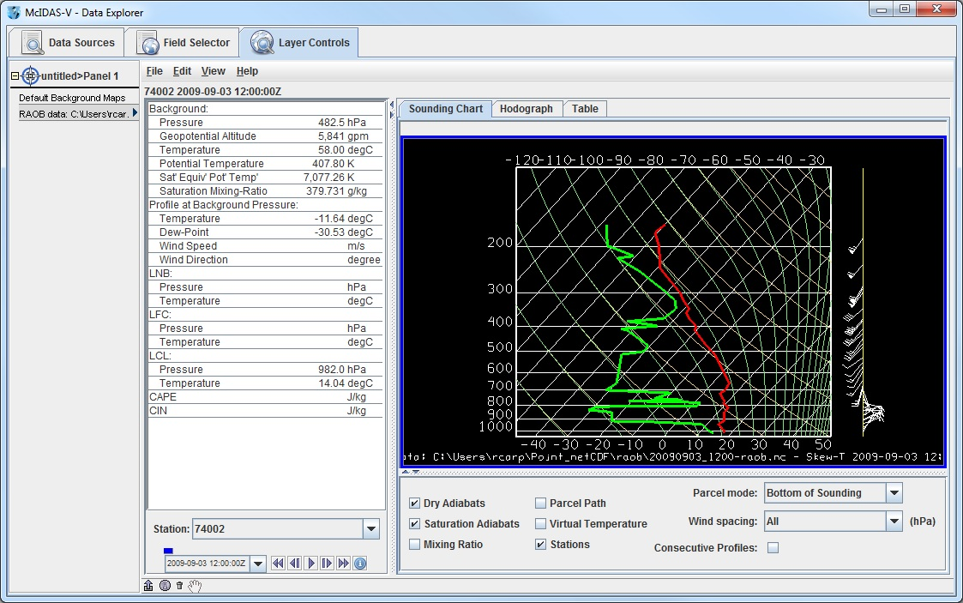

1. Modify the temperature and dewpoint profiles.
   1. *Left Click* on the first data-point to be modified and drag it horizontally along an isobar to the desired position, then move the pointer diagonally along an isotherm to keep the data-point at the desired position and to pick-up the next data-point.
   2. Repeat until done and then release the mouse button.
   3. To reset the sounding, use the ***Edit -> Reset sounding*** menu item in the ***Layer Controls*** tab.
   4. Use the checkboxes below the sounding to configure the sounding chart. When the **Stations** box is checked, you will see a square box in the **Main Display** indicating the location of each sounding selected in the ***Data Sources*** tab. Select a new station by *Left Clicking* another square box in the **Main Display**, or by choosing a station in the **Station** dropdown menu in the ***Layer Controls***.
   5. In the ***Layer Controls***, in addition to the ***Sounding Chart***, there are also tabs for a ***Hodograph***, and a ***Table*** of all of the data in the sounding.

**Problem Sets**

The previous examples were intended to give you a general knowledge of how to load and display surface and upper air point data.  The problem sets below are intended to introduce you to new topics related to the data, as well as challenge your knowledge of McIDAS-V.  We recommend that you attempt to complete each problem set before looking at the solutions, which are provided below the problem set.

1. Create a time series of surface Temperature, Dewpoint Temperature and Wind Barbs for five hours over any station. Change the Temperature and Dewpoint Temperature axes in the plot so they have the same range. Use six netCDF files provided from 03 UTC to 07 UTC and display the data in 15-minute intervals.
2. Modify the chart from problem #1 so you have three separate charts: Place Wind Barbs in the top left chart, Pressure in the top right chart, and Temperature and Dewpoint Temperature in the bottom chart (Hint: Change the chart names to separate out parameters!)
3. Using the same times used in problems 1 and 2, create your own station model layout that displays the Dewpoint Depression in green over the center of thes tation, the Temperature to the upper left, and Dewpoint Temperature to the upper right. Display the observations using the new layout and use 15-minute time intervals to display the data.

**Problem Set #1 – Solution**

Create a time series of surface Temperature, Dewpoint Temperature and Wind Barbs for five hours over Beijing (ZBAA). Change the Temperature and Dewpoint Temperature axes in the plot so they have the same range. Use six netCDF files provided from 03 UTC to 07 UTC and display the data in 15-minute intervals.

1. Remove all layers and data sources from the previous display.
2. Display the data from five files in the *<local path>***/Data/Point_netCDF/metar** directory:   
   **20090903_0300-metar.nc, 20090903_0400-metar.nc, 20090903_0500-metar.nc,**   
   **20090903_0600-metar.nc,** and **20090903_0700-metar.nc** files.
   1. In the ***Data Explorer***, open the ***General -> Files/Directories*** chooser.
   2. Navigate to the listed files. Highlight the five files by *Control+Left Click* on each file. Click **Add Source**.
   3. In the ***Field Selector***, select ***Point Data*** under **Fields**.
   4. In the lower-right panel, click the ***Layout Model*** tab and click the down arrows to select the parameter to plot. Select ***Observations -> METAR w/ Altimeter*** to plot a metar station model. Click **Create Display**.
   5. Change the interval to 15 minutes by clicking the icon to the right of the **Time Animation Controls**. Go to the ***Define Animation Times*** tab, select **Define your own list of times**, and the change **Interval** and **Round To** fields to 15 minutes.



* 1. Use the ***Zooming and Panning*** controls to zoom in on the display and *Left Click* on any station.

1. Create a time series plot of temperature and dewpoint.  
   1. In the ***Layer Controls***, click on the ***Plot*** tab, and at the bottom, scroll down through the list of fields until you find temperature.
   2. *Right Click* on **temperature** and select **Add to Chart**, and repeat for **dewpoint**.
2. Change the minimum and maximum values for the y-axis.  
   1. *Right Click* on the table of fields and select ***temperature -> Chart Properties***.
   2. In the **Range:** field, enter in a Min and Max value appropriate for both Temperature and Dewpoint Temperature (ex. *10* – *30*). Click **OK**.
   3. *Right Click* on the table of fields below the chart and select ***dewpoint -> Chart Properties***.
   4. To the right of the **Range:** field, there is a **...** button. Click on this button and select *Fixed Range from temperature...*, and click **OK**.
3. To add wind barbs, add speed (windSpeed) and direction (windDir) to the chart. When both of these parameters are added, they are converted into wind barbs.

**Problem Set #2 – Solution**

Modify the chart from problem #1 so there are three separate charts: Place Wind Barbs in the top left chart, Pressure in the top right chart, and Temperature and Dewpoint Temperature in the bottom chart (Hint: Change the chart names to separate out parameters!)

1. Return to the Temperature chart properties by *Right Clicking* on the table of fields and selecting ***temperature ‑> Chart Properties***.
   1. Enter in “*Temperature*” in the **Chart Name** field.
   2. Click **OK**. The Temperature plot should appear in a new chart below the other plot.
2. Repeat this step for Dewpoint Temperature and place it in the “*Temperature*” plot.
3. Add pressure (**altimeter**) to the charts and place it in a separate chart titled “*Pressure*”.
4. Select ***View -> Chart -> Layout -> Change Grid Layout*** from the ***Layer Controls*** menu.
   1. Use the **Columns** and **Rows** buttons to add/remove new columns and rows.
   2. *Left Click+Drag* on a chart to move it to a different location.
   3. Use the black squares around the individual charts to control their width and length.

**Problem Set #3 – Solution**

Using the same times used in problems 1 and 2, create your own station model layout that displays the Dewpoint Depression in green over the center of the station, the Temperature to the upper left, and Dewpoint Temperature to the upper right. Display the observations using the new layout and use 15-minute time intervals to display the data.

* 1. Remove all layers.
  2. In the **Main Display** select the ***Tools -> Layout Model Editor*** menu item.
  3. In the editor, select ***File -> New*** and enter in “*Dewpoint Depression*” for the name of the layout.
  4. Click on “123 Value” to add a numeric value and *Left Click* in the middle of the layout. The **Properties Dialog** box will pop up.
  5. In the **Parameter** field, enter: *=temperature-dewpoint*
  6. Change the **Foreground Color** to *green*, and click **OK**.
  7. Add Temperature (“temperature”, from the ‘123 Value’ field) and Dewpoint Temperature (“dewpoint”, from the ‘123 Value’ field) in the appropriate locations.
  8. In the editor select ***File -> Save*** and then close the **Layout Model Editor** window.
  9. Return to the ***Field Selector***, and display the same times of data with your newly created layout model.

1. Under **Fields**, select ***Point Data***.
2. Under **Displays**, select the ***Point Data -> Point Data Plot*** display type.
3. In the **Layout Model** tab in the lower right corner, change the model to ***Dewpoint Depression <local>***.
4. Click **Create Display**.
5. Change the interval to 15 minutes by clicking the icon to the right of the **Time Animation Controls**. Go to the ***Define Animation Times*** tab, select **Define your own list of times**, and the change **Interval** and **Round To** fields to 15 minutes.



1. Zoom in over the United States using the ***Projections -> Predefined -> US -> CONUS*** menu item in the **Main Display** window.
2. Loop through the times to see values for dewpoint depression change.

**Zooming, Panning, and Rotating Controls**

|  |  |  |
| --- | --- | --- |
| **Zooming** | **Panning** | **Rotating** |
|  | **Mouse** |  |
| **Shift-Left Drag:** Select a region by pressing the ***Shift*** key and dragging the left mouse button.  **Shift-Right Drag:** Hold ***Shift*** key and drag the right mouse button. Moving up zooms in, moving down zooms out. | **Control-Right Mouse Drag:** Hold ***Control*** key and drag right mouse to pan. | **Right Mouse Drag:** Drag right mouse to rotate. |
|  | **Scroll Wheel** |  |
| **Scroll Wheel-Up:** Zoom Out.  **Scroll Wheel-Down:** Zoom In. |  | **Control-Scroll Wheel-Up/Down:** Rotate clockwise/counter clockwise.  **Shift-Scroll Wheel-Up/Down:** Rotate forward/backward clockwise. |
|  | **Arrow Keys** |  |
| **Shift-Up:** Zoom In.  **Shift-Down:** Zoom Out. | **Control-Up arrow:** Pan Down.  **Control-Down arrow:** Pan Up.  **Control-Right arrow:** Pan Left.  **Control-Left arrow**: Pan Right. | **Left/Right arrow:** Rotate around vertical axis.  **Up/Down arrow:** Rotate around horizontal axis.  **Shift-Left/Right arrow:** Rotate Clockwise/Counterclockwise. |