McIDAS-V Tutorial  
Displaying JPSS Data  
updated August 2018 (software version 1.8)

McIDAS-V is a free, open source, visualization and data analysis software package that is the next generation in SSEC's 40-year history of sophisticated McIDAS software packages. McIDAS-V displays weather satellite (including hyperspectral) and other geophysical data in 2- and 3-dimensions. McIDAS-V can also analyze and manipulate the data with its powerful mathematical functions. McIDAS-V is built on SSEC's VisAD and Unidata's IDV libraries. The functionality of SSEC's HYDRA software package is also being integrated into McIDAS-V for viewing and analyzing hyperspectral satellite data.

More training materials are available on the McIDAS-V webpage and in the Getting Started chapter of the McIDAS-V User’s Guide, which is available from the Help menu within McIDAS-V. You will be notified at the startup of McIDAS-V when new versions are available on the McIDAS-V webpage - <http://www.ssec.wisc.edu/mcidas/software/v/>.

If you encounter an error or would like to request an enhancement, please post it to the McIDAS-V Support Forums - <http://www.ssec.wisc.edu/mcidas/forums/>. The forums also provide the opportunity to share information with other users.

This tutorial assumes that you have McIDAS-V installed on your machine, and that you know how to start McIDAS-V. If you cannot start McIDAS-V on your machine, you should follow the instructions in the document entitled *McIDAS-V Tutorial – Installation and Introduction*.

Terminology

There are two windows displayed when McIDAS-V first starts, the **McIDAS-V Main Display** (hereafter **Main Display**) and the **McIDAS-V Data Explorer** (hereafter **Data Explorer**).

The **Data Explorer** contains three tabs that appear in bold italics throughout this document: ***Data Sources*, *Field Selector***, and ***Layer Controls***. Data is selected in the ***Data Sources*** tab, loaded into the ***Field Selector***, displayed in the **Main Display**, and output is formatted in the ***Layer Controls***.

Menu trees will be listed as a series (e.g. ***Edit -> Remove -> All Layers and Data Sources***).  
  
Mouse clicks will be listed as combinations (e.g. *Shift+Left Click+Drag*).

**Introduction**

McIDAS-V has the ability of displaying JPSS (Suomi NPP and NOAA-20) data through the ***Under Development -> Imagery – JPSS*** chooser. Among the JPSS products that McIDAS-V can display are data from the VIIRS (all bands of SVM and SVI, EDRs, Day/Night band), CrIS, and ATMS instruments. In order for the data to be recognized by McIDAS-V, the geolocation files must be contained within the same directory as the data. Some sources of data, including NOAA’s CLASS, package the data and geolocation files together by default. Other sources of JPSS data may store the geolocation in a separate file from the data. Note that this chooser is still under development and improvements in functionality as well as the ability to utilize different JPSS products will be added in the future.

**Installing the VIIRS Formulas Plugin**

1. 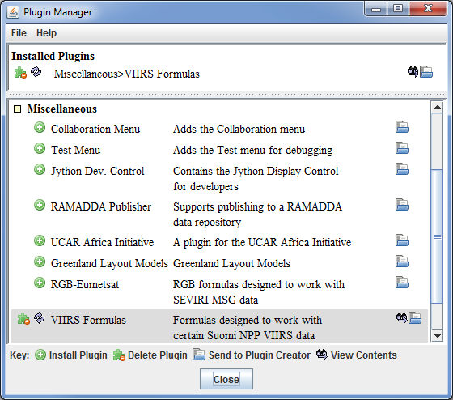This tutorial uses two formulas specifically designed to work with Suomi NPP VIIRS data. These formulas are not packaged as part of the core group of formulas in McIDAS-V, and must be added via a plugin. Add this plugin.  
   1. In the **Main Display** window, navigate to the ***Tools -> Plugins -> Manage*** menu item to open the **Plugin Manager**.
   2. The top of the **Plugin Manager** lists plugins currently installed, and the bottom panel lists out various plugins available for installation. Expand the ***Miscellaneous*** tree and click the green **Install Plugin** button next to ***VIIRS Formulas***.
   3. This pops up a message informing that McIDAS-V must be restarted to complete the installation of the plugin. Click **OK** through this message and restart McIDAS-V.

**Display a Single Granule of NOAA-20 Data**

1. Load a single granule of NOAA-20 SVM03 VIIRS data.  
   1. In the ***Data Sources*** tab of the **Data Explorer**, select ***Under Development -> Imagery – JPSS***.
   2. Under **Files**, select the following file:  
        
      *<local path>***/Data/JPSS/NOAA20/VIIRS/SVM03_j01_d20180513_t1814201\***  
        
      Note that the *<local path>***/Data/JPSS/NOAA20/VIIRS** directory contains nine SVM data granules (three timesteps of three different bands). There are also three GMTCO* geolocation files (one for each timestep) that are in this directory, but are either not visible or grayed out through this ***Imagery – JPSS*** chooser.
   3. Click **Add Source**.  
        
      Note that the first time a JPSS granule is added through this chooser, a **Plugin Compatibility Notice** window may appear letting users of the older version of the VIIRS Formulas plugin know that a new one is available. In step 1 above the most recent version of this plugin was installed. Click the *Do not show this message again* checkbox and click **OK**.
2. Display Radiance data at low resolution.  
   1. In the ***Field Selector*** tab of the **Data Explorer**, select the ***VIIRS-M3-SDR_All/Radiance*** field, and the ***Imagery -> Image Display*** display type.
   2. Note that the ***Region*** tab in the ***Field Selector*** shows a preview image of the selected field.
   3. Click **Create Display**.
   4. Investigate the display and note that the resolution of the display is course, not the native 750 meter resolution of the data. This is because no subsetting of the data was done in the ***Region*** tab of the ***Field Selector***.
3. Display Radiance data at the full resolution of the data.  
   1. From the ***Region*** tab of the ***Field Selector***, use *Shift+Left-Click+Drag* to draw a green box in the data. Any data contained within this box will be displayed at full resolution. Note that the entire box must be contained within the granule’s data.
   2. Click **Create Display**.
   3. Investigate the display and note that the resolution of the data has improved. However, note that the bowtie deletion lines still exist on the east and west edges of the granule.
4. Use the swathToGrid formula to display the Radiance data at full resolution with the bowtie deletion lines removed.  
   1. In the ***Field Selector*** tab of the **Data Explorer** select **Formulas**.
   2. Choose the ***swathToGrid*** formula, the ***Imagery -> Imagery Display*** display type, and click **Create Display**. Note that this formula was added as part of the plugin installed in step 1 above.
   3. In the **Select input** window, enter a value of *750* for **resolution in meters** and click **OK**.
   4. In the **Field Selector** window, select the ***VIIRS* -> Image -> VIIRS-M3-SDR_All/Radiance*** field.
   5. Wait for the ***Region*** tab to appear at the bottom of the **Field Selector** window showing a preview image of the granule and click **OK**.
   6. Investigate the display and notice that the data is now displayed at full resolution with the bowtie deletion lines removed.
   7. When you are done investigating the display, remove all layers and data sources.

**Create a RGB Display with Aggregated Granules**

McIDAS-V has the ability to aggregate several small granules into one large one by selecting multiple time-consecutive granules in the ***Data Sources*** tab of the **Data Explorer** before clicking **Add Source**. Multiple bands can also be included in the same data source if the times match up between the bands.

1. Create a data source of three time-consecutive granules of three visible SVM bands.
2. In the ***Data Sources*** tab of the **Data Explorer**, select ***Under Development -> Imagery – JPSS***.
3. Use *Shift+Left-Click* to select all of the SVM* data files.
4. Click **Add Source**.
5. From the ***Field Selector*** tab of the **Data Explorer**, notice that all three bands (SVM03, SVM04, and SVM05) are included in the list in the **Fields** panel.
6. Use the VIIRS_M_RGB(M5, M4, M3) formula to create a RGB display from the data source.
7. Add a new one-paneled map display by selecting ***File -> New Display Tab -> Map Display -> One Panel*** menu item. Close any previously-existing tabs.
8. In the ***Field Selector*** tab of the **Data Explorer**, select **Formulas**.
9. Choose the ***VIIRS_M_RGB(M5, M4, M3)*** formula, the ***RGB Composite*** display type, and click **Create Display**.
10. In the **Field Selector** window, select the following:  
    * 1. **Field M5: *VIIRS 2018-05-13 18:11:28 GMT -> Image -> VIIRS-M5-SDR_All/Radiance***.  
           
         Once the ***Region*** tab appears, use *Shift+Left-Click+Drag* to draw a bounding box within the bounds of the data. This subsetting step only has to be done for this field (the Red component of the formula) since this domain will be carried over to the Green and Blue fields. Make sure that the subsetted area includes land, water, and data near the east and/or west edges of the granule to include the bowtie deletion regions.
      2. **Field M4: *VIIRS 2018-05-13 18:11:28 GMT -> Image -> VIIRS-M4_SDR_All/Radiance***.
      3. **Field M3: *VIIRS 2018-05-13 18:11:28 GMT -> Image -> VIIRS-M3_SDR_All/Radiance***.
11. Once all three ***Region*** subset tabs are visible, click **OK** at the bottom of the **Field Selector** window.
12. Investigate and brighten the display to make it easier to interpret.
13. From the **Main Display** window, notice that the display looks mainly black and white, though the bowtie deletion lines have been removed and the data is at full (750 meter) resolution.
14. Click on the blue *RGB Composite* text in the **Legend** of the **Main Display** to get to the ***Layer Controls*** tab of the **Data Explorer**.
15. The intensities of the red, green, and blue colors are controlled by their Gamma values. Adjust all three colors to have a Gamma value of 0.4 by typing *0.4* into the **Common Gamma** field of the ***Layer Controls*** and click **Apply to All Gamma Fields**.
16. Go back to the **Main Display** and notice how the red, green, and blue colors are now more intense and you can see green and brown over the land and blue over areas of water.
17. By default, a wireframe box is drawn in the **Main Display**. This is the white box going around and partially through the data. Disable the wireframe box by unselecting ***View -> Show -> Wireframe Box*** from the panel in the **Main Display** window.
18. When you are done investigating the display, remove all layers and data sources.

Note that this formula suggests the user selects SVM05 for Red, SVM04 for Green, and SVM03 for Blue to create a true color RGB display. However, any bands can be used to create different types of RGB displays.

**Using CrIS Data in McIDAS-V**

This section utilizes CrIS data from NOAA-20. The *<local path>***/Data/JPSS/NOAA20/CrIS** directory contains SCRIS data files and GCRSO geolocation files. Only the SCRIS data files will be listed in the ***Imagery – JPSS*** chooser.

1. Create a data source of nine time-consecutive granules of SCRIS data.
2. In the ***Data Sources*** tab of the **Data Explorer**, select ***Under Development -> Imagery – JPSS***.
3. In the **Files** panel, navigate to the *<local path>***/Data/JPSS/NOAA20/CrIS** directory.
4. Use *Shift+Left-Click* to select all of the SCRIS* data files.
5. Click **Add Source**.
6. Display the data and investigate the display.
7. Add a new one-paneled map display by selecting ***File -> New Display Tab -> Map Display -> One Panel*** menu item. Close any previously-existing tabs.
8. In the **Fields** panel of the ***Field Selector***, verify that the ***CrIS-SDR_All/ES_RealLW*** field is selected.
9. In the **Displays** panel of the ***Field Selector***, select the ***Imagery -> MultiSpectral Display*** display type.
10. Click **Create Display**.
11. This display type creates a grayscale display in the **Main Display** window along with two data probes (originally stacked on top of each other), as well as a spectra in the ***Layer Controls***. Move the probes around in the **Main Display** window by using *Left-Click+Drag* to place one probe over a cloud and one over cloud-free land. Compare the spectras in the ***Layer Controls***.
12. From the ***Layer Controls*** tab of the **Data Explorer**, use *Left-Click+Drag* to move the green selector line to a new wavenumber value. Notice that the grayscale display in the **Main Display** window updates itself to reflect the new wavenumber.
13. When you are done investigating the display, remove all layers and data sources.

**Using ATMS Data in McIDAS-V**

This section utilizes ATMS data from NOAA-20. The *<local path>***/Data/JPSS/NOAA20/ATMS** directory contains SATMS data files and GATMO geolocation files. Only the SATMS data files will be listed in the ***Imagery – JPSS*** chooser.

1. Create a data source of eight time-consecutive granules of SATMS data.  
   1. In the ***Data Sources*** tab of the **Data Explorer**, select ***Under Development -> Imagery – JPSS***.
   2. In the **Files** panel, navigate to the *<local path>***/Data/JPSS/NOAA20/ATMS** directory.
   3. Use *Shift+Left-Click* to select all of the SATMS* data files.
   4. Click **Add Source**.
2. Display the data and investigate the display.  
   1. Add a new one-paneled map display by selecting ***File -> New Display Tab -> Map Display -> One Panel*** menu item. Close any previously-existing tabs.
   2. In the **Fields** panel of the ***Field Selector***, select ***MultiSpectral -> ATMS-SDR_All/BrightnessTemperature***.
   3. In the **Displays** panel of the ***Field Selector***, select the ***Imagery -> MultiSpectral Display*** display type.
   4. Click **Create Display**.
   5. Investigate the display as done in steps 10e and 10f above. One difference is this ATMS data uses channel numbers instead of wavenumbers. Notice how the longer wavelengths make areas with more precipitation stand out over Iowa and the Atlantic Ocean.

**Using Day/Night Band Data in McIDAS-V**

This section utilizes VIIRS Day/Night band data from Suomi NPP. This data, ordered from NOAA CLASS, packages the data (SVDNB) and geolocation (GDNBO) into the same file. Each file includes several small granules aggregated together to cover a relatively large geographical area.

1. Remove all layers and data sources from any previous displays via the ***Edit -> Remove -> All Layers and Data Sources*** menu item from the **Main Display**.
2. Add a new one-paneled map display by selecting ***File -> New Display Tab -> Map Display -> One Panel*** menu item. Close any previously-existing tabs.
3. Create a data source of the two time-consecutive files of GDNBO-SVDNB* files.  
   1. In the ***Data Sources*** tab of the **Data Explorer**, select ***Under Development -> Imagery – JPSS***.
   2. In the **Files** panel, navigate to the *<local path>***/Data/JPSS/SuomiNPP** directory.
   3. Use *Shift+Left-Click* to select both of the GDNBO-SVDNB* files.
   4. Click **Add Source**.
4. 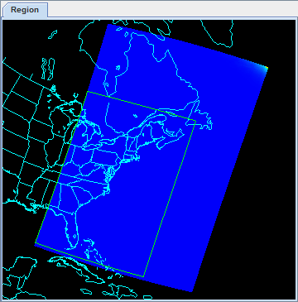Display the data and investigate the display.  
   1. In the **Fields** panel of the ***Field Selector***, select ***IMAGE -> VIIRS-DNB-SDR_All/Radiance***.
   2. In the **Displays** panel of the ***Field Selector***, select the ***Imagery -> Image Display*** display type.
   3. In the ***Region*** tab of the ***Field Selector***, use *Shift+Left-Click+Drag* to draw a green bounding contained entirely within the data over the eastern United States extending into the Atlantic (similar to this image). Any data in this bounding box will be displayed at the full resolution of the data.
   4. Click **Create Display**.
5. Investigate the display.  
   1. In the **Main Display** window, you will likely notice that no data is visible. This is due to the enhancement range values being set based on the minimum and maximum values contained in the data. Adjust the enhancement by *Right-Clicking* on the enhancement in the **Legend** and choosing ***Change Range…***.
   2. In the **Change Range** window, enter **From** and **To** values that better match up with the radiance values contained in the display. For example, you can use values of:  
        
      **From:** *8.8E-10*  
      **To:** *1.9E-8*
   3. This is near full-moon scene, which allows for a display similar to a daytime visible image to be viewed. Other features, such as city lights and ships can be viewed in this scene. The range set in step 17b can be expanded or contracted on either end to make different features easier to see.

**Problem Sets**

The previous examples were intended to give you a general knowledge of how to load and display JPSS data.  The problem sets below are intended to introduce you to new topics related to the data, as well as challenge your knowledge of McIDAS-V.  We recommend that you attempt to complete each problem set before looking at the solutions, which are provided below the problem set.  
  
Note that this example utilizes Suomi NPP data from NOAA CLASS. The files contain both the data and geolocation in the same file. Also, several small granules are aggregated together into one file, so a relatively large geographic domain is covered by a single file.

1. Using the *<local path>***/Data/JPSS/SuomiNPP/GMODO-SVM03-SVM04-SVM05\*** file, create an RGB image using the Reflectance field of all three bands. Create the display by using the **VIIRS_M_RGB(M5,M4,M3)** formula. Display the data at full-resolution and make sure to include a large portion of the granule in your subsetted region. Adjust the **Common Gamma** field in the ***Layer Controls*** to make the individual colors stand out more in the display.
2. Looking at the display over the Great Lakes, it is difficult to discern between clouds and snow over the land. Using the file loaded from question 1, display SVM14 brightness temperature data with the **swathToGrid** formula over the Great Lakes region. Adjust the enhancement to make the clouds display as white instead of black. Overlay this display on the RGB image created in problem 1. This longwave infrared band is useful to distinguish between clouds and snow.
3. Looking at the RGB display over Louisiana, smoke can be observed. Using the file loaded from question 1, display SVM13 brightness temperature data with the **swathToGrid** formula over Louisiana. Overlay this display on the RGB image created in problem 1. This medium-wave infrared band is useful to detect fire activity.
4. Determine the smoke concentration from the Louisiana fire using the <*local path*>/**Data/JPSS/SuomiNPP /GMTCO-VSUMO\*** VIIRS suspended matter EDR data. Overlay this display on the RGB image created in problem 1.

**Problem Set #1 – Solution**

Using the *<local path>***/Data/JPSS/SuomiNPP/GMODO-SVM03-SVM04-SVM05\*** file, create an RGB image using the Reflectance field of all three bands. Create the display by using the **VIIRS_M_RGB(M5,M4,M3)** formula. Display the data at full-resolution and make sure to include a large portion of the granule in your subsetted region. Adjust the **Common Gamma** field in the ***Layer Controls*** to make the individual colors stand out more in the display.

1. Remove all layers and data sources from the previous displays.
2. Select ***File -> New Display Tab -> Map Display -> One Panel*** to create a new one-panel map display tab.
3. Load in a granule containing three bands of VIIRS SVM visible data (SVM03, SVM04 and SVM05).  
   1. In the ***Data Sources*** tab of the **Data Explorer**, select ***Under Development******>******Imagery – Suomi NPP***
   2. Select *<local path>***/Data/JPSS/SuomiNPP/GMODO-SVM03-SVM04-SVM05_npp\***

**(**Note: this file packages the geolocation (GMODO) and the data (SVM*) together into the same file.)

* 1. Click the **Add Source** button.

1. Use theVIIRS formula to create a true-color RGB image with the bowtie effect removed.  
   1. In the ***Field Selector*** tab, under **Data Sources** select **Formulas**.
   2. Under **Fields**, select the **VIIRS_M_RGB(M5,M4,M3)** formula. Click **Create Display**.
   3. In the new **Field Selector** window, select:

* 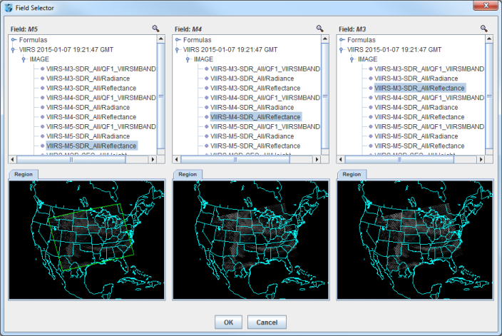For **Field: M5**, select ***VIIRS -> IMAGE -> VIIRS-M5-SDR_All/Reflectance***
* For **Field: M4**, select ***VIIRS -> IMAGE -> VIIRS-M4-SDR_All/Reflectance***
* For **Field: M3**, select ***VIIRS -> IMAGE -> VIIRS-M3-SDR_All/Reflectance***
  1. In the **Region** tab of **Field: M5**, use *Shift+Left-Click+Drag* to select a region to display at full-resolution. Select a region that contains most of the granule, as shown in the image above. It is not necessary to subset a region in for **M4** and **M3**, as the region selected for **M5** will be used for all fields.
  2. Click **OK** to display the results of the **VIIRS_M_RGB(M5,M4,M3)** formula.

1. Adjust the display to enhance the Red, Green, and Blue components of the display.  
   1. Navigate to the ***Layer Controls*** tab of the **Data Explorer**. By default, all **Gamma** values for all colors are set to 1.0. Change this value to 0.4 by entering in *0.4* in the **Common Gamma** field and clicking the **Apply to All Gamma Fields** button.
   2. Return to the **Main Display** window to observe the RGB display and also notice that the bowtie effect has been removed by the formula.

**Problem Set #2 – Solution**

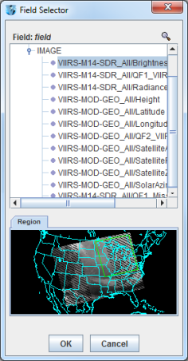Looking at the display over the Great Lakes, it is difficult to discern between clouds and snow over the land. Using the file loaded from question 1, display SVM14 brightness temperature data with the **swathToGrid** formula over the Great Lakes region. Adjust the enhancement to make the clouds display as white instead of black. Overlay this display on the RGB image created in problem 1. This longwave infrared band is useful to distinguish between clouds and snow.

1. Use the **swathToGrid** formula to create a full-resolution display of the data without the bowtie effect.  
   1. In the ***Field Selector*** tab, under **Data Sources** select **Formulas**.
   2. Under **Fields**, select the **swathToGrid** formula. Under **Displays**, select ***Imagery > Image Display***. Click **Create Display**.
   3. In the new **Select input** window, enter *750* for **res** and *1.0* for **mode**. Click **OK**.
   4. In the **Field Selector**, select ***VIIRS* -> IMAGE -> VIIRS-M14-SDR_All/BrightnessTemperature***.
   5. In the **Region** tab, use *Shift+Left-Click+Drag* to select a region over the Great Lakes (as seen in the image on the right) to display at full-resolution.
   6. Click **OK** to display the result of the **swathToGrid** formula.
2. Adjust the display to make the clouds over the Great Lakes appear as white instead of black and investigate the display.  
   1. Change the colorbar to Inverse Gray Scale. To do this, *Right-Click* on the colorbar in the **Legend** and select ***System -> Inverse Gray Scale***. This is done to make the lower data values (colder temperatures, such as clouds) display as white, while warmer temperatures are darker.
   2. Use the visibility checkbox in the **Legend** to toggle the SVM14 layer on and off to compare with the RGB display underneath. The temperature difference between clouds and snow in this infrared band allows the clouds to stand out more than they do in the visible bands used in the RGB display.

**Problem Set #3 – Solution**

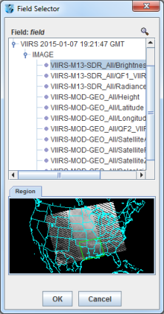Looking at the RGB display over Louisiana, smoke can be observed. Using the file loaded from question 1, display SVM13 brightness temperature data with the **swathToGrid** formula over Louisiana. Overlay this display on the RGB image created in problem 1. This medium-wave infrared band is useful to detect fire activity.

1. Use the **swathToGrid** formula to create a full-resolution display of the data without the bowtie deletion.  
   1. In the ***Field Selector*** tab, select **Formulas** under **Data Sources**.
   2. Under **Fields**, select the **swathToGrid** formula. Under **Displays**, select ***Imagery -> Image Display***. Click **Create Display**.
   3. In the new **Select input** window, enter *750* for **res** and *1.0* for **mode**. Click **OK**.
   4. In the **Field Selector** window, select ***VIIRS* -> IMAGE -> VIIRS-M13-SDR_All/BrightnessTemperature***.

In the **Region** tab, use *Shift+Left-Click+Drag* to select a region over Louisiana to display at full-resolution. Click **OK** to display the result of the **swathToGrid** formula.

1. Use the visibility checkbox in the **Legend** to toggle the SVM13 layer on and off to compare with the RGB display underneath.

**Problem Set #4 – Solution**

Determine the smoke concentration from the Louisiana fire using the <*local path*>/**Data/JPSS/SuomiNPP /GMTCO-VSUMO\*** VIIRS suspended matter EDR data. Overlay this display on the RGB image created in problem 1.

1. In the ***Data Sources*** tab of the **Data Explorer**, navigate to the ***Under Development*** *-****>******Imagery -> Suomi NPP*** chooser.  
   1. Under **Files**, select the following file:  
      *<local path>***/Data/JPSS/SuomiNPP/GMTCO-VSUMO\***
   2. Click the **Add Source** button.
2. Display the smoke concentration from the EDR data.  
   1. In the **Fields** panel of the **Field Selector**, select:  
      ***Image -> VIIRS-SusMat-EDR_/All/SmokeConcentration*** field.
   2. Select ***Imagery -> Image Display*** in the **Displays** panel of the ***Field Selector***.
   3. In the ***Region*** tab of the ***Field Selector***, use *Shift+Left-Click+Drag* to subset a region over Louisiana. Anything within this subsetted region will display at the full resolution of the data.
   4. Click **Create Display**.
3. Investigate the smoke concentration from the Louisiana fire.  
   1. In the **Legend** of the **Main Display**, toggle off the visibilities of the SVM13 and SVM14 data so only the RGB and the VIIRS EDR data is displayed.
   2. Navigate over the fire in Louisiana and toggle the VIIRS EDR layer on and off with the visibility checkbox in the **Legend**.

The following table lists out band, wavelength and resolution information for VIIRS SVM, DNB (Day/Night Band) and SVI data. Source: http://rammb.cira.colostate.edu/projects/npp/

**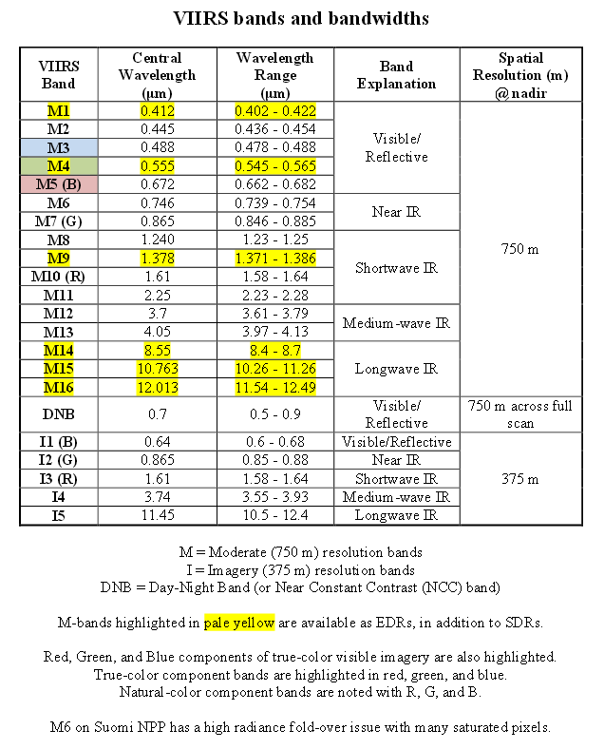  
  
  
  
Zooming, Panning, and Rotating Controls**

|  |  |  |
| --- | --- | --- |
| **Zooming** | **Panning** | **Rotating** |
|  | **Mouse** |  |
| **Shift-Left Drag:** Select a region by pressing the ***Shift*** key and dragging the left mouse button. **Shift-Right Drag:** Hold ***Shift*** key and drag the right mouse button. Moving up zooms in, moving down zooms out. | **Control-Right Mouse Drag:** Hold ***Control*** key and drag right mouse to pan. | **Right Mouse Drag:** Drag right mouse to rotate. |
|  | **Scroll Wheel** |  |
| **Scroll Wheel-Up:** Zoom Out. **Scroll Wheel-Down:** Zoom In. |  | **Control-Scroll Wheel-Up/Down:** Rotate clockwise/counter clockwise. **Shift-Scroll Wheel-Up/Down:** Rotate forward/backward clockwise. |
|  | **Arrow Keys** |  |
| **Shift-Up:** Zoom In. **Shift-Down:** Zoom Out. | **Control-Up arrow:** Pan Down. **Control-Down arrow:** Pan Up. **Control-Right arrow:** Pan Left. **Control-Left arrow**: Pan Right. | **Left/Right arrow:** Rotate around vertical axis. **Up/Down arrow:** Rotate around horizontal axis. **Shift-Left/Right arrow:** Rotate Clockwise/Counterclockwise. |