McIDAS-V Tutorial

Installation and Introduction

updated September 2018 (software version 1.8)

McIDAS-V is a free, open source, visualization and data analysis software package that is the next generation in SSEC's 40-year history of sophisticated McIDAS software packages. McIDAS-V displays weather satellite (including hyperspectral) and other geophysical data in 2- and 3-dimensions. McIDAS-V can also analyze and manipulate the data with its powerful mathematical functions. McIDAS-V is built on SSEC's VisAD and Unidata's IDV libraries. The functionality of SSEC's HYDRA software package is also being integrated into McIDAS-V for viewing and analyzing hyperspectral satellite data.

More training materials are available on the McIDAS-V webpage and in the Getting Started chapter of the McIDAS-V User’s Guide, which is available from the Help menu within McIDAS-V. You will be notified at the startup of McIDAS-V when new versions are available on the McIDAS-V webpage - <http://www.ssec.wisc.edu/mcidas/software/v/>.

If you encounter an error or would like to request an enhancement, please post it to the McIDAS-V Support Forums - <http://www.ssec.wisc.edu/mcidas/forums/>. The forums also provide the opportunity to share information with other users.

Terminology

There are two windows displayed when McIDAS-V first starts, the **McIDAS-V Main Display** (hereafter **Main Display**) and the **McIDAS-V Data Explorer** (hereafter **Data Explorer**).

The **Data Explorer** contains three tabs that appear in bold italics throughout this document: ***Data Sources*, *Field Selector***, and ***Layer Controls***. Data is selected in the ***Data Sources*** tab, loaded into the ***Field Selector***, displayed in the **Main Display**, and output is formatted in the ***Layer Controls***.

Menu trees will be listed as a series (e.g. ***Edit -> Remove -> All Layers and Data Sources***).

Mouse clicks will be listed as combinations (e.g. *Shift+Left Click+Drag)*.

**Installation of McIDAS-V**

The installation of McIDAS-V is a simple three step procedure (download, install, and run).

1. Download the appropriate package for your operating system from the McIDAS-V webpage. This file is only the installer and can be placed anywhere on your machine. When you run the installer in the next step, you can then indicate where you want McIDAS-V to be installed. The system requirements for McIDAS-V are also listed on the McIDAS-V webpage.

2. Install McIDAS-V by starting the installer by following the instructions appropriate for your operating system:

Mac OS X mount the .dmg and double-click the installer

Windows double-click the downloaded **.exe** file

All other platforms open a terminal window and run **sh ./<installer>.sh**

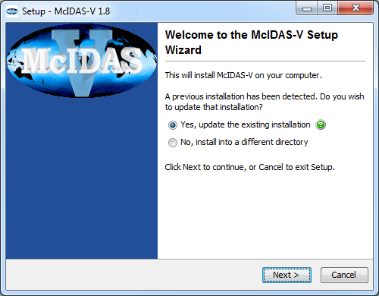

A GUI will walk you through the installation steps and allow you to create a program group and/or desktop icon.

3. Run McIDAS-V by following the instructions appropriate for your operating system:

Mac OS X *Double-click* on the McIDAS-V shortcut icon that was created in /Applications.

Windows *Double-click* on the McIDAS-V shortcut icon that was created on the Desktop.

All others At the UNIX prompt from the directory where McIDAS-V was installed,

run the command: **runMcV**

Note: By default, McIDAS-V uses 80% of the available memory on your machine. The maximum amount of memory is determined by the operating system. To manually change the amount of memory used by McIDAS-V, edit the **Maximum Heap Size** in the **Advanced** tab of the Preferences by selecting   
***Edit -> Preferences...*** from the main menu. The new amount of memory will be saved and used in subsequent sessions. For 32 bit operating systems, it is recommended to set this to no more than 1250 MB. The maximum value for 32 bit operating systems is 1536 MB. Exit McIDAS-V and start a new session to use this new memory setting.

**Welcome Window**

Upon initial startup, the **Welcome to McIDAS-V** window will be displayed.

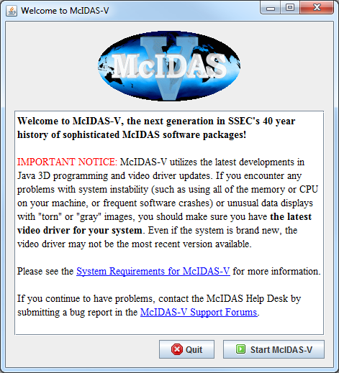

Please be sure to read this **IMPORTANT NOTICE**. Because McIDAS-V utilizes the latest developments in Java 3D programming and video driver updates, it is often necessary to update video drivers to solve some seemingly unrelated performance problems. Do not assume that because you have a new machine, you have the latest drivers. We have found brand new machines with drivers that are more than five years old!

After reading the notice in the Welcome window, click **Quit** to close the window, or click **Start McIDAS-V** to close the window and start McIDAS-V. Once McIDAS-V has been started, this window will not appear again.

**Introduction to McIDAS-V windows**

There are two main windows in the McIDAS-V application - the **Data Explorer** window and the **Main Display** window. Other windows may appear when needed.

|  |  |
| --- | --- |
|  |  |

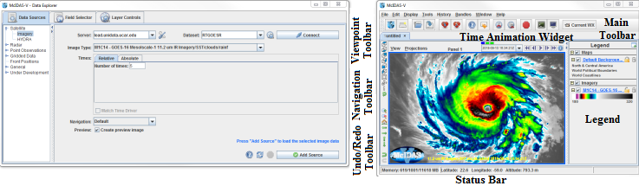

**Data Explorer** (shown on the left)

The **Data Explorer** window is central to McIDAS-V. It is used to choose data sources and parameters to display, the kinds of displays to make, and times of data to display. The first time McIDAS-V starts up, the **Data Explorer** defaults to the ***Satellite -> Imagery Chooser***. This chooser, along with several others, uses ADDE (Abstract Data Distribution Environment) servers to access data. McIDAS-V comes with a pre-configured list of several available free servers which contain real-time and archived atmospheric datasets.

**Main Display** (shown on the right)

The **Main Display** window includes the McIDAS-V display panels, legend, time animation controls, viewpoint controls for 3D displays, icons to zoom and pan, menus to control views and projections, and the main McIDAS-V menu. Navigating to ***Help -> User’s Guide*** in the Main Toolbar brings up the McIDAS-V User’s Guide, which has both a table of contents and a search function.

**Common Usage Scenario**

To create displays of data with McIDAS-V, the common usage scenario is:

* Choosing the source of data (local files, remote servers, etc.)
* Selecting parameters and display type
* Creating the display
* Controlling the display
* Creating a bundle

**Bundles**Bundles let you save a quick "snapshot" of McIDAS-V, including data sources, maps, and data displays. Bundles are small information files that specify the state of McIDAS-V. They are a kind of configuration file. They include information about what data sources are in use, which parameters from the data sources are displayed, and how they are displayed.

The purpose of bundles is for you to save a particular McIDAS-V setup and display. A bundle can be used for your own reference at a later time, or others using McIDAS-V can use bundles you made to see data the same way you did. There are two types of bundles, regular *.mcv bundles, and *.mcvz zipped bundles. These serve different purposes.

The *.mcv bundle, along with storing the setup and display options, stores a reference to the particular type of data you have loaded into McIDAS-V. For example, if you load in the most recent GFS, display pressure, and save your display as a *.mcv bundle, the next time the bundle is loaded, McIDAS-V will connect to the server/catalog where you got the data from originally, and display the most recent GFS pressure data. This type of bundle can be very useful in an operational environment, where you often want to look at the same products displaying the most recent data.

The *.mcvz bundle is different from the *.mcv bundle in that it actually stores data along with the bundle. For example, if you load in radar data for a tornado case that you want to look at again, but that may not be on the server at a later date, you can save your display as a *.mcvz zipped bundle. The next time this bundle is loaded in, the same exact data with the same display options will be displayed. This can be useful for case studies, where you always want to look at the same data.

**Data Explorer - Data Sources tab**

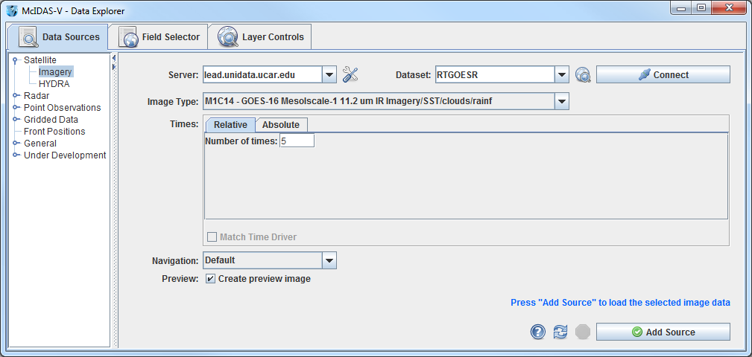

The ***Data Sources*** tab is used to locate remote data servers or local files for display in McIDAS-V. Once the type of data source is selected, a chooser with the appropriate selection criteria is displayed. ***Satellite -> Imagery*** is chosen above, and the ***Satellite -> Imagery*** chooser is displayed. Other data source types are the HYDRA multi-spectral display, Radar, Point Observations, Gridded Data and General files.

**Data Explorer - Field Selector tab**

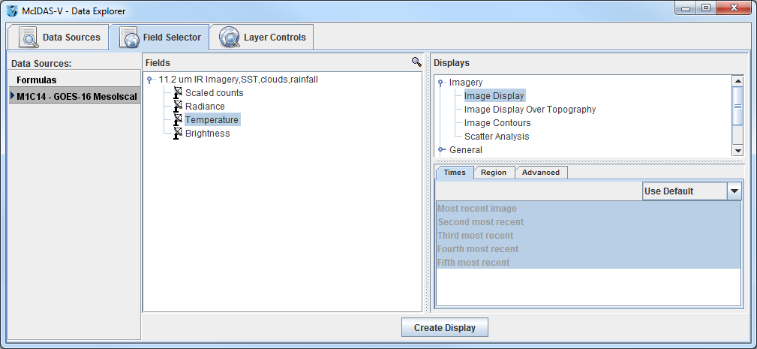

The ***Field Selector*** tab analyzes the data source to determine the displayable fields and parameters. With this information, a list of available displays is presented. In the **Subset** panel of the ***Field Selector*** there are tabs to select which times to display, which region to use, as well as a variety of advanced options. Note that the tabs in the **Subset** panel will differ dependent on which data source you loaded.

**Data Explorer - Layer Controls tab**

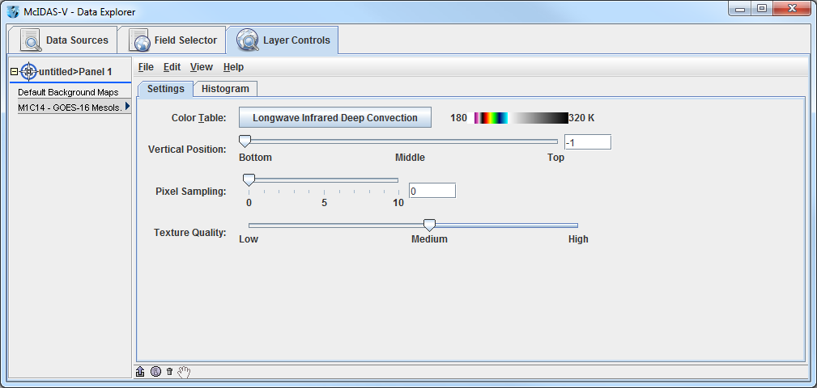

The ***Layer Controls*** tab contains the display options for the displayed fields and parameters which are referred to as layers. Changes made to each layer will be reflected in the **Main Display**. Also, if a graph, time series or special display was selected, it will display in the ***Layer Controls***.

**Introduction to McIDAS-V controls**

1. Load the *<local path>****/*Data/Installation/Intro-Bundle.mcvz** bundle to display NCEP GFS data in the **Main Display** window.
   1. In the **Main Menu Bar** in the **Main Display** window of McIDAS-V, select ***File -> Open File…****.*
   2. In the file browser, “Look In” the location where you downloaded the data files for this tutorial, select **Intro-Bundle.mcvz** and click **Open**.
   3. When prompted, select *Replace Session* to replace the current window with the contents of the bundle and click **OK**.
   4. Select *Remove all layers*.
   5. Select *Remove all data*.
   6. Select *Write to temporary directory*, check *Don’t show this again*, and click **OK**.  
        
      The **Main Display** will change to a view from the south, and two new 3D Surfaces will be listed in the **Legend** in the right panel of the **Main Display** window. One surface is a color-shaded image over topography. The other surface is an isosurface of a constant wind speed of 50 m/s. The yellow isosurface is shadowed for perspective, otherwise it would be one block of color.
2. Use *Right-Click+Drag* to rotate the display. Use the navigation controls listed on the last page of this document or the navigation controls on the left side of the **Main Display** to zoom in and out, and “move through” the data.
3. Toggle the 3D surfaces on and off in the display by clicking the checkbox next to each item in the **Legend** on the right side of the **Main Display** window.
4. Click on the name of each item in the **Legend** to bring up the ***Layer Controls*** to change the color table or the isosurface values. To change the unit of the isosurface to something other than **m/s**, in the ***Layer Controls*** menu select ***Edit -> Change Display Unit***.
5. Use the **Time Animation** controls at the top of the **Main Display** to loop through the images, or step through them one by one.

**Below is a list of supported data types, formats, and the method to access them in McIDAS-V.**

|  |  |  |  |
| --- | --- | --- | --- |
| **Data Type** | **Description** | **Supported Formats** | **Access Method** |
| Gridded | Numerical weather prediction models, climate analysis, gridded  oceanographic datasets, NCEP/NCAR Reanalysis | netCDF | local files, HTTP, TDS Servers |
| GRIB (versions 1&2) | local files, TDS Servers |
| Vis5D | local files, HTTP |
| GEMPAK | local files, TDS Servers |
| Satellite  Imagery | Geostationary and polar orbiter satellite imagery, derived satellite products | ADDE | ADDE servers, local & remote |
| McIDAS AREA | local files, local & remote ADDE |
| AIRS | local files |
| GINI | local files, TDS servers |
| AMSR-E Level 1b | local ADDE |
| AMSR-E Level 2a | local ADDE |
| AMSR-E Rain Product | local ADDE |
| EUMETCast LRIT | local ADDE |
| Meteosat OpenMTP | local ADDE |
| Meteosat Second Generation  (MSG) Level 1b | local ADDE |
| Metop AVHRR Level 1b | local ADDE |
| MODIS L1b MOD02  (MODIS Level 1b) | local ADDE |
| MODIS L2 MOD04  (Level 2 Aerosol) | local ADDE |
| MODIS L2 MOD06  (Level 2 Cloud Top Properties) | local ADDE |
| MODIS L2 MOD07  (Level 2 Atmospheric Profile) | local ADDE |
| MODIS L2 MOD28  (Level 2 Sea Surface Temperature Products) | local ADDE |
|  |
| MODIS L2 MOD35  (Level 2 Cloud Mask) | local ADDE |
| MODIS L2 MODR  (Level 2 Corrected Reflectance) | local ADDE |
| MSG HRIT FD and HRV | local ADDE |
| MTSAT HRIT | local ADDE |
| NOAA AVHRR Level 1b | local ADDE |
| SSMI (TeraScan netCDF) | local ADDE |
| TRMM (TeraScan netCDF) | local ADDE |
| Himawari-8 (*.DAT) * | local ADDE |
| INSAT-3D Imager * | local ADDE |
| INSAT-3D Sounder * | local ADDE |
| GOES-16 ABI (Level 1b) * | local ADDE |

|  |  |  |  |
| --- | --- | --- | --- |
| **Data Type** | **Description** | **Supported Formats** | **Access Method** |
| Radar | Radar images | Level II | local files or TDS (bzip2 compressed or uncompressed) |
|  | Level III/TDWR | ADDE Servers, local files, or TDS |
|  | Universal Format (UF) | local files |
|  | DORADE | local files |
| Point  Observational | Surface observations (METAR and  SYNOP), earthquake observations | ADDE | ADDE servers |
| netCDF (Unidata, AWIPS/MADIS formats) | local files |
| Text (ASCII, CSV), Excel spreadsheet | local files |
| Global balloon soundings (RAOB) | ADDE | ADDE servers |
| netCDF (Unidata, AWIPS/MADIS formats) | local files |
| CMA text format | local files |
| Trajectory | Aircraft observations | netCDF (RAF convention) | local files |
| Text (ASCII, CSV) | local files |
| GIS | Data typically used in Geographic Information Systems (GIS) | ESRI Shapefile | local files, HTTP |
| USGS DEM | local files |
| QuickTime | QuickTime movies (without extensions) | QuickTime | local files, HTTP |
|  |  |
| Flat Files | Flat (2-dimensional) data | Binary, ASCII, standard images (JPEG, GIF, etc.) | local files; Flat files chooser |

* The Himawari-8, INSAT-3D, and ABI local servers are currently supported on Linux and OS X platforms

**Zooming, Panning, and Rotating Controls**

|  |  |  |
| --- | --- | --- |
| **Zooming** | **Panning** | **Rotating** |
|  | **Mouse** |  |
| **Shift-Left Drag:** Select a region by pressing the ***Shift*** key and dragging the left mouse button.  **Shift-Right Drag:** Hold ***Shift*** key and drag the right mouse button. Moving up zooms in, moving down zooms out. | **Control-Right Mouse Drag:** Hold ***Control*** key and drag right mouse to pan. | **Right Mouse Drag:** Drag right mouse to rotate. |
|  | **Scroll Wheel** |  |
| **Scroll Wheel-Up:** Zoom Out.  **Scroll Wheel-Down:** Zoom In. |  | **Control-Scroll Wheel-Up/Down:** Rotate clockwise/counter clockwise.  **Shift-Scroll Wheel-Up/Down:** Rotate forward/backward clockwise. |
|  | **Arrow Keys** |  |
| **Shift-Up:** Zoom In.  **Shift-Down:** Zoom Out. | **Control-Up arrow:** Pan Down.  **Control-Down arrow:** Pan Up.  **Control-Right arrow:** Pan Left.  **Control-Left arrow**: Pan Right. | **Left/Right arrow:** Rotate around vertical axis.  **Up/Down arrow:** Rotate around horizontal axis.  **Shift-Left/Right arrow:** Rotate Clockwise/Counterclockwise. |