McIDAS-V Tutorial

Displaying Gridded Data

updated August 2018 (software version 1.8)

McIDAS-V is a free, open source, visualization and data analysis software package that is the next generation in SSEC's 40-year history of sophisticated McIDAS software packages. McIDAS-V displays weather satellite (including hyperspectral) and other geophysical data in 2- and 3-dimensions. McIDAS-V can also analyze and manipulate the data with its powerful mathematical functions. McIDAS-V is built on SSEC's VisAD and Unidata's IDV libraries. The functionality of SSEC's HYDRA software package is also being integrated into McIDAS-V for viewing and analyzing hyperspectral satellite data.

More training materials are available on the McIDAS-V webpage and in the Getting Started chapter of the McIDAS-V User’s Guide, which is available from the Help menu within McIDAS-V. You will be notified at the startup of McIDAS-V when new versions are available on the McIDAS-V webpage - <http://www.ssec.wisc.edu/mcidas/software/v/>.

If you encounter an error or would like to request an enhancement, please post it to the McIDAS-V Support Forums - <http://www.ssec.wisc.edu/mcidas/forums/>. The forums also provide the opportunity to share information with other users.

This tutorial assumes that you have McIDAS-V installed on your machine, and that you know how to start McIDAS-V. If you cannot start McIDAS-V on your machine, you should follow the instructions in the document entitled *McIDAS-V Tutorial – Installation and Introduction*.

In this McIDAS-V Tutorial, each exercise will be explained using two different methods of data access: pre-loaded data bundles and real-time access to default remote servers. If you have access to your own real-time servers, you may also use those, but be aware that different server configurations may make the explanations in this document not quite applicable to all data that you may load.

Terminology

There are two windows displayed when McIDAS-V first starts, the **McIDAS-V Main Display** (hereafter **Main Display**) and the **McIDAS-V Data Explorer** (hereafter **Data Explorer**).

The **Data Explorer** contains three tabs that appear in bold italics throughout this document: ***Data Sources*, *Field Selector***, and ***Layer Controls***. Data is selected in the ***Data Sources*** tab, loaded into the ***Field Selector***, displayed in the **Main Display**, and output is formatted in the ***Layer Controls***.

Menu trees will be listed as a series (e.g. ***Edit -> Remove -> All Layers and Data Sources***).  
  
Mouse clicks will be listed as combinations (e.g. *Shift+Left Click+Drag*).

**Displaying Gridded data: 2D**

1. Remove all layers and data sources from the previous displays.
2. If you are using real-time data, skip to step 3. Otherwise, load the data bundle  
    *<local path>***/Data/Gridded/Grid-GFS-Intro.mcvz**.  
   1. In the **Main Display**, select the ***File -> Open File…*** menu item.
   2. Navigate to the **Grid-GFS-Intro.mcvz** file and click **Open**.
   3. If prompted, in the **Open Bundle** dialog box, select the *Replace session* option and click **OK.**
3. If you are using real-time data, follow the instructions below. With real-time data, note that the field names referenced in later steps may be slightly different than how they are written in this tutorial.
   1. Select the ***Gridded Data -> Remote*** chooser from the ***Data Sources*** tab of the **Data Explorer**.
   2. From the **Catalog** pull down menu, select http://www.ssec.wisc.edu/mcidas/software/v/threddsRTModels.xml.
   3. Add the ***Realtime Data -> NCEP Model Data -> Global Forecast System (GFS) -> GFS-CONUS 80km -> Latest*** source.
4. Display the MSL Pressure.  
   1. In the ***Field Selector***, select the ***2D grid -> Pressure reduced to MSL @ msl*** field.
   2. Select the ***Plan Views -> Color-Shaded Plan View*** Display.
   3. In the ***Times*** tab, use the dropdown to choose **Use Selected**, and select the first six times.
   4. Click **Create Display**.
5. In the ***Layer Controls,*** turn on the option to **Shade Colors**.

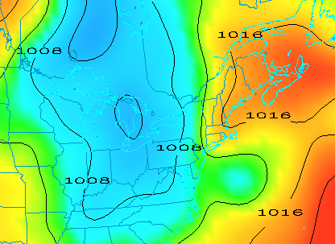

1. Go back to the ***Field Selector***, change the display type to ***Contour Plan View****,* and overlay the same field.
   1. Select the ***2D grid -> Pressure reduced to MSL @ msl*** field.
   2. Select the ***Plan Views -> Contour Plan View*** display type.
   3. Click **Create Display**. The contours will now overlay the ***Color-Shaded Plan View*** display.
2. In the ***Layer Controls***, click on the **Color Table** name (PressureMSL) to change the color table of the contours to ***System -> Solid Colors -> Black***.
3. In the ***Layer Controls*** tab, click the **Change** button for **Contour**. For **Labels**, change the **Align** item to *Horizontal* and move the **Frequency** slider up to a value of *Hi*. Click **OK**.
4. Zoom in over a region to see a display like that on the previous page.

**Displaying Gridded data: 3D**

1. Remove all layers. In the ***Field Selector***, select the ***3D grid -> Temperature @ Isobaric surface*** field.  
   1. Select the ***Plan Views -> Color-Filled Contour Plan View*** display type.
   2. In the ***Times*** tab select the first 6 images.
   3. In the ***Level*** tab, select *500 hPa*.
   4. Click **Create Display**.
2. Use the rotating and zooming controls to rotate the **Main Display** window. You can see that the 500 hPa surface is displayed above the map layer.
3. Keep the **Main Display** rotated so the difference in height between the map and the display can be seen.
4. Change the level of the display. Note that when the level is changed, both the plotted values and the z-level of the display change in the **Main Display**.  
   1. Click on *Latest NCEP GFS CONUS…* in the **Legend** to go to the ***Layer Controls*** for this item.
   2. Change the level to *850 hPa* by using the **Levels** menu.
   3. Change the contour interval to *2* Celsius by clicking on the **Change** button in the Contour section of the ***Layer Controls***.
5. Reset the projection using the button on the left side of the **Main Display** window



1. Change the level to *250 hPa* in the ***Layer Controls*** using the method in 13b. You should notice that the map does not show up on the displayed data.
2. Move the map above the 250 hPa contours and change the map colors to white.
   1. In the ***Layer Controls***, select *Default Background Maps* from the list of layers on the side of the tab.
   2. At the bottom of the ***Maps*** tab, move the **Position** slider to the z-level of 0.30 to move higher into the 3D display. You should now see that the map lines are drawn on the data displayed in the **Main Display**. However, the map lines may be hard to see since they are the same color as the data by default.
   3. In the ***Maps*** tab of the ***Layer Controls*** for Default Background Maps, change the map colors of “North & Central America”, “World Political Boundaries”, and “World Coastlines” to white. Do this by clicking on the colored square next to each of the map lines, selecting white, and hitting **OK**. The map lines should now be more clearly visible in the **Main Display** window.

**Displaying Gridded data: Ensembles**

1. Remove all layers and data sources.
2. If you are using real-time data, skip to step 19. Otherwise, load the local NetCDF file  
    *<local path>***/Data/Gridded/GEFS_Global_1p0deg_members**.  
   1. In the ***Data Sources*** tab of the **Data Explorer**, navigate to the ***Gridded Data -> Local*** chooser.
   2. Select the *<local path>***/Data/Gridded/GEFS_Global_1p0deg_members.nc**.
   3. Click **Add Source** and continue to step 20.
3. Add a gridded data source of ensemble members.  
   1. In the ***Data Sources*** tab of the **Data Explorer**, navigate to the ***Gridded Data -> Remote*** chooser.
   2. Select ***Realtime Data -> NCEP Model Data -> Global Ensemble Forecasting System (GEFS) -> GEFS Members - Forecasts -> latest\**** and click **Add Source**.

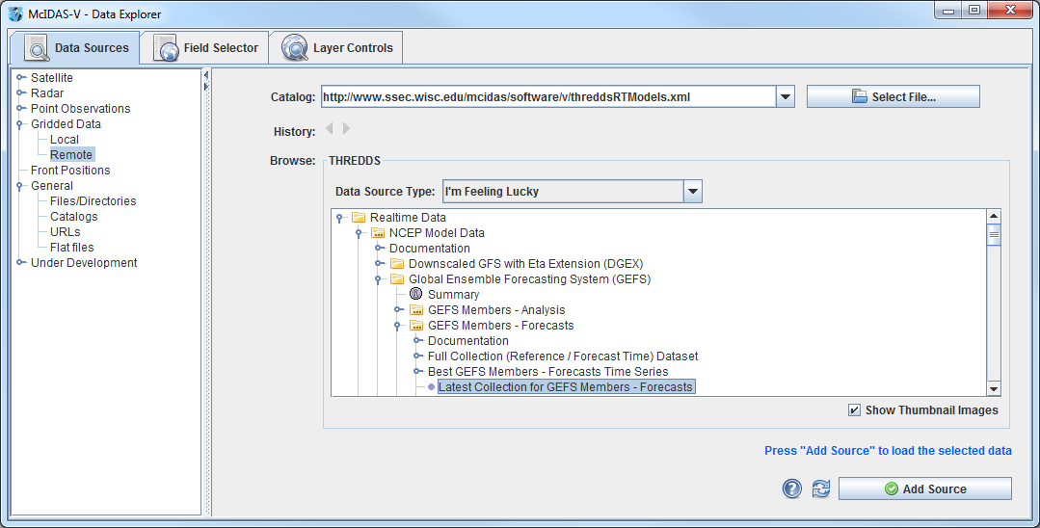

1. To ensure that the ensemble’s display uses the native projection of the data, verify that ***Projections -> Auto-set Projection*** is enabled in the **Main Display**.
2. Display MSLP data of a few ensemble members.
3. In the **Fields** panel of the ***Field Selector***, select the ***2D grid -> Mass -> Pressure reduced to MSL @ Mean sea level*** field. Note that this tree will not exist if working with the local NetCDF file, only the ***Pressure reduced to MSL @ Mean sea level*** field.
4. In the ***Ensemble*** subset tab, select (*command left-click*) members *.0*, *5.0*, *10.0*, *15.0*, and *20.0*.
5. In the ***Times*** subset tab, choose **Use Selected**. Then, select the first 10 times.
6. Click **Create Display**.
7. Inspect the display. Play through the loop to see how the ensemble members slowly begin diverging from each other you get further away from the initialization of the model run.
8. Note that by default the ensemble contours are colored by their member value (per the enhancement values of the colorbar in the **Legend** ranging from 0 to 20). Change the display to color the contours by pressure value instead of ensemble member.
9. In the ***Layer Controls*** for the ensemble layer, uncheck **Color by Member**.
10. Look at the display to notice that all of the contours are now the same color. This is because the range from the ensemble members (0-20) is still being applied to the enhancement. Since all of the pressure values are greater than 20 Pascals, the color value for the enhancement table maximum is used. Change the enhancement values to fit the range of data by *right-clicking* on the colorbar in the **Legend** and selecting ***Change Range***. In the **Change Range** window, enter a **From** value of *95200* and a **To** value of *105200*.
11. Use a formula to display the minimum pressure value of a few ensemble members.
12. Remove all layers.
13. In the ***Field Selector*** tab of the **Data Explorer**, click on **Formulas**.
14. In the **Fields** panel, select the ***Grids -> Ensembles -> Ensemble grid lowest values*** formula, the ***Imagery -> Image Display*** display type, and click **Create Display**.
15. In the **Field Selector** window, select the ***2D grid -> Mass -> Pressure reduced to MSL @ Mean sea level***. In the ***Times*** tab, select the first 10 times. In the ***Ensemble*** tab, select members *.0*, *5.0*, *10.0*, *15.0*, and *20.0*. Click **OK**.  
    - This generates a display of the first 10 timesteps of the ensemble. The ensemble members selected when evaluating the formula are used to determine the lowest pressure value at each location over each timestep.
16. The formula in step 23 provides the option for individually selecting which ensemble members are used in the formulas. As an alternative, a data source can be added that already has a derived mean and standard deviation for all ensemble members. Remove all layers and data sources.
17. If you are using real-time data, skip to step 27. Otherwise, load the local NetCDF file  
     *<local path>***/Data/Gridded/GEFS_Global_1p0deg_products**.  
    1. In the ***Data Sources*** tab of the **Data Explorer**, navigate to the ***Gridded Data -> Local*** chooser.
    2. Select the *<local path>***/Data/Gridded/GEFS_Global_1p0deg_products.nc**.
    3. Click **Add Source** and continue to step 28.
18. In the ***Data Sources*** tab of the **Data Explorer**, navigate to the ***Gridded Data -> Remote*** chooser.  
    1. In the ***Data Sources*** tab of the **Data Explorer**, navigate to the ***Gridded Data -> Remote*** chooser.
    2. Select ***Realtime Data -> NCEP Model Data -> Global Ensemble Forecasting System (GEFS) -> GEFS Derived Forecast Products -> latest\**** and click **Add Source**.
19. In the ***Field Selector***, select the ***2D grid -> Mass -> Pressure reduced to MSL (Unweighted mean of all members) @ Mean sea level***. Note that this tree will not exist if working with the local NetCDF file, only the ***Pressure reduced to MSL (Unweighted mean of all members) @ Mean sea level*** field.
20. Choose the ***Plan Views -> Contour Plan View*** display type, the first 10 times, and click **Create Display**.

**Problem Sets**

The previous examples were intended to give you a general knowledge of how to load and display gridded data.  The problem sets below are intended to introduce you to new topics related to the data, as well as challenge your knowledge of McIDAS-V.  We recommend that you attempt to complete each problem set before looking at the solutions, which are provided below the problem set.

1. Using data from the *<local path>***/Data/Gridded/Grid-GFS-Intro.mcvz** bundle, create a display of 2D Pressure with the 3D Color Shaded Image Over Topography display using the most recent time. Overlay Absolute Vorticity as an isosurface using the most recent time. Then, remove the Absolute Vorticity layer and add a Color-Filled Contour Cross Section of Relative Humidity using the oldest time.
2. Create a 3D globe display of jet stream winds and 2D surface temperature from grids for the first three times. Use the bundle *<local path>***/Data/Gridded/Grid-Problem-Globe.mcvz** to load the grids. Create a movie of your display rotating and playing the loop. Note: This bundle is large, so it may take a minute to open the file.
3. Create a display showing the difference between the 0Z and 6Z GFS Global 1 degree runs *2D Pressure Reduced to MSL @ msl* field for 2018-08-20 00:06:00Z. Change the units to millibars and then change the range to match the new units. Save a JPG image of the difference. You may use bundle *<local path>***/Data/Gridded/Grid-Problem-Difference.mcvz** or real-time data to load the grids. If you are using real-time data, do not use the 2018 date, but choose one individual time to use or both model runs.
4. Create a display of 2D trajectories colored by horizontal divergence overlaid on mean sea level pressure. Use the bundle *<local path>***/Data/Gridded/Grid-Problem-Trajectories.mcvz** or real-time data to load the grids. Only use the first 10 time steps included with the data for this problem. First, display MSLP data using the Color-Shaded Plan View display type. Change the enhancement to Inverse Gray Scale and set the enhancement range to match the data values. Second, draw trajectories colored by horizontal divergence over the full domain of the data. Shorten the trajectories to only be two time steps in length, and set them at a thickness of 2. Color the trajectories by the *<local path>***/Data/Gridded/Divergence.xml** enhancement. Note that the blue trajectories representing divergence are over areas of higher MSLP, whereas the yellow, orange, and red trajectories for negative divergence (i.e. convergence) are over areas of lower MSLP.

**Problem Set #1 – Solution**

Using data from the *<local path>***/Data/Gridded/Grid-GFS-Intro.mcvz** bundle, create a display of 2D Pressure with the 3D Color Shaded Image Over Topography display using the most recent time. Overlay Absolute Vorticity as an isosurface using the most recent time. Then, remove the Absolute Vorticity layer and add a Color-Filled Contour Cross Section of Relative Humidity using the oldest time.

1. Load the *<local path>***/Data/Gridded/Grid-GFS-Intro.mcvz** bundle.
2. Display the most recent 2D Pressure field over topography.
   1. In the **Fields** panel of the ***Field Selector***, select the ***2D grid -> Pressure reduced to MSL @ msl*** field.
   2. Under **Displays**, select the ***3D Surface -> Color-Shaded Image Over Topography*** display.
   3. In the ***Times*** tab of the ***Field Selector***, choose the first listed time only.
   4. Click **Create Display** and you will be prompted to enter the Topography field.
   5. In the new **Field Selector** window, select the ***Latest NCEP GFS CONUS 80km -> Geopotential_height @ surface*** field under **Field: Topography**, and click **OK**. The 2D field will be displayed over topography.
3. In the ***Layer Controls*** tab for the Pressure field, check the **Shade Colors** option.
4. Use the zooming and rotating controls to see the display in 3D. Reset the display projection using the icon on the left side of the **Main Display** window.



1. Display the most recent ***3D grid -> Absolute_vorticity @ isobaric*** with the ***3D Surface -> Isosurface*** display type. Click **Create Display**.
2. Zoom in over the US and rotate the display to see the absolute vorticity isosurface over the continental US.
3. The **Isosurface Value** in the ***Layer Controls*** can be used to change the value of absolute vorticity displayed. Change the value to *1 x 1.0e-5 s-1*.

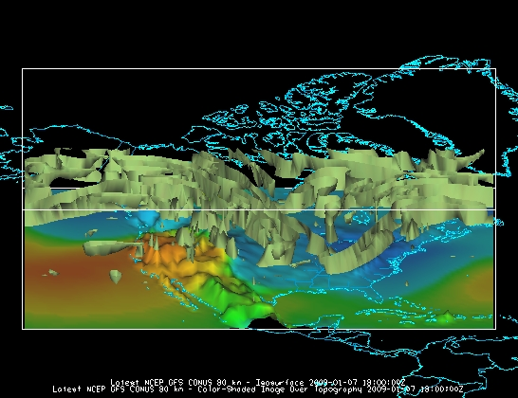

1. Remove the absolute vorticity isosurface layer from the display with the trashcan icon in the **Legend**.
2. In the **Field Selector**, select the earliest ***3D grid -> Relative_humidity @ Isobaric*** field using the ***Vertical Cross Sections ->*** ***Color-Filled Contour Cross Section*** display type. Click **Create Display**. The cross section will be displayed in 3D in the **Main Display** window and in 2D in the ***Layer Controls***.
3. To reposition the cross section in the **Main Display** window, *Left Click* on the plus or square to move the ends of the cross section, and the triangle to move the entire line.

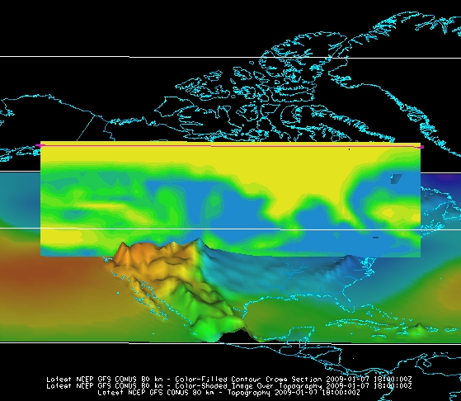

#### 

#### Problem Set #2 – Solution

Create a 3D globe display of jet stream winds and 2D surface temperature from grids for the first three times. Use the bundle *<local path>***/Data/Gridded/Grid-Problem-Globe.mcvz** to load the grids. Create a movie of your display rotating and playing the loop. Note: This bundle is large, so it may take a minute to open the file.

1. Add a one panel globe display tab by selecting ***File -> New Display Tab -> Globe Display -> One Panel*** from the **Main Display**.
2. Load the *<local path>***/Data/Gridded/Grid-Problem-Globe.mcvz** bundle via the ***File -> Open File…*** menu item in the **Main Display**. In the **Open Bundle** dialog box select the *Replace session* option and click **OK.** This is a large dataset, so it may take a minute to open the file.
3. Display the first three ***2D grid -> Temperature -> Temperature at Ground or water surface*** grids as a **Color-Filled Contour Plan View**. Overlay it again as contours.
4. Display the ***3D -> Momentum -> Derived -> Speed*** grid as a ***3D Isosurface*** for the same times.
5. In the ***Layer Controls***, change the following:
   1. Change **Isosurface Value** to *60 m/s*.
   2. Change the default “World Coastlines” map color to RGB *0-153-204* and the default “World Political Boundaries” map color to RGB *0-255-255*. This is done by going to the **Default Background Maps**, selecting the color square next to your desired map and navigating to the ***RGB*** tab.
6. Disable the wireframe box by unselecting ***View -> Show -> Wireframe Box***.
7. Start the loop and turn on the **Auto-Rotate View** option (***View -> Viewpoint -> Auto-Rotate View*** from the **Main Display**). Use the Zooming and Panning controls to observe the data from different views. (Depending on preference, it might help to turn the **Auto-Rotate View** option off.)
8. With the loop playing and the globe rotating, capture a movie of the display by selecting ***View -> Capture -> Movie…*** in the **Main Display**.

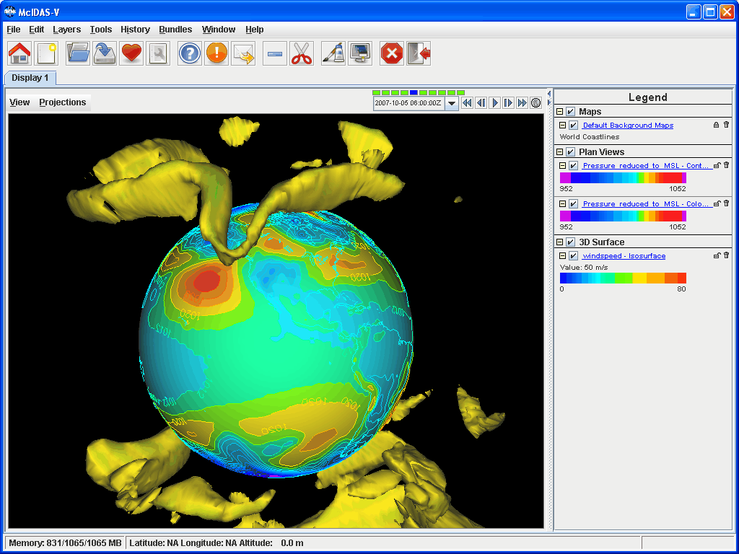

1. In the **Movie Capture** window, change **Rate:** to *0.25* seconds.
2. Move the **Main Window** and the **Movie Capture** window around so they do not overlap. (During the movie capture, if the view in the **Main Window** is obscured, the obscurities will be shown in the capture).
3. Start the movie capture by clicking **Automatically**.
4. Once the globe has rotated 360°, click **Stop**. Click **Save Movie** to save it as a QuickTime movie.

**Problem Set #3 – Solution**

Create a display showing the difference between the 0Z and 6Z GFS Global 1 degree runs ***2D Pressure Reduced to MSL @ msl*** field for 2018-08-20 00:06:00Z. Change the units to millibars and then change the range to match the new units. Save a JPG image of the difference. You may load the grids using real-time data or with the bundle *<local path>***/Data/Gridded/Grid-Problem-Difference.mcvz**. If you are using real-time data, do not use the 2018 date, but choose one individual time to use on both model runs.

1. Open a new tab and close the globe display tab.
2. If you are using real-time data, skip to step 4. Otherwise, load the data bundle *<local path>***/Data/Gridded/Grid-Problem-Difference.mcvz**. If prompted, in the **Open Bundle** dialog box select the *Replace session* option and click **OK.**
3. If you are using real-time data, follow the instructions below.
4. Remove all layers and data sources.
5. Return to the ***Data Sources*** tab, and load the 0Z and 6Z GFS *Global 1°* grids (***Realtime Data -> NCEP Model Data -> Global Forecast System (GFS) -> GFS One Degree - Global Coverage -> GFS One Degree Forecast -> GFS_Global_onedeg_YYYYMMDD_0000.grib2 (0600.grib2)***) for today into the ***Field Selector***.
6. Choose **Formulas** in the ***Field Selector***, and select ***Miscellaneous -> Simple difference a-b***.
7. In the **Displays** panel select ***Plan Views -> Color-Shaded Plan View*** and click **Create Display**. A **Field Selector** window will pop up prompting you for the two fields to subtract. You may need to expand the window to see the full descriptions.
8. For **Field: a**, select the 0Z run ***Pressure Reduced to MSL @ msl*** field and the 2018-08-20 00:06:00Z time.
9. For **Field: b**, select the 6Z run ***Pressure Reduced to MSL @ msl*** field and the 2018-08-20 00:06:00Z time. Click **OK**.

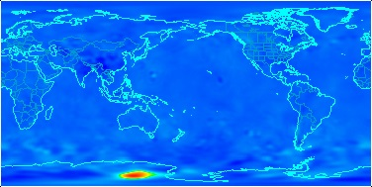

1. The resulting plot will show the difference between the two grids in Pascals. Change this to millibars.
2. In the ***Layer Controls***, select ***Edit -> Change Display Unit…***
3. Select *millibar* from the dropdown list and click **OK**. In the display, positive values indicate the 0Z forecast predicted a higher pressure than the 6Z, and negative values indicate the opposite.
4. Save the **Main Display** window as an image. Select the ***View -> Capture -> Image…*** menu item from the **Main Display**.
5. Under **Capture What**, change the radio button to *Full Window*.
6. Enter in a name, followed by the “.jpg” extension and click **Save**.

**Problem Set #4 – Solution**

Create a display of 2D trajectories colored by horizontal divergence overlaid on mean sea level pressure. Use the bundle *<local path>***/Data/Gridded/Grid-Problem-Trajectories.mcvz** or real-time data to load the grids. Only use the first 10 time steps included with the data for this problem. First, display MSLP data using the Color-Shaded Plan View display type. Change the enhancement to Inverse Gray Scale and set the enhancement range to match the data values. Second, draw trajectories colored by horizontal divergence over the full domain of the data. Shorten the trajectories to only be two time steps in length, and set them at a thickness of 2. Color the trajectories by the *<local path>***/Data/Gridded/Divergence.xml** enhancement. Note that the blue trajectories representing divergence are over areas of higher MSLP, whereas the yellow, orange, and red trajectories for negative divergence (i.e. convergence) are over areas of lower MSLP.

* + - 1. If you are using real-time data, skip to step 3. Otherwise, load the data bundle *<local path>***/Data/Gridded/Grid-Problem-Trajectories.mcvz**. If prompted, in the **Open Bundle** dialog box select the *Replace session* option and click **OK**. Skip to step 3.
      2. Create a new tab in the **Main Display**.
      3. If you are using real-time data, follow the instructions below.

Return to the ***Data Sources*** tab, and load the most recent GFS 80km CONUS data (***Realtime Data -> NCEP Model Data -> Global Forecast System (GFS) -> GFS CONUS 80km -> Latest NCEP GFS CONUS 80km)***) in the ***Field Selector***.

Click **Add Source**.

* + - 1. Display the first 10 times of MSLP data.
  1. Under **Fields** in the ***Field Selector***, select the ***2D grid -> Pressure reduced to MSL @ Mean sea level*** field.
  2. Under **Displays**, select ***Plan Views -> Color Shaded Plan View***.
  3. In the ***Times*** tab, use the dropdown menu to choose **Use Selected**, *Right-Click* and choose ***Select Range -> First 10***. Click **Create Display**.  
     + 1. Modify the enhancement and range of the MSLP layer.
  4. In the **Legend** of the **Main Display**, *Right-Click* on the enhancement and select ***System -> Inverse Gray Scale***.
  5. In the **Legend** of the **Main Display**, *Right-Click* on the enhancement and select ***Change Range…***.
  6. In the **Change Range** window, click the **Use Predefined** button and select ***From All Data***.
  7. Click **OK**.  
     + 1. Create a layer for the first 10 times of 2D trajectories colored by horizontal divergence.
  8. Under **Fields** in the ***Field Selector***, select the ***2D grid -> Derived -> Grid 2D Trajectory\**** field.
  9. Under **Displays**, select ***Trajectory Colored By Parameter***.
  10. In the ***Times*** tab, use the dropdown menu to choose **Use Selected**, *Right-Click* and choose ***Select Range -> First 10***. Click **Create Display**.
  11. In the **Field Selector** window, select ***2D grid > Derived -> Horizontal Divergence\****.
  12. Click **OK**.

1. Display trajectories over the full geographical domain of the data.  
   1. In the ***Layer Controls*** tab, click **Create Trajectory**.  
        
      Note that this will draw trajectories originating from every grid point included in the data. The **Trajectory Initial Area** menu items would allow for defining where the trajectories to begin:  
        
      *Points*: Select a variety of individual points in the display.  
      *ColsePolygon*: Draw any freehand shape in the display.  
      *Rectangle*: Draw a rectangle in the display  
        
      **Initial Area Skip Factor** would allow for striding the data so not every grid point is used. A stride of 0 originates trajectories at every grid point. Increasing this number decreases the number of trajectories in the display.
2. Adjust the trajectories to have a length of 2 timesteps and a width of 2.  
   1. In the ***Layer Controls***, enter a value of *2* for **Length Offset** and press *Enter*. This will make each trajectory have a length of two timesteps. The smaller this number, the shorter the trajectories.
   2. In the ***Layer Controls***, enter a value of *2* for **Line Width/Point Size** and press *Enter*.
3. Investigate other options in the ***Layer Controls***, including **Trajectory Form**, **Arrow**, and **Color Table**.
4. Play through the loop in the **Main Display** to see how the divergence values of the trajectories compare to the MSLP values.

**Challenge**

The bundle *<local path>***/Data/Gridded/Grid-Problem-Challenge.mcvz** contains 3D u and v data. Use the available data and display options to look for a jet entrance or exit region. To see this problem worked out, load in the <*local path*>/**Data/Gridded/Grid-Problem-Challenge-Result.mcvz** bundle.

For a reminder of jet entrance and exit regions, see the graphic below from:

<http://www4.ncsu.edu/~nwsfo/storage/training/jets/JETS.gifs/JET.4Cell.A.gif>

**Zooming, Panning, and Rotating Controls**

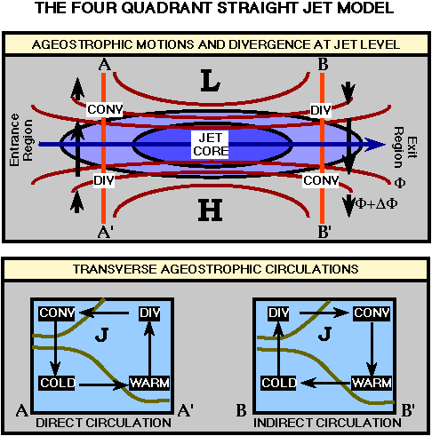

|  |  |  |
| --- | --- | --- |
| **Zooming** | **Panning** | **Rotating** |
|  | **Mouse** |  |
| **Shift-Left Drag:** Select a region by pressing the ***Shift*** key and dragging the left mouse button.  **Shift-Right Drag:** Hold ***Shift*** key and drag the right mouse button. Moving up zooms in, moving down zooms out. | **Control-Right Mouse Drag:** Hold ***Control*** key and drag right mouse to pan. | **Right Mouse Drag:** Drag right mouse to rotate. |
|  | **Scroll Wheel** |  |
| **Scroll Wheel-Up:** Zoom Out.  **Scroll Wheel-Down:** Zoom In. |  | **Control-Scroll Wheel-Up/Down:** Rotate clockwise/counter clockwise.  **Shift-Scroll Wheel-Up/Down:** Rotate forward/backward clockwise. |
|  | **Arrow Keys** |  |
| **Shift-Up:** Zoom In.  **Shift-Down:** Zoom Out. | **Control-Up arrow:** Pan Down.  **Control-Down arrow:** Pan Up.  **Control-Right arrow:** Pan Left.  **Control-Left arrow**: Pan Right. | **Left/Right arrow:** Rotate around vertical axis.  **Up/Down arrow:** Rotate around horizontal axis.  **Shift-Left/Right arrow:** Rotate Clockwise/Counterclockwise. |