McIDAS-V Tutorial

Using and Creating Formulas

updated October 2018 (software version 1.8)

McIDAS-V is a free, open source, visualization and data analysis software package that is the next generation in SSEC's 40-year history of sophisticated McIDAS software packages. McIDAS-V displays weather satellite (including hyperspectral) and other geophysical data in 2- and 3-dimensions. McIDAS-V can also analyze and manipulate the data with its powerful mathematical functions. McIDAS-V is built on SSEC's VisAD and Unidata's IDV libraries. The functionality of SSEC's HYDRA software package is also being integrated into McIDAS-V for viewing and analyzing hyperspectral satellite data.

More training materials are available on the McIDAS-V webpage and in the Getting Started chapter of the McIDAS-V User’s Guide, which is available from the Help menu within McIDAS-V. You will be notified at the startup of McIDAS-V when new versions are available on the McIDAS-V webpage - <http://www.ssec.wisc.edu/mcidas/software/v/>.

If you encounter an error or would like to request an enhancement, please post it to the McIDAS-V Support Forums - <http://www.ssec.wisc.edu/mcidas/forums/>. The forums also provide the opportunity to share information with other users.

This tutorial assumes that you have McIDAS-V installed on your machine, and that you know how to start McIDAS-V. If you cannot start McIDAS-V on your machine, you should follow the instructions in the document entitled *McIDAS-V Tutorial – Installation and Introduction*.

Terminology

There are two windows displayed when McIDAS-V first starts, the **McIDAS-V Main Display** (hereafter **Main Display**) and the **McIDAS-V Data Explorer** (hereafter **Data Explorer**).

The **Data Explorer** contains three tabs that appear in bold italics throughout this document: ***Data Sources*, *Field Selector***, and ***Layer Controls***. Data is selected in the ***Data Sources*** tab, loaded into the ***Field Selector***, displayed in the **Main Display**, and output is formatted in the ***Layer Controls***.

Menu trees will be listed as a series (e.g. ***Edit -> Remove -> All Layers and Data Sources***).  
  
Mouse clicks will be listed as combinations (e.g. *Shift+Left Click+Drag*).

**Introduction**

There are three methods of using formulas in McIDAS-V: system formulas which are provided as part of the McIDAS-V software, user-defined formulas which can be created and executed from within McIDAS-V, and user-defined formulas which can be defined in Jython code written by the user. This tutorial will cover the first two categories, those that can be created and used within McIDAS-V.

**System Formulas – Simple Subtraction**

1. Load the forecast data for Super Typhoon Megi.  
   1. In the ***Data* Sources** tab of the **Data Explorer**, open the ***Gridded Data*** tree and select ***Local***.
   2. Under **Look in**,individually add data sources for the following files:  
        
      *<local path>***/Data/Formulas/TyphoonMegi/gfs_4_20101017_0000_000.grb2***<local path>***/Data/Formulas/TyphoonMegi/gfs_4_20101017_0000_024.grb2**
2. Use the Simple Difference formula to subtract the 0 hour forecast from the 24 hour forecast Pressures.  
   1. In the ***Field Selector*** tab, select **Formulas** under **Data Sources**.
   2. Under **Fields**, open the ***Miscellaneous*** tree and select ***Simple difference a-b***.
   3. Under **Displays**,open the ***Imagery*** tree and select ***Image Display***.
   4. Click **Create Display**.
   5. In the new **Field Selector** window, select:  
      * For **Field: a**, open and select the ***gfs_4_20101017_0000_024.grb2 -> 2D grid -> Mass -> Pressure reduced to MSL @ Mean sea level***
      * For **Field: b**, open and select the ***gfs_4_20101017_0000_000.grb2 -> 2D grid -> Mass -> Pressure reduced to MSL @ Mean sea level***
   6. Click **OK** to display the results of the **Simple difference a-b** formula.
   7. Zoom into the Philippines area. The darker region southwest of the whiter region shows areas where pressure drops are forecasted.
   8. Drawing a line between the whiter and darker regions gives an indication of the predicted storm motion. To add a line, use the ***Display -> Add Range and Bearing*** menu item. *Left Click+Drag* to move one end point over the white region and the other over the dark region. The **Distance** will be reported in the **Legend**.

**System Formulas – Combining Multiple Formulas**

1. Remove all layers via the ***Edit -> Remove -> All Layers*** menu item in the **Main Display**.
2. Add the forecast verification file for the 24 hour forecast:  
   1. In the ***Data Sources*** tab, open the ***Gridded Data*** tree and select ***Local***.
   2. Add a data source for the file*<local path>****/* Data/Formulas/TyphoonMegi/ gfs_4_20101018_0000_000.grb2**.
3. Use the Simple Difference formula to subtract the verification grid (Oct 18 – 0Z, 0 hr) from the forecast grid (Oct 17 – 0Z, 24 hr).   
   1. In the ***Field Selector***, under **Data Sources**, select **Formulas**. Under **Fields**, open the ***Miscellaneous***tree and select ***Any Field*.** Under **Displays**,open the ***3D Surface*** tree and select ***Topography*.** Click **Create Display**.
   2. Using the new **Field Selector** window, select ***Formulas -> Miscellaneous -> Simple difference a-b***.Click **OK**.
   3. For **Field: a**, select ***gfs_4_20101017_0000_024.grb2 -> 3D -> Mass -> Geopotential height @ isobaric surface***
   4. Click the ***Level*** tab and select **100,000 Pa**.
   5. For **Field: b**, select ***gfs_4_20101018_0000_000.grb2 -> 3D -> Mass -> Geopotential height @ isobaric surface***.
   6. Click the ***Level*** tab and select **100,000 Pa**.Click **OK**.The display will use the (Forecast Grid – Verification Grid) equation for model verification.
4. Change the range of the color table to enhance features on the display.
   1. 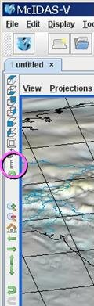From the **Legend** in the **Main Display**, *Right Click* on the color bar and select ***Change Range…***.
   2. In the **From**: text box, enter **-***200*, in the **To:** text box enter *200*. Click **OK**.
5. The display now showing is a 2-dimensional display of the (Forecast Grid – Verification Grid) results. However, recall that when the image was displayed, it was displayed as a 3D Topography surface. By default, the vertical range of McIDAS-V displays is 0-16,000 m. To view the data as topography, the vertical range will have to be changed to more closely match the range of the data. In this example, change the vertical range to -100 to 100 m.
   1. From the tool icons on the left side of the **Main Display** window, click the *Set the vertical range* icon (shown in the figure to the right).
   2. Change the **Min Value** to *-100*, **Max Value** to *100* and **Units** to *m***.** Click **OK.**
6. Sometimes when viewing 3-Dimensional data, the map becomes obscured by the data. If the map is hidden, move the Map layer up, so it is visible on the image.  
   1. From the **Legend**, *Left Click* on **Default Background Maps**.
   2. At the bottom of the ***Maps*** tab in the ***Layer Controls***, change the **Position** slider to a value of *0.3*. This will slide the map up in the **Main Display**.
7. Navigate through the display in the **Main Display** window using *Right Click+Drag* to visualize the 3D characteristics of this topographic display.

**System Formulas – Creating a Water Vapor Sea Surface Temperature Display**

1. Remove all layers and data sources via the ***Edit -> Remove -> All Layers and Data Sources*** menu item in the **Main Display**.
2. Create local datasets for global SST, water vapor, IR, and land/sea mask images:
   1. From the **Main Display** menu, select ***Tools -> Manage ADDE Datasets***.
   2. Select ***File -> New Local Dataset***.  
      1. For **Dataset**, enter *GLOBAL*. For **Image Type**, enter *SST*.
      2. Click the **Browse** button, choose *<local path*>**/ Data/Formulas/sea-surface-temperature**, and click **Open**.
      3. Click **Add Dataset**.
   3. Repeat step **11 b.** for Water vapor. (*GLOBAL*, *WV*, <*local path>/* **Data/Formulas/global-wv**). **Add Dataset**.
   4. Repeat step **11 b.** for Infrared. (*GLOBAL*, *IR*, *<local path*>**/ Data/Formulas/global-ir**). **Add Dataset**.
   5. Repeat step **11 b.** for Land-Sea-Mask. (*GLOBAL*, *Land-Sea-Mask*, *<local path*>**/ Data/Formulas /land-sea-mask**). **Add Dataset**.
   6. Click **OK** to close the **ADDE Data Manager**.
3. Load your Big Blue Marble basemap using the Flat files chooser and display the image:  
   1. From the ***Data Sources*** tab of the **Data Explorer**, open the ***General*** treeand select ***Flat files***.
   2. Select *<local path*>**/ Data/Formulas/basemap/blue-marble.jpg** for the file to load.
   3. For **Navigation**, select *Bounds*.  Enter *90* for **upper lat**, *-180* for **upper lon**, *-90* for **lower lat** and *180* for **lower lon**.
   4. Click **Add Source**,and from the ***Field Selector***, click **Create Display**.
4. Add your Sea Surface Temperature data source.  
   1. From the ***Data Sources*** tab of the **Data Explorer**,open the ***Satellite*** tree and select ***Imagery***.
   2. Select *<LOCAL-DATA>* as the **Server**.
   3. Select *GLOBAL* for the **Dataset** and click **Connect**.
   4. Select *SST* for the **Image Type**.
   5. In the ***Absolute*** tab, select the *2010-10-20 00:00:00Z* time, and click **Add Source**.
5. Add your Land/Sea Mask data source.  
   1. Using the ***Satellite ->*** ***Imagery*** chooser in the ***Data Sources*** tab of the **Data Explorer**, select ***Land-Sea-Mask*** for the **Image Type**.
   2. Select the ***Absolute*** tab, select the *2009-07-30 18:00:00Z* time, and click **Add Source**.
6. Create a display of Sea Surface Temperatures over just water areas:  
   1. In the ***Field Selector***, select **Formulas**.
   2. Open the ***Image Filters*** tree, select ***Discriminate Image Filter***, and click **Create Display**.
   3. From the **Select input** window, enter the following:

**brkpoint1**:*0* **brkpoint2**:*255* **brkpoint3**:*8* **brkpoint4**:*8* **replace**:*0*  
This formula applies a discriminate filter to two images by comparing elements in each image to different high and low breakpoints. Use this filter to mask off a portion of the first source image. Breakpoints 1 and 2 specify the range from the first dataset to be used, and break points 3 and 4 are for the second dataset. In this example, values of 8 are used from the land/sea mask and represent water regions.

* 1. 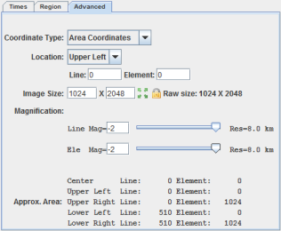Click **OK**.
  2. To define **image1** in the new **Field Selector** window**,** select ***SST -> Band: 1 -> Brightness***.
  3. In the ***Advanced*** tab, make sure your fields are the same as they are in the image on the right.
* Click the full size icon ().
* Set the **Coordinate Type** to be *Area Coordinates*.
* Set the **Location** to be *Upper Left*.
* For **Magnification**,change **Line Mag** and **Ele Mag** values to *-2*.   
  1. Repeat steps e and f to define **image2** as ***Land-Sea-Mask -> Band: 1 -> Brightness*.** Click **OK** to display the Land/Sea Mask image in the **Main Display**.

1. Change the color bar for the SST display and add some transparency to the color enhancement.
   1. From the **Legend**, *Right Click* on the color bar of the **SST - Image Display** and select   
      ***System -> Temperature*** to change the color table.
   2. *Right Click* on the color bar again and select ***Edit Color Table***.
   3. *Right Click*above the color bar, select ***Add Breakpoint -> At Data Point*.** Enter a value of *2* and click **OK** (as seen in figure to the lower-left).
   4. From the **Transparency** drop down box, select a value of*100%*.
   5. *Right Click*on the breakpoint you just created, select ***Edit Colors -> Transparency(100%) -> Left***This sets transparency to 100% for all brightness values less than 2 (as seen in figure to the lower-right).
   6. Click **OK** to close the **Color Table Editor**.

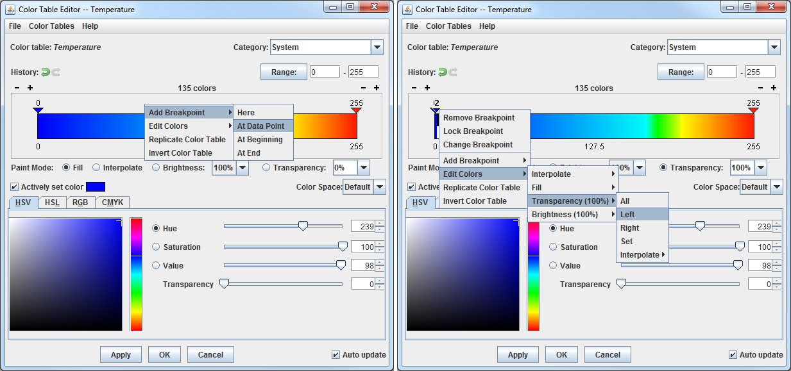

1. Create a display of the Water Vapor data.  
   1. Using the ***Satellite ->*** ***Imagery*** chooser in the ***Data Sources*** tab of the **Data Explorer**, select *WV* for the **Image Type**.
   2. In the ***Absolute*** tab, highlight the *2010-10-18 00:00:00Z* time, and click **Add Source**.
   3. From the ***Field Selector***, open the ***6.8 um*** tree, select ***Brightness***, and click **Create Display**.
2. Add transparency to the water vapor imagery. Use the same techniques as found in step 16.  
   1. From the **Legend**, *Right Click* on the color bar of the **WV - Image Display** and select ***Edit Color Table***.
   2. Add a breakpoint at the 135 data point, set the transparency to 100% and fill to the left (***Edit Colors -> Transparency -> Left***).
   3. Create another breakpoint at 200 and set the transparency to 0%. Now interpolate the transparency to the left (***Edit Colors -> Transparency -> Interpolate -> Left***).
   4. Click **OK** to close the **Color Table Editor**.

**Creating your own Formulas – Simple Example**

1. Add your custom formula to McIDAS-V.   
   1. From the **Main Display**, select ***Tools******-> Formulas -> Create Formula***.
   2. 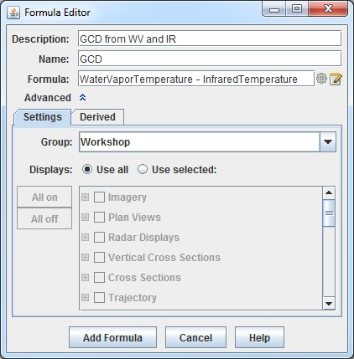In the **Description** text box, enter: *GCD from WV and IR*.  
      This is how the formula will be shown in the list of formulas in the ***Field Selector***.
   3. In the **Name** text box, enter: *GCD*  
      This value will be shown when you mouse over the formula in the ***Field Selector*** and is also used for parameter defaults.
   4. In the **Formula** text box, enter: *WaterVaporTemperature – InfraredTemperature*  
      Give your variables meaningful names. These will be listed in the ***Field Selector****.*(Note: No spaces are allowed in the variable names.)
   5. If the bottom **Settings** and **Advanced** tabs aren’t visible, click the arrows next to **Advanced**.
   6. In the **Group** text box enter: *Workshop*  
      You can create a tree structure of multiple groups – each of which can contain multiple formulas. This will be the name of the upper-level tree in the list of formulas in the ***Field Selector***.
   7. Click **Add Formula**.  
        
      Note: GCD stands for Global Convective Diagnostic. This is a day-night scheme that uses infrared and water vapor imagery to map deep convection by means of geostationary satellite images.
2. Add Water Vapor and Infrared data sources to use with the GCD formula.  
   1. Remove all layers and data sources by selecting ***Edit -> Remove -> Remove All Layers and Data Sources*** in the **Main Display**.
   2. From the ***Data Sources*** tab of the **Data Explorer**,open the ***Satellite -> Imagery*** chooser, and connect to the *<LOCAL-DATA> GLOBAL* dataset.
   3. Set the **Image Type** to*WV*, and select the ***Absolute*** image time of *2010-10-18 00:00:00Z*.
   4. Click **Add Source**.
   5. From ***Data Sources*** tab, change the **Image Type** to*IR*, and select the ***Absolute*** image time of *2010-10-18 00:00:00Z*.
   6. Click **Add Source**.
3. Display the data using the GCD formula you just created.  
   1. In the ***Field Selector*** tab, select **Formulas** under **Data Sources**.
   2. Under **Fields**, open the ***Workshop*** tree andselect ***GCD from WV and IR***.Select ***Imagery -> Image Display***display type. Click **Create Display**.
   3. 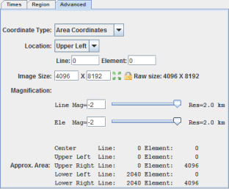In the new **Field Selector** window, for **WaterVaporTemperature**, select ***WV -> 6.8 um -> Temperature***.
   4. In the ***Advanced*** tab, make sure your fields are the same as they are in the image on the right.

* Click the full size icon ().
* Set the **Coordinate Type** to be *Area Coordinates*.
* Set the **Location** to be *Upper Left*.
* For **Magnification**,change **Line Mag** and **Ele Mag** values to *-2*.  
  1. From the ***Region*** tab, select an area in central Africa.
  2. For **InfraredTemperature**, select ***IR -> 10.7 um -> Temperature*** and repeat step **21 d**. Click **OK**.

The Results of the GCD formula are displayed in the **Main Display**. Hold down the middle mouse button and pan around the image to see the different values of GCD listed at the bottom of the **Main Display**.

**Creating a Derived Field**

1. Remove all layers and data sources from the previous displays.
2. Add a gridded data source. If you are using real-time data, skip to step 24.  
   1. In the ***Data Sources*** tab of the **Data Explorer**, navigate to the ***Gridded Data -> Local*** chooser.
   2. Select the *<local path>***/Data/Formulas/GFS_CONUS_80km_20160122_1800.nc**.
   3. Skip to step 25.
3. In the ***Data Sources*** tab of the **Data Explorer**, navigate to the ***Gridded Data -> Remote*** chooser.  
   1. Select ***Realtime Data -> NCEP Model Data -> Global Forecast System (GFS) -> GFS-CONUS 80km -> Latest\**** and click **Add Source**.
   2. Inspect the 2D native and derived fields.
   3. Expand the ***2D grid*** tree, and all of the fields listed directly under 2D grid are native fields, or fields included with the data.
   4. Expand the ***2D grid -> Derived*** tree to see all of the derived fields. These derived fields are generated through formulas “under the hood”. The majority of the formulas from these derived fields can be found by *right-clicking* on **Formulas** in the ***Field Selector*** and navigating to ***Edit Formulas -> Derived Quantities***.
4. Create a new derived quantity to inspect the difference between Pressure and MSLP.  
   1. In the ***Field Selector***, *right-click* on **Formulas** and select ***Create Formula***.
   2. At the top of the **Formula Editor** window, enter the following:  
      1. Description: *MSLP – pressure (from %N1% & %N2%)*
         1. This is how the derived field will list in the ***Field Selector***. The ‘N1’ and ‘N2’ will allow for the name of the derived field to include the names of the two fields that it was derived from: ***MSLP – pressure (from Pressure_reduced_to_MSL_msl & Pressure_surface)***
      2. Name: *pdiff*
         1. This is how the derived field can be referred to in a parameter default
      3. Formula: *sub(D1, D2)*
         1. This is the actual formula. D1 and D2 are used as placeholders for the two fields to be operated on. These fields will be defined in step 3d.

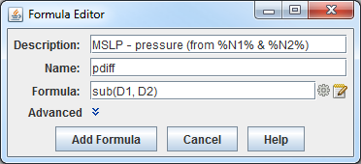

* 1. Expand **Advanced**.
  2. In the ***Derived*** tab, do the following:  
     1. Uncheck **For end user** and check **Create derived quantities**.  
        1. Unchecking **For end user** keeps the formula from being listed out with the rest of the formulas in the ***Field Selector***. Checking **Create derived quantities** creates a derived quantity (field) from this formula.
        2. In the **Parameters** menu, *right-click* in the text box, navigate through the menu tree to select the ***Pressure_reduced_to_MSL_msl*** field, type a comma ( , ), and *right-click* again to choose the ***Pressure_surface*** field. These fields are the **D1** and **D2** specified in the formula (step 25b iii above).
        3. The **Categories** menu here doesn’t have to be used since specific field names are being selected. If we were using an alias, such as PRESSURE, then this **Categories** menu could be used to tell McIDAS-V to only look for 2D gridded pressure fields by entering *GRID-2D-\**.
  3. Click **Add Formula**.

1. Investigate the placement of the derived field in the ***Field Selector*** and move it under the ***2D grid -> Derived*** tree.  
   1. In the ***Field Selector***, *right-click* on the **GFS CONUS 80km** data source and select ***Reload Data***. Once this is done, the data source will be re-loaded and the new formula created earlier will generate a derived quantity. Note that this derived quantity is listed at the bottom of the **Fields** panel, and not under ***2D grid -> Derived*** like the other 2D derived formulas (with remote data).
   2. Move this new derived field to under ***2D grid -> derived*** by editing the formula. To do this, *right-click* on **Formulas** in the ***Field Selector*** and select ***Edit Formulas -> Derived Quantities -> MSLP – pressure***.
   3. In the ***Derived*** tab at the bottom of the **Formula Editor** window, click the **Define Output Categories** button.
   4. This **Define Output Categories** window allows for specifying where this derived field should be listed. To get this field to list under ***2D grid -> Derived***, select *Use Data*, choose *All* for **Operand**, choose *All* for **Category**, then enter *Derived* for **Append**.

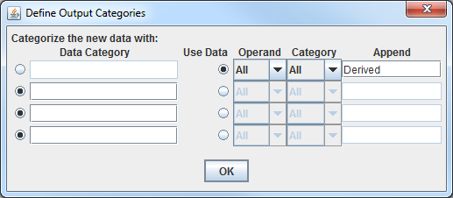

- The **Operand** dropdown refers to which operand in the formula (D1 and D2) will be used. This could be useful, for example, if the operands in the formula were from different categories such as a 2D and a 3D grid. Both of these grids are 2D so *All* can be used.

- The **Category** dropdown refers to which categories were defined when creating the formula. In this case, no categories were defined since specific field names were used. This could be used if an alias was used in the **Parameters** menu when creating the formula. For example, if TEMP (temperature) was specified as the alias, then there could be multiple categories (2D grid and 3D grid). This **Category** dropdown could then be used to say if you are putting the derived field under the 2D or 3D tree in the **Field Selector**.

- The **Append** menu informs McIDAS-V which menu tree (under the category tree) to place the derived field. In this case, the field is put under a tree called **Derived** which is under the **2D grid** tree (the tree where the MSLP and surface pressure fields are).

* 1. Click **OK** to close the **Define Output Categories** window.
  2. Click **Change Formula** save the formula and close the **Formula Editor** window.
  3. Reload the data again using the method from 26a and now the derived field will list under ***2D grid -> Derived***.

1. Display the data to see the difference between MSLP and surface pressure.  
   1. In the ***Field Selector***, choose the ***2D grid -> Derived -> MSLP – pressure*** field. Select the ***Plan Views -> Contour Plan View*** and the first 5 times. Click **Create Display**.
   2. Probe the display with the middle mouse button to see the pressure difference in Pascals. Change the display to millibars by going to the ***Layer Controls*** for the layer and selecting ***Edit -> Change Display Unit***. In this **Change Unit** window, use the dropdown to select *hPa*. Click **OK**.
2. It is possible to create a parameter default so millibars or hPa would be used as the display unit by when the display is created. This can be done by creating a parameter default.  
   1. In the **Main Display**, select ***Tools -> Parameters -> Defaults***.
   2. From the ***User Defaults*** tab, select ***File -> New Row***. In the **Parameter** menu, enter *pdiff*. This *pdiff* was defined in 25b ii as the name associated with the formula. Enter a **Range** of *-10* to *400* (or whatever range you think is suitable for the data). For **Unit**, use the dropdown to select *millibar* or type *hPa* if you prefer. Click **OK**.
   3. In the **Main Display**, create a new tab and then re-display the derived MSLP – pressure field.

**Zooming, Panning, and Rotating Controls**

|  |  |  |
| --- | --- | --- |
| **Zooming** | **Panning** | **Rotating** |
|  | **Mouse** |  |
| **Shift-Left Drag:** Select a region by pressing the ***Shift*** key and dragging the left mouse button.  **Shift-Right Drag:** Hold ***Shift*** key and drag the right mouse button. Moving up zooms in, moving down zooms out. | **Control-Right Mouse Drag:** Hold ***Control*** key and drag right mouse to pan. | **Right Mouse Drag:** Drag right mouse to rotate. |
|  | **Scroll Wheel** |  |
| **Scroll Wheel-Up:** Zoom Out.  **Scroll Wheel-Down:** Zoom In. |  | **Control-Scroll Wheel-Up/Down:** Rotate clockwise/counter clockwise.  **Shift-Scroll Wheel-Up/Down:** Rotate forward/backward clockwise. |
|  | **Arrow Keys** |  |
| **Shift-Up:** Zoom In.  **Shift-Down:** Zoom Out. | **Control-Up arrow:** Pan Down.  **Control-Down arrow:** Pan Up.  **Control-Right arrow:** Pan Left.  **Control-Left arrow**: Pan Right. | **Left/Right arrow:** Rotate around vertical axis.  **Up/Down arrow:** Rotate around horizontal axis.  **Shift-Left/Right arrow:** Rotate Clockwise/Counterclockwise. |