McIDAS-V Tutorial
Using Simulated ABI Data
updated June 2012 (software version 1.2)

McIDAS-V is a free, open source, visualization and data analysis software package that is the next generation in SSEC's 35-year history of sophisticated McIDAS software packages. McIDAS-V displays weather satellite (including hyperspectral) and other geophysical data in 2- and 3-dimensions. McIDAS-V can also analyze and manipulate the data with its powerful mathematical functions. McIDAS-V is built on SSEC's VisAD and Unidata's IDV libraries, and contains "Bridge" software that enables McIDAS-X users to run their commands and tasks in the McIDAS-V environment. The functionality of SSEC's HYDRA software package is also being integrated into McIDAS-V for viewing and analyzing hyperspectral satellite data.
More training materials are available on the McIDAS-V webpage and in the Getting Started chapter of the McIDAS-V User’s Guide, which is available from the Help menu within McIDAS-V. You will be notified at the startup of McIDAS-V when new versions are available on the McIDAS-V webpage - http://www.ssec.wisc.edu/mcidas/software/v/.
If you encounter an error or would like to request an enhancement, please post it to the McIDAS-V Support Forums - http://www.ssec.wisc.edu/mcidas/forums/. The forums also provide the opportunity to share information with other users.

This tutorial assumes that you have McIDAS-V installed on your machine, and that you know how to start McIDAS-V. If you can not start McIDAS-V on your machine, you should follow the instructions in the document entitled McIDAS-V Tutorial – Installation and Introduction.

Terminology
There are two windows displayed when McIDAS-V first starts, the McIDAS-V Main Display (hereafter Main Display) and the McIDAS-V Data Explorer (hereafter Data Explorer).
The Data Explorer contains three tabs that appear in bold italics throughout this document: Data Sources, Field Selector, and Layer Controls. Data is selected in the Data Sources tab, loaded into the Field Selector, displayed in the Main Display, and output is formatted in the Layer Controls.
Menu trees will be listed as a series (e.g. Edit ->Remove ->All Layers and Data Sources).
Mouse clicks will be listed as combinations (e.g. Shift+Left Click+Drag).

Loading ABI Data Bundles
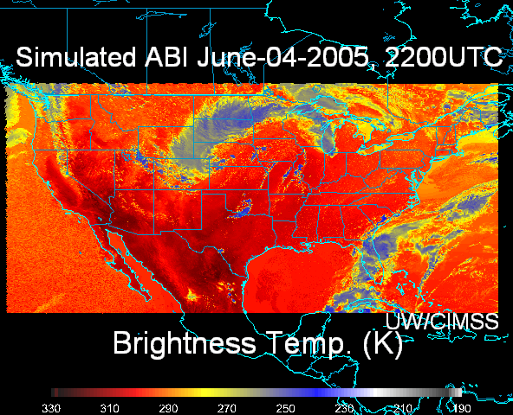
- Load the June-04-2005.mcvz data bundle (Figure 1).

  - In the Main Display, select File -> Open File. Locate <local path>/ABI/June-04-2005.mcvz bundle. Click Open.

- In the Open bundle window, select Replace Session in the drop-down list. Click OK.
There may be a pause, as the data is unzipped before the bundle loads. The bundle will load 16 bands of the simulated ABI data, listed under Plan Views in the Legend of the Main Display.
Figure 1: Display of June-04-2005.mcvz bundle

Exporting Data to Excel

- In the Field Selector, select Formulas under Data Sources.

- Expand Export list under Fields. Choose Export Grid to Excel. Select Image Display under Displays. Click Create Display.

- Enter a filename in the Select input window. Click OK.

- A Field Selector window appears for selection of data to export. Select ABI brightness temperatures (band10) 7.34 um. Click Stride tab. Uncheck “Use Default.” Select Every Fifth Point for X. By default, the X and Y strides will be linked (changing one changes the other as well). Select a file name/location and click OK.

- The image is displayed in the Main Display window. Open the excel file and view the data points.

Looping Through All 16 Bands

- Load the second bundle, Katrina.mcvz, showing Hurricane Katrina on August 28th, 2005 at 2200 UTC.

- Select Edit ->Remove ->All Layers and Data Sources from the Main Display before loading Katrina.mcvz to free memory for the new bundle.

- Load <local path>/ABI/Katrina.mcvz using the same procedure as before. The Main Display window size may need expansion to view all the text labels correctly. When the bundle loads, 10 simulated ABI bands are displayed (Figure 4).
  - Loop through the bands:

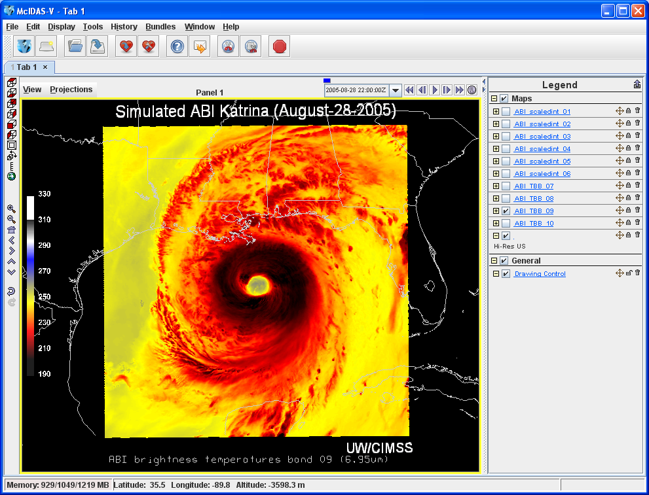
- Select View-> Displays ->Visibility Animation -> On in the Main Display. This loops through all layers in the Legend that are marked with the Visibility Toggle Lock in the unlocked position.

- To include a layer in the animation, click the Visibility Toggle Lock to “unlock” the current visibility of the layer. Lock the Drawing Control item to maintain the text throughout the animation.
- Uncheck View -> Displays ->Visibility Animation -> On to turn the loop off.

Figure 4: Display of Katrina.mcvz bundle
Loading Local Simulated ABI netCDF files
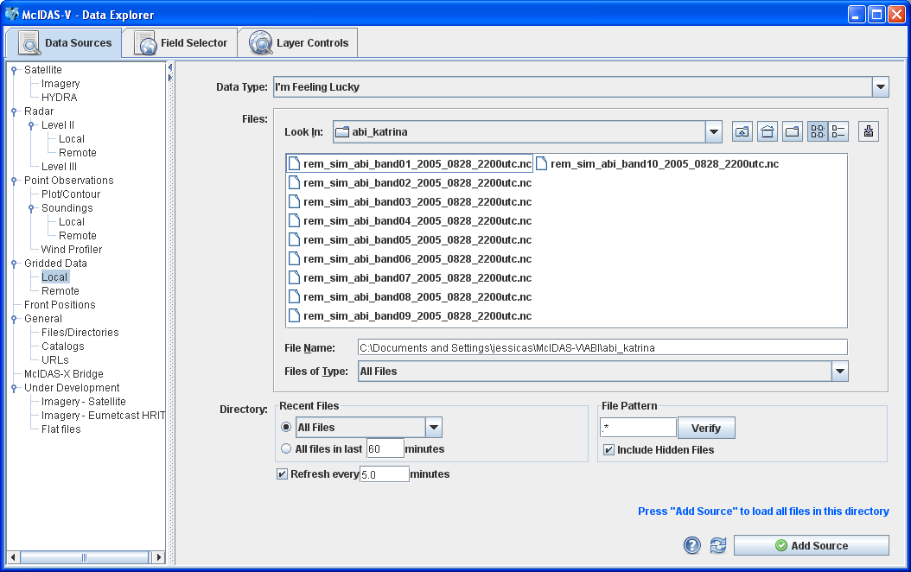
- Remove all layers and data.
- Load a local netCDF file.
- In the Data Sources tab of the Data Explorer, select General -> Files/Directories chooser. Locate the netCDF files in the
<local path>/ABI/Katrina directory. Select one file and click Add Source (Figure 5).
- Select the Field to be displayed under Fields, and Color-Shaded Plan View under Displays.
Figure 5: Loading netCDF data through General Files Chooser.
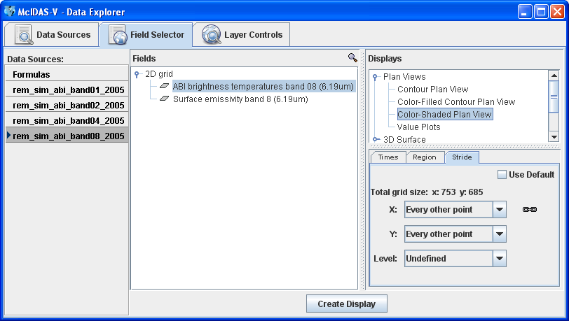
- Display a subset of the data region. Click Region, unselect Use Default, and left click + drag to select your desired region.

- Reduce the number of data points displayed (Figure 6). Click Stride, unselect Use Default, click on the drop down arrow for X:, and select Every other point. If necessary, repeat this process for the same for the Y. Click Create Display.
Figure 6: Field Selector with Strides tab active.

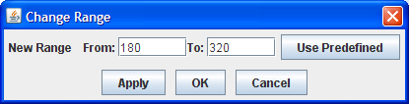
- Adjust the data range (Figure 7):
- Right click on the color bar in the Legend

- Select Change Range. A new Change Range window appears.
Figure 7: Change Range window to adjust the data plotted.

- Enter the new range and click OK. For example, 0 to 1 for the reflective bands or 180 to 320 for the IR Bands, 7-10.

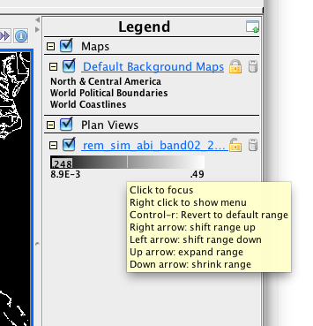
- Another method for stretching and shifting the range is available through the Legend colorbar (Figure 8).
- Left click on the color bar in the Legend of the Main Display to activate the Interactive Color Bar.

- Shift the range up with right and left arrows.

- Expand the range with the up and down arrows.
- Use Shift+left/right arrows to change the range faster.
- Adjust the color enhancement:
- Right click on the color bar in the Legend. Select System -> Gray Scale (for visible and near-IR bands 1-6) or System -> Temperature for the infrared (IR) bands.
Figure 8: The Legend colorbar allows stretching and shifting the display range.

Installing a Plugin

- In Main Display window, select File -> New Display Window -> Map Display. Note that the maximum number of panels available is currently Four Panels.

- Copy 4by4.jar locally and load through the plugins manager.
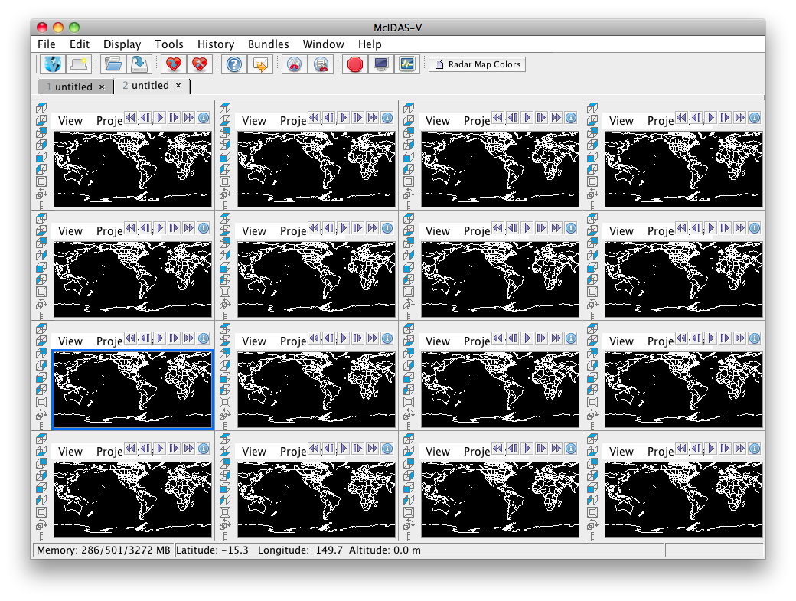
- In Main Menu, select Tools -> Plugins -> Manage.

- In the Plugin Manager window, select File -> Install Plugin From File.

- Navigate to location of 4by4.jar in the Open window. Select <local path>/ABI/4by4.jar. Click Open. Click OK after reading the message “You Must Restart McIDAS-V to complete the installation of this plugin.” Click Close to close the Plugin Manager.

- Exit McIDAS-V. McIDAS-V must be restarted to finish installation of plugin.

- Launch a new session of McIDAS-V.
Figure 10: Plugins add capability

- In Main Display window, select File -> New Display Tab -> Map View -> Four By Four. McIDAS-V now has the added capability of display 16 panels of data (Figure 10).
- Follow the instructions in the section entitled “Loading Local Simulated ABI netCDF files” to load one band into each panel.

The various ABI (Advanced Baseline Imager) visible (1,2), near-infrared (3-6) and infrared (7-16) bands, plus some of their uses, are listed in Figure 9. This table shows which band would be used in conjunction to highlight various features. For example, during the daylight hours, bands 2 and 3 for vegetation or a land mask, bands 2 and 4 for high versus low clouds, bands 2 and 5 for snow cover or water/ice clouds. During the day or nighttime, the IR bands can be used to identify fires, fog, cloud-top phase, upper-level SO₂, ozone, volcanic ash, land surface temperature, etc.
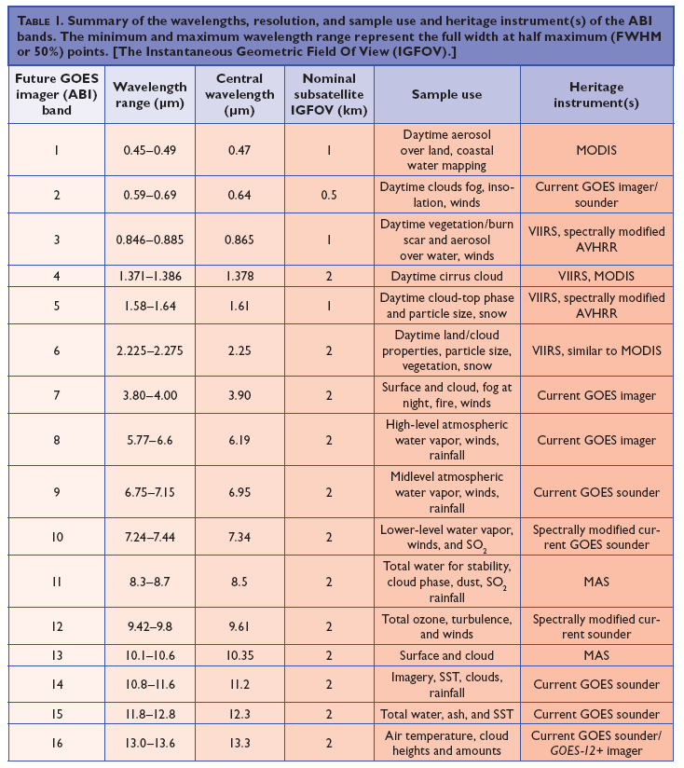
Figure 9: ABI band list from Schmit et al, 2005 (BAMS).

