GOES-R ABI Fact Sheet Band 7 (The “Shortwave window” infrared band)
The “need to know” Advanced Baseline Imager reference guide for the NWS forecaster

Front page – Maintain general layout

No changes needed to header banner (GOES-R satellite); title as above
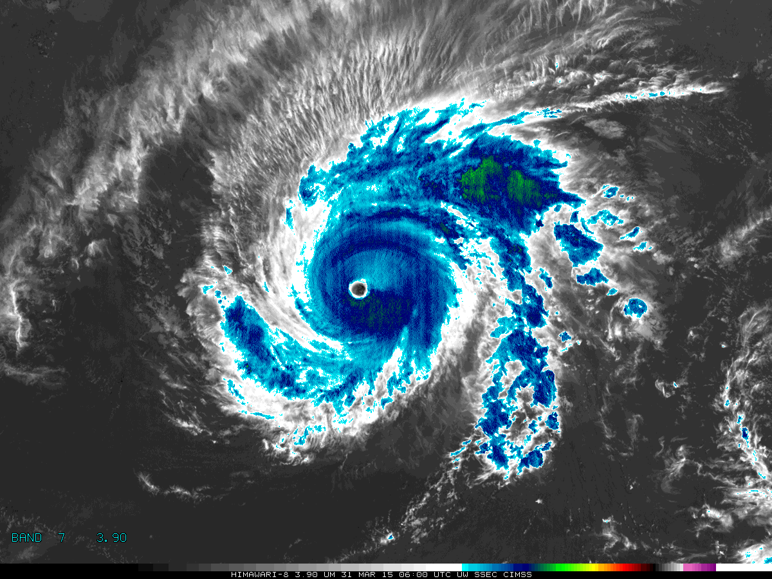

Above: The Advanced Himawari Imager (AHI) 3.9 μm for Typhoon Maysak from March 31, 2015 at 06 UTC. Credit: CIMSS and JMA.

In a nutshell

GOES-R ABI Band 7 (approximately 3.9 μm central, 3.8 μm to 4.0 μm)

Also similar Suomi NPP VIIRS Bands I4/M12/M13, MODIS Bands 20/21/22/23, AVHRR Band 3, SEVIRI Band 4, AHI Band 7

Available on current GOES (Imager and Sounder)

Nickname: “Shortwave window” infrared band

Availability: Both Day and Night, during the day contains a reflected solar component

Primary purpose: Low fog and stratus, clouds, fires, atmospheric motion vectors, volcanic ash, etc.

Uses similar to: At night, other longwave infrared window bands.
“Core” front text and image
The shortwave IR window (3.9 μm) band (on the current GOES imagers) has been demonstrated to be useful in many applications, including fog/low cloud identification at night, fire/hot-spot identification, volcanic eruption and ash detection, and daytime snow and ice detection. Low-level atmospheric vector winds can also be estimated using this band. The shortwave IR window is also useful for studying urban heat islands and clouds. Compared to the nighttime, there will be overall warmer temperatures in this shortwave window band during the daytime, due to the additional reflected solar component. Source: Schmit et al., 2005 in BAMS, and the ABI Weather Event Simulator (WES) Guide by CIMSS.

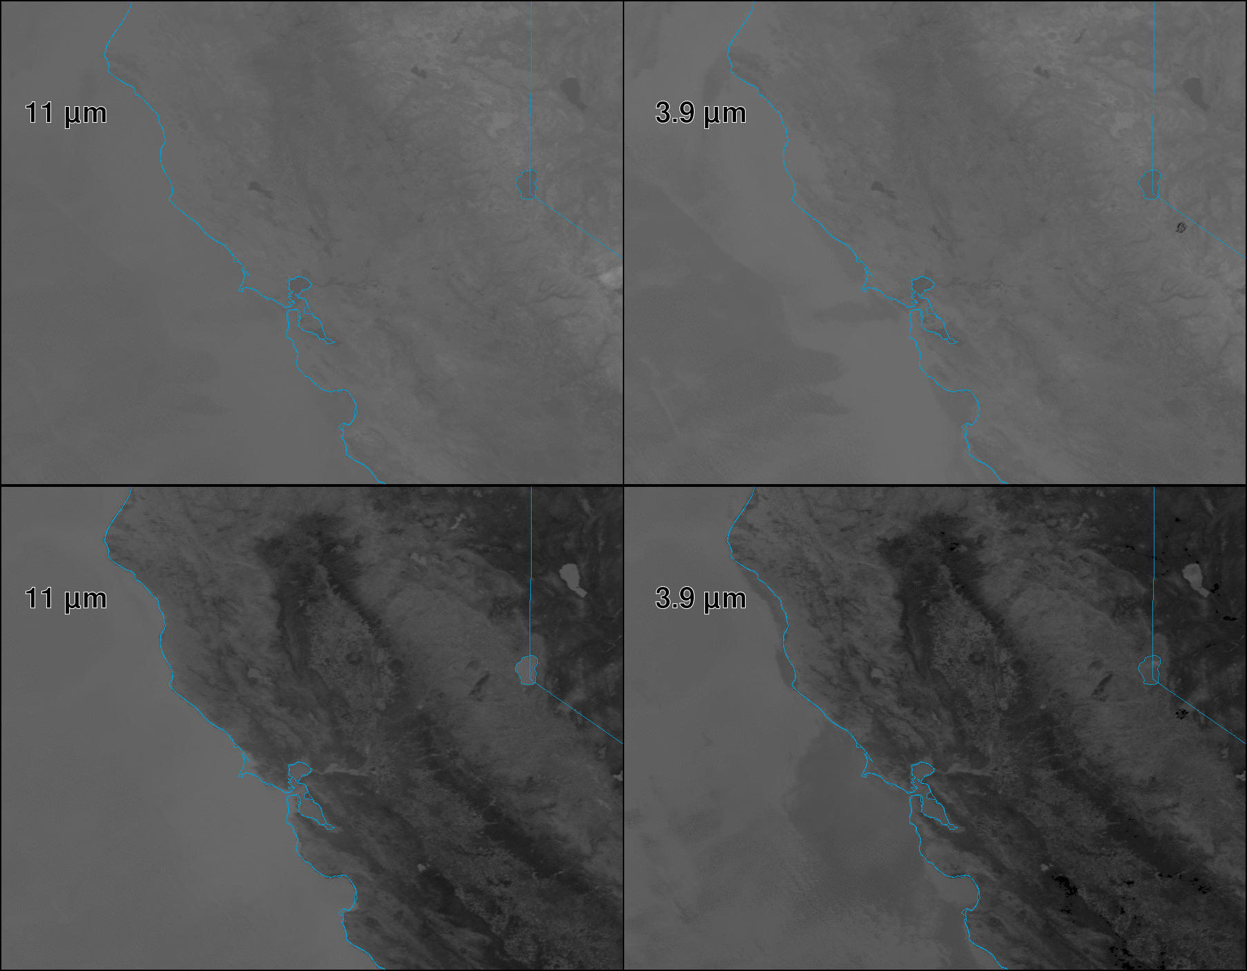
MODIS Aqua images from June 22, 2015, of the 11 μm (left panels) and 3.9 μm (right panels) bands. The top images are from 09:55 UTC (nighttime), while the lower panels are from 21:00 UTC (daytime). The fire (or hot spot) near the California/Nevada border (southeast of Lake Tahoe) is evident in the 3.9 μm imagery (Band 22). The 3.9 μm imagery brightness temperatures will generally be greater during the daytime due to additional reflected solar radiation. Fog is along the California coast. The same enhancements are used in each image, with the darker colors representing hotter temperatures. These images were made in McIDAS-V. Credit: SSEC.
Did You Know?

To fully understand a spectral band, not only its central wavelength needs to be considered, but also its spectral width. For example, the current GOES Imager and EUMETSAT imager both have bands nominally centered at 3.9 μm. Due to their spectral widths, the observed brightness temperatures can be quite different. During darkness, the spectrally wider EUMETSAT band (approximately 3.6 to 4.2 μm) can be cooler (due to more absorption associated with CO₂), while during the day, the wider EUMETSAT band can be warmer due to more reflected solar energy.

Tim’s Topics

- Use same photo as currently, although not that one that too zoomed in. :)

According to the Planck equation, a band centered at 3.9 μm has much more sensitivity to temperature than a band centered near 11 μm. It is for this reason that there are many uses for the 3.9 μm band, often in conjunction with a longwave infrared band. This is the case for both qualitative imagery and derived (level 2) products. Examples of qualitative applications include the imagery itself, band differences and/or combining the images in a Red-Green-Blue combination. As shown in the ABI products by band table, examples of quantitative products include: aerosol detection, clear sky cloud mask, cloud properties, derived atmospheric motion vectors, hot spot detection and characterization, snow cover, Sea Surface Temperature (SST) and fog/low stratus.

Tim Schmit is a research meteorologist with NOAA NESDIS in Madison, Wisconsin.

*(can crop off top of image below)*

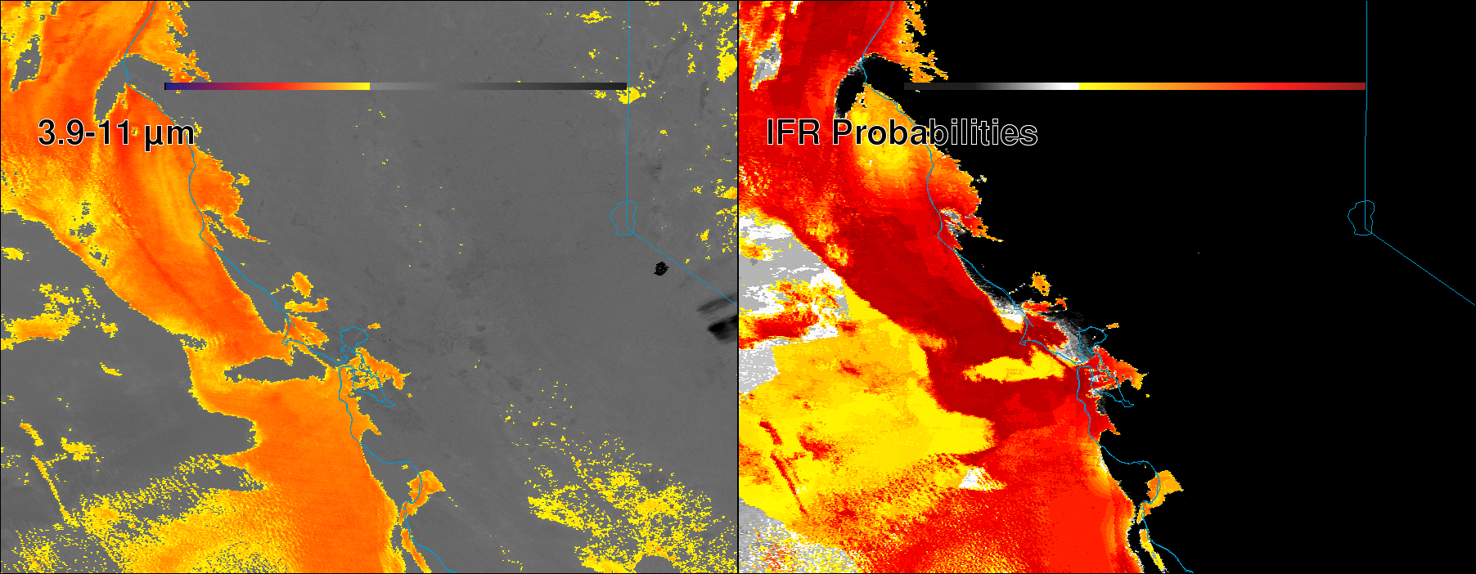
Caption: These images are from MODIS data on June 22, 2015 (09:55 UTC). The left hand panel is the difference image between the 3.9 and 11 μm, where negative differences are color-coded, beginning with a value of -1.2 K. The right hand panel is the GOES-R algorithm IFR Probabilities, where higher probabilities are color coded, beginning with 38%. Credit: ASPB and CIMSS.

Ward’s Words

- Same picture.

Of all of the spectral bands on the GOES-R ABI, Band 7 has the greatest bit depth. That is, the number of discrete values is greater than for the other bands. The reason for this is that Band 7 must be able to sense both very cold features (convective cloud tops) and very hot features (fires). Band 7 (the 3.9 μm) will be sent to AWIPS with a depth of 14 bits. The ABI was designed to sense a maximum temperature of 400 K in Band 7. The other ABI bands are delivered to AWIPS with a depth of 12 bits, and a maximum temperature that is lower and more consistent with maximum terrestrial or atmospheric temperatures – between 300 K and 330 K.

Bill “Hima-Ward-i” Ward is the ESSD Chief in NWS Pacific Region and a former Guam forecaster.

ABI Band Table

-- band table 7 –

ABI Band | Approximate Central  Wavelength (µm) | Band “Nickname” | Type | Nominal sub satellite pixel spacing (km)
7 | 3.9 | “Shortwave window” band | IR (with a reflected day-time solar component) | 2

ABI Band Product Table (same general layout)

Use band 7 (from excel file, separated by tab)

Bottom of back page (update date)

Further reading

GOES-R Overview: http://goes-r.gov

ABI Bands Quick Information Guides: http://www.goes-r.gov/education/ABI-bands-quick-info.html

CIMSS Fog Product Examples blog: http://fusedfog.ssec.wisc.edu/

CIMSS Satellite Blog: http://cimss.ssec.wisc.edu/goes/blog/archives/category/fog-detection

GOES-R COMET training: http://www.goes-r.gov/users/training/comet.html
GOES-R acronyms: http://www.goes-r.gov/resources/acronyms.html

