GOES-R ABI Fact Sheet Band 2 (“Red” visible)
The “need to know” Advanced Baseline Imager reference guide for the NWS forecaster

Front page – Maintain general layout

No changes needed to header banner (GOES-R satellite); title as above

Replace simulated hurricane image of band 1 with that of band 2 (see below).
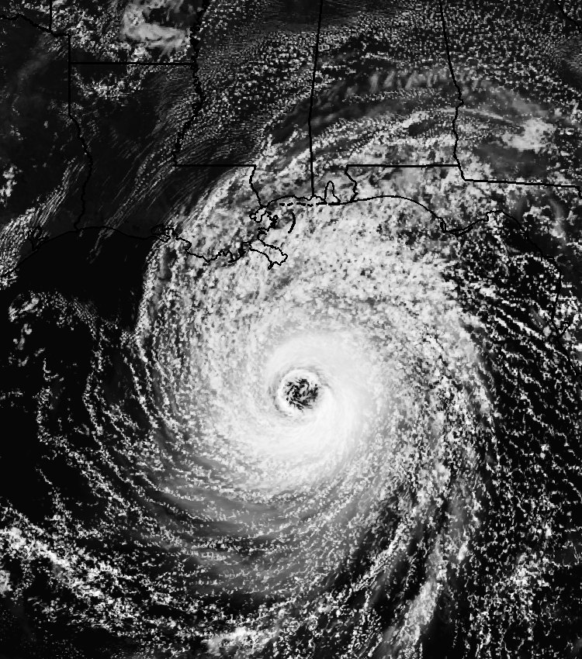

Caption: Above: Simulated image of ABI band 2 for Hurricane Katrina. This image was simulated via a combination of high spatial resolution numerical model runs and advanced ‘forward’ radiative transfer models. (Credit: CIMSS)

In a nutshell

GOES-R ABI Band 2 (approximately: 0.64 μm central, 0.60 μm to 0.68 μm)

Also similar to the Suomi NPP VIIRS Band I1

Similar band available on current GOES Imager

Nickname: “Red” visible band

Availability: Daytime only

Primary purpose: Clouds

Uses similar to: GOES-R ABI Band 1
“Core” front text and image
The second ABI visible band is the 0.6 μm (or “red” band). During the daytime, it will assist in the detection of fog, estimation of solar insolation and depiction of diurnal aspects of clouds. It is called the ‘red’ band because the center frequency of this band is near the ‘red’ part of the visible spectrum. The 0.6 μm visible band is also used for daytime snow and ice cover, detection of severe weather, low-level cloud-drift winds, smoke, volcanic ash, hurricane analysis, and winter storm analysis. A similar band on the current GOES imager has demonstrated many of these applications, although the ABI will offer improved spatial and temporal resolutions. This band is essential for a natural color RGB. Since there is no ‘green’ band on the ABI on the GOES-R series, this band will need to be approximated from other spectral bands for use in generating “true color” imagery. In the case of the ABI, this approach will be a look-up table using the “blue” (0.47 μm), “red” (0.64 μm) and the “veggie” (0.86 μm) bands. Source: Schmit et al., 2005 in BAMS, Miller et al. 2012 and the ABI Weather Event Simulator (WES) Guide by CIMSS.

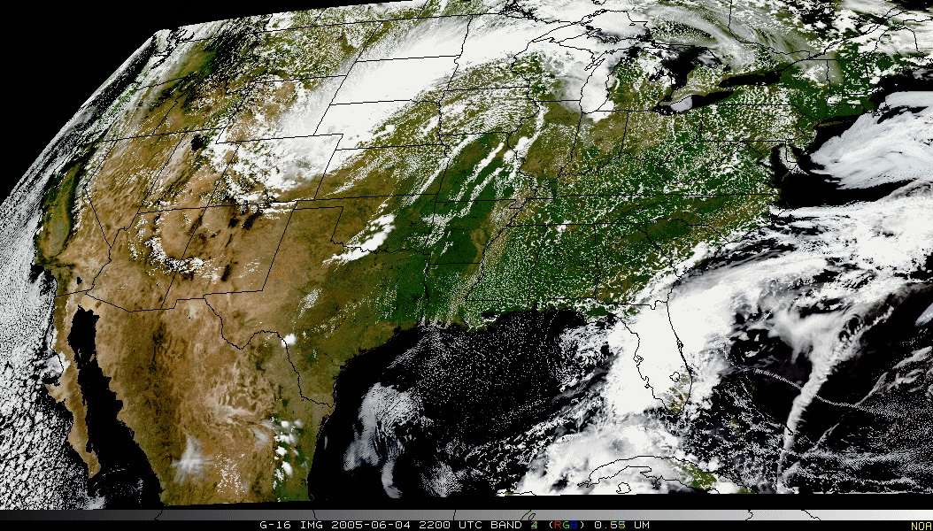
“True Color” with “blue”, synthetic “green” and “red” band from ABI simulated data (from CIMSS); image from Don Hillger, RAMMB.
Did You Know?

When generating derived (Level 2) products, such as cloud heights, each of the products directly uses a number of the ABI bands. Yet, many products may use other derived products are inputs, i.e., needed “upstream” products. For example, the derived product such as Total Precipitable Water (vapor) uses the cloud mask. Due to this product precedence, more bands are used that may be listed in a products by band table.

Tim’s Topics

- Use same photo as currently.

While many think that the visible band on the first geostationary imager on ATS-1 in December 1966 was a band centered at 0.64 μm, the band on ATS-1 actually peaked at approximately 0.52 μm. The approximately resolution for this sensor was between 3 and 4 km. It was this imager that took the first “full-disk Earth images from geosynchronous orbit” and the first “image of Earth and the moon together”.
During parts of 2012, 2013 and 2014, the GOES-14 imager has been operated in the SRSOR (Super Rapid Scan Operations for GOES-R) mode. Many phenomena were observed: convection, hurricanes, fires, smoke, etc. This mode allows images as often as every one minute and hence emulates the one minute imagery from mesoscale sectors possible from the ABI. These unique data are being used to better prepare for the ABI on the GOES-R series.

The 0.64 μm on the ABI has the finest spatial resolution of any of the ABI bands. The sub-point resolution is 0.5 km, as compared to approximately 1 km for today’s GOES imager visible band. In fact, the data volume from this one ABI band is comparable to that from all the infrared bands on the ABI. ABI will also be unique for U.S. geostationary imagers in that the data will be remapped for a “fixed grid” before sending out to users.

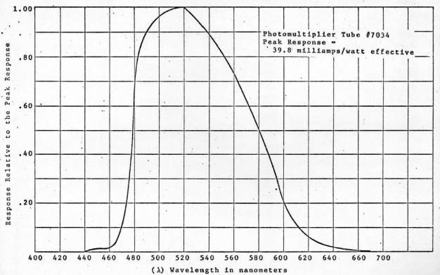

Caption: Overall Relative Spectral Response of the ATS-I Spin-Scan Cloud Camera from Thomsen, R., Parent, R., and Suomi, V. ATS-1 spin-scan cloud camera. (1968)

Tim Schmit is a research meteorologist with NOAA NESDIS in Madison, Wisconsin.

Andy’s ….. (replaces Carven’s Corner)

- New picture coming soon.

……..

….focus on improved spatial resolution of this band….

Update spectral bands plot and caption.

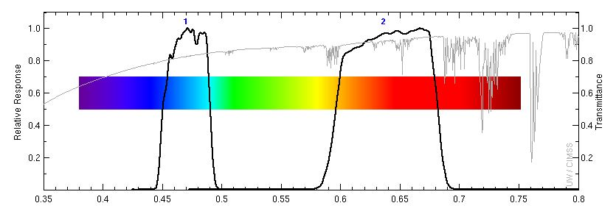

ABI visible spectral bands (black solid lines) and the total atmospheric transmittance (gray solid line). Lower transmittance restricts sensing lower in the atmosphere. (Credit: CIMSS)

ABI Band Table (same general layout)

Use band 2 (from excel file, separated by tab)

Bottom of back page (keep GOES-R logo and date (December 2014) in current position)

Further reading

GOES-R Overview: http://goes-r.gov/

ABI Bands Quick Information Guides: http://www.goes-r.gov/education/ABI-bands-quick-info.html

Imagery fact sheet: http://www.goes-r.gov/education/docs/fs_imagery.pdf

GOES-14 SRSOR: http://cimss.ssec.wisc.edu/goes/srsor2014/GOES-14_SRSOR.html

GOES-14 SRSOR JARS article: http://spie.org/Publications/Journal/10.1117/1.JRS.7.073462

Natural Color Imagery: http://www.goes-r.gov/resources/Scipubs/docs/2012/01431161.2011.pdf

GOES-R acronyms: http://www.goes-r.gov/resources/acronyms.html

###

