GOES-R ABI Fact Sheet Band 14 (longwave infrared window band)
The “need to know” Advanced Baseline Imager reference guide for the NWS forecaster

Front page – Maintain general layout

No changes needed to header banner (GOES-R satellite); title as above
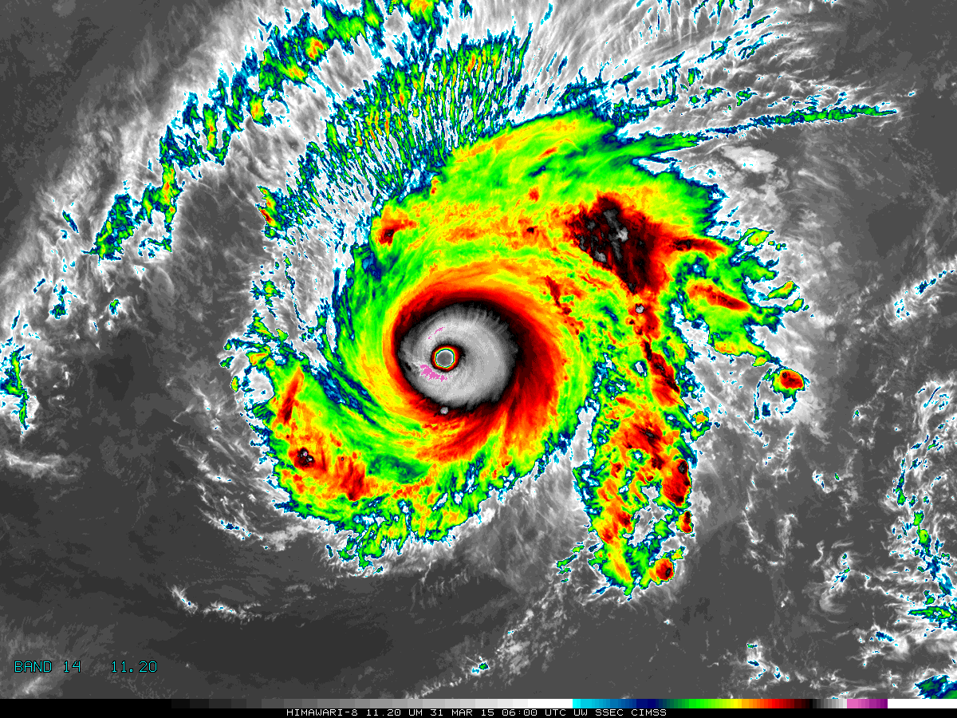

[Please crop out the colorbar.]

Above: The Advanced Himawari Imager (AHI) 11.2 μm longwave infrared window band image for Typhoon Maysak from March 31, 2015, at 6 UTC. Credit: CIMSS and JMA

In a nutshell

GOES-R ABI Band 14 (approximately 11.2 μm central, 10.8 μm to 11.6 μm)

Also similar to AHI Band 14 and Suomi NPP VIIRS Bands I5 and M15

Similar band available on current GOES Imager and Sounder

Nickname: Longwave infrared window band

Availability: Both day and night

Primary purpose: Clouds

Uses similar to: GOES-R ABI Bands 11, 13, and 15
“Core” front text and image
The traditional longwave infrared window (11.2 μm) band enables operational meteorologists to diagnose discrete clouds and organized features for general weather forecasting, analysis, and broadcasting applications. Observations from this infrared window channel can characterize atmospheric processes associated extratropical cyclones and also in single thunderstorms and convective complexes. The window channel also contributes to many satellite derived products, such as precipitation estimates, cloud-drift winds, hurricane intensity and track analyses, cloud-top heights, and volcanic ash detection, as well as fog detection, cloud phase, and cloud particle size estimates in a multi-spectral approach. Source: Schmit et al., 2005 in BAMS, and the ABI Weather Event Simulator (WES) Guide by CIMSS
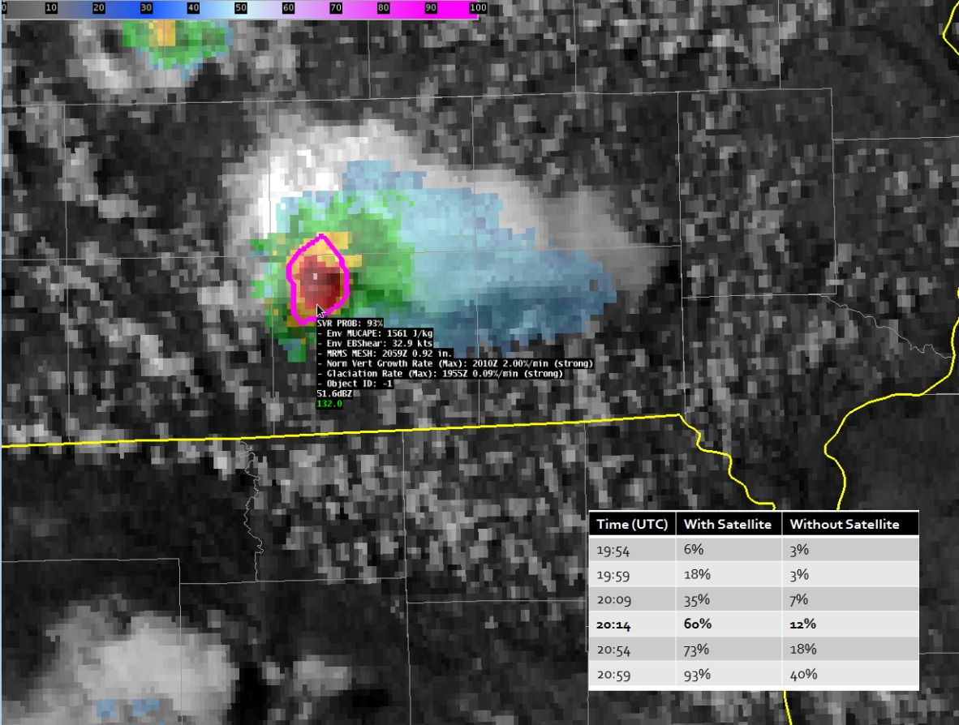

This figure depicts the GOES visible image at 20:59 UTC on June 18th, 2013, combined with radar and a contour of the probability of severe, or “ProbSevere”, a product that combines satellite observations with other data, such as radar and numerical weather prediction. The image was generated with AWIPS II. This ProbSevere probabilistic forecast is the likelihood a developing storm will produce severe weather within the next hour. The combined product suggested a 60% chance of a severe storm at 20:14 UTC. Rerunning ProbSevere without satellite data (e.g., cloud vertical growth rate from a window channel), the probability would have only been 12%. The much higher ProbSevere probability with satellite data offered 45 minute lead-time on the first severe weather report. The ProbSevere product will be improved in the GOES-R era, given the additional information from the ABI and total lightning from the GLM.
Did You Know?

1974 was the first year when geostationary imagers offered infrared imagery. Before this they only imaged the earth in the visible part of the electro-magnetic spectrum. In May of that year, both the Geosynchronous Very-high Resolution Radiometer (GVHRR) on Applications Technology Satellite (ATS)-6 and the Visible Infrared Spin-Scan Radiometer (VISSR) on the Synchronous Meteorological Satellite (SMS) were launched. ATS-6 was a three-axis stabilized spacecraft and the SMS legacy continued with GOES-1. Three-axis stabilization continues to keep weather satellites steady today, including GOES-R.

Tim’s Topics

- Use same photo as currently

There are three main types of products from GOES-R: baseline, future capability, and envisioned. The baseline products are part of the ground segment on “day one”. Examples of these include imagery, cloud properties, satellite derived winds, sea surface temperature, and total precipitable water.

The Algorithm Working Ground (AWG) developed the Algorithm Theoretical Basis Documents (ATBDs) for the future capability products. Examples of these products include overshooting tops and total ozone.

The final class of products contains those that were envisioned subsequently. The ProbSevere product is one such product. ProbSevere provides the probability that a storm will become severe within the next one hour. Other products include convective nearcasting and a host of decision aids such as image combinations.

We fully expect that the impact of the satellite component in blended products will increase with GOES-R as a result of more frequent images, a factor of four improvement in spatial resolution, more spectral bands for inferring cloud properties, and lightning mapping.

Tim Schmit is a research meteorologist with NOAA NESDIS in Madison, Wisconsin.

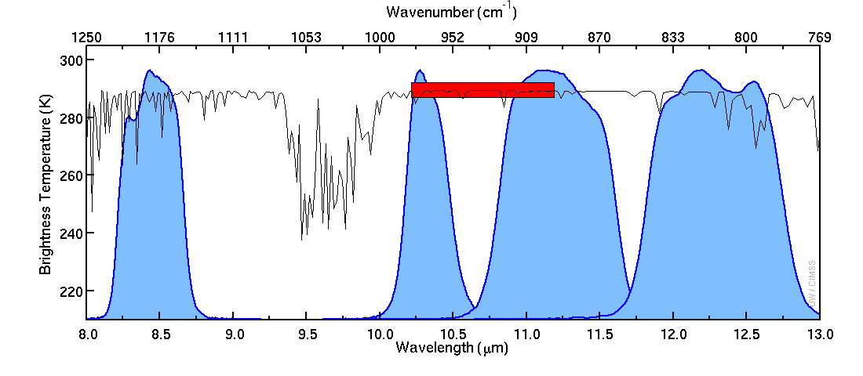
Caption: The solid blue curve represents the instrument response functions for the ABI longwave window bands. The red bar represents the spectral region where most of the energy is captured by the GOES Imager longwave window infrared band. The black line represents a high spectral resolution Earth-emitted spectrum. There is cooling due to ozone absorption within the ozone band wavelengths (centered at 9.7 μm). Credit: CIMSS.
Ken’s Corner

- No photo

Many operational uses for the infrared window band are well known with the widespread utility of the infrared window through the NWS, especially during the overnight hours. Recent applications of the infrared window are leveraging the coming improvements in temporal (5-minute) and spatial (2 km) resolution from the geostationary orbit. The rate of vertical cloud growth is an important input for fused products, which can help identify convective initiation, such as the GOES-R SATCAST and ProbSevere products. Additional “blended” products that combine observations and model output from different sources, will hopefully become more common in the future as it becomes recognized that forecasters have less time to review disparate sets of imagery and data in the forecast and warning process.

The takeaway message related to studies involving fused convective initiation aids is that trends in vertical cloud growth can portend changes in storm severity. When GOES-R imagery is available, use the infrared window to watch the evolution, upscale growth, and decay of convection via cloud top temperatures relative to radar.

Ken Johnson is the SSD Chief in NWS Eastern Region. Jordan Gerth contributed to this segment.

ABI Band Product Table (same general layout)

Use band 14 (from excel file, separated by tab)

Bottom of back page (update date)

Further reading

ABI Bands Quick Information Guides: http://www.goes-r.gov/education/ABI-bands-quick-info.html

ABI WES Guide: http://cimss.ssec.wisc.edu/goes/abi/loops/WES_for_GOES-R_ABI_2011_Version.pdf

ProbSevere: http://cimss.ssec.wisc.edu/severe_conv/probsev.html

HWT: https://satelliteliaisonblog.wordpress.com/2014/05/05/noaacimss-probsevere-model-introduced-at-ewp/

CIMSS Satellite Blog: http://cimss.ssec.wisc.edu/goes/blog/?s=infrared+window

GOES-R COMET training: http://www.goes-r.gov/users/training/comet.html
GOES-R acronyms: http://www.goes-r.gov/resources/acronyms.html

