Himawari AHI Fact Sheet Band 2 (“Green” visible)
The “need to know” Advanced Himawari Imager reference guide for the NWS forecaster

November 2014

Front page – Maintain general layout

No changes to header banner (GOES-R satellite); title as above

Replace simulated hurricane image with image from
http://www.jma.go.jp/jma/jma-eng/satellite/news/himawari89/20141007_himawari-8_successfully%20launched.pdf
Caption: The next-generation geostationary meteorological satellite of the Japan Meteorological Agency, Himawari-8, was successfully launched using H-IIA Launch Vehicle No. 25 at 5:16 UTC on 7 October 2014 from the Tanegashima Space Center in Kagoshima, Japan. Photo and caption source: Japan Meteorological Agency

In a nutshell

Himawari AHI (0.51 μm central, 0.50 μm to 0.53 μm)

Also similar to the Suomi NPP VIIRS Band M4

Not available on current GOES or with the GOES-R ABI

Nickname: “Green” visible band

Availability: Daytime only

Primary purpose: Solar insolation estimates

Uses similar to: GOES-R ABI Band 1, Band 2

“Core” front text and image
The 0.51 μm, or “green” band, is one of the three visible bands on the Himawari-8/9 Imager (AHI). The planned longitude for Himawari-8 is 140 East longitude. The Japan Meteorological Agency (JMA) recently launched this satellite with AHI as part of its payload. A very similar band, 0.55 μm, has been included on NASA’s MODIS and Suomi NPP VIIRS instruments. This band will provide daytime observations related to the land, clouds, and aerosols. This green band, combined with the “blue” (0.47 μm) and “red” (0.64 μm) bands will provide “natural color” imagery of the Earth-atmosphere system. This band is essential for a natural ‘true color’ Red-Green-Blue (RGB) composite. Measurements in the green band can be used for air pollution studies, and other products such as solar insolation estimates.

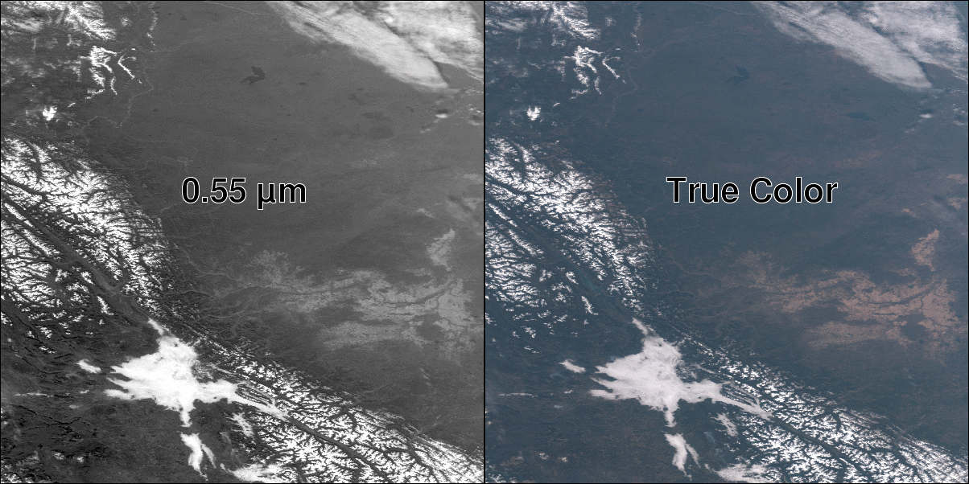
Suomi NPP images of a similar ‘green’ (left-hand side) and ‘true color’ (right-hand side) images. Note the snow, low cloud and vegetation in the 0.55 µm band, which is a key component to the true color image. The image is over part of Canada (October 17, 2014). Image from CIMSS

Did You Know?
Unlike the AHI, there is no ‘green’ band on the ABI on the GOES-R series. Hence, this band will need to be approximated from other spectral bands for use in generating ‘true color’ imagery. In the case of the ABI, this approach will be a look-up table using the ‘blue’ (0.47 μm), ‘red’ (0.64 μm) and the ‘veggie’ (0.86 μm) bands. Of course this is only an approximation.

Back page – Reformat layout
Remove “Baseline Products by Band” table, spectral bands plot, and small table near bottom of

Tim’s Topics

- Use same photo as currently.

There are two main avenues for acquiring AHI imagery from JMA in near real-time. The first is a downlink (HimawariCast) via a communication satellite, although this will be a limited number of bands (5) and at reduced spatial resolutions (4 and 1 km for the infrared and visible bands, respectively). This downlink option is only possible over part of the globe. The other option is via an internet cloud service for satellite providers, this option consists of the full resolution data (both spectrally and spatially) and hence a larger data rate.

A spectral band centered near 0.5 μm is unique in that it is an ingredient when generating ‘true color’ imagery (the ‘green’ band), but also that that wavelength is very near the peak intensity from our sun, as well as the peak wavelength for the response of the human eye. Also, aerosol products, such as optical depth, have a standard reference wavelength: 0.5 μm.
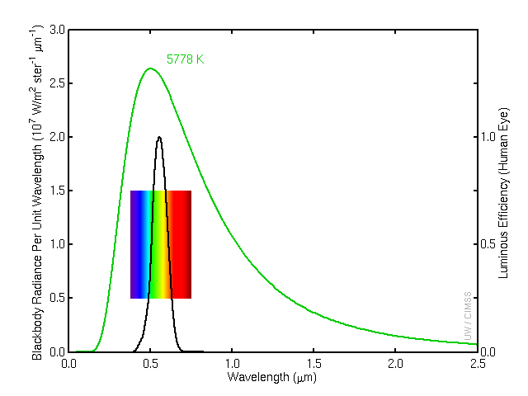
Caption: Intensity plots for the sun’s temperature and the human eye. Source: Paul Menzel, Matthew Gunshor, and the Colour and Vision Research laboratory. Credit: CIMSS.

Tim Schmit is a research meteorologist with NESDIS in Madison, Wisconsin.

Ward’s Words (replaces Carven’s Corner)

- Leave current picture for now. New picture from Bill coming soon.

In Pacific Region, we are very fortunate to have the opportunity with Japan’s Himawari satellite to explore the capabilities of the ABI prior to the launch of GOES-R. The Japanese Advanced Himawari Imagery, or AHI, is very similar to the ABI, with only a few differences. One of the major differences is that the AHI hosts a green visible band. Other than allowing us to produce true color imagery that is useful for communicating weather hazards to the public and our emergency partners, the green band can be used in concert with the 0.86 µm “Veggie” band to provide forecasters with information about land use and healthy vegetation for fire weather forecasting, as well as substantial vegetation on or near the surface of bodies of water.

The green band complements the blue and red visible bands, which have very similar utilities for monitoring cloud features during the day. Even with the green band, the AHI does not observe the complete visible band. For that reason, even with true color imagery using the green band, certain yellow and orange features may not appear on imagery in the same fashion that they are observable with the human eye.

NWS forecasters in Alaska Region and Pacific Region will be able to access imagery from Himawari in the summer of 2015. Full-resolution Himawari imagery will be shared with the NWS from NESDIS via a terrestrial line, but antennas in Alaska and Hawaii will also be able to receive a subset of the bands with a slightly reduced spatial resolution.

Bill Ward is the ESSD Chief in NWS Pacific Region and a former Guam forecaster.

Himawari Band Table

This chart lists the bands on the Advanced Himawari Imager. The AHI is a 16-band imager, where 15 of the 16 bands are spectrally similar to the Advanced Baseline Imager (ABI), where the AHI has the green band, although no 1.38 μm near-infrared band that is on the ABI. The 1.38 μm can be used for daytime detection of upper-level clouds.

Band | Approximate Central Wavelength |  | Band “Nickname” | Nominal sub satellite pixel spacing | Difference from ABI
1 | 0.47 µm (Blue) |  | “Blue” visible band | 1 km | None
2 | 0.51 µm (Green) |  | “Green” visible band | 1 km | Not present on ABI
3 | 0.64 µm (Red) |  | “Red” visible band | 0.5 km | None
4 | 0.86 µm |  | “Veggie” band | 1 km | Slight difference from central wavelength
5 | 1.6 µm |  | “Snow” band | 2 km | ABI resolution is 1 km
6 | 2.3 µm |  | “Cloud top phase” band | 2 km | Slight difference from central wavelength
7 | 3.9 µm |  | Shortwave IR band | 2 km | None
 |  | Water Vapor Channels
8 | 6.2 µm |  | Upper-level tropospheric water vapor band | 2 km | None
9 | 6.9 µm |  | Upper/mid-level tropospheric water vapor band | 2 km | None
10 | 7.3 µm |  | Lower mid-level water vapor band | 2 km | None
11 | 8.6 µm |  | “SO₂” longwave band | 2 km | Slight difference from central wavelength
12 | 9.6 µm |  | “Ozone” band | 2 km | None
 |  | Infrared Window Channels
13 | 10.4 µm |  | “Super clean” longwave band | 2 km | None
14 | 11.2 µm |  | “Clean” longwave band | 2 km | None
15 | 12.3 µm |  | “Dirty” longwave band | 2 km | Slight difference from central wavelength
16 | 13.3 µm |  | “CO₂” longwave band | 2 km | None

Source: Japan Meteorological Agency

Bottom of back page (keep GOES-R logo and date in current position)

References:
http://www.tandfonline.com/doi/abs/10.1080/01431161.2011.637529
http://www.cvrl.org/

Links:
http://www.jma.go.jp/jma/jma-eng/satellite/
http://www.data.jma.go.jp/mscweb/en/himawari89/

GOES-R acronyms:
http://www.goes-r.gov/resources/acronyms.html

