GOES-R ABI Fact Sheet Band 15 (“dirty” longwave infrared window band)
The “need to know” Advanced Baseline Imager reference guide for the NWS forecaster

Front page – Maintain general layout

No changes needed to header banner (GOES-R satellite); title as above
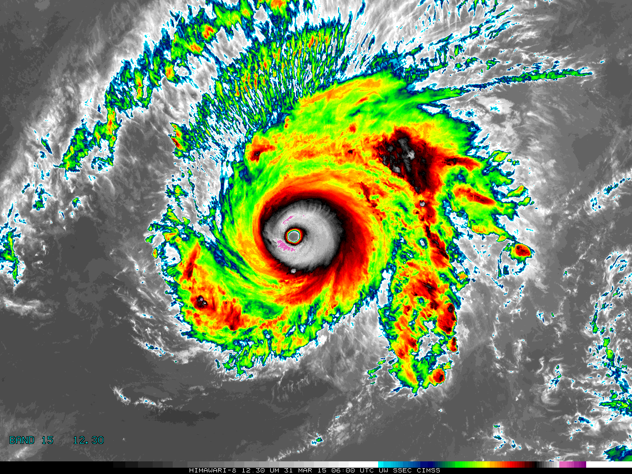

[Please crop out the colorbar.]

Above: The Advanced Himawari Imager (AHI) 12.4 μm band image for Typhoon Maysak from March 31, 2015, at 6 UTC. Credit: CIMSS and JMA

In a nutshell

GOES-R ABI Band 15 (approximately 12.3 μm central, 11.8 μm to 12.8 μm)

Similar to MODIS Band 32, SEVIRI Band 10, AHI Band 15, Suomi NPP VIIRS Band M16

Available on current GOES sounder

Nickname: “Dirty” longwave infrared window band

Availability: Both day and night

Primary purpose: Clouds

Uses similar to: GOES-R ABI Bands 11, 14, and 15
“Core” front text and image
The 12.3 µm, or longwave infrared “dirty” window band offers nearly continuous monitoring for numerous applications, though usually through a split window difference with a cleaner window channel. These differences can better estimate low-level moisture, volcanic ash, airborne dust/sand, sea surface temperature, and cloud particle size. For example, mid-tropospheric dust originating in the Sahara Desert is detectable with the 12.3 µm band. Identifying dust can be useful in assessing where the Atlantic basin is unlikely to support mature tropical cyclones. Furthermore, this band is a major component of the “air mass RGB composite” and the prospective total column ozone product. Source: Schmit et al., 2005 in BAMS, and the ABI Weather Event Simulator (WES) Guide by CIMSS
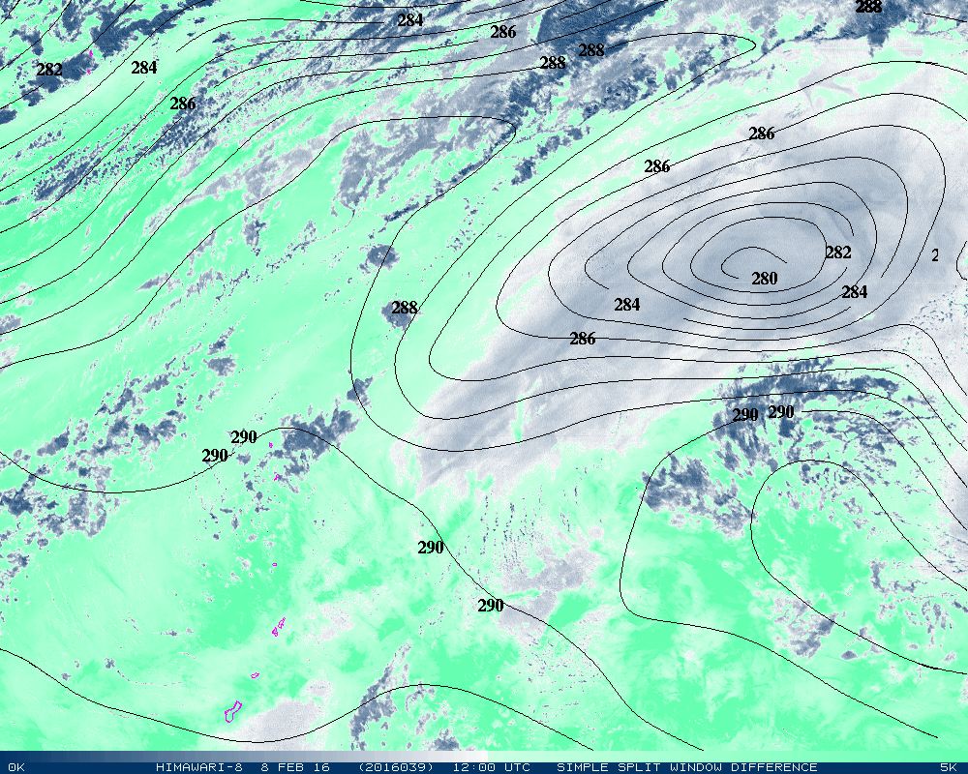
This simple split window difference from AHI over the western Pacific Ocean is valid on February 8, 2016, at 12:00 UTC. This brightness temperature difference of the 10.3 and 12.3 μm bands has no cloud mask applied. The difference range is between 0 and 5 K. Larger split window temperature differences (shades of dark blue or gray) represent drier air (e.g., less moisture absorption), and correspond to the drier dew points (in K) at 925 hPa from the GFS model (contours).

Did You Know?

A 12 µm band was on the GOES imagers on GOES-8 through GOES-11, but was then replaced with a 13.3 µm band on GOES-12. The plan was to evolve to a six-band imager for GOES-13 through GOES-15, but the imager never expanded to six bands. The 13.3 µm band continued through GOES-15. The 12.7 µm band is on the GOES sounders, but at a reduced spatial and temporal resolution and coverage compared to the imager.

Tim’s Topics

- Use same photo as previously

Observing moisture is a key for forecasting cloud formation, including convection. Satellite observations can monitor the high variability in space and time of moisture evolution. While a simple split difference may be useful, there are quantitative products that can also be leveraged. The 12 um band contributes to total precipitable water and lower level moisture information, reflected in legacy atmospheric profile products.

Tim Schmit is a research meteorologist with NOAA NESDIS in Madison, Wisconsin.

Ward’s Words

- Use same photo as previously

All of the infrared window channels are at least somewhat sensitive to water vapor absorption. While this may not be obvious from visual inspection of individual bands, split window differences—subtracting the pixel values of one band from another—are the best way to highlight those clear-air scenes where water vapor is influencing the brightness temperatures. For opaque convective cloud tops, the brightness temperatures between bands should be very similar among the longwave infrared window channels, because there is relatively little water vapor in the stratosphere.

Split window differences involving the 12 µm band are also valuable for distinguishing volcanic ash and dust silicates from cloud water and ice. This is because the emissivity of silicates is lower in the 10 µm band than the 12 µm band, while the reverse is true for cloud water and ice. This leads to higher 12 µm band brightness temperatures compared to the 10 µm band for volcanic ash scenes.

Bill “Hima-Ward-i” Ward is the ESSD Chief in NWS Pacific Region and a former Guam forecaster.

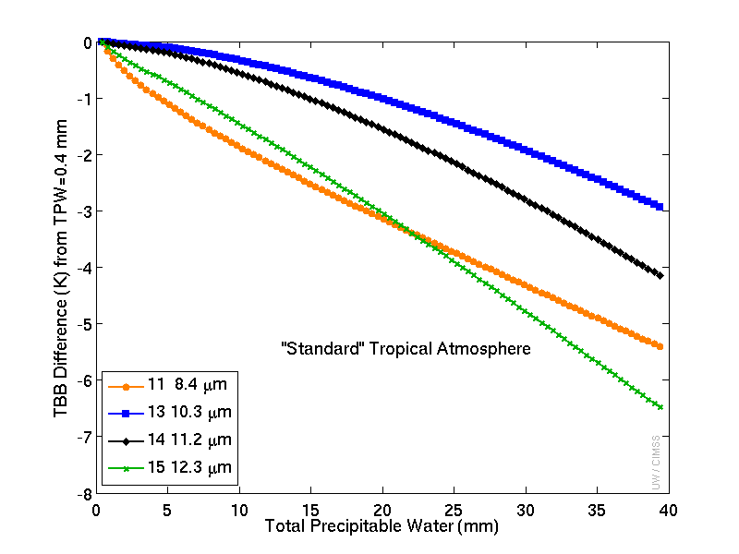
These clear-sky calculations demonstrate how the brightness temperatures change with atmospheric moisture for the four infrared window bands on ABI. With the same temperature profile, brightness temperatures are lower for higher water vapor concentrations. In general, more moisture causes more cooling as water vapor absorption occurs higher in the troposphere. The 10.3 μm shows the least amount of sensitivity to moisture (considered the "cleanest" window), while bands centered at 8.4 and 12.3 μm show the most (hence "dirty" window). Credit: CIMSS

ABI Band Product Table (same general layout)

Use Band 15 (from excel file, separated by tab)

Bottom of back page (update date)

Further reading

ABI Bands Quick Information Guides: http://www.goes-r.gov/education/ABI-bands-quick-info.html
ABI WES Guide: http://cimss.ssec.wisc.edu/goes/abi/loops/WES_for_GOES-R_ABI_2011_Version.pdf
Simulated ABI TBD: http://tinyurl.com/ABI-swd
CIMSS Satellite Blog: http://cimss.ssec.wisc.edu/goes/blog/archives/category/goes-12
GOES-R COMET training: http://www.goes-r.gov/users/training/comet.html
GOES-R acronyms: http://www.goes-r.gov/resources/acronyms.html
ABI Weighting Functions: http://cimss.ssec.wisc.edu/goes/wf/ABI/

