GOES-R ABI Fact Sheet Band 11 (“cloud-top phase” infrared band)
The “need to know” Advanced Baseline Imager reference guide for the NWS forecaster

Front page – Maintain general layout

No changes needed to header banner (GOES-R satellite); title as above
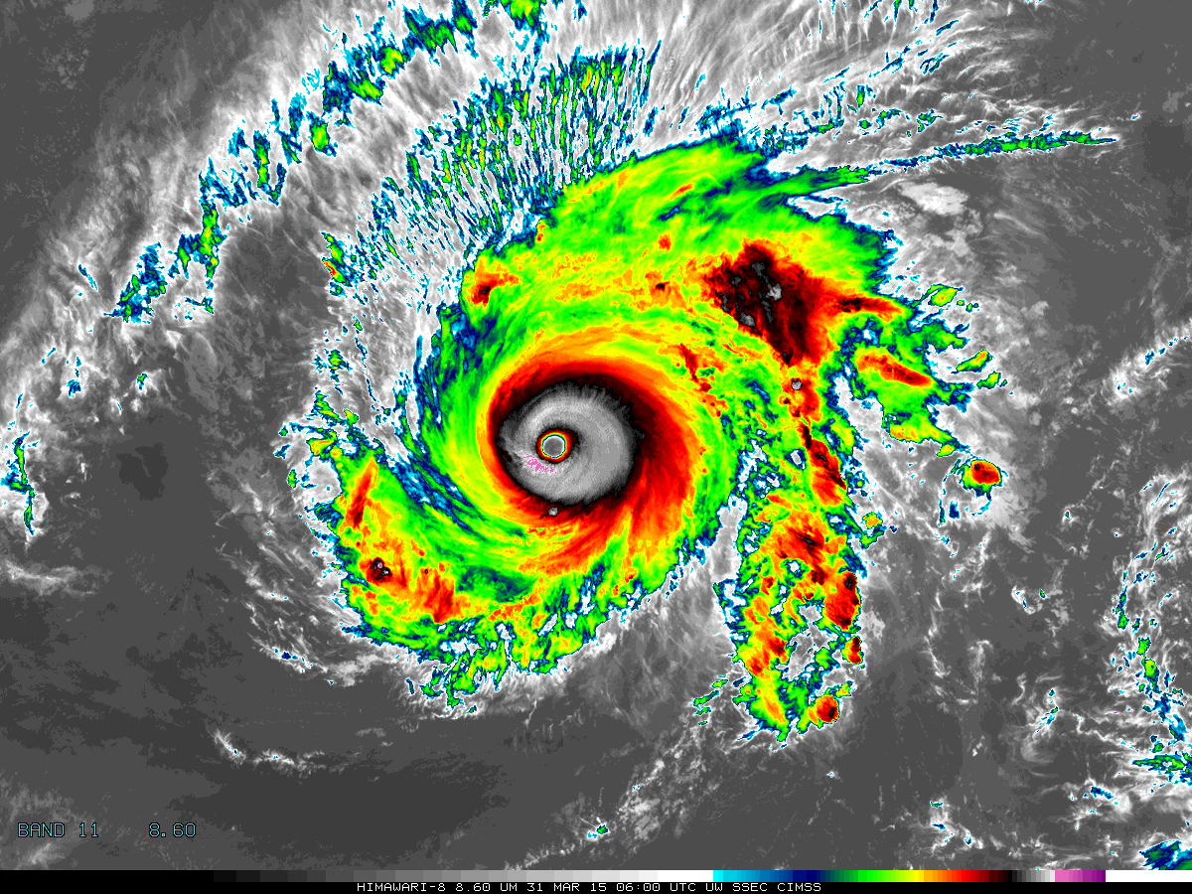

[Please crop out the colorbar.]

Above: The Advanced Himawari Imager (AHI) 8.6 μm for Typhoon Maysak from March 31, 2015 at 06 UTC. Credit: CIMSS and JMA.

In a nutshell

GOES-R ABI Band 11 (approximately 8.4 μm central, 8.2 μm to 8.7 μm)

Also similar to Suomi NPP VIIRS Band M14, MODIS Band 29, SEVIRI Band 7, AHI Band 11

Not available on current GOES Sounder nor Imager

Nickname: “Cloud-top phase” infrared band

Availability: Both Day and Night

Primary purpose: Cloud-top phase, dust, and SO₂ detection

Uses similar to: GOES-R ABI Bands 13, 14, and 15
“Core” front text and image
The 8.4 µm, or “cloud-top phase” band is used in combination with the 11.2 and 12.3 µm bands to derive cloud phase and type products. This band is similar to the “traditional” IR longwave window band, although the 8.4 µm band assists in determining the microphysical properties of clouds. Using this band produces a more accurate and consistent delineation of ice clouds from water clouds during both the day and night. The same three spectral bands enable detection of volcanic dust clouds containing aerosols and sulfur dioxide. Other uses of the 8.4 µm band include thin cirrus detection in conjunction with the 11.2 µm band, better atmospheric moisture correction in relatively dry atmospheres in conjunction with the 11.2 µm band, and estimation of surface properties in conjunction with the 10.3 µm band. This band is essential for generating many products. Source: Schmit et al., 2005 in BAMS, and the ABI Weather Event Simulator (WES) Guide by CIMSS.

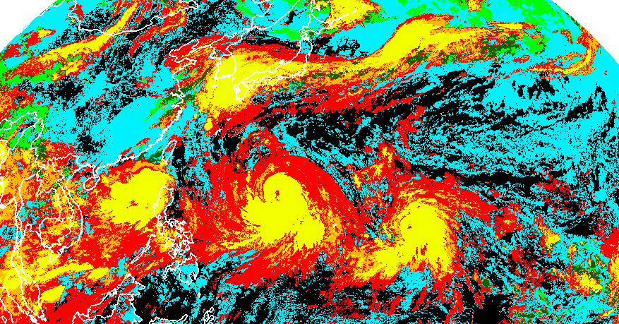
A derived product image of cloud type as diagnosed with AHI data shows three tropical systems over the western Pacific Ocean. This example demonstrates how a derived product can be used, instead of interrogating the individual spectral bands. The image is from July 7, 2015, at approximately 2:30 UTC. Credit: JMA, ASPB, and CIMSS. [The categories are: Clear (black), Liquid water (cyan); Supercooled Water (lime); Mixed Phase (green); Thick Ice (yellow); Thin Ice (red); and Multilayered Ice clouds (orange) – please match them to colors above when in production, note that some colors do not appear in the image, such as blue]
Did You Know?

The first geostationary imager with a band similar to Band 11 (8.4 μm) on the ABI was the SEVIRI from EUMETSAT, first available in 2002. The similar SEVIRI band is centered at 8.7 µm and has been used operationally for many uses, including for the monitoring of dust, volcanic ash, and cloud phase. The presence of this spectral band from the geostationary perspective helped make the case for the inclusion of this band on the GOES-R series.

Tim’s Topics

- Use same photo as currently

In late 1989, Steven A. Ackerman, then a researcher at CIMSS, wrote a memo to NOAA NESDIS. The purpose of the letter was to suggest that “as NOAA plans the spectral band passes for its future satellite instruments…consider a channel in the 8-8.5 µm region…based on recent observational and theoretical studies…found that 8 and 11 µm channels are very useful in detecting…cirrus information. Inclusion of the 8 µm channel removes the ambiguity associated with the use of the 11 and 12 µm channels alone. In addition, we have found that the combination of the 8 and 11 µm channels contain information regarding the microphysical properties of the cloud.” The memo was written and now this band is on the ABI, along with a host of other advanced geostationary imagers.

Tim Schmit is a research meteorologist with NOAA NESDIS in Madison, Wisconsin.

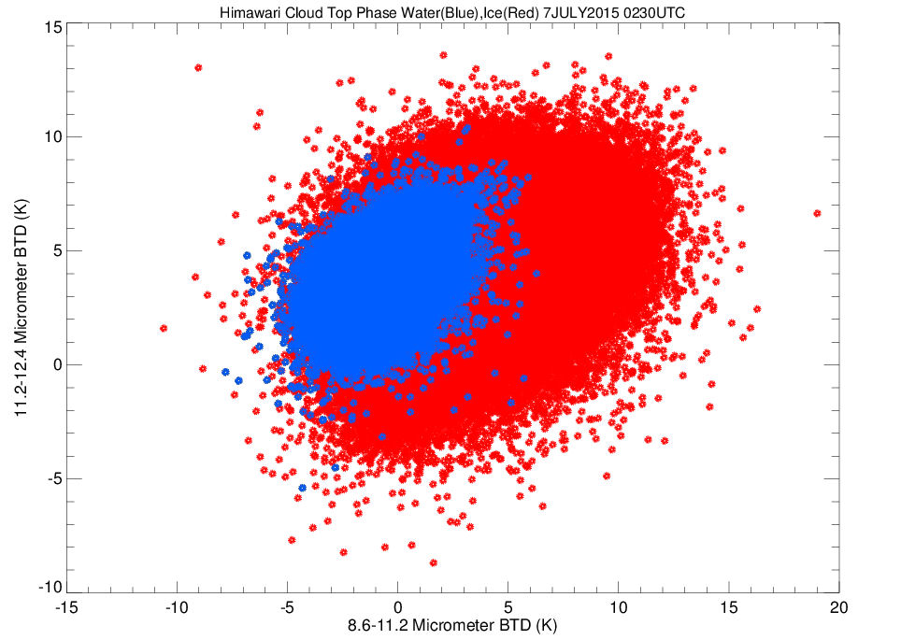
This scatterplot compares brightness temperature differences over an area of both water and ice clouds. Only ice clouds have brightness temperature differences (8.6 µm minus 11.2 µm) of more that approximately 5 K. Credit: JMA, ASPB, and CIMSS.
Ward’s Words

- Same picture.

There are four infrared window channels on the GOES-R ABI and Himawari AHI. It is important to know the nuances of the spectral response functions for these channels, because weak absorption of water vapor is evident to the critical user. This band is considered a “dirty window” because water vapor absorption is more prevalent than in the traditional window region at about 11.0 µm. The practical implication of this is that the brightness temperatures of surface features are slightly cooler in the presence of near-surface deep moisture. In addition, this band is useful for sulfur dioxide detection, also decreasing brightness temperatures.
Bill “Hima-Ward-i” Ward is the ESSD Chief in NWS Pacific Region and a former Guam forecaster.

ABI Band | Approximate Central  Wavelength (µm) | Band “Nickname” | Type | Nominal sub satellite pixel spacing (km)
11 | 8.4 | Cloud-top Phase | IR | 2
13 | 10.3 | "Clean" IR Longwave  Window | IR | 2
14 | 11.2 | IR Longwave Window | IR | 2
15 | 12.3 | "Dirty" Longwave Window | IR | 2

ABI Band Product Table (same general layout)

Use Band 11 (from excel file, separated by tab)

Bottom of back page (update date)

Further reading

ABI Bands Quick Information Guides: http://www.goes-r.gov/education/ABI-bands-quick-info.html

GOES-R VolAsh Fact Sheet: http://www.goes-r.gov/education/docs/Factsheet-Volcanic%20Ash.pdf

ABI Weighting Function page: http://cimss.ssec.wisc.edu/goes/wf/ABI/

CIMSS Satellite Blog: http://cimss.ssec.wisc.edu/goes/blog/archives/638

EUMETSAT: http://eumetrain.org/resources.html

GOES-R COMET training: http://www.goes-r.gov/users/training/comet.html
GOES-R acronyms: http://www.goes-r.gov/resources/acronyms.html

