GOES-R ABI Fact Sheet Band 6 (The “Cloud Particle size” near-infrared band)
The “need to know” Advanced Baseline Imager reference guide for the NWS forecaster

Front page – Maintain general layout

No changes needed to header banner (GOES-R satellite); title as above

Replace hurricane image with band (see below).
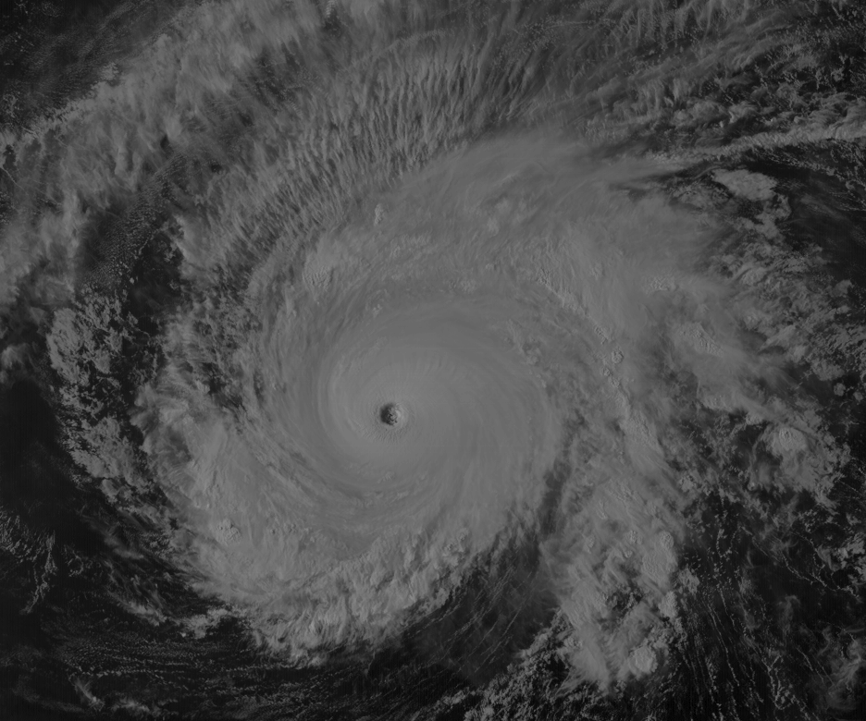

Caption: Above: Advanced Himawari Imager (AHI) 2.2 μm for Typhoon Maysak. This image was from March 31, 2015, at 6 UTC. Credit: CIMSS and JMA

In a nutshell

GOES-R ABI Band 6 (approximately 2.24 μm central, 2.22 μm to 2.27 μm)

Also similar Suomi NPP VIIRS Band M11, MODIS Band 7, Landsat Band 7, AHI Band 6

New for GOES-R Series, not available on current GOES

Nickname: “Cloud particle size” (near-infrared) band

Availability: Daytime for snow and cloud applications, nighttime for fire applications

Primary purpose: Cloud particle size, snow, cloud phase

Uses similar to: 1.6 μm for fire detection and cloud properties.
“Core” front text and image
The 2.2 μm band, in conjunction with other bands, will enable cloud particle size estimation; cloud particle growth is an indication of cloud development and intensity of that development. Other applications of the 2.2 μm band include use in a multispectral approach for aerosol particle size estimation (by characterizing the aerosol-free background over land), cloud screening, hot-spot detection, and snow detection. The MODIS and VIIRS cloud mask algorithms use a similar band. Source: Schmit et al., 2005 in BAMS, and the ABI Weather Event Simulator (WES) Guide by CIMSS.

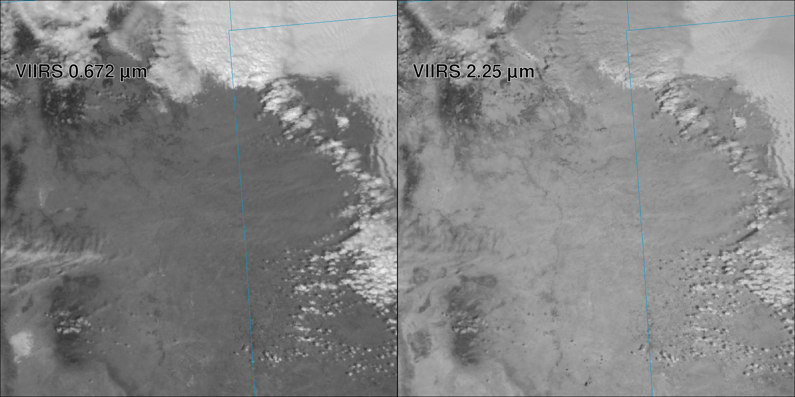
Suomi NPP VIIRS images (March 23, 2013 at 20:35 UTC) of the 0.67 and 2.2 μm bands. Note the darker phenomena in the 2.2 μm band for both ice clouds (near the top of the image) and White Sands, NM (lower left). These images were made in McIDAS-V. Credit: NASA and SSEC.
Did You Know?

Similar to the 1.6 μm band, the 2.2 μm band can be useful in determining hot spots. In fact, the 2.2 μm band is spectrally located closer to the maximum emitting temperature. While the 2.2 μm band can be used for cloud-top applications, it can also be thought of as the “fire and ice” band with applications related to hot spots and snow detection.

Tim’s Topics

- Same picture.

The near-infrared bands on the ABI are key for determining cloud properties. According to Andi Walther, in the GOES-R AWG Daytime Cloud Optical and Microphysical Properties (DCOMP) ATBD, “The main information content for Cloud Optical Depth (COD) lies in the conservative-scattering channel at about 0.64 μm. The absorption channel at 2.2 μm provides additional information on Cloud effective Particle size (CPS) and helps in directly to estimate COD by adjusting the differences in the phase function due to particle size. Liquid and ice water path are calculated subsequently from COD and CPS.” Hence, when one uses the liquid or ice water path, one is using, in part, the 2.2 μm information. Now, for forecasting applications, it might make sense to view the derived quantitative product, such as liquid or ice water path, and not just the one ABI band.

Tim Schmit is a research meteorologist with NOAA NESDIS in Madison, Wisconsin.

*(can crop off top of image below)*

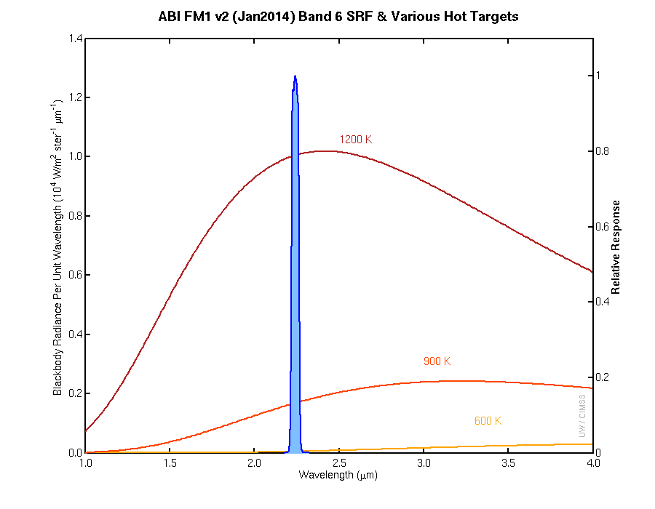
Caption: Planck curve showing the radiance for increasing wavelengths for three temperatures. Note how there is more energy from a fire at 2.2 μm, compared to 1.6 μm at these temperatures. Of course, most fires will not consume the entire pixel, decreasing the pixel reflectance in the imagery. Credit: CIMSS.

*(can crop off top of image below)*

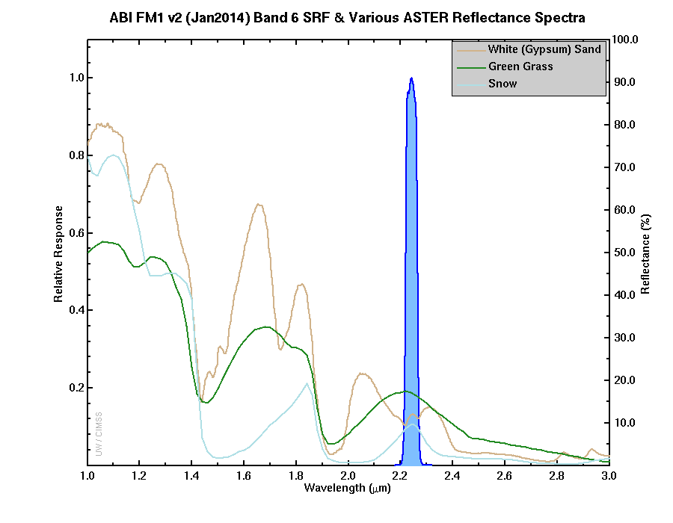

Caption: The ABI (blue shaded curve) spectral response function for the ABI 2.2 μm band 6, along with three high-spectral resolution curves. The plot of white gypsum sand (“brown solid line”) demonstrates how the 2.2 μm band is highly absorbing compared to the shorter wavelength bands. Credit CIMSS, ASTER spectral library.
Carven’s Corner

- Same picture.

One of the frustrations that meteorologists sometimes face with satellite imagery is discriminating land features from clouds. Using the 2.2 μm band, forecasters will find that snow, green grass, and certain white sands are all not particularly reflective, in contrast to water clouds. The challenge, however, is that ice cloud is also not very reflective in the 2.2 μm band, making it appear relatively dark in the imagery. Ice cloud is more reflective than what is evident using the 1.6 μm band, though. Outside of New Mexico (and shall we say, “Black Sands”), we anticipate that most forecasters will use the 1.6 μm band and its better spatial resolution in lieu of the 2.2 μm band.

That does not suggest that the 2.2 μm band is not without specialized applications, particularly for certain cloud algorithms and “hot spot” detection when fires have an emission temperature of greater than 600 K.

Carven Scott is the ESSD Chief in NWS Alaska Region and a former SOO.

ABI Band Table

-- band table 1 thru 6 –

ABI Band | Approximate Central  Wavelength (µm) | Band “Nickname” | Type | Nominal sub satellite pixel spacing (km)
1 | 0.47 | “Blue” band | Visible | 1
2 | 0.64 | “Red” band | Visible | 0.5
3 | 0.86 | “Veggie” band | Near-IR | 1
4 | 1.37 | “Cirrus” band | Near-IR | 2
5 | 1.6 | “Snow” band | Near-IR | 1
6 | 2.2 | “Cloud Particle size” band | Near-IR | 2

ABI Band Product Table (same general layout)

Use band 6 (from excel file, separated by tab)

Bottom of back page (update date)

Further reading

GOES-R Overview: http://goes-r.gov

ABI Bands Quick Information Guides: http://www.goes-r.gov/education/ABI-bands-quick-info.html

VIIRS example (fader): http://cimss.ssec.wisc.edu/goes/abi/viirs_clouds.html

Landsat: http://landsat.gsfc.nasa.gov/?page_id=5377

GOES-R COMET training: http://www.goes-r.gov/users/training/comet.html
GOES-R acronyms: http://www.goes-r.gov/resources/acronyms.html

