GOES-R ABI Fact Sheet Band 4 (The “Cirrus” near-infrared band)
The “need to know” Advanced Baseline Imager reference guide for the NWS forecaster

Front page – Maintain general layout

No changes needed to header banner (GOES-R satellite); title as above

Replace simulated hurricane image with band (see below).
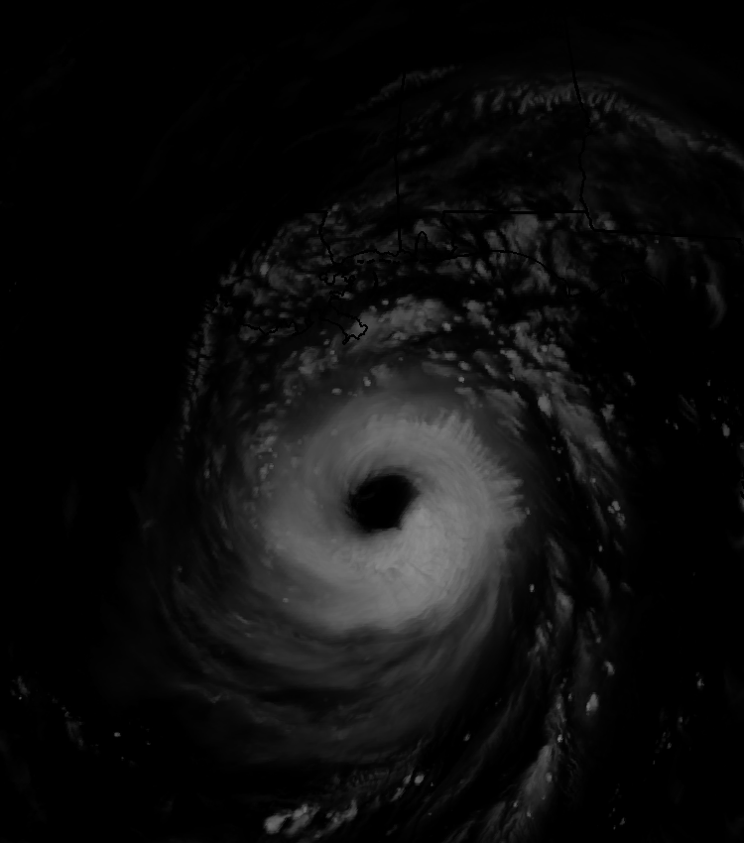

Caption: Above: Simulated image of ABI Band 4 (1.37 μm) for Hurricane Katrina. This image was simulated via a combination of high spatial resolution numerical model runs and advanced “forward” radiative transfer models. (Credit: CIMSS)

In a nutshell

GOES-R ABI Band 4 (approximately 1.37 μm central, 1.36 μm to 1.38 μm)

Also similar Suomi NPP VIIRS Band M9 and MODIS Band 26

New for GOES-R Series, not available on current GOES or Himawari-8

Nickname: “Cirrus” (near-infrared) band

Availability: Daytime only

Primary purpose: Cirrus detection

Uses similar to: None
“Core” front text and image
Another near-IR band, the “cirrus” band at 1.37 μm will detect very thin cirrus clouds during the day. This band is centered in a strong water vapor absorption spectral region. It does not routinely sense the lower troposphere, where there is substantial water vapor, and thus provides excellent daytime sensitivity to high, very thin cirrus under most circumstances, especially in warm, moist atmospheres. Correction for the presence of contrail and thin cirrus, which are possible with this band, is important when estimating many surface parameters. Hence, this band can be used to distinguish between low and high clouds or other bright objects and high clouds. Source: Schmit et al., 2005 in BAMS, and the ABI Weather Event Simulator (WES) Guide by CIMSS.

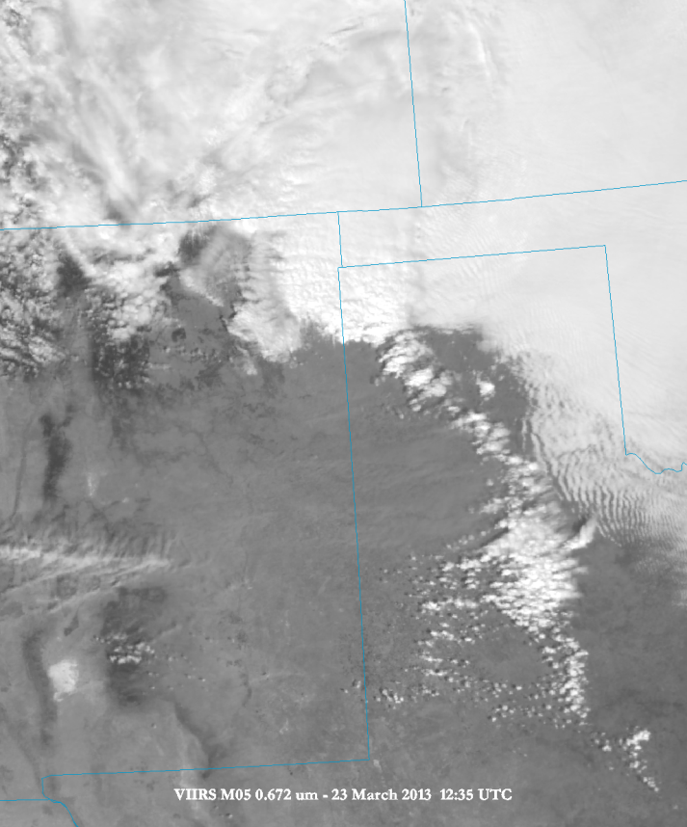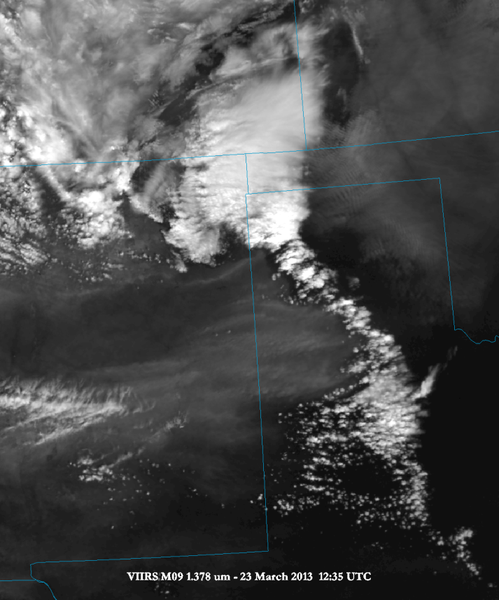
Caption: Suomi NPP VIIRS images (March 23, 2015 at 12:35 UTC) for the 0.672 μm (left hand side) and the 1.378 um (right hand side) over parts of New Mexico and Texas at 750 m resolution. The dust is much more apparent in the 1.378 μm band. These images were made using McIDAS-V. Credit: NASA and SSEC.

Note: These images could be cropped, as long as they are cropped the same.
Did You Know?

The nickname for the 1.37 μm band is the "cirrus" band, but it is also useful in detecting other upper-level features. The 1.37 μm band is not limited to only detecting upper level clouds, but under certain conditions can also detect smoke and ash plumes from volcanic activity. MODIS and VIIRS imagery from the 1.37 μm band have shown ash plumes which can be helpful in issuing volcanic ash SIGMETs for the aviation community.

Tim’s Topics

- Use same photo as currently, although not that one that too zoomed in.:)

Each of the spectral bands on the ABI have “champion”. The champion for this ABI band was Bo-Cai Gao, who was the lead author on “An algorithm using visible and 1.375 μm channels to retrieve cirrus cloud reflectances from aircraft and satellite data”. The idea of including this band on the ABI was further bolstered when it was approved by the NOAA research council, when ABI evolved from an 8 to 12 channel imager.
Note that the 1.88 μm has similar physics as the 1.37 μm band, given both are in strong water vapor absorption regions. It is this absorption that allows the cirrus clouds to stand out, since usually there is enough moisture in the troposphere, and especially near the surface, to block the surface signal.

The 1.37 μm on the ABI has a sub-point spatial resolution of 2 km. This is nominally the spatial resolution of ABI’s infrared bands. The GOES-R Cloud Mask algorithm uses, as one of its inputs, information from the 1.37 μm. The ATBD states this channel “has been shown to be extremely helpful in detecting thin cirrus, which can often be undetected by the other reflective channels”.

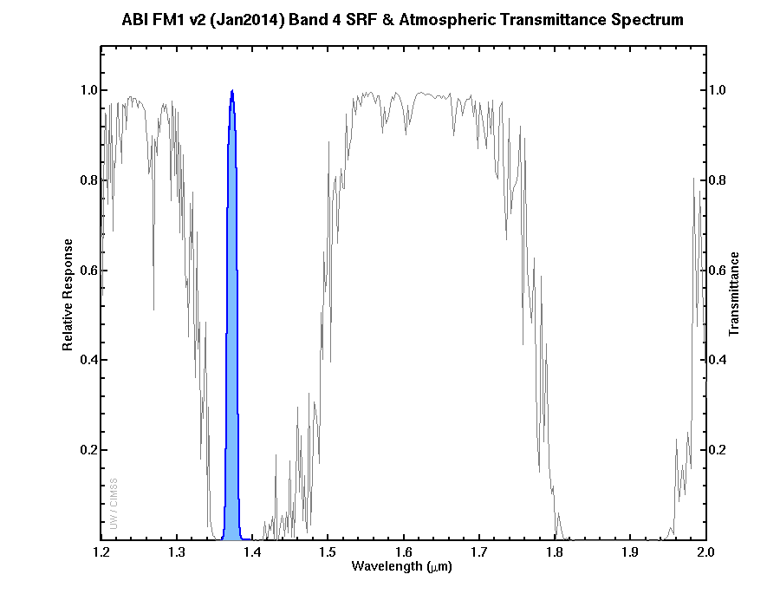
Caption: The ABI (blue shaded curve) spectral response function for the 1.37 μm band, along with a high-spectral resolution curve of the total transmittance through the atmosphere. Note how the 1.37 μm band is in the center of a water vapor absorption region and hence will appear dark for most clear sky scenes. Credit: CIMSS.
[Note that the top legend of the figure could be cropped off!]

Tim Schmit is a research meteorologist with NOAA NESDIS in Madison, Wisconsin.

Carven’s Corner

- Same picture.

Meteorologists may wonder how the “cirrus” band shows cloud scenes when there is relatively little water vapor in the atmosphere. When the column total precipitable water is less than about 10 mm, or 0.4 in, surface features will appear in cloud-free scenes. The drier the atmosphere, and lesser the viewing angle from the satellite, the more pronounced the surface features will appear.

Unlike most of the other near-infrared bands, the reflectance for dirt, snow, and grass are all approximately the same in the 1.37 μm band. Generally, reflectance is between 35% and 50% for these surface features. Cirrus over snow cover and an otherwise very dry troposphere may be more difficult to detect because of this, particularly in low light.

Using only satellite, one good way to verify whether the atmosphere is dry enough to view surface features is to compare a cloud-free scene in the 7.34 μm water vapor band to the 10.35 μm infrared window band. The lesser the absolute brightness temperature difference between these two bands for a given pixel, the drier the atmosphere.

In dry and windy regimes behind fronts passing over the southwestern United States, it is possible to see lofted dust in the “cirrus” band, in part due to the lesser absorption of limited tropospheric water vapor, particularly in the middle and upper levels.

Carven Scott is the ESSD Chief in NWS Alaska Region and a former SOO.

Space allowing:
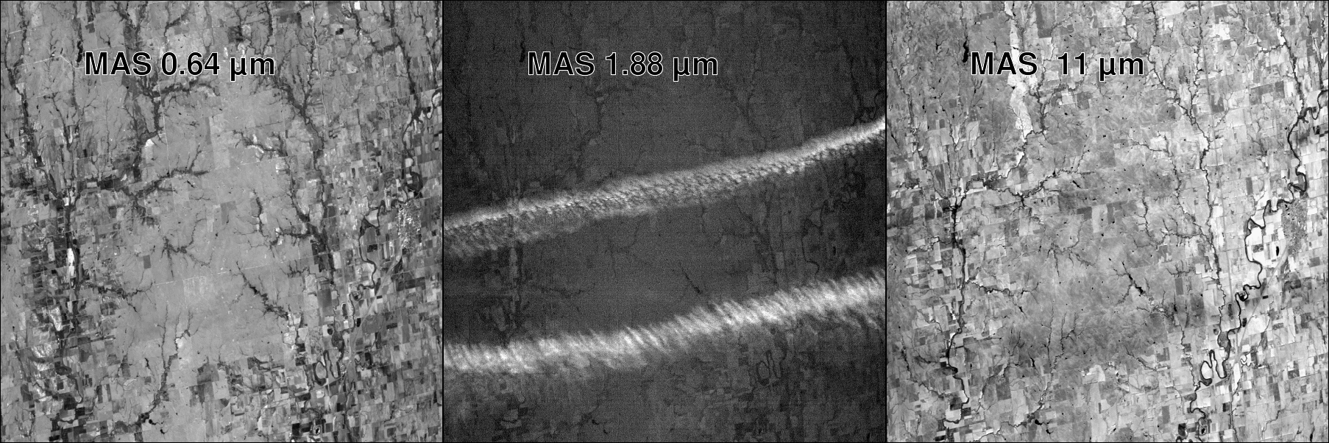
Caption: NASA’s MODIS (Moderate-Resolution Imaging Spectrometer) Airborne Simulator (MAS) was used, in part, to demonstrate several of the spectral bands of the ABI. This this case from the MAS, upper-level cirrus are clearly evident in the 1.88 μm image (center panel), but much less in the traditional visible band (left panel) and the longwave window band (right panel). Credit: NASA and SSEC.

ABI Band Table

ABI Band | Approximate Central  Wavelength (µm) | Band “Nickname” | Type | Nominal sub satellite pixel spacing (km)
4 | 1.37 | “Cirrus” band | Near-IR | 2

ABI Band Product Table (same general layout)

Use Band 4 (from Excel file, separated by tab)

Bottom of back page (update date)

Further reading

ABI Bands Quick Information Guides: http://www.goes-r.gov/education/ABI-bands-quick-info.html

Journal article: http://modis-atmos.gsfc.nasa.gov/_docs/Gao_et_al._%282002b%29.pdf

Weighting functions: https://cimss.ssec.wisc.edu/goes/abi/vis_IR/wghtfnc_trans.html
Cloud Mask ATBD: http://www.star.nesdis.noaa.gov/goesr/docs/ATBD/Cloud_Mask.pdf

GOES-R COMET training: http://www.goes-r.gov/users/training/comet.html
GOES-R acronyms: http://www.goes-r.gov/resources/acronyms.html

