GOES-R ABI Fact Sheet Band 16 ("CO₂" longwave infrared band)
The “need to know” Advanced Baseline Imager reference guide for the NWS forecaster

Front page – Maintain general layout

No changes needed to header banner (GOES-R satellite); title as above
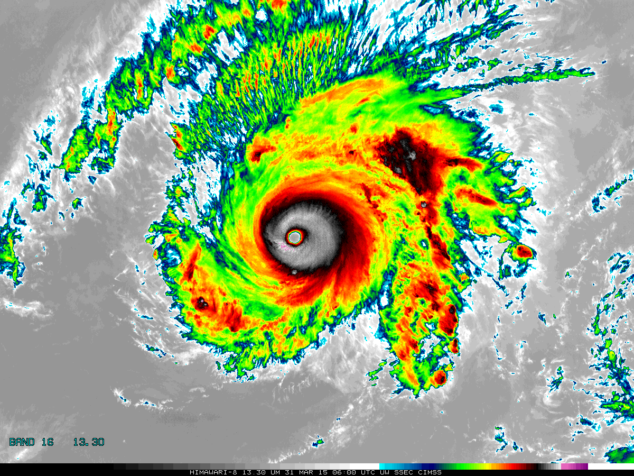

[Please crop out the colorbar.]

Above: The Advanced Himawari Imager (AHI) 13.3 μm band image for Typhoon Maysak from March 31, 2015, at 6 UTC. Credit: CIMSS and JMA

In a nutshell

GOES-R ABI Band 16 (approximately 13.3 μm central, 13.0 μm to 13.6 μm)

Similar to MODIS Band 33, SEVIRI Band 11, AHI Band 16

Available on current GOES (imager and sounder)

Nickname: "CO₂" longwave infrared band

Availability: Both day and night

Primary purpose: Air temperature, clouds

Uses similar to: None
“Core” front text and image
The 13.3 µm “carbon dioxide” band is used for mean tropospheric air temperature estimation, tropopause delineation, and as part of quantitative cloud products for cloud opacity estimation, cloud-top height assignments of cloud-drift motion vectors, and supplementing Automated Surface Observing System (ASOS) observations. It has been possible to demonstrate products created with the 13.3 μm band using the GOES-12 through GOES-15 imagers (since GOES-12 launch in 2001), as well as the current GOES sounders (since GOES-8 launch in 1994). This band is also useful when generating Red-Green-Blue (RGB) composite imagery, to highlight the high, cold, and likely icy clouds. Source: Schmit et al., 2005 in BAMS, and the ABI Weather Event Simulator (WES) Guide by CIMSS.

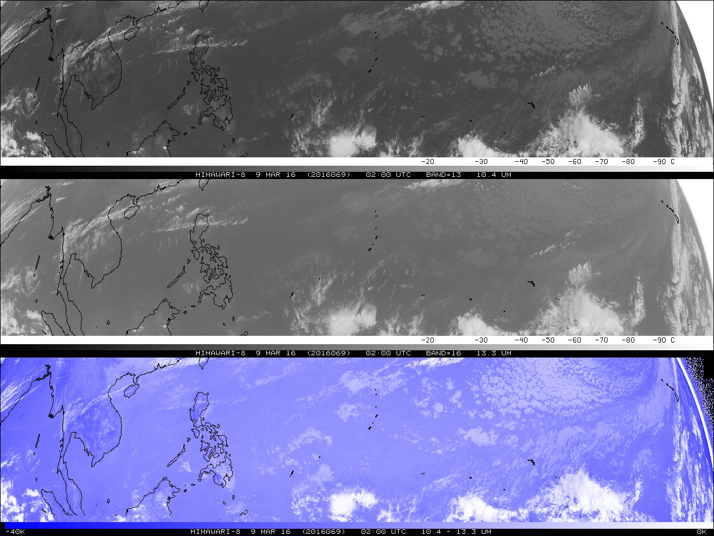

The top panel shows the “clean” longwave infrared window, ABI Band 13 centered at 10.4 μm, over the western Pacific Ocean on March 9, 2016, at approximately 2 UTC. The image is a brightness temperature plot where the warmer pixels are darker colors and the colder pixels are lighter colors. The middle panel uses the same color range at the same valid time, but depicts AHI Band 16 centered at 13.3 μm band. There are overall colder values, especially in cloud-free air, compared to the top panel. This is highlighted in the bottom panel, which is a difference of the above two AHI bands. The brightness temperature difference range goes from -40 K on the left to 0 K on the right. Cooler brightness temperatures due to predominantly CO₂ absorption in cloud-free skies are evident. Credit: ASPB

Did You Know?

The 13.3 µm “carbon dioxide” band will not only have better spatial resolution compared to past geostationary satellites, but also less noise. One measure of image quality for an infrared band is the Noise Equivalent delta Temperature (NEdT). A smaller NEdT is desirable, but noise tends to increase with better spatial resolution. For the 13.3 μm band on the ABI, the specification for the NEdT (at a reference temperature of 300 K) is 0.3 K. This is three times greater than the specifications for NEdT of the other ABI infrared bands. Fortunately, the worst NEdT estimate for the 13.3 μm band on the ABI is only approximately 0.07 K. These values compare to the specification on the current GOES imagers of 0.32 K, with measured performance of 0.13 K on GOES-15. Hence, the NEdT for the 13.3 μm band on the ABI is expected to be better than the current GOES imager, even though the spatial resolution on the ABI is approximately four times finer.

Tim’s Topics

- Use same photo as previously

The heritage sensors for the 13.3 μm band on the ABI are the CO₂ bands on the current GOES sounders, as well as the GOES imagers since GOES-12.

The 13.3 μm band on the ABI is used in several of the GOES-R baseline products. These include cloud-top height, pressure, and temperature. This band is also an input to the legacy moisture and temperature profiles, and hence the products derived from the profiles, such as TPW or the stability indices. This band is also used in the quantitative volcanic ash detection and height algorithm.

Tim Schmit is a research meteorologist with NOAA NESDIS in Madison, Wisconsin.

Ken’s Corner

- Photo TBA

Meteorologists have had the 13.3 μm “carbon dioxide” band for several years now, but probably have not used it much, in part because this band is better for science products than visual interpretation.

Compared to the lower wavelength infrared window channels, the CO₂ band brightness temperatures will generally be cooler, especially in scenes absent clouds, due to the general homogeneous distribution of CO₂ in the troposphere (with the concentration of CO₂ slightly decreasing in the stratosphere). However, it is not possible to retrieve (explicitly measure) CO₂ with a single spectral band due to the variable temperature structure of the lower atmosphere (so do not expect to find any pollution from factories). In addition, the 13.3 μm band, like many other infrared bands, is sensitive to water vapor absorption, further complicating the interpretation of brightness temperatures and spatial patterns. Yet this band is not opaque from water vapor or CO₂ absorption for all but extreme viewing angles, so surface emission will also impact the brightness temperature to at least a limited extent.

Ken Johnson is the SSD Chief in the NWS Eastern Region. Jordan Gerth contributed to this segment.
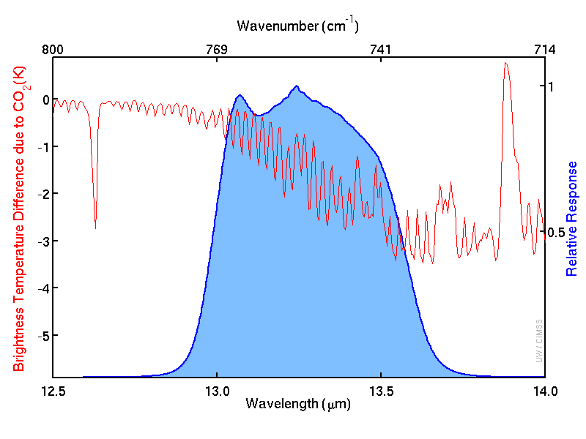
The system-level spectral response for ABI Band 16 (13.3 μm) is shown in blue. The red curve represents where an earth-emitted spectrum is modified due to CO₂. In certain spectral regions, there is actually a net warming. This is due to observing the warmer stratosphere, where there is also carbon dioxide.

ABI Band | Approximate Central  Wavelength (µm) | Band “Nickname” | Type | Nominal sub satellite pixel spacing (km)
16 | 13.3 | “CO₂” longwave infrared band | IR | 2

ABI Band Product Table (same general layout)

Use band 16 (from excel file, separated by tab)

Bottom of back page (update date)

Further reading

ABI Bands Quick Information Guides: http://www.goes-r.gov/education/ABI-bands-quick-info.html
ABI Weighting Functions: http://cimss.ssec.wisc.edu/goes/wf/ABI/
GOES-R spectral “web app”: http://cimss.ssec.wisc.edu/goes/webapps/bandapp/overview_goes-r.html
Near real-time RGB “web app”: http://cimss.ssec.wisc.edu/goes/webapps/satrgb/overview_near_realtime.html
GOES-R COMET training: http://www.goes-r.gov/users/training/comet.html
GOES-R acronyms: http://www.goes-r.gov/resources/acronyms.html

