AWIPS II and GOES-R: When updated information processing systems and new satellites meet
22 October 2010
Scheduled for launch in 2015, and expected for operational use as GOES-West starting in 2017, GOES-R (Geostationary Operational Environmental Satellite R-Series) will represent the first significant upgrade in capabilities to the United States’ geostationary satellite series since 1994. GOES-S (East) will launch in 2017 for operational use in 2020.
The GOES-R/S Advanced Baseline Imager (ABI) will provide five times faster spatial coverage, four times improved resolution, and three times more spectral channels than currently on GOES-13/14/15 (N/O/P). An optical sensor on the Geostationary Lightning Mapper (GLM) will provide continuous lightning flash rates.
The GOES-R Proving Ground is designed to showcase future capabilities and identify possible gaps as a forward-thinking exercise to prepare the end user for upcoming science and technology. It is a collective effort between many NOAA and NOAA-supported agencies and universities and connects research and operations to assure widespread day-one readiness through: applying current earth observing systems and numerical weather prediction models to demonstrate GOES-R capabilities today, transitioning new algorithms and techniques to the field early to assure forecaster familiarity with GOES-R products, and making operational meteorologists part of the discussion when it comes to designing and implementing effective GOES-R decision support products and visualization tools.
The additional capabilities of the ABI will produce approximately 60 times (5x4x3) more data than the current GOES Imager. If data is delivered at full bit depth (12 to 14 bits), approximately 50% more bandwidth will be required. Delivering geostationary satellite data in 2020 using a similar methodology as today may require up to 90 times more bandwidth than currently.
Prior to the launch of GOES-R, the processing and visualization software employed at NWS field offices will be upgraded. The Advanced Weather Interactive Processing System (AWIPS) II brings a new, integrated mapping interface which allows much more flexibility to meteorological analysis and data interrogation over large areas. Gone are the resolution restrictions to scales and the expectations that certain data is only useful on certain scales. AWIPS II represents an end-to-end, design-level overhaul of the legacy AWIPS to respond to changes in technology and data requirements over the previous decade.
Thus, the questions we have to answer include:
- Are the visualization tools in place to allow for effective interrogation of this data?
- How can we better devise blended products to deliver more information to the forecaster without requiring the review of multiple images (from different bands, satellites, times)?
- Is all satellite imagery needed by all AWIPS sites all the time?
- Is it time to rethink the delivery paradigm? Delivery data format?
NOAAPort is a satellite-based system used as the primary delivery mechanism for hydrometeorological data and model output to the field, as well as NOAA’s partners. In 2011, the delivery bandwidth will increase from 10 Mbps to 30 Mbps as part of upgrading the signal demodulators from DVB-S to DVB-S2. NOAAPort will remain the primary delivery mechanism through at least 2013.
“Push-pull” and “on-request” technology has been investigated as a way to deliver weather data to remote locations (FxNet and AWIPS II Thin Client), and could be expanded to alleviate bandwidth over NOAAPort for regional data and products.
AWIPS II will play a significant role in promoting the capabilities of GOES-R and new polar-orbiting satellites because the expanded distribution and development group will lead to an implementation of additional features which maximize the utility of satellite imagery and products in concert with other in-situ observations and model output. It will also allow for the efficient transfer of new science and technology into NWS operations without delay.
Our future AWIPS will not be confined to NWS offices, but extend to universities and become an integral part of the increasing research to operations activities. Now is the time to start investigating data overload, and developing methodology which optimizes the use of data, imagery, products, and tools which are situation and scenario relevant, and leads the decision support thought process.
Jordan Gerth
Cooperative Institute for Meteorological Satellite Studies (CIMSS)
University of Wisconsin, Madison

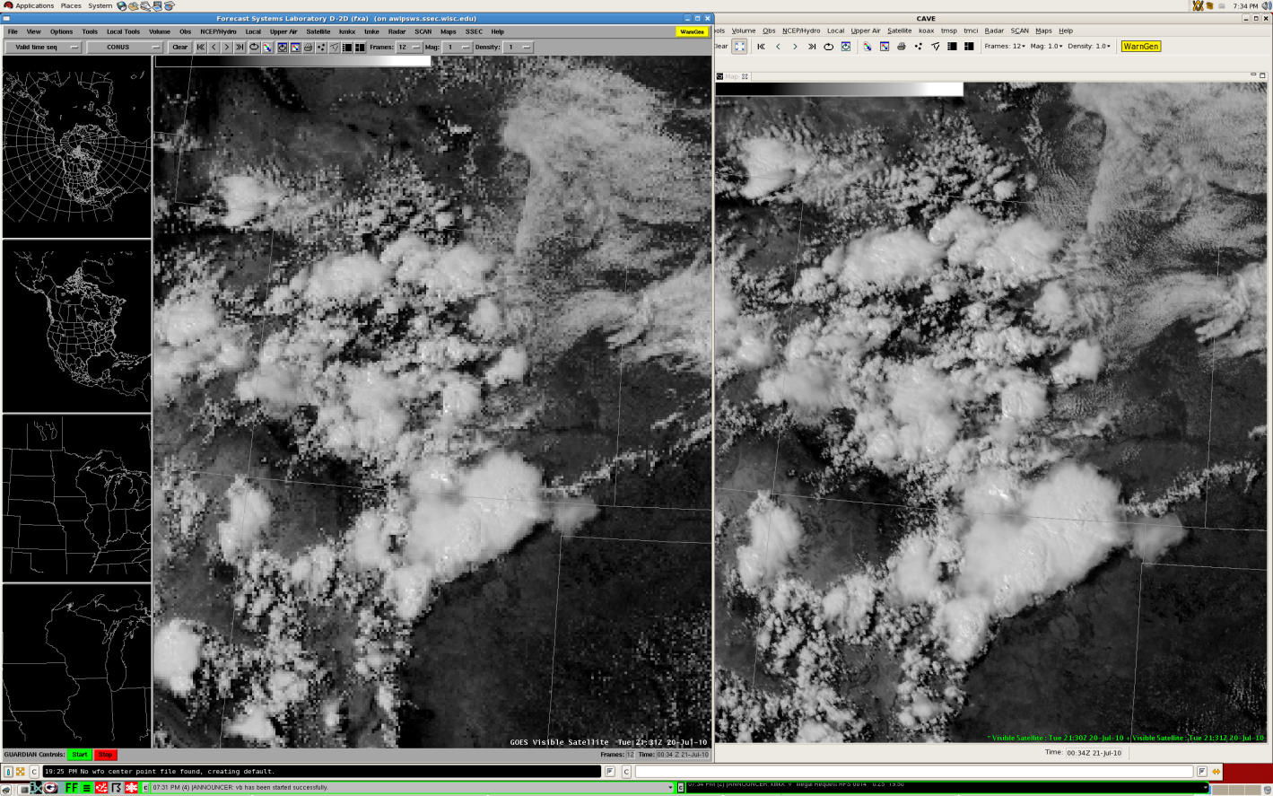
Figure 1: AWIPS II does not regionalize high-resolution geostationary satellite imagery like legacy AWIPS.
Web link to presentation: ftp://ftp.ssec.wisc.edu/pub/jordang/talkpost/GOESAWIPS2_6Oct10.pdf

