2006 update on baseline instruments for the GOES-R series

James J. Gurka#, Timothy J. Schmit@, Thomas M. Renkevens#, Mathew M. Gunshor*, Jun Li*

# NOAA/NESDIS, GOES-R Program Office
Greenbelt, MD

*Cooperative Institute for Meteorological Satellite Studies (CIMSS)
University of Wisconsin-Madison
Madison, WI 53706, U.S.A.

@NOAA/NESDIS, Center for SaTellite Applications and Research
Advanced Satellite Products Branch (ASPB)
Madison, WI 53706, U.S.A.

Abstract
In order to meet the requirements, documented by the Geostationary Operational Environmental Satellite (GOES) user communities, the instruments designated for the GOES-R notional baseline include an Advanced Baseline Imager (ABI), a Hyperspectral Environmental Suite (HES), a Geostationary Lightning Mapper (GLM), and advanced space and solar observing instruments including the Solar Imaging Suite (SIS) and the Space Environment In-Situ Suite (SEISS). These instruments will monitor a wide range of phenomena, including applications relating to: weather, climate, ocean, coastal zones, land, hazards, solar and space.

Keywords: GOES-R, GOES, ABI, HES, GLM, SIS, SEISS, environmental satellite

introduction

While plans for the full complement of instruments to fly on the GOES-R series are subject to change, this paper describes the instruments currently baselined for the series. The Advanced Baseline Imager is a state of the art, 16-channel imager covering 6 visible to near-IR bands (0.47 um to 2.25 um), and 10 infrared (IR) bands (3.9 um to 13.3 um). Spatial resolutions are band dependent, 0.5 km at nadir for broadband visible, 1.0 km for near IR and 2.0 km for IR. The ABI will be capable of scanning the Full Disk (FD) in approximately 5 minutes. ABI will improve every product from the current GOES Imager and will introduce a host of new products possible. Current products include: retrieved Atmospheric Motion Vectors (AMVs), Quantitative Precipitation Estimates (QPEs), cloud parameters, clear-sky radiances, and surface (skin) temperature; and detection and characterization of fires, volcanic ash, fog and (experimentally) cloud-top information. ABI will also provide cloud-top phase/particle size information and much improved snow detection, aerosol and smoke detection for air quality monitoring and forecasts. Other new products include vegetation monitoring and upper-level SO2 detection.

The Hyperspectral Environmental Suite is a multi channel imager and sounder instrument suite with three threshold tasks. HES will provide high-spectral resolution Hemispheric Disk Soundings (DS) and Severe Weather Mesoscale (SW/M) soundings and Coastal Waters (CW) imaging. NOAA and its industry partners have explored several options to minimize cost and risk in the development of HES, while maintaining substantial improvements over the current GOES filter wheel sounder capabilities. HES DS will provide 10 km IR resolution with a one-hour refresh rate of the full disk, 62° local zenith angle. SW/M will cover a 1000 x 1000 km square in less than 5 minutes, at approximately 5 km resolution in the IR. The HES will provide improved spectral resolution, on the order of 1 cm-1, compared to 20 cm-1 on today’s broadband sounders. This allows much improved vertical profiles of moisture and temperature. While the exact spectral coverage is still to be determined, it will include a region of carbon dioxide absorption for temperature sounding, a region of water vapor absorption for moisture sounding, and a window region. Improvements will be realized in nowcasting, short-range weather forecasting, and longer-range numerical weather prediction.

Coastal waters are highly dynamic. Tides, diurnal winds, river runoff, upwelling and storm winds drive currents from one to several knots. Three hour or better sampling is required to resolve these features, and to track red tides, oil spills or other features of concern for coastal environmental management. HES CW task will provide 9 channels covering 0.4 mm to 1.0 mm, with 375 m resolution and a 3-hour refresh rate. Coastal Waters are defined as the 400 km zone adjacent to CONUS (CONtinental U.S.).

The Geostationary Lightning Mapper will complement today’s operational ground based lightning detection systems, which only provide information on cloud to ground strikes over land, with information on total lightning flash rate (including both cloud to cloud and cloud to ground), over both land and adjacent oceans. It is anticipated that the GLM data will have immediate applications to aviation weather services, climatological studies, and severe thunderstorm forecasts and warnings.

Instrumentation on GOES-R to monitor the highly-variable solar and near-Earth space environment continues a long history of space weather observations from the GOES program. These observations are used to protect life and property of those adversely impacted by space weather conditions. The expanded services from GOES-R will improve our opportunity to support forecasters at NOAA’s Space Environment Center; customers in other government agencies, such as DOD and NASA; commercial users of space weather services; and international space environment services.

Additional capabilities include an improved user services, such as GOES-R ReBroadcast (GRB), Search and Rescue (SAR), Data Collection System (DCS), Emergency Managers Weather Information Network and Low Rate Information Transmission (LRIT)

The final baseline for the GOES-R series has not been decided, but the architecture options for the currently baselined instruments include a distributed architecture, or a consolidated architecture, or a combination of the two. The distributed architecture might be with two satellites (A-Sat and B-Sat) in the eastern slot (approximately 75 deg. West) and two in the west (approximately 135-138 deg. West). The exact location of the Western Satellite has not yet been determined, but it may be positioned farther to the west than the current GOES-West satellite. As an example, each A-Sat could host an ABI, a Solar Imaging Suite (SIS), a Geostationary Lightning Mapper (GLM), and services, including Data Collection System (DCS), Search and Rescue (SAR), Low Rate Information Transmission (LRIT), and Emergency Managers Information Network (EMWIN). Each B-Sat could host a HES, a Space Environmental In-Situ Suite (SEISS) and services.

The GOES-R Program schedule is provided (Fig. 1) which supports a GOES-R launch readiness date of 2012. The Fourth GOES Users’ Conference, which was held in May of 2006 offers a more complete summary of current GOES-R plans. The program presentations are available at: ftp://ftp.osd.noaa.gov/Goes-R/Fourth GOES-R User conf/.

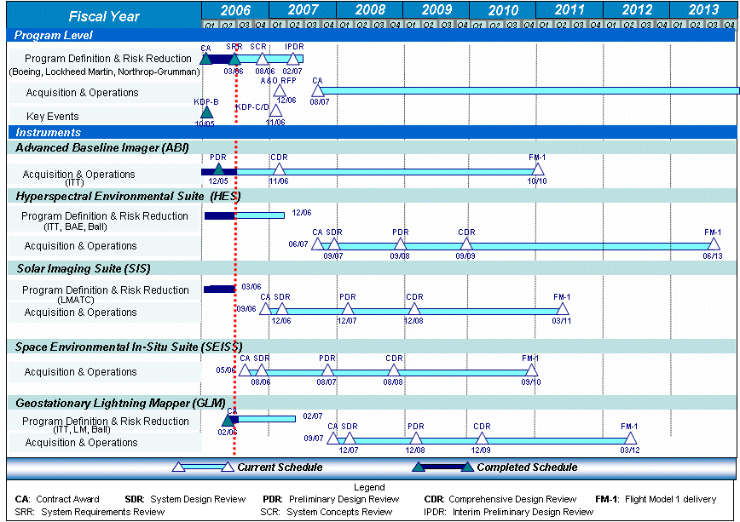

Fig. 1. GOES-R Program Schedule (as of April 2006)

Advanced Baseline Imager (abi)

The ABI represents an exciting expansion in geostationary remote sensing capabilities. The ABI addresses the needs of the GOES user communities by increasing spatial resolution (to better depict a wider range of phenomena), by scanning faster (to improve temporal sampling and to scan additional regions) and by adding spectral bands (to enable new and improved products). Every product that is being produced from the current GOES Imager will be improved with data from the ABI (Schmit et al, 2005). The ABI will improve the spatial resolution from nominally 4 to 2 km for the infrared bands and 1 to 0.5 km for the 0.6μm band, 2 km for the 1.38μm, and 1 km for the other visible/near-IR bands. There will be a five-fold increase of the coverage rate. The ABI expands the spectral band number to 16; five are similar to the 0.6, 4, 11, and 12μm windows and the 6.5μm water vapor band on the current GOES-8/11 imagers. The additional bands are a visible band at 0.47μm for aerosol detection and visibility estimation, a visible band at 0.86μm for the detection of aerosols and vegetation; a near-infrared band at 1.38μm to detect very thin cirrus clouds; a snow/cloud-discriminating 1.6μm band; the 2.26μm band will be used for particle size, vegetation and cloud properties/screening, hot spot detection, moisture determinations; mid-tropospheric water vapor absorption bands centered at approximately 7.0 and 7.34μm to track atmospheric motions; an 8.5μm band to detect volcanic dust clouds containing sulphuric acid aerosols and cloud phase; the 9.6μm band for monitoring total column ozone; the 10.35μm band to derive low-level moisture and cloud particle size; and the 13.3μm band useful for determining cloud top heights and effective cloud amounts. These 16-bands can be simulated using a mix of current satellite assets such as METEOSAT-8, MODIS and AIRS (Fig. 2). The channel selection for the ABI is a balance of heritage with existing GOES bands (on the imagers and sounders), consistency with bands on other satellites (both in geostationary and polar-orbits), and consideration for products that could be produced jointly with the advanced high-spectral resolution sounders.

In the continuous full disk mode, the ABI will provide data in all 16 spectral bands every 5 minutes covering the full disk. In the severe weather tasking mode, the ABI will provide data from the full disk every 15 minutes, while simultaneously providing data over the CONUS every 5 minutes, and a 1000x1000 km² area every 30 seconds. This high temporal update will provide users the visibility into rapidly developing storm systems.

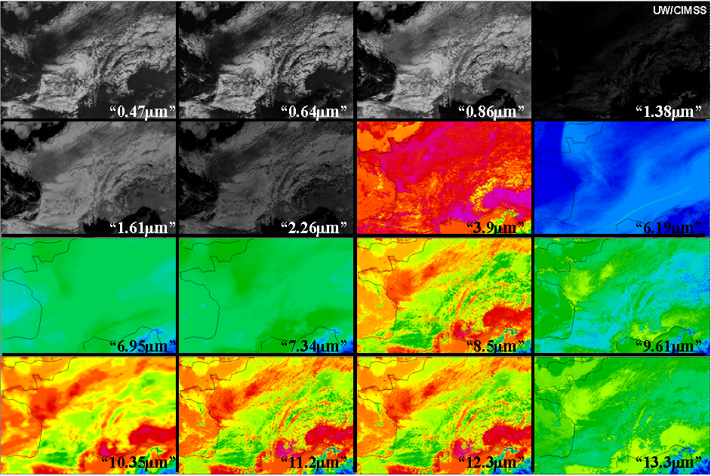

Fig. 2. The 16 ABI bands simulated with existing satellites.

Hyperspectral environmental suite (hes)

The HES will consist of either a single instrument or multiple instruments that can perform at least three tasks. These tasks include disk sounding (DS), Severe Weather/ mesoscale (SW/M) (sounding with high spectral infrared measurements), and coastal waters imaging (CW) (with high spatial resolution visible/near-infrared measurements). In the disk-sounding mode, the HES will have the capability to provide hourly coverage of the area within 62 degrees of the satellite local zenith angle with a 10 km footprint. In the severe weather/ mesoscale task, HES can provide coverage of a 1000 km by 1000 km area in less than 5 minutes, with a 5 km footprint. The HES spectral coverage details are not yet fully defined. They will include spectral coverage of the shortwave CO2, either side of the water vapor band, along with the longwave window and CO2 regions. For reference, the spectral regions (0-9) (Fig. 3) denote those that are under consideration for a sounder on EUMETSAT's METEOSAT Third Generation (MTG) series. For more information on HES Soundings, see Li et.al. 2004.

The coastal waters imaging function (Davis, 2005) will be capable of providing coverage of the coastal zone within 400 km of the continental U.S. coast every 3 hours with a footprint size of 375 m. HES will be able to provide coastal waters imaging simultaneously with either the DS task or the SW/M, but will not be able to perform the DS and SW/M at the same time.

In each of the three tasks, HES will have the flexibility to provide coverage as described above or to look at smaller areas at more frequent intervals. It will also have the flexibility to change between DS and SW/M tasks, and to change coverage areas almost instantaneously. Furthermore, while the coverage capacity is defined by the 62 degrees from local zenith angle within one hour, the HES will be capable of providing useful soundings out to at least 65 degrees from local zenith.

The HES atmospheric sounding function will provide observations approaching radiosonde quality. It will be capable of: 1) providing an accurate three-dimensional picture of atmospheric water vapor: 2) determine atmospheric motions much better by discriminating more levels of motion and assigning heights more accurately; 3) distinguishing between ice and water cloud and identify cloud particle size; 4) providing a finer field of view for better viewing between clouds and near cloud edges; 5) providing accurate land and sea surface temperatures and characteristics by accounting for emissivity effects; 6) distinguishing atmospheric constituents with improved certainty, including volcanic ash and ozone; and 7) detecting atmospheric inversions.

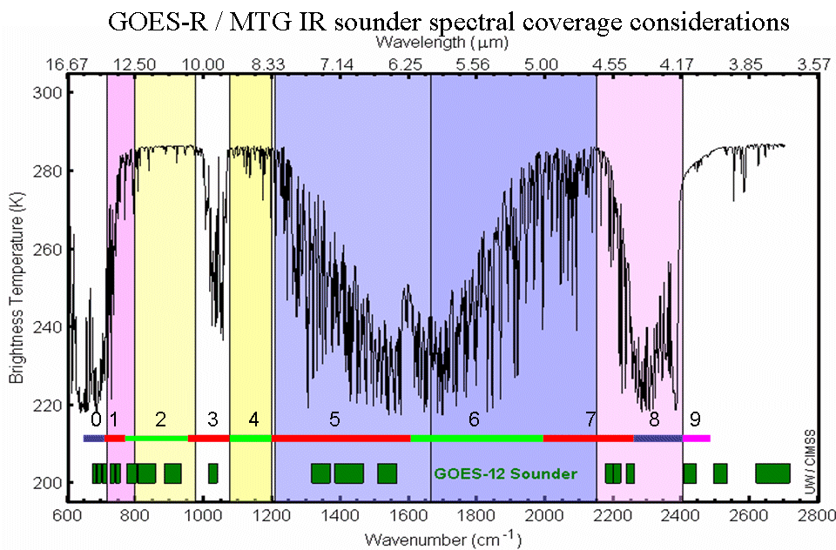
Fig. 3. The HES spectral coverage details are not yet fully defined. They will include spectral coverage of the shortwave CO2, either side of the water vapour band, along with the longwave window and CO2 regions. For reference, the spectral regions (0-9) denote those that are under consideration for a sounder on EUMETSAT’s METEOSAT Third Generation series.

geostationary lightning mapper (GLM)

The GLM will provide information to identify growing, active, and potentially destructive thunderstorms over land as well as ocean areas (Christian, 2006). Two primary advantages of the proposed lightning mapper on GOES-R over ground based systems, is that it will be able to detect total lightning flash rate (cloud to cloud and cloud to ground) rather than just cloud to ground flashes, and it will be able to detect lightning over ocean rather than just over land. Research (Goodman et.al. 1988; Williams et.al. 1989) indicates that GLM measurements could provide vital information to help the operational weather, aviation, disaster preparedness, or fire communities in a number of areas: 1) improvement in tornado and severe thunderstorm lead times and false alarm reduction; 2) more reliable warning of lightning ground strike hazards; 3) improvements in the initialization of numerical weather prediction models by better identification of deep convection; 5) improved routing of commercial, military, and private aircraft over oceanic regions where observations of thunderstorm intensity are scarce; 6) improved ability to monitor intensification or de-intensification of storms during radar outages, or where radar coverage is poor, such as in mountainous areas; 7) better short range forecasts of heavy rainfall and flash flooding; 8) ability to monitor the intensification of tropical cyclones, which is often accompanied by increased eyewall lightning activity; and 9) updates of lightning climatology within the GOES field of view. Fig. 4 shows the climatology derived from Low Earth Orbiting (LEO) satellite precursor missions.
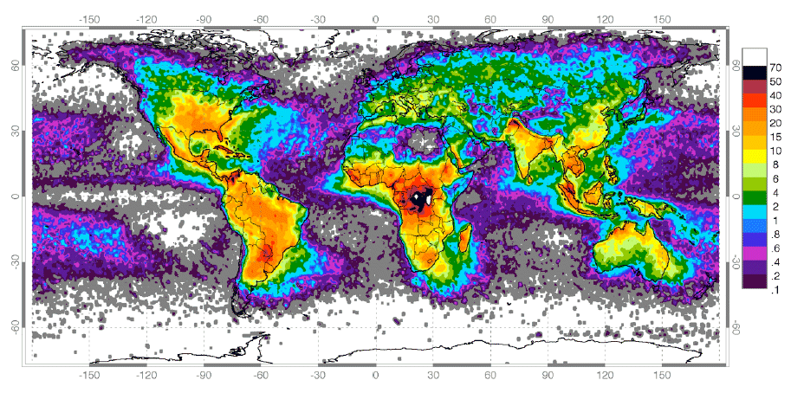
Fig. 4. Lightning Climatology (flashes / km^2 / year) from NASA LEO Precursors. (Image courtesy of D. Dennis Boccippio, NASA / MSFC and Joseph Schaefer, NOAA / SPC).

solar and near-Earth space environment monitoring

Instrumentation on GOES-R to monitor the highly-variable solar and near-Earth space environment continues a long history of space weather observations from the GOES program (Hill and Pizzo, 2003). These observations are used to protect life and property of those adversely impacted by space weather conditions (Fig. 5). The expanded services from GOES-R will improve our opportunity to support forecasters at NOAA’s Space Environment Center; customers in other government agencies, such as DOD and NASA; commercial users of space weather services; and international space environment services. The instruments that contribute to the new services and products include: the Solar Imaging Suite (SIS), that will be improved measurements of the solar EUV and X-ray radiation; a solar coronagraph (SCOR) that is part of the SIS suite of instruments, and is currently designated as a pre-planned product improvement instrument; and the energetic particle instruments, called the SEISS (Space Environment In-Situ Suite), that will provide multiple measurements characterizing the charged particle population, including measurements of the electron, proton, and heavy ion fluxes. Finally, Earth’s magnetic field will be measured by a magnetometer (MAG) which is part of the spacecraft procurement.

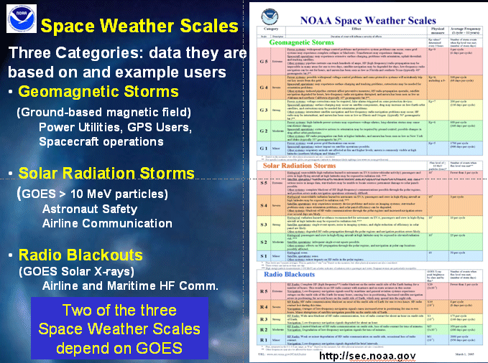

Fig. 5. GOES Measurements are unique and crucial. Two of the three Space Weather Scales depend on GOES data.

Summary

The GOES-R series is a critical component of the Global Earth Observation System of Systems (GEOSS) to meet the documented user needs. GOES-R will monitor a wide range of phenomena, including applications relating to: weather, climate, ocean, coastal zones, land, hazards, solar and space. In order to meet the requirements, documented by the GOES user communities, the instruments designated for the GOES-R notional baseline include an Advanced Baseline Imager (ABI), a Hyperspectral Environmental Suite (HES), a Geostationary Lightning Mapper (GLM), and advanced space and solar observing instruments including the Solar Imaging Suite (SIS) and the Space Environment In-Situ Suite (SEISS).

The Fourth GOES Users’ Conference, which was held in May of 2006 offers a more complete summary of current GOES-R plans. The program presentations are available at: ftp://ftp.osd.noaa.gov/Goes-R/Fourth GOES-R User conf/.

Acknowledgments

The authors would like to thank the entire GOES-R teams, both within the government (NOAA, NASA and Universities) and the private sector. Especially thanked are Howard J. Singer, NOAA/NWS/NCEP, Space Environment Center, W. Paul Menzel, Tim Walsh, NOAA/NESDIS, Curtiss Davis and Mark Abbott, Oregon State University and Mat Gunshor and Jun Li, CIMSS. The views, opinions, and findings contained in this report are those of the authors and should not be construed as an official National Oceanic and Atmospheric Administration or U.S. Government position, policy, or decision.

references

Christian, H.J., 2006: Geostationary lightning mapper (GLM). 2nd Conf. on Meteorological Applications of Lightning Data, Amer. Meteorol. Soc., Atlanta, paper J2.3.

Davis, C. O., 2005: The GOES-R coastal waters imager: a new capability for monitoring the coastal ocean, Infrared and Photoelectronic Imagers and Detector Devices. Edited by Longshore, Randolph E. Proceedings of the SPIE, Volume 5882, pp. 183-190 (2005).

Goodman, S.J., D.E. Buechler, P.D. Wright, and W.D. Rust, 1988: Lightning and precipitation history of a microburst-producing storm, Geophys, Res. Lett., 15, 1185-1188.

Hill, S., and V. J. Pizzo, 2003: Advanced solar imaging from the GOES-R spacecraft. Proceedings of SPIE -- Volume 4853. Innovative Telescopes and Instrumentation for Solar Astrophysics, Stephen L. Keil, Sergey V. Avakyan, Editors, pp. 465-478.

Li J., F. Sun, T. Schmit, W.P. Menzel, and J. Gurka, 2004: Study of the Hyperspectral Environmental Suite (HES) on GOES-R. 20th International Conference on IIPS, AMS, Seattle WA.

Schmit, T. J., M. M. Gunshor, W. Paul Menzel, J. Li, S. Bachmeier, J. J. Gurka, 2005: Introducing the Next-generation Advanced Baseline Imager (ABI) on GOES-R, Bull. Amer. Meteor. Soc., Vol 8, pp. 1079-1096.

Williams, E.R., M.E. Weber, and R.E. Orville, 1989: The relationship between lightning type and the convective state of thunderstorms, J. Geophys. Res., 94 13213-13220.

