Questions:
Video integration options. Scott has software
Some features only through video
Importance of adding case specific details.- if available
Should we or not include true color RGB? NO
Default Image annotations? CASE BY CASE
Video annotations options? Scott if needed
Link to SRF functions.

Scott to get SRF for Vis. IR and near-IR

Band 01 (0.47um)- Smoke

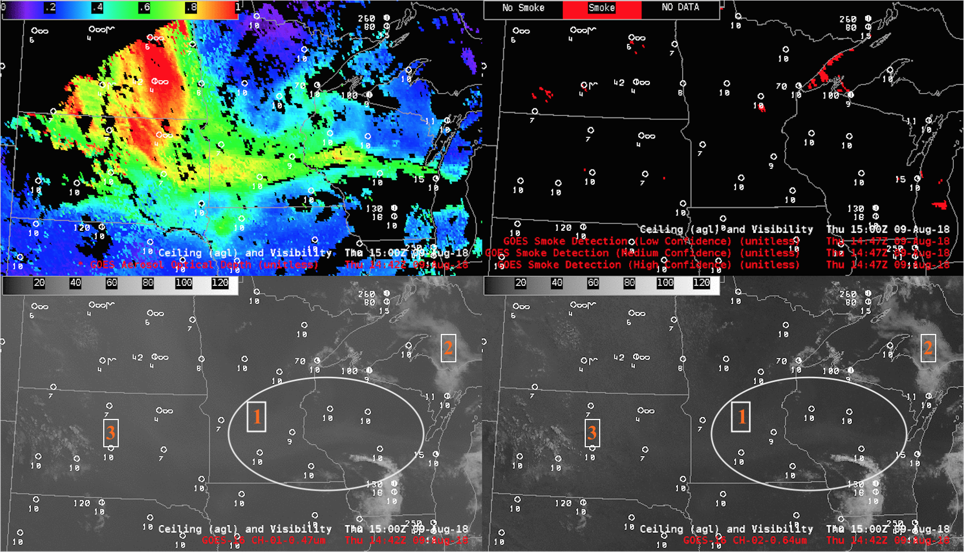
4-panel images showing widespread smoke over the Midwest on August-09-2018. The hazy signature of the widespread smoke was a bit more apparent in the 0.47 µm Visible imagery than the 0.64 µm Visible imagery, especially during mid-day when the sun-satellite “forward scattering angle” was at a minimum.
1: Some Smoke is more apparent in the Blue band(0.47um) than in the Red(0.64um).
2: Surface features show more distinctly in the Red band because of
better spatial resolution in the Red and enhanced Rayleigh
scattering than in the Blue band.
3: Clouds look similar in both blue and Red bands.

Band 02 (0.64um) : Resolution

- Above anvil cirrus plume:
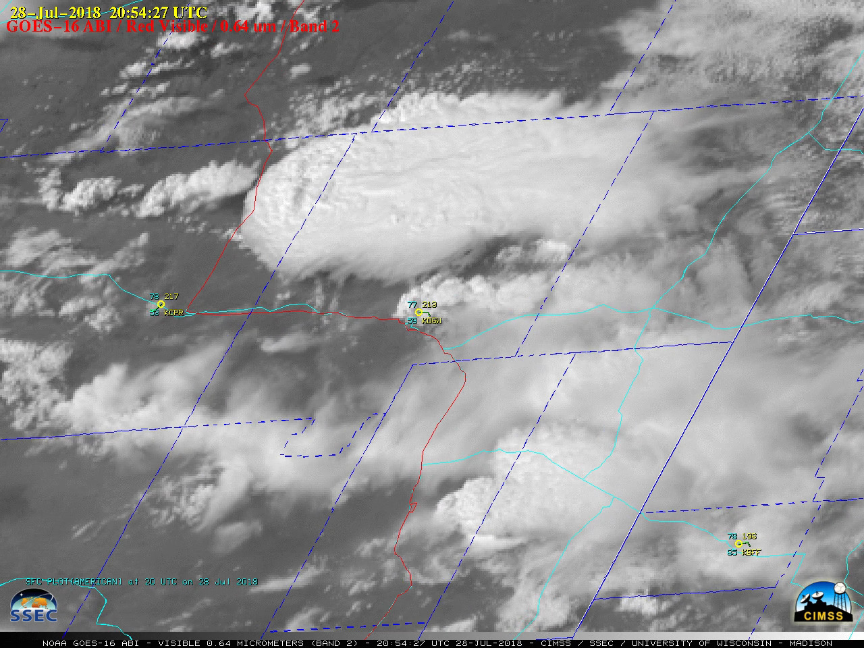
Above-anvil cirrus plumes seen with the developing supercell thunderstorm that produced tornados, large hail and damaging wins across parts of eastern Wyoming on July-28-2018.

- Severe thunderstorm, Above anvil plume (17 fealties)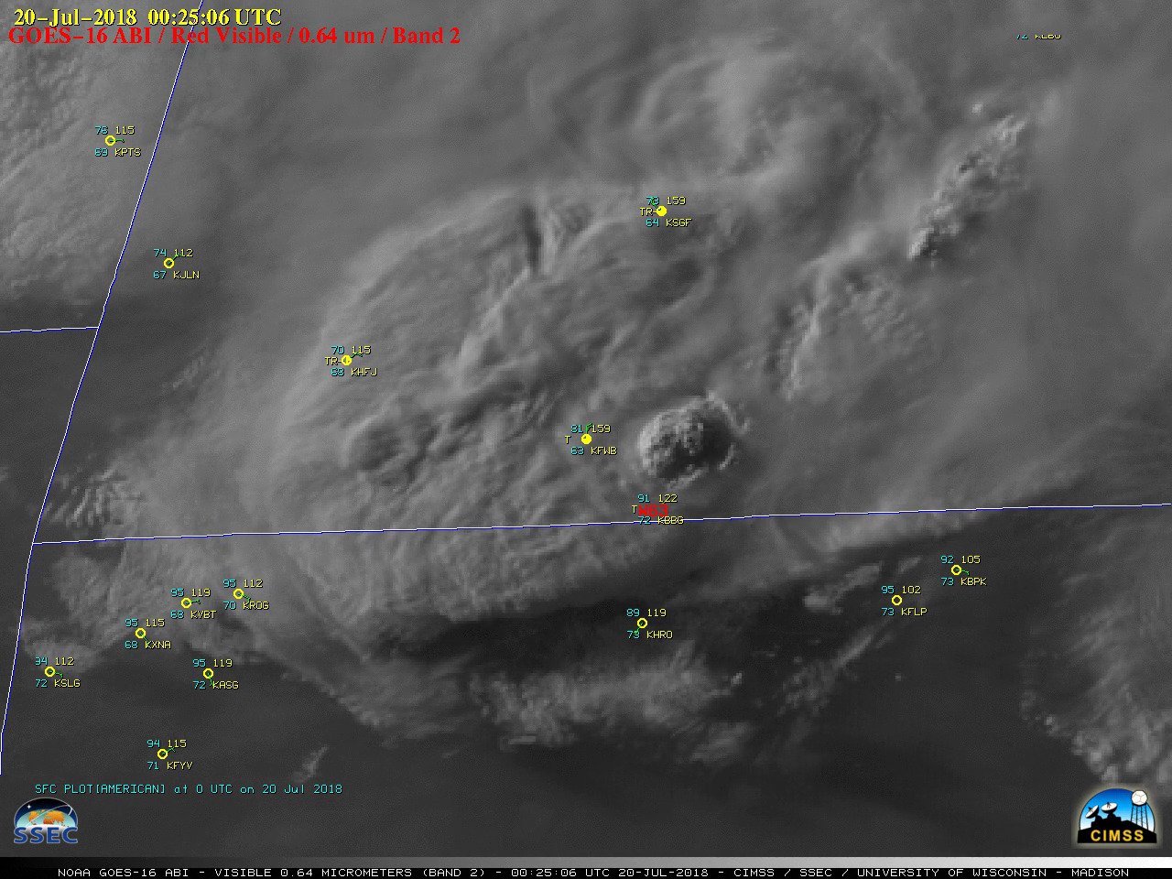 Rapid intensification of thunderstorms over far southwestern Missouri during the early evening hours on July-19-2018. Surface outflow boundaries from these storms produced damaging winds including gusts to 45 knots (52 mph) at Branson West at 2355 UTC and 55 knots (63 mph) at Branson at 0025UTC. Strong winds capsized a boat on Table Rock Lake (located about midway between Branson West Airport KFWB and Branson Airport KBBG, resulting in 17 fatalities.

- Parallel inflow feeder, Above anvil plume 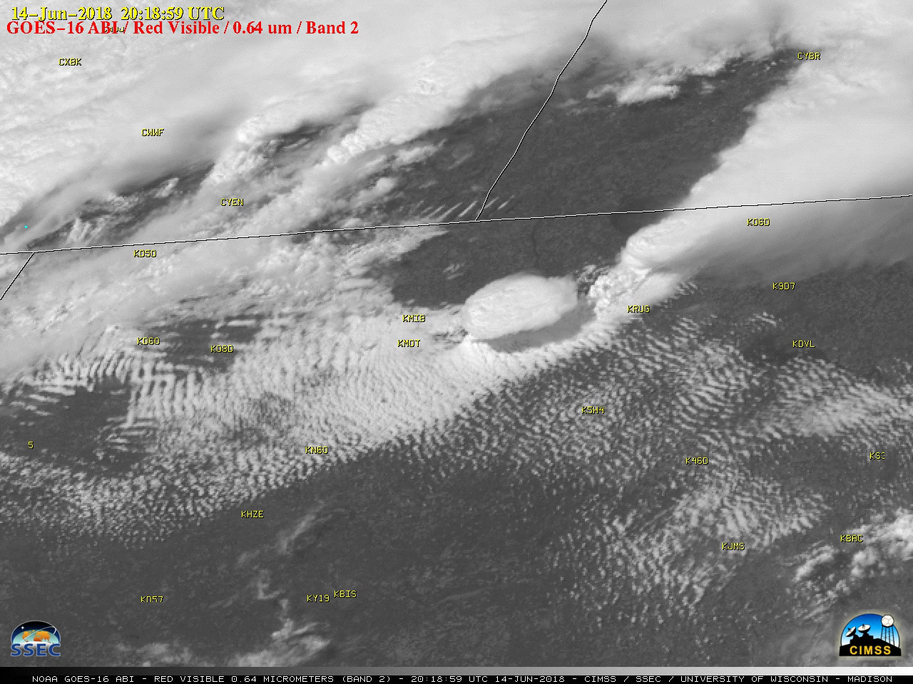 Well-defined parallel inflow feeder bands moving into the southern flank of the storm approaching Minot (KMOT) and Minot Air Force Base (KMIB) during the 1600-1900 UTC time period. Distinct above-anvil plumes were seen with a number of the stronger storms.

- Severe weather- Tornado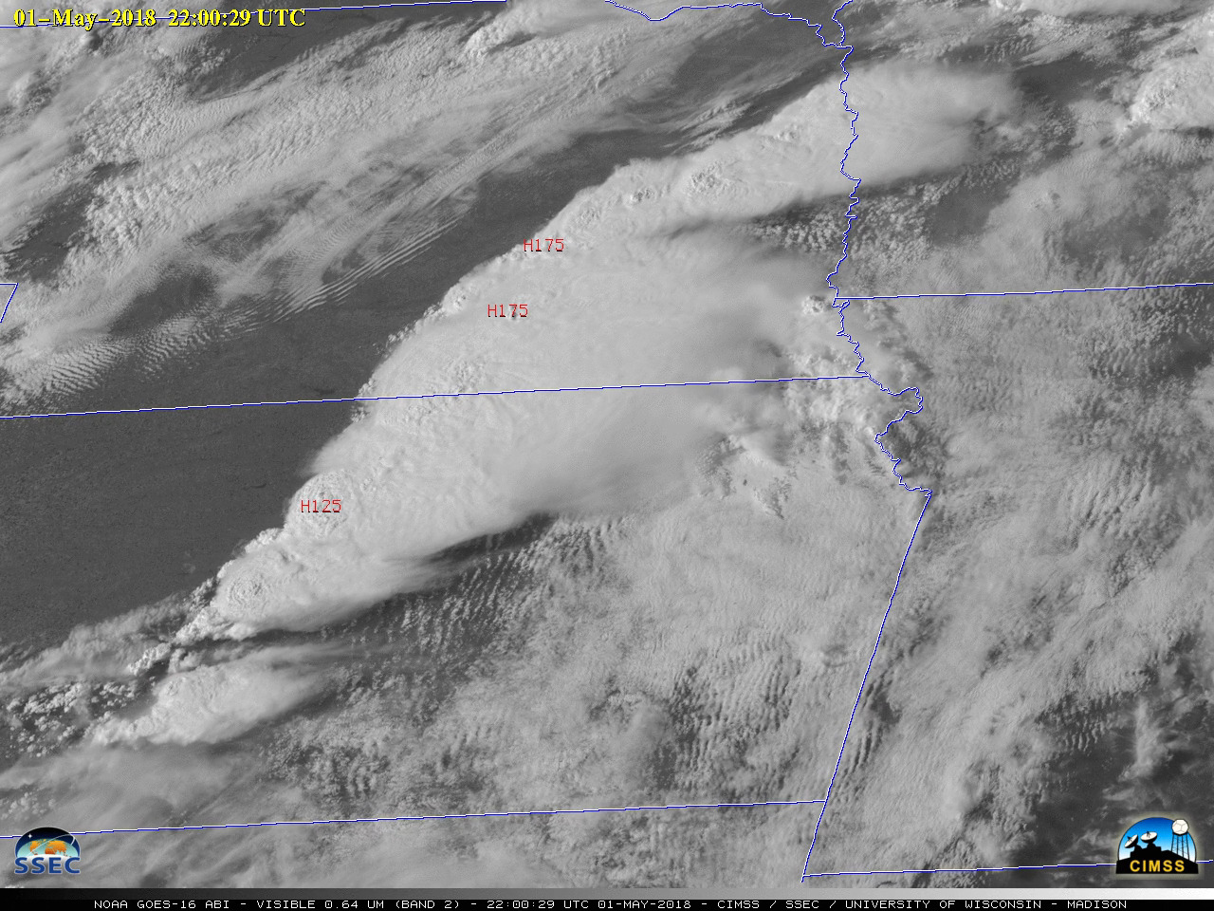
Severe thunderstorms produced tornadoes, large hail and damaging winds across parts of Kansas, Nebraska and Iowa on 01 May 2018. A Mesoscale Domain Sector provided images at 1-minute intervals.

(E) Pulsing overshooting tops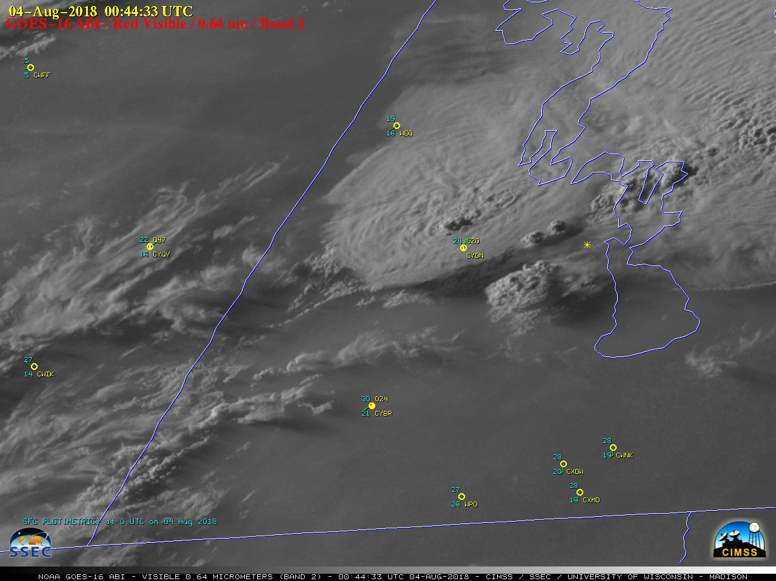

The development of a thunderstorm which produced an EF-4 tornado near Alonsa, Manitoba during the early evening hours on 03 August 2018. The cell began to develop southwest of Alonsa around 0020 UTC, and as the thunderstorm matured a series of pulsing overshooting tops could be seen. The haziness evident in the Visible imagery was due to smoke from wildfires in the western US and Canada.

(F) On-orbit visible calibration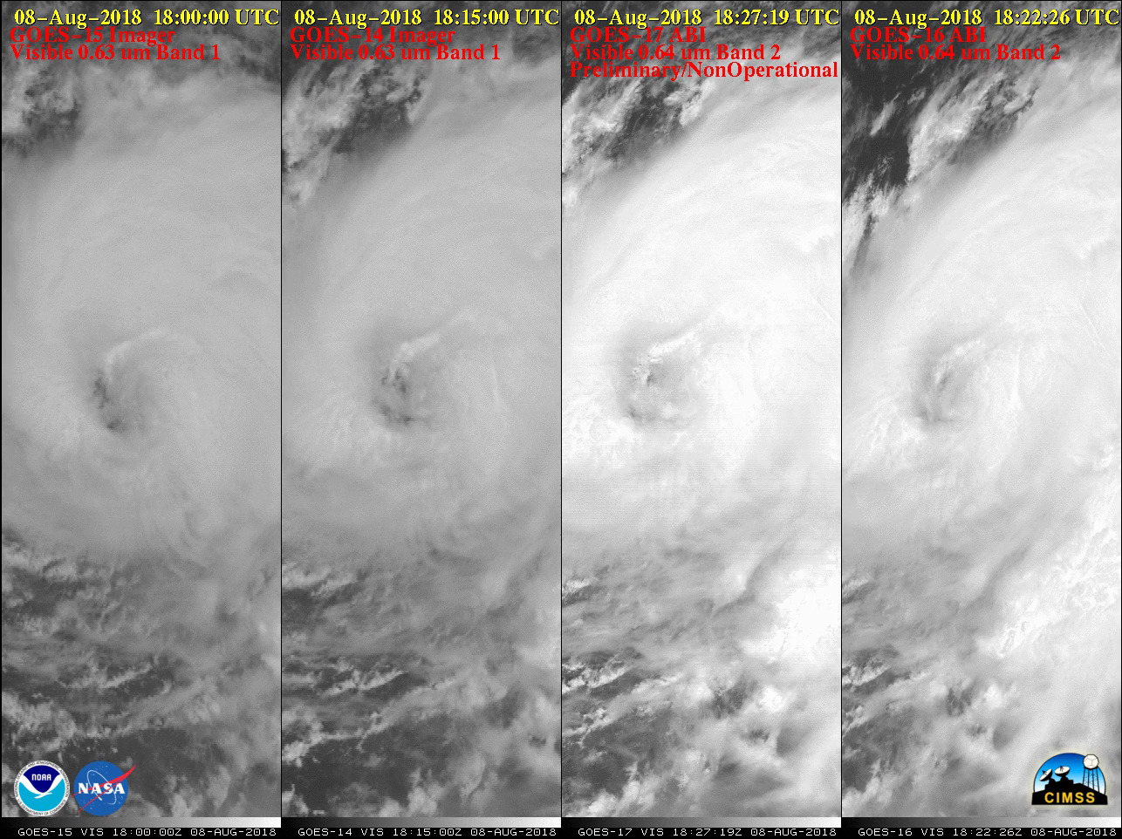
4-GOES comparison of Hurricane John in the East Pacific Ocean, note that the GOES-15 and GOES-14 Visible images do not appear as bright as those from GOES-17 and GOES-16 — prior to the GOES-R Series of satellites, the performance of visible detectors degraded over time, leading to imagery that appeared more dim as the Imager instrument aged. Visible detectors on the new ABI instrument benefit from on-orbit calibration to remedy this type of degradation.

(G) Low-level Derived Motion Winds

This imagery is the primary source of low-level (surface to 700 hPa) Derived Motion Winds during the daytime hours

BAND 3 (0.86 µm) VEGETATION

- Dark smoke plumes
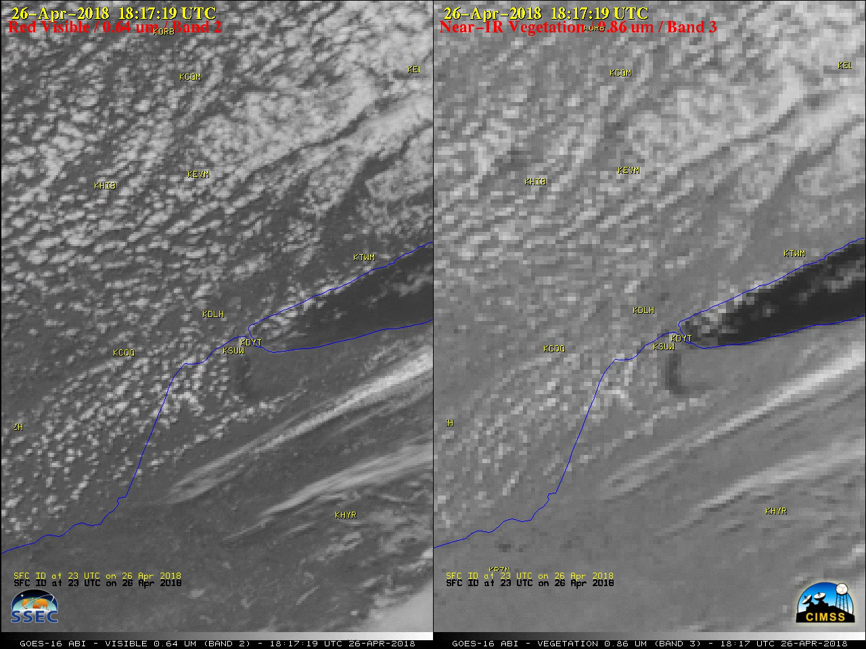
The explosion and subsequent fire was not sufficiently hot to be detected by the shortwave infrared 3.9 µm channel on GOES-16. However, the smoke plume is obvious in this animation, cooler than the background by 3-4ºC, and yellow in the enhancement chosen.
The dark smoke plume was also evident on Near-Infrared “Vegetation” (0.86 µm) images (above), aided by the additional contrast between the dark plume and the lighter gray appearance of the land surface

- Aerial extent of flooding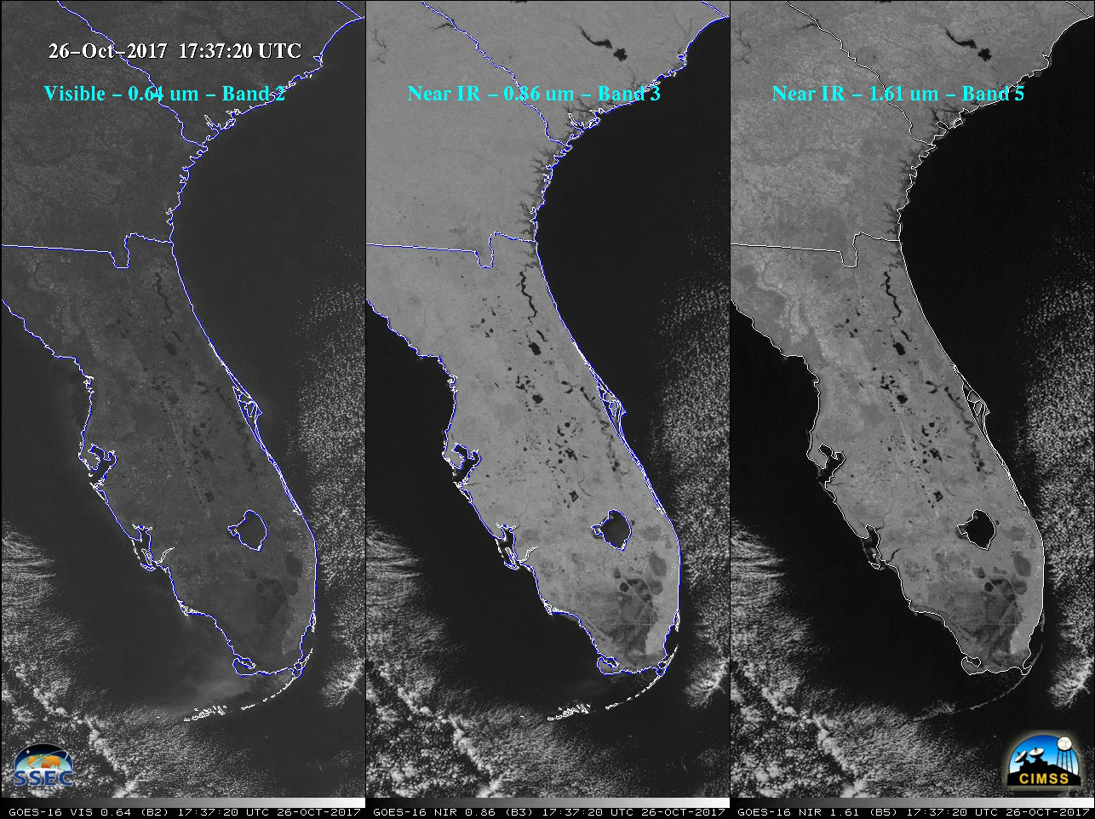
Comparison of GOES-16 “Red” Visible (0.64 µm), Near-Infrared “Vegetation” (0.86 µm) and Near-Infrared “Snow/Ice” (1.61 µm) images, showed that water was a strong absorber of radiation at 0.86 µm and 1.61 µm wavelengths — therefore wet ground, rivers, lakes and the oceans appeared dark in those images. This makes those two GOES-16 ABI spectral bands useful for identifying areas of flooding.

To do : Stott L To add burn scar image from Navada.

BAND 4 (1.37 µm) CIRRUS
- Dense airborne smoke
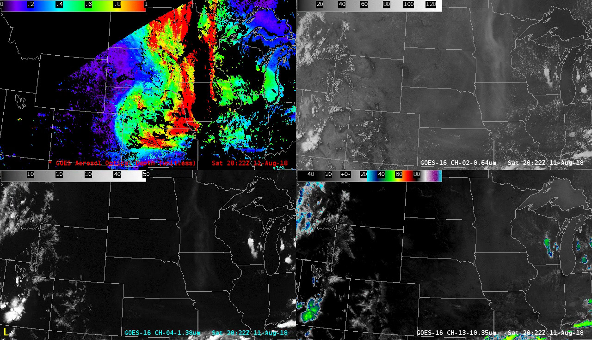GOES-16 Aerosol Optical Depth (top left), “Red” Visible (0.64 µm, top right). Near-Infrared “Cirrus” (1.37 µm, bottom left) and “Clean” Infrared Window (10.3 µm, bottom right)

Higher concentrations of airborne particles that are effective scatterers of light at the 1.37 µm wavelength (such as ice crystals, smoke, volcanic ash, or dust) will be detected using this imagery. Note the lack of a well defined signature on the 10.3 µm imagery — smoke is effectively transparent to radiation at these longer infrared wavelengths.

- Airborne dust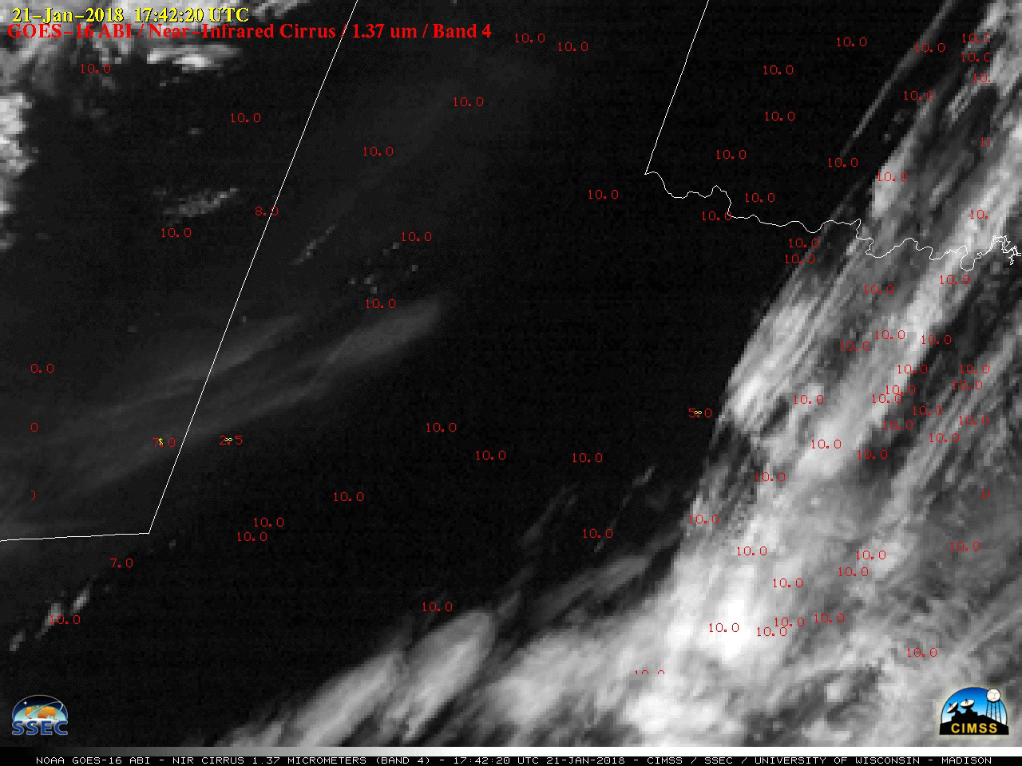
The dust signature was apparent on the Cirrus imagery because this spectral band can be used to detect any airborne particles that are effective scatterers of light (such as cirrus ice crystals, volcanic ash, dust/sand or haze).

BAND 5 (1.61 µm) SNOW/ICE
- Identification of Above-anvil cirrus plumes
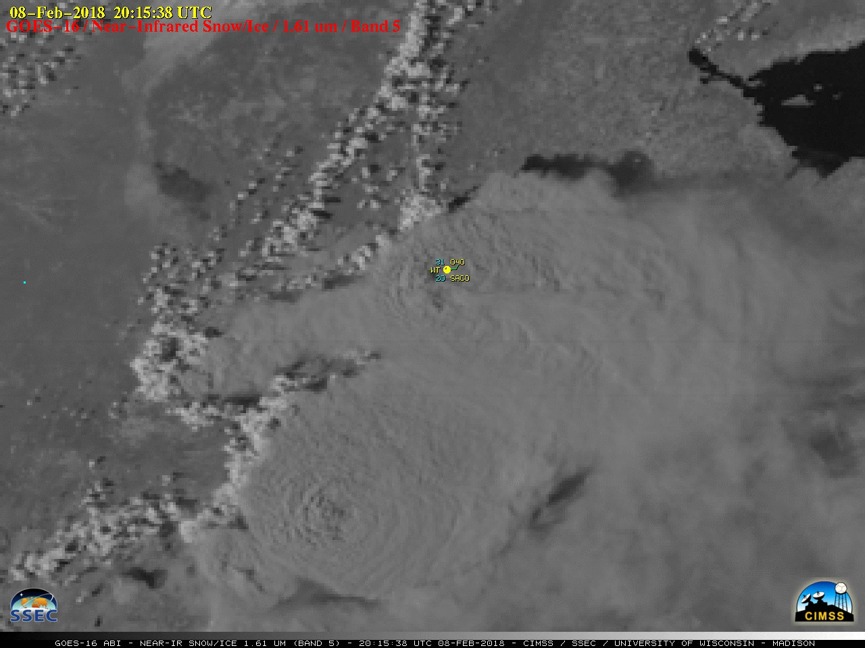
The above-anvil cirrus plumes could also be seen in GOES-16 Near-Infrared “Snow/Ice” (1.61 µm) images

Kaba: add arrows to low and high clouds, to highlight water vs ice
TODO: Scott L to add 1.61um snow/ice on ground Georgia.

- Detection of swaths of hail accumulation at the surface
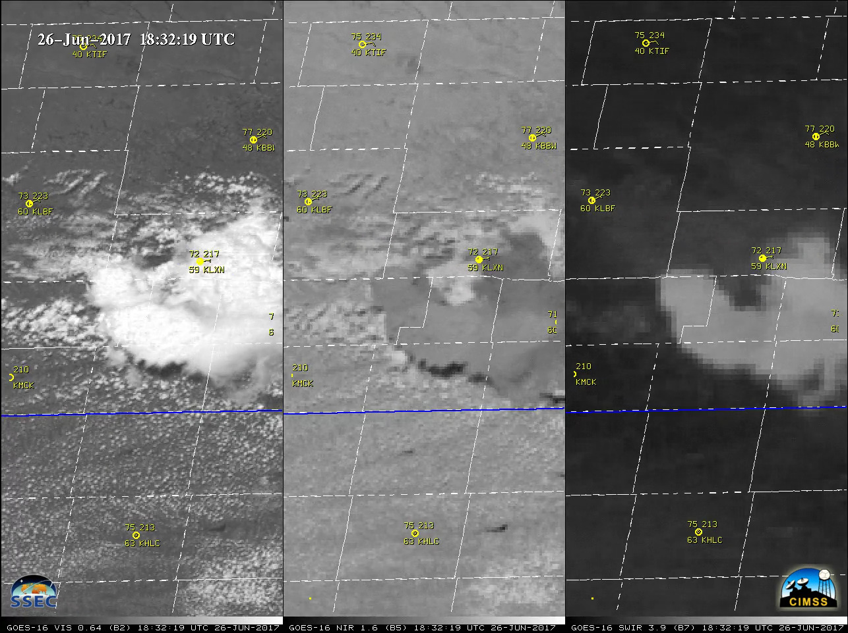
A 3-panel comparison of GOES-16 Visible (0.64 µm), Snow/Ice (1.61 µm) and Shortwave Infrared (3.9 µm) images (below) revealed a subtle signature of the hail swath on the Snow/Ice images (where ice features appear as darker shades of gray: southern NE | northern KS), while the Shortwave Infrared images showed that the hail and rainfall swath — accumulations in southern Kansas included 0.58″ at Clay Center and 0.49″ at Hebron — remained slightly cooler (lighter gray) as the adjacent dry land surfaces continued to warm during the early to middle afternoon hours. SPC storm reports listed hail of 1.75 inches in diameter in southern Nebraska and 1.25 inches in northern Kansas.

Another Hail swath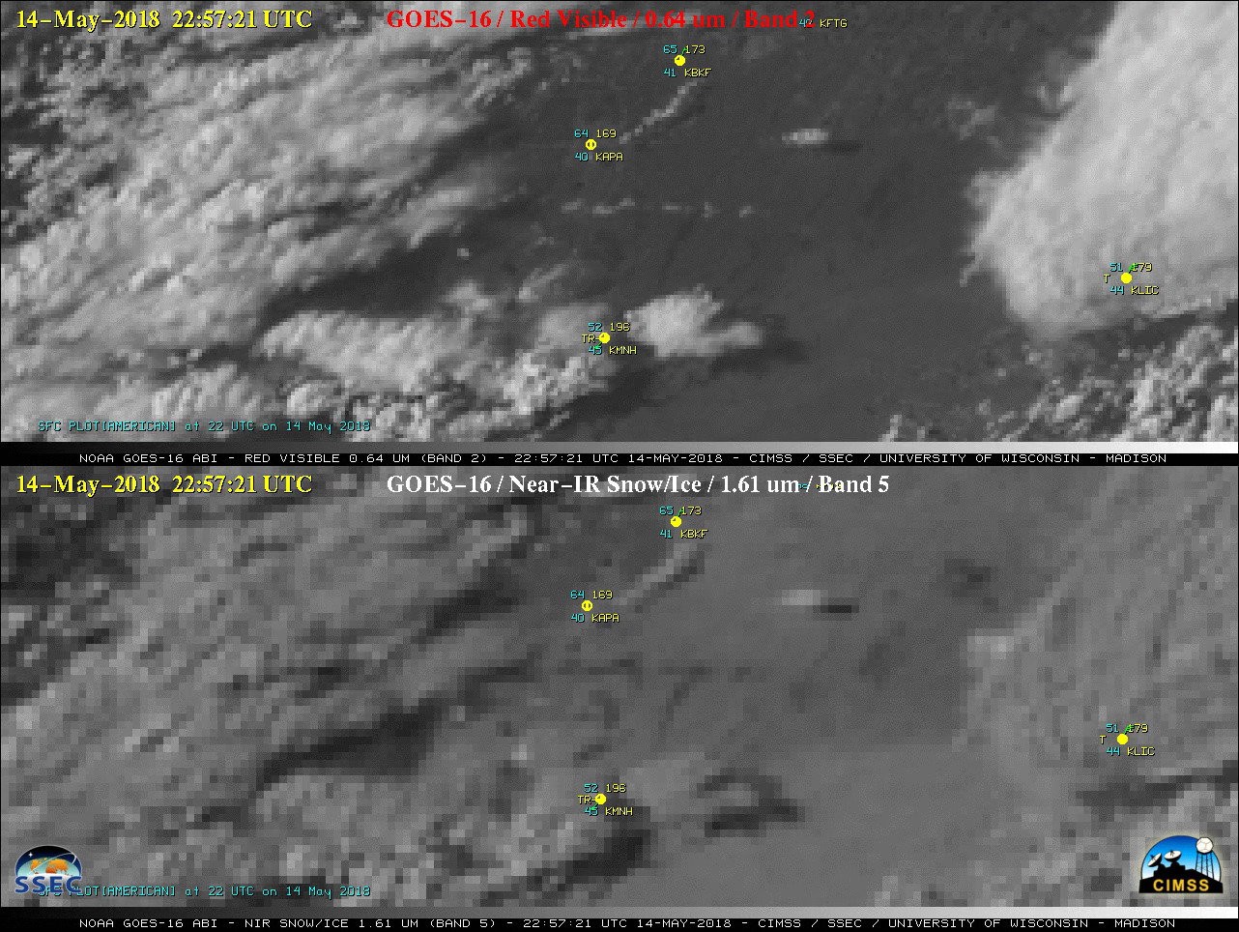GOES-16 “Red” Visible (0.64 µm, top) and Near-Infrared “Snow/Ice” (1.61 µm, bottom) images

- Diagnosis of the areal extent of flooding
GOES-16 Visible (0.64 µm, left), Near-Infrared “Vegetation” (0.86 µm, center) and Near-Infrared “Snow/Ice” (1.61 µm, right) images
A comparison of GOES-16 “Red” Visible (0.64 µm), Near-Infrared “Vegetation” (0.86 µm) and Near-Infrared “Snow/Ice” (1.61 µm) images (above) showed that water was a strong absorber of radiation at 0.86 µm and 1.61 µm wavelengths — therefore wet ground, rivers, lakes and the oceans appeared dark in those images. This makes those two GOES-16 ABI spectral bands useful for identifying areas of flooding.

BAND 6 (2.24 µm) CLOUD PARTICLE SIZE

(A) Thermal signatures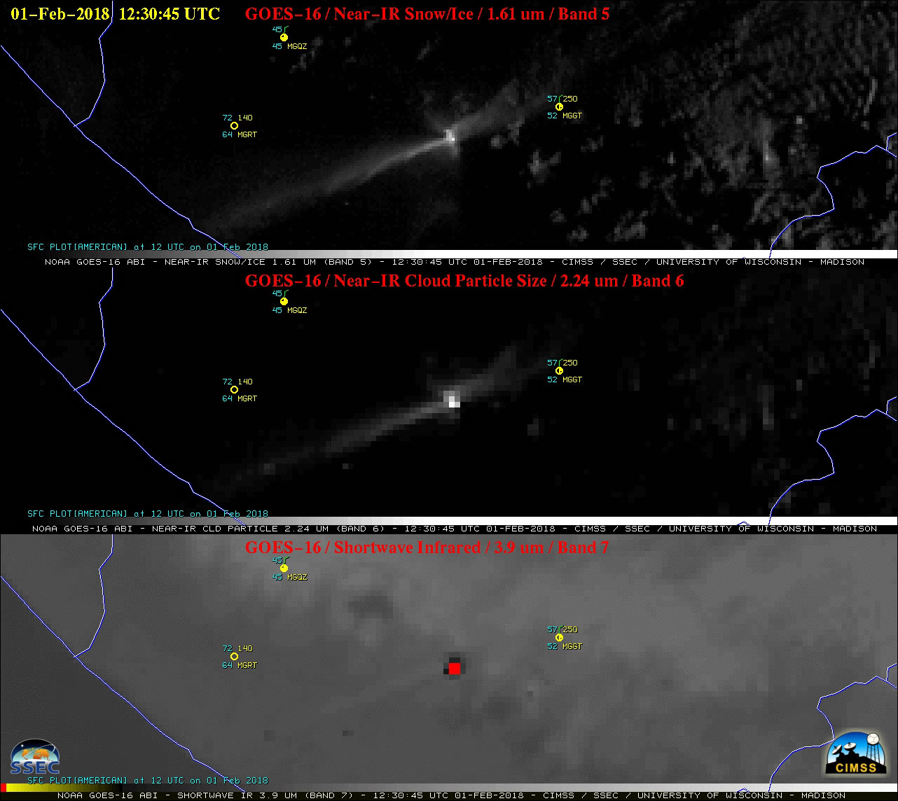

The thermal anomaly or “hot spot” could be seen on GOES-16 (GOES-East) Near-Infrared “Snow/Ice” (1.61 µm), Near-Infrared “Cloud Particle Size” (2.24 µm) and Shortwave Infrared (3.9 µm) images (above). In terms of the two Near-Infrared bands, even though the 1.61 µm band has better spatial resolution (1 km at satellite sub-point), the 2-km resolution 2.24 µm ? band is spectrally located closer to the peak emitted radiance of very hot features such as active volcanoes or large fires

Scott L: redo image in mcidas-x, figure out values displayed, and remove labels.

BAND 7 (3.9 µm) SHORTWAVE INFRARED
(A)
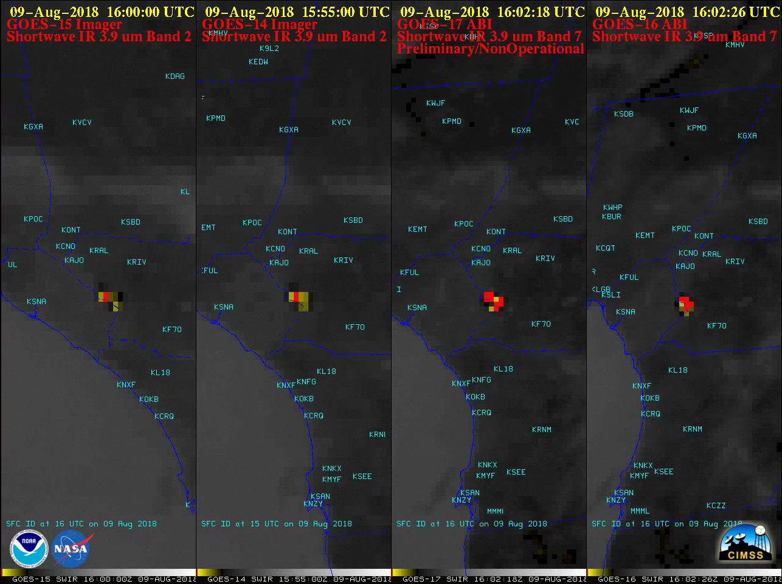

This 4-GOES comparison showing the diurnal behavior of a wildfire in southern California demonstrates how the accuracy of fire detection can be affected by (1) the satellite viewing angle, and (2) the shortwave infrared detector spatial resolution (4 km at satellite sub-point for the GOES-14/15 Imager, vs 2 km for the GOES-16/17 ABI):

- PyroCb
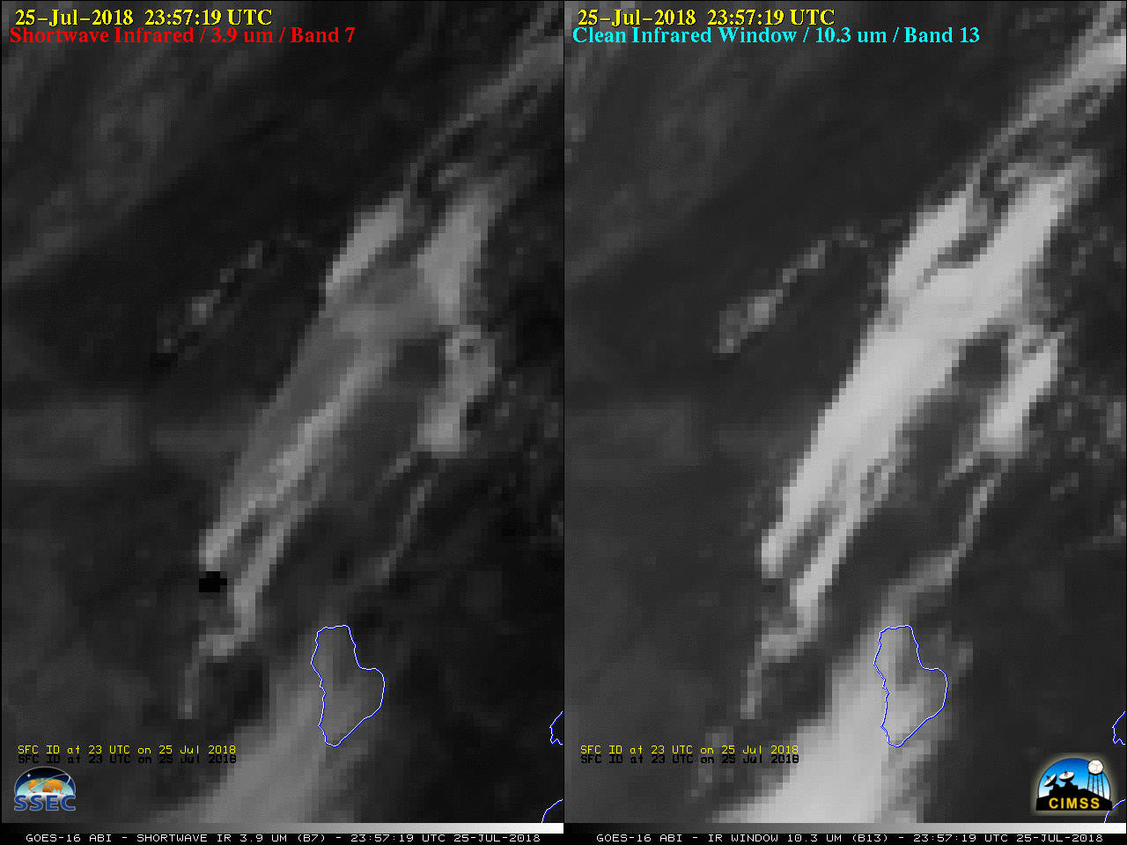

Pyrocumulonimbus (pyroCb) clouds produced by the Cranston Fire in southern California on 25 July 2018. PyroCb tops "seeded" by smoke particles are composed of smaller ice crystals (which reflect more solar radiation and appear warmer / darker shades of gray). Ice Crystal Size at anvil top affects the amount of reflected solar radiation at 3.9 mm and consequently the BT, displayed as a greyscale, with whites cold and blacks hot. 10.7 mm BTs are less affected by Ice Particle Size.

Scott L: Add Good fire and fog example.

BAND 8 (6.2 µm) UPPER-LEVEL WATER VAPOR --
BAND 9 (6.9 µm) MID-LEVEL WATER VAPOR --
BAND 10 (7.3 µm) LOW-LEVEL WATER VAPOR –
Add SRF details?

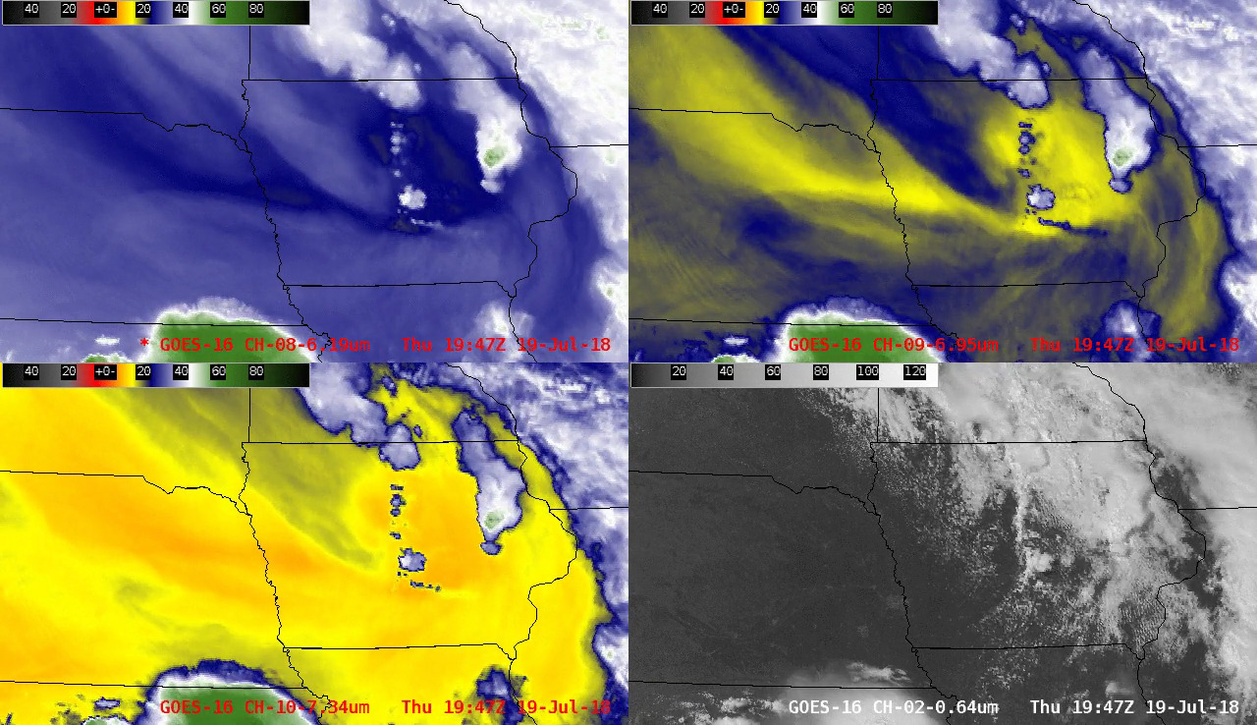

It is often useful to examine imagery from all 3 Water Vapor bands simultaneously (instead of separately) to identify and track important synoptic-scale features -- in this case, the well-defined signature of a mid-tropospheric lobe of vorticity moving from southeastern South Dakota across Iowa on 19 July 2018; this feature provided synoptic-scale forcing for ascent which aided in the development of severe thunderstorms in central and eastern Iowa (which produced two EF-3 tornadoes):

ADD ABOVE

BAND 10 (7.3 µm) LOW-LEVEL WATER VAPOR

GOES-16 Low-level Water Vapor (7.3 µm) imagery can also be used to initially track volcanic plumes that have high concentrations of SO2, as seen in 2 eruptions of Sierra Negra in the Galapagos:

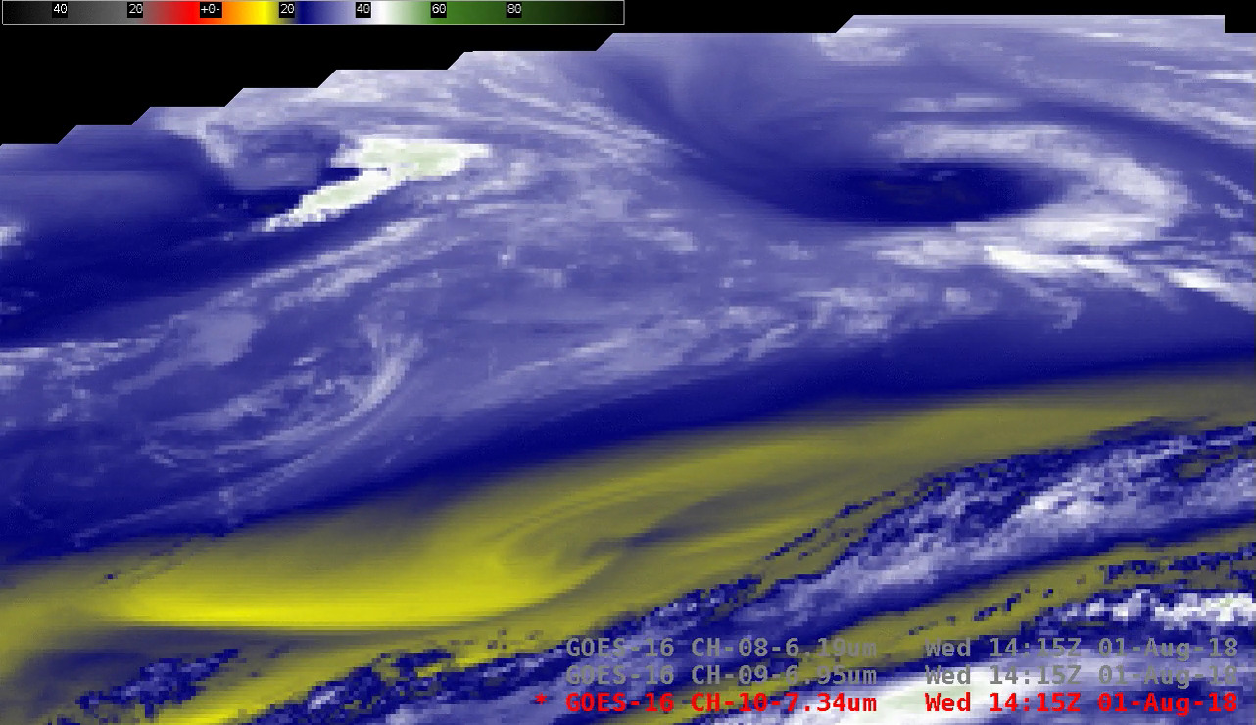 GOES-16 Low-level (7.3 µm), Mid-level (6.9 µm) and Upper-level (6.2 µm) Water Vapor images

Volcanic plume signature
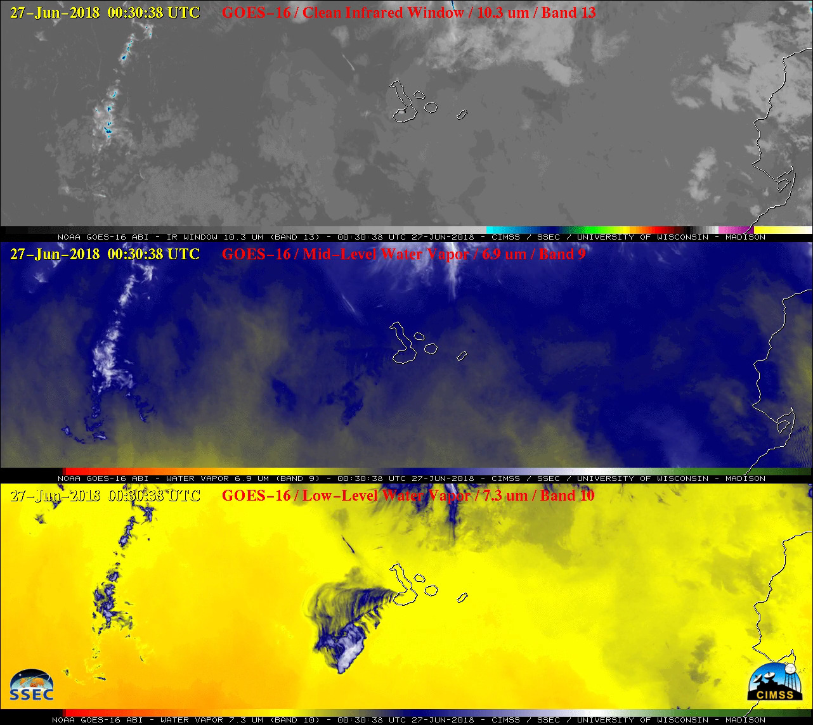
GOES-16 “Clean” Infrared Window (10.3 µm), Mid-level Water Vapor (6.9 µm) and Low-level Water Vapor (7.3 µm) images on 26 June 2018 showed that a signature of the volcanic plume was evident in the 7.3 µm imagery for several hours after it was no longer seen in the 10.3 µm or 6.9 µm imagery — this is due to the fact that the 7.3 µm spectral band is also sensitive to SO2 absorption (and this volcanic eruption produced large amounts of SO2):

KEEP
Another SO2-rich volcanic plume
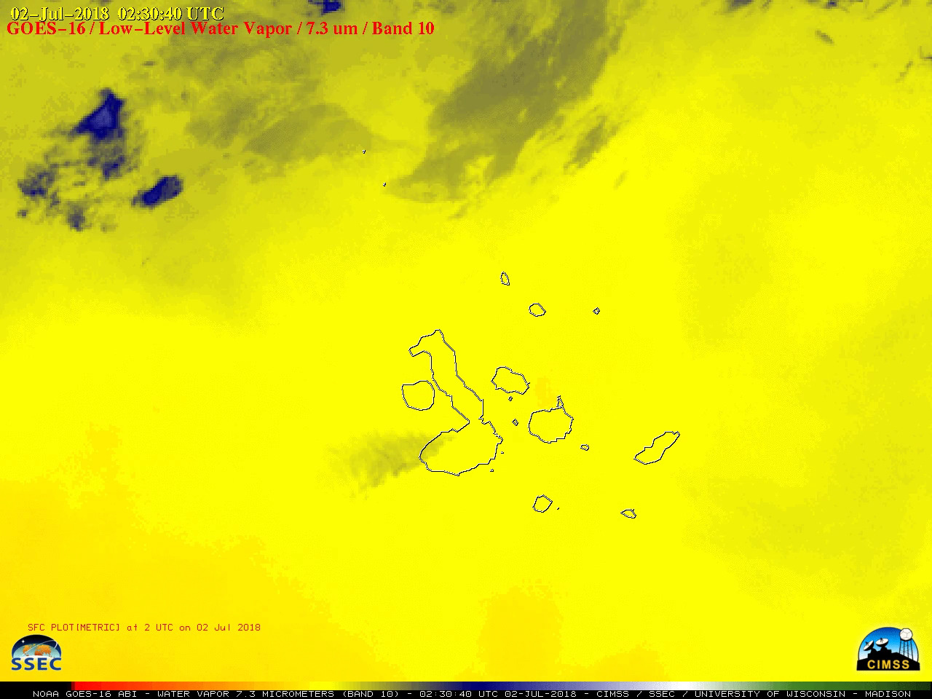

Scott to add 8.4 vs 11.2 comp.

BAND 13 (10.3 µm) CLEAN INFRARED WINDOW
Keep old docs

- "enhanced-V" cloud-top signature
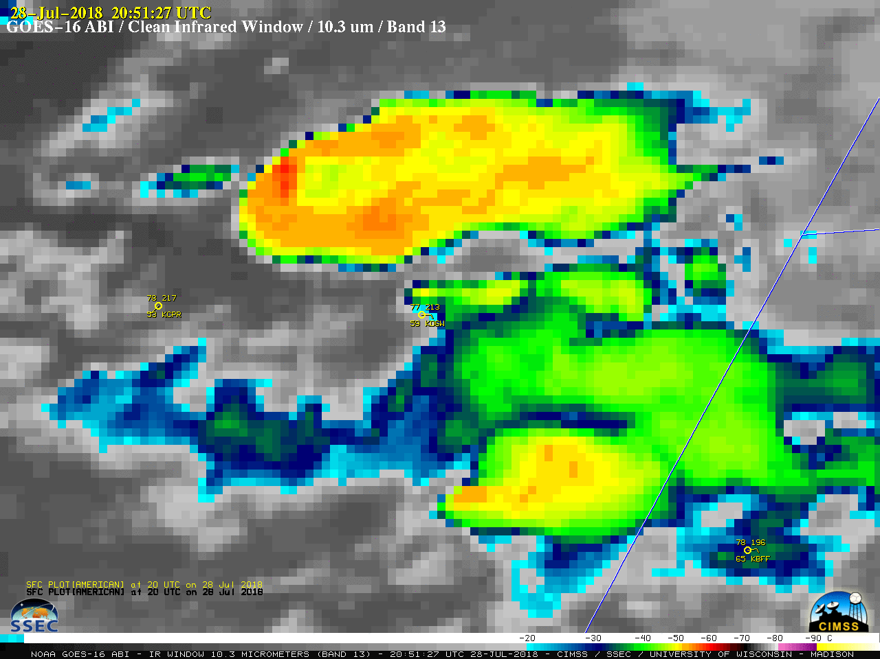
Infrared Window (10.3 µm) images revealed that the dominant northern storm began to exhibit a well-defined “enhanced-V” signature (2051 UTC image) about an hour before it began to produce tornadoes. Minimum cloud-top infrared brightness temperatures were in the -60 to -65ºC range (darker shades of red) with the stronger pulses of overshooting tops.

- Cold overshooting tops
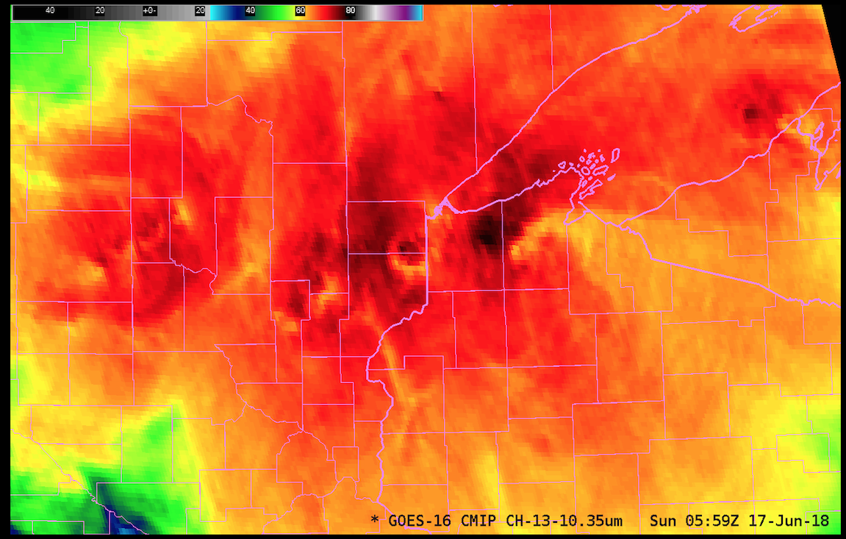
Persistent convection over northern Wisconsin, Minnesota and upper Michigan late Saturday (16 June)/early Sunday (17 June) caused significant flooding. The animation above shows GOES-16 ABI “Clean Window” Infrared Imagery from 0200-0600 UTC on 17 June. Note the persistence of the cold overshooting tops over western Bayfield County in northwestern Wisconsin! A longer Infrared animation (0110-1200 UTC) which includes hourly plots of precipitation type (yellow) and SPC storm reports of damaging winds (cyan) is available here. 7-day precipitation departures in some areas were 4 to 8 inches above normal for that period (or 600% of normal).

BAND 15 (12.3 µm) DIRTY INFRARED WINDOW

Used in tandem with the 10.3 µm Clean Infrared Window to identify airborne dust

Saharan air layer
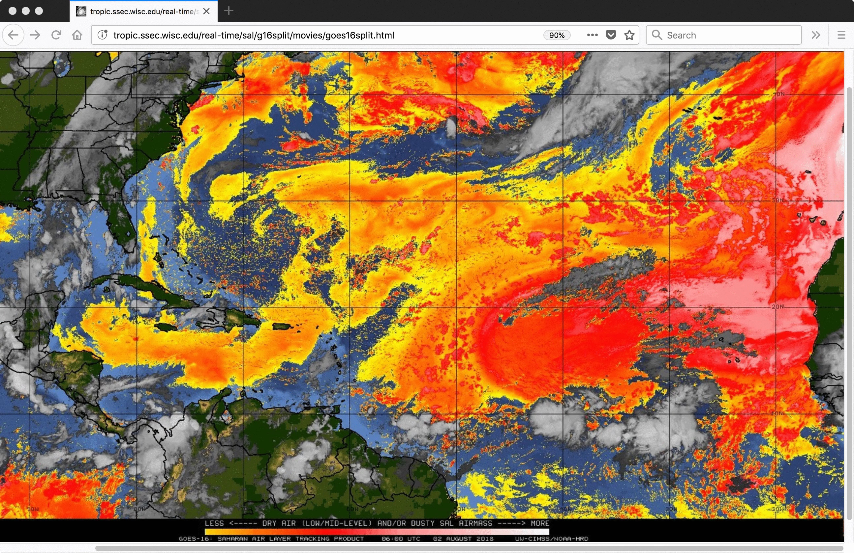
The GOES-16 (GOES-East) Saharan Air Layer (SAL) infrared Split Window (12.3 µm – 10.3 µm) product (above) showed a large outbreak of SAL dust that emerged from the northwest coast of Africa on 30 July 2018, eventually moving over the Lesser Antilles and Puerto Rico late in the day on 03 August.

Blowing dust

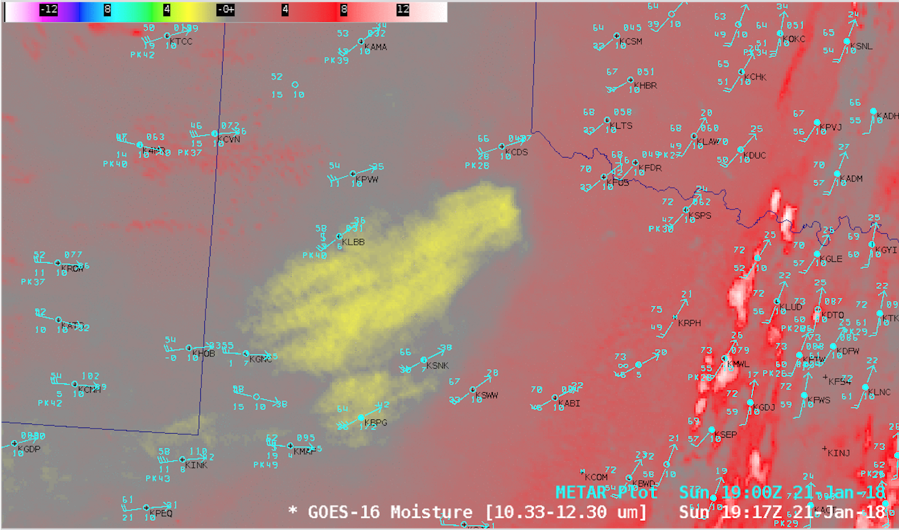
Strong winds in the wake of a cold frontal passage created large areas of blowing dust across the Panhandle Plains of northwestern Texas after 16 UTC on 21 January 2018. GOES-16 “Moisture” or “split-window difference” (10.3 µm – 12.3 µm) images (above) showed that the leading edge of this airborne dust moved over far southwestern Oklahoma after 20 UTC. (Note to AWIPS users: the default enhancement for this GOES-16 “Moisture” Channel Difference product was changed to “Grid/lowrange enhanced” to better highlight the dust with shades of yellow)

Scott L, to add moisture in clear skies

