Introduction:

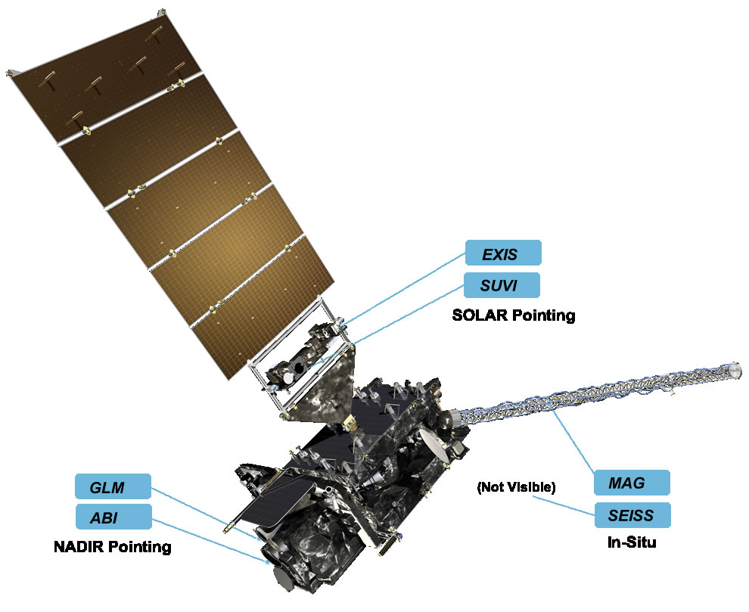

The Advanced Baseline Imager (ABI) on the Geostationary Operational Environmental Satellite (GOES)-R series has 16 spectral bands. Two bands are in the visible part of the electromagnetic spectrum, four are in the near-infrared, and ten are in the infrared. The ABI is similar to advanced geostationary imagers on other international satellite missions, such as the Advanced Himawari Imager (AHI) on Himawari-8 and -9. Operational meteorologists can investigate imagery from the ABI to better understand the state and evolution of the atmosphere. Various uses of the ABI spectral bands are described. GOES-R was launched on 19 November 2016 and became GOES-16 upon reaching geostationary orbit. GOES-16 is the first in a series of four spacecraft that will host ABI. GOES-16 became operational on 18 December 2017, in the GOES-East location. The ABI improvement is two orders of magnitude more than the legacy GOES imager due to more spectral bands and finer spatial and temporal resolutions

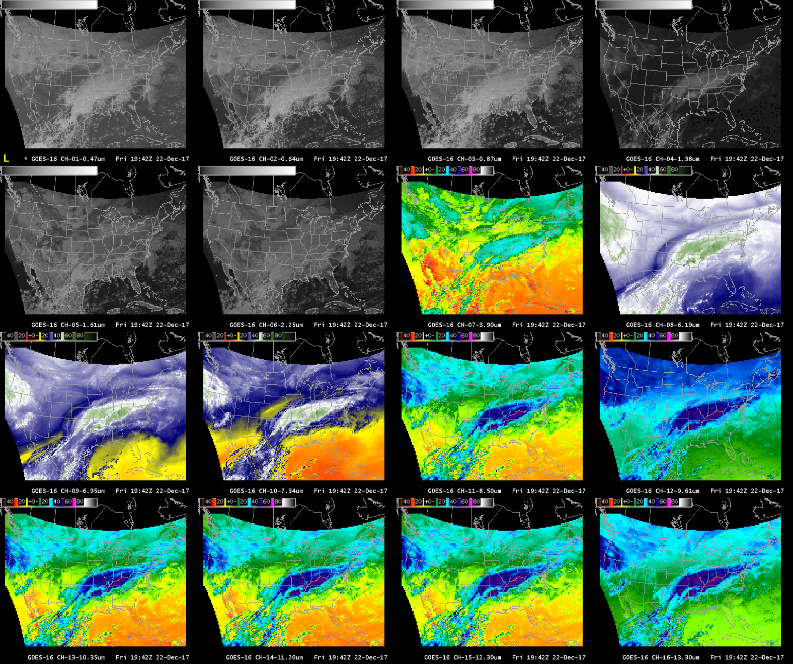

The 16 spectral bands of the ABI are shown as a 16-panel in the Advanced Weather Interactive Processing System (AWIPS). The first two bands sense
in the visible, the following four in the near-infrared, and the final ten in the infrared. The CONUS sector image is from 1942 UTC 22 December 2017. The range for the visible and NIR bands are from approximately 0 (black) to 1.2 (white) for reflectance factors and employ a square-root function to brighten the darker parts of the image.

Visible: Blue(0.47um) and Red (0.64um) :

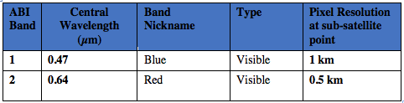

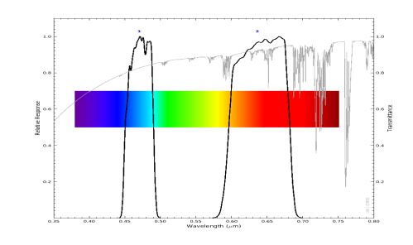
Above: ABI visible spectral bands (black solid lines) and atmospheric transmittance (grey line). There is decreased transmittance (increased scattering) at shorter wavelengths. (Credit: CIMSS and ASTER spectral library and Mat Gunshor)

Band 01: (0.47um)

Why is Blue Visible Band Imagery Important?
The 0.47 µm, or “Blue” visible band, is one of two visible bands on the ABI, and provides data for monitoring aerosols. Included on NASA’s MODIS and Suomi NPP VIIRS instruments, this band provides well-established benefits. The geostationary ABI 0.47 µm band will provide nearly continuous daytime observations of dust, haze, smoke and clouds. The 0.47 µm band is more sensitive to aerosols / dust / smoke because it samples a part of the electromagnetic spectrum where clear-sky atmospheric scattering is important.

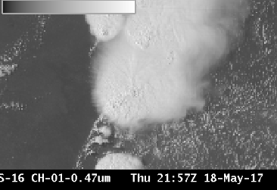

Primary Application:

Smoke and Aerosol: Highlight regions where visibility is reduced because of particulate matter. Faint smoke plumes at right are not visible in the “Red” band.

Input into Baseline Products: The 0.47 µm Blue band is a key component of the GOES-R Baseline Aerosol Products and Baseline Snow Products.
Input into RGB imagery: The Blue band, combined with a “Green” band simulated from the “Vegetation” band (0.86 µm) and the “Red” band (0.64 µm), will provide “natural color” imagery of the Earth.

Scattering Angle Affects Dust/Smoke Signal: Smoke and dust are more effective forward scatterers than backward scatterers. Thus, the smoke and dust signals will be much more apparent when the Sun is low in the sky vs. high in the sky.

Scattering and the Blue Sky: Clear-sky Rayleigh Scattering is greater in the “Blue” Visible band part of the electromagnetic spectrum than in the
“Red” Visible band part. This Rayleigh scattering causes the sky on Earth to be blue.

Input into RGB imagery: The “blue” visible band is used when creating “true color” imagery.

Limitations: The 0.47 µm band detects reflected visible solar radiation hence it is available during Daytime Only.

Compare visible bands:

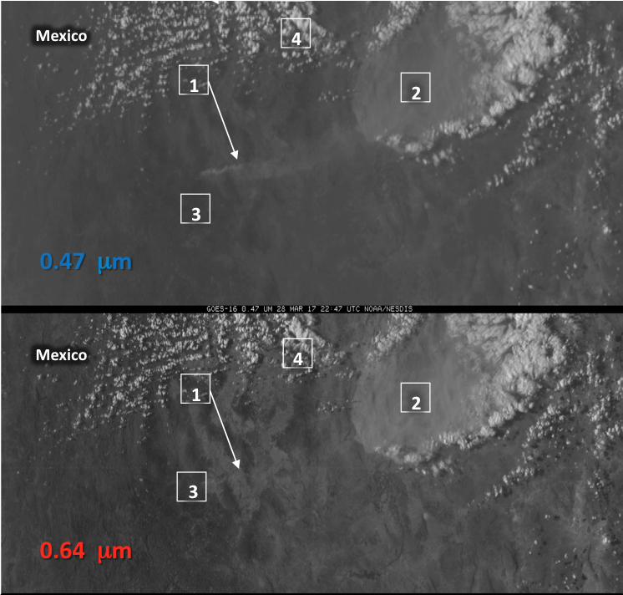
Blue Band (0.47 mm, top) and Red Band (0.64 mm, bottom) at 22:47 UTC on 28 March 2017

1: Smoke is very apparent in the Blue band band, but not in the Red.
2: Thick dust is apparent in both bands.
3: Surface features show more distinctly in the Red band because of
better spatial resolution in the Red enhanced Rayleigh scattering in
the Blue band.
4: Clouds look similar in both blue and Red bands.

Band 02 (0.64um):

Why is the Red Visible Band Important?
The ‘Red’ Visible band – 0.64 mm – has the finest spatial resolution (0.5 km at the sub-satellite point) of all ABI bands. Thus it is ideal to identify small-scale features such as river fogs and fog/clear air boundaries, or overshooting tops or cumulus clouds. It has also been used to document daytime snow and ice cover, diagnose low-level cloud-drift winds, assist with detection of volcanic ash and analysis of hurricanes and winter storms. The ‘Red’ Visible band is also essential for creation of “true color” imagery.

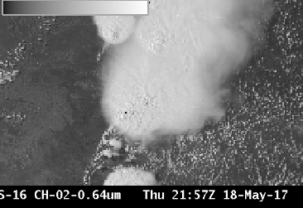

Primary application:
Detection / analysis of clouds and weather systems during daytime. Half-kilometer resolution allows detection of boundaries and small clouds , especially useful in mesoscale sectors for rapidly changing phenomena.
Application: Land absorbs energy at 0.64 µm; at longer near-infrared wavelengths, more energy is reflected. Thus, contrast between land and highly reflective clouds is greater over land in the “Red” Visible than in the “Veggie” or “Snow/Ice” bands.

Input into RGB imagery: The “Red” visible band is used when creating “true color” imagery.

Limitation:
Very large Data Volume: Excellent spatial resolution in the “Red” band means that the data volume from this one ABI band is comparable to that from all the infrared bands on the ABI.

Pixel reflectance in this band can exceed 100% over thick clouds for a large solar zenith angle because of contributions to reflectance from scattering within the cloud.

Limitations: The 0.64 µm band detects reflected visible solar radiation hence it is available during Daytime Only.

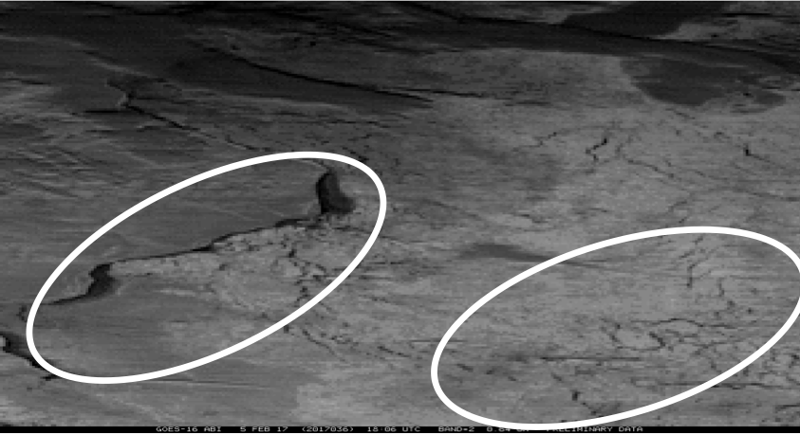GOES-16’s Red band has excellent resolution to enable identification of small features at High Latitudes, such as ice leads in Hudson Bay near 66 N Latitude, below

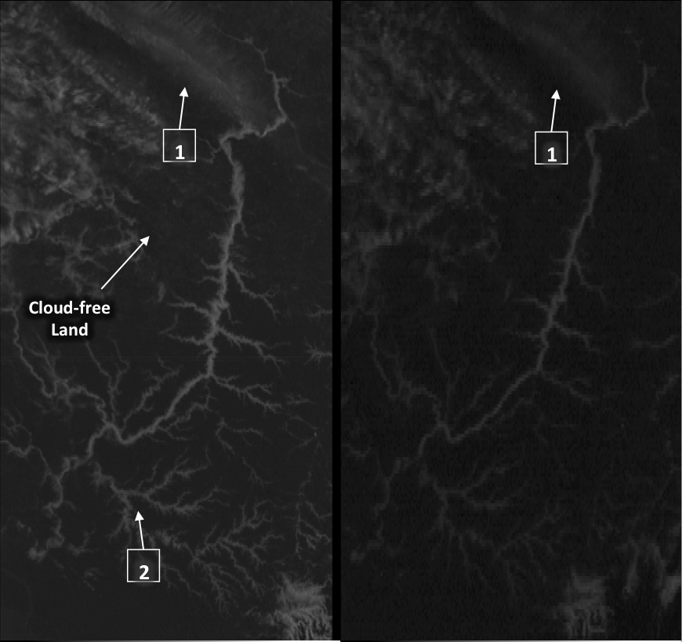
“Red Visible band” (0.64 mm) GOES-16 ABI (Left) and GOES-13 Imager (Right) at 1215 UTC, 02 April 2017

1: GOES-16 has onboard visible calibration so that bright whites will
not fade as the spacecraft ages as has happened with legacy GOES.

2: Half-kilometer resolution allows identification of small features such
as narrow river valleys full of fog and stratus.

3: Land features stand out well because atmospheric scattering is not
large at 0.64um.

Near IR: (0.86um), (1.37um), (1.61um), (2.24um)
ABI Band | Central Wavelength (µm) | Band Nickname | Type | Pixel Resolution at sub-satellite point
3 | 0.86 | Vegetation/Veggie | Near-Infrared | 1 km
4 | 1.37 | Cirrus | Near-Infrared | 2 km
5 | 1.61 | Snow/Ice | Near-Infrared | 1 km
6 | 2.24 | Cloud Phase | Near-Infrared | 2 km

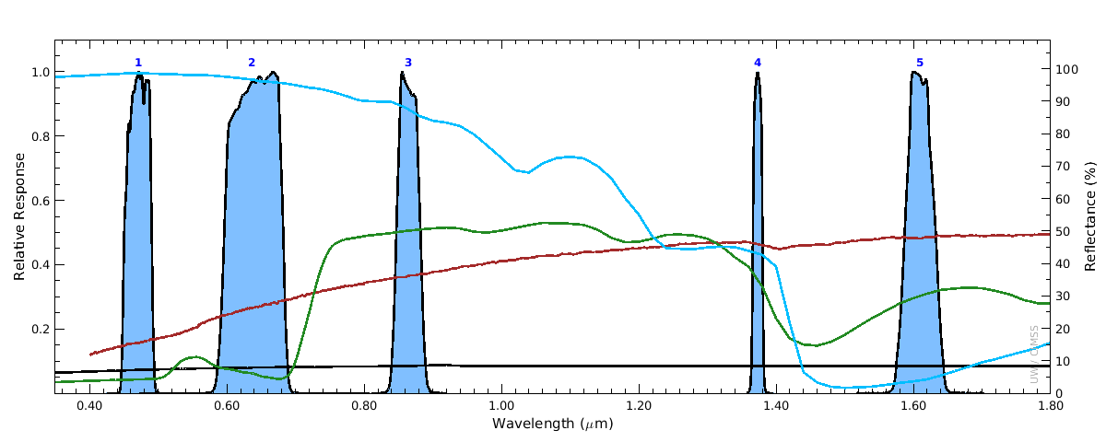
The visible and near-infrared spectral bands, shown in blue solid shaded areas, are underneath plotted reflectance spectra for snow (blue), grass (green), dirt (red), and asphalt (black). This plot explains why snow is bright in the visible bands, but dark in the “Snow/Ice” band at 1.6 μm. Reflectance spectra are from the Advanced Space borne Thermal Emission Reflection Radiometer (ASTER) spectral library.

Band 03 (0.86um) : “Veggie” Band
Why is the “Veggie” band Important?
The 0.86 μm band (a reflective band) detects daytime clouds, fog, and aerosols and is used to compute the normalized difference vegetation index (NDVI). Its nickname is the “veggie” or “vegetation” band. The 0.86 μm band can detect burn scars and thereby show land characteristics to determine fire and run-off potential. Vegetated land, in general, shows up brighter in this band than in visible bands. Land-water contrast is also large in this band. This band is essential to simulate a “green” band needed for a true color image from the ABI.

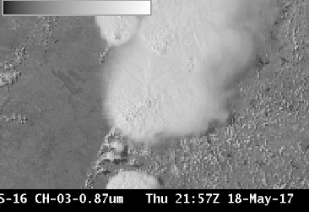

Primary Application:
The “Veggie” Band detects reflected solar energy and is therefore a daytime only band

Land is more reflective at 0.86 than in the visible bands, so the Vegetation band is very useful for detecting islands, lakes, flooded regions and land/sea boundaries.
The Vegetation band is used in the simulation of the “Green” band for simulated true color imagery.

Daytime-only application: The 0.86µm band detects reflected visible solar radiation.

Limitation: The Veggie band can be used as a stand-in for the “Green” band (for example, 0.51 µm from Himawari-8’s AHI) in RGB composites, but reflectance over vegetation at 0.86 µm is much greater than for Green Light and that must be accounted for. An example of this True Color imagery is shown on the next page.

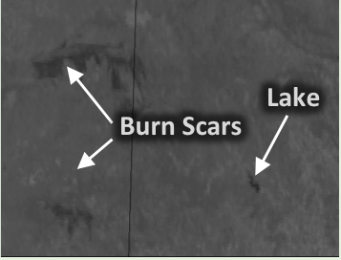
The Veggie band can detect burn scars, allowing for early identification of potential run-off issues.

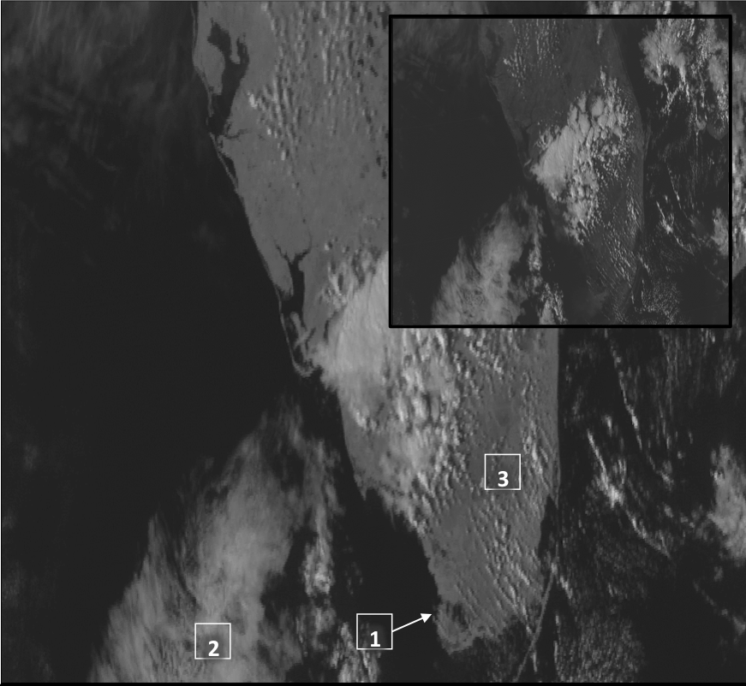
Veggie band 0.86 mm (Inset: Red Visible, 0.64 mm) from GOES-16 ABI at 2111 UTC, 01 March 2017.
1: Land-water contrast is high: coastlines stand out.

2: Cloud-water contrast means clouds are distinct over water.

3: Clouds over land are less distinct because land and clouds are both
reflective in the 0.86um imagery.

Band 04 (1.37um): “cirrus”
The Cirrus Band (1.37 mm) is unique among the reflective bands on the ABI in that it occupies a region of very strong absorption by water vapor in the electromagnetic spectrum. It will detect very thin cirrus clouds during the day. In the image at right of a Supercell thunderstorm over Oklahoma, low-level cumulus clouds east of the system are only faintly visible because energy at 1.37 mm has been absorbed as it moves through the moist atmosphere.

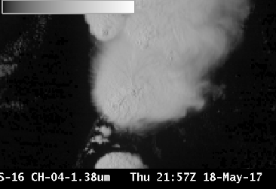

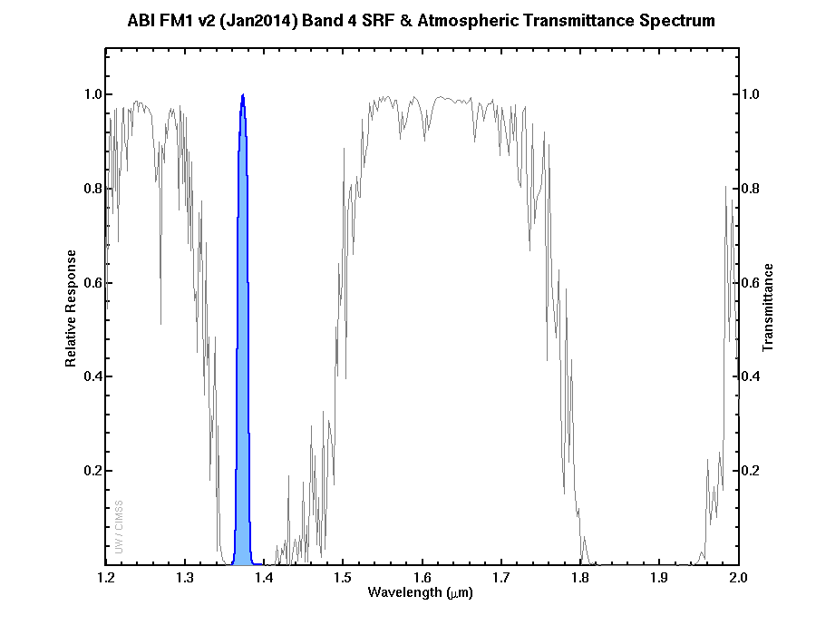
The Spectral Response Function for the Cirrus Channel is shown in blue at left. The grey line shows transmittance through the atmosphere. The Cirrus Channel is in a region where strong absorption (by water vapor) occurs. (Figure courtesy Mat Gunshor, CIMSS)

Primary Application:
Daytime only application: The 1.37 µm band detects reflected visible solar radiation.
This channel detects high clouds during the daytime. Very thin cirrus can be discerned.
Application: In a dry atmosphere, this band will detect highly reflective features, such as dust, or clouds, if there is limited water vapor above those features.
Application: The Cirrus Channel is an important part of the Daytime Cloud Mask computation because of its ability at detecting very thin cirrus.
Limitation: Theory suggests that about 12 mm of Total Perceptible Water is sufficient to absorb most of the solar radiation at 1.37 µm. Variable amounts of moisture in the atmosphere (and where in the vertical that moisture exists) influence how far down the satellite can see at this wavelength.
The Cirrus Channel is one of two near-infrared channels on ABI with 2-km resolution.
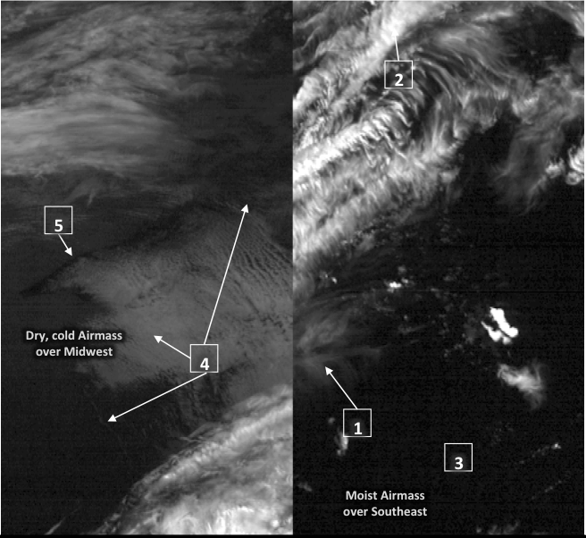GOES-16 ‘Cirrus Channel’ (1.37 mm) at 21:06 UTC, 08 February 2017

1: Thin cirrus easily detectable.

2: Thick cirrus shows up easily.

3: Low clouds are not detected in a moist atmosphere.

4: Coastlines visible in dry air.

Band 05 (1.61um): Snow Ice

Why is the Snow/Ice Band Important?
The Snow/Ice band takes advantage of the difference between the refraction components of water and ice at 1.61 mm. Liquid water clouds are bright in this channel; ice clouds are darker because ice absorbs (rather than reflects) radiation at 1.61 mm. Thus you can infer cloud phase: compare at right the darker region of the cirrus anvil to the more reflective water-based cumulus clouds to the right of the storm. Land/water contrast is great at 1.61 mm (lakes are readily apparent in the image) and shadows can be particularly striking. Fires can also be detected at night using this band
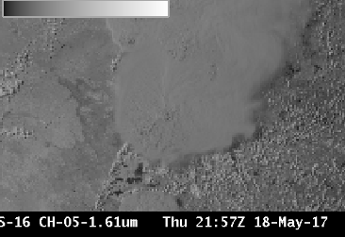

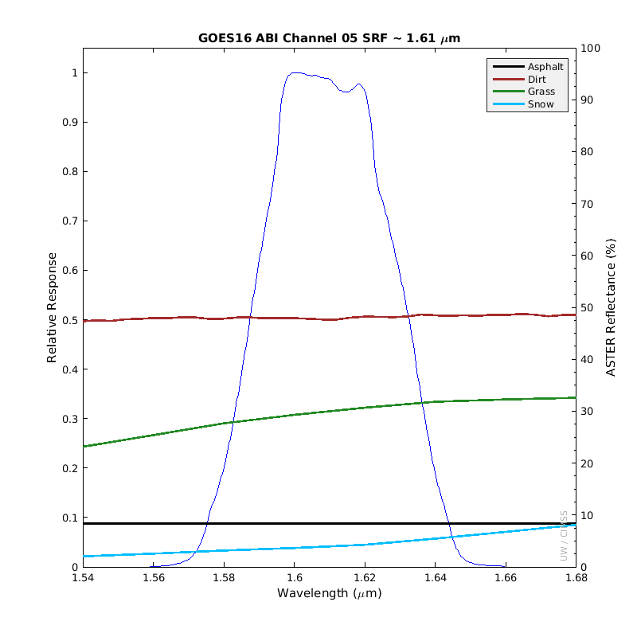
The Spectral Response Function (SRF) for the Snow/Ice Channel is shown in blue at right. The colored lines show reflectance of different surfaces: Asphalt (black), Grass (green) Dirt (red) and Snow (cyan). Note in particular the low reflectance of snow. Water clouds are highly reflective in this wavelength range (not shown)
Primary Application:
This band identifies regions of ice/ snow, as at right (centered on Lake Tahoe (A)): snow (B, for example) is bright in the Veggie Band (0.86 mm) but dark in the Snow/Ice Band (1.61 mm).
Daytime application: The 1.61 µm band detects reflected visible solar radiation.
Nighttime application: Fires can be detected using the 1.61 µm channel at night. This is especially true of very hot fires. The default enhancement in AWIPS must be changed to view fires at night. Care must also be taken to monitor clouds: cloud motion or development can block the night-time view of the fire.
Application: Fires emit radiation with a wavelength of 1.61 µm, so this band is useful to detect very hot fires at night, especially because spatial resolution is 1 km. The Snow/Ice Band is a component of some nighttime fire detection RGBs.
Application: The Snow/Ice Channel can be used to discriminate water-based clouds from a snow-covered surface.
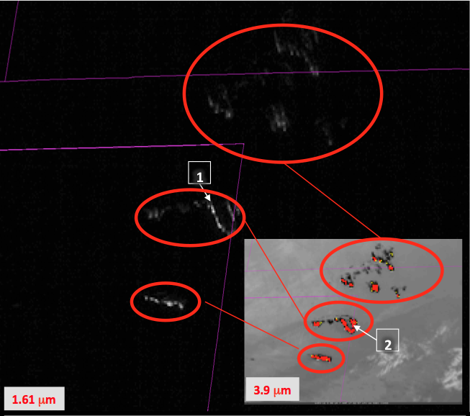GOES-16 ‘Snow/Ice Channel’ (1.61 mm) at 02:57 UTC, 07 March 2017 (Inset: 3.9 mm color-enhanced to show Hot Spots). The default 1.61 mm enhancement usually does not show fires – it must be changed
1: Hot fires emit 1.61um radiation that shows up well against the black background of night.
2: Inset shows the 3.9um image for the same time.
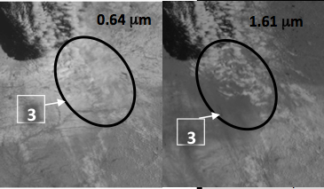
3: Use the 1.61um to distinguish clouds made of water from underlying snow.

Band 07 (3.9um): Shortwave Infrared
Why is the Shortwave Infrared Band Important?
The 3.9 μm band can be used to identify fog and low clouds at night, identify fire hot spots, detect volcanic ash, estimate sea-surface temperatures, and discriminate between ice crystal sizes during the day. Low-level atmospheric vector winds can be estimated with this band, and the band can be used to study urban heat islands. The 3.9 μm is unique among ABI bands because it senses both emitted terrestrial radiation as well as significant reflected solar radiation during the day.
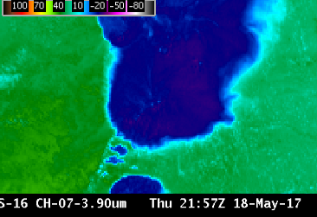

Primary Application: This infrared channel is used for fire detection; its short wavelength is more sensitive than longer wavelength infrared channels to the hottest part of the pixel.
Application: Small ice crystals reflect more solar 3.9 mm radiation than large crystals during daytime.
Application: Stratus clouds do not emit 3.9 µm radiation as a blackbody so the inferred temperature is colder than the temperature inferred from the 10.3 µm radiation (Stratus clouds emit 10.3 µm radiation as a blackbody). Thus, at night, stratus clouds are apparent in the brightness temperature difference.
Daytime: Solar reflectance adds to the detected 3.9 mm radiation. Compare 3.9 mm (above left) and 10.3 mm (above right) brightness temperatures at right: The 3.9 is much warmer.
Fire application: 2-km resolution means that very small fires can be overlooked.
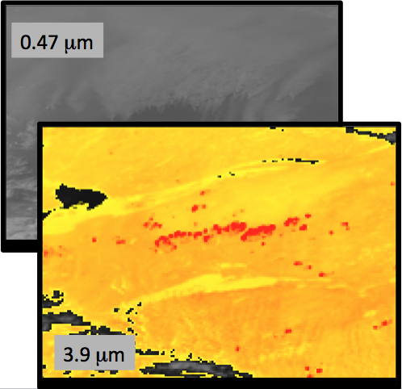 GOES-16 3.9 mm imagery, bottom left, enhanced so that the black/ yellow transition occurs at 12 C and the yellow/red transition occurs at 30 C, shows numerous hot spots (in red) associated with fires. The ‘Blue Band’ (0.47 mm), at left, shows the plumes of smoke produced by the fires. (2245 UTC, 14 August 2017). The 3.9 mm band has the most bit depth of any ABI band, containing 14 bits. The range of Brightness Temperatures detected is -75 C to 140 C.
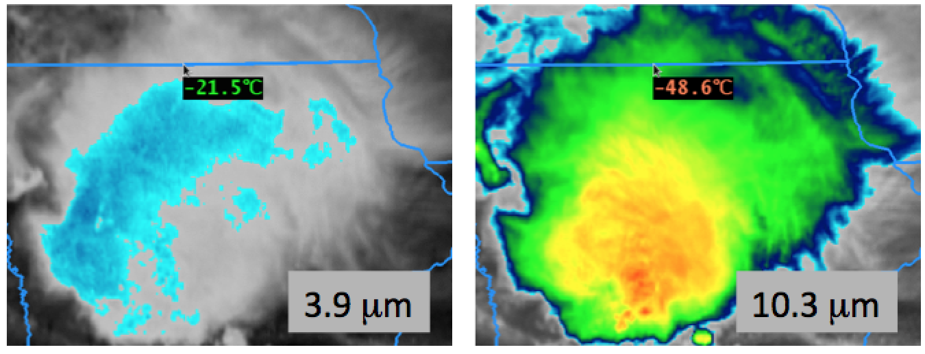The daytime imagery at left shows the warming at 3.9 mm that results from solar reflection. The same color enhancement is used for the 3.9 mm and 10.3 mm GOES-16 imagery.

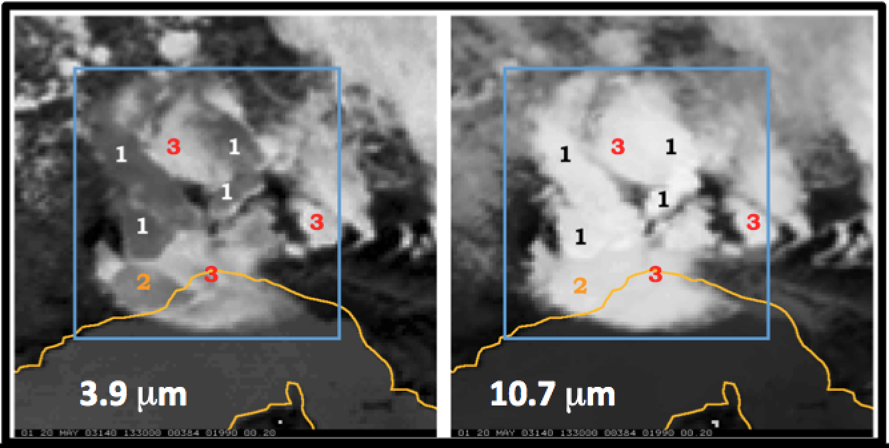GOES-12 3.9mm Brightness Temperatures (BTs) (Left) and 10.7 mm BTs. Ice Crystal Size at anvil top affects the amount of reflected solar radiation at 3.9 mm and consequently the BT, displayed as a greyscale, with whites cold and blacks hot. 10.7 mm BTs are less affected by Ice Particle Size. (Credit: Chad Gravelle, CIMSS/OPG)
Water vapor bands: 08, 09 and 10
Interpretation of water vapor imagery: The “water vapor” bands are infrared bands that sense the mean temperature of a layer of moisture — a layer whose altitude and depth can vary, depending on both the temperature/moisture profile of the atmospheric column and the satellite viewing angle. Examination of water vapor weighting function plots can help in the correct interpretation of the three-dimensional aspects of patterns displayed on water vapor imagery.

ABI Band | Approximate Central Wavelength (µm) | Band Nickname | Type | Nominal Pixel Resolution at sub-satellite point
8 | 6.2 | Upper-level tropospheric water vapor | Infrared | 2 km
9 | 6.9 | Mid-level tropospheric water vapor | Infrared | 2 km
10 | 7.3 | Lower-level tropospheric water vapor | Infrared | 2 km
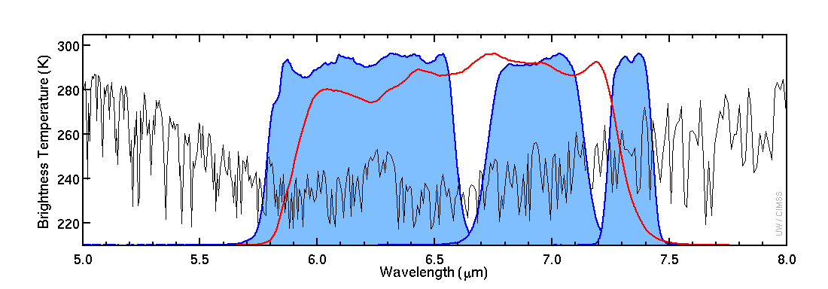
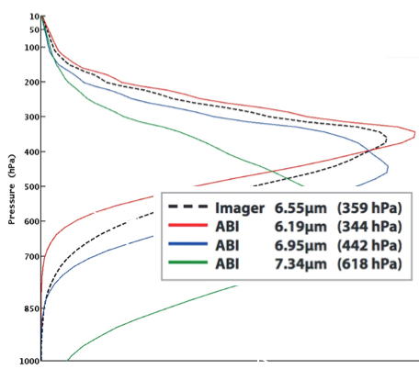
Weighting functions, plotted at right for legacy GOES and for ABI, depict the layer of the atmosphere from which radiation sensed by the satellite originated. These assume a clear sky and a US standard atmosphere. Weighting functions change as the vapor distribution changes, but in general the Mid Level Water Vapor band peaks in the middle of the three ABI bands. (Credit: CIMSS)
Infrared Water Vapor Channels are affected by cooling as the view angle increases. If the pixel location is farther from the sub-satellite point, the path the energy takes from Earth to satellite includes more of the colder upper atmosphere. For identical conditions, the brightness temperature might be 8 C cooler at the limb vs. at nadir.

Band 08 (6.2um): Upper level water vapor
Why is “Upper-level water vapor” band imagery important?
The 6.2 µm “Upper-level water vapor” band is one of three water vapor bands on the ABI, and is used for tracking upper-tropospheric winds, identifying jet streams, forecasting hurricane track and mid-latitude storm motion, monitoring severe weather potential, estimating upper/ mid-level moisture (for legacy vertical moisture profiles) and identifying regions where the potential for turbulence exists. Further, it can be used to validate numerical model initialization and warming/cooling with time can reveal vertical motions at mid- and upper levels.
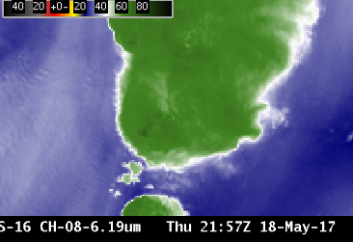
Primary Application
Atmospheric feature identification (jet streams, troughs/ridges, signatures of potential turbulence).
Input into Baseline Products: 6.2 µm imagery is input for the creation of Derived Motion Winds and Total Perceptible Water products.
Input into RGB imagery: Upper-level water vapor imagery is a key component of the Airmass RGB product, helping to highlight jet stream axes as well as dry ozone-rich stratospheric air associated with potential vorticity anomalies and tropopause folds.
Feature Identification: Cloudless features that will soon produce clouds/precipitation can be identified in 6.2 mm imagery.
Regions of dense cloudiness: Optically dense clouds obstruct the view of lower altitude moisture features.
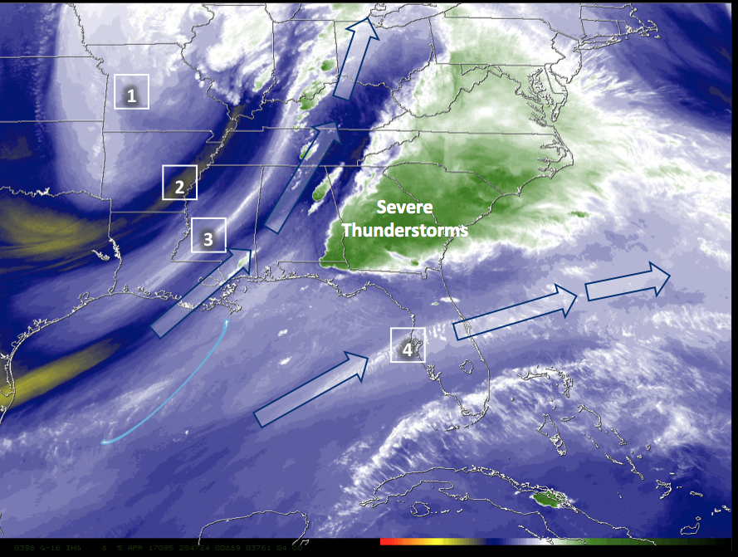Upper-Level Water Vapor Band (6.2 mm) image at 20:47 UTC on 05 April 2017
1: Upper-level trough Dry slot.
2: Polar jet stream axis subtropical jet steam axis.
3: In this example, there is diffluent flow aloft (depicted by arrows) between the subtropical and polar jets. High-impact weather is possible where diffluence occurs: Thunderstorms in this case.

Band 09 (6.9um) : Mid-level water vapor
Why is “Mid-level water vapor” band imagery important?
The 6.9 µm “Mid-level water vapor” band is one of three water vapor bands on the ABI, and is used for tracking middle-tropospheric winds, identifying jet streams, forecasting hurricane track and mid-latitude storm motion, monitoring severe weather potential, estimating mid-level moisture (for legacy vertical moisture profiles) and identifying regions where turbulence might exist. Surface features are usually not apparent in this band. Brightness Temperatures show cooling because of absorption of energy at 6.9 µm by water vapor.
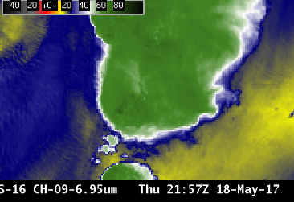

Primary Application
Atmospheric feature identification (jet streams, vorticity centers, signatures of potential turbulence, contrails).
Impact on operations: The lower noise and higher bit depth of ABI data, coupled with the improved spatial and temporal resolutions will allow for more small scale features to be resolved.
Input into Baseline Products: 6.9 µm imagery is input for the creation of Derived Motion Winds, the Cloud Mask, Stability Indices and Total Precipitable Water products. In addition, radiances from this and other bands can be assimilated into numerical models.
Regions of dense cloudiness: The presence of optically-dense clouds obstructs the view of lower altitude moisture features.
Interpretation of water vapor imagery: The “water vapor” bands are technically infrared bands that sense the mean temperature of a layer of moisture — a layer whose altitude and depth can vary, depending on both the temperature/moisture profile of the atmospheric column and the satellite-viewing angle. Thus, examination of water vapor weighting function plots might be necessary to interpret correctly the three-dimensional aspects of patterns displayed on water vapor imagery.
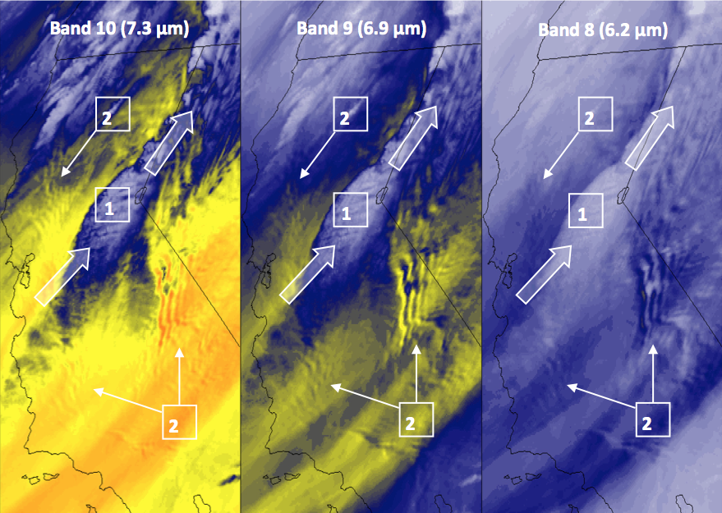
GOES-16 water vapor Band 10, Band 9 and Band 8 images at 12:02 UTC on 13 April 2017

Band 10 (7.3um): Lower-level water vapor
Why is “Lower-level water vapor” band imagery important?
The 7.3 µm “Lower-level water vapor” band is one of three water vapor bands on the ABI. It typically senses farthest down into the mid-troposphere in cloud-free regions, to around 500-750 hPa. It is used to track lower-tropospheric winds, identify jet streaks, monitor severe weather potential, estimate lower-level moisture (for legacy vertical moisture profiles), identify regions where the potential for turbulence exists, highlight volcanic plumes that are rich in sulphur dioxide (SO₂) and track Lake-Effect snow bands.
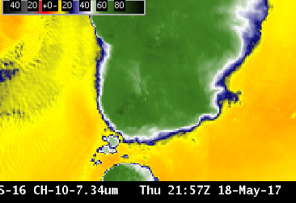

Primary Application
Atmospheric feature identification (jet streaks, dry slots, signatures of potential turbulence, contrails, downslope winds., Lake Effect.
Input into Baseline Products: The 7.3 µm imagery is used in the creation of Derived Motion Winds, the Cloud Mask, Stability Indices, Total Precipitable Water, Rain Rate, and Volcanic Ash products.
Application: Identification of volcanic plumes that have a high concentration of SO₂.
Regions of dense cloudiness: The presence of optically-dense clouds obstructs the view of lower altitude moisture features.
Interpretation of water vapor imagery: The “water vapor” bands are technically infrared bands which sense the mean temperature of a layer of moisture — a layer whose altitude and depth can vary, depending on both the temperature/moisture profile of the atmospheric column and the satellite viewing angle. Water vapor weighting function plots may help you correctly interpret the three-dimensional aspects of patterns displayed on water vapor imagery. Band 8 and Band 9 Quick Guides contain simple plots.

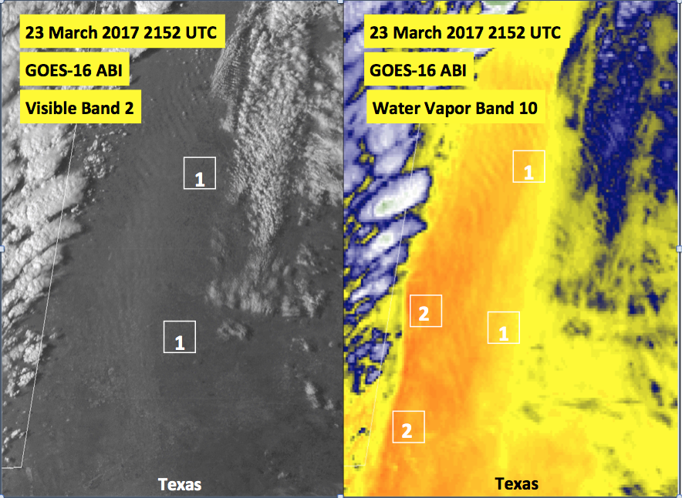
Visible (0.64 µm) and Lower-Level Water Vapor (7.3 µm) images, 21:52 UTC on 23 March 2017
To the east of the dryline oriented N-S along the Texas / New Mexico border, strong southerly winds caused blowing dust; plumes of lofted dust were organized into horizontal convective rolls aligned parallel to the wind flow

7.3um and 6.9um
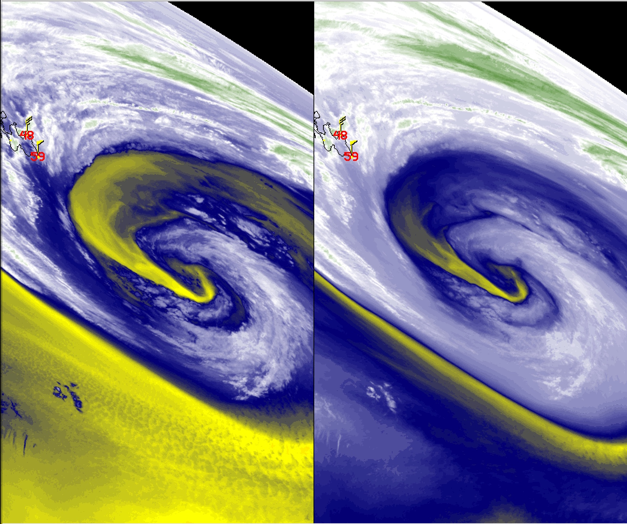
The 7.3 µm band can detect lower-level clouds when the middle/upper atmosphere is relatively dry— this example shows marine boundary layer stratocumulus over the Atlantic Ocean. (Credit: CIMSS)

Band 13 (10.3um) “clean long waive”

Why is “Clean longwave infrared window” band imagery important?
The 10.3 μm “clean” infrared window band is less sensitive than other infrared window bands to water vapor absorption, and therefore improves atmospheric moisture corrections, aids in cloud and other atmospheric feature identification/classification, estimation of cloud-top brightness temperature and cloud particle size, and surface property characterization in derived products.

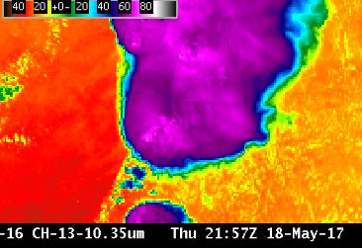
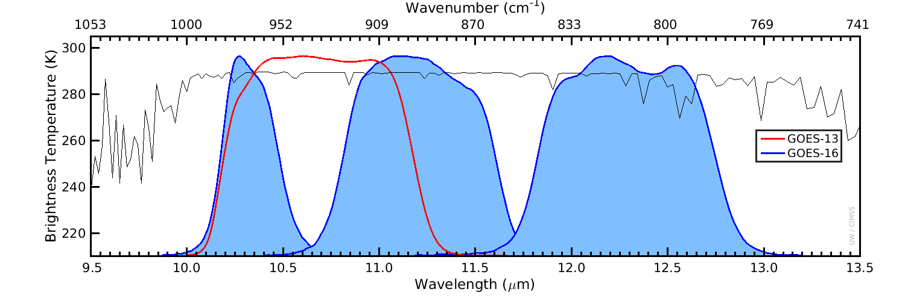

Primary Application
Continuous day/night cloud feature identification and classification, convective severe weather signatures, and hurricane intensity.
Input into Baseline Products: The 10.3 µm imagery is used in the creation of legacy vertical temperature/moisture profiles, stability indices, total precipitable water, sea surface temperature, Hurricane Intensity Estimate (HIE), and snow cover products. Input into RGBs: 10.3 mm imagery is used in many RGB composites and band differences.
Infrared vs surface air temperature: 10.3 µm brightness temperatures are not necessarily representative of 2-m shelter air temperatures
especially during the day, when the land can warm substantially compared to the near-surface air. Because there is some absorption of upwelling energy by atmospheric water vapor, the satellite-measured infrared brightness temperatures do not provide a truly accurate “skin temperature.” A Baseline Product is available that provides the Land Surface Temperature.

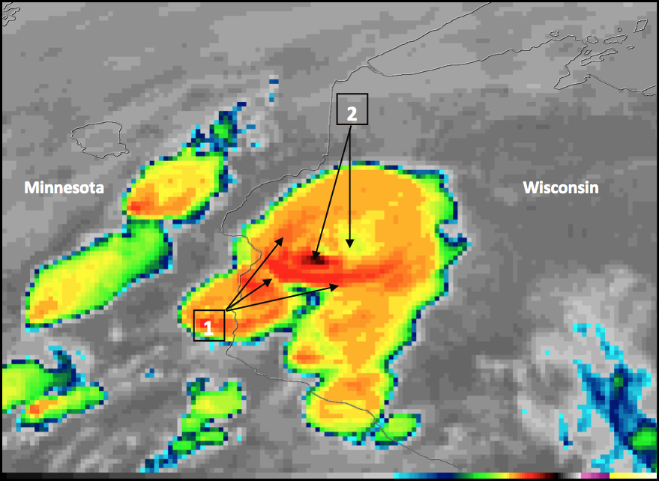
GOES-16 “Clean” Infrared Window (10.3 µm) image, 21:27 UTC on 16 May 2017

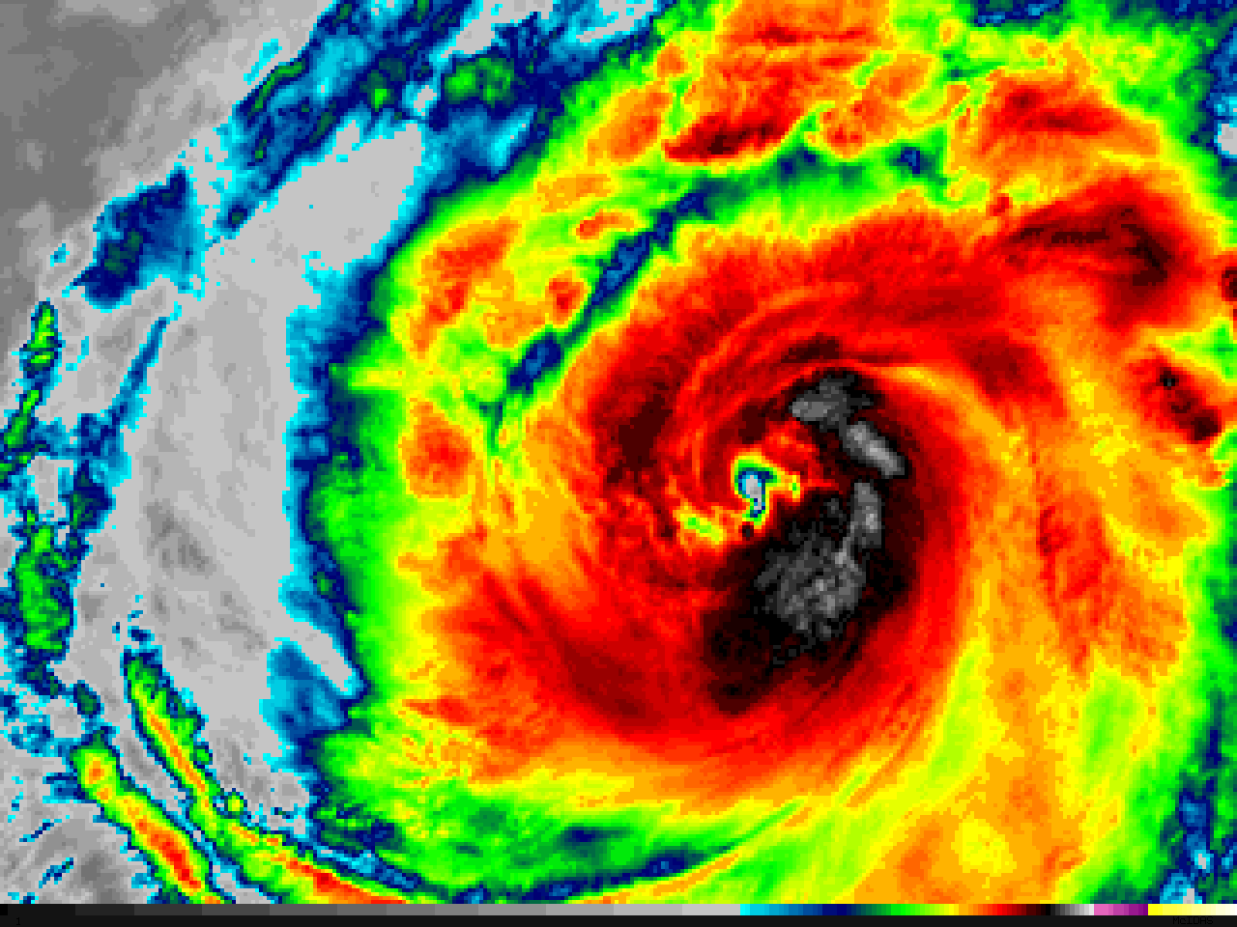
GOES-16 10.3 µm “Clean” Infrared Window images of Hurricane Dora in the East Pacific Ocean, showing the development of a well-defined eye during the 12-hour period between 14 UTC on 26 June (left) and 02 UTC on 27 June 2017 (right). Images are the same scale, showing storm contraction during intensification. (Credit: CIMSS)

Band 15 (12.3um) “Dirty window”
Why is the Dirty Window Band Important?
Absorption and re-emission of water vapor, particularly in the lower troposphere, slightly cools most non-cloud brightness temperatures (BTs) in the 12.3 μm band compared to the other infrared window channels: the more water vapor, the greater the BT difference. The 12.3 μm band and the 10.3 μm are used to compute the ‘split window difference’.
The 10.3 μm “Clean Window” channel is a better choice than the “Dirty Window” (12.3 μm) for the monitoring of simple atmospheric phenomena.
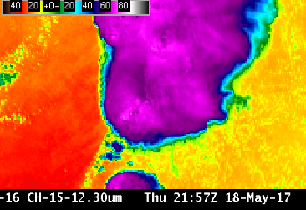

Primary Application: The Split Window Difference (SWD) (10.3 mm – 12.3 mm) can detect both moisture and dust, so the 12.3 mm channel is part of many Baseline Products, including Clear Sky Mask, Cloud Top Properties, Legacy Atmospheric Profiles, Volcanic Ash and Fire Hot Spot Characterization.
The SWD can distinguish volcanic ash and dust silicates from cloud water and ice. The emissivity of silicates is lower at 10.3 μm than at 12.3 μm, so 10.3 μm BTs are cooler than 12.3 μm BTs for dust and volcanic ash scenes. Airborne dust (including Saharan Air Layers that suppress tropical cyclogenesis) can also be detected by the SWD.
This is a “dirty” window: Water vapor absorbs atmospheric energy at 12.3 mm; that energy is subsequently re-emitted from higher, cooler temperatures. Thus, surface or near-surface BTs will be cooler than observed by near-surface shelter thermometers by an amount that is a function of the amount of moisture in the atmosphere. The amount of absorption (and cooling) is greater at 12.3 μm than at 11.2 μm and 10.3 μm, two other window channels on the ABI.
The 10.3 μm “Clean Window” channel is preferred to the “Dirty Window” (12.3 μm) for the monitoring of simple atmospheric phenomena.

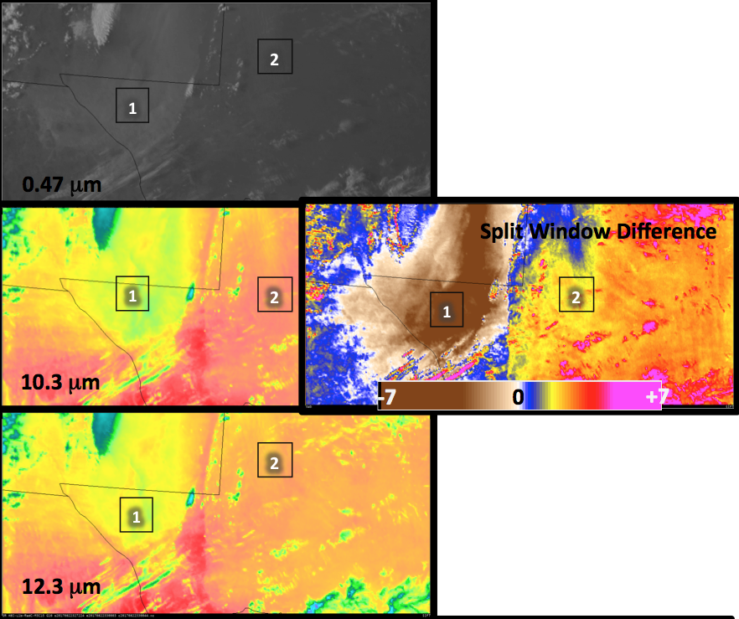
GOES-16 Imagery, 2327 UTC on 23 March 2017: Visible (0.47 mm), top left; Clean Window (10.3 mm), middle left; Dirty Window (12.3 mm), bottom left; Split Window Difference (10.3 mm – 12.3 mm), middle right, color enhancement of -7 º C to +7 º C

There is more water vapor absorption in the 12.3 mm band than in the 11.2 mm or 10.3 mm channels. In the plot at right, absorption by gases as a function of wavelength is shown by the spiky red line representing the perceived temperature based on Earth-emitted radiance (cooler values at towards the top). The 10.3 mm channel is the cleanest longwave window: it has the smallest amount of cooling due to water vapor absorption.

Remaining ABI bands:

GOS-16 ABI has a total of 16 bands, 11 of which has been covered above. Below are brief summaries of the remaining 5 bands.

Band 6 (2.24 um) “Cloud particle Size”
Why is the Cloud Particle Size Band Important?
The 2.24 μm band, in conjunction with other bands, enables cloud particle size estimation. Cloud particle size changes can indicate cloud development. The 2.24 μm band is also used with other bands to estimate aerosol particle size (by characterizing the aerosol-free background over land), to create cloud masking and to detect hot spots.
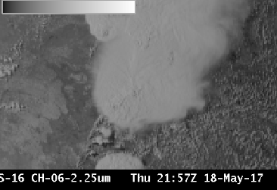
Primary Application: This band is used as input into derived products such as Cloud Mask, Aerosol Optical Depth and Cloud Phase. Cloud phase as shown in the figure can be used to predict icing threat. Hot fires emit radiation with a wavelength of 2.24 µm. GOES-16 can detect that emitted energy in the absence of clouds. This band is used as a component in some fire detection RGBs.
Band 11 (8.5 um) “Cloud Phase”
Why is the Infrared Cloud Phase Band Important?
The infrared 8.5 μm band is a window channel; there is little atmospheric absorption of energy in clear skies at this wavelength (unless SO₂ from a volcanic eruption is present). However, knowledge of emissivity is important in the interpretation of this Band: Differences in surface emissivity at 8.5 μm occur over different soil types, affecting the perceived brightness temperature. Water droplets also have different emissivity properties for 8.5 μm radiation compared to other wavelengths. The 8.5 μm band was not available on either the Legacy GOES Imager or GOES Sounder.
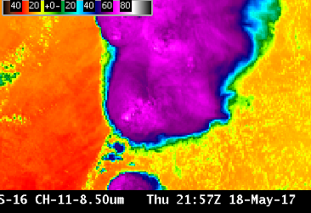

Primary Application: This is an important channel to monitor volcanic activity; also cloud Phase can be determined using the brightness temperature difference between the 8.5 mm and 11.2 mm Window Channels that is driven by emissivity differences.
Limitations: This is a “dirty” window, hence there is more water vapor absorption in this 8.5 mm channel than in the Clean Window Channel at 10.3 mm. Brightness Temperatures will be modulated by water vapor. For most purposes in tracking meteorological features, it makes more sense to use the cleaner 10.3 μm window channel.
Band 12 (9.6 um) “Ozone”

Why is the Ozone Band Important?
The 9.6 μm band gives information both day and night about the dynamics of the atmosphere near the tropopause. This band shows cooler temperatures than the clean window band because both ozone and water vapor absorb 9.6 μm atmospheric energy. The cooling effect is especially apparent at large zenith angles. This band alone cannot diagnose total column ozone: product generation using other bands will be necessary for that.
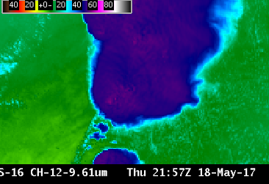
Primary Application: The Ozone Band is used in RGBs (it is a component of the Airmass RGB Product, for example) and in derived products (such as Legacy Atmospheric Profiles).
Limitations: Water vapor absorption occurs in this band, complicating the use of Band 12 (9.6 μm) because the horizontal distribution of ozone and water vapor varies across the globe. Brightness temperature will generally increase with less water vapor, less ozone, or with an increase in air temperature in the layer where water vapor or ozone occurs.

Band 14 (11.2 um) “Infrared Longwave”
Why is the Infrared Longwave Window Band Important?
The infrared 11.2 μm band is a window channel; however, there is absorption of energy by water vapor at this wavelength. Brightness Temperatures (BTs) are affected by this absorption, and 11.2 μm BTs will be cooler than clean window (10.3 μm) BTs – by an amount that is a function of the amount of moisture in the atmosphere. This band has similarities to the legacy infrared channel at 10.7 μm.
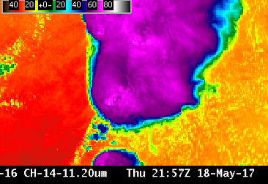
Primary Application: The 11.2 μm channel is used in ways that are similar to the clean window (10.3 μm). However, there is more absorption of 11.2 μm energy – than of 10.3 μm energy – by water vapor; thus clear-sky brightness temperatures are more affected by water vapor in this channel than in the Clean Window Channel at 10.3 μm. Data from the 11.2 μm channel is used in many Baseline Products, such as Fire Detection, Volcanic Ash Detection, Derived Motion Wind Vectors, Legacy Atmospheric Profiles including Precipitable Water, Cloud Top Properties, Aerosol Detection and Land Surface Temperature.
Limitations: This is not a “clean” window; hence water vapor absorbs atmospheric energy at 11.2 mm; that energy is subsequently re-emitted from higher, cooler temperatures. Thus, surface or near-surface clear-sky brightness temperatures will be cooler than observed by an amount that is a function of the amount of moisture in the atmosphere. The amount of absorption (and cooling) is greater at 11.2 μm than at 10.3 μm, but less than that at 12.3 μm, the “Dirty” Longwave Window.

Band 16 (13.3 um) “CO₂ Band”

Why is the CO₂ Band Important?
Products derived using the infrared 13.3 μm “Carbon Dioxide” band can be used to delineate the tropopause, to estimate cloud-top heights, to discern the level of Derived Motion Winds, to supplement Automated Surface Observing System (ASOS) sky observations and to identify Volcanic Ash. The 13.3 μm band is vital for Baseline Products; that is demonstrated by its presence on heritage GOES Imagers and Sounders. Despite its importance in products, the CO₂ channel is typically not used for visual interpretation of weather events.
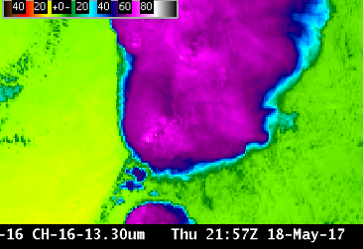
Primary Application: The 13.3 μm band on the ABI is used in many GOES-16 Baseline Products. These products include cloud mask, cloud-top height, pressure, and temperature. This band is an input to the legacy moisture and temperature profiles, and hence is used for the products derived from the profiles, such as total precipitable water and stability indices. This band is also used in the quantitative volcanic ash detection and height algorithm. Because the CO₂ band has a muted view of surface features, it can be used to create RGBs that highlight features at upper levels.
Limitations: This is a “dirty” window; Hence cooling in this band is associated with the ubiquitous nature of carbon dioxide (CO₂) in the atmosphere. That cooling is especially noticeable near the limb, moreso than almost any other ABI channel (see below). Earth’s surface is apparent in clear skies, but strong cooling from CO₂ means 13.3 μm brightness temperatures are much cooler than in other window channels at the limb.

