ABI Training

Welcome:

Welcome to this GOES-16 ABI training module that will introduce the Advanced Baseline Imager (ABI) Vis, near IR and IR channels on all GOES-R Series satellites. GOES-16 is the first in a series of four GOES-R series spacecraft that will host ABI. It was launched on 19 November 2016 and became GOES-16 upon reaching geostationary orbit. GOES-16 became operational as GOES-East on 18 December 2017.
The ABI improvement over previous GOES Imagers is two orders of magnitude because of an increase in the number of spectral bands and finer spatial and temporal resolutions. The ABI has 16 spectral bands: Two are in the visible part of the electromagnetic spectrum, four are in the near infrared, and ten are in the infrared. The 7 channels with the smallest wavelengths, from 0.47 to 3.9 µm, detect energy that is reflected from the Sun. Infrared Channels, from 3.9 µm to 13.3 µm measure energy that is emitted from the Earth/Atmosphere system. Very hot events – such as fires and Volcanic eruptions, can also emit radiation at short wavelengths, especially 1.61 and 2.24 µm. The ABI is similar to imagers on other international satellite missions, such as the Advanced Himawari Imager (AHI) on Himawari-8 and -9. Operational meteorologists can investigate imagery from the ABI to better understand the state and evolution of the atmosphere. Various uses of the ABI spectral bands will be described.
As of 2018, there are two baseline scan modes from the ABI. The more commonly used is the “flex” mode which provides a full disk scan every 15 minutes, a contiguous U.S. (CONUS) image every 5 minutes, and two mesoscale sector (nominally 1,000 km by 1,000 km) images every minute. Alternatively, the ABI can enter continuous full disk mode, the highest data rate from the imager, providing full disk scans every 5 minutes.

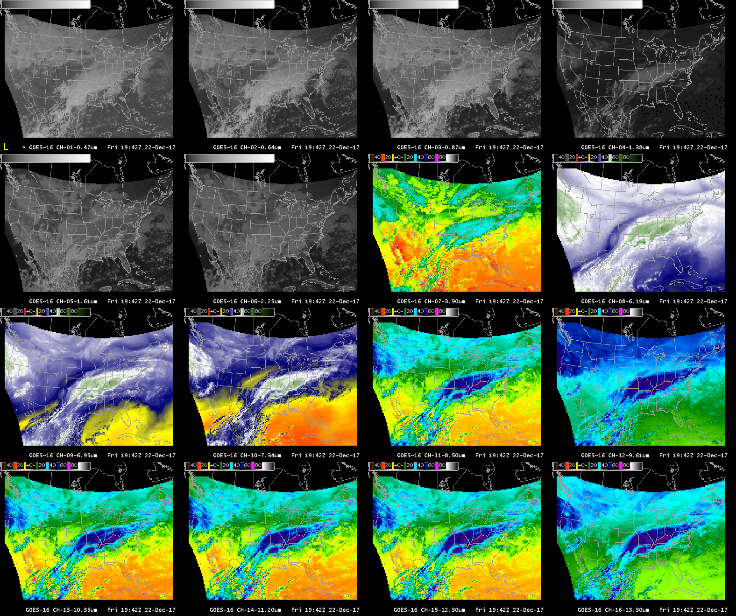
The 16 spectral bands of the ABI from a CONUS sector are shown as a 16-panel in the Advanced Weather Interactive Processing System (AWIPS)

****Scott L. promised to add SRF for Vis. IR and near-IR

The visible channels:
The ABI has two visible channels. These sense primarily reflected solar radiation at 0.47µm and 0.64µm and are known as the “Blue” and “Red” bands respectively. The 0.47µm has a spatial resolution of 1km while the 0.64µm has a 0.5km spatial resolution.

Band 01 (0.47µm):

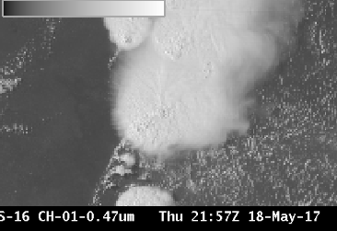

The 0.47 µm, or “Blue” visible band, senses radiation in a part of the electromagnetic spectrum where scattering is important. This channel is therefore useful for monitoring aerosols. The 0.47 µm band will provide nearly continuous daytime observations of dust, haze, smoke and clouds and it is a key component of GOES-R Baseline Aerosol Products and Baseline Snow Products. The Blue band in combination with a “Green” band simulated from the “Vegetation” band (0.86 µm) and the “Red” band (0.64 µm), provides approximate “natural true color” imagery of the Earth.

Users of the ‘Blue Band’ who are interested in detecting aerosols should be mindful that the scattering angle affects dust and smoke signals: smoke and dust are more effective forward scatterers than backward scatterers. Smoke and dust signals are more apparent when the sun is low in the sky vs. high in the sky.

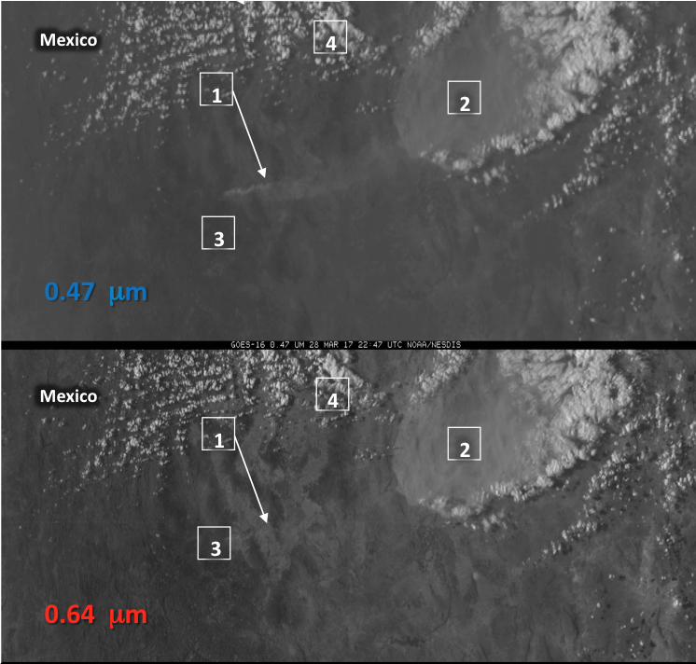
Blue Band (0.47 µm, top) and Red Band (0.64 µm, bottom) at 22:47 UTC on 28 March 2017

Compare the two visible bands in the imagery above.
1: Some Smoke is apparent in the Blue band, but not in the Red.
2: Thick dust is apparent in both bands.
3: Surface features show up more distinctly in the Red band because of better spatial resolution in the Red band and in the Blue band because of enhanced Rayleigh scattering.
4: Clouds look similar in both Blue and Red bands.

Band 02 (0.64um):

The second ABI visible band is the 0.64 μm (or “red” band). It has the finest spatial resolution (0.5 km at the sub-satellite point) of all ABI bands. During the daytime, it helps in the detection of fog, estimation of solar insolation and depiction of diurnal aspects of clouds. The 0.64 μm visible band is also used for daytime snow and ice cover, detection of severe weather, low-level cloud-drift winds, smoke, volcanic ash, hurricane analysis, and winter storm analysis. It is especially useful in mesoscale sectors for rapidly changing phenomena and is the primary band used to identify features in the visible, and is a legacy channel that extends GOES observations at visible wavelengths. The 0.64 μm “Red Band” is also essential for the generation of true color imagery. Because this band has the highest spatial resolution, it comes with very high data volumes. Indeed, this channel consumes for data space than all 10 Infrared Channels on ABI combined!
Both the Blue band and the Red Band (and other near-infrared channels) detect reflectance. Because of internal scattering within clouds, reflectance around local noon can exceed 100%. This is more common with the ‘Red’ Band because of its greater spatial resolution.

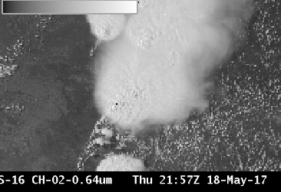

Sample applications for the Red band include: (1) Detecting above anvil plume (2) Pulsing overshooting tops and (3) Low-level Derived Motion Winds

- Parallel inflow feeder, Above anvil plume (add video)
ftp://ftp.ssec.wisc.edu/ABI/kaba/scottl/movies/band02-cirrusplume03.mp4

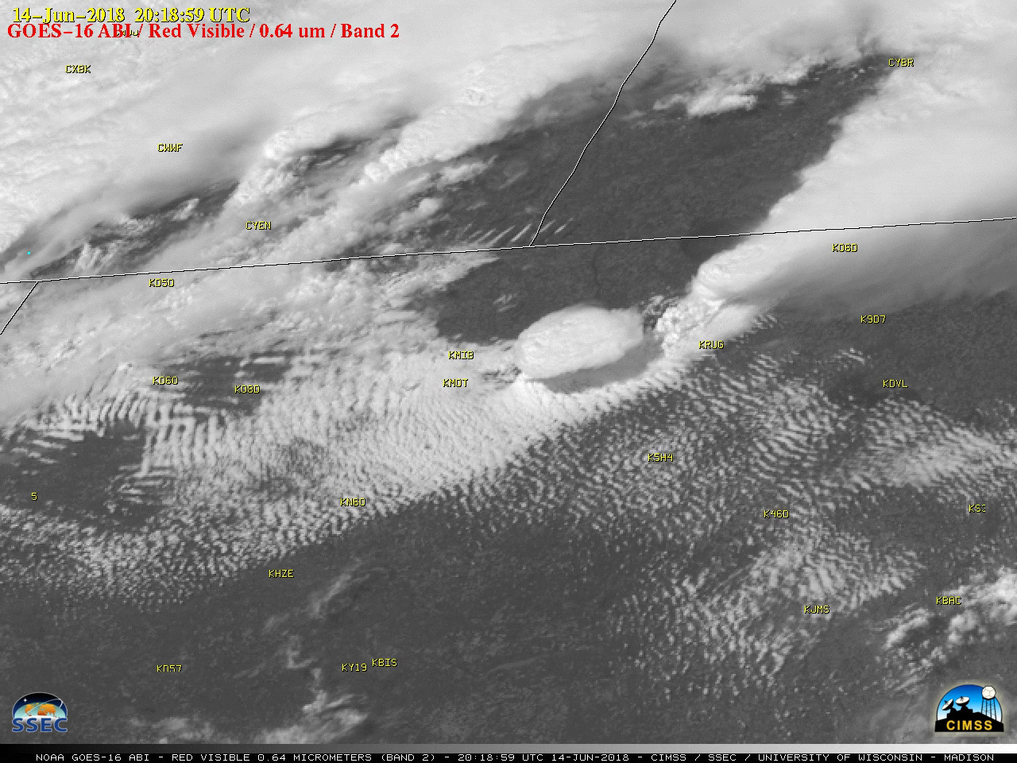
Well-defined parallel inflow feeder bands moving into the southern flank of the storm approaching Minot (KMOT) and Minot Air Force Base (KMIB) during the 1600-1900 UTC time period on June-14-2018. Distinct above-anvil plumes were seen with a number of the stronger storms. This led to the development of severe convection, which produced hail as large as 3.0 inches in diameter and 4 tornadoes (NWS Bismarck | NWS Grand Forks)

(2) Pulsing overshooting tops
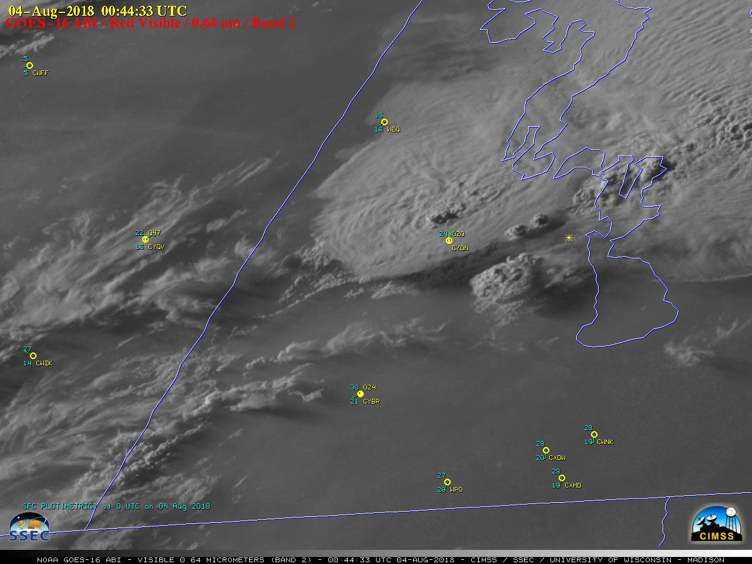
The development of a thunderstorm, which produced an EF-4 tornado near Alonsa, Manitoba during the early evening hours on 03 August 2018. The cell began to develop southwest of Alonsa around 0020 UTC, and as the thunderstorm matured a series of pulsing overshooting tops could be seen. The haziness evident in the Visible imagery was due to smoke from wildfires in the western US and Canada. This tornado resulted into at least one death in Manitoba and is the strongest tornado confirmed so far this year in all of North America.

(3) Low-level Derived Motion Winds
This imagery is the primary source of low-level (surface to 700 hPa) Derived Motion Winds during the daytime hours.

Near IR: (0.86um), (1.37um), (1.61um), (2.24um)
ABI Band | Central Wavelength (µm) | Band Nickname | Type | Pixel Resolution at sub-satellite point
3 | 0.86 | Vegetation/Veggie | Near-Infrared | 1 km
4 | 1.37 | Cirrus | Near-Infrared | 2 km
5 | 1.61 | Snow/Ice | Near-Infrared | 1 km
6 | 2.24 | Cloud Phase | Near-Infrared | 2 km

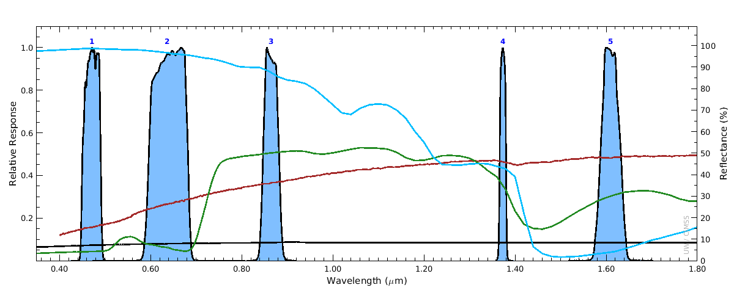
The plot above shows the spectral response functions for Bands 1-5 on ABI. These are the Visible and near-infrared spectral bands. Included in the plot are reflectance spectra for snow (blue), grass (green), soil (red), and asphalt (black). Snow has high reflectance in the visible bands, but low reflectance at 1.6 µm (the ‘Snow/Ice’ Channel). Note also how reflectance over soil and especially grass is low in the visible channels and much greater in the near infrared 0.86 “Veggie” band. Reflectance spectra are from the Advanced Space borne Thermal Emission Reflection Radiometer (ASTER) spectral library.

Band 03 (0.86um) : “Veggie” Band

Why is the “Veggie” band Important?

The 0.86μm band (a near-infrared or “reflective” band), can be used to detect daytime clouds, fog, and aerosols and for calculating a normalized difference vegetation index (NDVI). Because vegetated surfaces are highly reflective at this wavelength, the “Veggie Band” can identify burn scars: reflectance is different between vegetated and non-vegetated (that is, burnt) surfaces. This information is important in assessing the possibility of flash floods and mudslides. This ABI band has potential for detecting forest regrowth patterns. Also, because vegetated land, in general, is more reflective in this band (compared to visible bands), the veggie band is useful for identifying small islands in the ocean because of the good land/sea contrast.

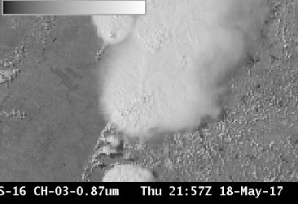

The Vegetation band is used to simulate a “Green” band in the creation of true color imagery. There is far more solar reflectance at 0.86 um than in the green part of the electromagnetic spectrum (around 0.51- 0.55 um), however, so only a small portion of the ‘Veggie’ Band signal is used as a simulated green band in the creation of True Color imagery.

Sample applications for the veggie band includes: (1) Analyzing the areal extent of flooding (2) Detecting wildfire burn scars

(1) Aerial extent of flooding
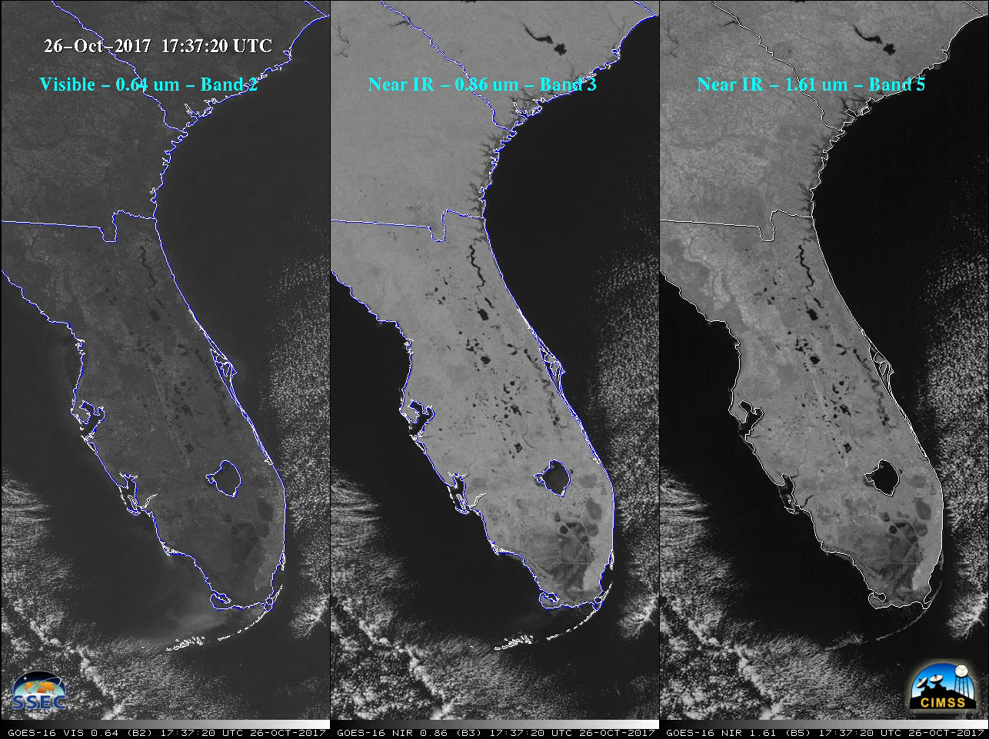
Comparison of GOES-16 “Red” Visible (0.64 µm), Near-Infrared “Vegetation” (0.86 µm) and Near-Infrared “Snow/Ice” (1.61 µm) images, showed that water was a strong absorber of radiation at 0.86 µm and 1.61 µm wavelengths — therefore wet ground, rivers, lakes and the oceans appeared dark in those images. This makes those two GOES-16 ABI spectral bands useful for identifying areas of flooding.

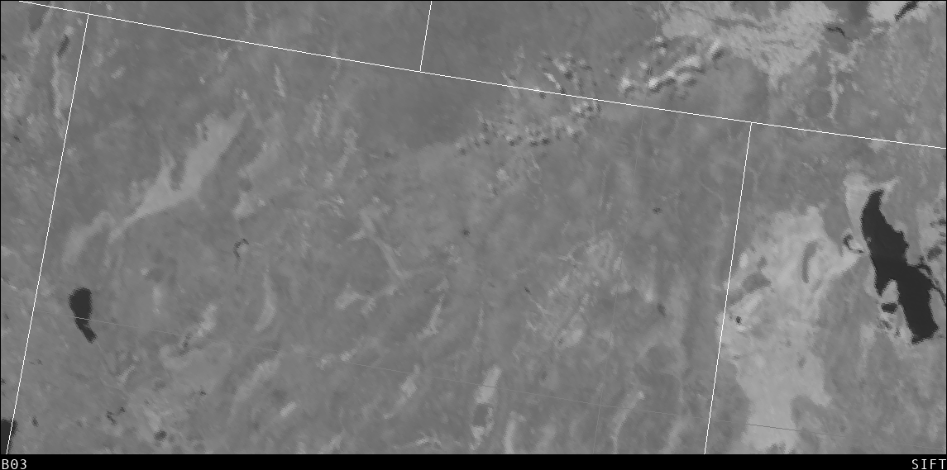
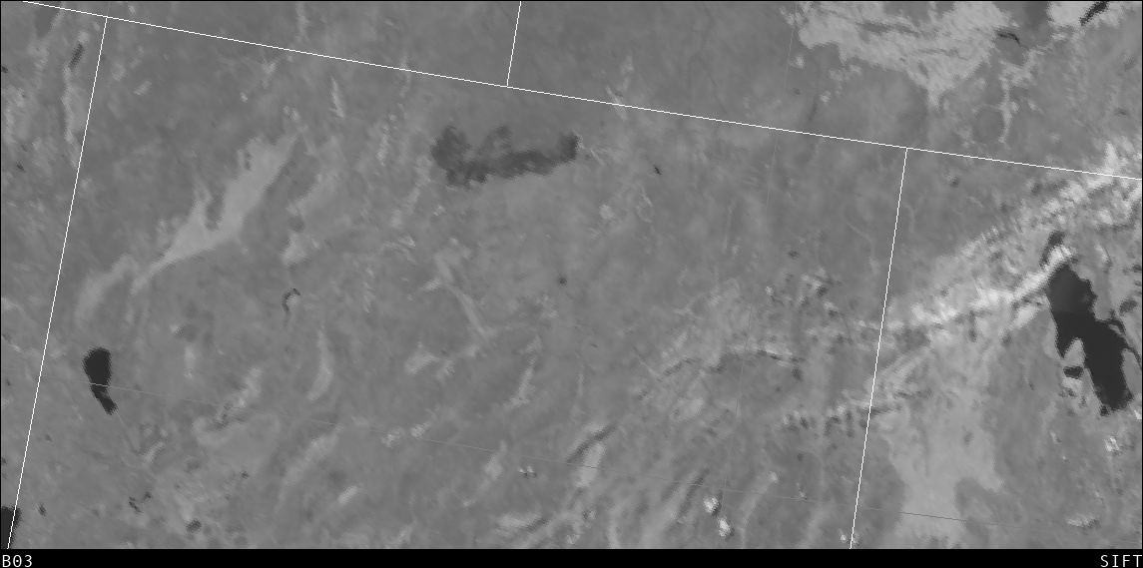
Top: Band 3 (0.86 µm) from 4 July 2018 (1847 UTC); Bottom: Band 3 (0.86 µm) from 11 July 2018 (1847 UTC). Note the development of a pronounced burn scar (circled) across northern Nevada during that 7-day period.

Band 04 (1.37um): “cirrus”

The Cirrus Band (1.37 mm) is unique among the reflective bands on the ABI in that it occupies a region of very strong absorption by water vapor in the electromagnetic spectrum. This channel thus does not routinely sense the lower troposphere, where there is substantial water vapor. It does provide excellent daytime sensitivity to high, very thin cirrus under most circumstances, especially in warm, moist atmospheres. Hence, this band can be used in concert with visible imagery to distinguish between low clouds (or other bright objects) and high clouds. Energy at 1.37 um that is reflected from bright objects will be absorbed by water vapor in the atmosphere. Low-level features (such as clouds, or highly reflective blowing dust) can be viewed in this channel if the atmosphere above the feature is very dry.
**** (Need a good figure to show this – maybe the one that shows moisture moving across OK and restricting the view of surface features as moisture increases?). Scott, I assume you are referring to the new figure added below, correct?

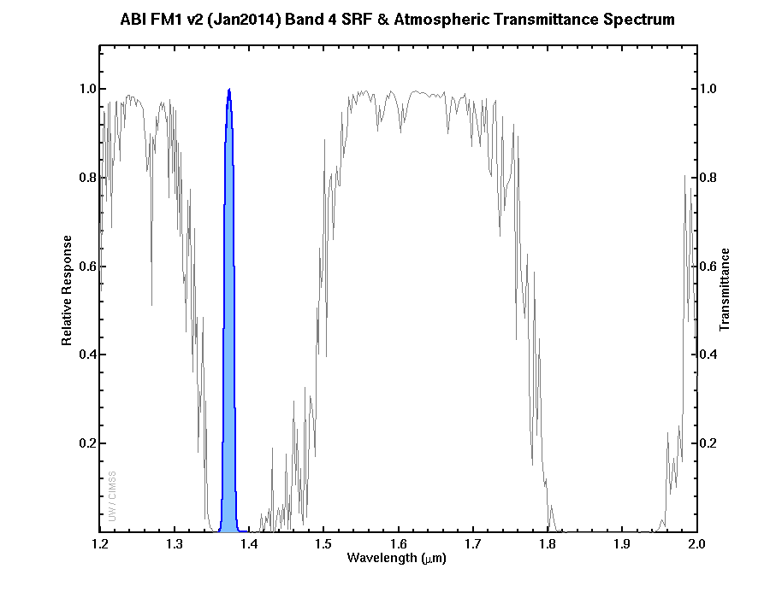
The Spectral Response Function for the Cirrus Channel is shown in blue at left. The grey line shows transmittance through the atmosphere. The Cirrus Channel is in a region where strong absorption (by water vapor) occurs. (Figure courtesy Mat Gunshor, CIMSS)

The Cirrus Channel is one of two near-infrared channels on ABI with 2-km resolution. Theory suggests that about 12 mm of Total Perceptible Water is sufficient to absorb most of the solar radiation at 1.37 µm. Variable amounts of moisture in the atmosphere (and where in the vertical that moisture exists) influence how far down the satellite can see at this wavelength.
Sample applications for the cirrus band includes: (1) Airborne dust in Texas and Oklahoma.

Airborne dust in Texas and Oklahoma
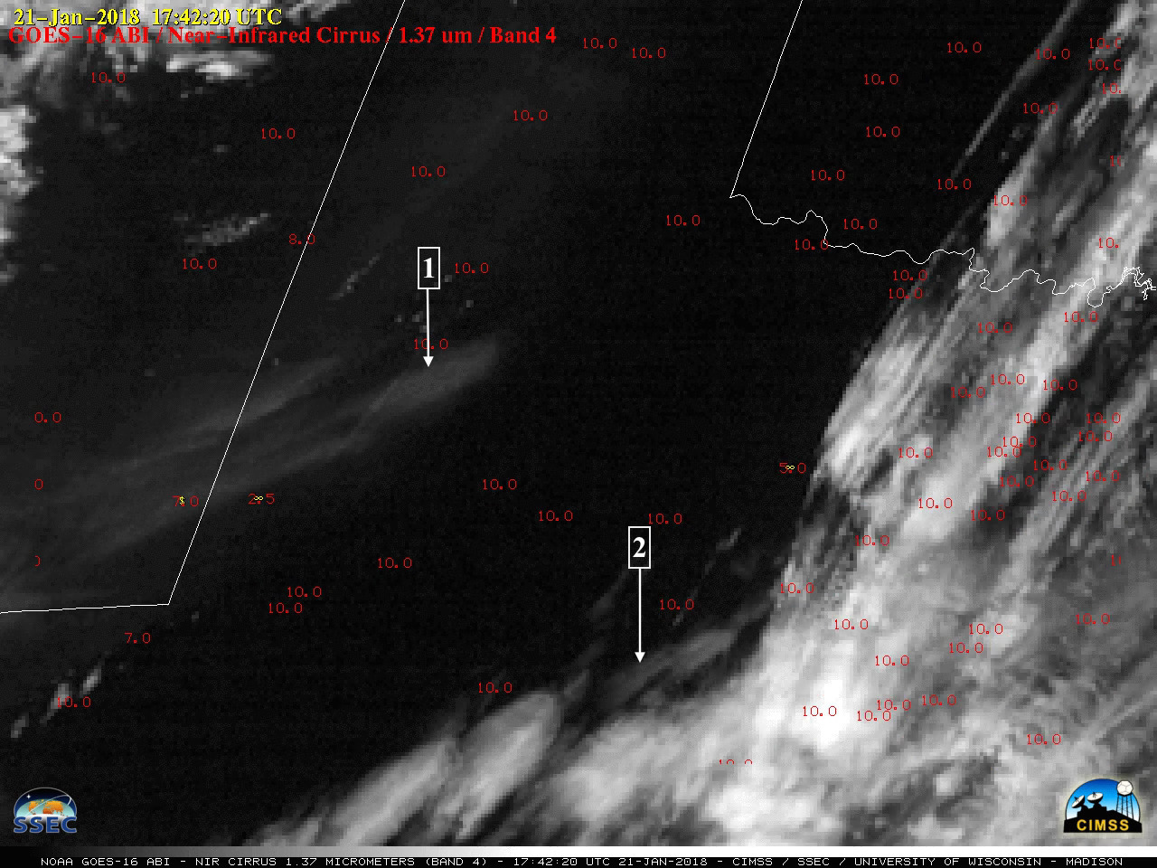
The dust signature was apparent on the Cirrus imagery because this spectral band can be used to detect any airborne particles that are effective scatterers of light (such as cirrus ice crystals, volcanic ash, dust/sand or haze).

1: Effective scattering of light in this channel makes it very easy to identify dust in this image.

2: High absorption of water vapor in the lower troposphere makes it easy to identify high thin cirrus.

Band 05 (1.61um): Snow Ice

Why is the Snow/Ice Band Important?

The 1.61 μm band exploits the relatively large difference between absorption of energy with a wavelength of 1.61 um by water droplets (which reflect such energy) and ice (which absorbs the energy). . Liquid water clouds are bright in this channel; ice clouds are darker because ice absorbs (rather than reflects) radiation at 1.61 mm. Thus you can infer cloud phase: compare in the image the darker region of the cirrus anvil to the more reflective water-based cumulus clouds to the right of the storm. Land/water contrast is great at 1.61 µm (lakes are readily apparent in clear skies) and shadows can be particularly striking. Additionally, a fire signal is present at 1.61 um for very hot fires, especially at night. This band can also highlight areas that have received an accrual of ice from freezing rain or sleet, even when on top of snow cover, and it is particularly useful to identify clouds made up of water droplets that exist over snow cover. In the visible, all such features are bright, but in the Snow/Ice Channel, the snow appears dark.
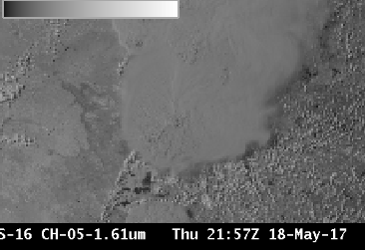

Sample applications for the snow/ice band includes: (1) Identifying above-anvil cirrus plumes (2) Identifying snow/ice on ground (3) Night time fire detection.

(1) Identification of Above-anvil cirrus plumes
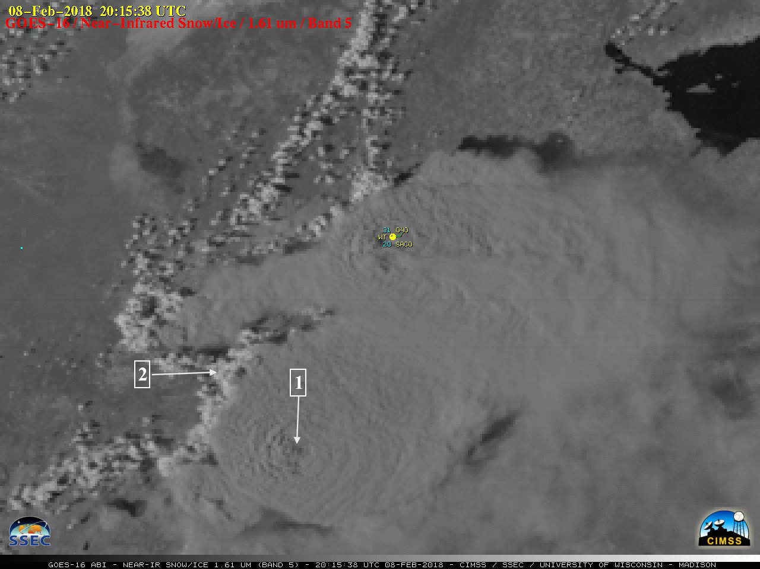
The above-anvil cirrus plumes could also be seen in GOES-16 Near-Infrared “Snow/Ice” (1.61 µm) images

1: Liquid water clouds reflect energy and appear bright at 1.61µm
2: Ice clouds absorb energy and appear darker at 1.61µm

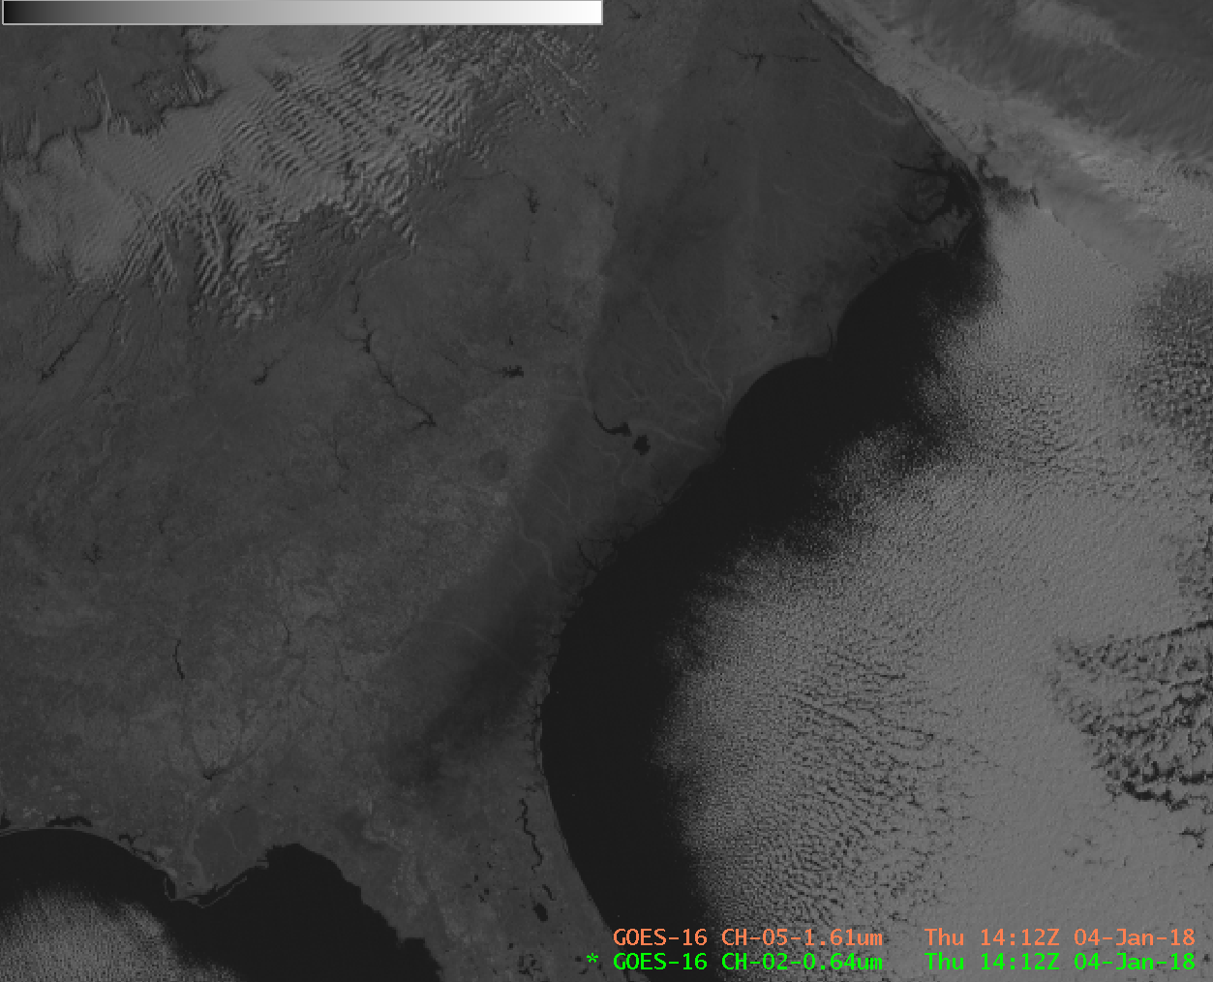
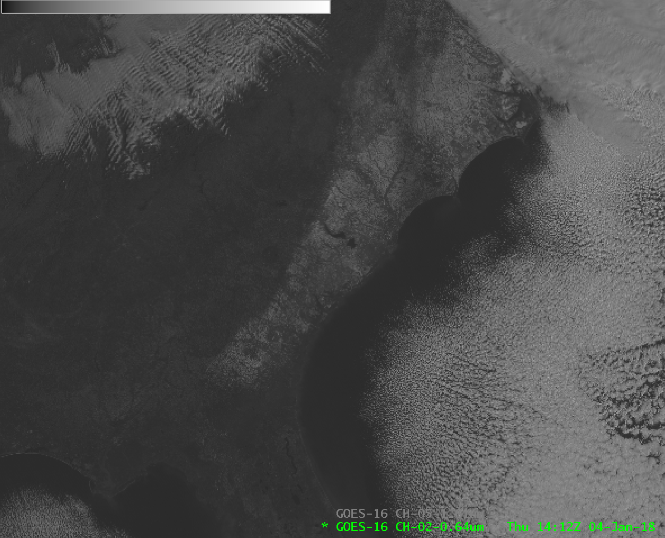

Night time application: Fires can be detected using the 1.61 µm channel at night. This is especially true of very hot fires. Care must be taken however to monitor clouds: cloud motion or development can block the night-time view of the fire.
(3) Night time fire detection
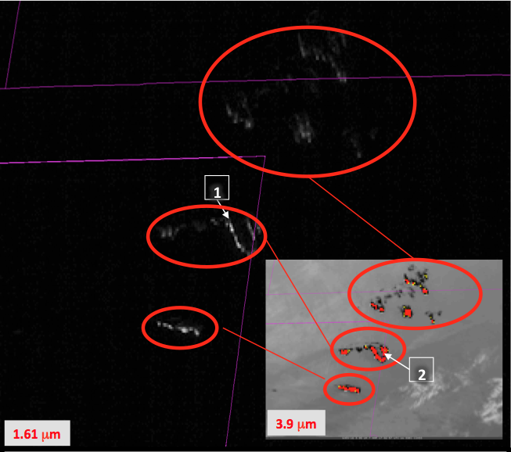GOES-16 ‘Snow/Ice Channel’ (1.61 mm) at 02:57 UTC, 07 March 2017 (Inset: 3.9 mm color-enhanced to show Hot Spots). The default 1.61 mm enhancement usually does not show fires – it must be changed
1: Hot fires emit 1.61µm radiation that shows up well against the black background of night.
2: Inset shows the 3.9µm image for the same time.

Band 06 (2.2μm): Cloud particle size

Why is the Cloud particle size band Important?

The 2.24 μm band, in conjunction with other bands, will enable cloud particle size estimation in GOES-16 Baseline Products. Reflectance in this channel is similar in many ways to reflectance in the Snow/Ice Channel at 1.61 μm, and the 2.24 μm Cloud Particle Size band has inferior resolution, so users of individual bands might prefer the higher resolution of the Snow/Ice Channel.
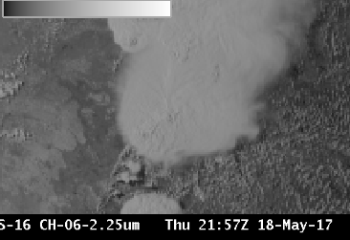

This channel does have a detectable signal for hot fires, and is a component of some fire detection RGBs. The channel can be used at night to detect the hottest fires, but care is required to monitor clouds. Cloud motion or development can block the view of the fire, mimicking a rapid extinguishing that might not have happened.

Sample applications for the Cloud particle size band includes: (1) identifying thermal signatures.

(1) Thermal signatures
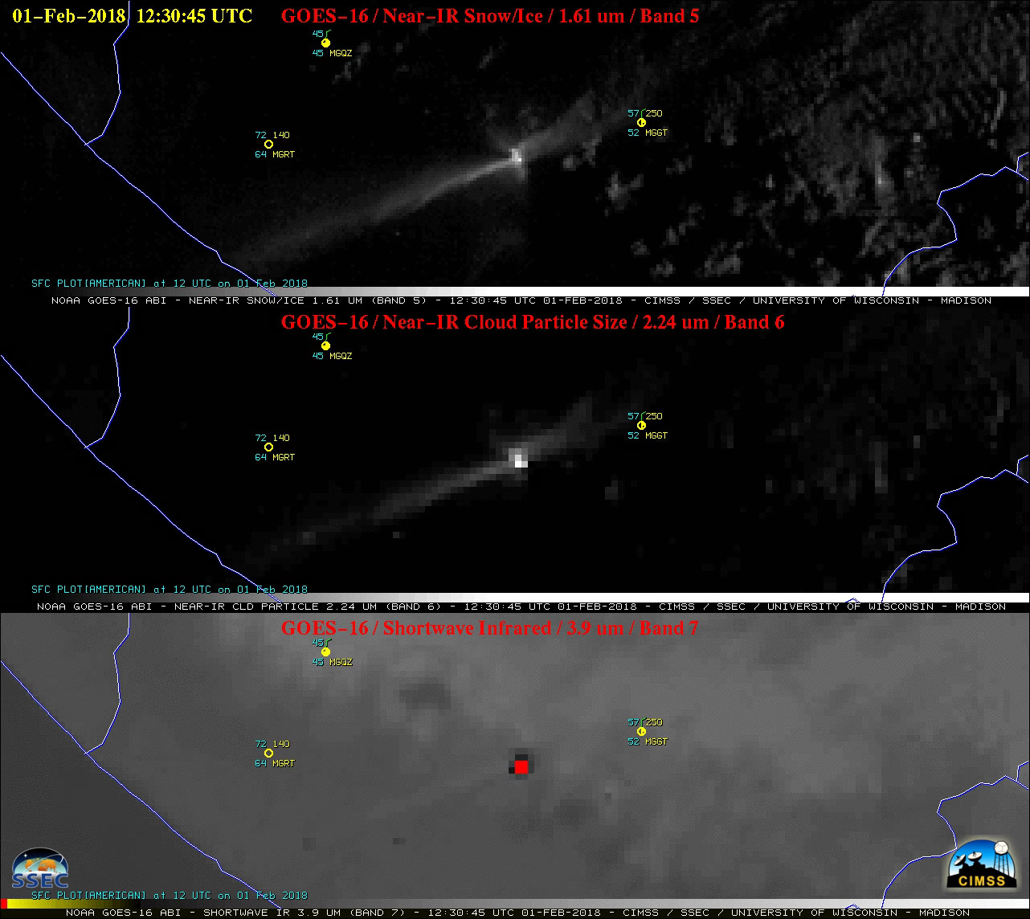

The thermal anomaly or “hot spot” could be seen on GOES-16 (GOES-East) Near-Infrared “Snow/Ice” (1.61 µm), Near-Infrared “Cloud Particle Size” (2.24 µm) and Shortwave Infrared (3.9 µm) images (above). In terms of the two Near-Infrared bands, even though the 1.61 µm band has better spatial resolution (1 km at satellite sub-point), the 2-km resolution 2.24 µm ? band is spectrally located closer to the peak emitted radiance of very hot features such as active volcanoes or large fires. In this case, the hottest 3.9 mm brightness temperature is 393 K (vs a background value around 285-290K); the largest albedo at 2.24 mm is 37% (vs, a background value between 1 and 3, generally; the largest albedo at 1.61 mm is 20 (vs a background value of 2-5%)

******Scott L promised to redo image in mcidas-x, figure out values displayed, and remove labels.
[1] Hot fires emit 2.24 µm radiation that shows up well against the black background of night.
[2] Fire not as distinct at 1.61 µm.
[3] Color-Enhanced 3.9 µm shows pixel temperatures as hot as 370
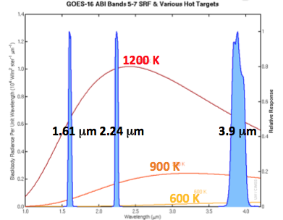
Spectral Response Functions for three GOES-16 channels; Very hot fires emit more energy at shorter wavelengths and the Cloud Particle Size band can detect that energy. Figure from Mat Gunshor, CIMSS.

Band 07 (3.9um): Shortwave Infrared
Why is the Shortwave Infrared Band Important?
The shortwave IR window (3.9 μm) band (which also exists on legacy GOES imagers) has a multitude of demonstrated uses. For example, in conjunction with longer wavelength infrared channels, it can identify regions of fog and low stratus at night and discriminate between ice crystal particle size in the day. It is used for identifying fires and hot spots, volcanic eruptions and ash, and snow and ice (during the day). Low-level derived motion winds can also be estimated using this band. The shortwave IR window is better able to monitor low-level temperatures than longer-wavelength infrared channels and is therefore useful for studying urban heat islands and clouds and for determining sea-surface and land-surface temperatures. The 3.9 μm is unique among ABI bands because it commonly senses both emitted terrestrial radiation as well as significant reflected solar radiation during the day. Reflected solar radiation during the day will significantly increase 3.9 μm brightness temperatures relative to other infrared channels.

This infrared channel is used for fire detection; its short wavelength is more sensitive than longer wavelength infrared channels to the hottest part of the pixel. The ABI was designed so that the dynamic range of Band 7 is largest for all ABI channels; this is because the channel is used to detect fires, and it can detect temperatures up to 417 K. The 2-km resolution means that very small fires can be overlooked, but the channel has demonstrated the ability to identify a single house fire. Additionally, small ice crystals reflect more solar radiation than large crystals during daytime at 3.9 μm.

Sample applications for the Shortwave Infrared band includes: (1) identifying Pyrocumulonimbus (pyroCb) (2) Fire and fog detection.

- Application: PyroCb
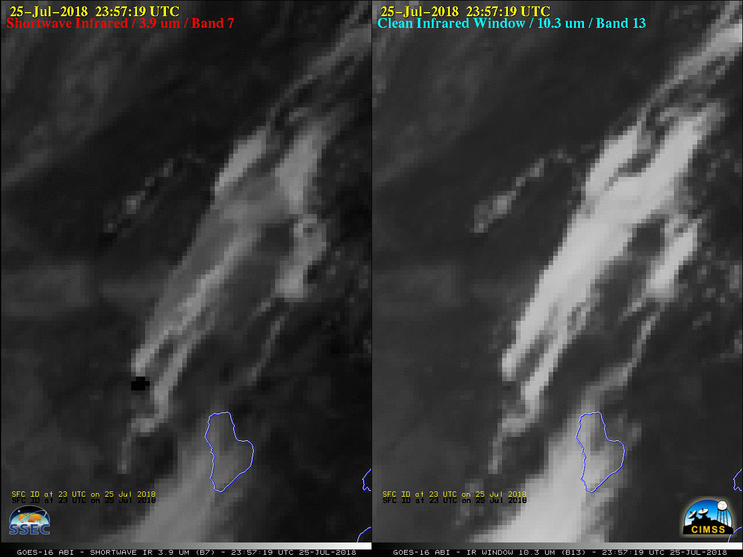
Pyrocumulonimbus (pyroCb) clouds produced by the Cranston Fire in southern California on 25 July 2018. PyroCb tops "seeded" by smoke particles are composed of smaller ice crystals (which reflect more solar radiation and appear warmer / darker shades of gray). Ice Crystal Size at anvil top affects the amount of reflected solar radiation at 3.9 μm and consequently the BT, displayed as a greyscale, with whites cold and blacks hot. 10.7 μm BTs are less affected by Ice Particle Size.

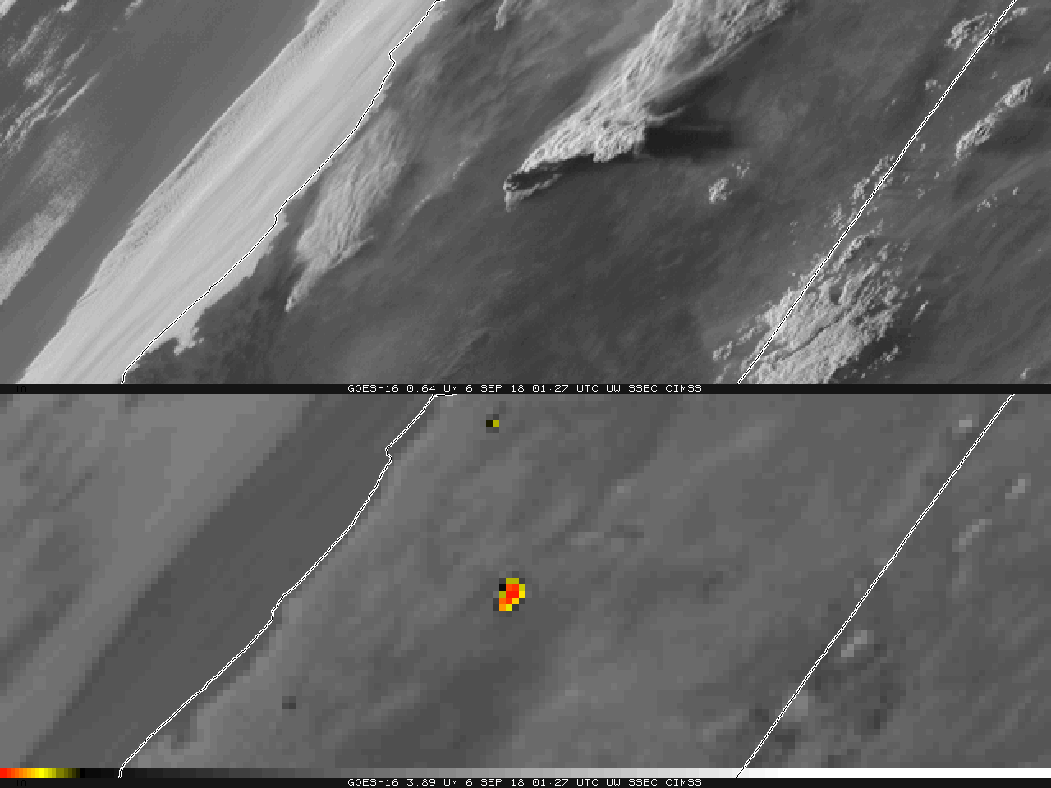
Top: GOES-16 Visible (0.64 μm) imagery of the Delta fire over northern California, 0127 UTC on 6 September 2018; Bottom: GOES-16 Shortwave IR (3.9 μm) imagery at the same time. Yellow and red pixels shows brightness temperatures exceeding 330K, red pixels correspond to brightness temperatures exceeding 400K.
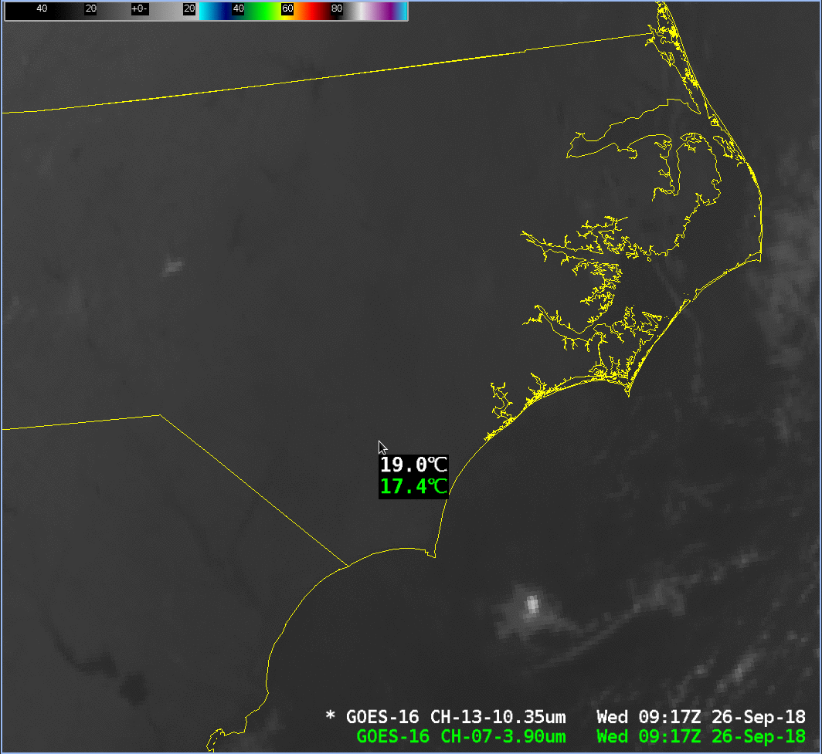
GOES-16 Shortwave Infrared (3.9 µm) and Clean Window (10.3 μm) infrared imagery over coastal North Carolina. The cursor samples both images; note that in this region of low stratus, the 3.9 μm brightness temperature is cooler.

Water vapor bands: 08 (6.19μm), 09(6.95μm) and 10 (7.34μm)
Interpretation of water vapor imagery: The “water vapor” bands – Band 8 (at 6.19 μm), Band 9 (at 6.95 μm) and Band 10 (at 7.34 μm) are infrared bands that sense the mean temperature of a layer of moisture — a layer whose altitude and depth can vary, depending on both the temperature/moisture profile of the atmospheric column and the satellite viewing angle. The spectral response functions for the three bands are shown below in blue (the red line shows the spectral response function for the 6.5 μm Water Vapor channel on GOES-13 through GOES-15). In addition, a black line is plotted; this is the temperature a satellite would sense (in clear skies) above a US Standard Atmosphere at the wavelengths plotted along the x-axis. There is significant cooling present in Bands 8-10. Energy at wavelengths between 6 and 8 micrometers that is emitted from the Earth is absorbed by water vapor in the atmosphere, and then re-emitted from a higher (colder) region of the atmosphere. This absorption and re-emission continues to higher and higher regions of the atmosphere until the upper limit of water vapor is reached, at which point the energy escapes to space. The absorption occurs more readily at 6.19 μm than at 6.95 or 7.34 um so that it is more difficult for energy at the shorter wavelength to escape from space without being absorbed. ?? this needs to be worded more clearly
The level from which energy is detected by the satellite can be computed using Weighting Functions -- this website is available for their display in real time (http://cimss.ssec.wisc.edu/goes/wf). (Include a Weighting Function or two here) The layer from which energy is detected will typically be higher, and the brightness temperatures colder, for air masses having more moisture, but also for regions that are far from the sub-satellite point (because more of the Earth-to-Satellite path length will be through the higher, colder atmosphere). For identical conditions, the brightness temperature might be 8 C cooler at the limb vs. at nadir.

ABI Band | Approximate Central Wavelength (µm) | Band Nickname | Type | Nominal Pixel Resolution at sub-satellite point
8 | 6.2 | Upper-level tropospheric water vapor | Infrared | 2 km
9 | 6.9 | Mid-level tropospheric water vapor | Infrared | 2 km
10 | 7.3 | Lower-level tropospheric water vapor | Infrared | 2 km
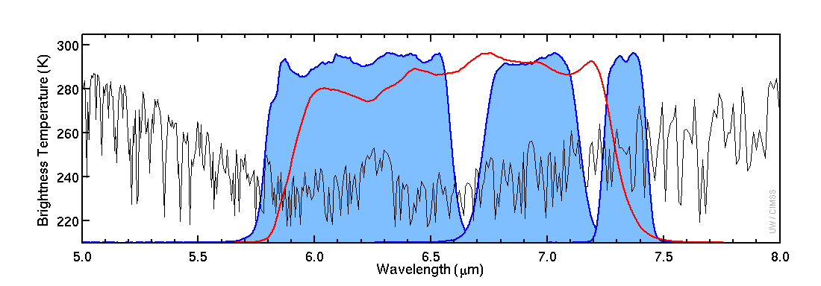
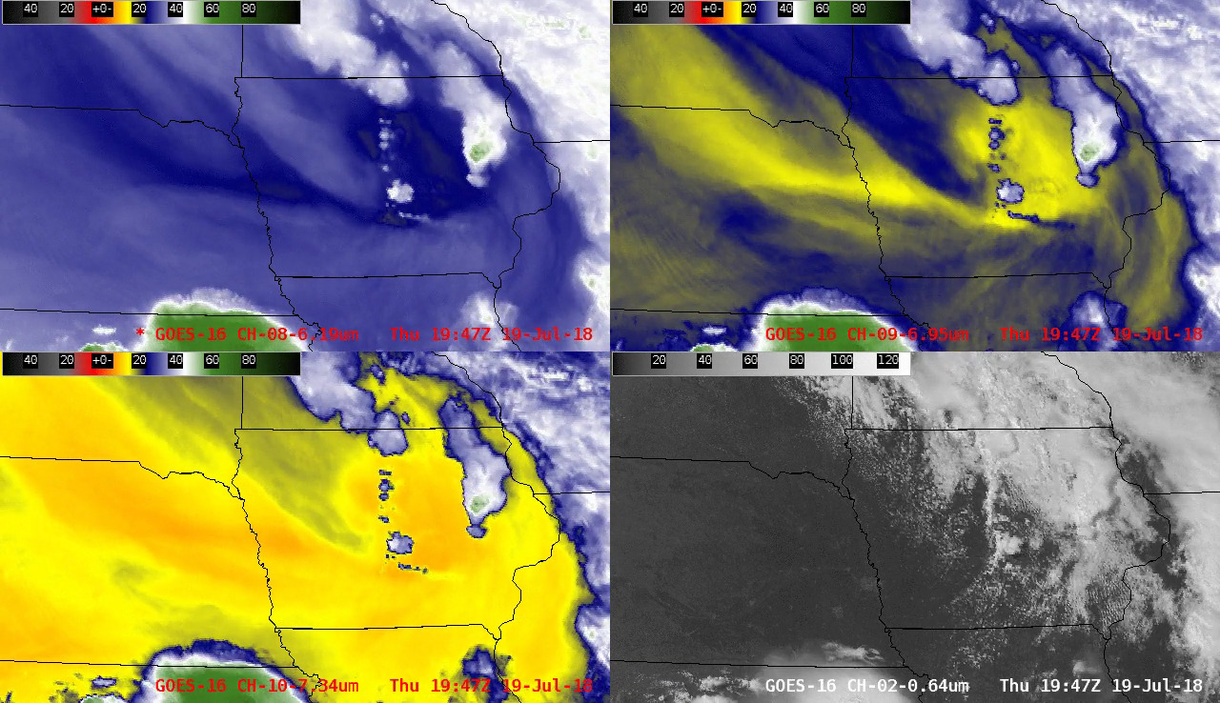
It is often useful to examine imagery from all 3 Water Vapor bands simultaneously (instead of separately) to identify and track important synoptic-scale features -- in this case, the well-defined signature of a mid-tropospheric lobe of vorticity moving from southeastern South Dakota across Iowa on 19 July 2018; this feature provided synoptic-scale forcing for ascent which aided in the development of severe thunderstorms in central and eastern Iowa (which produced two EF-3 tornadoes):

Band 08 (6.2μm): Upper level water vapor
The 6.2μm “Upper-level water vapor” band is used for upper-level tropospheric water vapor tracking, jet stream identification, hurricane track forecasting, mid-latitude storm forecasting, severe weather analysis, upper mid-level moisture estimation (for legacy vertical moisture profiles) and turbulence detection. This band can be used to estimate derived motion winds. In addition, the radiances from this and other bands will be used directly in Numerical Weather Prediction models. Cloud-free features that could eventually produce clouds/precipitation can be identified in 6.2 μm imagery (for example, vorticity maxima). In addition, Upper-level water vapor imagery is a key component of the Airmass RGB product, helping to highlight jet stream axes as well as dry ozone-rich stratospheric air associated with potential vorticity anomalies and tropopause folds. This water vapor band is most similar to those on legacy GOES imagers, although the current GOES water vapor band centered at 6.5 μm falls between ABI bands 6.2 and 7.0 μm. Note that thick clouds – as with any infrared channel – obscure the detection of low-level water vapor gradients.
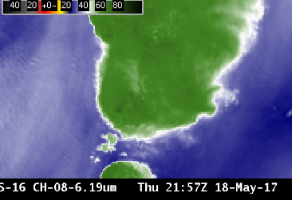
Feature Identification:
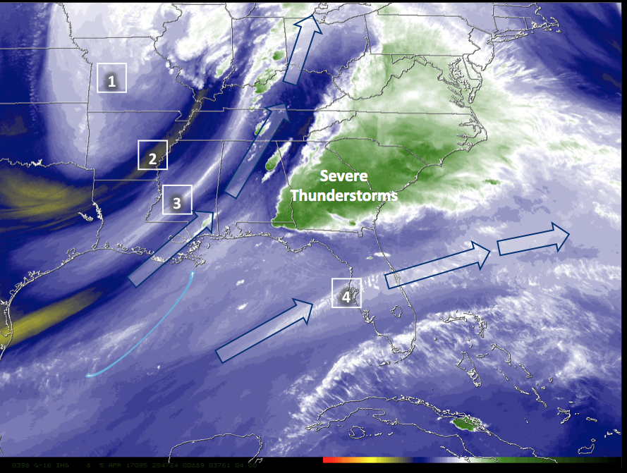Upper-Level Water Vapor Band (6.2 μm) image at 20:47 UTC on 05 April 2017
1: Upper-level trough.
2. Dry slot
3. Polar jet stream axis
4. Subtropical jet steam axis.
In this example, there is diffluent flow aloft (depicted by arrows) between the subtropical and polar jets. High-impact weather is possible where diffluence occurs: in this case, severe Thunderstorms.

Band 09 (6.9μm): Mid level water vapor
The Mid-level water vapor 6.9 μm band is one of three infrared mid-tropospheric water vapor bands on the ABI and in clear skies it senses atmospheric features in between the 6.19 and 7.34 μm water vapor bands. This band can be used for mid and upper-level tropospheric water vapor tracking, jet stream identification, hurricane track forecasting, mid-latitude storm forecasting, severe weather analysis, and mid-level moisture estimation (for legacy vertical moisture profiles). 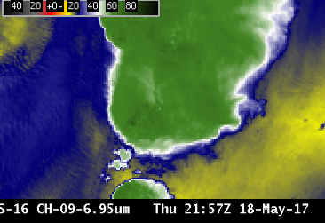The 6.9 μm band can be used to estimate atmospheric motion vectors and to detect turbulence. Surface features are usually not apparent in this band. In addition, the radiance from this, and other bands, will be used directly in Numerical Weather Prediction. This water vapor band is similar to a band on the GOES sounders, although the GOES Sounder band is spectrally more narrow. The heritage GOES imager water vapor band falls “between” this band and the 6.2 μm band.
Information from the 6.9 μm channel is input into many Baseline Products including Derived Motion Winds, Cloud Mask, Stability Indices and Total Precipitable Water products.

Band 10 (7.3um): Lower-level water vapor
The 7.3 μm “Lower-level water vapor” band, is one of three infrared water vapor bands on the ABI. It typically senses farthest down (compared to the other Water Vapor channels) into the mid-troposphere in cloud-free regions, typically to around 500-750 hPa. Thus, surface features are often apparent in this channel, especially over mountainous terrain. Information from this band is used to track lower-tropospheric winds, identify jet streaks, monitor severe weather potential, estimate lower-level moisture (for legacy vertical moisture profiles), identify regions where the potential for turbulence exists, and track Lake-Effect snow bands. Unlike the other two infrared water vapor bands, the 7.3 μm channel also has sensitivity to SO2; that is, energy at 7.34 μm is absorbed by sulfur dioxide that might be emitted by a volcano; this channel can therefore highlight volcanic plumes that are rich in sulphur dioxide (SO₂). Information on the distribution of moisture in the vertical can be gained by comparing this water vapor channel to the other two ABI water vapor channels.. This water vapor band is similar to a band on the legacy GOES sounders, although that bands is spectrally more narrow.

Information from the 7.34 μm channel is used in the creation of many Baseline GOES-R products, including Derived Motion Winds, the Cloud Mask, Stability Indices, Total Perceptible Water, Rain Rate, and Volcanic Ash products. In addition, because the difference between this channel and the 6.19 μm ‘Upper Level Water Vapor’ channel gives information about ths depth of moisture in the clear atmosphere, the difference is incorporated into many RGBs, including the Air Mass RGB.
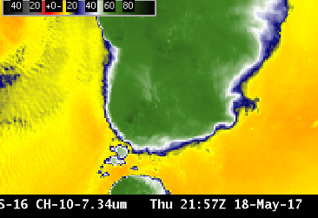

Another SO2-rich volcanic plume
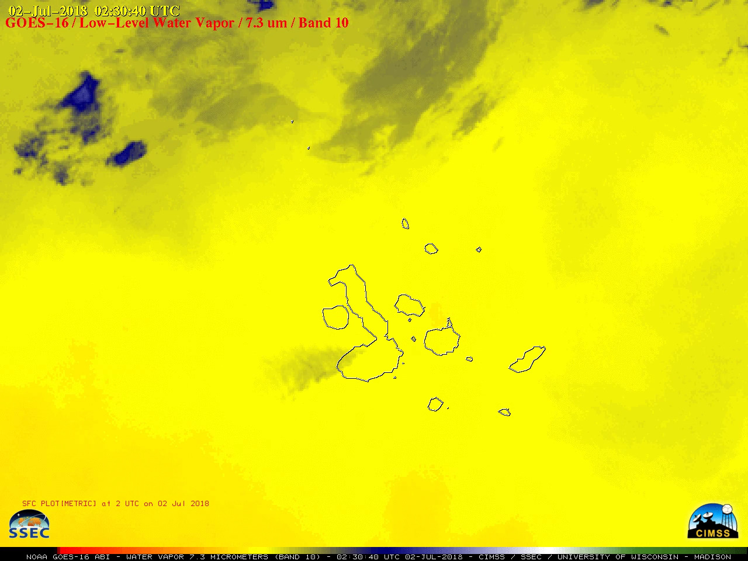

****** Scott promised to add 8.4 vs 11.2 comp.

7.3μm and 6.9μm
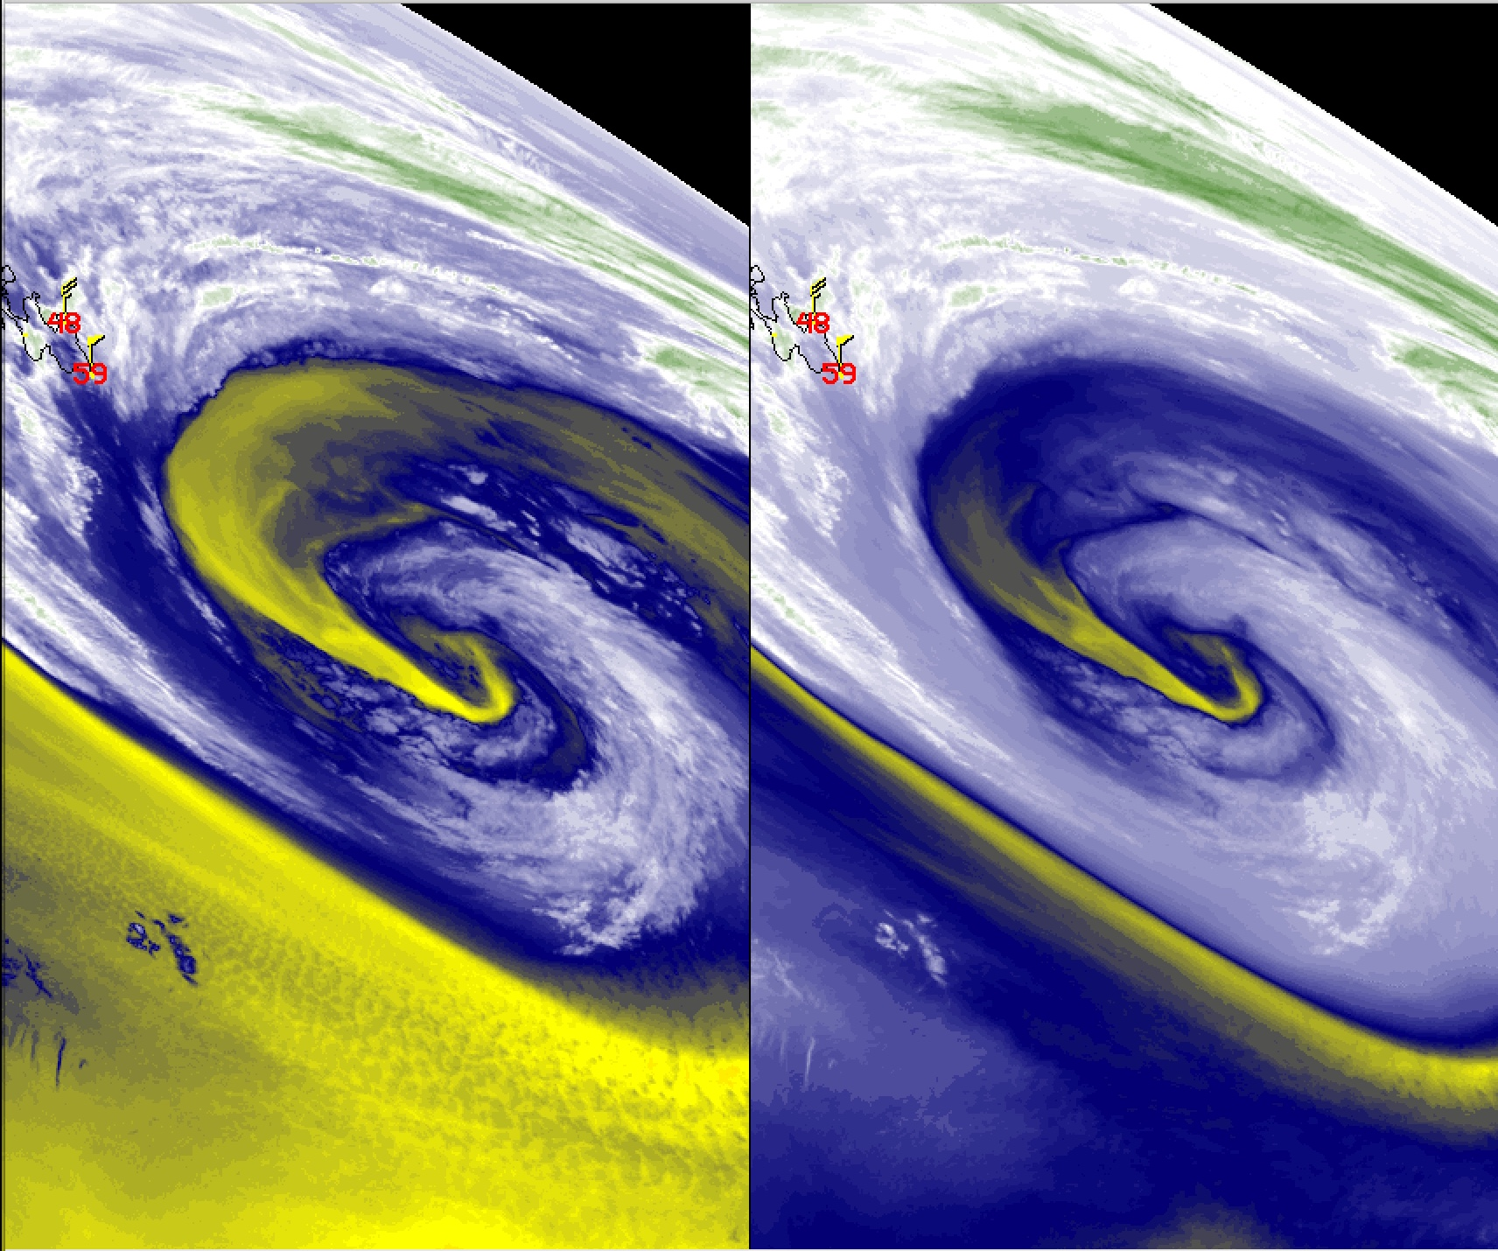
The 7.3 μm band can detect lower-level clouds when the middle/upper atmosphere is relatively dry— this example shows marine boundary layer stratocumulus over the Atlantic Ocean. (Credit: CIMSS)

Band 11 (8.5μm) “cloud Top phase”

Why is “Cloud Top Phase” band imagery important?
The 8.4 μm, or “cloud-top phase” band is a Window Channel; that typically sees the surface of the Earth when skies are clear. There is little atmospheric absorption of energy in clear skies at this wavelength (unless SO₂ from a volcanic eruption is present). Its important uses derive from comparisons to 11.2 and 12.3 μm bands to derive cloud microphysical properties (for example, cloud phase). Using this band in conjuction with 11.2 μm and/or 12.3 μm produces a more accurate and consistent delineation of ice clouds from water clouds during both day and night. The same three spectral bands enable detection of volcanic clouds containing ash aerosols and/or sulfur dioxide. Other uses of the 8.4 μm band include thin cirrus detection in conjunction with the 11.2 μm band, better atmospheric moisture correction in relatively dry atmospheres in conjunction with the 11.2 μm band, and estimation of surface properties in conjunction with the 10.3 μm band. As you might expect given those description, this band is essential in the generation of many Level 2 GOES-R Baseline products.
Knowledge of emissivity is important in the interpretation of this Band: Differences in surface emissivity at 8.5 μm occur over different soil types, affecting the perceived brightness temperature. Water droplets also have different emissivity properties for 8.4 μm radiation compared to other wavelengths. This band is new on NOAA Geostatonary Satellites: it was not available on either the Legacy GOES Imager or on the GOES Sounder.
There is more water vapor absorption in the 8.4 μm channel than in the Clean Window Channel at 10.3 μm. Brightness Temperatures will be modulated by water vapor. For most purposes in tracking meteorological features, it makes more sense to use the cleaner 10.3 μm window channel.

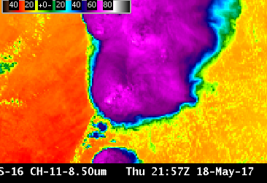
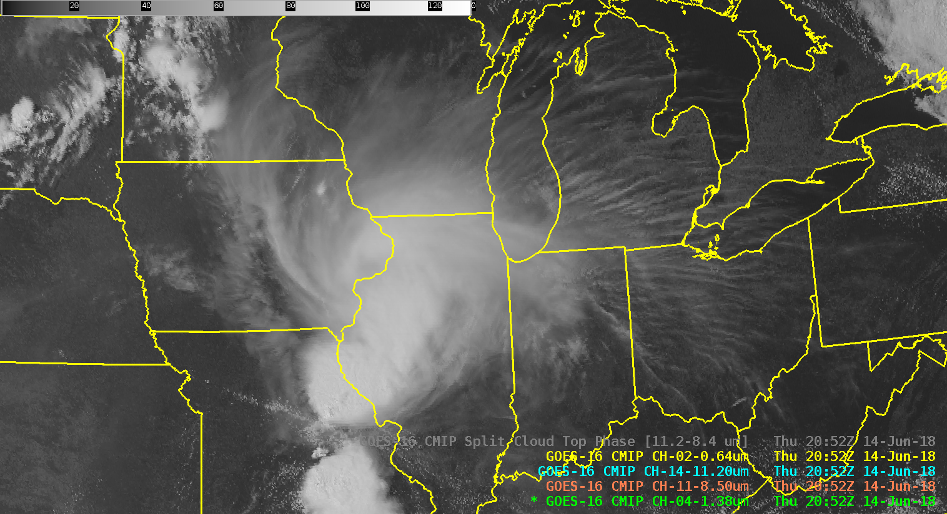

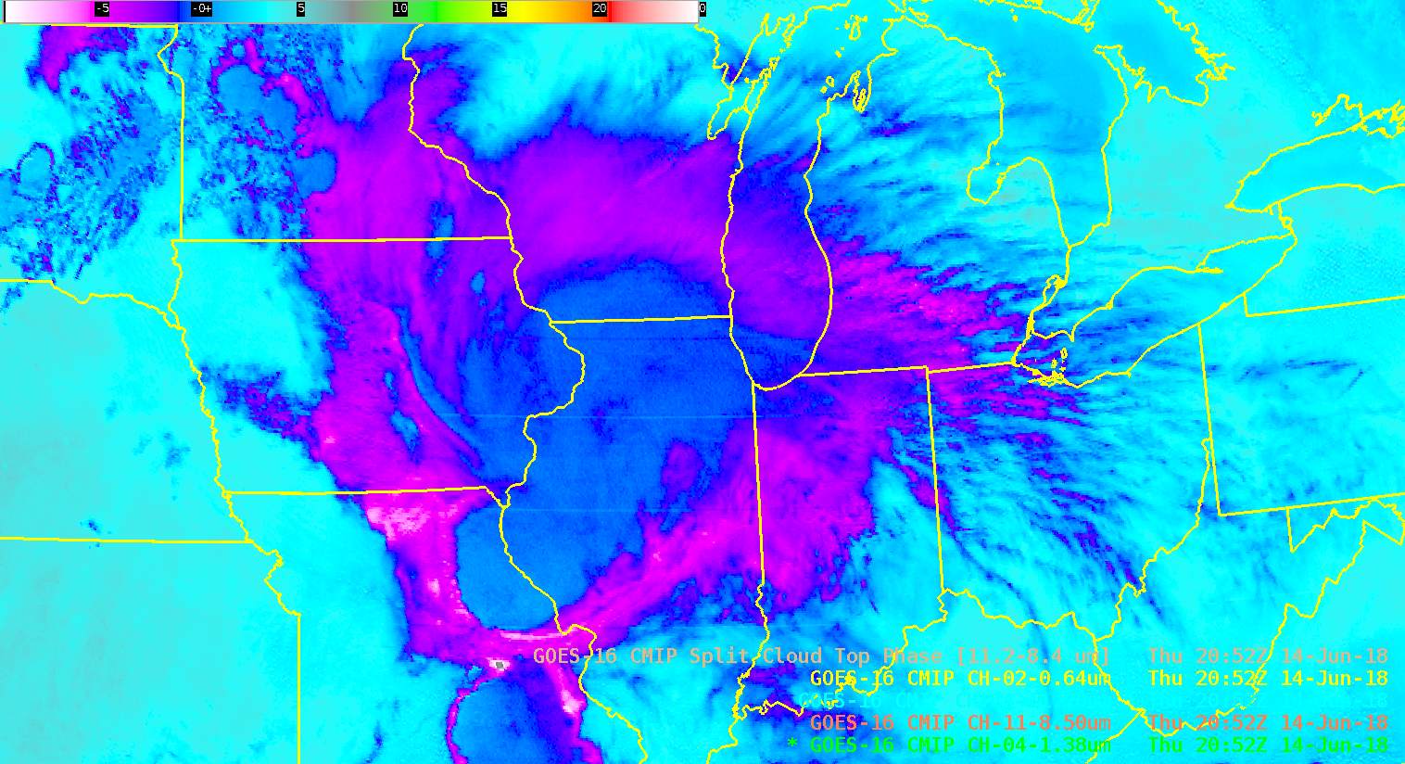
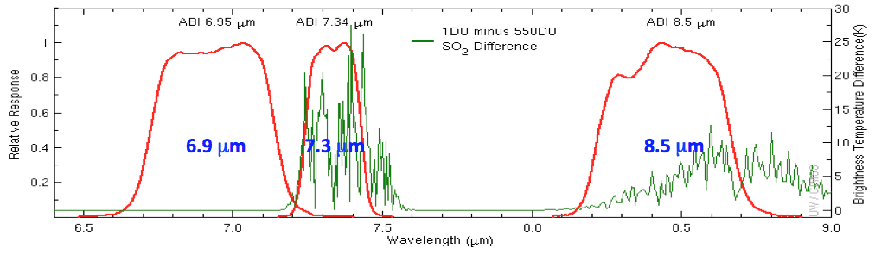
The figure above shows Spectral Response Functions in red for 3 ABI Channels and the large effect of SO₂ on the detected temperature (green line) at 7.3 μm (where there is also water vapor absorption) and at 8.5 μm. Both channels are thus useful for detecting volcanic clouds containing SO2.

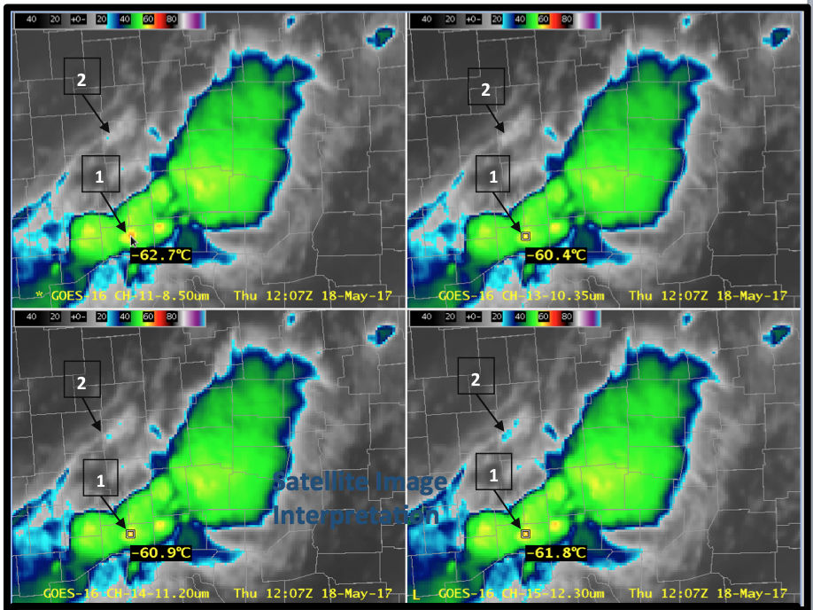GOES-16 Window Channels, 18 May 2017 at 1207 UTC. Upper Left: 8.5 μm ; Upper Right: 10.3 μm ; Lower Left: 11.2 μm ; Lower Right 12.3 μm
Band 12 (9.6μm) “Ozone Infrared ”

Why is “Ozone Infrared ” band imagery important?
The 9.6 μm “ozone” band provides information both day and night about the dynamics of the atmosphere near the tropopause. For (cloud-free) scenes of view, this band is cooler than the IR window bands because of absorption due to ozone. The cooling is especially apparent at large viewing angles (that is, far from the sub-satellite point, along the limb of the image). In general, larger amounts of ozone cause more cooling relative to the nominal surface emission. This band alone does not provide total column ozone; such a product would have to be computed using information from this and other spectral bands.
The Ozone Band is used in RGBs (it is a component of the Airmass RGB Product, for example) and in derived products (such as Legacy Atmospheric Profiles). It has as yet limited use as a stand-alone data source for operational meteorology.

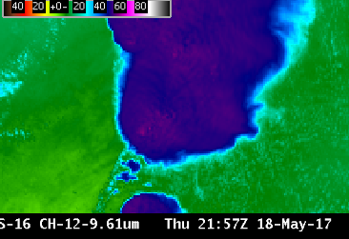

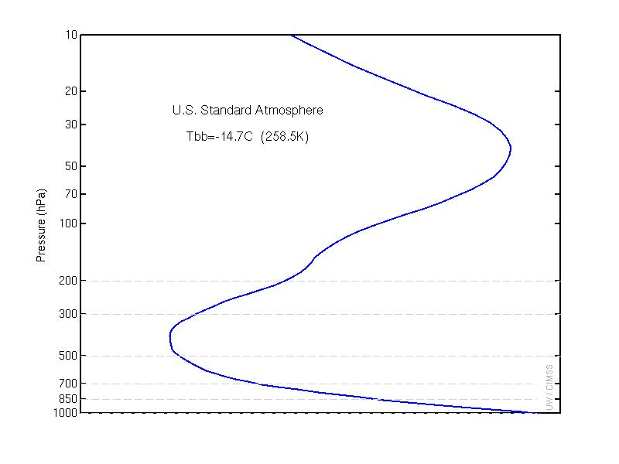
The clear-sky Weighting Function for this band, shown in right as the blue line, has peaks at the surface (a typical characteristic of bands that can view the surface) and in the stratosphere (where ozone is most common). Surface ozone cannot be detected by this channel because water vapor also absorbs atmospheric energy at 9.6 μm.
Primary Application:
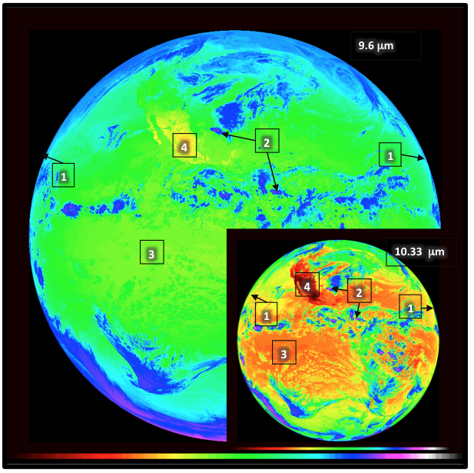
[1] The Full-Disk Ozone shows cooling all around the edges.
[2] Brightness Temperatures over deep convection are warmer (blue enhancement) than in the window channel (purple enhancement) because of absorption by ozone in the warmer stratosphere
[3] Band 12 Brightness Temperatures outside of deep convection are cooler (green enhancement) than in the window channel (yellow/orange enhancement) because of absorption by tropospheric water vapor and by stratospheric ozone
[4] Given a lack of clouds, surface features can be discerned, since the Ozone Channel is a Window Channel
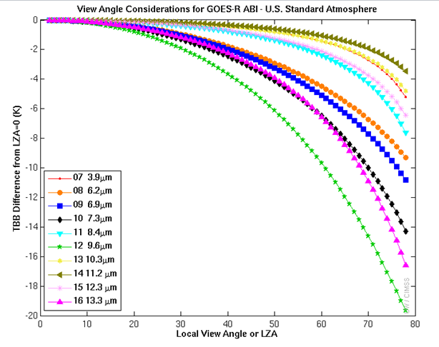
The 9.6 μm Band (the green line at right) shows the most cooling as you move farther from the sub-satellite point (relative to nadir views) for any ABI IR band.

Band 13 (10.3μm) “clean longwave”

Why is “Clean longwave infrared window” band imagery important?
The 10.3 μm atmospheric “clean” infrared window band is an important band more monitoring weather events both day and night. As such, its use should mimic that of the 10.7 μm channel on legacy GOES instruments. It is less sensitive than other infrared window channels to water vapor absorption and is used for atmospheric moisture corrections, cloud particle size estimation, and surface property characterization in derived products. It is used for continuous day/night cloud feature identification and classification, and for monitoring convective severe weather signatures and hurricane intensity. The clean window enables operational meteorologists to diagnose discrete clouds and organized features for general weather analysis, forecasting, and broadcasting applications. The clean window infrared channel is also compared to the 3.9 μm shortwave infrared channel to highlight low clouds at night and to discriminate ice particle size during the day. It is also a component of RGBs, such as the Advanced Nighttime Microphysics RGB and the Daytime Convection RGB.

In addition, 10.3 μm imagery is used in the creation Baseline Products such as legacy vertical temperature/moisture profiles, stability indices, total precipitable water, sea and land surface temperature, Advanced Dvorak Technique (ADT), and snow cover products.

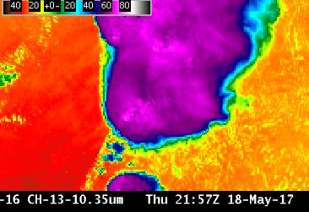
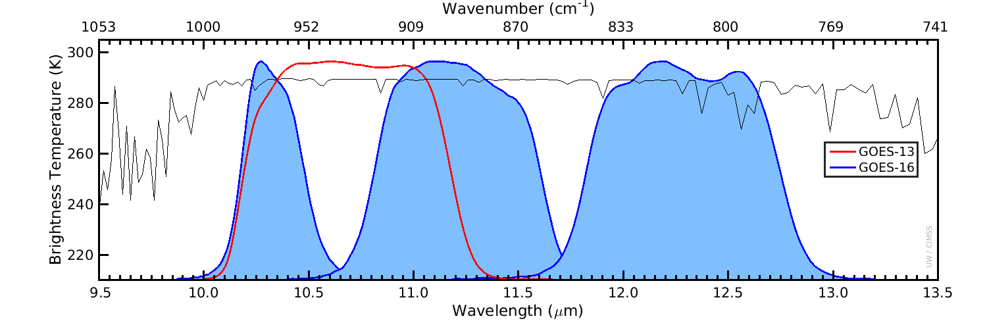

Input into Baseline Products:

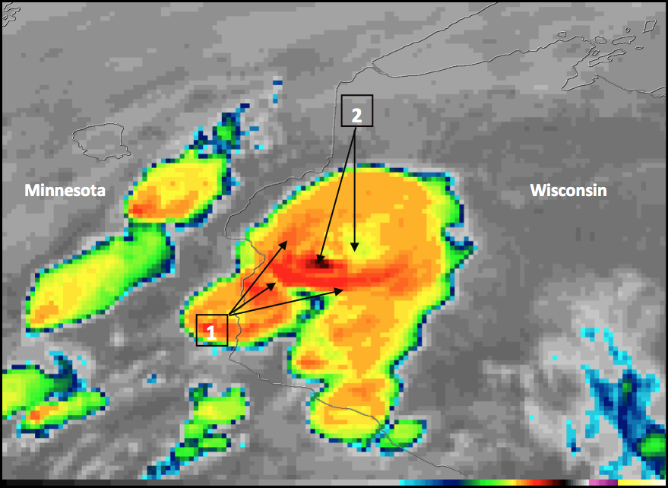
GOES-16 “Clean” Infrared Window (10.3 μm) image, 21:27 UTC on 16 May 2017

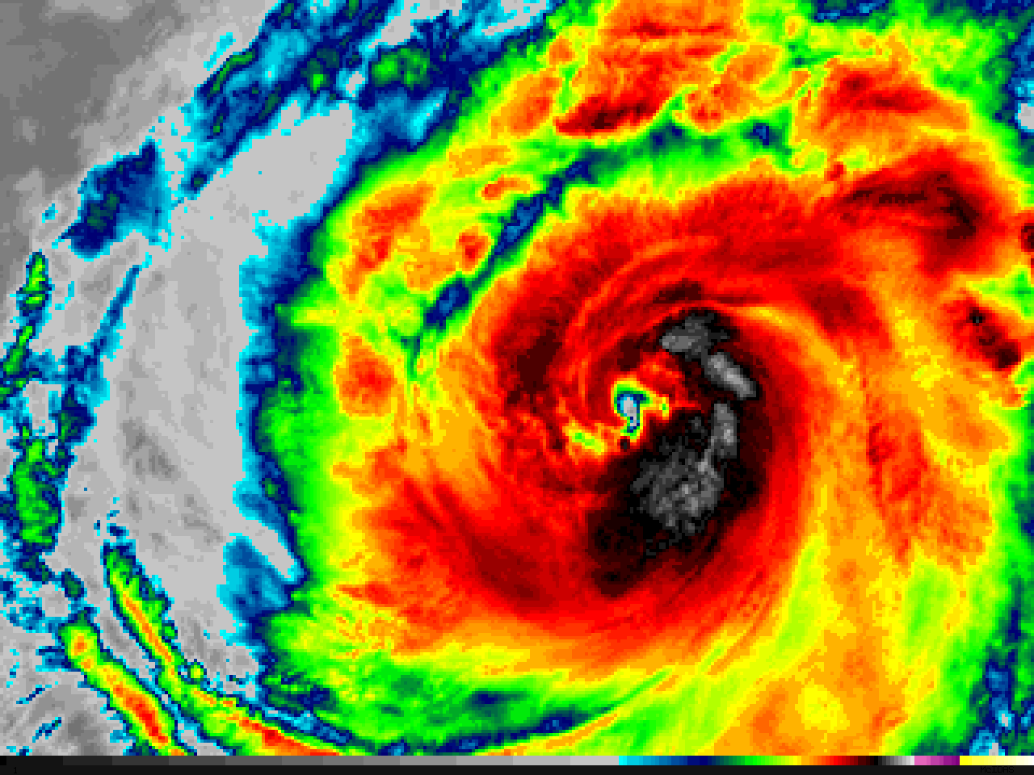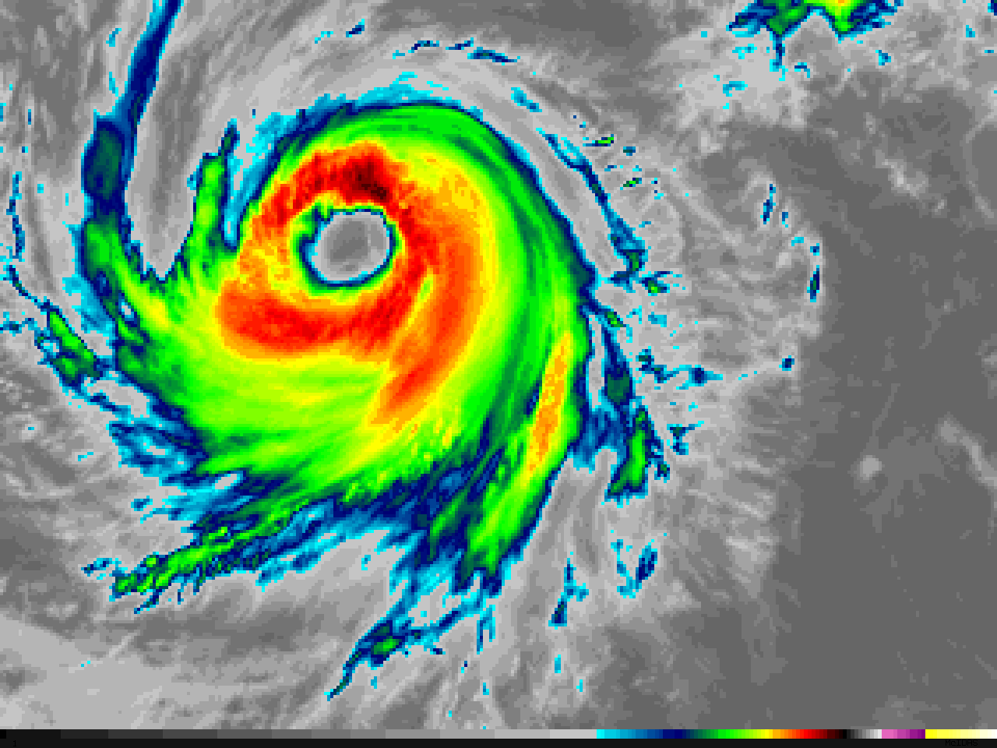
GOES-16 10.3 µm “Clean” Infrared Window images of Hurricane Dora in the East Pacific Ocean, showing the development of a well-defined eye during the 12-hour period between 14 UTC on 26 June (left) and 02 UTC on 27 June 2017 (right). Images are the same scale, showing storm contraction during intensification. (Credit: CIMSS)
Band 14 (11.2 μm) “Infrared Longwave”
Why is the Infrared Longwave Window Band Important?
The “Longwave Infrared” 11.2 μm band is a window channel; however, there is some absorption of energy by water vapor at this wavelength. Brightness Temperatures (BTs) are affected by this absorption: 11.2 μm BTs will be cooler than clean window (10.3 μm) BTs by an amount that is a function of the amount of moisture in the atmosphere. This band has many similarities to the legacy infrared channel at 10.7 μm.
The traditional longwave infrared window (11.2 μm) band enables operational meteorologists to diagnose discrete clouds and organized features for general weather forecasting, analysis, and broadcasting applications. Observations from this infrared window channel can characterize atmospheric processes associated with extratropical cyclones and also in isolated thunderstorms or larger-scale convective complexes. The ‘Clean Window’ (10.3 μm) is a better choice for such uses, however, because of less water vapor absorption at that wavelength.The 11.2 μm window channel does contribute to many satellite derived products, such as precipitation estimates, cloud-drift winds, hurricane intensity and track analyses, cloud-top heights, volcanic ash detection, and cloud phase and cloud particle size estimates (in a multi-spectral approach that also uses the 8.4 μm and 12.2 μm channels).
Perhaps the most vital use of the 11.2 um imagery is in the detection of fires. Fire-detection algorithms compare information at 3.9μm (Shortwave infrared) to information at 11.2 μm (Longwave infrared) to determine whether active fires are occurring within a satellite pixel.
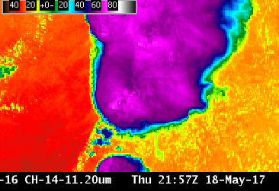

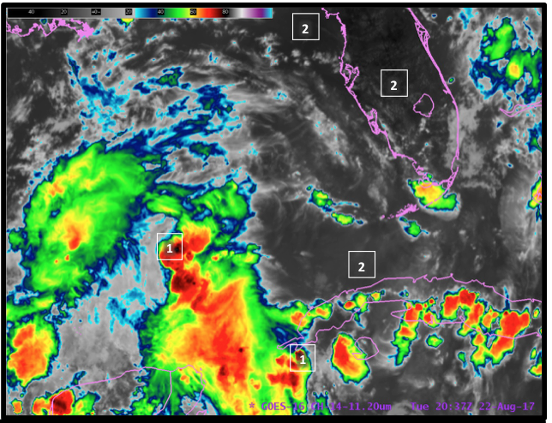
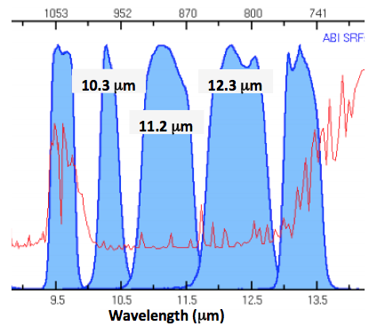
There is more water vapor absorption (designated by the red spikes in the plot at right) in the 12.3 μm band than in the 11.2 μm or 10.3 μm channels. The 10.3 μm channel is the cleanest window – that is, it has the smallest amount of cooling due to water vapor absorption.

Band 15 (12.3um) “Dirty window”
Why is the Dirty Window Band Important?
The “Dirty Window” channel at 12.3 μm, or longwave infrared “dirty” window band offers continuous monitoring for numerous applications often through a split window difference with the “Clean Window” 10.3 μm channel. (For single-banded observations in the infrared, of cloud features, for example, it is better to use the “Clean Window” channel rather than the “Dirty Window” channel) The channel difference between 12.3 and 10.3 can estimate low- level moisture, volcanic ash, airborne dust/sand, and improve estimates of sea surface temperature and cloud particle size.
Radiation at a wavelength of 12.3 μm that is moving up through the atmosphere will be absorbed somewhat by water vapor, and then re-emitted from a higher, colder part of the atmosphere. In contrast, radiation with a wavelength of 10.3 um is less affected by water vapor absorption. Because of this, the 12.3 μm band and the 10.3 μm are used to compute the ‘split window difference’ (SWD) that can be used to identify moisture gradients or changing moisture distributions. Care must be taken however: the SWD is very sensitive to skin temperature. The SWD can also highlight dust or volcanic ash in the atmosphere: radiation at a wavelength of 10.3 μm that is moving upwards through dust is absorbed by silicates and re-emitted from higher, colder temperatures. In contrast, radiation with a wavelength around 12.3 μm is unaffected by dust/ash.
The 12.3 μm channel is part of many Baseline Products, including the Clear Sky Mask, Cloud Top Properties, Legacy Atmospheric Profiles, Volcanic Ash Detection and Fire Hot Spot Characterization. The 12.3 μm channel is important, as part of the Split Window Difference, in detecting Saharan Air Layer dust that moves off of Africa and can suppress tropical cyclone formation or intensification.
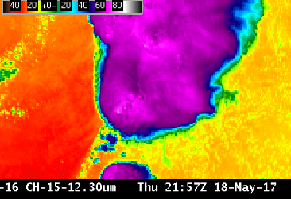

Sample applications for the “Dirty window” include: (1) identifying blowing dust (2) Detection of boundary layer moisture in clear skies.

(1) Blowing dust (Add video)
ftp://ftp.ssec.wisc.edu/ABI/kaba/scottl/movies/band15-blowingdust.gif
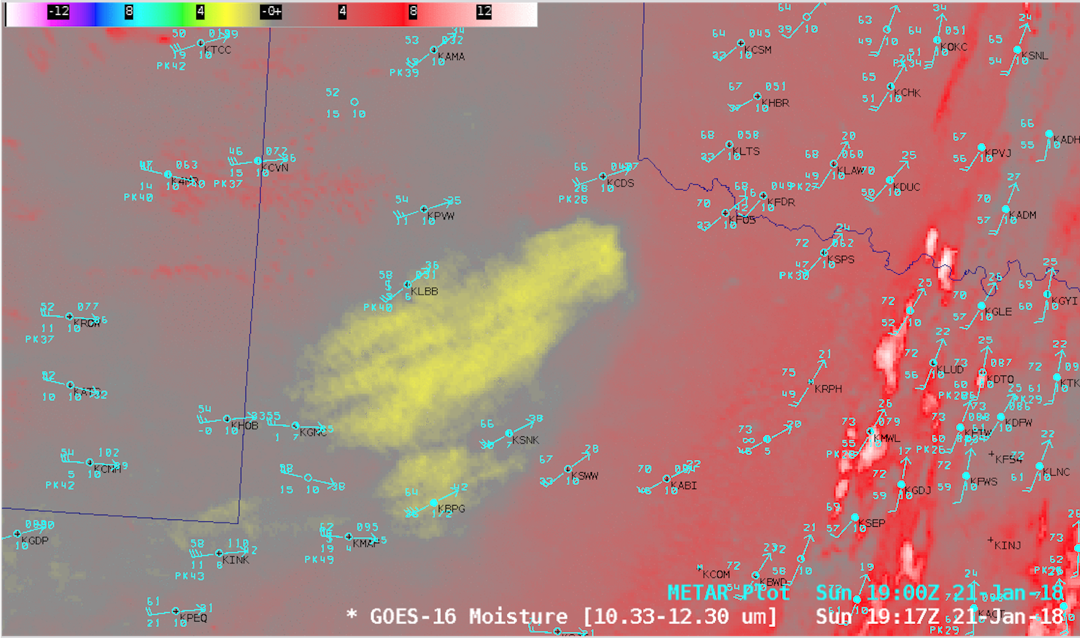
Strong winds in the wake of a cold frontal passage created large areas of blowing dust across the Panhandle Plains of northwestern Texas after 16 UTC on 21 January 2018. GOES-16 “Moisture” or “split-window difference” (10.3 µm – 12.3 µm) images (above) showed that the leading edge of this airborne dust moved over far southwestern Oklahoma after 20 UTC. (Note to AWIPS users: the default enhancement for this GOES-16 “Moisture” Channel Difference product was changed to “Grid/lowrange enhanced” to better highlight the dust with shades of yellow)

(2) ******** Scott L, promised to add moisture in clear skies

There is more water vapor absorption in the 12.3 μm band than in the 11.2 μm or 10.3 μm channels. In the plot at right, absorption by gases as a function of wavelength is shown by the spiky red line representing the perceived temperature based on Earth-emitted radiance (cooler values at towards the top). The 10.3 μm channel is the cleanest longwave window: it has the smallest amount of cooling due to water vapor absorption.

Band 16 (13.3 μm)

Why is the CO₂ Band Important?
The 13.3 μm “CO₂ Band” band is typically not used for routine monitoring/visual interpretation of weather phenomenon; the Clean Window is better suited for that purpose. However, data from this band can be used for mean tropospheric air temperature estimation, tropopause delineation, and as part of quantitative cloud products for cloud opacity estimation, cloud-top height assignments of cloud-drift motion vectors. The CO2 Band was also part of the legacy GOES Imager (from GOES-12 onward), and part of the GOES-Sounder. The 13.3 μm band on the ABI is used in many GOES-16 Baseline Products, including cloud mask, cloud-top height, pressure, and temperature. This band is an input to the legacy moisture and temperature profiles, and hence is used for the products derived from the profiles, such as total precipitable water and stability indices. This band is also used in the quantitative volcanic ash detection and height algorithm. Because the CO₂ band has a muted view of surface features, it can be used to create RGBs that highlight features at upper levels
This is a “dirty” window. Cooling in this band is associated with the ubiquitous nature of carbon dioxide (CO₂) in the atmosphere. That cooling is especially noticeable near the limb, more so than almost any other ABI channel (see below). Earth’s surface is apparent in clear skies, but strong cooling from CO₂ means 13.3 μm brightness temperatures are much cooler than in other window channels,.

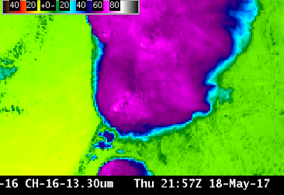
Limitations:
The figure above shows cooling as a function of zenith angle for clear skies. Cooling effects are strongest for the Ozone Band (9.6 μm, green stars), just a bit stronger than those for the CO₂ band (13.3 μm, magenta triangles)

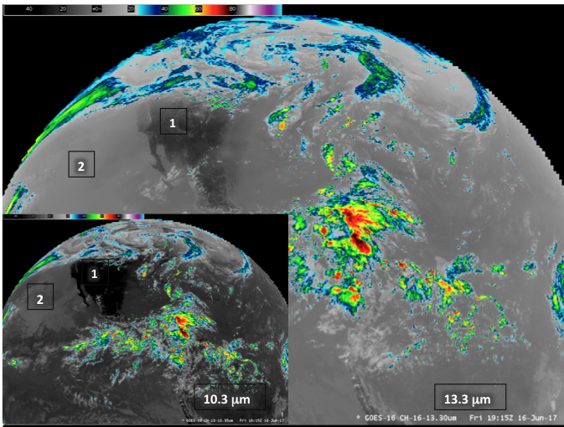

[1] The CO₂ channel is a window channel, meaning surface features can be apparent in clear air.

[2] Features over the ocean can also be apparent. However, Brightness Temperatures in clear air from the CO₂ channel are uniformly cooler than temperatures in the window channel (10.3 μm) because of cooling due to absorption (and re-emission) of atmospheric energy with a wavelength of 13.3 μm by CO₂ molecules.

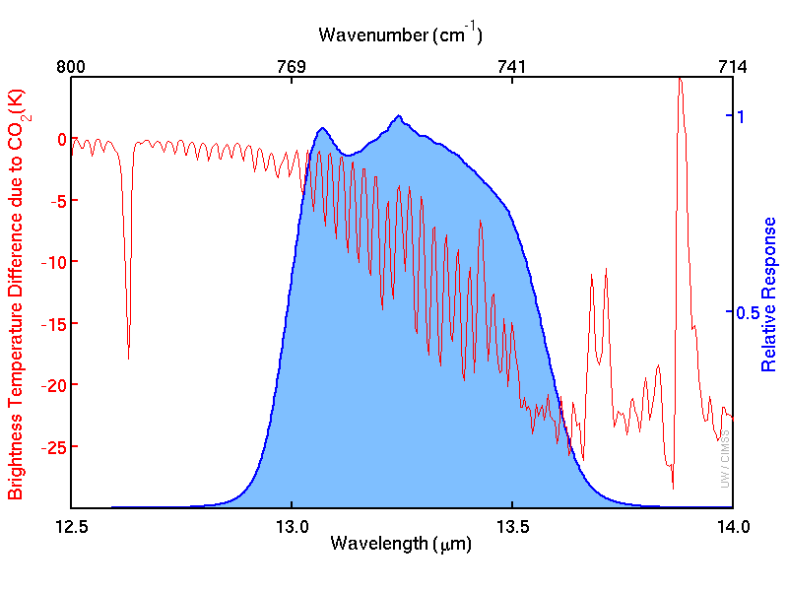

The spectral response function above for the 13.3 μm CO₂ channel, in blue at right, occupies the “shoulder” of a CO₂ absorption band between 13 μm and 14 μm. The cooling effect of CO₂ absorption is shown with the red line.

