Reviewer #1 (Comments to Author):
Using a linear combination of blue, red and NIR to construct the missing green band makes a lot of senses, the 0.86um could substitute the vegetation feature while blue and red to represent the bare surface, from the typical soil spectral, this equation might overestimate soil reflectance at the green band, and the true color image looks greener at bare area, does this issue matters?

It is correct that some soil features might be under or over estimated based on the percent of 0.86um incorporated into computing the missing green band. Different soil features will respond differently as shown in fig 01. Taking asphalt for example, the biased effect will be very minimal but soil features closer to green will be the most sensitive.
In our case we are taking only 10% of the 0.86um to add to 45% of the 0.47um and 45% of the 0.64um for a first estimate of the missing band before attempting any adjustments. We came to this conclusion as a first order green approximation by first developing a sweeping algorithm that gradually increments a single band by 1% at a time while holding the other two constant and comparing those results with the Japanese version of the ABI which has a green band as well as EPIC true color images for different seasons and different times.

****You list three construction methods and four enhancement approaches, actually, one of them are used and the other ones are not even used as reference. So I suggest the author to reorganize this part, remove the unused one or add some comparison.

Changed as suggested by reviewer.
We modified section 2 and section 4 to incorporate reviewer’s suggestions. Section 4.2, Fig 5A and 5C ABI RGB images were made using the fractional combination method. Section 4.3, Fig. 6 was made using the weighted nudging approach.
For enhancements, Fig. 5A utilizes the square root enhancement, Fig. 5B utilizes the Equalized Histogram and Fig. 6 utilizes the Inverse hyperbolic sine function.
Note each ABI RGB image shown in this paper utilizes one of the three methods and one of the four enhancements.

It is better to clarify which value is used in the processing, the reflectance or the digital number.

Changed as suggested by reviewer. We added details with reason for using ABI L1b radiance files as input instead of the L2 reflectance.

**********In the evaluation part, a quantity way would be more convincing to emphasize the agreement between ABI and EPIC.

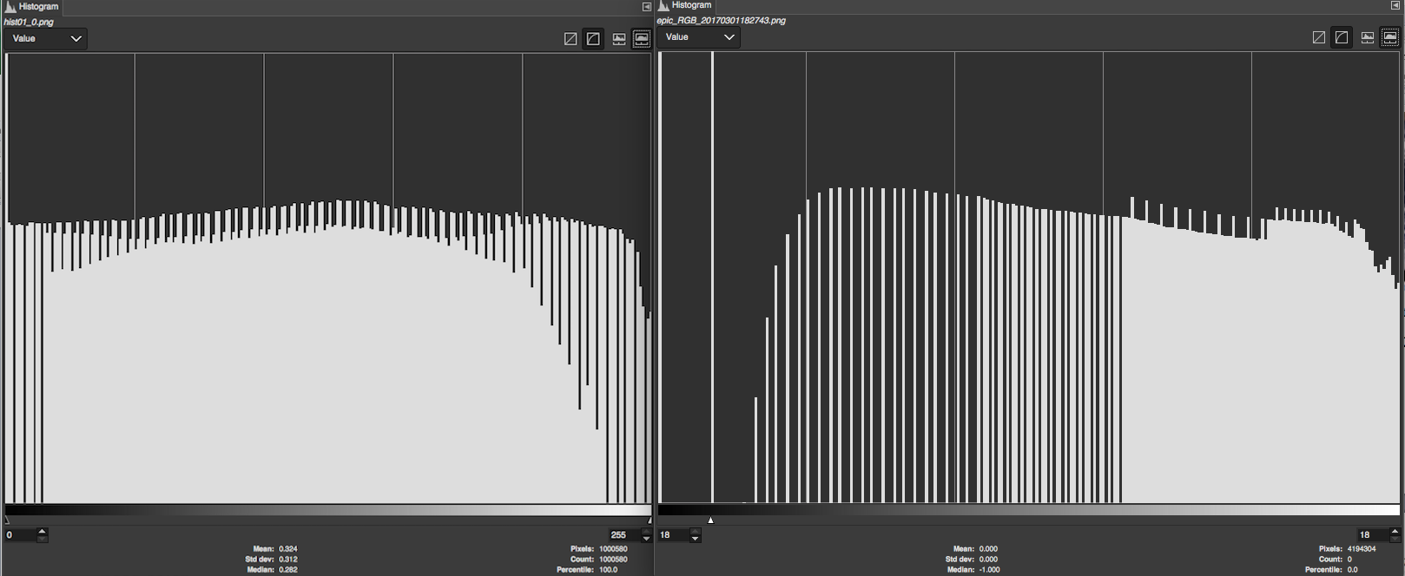
Fig. 1 shows the histogram functions of the ABI RGB component vs the EPIC RGB histogram. The x-axis shows the pixel value ranging from 0 to 255 and the Y-axis shows the counts.

We have investigated the issue suggested above by reviewer. We found that with RGB images, quantitative comparisons between multiple instruments such as ABI and EPIC did not provide us with much added information, since neither one of these may be deemed the true image. The differences between the instrument designs in spectral, spatial and temporal resolution in addition to the different orbits geostationary (at 22,000 miles) vs Lagrangian Point 1 (L1) (at about 1,000,000 miles) away, in addition to differences in scan times and completely different algorithms makes the quantitative comparisons unreliable for deducing valuable correlations. However if done right, the similarities are visually unmistakable. The main goal was to make a visually attractive image, not to accurately replicate the spectral radiometric information from a green band, though in order to get the image, one must attempt to replicate the green so we understand why the reviewer is interested.

Reviewer #2 (Comments to Author):
Review for: Earth & Space Science (AGU, publisher)
Paper #: 2018EA000379-T
Title:
Generate GOES-16 True Color Imagery without a Green Band
Authors:
Momodou Bah, Schmit Timothy, and Mat Gunshor
General Assessment:
The authors demonstrate how convincing "true" and "enhanced" RGB imagery can be produced when only B, G, and a NIR channel are available for GOES-16. This paper reads very much like an ATBD for these new representations of the GOES-16 L1B radiances. I can see why such "L2" products fill an acute need in the environment monitoring community, the members of which are key stakeholders for NOAA. We are talking here about the near-real time availability of imagery the is easy to interpret by an untrained image analyst looking for transient or evolving phenomena of particular interest. Section 4.4 provides a few examples.
After surveying several methods from the Earth imaging literature, the adopted method is described algorithmically, and examples are compared with similar products from EPIC/DSCOVR.
At the end, we are left wondering, however, if NOAA will make this product available systematically. If so, where? When? What file format? Etc. If not, will the relatively simple code needed to produce true and enhanced RGB images be available to users for download. If so, where? When? What languages?

Changed as suggested by reviewer:
At the time of this writing, there is no requirement from the NWS for true color imagery.
If someone we are working with requests code, supplying experimental code on a case-by-case basis will be considered. There are several places to find true color images on the web that are not directly from NOAA and NOAA NWS forecasters can make a version of our true color images in their operational system (AWIPS) and we mention this now in the conclusions.
I think the work fits into the broad goals of AGU's E&S Sci, but its equally broad readership would benefit from a significant revision, mostly in the figures and addressing the above questions. See following list.
Sequential comments/questions:
* l. 1: Title sounds strange. Generate --> Generating? or Generation of?
Changed as suggested by reviewer
* Fig. 1: bigger numbers
Changed as suggested by reviewer
* l. 166: missing "R"?
Changed as suggested by reviewer
* l. 193: spurious "," after gamma
Changed as suggested by reviewer

* Fig. 3: Key figure that needs huge improvement

Entire figure was redone to meet reviewers suggestions
- much bigger axis labels and #s and titles on 4 top panels
Changed as suggested by reviewer
- switch content of panels B and C to align with order of description in text
Changed as suggested by reviewer
- missing (1), (2), etc. in left column for lower panels
Changed as suggested by reviewer
- improve vertical axis values
Changed as suggested by reviewer
- VERY IMPORTANT --> explain equations in r.h. column:
+ what is the meaning of the parentheses?
Explained as suggested by reviewer
+ what is the "*" operation?
Explained as suggested by reviewer
+ explain the interesting expression for EQUALHIST method
Explained as suggested by reviewer
* Section 2.3.1: I recall learning somewhere that the neurones in the human vision system "fire" on a log-like scale in the intensity of light hitting the eye. Does this apparently universal default sqrt enhancement mimic that physiological behavior?

The SQRT function increases the relative brightness of things that are naturally darker in the imagery. Any similarity to the human eye’s response to light intensity was likely not intentional!
* Sections 2.3.2 and 3: Switch panel labeling and content in figure.
Changed as suggested by reviewer

* l. 250: why upper-case S?
Changed as suggested by reviewer
* l. 260: why upper-case N?
Changed as suggested by reviewer
* Section 4.3, Fig. 6: Nice to have another example of two-step method combination.
Please use the same data as in Fig. 5, so we can appreciate the difference.
Changed as suggested by reviewer
We re-processed all images in Fig. 5 to match the sample image shown in Fig. 6. All ABI images shown in Fig. 5 and Fig. 6 were generated using ABI L1b radiance files as input dated March-01st-2017 at 18:06z. The closest matching EPIC images we could find to compare with was March-01st-2017 at 18:27z
- Section 4.4, Fig. 7: Panels A and B are very dark in my color print-out. Kind of defeats the whole purpose. Please adjust something, or explain why we need to squint to see the feature of interest.

- Fig. 7: Panes A and B were specifically chosen amongst many images to highlight some of the natural features that can be captured by default in the ABI true color RGB images for the “enhanced” version (i.e Coral reefs and Muddy waters). The dark background is what makes this contrast easily visible in these cases. Without it, it will be even harder to easily visualize both on a screen and on a printer. Over the course of testing these RGB product’s, we also came to realize that the way a color image appears to a viewer is not only a function of the algorithm used to generate the images, but also the medium on which it is displayed including the monitor and printer used. We tested this by simultaneously displaying the same image on different windows PC’s and MAC laptops and noticed significant visual differences for the same RGB input. We learned that monitors and printer comes out with factory default settings for the red, green, blue and gamma settings but those default settings are not universal across different manufactures and these settings, may significantly affect the visualization of RGB images.

- * l. 306: ... in a [single] visible ...
- Changed as suggested by reviewer
- * l. 317: no Section 4.5?
- Changed as suggested by reviewer
- * l. 331: New parag before "Fig[ure] 8B" as it's a new topic.
- Changed as suggested by reviewer
- * l. 340: proving --> Proving
- Changed as suggested by reviewer
- * l. 353: Please check the "At time of writing" for an update.
- Changed as suggested by reviewer
* l. 393: minou --> Minou
- Changed as suggested by reviewer

The authors would like to thank the reviewers for their time and their valuable feedback! We have tried to address all of their comments and concerns and it has made for a better manuscript.

