MAIN CODE THAT CALLS SUB ROUTINES

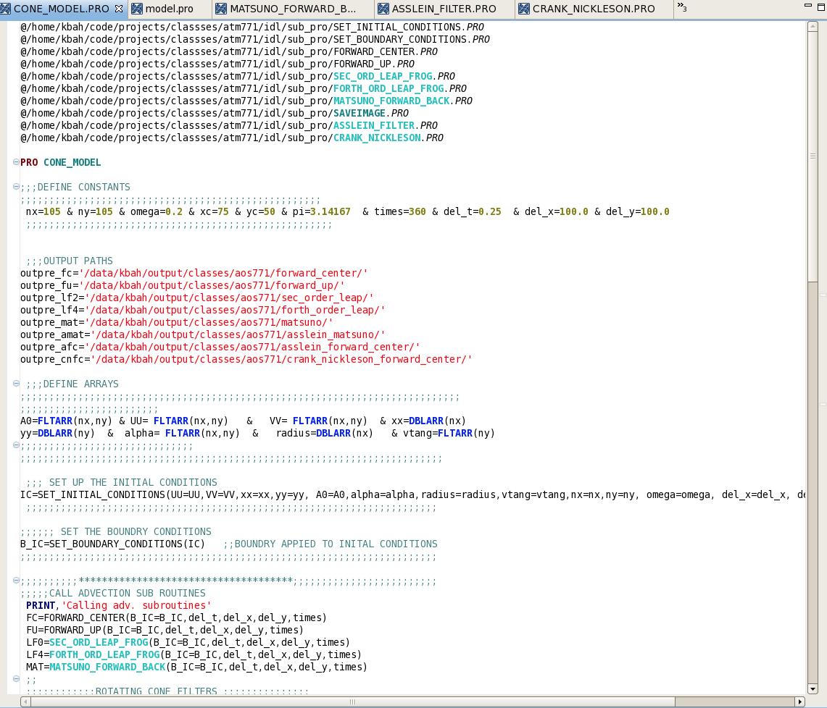

MAIN CODE CONTINUES……..

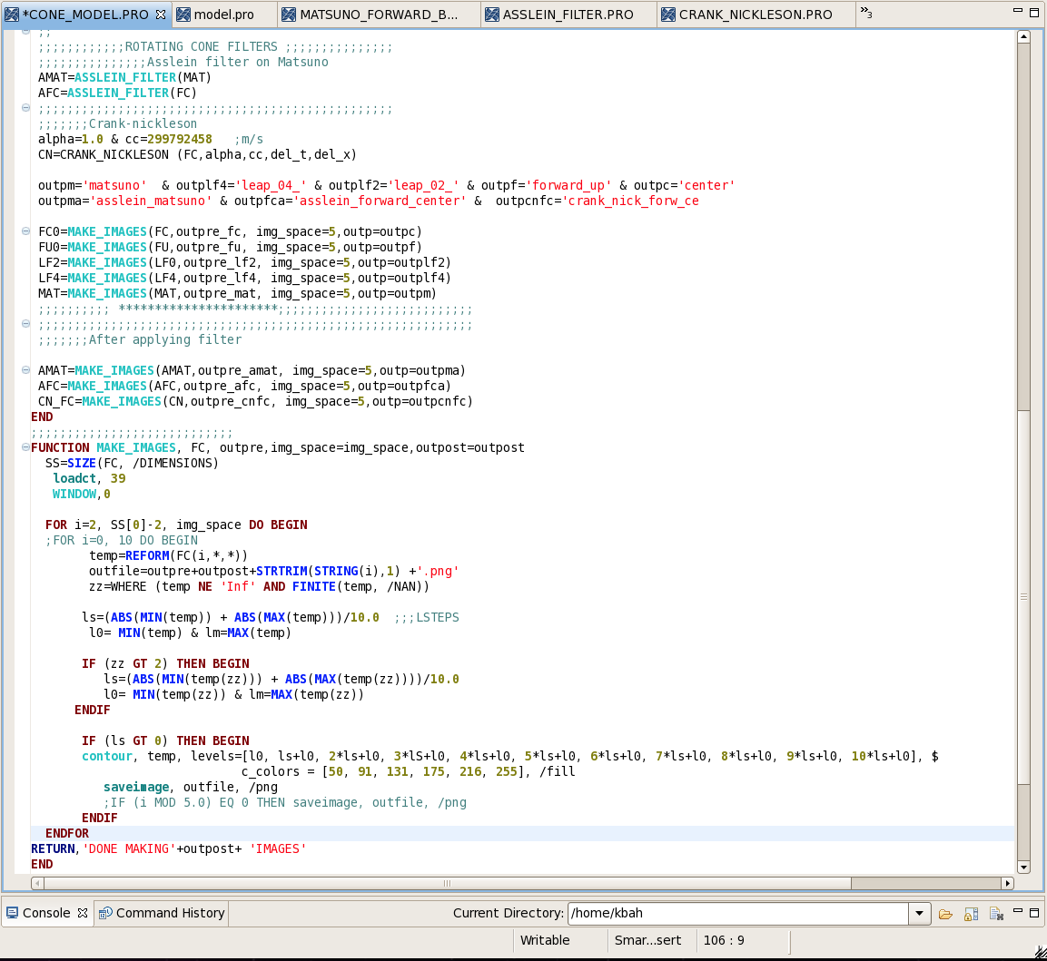

SUB ROUTINES TO SET UP INITIAL CONTIONS

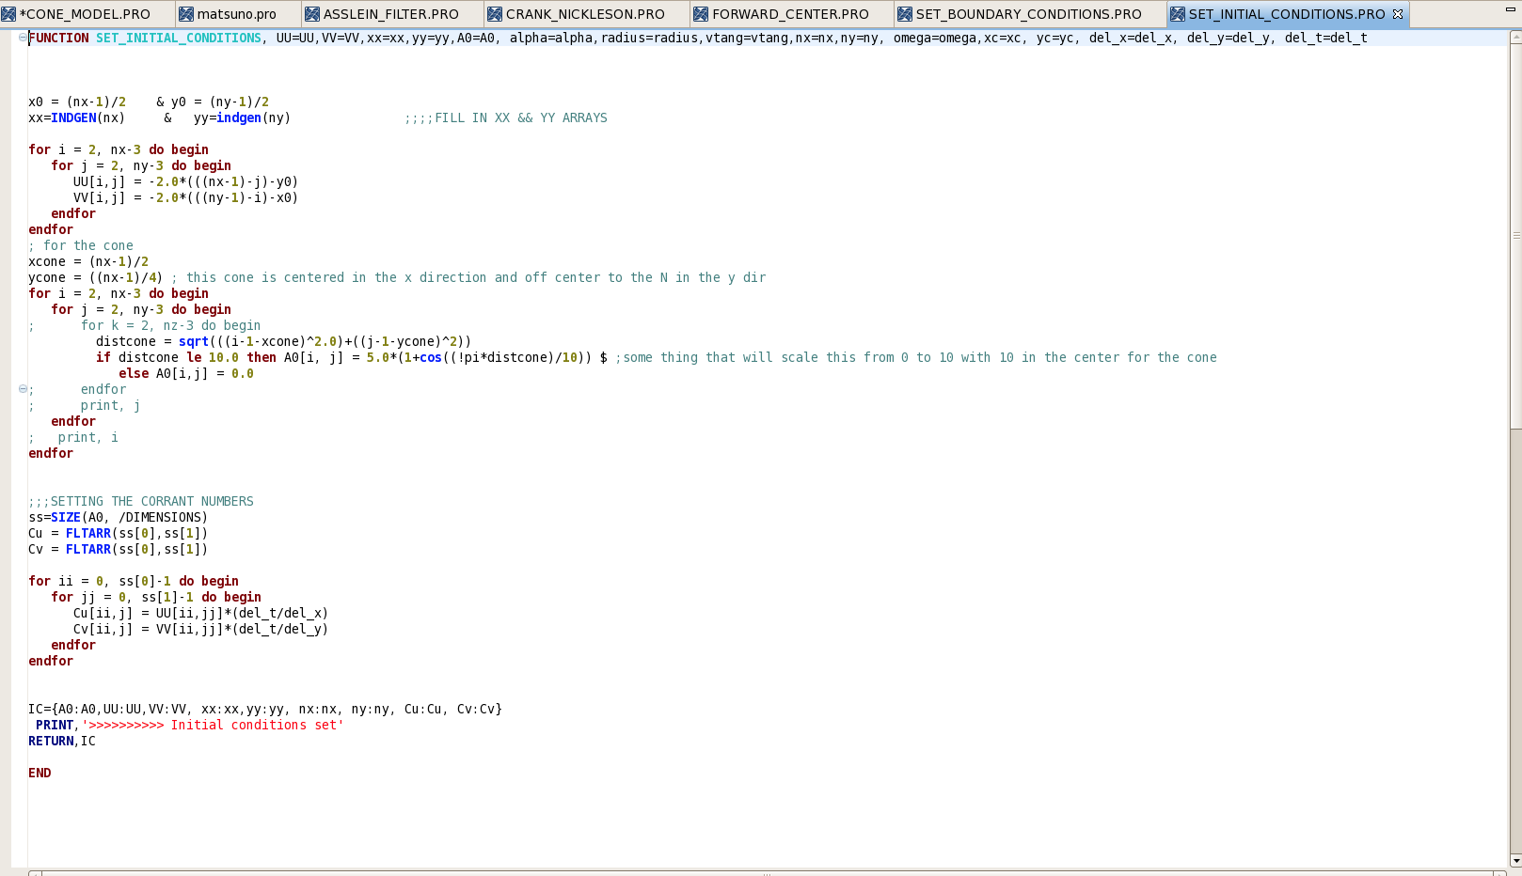

SUB ROUTINES TO SET UP BOUNDARY CONTIONS

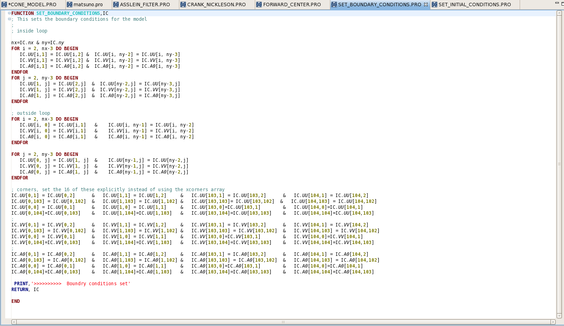

SUB ROUTINE: FORWARD CENTER
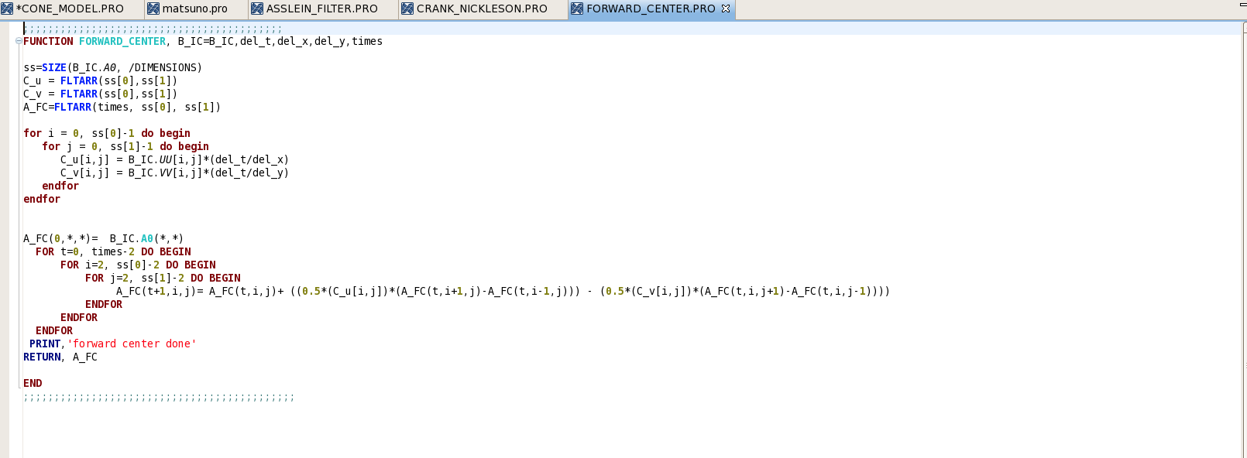

SUB ROUTINE: FORWARD UP
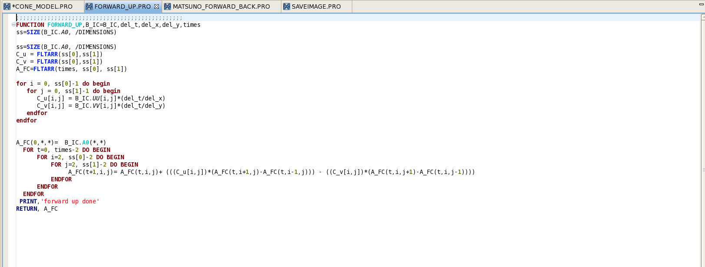

SUB ROUTINE: SECOND ORDER LEAP FROG
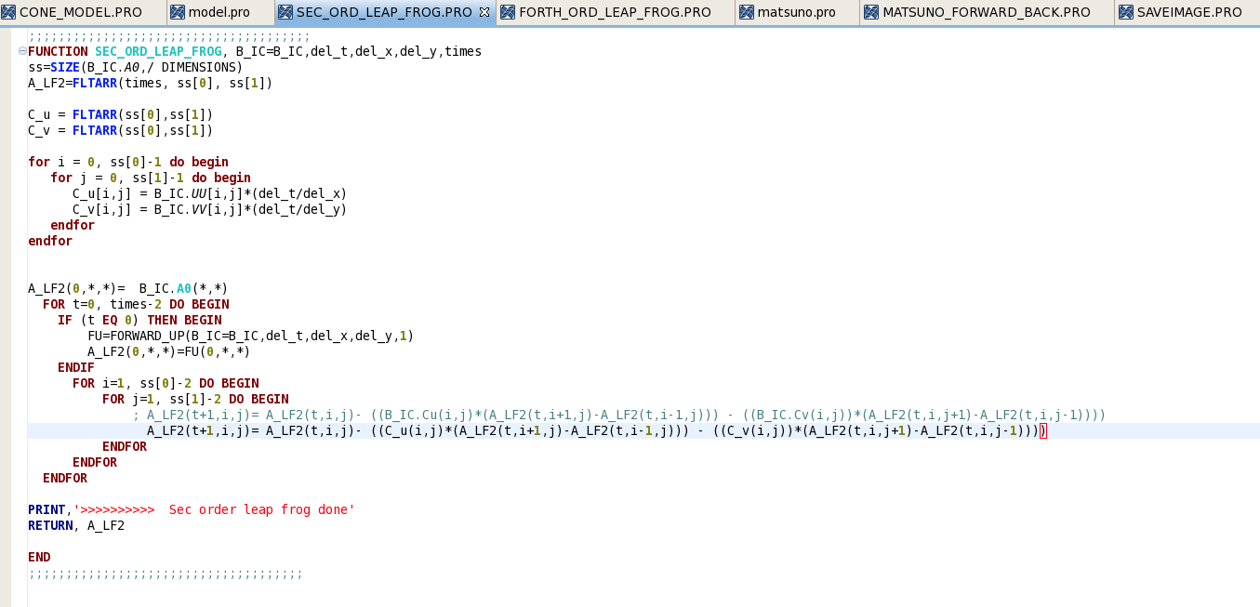

SUB ROUTINE: FORTH ORDER LEAP FROG

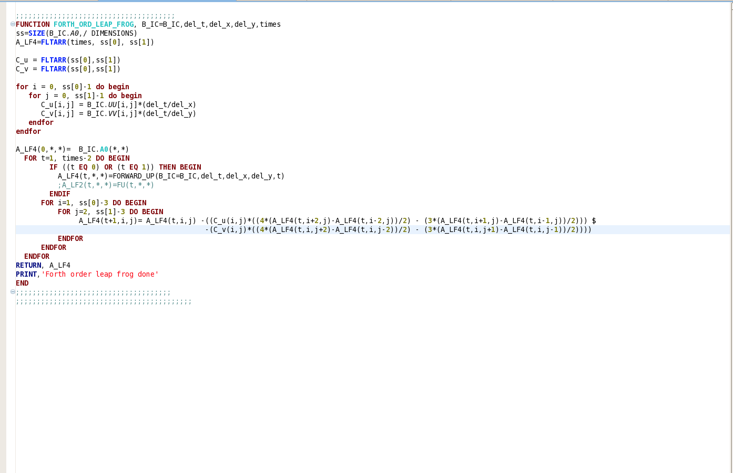

SUB ROUTINE: MATSUNO
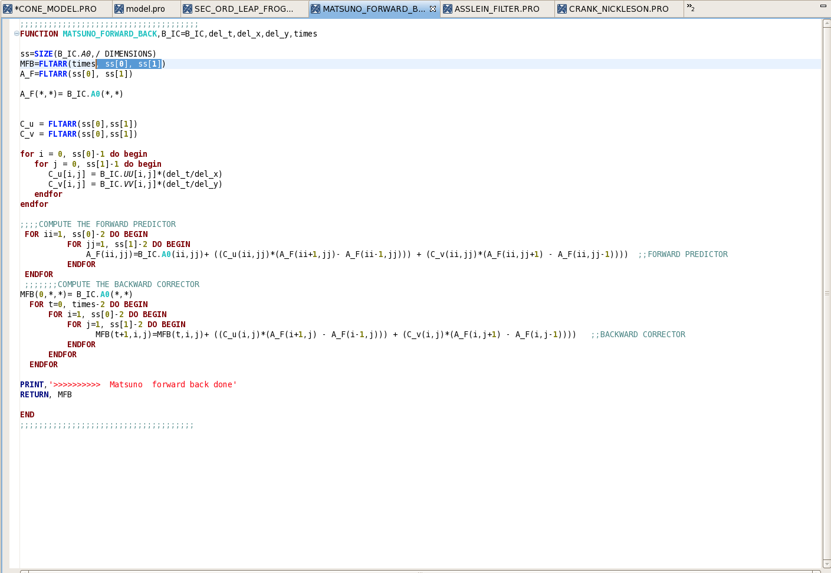

SUB ROUTINE: MATSUNO-FORWARD-BACK
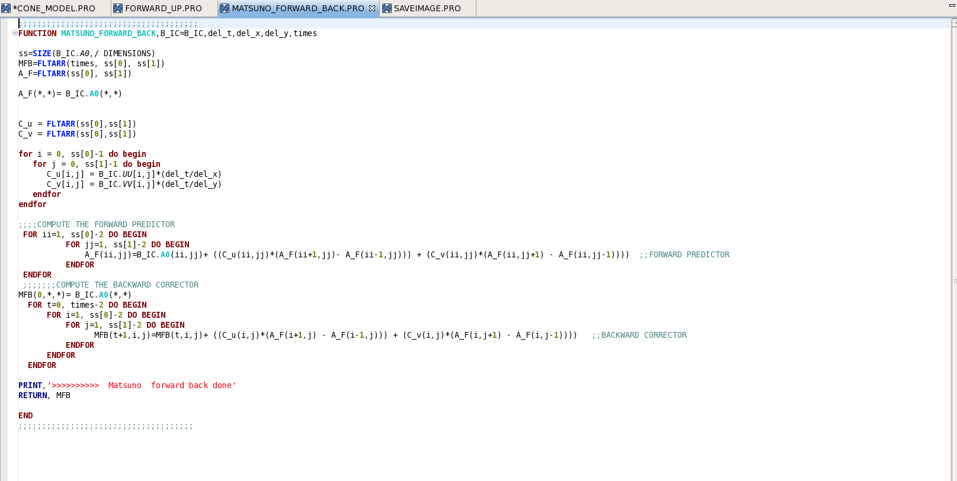

FILETES BUB ROUTINES
SUB ROUTINE: ASSLEIN FILTER, GETS CALLED TWICE FOR THE TWO LEAP FROG SCHEMES.
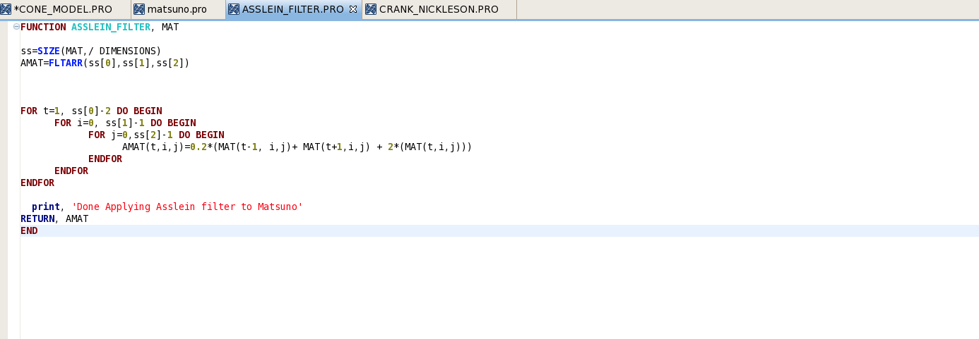

SUB ROUTINE: CRANK NICKLESON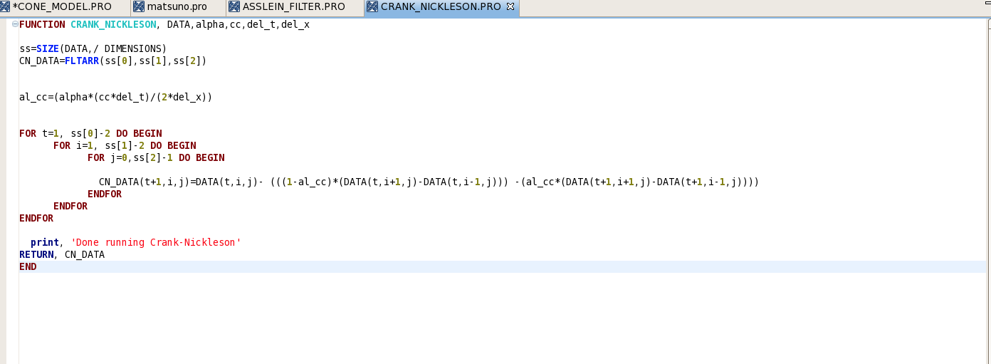
SUB ROUTINE: SECOND ORDER RUNGE KUTTA
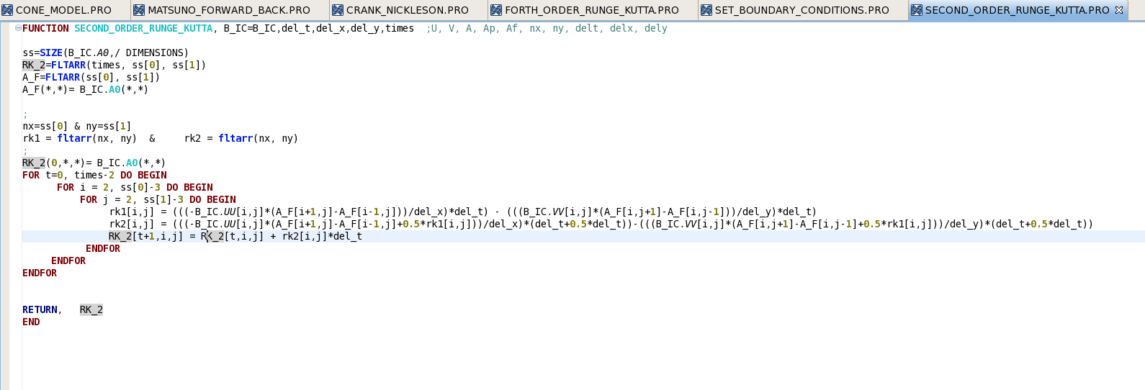

SUB ROUTINE: FORTH ORDER RUNGE KUTTA
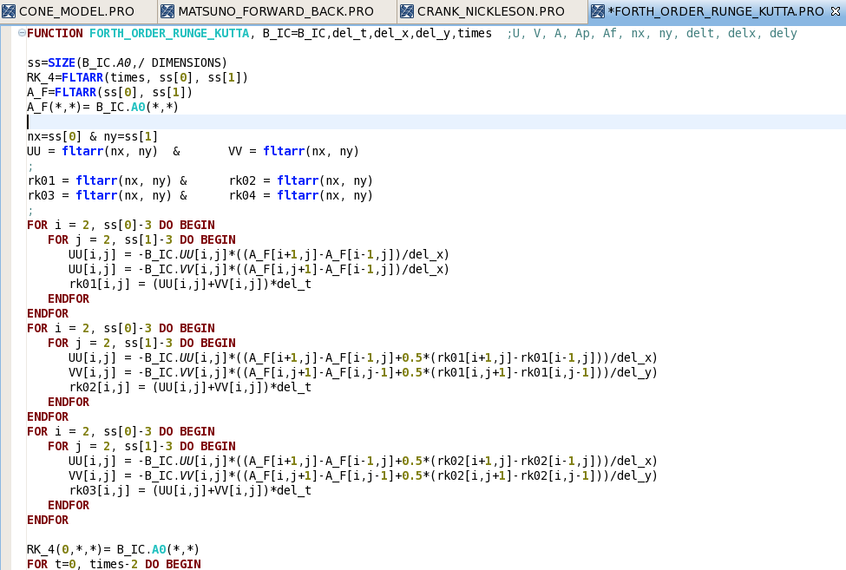

SUB ROUTINE: FORTH ORDER RUNGE KUTTA CONT ….
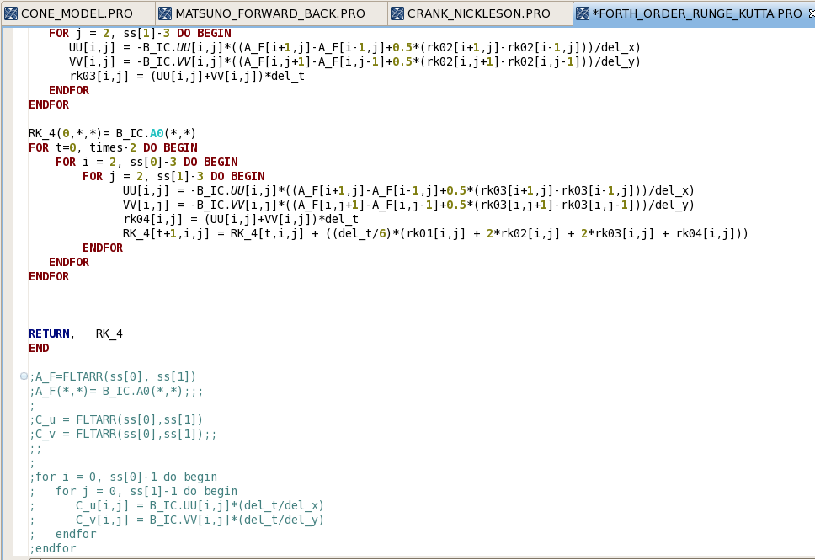

SUB ROUTINE: MAKE IMAGES
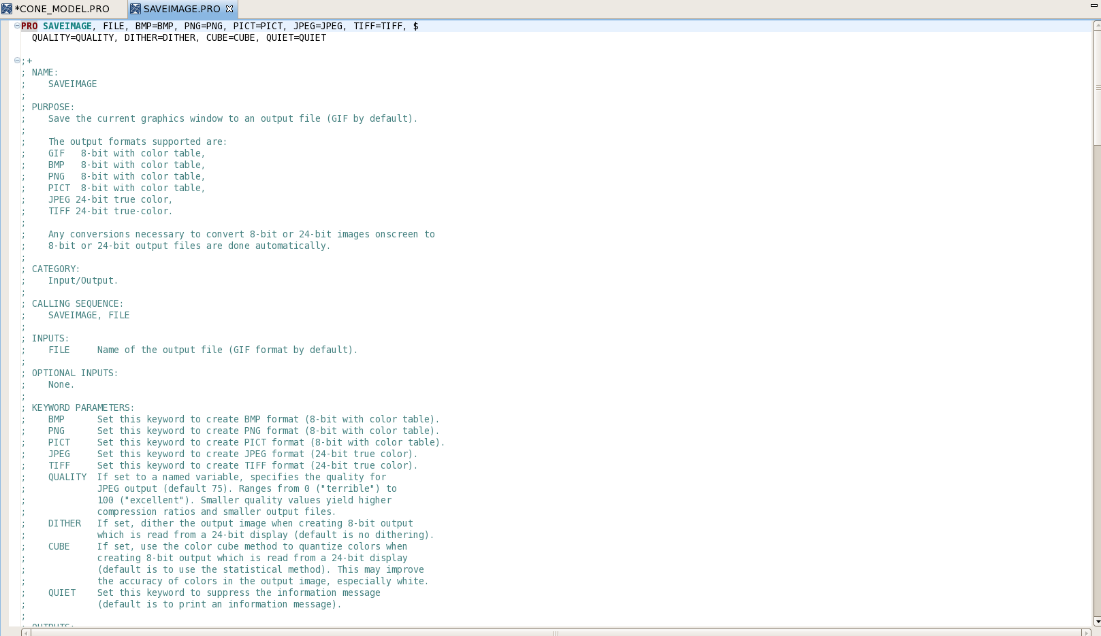

SUB ROUTINE: SAVE IMAGES CONT……

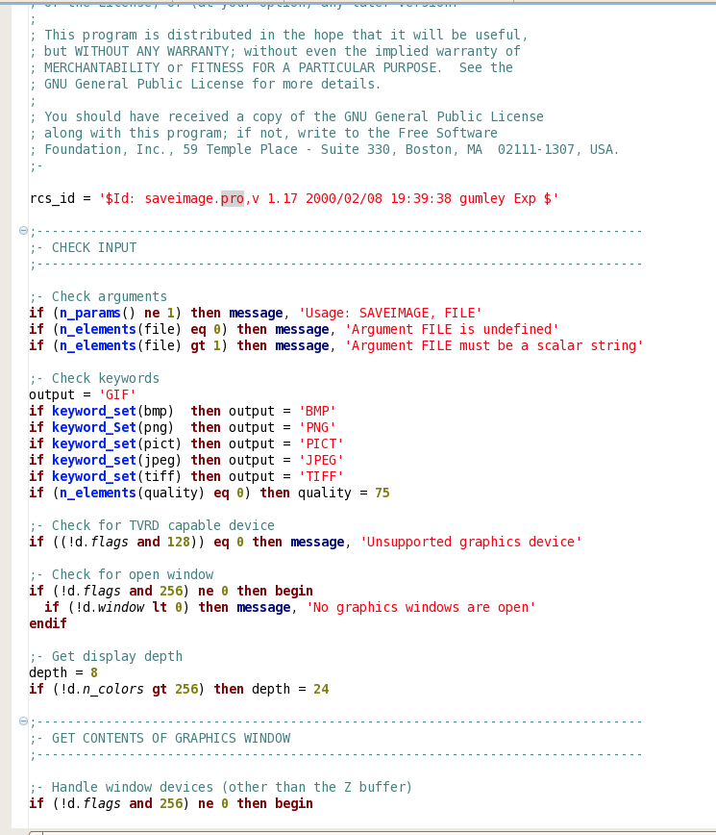

SUB ROUTINE: SAVE IMAGES CONT……
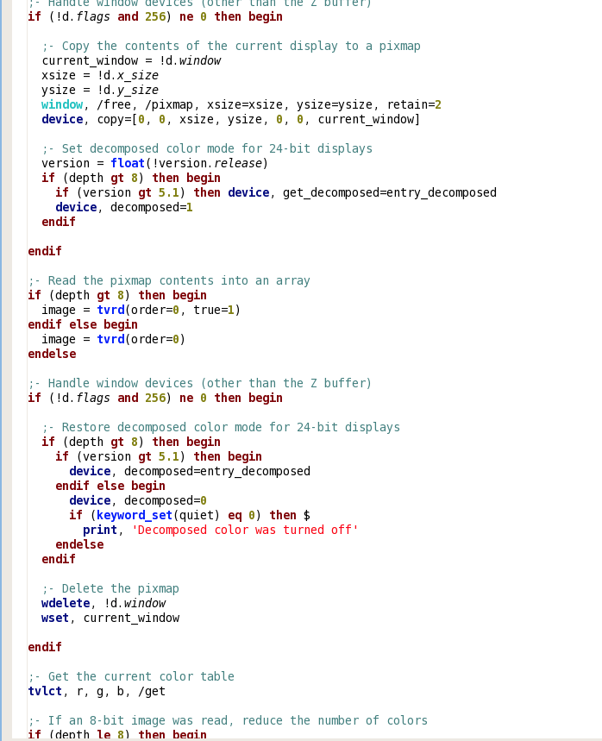

SUB ROUTINE: SAVE IMAGES CONT……
