AOS 745
Menzel
Lab 4 – Exploring low level moisture in AIRS, MODIS, and AMSU-A split windows

1. Open Hydra and load the file: AIRS.2005.08.28.103.L1B.AIRS_Rad.v4.0.9.0.G05241172839.hdf. Under Start open the MultiChannel Viewer and the following should appear (see Figure 1).

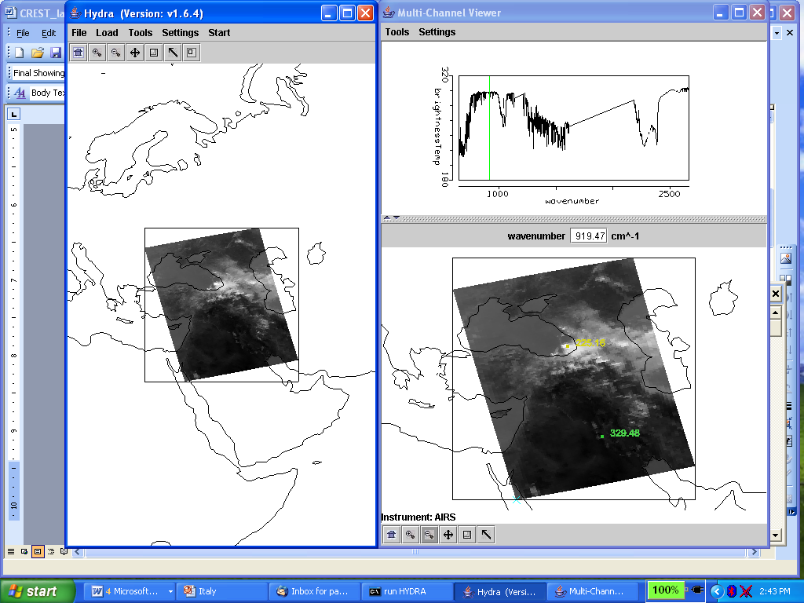
Figure 1: Hydra display of AIRS data showing BT spectra from warmest pixel and IRW image over the Black and Caspian Seas on 28 August 2005.

1a. Explore the image to view spectra measured in various pixels. To do this click on the arrow icon in the tool bar at the bottom of the MultiChannel Viewer and move the cursor around the image slowly, watching the spectra change from pixel to pixel. View a spectrum over the Black Sea in clear skies and locate the CO2, O3, and H2O absorption features.

1b. Engage the reference spectrum icon (look under Tools and find Reference Spectrum and click on). Show spectra from the eastern and western portions of the Black Sea; zoom in on the spectra near 870 cm-1 (see Figure 2).

1c. Calculate the BT difference on and off a H2O absorption line in the infrared window region (e.g. try 870.3 minus 871.3 cm-1). Color display the difference image (see Figure 3). What is the range of values in the scene? Differences in the eastern Black Sea are smaller than differences further west; what does this tell you about low level moisture? Explain.

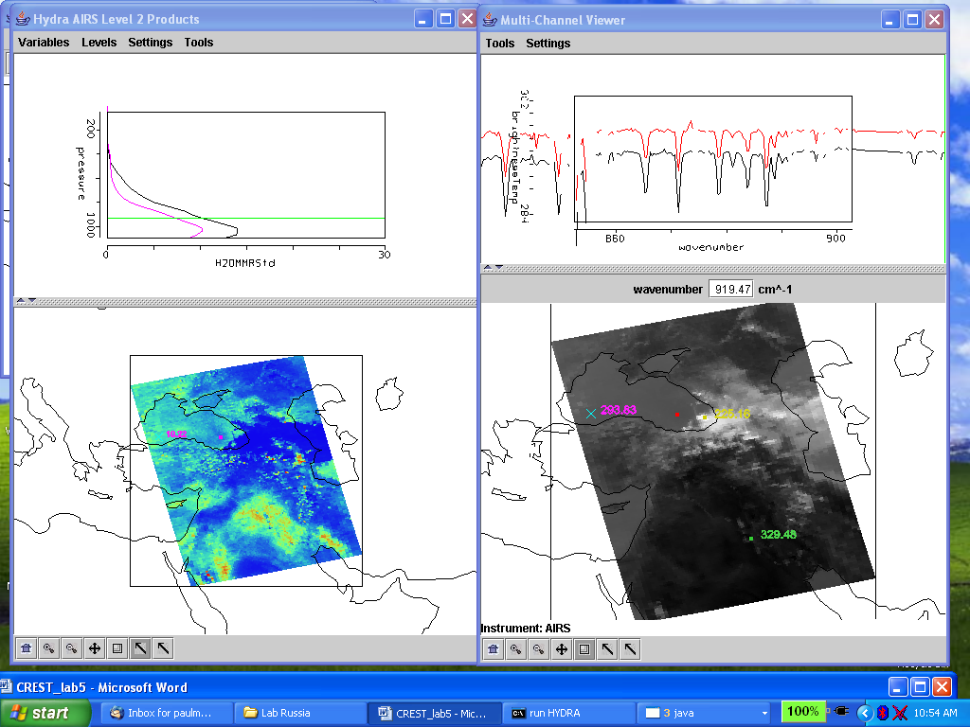.
Figure 2. MultiChannel Viewer display with zoom in on IR window spectra near 870 cm-1 over FOVs in eastern and western Black Sea.

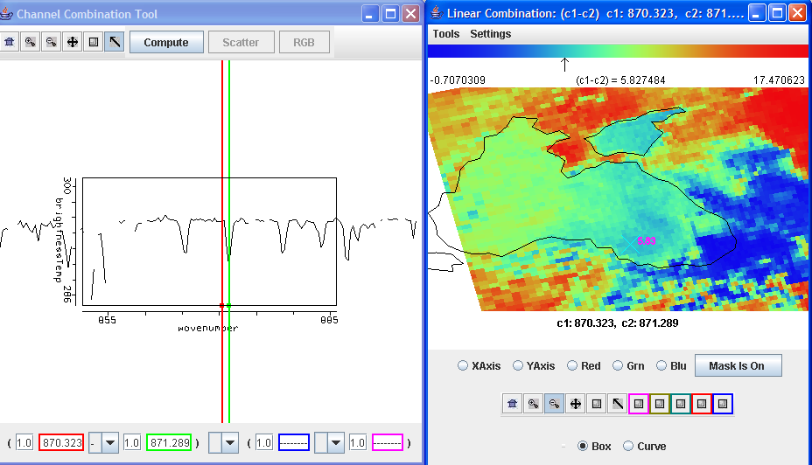

Figure 3. Micro-channel difference of 870.3 cm-1 (off H2O line) minus 871.3 cm-1 (on H2O line) indicating the low level water vapor concentrations over the Black Sea

1d. Keep the MultiChannel Viewer with the reference spectrum open. Using Hydra again load the AIRS retrievals for this scene found in AIRS.2005.08.28.103.atm_prof_rtv_npc030.hdf (leave the Multichannel Viewer with the AIRS data open). Under Variables select Air Temperture Profiles and under Tools turn Reference Profile on. Inspect the moisture retrieval image for 900 hPa. The western Black Sea appears to have more low level moisture than the eastern part. In the Multi-Channel Viewer display two spectra, one for a FOV in the moister region and one in the drier region. Zoom in on the two spectra at 870 cm-1 (click on the icon third from the right in the bottom tool and then click and drag over the appropriate part of the spectrum – repeat until full resolution of the absorption lines in the IR window are apparent). You should have something that looks like Figure 4. Does the on-line off-line brightness temperature difference in this part of the spectrum agree with the inference from the retrieval field? Explain?

Figure 4. (right) MultiChannel Viewer display with zoom in on IR window spectra near 870 cm-1 over FOVs in eastern and western Black Sea. (left) AIRS water vapor profile retrievals in the two selected FOVs and the 900 hPa water vapor retrieval field for the granule.

2. Use Hydra to load MYD021KM.A2005240.1020.005.2005242062607.hdf with co-located MODIS data. Open the Multi-channel Viewer and use Linear Combinations to calculate the split window BT difference over the Black Sea (BT31-BT32). Compare the temperature difference in the MODIS split window to the AIRS micro-channel on-line off-line from 1c.

3a. Explore the microwave data from AMSU

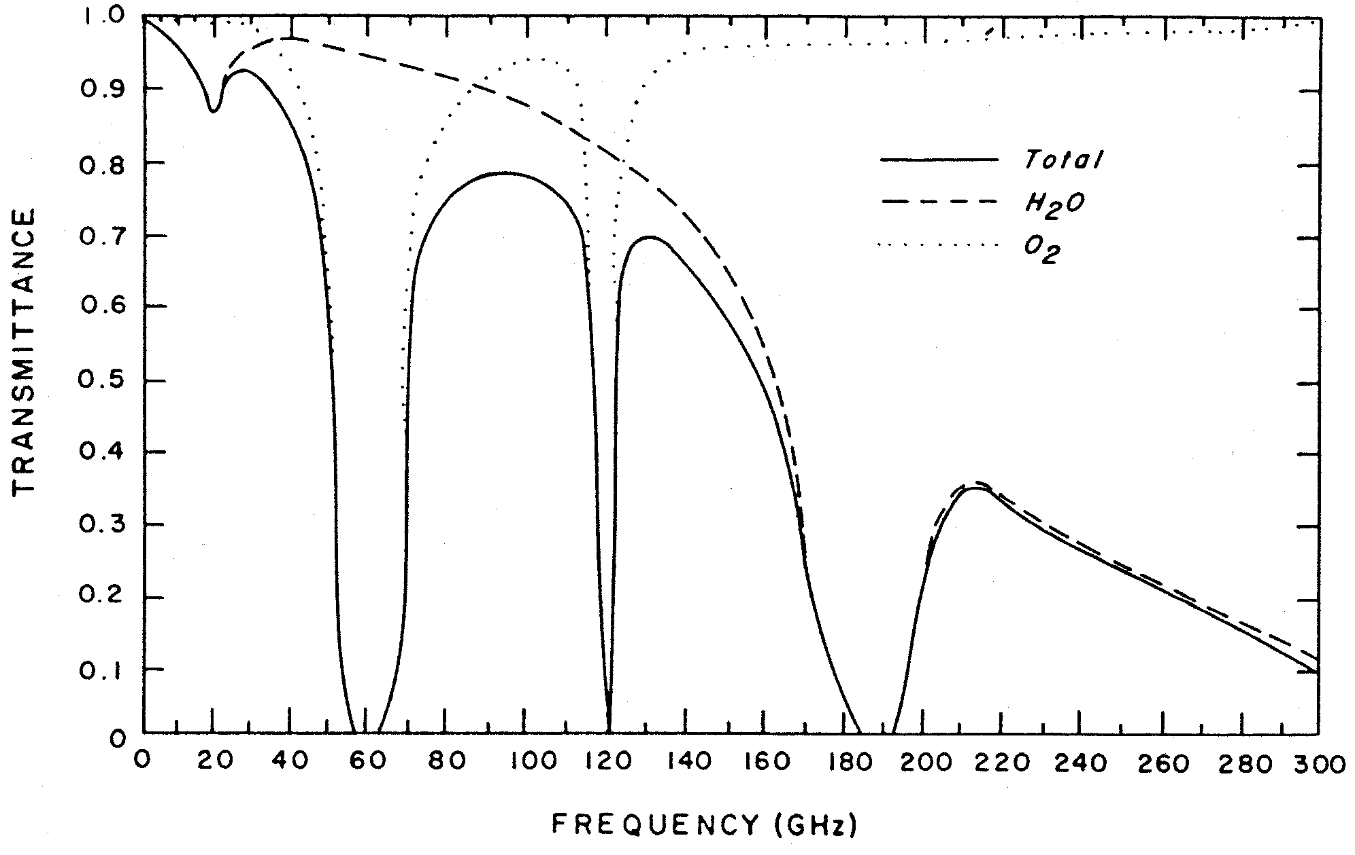

AMSU-A Band Frequency in GhZ
1 | 23,800
2 | 31,400
3 | 50,300
4 | 52,800
5 | 53596±115
6 | 54,400
7 | 54,940
8 | 55,500
9 | f₀=57,290.344
10 | f₀±217
11 | f₀±322.2±48
12 | f₀±322.2±22
13 | f₀±322.2±10
14 | f₀±322.2±4.5
15 | 89,000

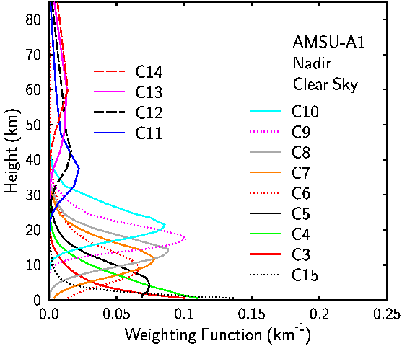

Using Hydra load the file: AIRS.2005.08.28.103.L1B.AMSU_Rad.v5.0.9.0.G07102220758.hdf. Under Start open the MultiChannel Viewer and the following should appear.

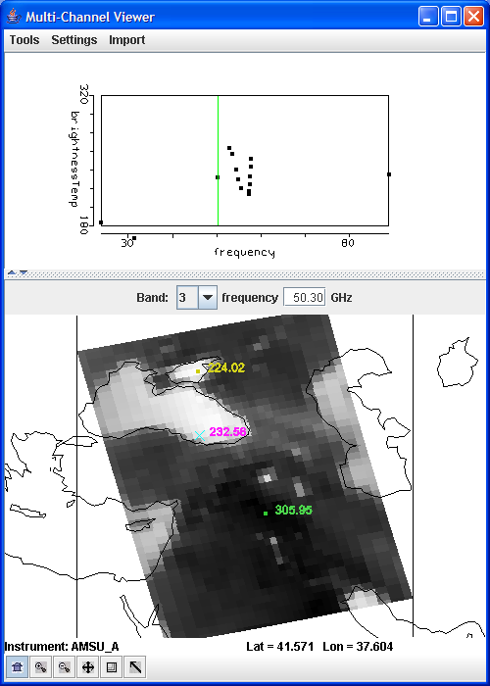

Figure 5. MultiChannel Viewer display of AMSU Band 3

Use the Start→Multi-Channel Viewer to open the actual data display interface. Look at the channels in sequence from Band 1 (23 GHz) to Band 15 (89 GHz). Note that Bands 1 – 5 and Band 15 show evidence radiation from the earth surface; how is this obvious? Band 4 is more opaque (due to O2 absorption) than Band 3; why are the BTs warmer over the ocean in Band 4 than Band 3? Band 9 is more opaque than Band 8; the BTs are colder over the ocean in Band 9 than Band 8 as one would expect. However Band 13 is more opaque than Band 12; but the BTs are warmer over the Black Sea in Band 13 than Band 12. Can you explain why?

3b. Use Linear Combinations to display Band 2 (31 GHz) minus Band 1 (23 GHz). How do these BT differences compare to AIRS micro-channel differences and MODIS split window differences? Note that Band 1 is more sensitive to low level moisture than Band 2. Compare the temperature difference in the AMSU split window to the AIRS micro-channel on-line off-line from 1c.

