AOS 745
Menzel
Lab 3 – Interrogating AIRS Data and Exploring Spectral Properties of Clouds and Moisture

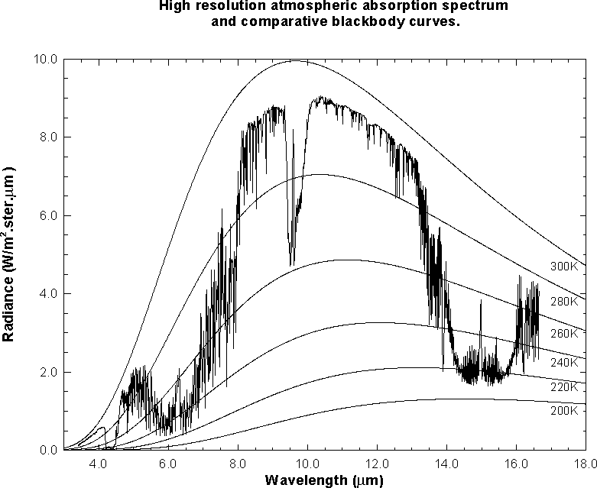

Figure 1: High resolution atmospheric absorption spectrum and comparative blackbody curves

1. Open Hydra and load the file: AIRS.2005.08.28.103.L1B.AIRS_Rad.v4.0.9.0.G05241172839.hdf. Under Start open the MultiChannel Viewer and the following should appear (see Figure 2).

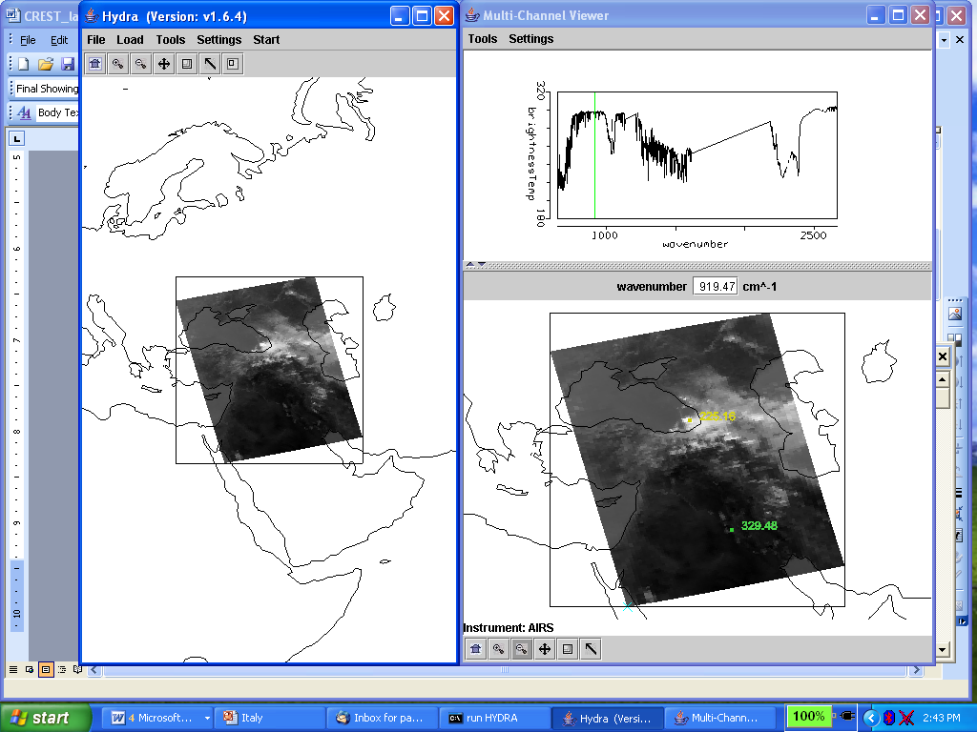

Figure 2: Hydra display of AIRS data showing BT spectra from warmest pixel and IRW image over the Black and Caspian Seas on 28 August 2005.

1a. Explore the image to view spectra measured in various pixels. To do this click on the arrow icon in the tool bar at the bottom of the MultiChannel Viewer and move the cursor around the image slowly, watching the spectra change from pixel to pixel. View a spectrum over the Black Sea in clear skies and locate the CO2, O3, and H2O absorption features. Now view a spectrum in the clouds at the eastern edge of the Black Sea. The brightness temperature (BT) at shorter wavelengths is now increasing as wavelengths decreases. Why?

1b. Engage the reference spectrum icon (look under Tools and find Reference Spectrum and click on). Show both the spectra from 1a simultaneously by engaging the arrows in the bottom tool bar (Figure 3). Why is the spectrum from the cloudy field of view showing very little change in brightness temperature as a function of wavenumber?

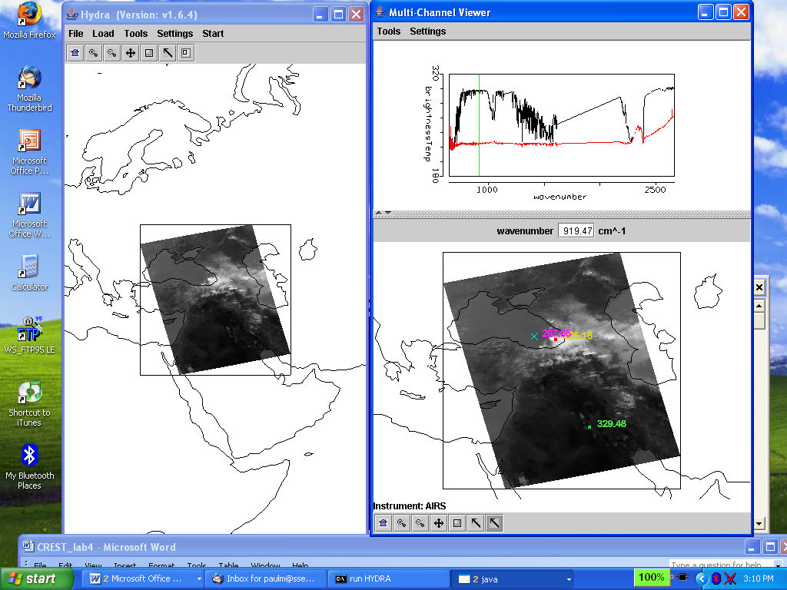

Figure 3: MultiChannel Viewer display with reference spectrum on showing cloudy and clear sky spectra over the Black Sea

2. Zoom in on the cloudy spectra at 1050 cm-1 (click on the zoom icon third from the right on the toolbar at the bottom and click and drag over the desired part of the spectra). The O3 absorption feature over clouds shows warmer BT as the wavenumber gets closer to the center of the absorption band. What does this tell you about the height of the cloud? Explain.

3. Zoom in on the spectra at 690 cm-1 where the clear and cloudy spectra begin to separate (click on the zoom icon third from the right on the toolbar at the bottom and click and drag over the desired part of the spectra). Plot spectral band images at 694.67 and 697.43 cm-1 and save on a ppt. Clouds are evident in one image but not the other. Explain why in the notes. Notice in the 697.43 cm-1 image the edge measurements are colder than the nadir measurements. Why?

4. Restore the full spectra (click on the left icon on the toolbar at the bottom and click over the spectra). Zoom in on th eastern portion of the Black Sea (see Figure 4). Compare the spectra for a clear pixel and a pixel covered by thin cloud. Save in a ppt. What does the infrared window portion of the spectrum look like? Assuming this is a transmissive ice cloud, what does this tell you about transmission through an ice cloud as a function of wavenumber between 800 and 1000 cm-1?

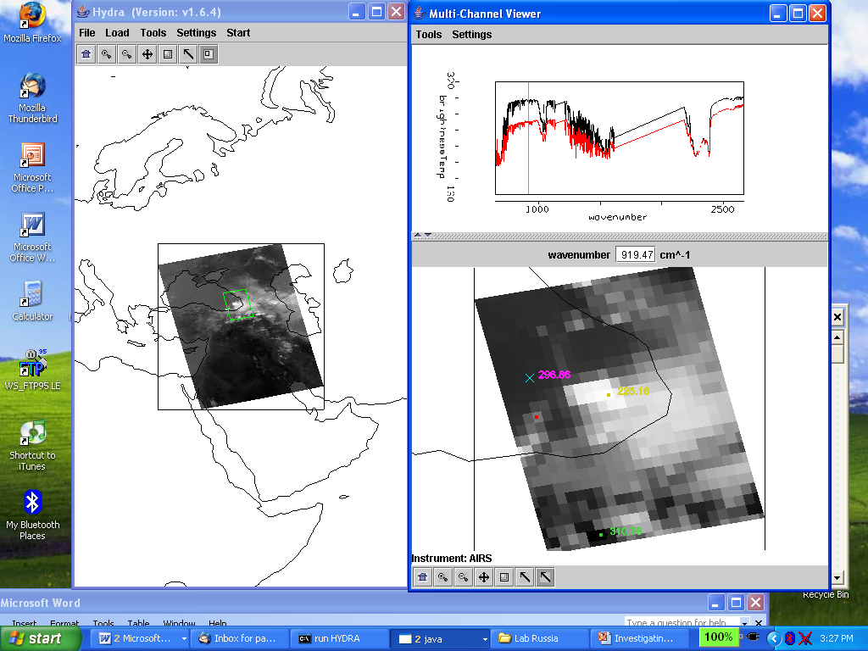

Figure 4: MultiChannel Viewer display of full resolution AIRS data showing partly cloudy and clear sky spectra over the Black Sea

5. Engage Linear Combinations (under Tools) to open the Channel Combination Tool display. What is the temperature difference for on-line off-line spectra at 735 cm⁻¹ for this scene? What is the temperature difference for on-line off-line spectra at 720 cm⁻¹ (at the Q branch of the CO₂ absorption band) for this scene? Save in a ppt. What does this imply about the 720 cm⁻¹ weighting function with respect to the 735 cm⁻¹ weighting function?

6. Keep the MultiChannel Viewer with the reference spectrum open. Using Hydra again load the AIRS retrievals for this scene found in AIRS.2005.08.28.103.atm_prof_rtv_npc030.hdf (leave the Multichannel Viewer with the AIRS data open). Under Variables select Air Temperture Profiles and under Tools turn Reference Profile on. In Multi-Channel Viewer, using the arrows in the bottom tool bar select one FOV directly in the cloud in the eastern Black Sea and another FOV nearby in clear skies.

6a. Observe the characteristic spectral signature of an opaque cloud in the Multi-Channel Viewer (see Figure 3). Now observe the temperature profiles for the two FOVs in the Hydra AIRS level 2 Products Window (see Figure 5). What can you infer about the height of the opaque cloud? Why? Inspect the temperature retrieval image for various pressure levels (in the Hydra AIRS level 2 Products Window use the first arrow in the bottom tool bar to move the horizontal green line to different pressure levels); the pressure level where the retrieval field shows large contrast over the cloud is indicative of its height.

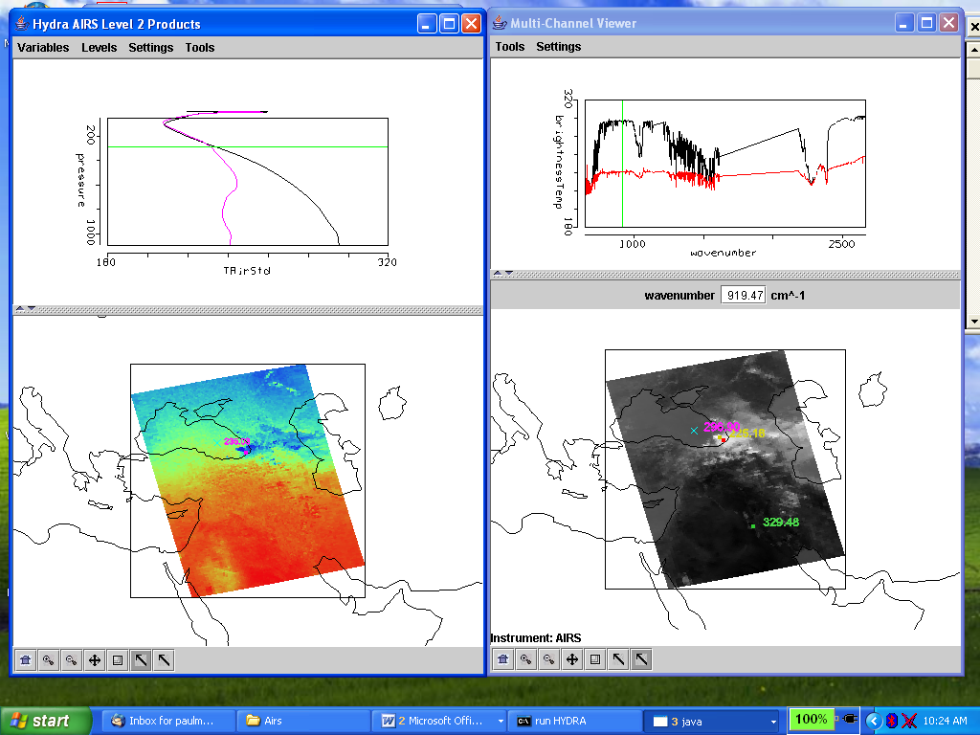

Figure 5. (right) MultiChannel Viewer display with reference spectrum on showing cloudy and clear sky AIRS spectra over the Black Sea. (left) AIRS temperature profile retrievals in clear and cloudy FOVs and the 300 hPa temperature retrieval field for the granule.

6b. Explore the spectra and the inferred height of several other clouds in the scene. Record their location and your estimate of their height. Save one example in a ppt.

7. Investigate atmospheric water vapor by displaying 1443 cm-1 measurements in the Multi-Channel Viewer. There is a dry band south of the Black Sea. Display the spectra and the water vapor profiles in and out of the dry band. Save in a ppt. Zoom in on the spectra between 1380 and 1420 cm-1. See Figure 6. Does the on-line off-line brightness temperature difference in this part of the spectrum agree with the inference from the retrieval field? Explain?

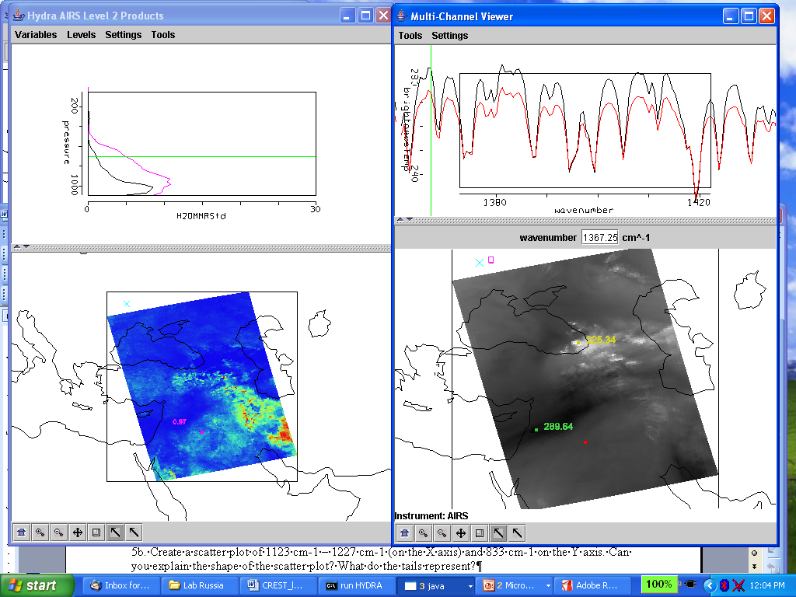

Figure 6. (right) MultiChannel Viewer display with zoom in on H2O spectra between 1380 and 1420 cm-1 over FOVs in and out of the dry band south of the Black Sea. (left) AIRS water vapor profile retrievals in the two selected FOVs and the 700 hPa water vapor retrieval field for the granule.

