AOS 745
Menzel
Lab 2 – Analyzing MODIS data viewing land, ocean, and atmosphere

Table: MODIS Channel Number, Wavelength (μm), and Primary Application

Reflective Bands Emissive Bands
1,2 0.645, 0.865 land/cld boundaries 20-23 3.750(2), 3.959, 4.050 sfc/cld temp
3,4 0.470, 0.555 land/cld properties 24,25 4.465, 4.515 atm temperature
5-7 1.24, 1.64, 2.13 “ 27,28 6.715, 7.325 water vapor
8-10 0.415, 0.443, 0.490 ocean color/chlorophyll 29 8.55 sfc/cld temp
11-13 0.531, 0.565, 0.653 “ 30 9.73 ozone
14-16 0.681, 0.75, 0.865 “ 31,32 11.03, 12.02 sfc/cld temp
17-19 0.905, 0.936, 0.940 atm water vapor 33-34 13.335, 13.635 cld top properties
26 1.375 cirrus clouds 35-36 13.935, 14.235 cld top properties

Figure 1: Spectral signatures from land, ocean, and atmosphere

1. Use Hydra to analyze the scene over Italy on 29 May 2001 detected by MODIS (find MOD021KM.A2001149.1030.005.2007054003907.hdf and load it into Hydra). Browse through the scene in several different wavelengths in the Multi-Channel Viewer window. Look at the scene both in BT and radiances (use BT > radiance under Settings):

1a. Verify that the surface features are distinguishable in the infrared window channels while in the infrared absorption channels they are not.

1b. Look at clouds, ocean, and vegetated surfaces in different reflective bands. For each type (by selecting a single Field Of View) describe the changes in reflectance for different channels (top panel of Multi-channel viewer window).

1c. Demonstrate some of the spectral signatures indicated in Figure 1. In each case identify which spectral signature you are demonstrating.
i. Look at snow in the Alps in 0.65 and 1.6 μm.
ii. Look at clouds and vegetation in northern Italy in 0.65 and 0.86 μm.
iii. Look at near shore waters in 0.55 and 0.45 μm.

2. Use Linear Combination combine spectral bands to explore the vegetation index that is based on the relatively low leaf and grass reflectance from spectral bands below 0.72 μm and relatively high reflectance from spectral bands above.

2a. Construct a pseudo image of normalized vegetation index NDVI = [Band 2 (0.86μm) – Band 1 (0.65μm)] / [Band 2 (0.86μm) + Band 1 (0.65μm)]. Can you discriminate regions with some vegetation from those with little? What are the NDVI values in regions without significant vegetation; what are they in vegetated regions? Create a color image of NDVI and save in a ppt slide. Make a transect of BT11 through vegetated to non-vegetated clear skies. Save in a ppt slide and comment on the effect of vegetation on surface temperature.

2b. Create an image of Band 31 (11.0 μm) using Compute. Map the NDVI values from 2a on the Y axis (by clicking the Y axis button) against Band 31 (11.0 μm) on the X axis (by clicking the X axis button). Click on the scatter button to open a scatter plot window. Select different regions in the scatter plot window (see Figure 2) and look at the corresponding points in the linear combination windows.

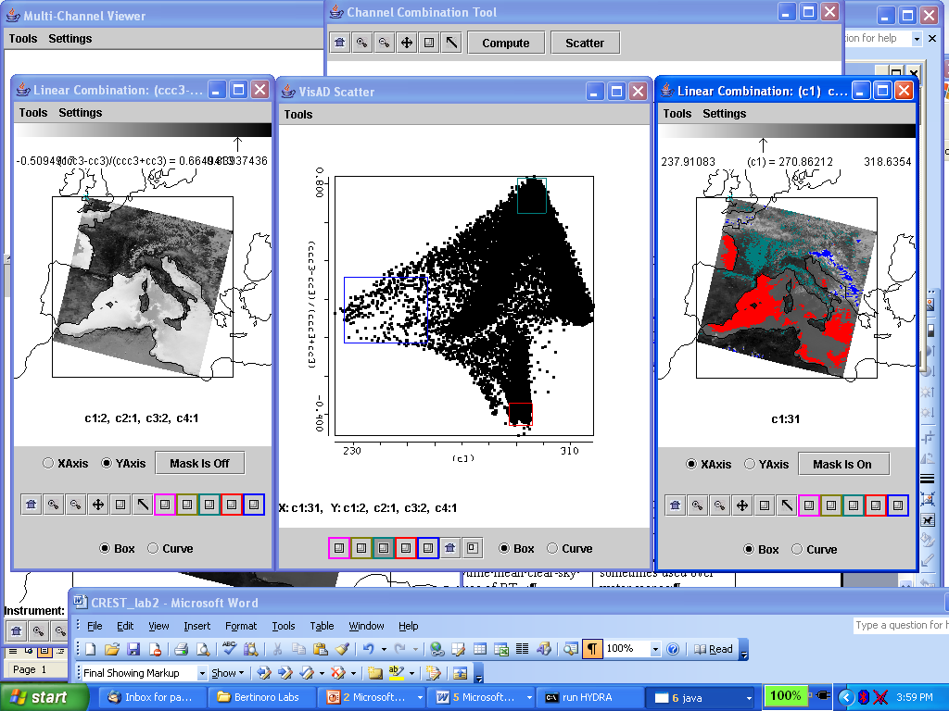

Figure 2: Scatter plot of NDVI (left image & y-axis) versus BT11 (right image & x-axis)
3. Look at clouds in different reflective bands. For each type (by selecting a single Field Of View) describe the changes in reflectance for different channels (top panel of Multi-channel viewer window). Now look at clouds in different thermal emissive bands. For each type (by selecting a single Field Of View) describe the changes in radiance detected in different channels (top panel of Multi-channel viewer window).

4a. Investigate the radiances emanating from the cloud within the scene in different wavelengths; look at the following bands
Band 1 (0.65 μm) – clouds and snow reflecting
Band 2 (0.86 μm) – contrast between vegetation and clouds diminished
Band 26 (1.38 μm) – only high clouds and moisture detected
Band 6 (1.64 μm) – water clouds reflecting, snow and ice clouds not reflecting
Band 20 (3.7 μm) – thermal emission plus solar reflection
Band 31 (11 μm) – clouds and snow colder than rest of scene
Band 35 (13.9 μm) – only upper atmospheric thermal emission detected.

4b. Using Linear Combination combine spectral bands that can be used to detect clouds and infer cloud properties. Try the following band combinations (by entering the suggested wavelengths in the colored boxes), and for each combination click on the compute button.

Band 2 (0.86 μm) / Band 1 (0.65 μm)
[Band 1 (0.65 μm) - Band 6 (1.6 μm)] / [Band 1 (0.65 μm) + Band 6 (1.6 μm)]
(Band 29 (8.6 μm) - Band 31 (11.0 μm)
(Band 31 (11.0 μm) - Band 32 (12.0 μm)

4c. Map each linear combination on the Y axis (by clicking the Y axis button) against Band 31 (11.0 μm) on the X axis (by clicking the X axis button). Click on Scatter to open a scatter plot window. Estimate what threshold values you would use in each test to indicate the presence of clouds? Select different regions in the scatter plot window and look at the corresponding points in the linear combination window.

4d. Look at the scatter plot of [Band 29 (8.6 μm) - Band 31 (11 μm)] versus [Band 31 (11 μm) - Band 32 (12 μm)]. Find where the largest differences occur in each image. Are there clouds in these brightness temperature difference images that could not be seen in the visible images?

5. Compare with the MODIS product files.

5a. Load the MODIS cloud mask (find the MOD35 file) using Hydra. How does the cloud mask compare with your own tests for cloud presence. Find three locations where you disagree and explain why you think the cloud mask is in error.

5b. Load the MODIS cloud phase product (find the MOD06 file) using Hydra. How does the cloud phase product compare with your own tests for cloud water/ice. Find three locations where you disagree and explain why you think the cloud product is in error.

6. Back in HYDRA subselect the region shown below. Compare the cloud depiction at 0.65 and 11 μm.
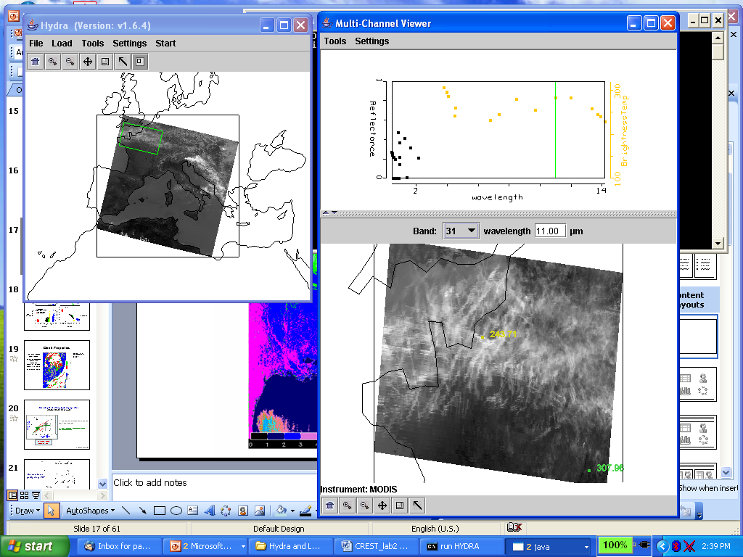

Figure 4: Cirrus clouds and clear sky

6a. Generate a scatter plot of Band 31 on the x-axis and Band 29 – Band 31 on the y-axis. Now you can select a rectangular region on the scatter plot and look at the images to determine the location of the selected points in the pseudo-images (See Figure 5a).

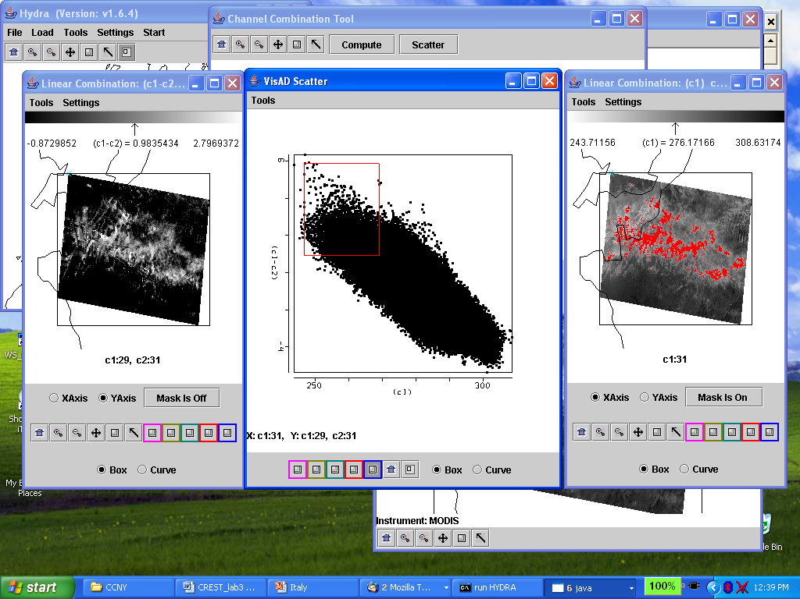

Figure 5a: Scatter plot of BT8.6-BT11 (left image) versus BT11 (right image) with BT8.6-BT11>1 and BT11>270 highlighted in red.

6b. Alternatively use the system to select a rectangular region of one of the pseudo-images that display the linear combinations and look at the position of the selected pixels in the scatter plot. (Figure 5b)

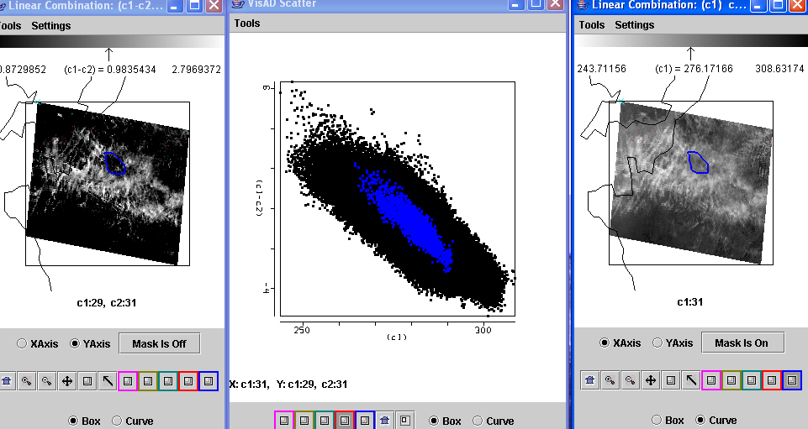

Figure 5b: Scatter plot of BT8.6-BT11 (left image) versus BT11 (right image) with selected cloud feature in BT11 image highlighted in blue and displayed on scatter plot.

6c. Which difference is larger for this cloud, [Band 29 (8.6 μm) - Band 31 (11 μm)] or [Band 31 (11 μm) - Band 32 (12 μm)]?

6d. Try to determine the type of cloud viewed in this region. Does Band 26 (1.38 µm) support or contradict your cloud classification. If you were to design and automated algorithm to detect these cloud types, what would you include in your algorithm?

7. Select a region off the east coast of Spain (see Figure 6a). Investigate the off shore for presence of chlorophyll (using Figure 6b). Create a pseudo image of channel 13h divided by channel 12 (see Figure 6c). Make a scatter plot with this pseudo image on the y axis and channel 20 (4 um) BTs on the x-axis. Isolate different areas in the offshore waters that are rich and poor in chlorophyll.

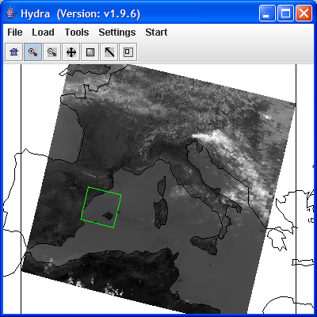

Figure 6a: River exit off the east coast of Spain.

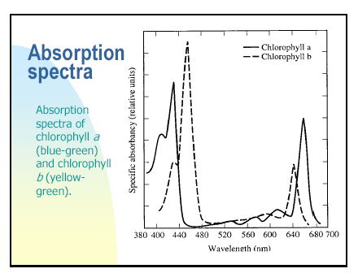
Figure 6b: River exit off the east coast of Spain.

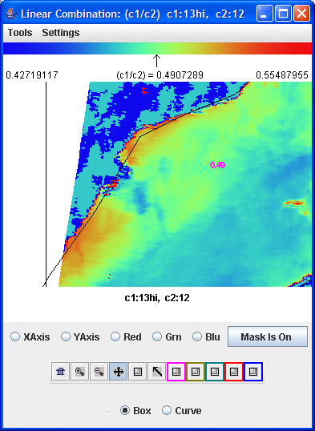

Figure 6c: River exit off the east coast of Spain highlighting chlorophyll gradients in the off shore waters.

