AOS 745
Menzel
Lab 1 – Using HYDRA to Inspect Multispectral Remote Sensing Data

Table: MODIS Channel Number, Wavelength (μm), and Primary Application

Reflective Bands Emissive Bands
1,2 0.645, 0.865 land/cld boundaries 20-23 3.750(2), 3.959, 4.050 sfc/cld temperature
3,4 0.470, 0.555 land/cld properties 24,25 4.465, 4.515 atm temperature
5-7 1.24, 1.64, 2.13 “ 27,28 6.715, 7.325 water vapor
8-10 0.415, 0.443, 0.490 ocean color/chlorophyll 29 8.55 sfc/cld temperature
11-13 0.531, 0.565, 0.653 “ 30 9.73 ozone
14-16 0.681, 0.75, 0.865 “ 31,32 11.03, 12.02 sfc/cld temperature
17-19 0.905, 0.936, 0.940 atm water vapor 33-34 13.335, 13.635, cld top properties
26 1.375 cirrus clouds 35-36 13.935, 14.235 cld top properties

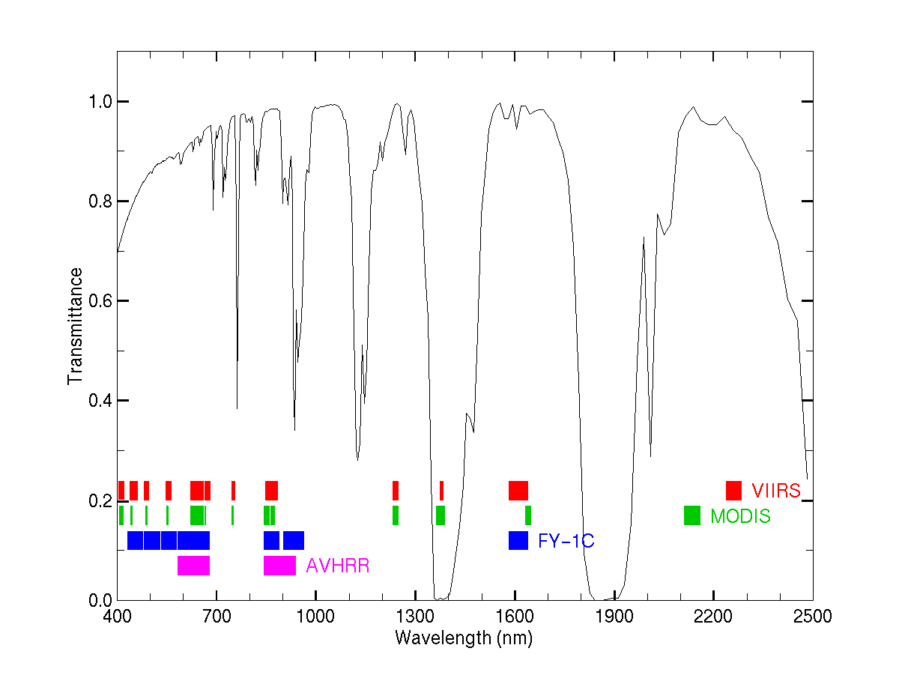

Inspect the scene over Italy on 29 May 2001 detected by MODIS using HYDRA (see the attached instruction sheet explaining how to run HYDRA). After engaging HYDRA, the HYDRA window will appear (Figure 1). To load a MODIS Level-1B 1KM file from disk, click on “data | local” and select the file to be loaded (e.g., MOD021KM.A2001149.1030.005.2007054003907.hdf). When the file is loaded, an image of the 11 μm radiances appears, as shown in Figure 2.

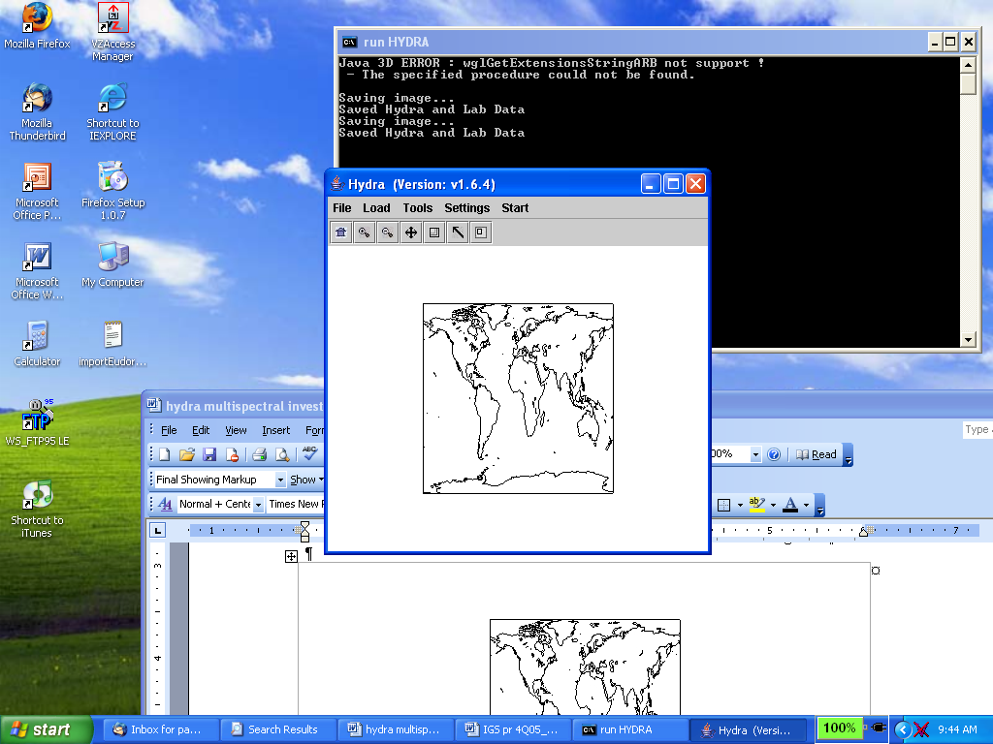

Figure 1: The HYDRA window.

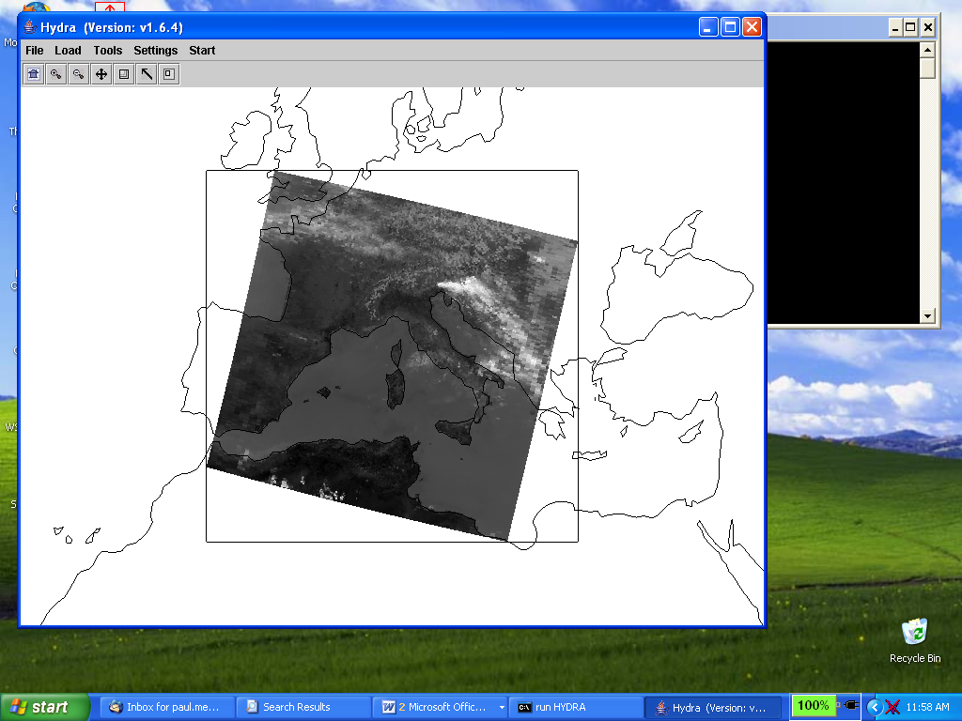

Figure 2: HYDRA window with a MODIS L1B 1KM file loaded.

- Get familiar with the command menu Settings. Band 31 (11 μm) is automatically displayed at reduced resolution. Try different black and white enhancements by adjusting the color range (Set Color Range). Use the toolbar at the top to zoom in and zoom out and translate the image. Reset the image. Display the image in color and try different color enhancements.

- Start the Multichannel Viewer. Display the data at full resolution by selecting a subset of the data displayed in the Hydra window (right icon in toolbar in the Hydra window). The one kilometer resolution data will appear in the Multichannel Viewer window (see Figure 3). Zoom in on island of Sardinia west of Italy in the Multi-Channel Viewer window and in the Hydra window – compare the resolution in the images. Use the arrow icon at the bottom of the Multichannel Viewer window to scroll around in the full resolution image – locate the lat & lon of the min and max brightness temperature values in the image.

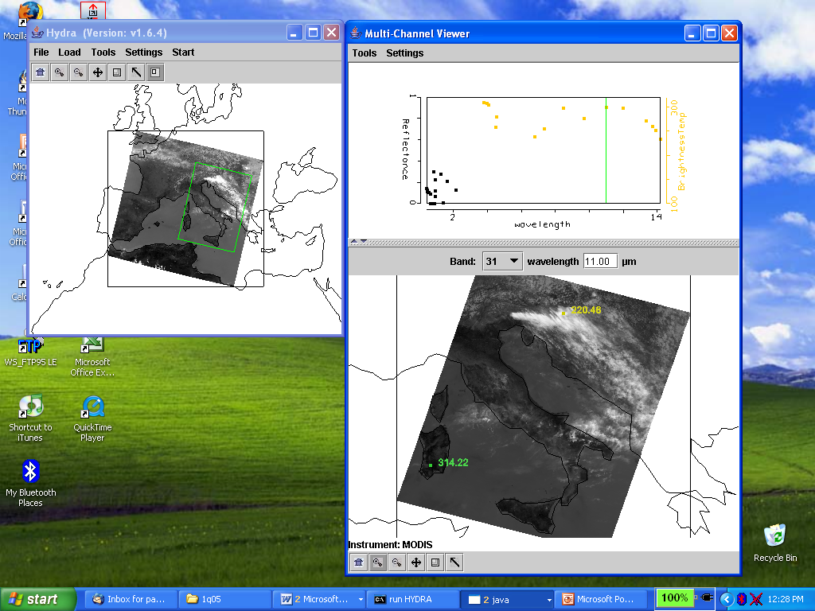

Figure 3: One kilometer resolution data displayed in the Multichannel Viewer window

- Zoom in on the clouds east of the Alps (using the right icon in the HYDRA window). Now select Band number 20 (3.8 μm) and display the image. Note how much warmer the 3.8 μm brightness temperatures are than those for 11 μm. What can be responsible for this? Create an image of 3.8 μm brightness temperatures allowing the range of values to span 270 to 310 K (using Set Color Range under Settings). Do the same for 11 μm. Create a power point slide with the two images side by side. Note how the clouds appear to be much larger in the 11 μm image.

- Zoom in on the shoreline in western Italy. Display a Reference Spectrum (under Tools). Compare the brightness temperature spectra in some locations near the shoreline (over land and sea) in northwestern Italy. Note the patches where the 3.8 μm brightness temperatures are much greater than those for 11 μm. What could be causing this?
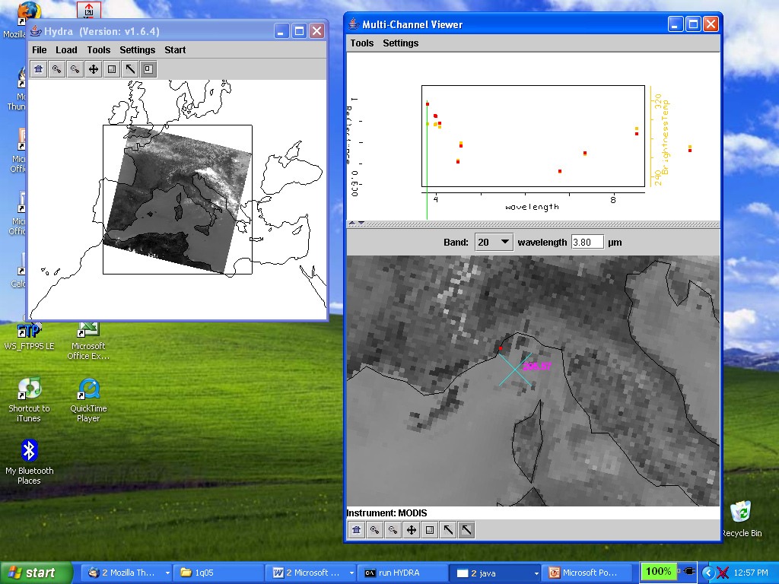

Figure 4: Multichannel Viewer window display of reference spectrum.

- Turn off the zoom feature and return to display of full scene at reduced (10 km) resolution. Display a Transect (under Tools) in the 3.8 μm image going through clouds, sea, and desert (see Figure 5). What are the min and max brightness temperatures encountered. Open another MultiChannel Viewer and do the same for 11 μm. Discuss the difference.

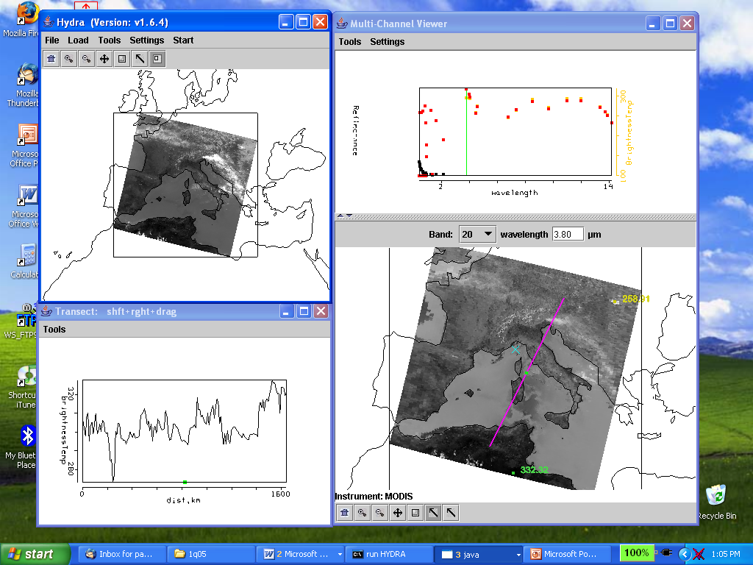

Figure 5: Brightness temperature transect of line displayed in Multichannel Viewer window

- Open Linear Combinations (under Tools). Create a pseudo image of 0.55 μm reflectances and mark the y-axis option. Create another of the 11 μm brightness temperatures and mark the x-acis option. Click on Scatter in the Channel Combination Tool window to generate a scatter plot (see Figure 6). Using the color areas boxes (or curves to encircle areas) to highlight pixels in the scatter plot and find where they are located in the images. Save your scatter plot and associated images on a power point slide. Explain high / low reflectances and cold / warm brightness temperature combinations in the notes section of the powerpoint slide. Construct the same scatter plot with radiances (W/ster/m2/μm) instead of reflectances and brightness temperatures.

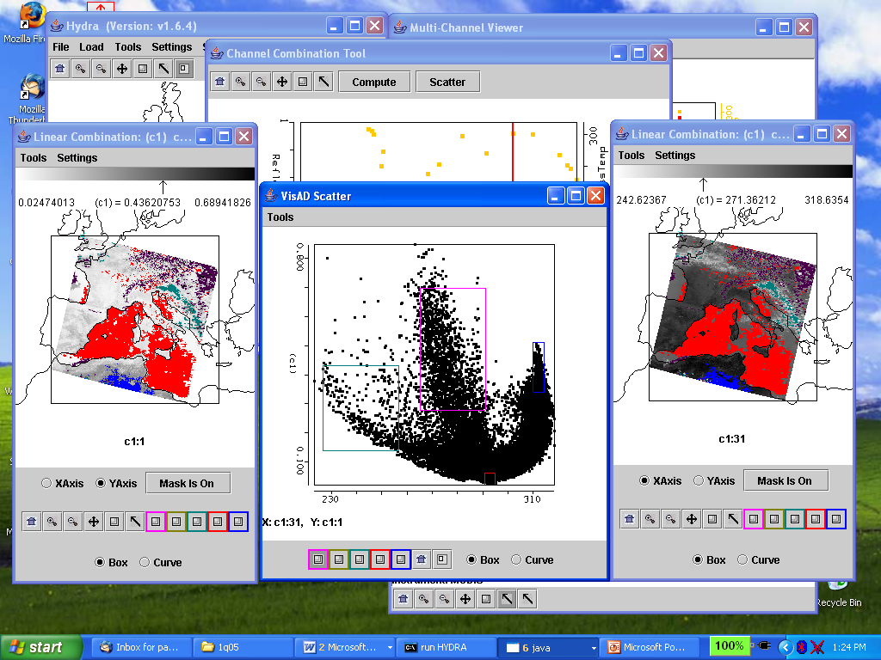

Figure 6: Scatter plot of vis on y-axis and IRW on x-axis

- Using the Linear Combinations window, create an image of the difference of 3.8 μm minus 11 μm brightness temperatures. Display the difference image in color. Use the color range to enhance features in various regions. Save this on a power point slide. Suggest three causes for the large differences for these two window channels? Explain.

8. In the notes section of the three power point slides created for exercises 3, 6, and 7 explain the features you see. Identify regions of ice clouds, ocean sun glint, coastal fog, desert, and snow.
Appendix – Summary of HYDRA Commands

HYDRA main window
Displays a world map and shows File, Load, Tools, Settings, and Start at top.

File offers
Exit to closes this window
New opens another HYDRA window

Load has the options
Local Data allows you to search local directories to find MODIS, AIRS, IASI, AMSU,
GOES, or SEVIRI data.
Remote Data allows you to get data from a remote server
(a) Terra or Aqua Direct Broadcast or (b) Goddard DAAC
GOES/MSG allows you to get geostationary satellite data from an ADDE server
Lidar allows you to display Calipso lidar data
AREA allows you to display McIDAS area files
After a data granule is selected HYDRA displays the infrared window (at reduced resolution 10 km for MODIS) on a world map.

Tools offers
Capture Display to save the image as a jpeg

Settings has
Set Color Range where the histogram of brightness temperatures or radiances can
be adjusted to maximize contrast – the color range can be altered with a
right click plus drag at either end of the color scale
Set Color Scale where Color, Gray and Inverse Gray gives choice of color, grey,
or inverse grey (which produces white clouds for infrared channels)

The toolbar at the top enables reset, zoom in, zoom out, translate, box magnify, find location, and subset at full resolution functions
Reset (left click on reset and then click on image to restore original image)
Zoom in (left click on zoom in plus click on image enables enlargement)
Zoom out (left click on zoom out plus click on image enables far view)
Translate (left click on translate plus click on image enables moving the image
within the window)
Rubber band zoom (left click on box plus click and drag to create box for enlargement)
Find location (left click on arrow plus click on image displays location of the chosen pixel)
Subset image at full resolution (only after Multi-Channel Viewer is engaged, then left
click on subset plus click and drag on image creates a subset of image at full resolution;
this is automatically transferred from HYDRA into the Multi-Channel Viewer when both
are engaged – data is displayed at reduced resolution by default unless subset function is used)

Start opens Multi Channel Viewer
wherein the measured spectra (wavenumber on x-axis and radiance or brightness
temperature on y-axis) is displayed along with a spectral band superimposed on a world map.
Left click on arrow icon in the bottom toolbar allows you to see the pixel value for a given
lat-lon (using left click and drag).

Tools menu (appears in Multi-Channel Viewer window)
Linear Combinations opens the Channel Combination Tool display where you
can specify linear combinations of spectral bands a,b,c and d
(a +-x / b) +-x / (c +-x / d).
RGB allows you to select a spectral channel for each color in the RGB display
Transect allows you to create a line on the image and see the temperatures or
radiances along the transect marked by shift plus right click and drag.
Capture Display allows you to save the image as a jpeg
Statistics displays the min and max values in the image
Reference Spectrum allows you to compare spectral measurements from two
selected pixels (controlled by the arrows in the bottom toolbar)

Settings (on the Multi-Channel Viewer) has
Set Color Range where the histogram of brightness temperatures or radiances can
be adjusted to maximize contrast – the color range can be altered with a
right click plus drag at either end of the color scale
BT->radiance allowing you to toggle from brightness temperatures to radiances
in the infrared spectral channels
Projection offers Lambert Equal Area or Instrument projections of the data
Set Color Scale where Color, Gray and Inverse Gray gives choice of color, grey,
or inverse grey (which produces white clouds)
Lat/Lon Grid can be superimposed on the image by using the toggle
Image Label labels the image with the instrument and day/time of the data

Import offers the opportunity to display lidar data (from Calipso and Cloudsat)

Channel Combination Tool (opened when Linear Combinations is selected) offers the usual tool bar
Compute creates a pseudo image of the selected linear combination (you can
indicate at the bottom your preference for this linear combination to be on
the x- or y-axis in the scatter plot) and displays a toolbar for image
manipulations (five color boxes are available in the toolbar to select
regions by boxes or curves in the image that will be displayed in the
scatter plot; a left click drag in the image highlights the chosen points in
the scatter plot).
Scatter creates a scatter plot of the chosen x- and y-axis linear combinations.
Five color area boxes (or area curves) in the bottom toolbar of the scatter plot
allow you to select points in the scatter plot that will be displayed in the
x-axis and y-axis images; a left click drag in the scatter plot highlights the
chosen points in the scatter plot and simultaneously in the x- and y-axis
images. Conversely (as indicated before) left click drag in the x- or y- axis
images shows the locations of the chosen pixels in the scatter plot. Each
color area box (or area curve) can be erased with a left click when the
color box is engaged; after erasure another area box (or area curve) can be
selected for this color. The zoom capability in the scatter plot (on the
bottom right of the toolbar) allows you to enlarge special features in the
scatter plot and investigated them in more detail.
RGB can be used to display an RGB where three pseudo images (created from
different linear combinations) have been selected to trigger the R, G, and B
color guns individually

Vewing Level 2 Products

When viewing level 2 products (staged in a separate file), HYDRA generates a display of that product. Current choices include the cloud mask (from MOD35), total column ozone and water vapor (from MOD07), cloud top properties (from MOD06), and AIRS profile retrievals (generated using a statistical regression retrieval algorithm trained with AIRS spectra calculated from radiosonde observations).

When viewing MOD07 or AIRS profiles, Variables offers the choice to display
air temperature profiles
total ozone
precipitable water
surface temperature
water vapor profiles
surface pressure

Levels offers 17 levels between 1100 and 50 hPa for the retrieval field display.

Settings offers a choice to Set Color Range, Set Color Scale, and Show Color Bar. The last choice enables superposition of a color bar label that identifies the values of the product associated with each color.

Tools offers the option of Capture Display that allows you to save the level 2 image as a jpeg, Transect that allows you to construct a transect across the level 2 product image, and Reference Profile that allows you to compare level 2 products from two selected pixels (controlled by the arrows in the bottom toolbar where the red dot indicates the location of the second profile).

