INSULATION: PREPARING FOR WINTER

ATTIC FLOOR INSULATION DELIVERED:
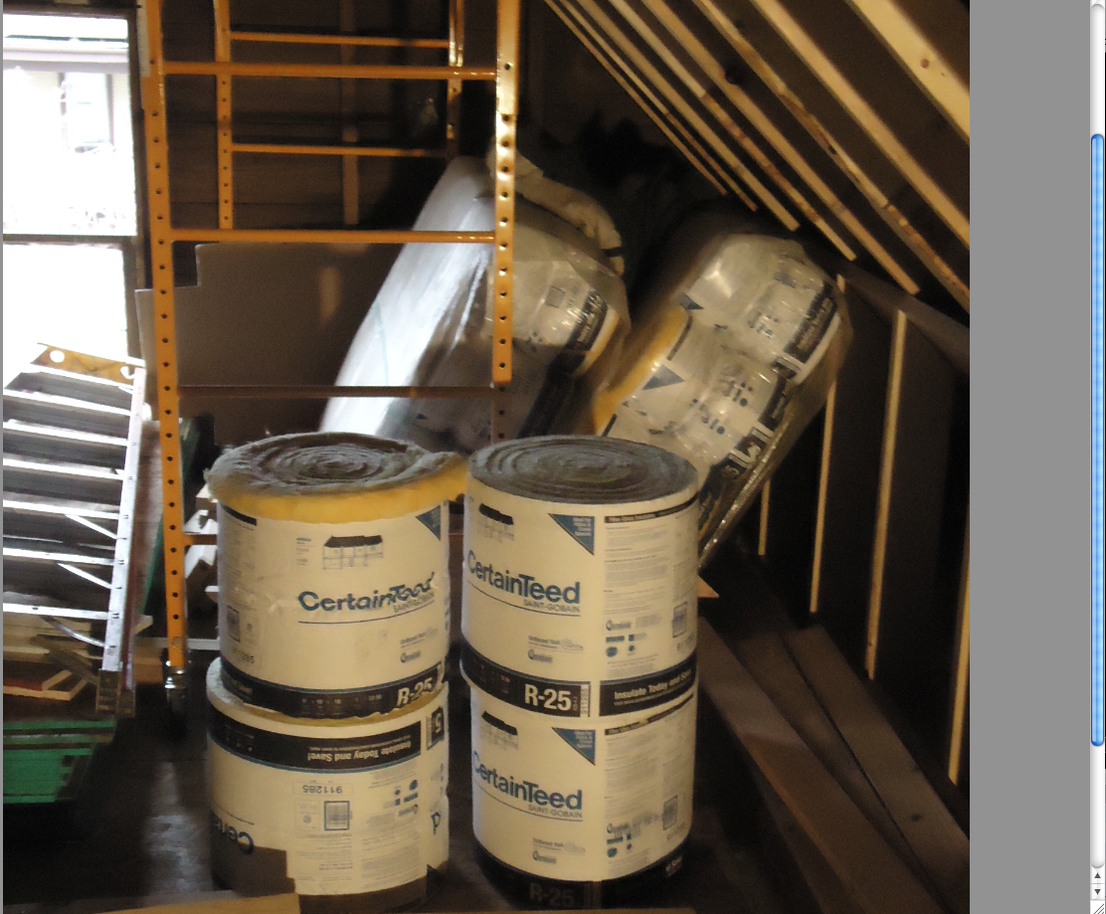

ATTIC FLOOR INSULATED AT R-50 ( 2 * R-25)
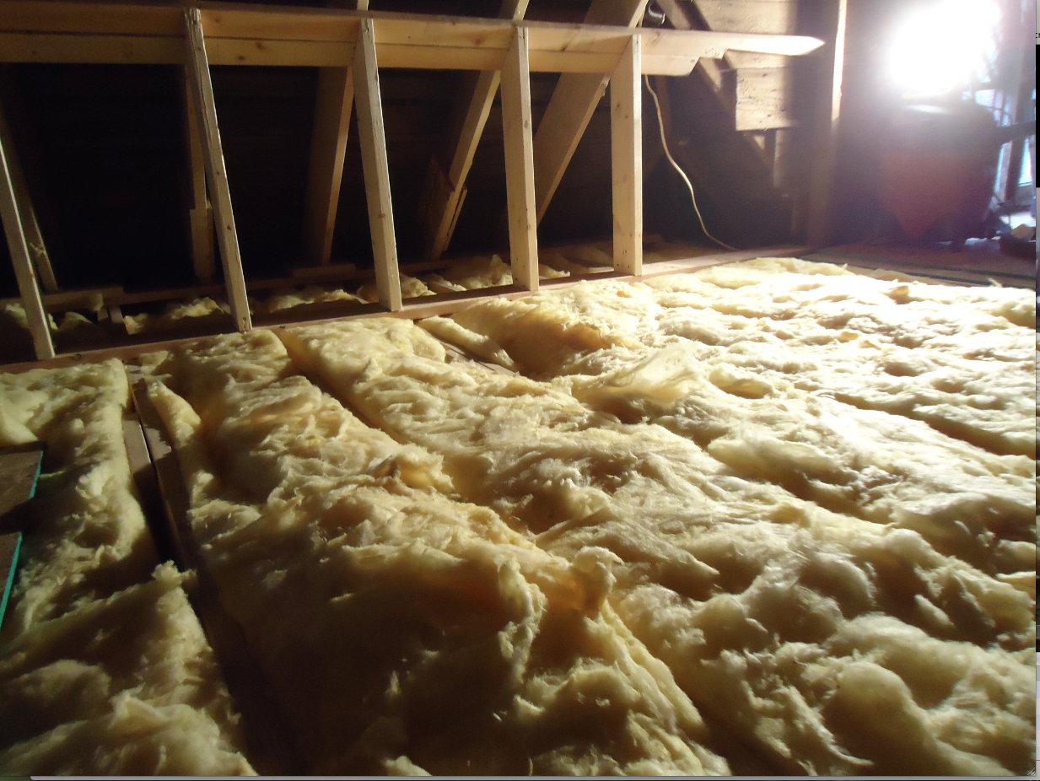

WHOLE ATTIC FLOOR FULLY INSULATED AT R-50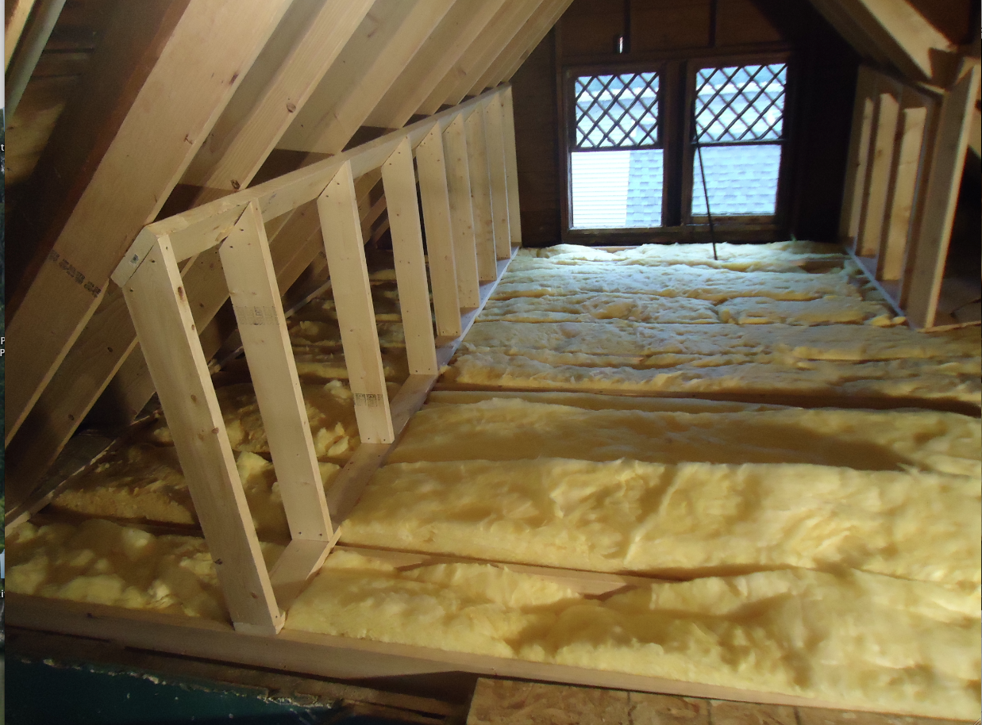
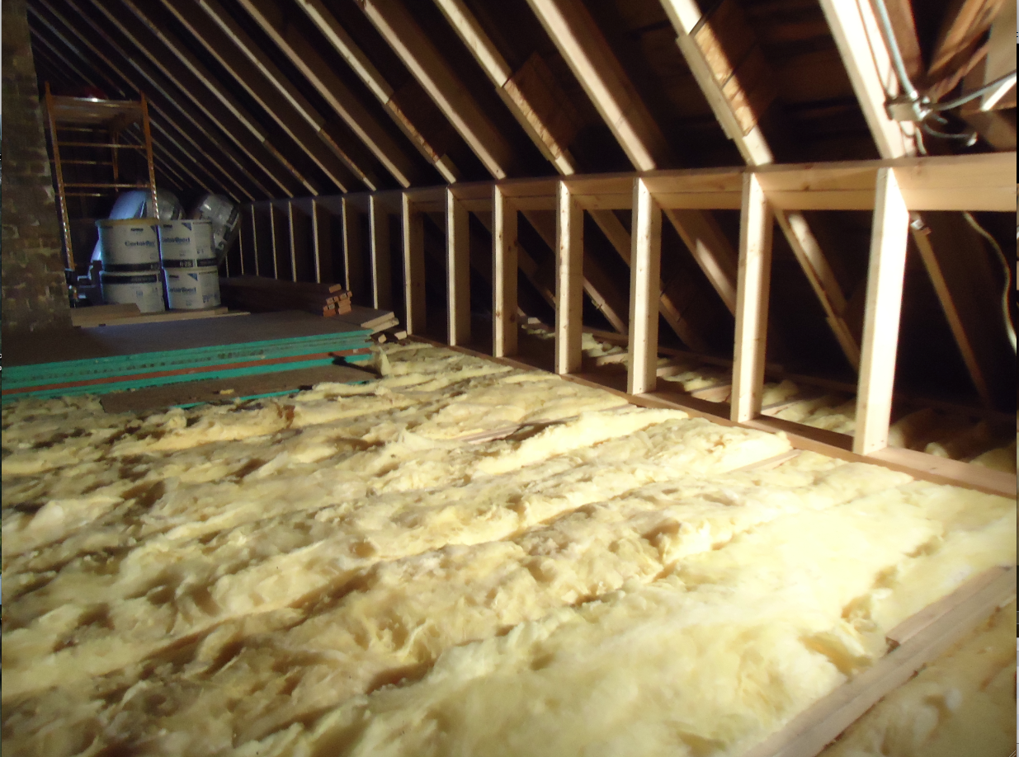

TEMPORARY FLOOR LAYED DOWN WITH STEEL ROOFING MATERIALS ON IT.
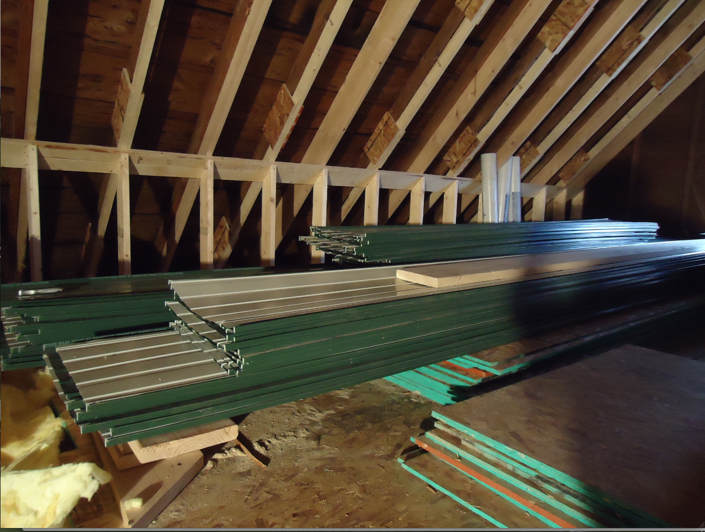

ATTIC BEFORE AND AFTER:
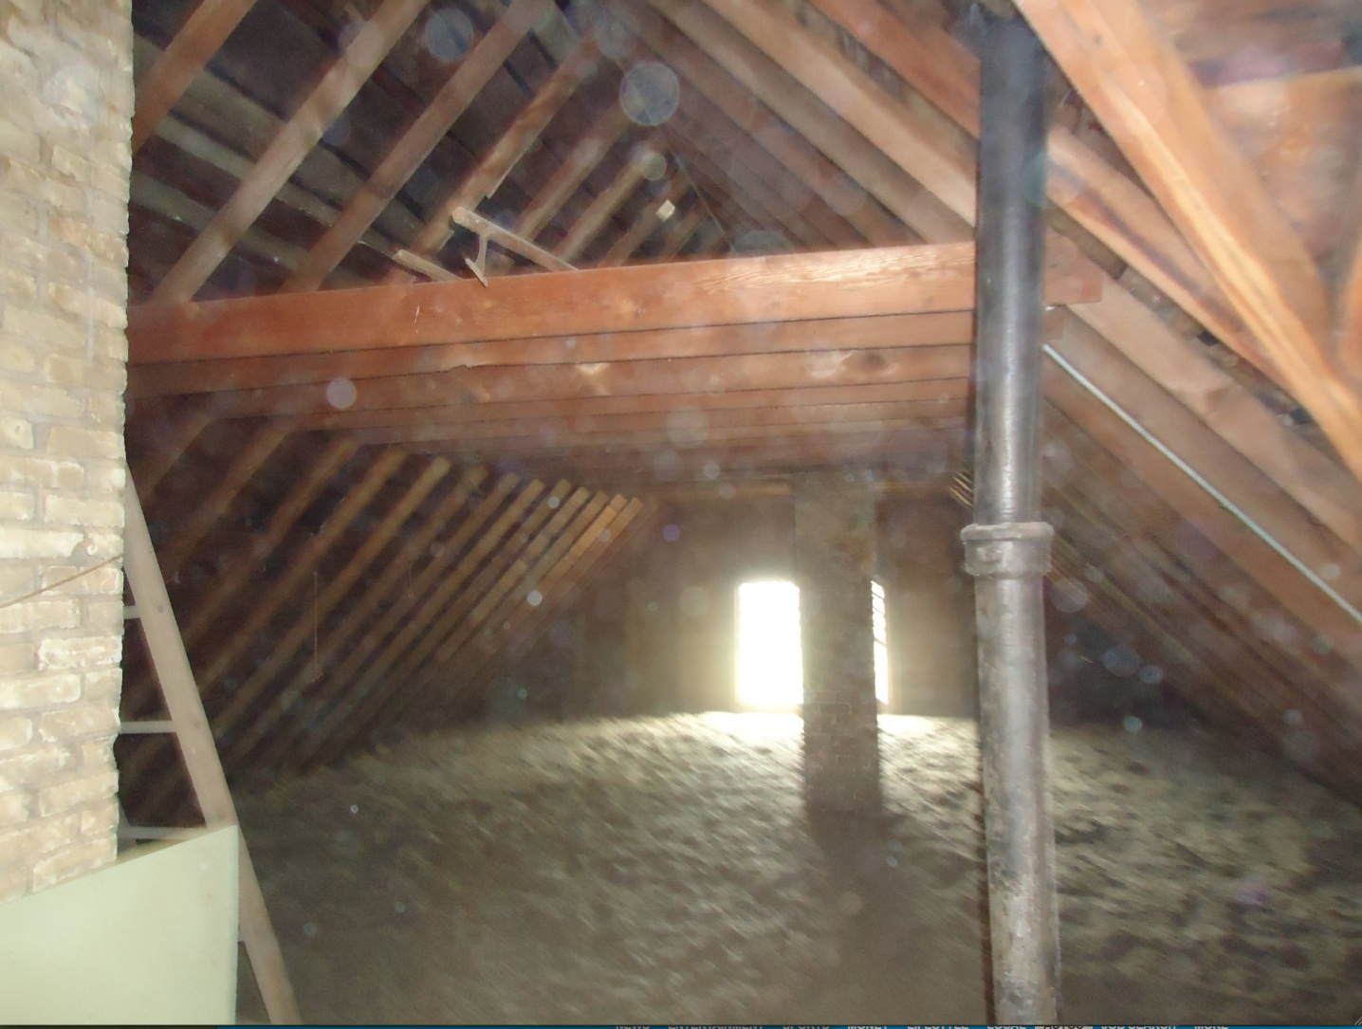

WINDOWS REPLACEMENT ON SECOND FLOOR:

We HAVE INSTALLED 8 WINDOWS SO FAR ON SECOND FLLOR AND HAVE 3 MORE TO GO. THE REST HAVE TO BE TEMPERED AND WE ARE AWAITING DELIVERY, SCHEDULED FOR JANUARY 9TH.

Note: we went with the brand new construction windows. I added new jam extensions and new trim casing. Low-E 366, Argon, Tilt, Nail Fin, Fiberglass mesh

SETTING UP SHOP:
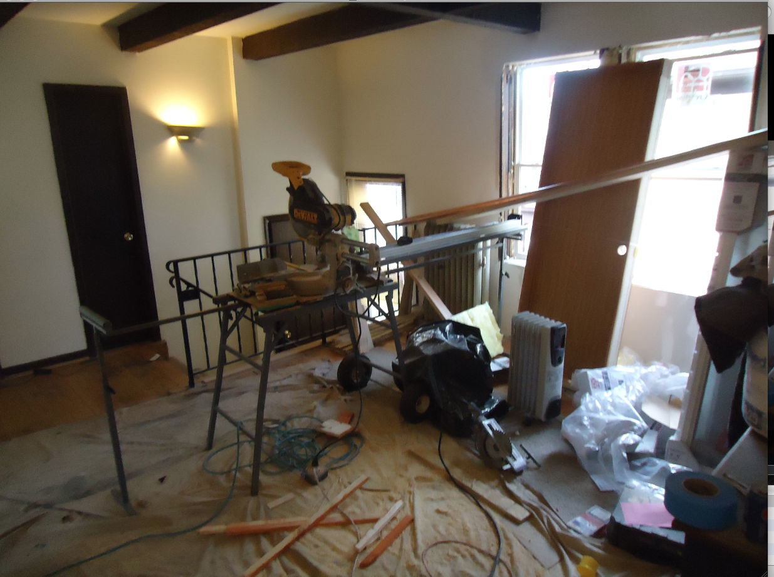

SECOND FLOOR:
1ST BR, Bigger window had to be special ordered and we are waiting for delivery.

1 New window, one old window.




