DRAFT -Beta version

WEATHER EVENT SIMULATOR (WES)

CIMSS University of Wisconsin-Madison
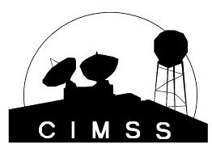
April 20, 2010

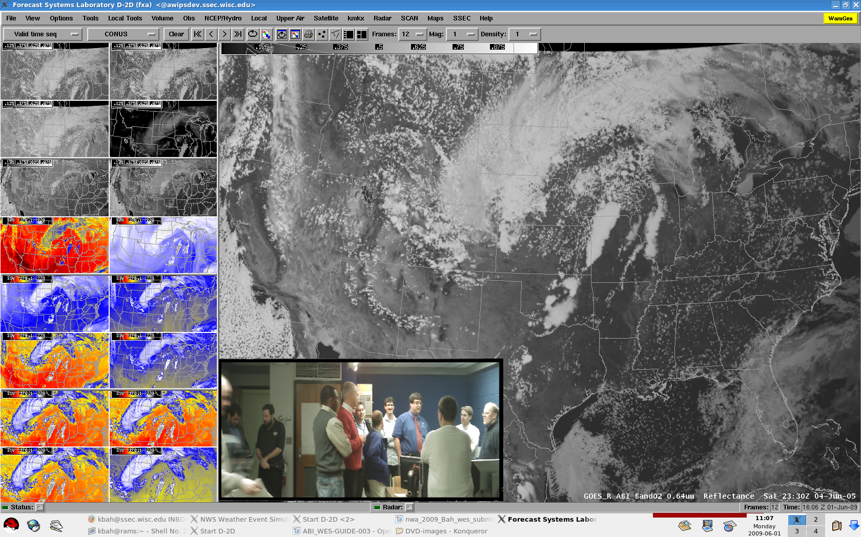  ABI Imagery  04-05 June 2005  Continental United States (CONUS)  28 August 2005  Hurricane Katrina  Pacific (West) case | WES  SIMULATION  GUIDE:  ADVANCED- BASELINE-  IMAGER (ABI).  
The ABI WES Development Team
CIMSS University of Wisconsin-Madison
NOAA/NESDIS Advanced Satellite Products Branch

Acknowledgments

This template of a Weather Event Simulator (WES) simulation guide borrows heavily from one developed by Rosemary Auld, which in turn borrowed heavily from that developed and released in early 2002 by a host of talented individuals at the NWS Warning Decision Training Branch (WDTB) in Norman, Oklahoma.

Many helped to produce this WES guide, especially, Kaba Bah and Jordan Gerth (CIMSS). Tim Schmit, of NOAA NESDIS Advanced Satellite Products Branch (ASPB) was also instrumental in the generation of this WES case. In addition, the GOES-R Proxy Team, especially Jason Otkin, is thanked for the high quality simulated data. The GOES-R Imagery Team is also thanked, including Mat Gunshor, CIMSS. Justin Sieglaff is thanked for the weather summary. Thanks also to the many NWS reviewers, especially Marcia Cronce of MKE. Finally, the support from the GOES-R Program Office, via the Proving Ground project, is acknowledged.

Table of Contents

Introduction: 3
Training Objectives : 6
The 04-05 June 2005 case study simulation: 7
The Weather: 7

Instructional Details: 9
Individual Bands: 10
Band01 12
Band02 13
Band03 14
Band04 15
Band05 16
Band06 17
Band07 18
Band08 19
Band09 20
Band10 21
Band11 22
Band12 23
Band13 24
Band14 25
Band15 26
Band16: .….........…....27
Spectral, Spatial and Temporal Improvements of GOES-R over current GOES: 28
ABI Spectral Improvements: 28
ABI Spatial Improvements: 29
ABI Temporal Improvements: 29
ABI Band Differences: 31
Other Simulated ABI cases: 33
Hurrican Katrina case: 33
Pacific (West) Simulations: 34
Mesoscale Simulations: 35
Comparing current GOES to GOES-R: 36
Select Reference: …........................................................................................................................................38
Introductory GOES-R ABI Videos: 40
Select links: 40
Appendix A-- ABI Spectral Bands: 41
Appendix B-- GOES-R Product Suite: 42
Appendix C-- Dertails on the simulation process: 43
Sample questions for WES ABI guide: 44

Introduction

The Advanced Baseline Image (ABI)

The Advanced Baseline Imager (ABI) will be on the GOES-R/S series. The GOES are denoted by letters on the ground, and then numbers after they reach their orbit. For example, GOES-R should become GOES-16. GOES-O was launched on June 27, 2009 and GOES-P was launched in March 2010. Current plans call for the GOES-R to be launched in late 2015 and operational in early 2017. Lessons from this ABI WES case can be applied before GOES-R is launched, given that the MODIS instruments supply some of the same spectral bands as on the ABI. The MODIS data are available experimentally within the AWIPS environment. The ABI is a 16-channel, imaging reflectometer/radiometer that will sense the visible, near-IR and the IR spectral regions. ABI spatial resolution will be nominally 2 km (at the satellite sub-point) for the infrared bands, 1 km for most near-IR bands and 0.5 km for the 0.64-μm visible band. While the instrument will allow a flexible scanning scenario, two basic modes are envisioned. One mode is that every 15 min ABI will scan the full disk (FD), plus the continental United States 3 times, plus a selectable mesoscale 1000 km × 1000 km area every 30 seconds. It is envisioned that two locations will be monitored, so for a given mesocale sector, its time resolution will be 1 min. The other mode is that the ABI can be programmed to scan the FD repeatedly. The FD image can be acquired in approximately 5 min. Each ABI band has been chosen to better meet validated user requirements by building upon experience with satellite and aircraft instruments. See appendix A for more information on the ABI bands.

Information Volume relative to current GOES

Compared to current GOES, the ABI has improved spectral, spatial, and temporal image resolution by factors of 3, 4, and 5 respectively. In addition, there will be improved radiometric and image navigation and registration performance. This allows for not only improved and new uses directly with the imagery, but it also allows for improved and new products to be derived from the ABI data.
Future versions of the ABI WES guide will include products as well as simulated imagery. See appendix B for a list of potential products derived from the ABI information.

Figure 1. The comparison of the information volume between current GOES Imager (red) and the GOES-R ABI (yellow) for the spectral, spatial and temporal resolutions.

The ABI will improve every product from the current GOES Imager and will introduce a host of new products, such as cloud-top phase/particle size information and improved snow/ice detection, total column ozone, aerosol and smoke detection for air quality monitoring and forecasts. Other new products include vegetation monitoring and upper-level sulfur dioxide detection. The ABI will begin a new era in U.S. environmental remote sensing with more spectral bands, faster imaging, and higher spatial resolution than the current GOES imager.

GOES  Imager  Band | Wavelength Range  (μm) | Central Wavelength  (μm) | Meteorological Objective
1 | 0.55 to 0.75 | 0.65 | Cloud cover and surface features during the day
2 | 3.8 to 4.0 | 3.9 | Low cloud/fog and fire detection
3 | 6.5 to 7.0  5.8 to 7.3 | 6.75 (GOES-8/11)  6.48 (GOES-12/15) | Upper-level water vapor
4 | 10.2 to 11.2 | 10.7 | Surface or cloud top temperature
5 | 11.5 to 12.5 | 12.0 (GOES-8/11) | Surface or cloud top temperature and low-level water vapor
6 | 12.9 to 13.7 | 13.3 (GOES-12/15) | CO₂ band: Cloud detection
Table of the current GOES Imagers. The wavelength values are nominal. From Hillger and Schmit.

Future GOES  Imager (ABI)  Band | Wavelength Range  (μm) | Central Wavelength  (μm) | Nominal sub-satellite IGFOV  (km) | “Nickname” and Type
1 | 0.45-0.49 | 0.47 | 1 | “Blue” band. Visible
2 | 0.59-0.69 | 0.64 | 0.5 | “Red” band. Visible
3 | 0.84-0.88 | 0.86 | 1 | “Veggie” band. Near-IR
4 | 1.365-1.395 | 1.38 | 2 | “Cirrus” band. Near-IR
5 | 1.58-1.64 | 1.61 | 1 | “Snow” band. Near-IR
6 | 2.235 - 2.285 | 2.26 | 2 | “Cloud-top phase” band. Near-IR
7 | 3.80-4.00 | 3.90 | 2 | Shortwave IR window band
8 | 5.77-6.6 | 6.19 | 2 | Upper-level tropospheric water vapor band. IR.
9 | 6.75-7.15 | 6.95 | 2 | Upper/mid-level tropospheric water vapor band. IR
10 | 7.24-7.44 | 7.34 | 2 | Lower mid-level water vapor band. IR
11 | 8.3-8.7 | 8.5 | 2 | “Cloud-top phase” band. IR
12 | 9.42-9.8 | 9.61 | 2 | “Ozone” band. IR
13 | 10.1-10.6 | 10.35 | 2 | “Clean” IR longwave window band
14 | 10.8-11.6 | 11.2 | 2 | IR longwave window band
15 | 11.8-12.8 | 12.3 | 2 | “Dirty” longwave window IR band
16 | 13.0-13.6 | 13.3 | 2 | “CO₂” longwave IR band

Table of ABI spectral band information. The wavelength values are nominal. Modified from Schmit et al.
Training Objectives
On successful completion of this simulation, the trainee should

1) Be familiar with the basic uses of each of the 16 ABI bands.

2) Understand and appreciate the advantages of having better spatial,
spectral and temporal resolution measurements.

3) Be familiar with some of the applications of band differencing techniques
such as estimation of low versus high clouds, cloud phase, mid level
temperature, etc.

The 04-05 June 2005 Case Study Simulation

Simulated ABI reflectance and brightness temperature data employed during this WES were computed using output from a high-resolution Weather Research and Forecasting (WRF) model simulation performed on a supercomputer at the National Center for Supercomputing Applications. The simulation contained 3 nested domains configured to represent the anticipated GOES-R scanning regions (i.e full disk, CONUS, and mesoscale). The simulation was initialized at 00 UTC on 04 June 2005 using 1º Global Forecasting System analysis and then integrated for 30 hours. Upon completion of the model simulation, the CIMSS forward radiative transfer modeling system was used to compute simulated radiance's for each ABI band. See appendix C for further details on the simulation process.

The Weather
One major reason for choosing 4-5 June 2005 for generating simulated GOES-R ABI radiance's was the large outbreak of significant severe weather reports across the central United States, from the Western Great Lakes southwest across portions of the Missouri and Mississippi Valleys into Oklahoma and northern Texas (Figure 2).

The synoptic setup for 12 UTC 4 June 2005 had a large-scale upper level trough over the Rocky Mountains/northern Plains and an upper level ridge over eastern US from the eastern Great Lakes south into the Appalachians. Within the upper-level trough, there were two noticeable short waves, one over eastern Nebraska/northwestern Missouri and another over northern New Mexico at 12 UTC 4 June 2005 (Figure 3). At the surface at 12 UTC, a broad area of low pressure was centered over South Dakota into Nebraska. A cold front/dry line extended south through central Kansas into western Oklahoma and western Texas. Further northeast, a warm front developed/sharpened later in the morning into the afternoon hours east from the area of low pressure across central Minnesota, central and southern Wisconsin into northern Illinois (Figure 4).

By early afternoon, an early morning convective complex associated with the lead short wave began to intensify and became severe over northern Illinois and southern Wisconsin. Ahead of the lead short wave, now over northern Illinois/southern Wisconsin, heating continued over central and northeastern Wisconsin and severe thunderstorm development continued into the afternoon and evening hours. Further south along the cold front/dry line, sunshine allowed for ample heating. This combined with the second short wave, lead to explosive severe thunderstorm development from southwestern Iowa/southeastern Nebraska southward into Oklahoma and northern Texas by mid to late afternoon. The severe thunderstorms continued into the overnight hours and into early June 5 as a broken squall line.
The GOES-R ABI simulated radiance's depict a very realistic data set of rapidly developing severe convection. While the simulation quite accurately developed convection in both time and space, the exact placement and timing of thunderstorm development is not important for this exercise. The importance of this simulation is the realistic set of radiance's for a convective outbreak, which is being used for training and preparation for GOES-R ABI.

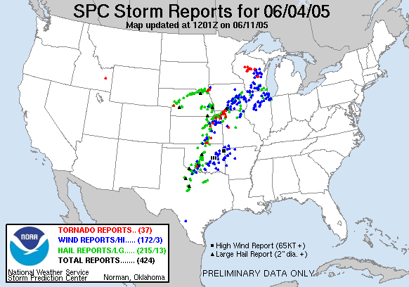
Figure 2. Storm reports from 4 June 2005. Source: Storm Prediction Center.

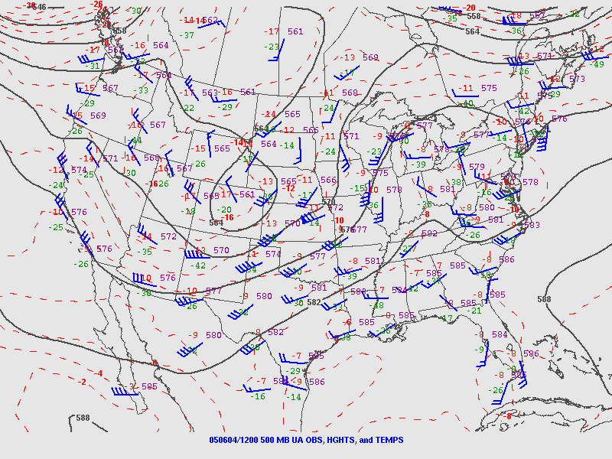
Figure 3. 500 hPa analysis at 12 UTC 4 June 2005. Source: Storm Prediction Center

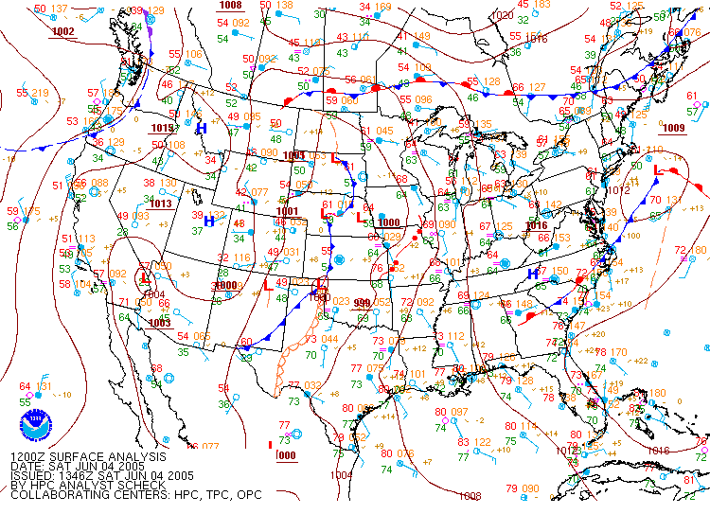
Figure 4. Surface Analysis at 12 UTC 4 June 2005. Source: Hydro meteorological Prediction Center

Instructional Details

Focus

The focus of these simulations is to showcase how the advanced imager on GOES-R/S will monitor rapidly changing convection and to introduce the various uses for the ABI bands. Future versions of this WES case should include products, derived from the simulated data, in addition to the images. The expected GOES-R product generation algorithms would be used.

It is expected that each user will proceed at his or her own pace.

This WES simulation is developed as part of the GOES-R proving ground concept to prepare forecasters for the amplification in the data resolution, both spatially, spectrally, and temporally. In other words, the ABI will provide data at higher spatial resolution more often (better temporal resolution) and in more channels (better spectral resolution). From this case, we can learn why some of the bands in the ABI instrument were chosen, how band differencing can be used to differentiate low vs high clouds, study cloud phase via visible, cloud phase via IR/near IR, and mid level temperatures, etc.

GOES-13 Sounder |  | GOES-8+ Imager |  | GOES-12+ Imager |  | MODIS |  | ABI
Band | Wvlength | Band | Wvlength | Band | Wvlength | Band | Wvlength | Band | Wvlength
18 | 3.75 |  |  |  |  | 20 | 3.8
17 | 3.98 | 2 | 3.9 | 2 | 3.9 | 21 | 4.0 | 7 | 3.9
 |  |  |  |  |  | 22 | 4.0
16 | 4.13 |  |  |  |  | 23 | 4.1
15 | 4.45 |  |  |  |  | 24 | 4.5
14 | 4.53 |  |  |  |  | 25 | 4.5
13 | 4.57
12 | 6.52 |  |  | 3 | 6.5 |  |  | 8 | 6.19
11 | 7.02 | 3 | 6.8 |  |  | 27 | 6.78 | 9 | 6.95
10 | 7.45 |  |  |  |  | 28 | 7.34 | 10 | 7.34
 |  |  |  |  |  | 29 | 8.55 | 11 | 8.5
9 | 9.70 |  |  |  |  | 30 | 9.72 | 12 | 9.61
 |  |  |  |  |  |  |  | 13 | 10.35
8 | 11.00 | 4 | 10.7 | 4 | 10.7 | 31 | 11.0 | 14 | 11.2
7 | 12.03 | 5 | 12.0 |  |  | 32 | 12.0 | 15 | 12.3
6 | 12.71
5 | 13.36 |  |  | 6 | 13.3 | 33 | 13.4 | 16 | 13.3
4 | 13.64 |  |  |  |  | 34 | 13.7
3 | 14.08 |  |  |  |  | 35 | 13.9
2 | 14.34 |  |  |  |  | 36 | 14.2
1 | 14.72
Table for the IR bands of the GOES Sounder, Imagers, MODIS and ABI.

Introduction to Individual bands
After installing the ABI WES case into your local machine or integrating it into your existing WES case, run “start_awips”. Once the AWIPS D2D window is displayed, you should see a display window similar to figure 5 shown below.
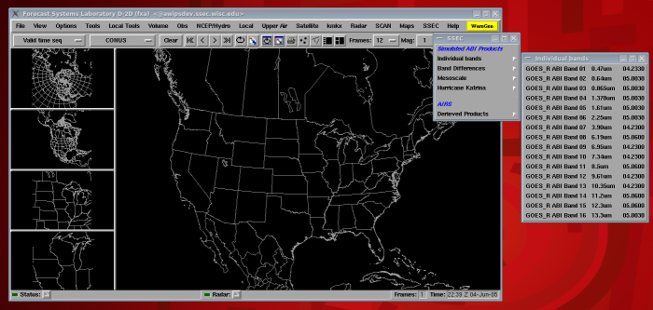
Figure 5. The default AWIPS D2D window with the simulated ABI menus under “SSEC”.

Adjust the frames from the default ‘12” to 64 for more complete loops.
Click on “SSEC” in the menu tab, then click on “Individual bands” to see the menu for all the 16 ABI bands as shown on right hand side of the figure 7.
Select a band of your choice under “Individual bands” and click on the loop button in the AWIPS D2D. You should see the frames of the selected band start loading and looping as it loads. To load a different band, go back to “Individual bands” and select a different band. Note that bands 01 through 06 (0.47 through 2.25 µm) which covers the visible and near IR regions shows reflectance while bands 07 though 16 (3.90 through 13.2 µm) shows brightness temperature.

Note that to load two bands at once, and then to toggle (or fade) between them is accomplished using the AWIPS “Toggle combination” key. Use the “.” (period on the alphanumeric keypad) to toggle images, or use the “+” and “-“ keys to fade an image on top of each other.
Individual Bands
Band 1 (Daytime “Blue” band)
The 0.47-μm, or ‘blue’ band, is one of the two visible bands on the ABI and will provide data throughout the day for monitoring aerosols. This band is well established on NASA’s MODIS instrument. The geostationary 0.47-μm band will provide nearly continuous daytime observations of dust, haze, smoke and clouds. Measurements of aerosol optical depths (or AOD) will help air quality monitoring and tracking. This blue band, combined with a green band (which will need to be simulated from other bands and/or sensors) and a red band, can provide “simulated natural color” imagery of the Earth. Measurements in the blue band may provide estimates of visibility. The 0.47-μm band will also be useful for air pollution studies and will improve numerous products that rely on clear-sky radiances (such as land and sea surface products). Other potential uses are related to solar insolation estimates.

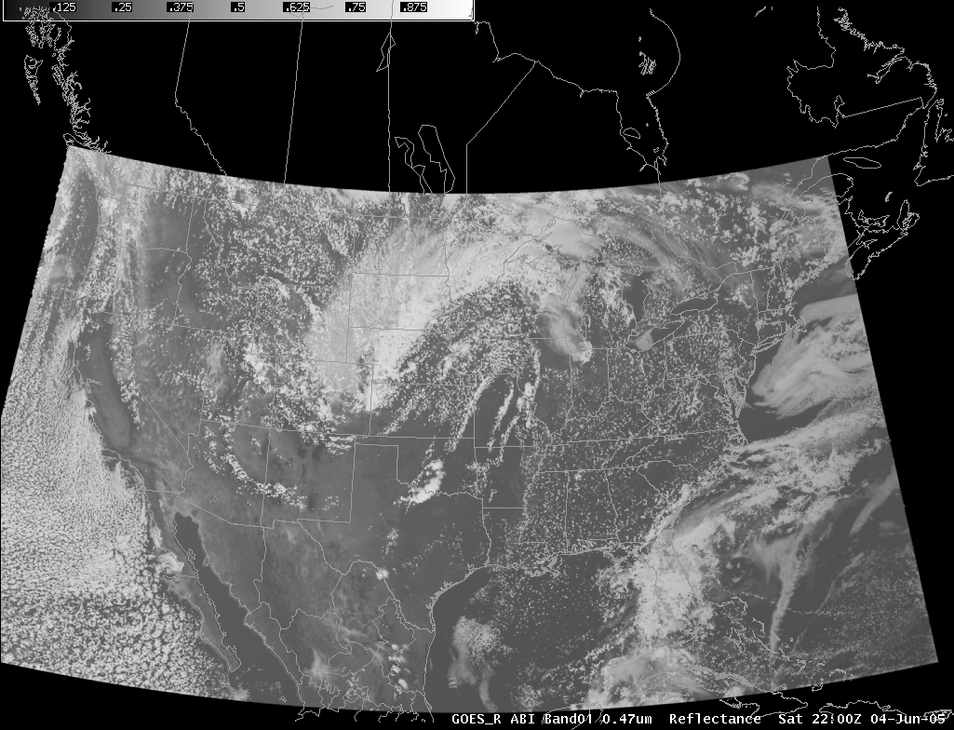
Figure 6. Simulated ABI band 01 (0. 47 µm) for 04 June 2005 at 22:00 UTC.

Click on “SSEC”; click on “Individual bands”; click on “GOES_R ABI Band 01”;click on the loop button in the AWIPS D2D.
The main difference between this band and the traditional visible band is that ABI Band 1 is more sensitive to smoke and aerosols (since there is more scattering at the shorter wavelengths). That said, this simulation does not include this affect. Note the fog over Lake Erie and the low clouds over the Atlantic.

Band 2 (Daytime “Red” band)
The second ABI visible band is the 0.6-μm (or ‘red’) band and during the daytime, will assist in the detection of fog, estimation of solar insolation and depiction of diurnal aspects of clouds. It’s called the ‘red’ band because the center frequency of this band is near the ‘red’ part of the visible spectrum. The 0.6-μm visible band is also used for daytime snow and ice cover, detection of severe weather, low-level cloud-drift winds, smoke, volcanic ash, hurricane analysis, and winter storm analysis. A similar band on the current GOES imager has demonstrated many of these applications, although the ABI will offer improved spatial and temporal resolutions.

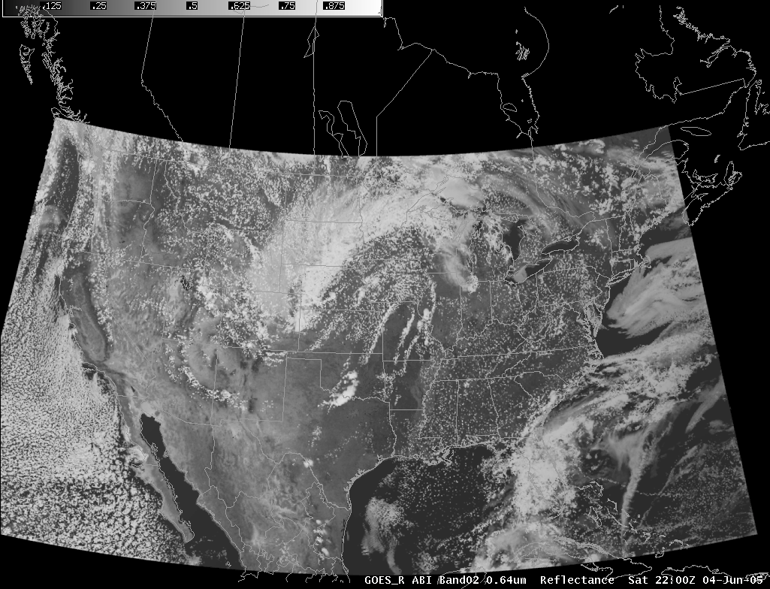
Figure 7 Simulated ABI band 02 (0.64 µm) for 04 June 2005 at 22:00 UTC.

Click on “SSEC”
Click on “Individual bands”
Click on “GOES_R ABI Band 02”
Click on the loop button in the AWIPS D2D.

Identify the different types of clouds you can see with only this single band.

Band 3 (Daytime “Veggie” band)
The 0.86-μm band (a near-infrared (or ‘reflective’ band), along with the 0.64-μm (“red”) ABI band 2, will be used for detecting daytime clouds, fog, and aerosols, and calculating a normalized difference vegetation index, hence it’s the ‘vegetation’ band. This band can help in determining vegetation amount, estimating aerosol properties, and studying ocean characteristics. The current GOES lone visible channel does not delineate burn scars, thus, this band on the ABI has potential for detecting forest regrowth patterns. It is anticipated that low-level winds may be derived from time sequences of the ABI band 3 (0.86- μm) images, especially over the water.

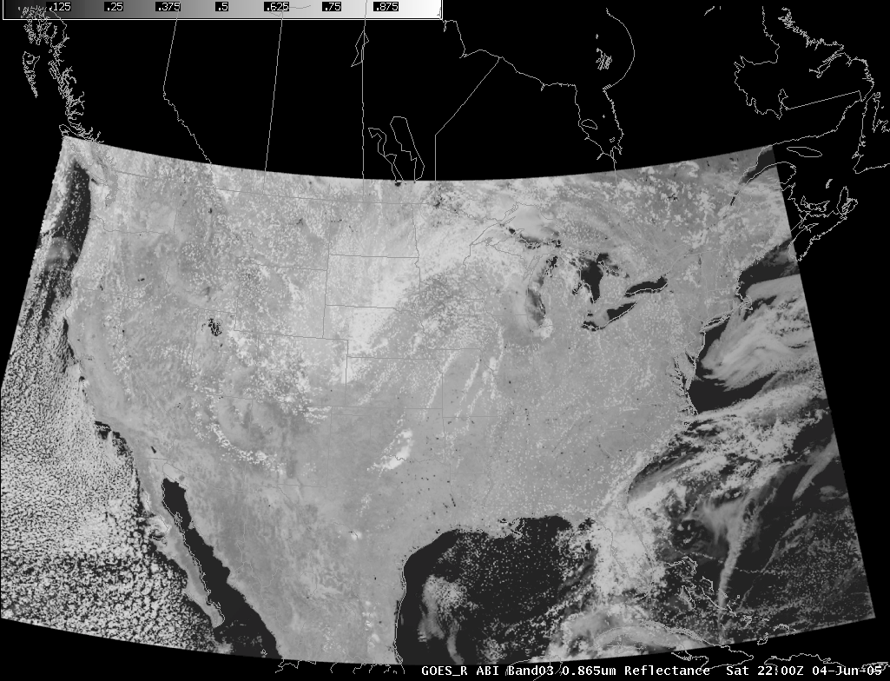
Figure 8. Simulated ABI band 03 (0.865 µm) for 04 June 2005 at 22:00 UTC.

Note how much brighter the vegetated land is, compared to the ABI band 2. This is due to more reflection. Also note both both images show relatively dark values over the water (ocean or lake). “Toggle” between ABI bands 2 and 3. Which areas are similar (water and clouds), which areas are different (vegetation).

Band 4 (Daytime “Cirrus” band)
Another near-IR band, the ‘cirrus band’ at 1.38-μm will detect very thin cirrus clouds during the day. This band is centered in a strong water vapor absorption spectral region. It does not sense the lower troposphere and thus provides excellent daytime sensitivity to high, very thin cirrus under most circumstances. Correction for the presence of contrail and thin cirrus, which are possible with this band, is important when estimating many surface parameters. Hence, this band can be used to distinguish between low and high clouds.

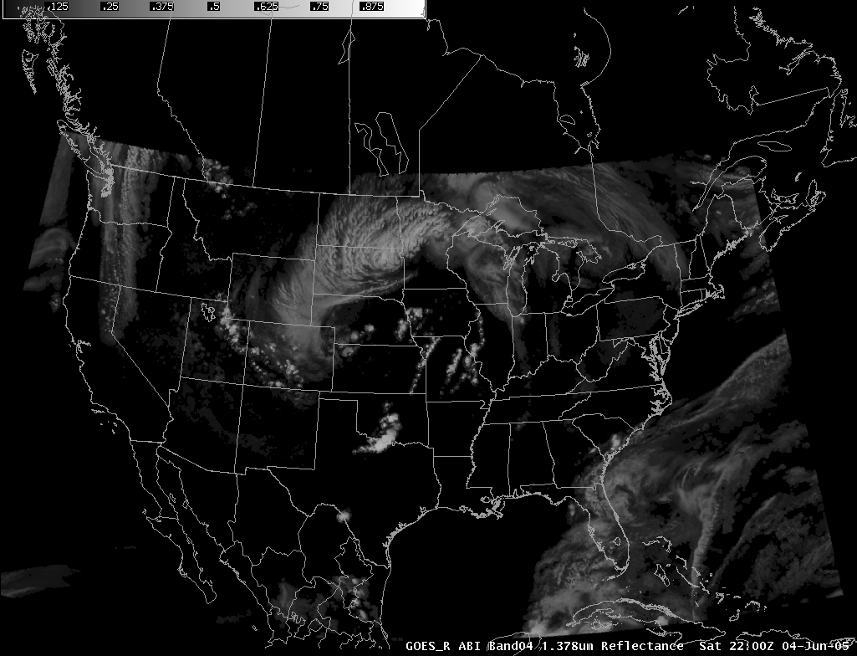
Figure 9. Simulated ABI band 04 (1.378 µm) for 04 June 2005 at 22:00 UTC.

Note for this scene, that no surface features (eg, coastlines) can be seen. “Toggle” between ABI band 4 and 2. Which are the high clouds, which must be the lower clouds/features.

Band 5 (Daytime “Snow” band)
In conjunction with other bands, the 1.6-μm, or “snow” band will be used for daytime cloud/snow/ice discrimination, total cloud cover estimation, cloud-top phase, and smoke detection from low-burn-rate fires. The 1.6-μm band has a relatively large difference between the imaginary refraction components between water and ice that makes daytime water/ice cloud delineation possible; this will be very useful for aircraft routing. This band has also been used (from MODIS) to highlight areas of previous freezing rain.

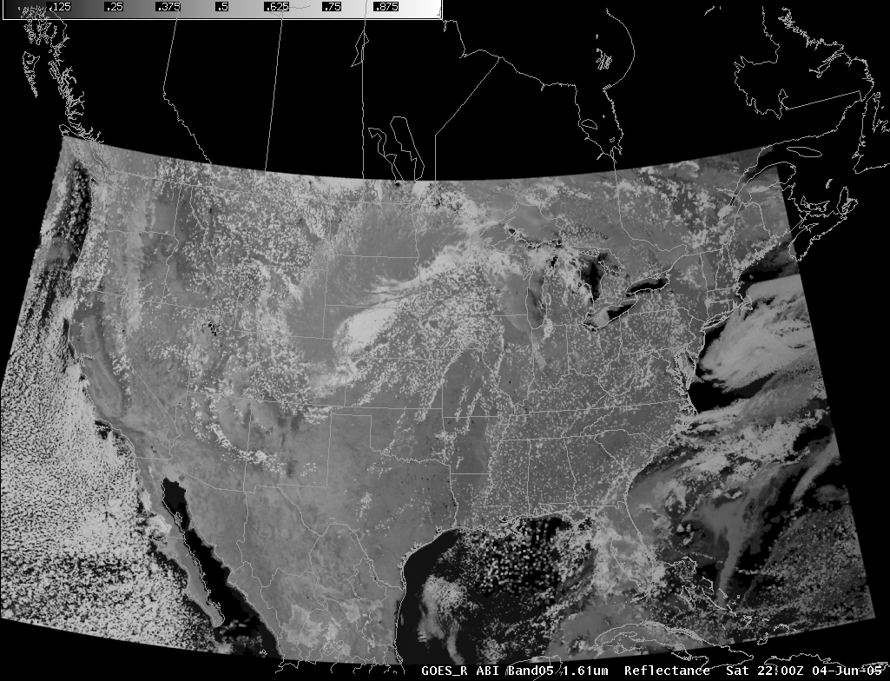
Figure 10. Simulated ABI band 05 (1.6 µm) for 04 June 2005 at 22:00 UTC.

Note the darker (more absorption) of the clouds over the Dakota’s. What type of clouds might these be? “Toggle” between ABI band 5 and band 2. Note the ‘less reflective’ (eg, darker) clouds in ABI band 5 are the ice clouds. Using this band, some high clouds can be more distinct, for example the clouds over OR and WA states.

Band 6 (Daytime “Cloud-top phase” band)
The 2.25-μm band, in conjunction with other bands, will enable during the daytime cloud particle size estimation; cloud particle growth is an indication of cloud development and intensity of that development. Other applications of the 2.25-μm band include use in a multi spectral approach for cloud-top phase, aerosol particle size estimation (by characterizing the aerosol-free background over land), cloud screening, hot-spot detection, snow detection, and total moisture determination. The MODIS cloud mask algorithm uses a similar band.

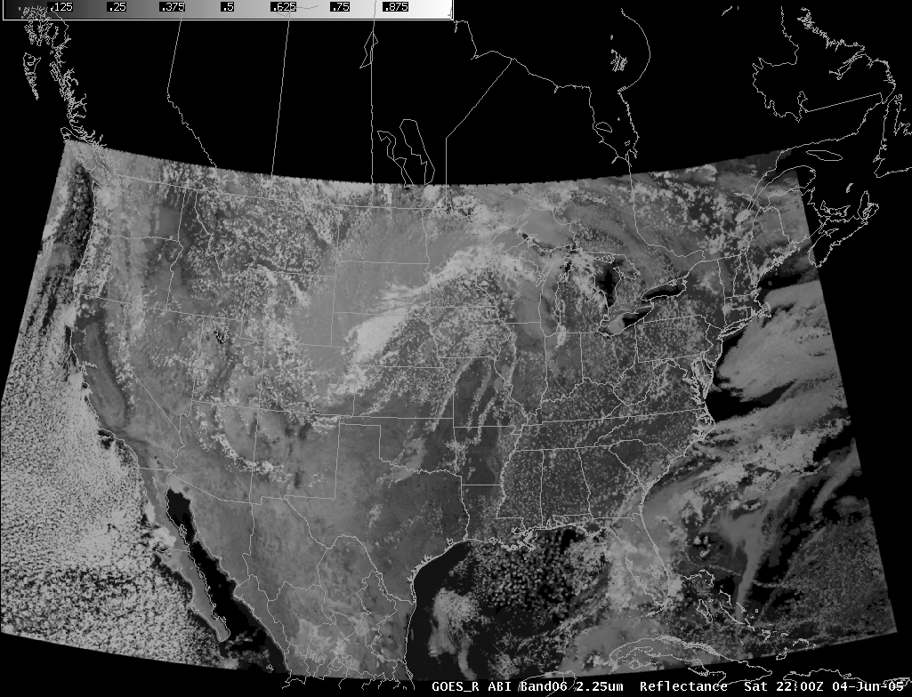
Figure 11. Simulated ABI band 6 (2.25 µm) for 04 June 2005 at 22:00 UTC.

Qualitatively, ABI band 6 is similar to band 5. Compare ABI band 6 to ABI band 2 (eg, the ‘red’ visible band). Note the location of ice versus water clouds. It is envisioned that various image differences will be most effective with this spectral band. This band, along with the various other ABI bands will be used for product generation.

Band 7 (Shortwave IR window band)
The shortwave IR window (3.9 μm) band (on the current GOES imagers) has been demonstrated to be useful in many applications, including fog/low cloud identification at night, fire/hot-spot identification, volcanic eruption and ash detection, and daytime snow and ice detection. Low-level atmospheric vector winds can also be estimated using this band. The shortwave IR window is also useful for studying urban heat islands and clouds.

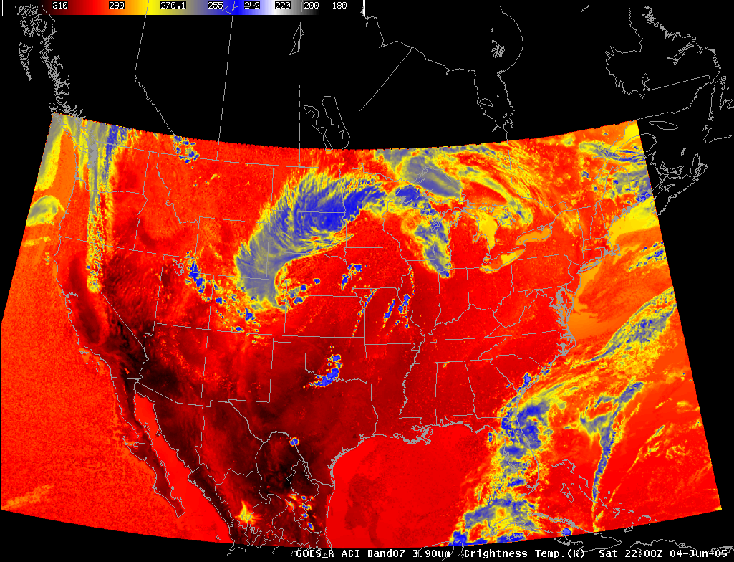
Figure 12. Simulated ABI band 07 (3.9µm) for 04 June 2005 at 22:00 UTC.

Note the overall warm temperatures in this shortwave window band, due to the additional reflected solar component. “Toggle” between this band and the ABI band 2 (eg, the ‘red’ visible band). As with today’s imager, this band will be differenced with the longwave IR window band for a number of applications, including: low cloud/fog, hot spots, low-level moisture, volcanic ash, etc. Note the fog/stratus over Lake Erie.

Band 8 (Upper-level tropospheric water vapor band)
This is one of the three water vapor bands on the ABI. The 6.2 micrometer “water vapor” band will be used for upper-level tropospheric water vapor tracking, jet stream identification (e.g., location of clear slots), hurricane track forecasting, mid latitude storm forecasting, severe weather analysis, and upper mid-level moisture estimation (for the legacy vertical moisture profiles) and possibly turbulence. This band can be used to estimate atmospheric motion vectors. This is the water vapor band most similar to those on heritage GOES imagers.

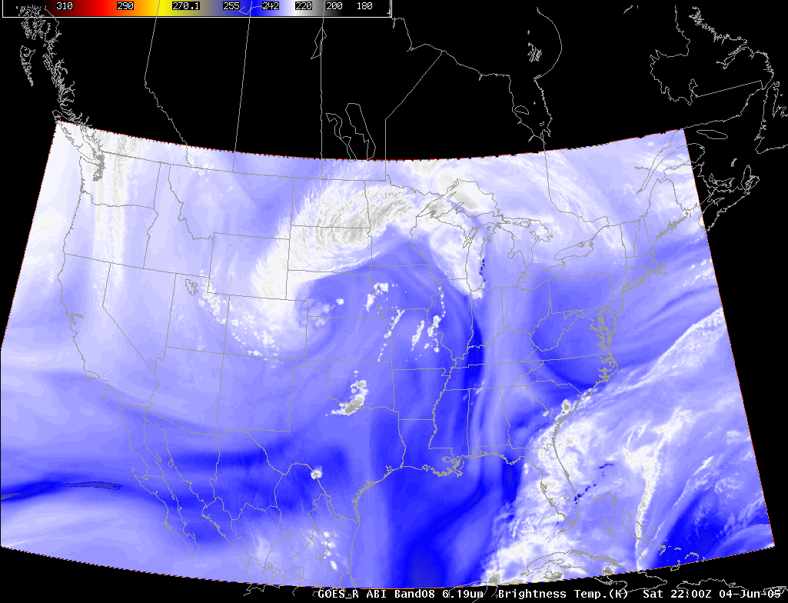
Figure 13. Simulated ABI band 08 (6.19 µm) for 04 June 2005 at 22:00 UTC.

Note the overall ‘cooler’ temperatures in this water vapor band, denoting a higher peaking spectral band. This band is very sensitive to upper level moisture.

Band 9 (Upper/mid-level tropospheric water vapor band)
The 7.0-μm “water vapor” band will be used for upper-level tropospheric water vapor tracking, jet stream identification, hurricane track forecasting, mid latitude storm forecasting, severe weather analysis, and mid-level moisture estimation (for the legacy vertical moisture profiles). This band can be used to estimate atmospheric motion vectors.

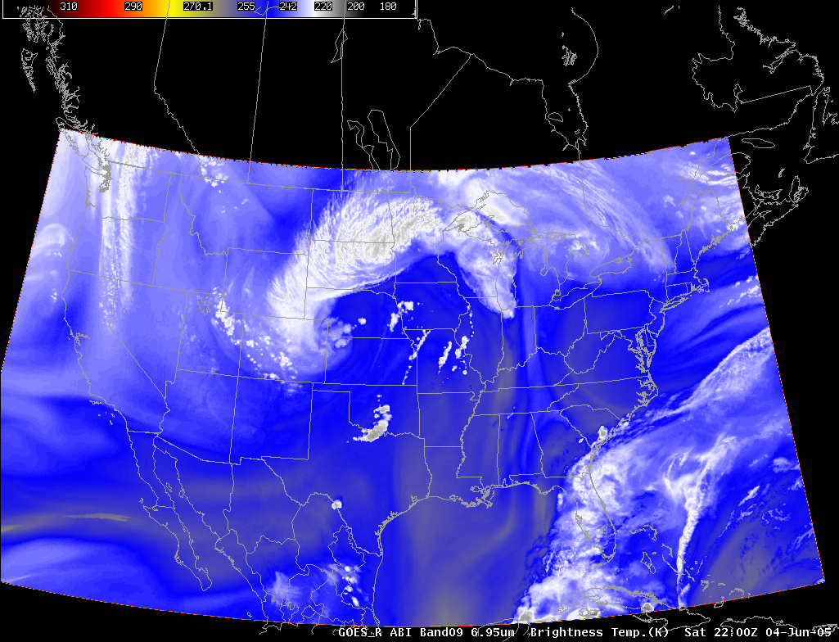
Figure 14. Simulated ABI band 09 (6.95 µm) for 04 June 2005 at 22:00 UTC.

This water vapor band peaks lower in the atmosphere (than ABI band 08) as evident by the slightly warmer brightness temperatures. This band is sensitive to mid-level moisture.

Band 10 (Lower mid-level water vapor band)
The 7.3-μm band reveals information about lower mid-level atmospheric flow and can help identify jet streaks. It has been proven to be useful in identifying and tracking volcanic plumes due to upper-level sulfur dioxide absorption. Vertical moisture information can be gained from comparison of measurements in all three water vapor bands as is done with current GOES sounder bands.

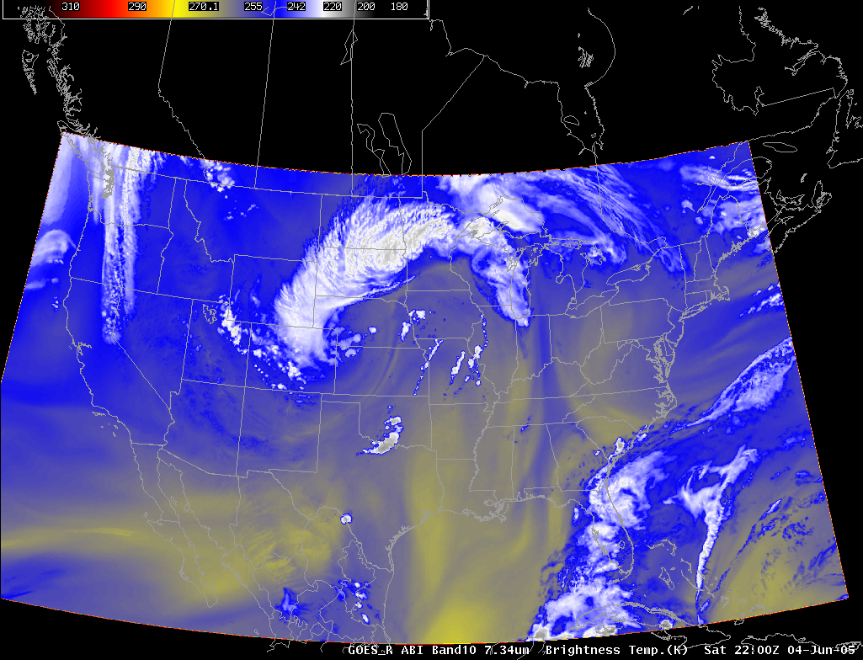
Figure 15. Simulated ABI band 10 (7.34 µm) for 04 June 2005 at 22:00 UTC.

This is the ‘warmest’ of the water vapor bands. ““Fade” or “toggle” between the three water vapor bands on the ABI. Note that current GOES imager, there is only one mid-level “water vapor” band.

Band 11 (“Cloud-top phase” band)
The 8.5-μm, or ‘cloud phase’ band has been used in combination with the 11.2-, and 12.3-μm bands to derive cloud top phase. This band is similar to the “traditional” IR longwave window band. This determination of the micro physical properties of clouds includes a more accurate and consistent delineation of ice clouds from water clouds during the day or night. The same three spectral bands enable detection of volcanic dust clouds containing sulfuric acid aerosols. Other uses of the 8.5-μm band include thin cirrus detection in conjunction with the 11.2-μm band, better atmospheric moisture correction in relatively dry atmospheres in conjunction with the 11.2-μm band, and estimation of surface properties in conjunction with the 10.35-μm band. This is also a key band in many product generations.

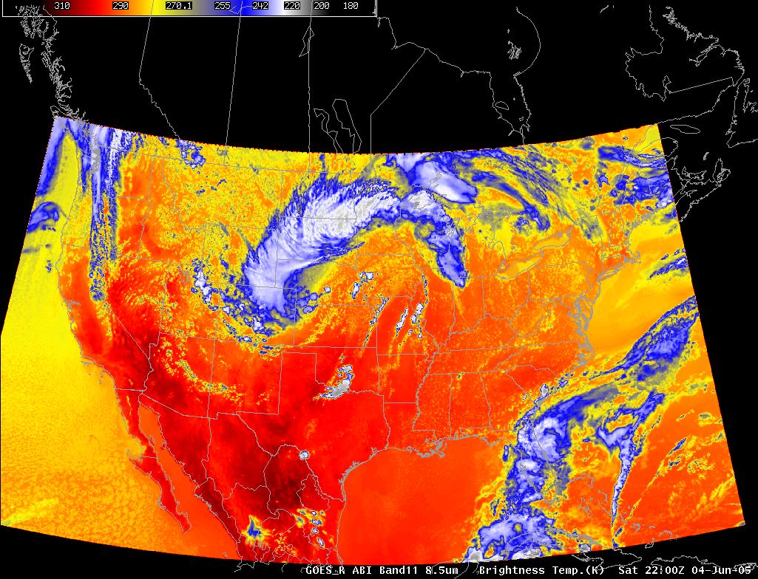
Figure 16. Simulated ABI band 11 (8.5 µm) for 04 June 2005 at 22:00 UTC.

Note, via a “fade” or “toggle” the similarity of this band to the traditional IR window band (ABI band 14).

Band 12 (“Ozone” band)
The “ozone” band at 9.6 μm will provide information both day and night about the dynamics of the atmosphere near the tropopause with both high spatial and temporal resolutions. A high temporal and spatial ozone product derived from the 9.6 μm may give some indications to clear-air turbulence in certain situations associated with tropopause folding. A similar band is on today’s sounders. Product generation will be key for estimating the ozone signature. This band/product can also be compared to upper-level potential vorticity.

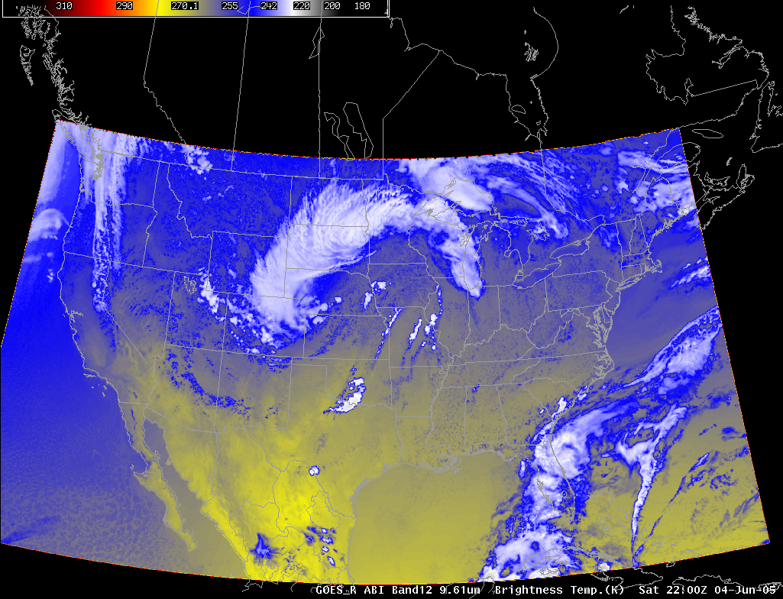
Figure 17. Simulated ABI band 12 (9.6 µm) for 04 June 2005 at 22:00 UTC.

This band is cooler than the window bands due to absorption due to ozone.

Band 13 (“Clean” IR longwave window band)
The 10.35-μm atmospheric “clean” window band is less sensitive to low-level moisture and, hence, helps with atmospheric moisture corrections, cloud particle size, and surface properties. It can also be used to estimate the cloud top height and many of the same uses of the traditional infrared window band.

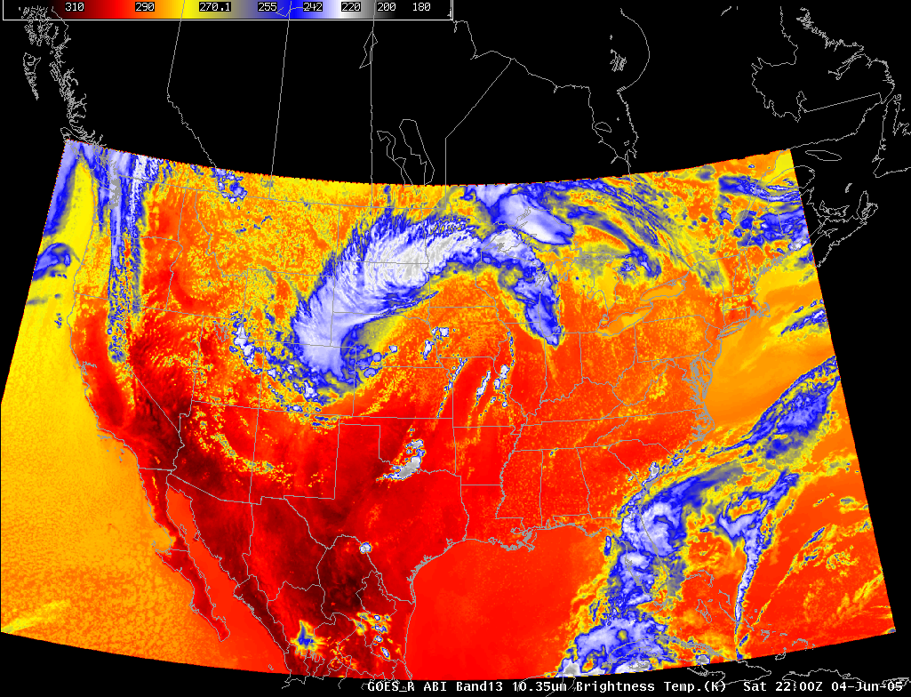
Figure 18. Simulated ABI band 13 (10.35 µm) for 04 June 2005 at 22:00 UTC.

This band is slightly warmer than the traditional longwave window, due to less atmospheric moisture absorption.

Band 14 (IR longwave window band)
The traditional longwave infrared window (11.2 μm) band provides day/night cloud analyses for general forecasting and broadcasting applications, precipitation estimates, severe weather analyses, cloud-drift winds, hurricane strength and track analyses, cloud-top heights, volcanic ash detection, fog detection in multi band products), winter storms, and cloud phase/particle size estimates in multi band products.

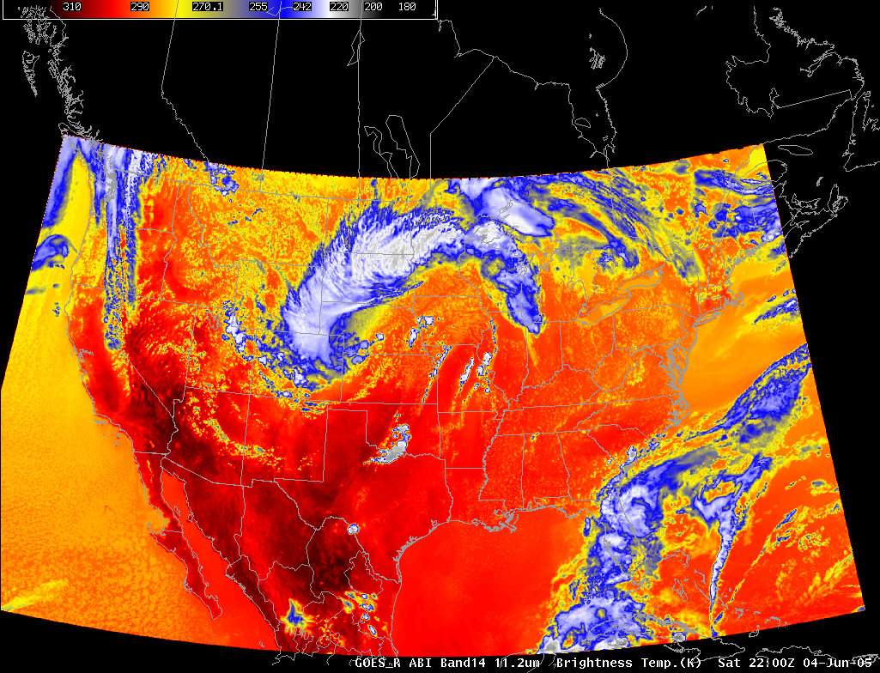
Figure 19. Simulated ABI band 14 (11.20 µm) for 04 June 2005 at 22:00 UTC.

This is the traditional IR window band. “Toggle” between this band and the cleaner window.

Band 15 (“Dirty” longwave window IR band)
The 12.3-μm, or ‘dirty window’ band offers nearly continuous monitoring for numerous applications, including low-level moisture determinations, volcanic ash identification, sea surface temperature measurements, and cloud particle size estimates (from multi band applications). It has been shown that mid level dust amounts (from the Saharan air layer) can be useful in determining hurricane intensification in the Atlantic basin.

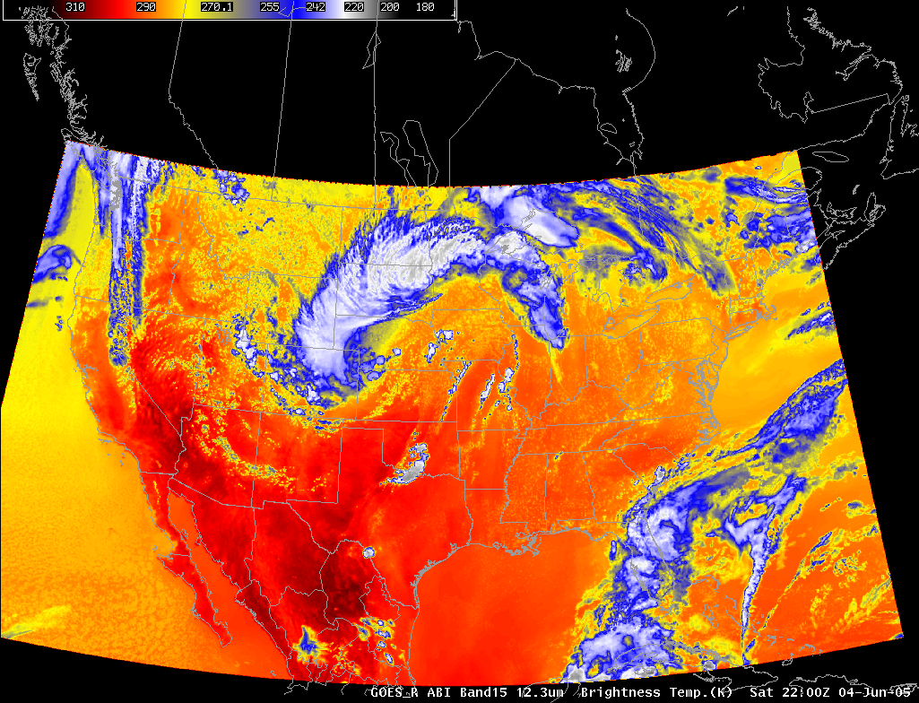
Figure 20. Simulated ABI band 15 (12.30 µm) for 04 June 2005 at 22:00 UTC.

This band is cooler than the window bands due to absorption due to moisture. “Toggle” between this band and one of the “cleaner” longwave atmospheric window bands.

Band 16 (“CO2” longwave IR band)
The 13.3-μm band is used for cloud-top height assignments of cloud-drift motion vectors, high-cloud products supplementing Automated Surface Observing System (or ASOS) observations, tropopause delineation, volcanic ash and estimation of cloud opacity. Products using the 13.3 μm band are being demonstrated with the GOES-12, -13, -O, and -P imagers, as well as the current GOES sounders.

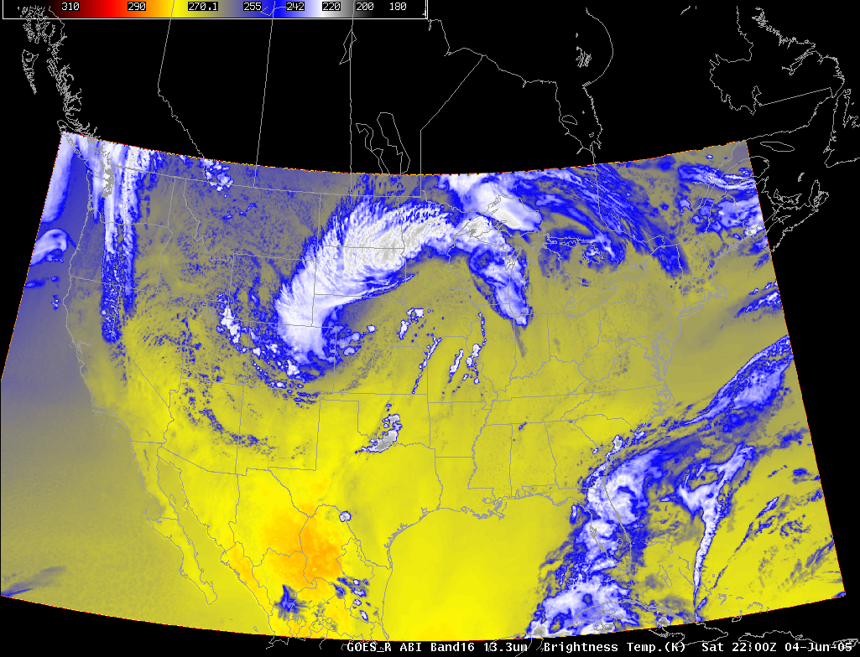
Figure 21. Simulated ABI band 16 (13.3 µm) for 04 June 2005 at 22:00 UTC.

This band is cooler than the window bands due to absorption due to CO₂. “Fade” or “toggle” between this band and one of the atmospheric windows.

Spectral, Spatial and Temporal Improvements of GOES-R over current GOES.
ABI Spectral Improvements:
Compared to the current GOES imager, the improved spectral resolution of the GOES-R ABI bands over current GOES is in the ratio of approximately 3:1 (16 channel: 5 channels). Below are are images to show the Spectral improvements of ABI relative to current GOES.
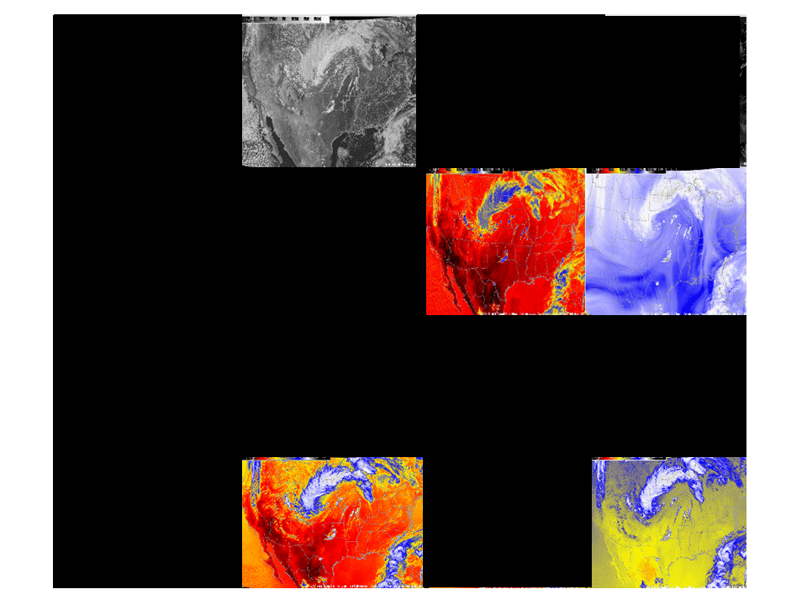
Figure 22. Corresponding current GOES imager (5 spectral bands) for 04 June 2005. Note that these are not the GOES images, but rather the bands that correspond to the GOES-12 Imager.
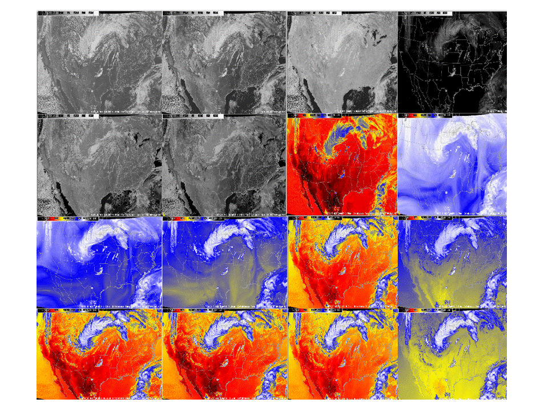
Figure 23. Simulated ABI data for all 16 channels on 04 June 2005. Displayed in AWIPS D2D, four panels at a time.
ABI Spatial Improvements

Nominally, there is a factor of four improvement in the spatial resolutions of the ABI over today's GOES imager. This means not only are certain features better resolved, say cloud edges, but there are many phenomena that can not be monitored. One such example is the finer resolution ‘rings’ associated with rapidly developing convection. In general, these can not be detected with the current GOES imagers.

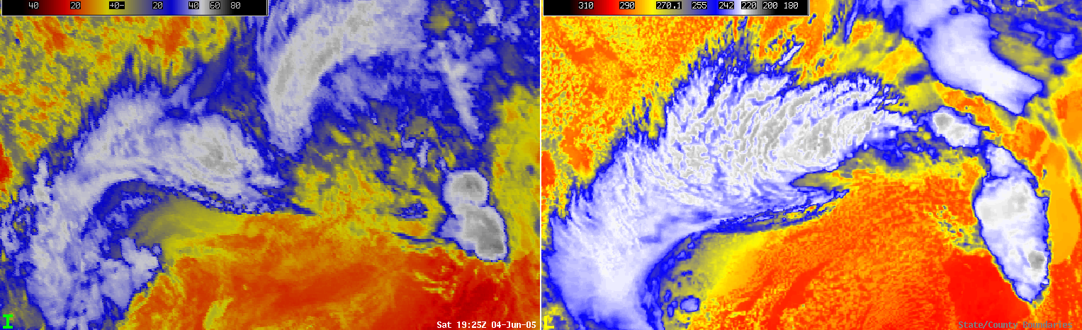

Figure 24. Example of the current GOES spatial resolution (left panel) and that expected from the ABI (right panel). The band shown here is the infrared window.

ABI Temporal Improvements

There are many improvements related to the temporal sampling of the ABI data, as opposed to the current GOES imager. For example, the ABI will scan the full disk at least every 15 minutes. This is contrasted to the every 3 hours that the current GOES scans the full disk. In addition, the CONUS region will be scanned by the ABI every 5 minutes. Again, this is a great improvement over the 15 or 30 minutes from the current GOES. (Sometimes the 30 minute gap is due to a full disk being scanned, other times it’s due to the uploading of coefficients (or ‘house-keeping’). Finally, the meso-scale scan will allow for routinely monitoring of rapidly changing phenomena, such as convection, fires and volcanoes. Recall that these rapid-scans do not come at the ‘expense’ for regional or global-scale monitoring.

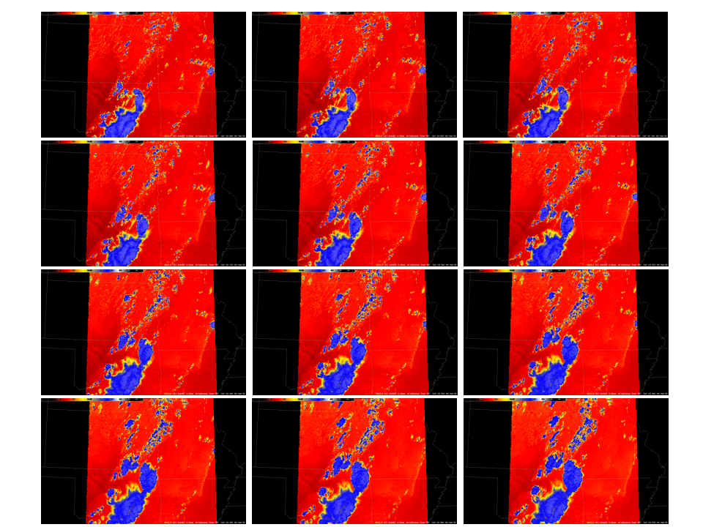

Figure 25. An example of how the ABI will scan the CONUS region routinely within an hour (i.e., 1 image every 5 minutes).

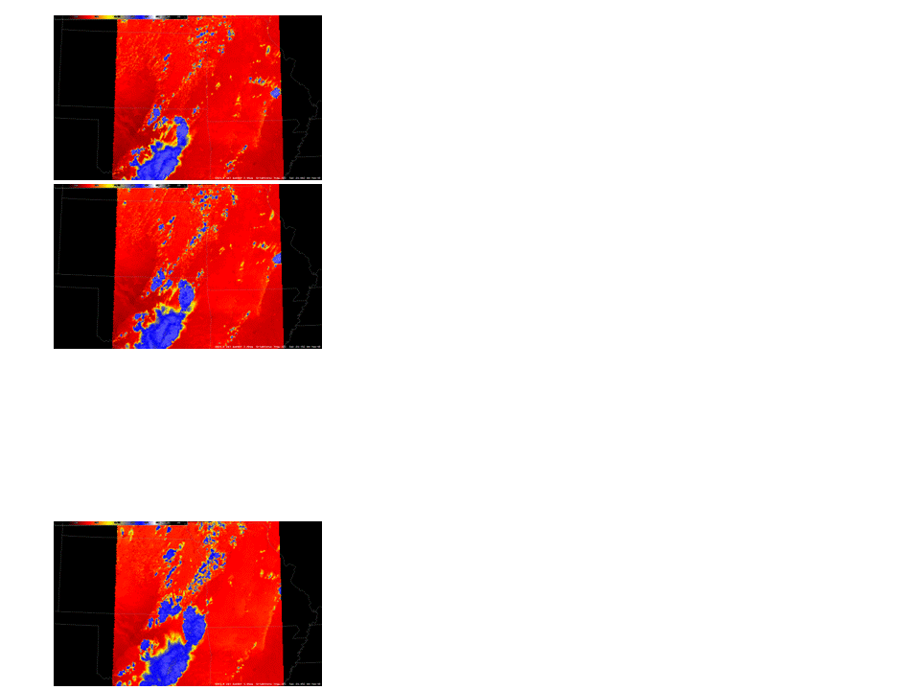
Figure 26. An example of how the current GOES imager routinely scans the CONUS region every 15 minutes, except when a full disk is being scanned there is a 30 minute gap.
ABI Band Differences

The ABI bands, in combination, can highlight a range of phenomena. For example, ABI band 2 versus 4 can delineate high from low clouds during the day.
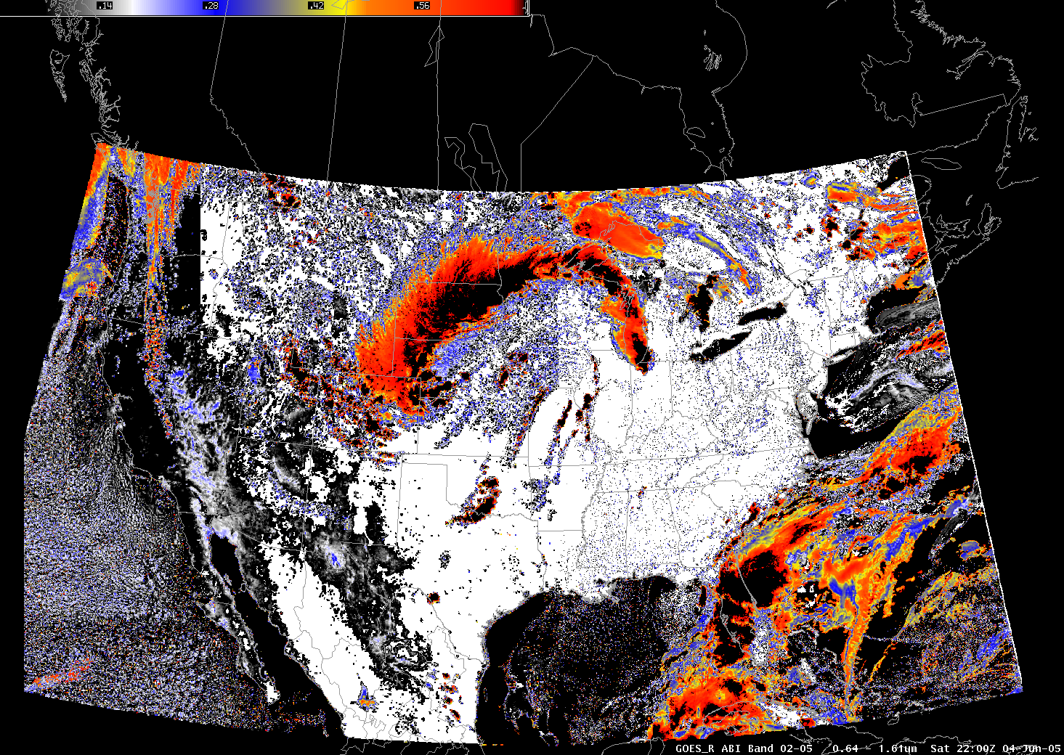
Figure 27. Example of daytime cloud phase; visible vs near-IR: ABI band 2 - 5 (eg, 0.6 - 1.6 um).

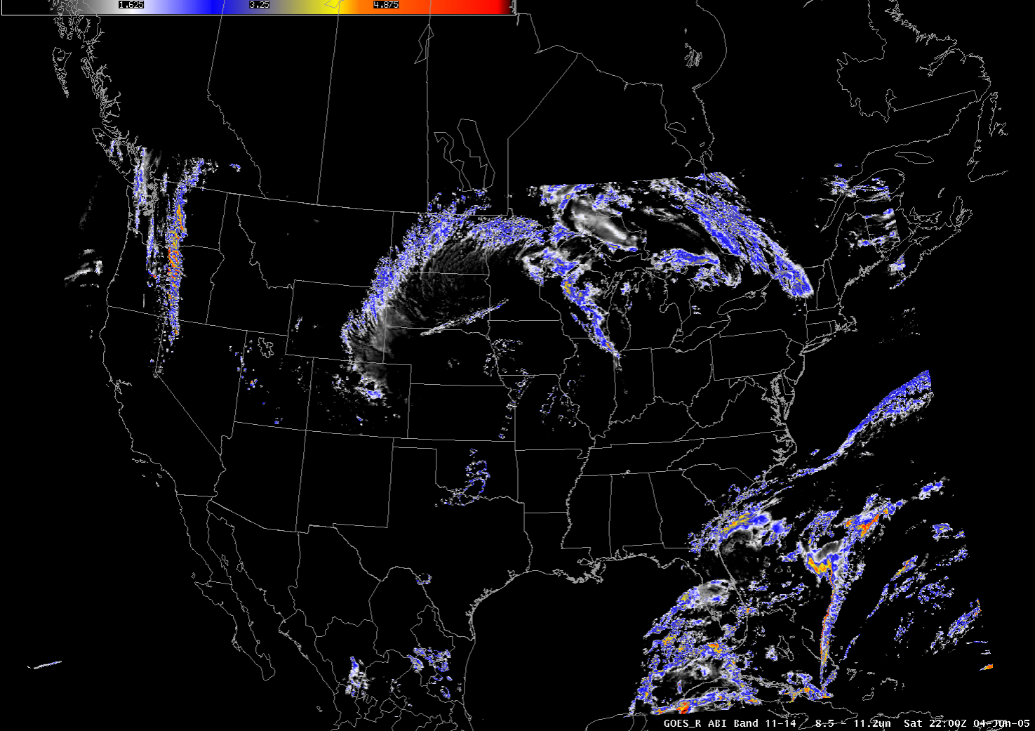
Figure 28. Example of glaciated clouds; ABI band 11-14 (eg, 8.5 - 11 um). Note the location of the ice clouds.

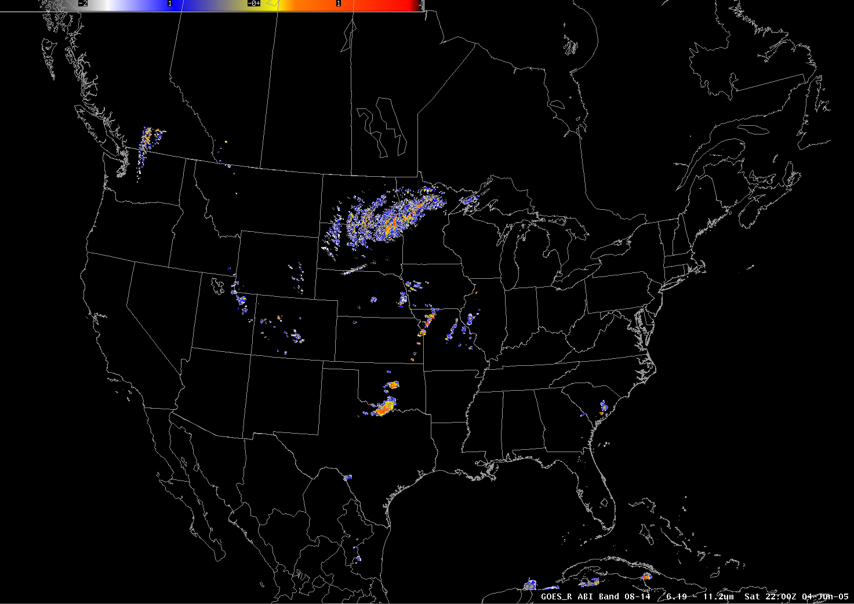
Figure 29. Upper-level information; ABI Band 8 – 14, eg, 6.2 – 11.2 um. Note the location of potentially over-shooting tops highlighted by the largest differences.

Other Simulated ABI cases

Hurricane Katrina Case

Each of the 16 ABI bands have also been simulated for Hurricane Katrina and can be found under “SSEC”, “Hurricane Katrina”.
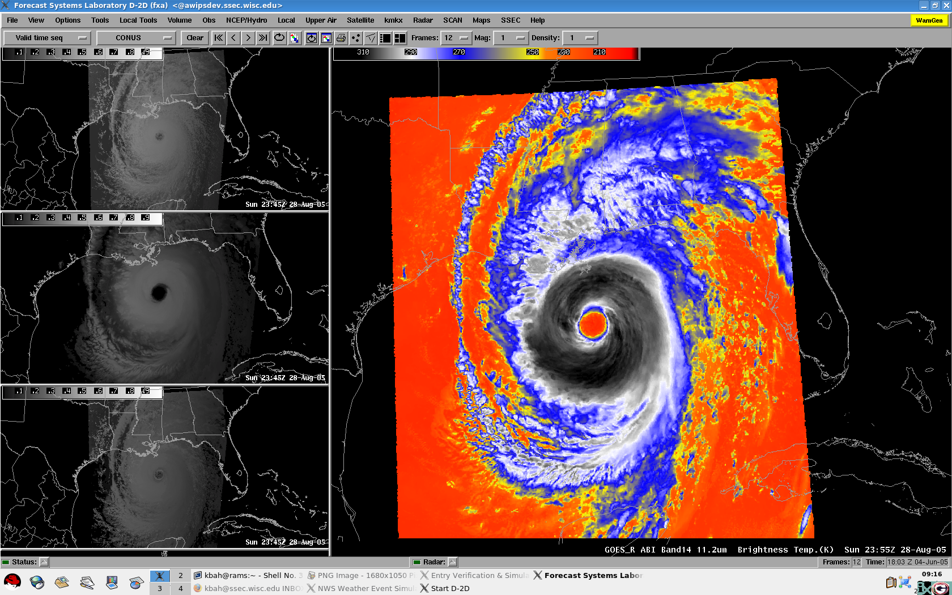
Figure 30. Four bands of the ABI are shown here from a simulated Katrina data set.
The simulated ABI data for Katrina can be used to show some of the same relationships of the ABI spectral bands and various phenomena, such as cloud-top phase or the location of convection.

Pacific (West) Simulations
Since current plans call for the GOES-R ABI to be positioned at 137degrees latitude over the pacific, we simulated the June 26th 2008 pacific case to mimic, in part, how ABI will view earth once it is launched. For this simulation, only one time period was included in this WES case.

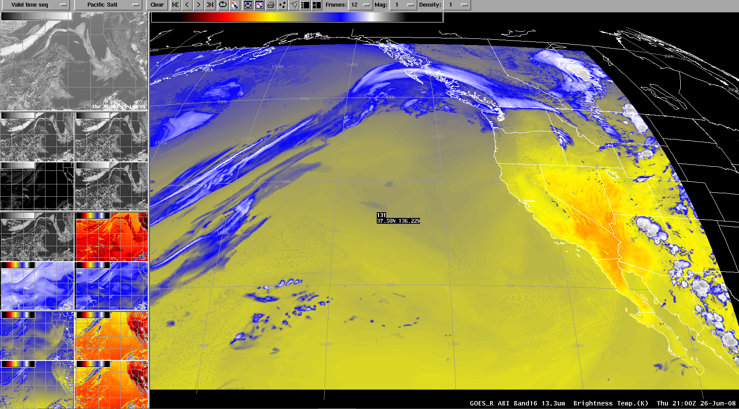
Figure 31. Shows band16 (13.3um) for the pacific projection on 26th-June-2008 at 21:00Z.

Mesoscale Simulation
One of the scanning modes on GOES-R ABI is the “flex scan mode”. When set to the mode, the ABI will scan a predefined 1000km*1000km area at 1 image per minute.
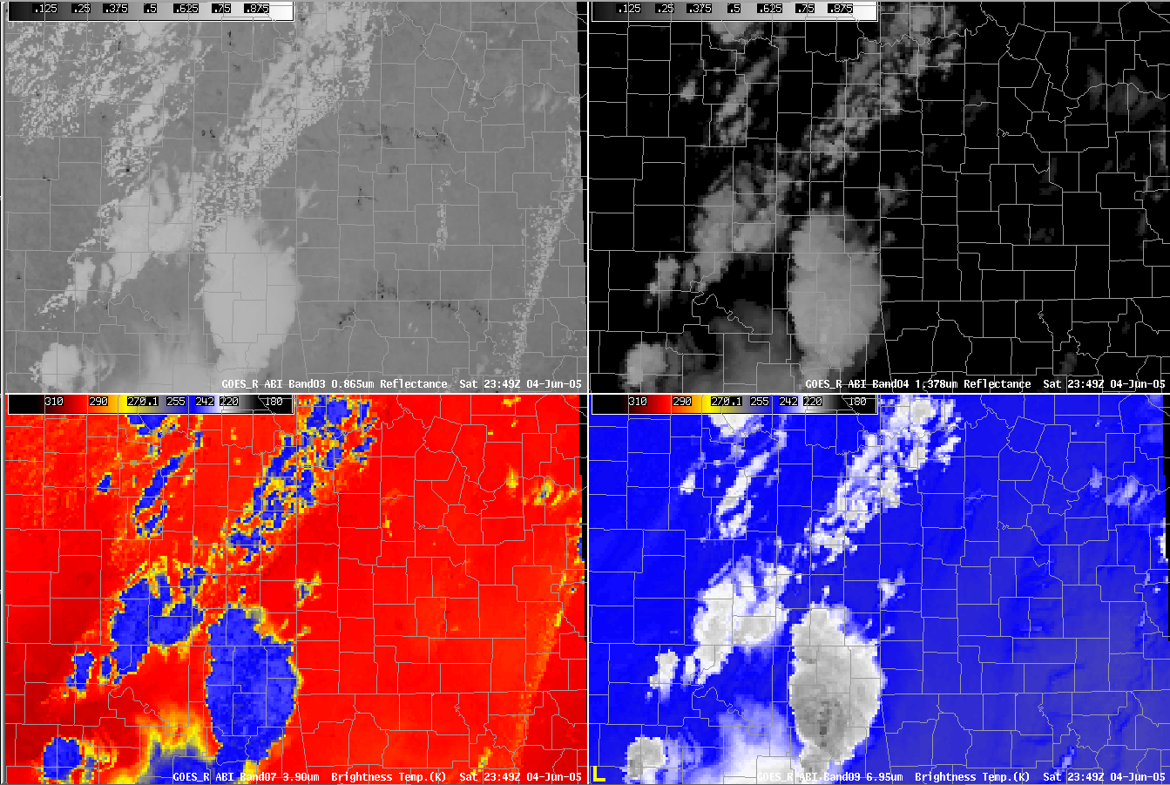
Figure 32. Four of the sixteen ABI bands covering a mesoscale region. The ABI will be able to scan meso scale images every 30 seconds. The bands shown in the image above are: Upper left band03 (0.865um), upper right band04 (1.378um), lower left band07 (3.90um) and lower right band09 (6.95um).

Comparing current GOES to GOES-R
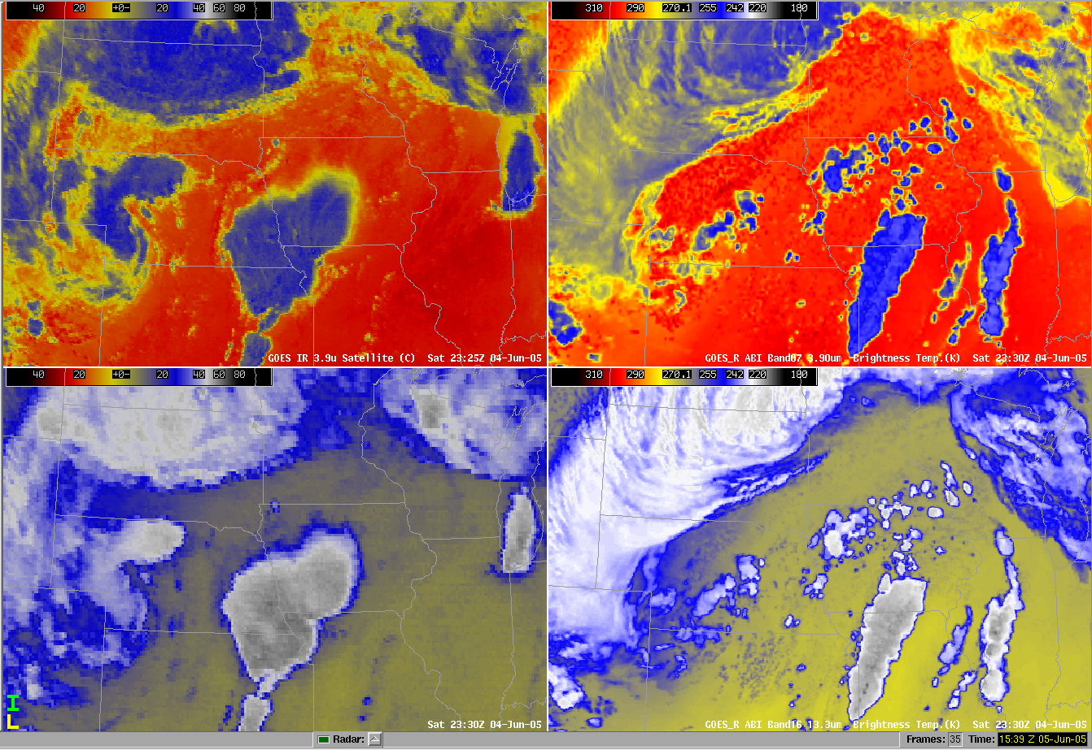
Figure 33. Shows comparison between current GOES and simulated GOES-R ABI bands. The images on the left shows current GOES images from the 3.9um and the 13.3um. The images on the right shows simulated ABI of the corresponding channels. (i.e 3.9 um and 13.3um). Note, of course, that the ABI images are simulated and hence not exactly corresponding to the actual GOES images. That said, the similar features have been resolved.

Using MODIS to learn about GOES-R ABI
To familiarize with some of the spectral bands of the ABI well before launch, MODIS data can be acquired and shown within the AWIPS environment. For further information please visit the links below.
VISITview lesson on MODIS:
http://cimss.ssec.wisc.edu/goes/visit/modis.html
Information on how to acquire near-realtime MODIS data in AWIPS:
http://www.ssec.wisc.edu/~jordang/awips-modis/index.html
Select References

Ackerman, S. A.; Schreiner, A. J.; Schmit, T. J.; Woolf, H. M.; Li, J. and Pavolonis, M., 2008: Using the GOES sounder to monitor upper level SO2 from volcanic eruptions. Journal of Geophysical Research, Volume 113, 2008, doi:10.1029/2007JD009622.
Dudhia, J. 1989: Numerical Study of Convection Observed During the Winter Monsoon Experiment Using a Mesoscale Two-Dimensional Model. J. Atmos. Sci., 46, 3077-3107.
Heidinger, A. K., C. O’Dell, R. Bennartz, and T. Greenwald, 2006: The successive-order-of-interaction radiative transfer model. Part I: Model development. J. Appl. Meteor. Clim., 45, 1388-1402.
Hillger, D.W., and T. J. Schmit, 2007: The GOES-13 Science Test: Imager and Sounder Radiance and Product Validations. NOAA/NESDIS Technical Report 125.
Mellor, G. L., and T. Yamada, 1982: Development of a turbulence closure model for geophysical fluid problems. Rev. Geophys. Space Phys., 20, 851-875.
Mlawer, E. J., S. J. Taubman, P. D. Brown, and M. J. Iacono, 1997: Radiative transfer for inhomogeneous atmospheres: RRTM, a validated correlated-k Model for the longwave. J. Geophys. Res., 102, 16663-16682.
Otkin, J. A., T. J. Greenwald, J. Sieglaff, and H.-L. Huang, 2009: Validation of a large-scale simulated brightness temperature dataset using SEVIRI satellite observations. [accepted for publication in J. Appl. Meteor. Climatol.]
Schmit, T. J., M. M. Gunshor, W. P. Menzel, J. Li, S. Bachmeier, J. J. Gurka, 2005: Introducing the Next-generation Advanced Baseline Imager (ABI) on GOES-R, Bull. Amer. Meteor. Soc., Vol 8, August, pp. 1079-1096.
Schmit, T. J., R. M. Rabin, A. S. Bachmeier, J. Li, M. M. Gunshor, H. Steigerwaldt, A. J. Schreiner, R. M. Aune, and G. S. Wade, 2009: Many uses of the geostationary operational environmental satellite-10 sounder and imager during a high inclination state, J. App. Rem. Sens., 3, 033514.
Skamarock, W. C., J. B. Klemp, J. Dudhia, D. O. Gill, D. M. Barker, W. Wang, and J. G. Powers, 2005: A description of the Advanced Research WRF Version 2. NCAR Tech. Note/TN-468+STR, 88 pp.
Thompson, G., P. R. Field, R. M. Rasmussen, and W. D. Hall, 2008: Explicit forecasts of winter precipitation using an improved bulk microphysics scheme. Part II: Implementation of a new snow parameterization. Mon. Wea. Rev, 136, 5095-5115.

Introductory GOES-R ABI Videos:
We have also packed Introductory ABI videos in the WES under the “wessl” directory. If you are interested in watching these videos after installing the WES case into your local machine or integrating it into your existing WES case, run “start_simulator”. Once the “simulation Entry” window pops up, click on the “select” button next to the “WESSL Script (optional)” button. Select “mkx-06-05.wessl”, Or enter the full path
eg “/awips/2005june05/wessl/mkx-06-05.wessl” and run it. After the Guardian pops up, you can then “start_awips”

Select Links

GOES-R:
http://www.goes-r.gov
http://www.goes-r.gov/education/index.html
http://www.meted.ucar.edu/index.htm
http://cimss.ssec.wisc.edu/goes_r/proving-ground.html

GOES:
http://goespoes.gsfc.nasa.gov/goes/index.html
http://goes.gsfc.nasa.gov/text/goes.databookn.html
http://rapidfire.sci.gsfc.nasa.gov/
http://goes.gsfc.nasa.gov/
http://rammb.cira.colostate.edu/projects/goes-n/
http://rammb.cira.colostate.edu/projects/goes-o/

UW/SSEC/CIMSS/ASPB:
http://cimss.ssec.wisc.edu/goes_r/awg/proxy/nwp/
http://cimss.ssec.wisc.edu/goes/abi/
http://cimss.ssec.wisc.edu/goes/abi/wf
http://cimss.ssec.wisc.edu/goes/blog/
http://www.ssec.wisc.edu/data/geo/
http://www.ssec.wisc.edu/~jordang/awips-modis/index.html
http://cimss.ssec.wisc.edu/dbs/SatelliteNotes/Notes.html

Appendix A -- ABI Spectral Bands
From Schmit et al (2005), note that the wavelength range is only approximate and does not reflect flight model instrument response functions:
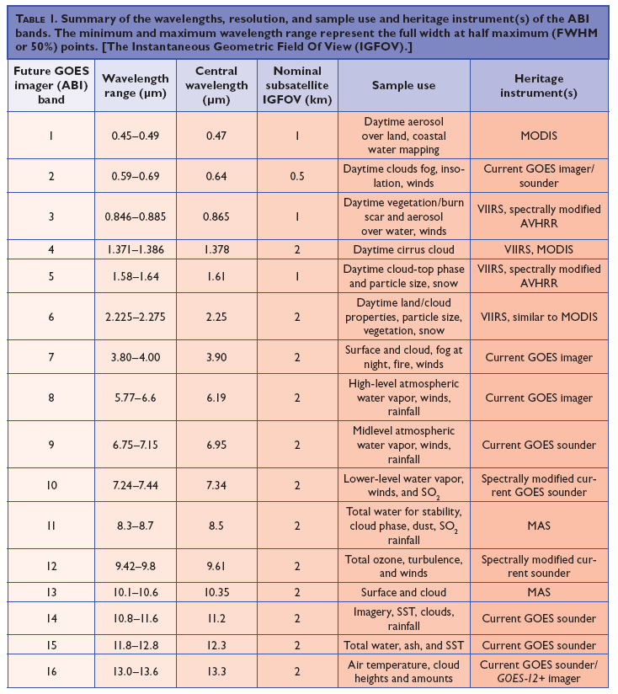

Appendix B – GOES-R Product Suite
While the exact GOES-R product suite is still being refined, the list has both ‘baseline’ and ‘option 2’ products. That said, it is expected that more new products will be developed ‘day 2’.

GOES-R Baseline Products |  |  | GOES-R Option 2 Products
Aerosol Detection (Including Smoke and Dust) |  |  | Aerosol Particle Size
Aerosol Optical Depth: AOD & Suspended Matter |  |  | Aircraft Icing Threat
Volcanic Ash: Detection and Height |  |  | Cloud Ice Water Path
Cloud and Moisture Imagery |  |  | Cloud Layers/Heights
Cloud Optical Depth |  |  | Cloud Liquid Water
Cloud Particle Size Distribution |  |  | Cloud Type
Cloud Top Phase |  |  | Convective Initiation
Cloud Top Height |  |  | Enhanced “V” / Overshooting Top Detection
Cloud Top Pressure |  |  | Low Cloud and Fog
Cloud Top Temperature |  |  | Tropopause Folding Turbulence Prediction
Hurricane Intensity |  |  | Visibility
Lightning Detection: Events, Groups & Flashes |  |  | Probability of Rainfall
Rainfall Rate / QPE |  |  | Rainfall Potential
Legacy Vertical Moisture Profile |  |  | Absorbed Shortwave Radiation: Surface
Legacy Vertical Temperature Profile |  |  | Downward Longwave Radiation: Surface
Derived Stability Indices |  |  | Upward Longwave Radiation: Surface
Total Precipitable Water |  |  | Upward Longwave Radiation : TOA
Clear Sky Masks |  |  | Ozone Total
Downward Shortwave Radiation: Surface |  |  | SO₂ Detection
Reflected Shortwave Radiation: TOA |  |  | Flood/Standing Water
Derived Motion Winds |  |  | Ice Cover
Fire/Hot Spot Characterization |  |  | Snow Depth (over Plains)
Land Surface (Skin) Temperature |  |  | Surface Albedo
Snow Cover |  |  | Surface Emissivity
Seas Surface Temperature (Skin) |  |  | Vegetation Fraction: Green
Energetic Heavy Ions |  |  | Vegetation Index
Mag. Electrons & Protons: Low Energy |  |  | Currents
Mag. Electrons & Protons: Med & High Energy |  |  | Currents: Offshore
Solar & Galactic Protons |  |  | Sea and Lake Ice: Age
Geomagnetic Field |  |  | Sea and Lake Ice: Concentration
Solar Flux: EUV |  |  | Sea and Lake Ice: Motion
Solar Flux: X-Ray
Solar Imagery: X-Ry
 | ABI | SUVI |  | EXIS
 | GLM | SEISS |  | Magnetometer

Appendix C – Details on the simulation process.
Sub-grid scale processes were parametrized using mixed-phase cloud micro-physics scheme, the Mellor-Yamada-Janjic planetary boundary layer scheme, and a shortwave and Rapid Radiative Transfer Model long-wave radiation schemes. Surface heat and moisture fluxes were calculated using the Noah land surface model. No cumulus parametrization scheme was used; therefore, all clouds were explicitly predicted by the micro-physics scheme.

The Successive Order of Interaction (SOI) model was used as the radiative transfer solver. The system contains separate modules for the ”reflective” (1-7) and “emissive” (7-16) bands. Note that band 7 (3.9 µm) has both a reflective and emitted component. Bands 7-16 will be available both day and night. Surface properties are taken from the CIMSS land surface IR emissivity product and the Infrared Sea Surface Emissivity Model for the infrared module, whereas MODIS land surface albedo products and an ocean surface reflectance model are used for the solar module.

Sample questions for WES ABI guide

Q: How many more bands will the ABI have compared to the current GOES Imager? In which part of the spectrum?
A: 11 new bands (5 in the visible/near-IR and 6 in the IR).

Q: What will one of the main uses for the 1.6 µm band be?
A: Daytime snow detection.

Q: What will one of the main uses of the 8.5 µm band be?
A: Day or night cloud phase.

Q: Which ABI band has the finest spatial resolutions?
A: The ‘red’ band at 0.6 µm (or ABI band 2).

Q: How much finer is the spatial resolution of the IR bands of the ABI than today’s imager?
A: Basically a factor or 4 (a factor of 2 in both directions). Of course it’s finer than this comparing to the 8 km bands on the current imagers.

Q: What is the finest time interval of the ABI, without sacrificing the scanning of other sectors?
A: 30 sec.

Q: Can the current GOES imager detect upper-level SO₂?
A: No, but the ABI can.

Q: When might the “cirrus” band (ABI #4) see the surface?
A: In dry atmospheres, say less than 10 mm.

Q: During the daytime, which two ABI might you compare to isolate the cloud phase?
A: The 0.6 µm band with either the 1.6 or 2.2 µm bands.

Q: What features might one be able to resolve in the ABI IR bands that is only sub-optimally sampled from the current imagers?
A: Waves on cloud tops, waves in the water vapor imagery, fog, etc.

Q: With data from the ABI, how often with the CONUS be scanned?
A: Every 5 minutes.

Q: Approximately how much more information with the ABI provide, compared to the current imager?
A: Approximately 50-60 times. (3.2 x 4 x 5)

