McIDAS-V Tutorial
Displaying Satellite Imagery
updated December 2013 (software version 1.4)

McIDAS-V is a free, open source, visualization and data analysis software package that is the next generation in SSEC's 40-year history of sophisticated McIDAS software packages. McIDAS-V displays weather satellite (including hyperspectral) and other geophysical data in 2- and 3-dimensions. McIDAS-V can also analyze and manipulate the data with its powerful mathematical functions. McIDAS-V is built on SSEC's VisAD and Unidata's IDV libraries, and contains "Bridge" software that enables McIDAS-X users to run their commands and tasks in the McIDAS-V environment. The functionality of SSEC's HYDRA software package is also being integrated into McIDAS-V for viewing and analyzing hyperspectral satellite data.

More training materials are available on the McIDAS-V webpage and in the Getting Started chapter of the McIDAS-V User’s Guide, which is available from the Help menu within McIDAS-V. Notifications at McIDAS-V startup alert users when there is a new version of McIDAS-V is available on the McIDAS-V webpage - http://www.ssec.wisc.edu/mcidas/software/v/

Please post error reports or feature requests to the McIDAS-V Support Forums - http://www.ssec.wisc.edu/mcidas/forums/http://dcdbs.ssec.wisc.edu/mcidasv/forums/. The forums also provide the opportunity to share information with other users.

In this McIDAS-V Tutorial, some exercises are explained using different methods of data access: local data files, pre-loaded data bundles and real-time access to default remote servers. If you have access to your own real-time ADDE servers, you may also use those, but different server configurations may make the explanations in this document not quite applicable to all loaded data..

This tutorial assumes McIDAS-V is installed, and can be started. For information about installing and starting McIDAS-V follow the instructions in the document entitled McIDAS-V Tutorial – Installation and Introduction.

Terminology
There are two windows displayed when McIDAS-V first starts, the McIDAS-V Main Display (hereafter Main Display) and the McIDAS-V Data Explorer (hereafter Data Explorer).
The Data Explorer contains three tabs that appear in bold italics throughout this document: Data Sources, Field Selector, and Layer Controls. Data is selected in the Data Sources tab, loaded into the Field Selector, displayed in the Main Display, and output is formatted in the Layer Controls.
Menu trees are listed as a series (e.g. Edit -> Remove -> All Layers and Data Sources).
Mouse clicks are listed as combinations (e.g. Shift+Left Click+Drag).

Loading Geostationary Satellite Images and Loops

- Create a local dataset to access the imagery files on your local machine. To load real-time data, skip to step 3.

  - In the Main Menu Bar in the Main Display window of McIDAS-V, select Tools -> Manage ADDE Datasets.

  - In the ADDE Data Manager, select File -> New Local Dataset. Enter the following parameters to define the dataset for the AREA files provided with this tutorial:
- Dataset – MTSAT
- Image Type – MTSAT satellite data
- Format – McIDAS AREA
- Directory – select the <local path>/Data/Satellite/mtsat_dust directory
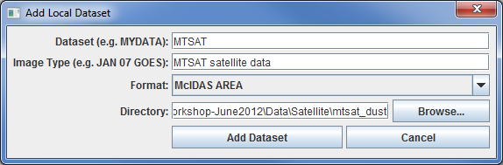
  - Click Add Dataset. Close the ADDE Data Manager by clicking Ok or select File -> Close.

- To load the data in this local dataset, follow these steps.
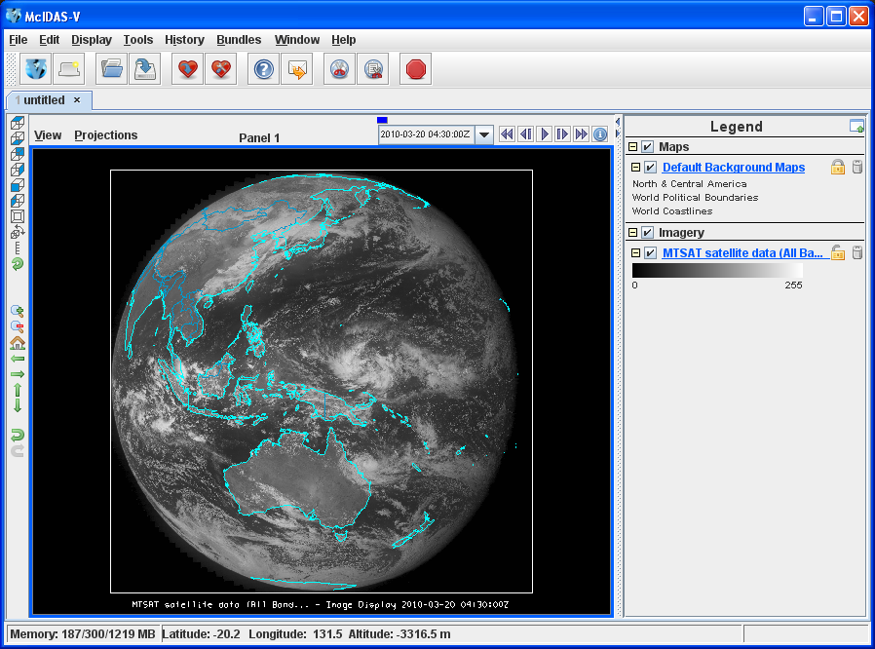
  - Click on the button in the main toolbar to go to the Data Explorer. Select the Data Sources tab if it is not the active tab.

  - From the Data Sources tab, select the Satellite -> Imagery chooser.

  - Build the server query using the drop down fields in the imagery chooser:

Server selection: Use the dropdown menu and scrollbar to select <LOCAL-DATA>.

Dataset selection: MTSAT

Click Connect.

  - Select the data to retrieve from the server:
Image Type : Choose MTSAT satellite data.
Click the absolute tab: Select an absolute time of 04:30 UTC.

Click Add Source. This both loads the data into the Field Selector and brings the Field Selector tab forward.

  - Click on the dropdown arrow to the left of 0.73 um VIS Cloud and Surface Features.
Select Brightness

  - Click Create Display. The 04:30 UTC 0.73 μm image displays in the Main Display window.
- To load real-time data, follow these steps. Data has already been loaded in steps 1 and 2, proceed to step 4.
  - Click on the button in the Main Toolbar to go to the Data Explorer. Select the Data Sources tab if it is not active.

  - Select the Satellite -> Imagery chooser from the Data Sources tab.

  - To access and query the default servers in McIDAS-V, select the following options in the chooser

Server: use the dropdown list and scrollbar to select adde.ucar.edu
Dataset: use the dropdown list and scrollbar to select RTIMAGES.
Click Connect.

  - Image Type : Choose GE-VIS - GOES-East 0.65 µm Visible
Click the absolute tab
Select an absolute time of 17:45 UTC from the previous day. (This step may be slow. When choosing absolute times, McIDAS-V queries the ADDE server for a list of all available times.)

Click Add Source. This both loads the data into the Field Selector and brings the Field Selector tab forward.

  - Click on the dropdown arrow to the left of 0.65 um VIS Cloud and Surface Features
Select Brightness.

  - Click Create Display. The 17:45 UTC 0.65 μm image displays in the Map Display window.

- Locate the zoom and pan controls in the left toolbar. Use the controls to inspect the image.

  - Reset the display projection by clicking on the icon below the zoom buttons on the left toolbar.

  - Turn off the Auto-set Projection option under the Projections menu of the Main Display. When this option is checked, the projection automatically changes to the native projection of the new layer. When this option is unchecked, all new layers are reprojected into the current projection.

- Using Layer Controls: Edit the maps display.

  - Click on Default Background Maps in the Legend to access the Layer Controls. The map controls has two tabs:
    - The Maps tab lists the available maps and provides controls to change the map visibility, line width, style and color
    - The Lat/Lon tab provides latitude/longitude lines and label controls.

At the bottom of both tabs, there is a Position slider that controls the vertical position of the maps in the Main Display.
  - Select the Maps tab: Use the available options to customize line style, width, color and visibility in the current map display.

  - (Optional) Select the Lat/Lon tab: add latitude and longitude lines and labels.

  - To save a default map configuration: Use the map Layer Controls select File -> Default Maps -> Save as the Default Map Set. The defaults will take affect the next time a new tab, window is created or when McIDAS-V is restarted.

- Click on the Field Selector tab in the Data Explorer to load an infrared image. To load real-time data skip to step 7.

  - Select 10.8 um IR Surface/Cloud-top Temp -> Temperature.
  - Click Create Display.

  - Skip to Step 8.

- For real-time data selection, follow the steps below.

  - Click on the Data Sources tab of the Data Explorer. Use the Satellite -> Imagery chooser with Server: adde.ucar.edu
Dataset: RTIMAGES
Click Connect
Image Type: Select the GE-IR – GOES-East 10.7 µm IR
Select the absolute tab: Select an absolute time of 17:45 UTC from the previous day.

  - Click Add Source. This both loads the data into the Field Selector and brings it forward

  - Select 10.7 um IR Surface/Cloud-top Features -> Temperature.

  - Click Create Display.

- The 10.8 µm temperature image is overlaid on the visible image.
  - To see the visible image, turn off the top MTSAT Satellite Data (All Bands...) checkbox in the Legend.
  - Turn the image back on.
  - Activate the Cursor/Data Readout option: Click and drag the middle mouse button. This displays a readout at the bottom of the Main Display consisting of a latitude, longitude, and data value at the cursor location . Since there are two layers in the main display, there are two lines in the readout with the appropriate values and units.
- Change the font and color of the labels on the Main Display.
  - In the Main Display window, choose Edit -> Preferences. Click on Display Window.
  - In the right column under Layer List Properties, change Font to Arial/Plain/14. Change the Color to a yellow hue. Click OK. View the changes in the Main Display.

- Notice the labels are the same in the Legend and on the Main Display. This can be customized.
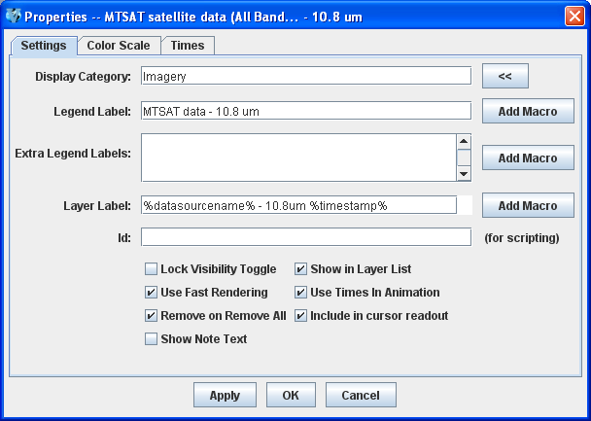
  - Right Click on the top Legend label, MTSAT satellite data (All Bands...). (Note: the label will be different when using real-time data.)
  - Choose Edit -> Properties... Enter the following for the Legend Label and Layer Label:
- Legend Label – MTSAT data – 10.8 um
- Layer Label - %datasourcename% - 10.8 um %timestamp%
  - Click OK.
- The Layer Controls, contains a histogram of the displayed imagery. Click on the 10.8 µm data layer in the right Legend of the Main Display to access the Layer Controls. Click on the Histogram tab for the 10.8 µm image. Zoom in on a range of data with a Shift->Left Click and Drag. Note the range of the data in the image display changes to match the histogram range. Click Reset to return to the original data range of the histogram image.

- Create a local dataset to access the FY2E Visible imagery files. To load real-time data skip to step 18.

  - If the Layer Controls is in front, select any Panel title to bring the Main Display forward. 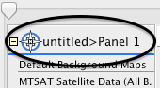

  - In the Main Display window, select the Tools -> Manage ADDE Datasets menu item.
  - In the ADDE Data Manager, select File -> New Local Dataset, and enter the following parameters:
- Dataset – MEGI_VIS
- Image Type – FY2E VIS satellite data
- Format – McIDAS AREA
- Directory – select the <local path>/Data/Satellite/fy2e_vis_megi directory
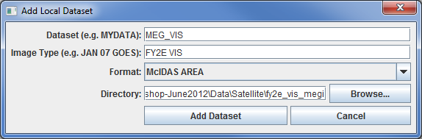
  - Click Add Dataset.
- Create a local dataset to access the FY2E Infrared imagery files on your machine.
  - In the ADDE Data Manager, select File -> New Local Dataset, and enter the following parameters:
- Dataset – MEGI_IR
- Image Type – FY2E IR
- Format – McIDAS-AREA
- Directory – select the <local path>/Data/Satellite/fy2e_ir_megi directory
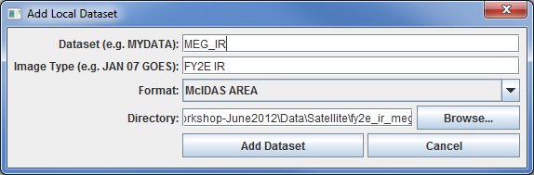
  - Click Add Dataset.

- Close the ADDE Data Manager by clicking Ok or select File -> Close.
  - If using real-time data, skip to step 18.
- Create a 4 panel display and change the name of the tab.

  - Select Edit -> Remove -> All Layers and Data Sources. If the Confirm Removal window is displayed, click Remove all layers and data.

  - Create a 4 panel tab: In the Main Display menu, Select File -> New Display Tab -> Map Display -> Four Panels..
  - Double Click on the “untitled” tab name and enter “FY2E 4-panel” in the entry box and click OK to change the tab name.

- Display the FY2E Visible image in the top left panel.
  - By default, the last panel created is the active panel. The lower right panel is highlighted with a default color of blue. Click on the top left panel to activate this panel for the next data load.

  - From the Satellite -> Imagery chooser in the Data Sources tab of the Data Explorer, select <LOCAL-DATA> for Server, select MEGI_VIS for Dataset, click Connect.

  - Choose the FY2E VIS satellite data Image Type and select a relative time of five most recent images. Check the Create Preview Image box. This checkbox displays the satellite data in the Region tab of the Field Selector instead of a blank regional map outlining data availability. Click Add Source to load the data in the Field Selector and bring it forward.

  - In the Fields panel, select 0.73 um VIS Cloud and Surface Features -> Brightness.

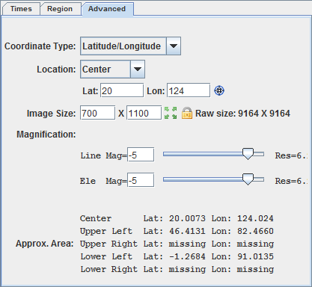
  - Locate and select the Advanced tab (bottom right window of Field Selector), change the centering of the image as well as the image size. The screenshot represents the values to enter.
    - Under Displays, click on the Advanced tab.
    - Change the Lat: to 20 and Lon: to 124.
    - Change the Image Size: to 700 X 1100.
    - Change the Magnification to -5 X -5.
    - Click Create Display.

The Magnification of -5 X -5 reduces the amount of data downloaded. The data is sampled with every fifth line and fifth element being sent from the server. Also note that the number of lines and elements chosen may not fit into the display window. Zoom out to display all the pixels requested.
- Repeat the actions in the previous step to display the FY2E IR images in the remaining panels.
  - Repeat step 16 using the MEGI_IR dataset and load the FY2E 10.8 µm brightness.
    - Click on the top right panel to make it active.
    - From the chooser select <LOCAL-DATA> for Server and MEGI_IR for Dataset. Click Connect.
    - Choose the FY2E IR satellite data Image Type, and select a relative time of 5 most recent images.
    - Click Add Source to show the Field Selector.
    - In the Fields panel, select 10.8 um IR Surface/Cloud-top Temp -> Brightness.
    - Under Displays, click on the Advanced tab.
    - Change the Lat: to 20 and Lon: to 124.
    - Change the Image Size: to 700 X 1100.
    - Change the Magnification to 1 X 1 to download the full resolution data.
    - Click Create Display.

  - Click the bottom left panel to make it active, and follow the steps above (after the Add Source step) to add FY2E IR 6.8 µm Brightness data to this panel.
  - Click the bottom right panel to make it active, and follow the steps above (after the Add Source step) to add FY2E IR 3.8 µm Brightness data to this panel.
  - Skip to step 20.
- Instructions for real-time data:

  - Select Edit -> Remove -> All Layers and Data Sources. If the Confirm Removal window is displayed, click Remove all layers and data.

  - Open a new 4 panel tab by selecting File -> New Display Tab -> Map Display -> Four Panels from the Main Menu.
  - By default, the last panel created is the active panel. The lower right panel is highlighted with a default color of blue. Click on the top left panel to activate this panel for the next data load.
  - Double Click on the “untitled” tab name and enter “GOES 4-panel” in the entry box and click OK to change the tab name.

  - Go to the Data Sources tab of the Data Explorer, and using the Satellite -> Imagery chooser Server: adde.ucar.edu
Dataset: RTIMAGES
Click Connect
Select the GOES-East 0.65 μm Image Type. In the Relative tab, select the 5 most recent images.

  - Click Add Source to load the data into the Field Selector and bring it forward.

  - Select 0.65 um VIS Cloud and Surface Features -> Brightness.

  - In the lower right corner of the Field Selector, open the Advanced tab. Change the Image size to 900 X 1800 and the Magnification to 1 X 1, and create the display. Dependent on the memory allocated to McIDAS-V, a warning message may pop up concering the amount of data being loaded; click OK.
- Click on the top right panel to make it the active tab. Repeat step 18 using GOES-East 3.9 µm in the top right panel, GOES-East 10.7 µm in the bottom left panel, and GOES-East 13.3 µm in the bottom right panel.

- The four tabs have shared views. Observe that, one panel will affect the other panels when using animation controls, zooming and panning..

- In one of the panels, animate the image loop and zoom in on an interesting weather feature. The other panels should also loop and zoom in on the same geographical location.
- Remove one of the panels from updating with the other panels by selecting Projections -> Share Views in that panel’s Projections menu.
- Data polling is another real-time data feature which updates the data and display when a new image exists. Steps a-d make polling active for all four data sources, initiate automatic reload, and check for new data every 10 minutes.
  - In the Field Selector tab, Right Click on the GOES-East 0.65 µm data source and select Properties. (Note: The option would function for local datasets if files are updated in the local dataset’s directory.)

  - Under Polling click on the Automatically Reload: Active checkbox. Click on the Reload Displays checkbox at the bottom of the window.

  - Click Apply and OK. Every 10 minutes (the default polling time) a check is made for a new image and if one exists, the satellite loop is automatically updated in the main display.

  - Repeat this step for the remaining three datasets.

Creating RGB images using formulas
- Create an RGB display from NASA’s high resolution Earth imagery, the Big Blue Marble (BBM) red, green and blue channels.

  - In the Main Display window, select File -> Open File… and select the <local path>/Data/Satellite/Sat-RGB-BBM.mcvz file to open. Select Replace session when prompted.
  - Create a new tab via File -> New Display Tab -> Map Display -> One Panel.
- Define the Red, Green, and Blue channels for your image display.
  - Click on Formulas under the Data Sources listed in the Field Selector.
  - Select Imagery -> Three Color (RGB) Image, and click Create Display.
  - In the Field Selector window, select Big Blue Marble red -> Band 1 as red, Big Blue Marble green -> Band 1 as green, Big Blue Marble blue -> Band 1 as blue, and click OK.

- Save this as a favorite bundle in the toolbar.

  - In the Main Display window, select the File -> Save Favorite… menu item.

  - Under Category select Toolbar and under Name enter in BBM.

  - Make sure the Save as zipped data bundle option is checked and click OK.

  - In the Save Data window choose the Save All Displayed Data option. Click OK. To the right of the toolbar buttons in the Main Display, there should now be a BBM button.

- Remove All Layers and Data Sources, and click on the BBM button to see the bundle load. Select Merge with active tab(s) when prompted.

Problem Sets

The previous examples provide the general knowledge required to to load and display satellite data. The problem sets below introduce new topics related to the data, as well as challenge your knowledge of McIDAS-V. It is recommend that you attempt to complete each problem set before reading the solutions provided below the problem set.

- Create a new local dataset for the mudslide files contained in <local path>/Data/Satellite/ fy2e_ir_zhouqu.
  - Load the five most recent FY2E 10.8 µm IR Temperature images from the Zhou Qu mudslide event
  - Change the enhancement to System -> Inverse Grayscale.
  - Change the range to enhance the colder clouds: create a color enhancement that has values from 190 to 273 interpolated between blue and green, and values greater than 273 interpolated to yellow
  - add a color bar to the image display window
  - save the loop as an animated gif.

- Create a Parameter default for temperature images so all FY2E Temperature images use the same enhancement and range as in Problem 1.
  - load several different bands of temperature (10.8 µm, 3.8 µm, etc.) and loop through the different bands.

- Display a masked loop of FY2E 10.8 µm brightness images from the Zhou Qu mudslide event
- overlay a masked range of 6.8 µm brightness images.
- Load a data transect for each image and sync them.
- Load a data probe/time series for the 10.8 µm temperature values with the 6.8 µm temperatures on the same graph.
- Create a new projection to center the display over China, and change the display to use this projection.

Problem Set #1 – Solution

Create a new local dataset for the mudslide files contained in <local path>/Data/Satellite/fy2e_ir_zhouqu. Load the five most recent FY2E 10.8 µm IR Temperature images from the Zhou Qu mudslide event and change the enhancement to System -> Inverse Grayscale. Change the range to enhance the colder clouds, create a color enhancement that has values from 190 to 273 interpolated between blue and green, and values greater than 273 interpolated to yellow, add a color bar to the image display window, and save the loop as an animated gif.

- Create a local dataset for the mudslide event data and display the 10.8µm temperature data at full resolution.

  - In the ADDE Data Manager, select File -> New Local Dataset. Define a dataset for the Infrared AREA files provided with this tutorial by entering the following parameters: Dataset: ZQ_IR Image Type: FY2E IR satellite data Format: McIDAS AREA. Under Directory:, select the <local path>/Data/Satellite/fy2e_ir_zhouqu. Close the ADDE Data Manager.

  - Select Edit -> Remove -> All Layers and Data Sources.
  - Return to the Data Explorer by clicking on the button in the Main Toolbar.

  - From the Satellite -> Imagery chooser select <LOCAL-DATA> for Server:, select ZQ_IR for Dataset:, click Connect.

  - Choose the FY2E IR satellite data Image Type and the 5 most recent times. Click Add Source to show the Field Selector.

  - Select 10.8 µm IR Surface/Cloud-top Temp -> Temperature.

  - Under Displays go to the Advanced tab. Move the magnification sliders to 1x1. Click in the Region tab. Shift+Left Click in the map display to choose China as the selected display region. Click Create Display.

- Right Click on the color table in the Legend and select Change Range.... Edit the values to focus on the colder clouds. Change the range to 180 to 290 K and click OK.

- To create a color enhancement, Right Click on the color table and select Edit Color Table. The inverse gray scale color table is loaded with a 180 to 290 K data range.

The editor uses “breakpoints” which are used for a number of things: showing the data value at a point along the color table and changing the colors (fill, interpolation or transparency) directly below the breakpoint. Breakpoints are indicated along the top of the color legend bar with little triangles and a number.

  - Create a new breakpoint at 273 K by Right Clicking on or near the color table and selecting Add Breakpoint -> At Data Point. Enter in 273 and click OK. By default, this breakpoint is active. The active breakpoint has a yellow outline around the triangle above the color table.

  - The Color Chooser in the lower half of the editor provides color selection. Use the slider bar to choose a green hue. Once the green hue has been selected, Left Click in the color display to choose a specific color, which updates the color of the breakpoint.

  - Click on the 180 breakpoint to make it active and use the same method to select a dark blue color.

  - Interpolate the colors from 180 to 273: Right Click on the 180 breakpoint and select Edit Colors -> Interpolate -> Right. The enhancement on the images automatically update.

  - Click on the 290 breakpoint, select a yellow color, and interpolate left to interpolate between 273 and 290.

  - Save the color table as IR Temps in the Satellite category.

    - At the top right of the editor, select Satellite from the Category pull down list.

    - Select File -> Save As..., enter in IR Temps and click OK. This color table now appears in the list of color tables as Satellite -> IR Temps. Close the Color Table Editor.

- Add a color bar to the top of the image.

  - In the Legend, Right Click on the FY2E IR satellite data and select Edit -> Properties….

  - In the Properties window chose the Color Scale tab. Click the Visible checkbox. Click the Visible and Show Unit checkboxes for Labels. Change the Font size to 18. Click OK.

- In the Main Display select View -> Capture -> Movie to bring up the Movie Capture window.

  - Make sure that the Main Display window is not obscured by any other window, including the Data Explorer and the Movie Capture window.
  - Click the Time Animation button. Each time in the loop is automatically captured.

  - When the capture is complete, a Save window appears. Select “Animated GIF” from the Files of Type pull down menu, enter in a file name, and click Save.

- Click Close to close the Movie Capture window.

- View the movie file in a browser window or movie application.
Problem Set #2 – Solution

Create a Parameter default for temperature images so all FY2E Temperature images use the same enhancement and range as in Problem 1. Then, load several different bands of temperature (10.8 µm, 3.8 µm, etc.) and loop through the different bands.

- From the Main Display window, select Tools -> Parameters -> Defaults from the Main Display to access the Parameter Defaults Editor.

  - Select File -> New Row from the editor menu.

  - Click the double down arrows to the right of the Parameter entry box and select Current Fields -> FY2E IR (All Bands) -> 37_Band2_TEMP.

  - Modify the Parameter name and replace “37” and “2” with an asterick followed by a period “*.”. The final result should be: *._Band*._TEMP. These *. symbols act as wildcards, allowing any value to be in its place.

  - Check the Color Table option and select Satellite -> IR Temps.

  - Check the Range option and enter in a range of 180 to 290.

  - Click OK.

  - Click Close in the Parameter Defaults Editor.

- Remove All Layers and Data Sources, and from the Satellite -> Imagery chooser select <LOCAL-DATA> for Server:, select MEGI_IR for Dataset:, click Connect.

  - Choose the FY2E IR satellite data Image Type and select the most recent time. Click Add Source.

  - Select 10.8 µm IR Surface/Cloud-top Temp -> Temperature.

  - Click Create Display. The Typhoon Megi image should have the same range and enhancement as the Zhou Qu loop did in the previous problem.

- Repeat using other FY2E Infrared bands with Temperature Data Types with the saved parameter default.

  - Load the 12.0 µm, 6.8 µm and 3.8 µm images in the same display

  - Use the View -> Bring to Front menu option in the Layer Controls for each band to bring the display to the front.

- To loop through the bands, in the Main Display use the View -> Displays -> Visibility Animation -> On option.

Problem Set #3 – Solution

Display a masked loop of FY2E 10.8 µm temperature images from the Zhou Qu mudslide event and overlay a masked range of 6.8 µm temperature images. Load a data transect for each image and sync them together. Load a data probe/time series for the 10.8 µm temperature values with the 6.8 µm temperatures on the same graph. Create a new projection to center the display over China, and change the display to use this projection.

- Remove All Layers and Data Sources.
- Display the FY2E IR data.
  - In the Data Sources tab of the Data Explorer, navigate to the Satellite -> Imagery chooser. Select <LOCAL-DATA> for the Server, select ZQ_IR for the Dataset, and click Connect.

  - Choose the FY2E IR satellite data Image Type and select the 5 most recent times. Click Add Source.

  - In the Field Selector tab, select Formulas under Data Sources. Under Fields, open the Imagery tree and select Mask Function. Click Create Display.

  - In the Select Input window, enter the following parameters, then click OK:

- comparison – <
- cutoff – 240
- useNaN – 1

  - In the new Field Selector window, select:
    - For Field: inputFieldForMask, open and select the ZQ_IR(All Bands)-> 10.8 µm IR Surface/Cloud-top Temp -> Temperature, and in the Region tab select a region over China.
    - For Field: displayFieldToBeMasked, open and select the ZQ_IR(All Bands)-> 10.8 µm IR Surface/Cloud-top Temp -> Temperature , and click OK.

  - Right Click on the color table in the Legend and select Change Range... Edit the values to match the range of values masked. Change the range to 240 to 180 K and click OK.

- In the Field Selector tab, select Formulas under Data Sources. Under Fields, open the Imagery tree and select Mask Within Range. Click Create Display.

- In the Select Input window, enter the following parameters, then click OK:

- minValue – 240
- maxValue – 258
- useNaN – 1

  - In the new Field Selector window, select:
    - For Field: inputFieldForMask, open and select the ZQ_IR(All Bands)-> 6.8 µm IR Mid-level Water Vapor -> Temperature, and in the Region tab select a region over China (should be selected from previous step).
    - For Field: displayFieldToBeMasked, open and select the ZQ_IR(All Bands)-> 6.8 µm IR Mid-level Water Vapor -> Temperature , and click OK.

  - Right Click on the color table in the Legend and select Change Range... Edit the values to match the range of values masked. Change the range to 258 to 240 K and click OK. To differentiate from the other layer, change the color enhancement. Right Click on the color table in the Legend and select Satellite -> IR Temps.

- Return to the Field Selector and select ZQ_IR (All Bands) under Data Sources. Under Fields, select 10.8 µm IR Surface/Cloud-top Temp -> Temperature. Under Displays, select the Data Transect display type and click Create Display.

- Repeat the data transect for the 6.8 µm -> Temperature image.

- Move the red and cyan data transects in the Main Display. Left Click+Drag on the triangle in the center to move the whole transect. Left Click+Drag on the “+” or “box” to move the endpoints of the transects. The transect will update in the Layer Controls.

- In the Legend, Right Click on both transects (under “Cross sections”) and select Edit -> Sharing -> Sharing On.

- In the Layer Controls, click on each transect layer and select View -> Undock from Data Explorer to remove the transects from the Data Explorer.

- Turn off the FY2E imagery by clicking off the Imagery checkbox in the Legend.

- Move the WV transect line, keeping it within the bounds of the image. Move one of the transects in the Main Display window and both transects will align and move to the same points.

- Create a Data Probe/Time Series display of 10.8 µm and 6.8 µm Temperatures.

  - Return to the Field Selector and select the 10.8 µm IR Surface/Cloud-top Temp -> Temperature field.

  - In the Displays panel, select Data Probe/Time Series and click Create Display. The data probe appears in the Main Display and the time series is in the Layer Controls. Animate the display to see the data probe time indicator (small black triangle at the top of the graph) and the values in the table below the graph changing with time.

  - Turn on the FY2E imagery by clicking on the Imagery checkbox in the Legend.

  - In the Main Display move the probe over a cloud with a Left Click+Drag. In the Layer Controls for the Data Probe, Right Click on the parameter name 37_Band2_TEMP, choose Add Parameter….

  - In the new Field Selector window choose 6.8 µm IR Mid-level Water Vapor -> Temperature. Click OK. The cyan 6.8 µm values are added to the graph.
- China is not a default projection included with McIDAS-V. Create a new projection to center the display over China.
  - In the Main Display window, select the Tools -> Projections -> Edit Map Projections menu item. This opens a Projection Manager window.
  - In the Projection Manager window, click the New button to create a new projection.
  - In the Define/Edit Projection window, create a projection over China.
- In the Name field, enter China
- In the Type field, select Lat/Lon
- In the Map panel, Left Click+Drag the black squares to create a bounding box over China.
- Click Save
  - Click OK to close the Projection Manager window.
- Apply the newly-created projection to the display. In the Main Display window, select the Projections -> Predefined -> China menu item at the bottom of the list.
The display is now centered over China, using the projection created in step 9. This projection is saved and can be used in subsequent sessions of McIDAS-V.

Zooming, Panning, and Rotating Controls

Zooming | Panning | Rotating
 | Mouse
Shift-Left Drag: Select a region by pressing the Shift key and dragging the left mouse button.  Shift-Right Drag: Hold Shift key and drag the right mouse button. Moving up zooms in, moving down zooms out. | Control-Right Mouse Drag: Hold Control key and drag right mouse to pan. | Right Mouse Drag: Drag right mouse to rotate.
 | Scroll Wheel
Scroll Wheel-Up: Zoom Out.  Scroll Wheel-Down: Zoom In. |  | Control-Scroll Wheel-Up/Down: Rotate clockwise/counter clockwise.  Shift-Scroll Wheel-Up/Down: Rotate forward/backward clockwise.
 | Arrow Keys
Shift-Up: Zoom In.  Shift-Down: Zoom Out. | Control-Up arrow: Pan Down.  Control-Down arrow: Pan Up.  Control-Right arrow: Pan Left.  Control-Left arrow: Pan Right. | Left/Right arrow: Rotate around vertical axis.  Up/Down arrow: Rotate around horizontal axis.  Shift-Left/Right arrow: Rotate Clockwise/Counterclockwise.

