McIDAS-V Tutorial
Installation and Introduction
updated December 2013 (software version 1.4)

McIDAS-V is a free, open source, visualization and data analysis software package that is the next generation in SSEC's 40-year history of sophisticated McIDAS software packages. McIDAS-V displays weather satellite (including hyperspectral) and other geophysical data in 2- and 3-dimensions. McIDAS-V can also analyze and manipulate the data with its powerful mathematical functions. McIDAS-V is built on SSEC's VisAD and Unidata's IDV libraries, and contains "Bridge" software that enables McIDAS-X users to run their commands and tasks in the McIDAS-V environment. The functionality of SSEC's HYDRA software package is also being integrated into McIDAS-V for viewing and analyzing hyperspectral satellite data.

All training materials are available on the McIDAS-V webpage and in the Getting Started chapter of the McIDAS-V User’s Guide, which is available from the Help menu within McIDAS-V. Notifications at McIDAS-V startup alert users when there is a new version of McIDAS-V is available on the McIDAS-V webpage - http://www.ssec.wisc.edu/mcidas/software/v/
Please post error reports or feature requests to the McIDAS-V Support Forums - http://www.ssec.wisc.edu/mcidas/forums/. The forums also provide the opportunity to share information with other users.

Terminology
There are two windows displayed when McIDAS-V first starts, the McIDAS-V Main Display (hereafter Main Display) and the McIDAS-V Data Explorer (hereafter Data Explorer).
The Data Explorer contains three tabs that appear in bold italics throughout this document: Data Sources, Field Selector, and Layer Controls. Data is selected in the Data Sources tab, loaded into the Field Selector, displayed in the Main Display, and output is formatted in the Layer Controls.
Menu trees are listed as a series (e.g. Edit -> Remove -> All Layers and Data Sources).
Mouse clicks are listed as combinations (e.g. Shift+Left Click+Drag).

Installation of McIDAS-V
The installation of McIDAS-V is a simple three step procedure (download, install, and run).

1. Download the appropriate package for your operating system from the McIDAS-V webpage. This file is the installer and can be placed anywhere on your machine. The McIDAS-V installation directory will be defined in the next step, when the installer is run. The system requirements for McIDAS-V are listed on the McIDAS-V webpage.

2. Install McIDAS-V: Start the installer by following the instructions appropriate for your operating system:
Mac OS X mount the .dmg and double-click the installer
Windows double-click the downloaded .exe file
All other platforms open a terminal window and run sh ./<installer>.sh
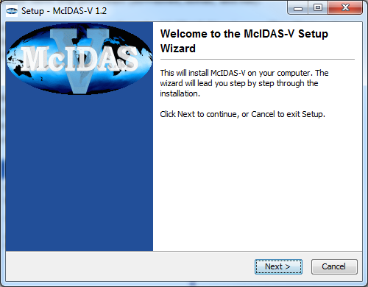
A GUI assists the installation process and allows creation of a program group and/or desktop icon.

3. Run McIDAS-V: Follow the instructions appropriate for your operating system:

Mac OS X Double-click on the McIDAS-V shortcut icon that was created in /Applications.
Windows Double-click on the McIDAS-V shortcut icon that was created on the Desktop.
All others At the UNIX prompt from the directory where McIDAS-V was installed,
run the command: McIDAS-V-System/runMcV

Note: By default, McIDAS-V uses 80% of the available machine memory. The maximum amount of memory is determined by the operating system. To manually change the memory used by McIDAS-V, edit the Maximum Heap Size
- Select Edit -> Preferences from the main menu
- Select the Advanced tab of the Users Preferences
- Enter the desired memory usage under Starup Options
- The new amount of memory is saved and used in subsequent sessions. For 32 bit operating systems, it is recommended to set this to no more than 1250 MB. The maximum value for 32 bit operating systems is 1536 MB.
- Exit McIDAS-V and start a new session to use this new memory setting.

Welcome Window

Upon initial startup, the Welcome to McIDAS-V window is displayed.

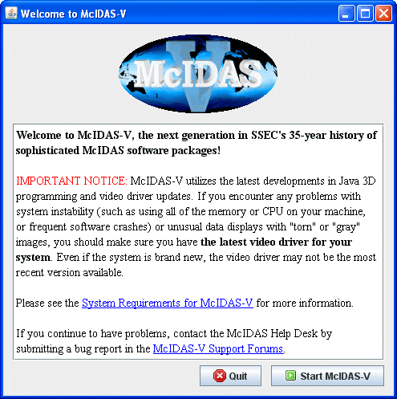
Please read the IMPORTANT NOTICE: McIDAS-V utilizes the latest developments in Java 3D programming and video driver updates, it is often necessary to update video drivers to solve some seemingly unrelated performance problems. Do not assume that because you have a new machine, you have the latest drivers. We have found brand new machines with drivers that are more than five years old!

After reading the notice in the Welcome window, click Quit to close the window, or click Start McIDAS-V to close the window and start McIDAS-V. Once McIDAS-V has been started, this window will not appear again.

Introduction to McIDAS-V windows
There are two main windows in the McIDAS-V application - the Data Explorer window and the Main Display window. Other windows appear when needed.
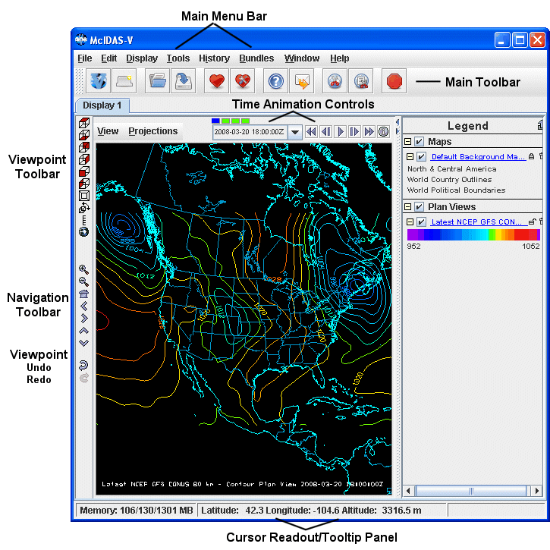

Data Explorer (shown on the left)
The Data Explorer window is central to McIDAS-V. It is used to choose the data display options. These options include the data source, parameters, display type, along with data times and any region selection or data reduction. The Data Explorer defaults to the Satellite -> Imagery Chooser for the first run of McIDAS-V. This chooser, along with several others, uses ADDE (Abstract Data Distribution Environment) servers to access data. McIDAS-V has a pre-configured list of free servers which contain real-time and archived atmospheric datasets.

Main Display (shown on the right)
The Main Display window includes the McIDAS-V display panels, legend, time animation controls, viewpoint controls for 3D displays, icons to zoom and pan, menus to control views and projections, and the main McIDAS-V menu. Navigate to Help -> User’s Guide in the Main Toolbar to access the McIDAS-V User’s Guide.

Common Usage Scenario
To create displays of data with McIDAS-V, the workflow is
- Choose the data source (local files, remote servers, etc.)
- Select parameters and display type
- Create the display
- Control the display
- Create a bundle and/or save images and movies

Bundles
Bundles are configuration files that specify the state of McIDAS-V. They include information about what data sources are in use, which parameters from the data sources are displayed, and how they are displayed. In a sense, they are a “snapshot” of a particular McIDAS-V session.
Bundles can be used save work for future reference, or can be used to share McIDAS-V data and displays with colleagues. There are two types of bundles, regular *.mcv bundles, and *.mcvz zipped bundles. These serve different purposes.
The *.mcv bundle, along with storing the setup and display options, stores a reference to the particular type of data loaded into McIDAS-V. For example, if you load the most recent GFS, display pressure, and save the display as a *.mcv bundle, the next time the bundle is loaded, McIDAS-V will connect to the same server/catalog from which the data was originally retrieved, and display the most recent GFS pressure data. This type of bundle can be very useful in an operational environment, where it is desirable to look at the same products but display the most recent data.
The *.mcvz bundle is different from the *.mcv bundle because it stores data with the bundle. For example, if radar data for a tornado case is loaded that may not be on the server at a later date, the display can be saved as a *.mcvz zipped bundle. The next time this bundle is loaded, the same data with the same display options is displayed. This is useful for case studies, where it is desirable to look at the same data.

Data Explorer - Data Sources tab
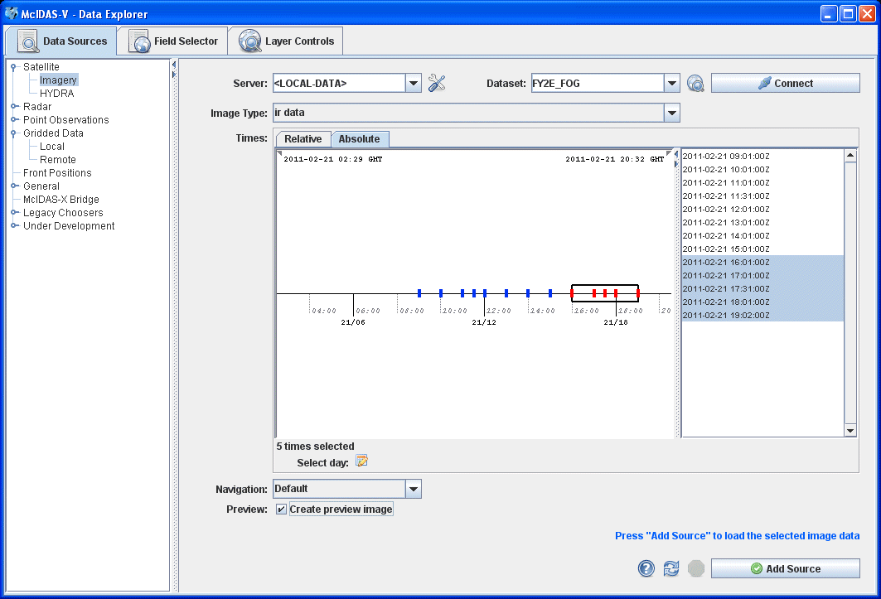
The Data Sources tab is used to locate remote data servers or local files for display in McIDAS-V. Once the type of data source is selected, a chooser with the appropriate selection criteria is displayed. Satellite -> Imagery is chosen above, and the Satellite -> Imagery chooser is displayed. Other data source types are the HYDRA multi-spectral display, Radar, Point Observations, Gridded Data, General files, and the McIDAS-X bridge.

Data Explorer - Field Selector tab
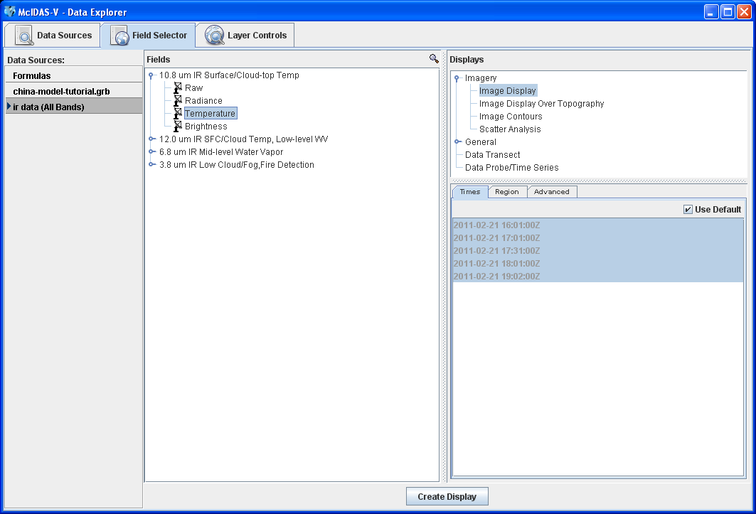
The Field Selector tab analyzes the data source to determine the displayable fields and parameters. With this information, a list of available displays is presented. In the Subset panel of the Field Selector there are tabs to select times to display, which region to use, as well as a variety of advanced options. Note that the tabs in the Subset panel will differ dependent on which data source is loaded.
Data Explorer - Layer Controls tab
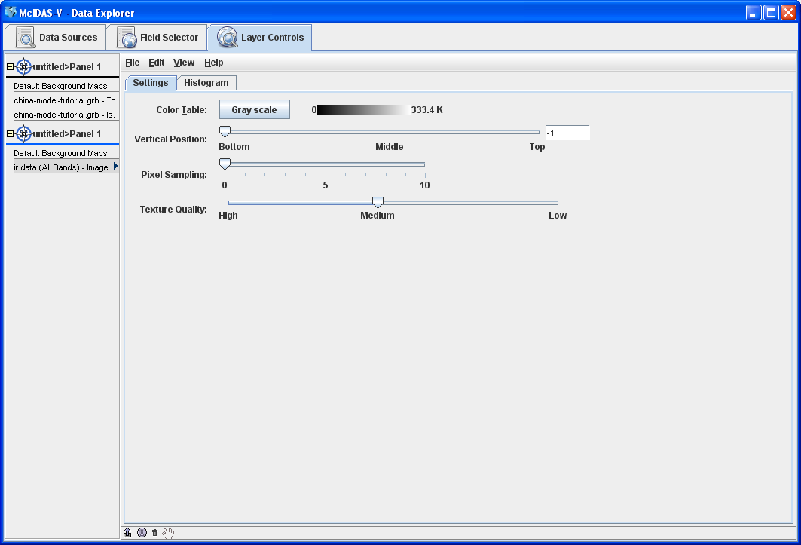

Displayed fields and parameters are known as Layers. The Layer Controls tab contains the display options for each layer. Changes made to any layer will be reflected in the Main Display. Also, graphs, time series and all non-navigated displays are drawn in the Layer Controls.

Introduction to McIDAS-V controls

- Load the <local path>/Data/Installation/Intro-Bundle.mcvz bundle to display NCEP GFS data in the Main Display window.

  - Use the Main Menu Bar of the Main Display window, Left Click to select File -> Open File….

  - In the file browser, “Look In” the location where you downloaded the data files for this tutorial, select Intro-Bundle.mcvz and Left Click Open.

  - When prompted, select Replace Session to replace the current window with the contents of the bundle and Left Click OK.

  - Select Remove all layers.

  - Select Remove all data.

  - Select Write to temporary directory, check Don’t show this again, and Left Click OK.
The Main Display will change to a view from the south, and two new 3D Surfaces will be listed in the right panel Legend of the Main Display window. One surface is a color-shaded image over topography. The other surface is an 50 m/s wind speed isosurface. The yellow isosurface is shadowed for perspective; otherwise it would be one block of color.
- Click and drag the right mouse button to rotate the display. Use the navigation controls listed on the last page of this document or the navigation controls on the left side of the Main Display to zoom in and out, and “move through” the data.
- Toggle the 3D surfaces on and off in the display by clicking the checkbox next to each item in the Legend on the right side of the Main Display window.
- Click on the name of each item in the Legend to access the Layer Control and change the color table or the isosurface values. To change the display unit of the isosurface, use the Layer Controls menu and select Edit -> Change Display Unit.
- Use the Time Animation controls at the top of the Main Display to animate, or step through the image sequence.

Apply Customized Display Settings to Multiple Layers

- Navigate to the Layer Controls. Under “Tab 1>Panel 1”, Select the top of the two layers listed “Latest NCEP GFS CONUS…”

- From the Layer Controls menu, select EditProperties

- Locate the “Legend Label” text input dialog box (see image below):

  - Remove: “%datasourcename% - %displayname%”
  - Type: “%displayname% - %longname%
  - The first layer should be labeled “Topography – Geopotential…” when steps 3a-b are complete.

- From the layer control, select EditDisplay Settings…
  - Note, the “Topography” layer is highlighted under the Source Displays dialog box. The settings for this layer are active in the Properties dialog box, and can be applied to other layers.
  - Under the Properties dialog box, check “Legend Label”
  - Under Target Displays select “Latest NCEP GFS CONUS 80 km – Isosurface…” (See illustration below)
  - Click “Apply>>”. The second layer should be labeled “Isosurface – Speed (from…” when steps 4a-c are complete.

This technique can be used to efficiently apply color tables, ranges, and many display settings to multiple layers.

Data Explorer - Layer Controls tab – Display Settings

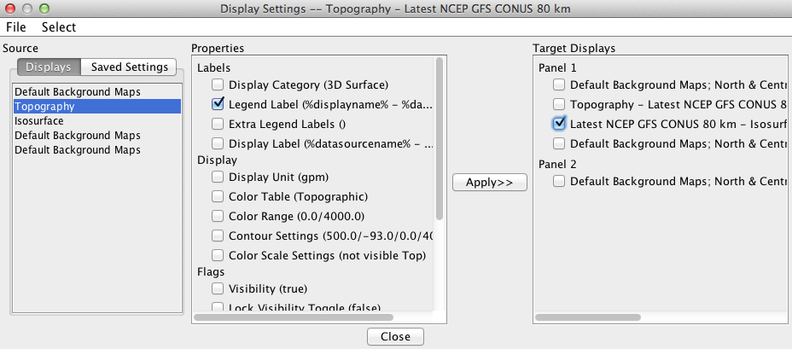

Moving a layer to a new panel

- Open a new tab using FileNew Display TabMap DisplayTwo Panels

- Navigate to the Layer Controls. Select the “Topography – Geopotential…” layer.
  - Place the mouse over “Drag and Drop” tool (),

  - Hold the left mouse button.

  - Continue holding left mouse button while moving the “Drag and Drop” square over “untitled >Panel 1.”

  - Release the left mouse button.

  - The displayed layer is now in panel 1 of the two-panel display.

- Repeat steps 2a-d for the “Isosurface – Speed” layer. Place the “Isosurface-Speed” layer in “untitled>Panel 2”

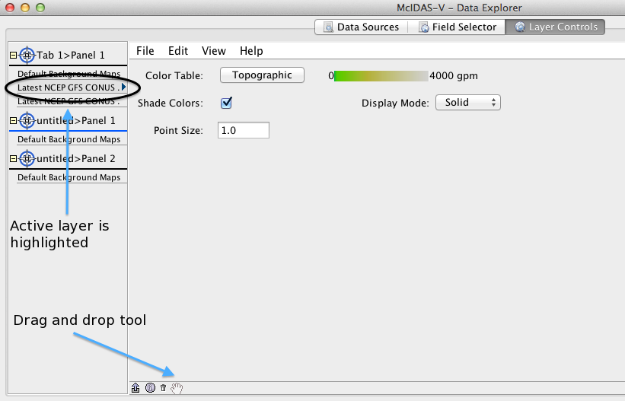

Below is a list of supported data types, formats, and the method to access them in McIDAS-V.

Data Type | Description | Supported Formats | Access Method
Gridded | Numerical weather prediction models, climate analysis, gridded  oceanographic datasets, NCEP/NCAR Reanalysis | netCDF | local files, HTTP, TDS Servers
 |  | GRIB (versions 1&2) | local files, TDS Servers
 |  | Vis5D | local files, HTTP
 |  | GEMPAK | local files, TDS Servers
Satellite  Imagery | Geostationary and polar orbiter satellite imagery, derived satellite products | ADDE | ADDE servers, local & remote
 |  | McIDAS AREA | local files, local & remote ADDE
 |  | AIRS | local files
 |  | GINI | local files, TDS servers
 |  | AMSR-E Level 1b | local ADDE
 |  | AMSR-E Rain Product | local ADDE
 |  | EUMETCast LRIT | local ADDE
 |  | Meteosat OpenMTP | local ADDE
 |  | Meteosat Second Generation  (MSG) Level 1b | local ADDE
 |  | Metop AVHRR Level 1b | local ADDE
 |  | MODIS L1b MOD02  (MODIS Level 1b) | local ADDE
 |  | MODIS L2 MOD04  (Level 2 Aerosol) | local ADDE
 |  | MODIS L2 MOD06  (Level 2 Cloud Top Properties) | local ADDE
 |  | MODIS L2 MOD07  (Level 2 Atmospheric Profile) | local ADDE
 |  | MODIS L2 MOD28  (Level 2 Sea Surface Temperature Products) | local ADDE
 |  | MODIS L2 MOD35  (Level 2 Cloud Mask) | local ADDE
 |  | MODIS L2 MODR  (Level 2 Corrected Reflectance) | local ADDE
 |  | MSG HRIT FD and HRV | local ADDE
 |  | MTSAT HRIT | local ADDE
 |  | NOAA AVHRR Level 1b | local ADDE
 |  | SSMI (TeraScan netCDF) | local ADDE
 |  | TRMM (TeraScan netCDF) | local ADDE
Radar | Radar images | Level II | local files or TDS (bzip2 compressed or uncompressed)
 |  | Level III/TDWR | ADDE Servers, local files or TDS
 |  | Universal Format (UF) | local files
 |  | DORADE | local files

Data Type | Description | Supported Formats | Access Method
Point  Observational | Surface observations (METAR and  SYNOP), earthquake observations | ADDE | ADDE servers
 |  | netCDF (Unidata, AWIPS/MADIS formats) | local files
 |  | Text (ASCII, CSV), Excel spreadsheet | local files
 | Global balloon soundings (RAOB) | ADDE | ADDE servers
 |  | netCDF (Unidata, AWIPS/MADIS formats) | local files
 |  | CMA text format | local files
 | NOAA Profiler Network winds | ADDE | ADDE servers
Trajectory | Aircraft observations | netCDF (RAF convention) | local files
 |  | Text (ASCII, CSV) | local files
GIS | Data typically used in Geographic Information Systems (GIS) | ESRI Shapefile | local files, HTTP
 |  | USGS DEM | local files
QuickTime | QuickTime movies (without extensions) | QuickTime | local files, HTTP

Zooming, Panning, and Rotating Controls

Zooming | Panning | Rotating
 | Mouse
Shift-Left Drag: Select a region by pressing the Shift key and dragging the left mouse button.  Shift-Right Drag: Hold Shift key and drag the right mouse button. Moving up zooms in, moving down zooms out. | Control-Right Mouse Drag: Hold Control key and drag right mouse to pan. | Right Mouse Drag: Drag right mouse to rotate.
 | Scroll Wheel
Scroll Wheel-Up: Zoom Out.  Scroll Wheel-Down: Zoom In. |  | Control-Scroll Wheel-Up/Down: Rotate clockwise/counter clockwise.  Shift-Scroll Wheel-Up/Down: Rotate forward/backward clockwise.
 | Arrow Keys
Shift-Up: Zoom In.  Shift-Down: Zoom Out. | Control-Up arrow: Pan Down.  Control-Down arrow: Pan Up.  Control-Right arrow: Pan Left.  Control-Left arrow: Pan Right. | Left/Right arrow: Rotate around vertical axis.  Up/Down arrow: Rotate around horizontal axis.  Shift-Left/Right arrow: Rotate Clockwise/Counterclockwise.

