McIDAS-V Tutorial
Displaying Gridded Data
updated December 2013 (software version 1.4)

McIDAS-V is a free, open source, visualization and data analysis software package that is the next generation in SSEC's 40-year history of sophisticated McIDAS software packages. McIDAS-V displays weather satellite (including hyperspectral) and other geophysical data in 2- and 3-dimensions. McIDAS-V can also analyze and manipulate the data with its powerful mathematical functions. McIDAS-V is built on SSEC's VisAD and Unidata's IDV libraries, and contains "Bridge" software that enables McIDAS-X users to run their commands and tasks in the McIDAS-V environment. The functionality of SSEC's HYDRA software package is also being integrated into McIDAS-V for viewing and analyzing hyperspectral satellite data.
More training materials are available on the McIDAS-V webpage and in the Getting Started chapter of the McIDAS-V User’s Guide, which is available from the Help menu within McIDAS-V. Notifications at McIDAS-V startup alert users when there is a new version of McIDAS-V is available on the McIDAS-V webpage - http://www.ssec.wisc.edu/mcidas/software/v/. Please post error reports the McIDAS-V Support Forums - http://www.ssec.wisc.edu/mcidas/forums/.
Please post error reports or feature requests to the McIDAS-V Support Forums - http://www.ssec.wisc.edu/mcidas/forums/http://dcdbs.ssec.wisc.edu/mcidasv/forums/. The forums also provide the opportunity to share information with other users.
This tutorial assumes McIDAS-V is installed, and can be run on your machine. For information about installing and running McIDAS-V follow the instructions in the document entitled McIDAS-V Tutorial – Installation and Introduction.

In this McIDAS-V Tutorial, each exercise is explained using two different methods of data access: pre-loaded data bundles and real-time access to default remote servers. If you have access to your own real-time servers, you may use those, but be aware that different server configurations may make the explanations in this document not applicable to all loaded.

Terminology
There are two windows displayed when McIDAS-V first starts, the McIDAS-V Main Display (hereafter Main Display) and the McIDAS-V Data Explorer (hereafter Data Explorer).
The Data Explorer contains three tabs that appear in bold italics throughout this document: Data Sources, Field Selector, and Layer Controls. Data is selected in the Data Sources tab, loaded into the Field Selector, displayed in the Main Display, and output is formatted in the Layer Controls.
Menu trees are listed as a series (e.g. Edit -> Remove -> All Layers and Data Sources).
Mouse clicks are listed as combinations (e.g. Shift+Left Click+Drag).

Displaying Gridded data: 2D

- Remove All Layers and Data Sources from the previous displays. (From the main toolbar or from the main menu EditRemoveAll Layers and Data Sources)
- For real-time data instructions, skip to step 3. Otherwise, load the data bundle
<local path>/Data/Gridded/Grid-GFS-Intro.mcvz.
  - In the Main Display, select the File -> Open File… menu item.
  - Navigate to the Grid-GFS-Intro.mcvz file and click Open.
  - In the Open Bundle dialog box, select the Replace session option and click OK.

  - Skip to Step 4

- Instructions for Real-time data.

  - Select the Gridded Data -> Remote chooser from the Data Sources tab of the Data Explorer.

  - From the Catalog pull down menu, select http://www.unidata.ucar.edu/georesources/threddsRtModels.xml.

  - Add the THREDDS Model Data -> NCEP Model Data -> Global Forecast System (GFS) -> GFS-CONUS 80km -> files -> Latest source.

- Display the MSL Pressure.
  - In the Field Selector, expand the dropdown arrow to the left of 2D grid. Select Pressure reduced to MSL @ msl field.

  - Select the Plan Views -> Color-Shaded Plan View Display.

  - In the Times tab, uncheck the Use Default checkbox and select the first six times.
  - Click Create Display.

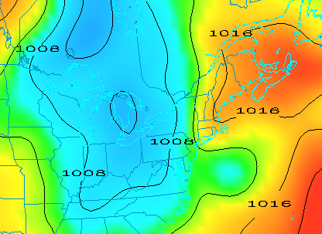
- In the Layer Controls, turn on the option to Shade Colors.

- Return to the Field Selector, change the Display type to Contour Plan View, and overlay the same field.

  - Select the 2D grid -> Pressure reduced to MSL @ msl field.
  - Select the Plan Views -> Contour Plan View display type.
  - Click Create Display. The contours now overlay the Color-Shaded Plan View display, but are not apparent.
- In the Layer Controls, click on the Color Table name (PressureMSL). Change the color table of the contours to System -> Solid Colors -> Black.
- In the Layer Controls tab, click the Change button for Contour. For Labels, change the Align item to Horizontal and move the Frequency slider up to a value of Hi.
- Zoom in over a region to see a display similar to the display shown on the previous page.

Displaying Gridded data: 3D

- Remove All Layers (not the Data). In the Field Selector, expand the dropwdown list to the left of 3D grid. Select Temperature @ isobaric field.
  - Select the Plan Views -> Color-Filled Contour Plan View display type.

  - In the Times tab select the first 6 images.

  - In the Level tab, select 500 hPa.

  - Click Create Display.

- Use the rotating and zooming controls to rotate the Main Display window. Verify that the 500hPa surface is displayed above the map layer.
- Keep the Main Display rotated so the difference in height between the map and the display is discernable.

- Change the level of the display. Note that when the level is changed, both the plotted values and the z-level of the display change in the Main Display.
  - Click on Latest NCEP GFS CONUS… in the Legend to access the Layer Controls for this item.

  - Change the level to 850 hPa by using the Levels menu.

  - Change the contour interval to 2 Celsius by clicking on the Change button in the Contour section of the Layer Controls.

- Reset the projection using the button on the left side of the Main Display window
- Change the level to 250 hPa in the Layer Controls using the method in 13b. Notice that the map is not visible above the contours.

- Move the map above the 250 hPa contours and change the map colors to white.

  - In the Layer Controls, select “Default Background Maps” from the list of layers on the side of the tab.
  - At the bottom of the Maps tab, move the Position slider to the z-level of 0.30 to move higher into the 3D display. The map lines should now be visible on the data displayed in the Main Display. However, the map lines are indistinct since the lines are drawn in the same color as the data.

  - In the Maps tab of the Layer Controls for Default Background Maps, change the map colors of “North & Central America”, “World Political Boundaries”, and “World Coastlines” to white: For each map click on the colored square next to each of the map lines, select white, click OK. The map lines are now clearly visible in the Main Display window.
Problem Sets

The previous examples provide the general knowledge necessary to load and display gridded data. The problem sets below introduce new topics related to the data, as well as challenge your knowledge of McIDAS-V. It is recommend that you attempt to complete each problem set before reading the solutions, which are provided below the problem set.

- Using data from the <local path>/Data/Gridded/Grid-GFS-Intro.mcvz bundle
  - Using the most recent time, create a display of 2D Pressure with the 3D Color Shaded Image Over Topography.
  - Overlay an Absolute Vorticity isosurface using the most recent time.
  - Remove the Absolute Vorticity layer and add a Relative Humidity Color-Filled Contour Cross Section using the oldest time.
- Use the bundle <local path>/Data/Gridded/Grid-Problem-Globe.mcvz to load the grids.
  - Create a 3D globe display of jet stream winds and 2D surface temperature from grids for the first three times.
  - Create a movie of the animation, which includes display rotation. Note: This bundle is large, so it may take a minute to open the file.
- Use the grids in the bundle <local path>/Data/Gridded/Grid-Problem-Difference.mcvz or load real-time data grids. When using real-time data, do not use the 2009 time, but choose one time or both model runs.
  - Create a display showing the difference between the 0Z and 6Z 2D Pressure Reduced to MSL @ msl field for 2009-05-29 00:00:00Z.
  - Change the units to millibars and change the range to match the new units.
  - Save a JPG image of the difference.

- Use the grids in the bundle <local path>/Data/Gridded/Grid-Problem-Trajectories.mcvz or real-time data grids.
  - Use the first 10 time steps of the data, to create a display of 2D trajectories colored by Relative Humidity overlaid on precipitable water.
  - Use the rectangle Trajectory Initial Area over the United States with an Initial Area Skip Factor of 2 to limit the number of trajectories drawn.
  - Shorten the number of time steps for the trajectories to two.
  - Set the trajectory thickness to 2.
  - Add a color scale for the relative humidity field to the Main Display.
  - Add a Color-Shaded Plan View of Precipitable water @ Entire atmosphere
  - Shade the colors
  - Change the colorbar to System > Gray Scale and set the transparency of the layer to 20%.

Problem Set #1 – Solution

Using data from the <local path>/Data/Gridded/Grid-GFS-Intro.mcvz bundle
- Using the most recent time, create a display of 2D Pressure with the 3D Color Shaded Image Over Topography.
- Overlay an Absolute Vorticity isosurface using the most recent time.
- Remove the Absolute Vorticity layer and add a Relative Humidity Color-Filled Contour Cross Section using the oldest time.

- Remove All Layers.

- Create a new tab.
- Display the most recent 2D Pressure field over topography.

  - In the Fields panel of the Field Selector, select the 2D grid -> Pressure reduced to MSL @ msl field.
  - Under Displays, select the 3D Surface -> Color-Shaded Image Over Topography display.
  - In the Times tab of the Field Selector, choose the first listed time only.
  - Click Create Display. A secondary field selector appears for topography field selection.

  - In the new Field Selector window, select the Latest NCEP GFS CONUS 80km -> Geopotential_height @ surface field under Field: Topography, select the earliest time under Times, and click OK. The 2D field is displayed as topography.
- In the Pressure field Layer Controls tab, check the Shade Colors option.
- View the display in 3D using the zooming and rotating controls..
- Reset the display projection using the icon on the left side of the Main Display window.

- Display the most recent 3D grid -> Absolute Vorticity @ isobaric with the 3D Surface -> Isosurface display type. Click Create Display.

- Zoom in over the US and rotate the display to see the absolute vorticity isosurface over the continental US.
- The Isosurface Value in the Layer Controls can be used to change the value of absolute vorticity displayed. Change the value to 5 (x 1.0e-5 s-1).
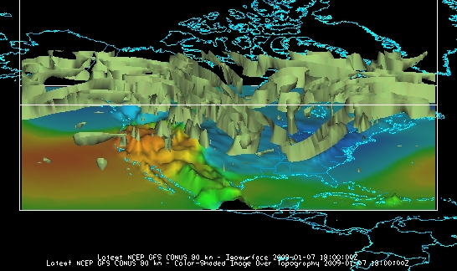

- Remove the absolute vorticity isosurface layer from the display.

- Select the earliest 3D grid -> Relative Humidity @ Isobaric field as a Color-Filled Contour Cross Section. Click Create Display. The cross section will be displayed in 3D in the Main Display window and in 2D in the Layer Controls.
- To reposition the cross section in the Main Display window, Left Click on the plus or square to move the ends of the cross section, and the triangle to move the entire line.
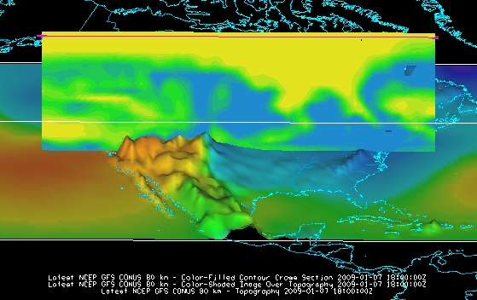

Problem Set #2 – Solution

- Use the bundle <local path>/Data/Gridded/Grid-Problem-Globe.mcvz to load the grids.
- Create a 3D globe display of jet stream winds and 2D surface temperature from grids for the first three times.
- Create a movie of the animation, which includes display rotation. Note: This bundle is large, so it may take a minute to open the file.

- Add a one panel globe display tab by selecting File -> New Display Tab -> Globe Display -> One Panel from the Main Display.

- Load bundle <local path>/Data/Gridded/Grid-Problem-Globe.mcvz via the File -> Open File… menu item in the Main Display. In the Open Bundle dialog box select the Replace session option and click OK. This is a large dataset, so it may take a minute to open the file.
- Display the first three 2D grid -> Temperature -> Temperature at Surface grids as a Color-Filled Contour Plan View. Overlay as contours.

- Next, display the 3D -> Momentum -> Derived -> Speed grid as a 3D Isosurface for the same times.
- In the Layer Controls, change the following:

  - Change Isosurface Value to 60 m/s.

  - Change the default World Coastlines map color to RGB 0-153-204 and the default World Political Boundaries map color to RGB 0-255-25: Use the Default Background Maps Layer Controls. Double-click the color square to the right of the desired map. The Set Map Linee Color chooser appears. Select the RGB tab. Enter the values Red: 0, Green: 255, Blue: 25.

- Start the loop and turn on the Auto-Rotate View option (View -> Viewpoint -> Auto-Rotate View from the Main Display). Use the Zooming and Panning controls to observe the data from different views. (Depending on preference, it might help to turn the Auto-Rotate View option off.)
- Click the play button on the animation toolbar and verify that the Auto-Rotate View option is on.

- Capture a movie of the rotating globe by selecting View -> Capture -> Movie… in the Main Display.
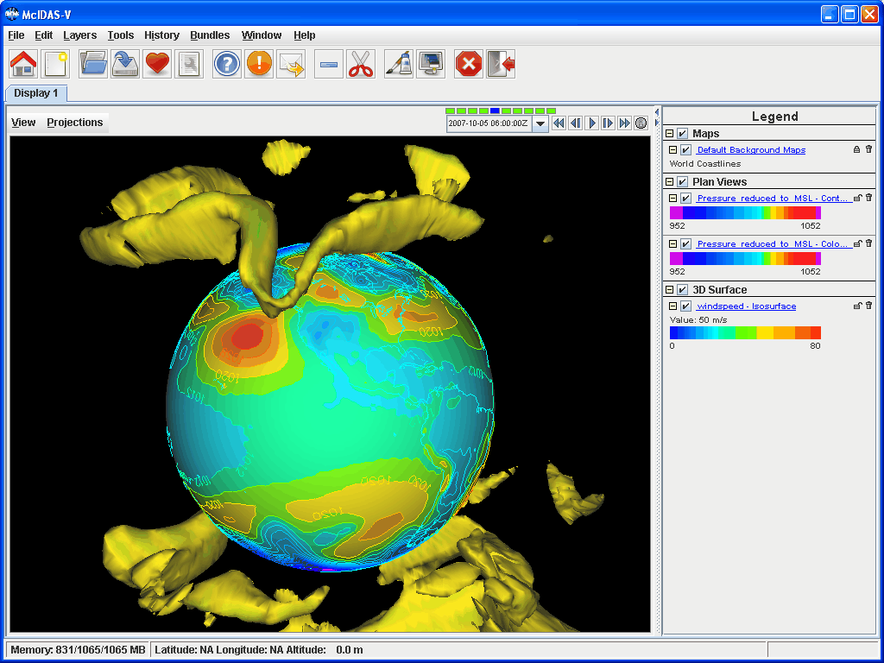
- In the Movie Capture window, change Rate: to 0.25 seconds.

- Move the Main Window and the Movie Capture window around so they do not overlap. (During the movie capture, if the view in the Main Window is obscured, the obstruction will appear in the movie).

- Start the movie capture by clicking Automatically.
- Once the globe has rotated 360°, click Stop. Click Save Movie to save it as a QuickTime movie.
Problem Set #3 – Solution

Use the data in the bundle <local path>/Data/Gridded/Grid-Problem-Difference.mcvz or load real-time data grids. When using real-time data, do not use the 2009 time, but choose one time or both model runs.
  - Create a display showing the difference between the 0Z and 6Z 2D Pressure Reduced to MSL @ msl field for 2009-05-29 00:00:00Z.
  - Change the units to millibars and change the range to match the new units.
  - Save a JPG image of the difference.

- Open a new tab and close the globe display tab.

- For real-time data instructions, skip to step 3. Otherwise, load the data bundle Grid-Problem-Difference.mcvz. In the Open Bundle dialog box select the Replace session option and click OK.

- Real-time data instructions. Skip to step 4 if the data has been loaded via a bundle.

- Remove All Layers and Data Sources.

- Return to the Data Sources tab, and load the 0Z and 6Z GFS Global 1° grids (NCEP Model Data -> Global Forecast System (GFS) -> GFS-Global onedeg -> GFS_Global_onedeg_YYYYMMDD_0000.grib2 (0600.grib2)) for today into the Field Selector.
- Choose Formulas in the Field Selector, and select Miscellaneous -> Simple difference a-b.

- In the Displays panel select Plan Views -> Color-Shaded Plan View and click Create Display. A Field Selector window will pop up prompting you for the two fields to subtract. You may need to expand the window to see the full descriptions.

- For Field: a, select the 0Z run Pressure Reduced to MSL @ msl field and 2009-05-29 00:00:00Z.

- For Field: b, select the 6Z run Pressure Reduced to MSL @ msl field and 2009-05-29 00:00:00Z. Click OK.
- The resulting plot will show the difference between the two grids in Pascals. Change this to millibars.

- In the Layer Controls, select Edit -> Change Display Unit…

- Select millibar from the dropdown list and click OK. To change the range of data values with the new units, Right Click on the color bar in the Legend and select Change Range. Click on Use Predefined -> From All Data and click OK. Positive values indicate the 0Z forecast predicted a higher pressure than the 6Z, and negative values indicate the opposite.
- Save the Main Display window as an image. Select the View -> Capture -> Image… menu item from the Main Display.

- Under Capture What, change the radio button to Full Window.

- Enter in a name, followed by the “.jpg” extension and click Save.
Problem Set #4 – Solution

Use the grids in the bundle <local path>/Data/Gridded/Grid-Problem-Trajectories.mcvz or real-time data grids.
- Use the first 10 time steps of the data, to create a display of 2D trajectories colored by Relative Humidity overlaid on precipitable water.
- Use the rectangle Trajectory Initial Area over the United States with an Initial Area Skip Factor of 2 to limit the number of trajectories drawn.
- Shorten the number of time steps for the trajectories to two.
- Set the trajectory thickness to 2.
- Add a color scale for the relative humidity field to the Main Display.
- Add a Color-Shaded Plan View of Precipitable water @ Entire atmosphere
- Shade the colors
- Change the colorbar to System > Gray Scale and set the transparency of the layer to 20%.

      - For real-time data, skip to step 2. Otherwise, load the data bundle Grid-Problem-Trajectories.mcvz. In the Open Bundle dialog box select the Replace session option and click OK. Skip to step 3

      - Real-time data instructions. If the data was loaded via a bundle, skip to step 3 .

              - Return to the Data Sources tab, and load the most recent GFS 80km CONUS data (NCEP Model Data > Global Forecast System (GFS) > GFS-CONUS 80km > files > Latest NCEP GFS CONUS 80km)) in the Field Selector.
              - Click Add Source.
      - Display the first 10 times of 2D trajectories colored by Relative Humidity.
  - Under Fields in the Field Selector, select the 2D grid > Derived > Grid 2D Trajectory* field.
  - Under Displays, select Trajectory Colored By Parameter.
  - In the Times tab, Right-Click and choose Select Range > First 10.
  - Click Create Display.
  - In the secondary Field Selector window, select Latest NCEP GFS CONUS 80km > 2D grid > Relative humidity*.
  - Click OK.
- Display trajectories over the United States.
  - In the Layer Controls tab, select the Rectangle Trajectory Initial Area.
  - In the Main Display window, use Left-Click+Drag to draw a rectangle over the United States. This will be the trajectories origin.

  - In the Layer Controls, set Initial Area Skip Factor to 2.
  - Click Create Trajectory.
- By default, the entire length of the trajectories is shown, which can lead to a cluttered display. Change this so the trajectories are only 2 time steps long at any given time in the loop. Set the trajectory width to 2.
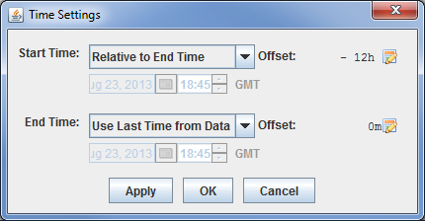
  - In the Times tab of the Layer Controls, select the Time Mode button.
  - For Start Time, change the dropdown menu to Relative to End Time. End Time is denoted as the current time step of the loop. Change the Start Time offset to (-12 hours) to make the trajectories only show the last 12 hours of data (or two 6-hour time steps).
  - Click OK in the Time Settings window.
  - In the Layout tab of the Layer Controls, change Line Width to 2.
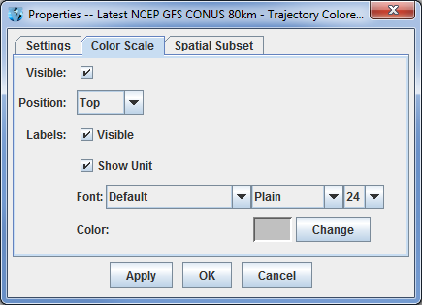
  - Play the loop in the Main Display to animate the trajectories paths. When done, pause the loop.
- Add a relative humidity color scale to the Main Display.
  - In the Layer Controls tab for relative humidity, select the Edit > Properties menu item.
  - In the Color Scale tab of the Properties window, turn on the Visible checkbox, turn on both the Visible and Show Unit checkboxes for Labels, and change the font size to 24.
  - Click OK.
- Overlay a Color-Shaded Plan View of precipitable water in the Main Display.
  - Under Fields in the Field Selector, select the 2D grid > Precipitable water* field.
  - Under Displays, select Plan Views > Color-Shaded Plan View.
  - In the Times tab, Right-Click and choose Select Range > First 10.
  - Click Create Display.
- Change the precipitable water display to use the System > Gray Scale colorbar, shade the colors, and set the transparency at 20%.
  - Right-Click on the colorbar in the Legend and select System > Gray Scale.
  - In the Layer Controls tab, select the Shade Colors item.
  - Right-Click on the colorbar in the Legend and select Transparency > 20%.
- Play the loop in the Main Display to compare the trajectories of relative humidity to precipitable water .

Challenge

The bundle <local path>/Data/Gridded/Grid-Problem-Challenge.mcvz contains 3D u and v data. Use the available data and display options to find a jet entrance or exit region. To view the problem worked solution, load the <local path>/Data/Gridded/Grid-Problem-Challenge-Result.mcvz bundle.

The graphic below is a model of jet entrance and exit regions:
http://www4.ncsu.edu/~nwsfo/storage/training/jets/JETS.gifs/JET.4Cell.A.gif

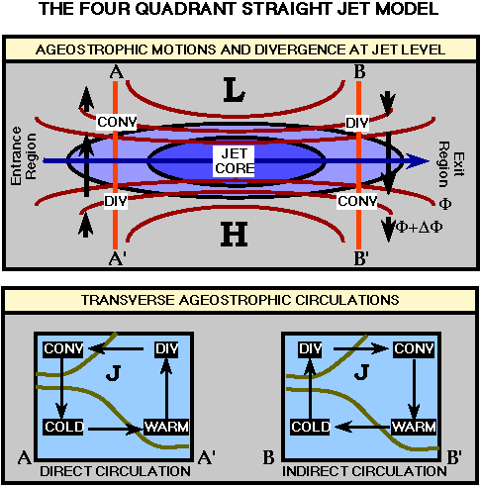
Zooming, Panning, and Rotating Controls

Zooming | Panning | Rotating
 | Mouse
Shift-Left Drag: Select a region by pressing the Shift key and dragging the left mouse button.  Shift-Right Drag: Hold Shift key and drag the right mouse button. Moving up zooms in, moving down zooms out. | Control-Right Mouse Drag: Hold Control key and drag right mouse to pan. | Right Mouse Drag: Drag right mouse to rotate.
 | Scroll Wheel
Scroll Wheel-Up: Zoom Out.  Scroll Wheel-Down: Zoom In. |  | Control-Scroll Wheel-Up/Down: Rotate clockwise/counter clockwise.  Shift-Scroll Wheel-Up/Down: Rotate forward/backward clockwise.
 | Arrow Keys
Shift-Up: Zoom In.  Shift-Down: Zoom Out. | Control-Up arrow: Pan Down.  Control-Down arrow: Pan Up.  Control-Right arrow: Pan Left.  Control-Left arrow: Pan Right. | Left/Right arrow: Rotate around vertical axis.  Up/Down arrow: Rotate around horizontal axis.  Shift-Left/Right arrow: Rotate Clockwise/Counterclockwise.

