McIDAS-V Tutorial

Using and Creating Formulas

updated December 2013 (software version 1.4)

McIDAS-V is a free, open source, visualization and data analysis software package that is the next generation in SSEC's 40-year history of sophisticated McIDAS software packages. McIDAS-V displays weather satellite (including hyperspectral) and other geophysical data in 2- and 3-dimensions. McIDAS-V can also analyze and manipulate the data with its powerful mathematical functions. McIDAS-V is built on SSEC's VisAD and Unidata's IDV libraries, and contains "Bridge" software that enables McIDAS-X users to run their commands and tasks in the McIDAS-V environment. The functionality of SSEC's HYDRA software package is also being integrated into McIDAS-V for viewing and analyzing hyperspectral satellite data.

More training materials are available on the McIDAS-V webpage and in the Getting Started chapter of the McIDAS-V User’s Guide, which is available from the Help menu within McIDAS-V. Notifications at McIDAS-V startup alert users when there is a new version of McIDAS-V is available on the McIDAS-V webpage - **<http://www.ssec.wisc.edu/mcidas/software/v/>**. Please post error reports the McIDAS-V Support Forums - <http://www.ssec.wisc.edu/mcidas/forums/>.

Please post error reports or feature requests to the McIDAS-V Support Forums - <http://www.ssec.wisc.edu/mcidas/forums/><http://dcdbs.ssec.wisc.edu/mcidasv/forums/>. The forums also provide the opportunity to share information with other users.

This tutorial assumes McIDAS-V is installed, and can be run on your machine. For information about installing and running McIDAS-V follow the instructions in the document entitled *McIDAS-V Tutorial – Installation and Introduction*.

Terminology

There are two windows displayed when McIDAS-V first starts, the **McIDAS-V Main Display** (hereafter **Main Display**) and the **McIDAS-V Data Explorer** (hereafter **Data Explorer**).

The **Data Explorer** contains three tabs that appear in bold italics throughout this document: ***Data Sources*, *Field Selector***, and ***Layer Controls***. Data is selected in the ***Data Sources*** tab, loaded into the ***Field Selector***, displayed in the **Main Display**, and output is formatted in the ***Layer Controls***.

Menu trees are listed as a series (e.g. ***Edit -> Remove -> All Layers and Data Sources***).  
  
Mouse clicks are listed as combinations (e.g. *Shift+Left Click+Drag*).

**Introduction**

There are three ways formulas are implemented in McIDAS-V: system formulas provided as part of the McIDAS-V software, user-defined formulas created and executed from within McIDAS-V, and user-defined formulas defined in Jython code written by the user. This tutorial will cover the first two categories, those that can be created and used within McIDAS-V.

**System Formulas – Simple Subtraction**

1. Load the forecast data for Super Typhoon Megi.  
   1. In the ***Data* Sources** tab of the **Data Explorer**, open the **Gridded Data** tree and select **Local**.
   2. Under **Look in**,individually add data sources for the following files:  
        
      *<local path>***/Data/Formulas/TyphoonMegi/gfs_4_20101017_0000_000.grb2***<local path>***/Data/Formulas/TyphoonMegi/gfs_4_20101017_0000_024.grb2**
2. Use the Simple Difference formula to subtract the 0 hour forecast from the 24 hour forecast Pressures.  
   1. In the ***Field Selector*** tab, select **Formulas** under **Data Sources**.
   2. Under **Fields**, open the ***Miscellaneous*** tree and select ***Simple difference a-b***.
   3. Under **Displays**,open the ***Imagery*** tree and select ***Image Display***.
   4. Click **Create Display**.
   5. In the new **Field Selector** window, select:  
      * For **Field: a**, open and select the ***gfs_4_20101017_0000_024.grb2 -> 2D grid -> Mass -> Pressure reduced to MSL @ Mean sea level***
      * For **Field: b**, open and select the ***gfs_4_20101017_0000_000.grb2 -> 2D grid -> Mass -> Pressure reduced to MSL @ Mean sea level***
   6. Click **OK** to display the results of the **Simple difference a-b** formula.
   7. Zoom into the Philippines area. The darker region southeast of the whiter region shows areas where pressure drops are forecasted. Drawing a line between the whiter and darker regions gives an indication of the predicted storm motion.

**System Formulas – Combining Multiple Formulas**

1. Remove All Layers via the ***Edit -> Remove -> All Layers*** menu item in the **Main Display**.
2. Add the forecast verification file for the 24 hour forecast:  
   1. In the ***Data Sources*** tab, open the ***Gridded Data*** tree and select ***Local***.
   2. Add a data source for the file*<local path>****/* Data/Formulas/TyphoonMegi/ gfs_4_20101018_0000_000.grb2**.
3. Use the Simple Difference formula to subtract the verification grid (Oct 18 – 0Z, 0 hr) from the forecast grid (Oct 17 – 0Z, 24 hr).   
   1. In the ***Field Selector***, under **Data Sources**, select **Formulas**. Under **Fields,** open the ***Miscellaneous***tree and select ***Any Field*.** Under **Displays,** open the ***3D Surface*** tree and select ***Topography*.** Click **Create Display**.
   2. Using the new **Field Selector** window, select ***Formulas -> Miscellaneous -> Simple difference a-b***.Click **OK**.
   3. For **Field: a**, select ***gfs_4_20101017_0000_024.grb2 -> 3D -> Mass -> Geopotential height @ isobaric surface***
   4. Click the ***Level*** tab and select **100,000 Pa.**
   5. For **Field: b**, select ***gfs_4_20101018_0000_000.grb2 -> 3D -> Mass -> Geopotential height @ isobaric surface***
   6. Click the ***Level*** tab and select **100,000 Pa.** Click **OK.** The display uses the (Forecast Grid – Verification Grid) equation for model verification.
4. Change the range of the color table to enhance features on the display.
   1. 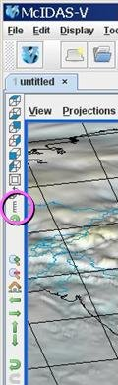From the **Legend** in the **Main Display**, *Right Click* on the color bar and select **Change Range…**.
   2. In the **From**: text box, enter **-200**, in the **To:** text box enter **200.** Click **OK**.
5. The display is showing a 2-dimensional display of the (Forecast Grid – Verification Grid) results. Recall that when the image was displayed, it was displayed as a 3D Topography surface. By default, the vertical range of McIDAS-V displays is 0-16,000 m. To view the topographical features of the data, the vertical range must be adjusted to closely match the data range. (In this example -100 to 100.)
   1. From the tool icons on the left side of the **Main Display** window, click the *Set the vertical range* icon (shown in the figure to the right).
   2. Change the **Min Value** to -**100**, **Max Value** to **100** and **Units** to **m.** Click **OK.**
6. Sometimes when viewing 3-Dimensional data, the map is obscured by the data. If the map is hidden, move the Map layer up, so it is visible over the image.  
   1. From the **Legend**, *Left Click* on **Default Background Maps**.
   2. At the bottom of the ***Maps*** tab in the ***Layer Controls***, change the **Position** slider to a value of 0.3. This will slide the map up in the **Main Display**.
7. Navigate through the display in the **Main Display** window using *Right Click+Drag* to visualize the 3D characteristics of this topographic display.

**System Formulas – Creating a Water Vapor Sea Surface Temperature Display**

1. Remove All Layers and Data Sources via the ***Edit -> Remove -> All Layers and Data Sources*** menu item in the **Main Display**.
2. Create local datasets for global SST, water vapor, IR, and land/sea mask images:
   1. From the **Main Display** menu, select ***Tools -> Manage ADDE Datasets***.
   2. Select ***File -> New Local Dataset***.  
      1. For **Dataset**, enter **GLOBAL**. For **Image Type**, enter **SST**.
      2. Click the **Browse** button, choose *<local path*>**/ Data/Formulas/sea-surface-temperature**, and click **Open**.
      3. Click **Add Dataset**.
   3. Repeat step **11 b.** for Water vapor. (**Global**, **WV**, <*local path>/* **Data/Formulas/global-wv**). **Add Dataset**.
   4. Repeat step **11 b.** for Infrared. (**GLOBAL**, **IR**, *<local path*>**/ Data/Formulas/global-ir**). **Add Dataset**.
   5. Repeat step **11 b.** for Land-Sea-Mask. (**GLOBAL**, **Land-Sea-Mask**, *<local path*>**/ Data/Formulas /land-sea-mask**). **Add Dataset**.
   6. Click **OK** to close the **ADDE Data Manager**.
3. Load the local copy of the Big Blue Marble basemap using the Flat files chooser and display the image:  
   1. From the ***Data Sources*** tab of the **Data Explorer**, open the ***General*** treeand select ***Flat files***.
   2. Select *<local path*>**/ Data/Formulas/basemap/blue-marble.jpg** for the file to load.
   3. For **Navigation**, select **Bounds**.  Enter the following bounds in the **Navigation** menu of the Flat Files Chooser

**UL Lat/Lon** enter **90**, **-180**

**LR Lat/Lon: -90** **180**

* 1. Click **Add Source,** and from the ***Field Selector***, click **Create Display**.

1. Add the local copy of the Sea Surface Temperature data source.  
   1. From the ***Data Sources*** tab of the **Data Explorer**,open the ***Satellite*** tree and select ***Imagery***.
   2. Select **<LOCAL-DATA>** as the **Server**.
   3. Select **GLOBAL** for the **Dataset** and click **Connect**.
   4. Select **SST** for the **Image Type**.
   5. In the ***Absolute*** tab, highlight the **2010-10-20 00:00:00Z** time, and click **Add Source**.
2. Add your Land/Sea Mask data source.  
   1. From the ***Data Sources*** tab of the **Data Explorer**,open the ***Satellite*** tree and select ***Imagery***.
   2. Select **<LOCAL-DATA>** as the **Server**.
   3. Select **GLOBAL** for the **Dataset** and click **Connect**.
   4. Select **Land-Sea-Mask** for the **Image Type**.
   5. Select the ***Absolute*** tab, highlight the **2009-07-30 18:00:00Z** time, and click **Add Source**.
3. Create a display of Sea Surface Temperatures over just water areas:  
   1. In the ***Field Selector***, select **Formulas**.
   2. Open the ***Image Filters*** tree, select ***Discriminate Image Filter***, and click **Create Display**.
   3. From the **Select input** window, enter the following:

**brkpoint1**: **0  
brkpoint2**: **255  
brkpoint3**: **8  
brkpoint4**: **8  
replace**: **0**  
This formula applies a discriminate filter to two images by comparing elements in each image to different high and low breakpoints. Use this filter to mask a portion of the first source image. Breakpoints 1 and 2 specify the range from the first dataset to be used, and break points 3 and 4 are for the second dataset. In this example, values of 8 are used from the land/sea mask and represent water regions.

* 1. 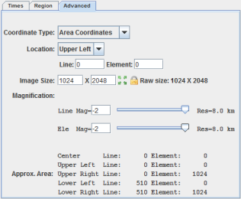Click **OK**.
  2. To define **image1** in the new **Field Selector** window**,** select ***SST -> Band: 1 -> Brightness***.
  3. In the ***Advanced*** tab, make sure the fields are the same as they are in the image on the right.
* Click the full size icon ().
* Set the **Coordinate Type** to be Area Coordinates.
* Set the **Location** to be Upper Left.
* For **Magnification**,change **Line Mag** and **Ele Mag** values to -2.   
  1. Repeat steps e and f to define **image2** as ***Land-Sea-Mask -> Band: 1 -> Brightness*.** Click **OK** to display the Land/Sea Mask image in the **Main Display**.

1. Change the color bar for the SST display and add some transparency to the color enhancement.
   1. From the **Legend**, *Right Click* on the color bar of the **SST - Image Display** and select   
      ***System -> Temperature*** to change the color table.
   2. *Right Click* on the color bar again and select **Edit Color Table**.
   3. 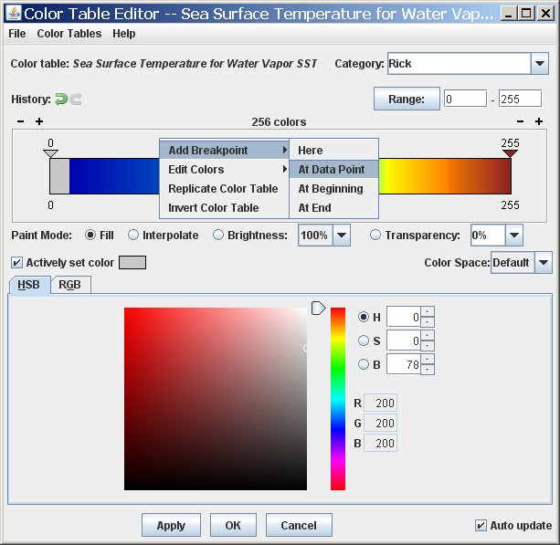*Right Click*above the color bar, select ***Add Breakpoint -> At Data Point*.** Enter a value of **2** and click **OK** (as seen in figure to the lower-left).
   4. From the **Transparency** drop down box, select a value of **100%**.
   5. *Right Click*on the breakpoint created in step 16c, select ***Edit Colors -> Transparency(100%) -> Left***This sets transparency to 100% for all brightness values less than 2 (as seen in figure to the lower-right).
   6. Click **OK** to close the **Color Table Editor**.

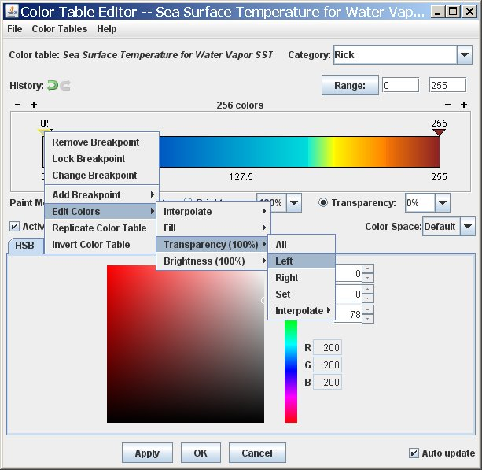

1. Create a display of the Water Vapor data.  
   1. From the ***Data Sources*** tab of the **Data Explorer**,open the ***Satellite*** tree and select ***Imagery***.
   2. Select **<LOCAL-DATA>** as the **Server**.
   3. Select **GLOBAL** for the **Dataset** and click **Connect**.
   4. Select **WV** for the **Image Type**.
   5. In the ***Absolute*** tab, highlight the **2010-10-18 00:00:00Z** image, and click **Add Source**.
2. 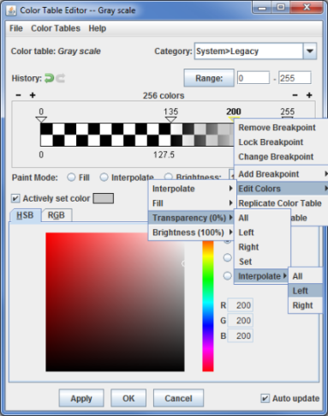From the ***Field Selector***, open the **6.8 um** tree, select **Brightness**, and click **Create Display**.
3. Add Transparency to the Water Vapor Imagery. Use the same techniques as found in step 16.  
   1. From the **Legend**, *Right Click* on the color bar of the **WV - Image Display** and select **Edit Color Table**.
   2. Add a breakpoint at the 135 data point, set the transparency to 100% and fill to the left (***Edit Colors -> Transparency -> Left***).
   3. Create another breakpoint at 200 and set the transparency to 0%. Now interpolate the transparency to the left (***Edit Colors -> Transparency -> Interpolate -> Left***).
   4. Click **OK** to close the **Color Table Editor**.

**Creating your own Formulas – Simple Example**

1. Add a custom formula to McIDAS-V.   
   1. From the **Main Display**, select ***Tools******-> Formulas -> Create Formula***.
   2. In the **Description** text box, enter: **GCD from WV and IR**.  
      This is how the formula is shown in the ***Field Selector*** list of formulas.
   3. In the **ID** text box, enter: **GCD**  
      This value appears when the mouse hovers over the formula in the ***Field Selector*** and is also used for parameter defaults.
   4. In the **Formula** text box, enter: **WaterVaporTemperature** – **InfraredTemperature**  
      Give the variables meaningful names. These will be listed in the ***Field Selector****.*(Note: No spaces are allowed in the variable names.)
   5. Click the arrows next to **Advanced**.
   6. In the **Group** text box enter: **Workshop**  
      It is possible to create a tree structure of multiple groups – each of which can contain multiple formulas. This will be the name of the upper-level tree in the list of formulas in the ***Field Selector***.
   7. Click **Add Formula**.  
        
      Note: GCD stands for Global Convective Diagnostic. This is a day-night scheme that uses infrared and water vapor imagery to map deep convection by means of geostationary satellite images.
2. Add Water Vapor and Infrared data sources to use with the GCD formula.  
   1. Remove All Layers and Data Sources by selecting ***Edit -> Remove -> Remove All Layers and Data Sources*** in the **Main Display**.
   2. From the ***Data Sources*** tab of the **Data Explorer**,open the ***Satellite -> Imagery*** chooser, and connect to the **<LOCAL-DATA> Global** dataset.
   3. Set the **Image Type** to **WV**, and select the **Absolute** image time of 2010-10-18 00:00:00Z.
   4. Click **Add Source**.
   5. From ***Data Sources*** tab, change the **Image Type** to **IR**, and select the **Absolute** image time of 2010-10-18 00:00:00Z.
   6. Click **Add Source**.
3. Display the data using the GCD formula created in Step 20.  
   1. In the ***Field Selector*** tab, select **Formulas** under **Data Sources**.
   2. Under **Fields,** open the **Workshop** tree andselect **GCD**.Select ***Imagery -> Image Display***display type. Click **Create Display**.
   3. 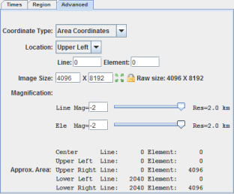In the new **Field Selector** window, for **WaterVaporTemperature**, select ***WV -> 6.8 um -> Temperature***.
   4. In the ***Advanced*** tab, copy the field values shown in the image on the right.

* Click the full size icon ().
* Set the **Coordinate Type** to be Area Coordinates.
* Set the **Location** to be Upper Left.
* For **Magnification**,change **Line Mag** and **Ele Mag** values to -2.  
  1. From the ***Region*** tab, select an area in central Africa.
  2. For **InfraredTemperature**, select ***IR -> 10.7 um -> Temperature***. Click **OK**.

The Results of the GCD formula are displayed in the **Main Display**. Hold down the middle mouse button and pan around the image to see the different values of GCD listed at the bottom of the **Main Display**.

**Zooming, Panning, and Rotating Controls**

|  |  |  |
| --- | --- | --- |
| **Zooming** | **Panning** | **Rotating** |
|  | **Mouse** |  |
| **Shift-Left Drag:** Select a region by pressing the ***Shift*** key and dragging the left mouse button.  **Shift-Right Drag:** Hold ***Shift*** key and drag the right mouse button. Moving up zooms in, moving down zooms out. | **Control-Right Mouse Drag:** Hold ***Control*** key and drag right mouse to pan. | **Right Mouse Drag:** Drag right mouse to rotate. |
|  | **Scroll Wheel** |  |
| **Scroll Wheel-Up:** Zoom Out.  **Scroll Wheel-Down:** Zoom In. |  | **Control-Scroll Wheel-Up/Down:** Rotate clockwise/counter clockwise.  **Shift-Scroll Wheel-Up/Down:** Rotate forward/backward clockwise. |
|  | **Arrow Keys** |  |
| **Shift-Up:** Zoom In.  **Shift-Down:** Zoom Out. | **Control-Up arrow:** Pan Down.  **Control-Down arrow:** Pan Up.  **Control-Right arrow:** Pan Left.  **Control-Left arrow**: Pan Right. | **Left/Right arrow:** Rotate around vertical axis.  **Up/Down arrow:** Rotate around horizontal axis.  **Shift-Left/Right arrow:** Rotate Clockwise/Counterclockwise. |