The GOES-15 Science Test:
Imager and Sounder Radiance and Product Validations

Editors:

Donald W. Hillger¹ and Timothy J. Schmit³

Other Contributors:

Americo Allegrino⁶, A. Scott Bachmeier⁴, Andrew Bailey⁶, Eric Brunning¹⁰, Hyre Bysal¹³, Jerry Cantril¹⁶, Lawrence Carey¹⁵, Jaime M. Daniels⁵, Prasanjit Dash², Michael Grotenhuis⁶, Mathew M. Gunshor⁴, Jay Hanna¹², Andy Harris¹⁰, Michael P. Hiatt², John A. Knaff¹, Jun Li⁴, Daniel T. Lindsey¹, Eileen M. Maturi⁹, Kevin Micke², Jon Mittaz¹⁰, Debra Molenar¹, James P. Nelson III⁴, Walt Petersen¹⁴, Robert Potash¹¹, Elaine Prins¹⁷, Gordana Rancic⁶, Dale G. Reinke², Christopher C. Schmidt⁴, Anthony J. Schreiner⁴, Christopher Schultz¹⁵, Dustin Sheffler¹², Dave Stettner⁴, William Straka⁴, Chris Velden⁴, Gary S. Wade³, Steve Wanzong⁴, Dave Watson², Xiangqian (Fred) Wu⁷, and Fangfang Yu⁸

Affiliations:

¹StAR/RAMMB (SaTellite Applications and Research/Regional and Mesoscale Meteorology Branch)
²CIRA (Cooperative Institute for Research in the Atmosphere), Colorado State University, Fort Collins

³StAR/ASPB (SaTellite Applications and Research/Advanced Satellite Products Branch)
⁴CIMSS (Cooperative Institute for Meteorological Satellite Studies)
University of Wisconsin, Madison

⁵StAR/OPDB (SaTellite Applications and Research/Operational Products Development Branch)
⁶I.M. Systems Group, Inc. (IMSG), Rockville, Maryland

⁷StAR/SPB (SaTellite Applications and Research/Sensor Physics Branch)
⁸ERT, Inc., Annapolis Junction, MD

⁹StAR/SOCD (SaTellite Applications and Research/Satellite Oceanography and Climatology Division)
¹⁰CICS (Cooperative Institute for Climate Studies)
University of Maryland, College Park
¹¹Science Systems and Applications, Inc. (SSAI)

¹²NOAA/NESDIS Satellite Analysis Branch (SAB)
¹³NOAA/NESDIS Office of Satellite Operations (OSO)

¹⁴NASA/MSFC (Marshall Space Flight Center), Earth Sciences Office
¹⁵University of Alabama, Huntsville, Department of Atmospheric Science

¹⁶Columbus, Inc.

¹⁷CIMSS – Consultant, Grass Valley, CA
TABLE OF CONTENTS

Executive Summary of the GOES-15 NOAA Science Test 1
1. Introduction 3
1.1. Goals for the GOES-15 Science Test 4
2. Satellite Schedules and Sectors 5
3. Changes to the GOES Imager from GOES-8 through GOES-15 11
4. GOES Data Quality 13
4.1. First Images 13
4.1.1. Visible 14
4.1.2. Infrared (IR) 15
4.1.3. Sounder 17
4.2. Spectral Response Functions (SRFs) 19
4.2.1. Imager 19
4.2.2. Sounder 20
4.3. Random Noise Estimates 20
4.3.1. Imager 21
4.3.2. Sounder 24
4.4. Striping Due to Multiple Detectors 28
4.4.1. Imager 28
4.4.2. Sounder 29
4.5. Initial post-launch calibration for the GOES-15 Imager visible band 30
4.6. GEO to GEO comparisons 31
4.7. Imager-to-Polar-Orbiter Comparisons 41
4.8. Stray-Light Analysis 48
4.9. Instrument Performance Monitoring 49
4.9.1. Telemetry Monitoring 49
4.9.2. Monitoring the GOES Sounder patch temperatures 51
4.10. Finer Spatial resolution GOES-15 Imager 52
4.1. Corrections of SRF for GOES-14/15 Imagers 54
5. Product Validation 57
5.1. Total Precipitable Water (TPW) from the Sounder 57
5.1.1. Validation of Precipitable Water (PW) Retrievals from the GOES-15 Sounder 57
5.2. Lifted Index (LI) from the Sounder 64
5.3. Cloud Parameters from the Sounder and Imager 66
5.4. Atmospheric Motion Vectors (AMVs) from the Imager 69
5.5. Clear Sky Brightness Temperature (CSBT) from the Imager 71
5.6. Sea Surface Temperature (SST) from the Imager 72
5.7. Fire Detection and Characterization 76
5.8. Volcanic Ash Detection 78
5.9. Total Column Ozone 79
5.10. GOES Surface and Insolation Product (GSIP) 80
5.11. Precipitation and Tropical Applications 82
6. Other Accomplishments with GOES-15 83
6.1. GOES-15 Imager Visible (band-1) SRF 83
6.2. Lunar calibration 86
6.3. Improved Image Navigation and Registration (INR) with GOES-15 87
6.4. Special 1-minute Scans 87
6.5. Special GOES-15 Scans 87
7. Super Rapid Scan Operations (SRSO) 88
7.1. Overview of Operations, 11 September 2010, 1 minute RSO, Southeast U.S. 88
8. Overall Recommendations Regarding this and Future GOES Science Tests 92
Acknowledgments 93
References / Bibliography 94
Appendix A: Web Sites Related to the GOES-15 Science Test 97
Appendix B: Acronyms (and Abbreviations) Used in this Report 98

LIST OF TABLES

Table 2.1: Summary of Test Schedules for the GOES-15 Science Test 7
Table 2.2: Daily Implementation of GOES-15 Science Test Schedules in 2010 8
Table 3.1: GOES Imager band nominal wavelengths (GOES-8 through 15) 11
Table 3.2: GOES Imager band nominal spatial resolution (GOES-12 through 15) 12
Table 4.1: GOES-15 Imager Noise Levels 21
Table 4.2: Summary of the Noise for GOES-8 through GOES-15 Imager Bands 21
Table 4.3: Summary of the noise (in temperature units) for GOES-8 through GOES-15 Imager IR bands. The specification (SPEC) noise levels are also listed. 23
Table 4.4: GOES-15 Sounder Noise Levels 24
Table 4.5: Summary of the Noise for GOES-8 through GOES-15 Sounder Bands 25
Table 4.6: GOES-15 Sounder NEdR compared to those from GOES-8 through GOES-14 and the specification noise values. 26
Table 4.7: GOES-15 Sounder NEdT compared to those from GOES-8 through GOES-14. 27
Table 4.8: GOES-15 Imager Detector-to-Detector Striping 29
Table 4.9: GOES-15 Sounder Detector-to-Detector Striping 30
Table 4.10: Mean Tb difference (K) and the standard deviation values for the IR bands between the Imagers on GOES-15 vs. GOES-13 and GOES-15 vs. GOES-11. 39
Table 4.11: Mean Tb difference (K) and the standard deviation values for the IR bands between the Sounders on GOES-15 vs. GOES-13 and GOES-15 vs. GOES-11. 41
Table 4.12: Comparison of GOES-15 Imager to IASI using the CIMSS-method. The bias is the mean of the absolute values of the differences. These comparisons were with the SRF used during the science test, not the shifted SRF. 41
Table 4.13: Brightness temperature (Tb) biases between GOES-15 Imager and AIRS/IASI for the daytime and nighttime collocated pixels between AIRS and IASI through GOES-15 Imager daytime collocation data using the GSICS-method. The Tb biases were based on the collocated pixels acquired from 3 June 2010 and 25 October 2010. Standard deviations are given in parentheses. Again, these values are before the final, shifted SRF were employed. 44
Table 4.14: GOES-15 Imager diurnal calibration variation. 46
Table 4.15: GOES-15 Sounder IR vs. IASI brightness temperature difference at nighttime, compared to other GOES Sounders using the GSICS-method. The data in the parentheses are the standard deviation of the Tb difference at the collocation pixels. 47
Table 4.16: GOES-15 Imager and Sounder telemetry parameters monitored with the GOES-IPM system during the PLT Science Test. 49
Table 4.17: Biases for selected GOES-14/15 Imager bands using the SRF as originally supplied by ITT (Rev. E), revised by ITT (Rev. H), further corrected by NOAA, and the recommended correction. 55
Table 5.1: Verification statistics for GOES-12 and GOES-15 retrieved PW, first guess (GFS) PW, and RAOB PW for 2 September 2010 to 21 September 2010. 58
Table 5.2: Verification statistics for GOES-15 vs. RAOB Match Verification Statistics NHEM winds (m/s): 11 September 2010 – 25 October 2010. MVD is the mean vector difference. 70
Table 5.3: RAOB Verification statistics for GOES-13 and GOES-15, collocated (0.1 deg, 25 hPa) for NHEM winds (m/s): 11 September 2010 – 25 October 2010 71
Table 7.1: Super Rapid Scan Operations (SRSO) during the GOES-15 Science Test 88

LIST OF FIGURES

Figure 1.1: GOES-P/15 spacecraft decal 3
Figure 3.1: The GOES-15 Imager weighting functions. 12
Figure 3.2: The GOES-15 Sounder weighting functions. 13
Figure 4.1: The first visible (0.63 μm) image from the GOES-15 Imager occurred on 6 April 2010 starting at approximately 1730 UTC. 14
Figure 4.2: A GOES-15 visible image on 6 April 2010 showing a close-up view centered Northern Hudson Bay and the Canadian Arctic Archipelago (showing some areas of ice-free water). 14
Figure 4.3: First GOES-15 full-disk visible and IR images from 6 and 26 April 2010, respectively. 15
Figure 4.4: GOES-15 Imager bands (top) and the corresponding GOES-13 Imager bands (bottom). Both sets of images are shown in their native projections. 16
Figure 4.5: The visible (band-19) image from the GOES-15 Sounder shows data from 8 April 2010. The west and east ‘saw-tooth’ edges are due to the geometry of collecting the pixels. 17
Figure 4.6: The first IR Sounder images for GOES-15 from 26 April 2010 (top) compared to GOES-13 (bottom). Both sets of images have been remapped to a common projection. 18
Figure 4.7: The four GOES-15 Imager IR-band SRFs super-imposed over the calculated high-resolution earth-emitted U.S. Standard Atmosphere spectrum. Absorption due to carbon dioxide (CO₂), water vapor (H₂O), and other gases are evident in the high-spectral-resolution earth-emitted spectrum. These are the ‘shifted’ revision H set (see Section 4.1). 19
Figure 4.8: The eighteen GOES-15 Sounder IR-band SRFs super-imposed over the calculated high-resolution earth-emitted U.S. Standard Atmosphere spectrum. These are the ‘shifted’ revision H set (see Section 4.1). 20
Figure 4.9: The mean standard deviation of the Imager space-view count at before and after the Imager space clamp events, and Sounder space-view count for GOES-11 through GOES-15. 22
Figure 4.10: Times series of the standard deviations of space-view count for the eight detectors of GOES-15 Imager visible band from 20 August 2010 at 1200 UTC – 23 August 2010 at 1200 UTC (left: pre-clamp space-view statistics, right: post-clamp space-view statistics). 22
Figure 4.11: Time series of the GOES-15 Imager NEdT calculated @ 300 K temperature, except band-3 @ 230 K, compared to the specifications. The ‘spec’ line is also plotted. The color of the points refer to the detector number. 23
Figure 4.12: Standard deviations of space-view count for the four GOES-15 Sounder visible detectors from 7 October 2010 at 0 UTC to 9 October 2010 at 0 UTC. 25
Figure 4.13: Diurnal variation of GOES-15 Sounder NEdT between 11 September 2010 and 12 September 2010. The solid line in each IR band plot is the specification value. The colors correspond to the 4 detectors. 28
Figure 4.14: Spatial distribution of GOES-15 Imager band-4 Tb values for the collocation scenes between GOES-13 (left) and GOES-11 (right). 31
Figure 4.15: Time-series of GOES-15 vs. GOES-13 post-launch calibrated visible reflectance difference (left) and the histogram of the visible reflectance difference (right). 32
Figure 4.16: SRF of the visible bands at GOES-15 vs. GOES-13 (top left) and GOES-15 vs. GOES-11 (top right). SRF of GOES-13 and GOES-15 four IR bands (red: GOES-15, blue: GOES-13). The simulated clear tropical TOA Tb values (in gray) are also plotted for the four IR bands. 33
Figure 4.17: Two-Dimensional smoothed histogram of GOES-13 band-2, 3, 4, and 6 pixel temperatures (K) vs. GOES-15 band-2, 3, 4, and 6 pixel temperatures. 36
Figure 4.18: Direct inter-comparison of GOES-15 vs. GOES-13 Imager IR bands. No account of differing SRF were made. 38
Figure 4.19: Latitudinal distribution of the mean Tb difference (dark dots) and the standard deviation (gray segments) between GOES-15 and GOES-13 for the four Imager IR bands (Tb difference = GOES-15 – GOES-13). 39
Figure 4.20: Spatial distribution of Sounder collocation pixels for GOES-15 vs. GOES-13 (left) and GOES-15 vs. GOES-11 (right). 40
Figure 4.21: SRF of GOES-15 Imager (top) and Sounder (bottom), together with the AIRS/IASI spectra. 43
Figure 4.22: GOES-15 Imager IR bands time series of the brightness temperature bias with AIRS and IASI inter-calibration. Note that the band-2 values are only for the daytime. Note that these are from the Science Test and hence before the SRF shift of bands 3 and 6. 45
Figure 4.23: The Mean Tb bias to AIRS/IASI for GOES-15 Imager IR bands. 46
Figure 4.24: Mean and standard deviation of GOES-11 through GOES-15 Sounder brightness temperature difference from nighttime IASI data using the GSICS-method. 47
Figure 4.25: GOES-15 Imager multi-panel. Note the “stray light” associated with the sun. 48
Figure 4.26: The GOES-15 Imager Platinum Resistance Thermometer (PRT, left) and scan mirror (right) temperature shown with various temporal scales. 50
Figure 4.27: GOES-15 Sounder BB temperature (left) and scan mirror temperature (right) at different temporal scales. 51
Figure 4.28: Time-series of narrow-range patch temperature of GOES-15 Sounder from 10 to 12 August 2010. 52
Figure 4.29: Diurnal variations of the GOES-15 Sounder patch temperature from 25 to 26 October 2010 (upper panel) and from 16 to 26 October 2010 (lower panel). 52
Figure 4.30: Improved Imager spatial resolution of the water vapor band for GOES-15 (lower panel) compared to GOES-11 (top panel) from 27 July 2010. 53
Figure 4.31: Improved Imager spatial resolution at 13.3 µm for GOES-15 (lower panel) compared to GOES-13 (top panel) from 26 April 2010. 54
Figure 4.32: Rev. E, Rev. H, and shifted Rev. H SRFs of GOES-14/15 Imager band-3 and band-6 (dash black, blue solid and red solid lines), together with the IASI simulated TOA Tb for a clear tropical atmospheric profile (gray lines at second y-axis). Note that Rev. G and Rev. H SRFs are identical for GOES-15 Imager IR bands. 55
Figure 4.33: Comparisons of the GOES-15 band-6 (top panel) and band-3 (lower panel) before (left hand side) and after (right hand side) after the spectral response shift was implemented. 56
Figure 5.1: Time series of Root Mean Square Error (RMSE) between GOES-13 and GOES-15 retrieved PW and RAOB PW for 2 September 2010 to 21 September 2010. 59
Figure 5.2: Time series of bias (GOES-RAOB) between GOES-13 and GOES-15 retrieved PW and RAOB PW for 2 September 2010 to 21 September 2010. 60
Figure 5.3: Time series of correlation between GOES-13 and GOES-15 retrieved PW and RAOB PW for 2 September 2010 to 21 September 2010. 61
Figure 5.4: Time series of the number of collocations between GOES-13 and GOES-15 retrieved PW and RAOB PW for 2 September 2010 to 21 September 2010. 62
Figure 5.5: GOES-15 (top panel) and GOES-13 (lower panel) retrieved TPW (mm) from the Sounder displayed as an image. Cloudy FOVs are denoted as shades of gray. The data are from 1800 UTC on 18 September 2010. Measurements from RAOBs are overlaid text. 63
Figure 5.6: GOES-15 Sounder TPW from two retrieval algorithms (i.e., “Ma” (upper-panel) and “Li” (lower-panel). Both images are from 18 September 2010. 64
Figure 5.7: GOES-15 (top) and GOES-13 (lower) retrieved LI from the Sounder displayed as an image. The data are from 1746 UTC on 18 September 2010. 65
Figure 5.8: GOES-15 Imager cloud-top pressure from 18 September 2010 starting at 1745 UTC. The Imager data have been remapped into the GOES-15 Sounder projection. 66
Figure 5.9: GOES-15 Sounder cloud-top pressure from 18 September 2010 starting at 1746 UTC. 67
Figure 5.10: GOES-13 cloud-top pressure from the Sounder from 1746 UTC on 18 September 2010. 67
Figure 5.11: EOS-Aqua MODIS cloud-top pressure at 1800 UTC on 18 September 2010. 68
Figure 5.12: GOES-15 Sounder visible image from the nominal 1746 UTC on 18 September 2010. 68
Figure 5.13: GOES-15 Northern Hemisphere (NHEM) cloud-drift AMV on 10 September 2010 at 1145 UTC. 69
Figure 5.14: GOES-15 Northern Hemisphere (NHEM) water vapor AMV on 10 September 2010 at 1145 UTC. 70
Figure 5.15: GOES-15 Imager CSBT cloud mask image from 18 September 2010 for the nominal 1800 UTC time (upper-left). On the upper-right is the GOES-13 Imager CSBT cloud mask image for the same date and nominal time as shown in the GOES-15 Imager satellite projection. Clear regions display the band-3 Water Vapor (6.5 µm) Brightness Temperature. GOES-15 Imager visible (lower-left) and Long Wave Window (lower-right) from 18 September 2010 for the nominal 1800 UTC time period. 72
Figure 5.16: The nighttime areas that are considered clear pixels based on Bayesian estimate of ≥98% clear sky probability. The mask is based on the highest clear sky probability for the three daytime images that went into generating this GOES-15 product. 73
Figure 5.17: The daytime areas that are considered clear pixels based on Bayesian estimate of ≥98% clear sky probability. The mask is based on the highest clear sky probability for the three daytime images that went into generating this GOES-15 product. 74
Figure 5.18: The SST from GOES-15 created by compositing three nighttime half hour SST McIDAS Area files with an applied threshold of ≥98% clear sky probability. 75
Figure 5.19: shows the SST from GOES-15 created by compositing three half hour daytime SST McIDAS Area files with an applied threshold of ≥98% clear sky probability. 75
Figure 5.20: GOES Imager 3.9 µm images from GOES-11 (left), GOES-15 (center) and GOES-13 (right). Each satellite is shown in its native perspective. 77
Figure 5.21: GOES Imager 3.9 µm time series from GOES-11, GOES-15, and GOES-13. 78
Figure 5.22: Example of GOES-13 Imager Total Column Ozone on 3 September 2010 at 1800 UTC. 79
Figure 5.23: Example of GOES-15 Imager Total Column Ozone on 3 September 2010 at 1800 UTC. The image is displayed in the GOES-15 perspective. 80
Figure 5.24: GOES-13 Imager downwelling surface insolation on 5 August 2011 beginning at 1745 UTC. 81
Figure 5.25: GOES-15 Imager downwelling surface insolation on 5 August 2011 beginning at 1745 UTC. 82
Figure 6.1: GOES-11 (blue) and GOES-15 (red) Imager visible (approximately 0.65 or 0.63 μm) band SRFs, with a representative spectrum for grass over-plotted (green). 84
Figure 6.2: Comparison of the visible (0.65 μm) imagery from GOES-11 and GOES-15 (0.63 μm) on 25 August 2010 demonstrates how certain features, such as surface vegetation, are more evident with the GOES-15 visible data. 85
Figure 6.3: GOES-15 Imager visible (0.65 μm) band imaged of the moon from various dates. 86
Figure 6.4: Ratio of observed and ROLO irradiance as a function of angle of incidence exhibits weak linear regression on 24 September 2010. 87
Figure 7.1: Time height cross-section of maximum reflectivity vs. height (top), minimum cloud top temperature (dashed line, top) and total flash rate (bottom). 89
Figure 7.2: A series of Plan Position Indicator (PPI) images from ARMOR on 11 September 2010, between 1817 and 1822 UTC at 11.4° elevation (height ≈ 6 km and temperature ≈ -10°C at range of interest). Panels A-C are at 1817 UTC, D-F at 1820 UTC, and G-I at 1822 UTC. From left to right, radar fields presented here are horizontal reflectivity (Z), differential reflectivity (ZDR), and correlation coefficient (ρ_{hv}). 90
Figure 7.3: Time height section of maximum reflectivity vs. height minimum cloud top temperature and total flash rate for two additional thunderstorms on 11 September 2010. Thunderstorm A (top) obtained a minimum temperature of 249 K before the first flash was observed, while thunderstorm C (bottom) had a minimum cloud top temperature of 256 K before the first flash was observed at 1728 UTC. 91

Executive Summary of the GOES-15 NOAA Science Test

The Science Test for GOES-15 produced several results and conclusions:

- GOES-15 Imager and Sounder data were collected during the six-week NOAA Science Test that took place during August/September 2010 while the satellite was stationed at 89.5ºW longitude. Additional pre-Science Test data, such as the first visible and IR images, were collected in April 2010.
- Imager and Sounder data were collected for a host of schedules, including rapid scan imagery. The GOES Variable (GVAR) datastream was stored at several locations for future access.
- Data collected through Keep Out Zones (KOZ) were tested, to ultimately provide additional imagery affected by solar contamination. These data are being used in a stray-light correction and notification algorithm that is being considered for operational implementation.

- Initial Infrared Atmospheric Sounding Interferometer (IASI) and Atmospheric Infrared Sounder (AIRS) high-spectral-resolution inter-calibrations with both the Imager and Sounder were verified for good radiometric accuracy, although biases were seen for bands 3 and 6 of the Imager.
- These Imager biases have been reduced by modifying, and operationally implementing, the updated system SRFs for Imager bands 3 and 6.
- The GOES Sounder instrument noise was comparable to the other GOES-N/O/P Sounders, after the Sounder patch temperature was controlled at the low level. Some striping remains, especially in band-15.

- Many Level 2 products were generated (atmospheric profiles and derived parameters, Atmospheric Motion Vectors (AMVs), cloud-top properties, Clear Sky Brightness Temperature (CSBT), Lifted Index (LI), Sea Surface Temperature (SST), total column ozone, surface insolation products, etc.) and validated.

- Various application areas, such as precipitation, volcanoes and fires were also investigated.
- Many GOES-15 images and examples were posted on the Web in near real-time.
- Special rapid-scan imagery was acquired, which offers a glimpse into the possibilities of the next generation geostationary imagers.

Instrument related results and conclusions:

- The detector size of the Imager 13.3 µm band (band-6) was changed from 8 km to 4 km by incorporating two detectors instead of one. The GVAR format was modified, similar to the GOES-14 changes to accommodate the extra detector.

- In order to operate the instruments (Imager and Sounder) during the eclipse periods and KOZ periods, improved spacecraft batteries and partial-image frames were utilized. Improved instrument performance means there will no longer be the required health and safety related KOZ outages.

- Colder patch (detector) temperatures were noted due to the new spacecraft design. In general, Imager and Sounder data from GOES-13 through GOES-15 are improved considerably in quality (noise level) to that from GOES-8 through GOES-12.

- The image navigation and registration with GOES-13 through GOES-15 are much improved, especially in comparison to GOES-8 through GOES-12.

- There is a potential reduction in detector-to-detector striping to be achieved through increasing the Imager scan-mirror dwell time on the blackbody from 0.2 s to 2 s.

- During GOES-15 Post-Launch science Test (PLT), from 11 August 2010 to 22 September 2010, the Imager patch temperature was controlled at low-level. Imager calibration-related telemetries were all functioning normally.

- The Sounder, however, had the so-called “blanket-heating” problem when the spacecraft was oriented in the upright position. During these two upright position periods, the Sounder patch temperature could not be controlled at low-level and experienced diurnal variations. These floating patch temperatures caused large detector noise, especially for the detectors at the long-wave bands.

- The Sounder calibration issue was characterized, as possibly due to the warming of part of the insulation blanket. This issue can be mitigated with satellite yaw-flips twice a year.

- Compared to GOES-11/12, GOES-N/O/P satellites have much better quality of visible data in term of reduced noise.

Introduction

The latest Geostationary Operational Environmental Satellite (GOES), GOES-P, was launched on 4 March 2010, and reached geostationary orbit at 89.5°W on 16 March 2010 to become GOES-15. Currently, GOES-15 Imager and Sounder await operational use. GOES-15 is the third, and final, of the three GOES-N/O/P series spacecraft.

The National Oceanic and Atmospheric Administration (NOAA)/National Environmental Satellite, Data, and Information Service (NESDIS) conducted a six-week GOES-15 Science Test that began 11 August 2010 and ended officially on 22 September 2010. The first three weeks of the Science Test schedule were integrated within the National Aeronautics and Space Administration (NASA) GOES-15 Post-Launch Test (PLT) schedule. An additional three weeks of the Science Test were performed under NOAA/NESDIS control.

GOES-15 has an Imager and Sounder similar to those on GOES-8/12, but GOES-15, like GOES-13 and 14, is on a different spacecraft bus. The new bus allows improvements both to navigation and registration, as well as the radiometrics. Due to larger spacecraft batteries, the GOES-N/O/P system is able to supply data through the eclipse periods, thereby addressing one of the major limitations of eclipse and related outages. Outages due to Keep Out Zones (KOZ) are also minimized. In terms of radiometric improvements, a colder patch (detector) temperature results in the GOES-13/14/15 instruments (Imager and Sounder) being less noisy. In addition, there is a potential reduction in detector-to-detector striping to be achieved through increasing the Imager scan-mirror dwell time on the blackbody from 0.2 s to 2 s. Finally, the navigation was improved due to the new spacecraft bus and the use of star trackers (as opposed to the previous method of edge-of-earth sensors). In general, the navigation accuracy (at nadir) improved from between 4-6 km with previous Imagers, to less than 2 km with those on the GOES-N/O/P satellites.

Figure 1.1: GOES-P/15 spacecraft decal

This report describes the NOAA/NESDIS Science Test portion only. The Imager and Sounder are covered, while the solar/space instruments are not. System performance and operational testing of the spacecraft and instrumentation was performed as part of the PLT. During the Science Test, GOES-15 was operated in a special test mode, where the default schedule involved routine emulation of either GOES-East or GOES-West operations. Numerous other scan schedules and sectors were constructed and used for both the Imager and the Sounder. GOES-15 was then placed into storage mode on 25 October 2010. At the time of the GOES-15 Science Test, GOES-12 was operating in the GOES-East position, and GOES-11 was operating in the GOES-West position. Since that time, GOES-13 has replaced GOES-12 at the operational GOES-East satellite.

Goals for the GOES-15 Science Test

First goal: To assess the quality of the GOES-15 radiance data. This evaluation was accomplished through comparison to data from other satellites or by calculating the signal-to-noise ratio compared to specifications, as well as assessing the striping in the imagery due to multiple detectors.

Second goal: To generate products from the GOES-15 data stream and compare to those produced from other satellites. These products included several Imager and Sounder products: land skin temperatures, temperature/moisture retrievals, Total Precipitable Water (TPW), Lifted Index (LI), cloud-top pressure, Atmospheric Motion Vectors (AMVs), surface insolation, and Sea Surface Temperatures (SSTs). Validation of these products was accomplished through comparisons to products generated from other satellites or through comparisons to radiosondes and ground-based instruments.

Third goal: To collect nearly-continuous rapid-scan imagery of interesting weather cases at temporal resolutions as fine as every 30 seconds, a capability of rapid-scan imagery from GOES-R that is not implemented operationally on the current GOES. The rapid-scan data may augment radar and lightning data, collected at special networks, to investigate the potential for improving severe weather forecasts.

Fourth goal: To monitor the impact of any instrument changes. Changes included the finer spatial resolution (detector sizes from 8 km to 4 km) for the Imager 13.3 µm band (band-6) which began on GOES-14. Other improvements which began with GOES-13 include: better navigation, improved calibration, and the capabilities of the GOES-N series to operate through eclipse, when the satellite is in the shadow of the earth, as well as to minimize outages due to KOZ, when the sun can potentially contaminate imagery by being within the Field Of View (FOV) of the instruments (Imager and Sounder).

Finally, the GOES-15 Imager and Sounder data were received via direct downlink at the following sites: (1) CIRA, Colorado State University, Fort Collins CO; (2) Space Science and Engineering Center (SSEC), University of Wisconsin-Madison, Madison WI; and (3) NOAA/NESDIS, Suitland/Camp Springs MD. Each site ingested, archived, and made the data available on its own internal network in McIDAS (Man computer Interactive Data Access System) format, as well as to other sites as needed. The NOAA-NESDIS Regional and Mesoscale Meteorology Branch (RAMMB) at CIRA also made the GOES-15 imagery available over the internet via RAMSDIS Online. Image and product loops were also made available on the CIMSS Web site. See Appendix A for the appropriate URLs for these and many other GOES-15 related Web sites. Other sites, such as NASA Goddard Space Flight Center (GSFC) also directly received the GOES-15 data stream.

This report documents results from these various activities undertaken by NOAA/NESDIS and its Cooperative Institutes during the Science Test. Organizations which participated in these GOES-15 Science Test activities included the: NOAA/NESDIS SaTellite Applications and Research (StAR); NOAA/NESDIS Office of Satellite Processing and Operations (OSPO); Cooperative Institute for Meteorological Satellite Studies (CIMSS); Cooperative Institute for Research in the Atmosphere (CIRA); NOAA/NESDIS Satellite Analysis Branch (SAB), and NASA Marshall Space Flight Center (MSFC). The GOES-15 NOAA Science Test was co-lead by D. Hillger and T. Schmit, both of NOAA/NEDSIS/STAR.

NOAA Technical Reports similar to this one were produced for the GOES-11 (Daniels et al. 2001), GOES-12 (Hillger et al. 2003), GOES-13 (Hillger and Schmit, 2007 and 2009), and GOES-14 (Hillger and Schmit, 2010) Science Tests. The reference/bibliography section contains articles related to the GOES-15 Science Test.

Satellite Schedules and Sectors

A total of eight schedules involving numerous predefined Imager and Sounder sectors were constructed for the GOES-15 Science Test. The choice of Imager and Sounder sectors was a result of input from the various research and development groups participating in the Science Test. Most of these schedules are similar to those run during the previous (GOES-14) Science Test (Hillger and Schmit 2010).

Thanks to dedicated support provided by the NOAA/NESDIS/Satellite Operations Control Center (SOCC) and the Office of Satellite Operations (OSO), a significant amount of flexibility existed with respect to switching and activating the schedules on a daily basis. The ease with which the schedules could be activated was important for capturing significant weather phenomena of varying scales and locations during the Science Test.

A brief summary of the eight schedules is provided in Table 2.1. The C5RTN and C4RTN schedules, emulating GOES-East or GOES-West operations respectively, were the default schedules if no other schedule was requested at the cutoff of 1 hour before the 1630 UTC daily schedule change time. For the Sounder, the default schedules also emulated normal GOES-East and GOES-West operations.

The C1CON schedule was mainly for emulating the temporal aspects of the GOES-R Advanced Baseline Imager (ABI) data, where five-minute images will be routine over CONUS. The C2SRSO and C3SRSO schedules, with images at 1-minute and 30-second intervals respectively, were prepared to provide the ability to call up Super Rapid Scan Operations (SRSO) during the Science Test. It should be noted, that the 30-second interval schedule was not executed, in part to better maximize capturing the rapidly changing phenomena. This is due to the fact that the 30-second scans cover a much smaller area than the 1-minute scans. The C6FD schedule allowed continuous 30-minute interval full-disk imaging of the entire hemisphere, although the ABI will be able to scan the full disk every 15 minutes. The C7MOON schedule provided specialized datasets of the moon, and the C8HUR sector allowed special 5-minute CONUS-sized hurricane sector, with a specified center point. Finally, the alternate C59RTN schedule contained partial-image frames that will be available to users during KOZ, to avoid solar contamination radiances and the detrimental effect on image products.

The daily implementation of the various schedules during the entire Science Test is presented in Table 2.2. The GOES-15 daily call-up began on 11 August 2010 and continued through 21 September 2010. GOES-15 continued to collect imagery for five more weeks, through 25 October 2010, before the GOES-15 Imager and Sounder were turned off.

Table 2.1: Summary of Test Schedules for the GOES-15 Science Test

Test Schedule Name | Imager | Sounder | Purpose
C1CON | Continuous 5-minute CONUS sector | 26-minute CONUS sector every 30 minutes | Test navigation, ABI-like (temporal) CONUS scans
C2SRSO | Continuous 1-minute rapid-scan (with center point specified for storm analysis) | 26-minute CONUS sector every 30 minutes | Test navigation, ABI-like (temporal) mesoscale scans
C3SRSO | Continuous 30-second rapid-scan (with center point specified for storm analysis) | 26-minute CONUS sector every 30 minutes | Coordination with lightning detection arrays in Huntsville AL, Norman OK, and Washington DC areas¹
C4RTN | Emulation of GOES-West routine operations⁴ | Emulation of GOES-West routine operations⁴ | Radiance and product comparisons
C5RTN (and C59RTN)⁴ | Emulation of GOES-East routine operations | Emulation of GOES-East routine operations | Radiance and product comparisons
C6FD | Continuous 30-minute Full Disk (including off-earth measurements) | Sectors on both east and west limbs every hour (including off-earth measurements)² | Imagery for noise, striping, etc.
C7MOON (depends on moon availability)⁵ | Capture moon off edge of earth (when possible) for calibration purposes | Inserted into current schedule | Test ABI lunar calibration concepts
C8HUR | Continuous 5-minute CONUS-size hurricane sector | Emulation of GOES-East routine operations | Hurricane monitoring for tropical cyclone field experiments³

¹Including the Hazardous Weather Testbed in North Alabama (centered at Huntsville AL, 34.72°N, 86.65°W), the Oklahoma Lightning Mapping Array (centered at Norman OK, 35.28°N, 97.92°W), and the Washington DC lightning mapping array (centered over Falls Church VA, 38.89°N, 77.17°W).
²Limb sectors similar to GOES Sounder scans during previous GOES Science Tests.
³In un-official support of two large field campaigns (NASA GRIP and NSF PREDICT).
⁴During the C4RTN and C5RTN schedules, special stray-light test sectors for both the Imager and Sounder were taken between 0400 and 0800 UTC starting 23 August 2010 [Julian Day 235].
⁵Successive images of the moon were captured on 26 April, 30 July, and 27 August 2010.
Table 2.2: Daily Implementation of GOES-15 Science Test Schedules in 2010
(Daily starting time: 1630 UTC)

Starting Date [Julian Day]  (Day of Week) | Test Schedule Name | Imager | Sounder | Purpose
Start of 6-week Science Test
August 11 [223]  (Wednesday) | C1CON | Continuous 5-minute CONUS sector | 26-minute CONUS sector every 30 minutes | ABI-like (temporal) CONUS scans
August 12 [224]  (Thursday) | C1CON | Continuous 5-minute CONUS sector | 26-minute CONUS sector every 30 minutes | ABI-like (temporal) CONUS scans
August 13 [225]  (Friday) | C1CON | Continuous 5-minute CONUS sector | 26-minute CONUS sector every 30 minutes | ABI-like (temporal) CONUS scans
August 14 [226]  (Saturday) | C5RTN | Emulation of GOES-East routine operations | Emulation of GOES-East routine operations | Radiance and product comparisons
August 15 [227]  (Sunday) | C5RTN | Emulation of GOES-East routine operations | Emulation of GOES-East routine operations | Radiance and product comparisons
August 16 [228]  (Monday) | C1CON | Continuous 5-minute CONUS sector | 26-minute CONUS sector every 30 minutes | ABI-like (temporal) CONUS scans
August 17 [229]  (Tuesday) | C1CON | Continuous 5-minute CONUS sector | 26-minute CONUS sector every 30 minutes | ABI-like (temporal) CONUS scans
August 18 [230]  (Wednesday) | C5RTN | Emulation of GOES-East routine operations | Emulation of GOES-East routine operations | Radiance and product comparisons
August 19 [231]  (Thursday) | C5RTN | Emulation of GOES-East routine operations | Emulation of GOES-East routine operations | Radiance and product comparisons
August 20 [232]  (Friday) | C5RTN | Emulation of GOES-East routine operations | Emulation of GOES-East routine operations | Radiance and product comparisons
August 21 [233]  (Saturday) | C6FD | Continuous 30-minute Full Disk | Sectors on both east and west limbs every hour | Imagery for noise, striping, etc.
August 22 [234]  (Sunday) | C6FD | Continuous 30-minute Full Disk | Sectors on both east and west limbs every hour | Imagery for noise, striping, etc.
August 23 [235]  (Monday) | C8HUR | Continuous 5-minute CONUS-size hurricane sector | Emulation of GOES-East routine operations | Hurricane monitoring
August 24 [236]  (Tuesday)  starting 0900 UTC | C2SRSO¹ | Continuous 1-minute rapid-scan (center point 18°N, 46°W) | 26-minute CONUS sector every 30 minutes | Hurricane (Danielle) monitoring
August 24 [236]  (Tuesday)  starting 2100 UTC | C8HUR | Continuous 5-minute CONUS-size hurricane sector | Emulation of GOES-East routine operations | Hurricane monitoring
August 25 [237]  (Wednesday) | C4RTN | Emulation of GOES-West routine operations | Emulation of GOES-West routine operations | Radiance and product comparisons
August 26 [238]  (Thursday) | C4RTN | Emulation of GOES-West routine operations | Emulation of GOES-West routine operations | Radiance and product comparisons
August 27 [239]  (Friday) | C4RTN | Emulation of GOES-West routine operations | Emulation of GOES-West routine operations | Radiance and product comparisons
August 27 [239]  (Friday)  ~1900 to ~2045 UTC | C7MOON | Capture moon off edge of earth | Inserted into current schedule | Test ABI lunar calibration concepts
August 28 [240]  (Saturday) | C8HUR² | Continuous 5-minute CONUS-size hurricane sector | Emulation of GOES-East routine operations | Hurricane monitoring
August 29 [241]  (Sunday) | C8HUR | Continuous 5-minute CONUS-size hurricane sector | Emulation of GOES-East routine operations | Hurricane monitoring
August 30 [242]  (Monday) | C8HUR | Continuous 5-minute CONUS-size hurricane sector | Emulation of GOES-East routine operations | Hurricane monitoring
August 31 [243]  (Tuesday)  ~1715 to ~2130 UTC [Day 244] | Yaw Flip Maneuver | Not specified | Not specified | Due to yaw flip, no Science Test schedule available
September 1 [244]  (Wednesday)  starting ~2230 UTC | C8HUR | Continuous 5-minute CONUS-size hurricane sector | Emulation of GOES-East routine operations | Hurricane (Earl) monitoring
September 2 [245]  (Thursday) | C1CON | Continuous 5-minute CONUS sector | 26-minute CONUS sector every 30 minutes | ABI-like (temporal) CONUS scans, including Hurricane (Earl) monitoring
September 3 [246]  (Friday)  0945 UTC to ~0045 UTC [Day 247] | C2SRSO | Continuous 1-minute rapid-scan (center point 39°N, 72°W) | 26-minute CONUS sector every 30 minutes | Hurricane (Earl) monitoring
September 4 [247]  (Saturday)  starting 0045 UTC | C6FD | Continuous 30-minute Full Disk | Sectors on both east and west limbs every hour | Imagery for noise, striping, etc.
September 5 [248]  (Sunday)  starting 0045 UTC | C6FD | Continuous 30-minute Full Disk | Sectors on both east and west limbs every hour | Imagery for noise, striping, etc.
September 6 [249]  (Monday)  starting 0045 UTC | C5RTN | Emulation of GOES-East routine operations | Emulation of GOES-East routine operations | Radiance and product comparisons
September 7 [250]  (Tuesday) | C1CON | Continuous 5-minute CONUS sector | 26-minute CONUS sector every 30 minutes | ABI-like (temporal) CONUS scans
September 8 [251]  (Wednesday) | C5RTN | Emulation of GOES-East routine operations | Emulation of GOES-East routine operations | Radiance and product comparisons
September 9 [252]  (Thursday) | C5RTN | Emulation of GOES-East routine operations | Emulation of GOES-East routine operations | Radiance and product comparisons
September 10 [253]  (Friday) | C5RTN | Emulation of GOES-East routine operations | Emulation of GOES-East routine operations | Radiance and product comparisons
September 11 [254]  (Saturday) | C2SRSO | Continuous 1-minute rapid-scan (center point 35°N, 87°W) | 26-minute CONUS sector every 30 minutes | Huntsville AL lightning mapping array
September 12 [255]  (Sunday) | C5RTNS | Emulation of GOES-East routine operations | Emulation of GOES-East routine operations | Special Sounder sectors for striping analysis/abatement
September 13 [256]  (Monday) | C2SRSO | Continuous 1-minute rapid-scan (center point 18°N, 51°W) | 26-minute CONUS sector every 30 minutes | Hurricane (Igor) monitoring
September 13 [256]  (Monday)  starting 2200 UTC | C8HUR | Continuous 5-minute CONUS-size hurricane sector | Emulation of GOES-East routine operations | Hurricane (Igor) monitoring
September 14 [257]  (Tuesday) | C8HUR | Continuous 5-minute CONUS-size hurricane sector | Emulation of GOES-East routine operations | Hurricane monitoring
September 15 [258]  (Wednesday) | C8HUR | Continuous 5-minute CONUS-size hurricane sector | Emulation of GOES-East routine operations | Hurricane monitoring
September 16 [259]  (Thursday) | C8HUR | Continuous 5-minute CONUS-size hurricane sector | Emulation of GOES-East routine operations | Hurricane monitoring
September 17 [260]  (Friday)  1145 UTC to ~0045 UTC [Day 261] | C2SRSO³ | Continuous 1-minute rapid-scan (center point 20°N, 96°W) | 26-minute CONUS sector every 30 minutes | Hurricane (Karl) monitoring
September 18 [261]  (Saturday)  starting 0045 UTC | C8HUR | Continuous 5-minute CONUS-size hurricane sector | Emulation of GOES-East routine operations | Hurricane monitoring
September 19 [262]  (Sunday) | C8HUR | Continuous 5-minute CONUS-size hurricane sector | Emulation of GOES-East routine operations | Hurricane monitoring
September 20 [263]  (Monday) | C2SRSO | Continuous 1-minute rapid-scan (center point 39°N, 114°W) | 26-minute CONUS sector every 30 minutes | Western fires and fog burnoff
September 21 [264]  (Tuesday)  starting 1245 UTC | C2SRSO | Continuous 1-minute rapid-scan (center point 41°N, 90°W) | 26-minute CONUS sector every 30 minutes | Potential severe weather
End of 6-week Science Test
Starting September 22 [265]  (Wednesday) | GOES-15 continued to operate through 24/25 October 2010 [Day 297/298], but with only two schedule options, either C5RTN, or a C5RTN schedule with occasional hurricane sectors. At that point the Imager and Sounder were put into storage mode.
September 23 and 24 [266 and 267]  (Thursday and Friday)  ~1900 to ~2045 UTC | C7MOON | Capture moon off edge of earth | Inserted into current schedule | Test ABI lunar calibration concepts
¹There is a gap in the intended C2SRSO collection, between ~1445 and ~1839 UTC [Day 236].
²There is a large gap in the intended C8HUR collection, between ~1622 and ~0245 UTC [Day 241].
³There is a delay in the start of the C2SRSO collection, from ~1145 to ~1415 UTC [Day 260].

Changes to the GOES Imager from GOES-8 through GOES-15

The differences in spectral bands between the two versions of the GOES Imager (Schmit et al. 2002a) are explained in Table 3.1. Each version has five bands. The Imagers on GOES-8 through GOES-11 contain bands 1 through 5. The Imagers on GOES-12, 13, 14, and 15 contain bands 1 through 4 and band-6.

Table 3.1: GOES Imager band nominal wavelengths (GOES-8 through 15)

GOES  Imager  Band | Wavelength Range  (μm) | Central Wavelength  (μm) | Meteorological Objective
1 | 0.53 to 0.75 | 0.65 (GOES-8/12)  0.63 (GOES-13/15) | Cloud cover and surface features during the day
2 | 3.8 to 4.0 | 3.9 | Low cloud/fog and fire detection
3 | 6.5 to 7.0  5.8 to 7.3 | 6.75 (GOES-8/11)  6.48 (GOES-12/15) | Upper-level water vapor
4 | 10.2 to 11.2 | 10.7 | Surface or cloud-top temperature
5 | 11.5 to 12.5 | 12.0 (GOES-8/11) | Surface or cloud-top temperature and low-level water vapor
6 | 12.9 to 13.7 | 13.3 (GOES-12/15) | CO₂ band: Cloud detection

The differences in the nominal spatial resolution between the more recent GOES Imager are explained in Table 3.2. The east-west over-sampling is not included in the table. The increased resolution of band-6 necessitated a change in the GOES Variable (GVAR) format, to include an additional block of data associated with two detectors instead of only one detector.

Table 3.2: GOES Imager band nominal spatial resolution (GOES-12 through 15)
GOES  Imager  Band | Central Wavelength  (μm) | Spatial Resolution  (km) | Number of Detectors
1 | 0.65 | 1 | 8
2 | 3.9 | 4 | 2
3 | 6.48 | 4 | 2
4 | 10.7 | 4 | 2
6 | 13.3 | 8 (GOES-12/13)  4 (GOES-14/15) | 1 (GOES-12/13)  2 (GOES-14/15)

Figures 3.1 and 3.2 show the nominal region of the atmosphere sensed by each Imager and Sounder band on GOES-15. Note these are representative of clear-skies and a nadir view.

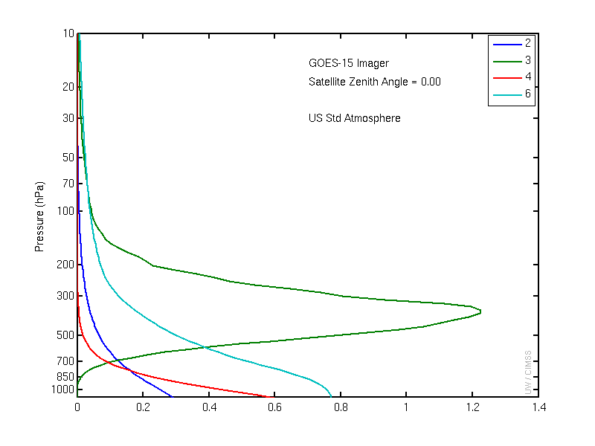
Figure 3.1: The GOES-15 Imager weighting functions.

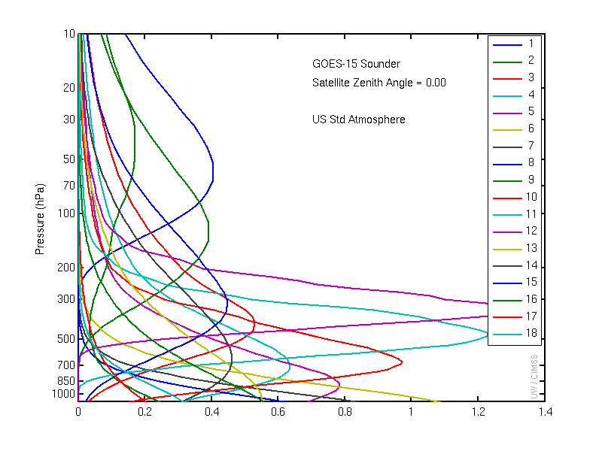
Figure 3.2: The GOES-15 Sounder weighting functions.

GOES Data Quality

First Images

The first step to ensure quality products is to verify the quality of the radiances that are used as inputs to the product generation. This process begins with a visual inspection of the images, at a number of spatial resolutions.

Visible

Figure 4.1: The first visible (0.63 μm) image from the GOES-15 Imager occurred on 6 April 2010 starting at approximately 1730 UTC.

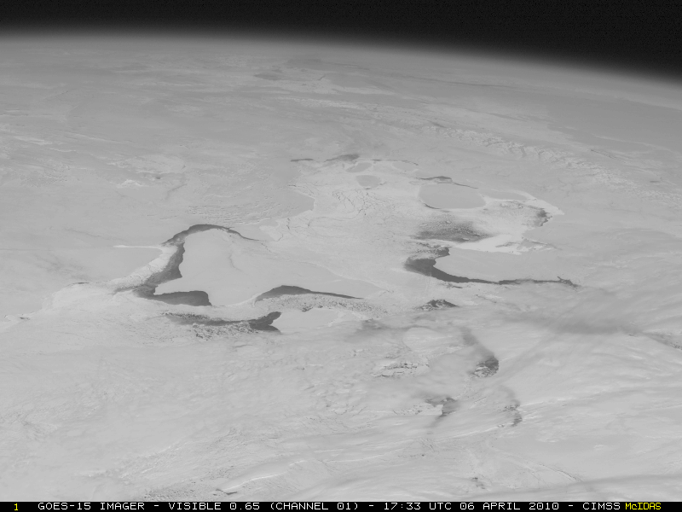

Figure 4.2: A GOES-15 visible image on 6 April 2010 showing a close-up view centered Northern Hudson Bay and the Canadian Arctic Archipelago (showing some areas of ice-free water).

Infrared (IR)

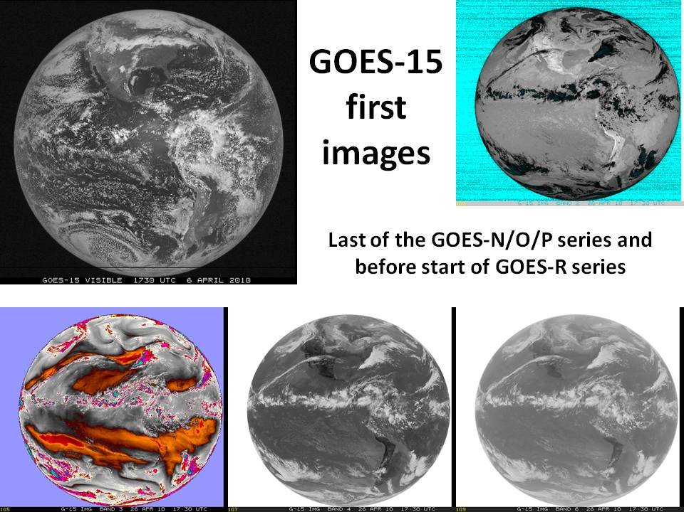
Figure 4.3: First GOES-15 full-disk visible and IR images from 6 and 26 April 2010, respectively.

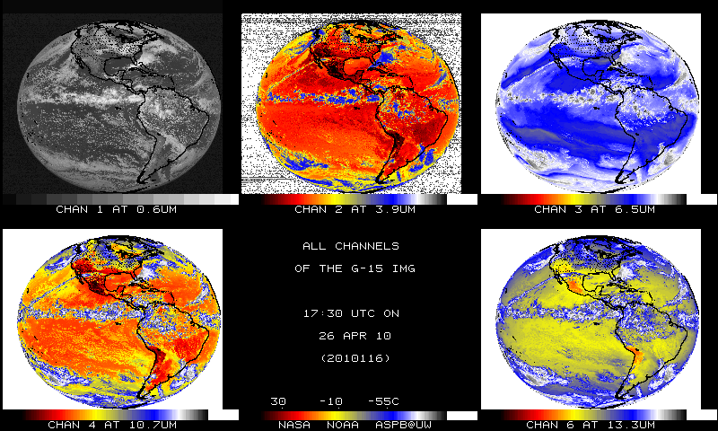
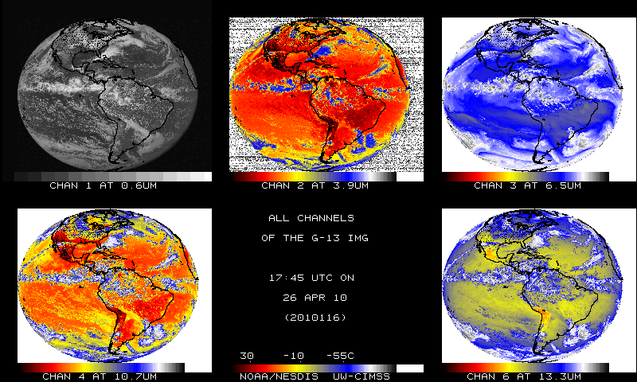
Figure 4.4: GOES-15 Imager bands (top) and the corresponding GOES-13 Imager bands (bottom). Both sets of images are shown in their native projections.

The images in Figure 4.4 have been sub-sampled. The sub-sampling is necessary, in part, due to the fact that the first GOES-14 Imager full-disk images were too wide.

Sounder

The first GOES-15 Sounder images showed good qualitative agreement with GOES-12.

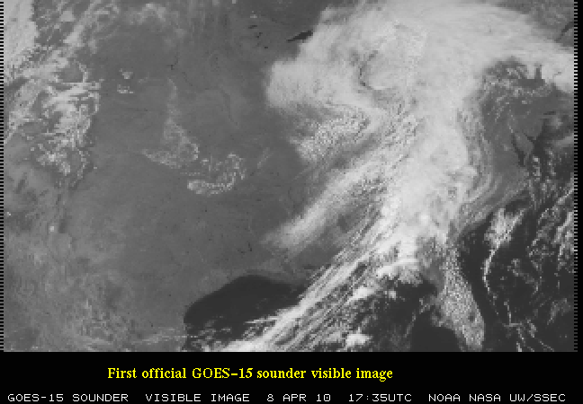
Figure 4.5: The visible (band-19) image from the GOES-15 Sounder shows data from 8 April 2010. The west and east ‘saw-tooth’ edges are due to the geometry of collecting the pixels.

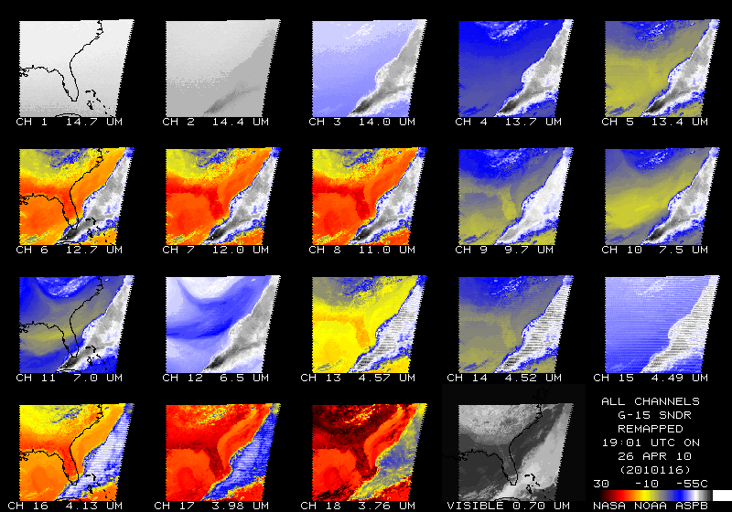

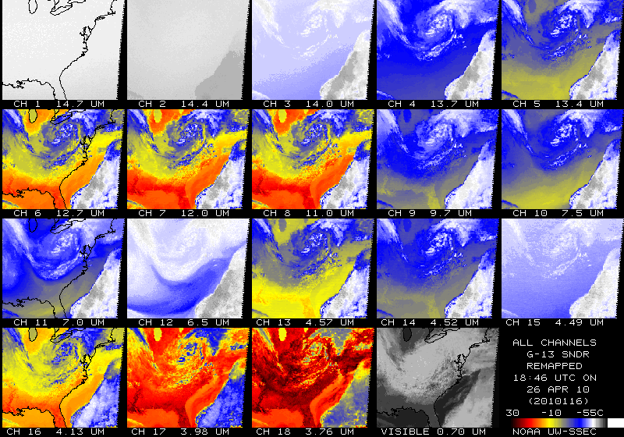
Figure 4.6: The first IR Sounder images for GOES-15 from 26 April 2010 (top) compared to GOES-13 (bottom). Both sets of images have been remapped to a common projection.

Spectral Response Functions (SRFs)

Imager

The GOES Spectral Response Functions (SRFs) for the GOES series Imagers can be found at
http://www.oso.noaa.gov/goes/goes-calibration/goes-imager-srfs.htm and are plotted in Figure 4.7. Note that there several versions off the GOES-15 Imager SRF, but the Rev. H should be used. The GOES-15 Imager is spectrally similar to the GOES-12 Imager, in that it has the spectrally-wide ‘water vapor’ band and that a 13.3 μm band has replaced the 12 μm band. Information about the GOES calibration can be found in Weinreb et al. (1997).

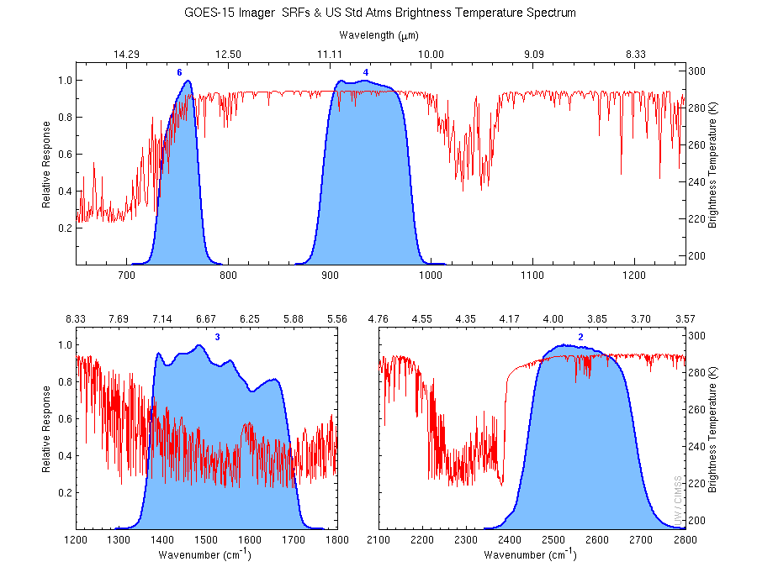
Figure 4.7: The four GOES-15 Imager IR-band SRFs super-imposed over the calculated high-resolution earth-emitted U.S. Standard Atmosphere spectrum. Absorption due to carbon dioxide (CO₂), water vapor (H₂O), and other gases are evident in the high-spectral-resolution earth-emitted spectrum. These are the ‘shifted’ revision H set (see Section 4.1).

Sounder

The GOES SRFs for the GOES series Sounders can be found at http://www.oso.noaa.gov/goes/goes-calibration/goes-sounder-srfs.htm and are plotted in Figure 4.8. The GOES-15 Sounder also has a Rev. F of the SRF. The overall band selection is unchanged from previous GOES Sounders (Schmit et al. 2002b). As before, the carbon dioxide (CO₂), ozone (O₃), and water vapor (H₂O) absorption bands are indicated in the calculated high-spectral-resolution earth-emitted U.S. Standard Atmosphere spectrum. The central wavenumbers (wavelengths) of the spectral bands range from 680 cm⁻¹ (14.7 μm) to 2667 cm⁻¹ (3.75 μm) (Menzel et al. 1998).

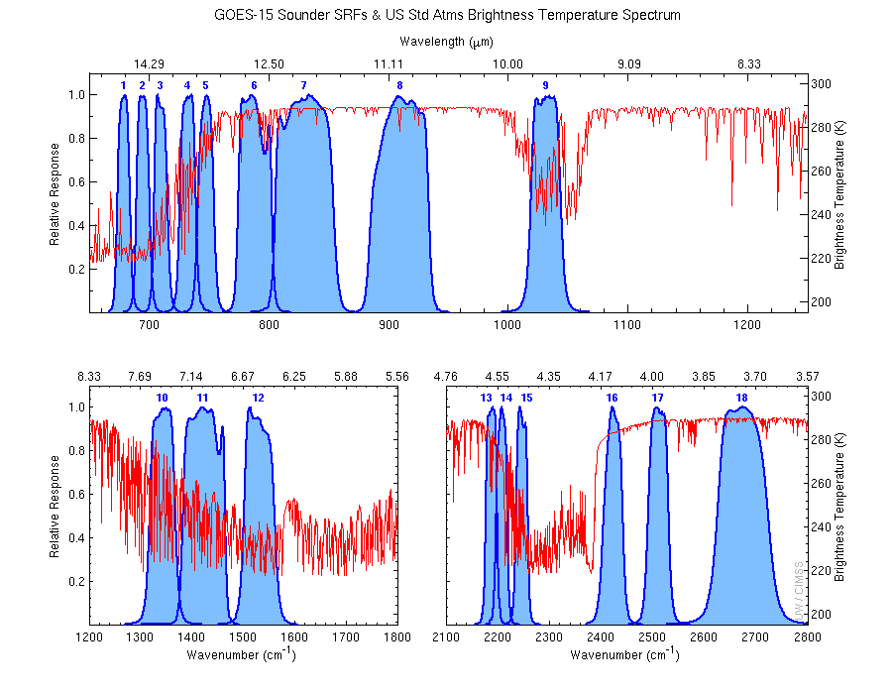
Figure 4.8: The eighteen GOES-15 Sounder IR-band SRFs super-imposed over the calculated high-resolution earth-emitted U.S. Standard Atmosphere spectrum. These are the ‘shifted’ revision H set (see Section 4.1).

Random Noise Estimates

Band noise estimates for the GOES-15 Imager and Sounder were computed using two different approaches. In the first approach, the band noise levels were determined by calculating the variance (and standard deviation) of radiance values in a space-look scene. The second approach involved performing a spatial structure analysis (Hillger and Vonder Haar 1988). Both approaches yielded nearly identical band noise estimates. Results of the both approaches are presented below.

Imager

Full-disk images for the Imager provided off-earth space views and allowed noise levels to be determined. Estimated noise levels for the GOES-15 Imager were averaged over time for both east and west-limb space views for 48 hours of data starting at 1645 UTC on 21 August 2010 and ending at 1615 UTC on 23 August 2010. Results are presented in Table 4.1 in radiance units. The limb-averaged noise levels (second to last column) compared well with those from simpler variance (standard deviation) analysis (last column), the values of which were computed on a smaller dataset on Julian days 2010247-2010248.

Table 4.1: GOES-15 Imager Noise Levels
(In radiance units, from 48 hours of limb/space views on Julian days 233-235 in 2010).

Imager Band | Central Wavelength  (μm) | East Limb | West Limb | Limb Average | Variance  Analysis
 |  | mW/(m²·sr·cm⁻¹)
2 | 3.9 | 0.0024 | 0.0023 | 0.0024 | 0.0023
3 | 6.5 | 0.022 | 0.022 | 0.022 | .022
4 | 10.7 | 0.095 | 0.102 | 0.099 | .094
6 | 13.3 | 0.22 | 0.22 | 0.22 | 0.22

A further comparison of the noise levels from the GOES-15 Imager with those from previous GOES Imagers is presented in Table 4.2. In this table the noise levels are given in temperature units. In general, noise levels were much improved over those for older GOES, with both GOES-13 and 14 in particular having lower noise in most bands than GOES-8 through 12.

Keep in mind as well, the finer pixel size for band-6 images (from 8 km to 4 km) on both GOES-14 and GOES-15 compared to GOES-13 could be expected to result in an increase in noise. But the noise levels for GOES-14 and GOES-15 band-6 are only slightly higher than it was for GOES-13.

Table 4.2: Summary of the Noise for GOES-8 through GOES-15 Imager Bands
(In temperature units; the Specification (SPEC) values are also listed).

Imager Band | Central  Wavelength  (μm) | GOES-15 | GOES-14 | GOES-13 | GOES-12 | GOES-11 | GOES-10 | GOES-9 | GOES-8 | SPEC
 |  | K @ 300 K, except band-3 @ 230 K
2 | 3.9 | 0.063 | 0.053 | 0.051 | 0.13 | 0.14 | 0.17 | 0.08 | 0.16 | 1.4
3 | 6.5 / 6.7 | 0.17 | 0.18 | 0.14 | 0.15 | 0.22 | 0.09 | 0.15 | 0.27 | 1.0
4 | 10.7 | 0.059 | 0.060 | 0.053 | 0.11 | 0.08 | 0.20 | 0.07 | 0.12 | 0.35
5 | 12.0 | - | - | - | - | 0.20 | 0.24 | 0.14 | 0.20 | 0.35
6 | 13.3 | 0.13 | 0.11 | 0.061 | 0.19 | - | - | - | - | 0.32
Band noise estimates for the GOES-15 Imager and Sounder visible band were also monitored at the GOES-15 Instrument Performance Monitoring (IPM) system. The visible band noise was evaluated with the standard deviation (1-sigma) of filtered space-view raw count ingested from the daytime GOES-15 GVAR Block 11 data. For the Imager, we examined the statistics of space-view data before and after the space clamp events. Since Sounder is clamped with filter wheel, the detector noise of the Sounder visible band was assessed with the space-view statistics at every two minutes. The results are shown in Figure 4.9, together with the noise values for the Imagers and Sounders onboard at GOES-11 through GOES-14. The noise of GOES-15 visible instruments are comparable to the other instruments of GOES-N/O/P series, though with not the least values. Compared to GOES-11/12, GOES-N/O/P satellites have much better quality of visible data in term of reduced noise, mainly resulted from hardware improvements such as the lower patch temperature.

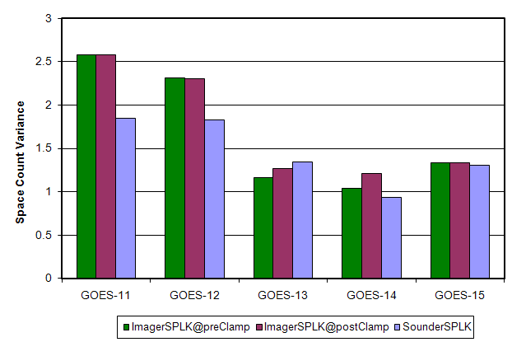

Figure 4.9: The mean standard deviation of the Imager space-view count at before and after the Imager space clamp events, and Sounder space-view count for GOES-11 through GOES-15.
Figure 4.10 is the standard deviation values of the 8 Imager visible detectors from 21 August 2010 to 23 August 2010. As shown in the figures, detector #3 of the Imager visible band is noisier than the other detectors at both pre-clamp and post-clamp space views.

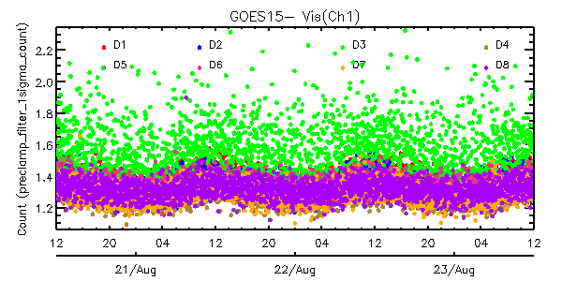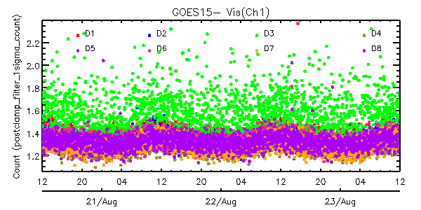
Figure 4.10: Times series of the standard deviations of space-view count for the eight detectors of GOES-15 Imager visible band from 20 August 2010 at 1200 UTC – 23 August 2010 at 1200 UTC (left: pre-clamp space-view statistics, right: post-clamp space-view statistics).
The noise in the GOES-15 IR bands was monitored using Noise Equivalent delta Radiance (NEdR) and Noise Equivalent delta Temperature (NEdT) of blackbody scan data with the GOES IPM system. GOES-15 Imager IR band noise in temperature units is compared to the rest of the GOES series (GOES-8 through GOES-14) in Table 4.3. The data clearly shows that the noise of all the GOES Imager Infrared (IR) bands are well below their specifications. The noise of the four GOES-15 IR bands are comparable with those of other GOES-N/O/P instruments and band-6 seems to be the noisiest among the all four similar instruments.

Table 4.3: Summary of the noise (in temperature units) for GOES-8 through GOES-15 Imager IR bands. The specification (SPEC) noise levels are also listed.
Imager Band | Central Wave-length (µm) | GOES-15 | GOES-14 | GOES-13 | GOES-12 | GOES-11 | GOES-10 | GOES-9 | GOES-8 | SPEC
 |  |  | K @ 300 K, except band-3 @ 230 K
2 | 3.9 | 0.064 | 0.057 | 0.059 | 0.102 | 0.123 | 0.090 | 0.094 | 0.092 | 1.4
3 | 6.5 | 0.186 | 0.197 | 0.170 | 0.149 | 0.265 | 0.149 | 0.134 | 0.160 | 1.0
4 | 10.7 | 0.044 | 0.051 | 0.045 | 0.073 | 0.073 | 0.061 | 0.055 | 0.173 | 0.35
5 | 12.0 | - | - | - | - | 0.176 | 0.112 | 0.123 | 0.172 | 0.35
6 | 13.3 | 0.118 | 0.106 | 0.067 | 0.102 | - | - | - | - | 0.32

Figure 4.11 clearly shows that the noise of each GOES-15 Imager IR detector is well below the specification and no significant NEdT trend can be observed.

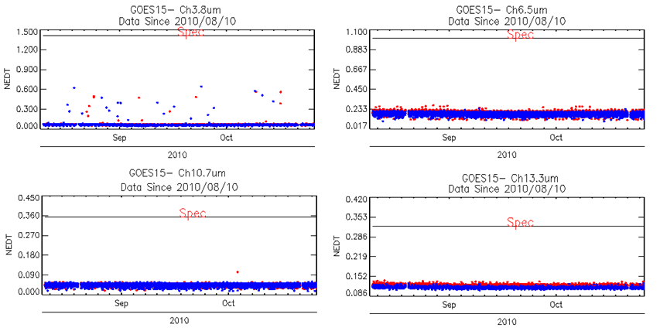
Figure 4.11: Time series of the GOES-15 Imager NEdT calculated @ 300 K temperature, except band-3 @ 230 K, compared to the specifications. The ‘spec’ line is also plotted. The color of the points refer to the detector number.

Sounder

Special GOES-15 limb-view Sounder sectors allow noise values to be determined by the scatter of radiance values looking at uniform off-earth space views. Noise values were computed for both west-limb and east-limb space-view data and averaged over the 32 hour period from 1630 UTC on 4 September 2010 through 0030 UTC on 6 September 2010. The limb-averaged values in Table 4.4 (second to last column) compare well to those from a simpler variance analysis (last column). Note that time frames with stray light were not included.

Table 4.4: GOES-15 Sounder Noise Levels
(In radiance units, from 32 hours of limb/space views on Julian days 247-248).
Sounder Band | Central Wavelength  (μm) | East Limb | West Limb | Limb Average | Variance  Analysis
 |  | mW/(m²·sr·cm⁻¹)
1 | 14.71 | 0.23 | 0.23 | 0.23 | 0.27
2 | 14.37 | 0.21 | 0.21 | 0.21 | 0.25
3 | 14.06 | 0.22 | 0.21 | 0.22 | 0.25
4 | 13.64 | 0.17 | 0.17 | 0.17 | 0.21
5 | 13.37 | 0.15 | 0.15 | 0.15 | 0.18
6 | 12.66 | 0.066 | 0.069 | 0.068 | 0.087
7 | 12.02 | 0.044 | 0.048 | 0.046 | 0.063
8 | 11.03 | 0.053 | 0.061 | 0.057 | 0.067
9 | 9.71 | 0.064 | 0.069 | 0.067 | 0.077
10 | 7.43 | 0.036 | 0.037 | 0.037 | 0.044
11 | 7.02 | 0.024 | 0.024 | 0.024 | 0.031
12 | 6.51 | 0.030 | 0.029 | 0.030 | 0.037
13 | 4.57 | 0.016 | 0.011 | 0.014 | 0.012
14 | 4.52 | 0.019 | 0.013 | 0.016 | 0.014
15 | 4.46 | 0.017 | 0.013 | 0.015 | 0.013
16 | 4.13 | 0.010 | 0.0064 | 0.0082 | 0.0079
17 | 3.98 | 0.0067 | 0.0042 | 0.0055 | 0.0059
18 | 3.74 | 0.0024 | 0.0014 | 0.0019 | 0.0027

A further comparison of the noise levels for the GOES-15 Sounder with those from previous GOES Sounders is presented in Table 4.5. Noise levels are in general much improved over those for older GOES, with GOES-13 through GOES-15 having lower noise in most bands than GOES-8 through 12.

Table 4.5: Summary of the Noise for GOES-8 through GOES-15 Sounder Bands
(In radiance units; the Specification (SPEC) values are also listed).

Sounder Band | Central  Wavelength  (μm) | GOES-15 | GOES-14 | GOES-13 | GOES-12 | GOES-11 | GOES-10 | GOES-9 | GOES-8 | SPEC
 |  | mW/(m²·sr·cm⁻¹)
1 | 14.71 | 0.23 | 0.29 | 0.32 | 0.77 | 0.67 | 0.71 | 1.16 | 1.76 | 0.66
2 | 14.37 | 0.21 | 0.24 | 0.25 | 0.61 | 0.51 | 0.51 | 0.80 | 1.21 | 0.58
3 | 14.06 | 0.22 | 0.21 | 0.23 | 0.45 | 0.37 | 0.41 | 0.56 | 0.98 | 0.54
4 | 13.64 | 0.17 | 0.16 | 0.18 | 0.39 | 0.36 | 0.41 | 0.46 | 0.74 | 0.45
5 | 13.37 | 0.15 | 0.15 | 0.18 | 0.34 | 0.34 | 0.36 | 0.45 | 0.68 | 0.44
6 | 12.66 | 0.068 | 0.073 | 0.095 | 0.14 | 0.17 | 0.16 | 0.19 | 0.32 | 0.25
7 | 12.02 | 0.046 | 0.053 | 0.086 | 0.11 | 0.11 | 0.09 | 0.13 | 0.20 | 0.16
8 | 11.03 | 0.057 | 0.076 | 0.10 | 0.11 | 0.14 | 0.12 | 0.09 | 0.13 | 0.16
9 | 9.71 | 0.067 | 0.068 | 0.11 | 0.14 | 0.13 | 0.10 | 0.11 | 0.16 | 0.33
10 | 7.43 | 0.037 | 0.039 | 0.081 | 0.099 | 0.09 | 0.07 | 0.08 | 0.08 | 0.16
11 | 7.02 | 0.024 | 0.025 | 0.046 | 0.059 | 0.06 | 0.04 | 0.05 | 0.07 | 0.12
12 | 6.51 | 0.030 | 0.029 | 0.063 | 0.11 | 0.11 | 0.07 | 0.09 | 0.11 | 0.15
13 | 4.57 | 0.014 | 0.0035 | 0.0061 | 0.0062 | 0.006 | 0.007 | 0.008 | 0.012 | 0.013
14 | 4.52 | 0.016 | 0.0035 | 0.0064 | 0.0062 | 0.007 | 0.005 | 0.007 | 0.010 | 0.013
15 | 4.46 | 0.015 | 0.0033 | 0.0055 | 0.0066 | 0.006 | 0.005 | 0.006 | 0.009 | 0.013
16 | 4.13 | 0.0082 | 0.0019 | 0.0030 | 0.0024 | 0.003 | 0.003 | 0.003 | 0.004 | 0.008
17 | 3.98 | 0.0055 | 0.0016 | 0.0026 | 0.0022 | 0.003 | 0.002 | 0.003 | 0.004 | 0.008
18 | 3.74 | 0.0019 | 0.00074 | 0.0011 | 0.00094 | 0.001 | 0.001 | 0.001 | 0.002 | 0.004

Figure 4.12 is the standard deviation values of the four Sounder visible detectors from 7 October 2010 to 9 October 2010. The four Sounder visible detectors have a similar standard deviation magnitude of the filtered space view.

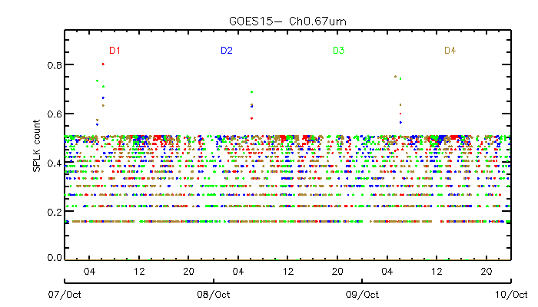

Figure 4.12: Standard deviations of space-view count for the four GOES-15 Sounder visible detectors from 7 October 2010 at 0 UTC to 9 October 2010 at 0 UTC.

GOES-15 Sounder noise was monitored with NEdR and NEdT at blackbody scan with measured blackbody temperature, and the results are also available at the GOES-15 IPM Web page. Tables 4.6 and 4.7 summarize the noise levels for GOES-8 through GOES-15. In general, the GOES-14 Sounder noise levels are improved compared to previous GOES Sounders.

Table 4.6: GOES-15 Sounder NEdR compared to those from GOES-8 through GOES-14 and the specification noise values.
Sounder Band | Central Wave-length (µm) | GOES-15 | GOES-14 | GOES-13 | GOES-12 | GOES-11 | GOES-10 | GOES-9 | GOES-8 | SPEC
 |  |  | mW/(m²·sr·cm⁻¹)
1 | 14.71 | 0.282 | 0.268 | 0.288 | 0.326 | 0.300 | 0.645 | 0.563 | 0.998 | 0.66
2 | 14.37 | 0.263 | 0.221 | 0.230 | 0.282 | 0.247 | 0.441 | 0.455 | 0.755 | 0.58
3 | 14.06 | 0.265 | 0.188 | 0.211 | 0.221 | 0.186 | 0.347 | 0.344 | 0.685 | 0.54
4 | 13.64 | 0.212 | 0.142 | 0.167 | 0.200 | 0.179 | 0.360 | 0.294 | 0.512 | 0.45
5 | 13.37 | 0.184 | 0.141 | 0.169 | 0.185 | 0.175 | 0.338 | 0.275 | 0.495 | 0.44
6 | 12.66 | 0.073 | 0.064 | 0.080 | 0.076 | 0.092 | 0.147 | 0.127 | 0.223 | 0.25
7 | 12.02 | 0.043 | 0.042 | 0.054 | 0.056 | 0.058 | 0.079 | 0.080 | 0.144 | 0.16
8 | 11.03 | 0.053 | 0.044 | 0.097 | 0.127 | 0.137 | 0.096 | 0.079 | 0.129 | 0.16
9 | 9.71 | 0.073 | 0.054 | 0.127 | 0.184 | 0.132 | 0.120 | 0.113 | 0.161 | 0.33
10 | 7.43 | 0.041 | 0.033 | 0.096 | 0.129 | 0.107 | 0.077 | 0.716 | 0.082 | 0.16
11 | 7.02 | 0.027 | 0.020 | 0.054 | 0.075 | 0.070 | 0.048 | 0.044 | 0.071 | 0.12
12 | 6.51 | 0.032 | 0.027 | 0.076 | 0.138 | 0.134 | 0.091 | 0.079 | 0.111 | 0.15
13 | 4.57 | 0.005 | 0.0028 | 0.0046 | 0.024 | 0.0045 | 0.006 | 0.006 | 0.008 | 0.013
14 | 4.52 | 0.005 | 0.0029 | 0.0049 | 0.023 | 0.0056 | 0.004 | 0.005 | 0.008 | 0.013
15 | 4.46 | 0.005 | 0.0025 | 0.0042 | 0.025 | 0.0044 | 0.004 | 0.005 | 0.008 | 0.013
16 | 4.13 | 0.003 | 0.0016 | 0.0023 | 0.009 | 0.0023 | 0.002 | 0.002 | 0.003 | 0.008
17 | 3.98 | 0.002 | 0.0013 | 0.0020 | 0.008 | 0.0021 | 0.002 | 0.002 | 0.002 | 0.008
18 | 3.74 | <0.0001 | <0.0001 | <0.0001 | 0.0033 | 0.0010 | <0.0001 | 0.001 | 0.002 | 0.004

Table 4.7: GOES-15 Sounder NEdT compared to those from GOES-8 through GOES-14.
Sounder Band | Central Wave-length (µm) | GOES-15 | GOES-14 | GOES-13 | GOES-12 | GOES-11 | GOES-10 | GOES-9 | GOES-8
 |  | K @ blackbody temperature
1 | 14.71 | 0.167 | 0.158 | 0.170 | 0.193 | 0.178 | 0.383 | 0.333 | 0.591
2 | 14.37 | 0.154 | 0.129 | 0.135 | 0.165 | 0.147 | 0.259 | 0.267 | 0.443
3 | 14.06 | 0.154 | 0.109 | 0.123 | 0.128 | 0.108 | 0.201 | 0.199 | 0.398
4 | 13.64 | 0.122 | 0.082 | 0.096 | 0.115 | 0.103 | 0.208 | 0.169 | 0.295
5 | 13.37 | 0.105 | 0.081 | 0.097 | 0.106 | 0.100 | 0.194 | 0.158 | 0.283
6 | 12.66 | 0.042 | 0.036 | 0.046 | 0.043 | 0.053 | 0.084 | 0.072 | 0.127
7 | 12.02 | 0.025 | 0.024 | 0.031 | 0.032 | 0.033 | 0.045 | 0.046 | 0.082
8 | 11.03 | 0.031 | 0.026 | 0.057 | 0.074 | 0.081 | 0.056 | 0.047 | 0.076
9 | 9.71 | 0.047 | 0.035 | 0.082 | 0.118 | 0.104 | 0.077 | 0.072 | 0.103
10 | 7.43 | 0.042 | 0.034 | 0.097 | 0.130 | 0.108 | 0.078 | 0.071 | 0.082
11 | 7.02 | 0.032 | 0.023 | 0.063 | 0.088 | 0.083 | 0.056 | 0.052 | 0.084
12 | 6.51 | 0.048 | 0.039 | 0.112 | 0.206 | 0.201 | 0.135 | 0.116 | 0.165
13 | 4.57 | 0.042 | 0.023 | 0.038 | 0.195 | 0.038 | 0.047 | 0.045 | 0.084
14 | 4.52 | 0.048 | 0.026 | 0.043 | 0.205 | 0.050 | 0.035 | 0.046 | 0.067
15 | 4.46 | 0.052 | 0.025 | 0.042 | 0.248 | 0.043 | 0.037 | 0.046 | 0.075
16 | 4.13 | 0.047 | 0.027 | 0.038 | 0.147 | 0.040 | 0.038 | 0.039 | 0.056
17 | 3.98 | 0.047 | 0.028 | 0.045 | 0.186 | 0.047 | 0.042 | 0.054 | 0.085
18 | 3.74 | <0.001 | <0.001 | <0.001 | 0.119 | 0.037 | <0.001 | 0.038 | 0.064

Figure 4.13 is the time-series of the NEdT for the four detectors at each IR band in mid-September 2011. The NEdT is very consistent over the two-day period and the noise of each GOES-15 Sounder IR band is well below its specification when the patch temperature was controlled at low-level.

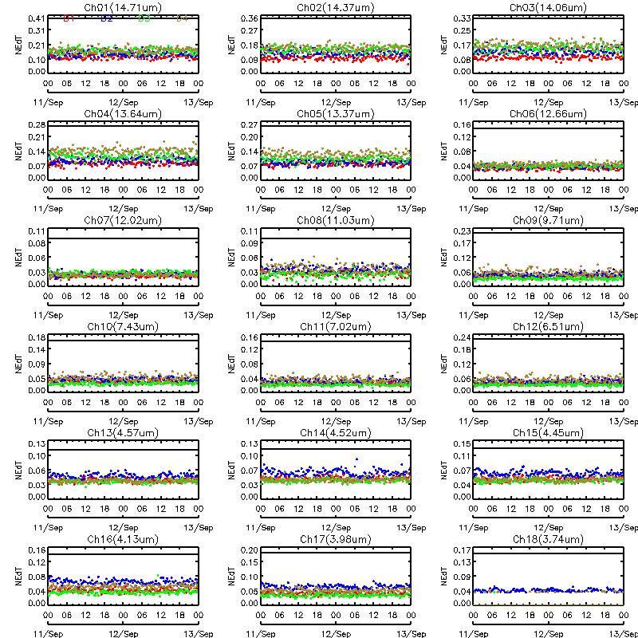
Figure 4.13: Diurnal variation of GOES-15 Sounder NEdT between 11 September 2010 and 12 September 2010. The solid line in each IR band plot is the specification value. The colors correspond to the 4 detectors.

Striping Due to Multiple Detectors

For the GOES Imager there are two detectors per spectral band, and for the GOES Sounder, there are four detectors for each spectral band. Differences between the measurements in these detectors can cause striping in GOES images. Striping becomes more obvious as random noise decreases, allowing the striping to dominate the random noise. Striping is defined as the difference between the average values for each detector from the average value in all detectors.

Imager

Full-disk images from the Imager provide off-earth space views, allowing both noise levels (reported above) and detector-to-detector striping to be determined in an otherwise constant signal situation. Table 4.8 gives estimates of GOES-15 Imager detector-to-detector striping for a 24 hour period starting at 1645 UTC on 21 August 2010 and ending at 1615 UTC on 23 August 2010. Striping was computed from off-earth space-view measurements on each side of the earth (columns 3 and 4). The limb averages (third to last column) are then determined and compared to the noise level (second to last column). A ratio of striping to noise is also computed (last column). All the ratios are less than 1, indicating that the striping is less than the noise. Because the noise has decreased with the latest GOES series, the striping can more obvious than for earlier GOES, as will be seen in some of the Sounder images presented later in this report.

Table 4.8: GOES-15 Imager Detector-to-Detector Striping
(In radiance units, from 48 hours of limb/space views on Julian days 233-235).

Imager Band | Central Wavelength  (μm) | East Limb | West Limb | Limb Average | Noise | Striping/Noise Ratio
 |  | mW/(m²·sr·cm⁻¹)
2 | 3.9 | 0.00103 | 0.00063 | 0.00083 | 0.0024 | 0.35
3 | 6.5 | 0.0026 | 0.0023 | 0.0025 | 0.022 | 0.11
4 | 10.7 | 0.025 | 0.026 | 0.026 | 0.099 | 0.26
6 | 13.3 | 0.024 | 0.0095 | 0.017 | 0.22 | 0.076

Sounder

Detector-to-detector striping for the Sounder is documented in Table 4.9 from measurements taken from the same off-earth space-view sectors used for the noise analysis for the Sounder, for the 32 hour period from 1630 UTC on 4 September 2010 through ~0030 UTC on 6 September 2010. The limb-averaged values (third from last column) are compared to the noise levels (second to last column), with the ratio of striping to noise in the last column. Values larger than one (sometimes much larger), indicate that striping is much more significant than noise for several of the Sounder bands. The largest ratios, for the longwave IR bands, do not mean that striping is obvious in the images from these bands, because the inherent signal is also very large in these window bands.

Table 4.9: GOES-15 Sounder Detector-to-Detector Striping
(In radiance units, from 32 hours of limb/space views on Julian days 247-248).

Sounder Band | Central Wavelength  (μm) | East Limb | West Limb | Limb Average | Noise | Striping/Noise Ratio
 |  | mW/(m²·sr·cm⁻¹)
1 | 14.71 | 0.48 | 0.81 | 0.65 | 0.23 | 2.8
2 | 14.37 | 0.42 | 0.74 | 0.58 | 0.21 | 2.8
3 | 14.06 | 0.52 | 0.92 | 0.72 | 0.22 | 3.3
4 | 13.64 | 0.71 | 1.22 | 0.97 | 0.17 | 5.7
5 | 13.37 | 0.80 | 1.31 | 1.06 | 0.15 | 7.0
6 | 12.66 | 1.08 | 1.79 | 1.44 | 0.068 | 21.1
7 | 12.02 | 1.06 | 1.77 | 1.42 | 0.046 | 30.8
8 | 11.03 | 0.95 | 1.44 | 1.20 | 0.057 | 21.0
9 | 9.71 | 0.42 | 0.66 | 0.54 | 0.067 | 8.1
10 | 7.43 | 0.17 | 0.29 | 0.23 | 0.037 | 6.2
11 | 7.02 | 0.10 | 0.19 | 0.15 | 0.024 | 6.0
12 | 6.51 | 0.043 | 0.061 | 0.052 | 0.030 | 1.7
13 | 4.57 | 0.031 | 0.034 | 0.033 | 0.014 | 2.3
14 | 4.52 | 0.020 | 0.017 | 0.019 | 0.016 | 1.2
15 | 4.46 | 0.017 | 0.011 | 0.014 | 0.015 | 0.9
16 | 4.13 | 0.015 | 0.017 | 0.016 | 0.0082 | 2.0
17 | 3.98 | 0.016 | 0.012 | 0.014 | 0.0055 | 2.5
18 | 3.74 | 0.0083 | 0.014 | 0.011 | 0.0019 | 5.9

Initial post-launch calibration for the GOES-15 Imager visible band

Due to lack of on-board calibration device for the GOES visible band, vicarious calibration is needed to derive accurate post-launch calibrated radiance/reflectance for the visible bands. Currently, the post-launch operational calibration of the GOES Imager visible band is based on the inter-calibration between GOES and Earth Observation System (EOS) Terra Moderate Resolution Imaging Spectroradiometer (MODIS) band-1 data (Wu and Sun 2005). The calibration correction of the post-launch GOES-15 Imager visible band data can be written as:

R_{post} = R_{pre} * C

Where R_{post} is the post-launch calibration reflectance/radiance for GOES-15 Imager visible band; R_{pre} is the pre-launch calibration reflectance/radiance (http://www.star.nesdis.noaa.gov/smcd/spb/fwu/homepage/GOES_Imager_Vis_PreCal.php); and C is the correction factor, C = 1.082 (±0.017). This result was derived based on the collocated GOES-15 and EOS-Terra MODIS pixels acquired on Julian days in 2010 of: 228, 244, 248, 253, 273, 276, 278, 285, 89, and 294.

GEO to GEO comparisons

During the PLT period, GOES-15 was orbiting at (89.5ºW), between GOES-11 (135ºW) and GOES-13 (75ºW) to emulate the GOES-11 and GOES-13 scan patterns. The comparison of reflectance or emissivity (radiance/brightness temperature) over the collocated regions offers a unique opportunity to evaluate the consistency of a same product retrieved from two different GOES satellites. Similar collocation criteria as the Geostationary Earth Orbit (GEO)-Low Earth Orbit (LEO) inter-calibration was applied to identify the GEO-GEO collocation scenes, including, 1) the distance between the centers of two GEO pixels should be within the radius of the nominal spatial resolution at nadir (spatial collocation), 2) the time difference between the two observations should be less than 5 minutes (temporal collocation) for Imagers and 15 minutes for Sounders, 3) the difference in the cosine of the viewing zenith angle should be within 1% (viewing geometry match).

Figure 4.14 shows the spatial distribution of collocation pixels of GOES-15 vs. GOES-13 Imagers (left) and GOES-15 vs. GOES-11 Imagers (right) in the north hemisphere. Due to the closer sub-satellite locations, the collocation pixels of GOES-15 vs. GOES-13 have much wider spatial distribution than GOES-15 vs. GOES-11, covering from the Equator to about 50° in latitude and centered about ±2° around 82.25°W. The GOES-15 vs. GOES-11 collocation pixel distribution is centered about ±0.6° at 112.25°W. The high frequency and large amount of collocation scenes provides an excellent opportunity to directly inter-compare the radiance from these two satellites. All the GEO-GEO inter-calibration results are based on the analysis of collocation data from 26 September 2010 to 28 September 2010 for GOES-15 vs. GOES-13 and from 26 August 2010 to 28 August 2010 for GOES-15 vs. GOES-11.
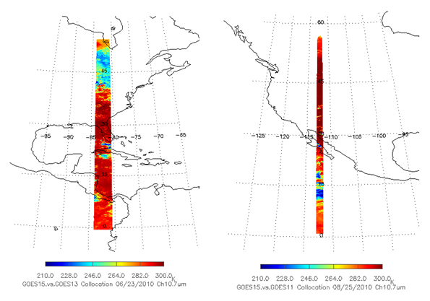
Figure 4.14: Spatial distribution of GOES-15 Imager band-4 Tb values for the collocation scenes between GOES-13 (left) and GOES-11 (right).

Figure 4.15 shows the difference of post-launch calibrated visible reflectance between GOES-15 and GOES-13 (left) and the histogram distribution of the visible reflectance difference (right). On average, the GOES-15 visible reflectance is about 1.0% higher than GOES-13 and 2.1% lower than GOES-11. The small visible reflectance difference between these radiometers indicates that the operational post-launch calibration corrections can reduce the “seam” feature along the overlapped areas. Causes of the difference include the SRF difference (Figure 4.16), bidirectional reflectance function distribution (BRDF), and the operational calibration uncertainty. Note the large SRF differences between the GOES-8/11, compared to GOES-13/15. This causes differences in the reflection from vegetative surfaces, given the sharp transition zone near 7.2 μm (not shown).

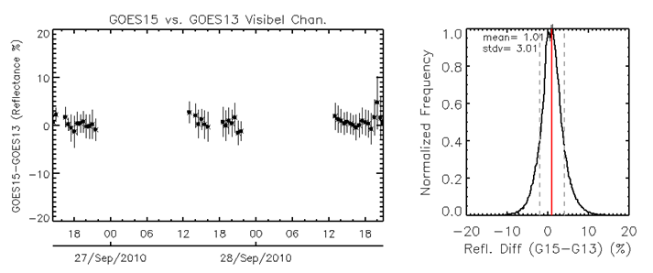
Figure 4.15: Time-series of GOES-15 vs. GOES-13 post-launch calibrated visible reflectance difference (left) and the histogram of the visible reflectance difference (right).

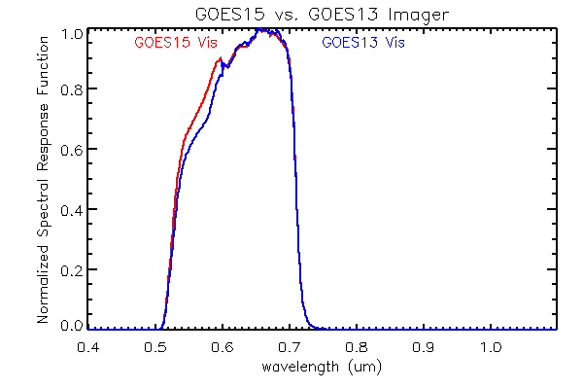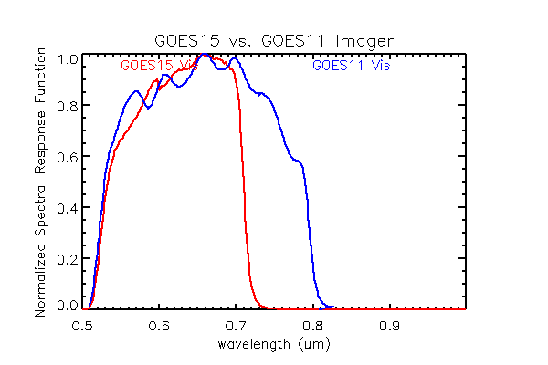
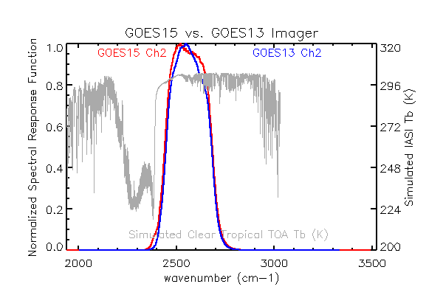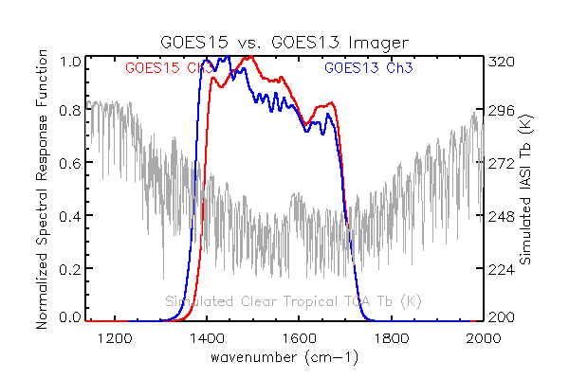
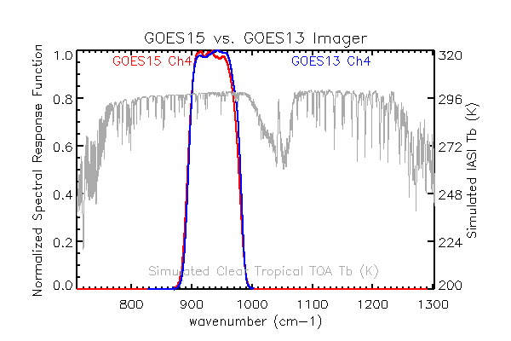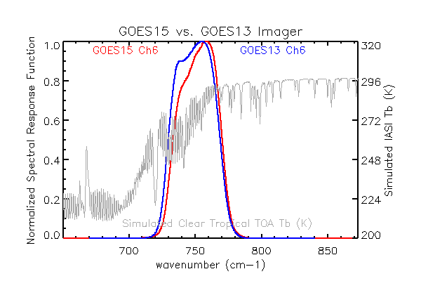
Figure 4.16: SRF of the visible bands at GOES-15 vs. GOES-13 (top left) and GOES-15 vs. GOES-11 (top right). SRF of GOES-13 and GOES-15 four IR bands (red: GOES-15, blue: GOES-13). The simulated clear tropical TOA Tb values (in gray) are also plotted for the four IR bands.

The distribution of the SRF plays a dominant role in determining the Tb difference at this direct GEO-GEO inter-comparison in this study, especially for the absorptive band-3 (6.5 µm) and band-6 (13.3 µm). Figure 4.16 shows the SRF of the four Imager IR bands at GOES-13 and GOES-15. The simulated clear tropical top-of-atmosphere (TOA) Tb values using the IASI spectra are also plotted for the four IR bands.

GOES-15 data were also evaluated by comparing pixel temperatures of a 10 x 10 pixel box in a Mercator projection centered at 40˚N / 82.25˚W for bands 2, 3, 4, and 6 to a similar domain on the operational GOES-East satellite (GOES-13). This location was chosen to keep the satellite zenith angle consistent between GOES-13 and GOES-15. All results were plotted in a two-dimensional smoothed histogram approach which allows for a better representation of data in dense areas (Eilers and Goeman 2004). Additionally, numerous statistics were calculated in order to determine the performance of the GOES-15 Imager bands compared to the respective Imager bands on GOES-13.

GOES-15 testing began at SAB on 11 August 2010 and was completed on 18 October 2010. This testing period resulted in sample sizes of over 180,000 pixels for all bands tested. Figure 4.17 shows two-dimensional smoothed histograms of GOES-13 vs. GOES-15 pixel temperatures taken from a 10 x 10 domain centered at 40˚N / 82.25˚W for bands 2, 3, 4, and 6. A dashed line representing the perfect fit line with numerous performance statistics is included on the graphs. A nearly perfect degree of correlation (r > 0.98) was observed between GOES-13 and GOES-15 pixel temperatures for all tested bands. On bands 2 and 4, no significant biases were detected in the data. Mean Absolute Errors (MAE) were less than or equal to roughly 1.5 K for bands 2 and 4. For bands 3 and 6, SAB did note a modest cold bias of roughly 1.2 K for GOES-15 band-3 data and a more significant warm bias of 2.7 K for GOES-15 band-6 data. MAEs for the band-3 and 6 pixel temperatures nearly matched the magnitude of the observed biases which suggests very few instances where GOES-15 pixel temperatures deviated from their respective observed bias. It is noted that the observed biases of the band-3 and 6 data is consistent with central wavelength shifts of both band-3 and 6 data on GOES-15, although the magnitude of band-6 data is larger than what SAB expected considering the small wavelength shift. This is consistent with the LEO-GEO comparisons that showed a large bias in bands 3 and 6, along with the fact that this analysis was done before implemented a SRF shift. Root Mean Square Errors (RMSE) in most cases were similar to their respective MAEs and this implies that the number of large errors were minimal. Any large errors that were observed were manually investigated and most were determined to be a function of slight navigational errors near cloud edges.

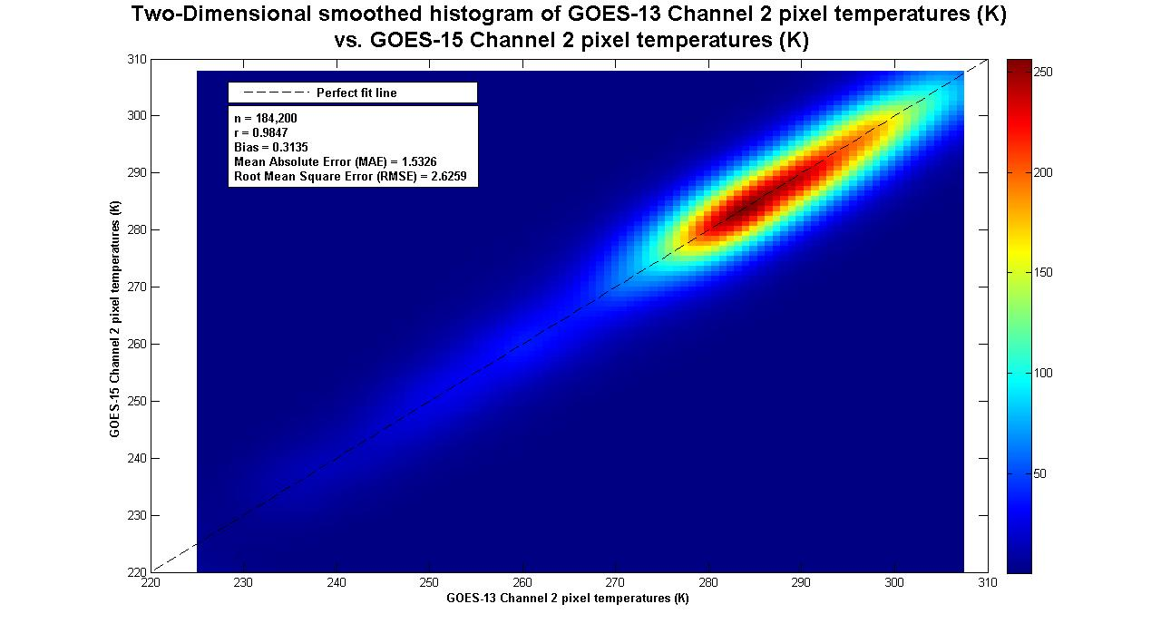
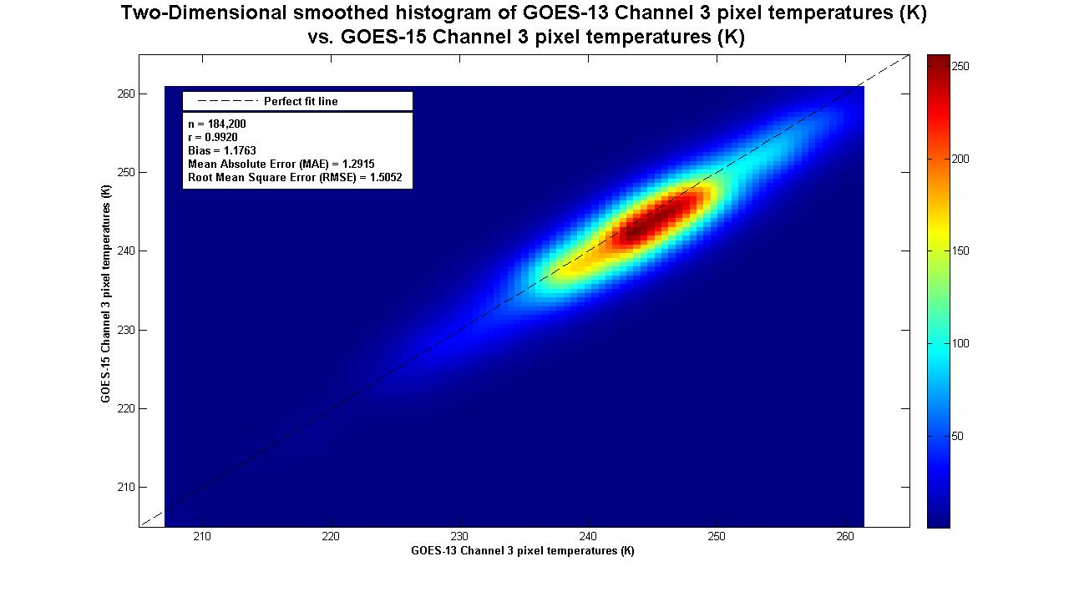
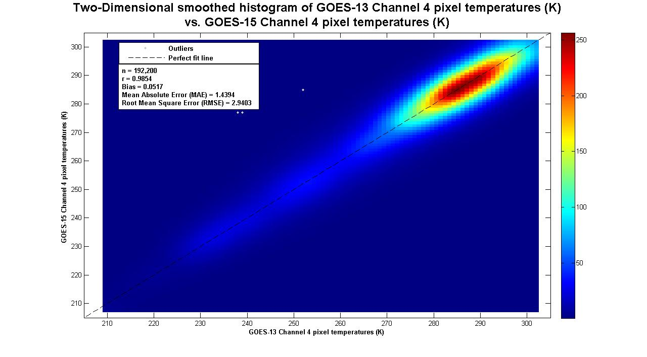
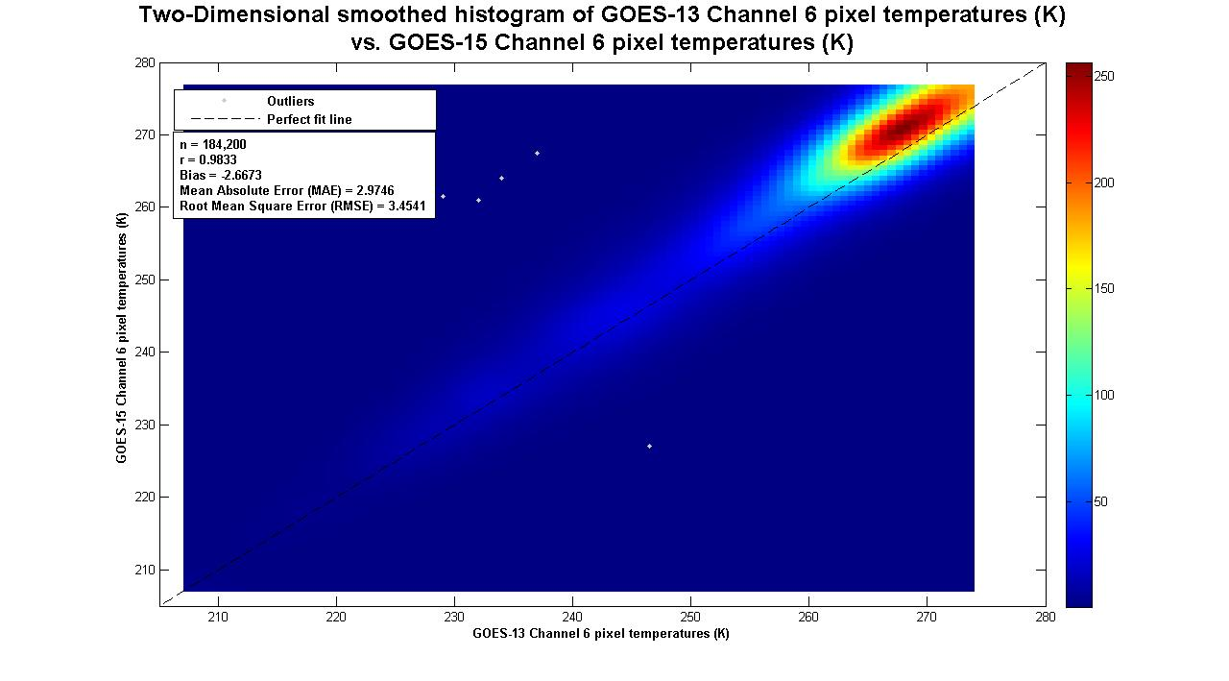
Figure 4.17: Two-Dimensional smoothed histogram of GOES-13 band-2, 3, 4, and 6 pixel temperatures (K) vs. GOES-15 band-2, 3, 4, and 6 pixel temperatures.
Figure 4.18 is the mean Tb difference (black dots) and standard deviation (gray line segments) between GOES-13 and GOES-15 for the four IR bands at half-hour time bins from 24 to 26 June 2010. Since band-2 (3.9 µm) can also receive reflected solar radiation, a large variation of daytime Tb difference statistics are expected as the two satellites always view the collocated pixels from different directions and the surface is usually characterized with directional reflectance. The small variation of Tb difference around the midnight time indicates there is still some Midnight Blackbody Calibration Correction (MBCC) calibration residual, although the correction in general performs well in this band for both satellites. The mean Tb difference between GOES-15 and GOES-13 is -0.30 (±0.19) K (Table 4.10).

The Tb difference and statistics are very consistent for band-3 (6.5 µm) as the atmospheric water vapor that the detectors of this band detect is relatively homogenous. The mean Tb difference between these two satellites is -0.05 (±0.06) K over the three day studies. Considering that GOES-15 has ~2 K Tb difference to AIRS/IASI and GOES-13 has <0.2 K Tb difference to these two hyperspectral radiometers, the large discrepancy of the GEO-LEO and GEO-GEO inter-calibration results is because the radiometric calibration of the absorptive bands is sensitive to the SRF distribution and SRF calibration uncertainty. Further work is needed to take account of the difference in the SRF.

The mean Tb difference of band-4 (10.7 µm) between GOES-15 and GOES-13 is 0.08 (±0.15) K. The small, consistent daytime Tb difference, together with the small Tb bias to AIRS/IASI of these two instruments, indicates that band-4 of both GOES-15 and GOES-13 is well-calibrated. The large Tb variation around midnight time are associated with the MBCC calibration residuals at these bands.

A large Tb difference can be observed for band-6 (13.3 µm). The mean Tb difference is 2.94 (±0.27) K. The discrepancy between the GEO-GEO and GEO-LEO inter-calibration is mainly due to the different SRFs at GOES-15 and GOES-13. More research is needed to understand the Tb variation between 1000-1800 UTC as this variation is unlikely related to the MBCC calibration residuals. Note that this analysis was done with the SRF available during NOAA science test.

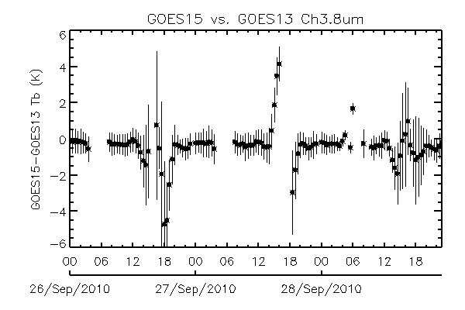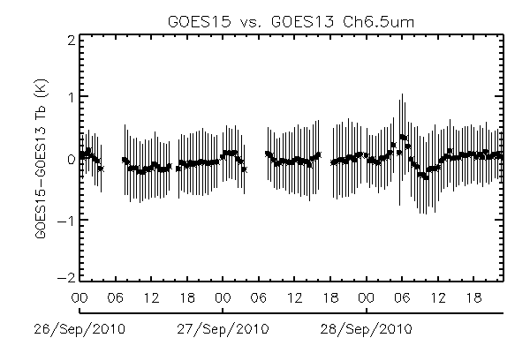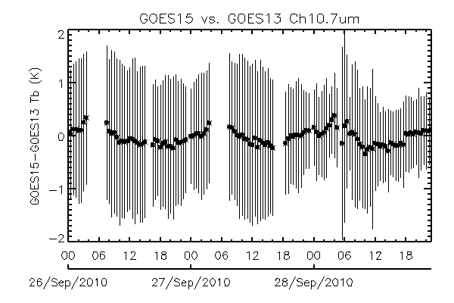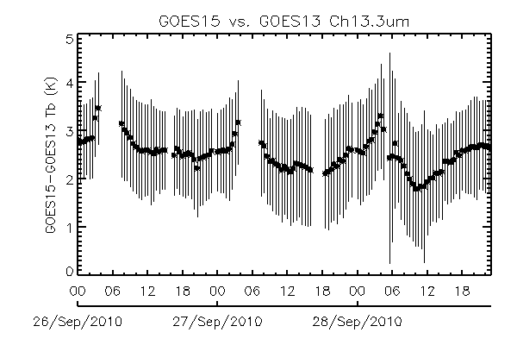

Figure 4.18: Direct inter-comparison of GOES-15 vs. GOES-13 Imager IR bands. No account of differing SRF were made.

Figure 4.19 plots the latitudinal distributions of the mean Tb difference (black dots) and the standard deviation (gray segments) between GOES-15 and GOES-13 within 0.5° latitude bins for the four IR bands on 10 August 2010. There is no significant Tb difference trend in bands 3 and 4, yet the Tb difference of band-6 increase significantly as the longitude increases. As the radiometric calibration of band-6 is especially sensitive to the SRF distribution (Wu et al. 2009), longitudinal dependent Tb bias is attributed to the increasing optical length which exaggerate the impact of SRF difference on the radiance of this band.

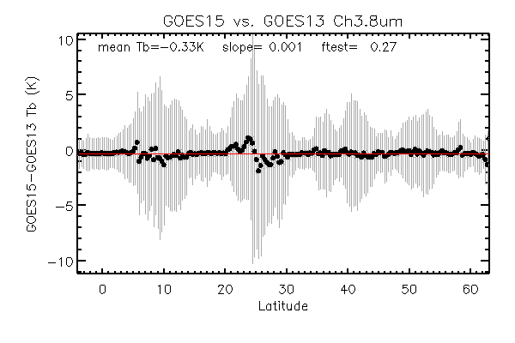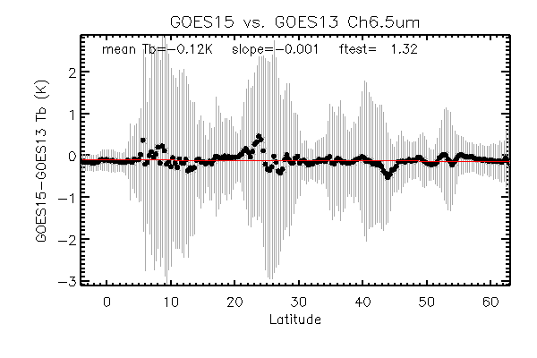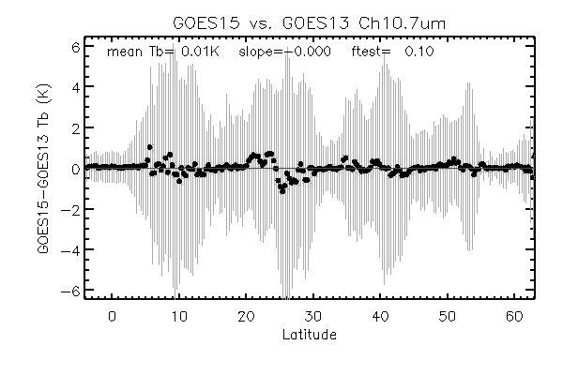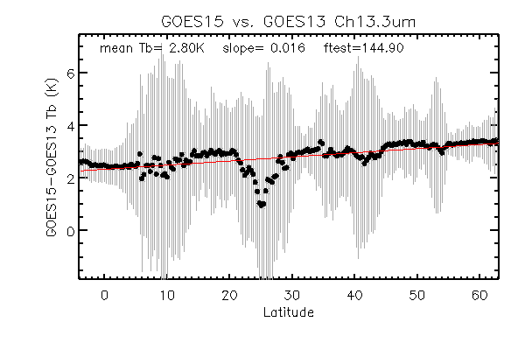
Figure 4.19: Latitudinal distribution of the mean Tb difference (dark dots) and the standard deviation (gray segments) between GOES-15 and GOES-13 for the four Imager IR bands (Tb difference = GOES-15 – GOES-13).

The mean Tb difference and standard deviation values for GOES-15 vs. GOES-13 and GOES-15 vs. GOES-11 are reported at Table 4.10. The mean Tb difference between GOES-15 and GOES-11 is -0.63 K, 2.51 K, and 0.41 K for bands 2, 3, and 4, respectively. The large standard deviation of the band-2 Tb difference (±1.00 K) is due to the strong BRDF effect during the daytime as these two satellites are located about 45º apart. The SRF difference is most likely the main factor causing the large band-3 Tb difference as the GOES-15 band-3 SRF is much wider than that of GOES-11.

Table 4.10: Mean Tb difference (K) and the standard deviation values for the IR bands between the Imagers on GOES-15 vs. GOES-13 and GOES-15 vs. GOES-11.

Imager Band | Central Wavelength  (μm) | GOES-15 – GOES-13 | GOES-15 – GOES-11
 |  | K
2 | 3.9 | -0.30 (±0.19) | -0.63 (±1.00)
3 | 6.5 | -0.05 (±0.06) | 2.51 (±0.13)
4 | 10.7 | 0.08 (±0.15) | 0.41 (±0.35)
6 | 13.3 | 2.94 (±0.27) | -

Similar collocation criteria are applied to identify the collocation pixels for the Sounder pairs, except that the maximum temporal difference is set to 15 minutes instead of 5 minutes. The spatial distribution of the collocation pixels are shown in Figure 4.20 for the two pairs of Sounder instruments. Similar to the Imager collocation, GOES-13 and GOES-15 have much wider collocation distribution than that of GOES-11 and GOES-15, due to the much closer sub-satellite deployment. The mean of the Tb difference and the standard deviation for the 18 IR bands are reported in Table 4.11. Note that no corrections have been done to account for SRF differences.
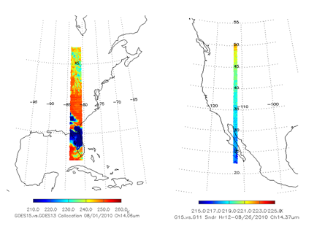
Figure 4.20: Spatial distribution of Sounder collocation pixels for GOES-15 vs. GOES-13 (left) and GOES-15 vs. GOES-11 (right).

Table 4.11: Mean Tb difference (K) and the standard deviation values for the IR bands between the Sounders on GOES-15 vs. GOES-13 and GOES-15 vs. GOES-11.

Sounder Band | Central Wavelength  (μm) | GOES-15 – GOES-13 | GOES-15 – GOES-11
 |  | K
1 | 14.71 | 0.23 (±0.09) | 0.95 (±0.64)
2 | 14.37 | -0.60 (±0.19) | -0.53 (±0.56)
3 | 14.06 | -0.05 (±0.12) | -2.73 (±0.58)
4 | 13.64 | 0.18 (±0.12) | 0.04 (±0.58)
5 | 13.37 | -0.84 (±0.10) | 0.66 (±0.68)
6 | 12.66 | 0.07 (±0.09) | 0.30 (±1.47)
7 | 12.02 | 0.12 (±0.16) | 0.26 (±1.25)
8 | 11.03 | 0.28 (±0.17) | -0.07 (±0.52)
9 | 9.71 | 0.25 (±0.21) | -0.12 (±0.44)
10 | 7.43 | 0.27 (±0.14) | -0.37 (±0.26)
11 | 7.02 | 0.26 (±0.19) | 0.40 (±0.27)
12 | 6.51 | 0.05 (±0.30) | 0.06 (±0.28)
13 | 4.57 | -0.21 (±0.31) | 3.50 (±0.42)
14 | 4.52 | 1.72 (±0.29) | 1.33 (±0.20)
15 | 4.46 | -1.05 (±0.39) | 4.62 (±0.39)
16 | 4.13 | 0.87 (±0.27) | -0.51 (±0.27)
17 | 3.98 | 0.26 (±0.36) | -0.11 (±0.31)
18 | 3.74 | 0.27 (±0.35) | -0.04 (±0.36)

Imager-to-Polar-Orbiter Comparisons

Data were collected during the Science Test near the GOES-15 sub-satellite point from the high-spectral-resolution IASI, on EUMETSAT’s polar-orbiting MetOp-A satellite. GOES-15 Imager data were collected within 30 minutes of polar-orbiter overpass time. During the Science Test there were 25, 55, 56 and 57 comparisons (respectively) between GOES-15 and IASI. The fewer number of band 2 comparisons are only night-time. The methodology that was applied, the CIMSS method, was nearly identical to that outlined in Gunshor et al. (2009), though applied to IASI data with no spectral gaps. The results are presented in Table 4.12. The mean brightness temperature difference for these comparisons show that GOES-15 was well calibrated, for bands 2 and 4, based on the accuracy of IASI measurements. The large Imager band-3 and band-6 bias on GOES-13 was subsequently reduced when the SRF was updated (see section 5.1).

Table 4.12: Comparison of GOES-15 Imager to IASI using the CIMSS-method. The bias is the mean of the absolute values of the differences. These comparisons were with the SRF used during the science test, not the shifted SRF.
Imager Band | Mean Temperature Differences (K) | Standard Deviations (K) | Number of cases
2 | -0.03 | 0.31 | Shortwave Window band (9 night cases)
3 | 1.98 | 0.38 | Water Vapor band (20 cases)
4 | -0.03 | 0.66 | Longwave IR Window band (22 cases)
6 | 0.53 | 0.59 | CO₂ Absorption band (23 cases)

The GOES-15 IR radiometric calibration accuracy was evaluated by inter-calibrating to two well-calibrated hyperspectral radiometers on LEO satellites, the Atmospheric Infrared Sounder (AIRS) on the EOS-Aqua satellite and the Infrared Atmospheric Sounding Interferometer (IASI) on the MetOp-A satellite (Wu et al. 2009). The collocation data were identified when both the GEO and LEO instruments view the same scene at similar time and viewing zenith angle. The detailed description of the collocation selection is also documented in the Global Satellite Inter-Calibration System (GSICS) GEO-LEO baseline inter-calibration Algorithm Theoretical Basis Document (ATBD). At each collocated scene, the hyperspectral measurements are transferred to the broadband radiance using the spectral convolution equation as follows:
where R_{LEO} is the simulated GOES measurement from AIRS/IASI radiances, R_{ν} is AIRS/IASI radiance at wavenumber ν, and Φ_{ν} is GOES spectral response at wavenumber ν. As shown in Figure 4.21, AIRS has a problem with spectral gaps and unstable or dead detectors. The Japanese Meteorological Agency (JMA)’s gap-filling method is applied to compensate for the discontinuities before the spectral convolution method is applied (Tahara and Kato 2009).

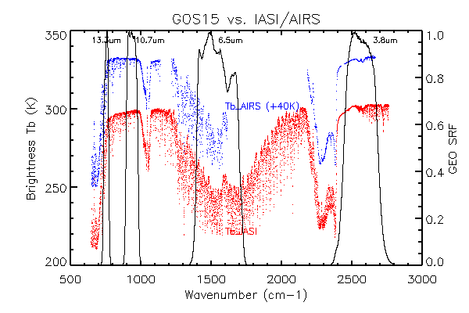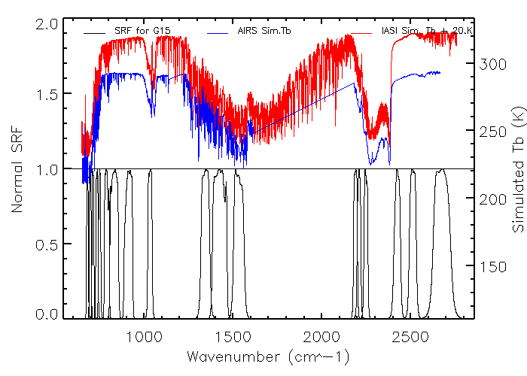
Figure 4.21: SRF of GOES-15 Imager (top) and Sounder (bottom), together with the AIRS/IASI spectra.

Two sets of GEO-LEO inter-calibration data, based on the daytime and nighttime collocation pixels, are used to evaluate the Imager IR radiometric calibration accuracy. Both inter-calibrations with AIRS and IASI yielded very similar results in Table 4.13. Note that during the GOES-15 PLT, the Imager SRFs that were used were the latest available, and hence not the Rev. H (shifted) that came out in August 2011 to correct the noted shift in the two absorptive bands. The Rev. H values have been employed, in the creation of GVAR, in the Satellite Operations Control Center (SOCC) data since 5 August 2011. The mean brightness temperature (Tb) difference listed in Table 4.13 are calculated with the homogeneous collocation pixels. Unlike GOES-12 which has very small GEO-LEO Tb differences at the water vapor band (6.5 μm), both the GOES-AIRS and GOES-IASI inter-calibration results indicated large and consistent bias for the GOES-15 water vapor band and CO₂ sensitive band. The two-IR window bands (bands 2 and 4) are well-calibrated with a Tb bias less than 0.2 K. The two absorptive bands, however, have relatively large Tb biases to both AIRS and IASI measurements. The Tb bias to AIRS/IASI for band-6 ranges from 0.66 K to 0.77 K, depending on the collocation time and LEO instrument. The water vapor band (band-3) has the largest Tb bias (~2 K) to both LEO instruments all the time, which exceeds specification. Noted that the implemented SRF during the Science Test is of version Rev. F, which is the same as Rev. E version for the Imager IR bands (ITT technical memo, 2010). Per this analysis, ITT, the instrument vendor, re-visited the pre-launch sample data and came with a new version of SRF (Rev. G). These data were then empirically shifted to reduce the systemic bias (Rev. H). The shortwave band (3.9 μm) had a large Tb difference during the daytime (not shown) due to reflect solar radiation. As shown in Figure 4.22 and 4.23, the Tb difference is consistent over the study period.

Table 4.13: Brightness temperature (Tb) biases between GOES-15 Imager and AIRS/IASI for the daytime and nighttime collocated pixels between AIRS and IASI through GOES-15 Imager daytime collocation data using the GSICS-method. The Tb biases were based on the collocated pixels acquired from 3 June 2010 and 25 October 2010. Standard deviations are given in parentheses. Again, these values are before the final, shifted SRF were employed.
Imager Band | Central Wavelength (μm) | daytime  (K) |  | nighttime  (K)
 |  | GOES-AIRS | GOES-IASI | GOES-IASI (9:30 pm)
2 | 3.9 | - | - | 0.09 (±0.08)
3 | 6.5 | 2.04 (±0.13) | 2.12 (±0.11) | 1.98 (±0.14)
4 | 10.7 | 0.18 (±0.18) | 0.10 (±0.20) | 0.03 (±0.10)
6 | 13.3 | 0.77 (±0.14) | 0.74 (±0.14) | 0.66 (±0.12)

These GSICS-method results are consistent with the CIMSS-method results in Table 4.13.

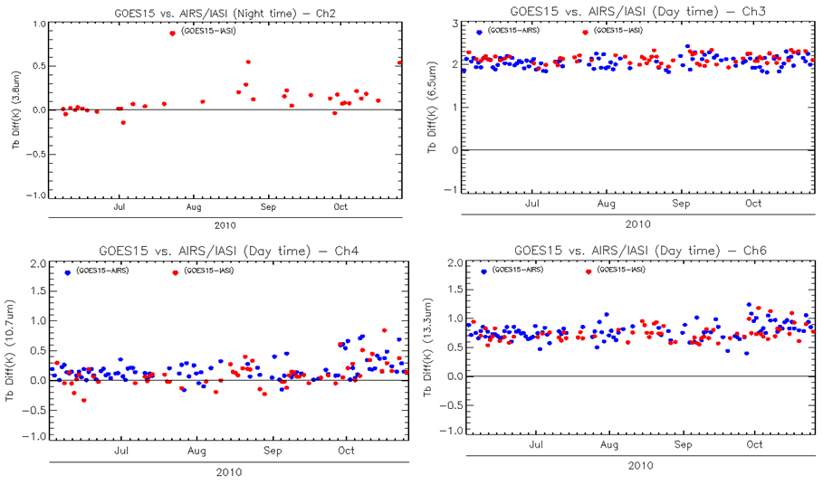
Figure 4.22: GOES-15 Imager IR bands time series of the brightness temperature bias with AIRS and IASI inter-calibration. Note that the band-2 values are only for the daytime. Note that these are from the Science Test and hence before the SRF shift of bands 3 and 6.

Like the other 3-axis stabilized GOES satellites, GOES-15 Imager and Sounder experience an abnormal heating process resulting in erroneous calibration slopes around the satellite midnight time (Johnson and Weinreb 1996). An empirical MBCC method was developed and implemented to mitigate this midnight calibration anomaly. Figure 4.23 shows the mean Tb bias to AIRS and IASI (open and solid dots at primary y-axis) and the frequency of MBCC onset frequency (solid line at second y-axis) at every half hour during the PLT period. Apparent diurnal calibration variation can be observed in bands 3, 4, and 6. Onset of MBCC varies at different bands. It should have the most affect 2-3 hours before “satellite” midnight and the next 3-6 hours after, depending on the IR band. Since MBCC is the major factor in determining the diurnal calibration variation, it was evaluated using the method described by Yu et al. (2011). The MBCC correction residual (ΔTb_{MBCC}) can be calculated as:

where Tb_{GEO-AIRS, noon} is the mean Tb difference between GOES and AIRS between 12:00 pm and 2:00 pm, and Tb_{GEO-AIRS, midnight} is the mean Tb difference between GOES and AIRS between 12:00 am and 2:00 am.

As shown in last column of Table 4.14, MBCC works very efficiently for band-6, and seems ineffective for bands 3 and 4. Although the MBCC has been intensively turned on around the midnight time, there is still about 0.35 K and 0.41 K calibration residuals for bands 3 and 4, respectively. Our previous analysis on the MBCC indicates that it works well for GOES-11/12/13 band-3 with less than 0.1 K to 0.2 K residual and less effective for band-4. More research may be needed to investigate the discrepancy on the band-3 MBCC correction for GOES-15. For band-2 (not shown), the small and consistent Tb bias to IASI before and after the MBCC onset implies that MBCC works well at this band.

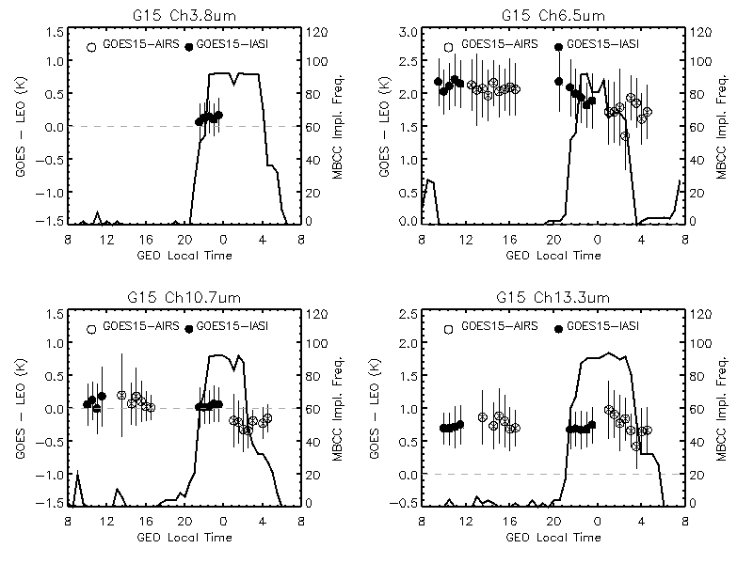
Figure 4.23: The Mean Tb bias to AIRS/IASI for GOES-15 Imager IR bands.

Table 4.14: GOES-15 Imager diurnal calibration variation.
Imager Band | Central Wavelength (µm) | mean GOES-AIRS (12:00 pm-2:00 pm) | Mean GOES-AIRS (12:00 am-2:00 am) | MBCC residual
3 | 6.5 | 2.07 | 1.72 | 0.35 K
4 | 10.7 | 0.20 | -0.21 | 0.41 K
6 | 13.3 | 0.87 | 0.91 | -0.04 K

A similar GEO-LEO inter-calibration (GSICS) method was applied to the GOES-15 Sounder IR bands to evaluate the radiometric calibration accuracy. Unlike the GEO-LEO inter-calibration for the GOES Imager data, the GOES vs. IASI collocation for the Sounder only occurs in the evening time. Figure 4.24 and Table 4.14 show the mean and standard deviation of the Tb bias to the IASI homogeneous scenes from 3 June 2010 to 3 August 2010 and compared with those of the other GOES satellites. The results indicate that GOES-15 Sounder IR bands are well-calibrated and comparable with the other two GOES-N/O/P instruments during this period. The Tb bias of most bands less than 0.2 K, except for band-5 (0.48 K) and band-13 (0.40 K). GOES Sounder band-18 is not included due to its spectral coverage.

Table 4.15: GOES-15 Sounder IR vs. IASI brightness temperature difference at nighttime, compared to other GOES Sounders using the GSICS-method. The data in the parentheses are the standard deviation of the Tb difference at the collocation pixels.
Sounder Band | Central Wavelength (µm) | GOES-15  Mean (±stdv)  (K) | GOES-14  Mean (±stdv)  (K) | GOES-13  Mean (±stdv)  (K) | GOES-12  Mean (±stdv)  (K)
1 | 14.71 | 0.23 (±0.15) | 0.274 (±0.195) | 0.19 (±0.17) | -0.006 (±0.233)
2 | 14.37 | 0.04 (±0.54) | 0.127 (±0.245) | 0.18 (±0.15) | 0.078 (±0.197)
3 | 14.06 | -0.10 (±0.98) | 0.103 (±0.610) | -0.02 (±0.48) | 0.180 (±0.739)
4 | 13.64 | 0.07 (±1.28) | 0.208 (±0.917) | 0.08 (±0.77) | -0.258 (±1.373)
5 | 13.37 | -0.48 (±1.42) | 0.041 (±1.159) | -0.10 (±1.05) | 0.313 (±1.837)
6 | 12.66 | -0.01 (±1.29) | 0.106 (±1.601) | 0.08 (±1.37) | -0.160 (±2.094)
7 | 12.02 | 0.01 (±1.15) | -0.041 (±1.575) | -0.01 (±1.46) | -0.086 (±2.068)
8 | 11.03 | 0.02 (±1.10) | -0.067 (±1.363) | 0.00 (±1.37) | -0.109 (±1.906)
9 | 9.71 | -0.15 (±0.94) | 0.076 (±0.838) | -0.04 (±1.01) | -0.055 (±1.366)
10 | 7.43 | -0.04 (±0.62) | -0.040 (±0.747) | -0.02 (±0.70) | -0.328 (±1.088)
11 | 7.02 | -0.05 (±0.62) | -0.121 (±0.574) | -0.28 (±0.60) | -0.119 (±0.994)
12 | 6.51 | -0.03 (±0.60) | -0.178 (±0.438) | -0.19 (±0.45) | -0.236 (±0.680)
13 | 4.57 | 0.40 (±0.51) | 0.263 (±0.506) | -0.12 (±0.62) | -0.883 (±1.052)
14 | 4.52 | -0.07 (±0.41) | -0.049 (±0.341) | -0.34 (±0.51) | -0.499 (±0.936)
15 | 4.45 | 0.06 (±0.44) | 0.144 (±0.506) | -0.55 (±0.42) | -5.076 (±2.766)
16 | 4.13 | 0.03 (±0.57) | 0.076 (±0.517) | -0.06 (±0.57) | 0.304 (±1.283)
17 | 3.98 | -0.01 (±0.66) | -0.116 (±0.648) | -0.13 (±0.65) | 0.106 (±1.529)

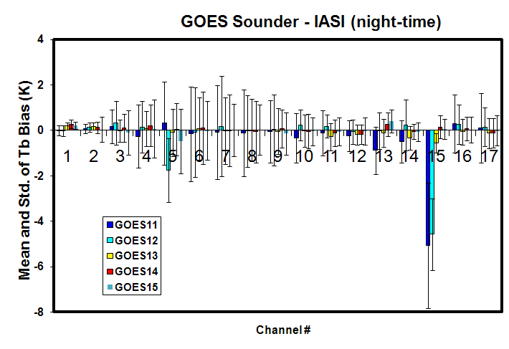
Figure 4.24: Mean and standard deviation of GOES-11 through GOES-15 Sounder brightness temperature difference from nighttime IASI data using the GSICS-method.

Stray-Light Analysis

By supplying data through the eclipse periods, the GOES-13/14/15 system addresses one of the major limitations which are eclipse and related outages. This change is possible due to larger spacecraft batteries. Outages due to KOZ will be minimized. Outages due to KOZ will be replaced by Stray-Light Zone outages and reduced by utilizing partial-image frames away from the sun and possibly stray-light correction via a Sensor Processing System (SPS) algorithm under development. Figure 4.25 shows why this correction is needed.

With the new capability of data during previous outages comes the risk of allowing images contaminated with the energy of the sun to be produced. An image with artificial brightness temperature excursions up to 75 K (e.g. Imager band-2) may affect products. To determine how much good data can be acquired, at the same time minimizing the amount of bad data, many scans were conducted during the eclipse period in 2010.

While all Imager bands can be affected, the visible and shortwave (band-2) are affected the most. There are investigations into the possibility of correcting these stray-light affected images before distribution via GVAR.

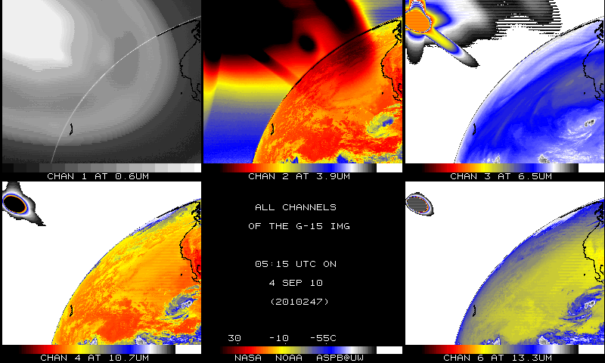
Figure 4.25: GOES-15 Imager multi-panel. Note the “stray light” associated with the sun.

In general, the GOES Sounder can be affected even more during the KOZ periods, due to the relatively slow Sounder scanning (not shown).

Instrument Performance Monitoring

The GOES IPM system uses the near real-time GVAR Block 11 (B11) data routinely downloaded from the NOAA Comprehensive Large Array-data Stewardship System (CLASS) data source. Four types of calibrated related parameters are ingested from the GVAR B11 data, including the instrument telemetry data, IR calibration coefficients, statistics of space-look and blackbody scan data. Instrument noise, such as NEdR and NEdT are also monitored for each detector. To detect any potential calibration anomaly, all these monitored parameters are displayed at various temporal scales for diurnal to long-term variations.

Telemetry Monitoring

The GOES-15 Imager and Sounder instrument performance was intensively monitored using the GVAR B11 data which were routinely downloaded from NOAA/CLASS from 11 August 2010 through 25 October 2010. Approximately 14 Imager and 16 Sounder telemetry parameters were monitored with the GOES IPM system (Yu and Wu 2010). The monitored GOES-15 IPM parameters are listed in Table 4.16. Most of these parameters were functioning well and comparable with the other GOES instruments. In this report, we summarized the behaviors of the Imager and Sounder blackbody (BB), scan mirror and patch temperatures as follows.

Table 4.16: GOES-15 Imager and Sounder telemetry parameters monitored with the GOES-IPM system during the PLT Science Test.
 | Telemetry variables | Detector Number  (Imager) | Detector Number  (Sounder)
1 | Electronics Temperature | 2 | 2
2 | Sensor Assembly Baseplate Temperature | 6 | 6
3 | BB Target Temperature | 8 | 8
4 | Scan Mirror Temperature | 1 | 1
5 | Telescope Primary Temperature | 1 | 1
6 | Telescope Secondary Temperature | 2 | 2
7 | Telescope Baffle Temperature | 2 | 2
8 | Aft Optics Temperature | 1 | 1
9 | Cooler Radiator Temperature | 1 | 1
10 | Wide Range IR Detector Temperature | 1 | 1
11 | Narrow Range IR Detector Temperature | 1 | 1
12 | Filter Wheel Housing Temperature | X | 1
13 | Filter Wheel Control Heater Voltage | X | 1
14 | Patch Control Voltage | 1 | 1
15 | Instrument Current | 1 | 1
16 | Cooler-Housing Temperature | 1 | 1

Similar to the other GOES Imagers (of the 3-axis design), the Imager experienced about +15 K diurnal variation in the blackbody (BB) temperature and +40 K variation in the scan mirror temperature with the highest temperature peak around satellite midnight time (Figure 4.26). During the eclipse period between 31 August 2010 and 13 October 2010, the diurnal variations of the telemetry temperature were reduced because of the reduced peak temperature. The reduced peak telemetry temperature during the eclipse season is also observed at the other GOES instruments.

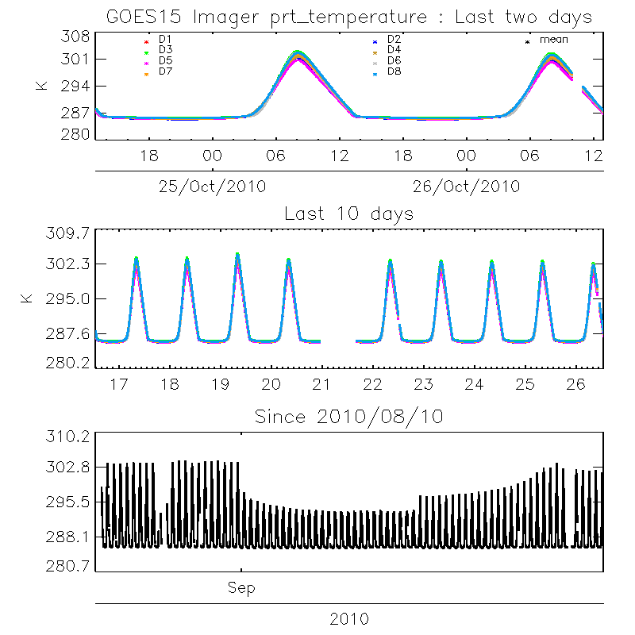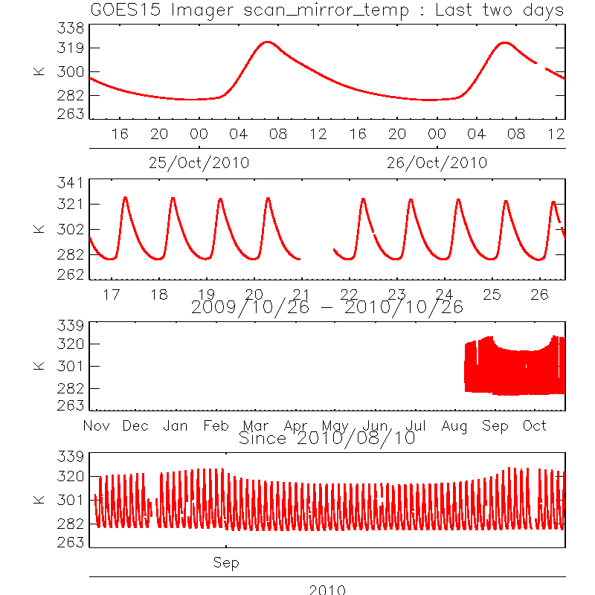

Figure 4.26: The GOES-15 Imager Platinum Resistance Thermometer (PRT, left) and scan mirror (right) temperature shown with various temporal scales.

The Imager patch temperature was controlled consistently at the low-level (~81 K) with slight variation of narrow patch temperature in the beginning of the PLT period. The wide-range patch temperature was slightly higher (~0.23 K) than the narrow-range one. Meanwhile, the two operational GOES, GOES-11 (GOES-West) and GOES-13 (GOES-East) Imagers, experienced the annual patch temperature switch from mid- to low-level in September 2010.

Similar to the other GOES instruments, GOES-15 Sounder BB and scan mirror also experienced significant diurnal variations with the highest temperature occurring around the satellite midnight (Figure 4.27). The magnitude of diurnal variation due to the reduced peak values can also be observed between 31 August 2010 and 13 October 2010.

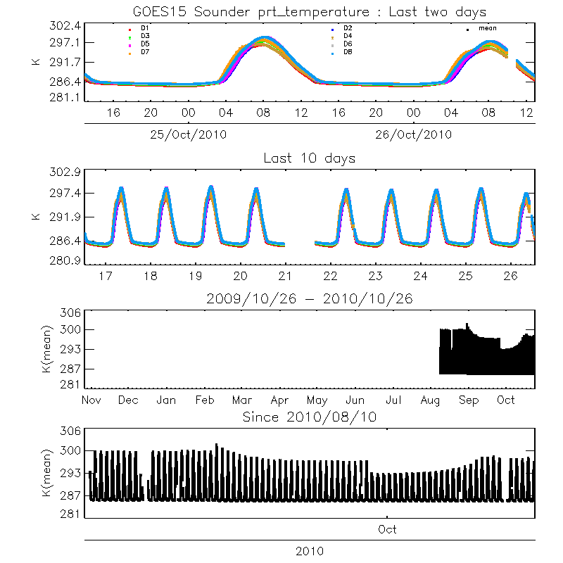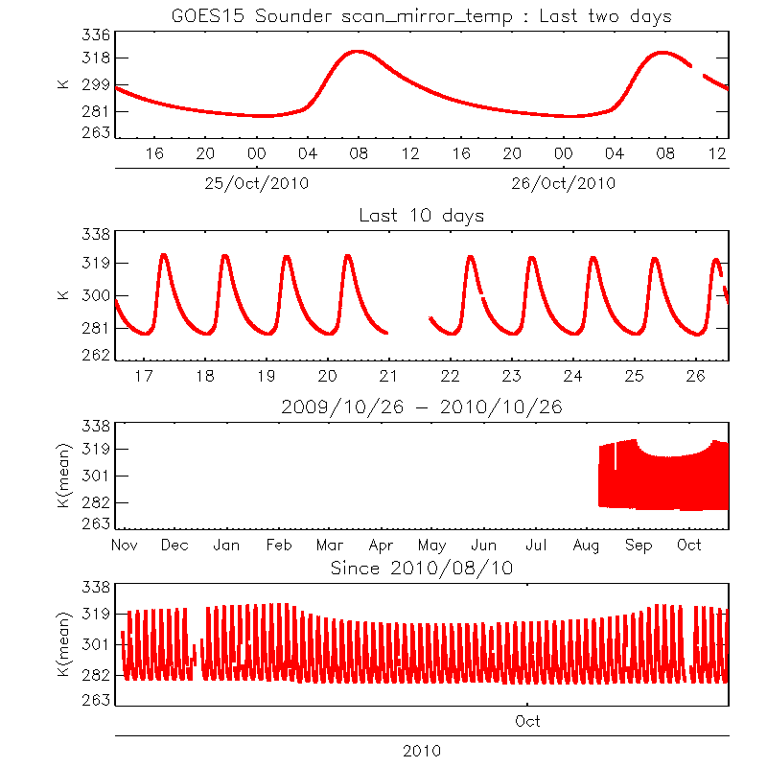
Figure 4.27: GOES-15 Sounder BB temperature (left) and scan mirror temperature (right) at different temporal scales.

Monitoring the GOES Sounder patch temperatures

GOES-15 Sounder patch experienced floating temperature resulting from the “blanket-heating” effect in the two periods of 11 August 2010 to 31 August 2010 and 17 September 2010 to 27 September 2010 (Figure 4.28). During these two periods, the spacecraft was flipped from inverted to upright orientations. Due to the “dislodged thermal blanket issue”, the Sounder patch temperature could not be controlled in upright orientation during summer. NOAA/NASA decided to invert the spacecraft (SC) to establish patch control so that the Science Test could be performed. SC was inverted on 31 August 2010, and the patch control “low” setting was reached soon after. Sounder patch began floating again on 17 September 2010 in the inverted orientation as the Sun declination was approaching equinox. First, the patch was raised to “mid” setting (~85 K) to reduce daily range on September 22. Then, on September 27, the SC was yaw-flipped to “upright” orientation (preferred orientation for winter) to achieve control at “low” patch setting (~81.6 K) (Figure 4.28). Slight diurnal variation (~0.02 K) can also be observed at “low” patch setting (Figure 4.29). Meanwhile the patch temperature of the two operational Sounders at GOES-11/13 switched from mid- to low-level in September 2010.

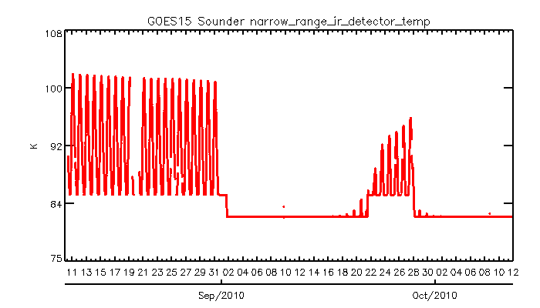
Figure 4.28: Time-series of narrow-range patch temperature of GOES-15 Sounder from 10 to 12 August 2010.

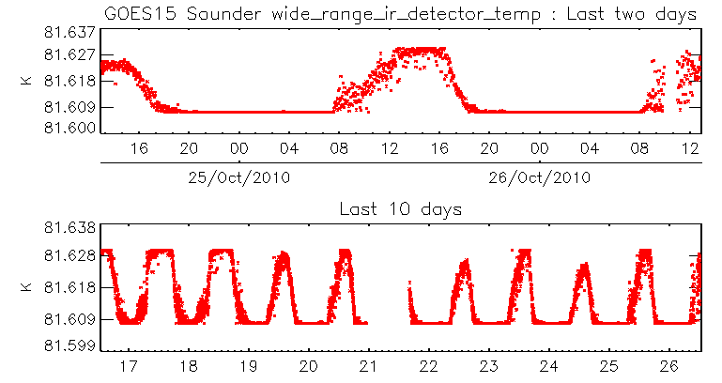
Figure 4.29: Diurnal variations of the GOES-15 Sounder patch temperature from 25 to 26 October 2010 (upper panel) and from 16 to 26 October 2010 (lower panel).

Finer Spatial resolution GOES-15 Imager

The water vapor band on the GOES-15 Imager is improved compared to that on the GOES-11 Imager. The detector sizes improve from 8 to 4 km. While each image is shown in its native position, the finer scale features on GOES-15 are clearly seen (Figure 4.30). The improved (4 km FOV at the sub-point) spatial resolution of the 13.3 µm (band-6) required changes to the GVAR format. Several issues with implementing the new GVAR format were discovered, communicated, rectified, and verified. For example, the paired detectors on the higher-resolution 13.3 µm band were inadvertently swapped when the satellite was in an inverted mode. This situation was quickly resolved. The image in Figure 4.31 demonstrated the improved spatial resolution of this band on the GOES-15 Imager, which is also the case with the GOES-14 Imager.

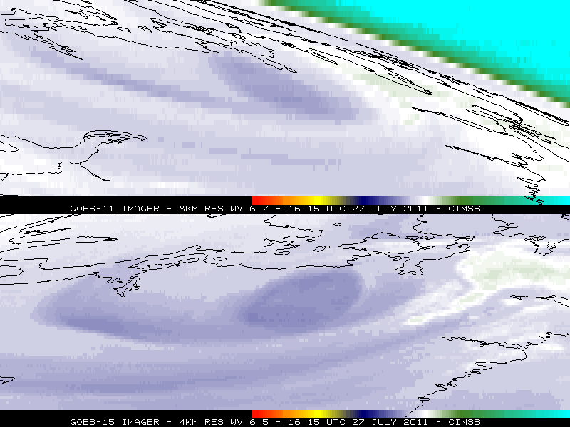
Figure 4.30: Improved Imager spatial resolution of the water vapor band for GOES-15 (lower panel) compared to GOES-11 (top panel) from 27 July 2010.

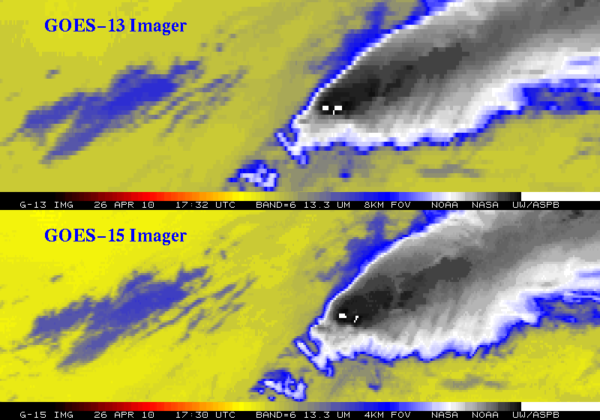
Figure 4.31: Improved Imager spatial resolution at 13.3 µm for GOES-15 (lower panel) compared to GOES-13 (top panel) from 26 April 2010.

Corrections of SRF for GOES-14/15 Imagers

During the Post-Launch Science Tests (PLT) of GOES-14 and GOES-15, NOAA reported biases for Imager band-3 (6.5 µm), based on the GSICS GEO-LEO inter-calibration analysis. The bias, in terms of brightness temperature (T_{b}), was +0.99 K for GOES-14 and +2.12 K for GOES-15 (Table 4.17, column 3). Biases of −0.50 K and +0.76 K were also found for Imager band-6 (13.3 µm) of GOES-14/15, respectively, which are within the specified accuracy requirement of 1 K.

In response, ITT Industries, the instrument vendor, re-analyzed the pre-flight instrument calibration data and revised the SRF, which were released as Rev. H. The radiometric calibration accuracy with Rev. H SRF was then evaluated using the simulated earth radiance as described in Wu and Yu (2011). Re-evaluation confirmed that Rev. H substantially reduced the bias, yet a residual bias of up to 1 K remained. While meeting (marginally for some bands) the instrument specification of 1 K, the bias can be attributed to uncertainty in the SRF (Wu et al. 2009). Therefore it was recommended to further correct the ITT Rev. H SRF by shifting the SRF (Wu and Yu 2011). The SRF of the shifted Rev. H SRF, together with the original Rev. G SRF for GOES-14/15 band-3 and band-6 are plotted at Figure 4.32. These shifted SRF were implemented on 5 August 2011 for both GOES-14 and GOES-15.

Table 4.17: Biases for selected GOES-14/15 Imager bands using the SRF as originally supplied by ITT (Rev. E), revised by ITT (Rev. H), further corrected by NOAA, and the recommended correction.
GOES and Band number | Central Wavelength (µm) | Bias with ITT Rev. E (K) | Bias with ITT Rev. H (K) | Recommended Shift (cm⁻¹) | Bias with Shifted SRF (K)
GOES-14 band-3 | 3.9 | 0.99 | 0.97 | −8.75 | +0.07
GOES-14 band-6 | 6.5 | -0.53 | -0.27 | -0.50 | +0.08
GOES-15 band-3 | 10.7 | 2.12 | 0.73 | -6.75 | +0.07
GOES-15 band-6 | 13.3 | 0.76 | 0.42 | +0.50 | +0.19

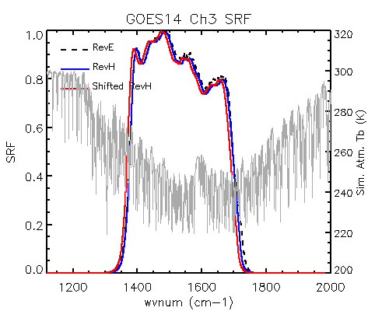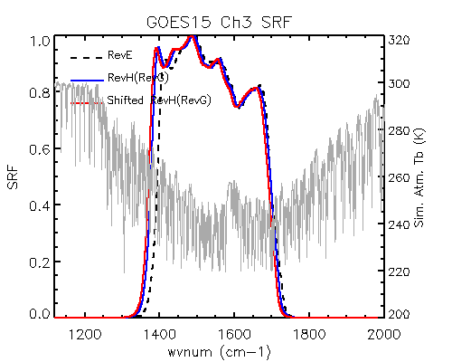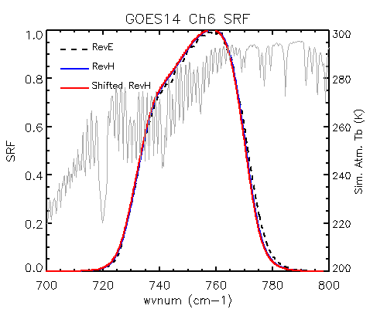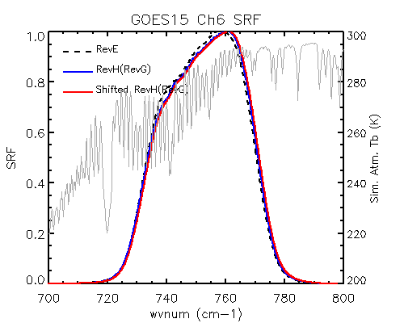

Figure 4.32: Rev. E, Rev. H, and shifted Rev. H SRFs of GOES-14/15 Imager band-3 and band-6 (dash black, blue solid and red solid lines), together with the IASI simulated TOA Tb for a clear tropical atmospheric profile (gray lines at second y-axis). Note that Rev. G and Rev. H SRFs are identical for GOES-15 Imager IR bands.

The quality of the GOES-15 Imager band-3 and 6 spectral shifts were also validated once GOES-15 began resending data in the fall of 2011. Note the greatly reduced bias on the few points on the right-hand side of Figure 4.33. The band-3 bias was reduced from over 2 K to approximately 0 K, comparing to high spectral resolution observations.
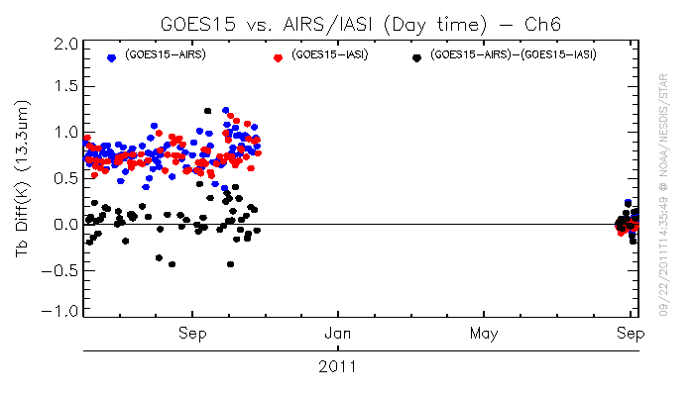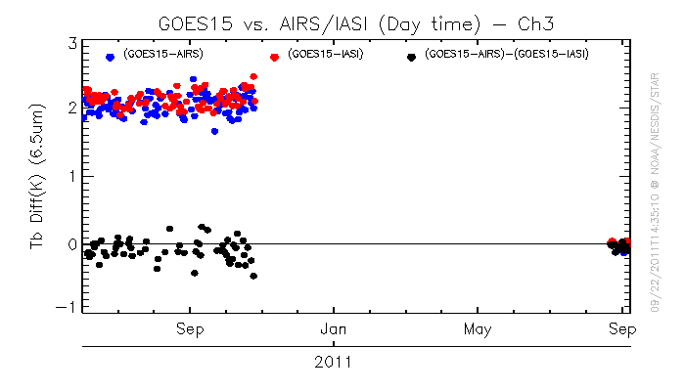
Figure 4.33: Comparisons of the GOES-15 band-6 (top panel) and band-3 (lower panel) before (left hand side) and after (right hand side) after the spectral response shift was implemented.

Product Validation

A number of products were generated with data from the GOES-15 instruments (Imager and Sounder) and then compared to the same products generated from other satellites or ground-based measurements. Products derived from the Sounder include: Total Precipitable Water (TPW), Lifted Index (LI), Clouds products, and Atmospheric Motion Vectors (AMVs). The products derived from the Imager include: Clouds, AMVs, CSBT, SST, and Fire Detection. It should be noted that most of these product comparisons were completed with the SRF available during the PLT.

Total Precipitable Water (TPW) from the Sounder

Validation of Precipitable Water (PW) Retrievals from the GOES-15 Sounder

GOES-15 retrievals of Precipitable Water (PW) were validated against Radiosonde Observation (RAOB) PW for 2 September 2010 to 21 September 2010. To achieve this, GOES-15 retrievals were collocated in space (within 11 km) and time (within 30 minutes) to daily RAOBs at 0 UTC and 1200 UTC. At the same time, these GOES-15 retrievals were collocated in space (within 11 km) and time (within 60 minutes) to GOES-13 retrievals. The relative performance of the GOES-15 PW retrievals, GOES-13 PW retrievals, and first guess PW supplied to the retrieval algorithm could then be compared since all of these PW values were collocated to the same RAOBs. Table 5.1 provides a summary of these statistics for the TPW and the PW at three layers (Sfc-900 hPa; 900-700 hPa, and 700-300 hPa). The short time period reflects instrument problems which were not resolved until 1 September 2010. Despite the short observational time period, the statistics indicate that the quality of the GOES-15 Sounder PW retrievals compare very well to the quality of the operational GOES-13 PW retrievals. The relatively large sample size is indicative of the low amount of cloudiness during this period.

Table 5.1: Verification statistics for GOES-12 and GOES-15 retrieved PW, first guess (GFS) PW, and RAOB PW for 2 September 2010 to 21 September 2010.
Statistic | GOES-13/RAOB | GOES-15/RAOB | Guess/RAOB | RAOB
Total Precipitable Water (TPW)
RMS (mm) | 3.99 | 4.11 | 4.70
Bias (mm) | -0.55 | -0.41 | -0.96
Correlation | 0.96 | 0.95 | 0.94
Mean (mm) | 28.46 | 28.60 | 28.05 | 29.01
Sample | 3907 | 3907 | 3907 | 3907
Layer Precipitable Water (surface to 900 hPa)
RMS (mm) | 2.08 | 2.07 | 2.27
Bias (mm) | -1.25 | -1.16 | -1.48
Correlation | 0.94 | 0.93 | 0.93
Mean (mm) | 9.65 | 9.74 | 9.42 | 10.90
Layer Precipitable Water (900 hPa to 700 hPa)
RMS (mm) | 2.40 | 2.44 | 2.55
Bias (mm) | -0.15 | -0.07 | -0.33
Correlation | 0.92 | 0.92 | 0.91
Mean (mm) | 12.89 | 12.97 | 12.71 | 13.04
Layer Precipitable Water (700 hPa to 300 hPa)
RMS (mm) | 1.75 | 1.75 | 2.04
Bias (mm) | 0.79 | 0.74 | 0.77
Correlation | 0.91 | 0.90 | 0.87
Mean (mm) | 5.79 | 5.74 | 5.77 | 5.00

Figures 5.1 through 5.4 present time series of various comparison statistics (GOES retrieved TPW vs. RAOB-observed TPW) for GOES-15 (in green with open circles) and GOES-13 (in red with filled circles) for the same time as in Table 5.1. Each tick mark represents a data point (2 points per day) with the calendar day label centered at 0 UTC of that day. A majority of the GOES-15 data points are very close to, if not on top of, the GOES-12 data points.

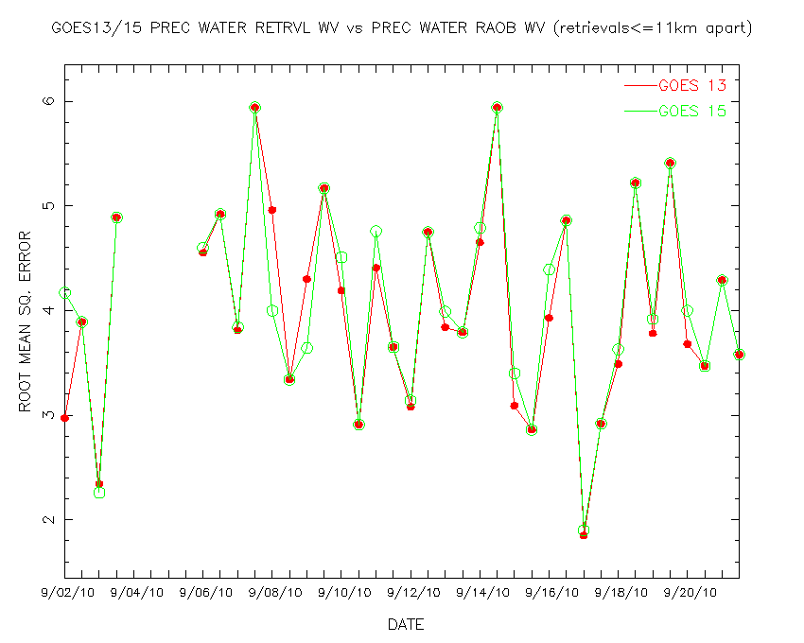
Figure 5.1: Time series of Root Mean Square Error (RMSE) between GOES-13 and GOES-15 retrieved PW and RAOB PW for 2 September 2010 to 21 September 2010.
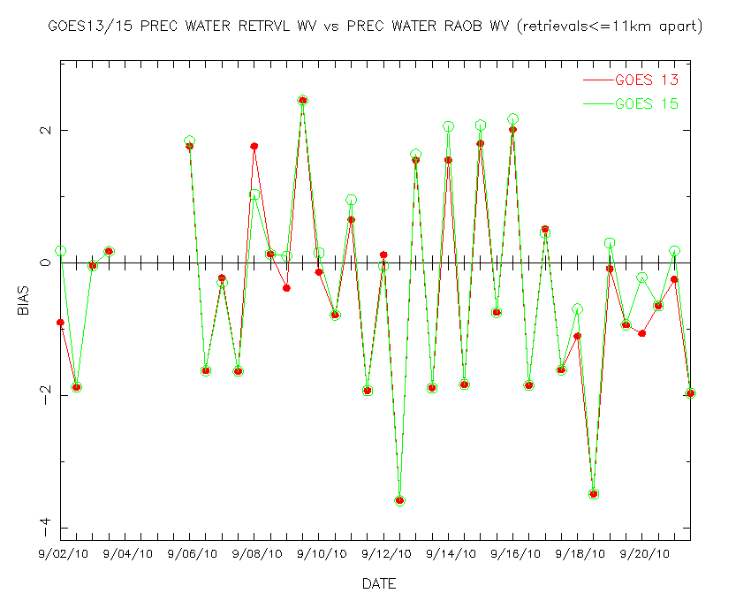
Figure 5.2: Time series of bias (GOES-RAOB) between GOES-13 and GOES-15 retrieved PW and RAOB PW for 2 September 2010 to 21 September 2010.
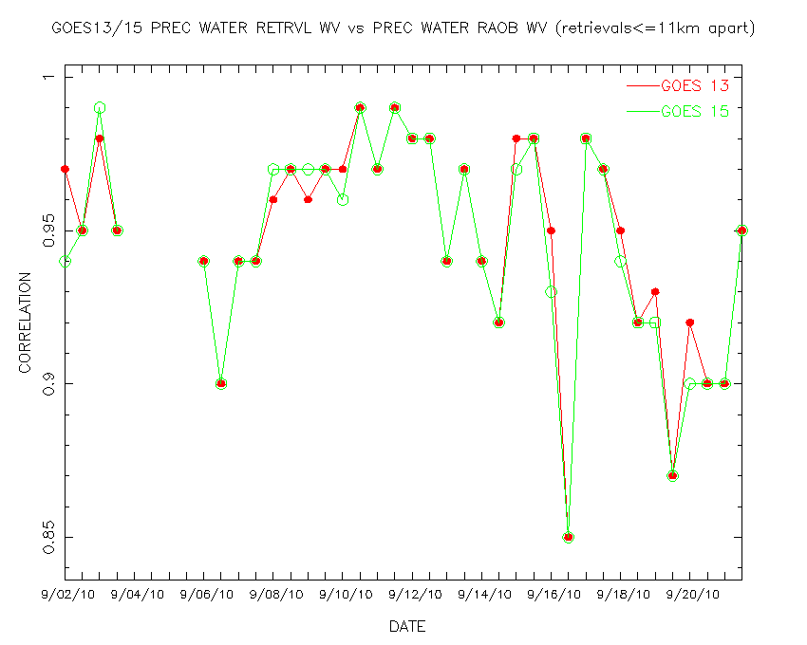
Figure 5.3: Time series of correlation between GOES-13 and GOES-15 retrieved PW and RAOB PW for 2 September 2010 to 21 September 2010.

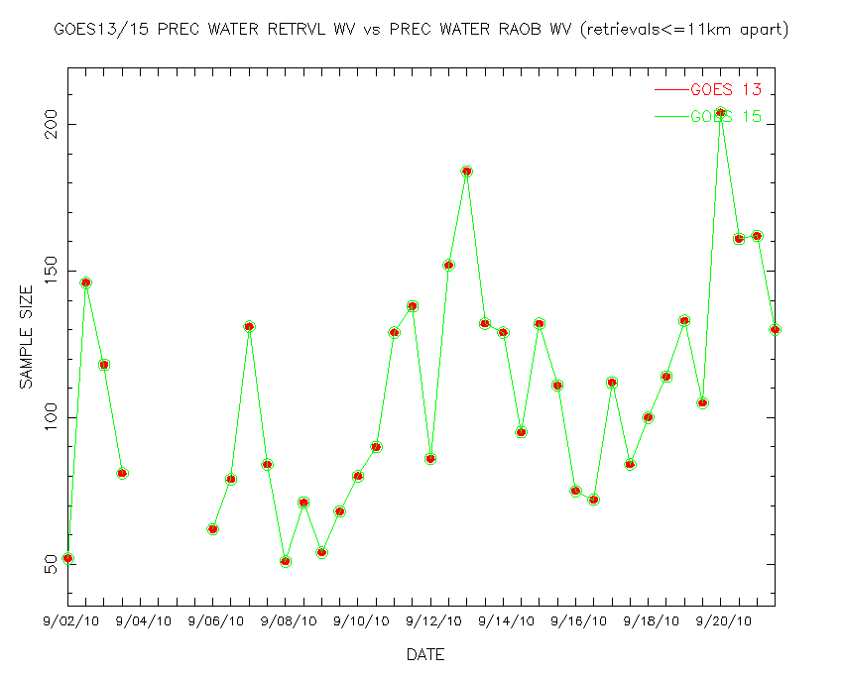
Figure 5.4: Time series of the number of collocations between GOES-13 and GOES-15 retrieved PW and RAOB PW for 2 September 2010 to 21 September 2010.

TPW retrievals (displayed in the form of an image) for GOES-13 and GOES-15 are presented in Figure 5.5 over the same area at approximately the same time. These retrievals are generated for each clear radiance FOV. Radiosonde measurements of TPW are plotted on top of the images. Qualitatively, there is good agreement between the GOES-13 and GOES-15 TPW retrievals that, in turn, compare reasonably well with the reported radiosonde measurements of TPW. Although the GOES-15 shows more striping, it should be noted that the calibration mode was not yet in full operational configuration at that time. When comparing measurements from two satellites, one must consider the different satellite orbital locations; even precisely co-located fields-of-view are seen through different atmospheric paths. Both sets of satellite retrievals and based on the “Li” method (Li et al. 2008). The striping in the GOES-15 Derived Product Image (DPI) may be due to striping in Sounder band-15 (and other) bands.

Figure 5.6 shows one time period with two retrieval methods (the “Li” and “Ma” (Ma et al. 1999) methods), note that the GPS/Met data (Wolfe and Gutman 2000) are over-plotted on each image.

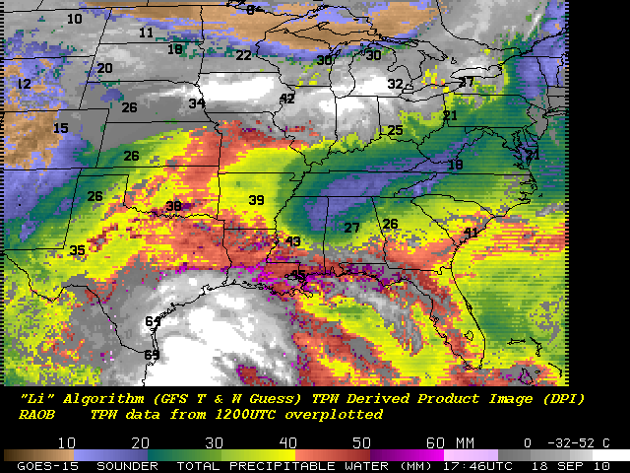

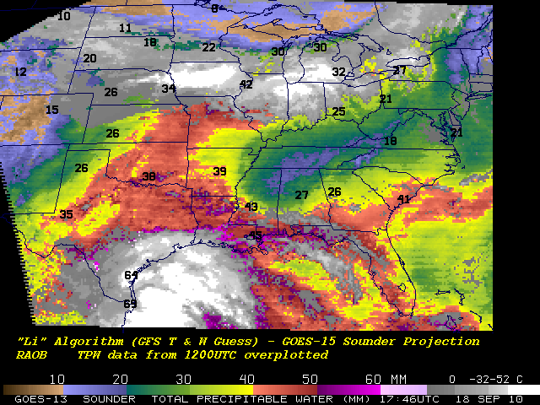
Figure 5.5: GOES-15 (top panel) and GOES-13 (lower panel) retrieved TPW (mm) from the Sounder displayed as an image. Cloudy FOVs are denoted as shades of gray. The data are from 1800 UTC on 18 September 2010. Measurements from RAOBs are overlaid text.

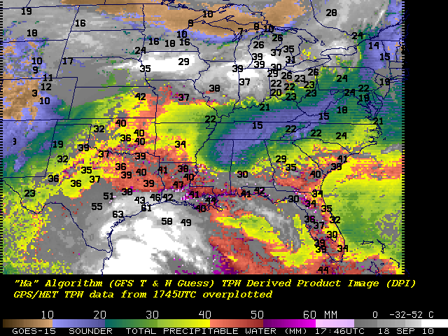

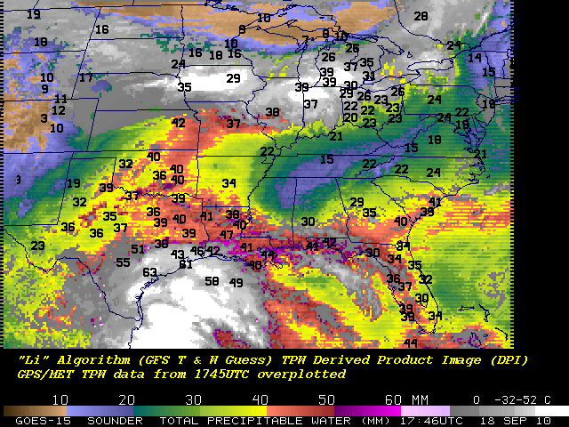
Figure 5.6: GOES-15 Sounder TPW from two retrieval algorithms (i.e., “Ma” (upper-panel) and “Li” (lower-panel). Both images are from 18 September 2010.

Lifted Index (LI) from the Sounder

The lifted index (LI) product is generated from the retrieved temperature and water vapor profiles that are generated from clear radiances for each FOV. Figure 5.7 shows LI retrievals (displayed in the form of an image) for GOES-13 and GOES-15 over the same area at approximately the same time, showing no discernible bias in the LI values. Both images are shown in the same projection.

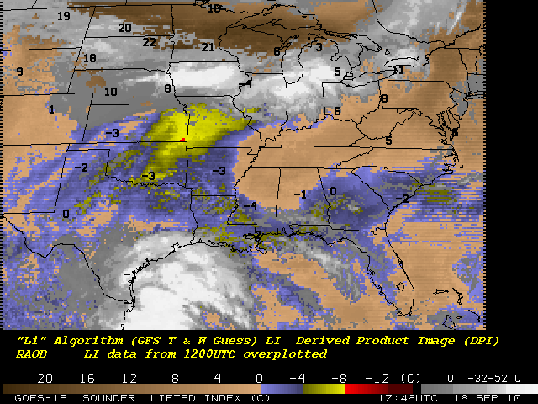
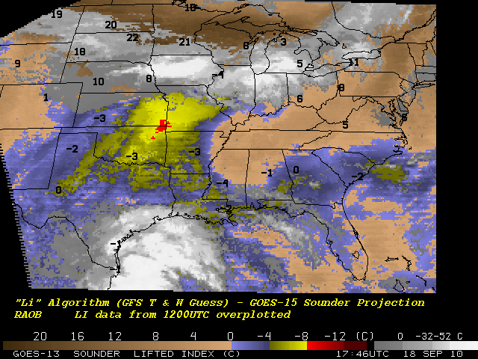
Figure 5.7: GOES-15 (top) and GOES-13 (lower) retrieved LI from the Sounder displayed as an image. The data are from 1746 UTC on 18 September 2010.

Cloud Parameters from the Sounder and Imager

The presence of the 13.3 µm band on the GOES-15 Imager, similar to the GOES-12 Imager, makes near full-disk cloud products possible. This product complements that from the GOES Sounders.

Figures 5.8 and 5.9 shows a comparison of GOES-15 Imager (and Sounder) cloud-top pressure derived product images from the fall of 2010. Not shown is the larger coverage possible from the Imager-based product. Another comparison between GOES-13 Sounder and MODIS on EOS-Aqua showed generally good correlations, as seen in Figures 5.10 through 5.12.

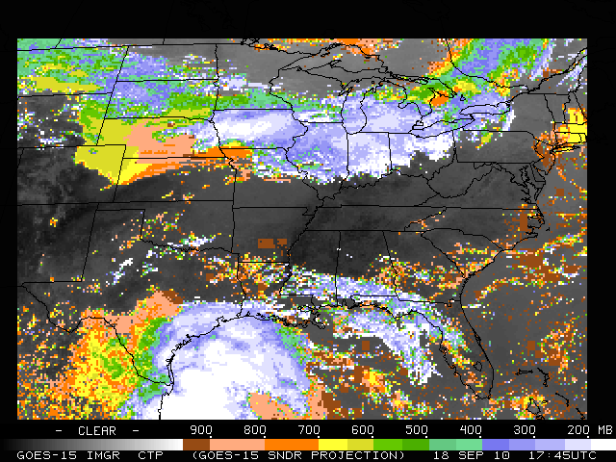
Figure 5.8: GOES-15 Imager cloud-top pressure from 18 September 2010 starting at 1745 UTC. The Imager data have been remapped into the GOES-15 Sounder projection.

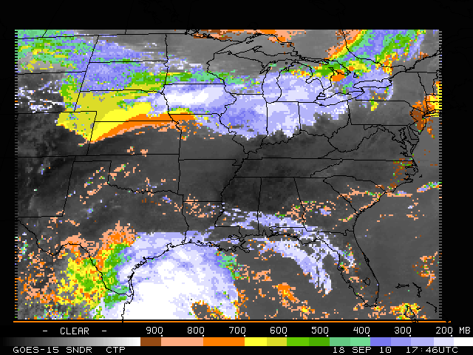
Figure 5.9: GOES-15 Sounder cloud-top pressure from 18 September 2010 starting at 1746 UTC.

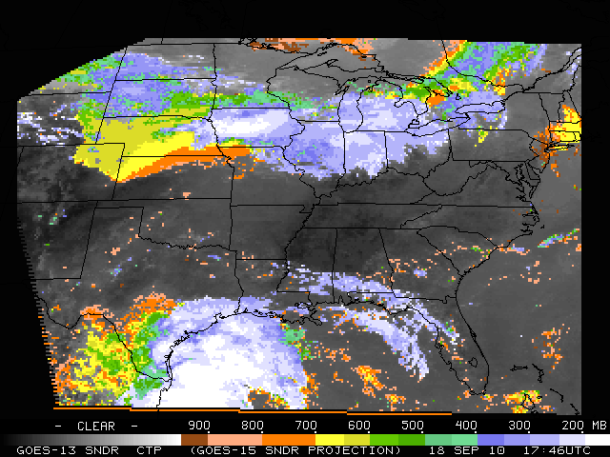
Figure 5.10: GOES-13 cloud-top pressure from the Sounder from 1746 UTC on 18 September 2010.

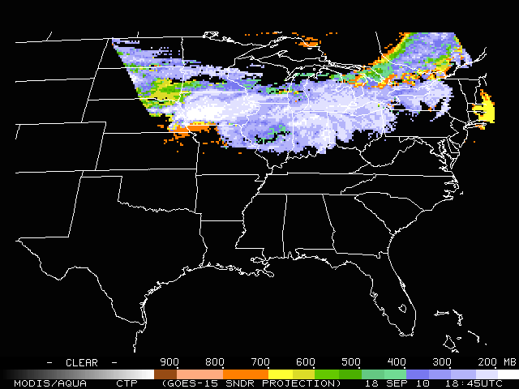
Figure 5.11: EOS-Aqua MODIS cloud-top pressure at 1800 UTC on 18 September 2010.

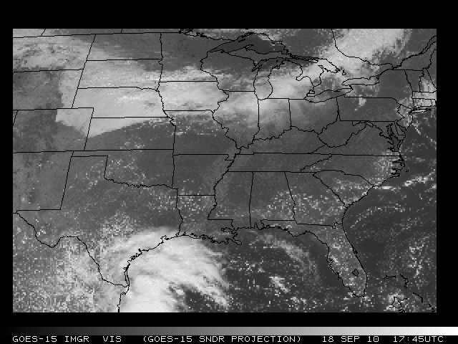
Figure 5.12: GOES-15 Sounder visible image from the nominal 1746 UTC on 18 September 2010.

Atmospheric Motion Vectors (AMVs) from the Imager

Atmospheric Motion Vectors (AMVs) from GOES are derived using a sequence of three images. Features targeted in the middle image (cirrus cloud edges, gradients in water vapor, small cumulus clouds, etc.) are tracked from the middle image back to the first image, and forward to the third image, thereby yielding two displacement vectors. These vectors are averaged to give the final wind vector, or AMV. This report summarizes the quality of AMVs from GOES-15 as part of the NOAA Science Test in 2010.

The varied imaging schedules activated during the GOES-15 Science Test provided an opportunity to run AMV assessments for what are currently considered operational as well as special case scenarios. A thinned sample (for display clarity) of AMVs from GOES-15 on 10 August 2010 at 11:45UTC are shown for Cloud-Drift (Figure 5.13) and Water Vapor (Figure 5.14) AMVs.

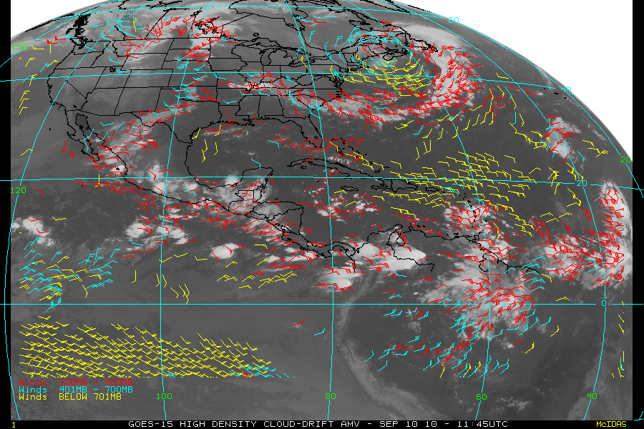
Figure 5.13: GOES-15 Northern Hemisphere (NHEM) cloud-drift AMV on 10 September 2010 at 1145 UTC.

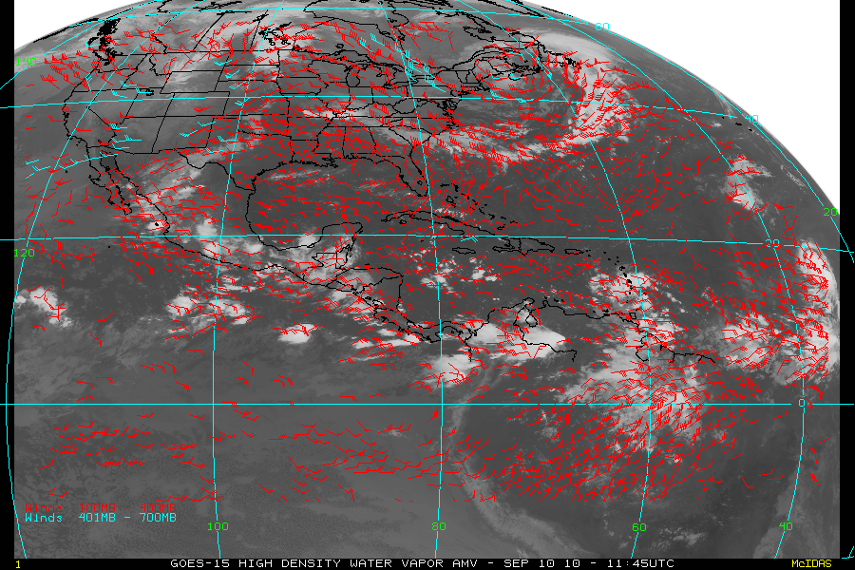
Figure 5.14: GOES-15 Northern Hemisphere (NHEM) water vapor AMV on 10 September 2010 at 1145 UTC.

During the Science Test objective statistical comparisons were made using collocated radiosonde (RAOB) data matched to the various GOES-15 AMVs. Table 5.2 shows the results of these GOES vs. RAOB match statistics for cloud-drift and Water Vapor AMVs.

Table 5.2: Verification statistics for GOES-15 vs. RAOB Match Verification Statistics NHEM winds (m/s): 11 September 2010 – 25 October 2010. MVD is the mean vector difference.
NHEM | RMS | MVD | Std Dev | Speed Bias | Mean Speed (Sat) | Mean Speed (RAOB) | Sample Size
Cloud-Drift | 6.23 | 5.14 | 3.52 | -0.63 | 15.21 | 15.85 | 25330
Water Vapor | 6.37 | 5.29 | 3.55 | -0.27 | 16.35 | 16.62 | 51413

Comparison statistics were also generated for collocated GOES-13 and GOES-15 AMV data sets with RAOBs. To be considered in the statistical evaluation, the respective GOES AMVs had to be within 0.1° horizontal and 25 hPa vertical. Table 5.3 shows the results of this comparison. The small differences confirm that the AMV products from GOES-15 are at least comparable in quality with the existing GOES-13 operational AMVs.

Table 5.3: RAOB Verification statistics for GOES-13 and GOES-15, collocated (0.1 deg, 25 hPa) for NHEM winds (m/s): 11 September 2010 – 25 October 2010
NHEM | RMS | MVD | Std Dev | Speed Bias | Mean Speed (Sat) | Mean Speed (RAOB) | Sample Size
GOES-13 Cloud-Drift | 6.14 | 5.03 | 3.53 | -0.68 | 14.54 | 15.23 | 1358
GOES-15 Cloud- Drift | 6.12 | 4.98 | 3.56 | -0.61 | 14.55 | 15.16 | 1358
GOES-13  Water Vapor | 6.19 | 5.13 | 3.46 | -0.26 | 15.18 | 15.44 | 4051
GOES-15  Water Vapor | 6.02 | 5.02 | 3.32 | -0.31 | 15.11 | 15.42 | 4051

Clear Sky Brightness Temperature (CSBT) from the Imager

A satellite-derived product, called the Clear-Sky Brightness Temperature (CSBT), based on Geostationary Operational Environmental Satellite (GOES) Imager radiance data, was originally requested by National Centers for Environmental Prediction (NCEP) / Environmental Modeling Center (EMC) and the European Centre for Medium-range Weather Forecasts (ECMWF) for assimilation into global weather prediction models to better analyze the initial atmospheric state.

Current coverage for the operational CSBT extends from roughly 67°S to 67°N and 30°W to 165°E for GOES-11, and GOES-13. The data are averaged over boxes of approximately 50 km per side. Each box consists of 187 FOVs (11 rows by 17 columns). For a given box a cloud detection algorithm is used. For each 50 km box the average brightness temperature for each IR band and the albedo in percent for the visible band are calculated along with the average clear and cloudy brightness temperatures. Additional parameters determined are the number of clear and cloudy FOVs, center latitude and longitude of the box, center local zenith and solar zenith angles of the box, land/sea flag, standard deviation of the average clear and cloudy brightness temperatures, and two quality indicator flags. The quality indicator flags provide information on the likelihood of a particular observation being affected by sun glint and the relative quality of the SST observation.

A derived product image, Figure 5.15 (top left), below is also generated. This product is a single FOV result. It is compared to a “merged” version of the current GOES-11 and GOES-13 derived image reformatted to the GOES-15 projection (Figure 5.15, top panels). In general, there is fair agreement between the GOES-15 image and the GOES-11/GOES-13 combined image. In addition the GOES-15 Imager visible and long wave window images are depicted (left and right, lower panels) and further demonstrate consistency between the two derived products.

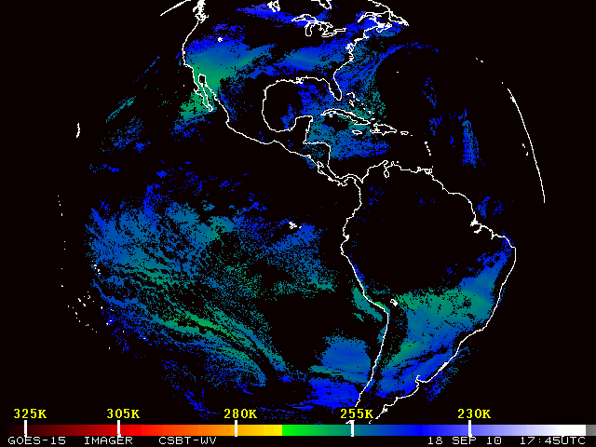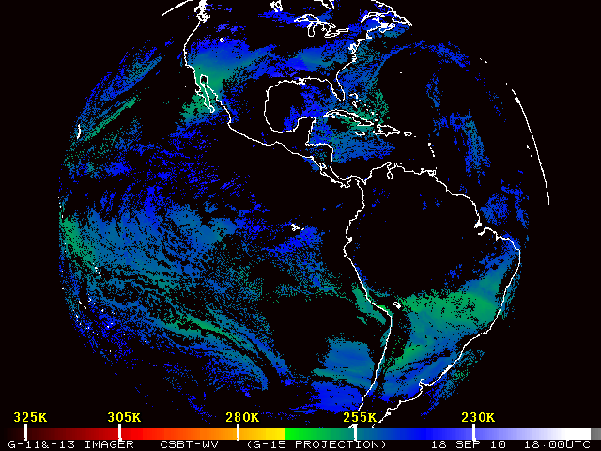
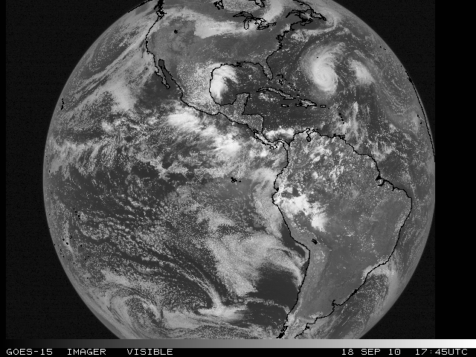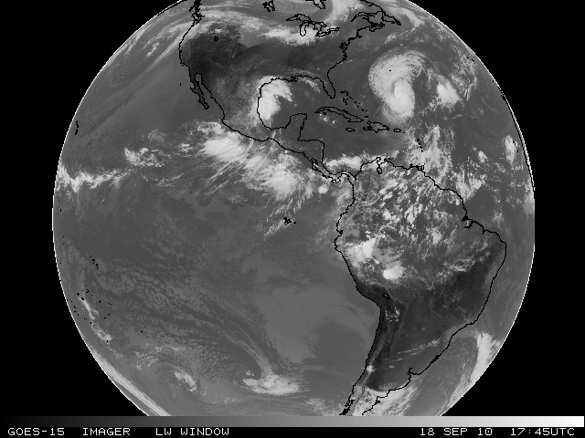
Figure 5.15: GOES-15 Imager CSBT cloud mask image from 18 September 2010 for the nominal 1800 UTC time (upper-left). On the upper-right is the GOES-13 Imager CSBT cloud mask image for the same date and nominal time as shown in the GOES-15 Imager satellite projection. Clear regions display the band-3 Water Vapor (6.5 µm) Brightness Temperature. GOES-15 Imager visible (lower-left) and Long Wave Window (lower-right) from 18 September 2010 for the nominal 1800 UTC time period.

Sea Surface Temperature (SST) from the Imager

GOES-15 Imager data were collected, archived locally, and used as input for Sea Surface Temperature (SST) retrievals. These were collected for the entire Science Test from 11 August 2010 to 25 October 2010. The sector for GOES-East is approximately 30°E to 110°W and 60°N to 45°S. Examples of GOES-15 SSTs for day and night with their associated Probability of Clear Skies are shown in the following figures.

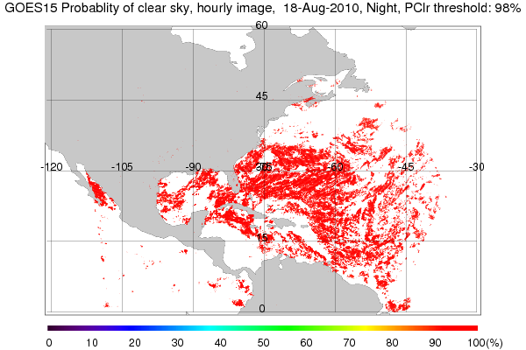
Figure 5.16: The nighttime areas that are considered clear pixels based on Bayesian estimate of ≥98% clear sky probability. The mask is based on the highest clear sky probability for the three daytime images that went into generating this GOES-15 product.

The GEO-SST software is comprised of two steps – SST retrievals generation, and estimation of cloud contamination probability. The cloud estimation is performed using a Bayesian estimation technique.

The GOES-15 coefficients for 75°W were used to generate SST retrievals. Then a Bayesian Cloud Mask was applied to obtain clear sky pixels. Bayes’ theorem is applied to estimate the probability of a particular pixel being clear of cloud. The inputs are the satellite-observed brightness temperatures, a measure of local texture and band brightness temperatures calculated for the given location and view angle. NCEP Global Forecast System (GFS) surface and upper air data and the Community Radiative Transfer Model (CRTM v2.0) fast radiative transfer model inputs are used. This method is described in detail in Merchant et al. (2005). Using the current form of the SST equation below, retrievals was generated for dual window (3.9 μm and 11 μm).

SST = a₀ + a₀ S + ∑_{i} (a_{i} + a_{i} S) T_{i}

where i is GOES-Imager band number (2, 4), S = satellite zenith angle – 1, and Ti is the band brightness temperature (K). Due to a lack of a 12 µm band on GOES-15, a single dual window form was used for both day and night with a correction for scattered solar radiation in the 3.9 µm band being applied for the daytime case (for details see Merchant et al. 2009).

The GEO-SST software for GOES-15 includes major capability upgrades from GOES-14 to enable the use of Physical Retrieval methodology, multi-dimensional lookup tables for Bayesian cloud estimates and other science upgrades.

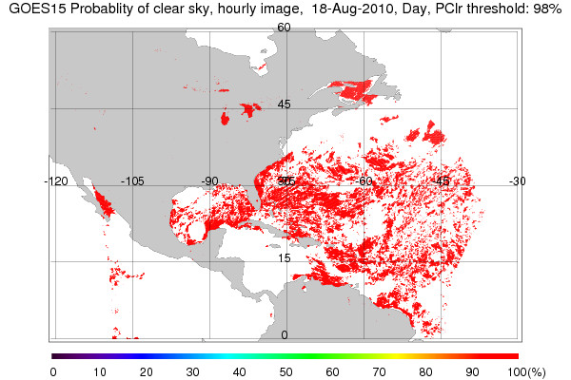

Figure 5.17: The daytime areas that are considered clear pixels based on Bayesian estimate of ≥98% clear sky probability. The mask is based on the highest clear sky probability for the three daytime images that went into generating this GOES-15 product.

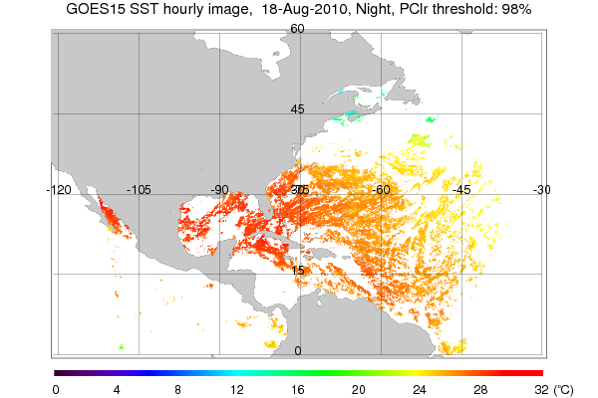
Figure 5.18: The SST from GOES-15 created by compositing three nighttime half hour SST McIDAS Area files with an applied threshold of ≥98% clear sky probability.
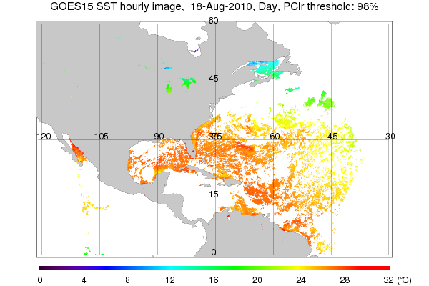
Figure 5.19: shows the SST from GOES-15 created by compositing three half hour daytime SST McIDAS Area files with an applied threshold of ≥98% clear sky probability.

Fire Detection and Characterization

Basic fire detection and characterization relies primarily on the short and long-wave IR window (3.9 µm, band-2; and 11 µm, band-4) data from the GOES Imager. These two IR windows and ancillary information are used to determine instantaneous estimates of sub-pixel fire size and temperature. The number of fires that can be successfully detected and characterized is related to the saturation temperature, or upper limit of the observed brightness temperatures, in the 3.9 µm band. A higher saturation temperature is preferable as it affords a greater opportunity to identify and estimate sub-pixel fire size and temperature. That said, the maximum saturation temperature should still be low enough to be transmitted via the GVAR data stream. Low saturation temperatures can result in the inability to distinguish fires from a hot background in places where the observed brightness temperature meets or exceeds the saturation temperature. Furthermore sub-pixel fire characterization is not possible for saturated pixels.

The SAB Fire desk completed most of their comparisons using the band-2 IR imagery. Comparisons done when solar reflectivity was near its minimal during sunset resulted in very small, if any, differences in fire or landmass temperature. Afternoon comparisons showed an apparent cool bias of 1 K to 3 K in non-hotspot areas (where a fire was not located). For hotspot (fire) detection, GOES-13 was often hotter than GOES-15 by as much as 7 K. This seems counter intuitive since all of the hotspots in the comparison were closer to the GOES-15 subpoint (all locations were west of 91°W) and solar reflection during daylight hours makes fires very sensitive to viewing angles, making direct comparison between different satellites tricky. Furthermore, a given fire may be observed and characterized very differently depending on its location in the respective GOES-13/GOES-15 pixels and the application of the Point Spread Function (PSF). More extensive band-2 IR comparisons would need to be done due to the highly sensitive nature of the 4 µm sensor to solar reflectivity, the rapidly changing radiative power of fires, and the GOES-13/GOES-15 observed differences due to the location of the fire in the pixels. Visible imagery comparisons for smoke analysis and blowing sand/dust plumes revealed no appreciative differences between GOES-15 and GOES-13 imagery.

A comparison of GOES-11 (GOES-West), GOES-15, and GOES-13 (GOES-East) 3.9 µm shortwave IR images in Figure 5.20 indicated that there was a hot spot on 9 September 2010. This was due to a large natural gas explosion that occurred in San Bruno, CA. The 3 sets of images are displayed in the native projection of their respective satellites. The fire “hotspots” showed up as warmer (darker black or yellow enhancement) pixels.

The plot in Figure 5.21 shows that the warmest 3.9 µm IR brightness temperature on the GOES-15 imagery for this case was approximately 318 K. More information on this case can be found at http://cimss.ssec.wisc.edu/goes/blog/archives/6752.

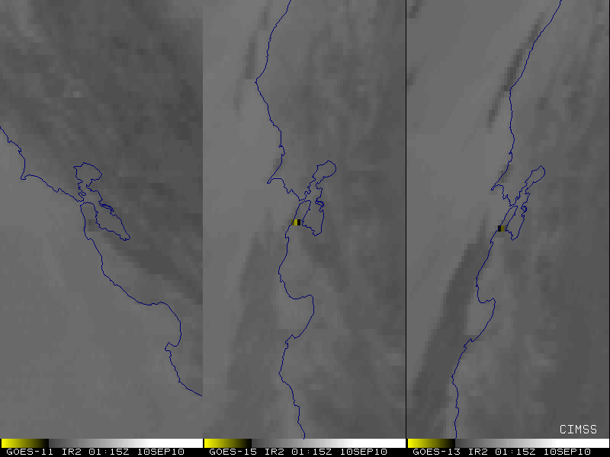
Figure 5.20: GOES Imager 3.9 µm images from GOES-11 (left), GOES-15 (center) and GOES-13 (right). Each satellite is shown in its native perspective.

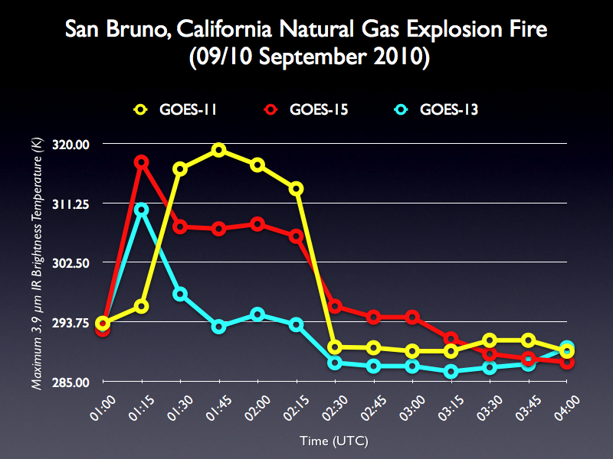
Figure 5.21: GOES Imager 3.9 µm time series from GOES-11, GOES-15, and GOES-13.

The GOES-15 Imager 3.9 µm band has a saturation temperature of approximately 337.4 K. For reference, the GOES-12 Imager 3.9 µm band has a saturation temperature of approximately 339 K, although this value has changed over time, peaking at approximately 342 K.

Preliminary indications are that GOES-15 is performing comparably to GOES-11 and GOES-13.

The Biomass Burning team at CIMSS currently produces fire products for GOES-11/GOES-12/GOES-13 covering North and South America. GOES-11/GOES-13 Wildfire Automated Biomass Burning Algorithm (WF_ABBA) fire products can be viewed at http://cimss.ssec.wisc.edu/goes/burn/wfabba.html in near real time.

Volcanic Ash Detection

The SAB Volcano desk noted only one time during the GOES-15 PLT that volcanic ash was able to be seen by both GOES-13 and GOES-15. Ash detection is very event driven and there was little volcanic activity in the SAB Volcano team’s areas of interest in August-September 2010. The ash signature was seen in visible imagery and showed up identically in the GOES-15 imagery compared to the GOES-13 imagery. A few cases where volcanic hotspots could be seen in multi-spectral imagery were noted with any differences being negligible. The multi-spectral imagery used for volcanic ash/hotspot detection is sensitive to the solar angle and thus the minor differences seen were attributed to the different positions of the satellites being compared. Thus, there were no differences with GOES-15 imagery that would result in degradation in performance for volcanic ash analysis.

Total Column Ozone

Total Column Ozone (TCO) is an experimental product from the GOES Sounder. The GOES-15 Sounder TCO is expected to be of similar, or higher, quality as derived from earlier GOES Sounders. Note the similar overall patterns between GOES-13 and GOES-15 shown in Figure 5.22 and 5.23.

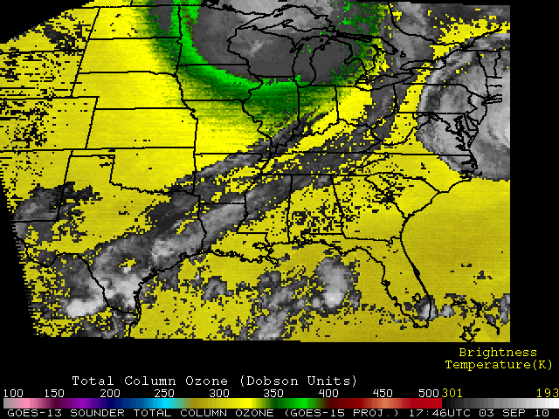
Figure 5.22: Example of GOES-13 Imager Total Column Ozone on 3 September 2010 at 1800 UTC.

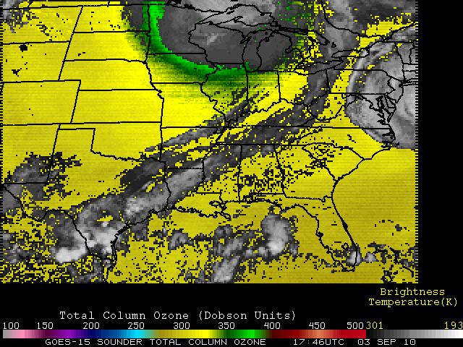
Figure 5.23: Example of GOES-15 Imager Total Column Ozone on 3 September 2010 at 1800 UTC. The image is displayed in the GOES-15 perspective.

GOES Surface and Insolation Product (GSIP)

The GOES Surface and Insolation Products (GSIP) system is operationally producing a suite of products relating primarily to upward and downward solar radiative fluxes at the surface and top of the atmosphere for the GOES series of satellites. As shown in Figures 5.24 and 5.25, the similarity of surface insolation derived from GOES-13 (the current GOES-EAST satellite) and GOES-15 data, as well as the other products, which are not shown, illustrates that GSIP is well on the way to continuing to produce a consistent dataset of the surface insolation products from the GOES-15 Imager.

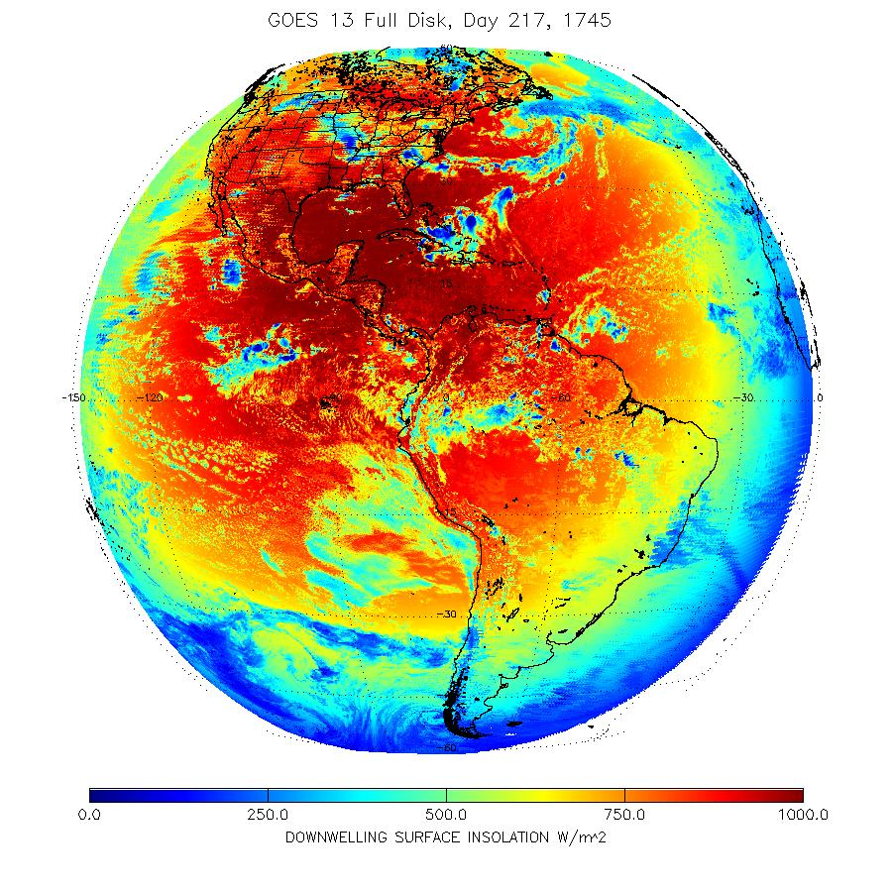
Figure 5.24: GOES-13 Imager downwelling surface insolation on 5 August 2011 beginning at 1745 UTC.

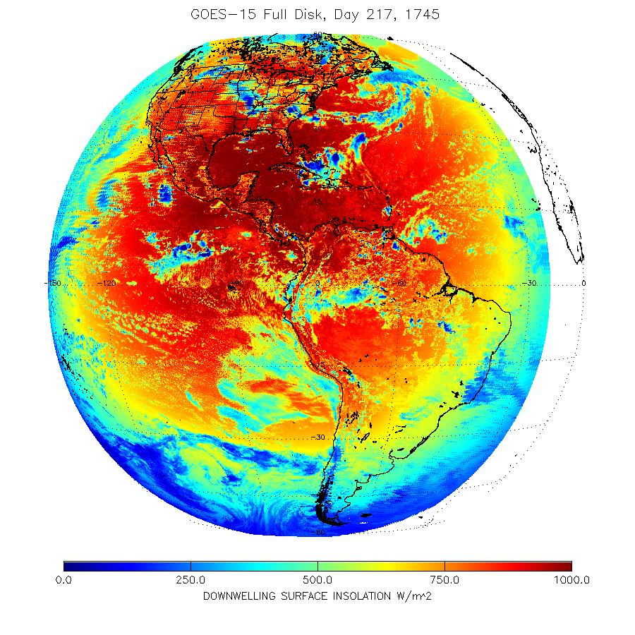
Figure 5.25: GOES-15 Imager downwelling surface insolation on 5 August 2011 beginning at 1745 UTC.

Precipitation and Tropical Applications

For the SAB Precipitation desk, analysts compared GOES-15 band-4 IR and band-1 visible imagery to that of GOES-13 or GOES-11. There were fourteen comparisons completed by the analysts involving a variety of meteorological events; such as thunderstorms, stratiform rain events, and hurricanes. Cloud top temperatures for this wide variety of events ranged from +15°C (warm surface) to -82°C (near the eye of Hurricane Igor). Of these fourteen meteorological events, there were only minor differences observed in both band-4 IR and visible bands. Very small deviations of 1-2°C or less were occasionally noticed in the band-4 data but this would not have affected or degraded Precipitation operations in any way. Any subtle differences in measurements and/or appearance were determined to be caused by the different viewing angles/parallax between GOES-15 and the comparison satellite (GOES-13 or 11).

Analysts of the Tropical desk also observed similar minor discrepancies in band-2 and band-4 IR imagery, with compared cloud top temperatures sometimes being slightly warmer and other times slightly colder. It's possible that this was the result of the viewing angle of the satellite, though this cannot be fully determined. Since the enhancement table used for the IR/SWIR is crucial to tropical cyclone intensity estimates it is conceivable that these differences, though small, could have negatively impacted operations if they were to occur near the breaks between the various gray shades of the imagery enhancement. The Tropical team also noted that they believed the visible imagery from GOES-15 was slightly brighter than either GOES-13 or GOES-11. This is consistent with GOES-15 being a newer instrument and hence less time for degradation in the visible bands.

Other Accomplishments with GOES-15

GOES-15 Imager Visible (band-1) SRF

A comparison of enhanced visible band images from GOES-11 and GOES-15 at 1500 UTC on 25 August 2010 is shown in Figures 6.1 and 6.2. Images from both satellites have been displayed in their native projections.

There are a couple of significant differences to note between the two visible images, while keeping in mind the very large difference in satellite view angles. GOES-15 is able to discern urban centers more readily than GOES-11 over this area, as well as variations in vegetation type. Examples of this are around the large metropolitan region of southeastern Wisconsin and northeastern Illinois (i.e. Milwaukee to Chicago). Also, both the Baraboo Range (located just to the northwest of Madison) and the “Military Ridge” (which runs east to west from Madison to Prairie du Chien) stand out more boldly in the GOES-15 image compared to the GOES-11 image. This difference is primarily due to the slight variation in the spectral width of the two visible bands on the GOES-11 and GOES-15 Imagers. A comparison of the visible band SRF for GOES-11 and GOES-15 shows that the sharper cutoff for wavelengths beyond 0.7 µm on the GOES-15 visible band makes it less sensitive to the signal from the mature corn crops, allowing greater contrast between the thick vegetation of the agricultural fields and the more sparsely vegetated cities, towns, and highway corridors.

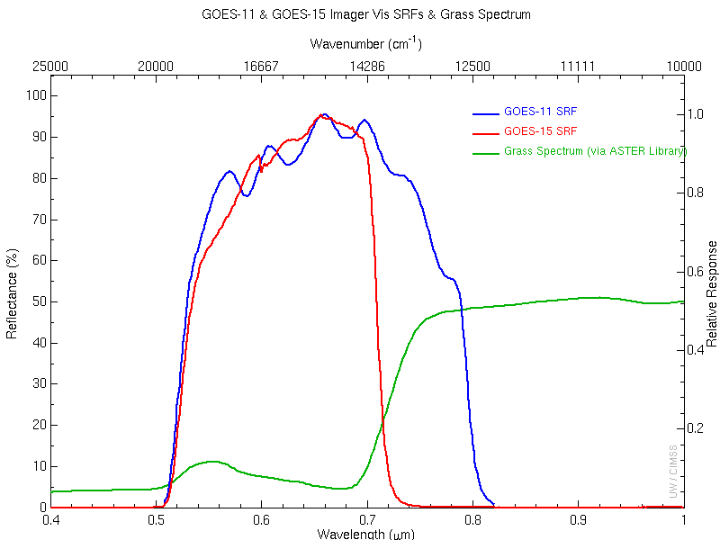
Figure 6.1: GOES-11 (blue) and GOES-15 (red) Imager visible (approximately 0.65 or 0.63 μm) band SRFs, with a representative spectrum for grass over-plotted (green).

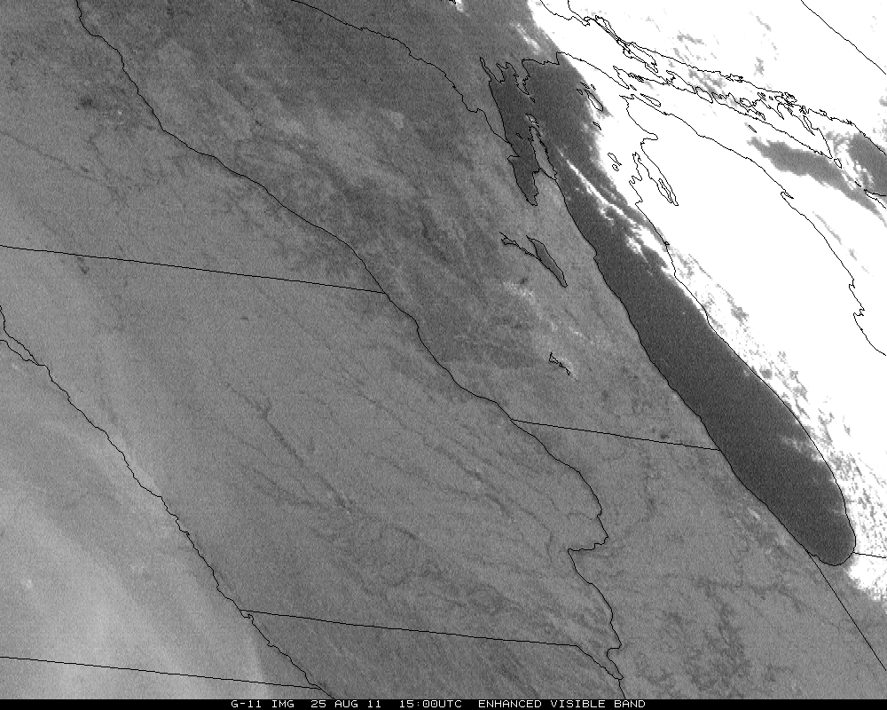

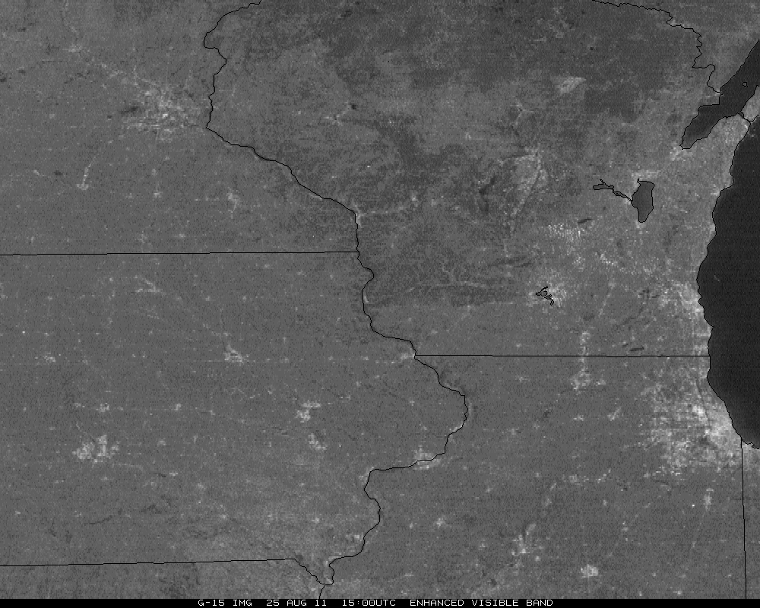

Figure 6.2: Comparison of the visible (0.65 μm) imagery from GOES-11 and GOES-15 (0.63 μm) on 25 August 2010 demonstrates how certain features, such as surface vegetation, are more evident with the GOES-15 visible data.

Lunar calibration

Several GOES-15 Imager datasets were acquired during the PLT. The main objective of these tests was to observe the lunar images as soon as possible in order to establish a baseline for future study of instrument degradation. While not intended, lunar images may allow an attempt on absolute calibration, although this theory has not been fully researched. Note that the image discontinuities are due to the relative changes in the satellite and moon geometry.

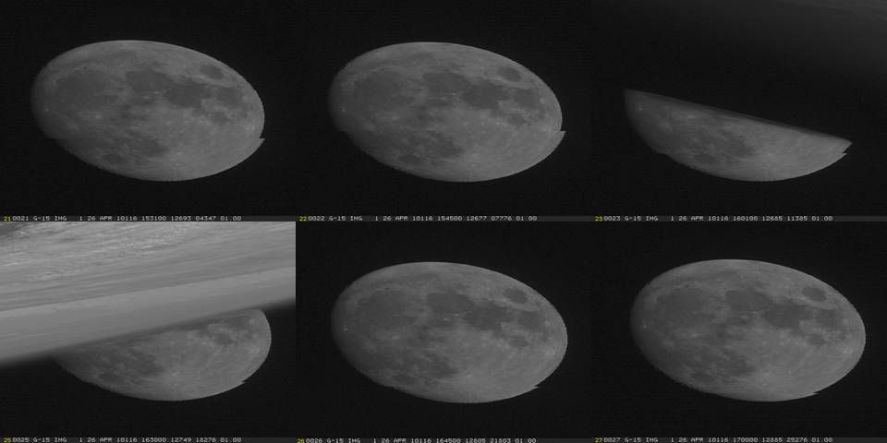

Figure 6.3: GOES-15 Imager visible (0.65 μm) band imaged of the moon from various dates.

The moon was intensively imaged on four different days during the PLT Science Test to investigate the scan-angle dependent reflectivity for the visible band: on 27 August 2011, in upright position and on 22, 23 and 24 September 2010 in yaw-flipped position. On each of these days between 13 and 84 consecutive Moon images were taken within 35 seconds of each other. Only the Moon images taken on 24 September 2010 (Julian Day 267) cover a large scan angle range from about 40.8º to 49.8º.

Although the Moon’s surface is a good reference for the vicarious calibration of the visible band, the measured Moon irradiance can be affected by the moon surface BRDF, change of moon phase angle and other sun-moon-satellite geometry relationships. However, the impact of these disturbances can be greatly reduced with the ratio of GOES-observed moon irradiance to the irradiance predicted with USGS (U.S. Geological Survey) Robotic Lunar Observation (ROLO) model (Stone and Kieffer 2006). Figure 6.4 shows the observed and model irradiance ratio against the scan angle using the data obtained on 24 September 2010. The GOES moon irradiance was estimated by summing up all pixels within a lunar subset (Wu et al. 2006). It clearly shows that moon brightness decreases for angle of incidence (AOI) up to 43º, peaks at approximately 45º, then decreases to 47º, beyond which it increases up to 50º. Similar, but fractional effects were observed on 22 and 23 September 2010, and 27 August 2010.

Figure 6.4: Ratio of observed and ROLO irradiance as a function of angle of incidence exhibits weak linear regression on 24 September 2010.

Improved Image Navigation and Registration (INR) with GOES-15

McIDAS images of GOES-15 visible band data show the good INR performance. One example is the rapid development of this thunderstorm (along with several other storms across Arizona) on 17 August 2010. The animation can be found at http://cimss.ssec.wisc.edu/goes/blog/archives/6380.

Special 1-minute Scans

On 21 September 2010, 1-minute interval GOES-15 visible images centered in the Midwest offers a compelling demonstration of the value of frequent imaging for monitoring the development and evolution of convection. This animation can be found at http://cimss.ssec.wisc.edu/goes/blog/archives/6849.

Another case was the special scans of Hurricane Igor, where A comparison of 1-minute interval GOES-15 SRSO images with the normal operational 30-minute interval GOES-13 visible images clearly demonstrates the advantage of higher temporal resolution for monitoring the evolution of the eye structure of the hurricane. More information can be found at: http://cimss.ssec.wisc.edu/goes/blog/archives/6790.

Special GOES-15 Scans
On 27 July 2011, when GOES-15 was out of storage and operated in a pre-operational mode, additional loops were made to show the GOES-15 Imager water vapor band and its 4 km resolution versus 8 km resolution on GOES-11. In the loops, the better depiction can clearly be seen of gradients (despite the vastly different view angles) and the better depiction of the mid-level vortex. These animations can be found at http://cimss.ssec.wisc.edu/goes/blog/archives/8529.

Super Rapid Scan Operations (SRSO)

During the GOES-15 Science Test, Super Rapid Scan Operations (SRSO) was called on seven separate days, typically corresponding to a meteorologically significant feature present on that day. As can be seen in Table 7.1, four of the seven calls were associated with active hurricanes in the Atlantic Ocean. On 11 September 2010, NASA/SPORT in Huntsville requested SRSO over northern Alabama due to expected convection in the region so they could do some comparisons with their Total Lightning Mapping Array. In every case, real-time loops were created and made available over the Web to the appropriate forecasters, whether they be from the National Hurricane Center or local National Weather Service forecast offices.

Table 7.1: Super Rapid Scan Operations (SRSO) during the GOES-15 Science Test
Date | Feature | Location
2010-08-24 | Hurricane Danielle | 18°N, 46°W
2010-09-03 | Hurricane Earl | 39°N, 72°W
2010-09-11 | Lightning Monitoring over Huntsville AL | 35°N, 87°W
2010-09-13 | Hurricane Igor | 18°N, 51°W
2010-09-17 | Hurricane Karl | 20°N, 96°W
2010-09-20 | Western Fires and Fog Burnoff | 39°N, 114°W
2010-09-21 | Potential Severe Weather | 41°N, 90°W

Overview of Operations, 11 September 2010, 1 minute RSO, Southeast U.S.

NOAA GOES-15 Rapid Scan Operations (RSO) were requested by the NASA/MSFC Earth Science Office to support research in algorithm development related to applications of future space based geostationary lightning mapping systems (i.e., NOAA GOES-R Lightning Mapper (GLM)) in high-impact weather events. The satellite data combined with ground-based radar and lightning networks provide a robust means of examining cell evolution, including relationships among cloud kinematic, microphysics and lightning properties.

Operations on 11 September 2010, were centered over North Central Alabama with the goal of monitoring convective growth and decay. In particular the objective of the day was to coordinate 1-minute GOES-15 scans with unique, high temporal, ground based measurements from the North Alabama Lightning Mapping Array (NALMA; Koshak et al. 2004), and the Advanced Radar for Meteorological and Operational Research (ARMOR; Petersen et al. 2007) C-band dual polarimetric radar.

Since most lightning casualties occur during the developing and dissipating portions of most thunderstorms, one important objective of current lightning research is better Nowcasting of lightning initiation and cessation. Figures 7.1 and 7.2 display a small isolated thunderstorm located just west of Huntsville between 1810 and 1850 UTC. Figure 7.2 is a sequence of ARMOR images at an elevation of 11.4° (height ≈ 6 km and temperature ≈ -10°C at range of interest) using horizontal reflectivity (Z), differential reflectivity (ZDR) and correlation coefficient (ρ_{hv}) at 1817 (A-C), 1820 (D-F), and 1822 UTC (G-I). At 1817 UTC the cell of interest had a well developed ZDR column (4 dB), with a dip in ρ_{hv} (≈0.90) in a region of moderate-to-high Z (35-50 dBZ), which is indicative of large supercooled rain drops, likely in the early stages of freezing. The cloud top temperature for this cell was near 261 K, and no lightning was present within the storm. At 1820 UTC, the ZDR column began to glaciate, as ZDR became smaller and a prominent lowering of ρ_{hv} continued, indicating mixed-phase precipitation (i.e., rain and frozen drops). By 1822 UTC, the glaciation of the supercooled raindrop column was likely complete, as suggested by the moderate Z (35-45 dBZ), low ZDR (< 1 dB) and high ρ_{hv} (≥ 0.98).

During the period from 1820-1822 UTC, the cloud top temperature dropped 1 K to 260 K. Between 1822 and 1829 UTC the cloud top cooled at a more rapid rate, as the temperature dropped to 257 K. At 1829 UTC the first lightning flashes from the thunderstorm were observed by the NALMA. The cloud top temperature continues to fall over the next 12 minutes and reaches a minimum of 238 K by 1841 UTC. During this period, the total flash rate for the thunderstorm peaked at 7 flashes per minute, and the thunderstorm top grew from 13 km to just below 15 km (Figure 7.1). At 1845 UTC the thunderstorm collapsed and the final two lightning flashes are observed soon after. Similar observations of decreasing cloud top temperatures prior to lightning initation were observed in several other thunderstorm cells from this day (e.g., Figure 7.3). Minimum temperatures observed just prior to the first flash in each storm ranged from 249-257 K.
Figure 7.1: Time height cross-section of maximum reflectivity vs. height (top), minimum cloud top temperature (dashed line, top) and total flash rate (bottom).

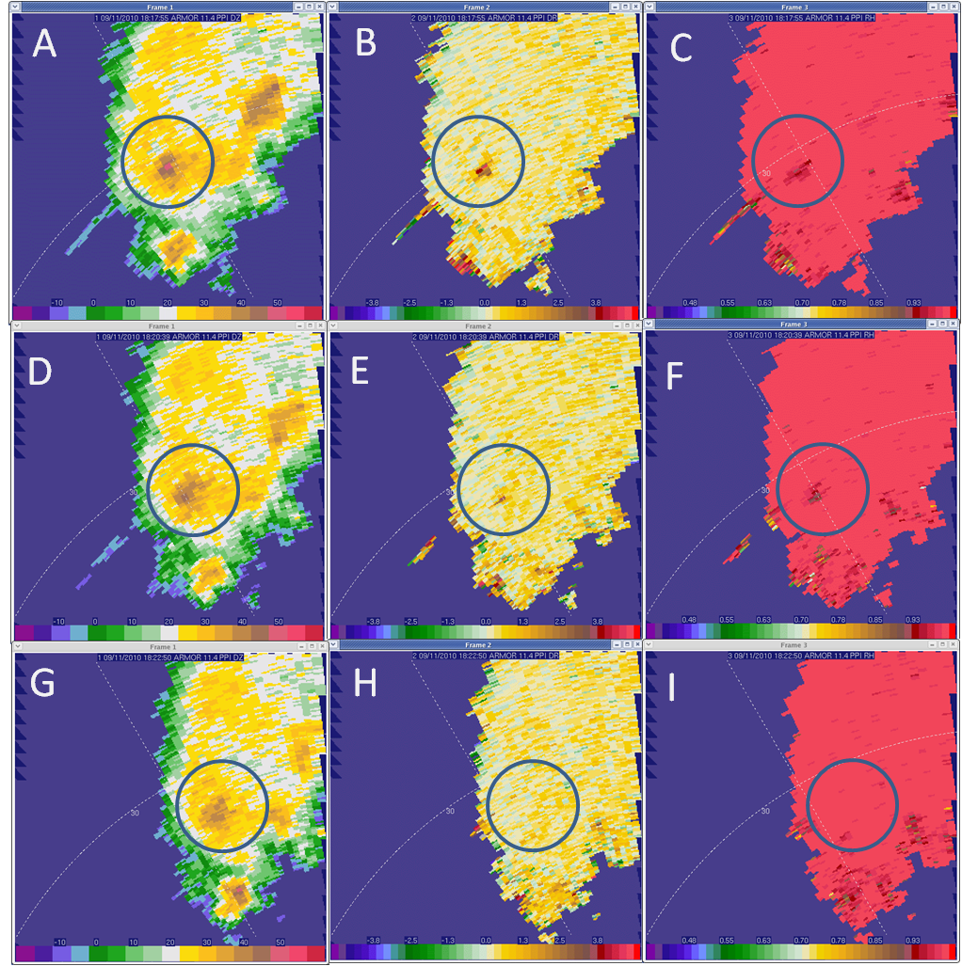

Figure 7.2: A series of Plan Position Indicator (PPI) images from ARMOR on 11 September 2010, between 1817 and 1822 UTC at 11.4° elevation (height ≈ 6 km and temperature ≈ -10°C at range of interest). Panels A-C are at 1817 UTC, D-F at 1820 UTC, and G-I at 1822 UTC. From left to right, radar fields presented here are horizontal reflectivity (Z), differential reflectivity (ZDR), and correlation coefficient (ρ_{hv}).

Figure 7.3: Time height section of maximum reflectivity vs. height minimum cloud top temperature and total flash rate for two additional thunderstorms on 11 September 2010. Thunderstorm A (top) obtained a minimum temperature of 249 K before the first flash was observed, while thunderstorm C (bottom) had a minimum cloud top temperature of 256 K before the first flash was observed at 1728 UTC.

Overall Recommendations Regarding this and Future GOES Science Tests

The following conclusions and recommendations were drawn during the GOES-15 Science Test:

- Each of the four main goals of the GOES-15 Science Test were accomplished. These were to characterize the radiance integrity, product generation, acquire unique image sequences, and monitor instrument changes.

- The updated (Rev. H with the STAR correction) Imager and Sounder SRF should be used for any subsequent product generation. In the future, the latest system SRF should be made available well before the start of the Science Test.

- Science Tests should continue as a vital aspect of the checkout of each GOES satellite, as studying real-time data is an effective way to detect problems in the data stream, ground systems and product generation/use. To best test the overall system, the data should continue to flow via the operational path, even before the operation period.

- Science Test duration should be at least 5 weeks for ‘mature’ systems (and ideally should be during times with active convection over the continental U.S.). Much longer Science Tests will be needed for new systems such as GOES-R. It is expected on the order of a year will be needed for the many steps of engineering, science, products, validation and user readiness. This could be split between a 6-month period during the NASA controlled time, followed by a 6-month period after the hand-over to NOAA. A longer period would also increase the odds of observing episodic events, such as volcanic activity.

- A Science Test could be preceded by several weeks of GOES-East and/or GOES-West schedule emulations. This would allow for more routine testing in operations, and then more flexibility during the Science Test itself. The Science Test should contain a mixture of the expected operational scan scenarios, along with any needed special scans.

- An additional aspect to the Science Test could involve yearly checkout of GOES data when individual spacecraft are taken out of storage and turned on for other purposes.

- While the GOES-15 GVAR data are captured and saved by a number of research groups, these unique and important pre-operational data should be part of the official GOES archive and be made available.

- Ideally as many groups as possible should get access to the pre-operational images and products. This would help test the flow and quality of the information before operations. This is especially important for Numerical Weather Prediction (NWP) applications.

Acknowledgments

A large number of people played important roles in the success of the GOES-15 Science Test. The contributors listed on the front cover of this report provided analysis of GOES-15 radiance data and Imager and Sounder products. Yet, it takes many, to accomplish the needed tasks to check-out a satellite. These include the government (NOAA, NASA), industry (Boeing, contractors, etc) and Universities (Cooperative Institutes, etc). Dan Lindsey and John Knaff (StAR/RAMMB), Gary Wade (StAR/ASPB), and Scott Bachmeier (UW/CIMSS) are specially thanked for their participation in the daily coordination where decisions were made to determine which test schedules should be implemented in order to either capture interesting weather events, or to meet the requirements for the various data tests and generation of products. Scott is also thanked for his many informative satellite blog posts. Istvan Laszlo is thanked for his input on the GSIP images. In addition, thanks to Kevin Ludlum (GOES Scheduling Lead) and the rest of the GOES-15 Team at NOAA/NESDIS Office of Satellite Operations (OSO), for coordinating and establishing the numerous schedules and sectors used during the Science Test. Matt Seybold and Natalia Donoho of the Satellite Services Division User Services are also thanked. The entire SAB staff is thanked for their analysis with respect to the tropical, fire, volcano and precipitation desks. Hyre Bysal, John Tsui, Ken Mitchell, J. Paul Douglas, Tom Renkevens and Mike Weinreb are thanked for their GOES engineering and calibration expertise.

The following are also acknowledged for their detailed reviews of the final document: Leanne Avila, and Thomas Wrublewski.

This project was funded by the NOAA/NESDIS Office of Systems Development (OSD) via the GOES I/M Product Improvement Plan (GIMPAP).

The views, opinions, and findings contained in this article are those of the authors/contributors and should not be construed as an official National Oceanic and Atmospheric Administration or U.S. Government position, policy, or decision.

References / Bibliography

Daniels, J.M., T.J. Schmit, and D.W. Hillger, 2001: Imager and Sounder Radiance and Product Validations for the GOES-11 Science Test, NOAA Technical Report NESDIS 103, (August), 49 pp.

Eilers, P.H.C., and Goeman, J.J., 2004: Enhancing scatter plots with smoothed densities, Bioinformatics, 20(5):623-628.

Gunshor, M., T. Schmit, W. Menzel, and D. Tobin, 2009: Inter-calibration of broadband Geostationary Imagers using AIRS, J. Atmos. Oceanic Tech., 26, 746-758.

Hillger, D.W., and T.J. Schmit, 2007: Imager and Sounder Radiance and Product Validation for the GOES-13 Science Test. NOAA Technical Report, NESDIS 125, (September), 75 pp.

Hillger, D.W., and T.J. Schmit, 2009: The GOES-13 Science Test: A Synopsis, Bull. Amer. Meteor. Soc., 90, 6-11.

Hillger, D.W., and T.J. Schmit, 2010: Imager and Sounder Radiance and Product Validation for the GOES-14 Science Test, NOAA Technical Report, NESDIS 131, (September), 105 pp.

Hillger, D.W., T.J. Schmit, and J.M. Daniels, 2003: Imager and Sounder Radiance and Product Validation for the GOES-12 Science Test, NOAA Technical Report, NESDIS 115, (September), 70 pp.

Hillger, D.W., and T.H. Vonder Haar, 1988: Estimating Noise Levels of Remotely Sensed Measurements from Satellites Using Spatial Structure Analysis, J. Atmos. Oceanic Technol., 5, 206-214.

Johnson, R., and M. Weinreb, 1996: GOES-8 Imager mid-night effects and slope correction. Proc. SPIE, Vol. 2812, 596, dio:10.1117/12.254104.

Koshak, W.J., R.J. Solakiewicz, R.J. Blakeslee, S.J. Goodman, H.J. Christian, J.M. Hall, J.C. Bailey, E.P. Krider, M.G. Bateman, D.J. Boccippio, D.M. Mach, E.W. McCaul, M.F. Stewart, D.E. Buechler, W.A. Petersen, and D.J. Cecil, 2004: North Alabama Lightning Mapping Array (LMA): VHF source retrieval algorithm and error analysis, J. Atmos. Ocean. Tech., 21, 543-558.

Li, Z., J. Li, W.P. Menzel, T.J. Schmit, J.P. Nelson III, J. Daniels, and S.A. Ackerman, 2008: GOES sounding improvement and applications to severe storm nowcasting, Geophys. Res. Lett., 35, L03806, doi:10.1029/2007GL032797.

Ma, X.L., T. Schmit, and W.L. Smith, 1999: A non-linear physical retrieval algorithm - its application to the GOES-8/9 Sounder, J. Appl. Meteor., 38, 501-513.

Menzel, W.P., F.C. Holt, T.J. Schmit, R.M. Aune, G.S. Wade, D.G. Gray, and A.J. Schreiner, 1998: Application of GOES-8/9 Soundings to weather forecasting and nowcasting, Bull. Amer. Meteor. Soc., 79, 2059-2078.

Merchant, C.J., A.R. Harris, E. Maturi, and S. MacCallum, 2005: Probabilistic physically-based cloud-screening of satellite infrared imagery for operational sea surface temperature retrieval, Quart. J. Roy. Meteorol. Soc., 131(611), 2735-2755.

Merchant, C.J., A.R. Harris, E. Maturi, O. Embury, S.N. MacCallum, J. Mittaz, and C.P. Old, 2009: Sea Surface Temperature Estimation from the Geostationary Operational Environmental Satellite 12 (GOES-12), J. Atmos. Oceanic Technol., 26, 570-581.

Petersen, W.A., K.R. Knupp, D.J. Cecil, and J.R. Mecikalski, 2007: The University of Alabama Huntsville THOR Center instrumentation: Research and operational collaboration. Preprints, 33rd International Conf. Radar Meteorology, Cairns, Australia, Amer. Meteor. Soc.

Schmit, T.J., E.M. Prins, A.J. Schreiner, and J.J. Gurka, 2002a: Introducing the GOES-M Imager, Nat. Wea. Assoc. Digest, 25, 2-10.

Schmit, T.J., W.F. Feltz, W.P. Menzel, J. Jung, A.P. Noel, J.N. Heil, J.P. Nelson III, G.S. Wade, 2002b: Validation and Use of GOES Sounder Moisture Information, Wea. Forecasting, 17, 139-154.

Stone, T.C., and H.H. Kieffer, 2006: Use of the Moon to support on-orbit sensor calibration for climate change measurements, Proc. SPIE, 6296 6296Y-1-9.

Tahara, Y., and K. Kato, 2009: New spectral compensation method for inter-calibration using high spectral resolution sounder, Met. Sat. Center Technical Note, No. 52, 1-37.

Weinreb, M.P., M. Jamison, N. Fulton, Y. Chen, J.X. Johnson, J. Bremer, C. Smith, and
J. Baucom, 1997: Operational calibration of Geostationary Operational Environmental
Satellite-8 and -9 Imagers and Sounders. Appl. Opt., 36, 6895-6904.

Wolfe, D., and S.I. Gutman, 2000: Developing an operational, surface-based, GPS, water vapor observing system for NOAA: Network design and results. J. Atmospheric and Oceanic Tech., 17, 426-440.

Wu, X., and S. Sun, 2005: Post-launch calibration of GOES Imager visible band using MODIS, Proc. SPIE, Vol. 5882, doi:10.1117/12.615401.

Wu, X., T. Schmit, and M. Gunshor, 2009: Correction for GOES-13 Imager 13.3 µm Channel Spectral Response Function, NOAA/NESDIS/STAR Calibration Product Oversight Panel (CalPOP) Technical Memorandum, 13 March, 9 pp.

Wu, X., T. Stone, F. Yu, and D. Han, 2006: Vicarious calibration of GOES Imager visible channel using the Moon, Proc. SPIE, 6296, doi:10.1117/12.681591.

Wu, X., and F. Yu, 2011: Personal communication.

Yu, F. and X. Wu, 2010: Instrument performance monitoring of GOES Imager and Sounder instruments, Calcon (http://www.sdl.usu.edu/conferences/calcon/previous), 23-26 August, Logan, UT.
Yu, F., X. Wu, M.K. Rama Varma Raja, L. Wang, Y. Li, and M. Goldberg, 2011. Evaluation of the diurnal and scan angle calibration variation of GOES Imager infrared instruments, submitted to IEEE Transactions on Geosciences and Remote Sensing.

Appendix A: Web Sites Related to the GOES-15 Science Test

GOES-15 NOAA/Science Post-Launch Test: http://rammb.cira.colostate.edu/projects/goes-p
(updated daily during the Science Test)

GOES-15 RAMSDIS Online: http://rammb.cira.colostate.edu/ramsdis/online/goes-15.asp
(contained real-time GOES-15 imagery and products during the Science Test)

CIMSS Satellite Blog: Archive for the 'GOES-15' Category: http://cimss.ssec.wisc.edu/goes/blog/archives/category/goes-15

NESDIS/StAR: GOES-15 First Images Transmitted: http://www.star.nesdis.noaa.gov/star/news2010_201004_GOES15.php
NOAA: GOES-15 Weather Satellite Captures Its First Image of Earth: http://www.noaanews.noaa.gov/stories2010/20100407_goes15.html

CIMSS GOES Calibration:
http://cimss.ssec.wisc.edu/goes/calibration

NOAA: GOES Imager and Sounder SRF:
http://www.oso.noaa.gov/goes/goes-calibration/goes-imager-srfs.htm
http://www.oso.noaa.gov/goes/goes-calibration/goes-sounder-srfs.htm

GOES Imager Calibration:
http://www.star.nesdis.noaa.gov/smcd/spb/fwu/homepage/GOES_Imager.php

Global Satellite Inter-Calibration System (GSICS) GEO-LEO baseline inter-calibration ATBD
https://gsics.nesdis.noaa.gov/pub/Development/AtbdCentral/ATBD_for_NOAA_Inter-Calibration_of_GOES-AIRSIASI.2011.06.15.doc

NOAA, Office of Systems Development: The GOES-P Spacecraft: http://www.osd.noaa.gov/Spacecraft%20Systems/Geostationary_Sat/GOES_Sat_Info/goes_p_info.html (including GOES Data Book: http://goes.gsfc.nasa.gov/text/goes.databookn.html)
NASA GSFC: GOES-P Mission Overview video: http://www.youtube.com/watch?v=QpBSwwCPC94&list=PL05E2409F3516100B&index=6
NASA GSFC: GOES-O Project: GOES-O Spacecraft: http://goespoes.gsfc.nasa.gov/goes/spacecraft/goes_o_spacecraft.html
NASA-HQ: GOES-O Mission: http://www.nasa.gov/mission_pages/GOES-O/main/index.html
Boeing: GOES-N/P: http://www.boeing.com/defense-space/space/bss/factsheets/601/goes_nopq/goes_nopq.html
CLASS: http://www.class.ngdc.noaa.gov/saa/ products/welcome

Appendix B: Acronyms (and Abbreviations) Used in this Report

ABI Advanced Baseline Imager (GOES-R)
AIRS Atmospheric InfraRed Sounder
AMV Atmospheric Motion Vector
AOI Angle of Incidence
ARMOR Advanced Radar for Meteorological and Operational Research
ASPB Advanced Satellite Products Branch
ATBD Algorithm Theoretical Basis Document
BB Black Body
BRDF Bi-directional Reflectance Distribution Function
CICS Cooperative Institute for Climate Studies
CIMSS Cooperative Institute for Meteorological Satellite Studies
CIRA Cooperative Institute for Research in the Atmosphere
CLASS Comprehensive Large Array-data Stewardship System
CON CONUS (sector)
CONUS Continental United States
CRTM Community Radiative Transfer Model
CSBT Clear Sky Brightness Temperature
CSU Colorado State University
dB Decibel
dBZ Decibels of Z (radar reflectivity)
DPI Derived Product Image
ECMWF European Centre for Medium-range Weather Forecasts
EOS Earth Observation System
EUMETSAT European Organization for the Exploitation of Meteorological Satellites
FD Full Disk (sector)
FED Flash Extent Density (lightning)
FOV Field Of View
GEO Geostationary Earth Orbit
GFS Global Forecast System
GIMPAP GOES I/M Product Improvement Plan
GLM GOES-R Lightning Mapper
GOES Geostationary Operational Environmental Satellite
GOES-R Next generation GOES, starting with GOES-R
GRIP Genesis and Rapid Intensification Processes
GPS Global Positioning System
GSFC Goddard Space Flight Center
GSICS Global Space-based Inter-Calibration System
GSIP GOES Surface and Insolation Product
GVAR GOES Variable (data format)
HK Housekeeping
hPa Hectopascals (equivalent to millibars in non-SI terminology)
HUR Hurricane (sector)
IASI Infrared Atmospheric Sounding Interferometer
INR Image Navigation and Registration
IPM Instrument Performance Monitoring
IR InfraRed
ITT ITT Corporation
JMA Japanese Meteorological Agency
KOZ Keep Out Zone
LEO Low Earth Orbit
LI Lifted Index
LMA Lightning Mapping Array
LW Longwave
LWIR LongWave InfraRed
MAE Mean Absolute Error
MBCC Midnight Blackbody Calibration Correction
McIDAS Man-Computer Interactive Data Access System
MetOp Meteorological Operational (satellite)
MOON Moon (sector)
MSFC Marshall Space Flight Center
MTF Modulation Transfer Function
MTSat Multi-functional Transport Satellite
MVD Mean Vector Difference
NALMA North Alabama Lightning Mapping Array
NASA National Aeronautics and Space Administration
NCEP National Centers for Environmental Prediction
NEdR Noise Equivalent delta Radiance (Sometimes given as NEdN)
NEdT Noise Equivalent delta Temperature
NESDIS National Environnemental Satellite, Data, and Information Service
NHEM Northern Hemisphere
NOAA National Oceanic and Atmospheric Administration
NSF National Science Foundation
NSSTC National Space Science and Technology Center
NWP Numerical Weather Prediction
OSD Office of Systems Development
OPDB Operational Products Development Branch
ORA Office of Research and Applications (now StAR)
OSDPD Office of Satellite Data Processing and Distribution
OSO Office of Satellite Operations
OSPO Office of Satellite Processing and Operations
PLST Post-Launch Science Test
PLT Post-Launch Test
PPI Plan Position Indicator
PREDICT PRE-Depression Investigation of Cloud-systems in the Tropics
PRT Platinum Resistance Thermometer
PSF Point Spread Function
PW Precipitable Water
RAMMB Regional and Mesoscale Meteorology Branch
RAMSDIS RAMM Advanced Meteorological Satellite Demonstration and Interpretation System
RAOB Radiosonde Observation
Rev. Revision
RMS Root Mean Square
RMSE Root Mean Square Error
ROLO Robotic Lunar Observation
RSO Rapid Scan Operations (or sector)
RT Real Time
RTM Radiative Transfer Model
RTN Routine (sector)
SAB Satellite Analysis Branch
SNR Signal to Noise Ratio
SOCC Satellite Operations Control Center
SOCD Satellite Oceanography and Climatology Division
SC Spacecraft
SPB Sensor Physics Branch
SPC Storm Prediction Center
SPEC Specifications
SPLK Space Look
SPoRT Short-term Predication Research and Transition center
SPS Sensor Processing System
SRF Spectral Response Function
SRSO Super Rapid Scan Operations
SSEC Space Science and Engineering Center
SST Sea Surface Temperature
StAR SaTellite Applications and Research (formerly ORA)
stdv Standard deviation
SW Shortwave
SWIR Split-Window InfraRed
Tb Brightness temperature
TCO Total Column Ozone
THOR Tornado and Hazardous weather Observations Research center
TPW Total Precipitable Water
UAH University of Alabama, Huntsville
USGS U.S. Geological Survey
UTC Coordinated Universal Time
μm Micrometers (micron was officially declared obsolete in 1968)
UW University of Wisconsin (Madison)
WF_ABBA Wildfire Automated Biomass Burning Algorithm
WMO World Meteorological Organization
WV Water Vapor
WWRP World Weather Research Program
XRS X-Ray Sensor
Z Radar reflectivity
ZDR Differential reflectivity

