The GOES-15 Science Test:
Imager and Sounder Radiance and Product Validations

Editors:

Donald W. Hillger¹ and Timothy J. Schmit³

Other Contributors:

Americo Allegrino⁶, A. Scott Bachmeier⁴, Andrew Bailey⁶, Eric Brunning¹⁰, Hyre Bysal¹³, Jerry Cantril¹⁶, Lawrence Carey¹⁵, Jaime M. Daniels⁵, Prasanjit Dash², Michael Grotenhuis⁶, Mathew M. Gunshor⁴, Jay Hanna¹², Andy Harris¹⁰, Michael P. Hiatt², John A. Knaff¹, Jun Li⁴, Daniel T. Lindsey¹, Eileen M. Maturi⁹, Kevin Micke², Jon Mittaz¹⁰, James P. Nelson III⁴, Walt Petersen¹⁴, Robert Potash¹¹, Elaine Prins¹⁷, Gordana Rancic⁶, Dale G. Reinke², Christopher C. Schmidt⁴, Anthony J. Schreiner⁴, Christopher Schultz¹⁵, Elise Schultz¹⁵, Dustin Sheffler¹², Dave Stettner⁴, William Straka⁴, Chris Velden⁴, Gary S. Wade³, Steve Wanzong⁴, Dave Watson², Crystal Woodard¹⁵, Xiangqian Wu⁷, and Fangfang Yu⁸

Affiliations:

¹StAR/RAMMB (SaTellite Applications and Research/Regional and Mesoscale Meteorology Branch)
²CIRA (Cooperative Institute for Research in the Atmosphere) Colorado State University, Fort Collins

³StAR/ASPB (SaTellite Applications and Research/Advanced Satellite Products Branch)
⁴CIMSS (Cooperative Institute for Meteorological Satellite Studies)
University of Wisconsin, Madison

⁵StAR/OPDB (SaTellite Applications and Research/Operational Products Development Branch)
⁶I.M. Systems Group, Inc. (IMSG), Rockville, Maryland

⁷StAR/SPB (SaTellite Applications and Research/Sensor Physics Branch)
⁸ERT, Inc., Annapolis Junction, MD

⁹StAR/SOCD (SaTellite Applications and Research/Satellite Oceanography and Climatology Branch)
¹⁰CICS (Cooperative Institute for Climate Studies)
University of Maryland, College Park
¹¹Science Systems and Applications Inc (SSAI)

¹²NOAA/NESDIS Satellite Analysis Branch (SAB)
¹³NOAA/NESDIS Office of Satellite Operations (OSO)

¹⁴NASA/MSFC (Marshall Space Flight Center), Earth Sciences Office
¹⁵University of Alabama, Huntsville

¹⁶Columbus Inc.

¹⁷CIMSS – Consultant, Grass Valley, CA
TABLE OF CONTENTS

Executive Summary of the GOES-15 NOAA Science Test 1
1.1. Goals for the GOES-15 Science Test 4
2. Satellite Schedules and Sectors 5
3. Changes to the GOES Imager from GOES-8 through GOES-15 10
4. GOES Data Quality 12
4.1. First Images 12
4.1.1. Visible 12
4.1.2. Infrared (IR) 14
4.1.3. Sounder 16
4.2. Spectral Response Functions (SRFs) 18
4.2.1. Imager 18
4.2.2. Sounder 18
4.3. Random Noise Estimates 19
4.3.1. Imager 20
4.3.2. Sounder 23
4.4. Striping Due to Multiple Detectors 27
4.4.1. Imager 27
4.4.2. Sounder 27
4.5. Initial post-launch calibration for the GOES-15 Imager visible channel 28
4.6. GEO to GEO comparisons 29
4.7. Imager-to-Polar-Orbiter Comparisons 38
4.8. Stray Light Analysis 44
4.9. Instrument Performance Monitoring 45
4.9.1. Telemetry Monitoring 45
4.9.2. Monitoring the GOES Sounder patch temperatures 47
4.9.3. Initial Post-launch Calibration for the Imager Visible Band 48
4.10. Finer Spatial resolution GOES-15 Imager 49
4.1. Corrections of SRF for GOES-14/15 Imagers 50
5. Product Validation 53
5.1. Total Precipitable Water (TPW) from the Sounder 53
5.1.1. Validation of Precipitable Water (PW) Retrievals from the GOES-15 Sounder 53
5.2. Lifted Index (LI) from the Sounder 60
5.3. Cloud Parameters from the Sounder and Imager 61
5.4. Atmospheric Motion Vectors (AMVs) from the Imager 64
5.5. Clear Sky Brightness Temperature (CSBT) from the Imager 66
5.6. Sea Surface Temperature (SST) from the Imager 67
5.7. Fire Detection and Characterization 71
5.8. Volcanic Ash Detection 73
5.9. Total Column Ozone 74
5.10. GOES Surface and Insolation Product (GSIP) 75
5.11. Precipitation and Tropical applications 77
6. Other Accomplishments with GOES-15 78
6.1. GOES-15 Imager Visible (band 1) Spectral Response 78
6.2. Lunar calibration 81
6.3. Improved Image Navigation and Registration (INR) with GOES-15 82
6.4. Special 1-minute Scans 82
6.5. Special GOES-15 Scans 82
7. Coordination with University of Alabama/Huntsville 83
7.1. Deep Convection: Example Case Studies 84
7.1.1. Marginal Lightning and Severe Weather: 2 December 2009 84
7.1.2. Severe Convection: 8-9 December 2009 87
7.2. Winter Storm Events 89
7.2.1. Washington DC, 19 December 2009 89
7.2.2. Oklahoma, 24 December 2009 90
7.3. SRSO for Lightning Summary 91
8. Overall Recommendations Regarding this and Future GOES Science Tests 92
Acknowledgments 93
References/Bibliography 94
Appendix A: Web Sites Related to the GOES-15 Science Test 96
Appendix B: Acronyms Used in this Report 97

LIST OF TABLES

Table 2.1: Summary of Test Schedules for the GOES-15 Science Test 6
Table 2.2: Daily Implementation of GOES-15 Science Test Schedules in 2010 7
Table 3.1: GOES Imager band nominal wavelengths (GOES-8 through 15) 10
Table 3.2: GOES Imager band nominal spatial resolution (GOES-12 through 15) 11
Table 4.1: GOES-15 Imager Noise Levels 20
Table 4.2: Summary of the Noise for GOES-8 through GOES-15 Imager Bands 20
Table 4.3: Summary of the noise (in temperature units) for GOES-8 through GOES-15 Imager IR bands. The specification (SPEC) noise levels are also listed. 22
Table 4.4: GOES-15 Sounder Noise Levels 23
Table 4.5: Summary of the Noise for GOES-8 through GOES-15 Sounder Bands 23
Table 4.6: GOES-15 Sounder NEdR compared to those from GOES-8 through GOES-14 and the specification noise values. 25
Table 4.7: GOES-15 Sounder NEdT compared to those from GOES-8 through GOES-14. 25
Table 4.8: GOES-15 Imager Detector-to-Detector Striping 27
Table 4.9: GOES-15 Sounder Detector-to-Detector Striping 28
Table 4.10: Mean Tb difference (K) and the standard deviation values for the IR channels between the Imagers on GOES-15 vs. GOES-13 and GOES-15 vs. GOES-11. 36
Table 4.11: Mean Tb difference (K) and the standard deviation values for the IR channels between the Sounders on GOES-15 vs. GOES-13 and GOES-15 vs. GOES-11. 37
Table 4.12: Comparison of GOES-15 Imager to Infrared Atmospheric Sounding Interferometer (IASI) using the CIMSS-method. The bias is the mean of the absolute values of the differences. 38
Table 4.13: Brightness temperature (Tb) biases between GOES-15 Imager and AIRS/IASI for the daytime and nighttime collocated pixels between AIRS and IASI through GOES-14 Imager daytime collocation data using the GSICS-method. The Tb biases were based on the collocated pixels acquired from June 3, 2010 and October 25, 2010. Standard deviations are given in parentheses. Again, these values are before the final, shifted SRF were employed. 40
Table 4.14: GOES-15 Imager diurnal calibration variation. 42
Table 4.15: GOES-15 Sounder IR vs. IASI brightness temperature difference at nighttime, compared to other GOES Sounders using the GSICS-method. The data in the parentheses are the standard deviation of the Tb difference at the collocation pixels. 43
Table 4.16: GOES-15 Imager and Sounder telemetry parameters monitored with the GOES-IPM system during the PLT science test period. 45
Table 4.17: Biases for selected GOES-14/15 Imager channels using the SRF as originally supplied by ITT (Rev. E), revised by ITT (Rev. H), further corrected by NOAA, and the recommended correction. 51
Table 5.1: Verification statistics for GOES-12 and GOES-15 retrieved precipitable water, first guess (GFS) precipitable water, and radiosonde observations of precipitable water for the period 2 September 2010 to 21 September 2010. 53
Table 5.2: Verification statistics for GOES-15 vs. RAOB Match Verification Statistics NHEM winds (m/s): 11 September 2010 – 25 October 2010. MVD is the mean vector difference. 65
Table 5.3: RAOB Verification statistics for GOES-13 and GOES-15, collocated (0.1 deg, 25 hPa) for NHEM winds (m/s): 11 September 2010 – 25 October 2010 66
Table 7.1: Summary of significant case study dates for MSFC GOES-14 SRSO 83

LIST OF FIGURES

Figure 1.1: GOES-P/15 spacecraft decal 3
Figure 3.1: The GOES-15 Imager weighting functions. 11
Figure 3.2: The GOES-15 Sounder weighting functions. 12
Figure 4.1: The first visible (0.63 μm) image from the GOES-15 Imager occurred on 6 April 2010 starting at approximately 1730 UTC. 13
Figure 4.2: A GOES-15 visible image on 6 April 2010 showing a close-up view centered Northern Hudson Bay and the Canadian Arctic Archipelago (showing some areas of ice-free water). 13
Figure 4.3: First GOES-15 full-disk visible and infrared images from 6 and 26 April 2010, respectively. 14
Figure 4.4: GOES-15 Imager bands (top) and the corresponding GOES-13 Imager bands (bottom). Both sets of images are shown in their native projections. 15
Figure 4.5: The visible (band-19) image from the GOES-15 Sounder shows data from 8 April 2010. The west and east ‘saw-tooth’ edges are due to the geometry of collecting the pixels. 16
Figure 4.6: The first IR Sounder images for GOES-15 from 26 April 2010 (top) compared to GOES-13 (bottom). Both sets of images have been remapped to a common projection. 17
Figure 4.7: The four GOES-15 Imager IR-band SRFs super-imposed over the calculated high-resolution earth-emitted U.S. Standard Atmosphere spectrum. Absorption due to carbon dioxide (CO₂), water vapor (H₂O), and other gases are evident in the high-spectral resolution earth-emitted spectrum. 18
Figure 4.8: The eighteen GOES-15 Sounder IR-band SRFs super-imposed over the calculated high-resolution earth-emitted U.S. Standard Atmosphere spectrum. 19
Figure 4.9: The mean standard deviation of the Imager space view count at before and after the Imager space clamp events, and Sounder space view count for GOES-11 through GOES-15. 21
Figure 4.10: Times series of the standard deviations of space view count for the eight detectors of GOES15 Imager visible channel from August 20, 2010 (12:00UTC)– August 23, 2010 (12:00UTC) (left: pre-clamp space view statistics, right: post-clamp space view statistics). 21
Figure 4.11: Time series of the GOES-15 Imager NEdT calculated at 300 K temperature, except band-3 at 230 K, compared to the specifications. The ‘spec’ line is also plotted. The color of the points refer to the detector number. 22
Figure 4.12: Standard deviations of space view count for the four GOES-15 Sounder visible detectors from October 7, 2010 (00:00UTC) to October 9, 2010 (00:00UTC). 24
Figure 4.13: Diurnal variation of GOES-15 Sounder NEdT between September 11, 2010 and September 12, 2010. The solid line in each IR channel plot is the specification value. The colors correspond to the 4 detectors. 26
Figure 4.14: Spatial distribution of GOES 15 Imager band 4 Tb values for the collocation scenes between GOES-13 (left) and GOES-11(right). 29
Figure 4.15: Time-series of GOES-15 vs. GOES-13 post-launch calibrated reflectance difference (left) and the histogram of the reflectance difference (right). 30
Figure 4.16: SRF of the visible channels at GOES-15 vs. GOES-13 (top left) and GOES-15 vs. GOES-11 (top right). SRF of GOES-13 and GOES-15 four IR channels (red: GOES-15, blue: GOES-13). The simulated clear tropical TOA Tb values (in gray) are also plotted for the four IR channels. 31
Figure 4.17: Two-Dimensional smoothed histogram of GOES-13 Band 2, 3, 4 and 6 pixel temperatures (K) vs. GOES-15 Band 2, 3, 4 and 6 pixel temperatures. 34
Figure 4.18: Direct inter-comparison of GOES15 vs. GOES-13 Imager IR channels. No account of differing SRF were made. 35
Figure 4.19: Latitudinal distribution of the mean Tb difference (dark dots) and the standard deviation (gray segments) between GOES-15 and GOES-13 for the four Imager IR channels (Tb difference = GOES-15 – GOES-13). 36
Figure 4.20: Spatial distribution of Sounder collocation pixels for GOES-15 vs. GOES-13 (left) and GOES-15 vs. GOES11 (right). 37
Figure 4.21: Spectral response function of GOES-15 Imager (top) and Sounder (bottom), together with the AIRS/IASI spectra. 39
Figure 4.22: GOES-15 Imager IR bands time series of the brightness temperature bias with AIRS and IASI inter-calibration. Note that the band 2 values are only for the daytime. Note that these are from the Science test period and hence before the SRF shift of bands 3 and 6. 41
Figure 4.23: The Mean Tb bias to AIRS/ IASI for GOES-15 Imager IR channels. 42
Figure 4.24: Mean and standard deviation of GOES-11 through -15 Sounder brightness temperature difference from nighttime IASI data using the GSICS-method. 43
Figure 4.25: GOES-11 and GOES-15 Imager (right panel). Note the lack of data from GOES-11, due to being in an outage period. 44
Figure 4.26: The GOES-15 Imager PRT (left) and scan mirror (right) temperature shown with various temporal scales. 46
Figure 4.27: GOES-15 Sounder BB temperature (left) and scan mirror temperature (right) at different temporal scales. 47
Figure 4.28: Time-series of narrow-range patch temperature of GOES-15 Sounder from August 10 to 12, 2010. 48
Figure 4. 29: Diurnal variations of the GOES-15 Sounder patch temperature from October 25 to 26, 2010 (upper panel) and from October 16 to 26, 2010 (lower panel). 48
Figure 4.30: Improved Imager spatial resolution of the water vapor band for GOES-15 (lower panel) compared to GOES-11 (top panel) from 27 July 2010. 49
Figure 4.31: Improved Imager spatial resolution at 13.3 µm for GOES-15 (lower panel) compared to GOES-13 (top panel) from 26 August 2009. 50
Figure 4.32: Reversion E, Reversion H, and shifted Reversion H spectral response functions of GOES-14/15 Imager band 3 and band 6 (dash black, blue solid and red solid lines), together with the IASI simulated TOA Tb for a clear tropical atmospheric profile (gray lines at second y-axis). Note that RevG and RevH SRFs are identical for GOES-15 Imager IR channels. 51
Figure 4.33: Preliminary comparisons of the GOES-15 band 6 (top panel) and band 3 (lower panel) before (left hand side) and after (right hand side) after the spectral response shift was implemented. 52
Figure 5.1: Time series of Root Mean Square Error (RMSE) between GOES-13 and GOES-15 retrieved precipitable water and radiosonde observation of precipitable water over the period 2 September 2010 to 21 September 2010. 54
Figure 5.2: Time series of bias (GOES-radiosonde) between GOES-13 and GOES-15 retrieved precipitable water and radiosonde observation of precipitable water over the period 2 September 2010 to 21 September 2010. 55
Figure 5.3: Time series of correlation between GOES-13 and GOES-15 retrieved precipitable water and radiosonde observation of precipitable water over the period 2 September 2009 to 21 September 2010. 56
Figure 5.4: Time series of the number of collocations between GOES-13 and GOES-15 retrieved precipitable water and radiosonde observation of precipitable water over the period 2 September 2010 to 21 September 2010. 57
Figure 5.5: GOES-15 (top panel) and GOES-13 (lower panel) retrieved TPW (mm) from the Sounder displayed as an image. Cloudy FOVs are denoted as shades of gray. The data are from 18 UTC on 18 September 2010. Measurements from radiosondes are overlaid as white text. 58
Figure 5.6: GOES-15 Sounder TPW from two retrieval algorithms (i.e., “Ma” (upper-panel) and “Li” (lower-panel). Both images are from 18 September 2010. 59
Figure 5.7: GOES-14 (top) and GOES-12 (lower) retrieved Lifted Index (LI) from the Sounder displayed as an image. The data are from 1746 UTC on 14 December 2009. 61
Figure 5.8: GOES-15 Imager cloud-top pressure from 18 September 2010 starting at 1745 UTC. The Imager data have been remapped into the GOES-15 Sounder projection. 61
Figure 5.9: GOES-15 Sounder cloud-top pressure from 18 September 2010 starting at 1746 UTC. 62
Figure 5.10: GOES-13 cloud-top pressure from the Sounder from 1746 UTC on 18 September 2010. 62
Figure 5.11: MODIS/AQUA cloud-top pressure at 18 UTC on 18 September 2010. 63
Figure 5.12: GOES-15 Sounder visible image from the nominal 1746 UTC on 18 September 2010. 63
Figure 5.13: GOES-15 Northern Hemisphere (NHEM) cloud drift AMV on September 10, 2010 at 1145 UTC. 64
Figure 5.14: GOES-15 Northern Hemisphere (NHEM) water vapor AMV on September 10, 2010 at 1145 UTC. 65
Figure 5.15: GOES-15 Imager Clear Sky Brightness Temperature (CSBT) cloud mask image from 18 September 2010 for the nominal 18 UTC time period (upper-left). On the upper-right is the GOES-13 Imager CSBT cloud mask image for the same date and nominal time period as shown in the GOES-15 Imager satellite projection. Clear regions display the band 3 Water Vapor (6.5 µm) Brightness Temperature. GOES-15 Imager Visible (lower-left) and Long Wave Window (lower-right) from 18 September 2010 for the nominal 18 UTC time period. 67
Figure 5.16: The nighttime areas that are considered clear pixels based on Bayesian estimate of ≥98% clear sky probability. The mask is based on the highest clear sky probability for the three daytime images that went into generating this GOES-15 product. 68
Figure 5.17: The daytime areas that are considered clear pixels based on Bayesian estimate of ≥98% clear sky probability. The mask is based on the highest clear sky probability for the three daytime images that went into generating this GOES-15 product. 69
Figure 5.18: The Sea Surface temperature from GOES-15 created by compositing three nighttime half hour SST McIDAS Area files with an applied threshold of ≥98% clear sky probability. 70
Figure 5.19: shows the Sea Surface temperature from GOES-15 created by compositing three half hour daytime SST McIDAS Area files with an applied threshold of ≥98% clear sky probability. 71
Figure 5.20: GOES Imager 3.9 µm images from GOES-11 (left), GOES-15 (center) and GOES-13 (right). Each satellite is shown in its native perspective. 72
Figure 5.21: GOES Imager 3.9 µm time series from GOES-11, GOES-15 and GOES-13. 73
Figure 5.22: Example of GOES-13 Imager Total Column Ozone on 3 September 2010 at 1800 UTC. 74
Figure 5.23: Example of GOES-15 Imager Total Column Ozone on 3 September 2010 at 1800 UTC. The image is displayed in the GOES-15 perspective. 75
Figure 5.24: GOES-13 Imager downwelling surface insolation on August 5, 2011 beginning at 1745 UTC. 76
Figure 5.25: GOES-15 Imager downwelling surface insolation on August 5, 2011 beginning at 1745 UTC. 77
Figure 6.1: GOES-12 (blue) and GOES-14 (red) Imager visible (approximately 0.65 or 0.63 μm) band SRFs, with a representative spectrum for grass over-plotted (green). 79
Figure 6.2: Comparison of the visible (0.65 μm) imagery from GOES-11 and GOES-15 (0.63 μm) on 25 August 2010 demonstrates how certain features, such as surface vegetation, are more evident with the GOES-15 visible data. 80
Figure 6.3: GOES-15 Imager visible (0.65 μm) band imaged of the moon from various dates. 81
Figure 6.4: Ratio of observed and ROLO irradiance as a function of angle of incidence exhibits weak linear regression on September 24, 2010. 82
Figure 7.1: PPI from ARMOR at 2103 UTC on 2 December 2009 at 0.7° elevation. Reflectivity (upper-left), radial velocity (upper-right), differential reflectivity (lower-left) and specific differential phase (lower-right) are all shown. The cell that prompted the tornado warning is highlighted by the red arrow. Cells just to the south of the tornado-warned storm briefly produced lightning about 2130 UTC (yellow arrows). 84
Figure 7.2: Dual Doppler Analysis using the WSR 88D radar at Hytop AL (KHTX) and UA Huntsville’s ARMOR radar (2103 UTC). Shown are reflectivity (shaded) and ground-relative wind vectors. The cell that prompted the tornado warning is highlighted by the red arrow. Cells just to the south of the tornado-warned storm are producing lightning. Only very slight rotation is evident in the hook region of the dual-Doppler analysis. 85
Figure 7.3: Total lightning measurements using the North Alabama Lightning Mapping Array for 2 December 2009 at 2130-2140 UTC. Vertical lines in the top panel represent lightning flashes, while the lower three panels represent the distribution of VHF sources in the XY (lower-right), XZ (middle) and YZ (lower-right) directions. Cooler colors represent flashes that occur earlier, while warmer colors show flashes that occur later in the period. Not unexpectedly, the source heights in this storm are relatively low in altitude. 86
Figure 7.4: ARMOR image 2116 UTC at 3.4° elevation. Displayed are: reflectivity (CZ, upper-left), specific differential phase (KD, upper-middle), visible GOES-14 with lightning Flash Extent Density (FED, upper-right) at 2116 UTC, differential reflectivity (CD, lower-left), correlation coefficient (RH, lower-middle), and visible GOES-14 with FED at 2118 UTC (lower-right). A large drop core is identified in the dual-polarization data 50 km east of the radar along the apex of the bowed reflectivity feature. 87
Figure 7.5: As in previous figure, but 2121 UTC for ARMOR image, 2120 UTC for specific differential phase, and 2121 UTC for lightning FED. 88

Executive Summary of the GOES-15 NOAA Science Test

The Science Test for GOES-15 produced several results and conclusions:

- GOES-15 Imager and Sounder data were collected during the six-week NOAA Science Test that took place during August/September 2010 while the satellite was stationed at 89.5ºW longitude. Additional pre-Science Test data, such as the first visible and IR images, were collected in April 2010.
- Imager and Sounder data were collected for a host of schedules, including rapid scan imagery. The GVAR datastream was stored at several locations for future access.
- Data collected through Keep-Out-Zones were tested, to ultimately provide additional imagery affected by solar contamination. These data are being used in a stray light correction and notification algorithm that is being considered for operational implementation.

- Initial Infrared Atmospheric Sounding Interferometer (IASI) and Atmospheric Infrared Sounder (AIRS) high-spectral resolution inter-calibrations with both the Imager and Sounder were verified for good radiometric accuracy, although biases were seen for bands 3 and 6 of the Imager.
- These Imager biases have been reduced by modifying, and operationally implementing, the updated system spectral response functions for Imager bands 3 and 6.
- The GOES Sounder instrument noise was comparable to the other GOES-NOP Sounders, after the Sounder patch temperature was controlled at the low level. Some striping remains, especially in band 15.

- Many level 2 products were generated (atmospheric profiles and derived parameters, atmospheric motion vectors, cloud-top properties, Clear Sky Brightness Temperature (CSBT), Lifted Index, Sea Surface Temperature (SST), total column ozone, surface insolation products, etc.) and validated.

- Various application areas, such as precipitation, volcanoes and fires were also investigated.
- Many GOES-15 images and examples were posted on the Web in near real-time.
- Special rapid-scan imagery was acquired, which offers a glimpse into the possibilities of the next generation geostationary imagers.

Instrument related results and conclusions:

- The detector size of the Imager 13.3 µm band (band-6) was changed from 8 km to 4 km by incorporating two detectors instead of one. The GVAR format was modified, similar to the GOES-14 changes to accommodate the extra detector.

- In order to operate the instruments (Imager and Sounder) during the eclipse periods and Keep-Out-Zone (KOZ) periods, improved spacecraft batteries and partial-image frames were utilized. Improved instrument performance means there will no longer be the required health and safety related KOZ outages.

- Colder patch (detector) temperatures were noted due to the new spacecraft design. In general, Imager and Sounder data from GOES-13 through GOES-15 are improved considerably in quality (noise level) to that from GOES-8 through GOES-12.

- The image navigation and registration with GOES-13 through GOES-15 are much improved, especially in comparison to GOES-8 through GOES-12.

- There is a potential reduction in detector-to-detector striping to be achieved through increasing the Imager scan-mirror dwell time on the blackbody from 0.2 s to 2 s.

- During GOES-15 Post-launch science test (PLT) period from August 11, 2010 to Sept. 22, 2010, the Imager patch temperature was controlled at low-level. Imager calibration-related telemetries were all functioning normally.

- The Sounder, however, had the so-called “blanket-heating” problem when the spacecraft was oriented in the upright position. During these two upright position periods, the Sounder patch temperature could not be controlled at low-level and experienced diurnal variations. These floating patch temperatures caused large detector noise, especially for the detectors at the long-wave channels.

- This Sounder calibration issue was identified, possibly due to the warming of part of the insulation blanket. This issue can be mitigated with satellite yaw-flips twice a year.

- Compared to GOES-11/12, GOES-NOP satellites have much better quality of visible data in term of reduced noise.

Introduction

The latest Geostationary Operational Environmental Satellite (GOES), GOES-p, was launched on 4 March 2010, and reached geostationary orbit at 89.5°W on 16 March 2010 to become GOES-15. Currently, GOES-15 Imager and Sounder await operational use. GOES-15 is the third, and final, of the three GOES-N/O/P series spacecraft.

The National Oceanic and Atmospheric Administration (NOAA)/National Environmental Satellite, Data, and Information Service (NESDIS) conducted a six-week GOES-15 Science Test that began 11 August 2010 and ended officially on 22 September 2010. The first three weeks of the Science Test schedule were integrated within the National Aeronautics and Space Administration (NASA) GOES-15 Post-Launch Test (PLT) schedule. An additional three weeks of the Science Test were performed under NOAA/NESDIS control.

GOES-15 has an Imager and Sounder similar to those on GOES-8/12, but GOES-15, like GOES-13 and 14, is on a different spacecraft bus. The new bus allows improvements both to navigation and registration, as well as the radiometrics. Due to larger spacecraft batteries, the GOES-N/O/P system is able to supply data through the eclipse periods, thereby addressing one of the major limitations of eclipse and related outages. Outages due to Keep Out Zones (KOZ) are also minimized. In terms of radiometric improvements, a colder patch (detector) temperature results in the GOES-13/14/15 instruments (Imager and Sounder) being less noisy. In addition, there is a potential reduction in detector-to-detector striping to be achieved through increasing the Imager scan-mirror dwell time on the blackbody from 0.2 s to 2 s. Finally, the navigation was improved due to the new spacecraft bus and the use of star trackers (as opposed to the previous method of edge-of-earth sensors). In general, the navigation accuracy (at nadir) improves from between 4-6 km with previous Imagers to less than 2 km with those on the GOES-N/O/P satellites.

Figure 1.1: GOES-P/15 spacecraft decal

This report describes the NOAA/NESDIS Science Test portion only. The Imager and Sounder are covered, while the solar/space instruments are not. System performance and operational testing of the spacecraft and instrumentation was performed as part of the PLT. During the Science Test, GOES-15 was operated in a special test mode, where the default schedule involved routine emulation of either GOES-East or GOES-West operations. Numerous other scan schedules and sectors were constructed and used for both the Imager and the Sounder. GOES-15 was then placed into storage mode on 25 October 2010. Current plans call for GOES-15 to remain in storage until after GOES-14 has become operational. At the time of the GOES-15 Science Test, GOES-12 was operating in the GOES-East position, and GOES-11 was operating in the GOES-West position. Since that time, GOES-13 has replaced GOES-12 at the operational GOES-East satellite.

Goals for the GOES-15 Science Test

First goal: To assess the quality of the GOES-15 radiance data. This evaluation was accomplished through comparison to data from other satellites or by calculating the signal-to-noise ratio compared to specifications, as well as assessing the striping in the imagery due to multiple detectors.

Second goal: To generate products from the GOES-15 data stream and compare to those produced from other satellites. These products included several Imager and Sounder products: land skin temperatures, temperature/moisture retrievals, total precipitable water, lifted index, cloud-top pressure, atmospheric motion vectors, surface insolation, and sea surface temperatures. Validation of these products was accomplished through comparisons to products generated from other satellites or through comparisons to radiosondes and ground-based instruments.

Third goal: To collect nearly-continuous rapid-scan imagery of interesting weather cases at temporal resolutions as fine as every 30 seconds, a capability of rapid-scan imagery from GOES-R that is not implemented operationally on the current GOES. The rapid-scan data may augment radar and lightning data, collected at special networks, to investigate the potential for improving severe weather forecasts.

Fourth goal: To monitor the impact of any instrument changes. Changes included the finer spatial resolution (detector sizes from 8 km to 4 km) for the Imager 13.3 µm band (band-6) which began on GOES-14. Other improvements which began with GOES-13 include: better navigation, improved calibration and the capabilities of the GOES-N series to operate through eclipse, when the satellite is in the shadow of the earth, as well as to minimize outages due to Keep Out Zones (KOZ), when the sun can potentially contaminate imagery by being within the field of view of the instruments (Imager and Sounder).

Finally, the GOES-15 Imager and Sounder data were received via direct downlink at the following sites: (1) CIRA, Colorado State University, Fort Collins CO; (2) Space Science and Engineering Center (SSEC), University of Wisconsin-Madison, Madison WI; and (3) NOAA/NESDIS, Suitland/Camp Springs MD. Each site ingested, archived, and made the data available on its own internal network in McIDAS (Man computer Interactive Data Access System) format, as well as to other sites as needed. The NOAA-NESDIS Regional and Mesoscale Meteorology Branch (RAMMB) at CIRA also made the GOES-15 imagery available over the internet via RAMSDIS Online. Image and product loops were also made available on the CIMSS Web site. See Appendix A for the appropriate URLs for these and many other GOES-15 related Web sites. Other sites, such as NASA Goddard also directly received the GOES-15 data stream.

This report documents results from these various activities undertaken by NOAA/NESDIS and its Cooperative Institutes during this test period. Organizations which participated in these GOES-15 Science Test activities included the: NOAA/NESDIS SaTellite Applications and Research (StAR); NOAA/NESDIS Office of Satellite Processing and Operations (OSPO); Cooperative Institute for Meteorological Satellite Studies (CIMSS); Cooperative Institute for Research in the Atmosphere (CIRA); NOAA/NESDIS Satellite Analysis Branch (SAB), and NASA/MSFC. The GOES-15 NOAA Science Test was co-lead by D. Hillger and T. Schmit, both of NOAA/NEDSIS/STAR.

NOAA Technical Reports similar to this one were produced for both the GOES-11 (Daniels et al. 2001), GOES-12 (Hillger et al. 2003), GOES-13 (Hillger and Schmit, 2007 and 2009), and GOES-14 (Hillger and Schmit, 2010) Science Tests. The reference/bibliography section contains other articles related to the GOES-15 Science Test.

Satellite Schedules and Sectors

A total of eight schedules involving numerous predefined Imager and Sounder sectors were constructed for the GOES-15 Science Test. The choice of Imager and Sounder sectors was a result of input from the various research and development groups participating in the Science Test. Most of these schedules are similar to those run during the previous (GOES-14) Science Test (Hillger and Schmit 2010).

Thanks to dedicated support provided by the NOAA/NESDIS/Satellite Operations Control Center (SOCC) and the Office of Satellite Operations (OSO), a significant amount of flexibility existed with respect to switching and activating the schedules on a daily basis. The ease with which the schedules could be activated was important for capturing significant weather phenomena of varying scales and locations during the Science Test period.

A brief summary of the eight schedules is provided in Table 2.1. The C5RTN and C4RTN schedules, emulating GOES-East or GOES-West operations respectively, were the default schedules if no other schedule was requested at the cutoff of 1 hour before the 1630 UTC daily schedule change time. For the Sounder, the default schedules were also emulated normal GOES-East and GOES-West operations.

The C1CON schedule was mainly for emulating the temporal aspects of the GOES-R Advanced Baseline Imager (ABI) data, where five-minute images will be routine over CONUS. The C2SRSO and C3SRSO schedules, with images at 1-minute and 30-second intervals respectively, were prepared to provide the ability to call up Super Rapid Scan Operations (SRSO) during the test period. It should be noted, that the 30-second interval schedule was not executed, in part to better maximize capturing the rapidly changing phenomena. This is due to the fact that the 30-second scans cover much less area than even the 1-min scans. The C6FD schedule allowed continuous 30-minute interval full-disk imaging of the entire hemisphere, although the ABI will be able to scan the full disk every 15 minutes. The C7MOON and “C8” schedules provided specialized datasets of the moon, and for line-shifted over-sampling of Imager data to emulate the higher spatial resolution of the GOES-R ABI, respectively. Finally, the C59RTN schedule contained partial-image frames that will be available to users during Keep-Out-Zones, to avoid solar contamination radiances and the detrimental effect on image products.

The daily implementation of the various schedules during the entire Science Test is presented in Table 2.2. The GOES-15 daily call-up began on 11 August 2010 and continued through 21 September 2010. GOES-15 continued to collect imagery for five more weeks, through 25 October 2010, before the GOES-15 Imager and Sounder were turned off.

Table 2.1: Summary of Test Schedules for the GOES-15 Science Test

Test Schedule Name | Imager | Sounder | Purpose
C1CON | Continuous 5-minute CONUS sector | 26-minute CONUS sector every 30 minutes | Test navigation, ABI-like (temporal) CONUS scans
C2SRSO | Continuous 1-minute rapid-scan (with center point specified for storm analysis) | 26-minute CONUS sector every 30 minutes | Test navigation, ABI-like (temporal) mesoscale scans
C3SRSO | Continuous 30-second rapid-scan (with center point specified for storm analysis) | 26-minute CONUS sector every 30 minutes | Coordination with lightning detection arrays in Huntsville AL, Norman OK, and Washington DC areas¹
C4RTN | Emulation of GOES-West routine operations⁴ | Emulation of GOES-West routine operations⁴ | Radiance and product comparisons
C5RTN | Emulation of GOES-East routine operations⁴ | Emulation of GOES-East routine operations⁴ | Radiance and product comparisons
C6FD | Continuous 30-minute Full Disk (including off-earth measurements) | Sectors on both east and west limbs every hour (including off-earth measurements)² | Imagery for noise, striping, etc.
C7MOON (depends on moon availability)⁵ | Capture moon off edge of earth (when possible) for calibration purposes | Inserted into current schedule | Test ABI lunar calibration concepts
C8HUR | Continuous 5-minute CONUS-size hurricane sector | Emulation of GOES-East routine operations | Hurricane monitoring for tropical cyclone field experiments³
¹Including the Hazardous Weather Testbed in North Alabama (centered at Huntsville AL, 34.72°N 86.65°W), the Oklahoma Lightning Mapping Array (centered at Norman OK, 35.28°N 97.92°W), and the Washington DC lightning mapping array (centered over Falls Church VA, 38.89°N 77.17°W).
²Limb sectors similar to GOES Sounder scans during previous GOES Science Tests.
³In un-official support of two large field campaigns (NASA GRIP and NSF PREDICT).
⁴During C4RTN and C5RTN schedules, special stray light test sectors for both the Imager and Sounder were taken between 0400 and 0800 UTC starting 23 August 2010 [Julian Day 235].
⁵Successive images of the moon were captured on 26 April, 30 July, and 27 August.
Table 2.2: Daily Implementation of GOES-15 Science Test Schedules in 2010
(Daily starting time: 1630 UTC)

Starting Date [Julian Day]  (Day of Week) | Test Schedule Name | Imager | Sounder | Purpose
Start of 6-week Science Test
August 11 [223]  (Wednesday) | C1CON | Continuous 5-minute CONUS sector | 26-minute CONUS sector every 30 minutes | ABI-like (temporal) CONUS scans
August 12 [224]  (Thursday) | C1CON | Continuous 5-minute CONUS sector | 26-minute CONUS sector every 30 minutes | ABI-like (temporal) CONUS scans
August 13 [225]  (Friday) | C1CON | Continuous 5-minute CONUS sector | 26-minute CONUS sector every 30 minutes | ABI-like (temporal) CONUS scans
August 14 [226]  (Saturday) | C5RTN | Emulation of GOES-East routine operations | Emulation of GOES-East routine operations | Radiance and product comparisons
August 15 [227]  (Sunday) | C5RTN | Emulation of GOES-East routine operations | Emulation of GOES-East routine operations | Radiance and product comparisons
August 16 [228]  (Monday) | C1CON | Continuous 5-minute CONUS sector | 26-minute CONUS sector every 30 minutes | ABI-like (temporal) CONUS scans
August 17 [229]  (Tuesday) | C1CON | Continuous 5-minute CONUS sector | 26-minute CONUS sector every 30 minutes | ABI-like (temporal) CONUS scans
August 18 [230]  (Wednesday) | C5RTN | Emulation of GOES-East routine operations | Emulation of GOES-East routine operations | Radiance and product comparisons
August 19 [231]  (Thursday) | C5RTN | Emulation of GOES-East routine operations | Emulation of GOES-East routine operations | Radiance and product comparisons
August 20 [232]  (Friday) | C5RTN | Emulation of GOES-East routine operations | Emulation of GOES-East routine operations | Radiance and product comparisons
August 21 [233]  (Saturday) | C6FD | Continuous 30-minute Full Disk | Sectors on both east and west limbs every hour | Imagery for noise, striping, etc.
August 22 [234]  (Sunday) | C6FD | Continuous 30-minute Full Disk | Sectors on both east and west limbs every hour | Imagery for noise, striping, etc.
August 23 [235]  (Monday) | C8HUR | Continuous 5-minute CONUS-size hurricane sector | Emulation of GOES-East routine operations | Hurricane monitoring
August 24 [236]  (Tuesday)  starting 0900 UTC | C2SRSO¹ | Continuous 1-minute rapid-scan (center point 18°N, 46°W) | 26-minute CONUS sector every 30 minutes | Hurricane (Danielle) monitoring
August 24 [236]  (Tuesday)  starting 2100 UTC | C8HUR | Continuous 5-minute CONUS-size hurricane sector | Emulation of GOES-East routine operations | Hurricane monitoring
August 25 [237]  (Wednesday) | C4RTN | Emulation of GOES-West routine operations | Emulation of GOES-West routine operations | Radiance and product comparisons
August 26 [238]  (Thursday) | C4RTN | Emulation of GOES-West routine operations | Emulation of GOES-West routine operations | Radiance and product comparisons
August 27 [239]  (Friday) | C4RTN | Emulation of GOES-West routine operations | Emulation of GOES-West routine operations | Radiance and product comparisons
August 27 [239]  (Friday)  ~1900 to ~2045 UTC | C7MOON | Capture moon off edge of earth | Inserted into current schedule | Test ABI lunar calibration concepts
August 28 [240]  (Saturday) | C8HUR² | Continuous 5-minute CONUS-size hurricane sector | Emulation of GOES-East routine operations | Hurricane monitoring
August 29 [241]  (Sunday) | C8HUR | Continuous 5-minute CONUS-size hurricane sector | Emulation of GOES-East routine operations | Hurricane monitoring
August 30 [242]  (Monday) | C8HUR | Continuous 5-minute CONUS-size hurricane sector | Emulation of GOES-East routine operations | Hurricane monitoring
August 31 [243]  (Tuesday)  ~1715 to ~2130 UTC [Day 244] | Yaw Flip Maneuver | Not specified | Not specified | Due to yaw flip, no Science Test schedule available
September 1 [244]  (Wednesday)  starting ~2230 UTC | C8HUR | Continuous 5-minute CONUS-size hurricane sector | Emulation of GOES-East routine operations | Hurricane (Earl) monitoring
September 2 [245]  (Thursday) | C1CON | Continuous 5-minute CONUS sector | 26-minute CONUS sector every 30 minutes | ABI-like (temporal) CONUS scans, including Hurricane (Earl) monitoring
September 3 [246]  (Friday)  0945 UTC to ~0045 UTC [Day 247] | C2SRSO | Continuous 1-minute rapid-scan (center point 39°N, 72°W) | 26-minute CONUS sector every 30 minutes | Hurricane (Earl) monitoring
September 4 [247]  (Saturday)  starting 0045 UTC | C6FD | Continuous 30-minute Full Disk | Sectors on both east and west limbs every hour | Imagery for noise, striping, etc.
September 5 [248]  (Sunday)  starting 0045 UTC | C6FD | Continuous 30-minute Full Disk | Sectors on both east and west limbs every hour | Imagery for noise, striping, etc.
September 6 [249]  (Monday)  starting 0045 UTC | C5RTN | Emulation of GOES-East routine operations | Emulation of GOES-East routine operations | Radiance and product comparisons
September 7 [250]  (Tuesday) | C1CON | Continuous 5-minute CONUS sector | 26-minute CONUS sector every 30 minutes | ABI-like (temporal) CONUS scans
September 8 [251]  (Wednesday) | C5RTN | Emulation of GOES-East routine operations | Emulation of GOES-East routine operations | Radiance and product comparisons
September 9 [252]  (Thursday) | C5RTN | Emulation of GOES-East routine operations | Emulation of GOES-East routine operations | Radiance and product comparisons
September 10 [253]  (Friday) | C5RTN | Emulation of GOES-East routine operations | Emulation of GOES-East routine operations | Radiance and product comparisons
September 11 [254]  (Saturday) | C2SRSO | Continuous 1-minute rapid-scan (center point 35°N, 87°W) | 26-minute CONUS sector every 30 minutes | Huntsville AL lightning mapping array
September 12 [255]  (Sunday) | C5RTNS | Emulation of GOES-East routine operations | Emulation of GOES-East routine operations | Special Sounder sectors for striping analysis/abatement
September 13 [256]  (Monday) | C2SRSO | Continuous 1-minute rapid-scan (center point 18°N, 51°W) | 26-minute CONUS sector every 30 minutes | Hurricane (Igor) monitoring
September 13 [256]  (Monday)  starting 2200 UTC | C8HUR | Continuous 5-minute CONUS-size hurricane sector | Emulation of GOES-East routine operations | Hurricane (Igor) monitoring
September 14 [257]  (Tuesday) | C8HUR | Continuous 5-minute CONUS-size hurricane sector | Emulation of GOES-East routine operations | Hurricane monitoring
September 15 [258]  (Wednesday) | C8HUR | Continuous 5-minute CONUS-size hurricane sector | Emulation of GOES-East routine operations | Hurricane monitoring
September 16 [259]  (Thursday) | C8HUR | Continuous 5-minute CONUS-size hurricane sector | Emulation of GOES-East routine operations | Hurricane monitoring
September 17 [260]  (Friday)  1145 UTC to ~0045 UTC [Day 261] | C2SRSO³ | Continuous 1-minute rapid-scan (center point 20°N, 96°W) | 26-minute CONUS sector every 30 minutes | Hurricane (Karl) monitoring
September 18 [261]  (Saturday)  starting 0045 UTC | C8HUR | Continuous 5-minute CONUS-size hurricane sector | Emulation of GOES-East routine operations | Hurricane monitoring
September 19 [262]  (Sunday) | C8HUR | Continuous 5-minute CONUS-size hurricane sector | Emulation of GOES-East routine operations | Hurricane monitoring
September 20 [263]  (Monday) | C2SRSO | Continuous 1-minute rapid-scan (center point 39°N, 114°W) | 26-minute CONUS sector every 30 minutes | Western fires and fog burnoff
September 21 [264]  (Tuesday)  starting 1245 UTC | C2SRSO | Continuous 1-minute rapid-scan (center point 41°N, 90°W) | 26-minute CONUS sector every 30 minutes | Potential severe weather
End of 6-week Science Test
Starting September 22 [265]  (Wednesday) | GOES-15 continued to operate through 24/25 October 2010 [Day 297/298], but with only two schedule options, either C5RTN, or a C5RTN schedule with occasional hurricane sectors. At that point the Imager and Sounder were put into storage mode.
September 23 and 24 [266 and 267]  (Thursday and Friday)  ~1900 to ~2045 UTC | C7MOON | Capture moon off edge of earth | Inserted into current schedule | Test ABI lunar calibration concepts
¹There is a gap in the intended C2SRSO collection, between ~1445 and ~1839 UTC [Day 236].
²There is a large gap in the intended C8HUR collection, between ~1622 and ~0245 UTC [Day 241].
³There is a delay in the start of the C2SRSO collection, from ~1145 to ~1415 UTC [Day 260].

Changes to the GOES Imager from GOES-8 through GOES-15

The differences in spectral bands between the two versions of the GOES Imager (Schmit et al. 2002a) are explained in Table 3.1. Each version has five bands. The Imager on GOES-8 through GOES-11 contains bands 1 through 5. The Imagers on GOES-12, 13, 14, and 15 contain bands 1 through 4 and band-6.

Table 3.1: GOES Imager band nominal wavelengths (GOES-8 through 15)

GOES  Imager  Band | Wavelength Range  (μm) | Central Wavelength  (μm) | Meteorological Objective
1 | 0.53 to 0.75 | 0.65 (GOES-8/12)  0.63 (GOES-13/15) | Cloud cover and surface features during the day
2 | 3.8 to 4.0 | 3.9 | Low cloud/fog and fire detection
3 | 6.5 to 7.0  5.8 to 7.3 | 6.75 (GOES-8/11)  6.48 (GOES-12/15) | Upper-level water vapor
4 | 10.2 to 11.2 | 10.7 | Surface or cloud-top temperature
5 | 11.5 to 12.5 | 12.0 (GOES-8/11) | Surface or cloud-top temperature and low-level water vapor
6 | 12.9 to 13.7 | 13.3 (GOES-12/15) | CO₂ band: Cloud detection

The differences in the nominal spatial resolution between the more recent GOES Imager are explained in Table 3.2. The east-west over-sampling is not included in the table. The increased resolution of band-6 necessitated a change in the GVAR format, to include an additional block of data associated with two detectors instead of only one detector.

Table 3.2: GOES Imager band nominal spatial resolution (GOES-12 through 15)

GOES  Imager  Band | Central Wavelength  (μm) | Spatial Resolution  (km) | Number of Detectors
1 | 0.65 | 1 | 8
2 | 3.9 | 4 | 2
3 | 6.48 | 4 | 2
4 | 10.7 | 4 | 2
6 | 13.3 | 8 (GOES-12/13)  4 (GOES-14/15) | 1 (GOES-12/13)  2 (GOES-14/15)

Figures 3.1 and 3.2 show the nominal region of the atmosphere sensed by each Imager and Sounder band on GOES-15. Note these are representative of clear-skies and a nadir view.

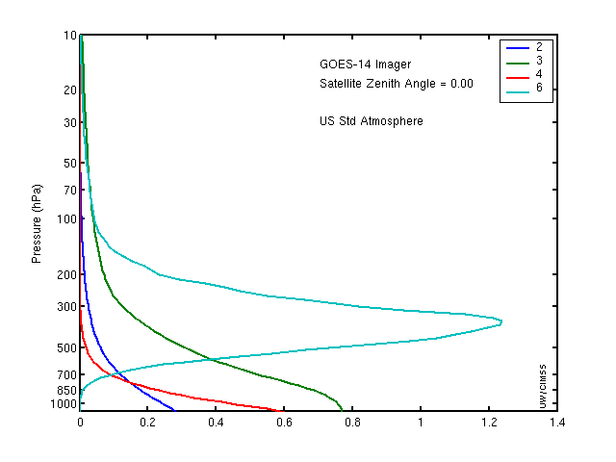
Figure 3.1: The GOES-15 Imager weighting functions.

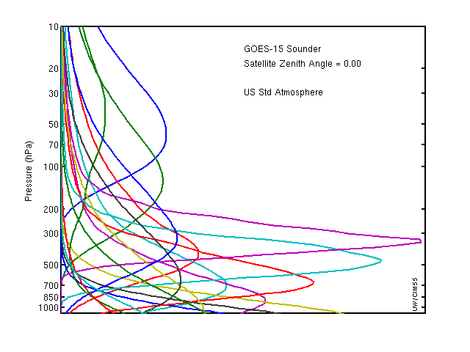
Figure 3.2: The GOES-15 Sounder weighting functions.

GOES Data Quality

First Images

The first step to ensure quality products is to verify the quality of the radiances that are used as inputs to the product generation. This process begins with a visual inspection of the images, at a number of spatial resolutions.

Visible

Figure 4.1: The first visible (0.63 μm) image from the GOES-15 Imager occurred on 6 April 2010 starting at approximately 1730 UTC.

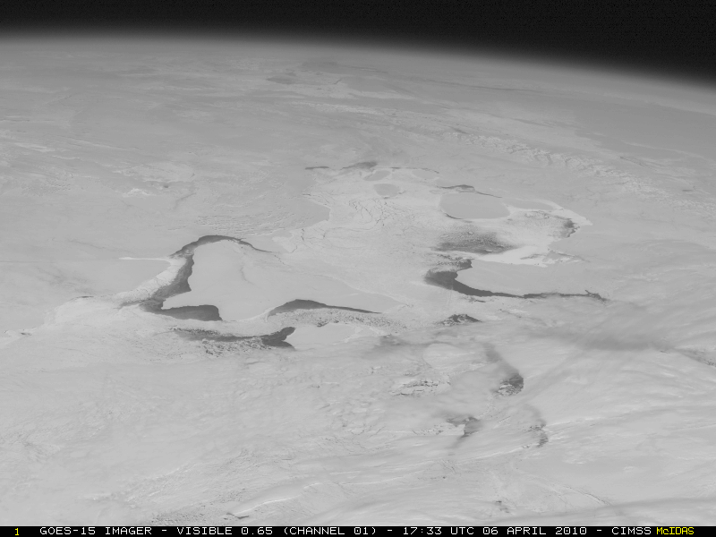
Figure 4.2: A GOES-15 visible image on 6 April 2010 showing a close-up view centered Northern Hudson Bay and the Canadian Arctic Archipelago (showing some areas of ice-free water).

Infrared (IR)

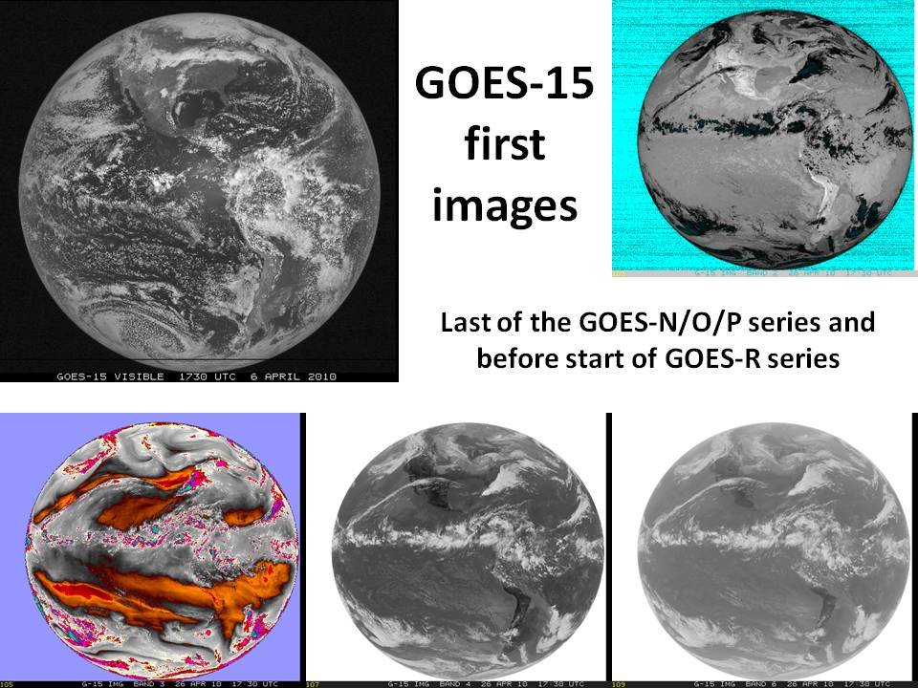
Figure 4.3: First GOES-15 full-disk visible and infrared images from 6 and 26 April 2010, respectively.

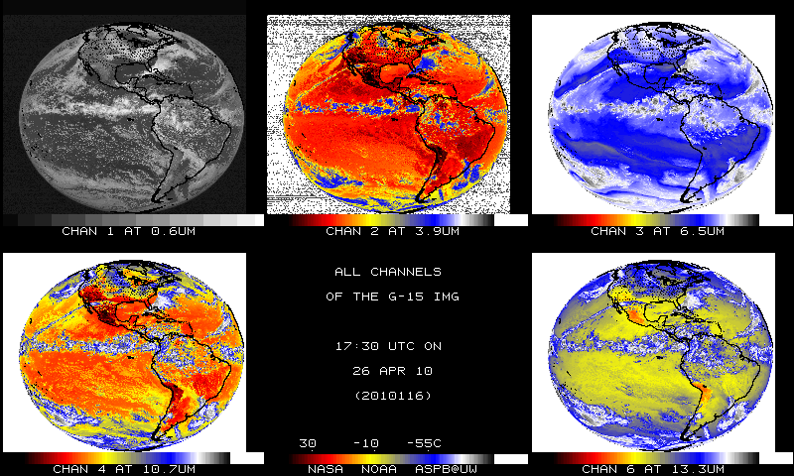
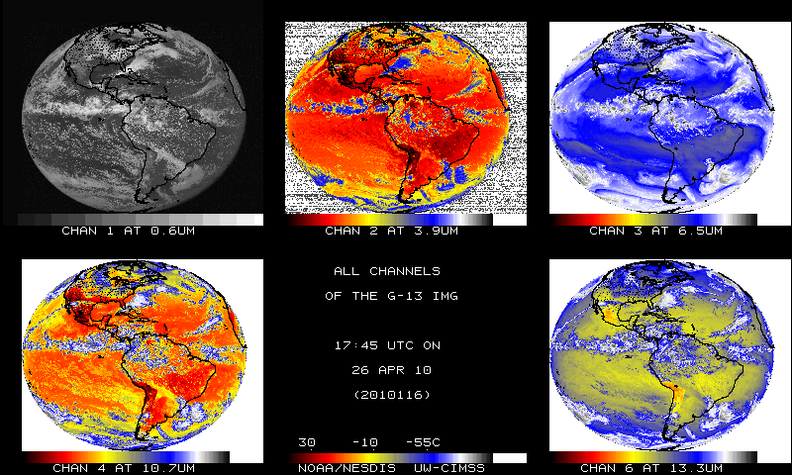
Figure 4.4: GOES-15 Imager bands (top) and the corresponding GOES-13 Imager bands (bottom). Both sets of images are shown in their native projections.

The images in Figure 4.4 have been sub-sampled. The sub-sampling is necessary, in part, due to the fact that the first GOES-14 Imager full disk images were too wide.

Sounder

The first GOES-15 Sounder images showed good qualitative agreement with GOES-12.

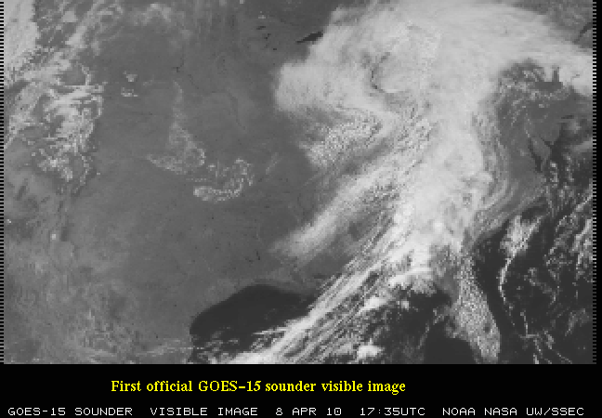
Figure 4.5: The visible (band-19) image from the GOES-15 Sounder shows data from 8 April 2010. The west and east ‘saw-tooth’ edges are due to the geometry of collecting the pixels.

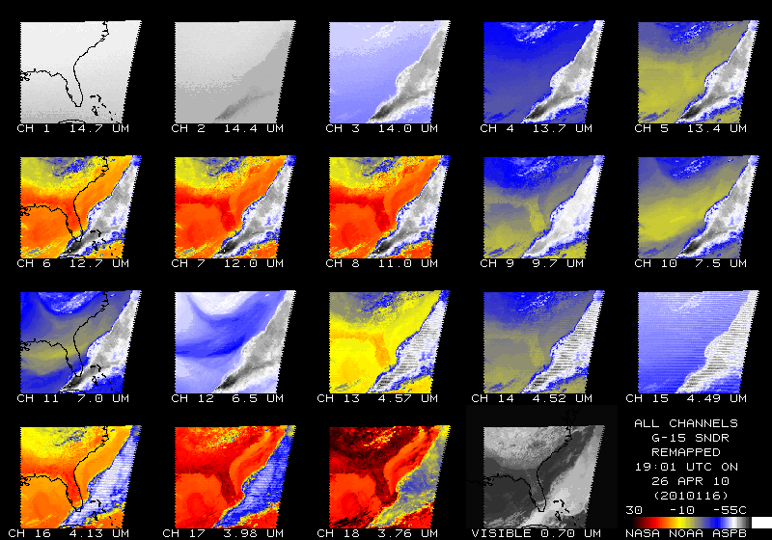

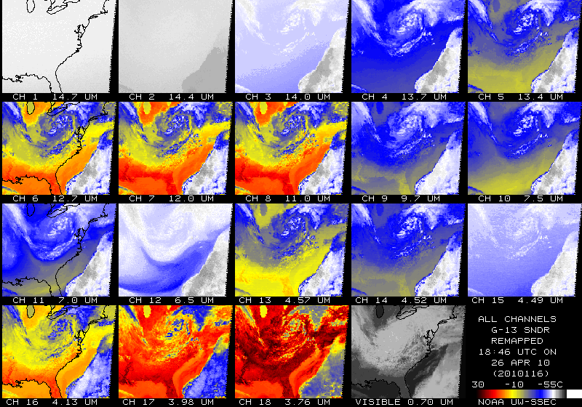
Figure 4.6: The first IR Sounder images for GOES-15 from 26 April 2010 (top) compared to GOES-13 (bottom). Both sets of images have been remapped to a common projection.

Spectral Response Functions (SRFs)

Imager

The GOES spectral response functions (SRFs) for the GOES series Imagers can be found at
http://www.oso.noaa.gov/goes/goes-calibration/goes-imager-srfs.htm and are plotted in Figure 4.7. Note that there several versions off the GOES-15 Imager SRF, but the Revision H should be used. The GOES-15 Imager is spectrally similar to the GOES-12 Imager, in that it has the spectrally-wide ‘water vapor’ band and that a 13.3 μm band has replaced the 12 μm band. Information about the GOES calibration can be found in Weinreb et al. (1997).

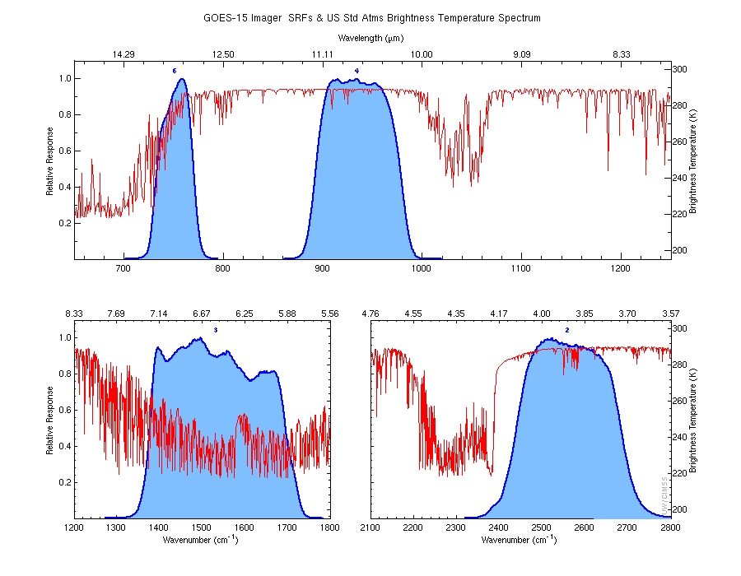
Figure 4.7: The four GOES-15 Imager IR-band SRFs super-imposed over the calculated high-resolution earth-emitted U.S. Standard Atmosphere spectrum. Absorption due to carbon dioxide (CO₂), water vapor (H₂O), and other gases are evident in the high-spectral resolution earth-emitted spectrum.

Sounder

The GOES SRFs for the GOES series Sounders can be found at http://www.oso.noaa.gov/goes/goes-calibration/goes-sounder-srfs.htm and are plotted in Figure 4.8. The GOES-15 Sounder also has a Revision F of the SRF. The overall band selection is unchanged from previous GOES Sounders (Schmit et al. 2002b). As before, the carbon dioxide (CO₂), ozone (O₃), and water vapor (H₂O) absorption bands are indicated in the calculated high-spectral resolution earth-emitted U.S. Standard Atmosphere spectrum. The central wavenumbers (wavelengths) of the spectral bands range from 680 cm⁻¹ (14.7 μm) to 2667 cm⁻¹ (3.75 μm) (Menzel et al. 1998).

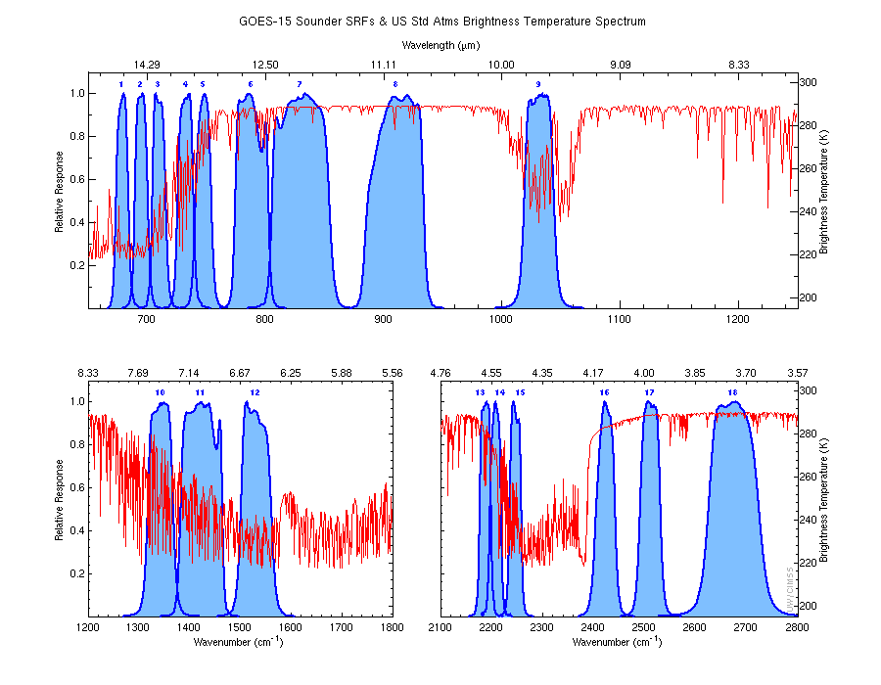
Figure 4.8: The eighteen GOES-15 Sounder IR-band SRFs super-imposed over the calculated high-resolution earth-emitted U.S. Standard Atmosphere spectrum.

Random Noise Estimates

Band noise estimates for the GOES-15 Imager and Sounder were computed using two different approaches. In the first approach, the band noise levels were determined by calculating the variance (and standard deviation) of radiance values in a space-look scene. The second approach involved performing a spatial structure analysis (Hillger and Vonder Haar, 1988). Both approaches yielded nearly identical band noise estimates. Results of the both approaches are presented below.

Imager

Full-disk images for the Imager provided off-earth space views and allowed noise levels to be determined. Estimated noise levels for the GOES-15 Imager were averaged over time for both east and west-limb space views for 48 hours of data starting at 1645 UTC on 21 August 2010 and ending at 1615 UTC on 23 August 2010. Results are presented in Table 4.1 in radiance units. The limb-averaged noise levels (second to last column) compared well with those from simpler variance (standard deviation) analysis (last column), the values of which were computed on a much smaller dataset.

Table 4.1: GOES-15 Imager Noise Levels
(In radiance units, from 48 hours of limb/space views on Julian days 233-235 in 2010).

Imager Band | Central Wavelength  (μm) | East Limb | West Limb | Limb Average | Variance  Analysis
 |  | mW/(m²·sr·cm⁻¹)
2 | 3.9 | 0.0024 | 0.0023 | 0.0024
3 | 6.5 | 0.022 | 0.022 | 0.022
4 | 10.7 | 0.095 | 0.102 | 0.099
6 | 13.3 | 0.22 | 0.22 | 0.22

A further comparison of the noise levels from the GOES-15 Imager with those from previous GOES Imagers is presented in Table 4.2. In this table the noise levels are given in temperature units. In general, noise levels were much improved over those for older GOES, with both GOES-13 and 14 in particular having lower noise in most bands than GOES-8 through 12.

Keep in mind as well, the finer pixel size for band-6 images (from 8 km to 4 km) on both GOES-14 and GOES-15 compared to GOES-13 could be expected to result in an increase in noise. But the noise levels for GOES-14 and GOES-15 band-6 are only slightly higher than it was for GOES-13.

Table 4.2: Summary of the Noise for GOES-8 through GOES-15 Imager Bands
(In temperature units; the Specification (SPEC) values are also listed).

Imager Band | Central  Wavelength  (μm) | GOES-15 | GOES-14 | GOES-13 | GOES-12 | GOES-11 | GOES-10 | GOES-9 | GOES-8 | SPEC
 |  | K @ 300 K, except band-3 @ 230 K
2 | 3.9 | 0.063 | 0.053 | 0.051 | 0.13 | 0.14 | 0.17 | 0.08 | 0.16 | 1.40
3 | 6.5 / 6.7 | 0.17 | 0.18 | 0.14 | 0.15 | 0.22 | 0.09 | 0.15 | 0.27 | 1.00
4 | 10.7 | 0.059 | 0.060 | 0.053 | 0.11 | 0.08 | 0.20 | 0.07 | 0.12 | 0.35
5 | 12.0 |  | - | - | - | 0.20 | 0.24 | 0.14 | 0.20 | 0.35
6 | 13.3 | 0.13 | 0.11 | 0.061 | 0.19 | - | - | - | - | 0.32

Band noise estimates for the GOES-15 Imager and Sounder visible band were also monitored at the GOES-15 Instrument Performance Monitoring (IPM) system. The visible channel noise was evaluated with the standard deviation (1-sigma) of filtered space view raw count ingested from the day-time GOES-15 GVAR Block11 data. For the Imager, we examined the statistics of space view data before and after the space clamp events. Since Sounder is clamped with filter wheel, the detector noise of the Sounder visible channel was assessed with the space view statistics at every two minutes. The results are shown in Figure 4.9, together with the noise values for the Imagers and Sounders onboard at GOES-11 through GOES-14. The noises of GOES-15 visible instruments are comparable to the other instruments of GOES-NOP series, though with not the least values. Compared to GOES-11/12, GOES-NOP satellites have much better quality of visible data in term of reduced noise, mainly resulted from hardware improvements such as the lower patch temperature.

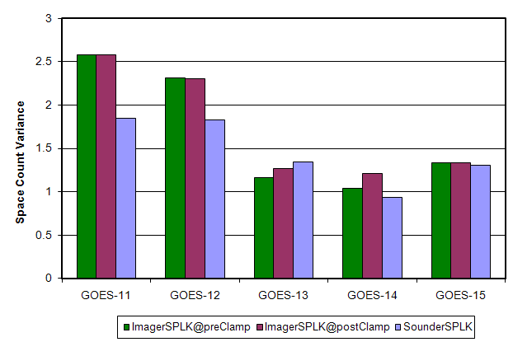

Figure 4.9: The mean standard deviation of the Imager space view count at before and after the Imager space clamp events, and Sounder space view count for GOES-11 through GOES-15.
Figure 4.10 is the standard deviation values of the 8 Imager visible detectors from August 21, 2010 to August 23, 2010. As shown in the figures, detector #3 of the Imager visible channel is noisier than the other detectors at both pre-clamp and post-clamp space views.

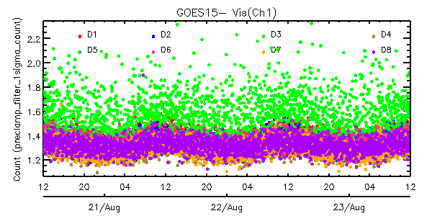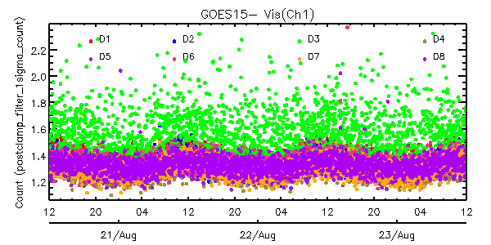
Figure 4.10: Times series of the standard deviations of space view count for the eight detectors of GOES15 Imager visible channel from August 20, 2010 (12:00UTC)– August 23, 2010 (12:00UTC) (left: pre-clamp space view statistics, right: post-clamp space view statistics).
The noise in the GOES-15 IR bands was monitored using Noise Equivalent delta Radiance (NEdR) and Noise Equivalent delta Temperature (NEdT) of blackbody scan data with the GOES IPM system. GOES-15 Imager IR band noise in temperature units is compared to the rest of the GOES series (GOES-8 through GOES-14) in Table 4.3. The data clearly shows that the noises of all the GOES Imager Infrared (IR) channels are well below their specifications. The noises of the four GOES-15 IR channels are comparable with those of other GOES NOP instruments and band 6 seems to be the noisiest among the all four similar instruments.

Table 4.3: Summary of the noise (in temperature units) for GOES-8 through GOES-15 Imager IR bands. The specification (SPEC) noise levels are also listed.

Band | Central wave-length (µm) | 15 | 14 | 13 | 12 | 11 | 10 | 9 | 8 | SPEC
 |  |  | K @ 300 K, except band-3 @ 230 K
2 | 3.9 | 0.064 | 0.057 | 0.059 | 0.102 | 0.123 | 0.090 | 0.094 | 0.092 | 1.4
3 | 6.5 | 0.186 | 0.197 | 0.170 | 0.149 | 0.265 | 0.149 | 0.134 | 0.160 | 1.0
4 | 10.7 | 0.044 | 0.051 | 0.045 | 0.073 | 0.073 | 0.061 | 0.055 | 0.173 | 0.35
5 | 12.0 |  |  |  |  | 0.176 | 0.112 | 0.123 | 0.172 | 0.35
6 | 13.3 | 0.118 | 0.106 | 0.067 | 0.102 |  |  |  |  | 0.32

Figure 4.11 clearly shows that the noise of each GOES-15 Imager IR detector is well below the specification and no significant NEdT trend can be observed.

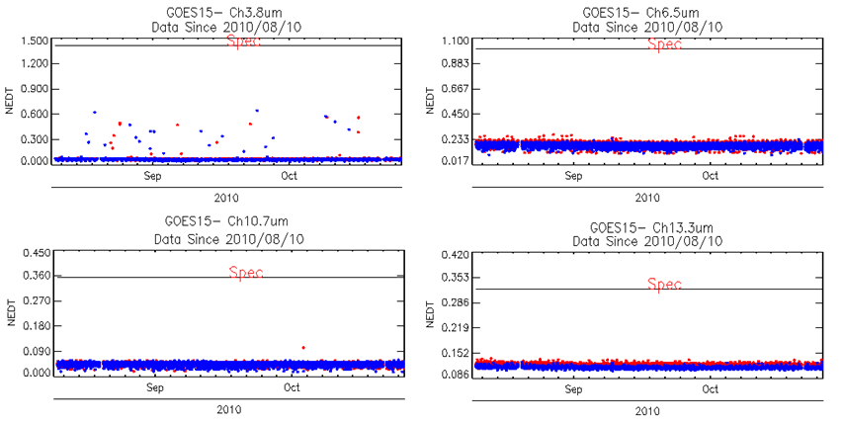
Figure 4.11: Time series of the GOES-15 Imager NEdT calculated at 300 K temperature, except band-3 at 230 K, compared to the specifications. The ‘spec’ line is also plotted. The color of the points refer to the detector number.

Sounder

Special GOES-15 limb-view Sounder sectors allow noise values to be determined by the scatter of radiance values looking at uniform off-earth space views. Noise values were computed for both west-limb and east-limb space-view data and averaged over the 32 hour period from 1630 UTC on 4 September 2010 through 0030 UTC on 6 December 2010. The limb-averaged values in Table 4.4 (second to last column) compare well to those from a simpler variance analysis (last column).

Table 4.4: GOES-15 Sounder Noise Levels
(In radiance units, from 32 hours of limb/space views on Julian days 247-248).

Sounder Band | Central Wavelength  (μm) | East Limb | West Limb | Limb Average | Variance  Analysis
 |  | mW/(m²·sr·cm⁻¹)
1 | 14.71 | 0.23 | 0.23 | 0.23
2 | 14.37 | 0.21 | 0.21 | 0.21
3 | 14.06 | 0.22 | 0.21 | 0.22
4 | 13.64 | 0.17 | 0.17 | 0.17
5 | 13.37 | 0.15 | 0.15 | 0.15
6 | 12.66 | 0.066 | 0.069 | 0.068
7 | 12.02 | 0.044 | 0.048 | 0.046
8 | 11.03 | 0.053 | 0.061 | 0.057
9 | 9.71 | 0.064 | 0.069 | 0.067
10 | 7.43 | 0.036 | 0.037 | 0.037
11 | 7.02 | 0.024 | 0.024 | 0.024
12 | 6.51 | 0.030 | 0.029 | 0.030
13 | 4.57 | 0.016 | 0.011 | 0.014
14 | 4.52 | 0.019 | 0.013 | 0.016
15 | 4.46 | 0.017 | 0.013 | 0.015
16 | 4.13 | 0.010 | 0.0064 | 0.0082
17 | 3.98 | 0.0067 | 0.0042 | 0.0055
18 | 3.74 | 0.0024 | 0.0014 | 0.0019

A further comparison of the noise levels for the GOES-15 Sounder with those from previous GOES Sounders is presented in Table 4.5. Noise levels are in general much improved over those for older GOES, with GOES-13 through GOES-15 having lower noise in most bands than GOES-8 through 12.

Table 4.5: Summary of the Noise for GOES-8 through GOES-15 Sounder Bands
(In radiance units; the Specification (SPEC) values are also listed).

Sounder Band | Central  Wavelength  (μm) | GOES-15 | GOES-14 | GOES-13 | GOES-12 | GOES-11 | GOES-10 | GOES-9 | GOES-8 | SPEC
 |  | mW/(m²·sr·cm⁻¹)
1 | 14.71 | 0.23 | 0.29 | 0.32 | 0.77 | 0.67 | 0.71 | 1.16 | 1.76 | 0.66
2 | 14.37 | 0.21 | 0.24 | 0.25 | 0.61 | 0.51 | 0.51 | 0.80 | 1.21 | 0.58
3 | 14.06 | 0.22 | 0.21 | 0.23 | 0.45 | 0.37 | 0.41 | 0.56 | 0.98 | 0.54
4 | 13.64 | 0.17 | 0.16 | 0.18 | 0.39 | 0.36 | 0.41 | 0.46 | 0.74 | 0.45
5 | 13.37 | 0.15 | 0.15 | 0.18 | 0.34 | 0.34 | 0.36 | 0.45 | 0.68 | 0.44
6 | 12.66 | 0.068 | 0.073 | 0.095 | 0.14 | 0.17 | 0.16 | 0.19 | 0.32 | 0.25
7 | 12.02 | 0.046 | 0.053 | 0.086 | 0.11 | 0.11 | 0.09 | 0.13 | 0.20 | 0.16
8 | 11.03 | 0.057 | 0.076 | 0.10 | 0.11 | 0.14 | 0.12 | 0.09 | 0.13 | 0.16
9 | 9.71 | 0.067 | 0.068 | 0.11 | 0.14 | 0.13 | 0.10 | 0.11 | 0.16 | 0.33
10 | 7.43 | 0.037 | 0.039 | 0.081 | 0.099 | 0.09 | 0.07 | 0.08 | 0.08 | 0.16
11 | 7.02 | 0.024 | 0.025 | 0.046 | 0.059 | 0.06 | 0.04 | 0.05 | 0.07 | 0.12
12 | 6.51 | 0.030 | 0.029 | 0.063 | 0.11 | 0.11 | 0.07 | 0.09 | 0.11 | 0.15
13 | 4.57 | 0.014 | 0.0035 | 0.0061 | 0.0062 | 0.006 | 0.007 | 0.008 | 0.012 | 0.013
14 | 4.52 | 0.016 | 0.0035 | 0.0064 | 0.0062 | 0.007 | 0.005 | 0.007 | 0.010 | 0.013
15 | 4.46 | 0.015 | 0.0033 | 0.0055 | 0.0066 | 0.006 | 0.005 | 0.006 | 0.009 | 0.013
16 | 4.13 | 0.0082 | 0.0019 | 0.0030 | 0.0024 | 0.003 | 0.003 | 0.003 | 0.004 | 0.008
17 | 3.98 | 0.0055 | 0.0016 | 0.0026 | 0.0022 | 0.003 | 0.002 | 0.003 | 0.004 | 0.008
18 | 3.74 | 0.0019 | 0.00074 | 0.0011 | 0.00094 | 0.001 | 0.001 | 0.001 | 0.002 | 0.004

Figure 4.12 is the standard deviation values of the four Sounder visible detectors from October 7, 2010 to October 9, 2010. The four Sounder visible detectors have a similar standard deviation magnitude of the filtered space view.

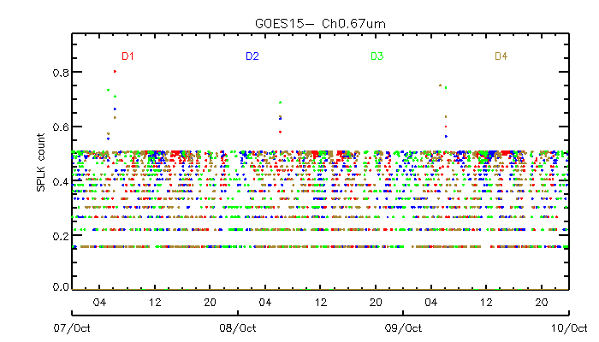

Figure 4.12: Standard deviations of space view count for the four GOES-15 Sounder visible detectors from October 7, 2010 (00:00UTC) to October 9, 2010 (00:00UTC).

GOES-15 Sounder noise was monitored with NEdR and NEdT at blackbody scan with measured blackbody temperature, and the results are also available at the GOES-15 IPM Web page. Tables 4.6 and 4.7 summarize the noise levels for GOES-8 through GOES-15. In general, the GOES-14 Sounder noise levels are improved compared to previous GOES Sounders.

Table 4.6: GOES-15 Sounder NEdR compared to those from GOES-8 through GOES-14 and the specification noise values.
Sounder Band | Central Wave-length (µm) | 15 | 14 | 13 | 12 | 11 | 10 | 9 | 8 | SPEC
 |  |  | mW/(m²·sr·cm⁻¹)
1 | 14.71 | 0.282 | 0.268 | 0.288 | 0.326 | 0.300 | 0.645 | 0.563 | 0.998 | 0.66
2 | 14.37 | 0.263 | 0.221 | 0.230 | 0.282 | 0.247 | 0.441 | 0.455 | 0.755 | 0.58
3 | 14.06 | 0.265 | 0.188 | 0.211 | 0.221 | 0.186 | 0.347 | 0.344 | 0.685 | 0.54
4 | 13.64 | 0.212 | 0.142 | 0.167 | 0.200 | 0.179 | 0.360 | 0.294 | 0.512 | 0.45
5 | 13.37 | 0.184 | 0.141 | 0.169 | 0.185 | 0.175 | 0.338 | 0.275 | 0.495 | 0.44
6 | 12.66 | 0.073 | 0.064 | 0.080 | 0.076 | 0.092 | 0.147 | 0.127 | 0.223 | 0.25
7 | 12.02 | 0.043 | 0.042 | 0.054 | 0.056 | 0.058 | 0.079 | 0.080 | 0.144 | 0.16
8 | 11.03 | 0.053 | 0.044 | 0.097 | 0.127 | 0.137 | 0.096 | 0.079 | 0.129 | 0.16
9 | 9.71 | 0.073 | 0.054 | 0.127 | 0.184 | 0.132 | 0.120 | 0.113 | 0.161 | 0.33
10 | 7.43 | 0.041 | 0.033 | 0.096 | 0.129 | 0.107 | 0.077 | 0.716 | 0.082 | 0.16
11 | 7.02 | 0.027 | 0.020 | 0.054 | 0.075 | 0.070 | 0.048 | 0.044 | 0.071 | 0.12
12 | 6.51 | 0.032 | 0.027 | 0.076 | 0.138 | 0.134 | 0.091 | 0.079 | 0.111 | 0.15
13 | 4.57 | 0.005 | 0.0028 | 0.0046 | 0.024 | 0.0045 | 0.006 | 0.006 | 0.008 | 0.013
14 | 4.52 | 0.005 | 0.0029 | 0.0049 | 0.023 | 0.0056 | 0.004 | 0.005 | 0.008 | 0.013
15 | 4.46 | 0.005 | 0.0025 | 0.0042 | 0.025 | 0.0044 | 0.004 | 0.005 | 0.008 | 0.013
16 | 4.13 | 0.003 | 0.0016 | 0.0023 | 0.009 | 0.0023 | 0.002 | 0.002 | 0.003 | 0.008
17 | 3.98 | 0.002 | 0.0013 | 0.0020 | 0.008 | 0.0021 | 0.002 | 0.002 | 0.002 | 0.008
18 | 3.74 | <0.0001 | <0.0001 | <0.0001 | 0.0033 | 0.0010 | <0.0001 | 0.001 | 0.002 | 0.004

Table 4.7: GOES-15 Sounder NEdT compared to those from GOES-8 through GOES-14.

Sounder Band | Central Wave-length (µm) | GOES-15 | GOES-14 | GOES-13 | GOES-12 | GOES-11 | GOES-10 | GOES-9 | GOES-8
 |  | K @ blackbody temperature
1 | 14.71 | 0.167 | 0.158 | 0.170 | 0.193 | 0.178 | 0.383 | 0.333 | 0.591
2 | 14.37 | 0.154 | 0.129 | 0.135 | 0.165 | 0.147 | 0.259 | 0.267 | 0.443
3 | 14.06 | 0.154 | 0.109 | 0.123 | 0.128 | 0.108 | 0.201 | 0.199 | 0.398
4 | 13.64 | 0.122 | 0.082 | 0.096 | 0.115 | 0.103 | 0.208 | 0.169 | 0.295
5 | 13.37 | 0.105 | 0.081 | 0.097 | 0.106 | 0.100 | 0.194 | 0.158 | 0.283
6 | 12.66 | 0.042 | 0.036 | 0.046 | 0.043 | 0.053 | 0.084 | 0.072 | 0.127
7 | 12.02 | 0.025 | 0.024 | 0.031 | 0.032 | 0.033 | 0.045 | 0.046 | 0.082
8 | 11.03 | 0.031 | 0.026 | 0.057 | 0.074 | 0.081 | 0.056 | 0.047 | 0.076
9 | 9.71 | 0.047 | 0.035 | 0.082 | 0.118 | 0.104 | 0.077 | 0.072 | 0.103
10 | 7.43 | 0.042 | 0.034 | 0.097 | 0.130 | 0.108 | 0.078 | 0.071 | 0.082
11 | 7.02 | 0.032 | 0.023 | 0.063 | 0.088 | 0.083 | 0.056 | 0.052 | 0.084
12 | 6.51 | 0.048 | 0.039 | 0.112 | 0.206 | 0.201 | 0.135 | 0.116 | 0.165
13 | 4.57 | 0.042 | 0.023 | 0.038 | 0.195 | 0.038 | 0.047 | 0.045 | 0.084
14 | 4.52 | 0.048 | 0.026 | 0.043 | 0.205 | 0.050 | 0.035 | 0.046 | 0.067
15 | 4.46 | 0.052 | 0.025 | 0.042 | 0.248 | 0.043 | 0.037 | 0.046 | 0.075
16 | 4.13 | 0.047 | 0.027 | 0.038 | 0.147 | 0.040 | 0.038 | 0.039 | 0.056
17 | 3.98 | 0.047 | 0.028 | 0.045 | 0.186 | 0.047 | 0.042 | 0.054 | 0.085
18 | 3.74 | <0.001 | <0.001 | <0.001 | 0.119 | 0.037 | <0.001 | 0.038 | 0.064

Figure 4.13 is the time-series of the NEdT for the four detectors at each IR channel in mid-September, 2011. The NEdT is very consistent over the two-day period and the noise of each GOES-15 Sounder IR channel is well below its specification when the patch temperature was controlled at low-level.

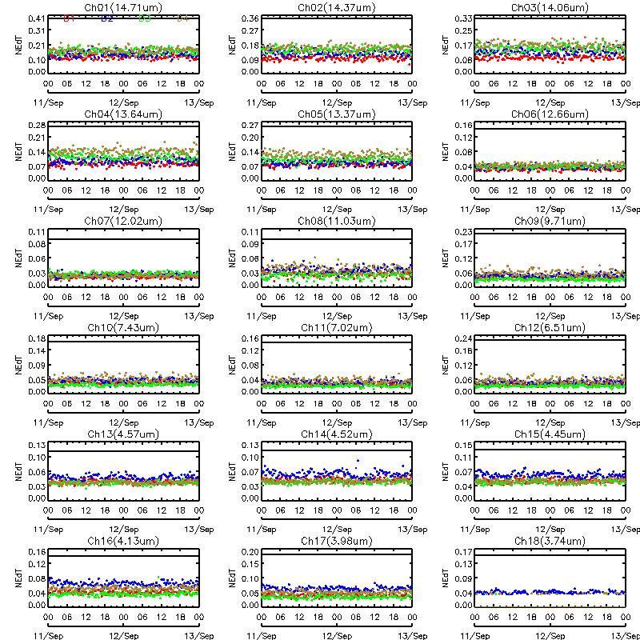
Figure 4.13: Diurnal variation of GOES-15 Sounder NEdT between September 11, 2010 and September 12, 2010. The solid line in each IR channel plot is the specification value. The colors correspond to the 4 detectors.

Striping Due to Multiple Detectors

For the GOES Imager there are two detectors per spectral band, and for the GOES Sounder, there are four detectors for each spectral band. Differences between the measurements in these detectors can cause striping in GOES images. Striping becomes more obvious as random noise decreases, allowing the striping to dominate the random noise. Striping is defined as the difference between the average values for each detector from the average value in all detectors.

Imager

Full-disk images from the Imager provide off-earth space views, allowing both noise levels (reported above) and detector-to-detector striping to be determined in an otherwise constant signal situation. Table 4.8 gives estimates of GOES-15 Imager detector-to-detector striping for a 24 hour period starting at 1645 UTC 21 August 2010 and ending at 1615 UTC on 23 August 2010. Striping was computed from off-earth space-view measurements on each side of the earth (columns 3 and 4). The limb averages (third to last column) are then determined and compared to the noise level (second to last column). A ratio of striping to noise is also computed (last column). All the ratios are less than 1, indicating that the striping is less than the noise. Because the noise has decreased with the latest GOES series, the striping can more obvious than for earlier GOES, as will be seen in some of the Sounder images presented later in this report.

Table 4.8: GOES-15 Imager Detector-to-Detector Striping
(In radiance units, from 48 hours of limb/space views on Julian days 233-235).

Imager Band | Central Wavelength  (μm) | East Limb | West Limb | Limb Average | Noise | Striping/Noise Ratio
 |  | mW/(m²·sr·cm⁻¹)
2 | 3.9 | 0.00103 | 0.00063 | 0.00083 | 0.0024 | 0.35
3 | 6.5 | 0.0026 | 0.0023 | 0.0025 | 0.022 | 0.11
4 | 10.7 | 0.025 | 0.026 | 0.026 | 0.099 | 0.26
6 | 13.3 | 0.024 | 0.0095 | 0.017 | 0.22 | 0.076

Sounder

Detector-to-detector striping for the Sounder is documented in Table 4.9 from measurements taken from the same off-earth space-view sectors used for the noise analysis for the Sounder, for the 32 hour period from 1630 UTC on 4 September 2010 through ~0030 UTC on 6 December 2010. The limb-averaged values (third from last column) are compared to the noise levels (second to last column), with the ratio of striping to noise in the last column. Values larger than one (sometimes much larger), indicate that striping is much more significant than noise for several of the Sounder bands. The largest ratios, for the longwave IR bands, do not mean that striping is obvious in the images from these bands, because the inherent signal is also very large in these window bands.

Table 4.9: GOES-15 Sounder Detector-to-Detector Striping
(In radiance units, from 32 hours of limb/space views on Julian days 247-248).

Sounder Band | Central Wavelength  (μm) | East Limb | West Limb | Limb Average | Noise | Striping/Noise Ratio
 |  | mW/(m²·sr·cm⁻¹)
1 | 14.71 | 0.48 | 0.81 | 0.65 | 0.23 | 2.8
2 | 14.37 | 0.42 | 0.74 | 0.58 | 0.21 | 2.8
3 | 14.06 | 0.52 | 0.92 | 0.72 | 0.22 | 3.3
4 | 13.64 | 0.71 | 1.22 | 0.97 | 0.17 | 5.7
5 | 13.37 | 0.80 | 1.31 | 1.06 | 0.15 | 7.0
6 | 12.66 | 1.08 | 1.79 | 1.44 | 0.068 | 21.1
7 | 12.02 | 1.06 | 1.77 | 1.42 | 0.046 | 30.8
8 | 11.03 | 0.95 | 1.44 | 1.20 | 0.057 | 21.0
9 | 9.71 | 0.42 | 0.66 | 0.54 | 0.067 | 8.1
10 | 7.43 | 0.17 | 0.29 | 0.23 | 0.037 | 6.2
11 | 7.02 | 0.10 | 0.19 | 0.15 | 0.024 | 6.0
12 | 6.51 | 0.043 | 0.061 | 0.052 | 0.030 | 1.7
13 | 4.57 | 0.031 | 0.034 | 0.033 | 0.014 | 2.3
14 | 4.52 | 0.020 | 0.017 | 0.019 | 0.016 | 1.2
15 | 4.46 | 0.017 | 0.011 | 0.014 | 0.015 | 0.9
16 | 4.13 | 0.015 | 0.017 | 0.016 | 0.0082 | 2.0
17 | 3.98 | 0.016 | 0.012 | 0.014 | 0.0055 | 2.5
18 | 3.74 | 0.0083 | 0.014 | 0.011 | 0.0019 | 5.9

Initial post-launch calibration for the GOES-15 Imager visible channel

Due to lack of on-board calibration device for the GOES visible channel, vicarious calibration is needed to derive accurate post-launch calibrated radiance/reflectance for the visible channels. Currently, the post-launch operational calibration of the GOES Imager visible channel is based on the inter-calibration between GOES and Terra Moderate Resolution Imaging Spectroradiometer (MODIS) Band 1 data (Wu and Sun 2005). The calibration correction of the post-launch GOES-15 Imager visible channel data can be written as:

R_{post} = R_{pre} * C

Where R_{post} is the post-launch calibration reflectance/radiance for GOES-15 Imager visible channel; R_{pre} is the pre-launch calibration reflectance/radiance (http://www.star.nesdis.noaa.gov/smcd/spb/fwu/homepage/GOES_Imager_Vis_PreCal.php); and C is the correction factor, C = 1.082(±0.017). This result was derived based on the collocated GOES-15 and Terra MODIS pixels acquired on Julian days in 2010 of: 228, 244, 248, 253, 273, 276, 278, 285, 89, and 294.

GEO to GEO comparisons

During the PLT period, GOES-15 was orbiting at (89.5ºW), between GOES-11 (135ºW) and GOES-13 (75ºW) to emulate the GOES-11 and -13 scan patterns. The comparison of reflectance or emissivity (radiance/brightness temperature) over the collocated regions offers a unique opportunity to evaluate the consistency of a same product retrieved from two different GOES satellites. Similar collocation criteria as the GEO-LEO inter-calibration was applied to identify the GEO-GEO collocation scenes, including, 1) the distance between the centers of two GEO pixels should be within the radius of the nominal spatial resolution at nadir (spatial collocation), 2) the time difference between the two observations should be less than 5 minutes (temporal collocation) for Imagers and 15 minutes for Sounders, 3) the difference in the cosine of the viewing zenith angle should be within 1% (viewing geometry match).

Figure 4.14 shows the spatial distribution of collocation pixels of GOES-15 vs. GOES-13 Imagers (left) and GOES-15 vs. GOES-11 Imagers (right) in the north hemisphere. Due to the closer sub-satellite locations, the collocation pixels of GOES-15 vs. GOES-13 have much wider spatial distribution than GOES-15 vs. GOES-11, covering from the Equator to about 50o in latitude and centered about ±2º around 82.25W in longitude. The GOES-15 vs. GOES-11 collocation pixel distribution is centered about ±0.6º at 112.25ºW meridian. The high frequency and large amount of collocation scenes provides an excellent opportunity to directly inter-compare the radiance from these two satellites. All the GEO-GEO inter-calibration results are based on the analysis of collocation data from September 26, 2010 to September 28, 2010 for GOES-15 vs. GOES-13 and from August 26, 2010 to August 28, 2010 for GOES-15 vs. GOES-11.
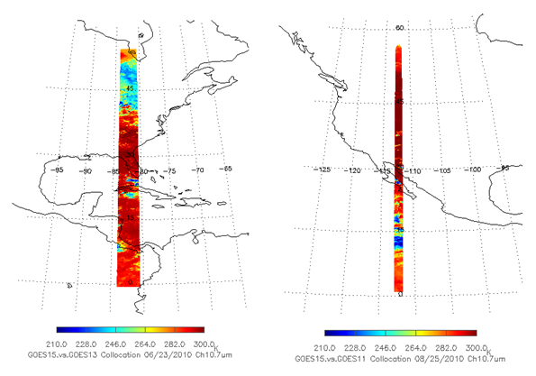
Figure 4.14: Spatial distribution of GOES 15 Imager band 4 Tb values for the collocation scenes between GOES-13 (left) and GOES-11(right).

Figure 4.15 shows the difference of post-launch calibrated reflectance between GOES-15 and GOES-13 (left) and the histogram distribution of the reflectance difference (right). On average, the GOES-15 reflectance is about 1.0% higher than GOES-13 and 2.1% lower than GOES-11. The small reflectance difference between these radiometers indicates that the operational post-launch calibration corrections can reduce the “seam” feature along the overlapped areas. Causes of the difference include the SRF difference (Figure 4.16), bidirectional reflectance function distribution (BRDF), and the operational calibration uncertainty. Note the large SRF differences between the GOES-8/11, compared to GOES-13/15. This causes differences in the reflection from vegetative surfaces, given the sharp transition zone near 7.2 μm (not shown).

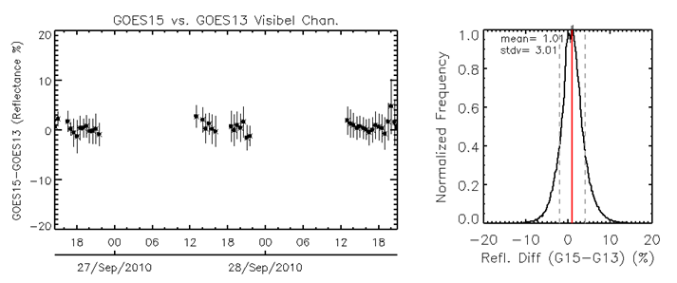
Figure 4.15: Time-series of GOES-15 vs. GOES-13 post-launch calibrated reflectance difference (left) and the histogram of the reflectance difference (right).

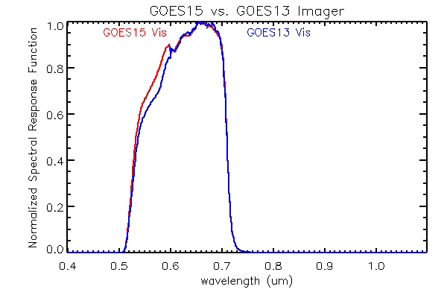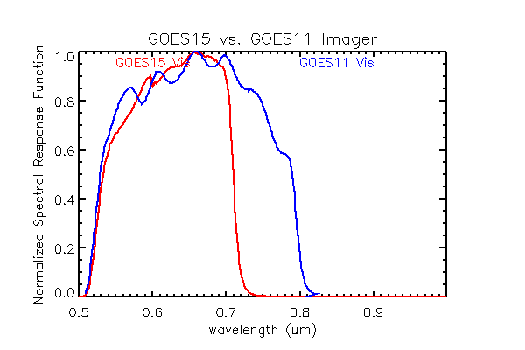
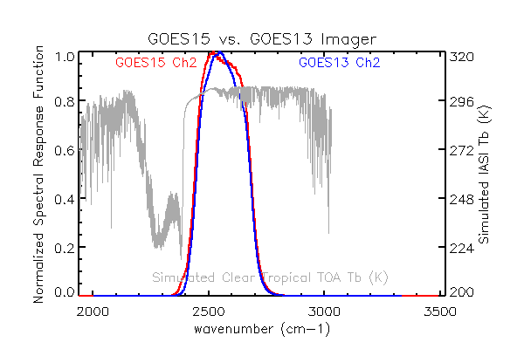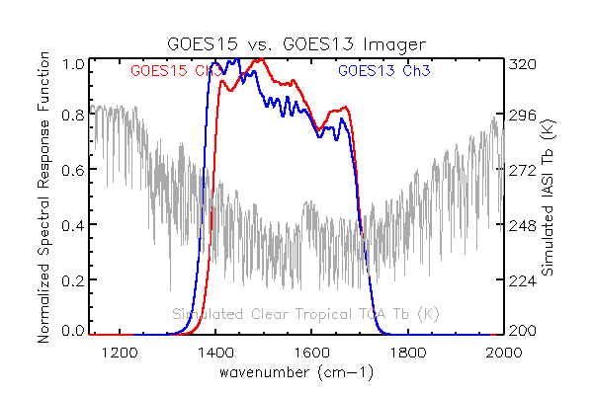
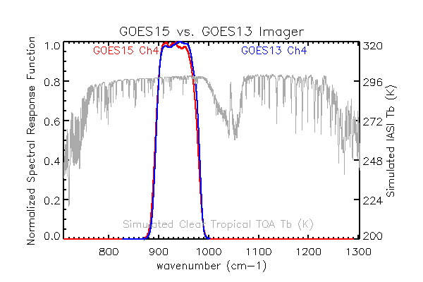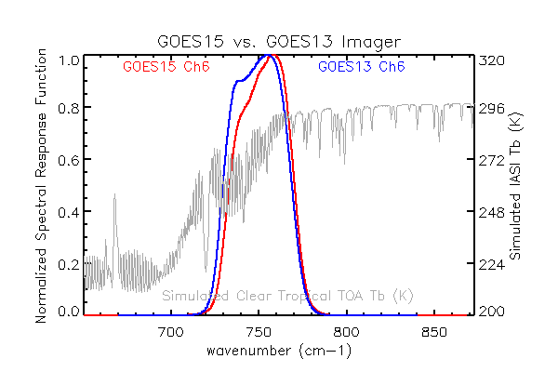
Figure 4.16: SRF of the visible channels at GOES-15 vs. GOES-13 (top left) and GOES-15 vs. GOES-11 (top right). SRF of GOES-13 and GOES-15 four IR channels (red: GOES-15, blue: GOES-13). The simulated clear tropical TOA Tb values (in gray) are also plotted for the four IR channels.

The distribution of the spectral response function plays a dominant role in determining the Tb difference at this direct GEO-GEO inter-comparison in this study, especially for the absorptive channels of band 3 (6.5µm) and band 6 (13.3µm). Figure 4.16 shows the SRF of the four Imager IR channels at GOES-13 and GOES-15. The simulated clear tropical top-of-atmosphere (TOA) Tb values using the IASI spectra are also plotted for the four IR channels.

GOES-15 data were also evaluated by comparing pixel temperatures of a 10 x 10 pixel box in a Mercator projection centered at 40˚N/82.25˚W for bands 2, 3, 4 and 6 to a similar domain on the operational GOES-East satellite (GOES-13). This location was chosen to keep the satellite zenith angle consistent between GOES-13 and GOES-15. All results were plotted in a two-dimensional smoothed histogram approach which allows for a better representation of data in dense areas (Eilers and Goeman 2004). Additionally, numerous statistics were calculated in order to determine the performance of the GOES-15 imager bands compared to the respective imager bands on GOES-13.

GOES-15 testing began in SAB on August 11, 2010 and was completed on October 18, 2010. This testing period resulted in sample sizes of over 180,000 pixels for all bands tested. Figure 4.17 shows two-dimensional smoothed histograms of GOES-13 vs. GOES-15 pixel temperatures taken from a 10 x 10 domain centered at 40˚N/82.25˚W for bands 2, 3, 4 and 6. A dashed line representing the perfect fit line with numerous performance statistics is included on the graphs. A nearly perfect degree of correlation (r > 0.98) was observed between GOES-13 and GOES-15 pixel temperatures for all tested bands. On bands 2 and 4, no significant biases were detected in the data. Mean Absolute Errors (MAE) were less than or equal to roughly 1.5 K for bands 2 and 4. For bands 3 and 6, SAB did note a modest cold bias of roughly 1.2 K for GOES-15 band 3 data and a more significant warm bias of 2.7 K for GOES-15 band 6 data. MAE's for the channel 3 and 6 pixel temperatures nearly matched the magnitude of the observed biases which suggests very few instances where GOES-15 pixel temperatures deviated from their respective observed bias. It is noted that the observed biases of the band 3 and 6 data is consistent with central wavelength shifts of both band 3 and 6 data on GOES-15 although the magnitude of channel 6 data is larger than what SAB expected considering the small wavelength shift. This is consistent with the polar-to-geo comparisons that showed a large bias in bands 3 and 6, along with the fact that this analysis was done before implemented a SRF shift. Root Mean Square Errors (RMSE) in most cases were similar to their respective MAE’s and this implies that the number of large errors were minimal. Any large errors that were observed were manually investigated and most were determined to be a function of slight navigational errors near cloud edges.

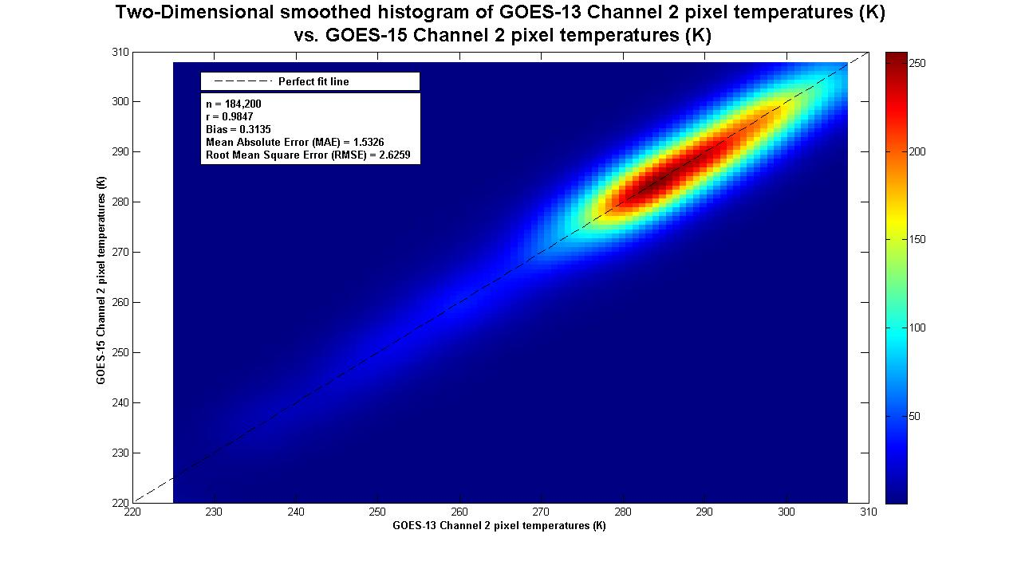
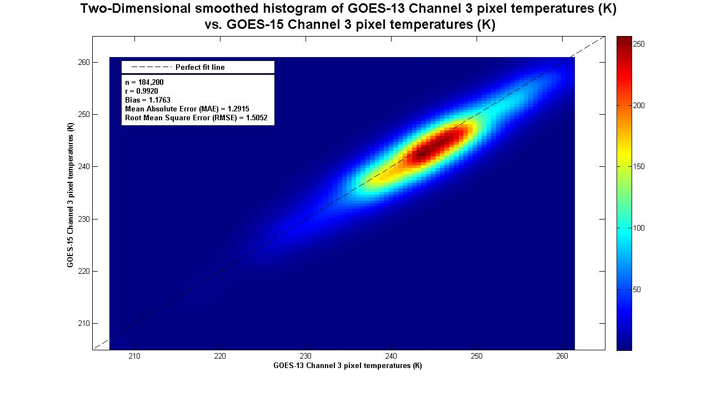
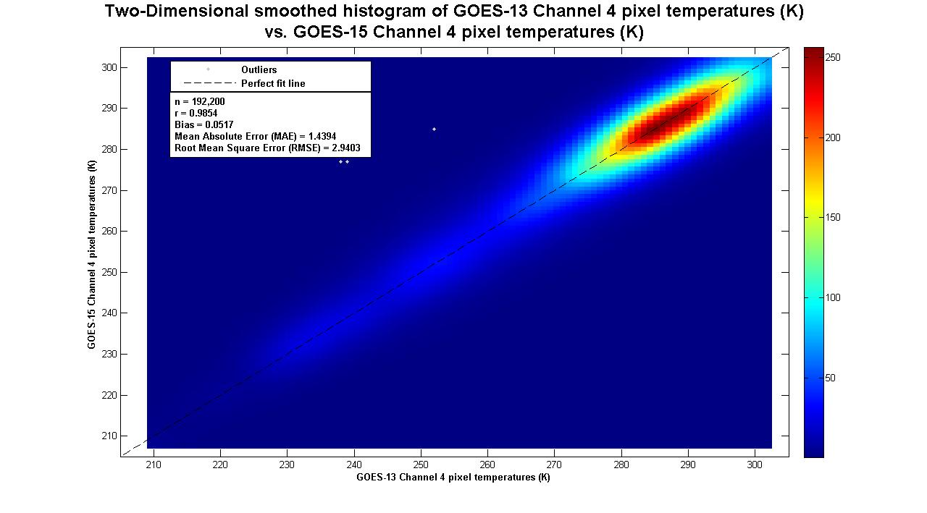
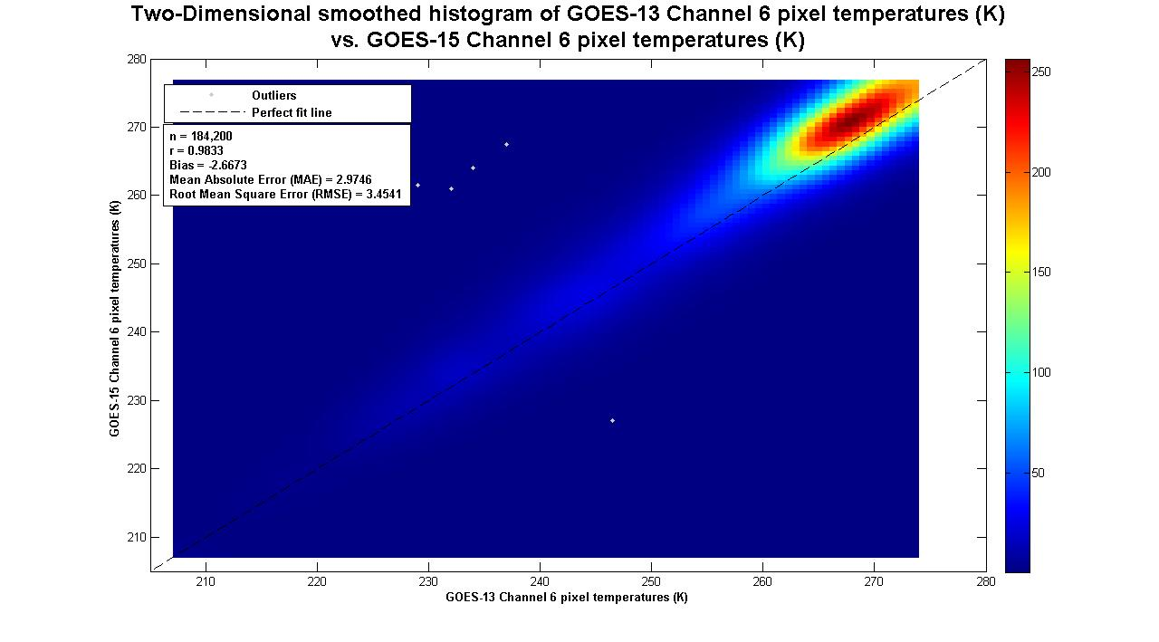
Figure 4.17: Two-Dimensional smoothed histogram of GOES-13 Band 2, 3, 4 and 6 pixel temperatures (K) vs. GOES-15 Band 2, 3, 4 and 6 pixel temperatures.
Figure 4.18 is the mean Tb difference (black dots) and standard deviation (gray line segments) between GOES-13 and GOES-15 for the four IR channels at half-hour time bins from June 24 to 26, 2010. Since band 2 (3.9µm) can also receive reflected solar radiation, a large variation of day-time Tb difference statistics are expected as the two satellites always view the collocated pixels from different directions and the surface is usually characterized with directional reflectance. The small variation of Tb difference around the midnight time indicates there is still some MBCC calibration residual, although it in general performs well at this channel at both satellite. The mean Tb difference between GOES-15 and GOES-13 is -0.30(±0.19) K (Table 4.10).

The Tb difference and statistics are very consistent for band 3 (6.5µm) as the atmospheric water vapor that the detectors of this channel detect is relatively homogenous. The mean Tb difference between these two satellites is -0.05 (±0.06) K over the three day studies. Considering that GOES-15 has ~2K Tb difference to AIRS/IASI and GOES-13 has <0.2K Tb difference to these two hyperspectral radiometers, the large discrepancy of the GEO-LEO and GEO-GEO inter-calibration results is because the radiometric calibration of the absorptive channels is sensitive to the spectral response function (SRF) distribution and SRF calibration uncertainty. Further work is needed to take account of the difference in the SRF.

The mean Tb difference of band 4 (10.7µm) between GOES-15 and GOES-13 is 0.08 (±0.15) K. The small, consistent day-time Tb difference, together with the small Tb bias to AIRS/IASI of these two instruments, indicates that band 4 of both GOES-15 and GOES-13 is well-calibrated. The large Tb variation around midnight time are associated with the MBCC calibration residuals at these channels.

A large Tb difference can be observed for band 6 (13.3µm). The mean Tb difference is 2.94(±0.27) K. The discrepancy between the GEO-GEO and GEO-LEO inter-calibration is mainly due to the different SRFs at GOES-15 and GOES-13. More research is needed to understand the Tb variation between 10:00-18:00 UTC as this variation is unlikely related to the MBCC calibration residuals. Note that this analysis was done with the SRF available during NOAA science test.

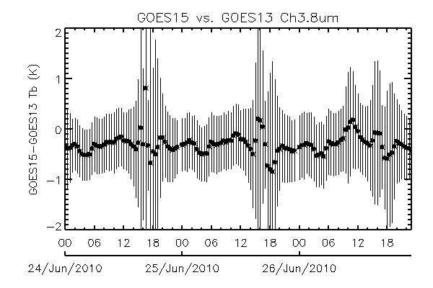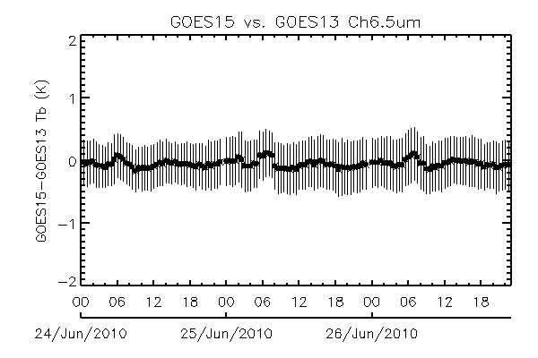
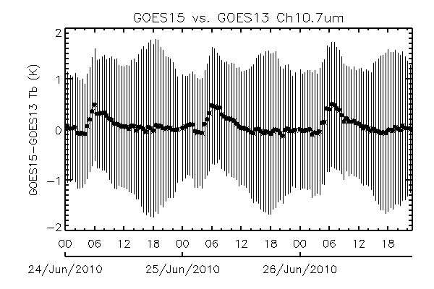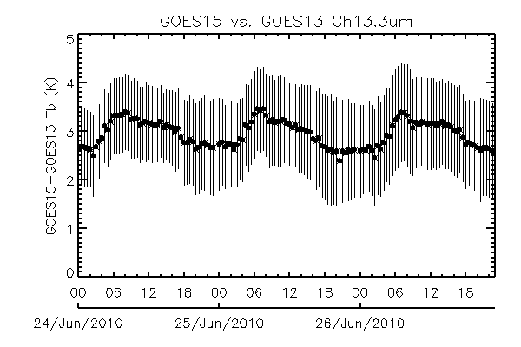
Figure 4.18: Direct inter-comparison of GOES15 vs. GOES-13 Imager IR channels. No account of differing SRF were made.

Figure 4.19 plots the latitudinal distributions of the mean Tb difference (black dots) and the standard deviation (gray segments) between GOES-15 and GOES-13 within 0.5º latitude bins for the four IR channels on August 10, 2010. There is no significant Tb difference trend in bands 3 and 4, yet the Tb difference of band 6 increase significantly as the longitude increases. As the radiometric calibration of band 6 is especially sensitive to the SRF distribution (Wu et al. 2009), longitudinal dependent Tb bias is attributed to the increasing optical length which exaggerate the impact of SRF difference on the radiance of this channel.

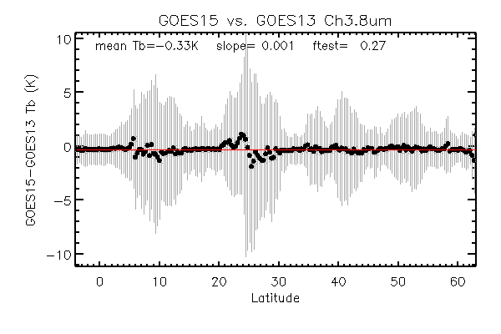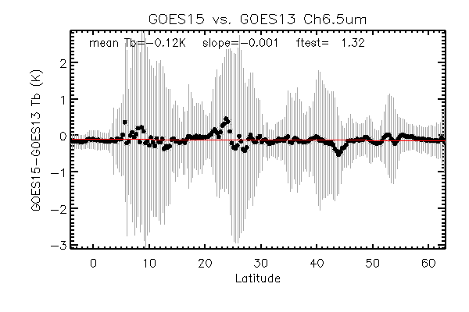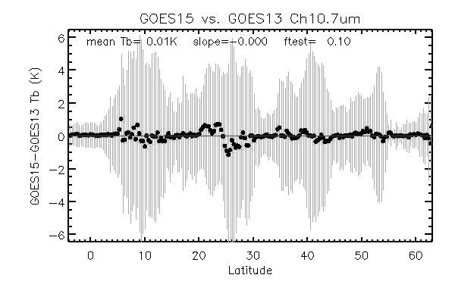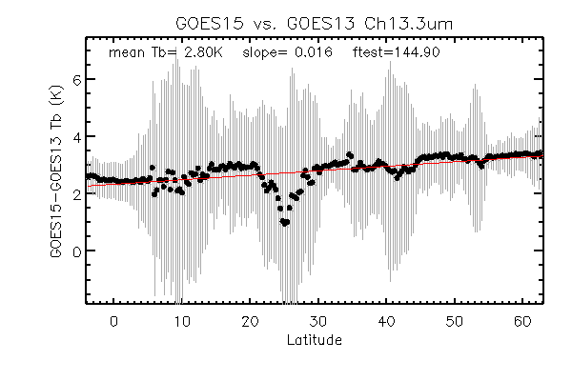
Figure 4.19: Latitudinal distribution of the mean Tb difference (dark dots) and the standard deviation (gray segments) between GOES-15 and GOES-13 for the four Imager IR channels (Tb difference = GOES-15 – GOES-13).

The mean Tb difference and standard deviation values for GOES-15 vs. GOES-13 and GOES-15 vs. GOES-11 are reported at Table 4.10. The mean Tb difference between GOES-15 and GOES-11 is -0.63K, 2.51K and 0.41K for bands 2, 3 4, respectively. The large standard deviation of the band 2 Tb difference (±1.00K) is due to the strong BRDF effect during the day-time as these two satellites are located about 45º apart. The SRF difference is most likely the main factor causing the large band 3 Tb difference as the GOES-15 band 3 SRF is much wider than that of GOES-11.

Table 4.10: Mean Tb difference (K) and the standard deviation values for the IR channels between the Imagers on GOES-15 vs. GOES-13 and GOES-15 vs. GOES-11.

Imager Band | Central Wavelength  (μm) |  | G15 – G13 |  | G15 – G11
 |  | K
2 | 3.9 |  | -0.30 (±0.19) |  | -0.63 (±1.00)
3 | 6.5 |  | -0.05 (±0.06) |  | 2.51 (±0.13)
4 | 10.7 |  | 0.08 (±0.15) |  | 0.41 (±0.35)
6 | 13.3 |  | 2.94 (±0.27)

Similar collocation criteria are applied to identify the collocation pixels for the Sounder pairs, except that the maximum temporal difference is set to 15 minutes instead of 5 minutes. The spatial distribution of the collocation pixels are shown in Figure 4.20 for the two pairs of Sounder instruments. Similar to the Imager collocation, GOES-13 and -15 have much wider collocation distribution than that of GOES-11 and GOES-15, due to the much closer sub-satellite deployment. The mean of the Tb difference and the standard deviation for the 18 IR channels are reported in Table 4.11. Note that no corrections have been done to account for SRF differences.
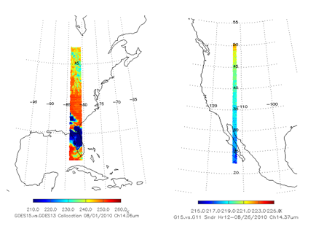
Figure 4.20: Spatial distribution of Sounder collocation pixels for GOES-15 vs. GOES-13 (left) and GOES-15 vs. GOES11 (right).

Table 4.11: Mean Tb difference (K) and the standard deviation values for the IR channels between the Sounders on GOES-15 vs. GOES-13 and GOES-15 vs. GOES-11.

Imager Band | Central Wavelength  (μm) |  | G15 – G13 |  | G15 – G11
 |  | K
1 | 14.71 |  | 0.23 (±0.09) |  | 0.95(±0.64)
2 | 14.37 |  | -0.60(±0.19) |  | -0.53(±0.56)
3 | 14.06 |  | -0.05(±0.12) |  | -2.73(±0.58)
4 | 13.64 |  | 0.18(±0.12) |  | 0.04(±0.58)
5 | 13.37 |  | -0.84(±0.10) |  | 0.66(±0.68)
6 | 12.66 |  | 0.07(±0.09) |  | 0.30(±1.47)
7 | 12.02 |  | 0.12(±0.16) |  | 0.26(±1.25)
8 | 11.03 |  | 0.28(±0.17) |  | -0.07(±0.52)
9 | 9.71 |  | 0.25(±0.21) |  | -0.12(±0.44)
10 | 7.43 |  | 0.27(±0.14) |  | -0.37(±0.26)
11 | 7.02 |  | 0.26(±0.19) |  | 0.40(±0.27)
12 | 6.51 |  | 0.05(±0.30) |  | 0.06(±0.28)
13 | 4.57 |  | -0.21(±0.31) |  | 3.50(±0.42)
14 | 4.52 |  | 1.72(±0.29) |  | 1.33(±0.20)
15 | 4.46 |  | -1.05(±0.39) |  | 4.62(0.39)
16 | 4.13 |  | 0.87(±0.27) |  | -0.51(±0.27)
17 | 3.98 |  | 0.26(±0.36) |  | -0.11(±0.31)
18 | 3.74 |  | 0.27(±0.35) |  | -0.04(±0.36)

Imager-to-Polar-Orbiter Comparisons

Data were collected during the checkout period near the GOES-15 sub-satellite point from the high spectral resolution IASI, polar-orbiting on EUMETSAT’s MetOp-A satellite. GOES-15 Imager data were collected within 30 minutes of polar-orbiter overpass time. During the checkout period there were approximately XXXX comparisons between GOES-15 and IASI. The methodology used, the CIMSS method, was nearly identical to that outlined in Gunshor et al. 2009, though applied to IASI data with no spectral gaps. The results are presented in Table 4.10. The mean brightness temperature difference for these comparisons show that GOES-15 is well calibrated based on the accuracy of IASI measurements. The large Imager band-6 bias on GOES-13 was subsequently reduced when the SRF was updated.

Table 4.12: Comparison of GOES-15 Imager to Infrared Atmospheric Sounding Interferometer (IASI) using the CIMSS-method. The bias is the mean of the absolute values of the differences.

Imager Band | Mean temperature differences (K) | Standard Deviations (K) | Number of cases
2 |  |  | Shortwave Window band (9 night cases)
3 |  |  | Water Vapor band (20 cases)
4 |  |  | Longwave IR Window band (22 cases)
6 |  |  | CO₂ Absorption band (23 cases)

The GOES-15 IR radiometric calibration accuracy was evaluated by inter-calibrating to two well-calibrated hyperspectral radiometers on Low Earth Orbit (LEO) satellites, the Atmospheric Infrared Sounder (AIRS) on the Aqua satellite and the Infrared Atmospheric Sounding Interferometer (IASI) on the Metop-A satellite (Wu et al. 2009). The collocation data were identified when both the Geostationary (GEO) and LEO instruments view the same scene at similar time and viewing zenith angle. The detailed description of the collocation selection is also documented in the Global Satellite Inter-Calibration System (GSICS) GEO-LEO baseline inter-calibration algorithm theoretical baseline document (ATBD). At each collocated scene, the hyperspectral measurements are transferred to the broadband radiance using the spectral convolution equation as follows:
where R_{LEO} is the simulated GOES measurement from AIRS/IASI radiances, R_{ν} is AIRS/IASI radiance at wavenumber ν, and Φ_{ν} is GOES spectral response at wavenumber ν. As shown in Figure 4.21, AIRS has a problem with spectral gaps and unstable or dead detectors. The Japanese Meteorological Agency (JMA)’s gap-filling method is applied to compensate for the discontinuities before the spectral convolution method is applied (Tahara and Kato 2009).

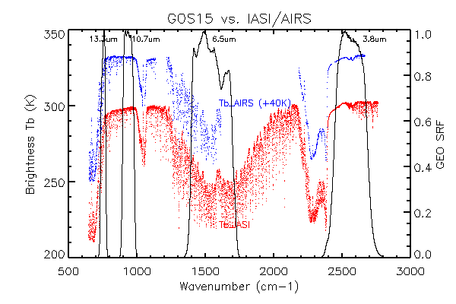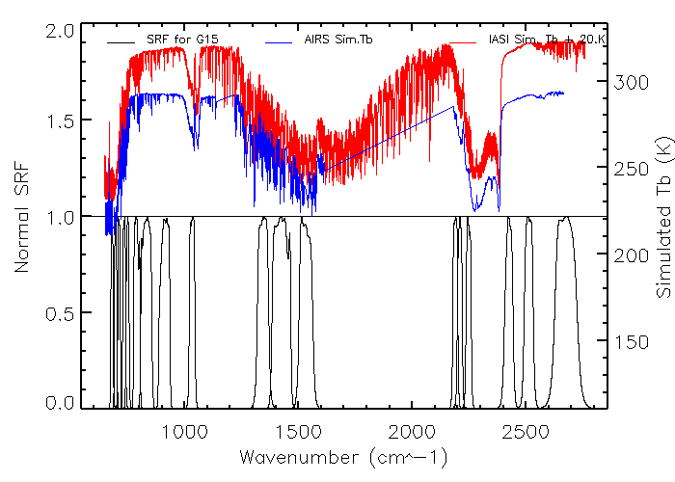
Figure 4.21: Spectral response function of GOES-15 Imager (top) and Sounder (bottom), together with the AIRS/IASI spectra.

Two sets of GEO-LEO inter-calibration data, based on the daytime and nighttime collocation pixels, are used to evaluate the Imager IR radiometric calibration accuracy. Both inter-calibrations with AIRS and IASI yielded very similar results in Table 4.11. Note that during the GOES-15 PLT, the Imager SRFs that were used were the latest available, and hence not the Rev H (shifted) that came out in August of 2011 to correct the noted shift in the two absorptive bands. The Rev H values have been employed in the Satellite Operations Control Center (SOCC) data since August 5, 2011. The mean brightness temperature (Tb) difference listed in Table 4.11 are calculated with the homogeneous collocation pixels. Unlike GOES-12 which has very small GEO-LEO Tb differences at the water vapor band (6.5 μm), both the GOES-AIRS and GOES-IASI inter-calibration results indicated large and consistent bias for the GOES-15 water vapor band and CO2 sensitive band. The two-IR window channels (Ch2 and Ch4) are well-calibrated with a Tb bias less than 0.2K. The two absorptive channels, however, have relatively large Tb biases to both AIRS and IASI measurements. The Tb bias to AIRS/IASI for Ch6 ranges from 0.66K – 0.77K, depending on the collocation time and LEO instrument. The water vapor channel (Ch3) has the largest Tb bias (~2K) to both LEO instruments all the time, which exceeds specification. Noted that the implemented SRF during the PLT science test period is of version Rev F, which is the same as Rev E version for the Imager IR channels (ITT technical memo, 2010). Per this analysis, ITT, the instrument vendor, re-visited the pre-launch sample data and came with a new version of SRF (Rev G). These data were then empirically shifted to reduced the systemic bias (Rev H). The shortwave band (3.9 μm) had a large Tb difference during the daytime (not shown) due to reflect solar radiation. As shown in Figure 4.22 and 4.23, the Tb difference is consistent over the study period.

Table 4.13: Brightness temperature (Tb) biases between GOES-15 Imager and AIRS/IASI for the daytime and nighttime collocated pixels between AIRS and IASI through GOES-14 Imager daytime collocation data using the GSICS-method. The Tb biases were based on the collocated pixels acquired from June 3, 2010 and October 25, 2010. Standard deviations are given in parentheses. Again, these values are before the final, shifted SRF were employed.

Band number | Central wavelength (μm) | daytime  (K) |  | nighttime  (K)
 |  | GOES-AIRS | GOES-IASI | GOES-IASI (9:30 pm)
2 | 3.9 |  |  | 0.09(±0.08)
3 | 6.5 | 2.04(±0.13) | 2.12(±0.11) | 1.98(±0.14)
4 | 10.7 | 0.18(±0.18) | 0.10(±0.20) | 0.03(±0.10)
6 | 13.3 | 0.77(±0.14) | 0.74(±0.14) | 0.66(±0.12)

These GSICS-method results are consistent with the CIMSS-method results in Table 4.13.

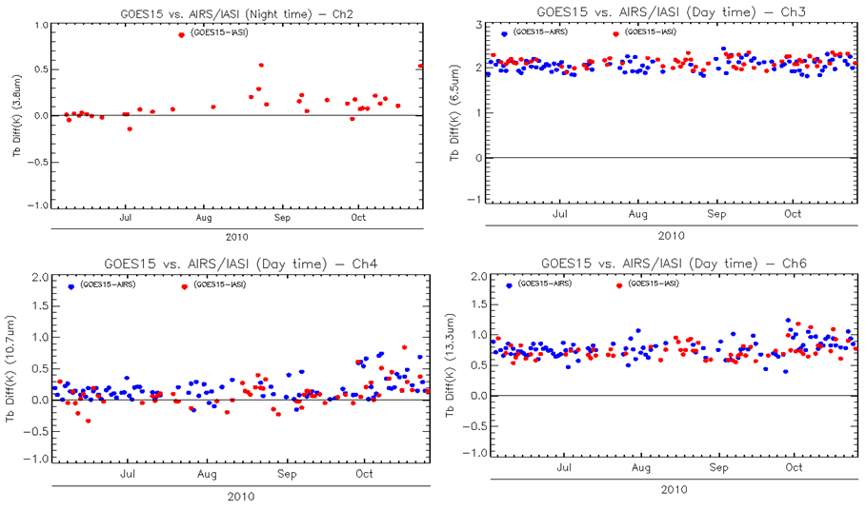
Figure 4.22: GOES-15 Imager IR bands time series of the brightness temperature bias with AIRS and IASI inter-calibration. Note that the band 2 values are only for the daytime. Note that these are from the Science test period and hence before the SRF shift of bands 3 and 6.

Like the other 3-axis stabilized GOES satellites, GOES-15 Imager and Sounder experience an abnormal heating process resulting in erroneous calibration slopes around the satellite midnight time (Johnson and Weinreb 1996). An empirical Midnight Blackbody Calibration Correction (MBCC) method was developed and implemented to mitigate this midnight calibration anomaly. Figure 4.23 shows the mean Tb bias to AIRS and IASI (open and solid dots at primary y-axis) and the frequency of MBCC onset frequency (solid line at second y-axis) at every half hour during the PLT period. Apparent diurnal calibration variation can be observed in Ch3, Ch4 and Ch6. Onset of MBCC varies at different channels. It should have the most affect 2-3 hours before midnight and the next 3-6 hours after, depending on the IR channel. Since MBCC is the major factor in determining the diurnal calibration variation, it was evaluated using the method described by Yu et al. (2011). The MBCC correction residual (ΔTb_{MBCC}) can be calculated as:

where Tb_{GEO-AIRS, noon} is the mean Tb difference between GOES and AIRS between 12:00pm and 2:00pm, and Tb_{GEO-AIRS, midnight} is the mean Tb difference between GOES and AIRS between 12:00am and 2:00am.

As shown in last column of Table 6, MBCC works very efficiently for band 6, and seems ineffective for bands 3 and 4. Although the MBCC has been intensively turned on around the midnight time, there is still about 0.35K and 0.41K calibration residuals for bands 3 and 4, respectively. Our previous analysis on the MBCC indicates that it works well for GOES-11/12/13 band 3 with less than 0.1-0.2K residual and less effective for band 4. More research may be needed to investigate the discrepancy on the band 3 MBCC correction for GOES-15. For band 2 (not shown), the small and consistent Tb bias to IASI before and after the MBCC onset implies that MBCC works well at this channel.

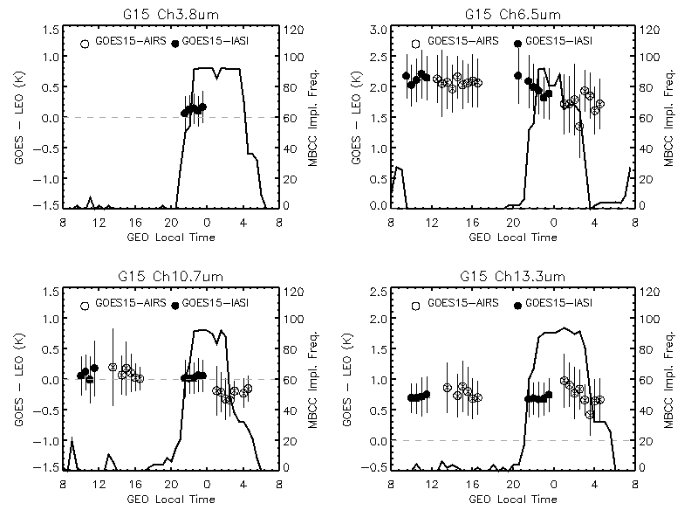
Figure 4.23: The Mean Tb bias to AIRS/ IASI for GOES-15 Imager IR channels.

Table 4.14: GOES-15 Imager diurnal calibration variation.

Band number | Central wavelength (µm) | mean GOES-AIRS (12:00pm-2:00pm) | Mean GOES-AIRS (12:00am-2:00am) | MBCC residual
3 | 6.5 | 2.07 | 1.72 | 0.35K
4 | 10.7 | 0.20 | -0.21 | 0.41K
6 | 13.3 | 0.87 | 0.91 | -0.04K

A similar GEO-LEO inter-calibration (GSICS) method was applied to the GOES-15 Sounder IR channels to evaluate the radiometric calibration accuracy. Unlike the GEO-LEO inter-calibration for the GOES Imager data, the GOES vs. IASI collocation for the Sounder only occurs in the evening time. Figure 4.24 and Table 4.14 show the mean and standard deviation of the Tb bias to the IASI homogeneous scenes from June 3, 2010 to August 3, 2010 and compared with those of the other GOES satellites. The results indicate that GOES-15 Sounder IR channels are well-calibrated and comparable with the other two GOES-NOP instruments during this period. The Tb bias of most channels less than 0.2K, except for band 5 (0.48K) and band 13 (0.40K). GOES sounder band 18 is not included due to its spectral coverage.
Table 4.15: GOES-15 Sounder IR vs. IASI brightness temperature difference at nighttime, compared to other GOES Sounders using the GSICS-method. The data in the parentheses are the standard deviation of the Tb difference at the collocation pixels.

Band number | Central wavelength (µm) | GOES-15  Mean (±stdv)  (K) | GOES-14  Mean (±stdv)  (K) | GOES-13  Mean (±stdv)  (K) | GOES-12  Mean (±stdv)  (K)
1 | 14.71 | 0.23(±0.15) | 0.274 (±0.195) | 0.19(±0.17) | -0.006 (±0.233)
2 | 14.37 | 0.04(±0.54) | 0.127 (±0.245) | 0.18(±0.15) | 0.078 (±0.197)
3 | 14.06 | -0.10(±0.98) | 0.103 (±0.610) | -0.02(±0.48) | 0.180 (±0.739)
4 | 13.64 | 0.07(±1.28) | 0.208 (±0.917) | 0.08(±0.77) | -0.258 (±1.373)
5 | 13.37 | -0.48(±1.42) | 0.041 (±1.159) | -0.10(±1.05) | 0.313 (±1.837)
6 | 12.66 | -0.01(±1.29) | 0.106 (±1.601) | 0.08(±1.37) | -0.160 (±2.094)
7 | 12.02 | 0.01(±1.15) | -0.041 (±1.575) | -0.01(±1.46) | -0.086 (±2.068)
8 | 11.03 | 0.02(±1.10) | -0.067 (±1.363) | 0.00(±1.37) | -0.109 (±1.906)
9 | 9.71 | -0.15(±0.94) | 0.076 (±0.838) | -0.04(±1.01) | -0.055 (±1.366)
10 | 7.43 | -0.04(±0.62) | -0.040 (±0.747) | -0.02(±0.70) | -0.328 (±1.088)
11 | 7.02 | -0.05(±0.62) | -0.121 (±0.574) | -0.28(±0.60) | -0.119 (±0.994)
12 | 6.51 | -0.03(±0.60) | -0.178 (±0.438) | -0.19(±0.45) | -0.236 (±0.680)
13 | 4.57 | 0.40(±0.51) | 0.263 (±0.506) | -0.12(±0.62) | -0.883 (±1.052)
14 | 4.52 | -0.07(±0.41) | -0.049 (±0.341) | -0.34(±0.51) | -0.499 (±0.936)
15 | 4.45 | 0.06(±0.44) | 0.144 (±0.506) | -0.55(±0.42) | -5.076 (±2.766)
16 | 4.13 | 0.03(±0.57) | 0.076 (±0.517) | -0.06(±0.57) | 0.304 (±1.283)
17 | 3.98 | -0.01(±0.66) | -0.116 (±0.648) | -0.13(±0.65) | 0.106 (±1.529)

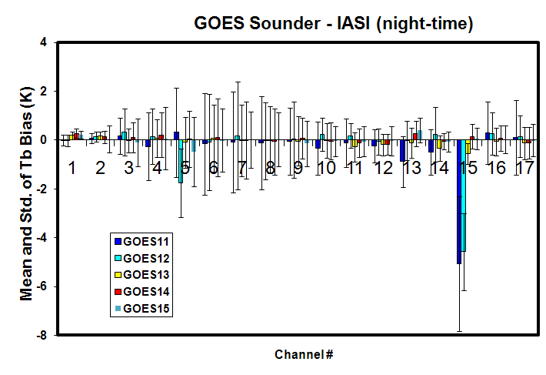
Figure 4.24: Mean and standard deviation of GOES-11 through -15 Sounder brightness temperature difference from nighttime IASI data using the GSICS-method.

Stray Light Analysis

By supplying data through the eclipse periods, the GOES-13/14/15 system addresses one of the major current limitations which are eclipse and related outages. This change is possible due to larger spacecraft batteries. Outages due to Keep Out Zones (KOZ) will be minimized. See Figure 4.25 for an image from 27 August 2010 comparing GOES-15 to GOES-11 for an eclipse time. Note the GOES-11 data outage. Outages due to Keep Out Zone (KOZ) will be replaced by Stray Light Zone outages and reduced by shifting frames away from the sun and possibly stray light correction via a SPS algorithm under development.

With the new capability of data during previous outages comes the risk of allowing images contaminated with the energy of the sun to be produced. An image with artificial brightness temperature excursions up to 75 K (e.g. imager band 2) may affect products. To determine how much good data can be acquired, at the same time minimizing the amount of bad data, many scans were conducted during the eclipse period in 2010.

While all Imager bands can be affected, the visible and shortwave (band 2) are affected the most. There are investigations into the possibility of correcting these stray-light affected images before distribution via GVAR.

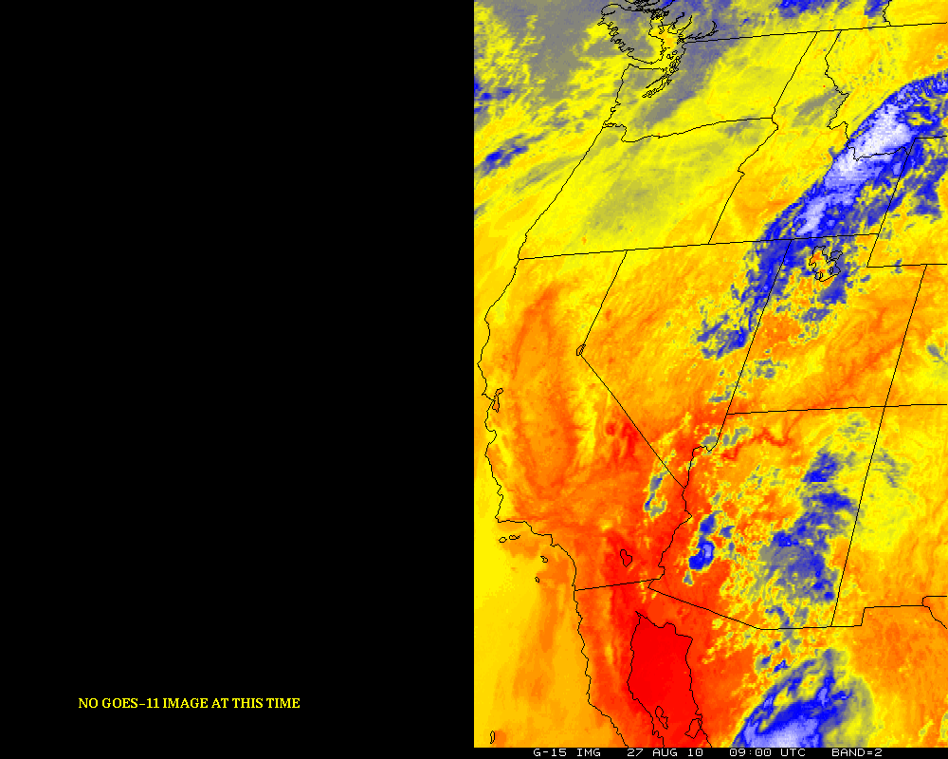
Figure 4.25: GOES-11 and GOES-15 Imager (right panel). Note the lack of data from GOES-11, due to being in an outage period.

In general, the GOES Sounder can be affected even more during the KOZ periods, due to the relatively slow Sounder scanning (not shown).

Instrument Performance Monitoring

The GOES IPM system uses the near real-time GOES Variable Format (GVAR) Block 11 (B11) data routinely downloaded from the NOAA Comprehensive Large Array-data Stewardship System data source. Four types of calibrated related parameters are ingested from the GVAR B11 data, including the instrument telemetry data, infrared (IR) calibration coefficients, statistics of space-look and blackbody scan data. Instrument noise, such as NEdR and NEdT are also monitored for each detector. To detect any potential calibration anomaly, all these monitored parameters are displayed at various temporal scales for diurnal to long-term variations.

Telemetry Monitoring

The GOES-15 Imager and Sounder instrument performance was intensively monitored using the GVAR (GOES VARiable Format) Block11 (B11) data which were routinely downloaded from NOAA/CLASS (Comprehensive Large Array-data Stewardship System) from August 11, 2010 through October 25, 2010. Approximately 14 Imager and 16 Sounder telemetry parameters were monitored with the GOES IPM system (Yu and Wu 2010). The monitored GOES-15 IPM parameters are listed in Table 4.16. Most of these parameters were functioning well and comparable with the other GOES instruments. In this report, we summarized the behaviors of the Imager and Sounder blackbody (BB), scan mirror and patch temperatures as follows.

Table 4.16: GOES-15 Imager and Sounder telemetry parameters monitored with the GOES-IPM system during the PLT science test period.
 | Telemetry variables | Detector Number  (Imager) | Detector Number  (Sounder)
1 | Electronics Temperature | 2 | 2
2 | Sensor Assembly Baseplate Temperature | 6 | 6
3 | BB Target Temperature | 8 | 8
4 | Scan Mirror Temperature | 1 | 1
5 | Telescope Primary Temperature | 1 | 1
6 | Telescope Secondary Temperature | 2 | 2
7 | Telescope Baffle Temperature | 2 | 2
8 | Aft Optics Temperature | 1 | 1
9 | Cooler Radiator Temperature | 1 | 1
10 | Wide Range IR Detector Temperature | 1 | 1
11 | Narrow Range IR Detector Temperature | 1 | 1
12 | Filter Wheel Housing Temperature | X | 1
13 | Filter Wheel Control Heater Voltage | X | 1
14 | Patch Control Voltage | 1 | 1
15 | Instrument Current | 1 | 1
16 | Cooler-Housing Temperature | 1 | 1
Similar to the other GOES Imagers (of the 3-axis design), the Imager experienced about +15K diurnal variation in the blackbody (BB) temperature and +40K variation in the scan mirror temperature with the highest temperature peak around satellite midnight time (Figure 4.26). During the eclipse period between August 31, 2010 and October 13, 2010, the diurnal variations of the telemetry temperature were reduced because of the reduced peak temperature. The reduced peak telemetry temperature during the eclipse season is also observed at the other GOES instruments.

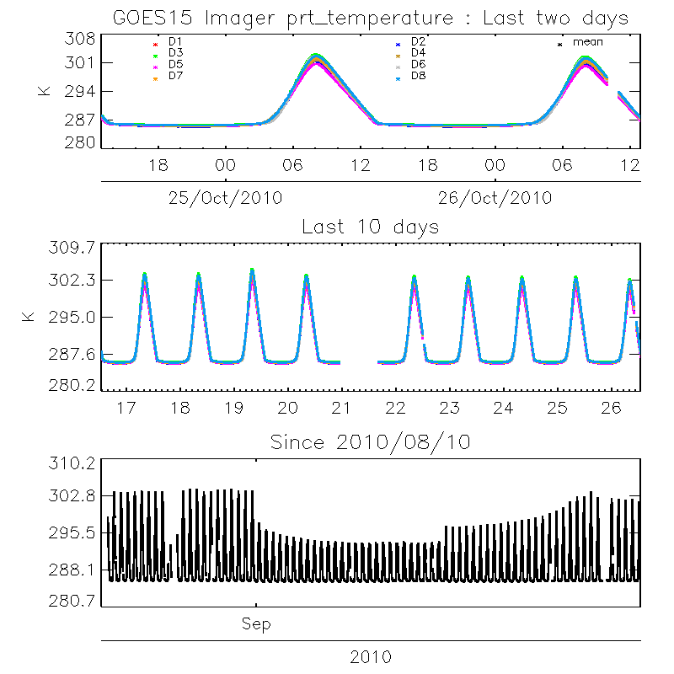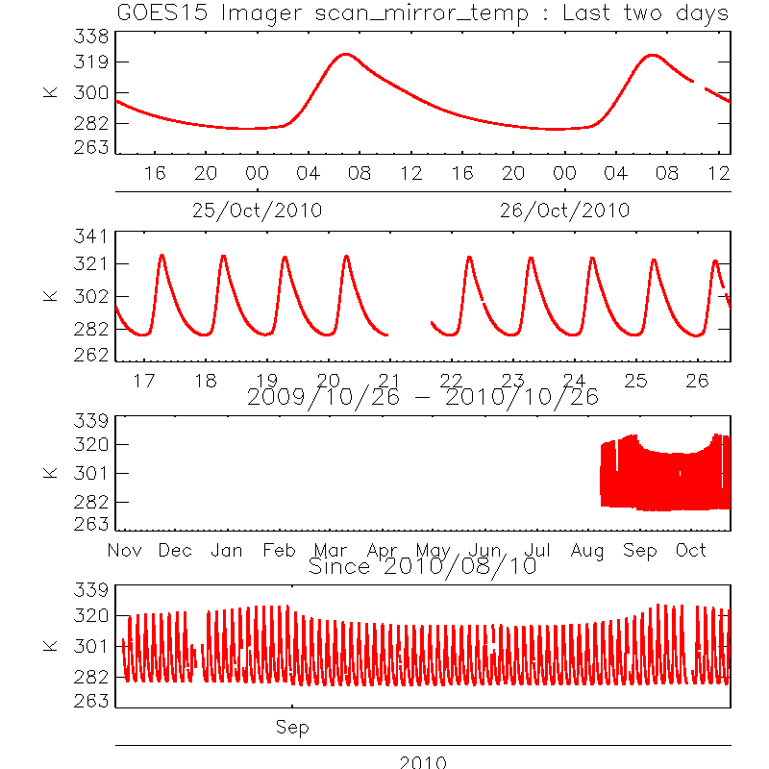

Figure 4.26: The GOES-15 Imager PRT (left) and scan mirror (right) temperature shown with various temporal scales.

The Imager patch temperature was controlled consistently at the low-level (~81K) with slight variation of narrow patch temperature in the beginning of the PLT period. The wide-range patch temperature was slightly higher (~0.23K) than the narrow-range one. Meanwhile, the two operational GOES, GOES-11 (GOES-West) and GOES-13 (GOES-East) Imagers, experienced the annual patch temperature switch from mid- to low-level in September.

Similar to the other GOES instruments, GOES-15 Sounder BB and scan mirror also experienced significant diurnal variations with the highest temperature occurring around the satellite midnight (Figure 4.27). The magnitude of diurnal variation due to the reduced peak values can also be observed between August 31, 2010 and October 13, 2010.

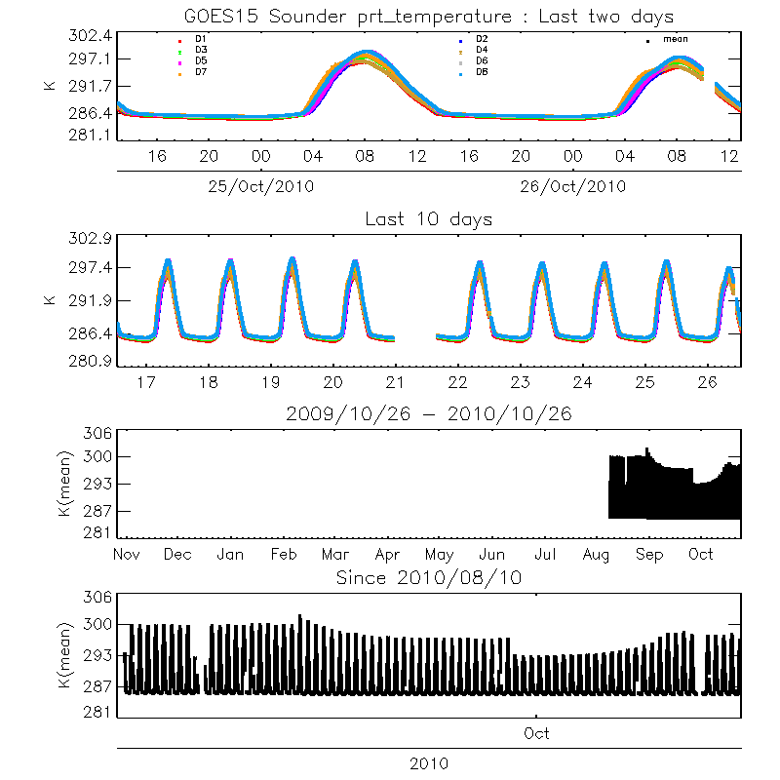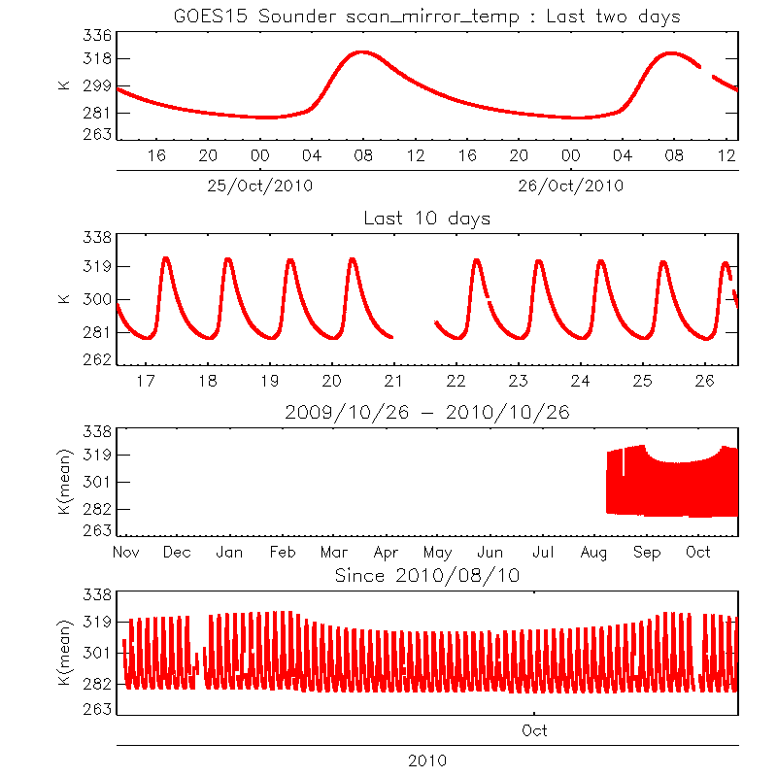
Figure 4.27: GOES-15 Sounder BB temperature (left) and scan mirror temperature (right) at different temporal scales.

Monitoring the GOES Sounder patch temperatures

GOES-15 Sounder patch experienced floating temperature resulting from the “blanket-heating” effect in the two periods of August 11, 2010 to August 31, 2010 and September 17, 2010 to September 27, 2010 (Figure 4.28). During these two periods, the spacecraft was flipped from inverted to upright orientations. Due to the “dislodged thermal blanket issue”, the Sounder patch temperature could not be controlled in upright orientation during summer. NOAA/NASA decided to invert the space craft (SC) to establish patch control so that the Science Test could be performed. SC was inverted on August 31, 2010, and the patch control “low” setting was reached soon after. Sounder patch began floating again on September 17 in the inverted orientation as the Sun declination was approaching equinox. First, the patch was raised to “mid” setting (~85K) to reduce daily range on September 22. Then, on September 27, the SC was yaw-flipped to “upright” orientation (preferred orientation for winter) to achieve control at “low” patch setting (~81.6K) (Figure 4.28). Slight diurnal variation (~0.02K) can also be observed at “low” patch setting (Figure 4.29). Meanwhile the patch temperature of the two operational Sounders at GOES-11/13 switched from mid- to low-level in September, 2010.

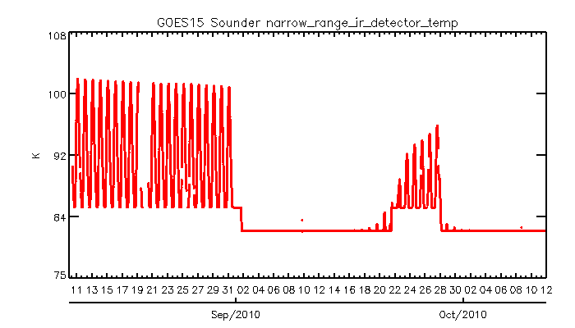
Figure 4.28: Time-series of narrow-range patch temperature of GOES-15 Sounder from August 10 to 12, 2010.

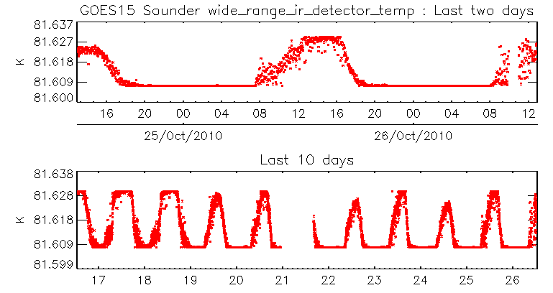
Figure 4. 29: Diurnal variations of the GOES-15 Sounder patch temperature from October 25 to 26, 2010 (upper panel) and from October 16 to 26, 2010 (lower panel).

Initial Post-launch Calibration for the Imager Visible Band

The visible bands of GOES-14 Imager experience continuous degradation once commissioned in orbit. A post-launch calibration method has been developed to correct for such degradation using the collocated cloud pixels of GOES-14 and Terra Moderate Resolution Imaging Spectroradiometer (MODIS) band-1 data (Wu and Sun, 2004).

R_{post} = R_{pre} * C₁
where R_{post} is the post-launch calibration reflectance/radiance for the GOES-14 Imager visible band; R_{pre} is the pre-launch calibration reflectance/radiance; and C₁ is the correction factor, C₁ = 1.0695. This result was derived based on the collocated GOES-14 and Terra MODIS pixels acquired on Y09D357.

Finer Spatial resolution GOES-15 Imager

The water vapor band on the GOES-15 imager is improved compared to that on the GOES-11 imager. The detector sizes improve from 8 to 4 km. While each image is shown in its native position, the finer scale features on GOES-15 are clearly seen (Figure 4.30). The improved (4 km field-of-view at the sub-point) spatial resolution of the 13.3 µm (band 6) required changes to the GVAR format. Several issues with implementing the new GVAR format were discovered, communicated, rectified, and verified. For example, the paired detectors on the higher-resolution 13.3 µm band were inadvertently swapped when the satellite was in an inverted mode. This situation was quickly resolved. The image in Figure 4.31 demonstrated the improved spatial resolution of this band on the GOES-15 imager, which is also the case with the GOES-14 Imager.

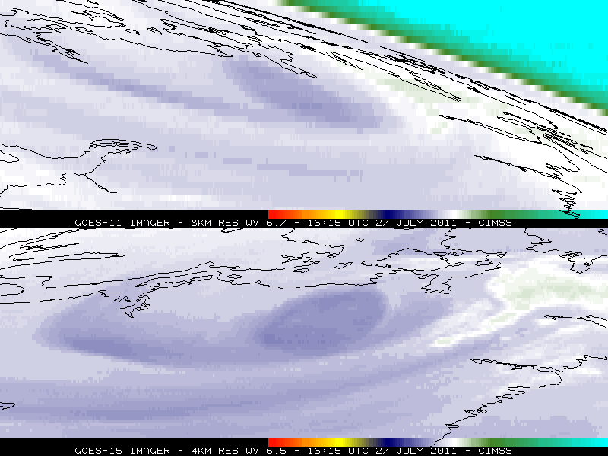
Figure 4.30: Improved Imager spatial resolution of the water vapor band for GOES-15 (lower panel) compared to GOES-11 (top panel) from 27 July 2010.

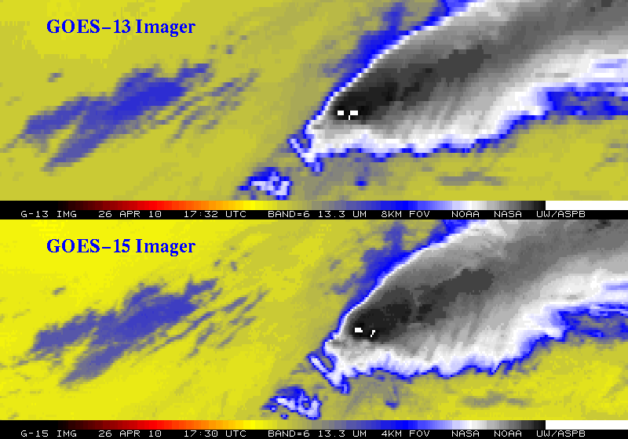
Figure 4.31: Improved Imager spatial resolution at 13.3 µm for GOES-15 (lower panel) compared to GOES-13 (top panel) from 26 August 2009.

Corrections of SRF for GOES-14/15 Imagers

During the Post-Launch Science Tests (PLT) of GOES-14 and GOES-15, NOAA reported biases for Imager Ch3 (6.5µm), based on the GSICS GEO-LEO inter-calibration analysis. The bias, in terms of brightness temperature (T_{b}), was +0.99K for GOES-14 and +2.12K for GOES-15 (Table 20, 2nd column). Biases of −0.50K and +0.76K were also found for Imager band 6 (13.3µm) of GOES-14/15, respectively, which are within the specified accuracy requirement of 1K.

In response, ITT Industries, the instrument vendor, re-analyzed the pre-flight instrument calibration data and revised the SRF, which were released as Rev. H. The radiometric calibration accuracy with Rev H SRF was then evaluated using the simulated earth radiance as described in Wu and Yu (2011). Re-evaluation confirmed that Rev. H substantially reduced the bias, yet a residual bias of up to 1K remained. While meeting (marginally for some channels) the instrument specification of 1K, the bias can be attributed to uncertainty in the SRF (Wu et al. 2010). Therefore it was recommended to further correct the ITT Rev. H SRF by shifting the SRF (Wu and Yu 2011). The SRF of the shifted Rev H SRF, together with the original Rev G SRF for GOES-14/15 band 3 and band 6 are plotted at Figure 4.32. These shifted SRF were implemented on August 5, 2011 for both GOES-14 and -15.

Table 4.17: Biases for selected GOES-14/15 Imager channels using the SRF as originally supplied by ITT (Rev. E), revised by ITT (Rev. H), further corrected by NOAA, and the recommended correction.
GOES/ Band number | Central wavelength (µm) | Bias with ITT Rev. E (K) | Bias with ITT Rev. H (K) | Recommended Shift (cm-1) | Bias with shifted SRF (K)
G14 band3 | 3.9 | 0.99 | 0.97 | −8.75 | +0.07
G14 band6 | 6.5 | -0.53 | -0.27 | -0.50 | +0.08
G15 band3 | 10.7 | 2.12 | 0.73 | -6.75 | +0.07
G15 band6 | 13.3 | 0.76 | 0.42 | +0.50 | +0.19

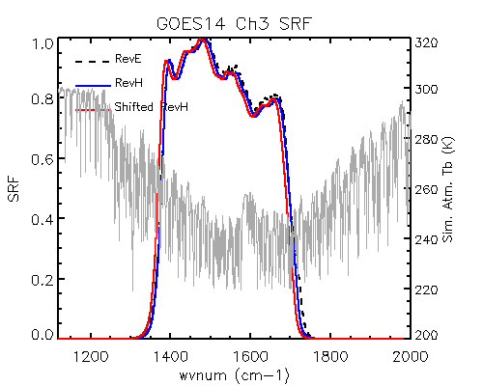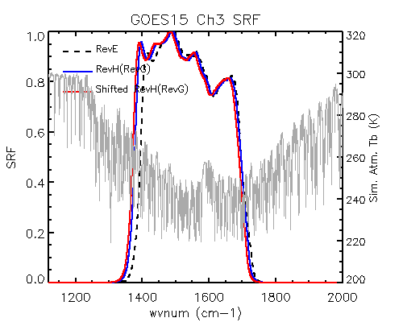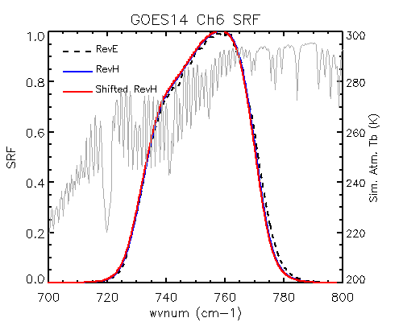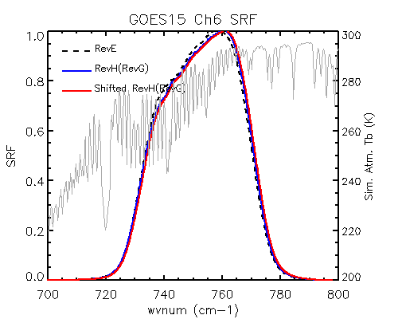

Figure 4.32: Reversion E, Reversion H, and shifted Reversion H spectral response functions of GOES-14/15 Imager band 3 and band 6 (dash black, blue solid and red solid lines), together with the IASI simulated TOA Tb for a clear tropical atmospheric profile (gray lines at second y-axis). Note that RevG and RevH SRFs are identical for GOES-15 Imager IR channels.

The quality of the GOES-15 Imager band 3 and 6 spectral shifts were also validated once GOES-15 began resending data in the fall of 2011. Note the greatly reduced bias on the few points on the right-hand side of Figure 4.33.
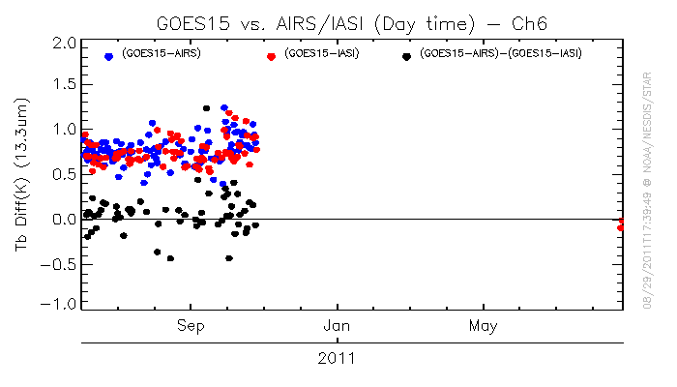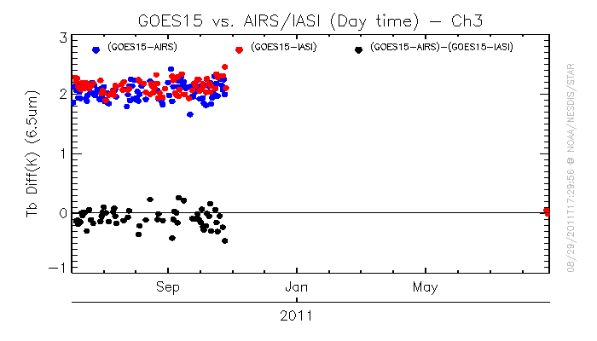
Figure 4.33: Preliminary comparisons of the GOES-15 band 6 (top panel) and band 3 (lower panel) before (left hand side) and after (right hand side) after the spectral response shift was implemented.

Product Validation

A number of products were generated with data from the GOES-15 instruments (Imager and Sounder) and then compared to the same products generated from other satellites or ground-based measurements. Products derived from the Sounder include: Total Precipitable Water (TPW), Lifted Index (LI), Clouds products, and Atmospheric Motion Vectors. The products derived from the Imager include: Clouds, Atmospheric Motion Vectors, Clear Sky Brightness Temperature (CSBT), Sea Surface Temperature (SST), and Fire Detection. It should be noted that most of these product compressions were completed with the SRF available during the PLT.

Total Precipitable Water (TPW) from the Sounder

Validation of Precipitable Water (PW) Retrievals from the GOES-15 Sounder

GOES-15 retrievals of precipitable water were validated against radiosonde observations of precipitable water for the period 2 September 2010 to 21 September 2010. To achieve this, GOES-15 retrievals were collocated in space (within 11 km) and time (within 30 minutes) to daily radiosonde observations at 0000 UTC and 1200 UTC. At the same time, these GOES-15 retrievals were collocated in space (within 11 km) and time (within 60 minutes) to GOES-13 retrievals. The relative performance of the GOES-15 PW retrievals, GOES-13 PW retrievals, and first guess PW supplied to the retrieval algorithm could then be compared since all of these PW values were collocated to the same radiosonde observation. Table 5.1 provides a summary of these statistics for the Total Precipitable Water (TPW) and the PW at three layers (Sfc-900 hPa; 900-700 hPa, and 700-300 hPa). The short time period reflects instrument problems which were not resolved until September 1. Despite the short observational time period, the statistics indicate that the quality of the GOES-15 Sounder PW retrievals compare very well to the quality of the operational GOES-13 PW retrievals. The relatively large sample size is indicative of the low amount of cloudiness during this period.

Table 5.1: Verification statistics for GOES-12 and GOES-15 retrieved precipitable water, first guess (GFS) precipitable water, and radiosonde observations of precipitable water for the period 2 September 2010 to 21 September 2010.

Statistic | GOES-13/RAOB | GOES-15/RAOB | GUESS/RAOB | RAOB
Total Precipitable Water
RMS (mm) | 3.99 | 4.11 | 4.70
Bias (mm) | -0.55 | -0.41 | -0.96
Correlation | 0.96 | 0.95 | 0.94
Mean (mm) | 28.46 | 28.60 | 28.05 | 29.01
Sample | 3907 | 3907 | 3907 | 3907
Layer Precipitable Water (surface to 900 hPa)
RMS (mm) | 2.08 | 2.07 | 2.27
Bias (mm) | -1.25 | -1.16 | -1.48
Correlation | 0.94 | 0.93 | 0.93
Mean (mm) | 9.65 | 9.74 | 9.42 | 10.90
Layer Precipitable Water (900 hPa to 700 hPa)
RMS (mm) | 2.40 | 2.44 | 2.55
Bias (mm) | -0.15 | -0.07 | -0.33
Correlation | 0.92 | 0.92 | 0.91
Mean (mm) | 12.89 | 12.97 | 12.71 | 13.04
Layer Precipitable Water (700 hPa to 300 hPa)
RMS (mm) | 1.75 | 1.75 | 2.04
Bias (mm) | 0.79 | 0.74 | 0.77
Correlation | 0.91 | 0.90 | 0.87
Mean (mm) | 5.79 | 5.74 | 5.77 | 5.00

Figures 5.1 through 5.4 present time series of various comparison statistics (GOES retrieved TPW vs. radiosonde observed TPW) for GOES-15 (in green with open circles) and GOES-13 (in red with filled circles) for the same time as in Table 5.1. Each tick mark represents a data point (2 points per day) with the calendar day label centered at 0000 UTC of that day. A majority of the GOES-15 data points are very close to, if not on top of, the GOES-12 data points.

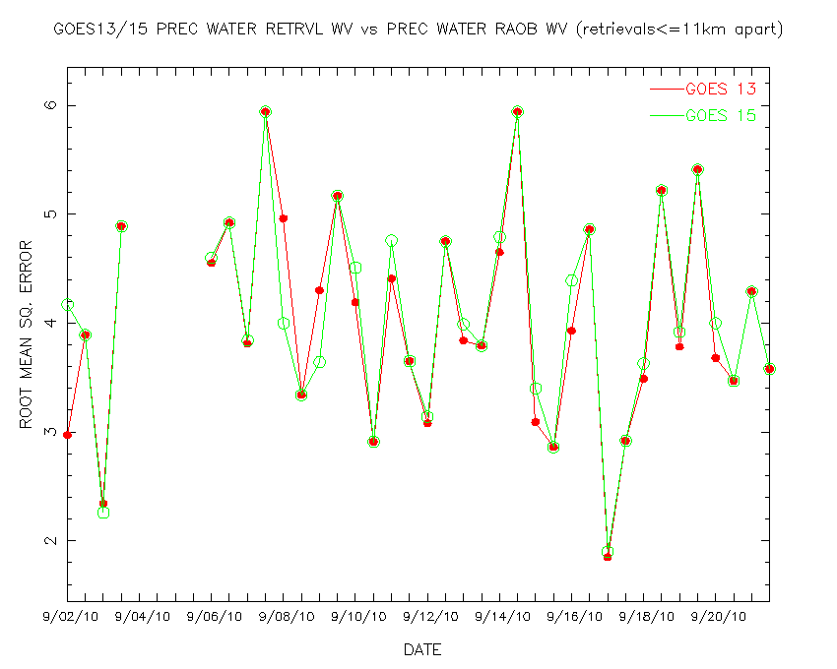
Figure 5.1: Time series of Root Mean Square Error (RMSE) between GOES-13 and GOES-15 retrieved precipitable water and radiosonde observation of precipitable water over the period 2 September 2010 to 21 September 2010.
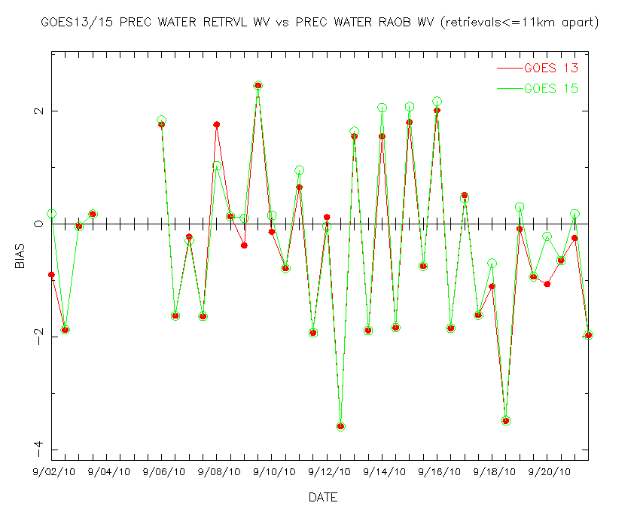
Figure 5.2: Time series of bias (GOES-radiosonde) between GOES-13 and GOES-15 retrieved precipitable water and radiosonde observation of precipitable water over the period 2 September 2010 to 21 September 2010.
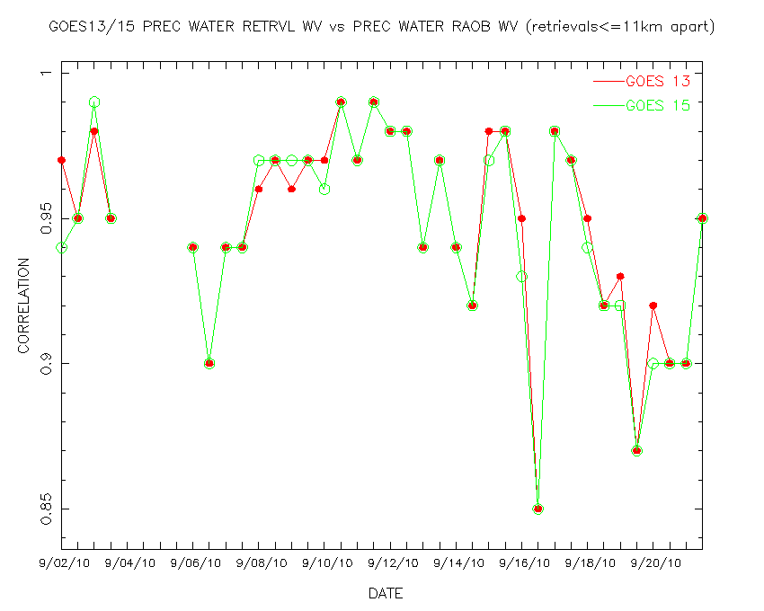
Figure 5.3: Time series of correlation between GOES-13 and GOES-15 retrieved precipitable water and radiosonde observation of precipitable water over the period 2 September 2009 to 21 September 2010.

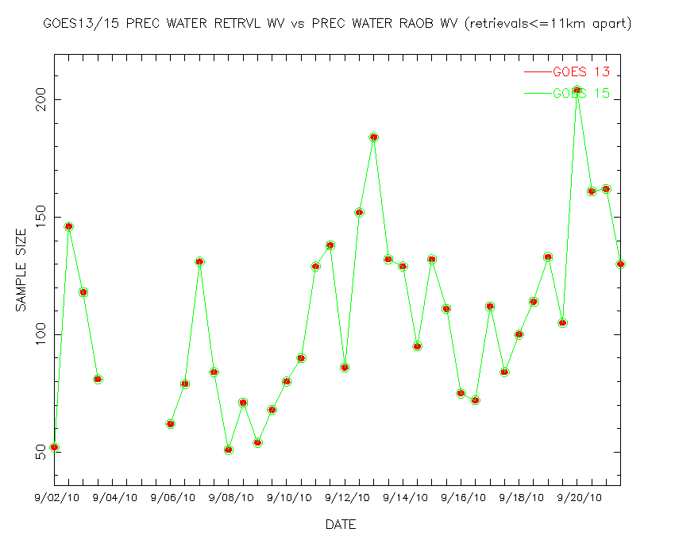
Figure 5.4: Time series of the number of collocations between GOES-13 and GOES-15 retrieved precipitable water and radiosonde observation of precipitable water over the period 2 September 2010 to 21 September 2010.

Total precipitable water retrievals (displayed in the form of an image) for GOES-13 and GOES-15 are presented in Figure 5.5 over the same area at approximately the same time. These retrievals are generated for each clear radiance Field-Of-View (FOV). Radiosonde measurements of TPW are plotted on top of the images. Qualitatively, there is good agreement between the GOES-13 and GOES-15 TPW retrievals that, in turn, compare reasonably well with the reported radiosonde measurements of TPW. When comparing measurements from two satellites, one must consider the different satellite orbital locations; even precisely co-located fields-of-view are seen through different atmospheric paths. The striping in the GOES-15 DPI may be due to striping in sounder band 15 (and other) bands.

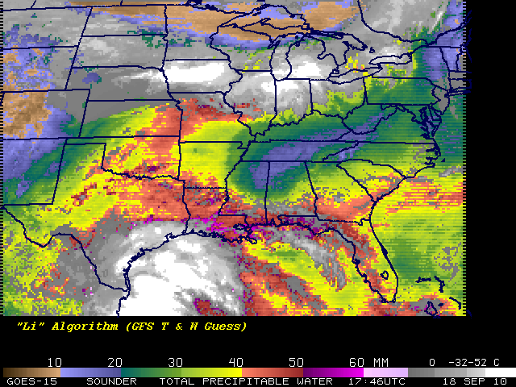
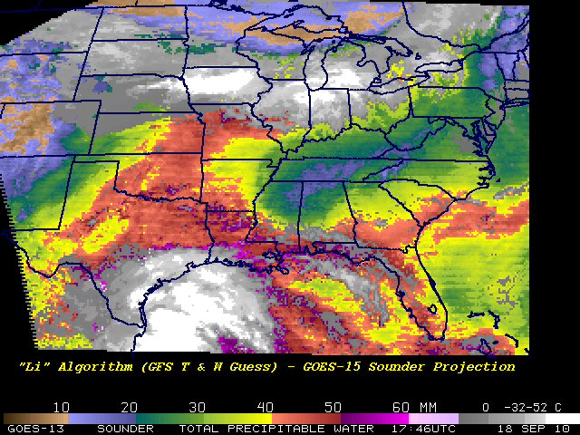
Figure 5.5: GOES-15 (top panel) and GOES-13 (lower panel) retrieved TPW (mm) from the Sounder displayed as an image. Cloudy FOVs are denoted as shades of gray. The data are from 18 UTC on 18 September 2010. Measurements from radiosondes are overlaid as white text.

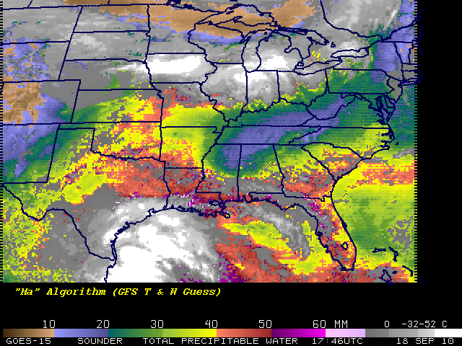
Figure 5.6: GOES-15 Sounder TPW from two retrieval algorithms (i.e., “Ma” (upper-panel) and “Li” (lower-panel). Both images are from 18 September 2010.
Figure 5.6 shows one time period with two retrieval methods, note that the GPS/Met data are over-plotted on each image.

Lifted Index (LI) from the Sounder

The lifted index (LI) product is generated from the retrieved temperature and water vapor profiles (Ma et al. 1999) that are generated from clear radiances for each FOV. Figure 5.7 shows lifted index retrievals (displayed in the form of an image) for GOES-12 and GOES-14 over the same area at approximately the same time, showing no discernible bias in the LI values. Both images are shown in the GOES-12 projection. Of course the overall large (stable) LI values also illustrates that ideally satellite post-launch check-outs should be conducted in seasons with more atmospheric moisture/instability.

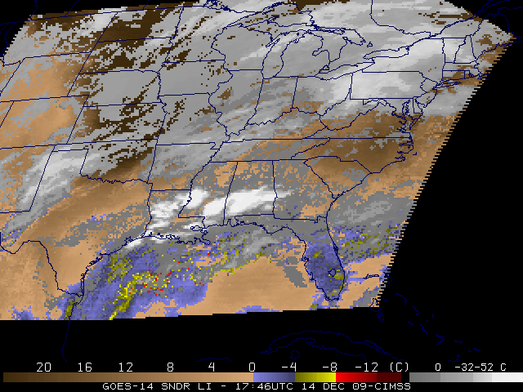
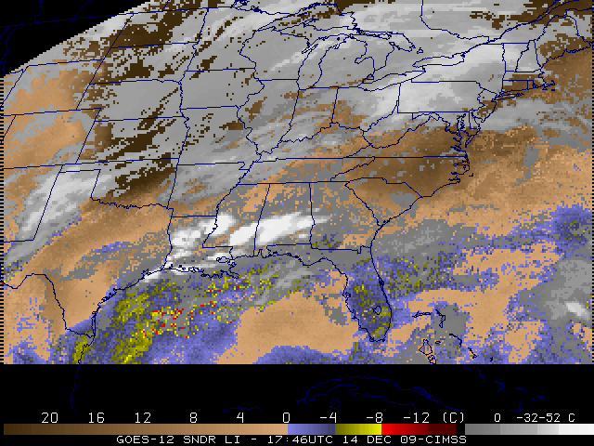

Figure 5.7: GOES-14 (top) and GOES-12 (lower) retrieved Lifted Index (LI) from the Sounder displayed as an image. The data are from 1746 UTC on 14 December 2009.

Cloud Parameters from the Sounder and Imager

The presence of the 13.3 µm band on the GOES-15 Imager, similar to the GOES-12 Imager, makes near full-disk cloud products possible. This product complements that from the GOES Sounders.

Figures 5.8 and 5.9 shows a comparison of GOES-15 Imager (and Sounder) cloud-top pressure derived product images from the fall of 2010. Not shown is the larger coverage possible from the Imager-based product. Another comparison between GOES-13 Sounder and MODIS on Aqua showed generally good correlations, as seen in Figures 5.10 through 5.12.

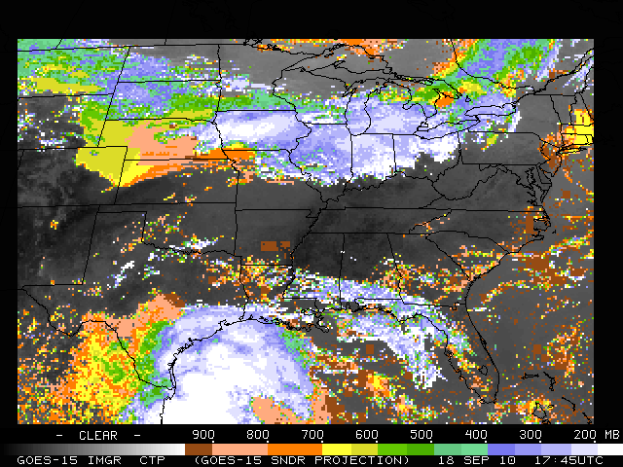
Figure 5.8: GOES-15 Imager cloud-top pressure from 18 September 2010 starting at 1745 UTC. The Imager data have been remapped into the GOES-15 Sounder projection.

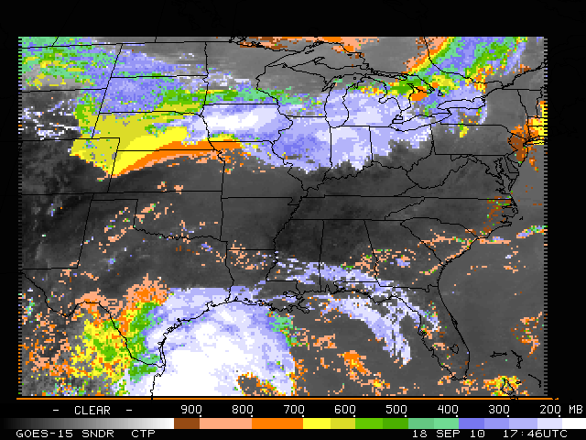
Figure 5.9: GOES-15 Sounder cloud-top pressure from 18 September 2010 starting at 1746 UTC.

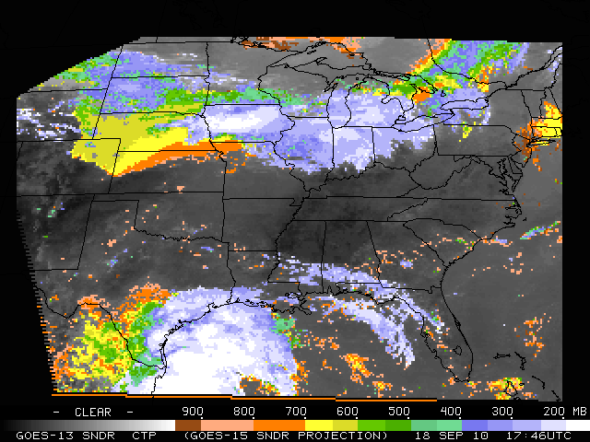
Figure 5.10: GOES-13 cloud-top pressure from the Sounder from 1746 UTC on 18 September 2010.

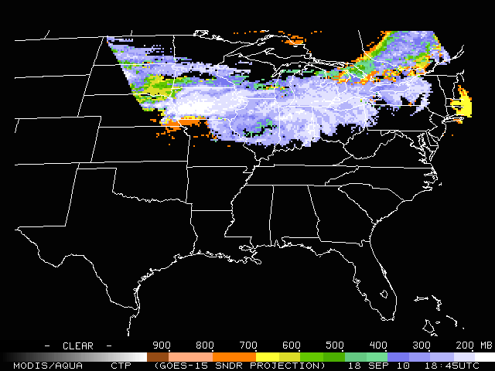
Figure 5.11: MODIS/AQUA cloud-top pressure at 18 UTC on 18 September 2010.

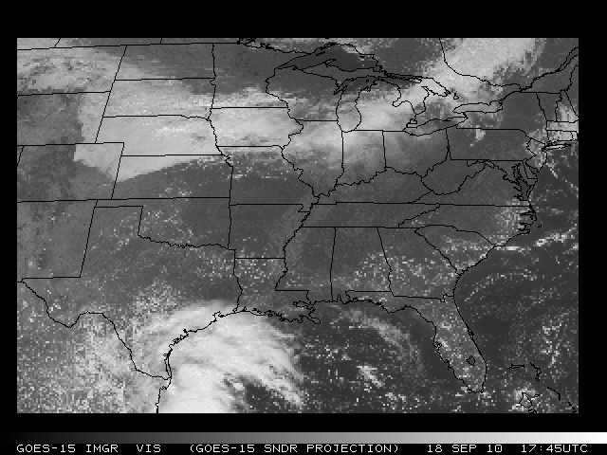
Figure 5.12: GOES-15 Sounder visible image from the nominal 1746 UTC on 18 September 2010.

Atmospheric Motion Vectors (AMVs) from the Imager

Atmospheric Motion Vectors (AMVs) from GOES are derived using a sequence of three images. Features targeted in the middle image (cirrus cloud edges, gradients in water vapor, small cumulus clouds, etc.) are tracked from the middle image back to the first image, and forward to the third image, thereby yielding two displacement vectors. These vectors are averaged to give the final wind vector, or AMV. This report summarizes the quality of AMVs from GOES-15 as part of the NOAA Science test in 2010.

The varied imaging schedules activated during the GOES-15 Science Test provided an opportunity to run AMV assessments for what are currently considered operational as well as special case scenarios. A thinned sample (for display clarity) of AMVs from GOES-15 on 10 August 2010 at 11:45UTC are shown for Cloud-Drift (Figure 5.13) and Water Vapor (Figure 5.14) AMVs.

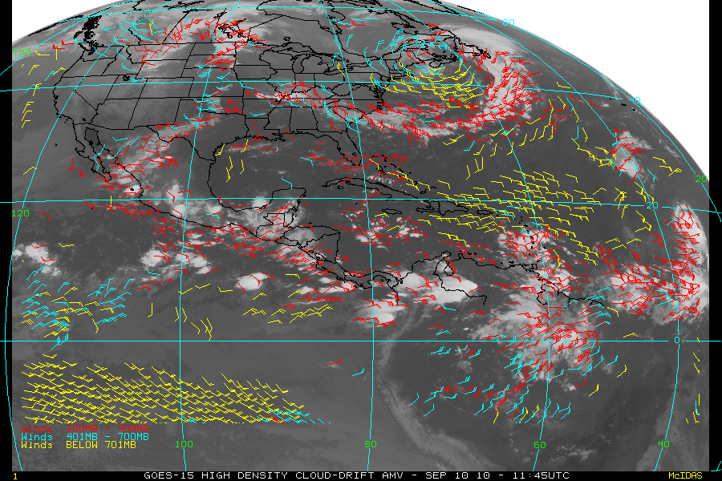
Figure 5.13: GOES-15 Northern Hemisphere (NHEM) cloud drift AMV on September 10, 2010 at 1145 UTC.

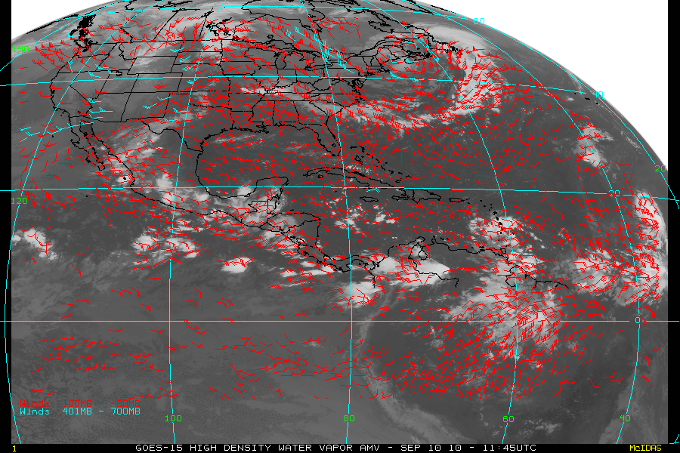
Figure 5.14: GOES-15 Northern Hemisphere (NHEM) water vapor AMV on September 10, 2010 at 1145 UTC.

During the science test objective statistical comparisons were made using collocated radiosonde (RAOB) data matched to the various GOES-15 AMVs. Table 5.2 shows the results of these GOES vs. RAOB match statistics for Cloud Drift and Water Vapor AMVs.

Table 5.2: Verification statistics for GOES-15 vs. RAOB Match Verification Statistics NHEM winds (m/s): 11 September 2010 – 25 October 2010. MVD is the mean vector difference.
NHEM | RMS | MVD | Std Dev | Speed Bias | Mean Speed (Sat) | Mean Speed (RAOB) | Sample Size
Cloud-Drift | 6.23 | 5.14 | 3.52 | -0.63 | 15.21 | 15.85 | 25330
Water Vapor | 6.37 | 5.29 | 3.55 | -0.27 | 16.35 | 16.62 | 51413

Comparison statistics were also generated for collocated GOES-13 and GOES-15 AMV data sets with RAOB observations. To be considered in the statistical evaluation, the respective GOES AMVs had to be within 1/10 degree horizontal and 25 hPavertical. Table 5.3 shows the results of this comparison. The small differences confirm that the AMV products from GOES-15 are at least comparable in quality with the existing GOES-13 operational AMVs.

Table 5.3: RAOB Verification statistics for GOES-13 and GOES-15, collocated (0.1 deg, 25 hPa) for NHEM winds (m/s): 11 September 2010 – 25 October 2010
NHEM | RMS | MVD | Std Dev | Speed Bias | Mean Speed (Sat) | Mean Speed (RAOB) | Sample Size
GOES-13 Cloud-Drift | 6.14 | 5.03 | 3.53 | -0.68 | 14.54 | 15.23 | 1358
GOES-15 Cloud- Drift | 6.12 | 4.98 | 3.56 | -0.61 | 14.55 | 15.16 | 1358
GOES-13  Water Vapor | 6.19 | 5.13 | 3.46 | -0.26 | 15.18 | 15.44 | 4051
GOES-15  Water Vapor | 6.02 | 5.02 | 3.32 | -0.31 | 15.11 | 15.42 | 4051

Clear Sky Brightness Temperature (CSBT) from the Imager

A satellite-derived product, called the Clear-Sky Brightness Temperature (CSBT), based on Geostationary Operational Environmental Satellite (GOES) Imager radiance data, was originally requested by National Centers for Environmental Prediction (NCEP)/ Environmental Modeling Center (EMC) and the European Centre for Medium-range Weather Forecasts (ECMWF) for assimilation into global weather prediction models to better analyze the initial atmospheric state.

Current coverage for the operational CSBT extends from roughly 67S to 67N and 30W to 165E for GOES -11, and -13. The data are averaged over boxes of approximately 50 km per side. Each box consists of 187 (eleven rows by seventeen columns) FOVs. For a given box a cloud detection algorithm is used. For each 50 km box the average brightness temperature for each infrared (IR) band and the albedo in percent for the visible band are calculated along with the average clear and cloudy brightness temperatures. Additional parameters determined are the number of clear and cloudy FOVs, center latitude and longitude of the box, center local zenith and solar zenith angles of the box, land/sea flag, standard deviation of the average clear and cloudy brightness temperatures, and two quality indicator flags. The quality indicator flags provide information on the likelihood of a particular observation being affected by sun glint and the relative quality of the SST observation.

A derived product image, Fig. 5.15 (top left), below is also generated. This product is a single FOV result. It is compared to a “merged” version of the current GOES-11 and -13 derived image reformatted to the GOES-15 projection (Fig. 5.15, top panels). In general, there is fair agreement between the GOES-15 image and the GOES-11/-13 combined image. In addition the GOES-15 Imager visible and long wave window images are depicted (left and right, lower panels) and further demonstrate consistency between the two derived products.

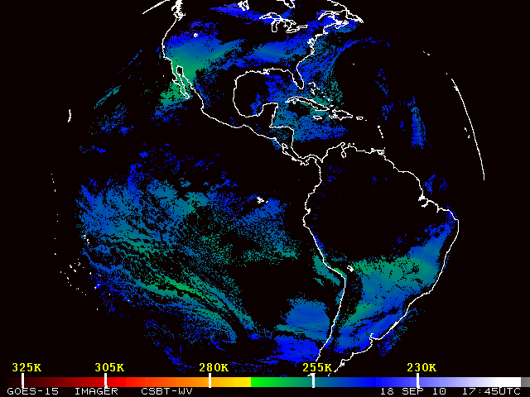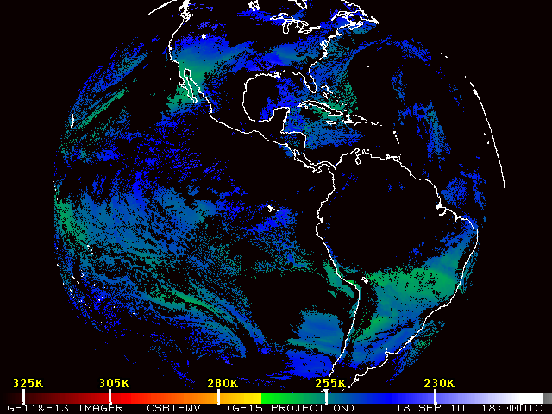
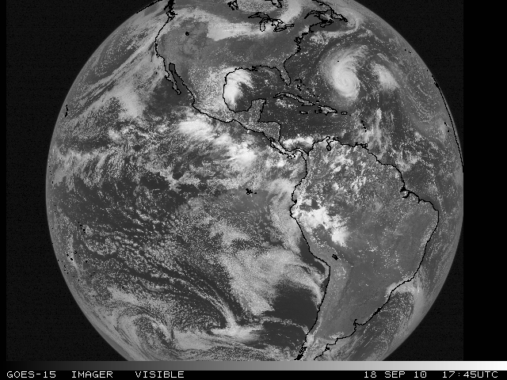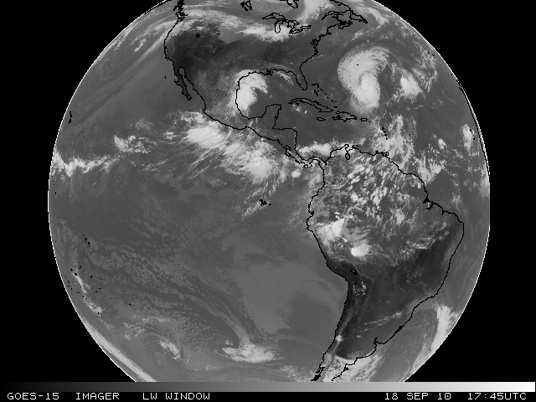
Figure 5.15: GOES-15 Imager Clear Sky Brightness Temperature (CSBT) cloud mask image from 18 September 2010 for the nominal 18 UTC time period (upper-left). On the upper-right is the GOES-13 Imager CSBT cloud mask image for the same date and nominal time period as shown in the GOES-15 Imager satellite projection. Clear regions display the band 3 Water Vapor (6.5 µm) Brightness Temperature. GOES-15 Imager Visible (lower-left) and Long Wave Window (lower-right) from 18 September 2010 for the nominal 18 UTC time period.

Sea Surface Temperature (SST) from the Imager

GOES-15 Imager data were collected, archived locally, and used as input for Sea Surface Temperature (SST) retrievals. These were collected for the entire test period of August 11 to October 25, 2010. The sector for GOES-East is approximately 30° E to 110° W and 60° N to 45° S. Examples of GOES-15 SSTs for day and night with their associated Probability of Clear Skies are shown in the following figures.

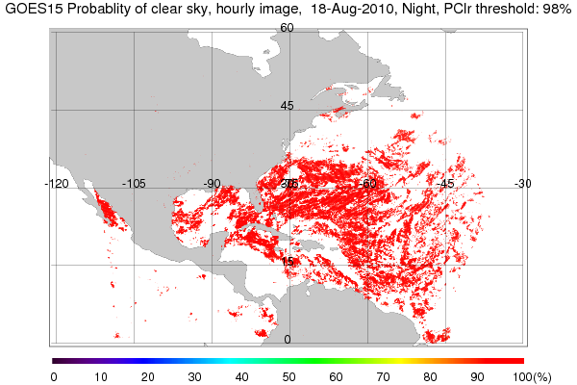
Figure 5.16: The nighttime areas that are considered clear pixels based on Bayesian estimate of ≥98% clear sky probability. The mask is based on the highest clear sky probability for the three daytime images that went into generating this GOES-15 product.

The GEO-SST software is comprised of two steps – SST retrievals generation and estimation of cloud contamination probability. The cloud estimation is performed using a Bayesian estimation technique.

The GOES-15 coefficients for 75 °W were used to generate SST retrievals. Then a Bayesian Cloud Mask was applied to obtain clear sky pixels. Bayes’ theorem is applied to estimate the probability of a particular pixel being clear of cloud. The inputs are the satellite-observed brightness temperatures, a measure of local texture and band brightness temperatures calculated for the given location and view angle. uNCEP Global Forecast System (GFS) surface and upper air data and the Community Radiative Transfer Model (CRTM- v2.0) fast radiative transfer model inputs are used. This method is described in detail in Merchant et al (2005). Using the current form of the SST equation below, retrievals was generated for dual window (3.9 μm and 11 μm).
SST=a₀ + a₀ S + ∑_{i} (a_{i} + a_{i} S) T_{i}

where i is GOES-Imager band number (2, 4), S = satellite zenith angle – 1, and Ti is the band brightness temperature (K). Due to a lack of a 12 µm band on GOES-15, a single dual window form was used for both day and night with a correction for scattered solar radiation in the 3.9 µm band being applied for the daytime case (for details see Merchant et al. 2009).

The GEO-SST software for GOES-15 includes major capability upgrades from GOES-14 to enable the use of Physical Retrieval methodology, multi-dimensional lookup tables for Bayesian cloud estimates and other science upgrades.

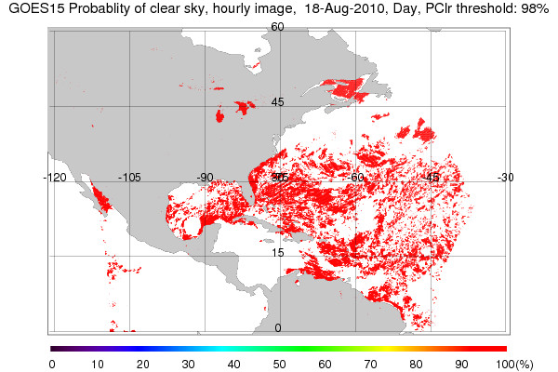

Figure 5.17: The daytime areas that are considered clear pixels based on Bayesian estimate of ≥98% clear sky probability. The mask is based on the highest clear sky probability for the three daytime images that went into generating this GOES-15 product.

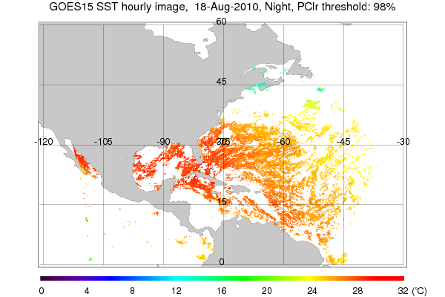
Figure 5.18: The Sea Surface temperature from GOES-15 created by compositing three nighttime half hour SST McIDAS Area files with an applied threshold of ≥98% clear sky probability.

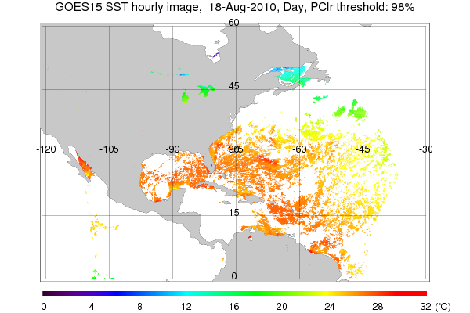
Figure 5.19: shows the Sea Surface temperature from GOES-15 created by compositing three half hour daytime SST McIDAS Area files with an applied threshold of ≥98% clear sky probability.

Fire Detection and Characterization

Basic fire detection and characterization relies primarily on the short and long-wave IR window (3.9 µm, band 2 and 11 µm, band 4) data from the GOES Imager. These two IR windows and ancillary information are used to determine instantaneous estimates of sub-pixel fire size and temperature. The number of fires that can be successfully detected and characterized is related to the saturation temperature, or upper limit of the observed brightness temperatures, in the 3.9 µm band. A higher saturation temperature is preferable as it affords a greater opportunity to identify and estimate sub-pixel fire size and temperature. That said, the maximum saturation temperature should still be low enough to be transmitted via the GVAR data stream. Low saturation temperatures can result in the inability to distinguish fires from a hot background in places where the observed brightness temperature meets or exceeds the saturation temperature. Furthermore sub-pixel fire characterization is not possible for saturated pixels.

The SAB Fire desk completed most of their comparisons using the band 2 IR imagery. Comparisons done when solar reflectivity was near its minimal during sunset resulted in very small, if any, differences in fire or landmass temperature. Afternoon comparisons showed an apparent cool bias of 1-3K in non-hotspot areas (where a fire was not located). For hotspot (fire) detection, GOES-13 was often hotter than GOES-15 by as much as 7K. This seems counter intuitive since all of the hotspots in the comparison were closer to the GOES-15 subpoint (all locations were west of 91W) and solar reflection during daylight hours makes fires very sensitive to viewing angles, making direct comparison between different satellites tricky. Furthermore, a given fire may be observed and characterized very differently depending on its location in the respective GOES-13/GOES-15 pixels and the application of the point spread function (PSF). More extensive band 2 IR comparisons would need to be done due to the highly sensitive nature of the 4 micrometer sensor to solar reflectivity, the rapidly changing radiative power of fires, and the GOES-13/-15 observed differences due to the location of the fire in the pixels. Visible imagery comparisons for smoke analysis and blowing sand/dust plumes revealed no appreciative differences between GOES-15 and GOES-13 imagery.

A comparison of GOES-11 (GOES West), GOES-15, and GOES-13 (GOES East) 3.9 µm shortwave IR images in Figure 5.20 indicated that there was a hot spot on 9 September 2010. This was due to a large natural gas explosion that occurred in San Bruno, CA. The 3 sets of images are displayed in the native projection of their respective satellites. The fire “hotspots” showed up as warmer (darker black or yellow enhancement) pixels.

The plot in Figure 5.21 shows that the warmest 3.9 µm IR brightness temperature on the GOES-15 imagery for this case was approximately 318K. More information on this case can be found at http://cimss.ssec.wisc.edu/goes/blog/archives/6752.

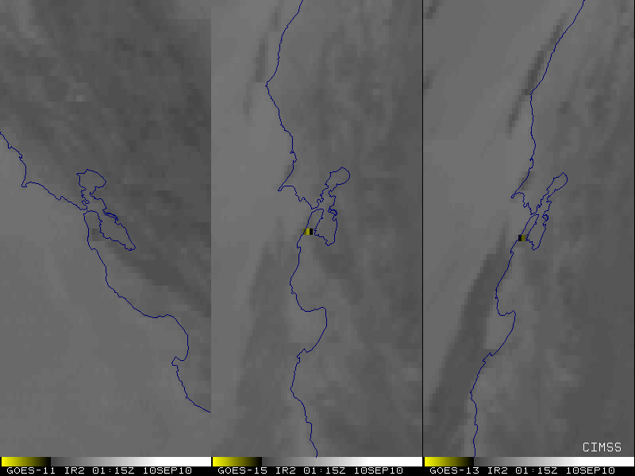
Figure 5.20: GOES Imager 3.9 µm images from GOES-11 (left), GOES-15 (center) and GOES-13 (right). Each satellite is shown in its native perspective.

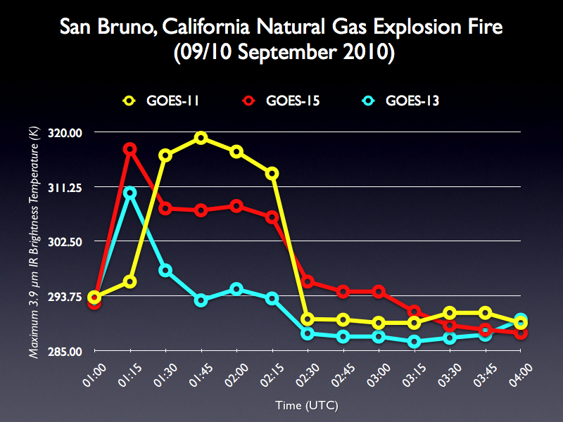
Figure 5.21: GOES Imager 3.9 µm time series from GOES-11, GOES-15 and GOES-13.

The GOES-15 Imager 3.9 µm band has a saturation temperature of approximately 337.4 K. For reference, the GOES-12 Imager 3.9 µm band has a saturation temperature of approximately 339 K, although this value has changed over time, peaking at approximately 342K.

Preliminary indications are that GOES-15 is performing comparably to GOES-11 and GOES-13.

The Biomass Burning team at CIMSS currently produces fire products for GOES-11/-12/-13 covering North and South America. GOES-11/-13 Wildfire Automated Biomass Burning Algorithm (WF_ABBA) fire products can be viewed at http://cimss.ssec.wisc.edu/goes/burn/wfabba.html in near real time.

Volcanic Ash Detection

The SAB Volcano desk noted only one time during the GOES-15 post launch test that volcanic ash was able to be seen by both GOES-13 and GOES-15. Ash detection is very event driven and there was little volcanic activity in the SAB Volcano team’s areas of interest in the August-September period on 2010. The ash signature was seen in visible imagery and showed up identically in the GOES-15 imagery compared to the GOES-13 imagery. A few cases where volcanic hotspots could be seen in multi-spectral imagery were noted with any differences being negligible. The multi-spectral imagery used for volcanic ash/hotspot detection is sensitive to the solar angle and thus the minor differences seen were attributed to the different positions of the satellites being compared. Thus, there were no differences with GOES-15 imagery that would result in degradation in performance for volcanic ash analysis.

Total Column Ozone

Total Column Ozone (TCO) is an experimental product from the GOES Sounder. The GOES-15 Sounder TCO is expected to be of similar, or higher, quality as derived from earlier GOES Sounders. Note the similar overall patterns between GOES-13 and GOES-15 shown in Figure 5.22 and 5.23.

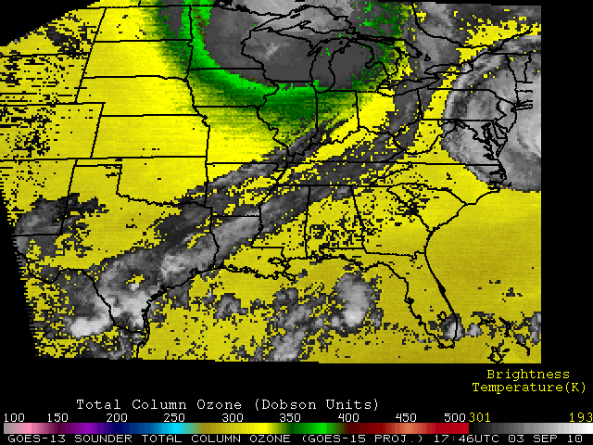
Figure 5.22: Example of GOES-13 Imager Total Column Ozone on 3 September 2010 at 1800 UTC.

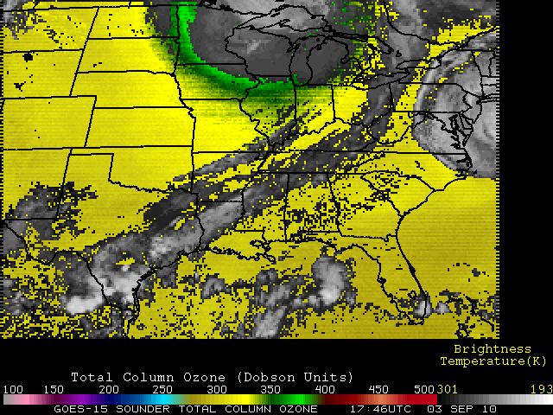
Figure 5.23: Example of GOES-15 Imager Total Column Ozone on 3 September 2010 at 1800 UTC. The image is displayed in the GOES-15 perspective.

GOES Surface and Insolation Product (GSIP)

The GOES Surface and Insolation Products (GSIP) system is operationally producing a suite of products relating primarily to upward and downward solar radiative fluxes at the surface and top of the atmosphere for the GOES series of satellites. As shown in the above two images, the similarity of surface insolation derived from GOES-13 (the current GOES-EAST satellite) and GOES-15 data, as well as the other products, which are not shown, illustrates that GSIP is well on the way to continuing to produce a consistent dataset of the surface insolation products from the GOES-15 imager.

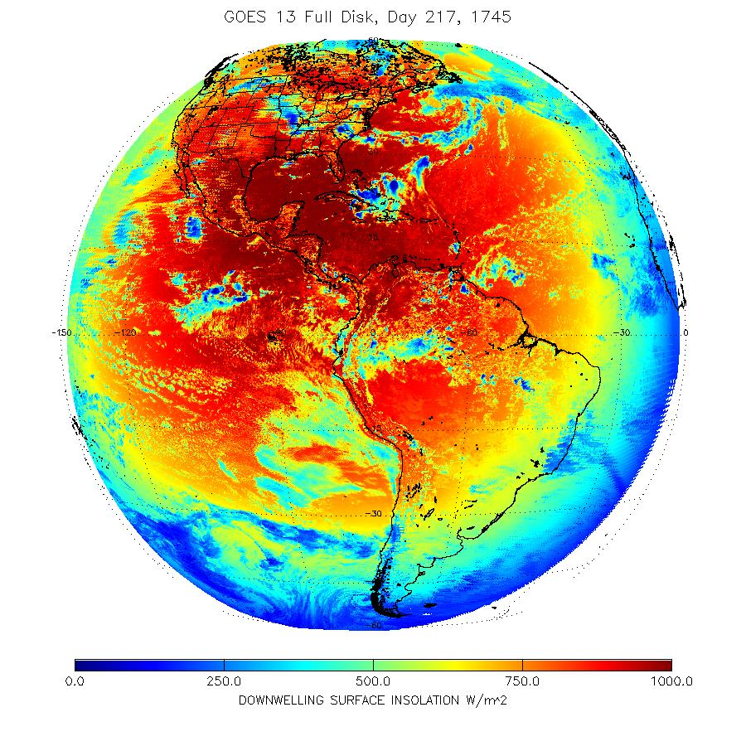
Figure 5.24: GOES-13 Imager downwelling surface insolation on August 5, 2011 beginning at 1745 UTC.

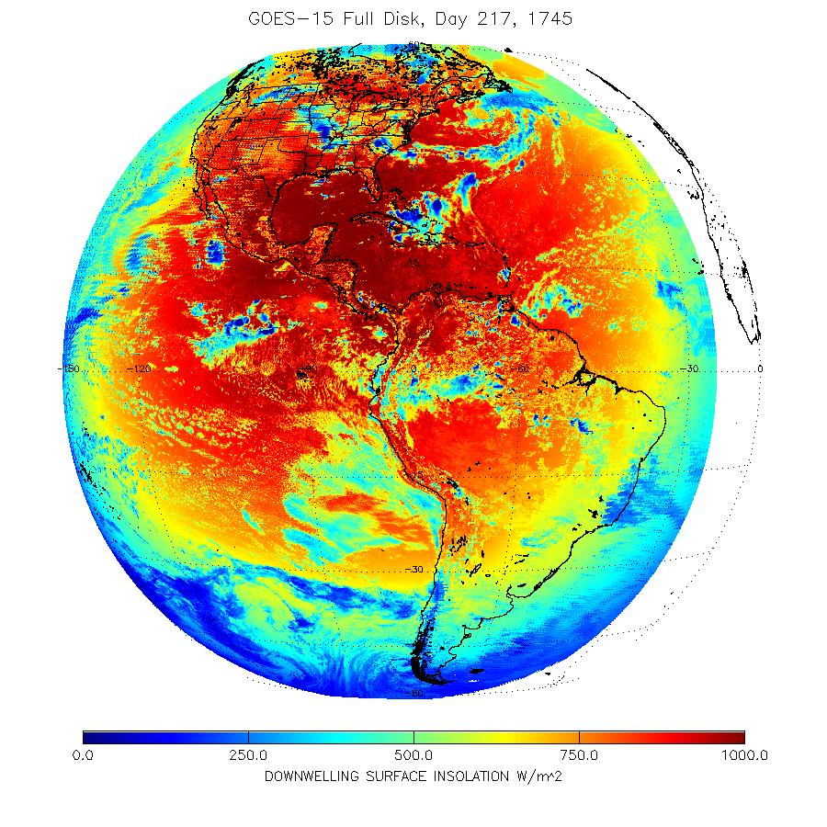
Figure 5.25: GOES-15 Imager downwelling surface insolation on August 5, 2011 beginning at 1745 UTC.

Precipitation and Tropical applications

For the SAB Precipitation desk, analysts compared GOES-15 band 4 IR and band 1 Visible imagery to that of GOES-13 or GOES-11. There were fourteen comparisons completed by the analysts involving a variety of meteorological events; such as thunderstorms, stratiform rain events, and hurricanes. Cloud top temperatures for this wide variety of events ranged from +15C (warm surface) to -82C (near the eye of Hurricane Igor). Of these fourteen meteorological events, there were only minor differences observed in both band 4 IR and Visible channels. Very small deviations of 1-2 degrees Celsius or less were occasionally noticed in the band 4 data but this would not have affected or degraded Precipitation operations in any way. Any subtle differences in measurements and/or appearance were determined to be caused by the different viewing angles/parallax between GOES-15 and the comparison satellite (GOES-13 or 11).

Analysts of the Tropical desk also observed similar minor discrepancies in band 2 and 4 IR imagery, with compared cloud top temperatures sometimes being slightly warmer and other times slightly colder. It's possible that this was the result of the viewing angle of the satellite, though this cannot be fully determined. Since the enhancement table used for the IR/SWIR is crucial to tropical cyclone intensity estimates it is conceivable that these differences, though small, could have negatively impacted operations if they were to occur near the breaks between the various gray shades of the imagery enhancement. The Tropical team also noted that they believed the Visible imagery from GOES-15 was slightly brighter than either GOES-13 or GOES-11. This is consistent with GOES-15 being a newer instrument and hence less time for degradation in the visible bands.

Other Accomplishments with GOES-15

GOES-15 Imager Visible (band 1) Spectral Response

A comparison of enhanced visible band images from GOES-11 and GOES-15 at 1500 UTC on 25 August 2010 is shown in Figures 6.1 and 6.2. Images from both satellites have been displayed in their native projections.

There are a couple of significant differences to note between the two visible images, while keeping in mind the very large difference in satellite view angles. GOES-15 is able to discern urban centers more readily than GOES-11 over this area, as well as variations in vegetation type. Examples of this are around the large metropolitan region of southeastern Wisconsin and northeastern Illinois (i.e. Milwaukee to Chicago). Also, both the Baraboo Range (located just to the northwest of Madison) and the “Military Ridge” (which runs east to west from Madison to Prairie du Chien) stand out more boldly in the GOES-15 image compared to the GOES-11 image. This difference is primarily due to the slight variation in the spectral width of the two visible bands on the GOES-11 and GOES-15 Imagers. A comparison of the visible band spectral response function for GOES-11 and GOES-15 shows that the sharper cutoff for wavelengths beyond 0.7 µm on the GOES-15 visible band makes it less sensitive to the signal from the mature corn crops, allowing greater contrast between the thick vegetation of the agricultural fields and the more sparsely vegetated cities, towns, and highway corridors.

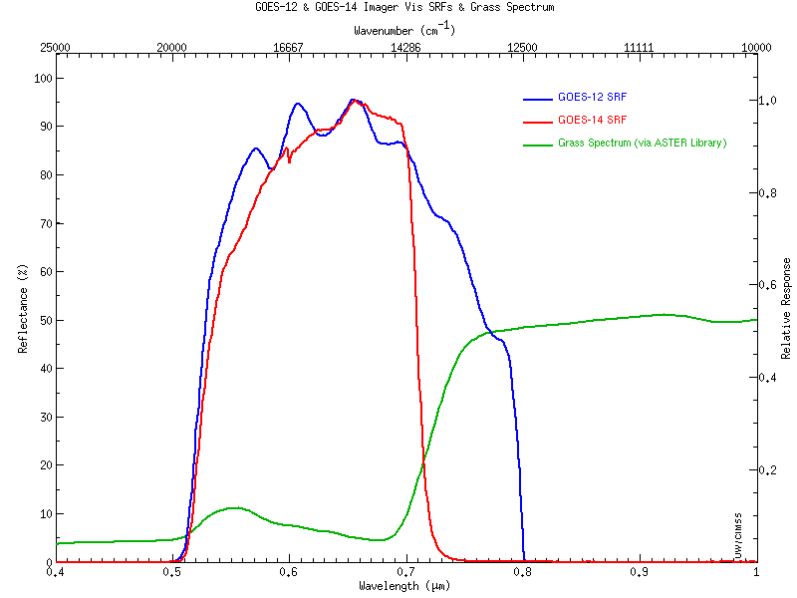

Figure 6.1: GOES-11 (blue) and GOES-15 (red) Imager visible (approximately 0.65 or 0.63 μm) band SRFs, with a representative spectrum for grass over-plotted (green).

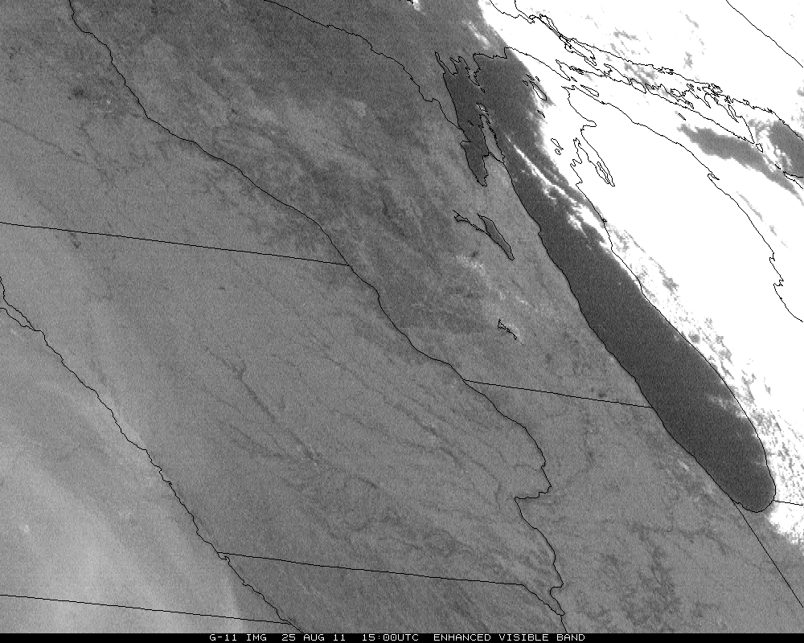

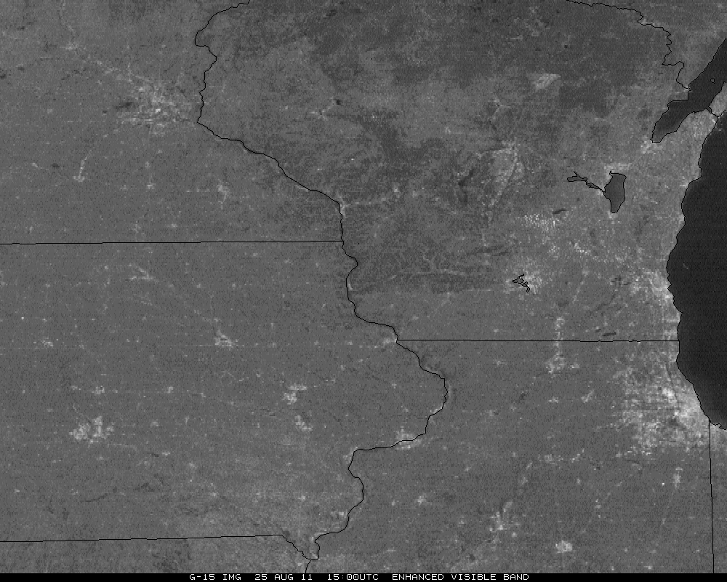

Figure 6.2: Comparison of the visible (0.65 μm) imagery from GOES-11 and GOES-15 (0.63 μm) on 25 August 2010 demonstrates how certain features, such as surface vegetation, are more evident with the GOES-15 visible data.

Lunar calibration

Several GOES-15 Imager datasets were acquired during the PLT. The main objective of these tests was to observe the lunar images as soon as possible in order to establish a baseline for future study of instrument degradation. While not intended, lunar images may allow an attempt on absolute calibration, although this theory has not been fully researched. Note that the image discontinuities are due to the relative changes in the satellite and moon geometry.

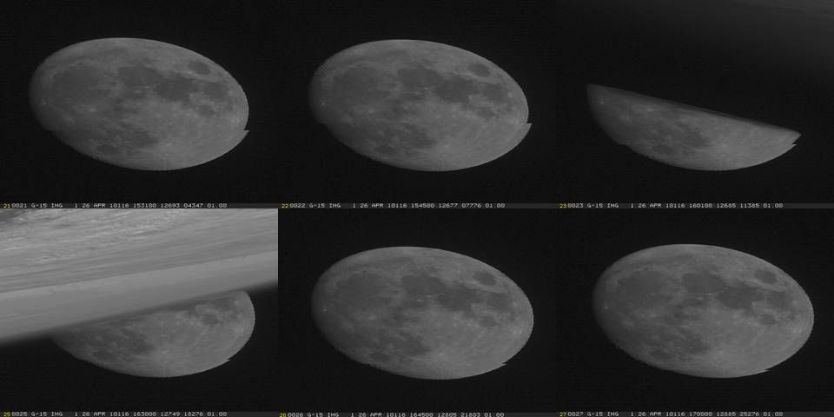

Figure 6.3: GOES-15 Imager visible (0.65 μm) band imaged of the moon from various dates.

The moon was intensively imaged on four different days during the PLT science test period to investigate the scan-angle dependent reflectivity for the visible channel: on August 27th, in upright position and on September 22, 23 and 24, 2010 in yaw-flipped position. On each of these days between 13 and 84 consecutive Moon images were taken within 35 seconds of each other. Only the Moon images taken on September 24 (Day 267) cover a large scan angle range from about 40.8º to 49.8º.

Although the Moon’s surface is a good reference for the vicarious calibration of the visible channel, the measured Moon irradiance can be affected by the moon surface BRDF, change of moon phase angle and other sun-moon-satellite geometry relationships. However, the impact of these disturbances can be greatly reduced with the ratio of GOES observed moon irradiance to the irradiance predicted with USGS Robotic Lunar Observation (ROLO) model (Stone and Kieffer 2006). Figure 6.4 shows the observed and model irradiance ratio against the scan angle using the data obtained on September 24, 2010. The GOES moon irradiance was estimated by summing up all pixels within a lunar subset (Wu et al. 2006). It clearly shows that moon brightness decreases for angle of incidence (AOI) up to 43º degrees, peaks at approximately 45º degrees then decreases to 47º, beyond which it increases up to 50º degrees. Similar, but fractional effects were observed on September 22nd, 23rd, and August 27th, 2010.

Figure 6.4: Ratio of observed and ROLO irradiance as a function of angle of incidence exhibits weak linear regression on September 24, 2010.

Improved Image Navigation and Registration (INR) with GOES-15

McIDAS images of GOES-15 visible band data show the good INR performance. One example is the rapid development of this thunderstorm (along with several other storms across Arizona) on August 17. The animation can be found at http://cimss.ssec.wisc.edu/goes/blog/archives/6380.

Special 1-minute Scans

On 21 September 2010, 1-minute interval GOES-15 visible images centered in the Midwest offers a compelling demonstration of the value of frequent imaging for monitoring the development and evolution of convection. This animation can be found at http://cimss.ssec.wisc.edu/goes/blog/archives/6849.

Another case was the special scans of Hurricane Igor, where A comparison of 1-minute interval GOES-15 SRSO images with the normal operational 30-minute interval GOES-13 visible images clearly demonstrates the advantage of higher temporal resolution for monitoring the evolution of the eye structure of the hurricane. More information can be found at: http://cimss.ssec.wisc.edu/goes/blog/archives/6790.

Special GOES-15 Scans
On 27 July 2011, when GOES-15 was out of storage and operated in a pre-operational mode, additional loops were made to show the GOES-15 Imager water vapor channel and its 4-km resolution versus 8-km resolution on GOES-11. In the loops, the better depiction can clearly be seen of gradients (despite the vastly different view angles) and the better depiction of the mid-level vortex. These animations can be found at http://cimss.ssec.wisc.edu/goes/blog/archives/8529.

Coordination with University of Alabama/Huntsville

As part of NOAA's GOES-14 Science Test, SRSO (1-minute data) were requested by the NASA MSFC Earth Science Office to support research in algorithm development related to applications of future space based geostationary lightning mapping systems (i.e., GOES-R GLM) in high-impact weather events. Accordingly, ground based assets including the UAH ARMOR dual-polarization radar, KOUN dual-polarization radar, WSR-88D radar, and VHF lightning mapping arrays in N. Alabama (NALMA), Washington D.C. (DCLMA), Oklahoma (OKLMA) and Cape Canaveral, Florida (KSC), combined with the GOES-14 SRSO, comprise the set of tools to be used for the investigation. Collectively, the satellite data combined with the aforementioned datasets provide a robust means of examining cell evolution, including relationships of cloud kinematic trends with lightning and microphysical properties.

The specific objectives of the SRSO requests at MSFC can be summarized as follows: 1) Capture lightning-producing convection (hopefully severe) within view of the GOES-14 and ground-based assets; 2) For suitable lightning-producing cases identify precipitation and/or kinematic structure and behavior as observed from ground and space-based assets and compare to null cases (i.e., no lightning, but convective) in coincident SRSO domains; and 3) Capture winter storm cases to test hypotheses about thermodynamic and kinematic environments responsible for electrification, and the altitude and extent of charge regions. Of particular interest is the interaction of the warm conveyor belt with wrap-around precipitation in the deformation zone. The GOES super-rapid-scan data makes it easy to track individual cumuliform convective elements with time and to correlate these features with radar observations and ground strike data from commercial networks in later post-analysis. These features will be compared with the studies of Market et al. (2006, 2009), who also looked at lightning in synoptic-scale snowstorms.

Table 7.1: Summary of significant case study dates for MSFC GOES-14 SRSO
Date | Location | Case | Data
2009-12-2/3 | Northern Alabama | Weak lightning-producing convection; tornado warning. | SRSO, ARMOR dual-polarization, NALMA, regional WSR-88D
2009-12-8/9 | Northern Alabama | Deep convection, copious lightning, severe wind event | SRSO, ARMOR dual-polarization, NALMA, regional WSR-88D
2009-12-18/19 | Washington D.C. | Winter storm case (possible lightning) | SRSO, DCLMA, WSR-88D
2009-12-24 | Eastern Oklahoma | Winter storm with thundersnow | SRSO, OKLMA, KOUN dual-polarization, WSR-88D

Table 7.1 presents a summary listing of the significant case dates (i.e., those designated as “primary” research cases) selected from the SRSO attempts. It must be noted that relative to objectives 1-3, this data collection was highly successful. Of course, several other SRSOs were conducted (e.g., focused Cape Canaveral area), but these SRSOs did not result in overly positive results.

Deep Convection: Example Case Studies

Marginal Lightning and Severe Weather: 2 December 2009

A thin line of precipitation pushed through N. Alabama on the afternoon of 2 December 2009. A tornado warning was issued by the National Weather Service in Huntsville, at 2105 UTC on a small storm in eastern Jackson County AL (Figure 7.1, red arrow). Figure 7.2 shows a dual Doppler analysis of this storm in eastern Jackson County at 2103 UTC. Rotation is not well defined in this storm, and it produced no detectable lightning; however, ARMOR reflectivity data indicated a small hook-like appendage on the southwestern flank of the warned cell. Note that the KHTX 88D had a much closer view of the system. Storms just to the south of this cell eventually did produce lightning at about 2130 UTC (Figure 7.3).

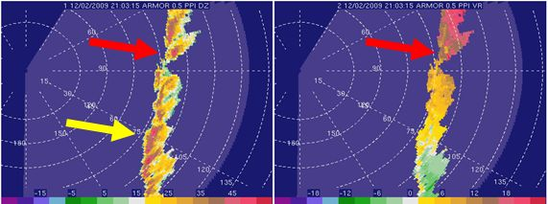

Figure 7.1: PPI from ARMOR at 2103 UTC on 2 December 2009 at 0.7° elevation. Reflectivity (upper-left), radial velocity (upper-right), differential reflectivity (lower-left) and specific differential phase (lower-right) are all shown. The cell that prompted the tornado warning is highlighted by the red arrow. Cells just to the south of the tornado-warned storm briefly produced lightning about 2130 UTC (yellow arrows).

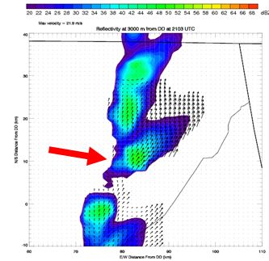
Figure 7.2: Dual Doppler Analysis using the WSR 88D radar at Hytop AL (KHTX) and UA Huntsville’s ARMOR radar (2103 UTC). Shown are reflectivity (shaded) and ground-relative wind vectors. The cell that prompted the tornado warning is highlighted by the red arrow. Cells just to the south of the tornado-warned storm are producing lightning. Only very slight rotation is evident in the hook region of the dual-Doppler analysis.
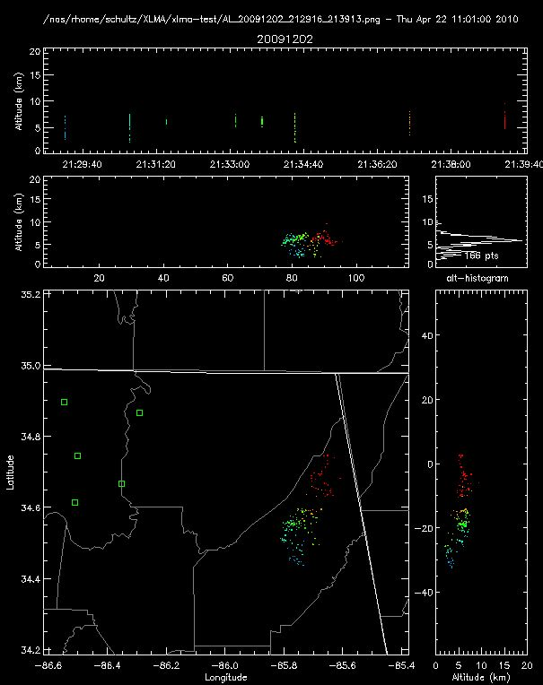

Figure 7.3: Total lightning measurements using the North Alabama Lightning Mapping Array for 2 December 2009 at 2130-2140 UTC. Vertical lines in the top panel represent lightning flashes, while the lower three panels represent the distribution of VHF sources in the XY (lower-right), XZ (middle) and YZ (lower-right) directions. Cooler colors represent flashes that occur earlier, while warmer colors show flashes that occur later in the period. Not unexpectedly, the source heights in this storm are relatively low in altitude.

Note: No satellite data have been analyzed for this case yet.

Severe Convection: 8-9 December 2009

This event (Figure 7.4) was long-lived (perhaps the best of the SRSO convective data collections), and characterized by 4-6 inches of heavy precipitation, local flooding, and severe wind damage to trees and power lines.

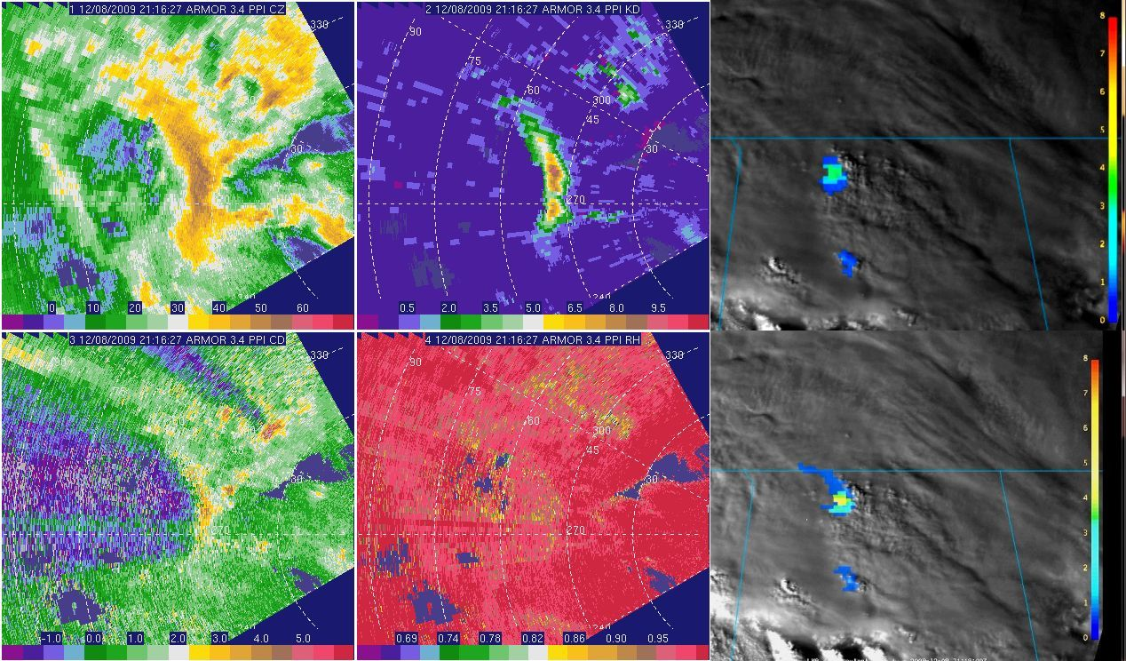

Figure 7.4: ARMOR image 2116 UTC at 3.4° elevation. Displayed are: reflectivity (CZ, upper-left), specific differential phase (KD, upper-middle), visible GOES-14 with lightning Flash Extent Density (FED, upper-right) at 2116 UTC, differential reflectivity (CD, lower-left), correlation coefficient (RH, lower-middle), and visible GOES-14 with FED at 2118 UTC (lower-right). A large drop core is identified in the dual-polarization data 50 km east of the radar along the apex of the bowed reflectivity feature.

The first round of thunderstorms for this event occurred on the afternoon of 8 December as a warm front lifted northward through north Alabama, and the event was extensively sampled by the NALMA and the ARMOR radar in volume scanning mode. Several percolating thunderstorm tops were observed in the SRSO visible imagery and an accompanying imagery loop which can be found at http://cics.umd.edu/~ebruning/GOES14sciencetest.html. Near most of the growing tops in the GOES-14 satellite data associated with this storm, lightning was observed (not parallax corrected), further identifying/confirming the location of thunderstorm updrafts.

The most prolific lightning producing thunderstorm within this first wave of precipitation moved through N. Alabama between 2000 and 2300 UTC. Peak total flash rates with this thunderstorm cell were observed to be ~6-7 flashes per minute. In Figures 7.4 through 7.5 these flash rates peak near the apex of a slight bow in the system where the heaviest rainfall (indicated by KDP) is located. The cell underwent growth between 2115 and 2120 UTC, a period where the largest 1 minute flash rates were observed. Several more clusters of low flashing thunderstorms were observed through 0000 UTC and thereafter as a cold front progressed eastward. These storms continued to produce severe weather, heavy rain and flooding (hence numerous events exist for this SRSO).

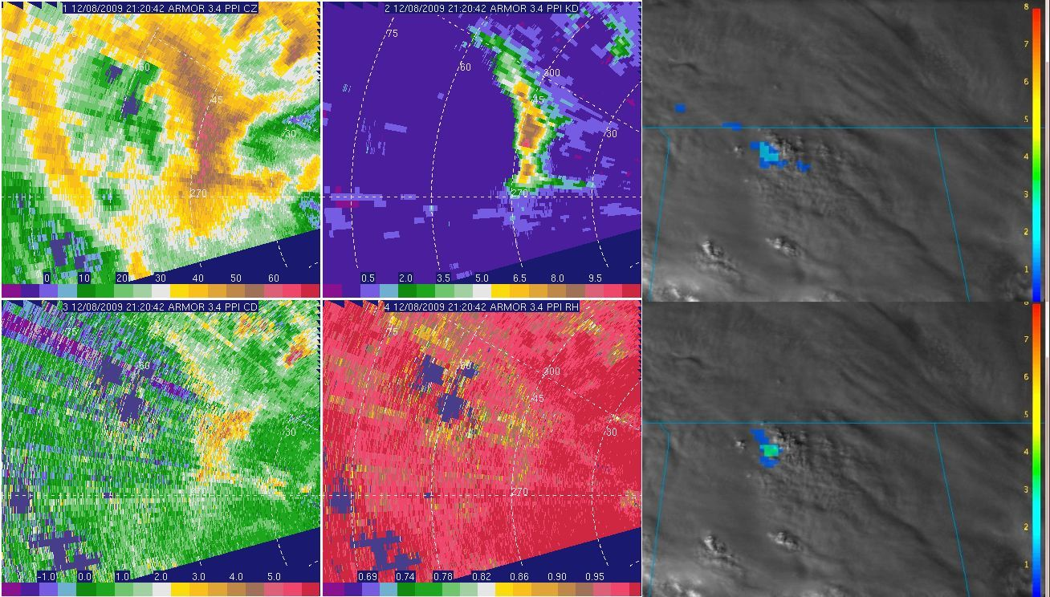

Figure 7.5: As in previous figure, but 2121 UTC for ARMOR image, 2120 UTC for specific differential phase, and 2121 UTC for lightning FED.

Winter Storm Events

Washington DC, 19 December 2009

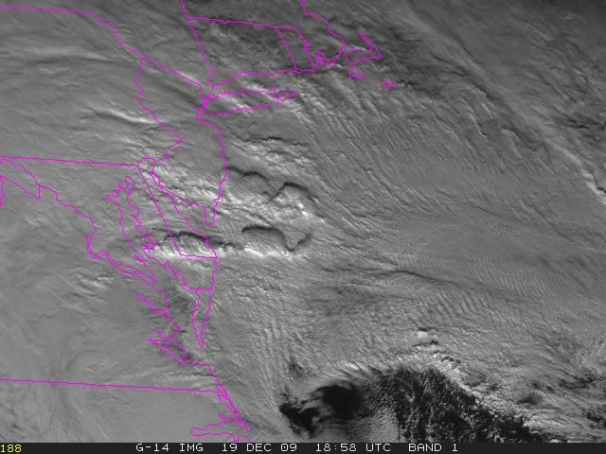

Figure 7.6: GOES-14 super-rapid-scan imagery from 1858 UTC on 19 December 2009 showing deep convective cells over the Delmarva Peninsula and southern New Jersey. Heavy snow was ongoing over adjacent parts of Maryland, Virginia, and Pennsylvania.

A coastal low-pressure system was responsible for a major snowfall on 19 December 2009 over Virginia and Maryland, including the DC metro area, which received between 16-20 inches storm total snow accumulation. There were a number of public and media reports of thunder in the Arlington VA area, though the Washington DC Lightning Mapping Array did not detect any flashes. During 1800-1900 UTC, two northward-moving, east-west oriented bands (Figure 7.6) of deep convection were observed on visible imagery over lower southern Maryland, Delaware and southern New Jersey (for reference, the imagery loop can be viewed at http://rammb.cira.colostate.edu/projects/svr_vis/eastcoast_snowstorm/ch1loop.asp.

The 1-minute scans that were captured in real-time were provided via Website and distributed to the Storm Prediction Center (SPC) operations and were used whenever available.

The absence of detected lightning in such deep convection is scientifically interesting as a null case. The GOES super-rapid-scan data make it easy to track individual cumuliform convective elements with time and to correlate these features with radar observations and ground strike data from commercial networks in later post-analysis. In fact, some of these commercial networks reported ground strikes nearer to Philadelphia.

While lightning was also observed during the historical February 2010 snow storm in the DC area (http://cics.umd.edu/~ebruning/snow/Feb6-DCLMA.html), super-rapid-scan science test data were not available for this case.

Oklahoma, 24 December 2009

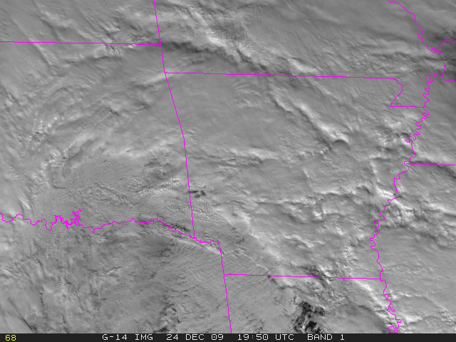

Figure 7.7: GOES-14 super-rapid-scan imagery from 1950 UTC on 24 December 2009. The convective activity over eastern Oklahoma was moving to the west-northwest, while the snow-bearing clouds along the western edge of the image were moving more south-southwesterly.

The satellite presentation in this case (Figure 7.7) was similar to that of the 19 December Washington DC case, with heavy snow under a dense, relatively homogeneous overcast in the wrap-around precipitation west and northwest of the low center, and evidence of deeper convection to the east and southeast of the low, where cirrus was relatively absent. Loops of some of the super rapid scan data from this case can be found at http://rammb.cira.colostate.edu/projects/svr_vis/24dec09/ch1loop_okc.asp.

In addition, a satellite animation comparing these 1-min observations to the routine 15 or 30-min observations can be found at http://cimss.ssec.wisc.edu/goes/blog/archives/4163, specifically http://cimss.ssec.wisc.edu/goes/blog/wp-content/uploads/2009/12/ecb_g12g14_vis_anim.gif.

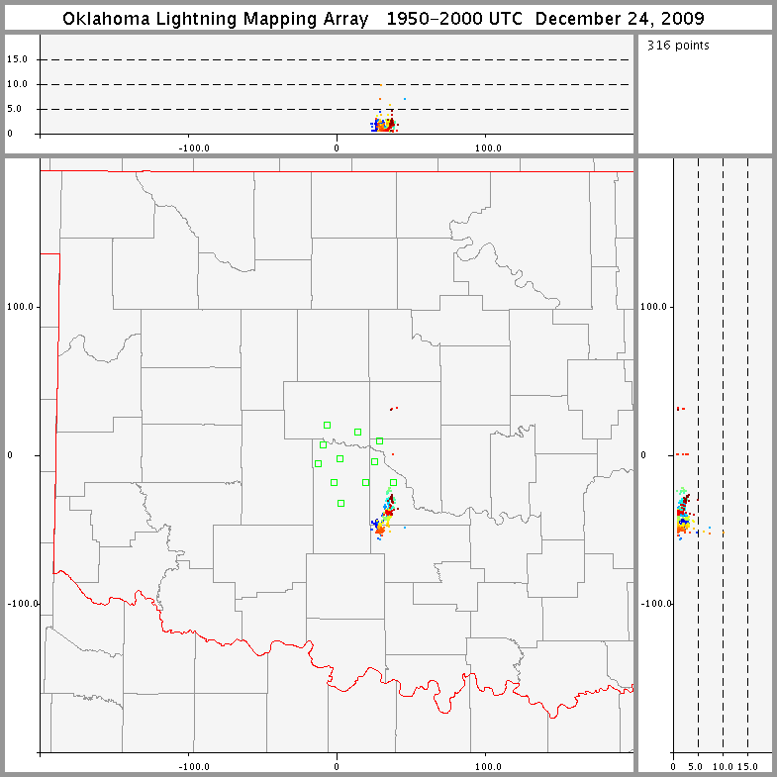

Figure 7.8: Lightning observed by the Oklahoma Lightning Mapping Array in McClain County between 1950 and 2000 UTC on 24 December 2009. (Image courtesy of Don MacGorman, NOAA/OAR/NSSL.)

The Oklahoma Lightning Mapping Array (Figure 7.8) detected a few lightning flashes in the wrap-around precipitation at 1200, 1500, and 1900-2000 UTC. Detections were generally at low altitude, so radio towers or other tall objects might have played a role in flash initiation.

SRSO for Lightning Summary

Several excellent and varied cases were collected via GOES-15 SRSO activities supporting lightning algorithm research and physics at NASA MSFC. Future research will use the SRSO information (both visible and IR) to examine use of the satellite data in future GOES-R applications that will integrate ABI imagery with Geostationary Lightning Mapper data.

Overall Recommendations Regarding this and Future GOES Science Tests

The following conclusions and recommendations were drawn during the GOES-15 Science Test:

- Each of the four main goals of the GOES-15 science test were accomplished. These were to characterize the radiance integrity, product generation, acquire unique image sequences and monitor instrument changes.

- The updated (Rev H with the STAR correction) Imager and Sounder SRF should be used for any subsequent product generation. In the future, the latest system SRF should be made available well before the start of the science test.

- Science Tests should continue as a vital aspect of the checkout of each GOES satellite, as studying real-time data is an effective way to detect problems in the data stream, ground systems and product generation/use. To best test the overall system, the data should continue to flow via the operational path, even before the operation period.

- Science Test duration should be at least 5 weeks for ‘mature’ systems (and ideally should be during times with active convection over the continental U.S.). Much longer test periods will be needed for new systems such as GOES-R. It is expected on the order of a year will be needed for the many steps of engineering, science, products, validation and user readiness. This could be split between a 6 month period during the NASA controlled time, followed by a 6 month period after the hand-over to NOAA. A longer period would also increase the odds of observing episodic events, such as volcanic activity.

- A Science Test could be preceded by several weeks of GOES-East and/or GOES-West schedule emulations. This would allow for more routine testing in operations, and then more flexibility during the science test itself. The science test should contain a mixture of the expected operational scan scenarios, along with any needed special scans.

- An additional aspect to the Science Test could involve yearly checkout of GOES data when individual spacecraft are taken out of storage and turned on for other purposes.

- While the GOES-15 GVAR data are captured and saved by a number of research groups, these unique and important pre-operational data should be part of the official GOES archive and be made available.

- Ideally as many groups as possible should get access to the pre-operational images and products. This would help test the flow and quality of the information before operations. This is especially important for NWP applications.

Acknowledgments

A large number of people played important roles in the success of the GOES-15 Science Test. The contributors listed on the front cover of this report provided analysis of GOES-15 radiance data and Imager and Sounder products. Yet, it takes many, to accomplish the needed tasks to check-out a satellite. These include the government (NOAA, NASA), industry (Boeing, contractors, etc) and Universities (cooperative institutes, etc). Dan Lindsey and John Knaff (StAR/RAMMB), Gary Wade (StAR/ASPB), and Scott Bachmeier (UW/CIMSS) are specially thanked for their participation in the daily coordination where decisions were made to determine which test schedules should be implemented in order to either capture interesting weather events, or to meet the requirements for the various data tests and generation of products. Scott is also thanked for his many informative satellite blog posts. Istvan Laszlo is thanked for his input on the GSIP images. In addition, thanks to Kevin Ludlum (GOES Scheduling Lead) and the rest of the GOES-15 Team at NOAA/NESDIS Office of Satellite Operations (OSO), for coordinating and establishing the numerous schedules and sectors used during the Science Test. Matt Seybold and Natalia Donoho of the Satellite Services Division User Services are also thanked. The entire SAB staff is thanked for their analysis with respect to the tropical, fire, volcano and precipitation desks. Hyre Bysal, John Tsui, Ken Mitchell, J. Paul Douglas, Tom Renkevens and Mike Weinreb are thanked for their GOES engineering and calibration expertise.

The following are also acknowledged for their detailed reviews of the final document: Katherine Maclay, Leanne Avila, and Thomas Wrublewski.

This project was funded by the NOAA/NESDIS Office of Systems Development (OSD) via the GOES I/M Product Improvement Plan (GIMPAP).

The views, opinions, and findings contained in this article are those of the authors/contributors and should not be construed as an official National Oceanic and Atmospheric Administration or U.S. Government position, policy, or decision.

References/Bibliography

Daniels, J.M., T.J. Schmit, and D.W. Hillger, 2001: Imager and Sounder Radiance and Product Validations for the GOES-11 Science Test, NOAA Technical Report NESDIS 103, (August), 49 pp.

Eilers, P.H.C., and Goeman, J.J., 2004: Enhancing scatter plots with smoothed densities, Bioinformatics 20(5):623-628.

Gunshor, M., T. Schmit, W. Menzel and D. Tobin, 2009: Inter-calibration of broadband Geostationary Imagers using AIRS, J. Atmos. Oceanic Tech., 26, 746-758.

Johnson, R., and M. Weinreb, 1996: GOES-8 Imager mid-night effects and slope correction. Proc. SPIE, Vol. 2812, 596, dio:10.1117/12.254104.

Jolliffe, I.T., and D.B. Stephenson, 2003: Forecast Verification. A Practitioner's Guide in Atmospheric Science, Wiley and Sons Ltd, 240 pp.

Hillger, D.W., and T.J. Schmit, 2007: Imager and Sounder Radiance and Product Validation for the GOES-13 Science Test. NOAA Technical Report, NESDIS 125, (September), 75 pp.

Hillger, D.W., and T.J. Schmit, 2009: The GOES-13 Science Test: A Synopsis. Bull. Amer. Meteor. Soc., 90, 6-11.

Hillger, D.W., and T.J. Schmit, 2010: Imager and Sounder Radiance and Product Validation for the GOES-14 Science Test. NOAA Technical Report, NESDIS 131, (September), 105 pp.

Hillger, D.W., T.J. Schmit, and J.M. Daniels, 2003: Imager and Sounder Radiance and Product Validation for the GOES-12 Science Test. NOAA Technical Report, NESDIS 115, (September), 70 pp.

Hillger, D.W., and T.H. Vonder Haar, 1988: Estimating Noise Levels of Remotely Sensed Measurements from Satellites Using Spatial Structure Analysis. J. Atmos. Oceanic Technol., 5, 206-214.

Ma, X. L., T. Schmit, and W.L. Smith, 1999: A non-linear physical retrieval algorithm - its application to the GOES-8/9 Sounder. J. Appl. Meteor., 38, 501-513.

Menzel, W.P., F.C. Holt, T.J. Schmit, R.M. Aune, G.S. Wade, D.G. Gray, and A.J. Schreiner, 1998: Application of GOES-8/9 Soundings to weather forecasting and nowcasting. Bull. Amer. Meteor. Soc., 79, 2059-2078.

Merchant, C.J., A.R. Harris, E. Maturi, and S. MacCallum, 2005: Probabilistic physically-based cloud-screening of satellite infrared imagery for operational sea surface temperature retrieval. Quart. J. Roy. Meteorol. Soc., 131(611), 2735-2755.

Merchant, C.J., A.R. Harris, E. Maturi, O. Embury, S.N. MacCallum, J. Mittaz, and C.P. Old, 2009: Sea Surface Temperature Estimation from the Geostationary Operational Environmental Satellite 12 (GOES-12), J. Atmos. Oceanic Technol., 26, 570-581.

Schmit, T.J., E.M. Prins, A.J. Schreiner, and J.J. Gurka, 2002a: Introducing the GOES-M Imager. Nat. Wea. Assoc. Digest, 25, 2-10.

Schmit, T.J., W.F. Feltz, W.P. Menzel, J. Jung, A.P. Noel, J.N. Heil, J.P. Nelson III, G.S. Wade, 2002b: Validation and Use of GOES Sounder Moisture Information. Wea. Forecasting, 17, 139-154.

Stone, T.C. and H.H Kieffer, 2006. Use of the Moon to support on-orbit sensor calibration for climate change measurements, Proc. SPIE, 6296 6296Y-1-9.

Tahara, Y. and K. Kato, 2009: New spectral compensation method for inter-calibration using high spectral resolution sounder, Met. Sat. Center Technical Note, No. 52, 1-37.

Wu, X. and S. Sun, 2004: Post-launch calibration of GOES Imager visible band using MODIS, Proc. SPIE, Vol. 5882, doi:10.1117/12.615401.

Wu, X., T. Schmit, and M. Gunshor, 2009: Correction for GOES-13 Imager 13.3 µm Channel Spectral Response Function. NOAA/NESDIS/STAR Calibration Product Oversight Panel (CalPOP) Technical Memorandum, 13 March, 9 pp.

Wu, X., T. Stone and F. Yu, and D. Han, 2006. Vicarious calibration of GOES Imager visible channel using the Moon. Proc. SPIE, 6296, doi:10.1117/12.681591.

Weinreb, M.P., M. Jamison, N. Fulton, Y. Chen, J.X. Johnson, J. Bremer, C. Smith, and
J. Baucom, 1997: Operational calibration of Geostationary Operational Environmental
Satellite-8 and -9 Imagers and Sounders. Appl. Opt., 36, 6895-6904.

Weinreb, M. and K. Mitchell, 2010: Personal communication on the issues with GOES-14 Imager space-look count.

Appendix A: Web Sites Related to the GOES-15 Science Test

GOES-15 NOAA/Science Post Launch Test: http://rammb.cira.colostate.edu/projects/goes-p
(updated daily during the Science Test)

GOES-15 RAMSDIS Online: http://rammb.cira.colostate.edu/ramsdis/online/goes-15.asp
(contained real-time GOES-15 imagery and product during the Science Test)

CIMSS Satellite Blog: Archive for the 'GOES-15' Category: http://cimss.ssec.wisc.edu/goes/blog/archives/category/goes-15

NESDIS/StAR: GOES-15 First Images Transmitted: http://www.star.nesdis.noaa.gov/star/news2010_201004_GOES15.php
NOAA: GOES-15 Weather Satellite Captures Its First Image of Earth: http://www.noaanews.noaa.gov/stories2010/20100407_goes15.html

CIMSS GOES Calibration:
http://cimss.ssec.wisc.edu/goes/calibration

NOAA: GOES Imager and Sounder SRF:
http://www.oso.noaa.gov/goes/goes-calibration/goes-imager-srfs.htm
http://www.oso.noaa.gov/goes/goes-calibration/goes-sounder-srfs.htm

STAR Calibration and :
http://www.star.nesdis.noaa.gov/smcd/spb/fwu/homepage/GOES_Imager.php

Global Satellite Inter-Calibration System (GSICS) GEO-LEO baseline inter-calibration ATBD
https://gsics.nesdis.noaa.gov/pub/Development/AtbdCentral/ATBD_for_NOAA_Inter-Calibration_of_GOES-AIRSIASI.2011.06.15.doc

NOAA, Office of Systems Development: The GOES-P Spacecraft: http://www.osd.noaa.gov/Spacecraft%20Systems/Geostationary_Sat/GOES_Sat_Info/goes_p_info.html (including GOES Data Book: http://goes.gsfc.nasa.gov/text/goes.databookn.html)
NASA GSFC: GOES-P Mission Overview video: http://www.youtube.com/watch?v=QpBSwwCPC94&list=PL05E2409F3516100B&index=6
NASA GSFC: GOES-O Project: GOES-O Spacecraft: http://goespoes.gsfc.nasa.gov/goes/spacecraft/goes_o_spacecraft.html
NASA-HQ: GOES-O Mission: http://www.nasa.gov/mission_pages/GOES-O/main/index.html
Boeing: GOES-N/P: http://www.boeing.com/defense-space/space/bss/factsheets/601/goes_nopq/goes_nopq.html
CLASS: http://www.class.ngdc.noaa.gov/saa/ products/welcome

Appendix B: Acronyms Used in this Report

ABI Advanced Baseline Imager (GOES-R)
AIRS Atmospheric InfraRed Sounder
AMV Atmospheric Motion Vector
ARMOR Advanced Radar for Meteorological and Operational Research
ASPB Advanced Satellite Products Branch
BB Black Body
BRDF Bi-directional Reflectance Distribution Function
CICS Cooperative Institute for Climate Studies
CIMSS Cooperative Institute for Meteorological Satellite Studies
CIRA Cooperative Institute for Research in the Atmosphere
CONUS Continental United States
CRTM Community Radiative Transfer Model
CSBT Clear Sky Brightness Temperature
CSU Colorado State University
DPI Derived Product Image
EUMETSAT European Organization for the Exploitation of Meteorological Satellites
FED Flash Extent Density (lightning)
FOV Field Of View
GEO Geostationary Earth Orbit
GOES Geostationary Operational Environmental Satellite
GOES-R Next generation GOES, starting with GOES-R
GPS Global Positioning System
GSICS Global Space-based Inter-Calibration System
GSIP GOES Surface and Insolation Product
GVAR GOES Variable (data format)
HK Housekeeping
hPa Hectopascals (equivalent to millibars in non-SI terminology)
IASI Infrared Atmospheric Sounding Interferometer
IPM Instrument Performance Monitoring
INR Image Navigation and Registration
IR InfraRed
JMA Japanese Meteorological Agency
KOZ Keep Out Zone
LEO Low Earth Orbit
LI Lifted Index
LMA Lightning Mapping Array
LW Longwave
LWIR LongWave InfraRed
MAE Mean Absolute Error
McIDAS Man-Computer Interactive Data Access System
MetOp Meteorological Operational (satellite)
MSFC Marshall Space Flight Center
MTF Modulation Transfer Function
MTSat Multi-functional Transport Satellite
NASA National Aeronautics and Space Administration
NEdR Noise Equivalent delta Radiance (Sometimes given as NEdN)
NEdT Noise Equivalent delta Temperature
NESDIS National Environnemental Satellite, Data, and Information Service
NSSTC National Space Science and Technology Center
NOAA National Oceanic and Atmospheric Administration
OSD Office of Systems Development
OPDB Operational Products Development Branch
ORA Office of Research and Applications (now StAR)
OSDPD Office of Satellite Data Processing and Distribution
OSO Office of Satellite Operations
PLST Post Launch Science Test
PLT Post Launch Test
PPI Plan Position Indicator
PRT Platinum Resistance Thermometer
PW Precipitable Water
RAMMB Regional and Mesoscale Meteorology Branch
RAMSDIS RAMM Advanced Meteorological Satellite Demonstration and Interpretation System
RAOB Radiosonde Observation
RMS Root Mean Square
RMSE Root Mean Square Error
RSO Rapid Scan Operations
RT Real Time
RTM Radiative Transfer Model
SAB Satellite Analysis Branch
SNR Signal to Noise Ratio
SOCC Satellite Operations Control Center
SPB Sensor Physics Branch
SPC Storm Prediction Center
SPEC Specifications
SPLK Space Look
SPoRT Short-term Predication Research and Transition center
SPS Sensor Processing System
SRF Spectral Response Function
SRSO Super Rapid Scan Operations
SSEC Space Science and Engineering Center
SST Sea Surface Temperature
StAR SaTellite Applications and Research (formerly ORA)
SW Shortwave
SWIR Split-Window InfraRed
Tb Brightness temperature
TCO Total Column Ozone
THOR Tornado and Hazardous weather Observations Research center
TPW Total Precipitable Water
UAH University of Alabama, Huntsville
UTC Coordinated Universal Time
μm Micrometers (micron was officially declared obsolete in 1968)
UW University of Wisconsin (Madison)
WMO World Meteorological Organization
WV Water Vapor
WWRP World Weather Research Program
XRS X-Ray Sensor

