GOES-R ABI Script

Reviewers: The module is divided into 4 sections. Section 1 will be a stand-alone video. Section 2 will be an interactive section where users explore ABI's channels and what they provide. Section 3 will be formatted like the Environmental Monitoring section of GOES-R Benefits, with each application its own movie. Section 4 will contain information and links.

As you review the script, please identify where you find errors or things that are unclear. If you find an error, it'd be useful if you could identify what we should say instead. If you know of better images to show, send us their links. But at this point, we're more interested in your feedback on the text than the graphics. Thanks for doing the review!

Outline:
SECTION 1: INTRODUCTION
SECTION 2: EXPLORE THE SPECTRUM
SECTION 3: APPLICATIONS
SECTION 4: RESOURCES

SCRIPT
SECTION 1: INTRODUCTION
A strong surge of moist unstable air is being transported into the region ahead of an approaching cold front and an upper-level shortwave. These features are expected to help trigger a round of potentially severe convection during the mid-afternoon to late evening hours. Outflow boundaries from morning thunderstorms are also likely to help focus some of the initial development of convection.

[show 1102 to 1615 UTC Vis loop over Upper Midwest prior to deep convection]

You are monitoring GOES visible and infrared imagery, along with quantitative products, for towering cumulus that can provide extra lead time before strong radar echoes show up and indicate that severe weather may be imminent. Current 15-minute (or 30-minute) GOES imagery makes it difficult to capture individual cells that can form and intensify rapidly. Tracking the cells is also complicated by the scan intervals. They're either too long or not concurrent with the 5-minute radar updates.

[show 1515 to 1745/1815 (or 2015 UTC Vis+base ref overlay]

The GOES-R Advanced Baseline Imager (or ABI) will offer significant improvements to imaging resolution, refresh rates, and spectral coverage that will greatly facilitate the monitoring of the pre-convective and storm environments. Image products will capture storm evolution from the earliest stages of convective cloud formation to dissipation in detail that's never been seen before. In addition, ABI’s enhanced capabilities will allow imaging data (or derived parameters) to be combined with radar, lightning, and other data sets in new ways that leverage the strengths of each observing system and give forecasters the tools needed for improved analyses, nowcasts, and short-term forecasts.

[look for something, maybe sim 5-min ABI loop, with lightning overlay?]
Why not a Cloud-top cooling image?
http://goesrhwt.blogspot.com/2012/05/ewp-uw-ctc-45-minute-lead-time-on.html

This scenario highlights some of the improvements that the GOES-R ABI instrument will bring to weather forecasting. The rest of this module takes a closer look at the ABI's capabilities and improvements, showing how they will impact other forecast situations, numerical weather prediction (NWP), and climate and environmental monitoring.

The first GOES–R satellite is expected to launch in late 2015. It will begin nearly a decade of service to improve the quality and timeliness of weather and other environmental observations. A cornerstone of the mission is the 16-channel ABI (Advanced Baseline Imager) instrument.

The ABI will improve on the current GOES imager with:
- Increased spectral coverage
- Four times higher spatial resolutions
- Five times faster imaging
- Improved image pixel geolocation and instrument performance

Let's review these one by one.

Increased spectral coverage
The ABI has a total of 16 rather than 5 spectral channels in the visible, near-infrared, and infrared regions. A new channel in the shorter wavelength portion of the visible spectrum (also known as the “blue” region) will improve aerosol detection. In the near-infrared, four new channels will offer dramatic improvements for characterizing land and cloud properties and detecting aerosols over water. And in the middle and longwave portions of the infrared, six additional channels will improve depictions of tropospheric water vapor, dust, ash, SO₂, ozone, clouds, rainfall, and surface temperature.

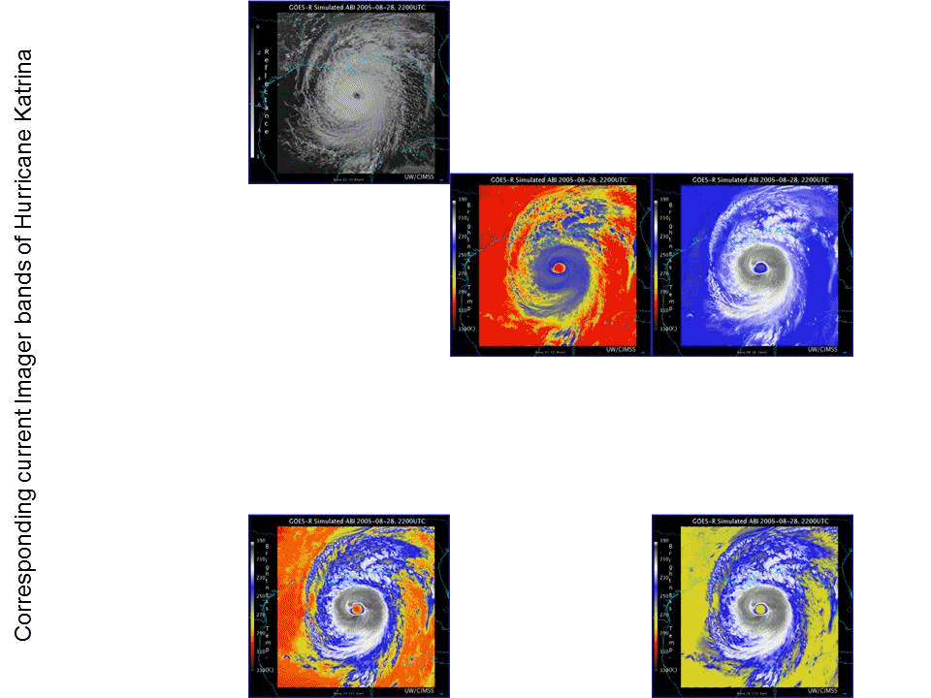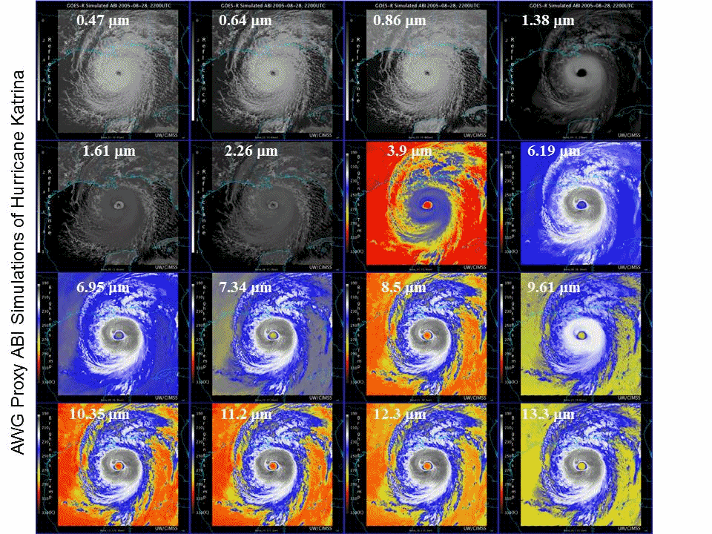
\building\16_vs_5_bands_Katrina_GOES.gif \building\16_vs_5_bands_Katrina_ABI.gif
Jim: We’ll introduce the spectrum here, highlighting the GOES and ABI channels. We'll provide more in-depth info in the next section.
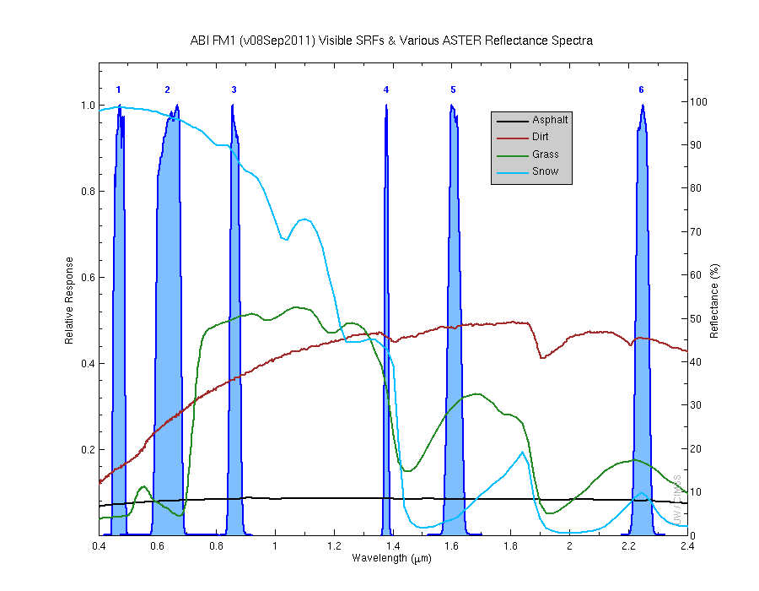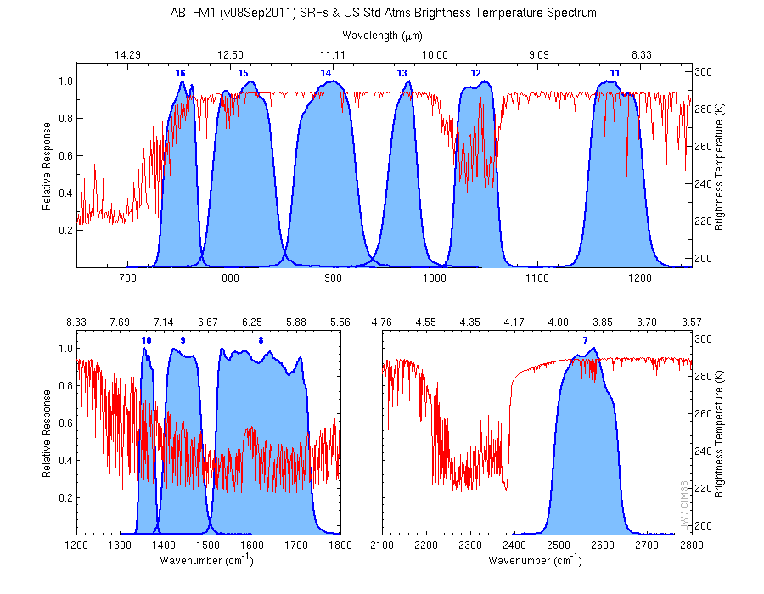

Higher spatial resolution
Most ABI channels will have 4 times higher spatial resolution than the current GOES channels. This is due to times better in both directions. Resolution for the current visible channel will increase from 1 to 0.5 km, and the resolution for the new shortwave visible channel (the so-called “blue” channel) will be 1 km. Two of the new near-infrared channels will be sampled at 1 km, with resolution for the remaining near-infrared and infrared channels increasing from 4 to 2 km.

Will show some comparison images
See ppt on ftp. One nice set is wave clouds associated with turbulence.

Faster imaging
ABI imagery and derived products will be produced for most of the Western Hemisphere every 15 minutes compared to the current three-hour interval. Over the contiguous United States, the viewing interval will shrink from the current 15 or 30 minutes to every 5 minutes. And a smaller–scale movable area will provide imagery and a subset of products every 30 seconds or 2 areas every minute during severe weather and to monitor other environmental phenomena.

As this two-hour ABI simulation shows, all three coverage intervals will update and provide products concurrently and continually. ABI’s new scanning technology will eliminate scheduling conflicts and tradeoffs necessary for the current GOES.

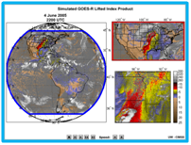

Also consider some 1-minute imagery? See ftp ppt.

Improved image pixel geolocation and instrument performance
Landmarks and other features on the ground often move in animations of current GOES imagery. This is especially noticeable when viewing high-resolution visible imagery. Some of the shifting can be as much as 4 km during the daytime and 6 km at night.

bottom two panels only
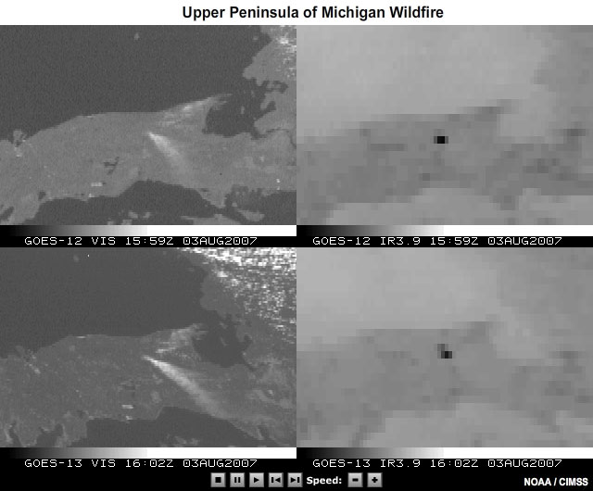

With a more advanced spacecraft and onboard image navigation and registration system, GOES-R ABI will reduce the amount of image-to-image movement of surface features to 2 km during daytime and 3 km at night.

Pixel noise will also be reduced in ABI imagery and products. With the current GOES, pixel noise becomes apparent when relatively little energy hits a detector. The effect is most common in the 3.9 micrometer channel, where relatively little energy is available at cold temperatures, and in the visible near sunrise and sunset. Noisy pixels are especially noticeable for very cold wintertime scenes during nighttime and for thick cirrus cloud cover such as the cold anvil cirrus cloud found atop thunderstorms.

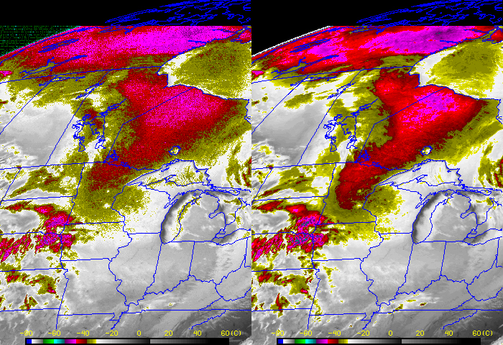
use left panels
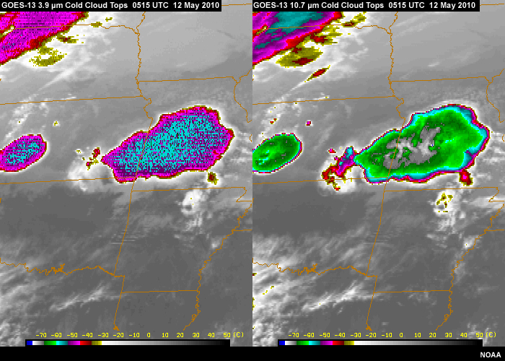

ABI imagery will have less noise and pixel values will be better calibrated. This will improve the visual appearance of imagery and allow for more accurate derived products. These include cloud top particle size and liquid water content, vegetation health, fire properties, surface temperature, and aerosol properties related to pollution, dust, and smoke. Improved clear-sky brightness temperatures will provide better support for analysis and nowcasting, numerical weather prediction, and climate applications.

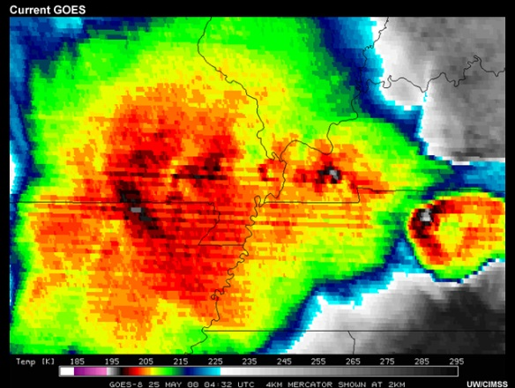
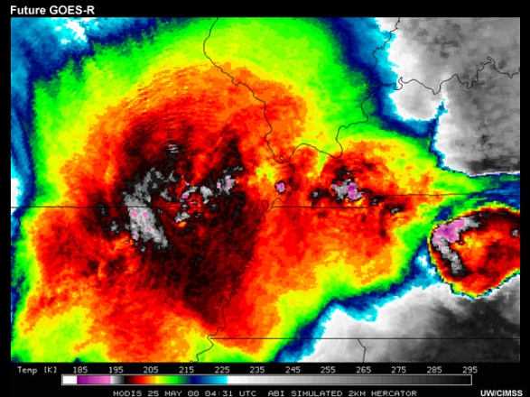

Collectively, these improvements will result in more accurate measurements for observing detailed structures and subtle features, especially on the regional and meso-scales. Improved measurements will also make it easier to fuse ABI data with observations from other satellites and other observing platforms and systems.

As a result of these improvements, the ABI will produce 50 times more information than earlier GOES.

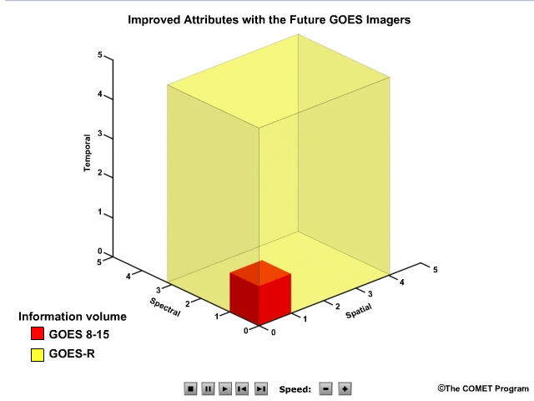

Text on the page below the video:
Select the other tabs in the menu.
- Explore the ABI Spectrum lets you interactively explore ABI's channels and the features and phenomena that they will be able to monitor.
- Applications focuses on the improvements that ABI will bring to forecasting, numerical modeling, and climate and environmental monitoring. It uses scenarios to highlight current GOES capabilities and the changes expected with ABI.
- Resources contains a summary and additional information about GOES-R ABI.

SECTION 2: EXPLORE THE SPECTRUM
This section lets you interactively explore ABI's spectral coverage and the features and phenomena that the channels can monitor. Click each channel on the graphic for a description and sample image, then answer the questions below.

We'll show an interactive spectrum that users can explore. They'll click on each ABI channel for a sample image and info about its applications and uses. We'll draw on info in the Summary table in the 2005 BAMS article.
Will image pop-up? Similar to: http://cimss.ssec.wisc.edu/goes/abi/vis_IR/smoke.html
(but not using these images).

QUESTIONS:
If you want to monitor the phenomena in the left column, which channel (or set of channels) provides the most useful information and should be checked? Drag each channel or channel set to the appropriate phenomena. When you are finished, click Done.
Phenomena | Channel(s)
Turbulence | 8, 12
Sea surface temperature | 14, 15
Snow | 2, 5, 6
Midlevel water vapor | 9
Sulfur dioxide | 10, 11
Fog at night | 7

Of course many algorithms use channel pares, or more. See slide in ftp ppt. Please include wavelength as well as the ABI channel number.

In general, what types of phenomena does each spectral region detect? [this could also be a matching exercise]
- Visible
- Short-range infrared
- Long-range infrared
- Water vapor
- Microwave

Feedback: To be written

SECTION 4: APPLICATIONS
This section focuses on the improvements that ABI will bring to forecasting, numerical modeling, and climate and environmental monitoring. Click each application to learn about the current GOES capabilities and changes expected with ABI.

1: Nowcasting Convection
A cold front and developing dryline are moving into a moist and conditionally unstable airmass across your region. Strong and potentially severe convection are expected to form during the afternoon. From GOES visible imagery, you can already see towering cumulus clouds forming ahead of the dryline and portions of the cold front. You would like to determine which of the immature cells have a greater chance of becoming deep convection and producing severe weather. Figuring this out as early as possible will let you increase your lead time should it become necessary to issue a warning.

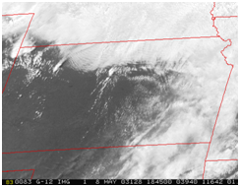
[Placeholder for GOES-12/East Vis imagery loop prior to G-12 2325 UTC, 8 May 2003, and outbreak of deep convection]

Even with the limited number of current GOES spectral channels, efforts to leverage them for identification and early diagnosis of rapidly deepening convection have met with some success. Strong infrared-based cloud top cooling rates, for example, are an early indicator of cells with a greater potential for producing severe weather down the road.
Despite these efforts, additional spectral coverage and a higher refresh rate are needed to adequately capture and monitor cloud properties and the cloud environment, since they’re closely linked to storm development and evolve on very short time scales.

GOES-12 CTC 1545 UTC 17 Jun 09 [PD: placeholder for 1543 UTC KUEX LEVEL-III base ref plot]
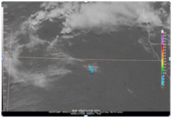
GOES-12 CTC 1610 UTC 17 Jun 09 [KUEX BASE REF 1622 UTC [PD: recapture for size & clarity]
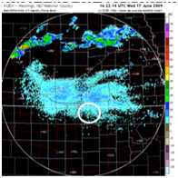
GOES-12 CTC 1732 UTC 17 Jun 09 KUEX BASE REF 1735 UTC [PD: recapture for size & clarity]
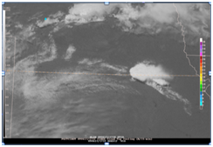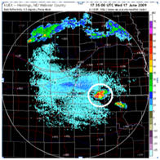

Despite these efforts, additional spectral coverage and a higher refresh rate are needed to adequately capture and monitor cloud properties and the cloud environment since these are closely linked to storm development and evolve on very short time scales.

The ABI’s 16 channels and frequent imaging will show changes in cloud top phase and particle size that can be used to assess storm growth and severity potential, even before a convective storm reaches its peak intensity. Also, special thirty second to one-minute imaging intervals will be available for selectable ‘regions of interest’ and will allow monitoring of very rapid changes throughout a storm’s life cycle.

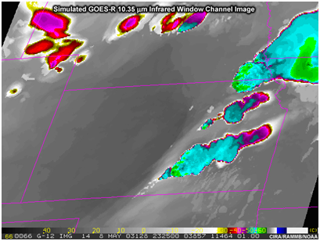
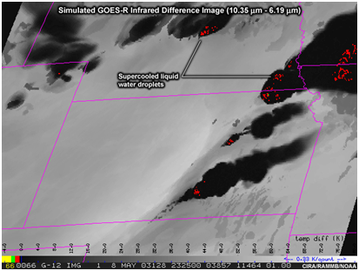

Greater 2-km spatial resolution will provide a clearer picture of storm top signatures such as the “warm wake” or “enhanced V” (over over-shooting tops) known to be associated with severe storms.

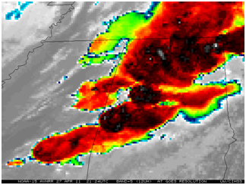
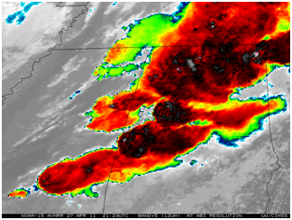

Rapid imaging and improved pixel geolocation will increase the number and accuracy of high-resolution mesoscale atmospheric motion vectors that allow monitoring of storm–scale upper–level divergence and low–level convergence, which are important for storm maintenance.

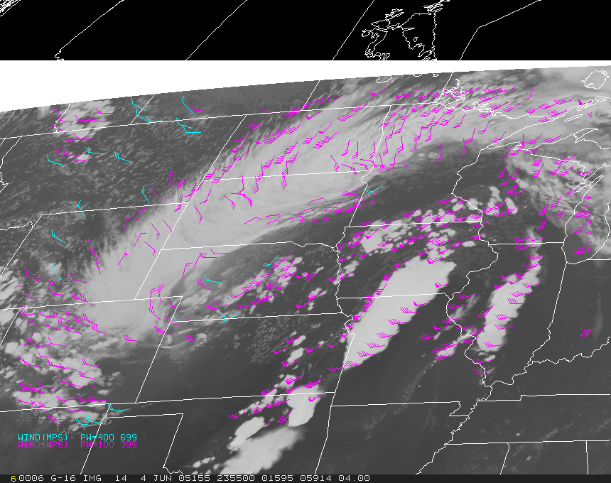

The combination of continuous lightning flash rate and trend measurements from the Geostationary Lightning Mapper (or GLM) and cloud top measurements from the ABI will help forecasters determine related trends in thunderstorm intensification and decay. This is expected to improve the warning lead time for tornadoes.

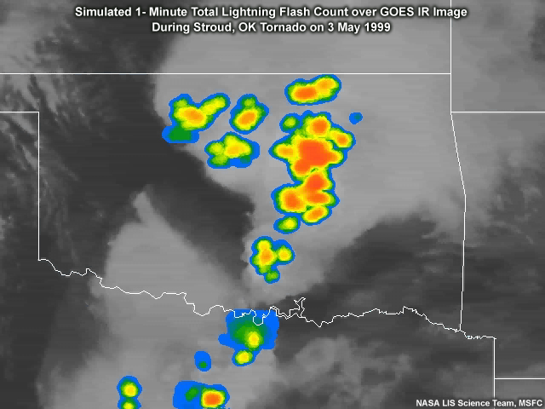

The enhanced capabilities of the GOES-R ABI will help provide an end–to–end, satellite–based thunderstorm nowcasting system. It will offer continuous information on pre–convective stability, convective initiation, storm maintenance, and cloud dissipation that will help forecasters improve lead time and forecast accuracy.

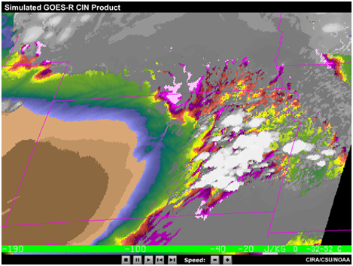

2: Forecasting Flood Potential
Thunderstorms have developed in your area, and you need to forecast the potential for flooding in mountainous terrain with limited radar coverage. Current GOES infrared imagery and derived precipitation estimates may alert you that rainfall has probably started. But the imagery's relatively poor time resolution and granular spatial resolution in the infrared are insufficient for capturing the finer details in storm structures. These include the locations of convective updrafts, cloud top temperature signatures, cloud top microphysics, and trends associated with potentially severe storms. All of this information would be useful to more accurately assess the coverage and likely magnitude of potentially heavy rainfall. Without more detailed and comprehensive observations, it's more difficult to anticipate when and where the potential for flooding may be greatest.

With enhanced spectral and spatial resolution, the ABI will better characterize cloud–top microphysical properties, such as hydrometeor phase and size distribution, that are important for diagnosing thunderstorm dynamics. This will improve the prediction of convective initiation and improve your ability to determine when flash flooding may be imminent.

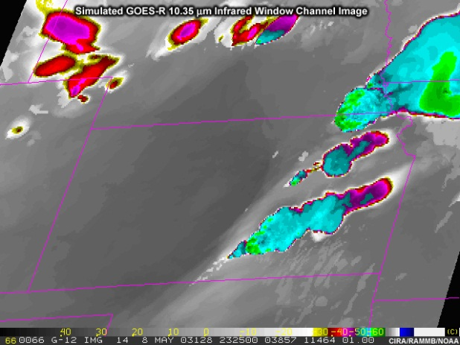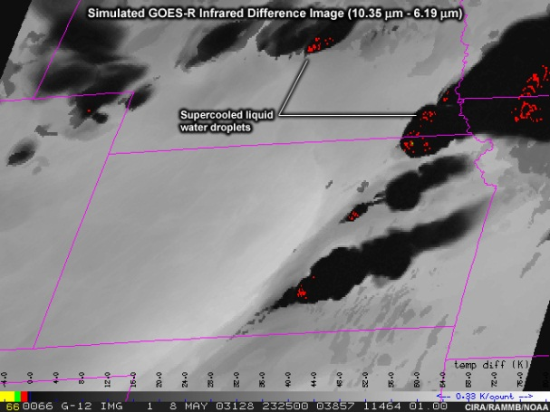

In combination with lightning data from the Geostationary Lightning Mapper or GLM, this information will provide new insights into precipitation formation processes and will improve precipitation estimates.

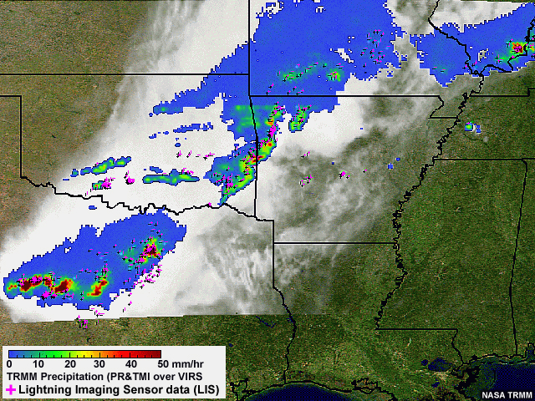

When flooding is anticipated, the ABI's ability to scan focused areas at 30-second intervals will allow for better observation of rapidly changing storm conditions, improved monitoring of rainfall trends, and the issuance of more timely and accurate flash flood watches and warnings to help emergency managers make better informed decisions.

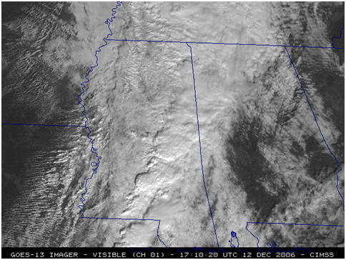

3: Monitoring Wildfires
Assume that you're an incident meteorologist (or IMET) in a remote location. You're supporting firefighting activities for a rapidly growing wildfire.

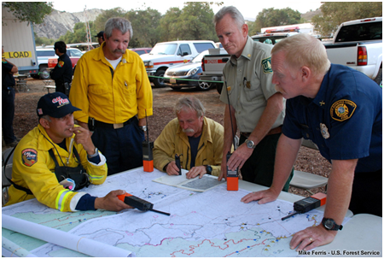

You have access to 15 or 30-minute GOES shortwave infrared imagery to help monitor hot spots. But the relatively poor pixel resolution, limited radiometric sensitivity, and occasional movement (or jittering) of the imagery don’t let you accurately identify all of the hot spots and their coverage, or characterize their temperature very well.
[Note that current GOES imager only offers 30 min imagery every 3 hours.]

ABI’s improved sensitivity to hotter temperatures, greater spatial resolution, and more accurate pixel geolocation will improve the detection and characterization of fires and hot spots, and help you estimate their size and temperature. Imaging at 5-minute and up to 30-second intervals will let you monitor rapidly changing wildfire conditions. Additional channels in the visible and near-infrared will also provide improved detection and monitoring of smoke and potentially harmful concentrations of airborne particulates.

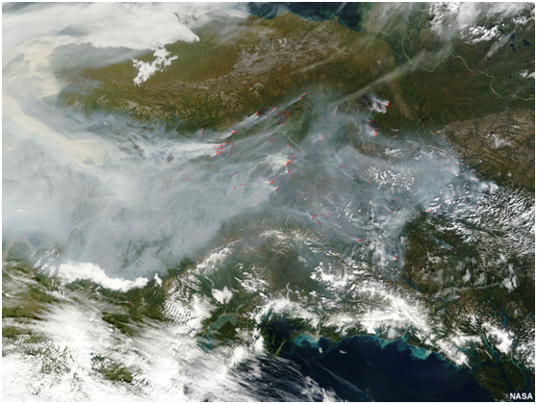

Land cover products made from ABI data will help monitor burn scars. This will let forecasters identify areas prone to flash flooding and debris flows when heavy rainfall threatens.

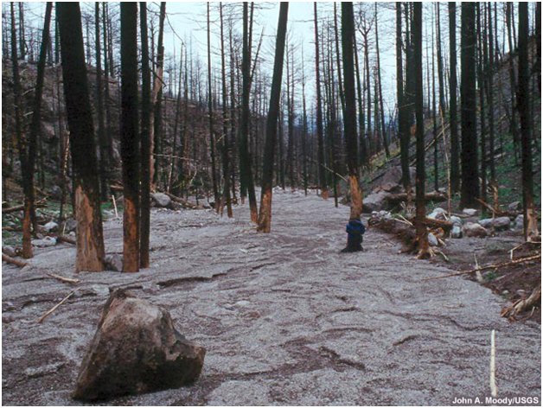

The ABI's increased spatial resolution and spectral coverage will also provide more detailed and frequent views of vegetation conditions and trends that are useful for assessing the wildland fire threat.

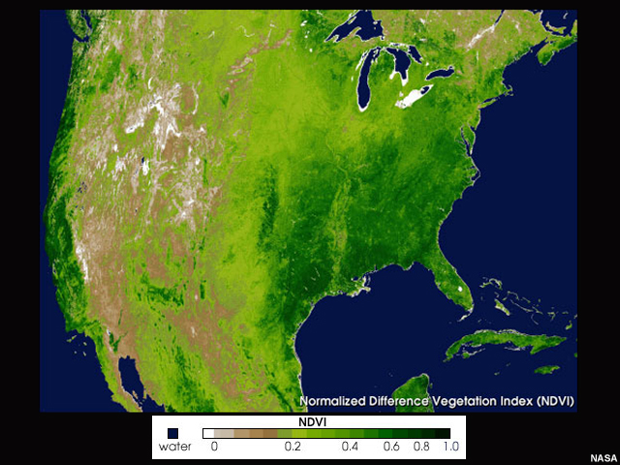

4: Land Cover
Weather satellites are providing more and more detailed information to help forecasters, planners, and decision makers gauge Earth's surface conditions and monitor ecosystems affected by extreme weather, climate change, and human activity.

Daily land cover products are available from polar-orbiting satellites, but cloud cover can obscure much of the ground over a given region. Geostationary imagery can provide some clear views of the surface due to more frequent imaging. But current GOES satellites don’t have the additional spectral channels needed to assess, for example, vegetation “greenness” or the extent of flooding.

[Placeholder for an image pair: Leo NDVI product, GOES Vis image]

The ABI will give geostationary satellites the capacity to observe land cover with resolution closer to that of polar orbiting satellite imagers such as MODIS. The ABI's increased spatial resolution and expanded spectral coverage will allow for more detailed views of surface conditions than have ever been provided by a GOES.

[Placeholder for a proxy ABI land cover product if one can be found?]
Could ask AWG (eg, Jaime Danels) or see ftp ppt, for a ‘classic’ case from MODIS.

With more imaging channels and calibrated measurements, forecasters and land managers will be better able to discriminate surface features and assess vegetation condition and growth, which are important for agriculture and wildland fire concerns.

MISR_Vegetation_Growth.jpg, 37911
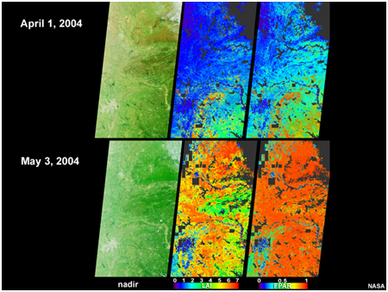
Or use this ani? ndvi_modis_kenya_2009.swf from ASMET/East Africa copy fla/jpg/record over
Not sure if ABI will have these bands, certainly will not have the spatial resolution.
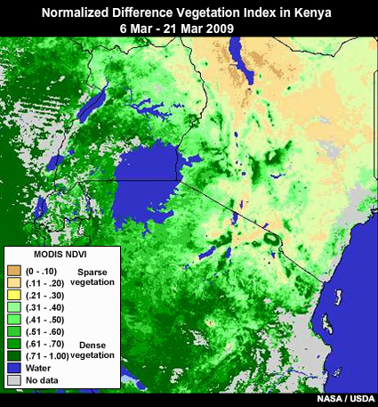

The ABI's more frequent refresh rate will increase the likelihood of viewing surface features in cloud–free conditions. If something over Europe is going to be used, why not SEVIRI?
http://oiswww.eumetsat.org/WEBOPS/iotm/iotm/20030804_vegetation/20030804_vegetation.html

ABI products will highlight flood conditions and standing water, helping forecasters, hydrologists, and NWP models predict the impacts on local weather conditions and communities.

Myanmar_Flooding_Cyclone_Nargis.swf [have jpg], 37912
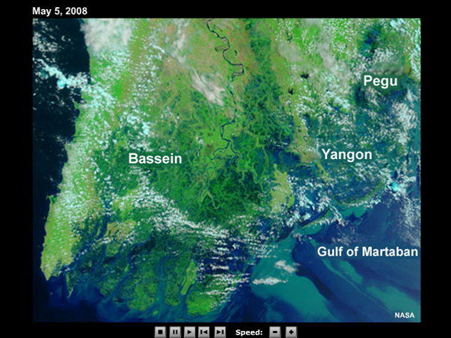

Finally, ABI’s additional visible and infrared channels and derived products will make it easier to identify snow– and ice–covered regions following winter storms. Quantitative products will also be possible.

RGB_Snow_and_Fog.swf, 37913 [2-frame Vis to RGB fade]
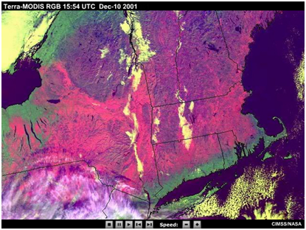

5: Hurricane Monitoring and Forecasts

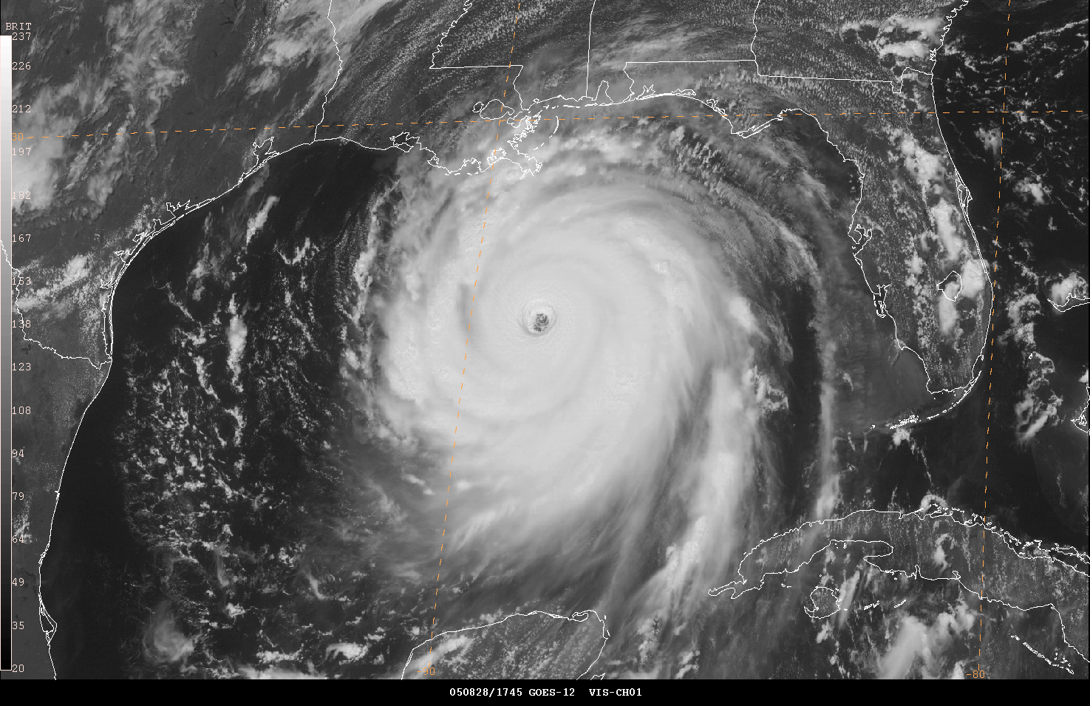

You work at a hurricane forecast center and are keeping a close eye on a tropical cyclone as it approaches a populated coastal area. You are monitoring the storm for any sudden intensification or unanticipated change in its projected path.

[IR Win ch. image loop during Katrina from 0615 to 1745 28 Aug, time of peak intensity. PD making]

With the storm still beyond the range of land-based radar, current GOES 15-minute imagery helps you monitor the storm’s structure and movement. Occasional periods of 7.5-minute rapid scan imagery provide some additional information on more rapidly evolving features, but schedule interruptions result in longer gaps. Some of the longer gaps, 30 minutes in duration, happen during 3-hourly scans of the full Earth disk.

[Show/zoom into full-res 4-km loop centered more on Katrina. PD making]

The 4-km infrared resolution also tends to miss finer scale structures within the storm’s rainbands and eyewall region. Current GOES imagers also lack a CO₂ channel that would help produce more accurate cloud top height assignments used in a variety of applications, including cloud motion wind determination.

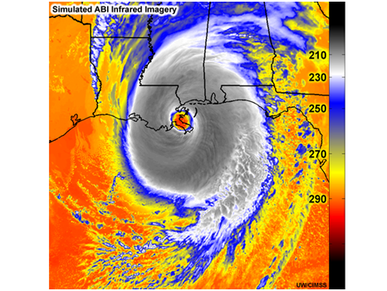

The ABI and Geostationary Lightning Mapper (or GLM) are the keys to the GOES–R satellite's enhanced observing capabilities.

ABI’s reduced noise and improved calibration will result in more accurate infrared channel brightness temperature measurements of the deep convective cloud tops circulating around a developing storm. These measurements are critical inputs for the widely used Dvorak Technique for determining tropical cyclone intensity estimates in terms of wind speed and mean sea level pressure.

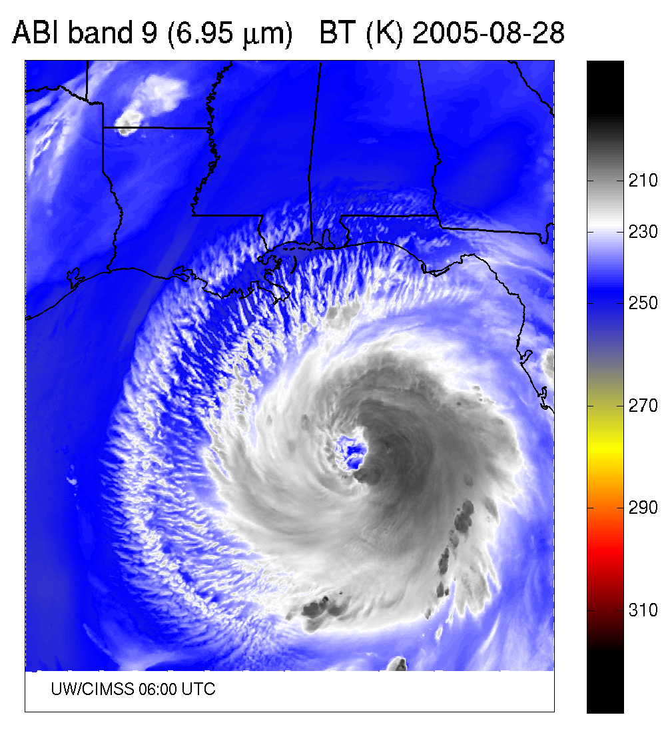

The combination of the ABI's engineering improvements, greater spectral coverage, and increased spatial and temporal resolutions will provide an expanded suite of imagery and derived products that:
- Enhance our ability to determine storm centers and motions
- Provide more accurate measurements of sea surface temperatures, allowing for better evaluation of the energy available for tropical cyclone development
- Improve wind, cloud, and rainfall analyses that feed into numerical forecast models for improved forecasts of hurricane intensity and track, and
- Supply superior detection of water vapor and dust so that dry air intrusions that impede hurricane development will be better identified

GOES-12 4 km 15 min. Atmospheric Motion Winds Simulated ABI 2 km 5 min. Atmospheric Motion Winds
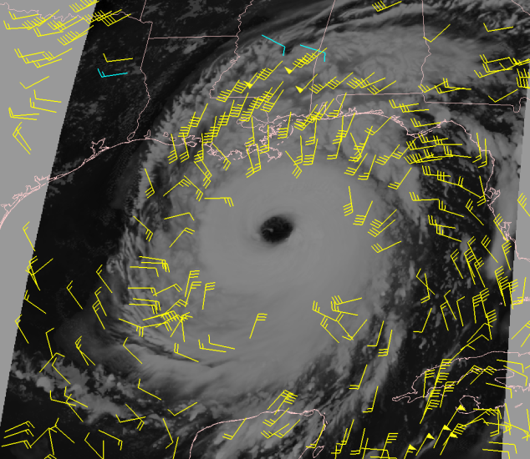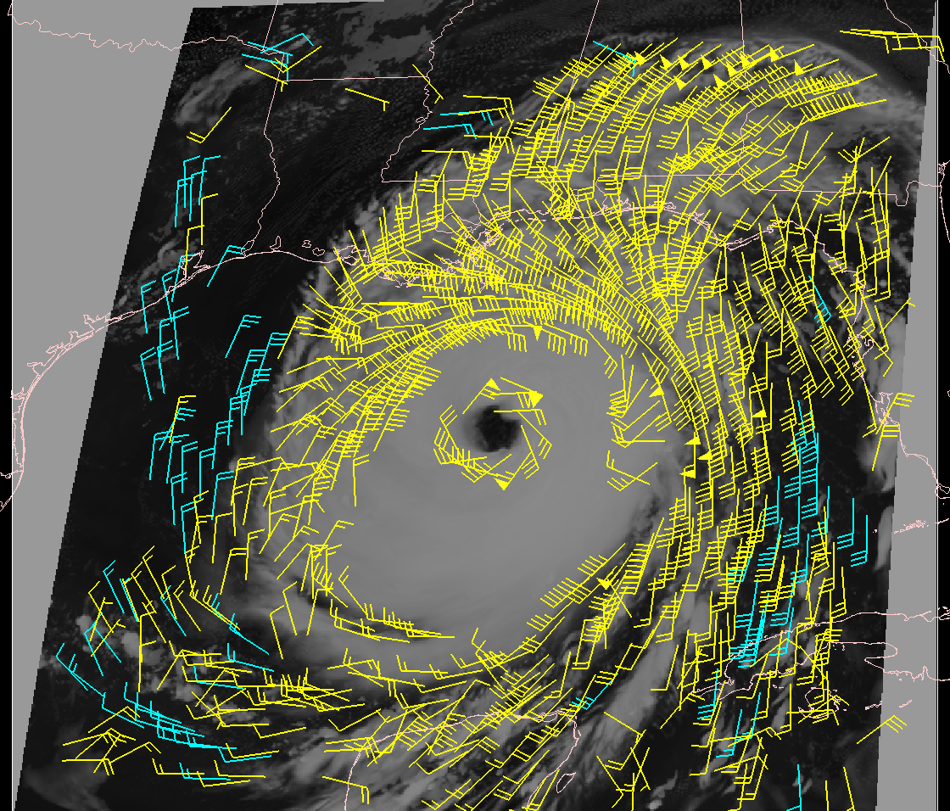

The GLM's continuous full Earth disk observation of lightning activity will offer important insights into tropical cyclone physics and dynamics. When added to forecast models, these observations will help improve cyclone intensity forecasts.

GLM_coverage_hurricane_impact.jpg, 38610 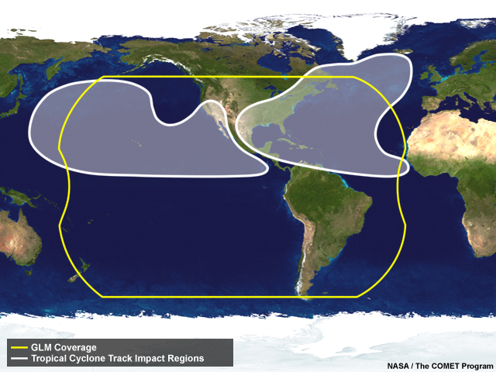

6: Monitoring Climate
Geostationary satellites can resolve diurnal and seasonal climate cycles that polar orbiters are unable to monitor. This helps climate scientists better monitor events such as tropical cyclones, El Niño and La Niña cycles, and monsoons.

G-13 IR ch.4 3-hourly (24 hour) loop [PD will build animation]
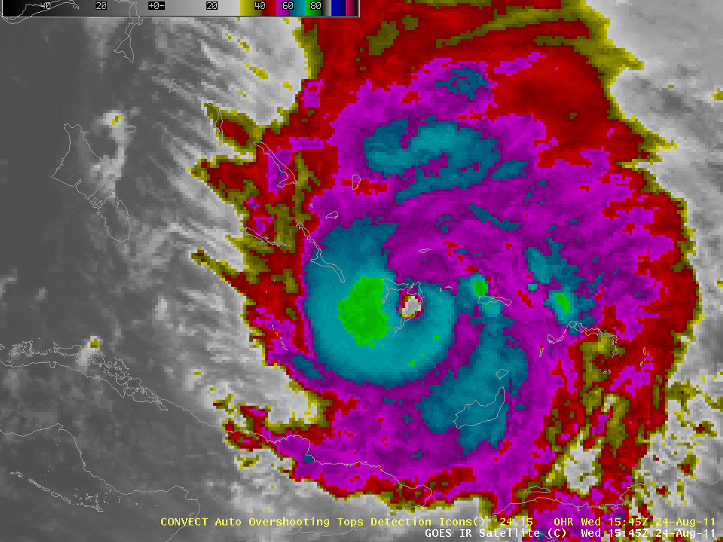
El_nino_wx_patterns.jpg [use this?] 37915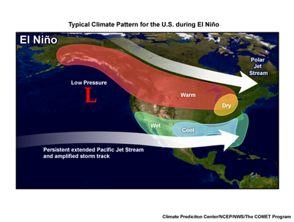

But GOES observations lack the coverage and accuracy needed for a more detailed and longer-term survey of key climate variables. The ABI instrument will help address this. It will provide a more accurate and complete view of water vapor, precipitation, surface temperatures, radiation, smoke, dust and other aerosols, trace gases and other key climate parameters that need to be monitored on a continuous basis.

[show montage including thumbnail for each climate parameter
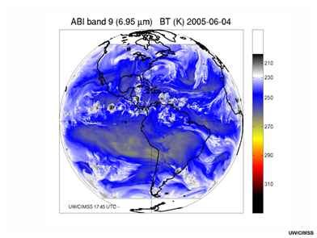

The ABI's high refresh rate will provide more opportunities to obtain visible and infrared observations of Earth’s surface that are not degraded by cloud cover.

cloudy_SST_scene_NOAA-18.jpg, 37916
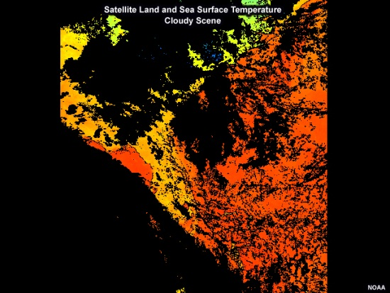
less_cloudy_SST_scene_NOAA-18.jpg, 37917
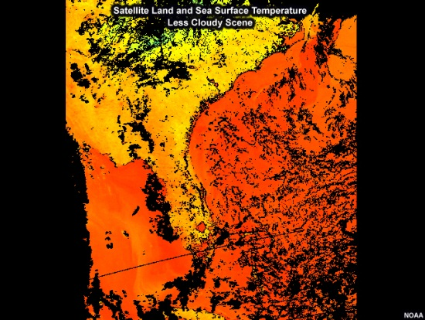

7: Air Quality
GOES' relatively few channels limits its ability to estimate the distribution and concentration of pollutants and other potentially hazardous trace gases.

ABI's expanded spectral coverage and scan rate will improve the detection and monitoring of human-induced and natural hazards across the Western Hemisphere. These include dust, smoke, and aerosols that lead to smog formation and degrade visibility as well as ozone, volcanic ash, and sulfur dioxide that impact air quality.

Kasatochi_Aura_SO2_Plume.jpg, 37924 [use this?]
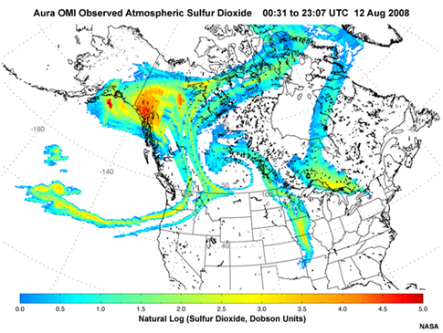

When data from the ABI and GLM are coupled with numerical dispersion models, forecasters and other decision makers will have near real-time data to help assess air quality risks to the public, environment, aviation, and other commercial interests.

epa_air_quality_index.jpg [redone, update old record: http://airnow.gov/index.cfm?action=aqibasics.aqi]
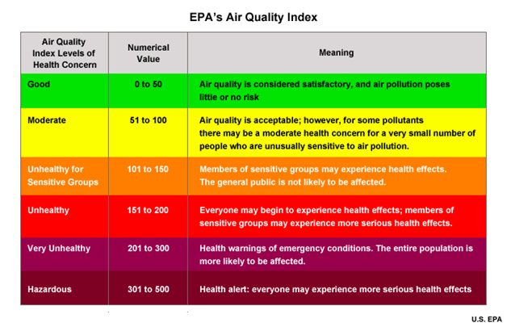
[or could use an EPA’s air quality plot: peak_pm25_usa_point_10jun12.jpg [shows particulate matter, e.g. from combustion (motor vehicles, power plants, wood burning, forest fires, ag burning, some industrial)]
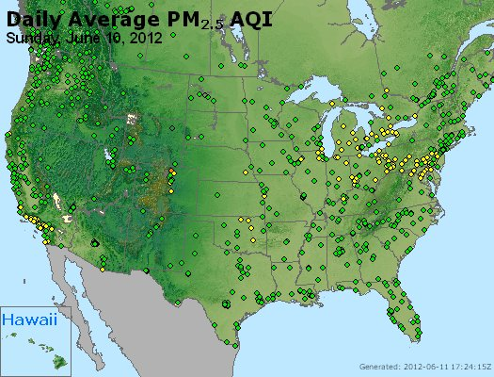

peak_o3_usa_point_10jun12.jpg [ozone near ground level, e.g. from vehicles, power plants, industrial boilers, refineries, chemical plants, from other chemical + solar reactions]
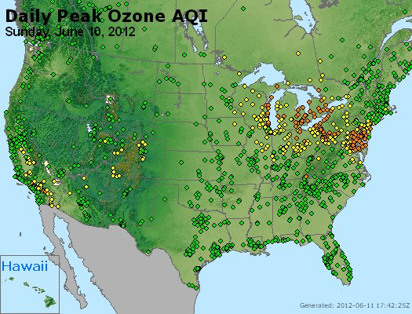

8: Aviation: Cloud Icing

barbados_forecasters_mod_ffk1.jpg[if use, copy over record]
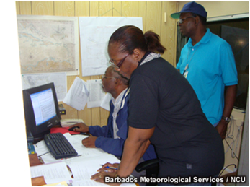

You are an aviation weather forecaster concerned about the potential icing risk posed by a thick stratus cloud deck over a relatively small airport with sparse pilot observations. A nearby radiosonde observation and GOES infrared cloud top temperatures suggest that the potential for icing exists. But you need more detailed information about the content of the cloud cover. Is the cloud top composed mainly of supercooled liquid or is it a mixture of liquid and ice, or primarily ice?

To be useful for icing detection, satellite observations should be sensitive to the spatial and temporal variation of many cloud–top properties, such as temperature, phase, droplet size, and liquid water and ice content.

8_May_2003_Simulated_Cloud_Top.swf, 37928 [have jpg]
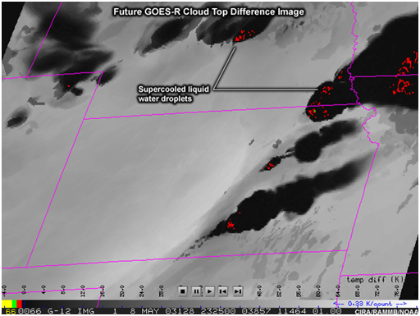

Current GOES satellites lack the ability to adequately define these conditions, limiting the accuracy and detail of their icing potential products.

The ABI will reveal detailed information about cloud development and structure, letting forecasters better monitor cloud evolution, diagnose cloud type, and identify different cloud layers. 'Wet' clouds pose the greatest icing threat to aircraft, and the ABI's increased spectral coverage will improve products that distinguish between clouds that are 'dry' and 'wet'.

070828_GOES-12_VIS.jpg, 37929
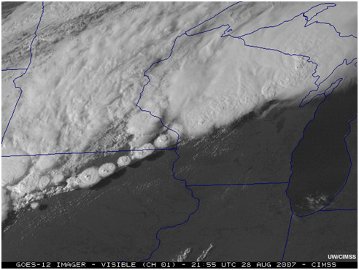

ABI's capabilities will help pilots locate when and where icing may occur. They will also reduce delays and improve weather briefings, flight planning, air traffic routing, hazard advisories, and aircraft safety.

airplane_crash_simulated.jpg, 37927 [use this?]
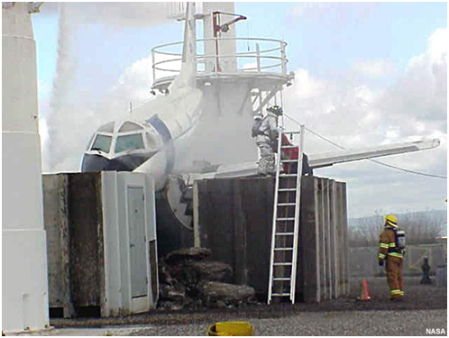

9: Nowcasting fog and low visibility

You are keeping an eye on the potential for fog, low ceilings, and limited visibility conditions forming overnight. Current GOES imagery can give you a heads up about the initial formation and movement of low-level cloud cover. But its relatively coarse infrared resolution, limited number of spectral channels, and 15-minute updates mean that the details are either poorly sampled or often missed altogether.

Current_vs_Future_GOES_Fog.swf frame 1 37872 [Perhaps show this pair first simply to show current detection shortcomings.]
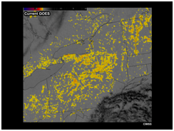
Current_vs_Future_GOES_Fog.swf frame 2 of fade
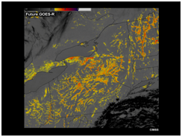

With its improved spatial resolution and increased 5-minute refresh rate, the GOES-R ABI will be a much better tool for monitoring fog and low clouds as they form, tracking their movement, and monitoring their dissipation.

[placeholder for 5-minute GOES-13/East super rapid scan ops BTD images over Kansas, 12 Apr 2010 Use mainly to illustrate the 5-minute refresh rate. PD building]

Additional infrared channels will give aviation forecasters improved measurements of cloud top height and estimates of ceilings, visibility, and cloud thickness.

(left panels) Instrument Flight Rules (IFR) Probability (e.g. ceilings 500 to <1000 ft AGL and/or visibility < 1 mile) (right panels) Liquid Water Cloud Thickness (ft)

Current GOES-East (GOES-13)
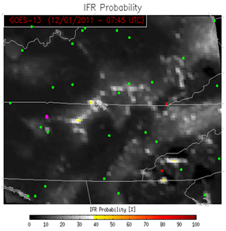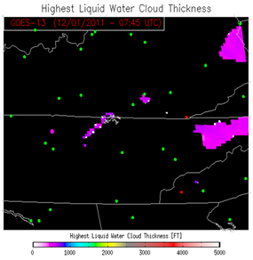
Simulated GOES-R ABI (using MODIS)
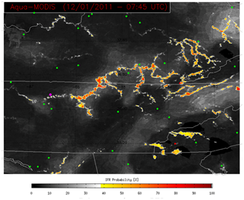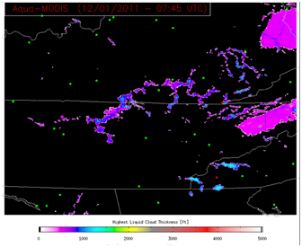

Algorithms being developed for enhanced GOES-R ABI cloud products are being tested on proxy data sets (including current GOES data) through proving ground and testbed activities. Although the algorithms are designed for future GOES-R capabilities, they’re showing significant promise for improving the cloud products used by forecasters today.

GOES-13 11-3.9 Brightness Temperature Difference 1115 UTC 28 Feb 2012
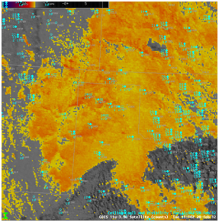
\originals\fog_low_clouds\FLS_products\btd_4km_goes13_28feb12.png
GOES-13 IFR Probability 1115 UTC 28 Feb 2012
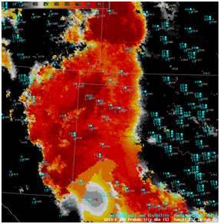

10: Coastal and Marine
GOES satellites are useful for tracking storms, forecasting precipitation, and monitoring sea surface temperatures. But they're unable to accurately detect fine variations that are important for improving local forecasts.

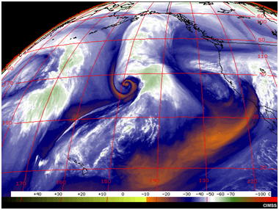

ABI's infrared channels will provide more detailed and accurate information on sea surface temperatures, which will improve forecasts of tropical storm intensity, sea breeze circulations, coastal convection, and changes in weather patterns associated with climate oscillations such as the El Nino/La Nina cycle.

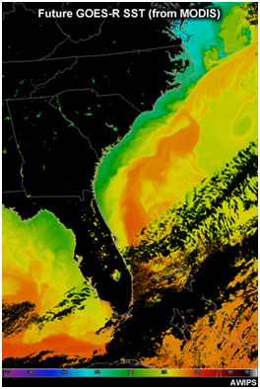

The combination of new spectral channels and microwave capabilities on polar-orbiting satellites will improve precipitable water and rainfall estimates for weather systems over the vast oceanic regions.

Dolly_TRMM_PR_15dbz_isosurface.jpg, 37936
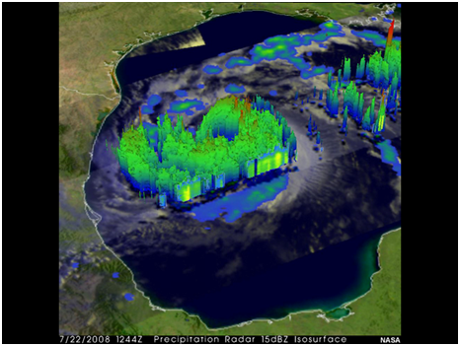
ABI's 5-minute refresh rates will enable the derivation of enhanced environmental winds for input to numerical forecast models. This should lead to improvements in mid–latitude and tropical cyclone intensity and track forecasts.

Current GOES Future GOES-R
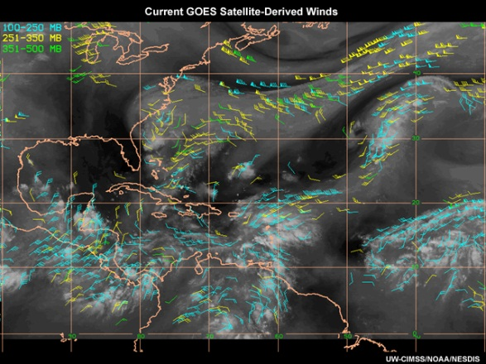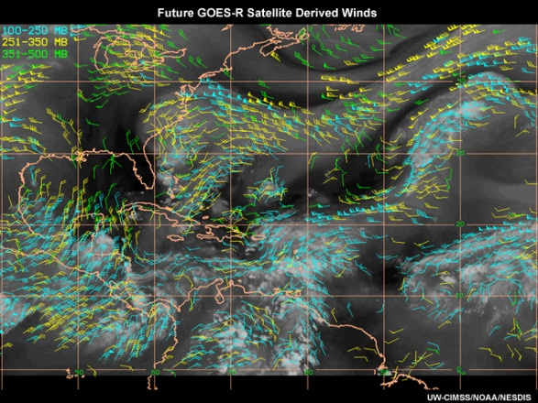

Finally, GOES-R ABI and GLM observations will offer new observing capabilities to improve forecasts for a variety of phenomena including tropical and midlatitude storms, thunderstorms, coastal fog, low clouds, air quality, high winds, ocean turbidity, and changing climate conditions.

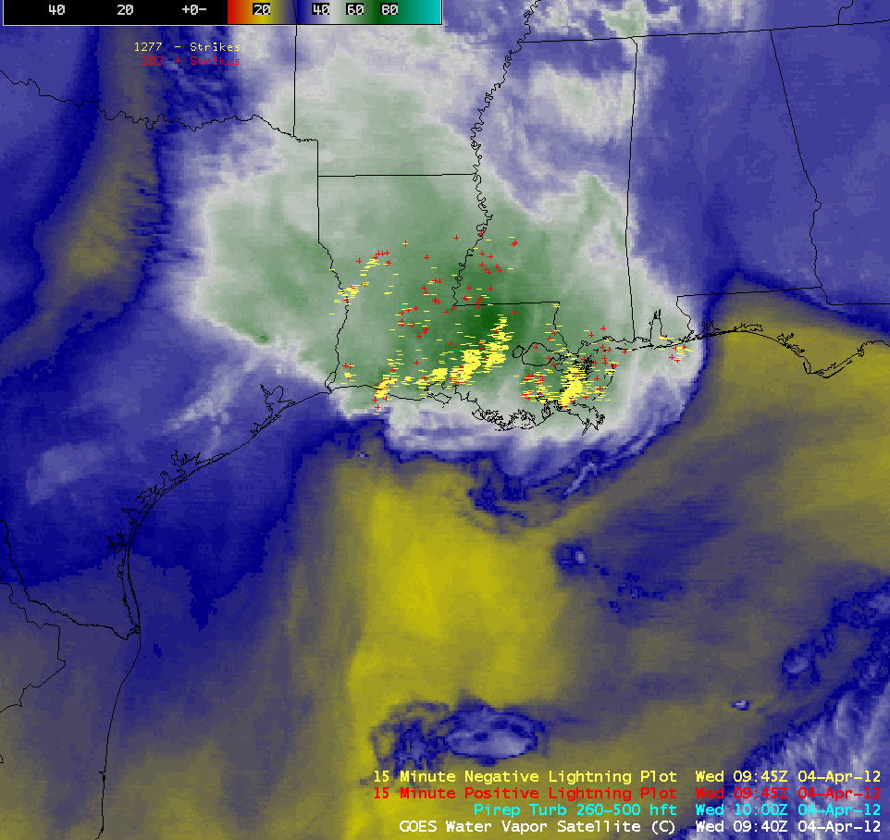

SECTION 4: RESOURCES
- Tables
- Graphs
- References and Internet Resources

