Rapid Refresh Information of Significant Events: Preparing users for the next generation of geostationary operational satellites

Timothy J. Schmit,ª Steven J. Goodman,^{b} Mathew M. Gunshor,^{c} Justin Sieglaff,^{c} Andrew K. Heidinger,ª A. Scott Bachmeier,^{c} Scott S. Lindstrom,^{c} Amanda Terborg,^{c} Joleen Feltz,^{c} Kaba Bah,^{c}
Scott Rudlosky,^{f} Daniel T. Lindsey,^{d} Robert M. Rabin,^{e} and Christopher C. Schmidt^{c}

ª NOAA Center for Satellite Applications and Research,
Advanced Satellite Products Branch (ASPB), 1225 West Dayton Street, Madison, Wisconsin, USA, (608) 263-0291
tim.j.schmit@noaa.gov
^{b} NOAA/NESDIS GOES-R Program Office,
NASA GSFC Code 417, Greenbelt, Maryland, USA
^{c} Cooperative Institute for Meteorological Satellite Studies (CIMSS), University of Wisconsin-Madison, Madison, Wisconsin, USA
^{d} NOAA Center for Satellite Applications and Research, Fort Collins, Colorado, USA
^{e} NOAA/NSSL, Norman, Oklahoma, USA
^{f} NOAA Center for Satellite Applications and Research,
College Park, MD, USA

11-December-2013
Abstract
The Geostationary Operational Environmental Satellite (GOES)-14 Imager was operated by National Oceanic and Atmospheric Administration (NOAA) in an experimental rapid scan 1-minute mode during parts of the summers of 2012 and 2013. This scan mode is called Super Rapid Scan Operations for GOES-R (SRSOR) and emulates the high temporal resolution sampling of the mesoscale region scanning of the Advanced Baseline Imager (ABI) on the next generation GOES-R series. Many phenomena were observed from GOES-14, including fog, clouds, severe storms, fires and smoke (including the California Rim Fire), and several tropical cyclones. Over 6 days of SRSOR data were acquired in 2012 of Hurricane Sandy. In 2013, the first two days of SRSOR in June observed the propagation and evolution of the mid-Atlantic Derecho events. The data from August of 2013 were unique in that the GOES imager operated in nearly continuous 1-minute mode; prior to this, the 1-minute data were interrupted every 3 hours for full disk scans. These data are helping better prepare users for the next generation imager which will be able to routinely acquire mesoscale (1,000 km x 1,000 km) images every 30 seconds (or two separate locations every minute). In addition, these experimental data were used in a number of NOAA testbeds and operational centers, including at NOAA’s Storm Prediction Center (SPC), the Aviation Weather Center (AWC), the Ocean Prediction Center (OPC), and the National Hurricane Center (NHC). Several animations are included showcasing the rapid change of the many phenomena observed during SRSOR from the GOES-14 Imager.
Capsule
The GOES-14 Imager collected experimental rapid scan 1-minute images. These special scans emulated the high temporal resolution sampling of the imager on the next generation GOES-R series.

SRSOR Overview
The Geostationary Operational Environmental Satellite (GOES)-14 Imager was operated by National Oceanic and Atmospheric Administration (NOAA) in an experimental rapid scan 1-minute mode during parts of 2012 and 2013 while the satellite was in its normal annual north/south maneuver and performance testing. This scan mode was called Super Rapid Scan Operations for GOES-R (SRSOR). These special scans emulated the high temporal resolution sampling of the mesoscale images from the Advanced Baseline Imager (ABI) included on the next generation GOES-R series satellites (Schmit et al, 2005). The GOES-R also will carry the first Geostationary Lightning Mapper (GLM), which will monitor total lightning activity (Goodman et al., 2012) and complement the ABI information in regions of overlap. GOES-R is slated to launch in early 2016. Many phenomena were observed from GOES-14 during this experiment, including fog, clouds, severe storms, monsoon moisture, fires and smoke (including the California Rim Fire), and several tropical cyclones. These data are helping better prepare users for the next generation GOES-R imager which will be able to routinely take mesoscale (1,000 km x 1,000 km) images every 30 seconds over one location (or every minute over two separate locations). In addition, these experimental data were used in a number of NOAA testbeds and operational centers, including at NOAA’s Storm Prediction Center (SPC), the Aviation Weather Center (AWC), the Weather Prediction Center (WPC), the Ocean Prediction Center (OPC), and the National Hurricane Center (NHC). For example, at the SPC MetWatch desk, the SRSOR data provided enhanced situational awareness of an “outflow boundary and nearby frontal zone which was not readily apparent in the scant surface data.” Forecasters reported the 1-min imagery “helped to increase lead-time for convective development” and “more easily determine whether convection was elevated or rooted in the boundary layer.” They also stated that it “could be helpful in radar gap areas, and where there is less confidence in radar.” Several animations are included to showcase the rapid change of the many phenomena observed during SRSOR from the GOES-14 Imager.

Table 1 lists the comparison of various GOES-East schedules. These include routine, RSO (Rapid Scan Operations), SRSO (Super Rapid Scan Operations), SRSOR (Super Rapid Scan Operations for GOES-R) and that expected from the ABI on the GOES-R series. Note that there are two versions of the SRSOR schedule, one with full disk imaging every 3 hours and one without. The SRSOR data from August of 2013 ran the latter schedule. The area near the middle of the image over northwestern Illinois in Figure 1 demonstrates how much can change over only 34 minutes. This underscores the need for the geostationary vantage point to observe rapidly changing phenomena.

The SRSOR campaign of 2012 included approximately 38 days of SRSOR data. In fact, over six days of SRSOR data of Hurricane Sandy were acquired in late October (Schmit et al., 2013; Folmer et al., 2014). Many operational uses were noted: “Examples from the SRSOR data included better determining the cyclone center early in the daylight hours by the NHC, improved monitoring of cumulus cloud fields prior to convective initiation by the SPC, utilizing the imagery animations and derived AMVs by the OPC, identifying meso-high locations associated with hurricanes to better assess the rainfall potential by WPC, monitoring smoke plumes by the Satellite Analysis Branch, and overshooting tops (OT) detection by the forecast offices” (Schmit et al, 2013). More information has been posted at: http://cimss.ssec.wisc.edu/goes/srsor/GOES-14_SRSOR.html. In 2012 the GOES-14 instrument was taking experimental images to gather data needed for the imager stray light correction, so SRSOR imagery could be acquired during the other times of the day.
In June 2013, the first two days of SRSOR, the mid-Atlantic Derecho events were observed. These were days after GOES-14 had been the operational GOES-East satellite. GOES-13 had a major anomaly, possibly due to a collision with a micro-meteoroid (Aviation Week, 2013). The data from August of 2013 were unique in that the GOES imager operated in nearly continuous 1-minute mode. For the first time there were no 30 minute outages of the 1-minute data when full disk images had been scanned every 3 hours under the prior SRSOR schedule. The SRSOR campaign of 2013 included approximately 14 days of SRSOR data. See Table 2 for schedule and daily image center point information. Deciding on the daily center point included a number of factors. Daily center point decisions were based on a number of factors, among these factors were SPC and HPC outlooks and whether or not the region had been recently scanned. On several days, the location was decided in part to coincide with other observations from a NASA field experiment called SEAC4RS (Studies of Emissions and Atmospheric Composition, Clouds and Climate Coupling by Regional Surveys) and ground-based lightning mapping networks providing GLM total lightning proxy data. More information about the SRSOR schedules in 2013 has been posted at: http://cimss.ssec.wisc.edu/goes/srsor2013/GOES-14_SRSOR.html. The recent SRSOR imagery continues the long legacy of rapid scan imagery from GOES, as stated by Davis (2007): “Rapid interval imaging has been an important component of the GOES research program since 1975. In 1979 during a project known as SESAME (Severe Environmental Storm and Mesoscale Experiment) two GOES satellites were synchronized to produce three minute interval rapid scan imagery to study storm development”. Fujita and others demonstrated the many uses of these data (Purdom, 1976).

Derecho Event of June 12 and 13, 2013
The GOES-14 satellite was placed into SRSOR mode to monitor the development of severe weather over a SPC High Risk region on 12 June 2013. In SRSOR mode, images were available at 1-minute intervals (compared to the routine 15-minute image interval). The development of numerous large thunderstorms can be seen on GOES-14 SRSOR 0.63 µm visible channel images. These storms produced tornadoes, large hail, and damaging winds across parts of Minnesota, Iowa, Wisconsin, and Illinois according to NOAA SPC storm reports. One item of interest revealed on the 1-minute imagery was the appearance of “inflow feeder band” clouds (Weaver and Lindsey, 2004) that developed along the western edge of the large thunderstorm which was located over northeastern Iowa during the 2015 – 2058 UTC; without the 1-minute temporal resolution, such subtle mesoscale features would be difficult if not impossible to identify with conventional 15-minute imagery. Numerous overshooting tops could also be seen on some larger storms. The severe weather reports from NOAA’s SPC are over-plotted, showing the active weather associated with a Derecho. The plotted reports are the preliminary, filtered and follow the SPC time range convention of 12 UTC on the preceding day to 12 UTC on the given day (Figure 2 and Figure 3 for June 12 and 13, respectively). Tornadoes reports are plotted in red, hail in green and winds in blue, note that these reports have been parallax corrected to be more consistent with the satellite view. These figures also show the coverage each minute from the current GOES imager in SRSOR mode.

The Washington D.C. Lightning Mapping Array (DCLMA), one of a handful of regional multi-station total lightning mapping networks, provides detailed 3-D lightning observations. Knowledge of rapidly changing lightning patterns in developing storms enhance the situational awareness of forecasters and help inform decision makers regarding severe weather and lightning threats. These data have been combined with GOES-14 visible SRSOR information to illustrate a potential new blended product that could be provided to weather forecasters and broadcast meteorologists in the GOES-R era (Figure 4). Recent studies have shown that rapidly increasing lightning flash rates (colloquially known as “lightning jumps”) often precede severe winds, hail, and tornadoes (Schultz et al., 2009; 2011). Lightning jumps are evident ~20 minutes prior to each of the tornadoes shown in Fig. 4, and frequent lightning flashes persist throughout the duration of both tornadoes. The GOES-14 and DCLMA image is complemented by an animation in the online supplement for this article (available at http://dx.doi.org.10.1175/BAMSD-14-yyyyy.1) while a larger satellite only view is at: http://dx.doi.org.10.1175/BAMSD-14-yyyyy.2.

Fog over Pennsylvania on August 20, 2013
Valley fog was clearly evident in the GOES imager visible band over Pennsylvania (Figure 5). While fog may not change rapidly, the finer time resolution imagery may provide faster, more accurate detection, or a better understanding of fog formation and dissipation. More frequent images increase product confidence by better capturing any changes. Time is critical when detecting fog that may affect surface transportation, such as fog in river valleys or at airports. A combination of the infrared bands (along with other data) can be used to detect fog and low stratus at night. The improved spectral, temporal and spatial capabilities of the ABI will provide an improved product. The GOES-14 image of low cloud and fog referenced in the text is complemented by an animation in the online supplement for this article (available at http://dx.doi.org.10.1175/BAMSD-14-yyyyy.3).

Severe Convection over the Midwest on August 21, 2013
A cold front moving through Wisconsin triggered severe convection (NOAA SPC storm reports of wind and hail) on August 21, 2013. GOES-14 SRSOR data provided a compelling look at the convective development at 1-minute refresh intervals. The Cloud Top Cooling (CTC) product developed for GOES/GOES-R at the University of Wisconsin (UW), known as UW-CTC, provides an estimate of the cooling rate of the cloud tops, to give better ‘situational awareness’ (Dworak et al., 2013; Sieglaff et al., 2011, 2013). Figure 6 shows the GOES-14 visible band on August 21, 2013 with the UW-CTC product over-plotted in red. The rear inflow into the convection near Rice Lake, WI, was very apparent. The figure illustrates the timing of the detection of rapidly cooling (vertically growing) convection with both the SRSOR and routine GOES imager operations. The GOES-14 image of UW-CTC complemented by an animation in the online supplement for this article (available at http://dx.doi.org.10.1175/BAMSD-14-yyyyyy.4). An animation with SPC storm reports is also available (http://dx.doi.org.10.1175/BAMSD-14-yyyyyy.5). These reports have been parallax-corrected.
The 3rd annual Summer Experiment at the Aviation Weather Testbed (AWT) in Kansas City, MO, took place 2013 August 12-23, with a two-fold purpose: (1) it provided a pre-operational environment in which to test and evaluate new GOES-R proxy products, and (2) it aided in familiarizing forecasters with the capabilities of the next generation GOES series. The goal with the SRSOR information was to familiarize forecasters with the temporal latency expected with the GOES-R ABI in its mesoscale mode and how it will benefit operations. Participation throughout the two-week period included 14 operational forecasters from the Aviation Weather Center (AWC), as well as 44 external visitors varied organizations throughout the aviation community which included government personnel, commercial entities, and aviation research interests. For example, participants came from the Federal Aviation Administration (FAA), Lockheed Martin, United Parcel Service (UPS), the Air Force Weather Agency (AFWA), the GOES-R program, Earth Networks, various research entities within NOAA, and numerous universities. Operational forecasting desks with real-time, nowcasting responsibilities such as the Convective Significant Meteorological Information (SIGMET), CSIG, and National Aviation Meteorologist (NAM) desks, consistently used the 1-minute imagery as a situational awareness tool. These forecasters were able to identify details missed in the typical 15-minute latency of current GOES. An excellent example of this was noted in association with convective development around the area known as the Minneapolis Air Route Traffic Control Center (Figure 7). Participants used the 1-minute imagery to monitor the convective development just to the northeast of the circle in that figure. In particular, the growth of the southwestern-most cell closest to Minneapolis was very obvious in the SRSOR information, especially the rapid expansion of the anvil as it began to impede the airspace above the center. Having this additional detail will provide air traffic managers and aviation forecasters a more accurate picture of the growth rate or dissipation of convection, and thus allow for more efficient and safer air traffic control. Forecasters were very pleased with the SRSOR imagery overall and eagerly anticipate it in operations on a permanent basis come the launch and operation of GOES-R. (http://testbed.aviationweather.gov/page/public?name=2013_Summer_Experiment)

Figure 8 shows an analysis performed using the Algorithm Working Group (AWG) Cloud Height Algorithm ACHA products generated from 1 minute SRSOR data. The upper-panels show a broad-view of the ACHA cloud-top temperature product at 20 UTC, 21 UTC and 22 UTC. The lower panel shows a metric computed with the region defined by the black boxes in the top panels. The dashed line shows the maximum cloud-top height for clouds with opaque cloud types. The restriction to opaque cloud types removes the non-convective signal offered by cirrus clouds. The time series captures the vertical velocity of the growing convective cells early in development of this line and he tallest clouds increased by 3 km higher in the 30 minutes period from 1930 UTC to 2000 UTC. The availability of 1 minute data provides a much more accurate ability to estimate these vertical velocities than 15 minute resolution data. After 22 UTC, the undulation in the maximum cloud height values likely represent gravity waves which are poorly sampled at the 15 minute resolution data. Also shown (solid line) are a time series of the radar data that were obtained from a national (CONUS) 3D radar mosaic grid with a 1-km horizontal resolution over 31 vertical levels. The number of points are plotted in the defined box with heights greater than 10 km. The National Mosiac and Multi-sensor QPE (NMQ) system (Zhang et al, 2011) takes base level data from all available radars (NEXRAD, Canadian, TDWR, etc.), performs quality control, and combines reflectivity observations onto a 3D cartesian grid. The plot shows the areal coverage of the 18dBZ reflectivity at heights of at least 10km AGL. Both the satellite and radar views show the rapid changes in the clouds, although as expected, they represent different aspects of the cloud.

Severe Convection over Wisconsin August 26, 2013
NOAA’s SPC used the GOES-14 SRSOR information on several days including on August 26, 2013, stating in a forecast discussion: “TOWERING CU ROOTED IN THE BOUNDARY LAYER IS INCREASING IN AREAL COVERAGE OVER THE PAST HR PER 1-MIN SUPER RAPID SCAN VISIBLE SATELLITE IMAGERY” (http://www.spc.noaa.gov/products/md/md1777.html). One method of combining the views of the visible and longwave window imagery is known as the ‘sandwich’ product (M. Setvák, personal communication: http://essl.org/cwg/?page_id=143). The two layers of this blended product are the full resolution visible imagery and a color-enhanced longwave window band that is shown with a partial transparency (Figure 9). Of course rapid developing convection is interesting for mulitple reasons, and so is the rapid dissipation that was evident on this day. The GOES-14 ‘sandwich product’ referenced in the text is complemented by an animation in the online supplement for this article (available at http://dx.doi.org.10.1175/BAMSD-14-yyyyy.6). SRSOR data showed both rapid dissipation, but also an undular bore over southern Wisconsin on the morning of 26 August. The presence of two over-shooting tops (OST) at 13:00 UTC was evident (Figure 10). An OST is derived from a combination of the infrared bands (Bedka et al., 2010). However, parallel lines of low clouds marked the leading edge of the bore, later in the day (after 1600 UTC, northwest of Madison, WI). The GOES-14 animation in the online supplement for this article (available at http://dx.doi.org.10.1175/BAMSD-14-yyyyy.7) also shows the transformation of the atmosphere from convectively unstable, with transverse bands in the cirrus outflow suggestive of turbulence, to an atmosphere with mid-level cumuliform clouds (over northwest Wisconsin) in the wake of a departing mesoscale system. [Note that the images do contain some ‘salt and pepper’ noise artifacts.] The cirrus continues to erode and dissipation of the low to mid-level clouds mark the exit of the mesoscale system from the region. Low- and mid-level clouds have dissipated. The bore requires a stable layer to propagate; therefore, when the lower atmosphere destabilizes with diurnal heating, the bore dissipates.

California Rim Fire on August 19 and 22, 2013

On August 19, 2013, the Rim Fire complex in Groveland, CA spawned a pyrocumulonimbus cloud (pyroCb; Fromm et al. 2010) as it burned through the Stanislaus National Forest. The GOES-14 SRSOR visible imagery showed a white plume (our soon-to-be pyroCb) erupting from the fire complex in the center of the image at approximately 2300 UTC (Figure 11). The fire complex was enveloped by convection from the east as the evening progressed, but the path of the initial “pyroburst” was seen throughout. As this plume drifted to the northwest, it developed into a pyroCb, casting a shadow over some lower-level clouds. The GOES-14 shortwave InfraRed (IR) imagery showed the pyroCb (lighter pixels) which emanated from the fire complex (red pixels). The GOES-14 imagery referenced in the text is complemented by an animation in the online supplement for this article (available at http://dx.doi.org.10.1175/BAMSD-14-yyyyy.8).
Quantitative derived products have the capability to derive multiple pieces of information from the radiances. The Wildfire Automated Biomass Burning Algorithm (WFABBA) not only reports locations of detected fires, but also derives information about fire characteristics. For example, it is postulated that a hot spot with greater temporal changes in fire radiative power (FRP) may be more erratic than a hot spot with a more uniform fire radiative power. It is shown for August 22, 2013 that the high time resolution GOES-14 SRSOR allows for sensing these rapid changes in FRP (Figure 12). A sequence of GOES-14 SRSOR 0.63 µm visible channel images showed that the initial northward motion of the smoke plume transitioned to a more northeasterly motion after approximately 1700 UTC (Figure 13). This was due to a shift in the winds aloft as a semi-stationary cut-off low just west of the coast of California began to move northward during the day. This shift is best seen in the GOES-14 animation in the online supplement for this article (available at http://dx.doi.org.10.1175/BAMSD-14-yyyyy.9).
The best information about fires and smoke, results from combing information provided by both geostationary and polar orbiting observations. For instance, the Suomi National Polar-orbiting Partnership (NPP) Visible Infrared Imaging Radiometer Suite (VIIRS) 3.74 µm shortwave IR and 0.7 µm Day/Night Band (DNB; Miller et al. 2012) data monitored signatures of the Rim Fire which had been burning since 17 August near Yosemite National Park in California (not shown). On the shortwave IR image, numerous “hot spots” revealed the location of larger, hotter fires burning along the periphery of the large burn scar. The Day/Night Band image, also on Suomi NPP, demonstrated (1) a bright white glow over the area of active fires, and (2) light gray signatures of the primary middle to upper altitude smoke plume that was moving northward, In addition, it observed an area of lower altitude smoke that was moving westward toward lower elevations. Due to ample illumination from a 98% full waning gibbous Moon phase, the “visible image at night” capability of the Day/Night Band proved useful for identifying the location of the smoke plumes. In fact, when a pass occurs from Lansdat-8, the 30-meter resolution information provides a detailed view suitable for validations. These examples demonstrate the many potential synergies by using both geostationary and polar-orbiting information, along with other information.

Summary
The GOES-14 Imager was operated in an experimental rapid scan 1-minute mode during parts of the summer in 2012 and 2013. These special scans, called Super Rapid Scan Operations for GOES-R (SRSOR) emulated the high temporal resolution sampling of the ABI on the next generation GOES-R series. Many phenomena were observed from GOES-14, including fog, clouds, convection, severe storms, fires and smoke (including the California Rim Fire), monsoon moisture and several tropical cyclones. These data are helping users better prepare for the next generation GOES-R imager which will be able to routinely scan mesoscale images every 30 seconds (or two separate locations every minute). In addition, these experimental data were used in a number of NOAA testbeds, including those at NOAA’s Storm Prediction Center (SPC), the Aviation Weather Center (AWC), the Ocean Prediction Center and others. The applications included monitoring towering cumulus, rapidly growing convection, heavy precipitation, fires, smoke, over-shooting tops, cloud-top cooling, monitoring outflow boundaries and frontal zones, earlier detection of convection dissipation, increasing lead-time for convective development and a better understanding of convective processes. Forecasters stated that super rapid scan imagery could be helpful in radar gap areas. Many animations are available to showcase the rapid change of the multiple phenomena observed during SRSOR from the GOES-14 Imager. This articles provides exciting examples of actual applications of GOES-14 1-min refresh SRSOR datasets collected in the summers of 2013 and 2013. This hints at what will be capable with the ABI on the GOES-R series. All of the GOES-14 GVAR (GOES Variable) data have been archived, either by CLASS (Comprehensive Large Array-data Stewardship System), the SSEC data center, and possibly others. One challenge for the GOES-R era will be to effectively use the rapid scan imagery and derived products, along with other measurements, to best monitor the earth/atmosphere system in order to enhance the timeliness of forecasts and warnings for a wide range of environmental phenomena that impact human activities.
Acknowledgements

The authors thank the many contributors to the generation of the GOES-14 SRSOR Imager data streams. The NOAA National Environmental Satellite, Data, and Information Service (NESDIS) Office of Satellite and Product Operations (OSPO) are especially thanked for the production of the GVAR data. Thanks to: Vanessa Griffin, Kevin Ludlum, GOES shift supervisors and operators, John Tsui, Tom Renkevens, Ralph Petersen, Steve Weiss, Jaime Daniels, Bill Bellon, Pete Pokrandt, Michael J. Folmer, Gregg Gallina, Jordan Gerth, William Straka, Chad Gravelle, Bill Line, Mark Ruminski, Bryan Baum, John L. Cintineo, Lee Cronce, Christopher S. Velden, Kristopher M. Bedka, Mike Hiley, Carrie Langston, Wayne Feltz, and Louis Nguyen. James P. Nelson III and Gary S. Wade are thanked for Figure 2 and Figure 3; while Patrick Meyers is thanked for Figure 4. Martin Setvák is thanked for his work with the ‘sandwich product’. Special thanks to Jerry Robaidek and the SSEC Data Center staff who acquired the GOES-14 data in real-time, and subsequently archived them, at the SSEC Data Center. The Man computer Interactive Data Access System (McIDAS-X or V) was used to create most of the images. The views, opinions, and findings contained in this report are those of the authors and should not be construed as an official National Oceanic and Atmospheric Administration or U.S. Government position, policy, or decision. More information on many of these cases can be found in the CIMSS Satellite blog, under the GOES-14 category: http://cimss.ssec.wisc.edu/goes/blog/archives/category/goes-14.

References

Aviation Week, GOES Control Problem Could Be Due To Micrometeroid Collision, May 30, 2013, http://www.aviationweek.com/Article.aspx?id=/article-xml/asd_05_30_2013_p03-01-583298.xml
Bedka, K. M., J. Brunner, R. Dworak, W. Feltz, J. Otkin, and T. Greenwald, 2010: Objective satellite-based overshooting top detection using infrared window channel brightness temperature gradients. J. Appl. Meteor. And Climatol., 49, 181-202. http://dx.doi.org/10.1175/2009JAMC2286.1
Davis G; History of the NOAA satellite program. J. Appl. Remote Sens. 0001;1(1):012504-012504-18.
Dworak, R.; Bedka, K., Brunner, J. and F. Wayne, 2012: Comparison between GOES-12 overshooting-top detections, WSR-88D radar reflectivity, and severe storm reports. Wea. Forecasting, 27, Issue 3, 684–699. http://dx.doi.org/10.1175/WAF-D-11-00070.1
Folmer M. J., and co-authors, 2014: Use of Satellite Tools to Monitor and Predict “Hurricane Sandy 2012” – Current and Emerging Products, submitted to the National Weather Association Digest.
Fromm, M., D.T. Lindsey, R. Servranckx, G. Yue, T. Trickl, R. Sica, P. Doucet, S. Godin-Beekmann, 2010: The Untold Story of Pyrocumulonimbus. Bull. Amer. Meteor. Soc., 91:9, 1193–1209. doi: 10.1175/2010BAMS3004.1
Goodman, Steven J., and Coauthors, 2012: The GOES-R Proving Ground: Accelerating User Readiness for the Next-Generation Geostationary Environmental Satellite System. Bull. Amer. Meteor. Soc., 93, 1029–1040. doi: http://dx.doi.org/10.1175/BAMS-D-11-00175.1
Miller, S.D, S. Mills, C. Elvidge, D.T. Lindsey, T. Lee, and J. Hawkins, 2012: Suomi satellite brings to light a unique frontier of nighttime environmental sensing capabilities, Proceedings of the National Academy of Sciences. http://www.pnas.org/content/early/2012/09/05/1207034109.full.pdf+html?with-ds=yes
Purdom, J. F. W., 1976: Some uses of high-resolution GOES imagery in the mesoscale forecasting of convection and its behavior. Mon. Wea. Rev., 104, 1474–1483. http://dx.doi.org/10.1175/1520-0493(1976)104<1474:SUOHRG>2.0.CO;2
Schmit, T. J., M. M. Gunshor, W. P. Menzel, J. Li, S. Bachmeier, and J. J. Gurka, 2005: “Introducing the Next-generation Advanced Baseline Imager (ABI) on GOES-R”, Bull. Amer. Meteor. Soc., 8, August, pp. 1079-1096. doi: http://dx.doi.org/10.1175/BAMS-86-8-1079
Schmit, T. J., and co-authors, 2013: GOES-14 Super Rapid Scan Operations to Prepare for GOES-R, Accepted to J. Applied Remote Sensing.
Schultz, Christopher J., Walter A. Petersen, and Lawrence D. Carey, 2009: Preliminary Development and Evaluation of Lightning Jump Algorithms for the Real-Time Detection of Severe Weather. J. Appl. Meteor. Climatol., 48, 2543–2563. doi: http://dx.doi.org/10.1175/2009JAMC2237.1
Schultz, Christopher J., Walter A. Petersen, Lawrence D. Carey, 2011: Lightning and Severe Weather: A Comparison between Total and Cloud-to-Ground Lightning Trends. Wea. Forecasting, 26, 744–755. http://dx.doi.org/10.1175/WAF-D-10-05026.1
Sieglaff, Justin M.; Cronce, Lee M. and Feltz, Wayne F., 2013: Improving satellite-based convective cloud growth monitoring with visible optical depth retrievals. Journal of Applied Meteorology and Climatology, http://dx.doi.org/10.1175/JAMC-D-13-0139.1
Sieglaff, Justin M.; Hartung, Daniel C.; Feltz, Wayne F.; Cronce, Lee M. and Lakshmanan, Valliappa, 2013: A satellite-based convective cloud object tracking and multipurpose data fusion tool with application to developing convection. J. Atmos. Oceanic Technol., Volume 30, 510–525. http://dx.doi.org/10.1175/JTECH-D-12-00114.1
Weaver, J.F., and D.T. Lindsey, 2004: Some frequently overlooked visual severe thunderstorm characteristics observed on GOES imagery – a topic for future research. Mon. Wea. Rev., 132, 1529-1533. http://dx.doi.org/10.1175/1520-0493(2004)132<1529:SFOSTC>2.0.CO;2
Zhang, J. , K. Howard, C. Langston, S. Vasiloff, B. Kaney, A. Arthur, S. Van Cooten, K. Kelleher, D. Kitzmiller, F. Ding, D. J. Seo, E. Wells, C. Dempsey, 2011: National Mosaic and Multi-sensor QPE (NMQ) System: Description, Results, and Future Plans. Bull. Amer. Meteor. Soc., 92, 1321–1338. http://dx.doi.org/10.1175/2011BAMS-D-11-00047.1

Tables
Table 1. Comparison of GOES-East Imager schedules, including routine, RSO, SRSO, SRSOR and GOES-R ABI. The approximate number of images over three hours is also listed. FD is a Full Disk, NHE is Northern Hemisphere Extended, NH is Northern Hemisphere, CONUS is Continental U.S., SHEMI is a Southern Hemisphere, SA is South America scans and meso is a mesoscale sized image.
Table 2. Starting day (with ordinal day number), schedules, start times, and location with SRSOR from GOES-14 during 2013.

 | Routine | RSO | SRSO | SRSOR | SRSOR  (No FD) | GOES-R ABI
# of images  (in 3 hours) | 16 | 26 | 56 | 129 | 157 | ~400
# of images covering part of CONUS  (in 3 hours) | 11 | 21 | 56 | 129 | 157 | ~400
Finest refresh time (min) | 15 | 5 | 1 | 1 | 1 | 0.5
2nd slowest refresh rate (min) | 15 | 10 | 10 | 4 | 4 | 5
Slowest refresh rate (min) | 30 | 30 | 30 | 30 | 15 | 15
Sectors Scanned (listed by size) | FD, NHE,CONUS, SHEMI | FD, NH, CONUS, SA | FD, NH, CONUS, MESO | FD, MESO | FD, MESO | FD, CONUS, MESO
Table 1. Comparison of GOES-East Imager schedules, including routine, RSO, SRSO, SRSOR and GOES-R ABI. The approximate number of images over three hours is also listed. FD is a Full Disk, NHE is Northern Hemisphere Extended, NH is Northern Hemisphere, CONUS is Continental U.S., SHEMI is a Southern Hemisphere, SA is South America scans and meso is a mesoscale sized image.

Starting Date | Schedule | Starting Time | Center Point | Comments
June 12 [163] | SRSOR | 16:14:30 UTC 11:44:30 UTC | 37N 85W | Moderate Risk over IL, IN, OH
June 13 [164] | SRSOR | 11:44:30 UTC 12:14:30 UTC | 36N 84W | Moderate Risk over MD, DE etc.
August 13 [225] | SRSOR (no FD) | 11:14:30 UTC 11:14:00 UTC | 39N 115W | Pacific NW fires, etc.
August 14 [226] | SRSOR (no FD) | 11:14:30 UTC 11:14:00 UTC | 37N 85W | South East US. E/W maneuver ~1220-1230 UTC
August 15 [227] | SRSOR (no FD) | 11:14:30 UTC 11:14:00 UTC | 32N 85W | Global Hawk (GH) ferry flight + Gulf of Mexico Convection
August 19 [231] | SRSOR (No FD) | 11:14:30 UTC 11:14:00 UTC | 39N 115W | West Coast, NW Fires, etc.
August 20 [232] | SRSOR (No FD) | 11:14:30 UTC 11:14:00 UTC | 37N 84W | South East US, GH take-off, AWC support, etc.
August 21 [233] | SRSOR (No FD) | 11:14:30 UTC 11:14:00 UTC | 39N 93W | Slight Risk over MN
August 22 [234] | SRSOR (No FD) | 11:14:30 UTC 11:14:00 UTC | 39N 115W | Western US, fires, etc.
August 23 [235] | SRSOR (No FD) | 11:14:30 UTC 11:14:00 UTC | 35N 91W | SEAC4RS field experiment
August 24 [236] | SRSOR (No FD) | 11:14:30 UTC 11:14:00 UTC | 39N 98W | Northern Plains, slight risk
August 25 [237] | SRSOR (No FD) | 11:14:30 UTC 11:14:00 UTC | 37N 113W | Monsoon convection over South West US
August 26 [238] | SRSOR (No FD) | 11:14:30 UTC 11:14:00 UTC | 40N 96W | Convection over Upper Midwest
August 27 [239] | SRSOR (No FD) | 11:14:30 UTC 11:14:00 UTC | 39N 115W | West Coast: Monsoon, SEAC4RS flights, etc.
August 28 [240] | Schedule tests | 11:14:30 UTC 14:14:00 UTC | 39N 115W | Optimized Super Rapid Scan
August 28 [240] | Schedule tests | 14:14:30 UTC 17:00:00 UTC | N/A | Optimized Rapid Scan
Table 2. Starting day (with ordinal day number), schedules, start times, and location with SRSOR from GOES-14 during 2013.

List of Figure Captions
Figure 1. GOES-14 visible image on June 12, 2013 showing rapid convective development forming over approximately 30 minutes in northwest Illinois.
Figure 2. A demonstration of the GOES-14 SRSOR coverage (June 12, 2013) in one minute mode, with the days severe weather reports plotted (the colors indicate the type). The satellite image is of the 10.7 μm longwave window (GOES Imager band 4).
Figure 3. GOES-14 SRSOR coverage area in one minute mode, with the days severe weather reports, for June 13, 2013. The satellite image is of the 10.7 μm longwave window.
Figure 4. Visible GOES-14 SRSOR imagery blended with DCLMA lightning observations to illustrate a potential new GOES-R product. Red lines indicate the paths of two F-0 tornadoes, and the red circles illustrate their estimated locations at 1941 UTC on 13 June 2013 (animation available at http://dx.doi.org.10.1175/BAMSD-14-yyyyy.1).
Figure 5. Enhanced GOES-14 Visible image of fog and low stratus on August 20, 2013 at 1300 UTC (animation available at http://dx.doi.org.10.1175/BAMSD-14-yyyyy.3).
Figure 6. GOES-14 visible band on August 21, 2013 with University of Wisconsin-Cloud Top Cooling (UW-CTC) for the SRSOR timing (left panel) and the timing of routine GOES operations (right panel). The SRSOR shows the convective cloud-top cooling over far northern Wisconsin well before that from routine operations (animation available at http://dx.doi.org.10.1175/BAMSD-14-yyyyy.4).
Figure 7. One minute visible imagery and Aircraft Situation Display to Industry (ASDI) flight routes over the Minneapolis Air Traffic Control Center on August 21, 2013 at 2100 UTC.
Figure 8. Time Series of the Cloud Height on August 21, 2013. Time Series of ACHA results between 18 and 24 UTC on August 21, 2013. Top three images show ACHA cloud-top temperature at 20, 21 and 22 UTC. The dashed line is the maximum satellite cloud-top height for opaque cloud types over the box drawn in the top three images. The time series from the radar (solid line) also shows the rapid changes.
Figure 9. Combined visible and infrared 'sandwich' product from August 26, 2013 at 13:01 UTC (animation available at http://dx.doi.org.10.1175/BAMSD-14-yyyyy.5).
Figure 10. GOES-14 visible image and derived Over-shooting Tops from August 26, 2013 at 13:00 UTC (animation available at http://dx.doi.org.10.1175/BAMSD-14-yyyyy.6).
Figure 11. GOES-14 Visible (left panels) and shortwave infrared window (right panels) from the California Rim fire for August 19, 2013. Note that warm temperatures have been color-coded to be dark, with the hottest pixels red (animation available at http://dx.doi.org.10.1175/BAMSD-14-yyyyy.7).
Figure 12. Time series of Fire Radiative Power (FRP) from WFABBA of GOES-14 SRSOR and GOES-15 data from 13 to 20 UTC on August 22, 2013. The dots represent the times, while the lines represent running averages. The cyan line is from the higher time resolution GOES-14 SRSOR data, while the blue line is derived from GOES-15 views.
Figure 13. GOES-14 visible image enhanced to better visual the smoke from the California Rim fire on August 22, 2013 (animation available at http://dx.doi.org.10.1175/BAMSD-14-yyyyy.8).

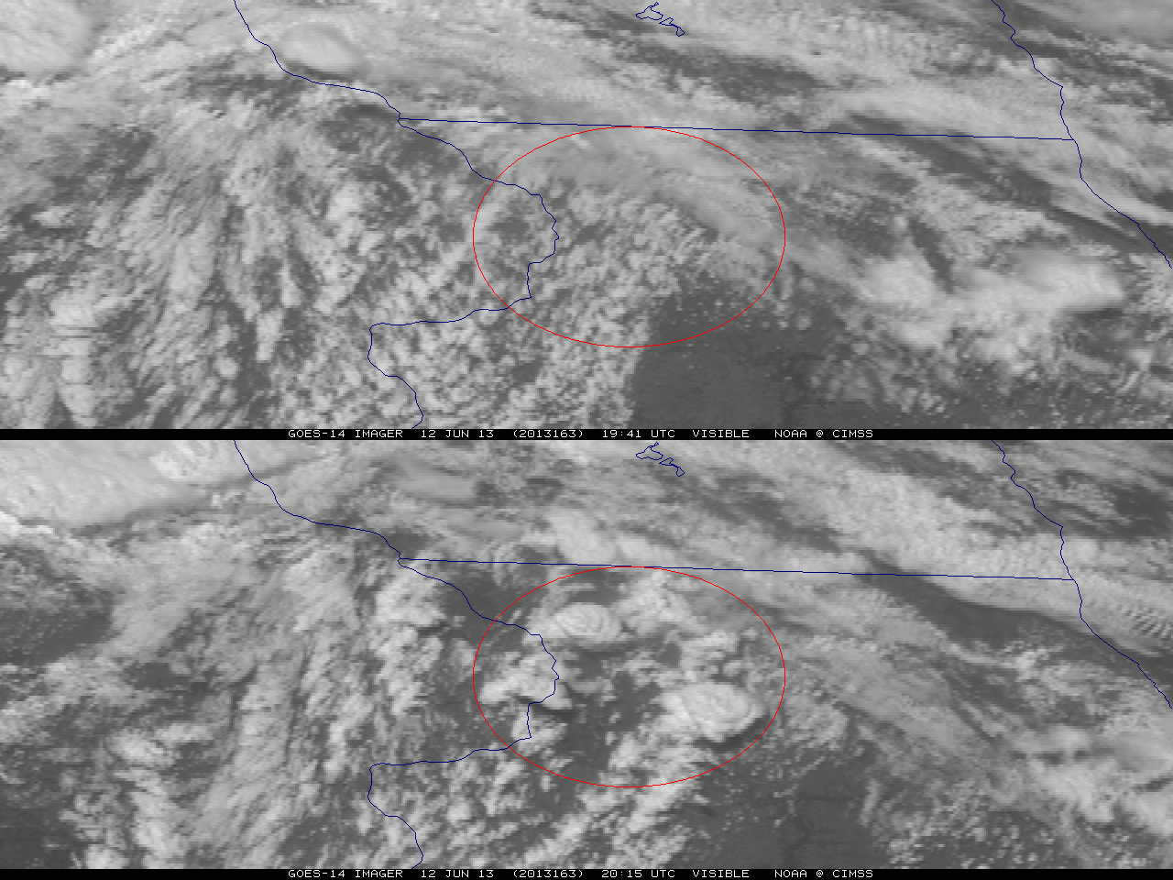
Figure 1. GOES-14 visible image on June 12, 2013 showing rapid convective development forming over approximately 30 minutes in northwest Illinois.

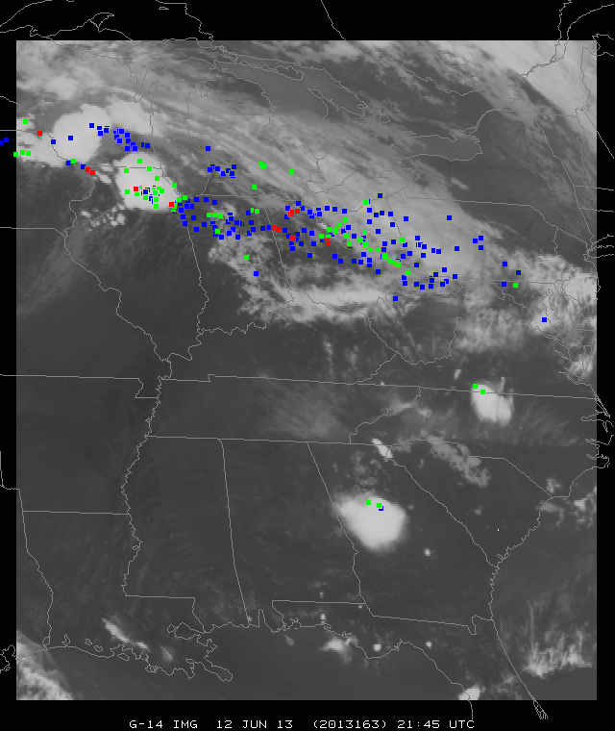
Figure 2. A demonstration of the GOES-14 SRSOR coverage (June 12, 2013) in one minute mode, with the days severe weather reports plotted (the colors indicate the type). The satellite image is of the 10.7 μm longwave window (GOES Imager band 4).
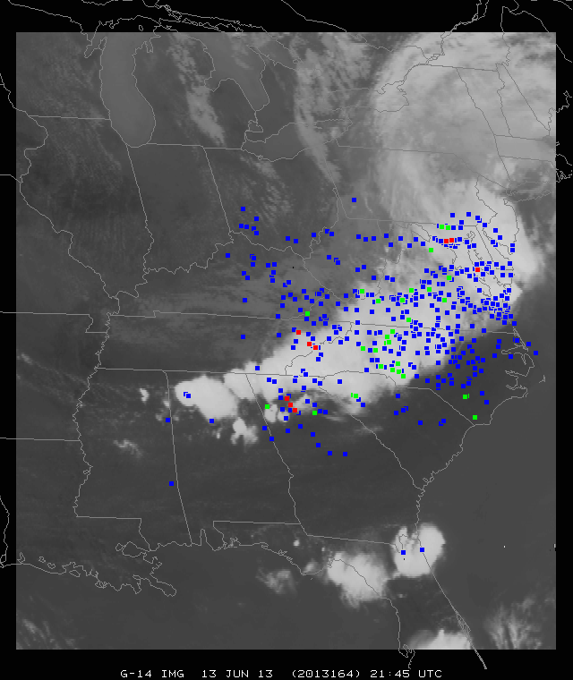
Figure 3. GOES-14 SRSOR coverage area in one minute mode, with the days severe weather reports, for June 13, 2013. The satellite image is of the 10.7 μm longwave window.

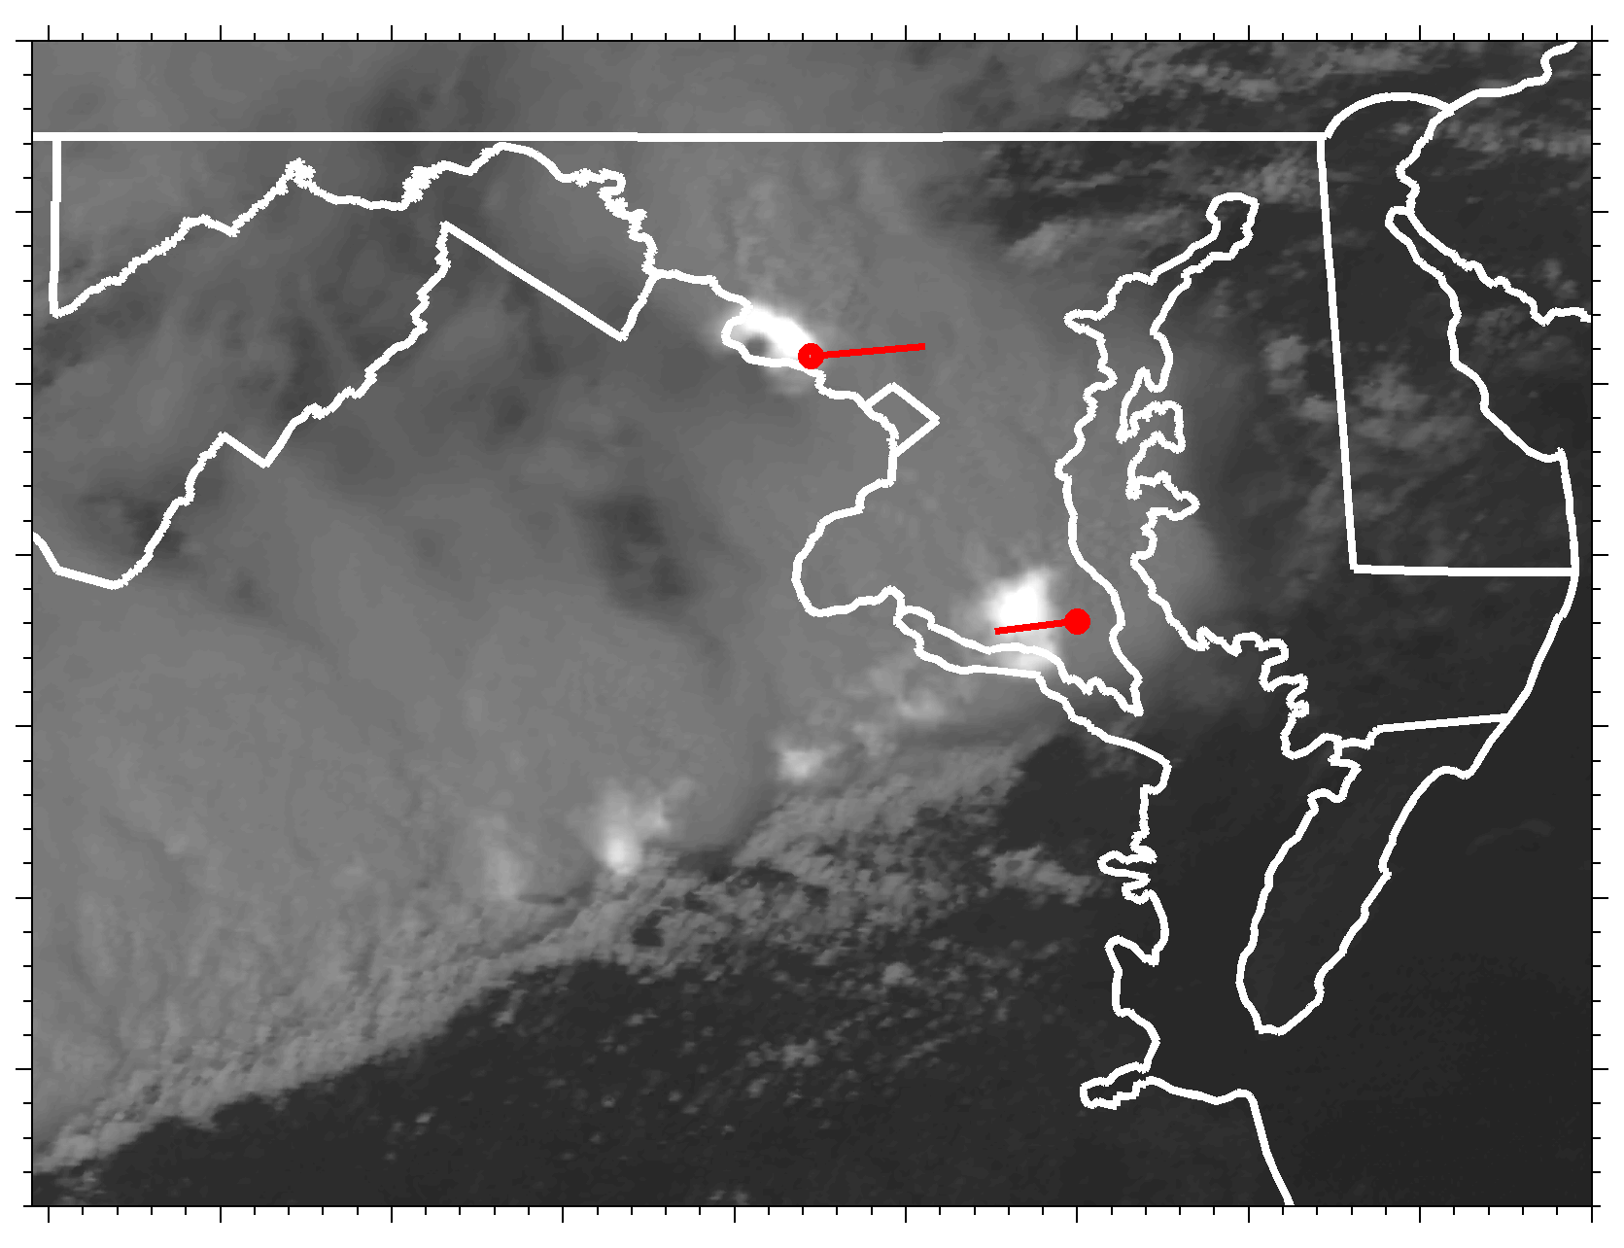
Figure 4. Visible GOES-14 SRSOR imagery blended with DCLMA lightning observations to illustrate a potential new GOES-R product. Red lines indicate the paths of two F-0 tornadoes, and the red circles illustrate their estimated locations at 1941 UTC on 13 June 2013 (animation available at http://dx.doi.org.10.1175/BAMSD-14-yyyyy.1).
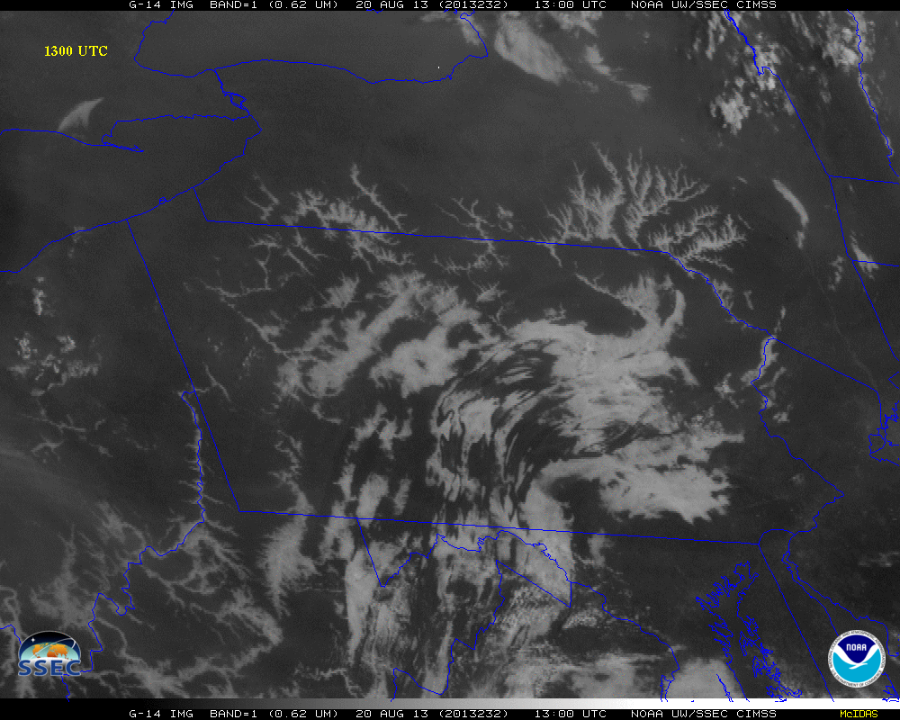
Figure 5. Enhanced GOES-14 Visible image of fog and low stratus on August 20, 2013 at 1300 UTC (animation available at http://dx.doi.org.10.1175/BAMSD-14-yyyyy.3).

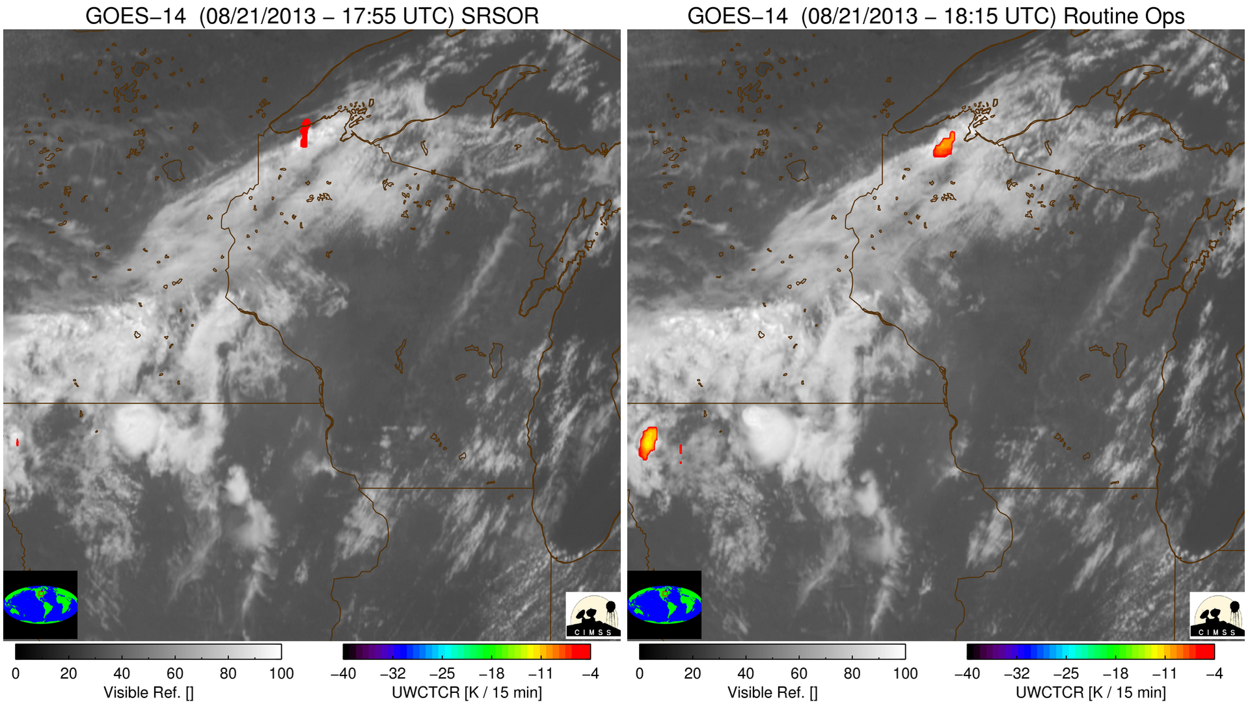
Figure 6. GOES-14 visible band on August 21, 2013 with University of Wisconsin-Cloud Top Cooling (UW-CTC) for the SRSOR timing (left panel) and the timing of routine GOES operations (right panel). The SRSOR shows the convective cloud-top cooling over far northern Wisconsin well before that from routine operations (animation available at http://dx.doi.org.10.1175/BAMSD-14-yyyyy.4).

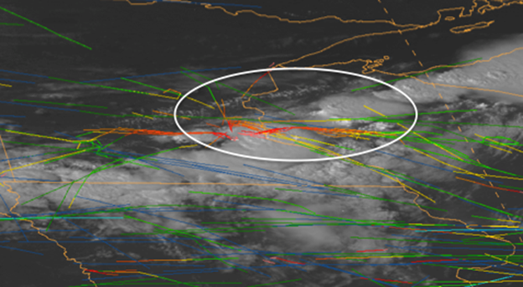
Figure 7. One minute visible imagery and Aircraft Situation Display to Industry (ASDI) flight routes over the Minneapolis Air Traffic Control Center on August 21, 2013 at 2100 UTC.

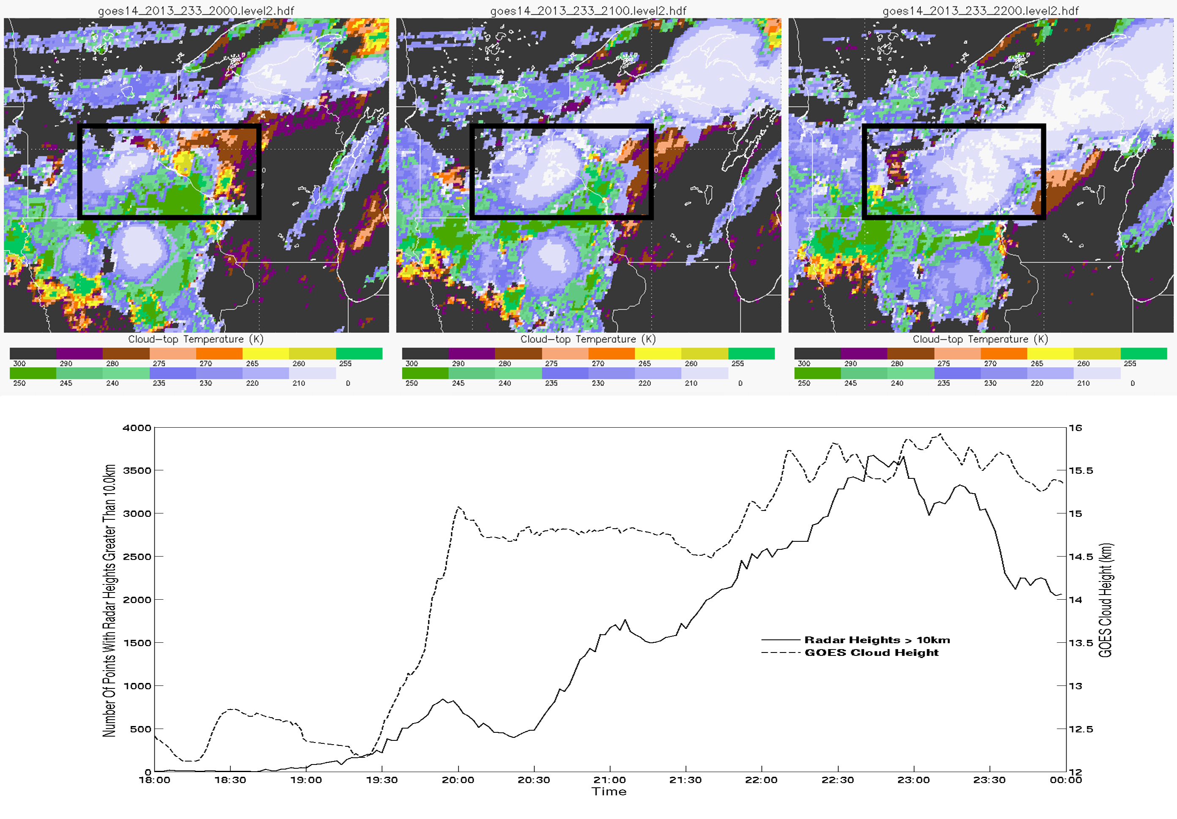
Figure 8. Time Series of the Cloud Height on August 21, 2013. Time Series of ACHA results between 18 and 24 UTC on August 21, 2013. Top three images show ACHA cloud-top temperature at 20, 21 and 22 UTC. The dashed line is the maximum satellite cloud-top height for opaque cloud types over the box drawn in the top three images. The time series from the radar (solid line) also shows rapid changes.
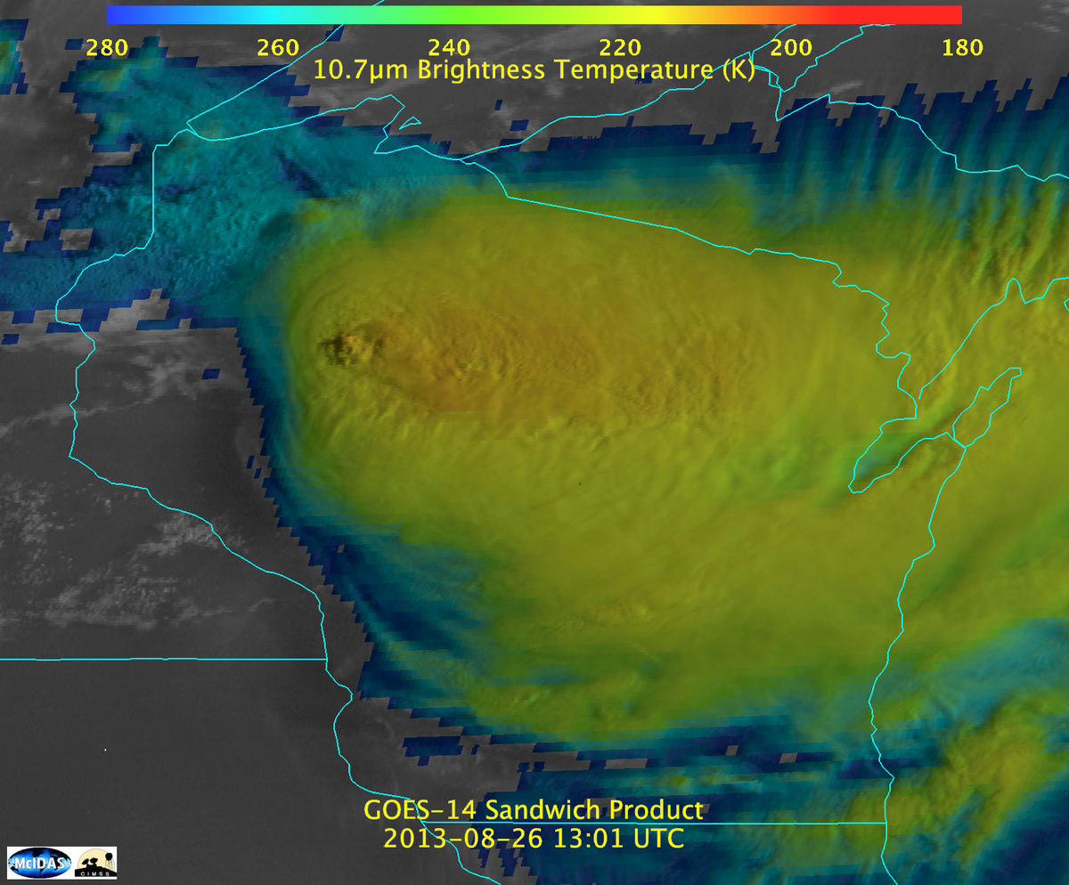
Figure 9. Combined visible and infrared 'sandwich' product from August 26, 2013 at 13:01 UTC (animation available at http://dx.doi.org.10.1175/BAMSD-14-yyyyy.5).
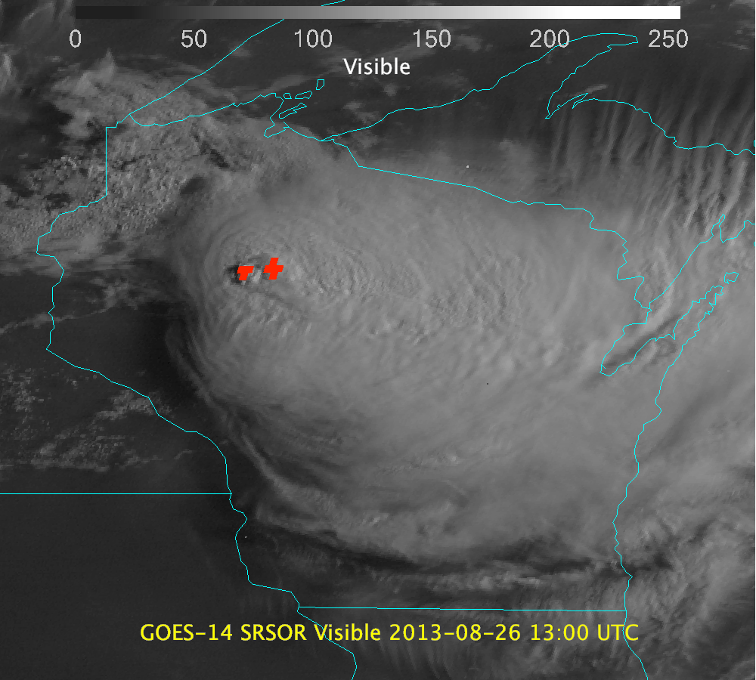
Figure 10. GOES-14 visible image and derived Over-shooting Tops from August 26, 2013 at 13:00 UTC (animation available at http://dx.doi.org.10.1175/BAMSD-14-yyyyy.6).
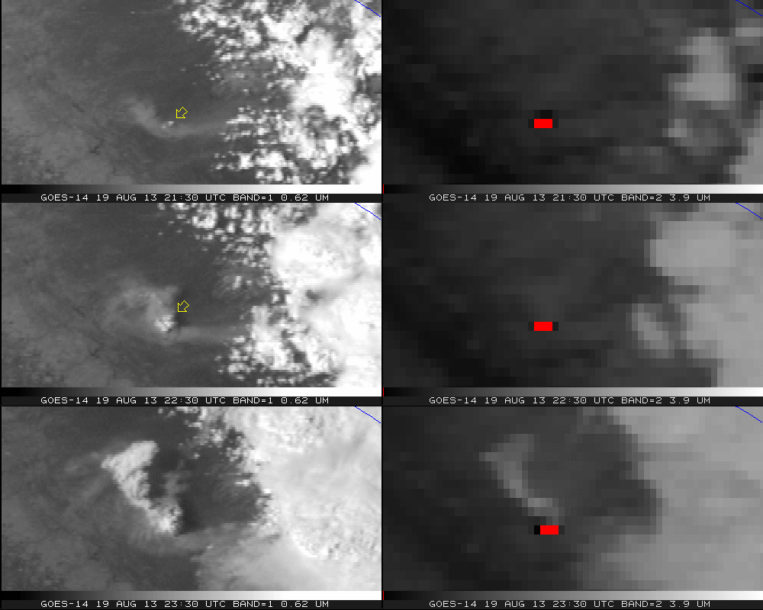
Figure 11. GOES-14 Visible (left panels) and shortwave infrared window (right panels) from the California Rim fire for August 19, 2013. Note that warm temperatures have been color-coded to be dark, with the hottest pixels red (animation available at http://dx.doi.org.10.1175/BAMSD-14-yyyyy.7).

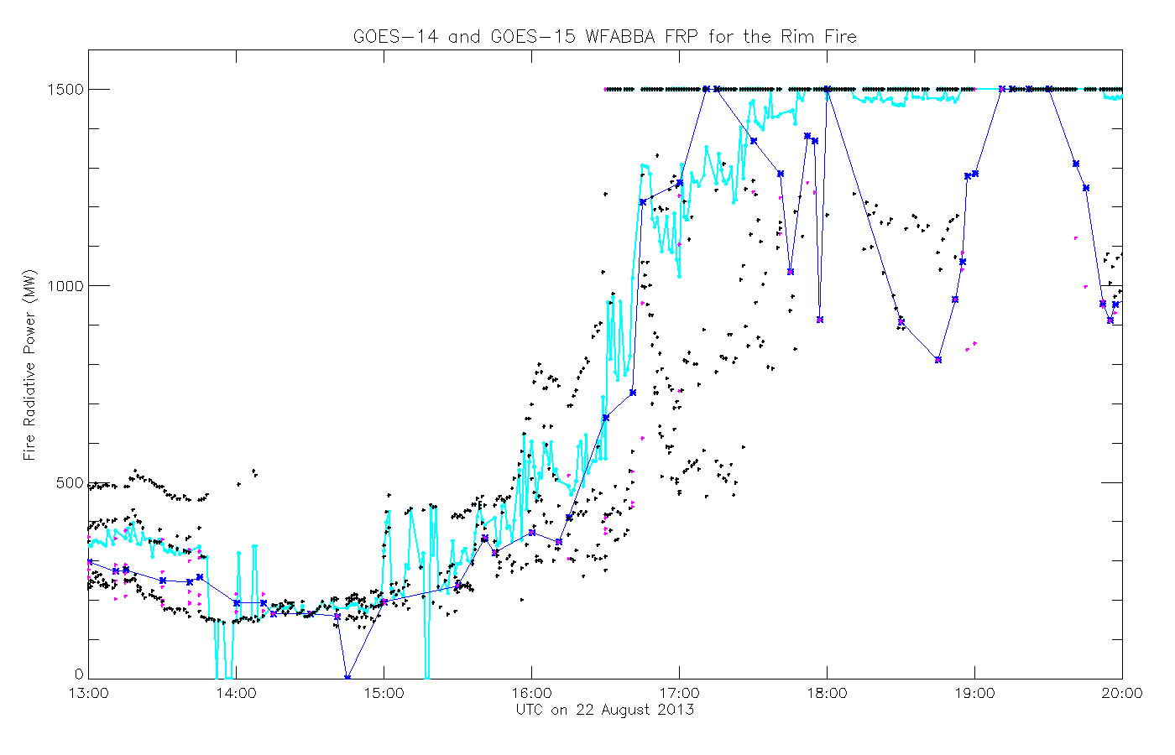
Figure 12. Time series of Fire Radiative Power (FRP) from WFABBA of GOES-14 SRSOR and GOES-15 data from 13 to 20 UTC on August 22, 2013. The dots represent the times, while the lines represent running averages. The cyan line is from the higher time resolution GOES-14 SRSOR data, while the blue line is derived from GOES-15 views.
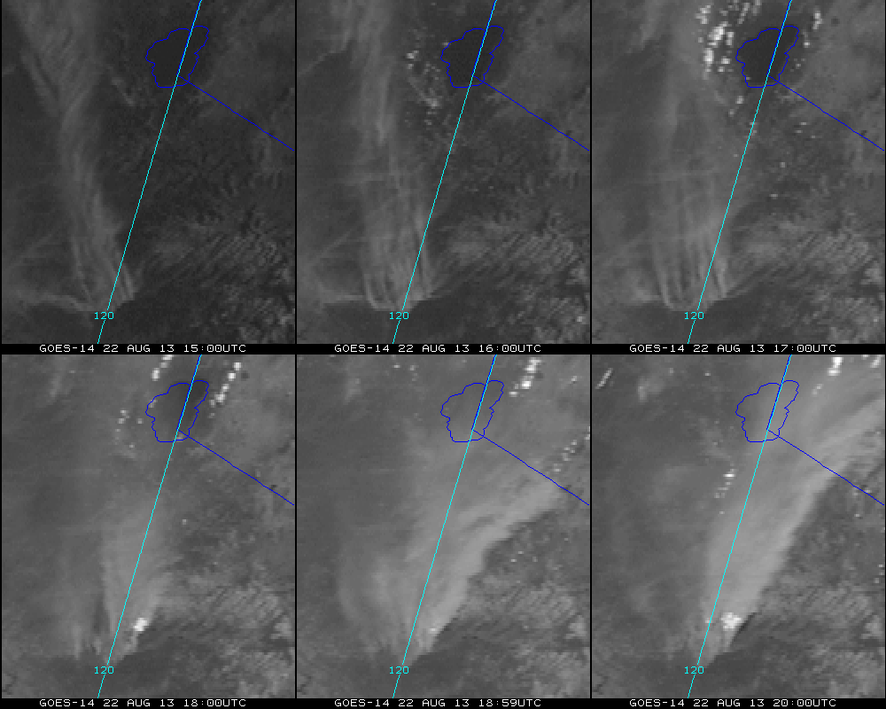
Figure 13. GOES-14 visible image enhanced to better visual the smoke from the California Rim fire on August 22, 2013 (animation available at http://dx.doi.org.10.1175/BAMSD-14-yyyyy.8).

Supplemental Material:
1.
Visible imagery and DCLMA observations of the derecho on June 13, 2013:
http://cimss.ssec.wisc.edu/goes/srsor2013/Tornado_Lightning_hires.mp4
2.
Visible imagery on June 13, 2013:
http://cimss.ssec.wisc.edu/goes/srsor2013/800x1000_GOES_B1_DERECHO_animated_2013164_180400_182_2013165_004900_182_X.mp4
3.
Fog and low stratus on August 20, 2013:
http://cimss.ssec.wisc.edu/goes/srsor2013/800x1000_GOES_B1_FOG_PA_animated_2013232_111500_182_2013232_151500_182_FOG_DAN.mp4
4.
GOES-14 visible band with University of Wisconsin-Cloud Top Cooling (UW-CTC) for the SRSOR timing (left panel) and the timing of routine GOES operations (right panel) on August 21, 2013: http://cimss.ssec.wisc.edu/goes/srsor2013/goes14_srsor_uwctc_aug212013.mp4
5.
GOES-14 visible band on August 21, 2013 with over-plotted serve weather reports (that have been parallax corrected, assuming a height of 12 km):
http://cimss.ssec.wisc.edu/goes/srsor2013/900x900_GOES_B1_CONV_WI_SWX_PCS_animated_2013233_173000_182_2013234_010000_182_X.mp4
6.
Combined visible and infrared 'sandwich' product from August 26, 2013:
http://cimss.ssec.wisc.edu/goes/srsor2013/GOES14_sandwich_larger.mp4
7.
GOES-14 visible image and derived Over-shooting Tops from August 26, 2013:
http://cimss.ssec.wisc.edu/goes/srsor2013/agoes14_other_WI_26th_20130826_enh.mp4
8.
California Rim Fire on August 19, 2013:
http://cimss.ssec.wisc.edu/goes/srsor2013/GOES14_VIS_IR2_19AUG2013loop_redo.mp4
9.
California Rim Fire on August 22, 2013:
http://cimss.ssec.wisc.edu/goes/srsor2013/800x1000_GOES_B1_RIM_FIRE_animated_2013234_150000_182_2013234_200000_182_X.mp4

